Are we teaching our designers as much as we could?

With so much clothing produced, we need to teach our designers how to get as much a tactile education as a virtual one.

This article is about an ongoing PhD research with the aim to develop an alternative design process for the initial design stages. This alternative way to create shape and volume for garments caters for the body’s concave and convex shapes and enables the designer to consider body movements. The development evolved from case studies of Madame Grès and Madeleine Vionnet and their innovative design and construction techniques. Madame Grès’ sculpting with pleats and Madeleine Vionnet’s geometrical cloth approach at the beginning of the draping process contributed to the development of this design approach called SCT -Split Cloth Technique (see photos).

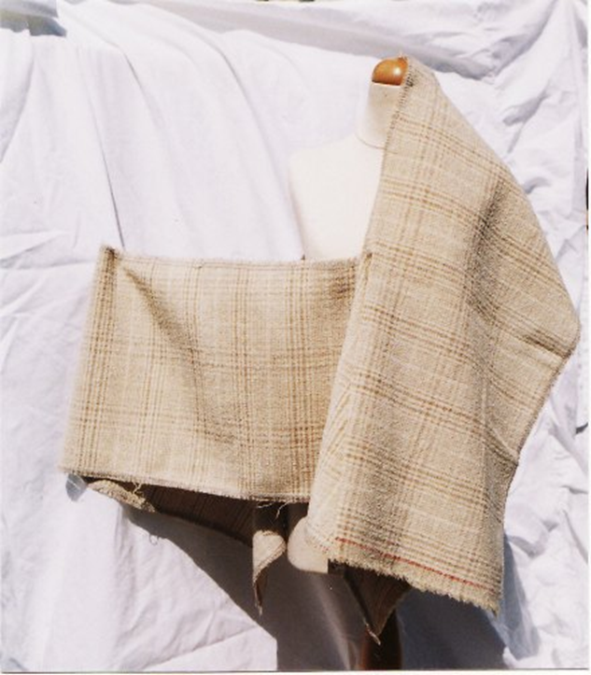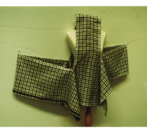
Photos of SCT cloths with 1 split (left) and 2 splits (right)

The results of the research and the utility of SCT were confirmed through extensive peer evaluations with participants from the academic and non-academic field.

When evaluating the technique, its value to education became very prevalent. SCT will also be able to give design impulses outside the fashion industry, for example in interior design or designs for the performing arts.

How does it work? Conventional fashion design uses various darts and pleats to shape the fabric. SCT achieves shape and volume by cutting the fabric before or during the process of creating the overall silhouette, rather than afterwards. In that way the cutting becomes a primary element in the initial design stage, often directing the design process and with that, the shaping of the garment.

A key finding was the creativity-enhancing aspect of the technique, leading to a more imaginative approach to garment design. Starting the design process on the stand or model, SCT offers the development of a wider range of shapes and silhouettes and offers an immediate experience of fabric weight, texture and fluidity .

SCT, an enhanced three-dimensional design technique

The concept of inserting a cut into fabric has been explored before, yet it does not seem to have been implemented as a separate technique or teaching method.

It can be used for a variety of purposes and situations:

For the creation of new garments.

As a tool to enhance parts of garments esp. around specific areas such as e.g. sleeves or shoulders.

For the application in the up-cycling market as a technique to enhance and re-use used garments or cut-offs from the production process.

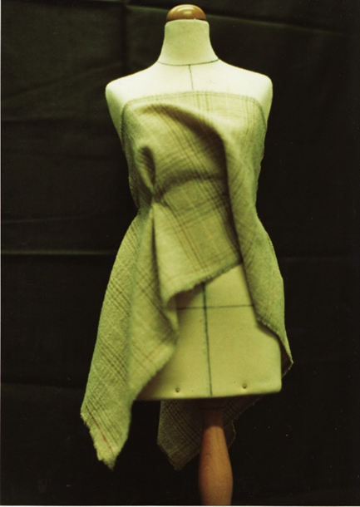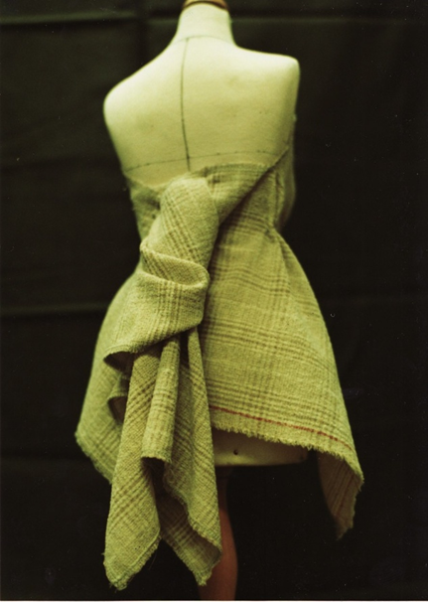
Sample SCT toile (1 split)

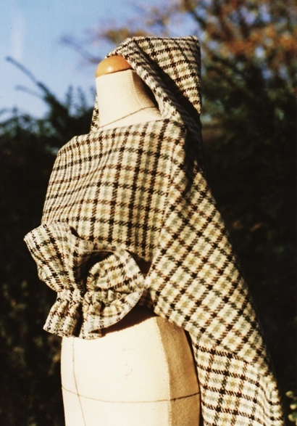
Sample SCT toile (2 splits)

Generic Benefits of SCT

It was commented that SCT does “open the thought process”

The creative process can be further enhanced by considerations about where the cut is applied. It can be cut directly on the 3D shape or before the cloth is put on the 3D shape, e.g. on a table.

In the first case the key question could be: “How can I use a cut in the design that I am currently developing?”

In the second case it could be: “What designs can be made by inserting cut(s) into the cloth and then apply it to the 3D-form?”

Benefits to Fashion Practitioners

A key benefit for the design process in industry are the quick response times. For the ever shortening fashion cycles, SCT, when applied e.g. as concept tool for the initial stages, can be a very effective method to develop ideas quickly.

Similar to the benefits in university education, SCT can offer the same educational benefits for in-house training of practitioners for either novices or for seasoned practitioners that want to enhance their skill portfolio.

Fashion Education

With the diversifying trends in fashion, the increasing multitude of influences, the increasing rate of change as well as the capabilities of CAD, there is a requirement for the educational system to bring people to the industry with a thorough grounding in the basic skills. To that effect SCT can be a central method in design education in order to give garments a more emotional and human appeal and more individuality.

Key benefits for students & teaching staff

Due to modern technology and CAD fashion design students enter design education with less and less craft and practical knowledge. There is also the view that many fashion design students have somewhat inflated ideas about the role of the designer, yet limited appreciation for the various other functions (modeliste, pattern cutter, dress maker) in the design process. The latter ones are often the roles that many of those design students will be working in after their education. The “hands-on” experience of SCT will enhance that understanding and appreciation.

Complementing the focus on CAD and the virtual fashion world, SCT can, as a more in-depth experience than conventional draping, offer “hands-on” work with fabric in order to compensate for the lack of exposure to actual fabric that the extensive and increasing application of CAD in fashion education might lead to. A thorough and deep experience with fabrics and garments early in the design education can deliver an understanding of fabrics, their behaviour and properties for which there may be lesser opportunities at later stages of the career.

SCT has been described by students and educational practitioners during the peer evaluations as an enjoyable and satisfying teaching technique.

Fashion design training in the UK had been driven over a long time by an approach that focused on drawing sketches initially. Through the use of pattern block libraries, the sketched garments were then tried to be made from existing blocks. SCT enables students to overcome the restrictions of existing blocks and adopt a more exploratory design approach.

The concept of independent learning played an increasingly important role over the last decades in the education system. SCT as a teaching method is very suitable for independent learning. In fact, the explorative nature of the SCT learning process and the potential for the students to find their own direction is probably best realised without direct supervision. For the teaching staff this means that they can focus on students that need more individual guidance at the beginning, whilst the more advanced or adventurous can be left alone.

SCT allows for a deeper, more holistic learning experience because more physical senses are involved in a more dynamic manner and the physical properties of the fabric etc. are being experienced rather than staying as abstract concepts.

Sustainable Fashion

SCT can support the sustainability requirements for the industry in two ways:

- Through its upcycling potential by offering a design technique that can enhance used garments.
- By making good use of cut-offs fabrics for example in an educational environment.

The Future

The Peer evaluations confirmed the usefulness of SCT as a teaching tool. Some university staff even suggested “SCT-type blocks” as a useful addition to the curriculum.
In the light of these educational benefits it is planned to publish an illustrated educationalist booklet. Also discussions have been initiated with various universities about how SCT can be brought into the curriculum for example in conjunction with CAD related topics.

