CHALLENGES IN IMPLEMENTING PUBLIC PRIVATE PARTNERSHIP STRATEGY FOR INFRASTRUCTURE DELIVERY IN NIGERIA
Solomon Olusola Babatunde, Srinath Perera, Chika Udeaja and Lei Zhou
Faculty of Engineering and Environment, Northumbria University,
Newcastle upon Tyne, NE1 8ST, UK

Correspondence E-mail: srinath.perera@northumbria.ac.uk
ABSTRACT

The Nigerian government’s efforts at engaging the private sector in the massive infrastructure development necessary to meet its goal of being one of the best 20 economies in the world by 2020. However, using PPP for infrastructure delivery in Nigeria is becoming a problem. The purpose of this research is to identify key challenges in implementing PPP in Nigeria with a view to suggesting strategies to address the challenges confronting PPP infrastructural projects in Nigeria. The research adopted case studies on two PPP infrastructural projects viz; the concession of Murtala Mohammed Airport Terminal 2, Lagos and the concession of 105 KM Lagos –Ibadan expressway. The research reviews documentary reports, project documents, among others to identify the sequence of events as to the project unfold and to describe the process of project conception and delivery. The research identified eight main challenges confronting PPP infrastructural deliveries in Nigeria, this includes, inadequate knowledge, skills and capacity by participants both in public and the private sectors; poor evaluation, monitoring and due diligence by government; non-competitive bidding; signing of contract with no design and evidence of financing; difficulty in accessing credit facility from banks both locally and internationally; land acquisition problem; failure of risk allocations between the government and the concessionaire; and politicization of the concessions. The research study suggested strategies such as, development of an innovate financing model for PPP projects, organize continuous trainings, workshops and conferences for public sector employees, and public enlightenment by stakeholders at very early stage of PPP cycle. These strategies are highly imperative to address the key identified challenges facing the PPP implementation in Nigeria with a view to enhancing PPP infrastructural projects.

Keywords: BOT, Concessions, Financing, PPP, Project, Nigeria.

1 INTRODUCTION

Physical infrastructure has long been identified as a catalyst for economic growth. Public Private Partnerships (PPPs) are a veritable vehicle for the development of the Nation’s infrastructure. The involvement of the private sector in the development and financing of public facilities and services has increased substantially over the past decade (Li et al., 2005a). For instance, many PPP projects in the UK and other developed economies are regarded as successful (Qiao et al., 2001; Jefferies et al., 2002; Li et al., 2005a). According to (Li et al., 2005b) PPP forms of procurement is recognised as an effective way of delivering value-for-money in the public infrastructure development or services delivering. It seeks to combine the advantages of competitive tendering and flexible negotiation, and to allocate risk on an agreed basis between the public and private sectors (Li et al., 2005b). PPPs are commonly used to accelerate economic growth, development and infrastructure delivery and to achieve quality service delivery and good governance (Akintoye and Liyanage, 2011).

International Institute for Sustainable Development Report (2012) states that between 1990 and 2009 there are more than 1,300 PPP contracts signed within the European Union (EU), with a combined capital value in excess of €250 billion. The UK, Spain, Germany, Italy, France and Portugal are the main proponents of PPP in Europe, together accounting for 92 per cent of all PPPs between1990–2009. The UK is far and beyond the biggest user of PPP with some 67 per cent of the total EU numbers, with Spain the closest competitor a distant second with 10 per cent. According to Public Works Financing Newsletter (2010) United States had a total of 363 funded PPP projects between 1985 and 2010, with a total value in excess of US$59.5 billion. In Australia, PPPs capture a large slice of the infrastructure market in terms of total government procurement, at between 10–15 per cent (Infrastructure Partnerships Australia, 2007), and had already seen more than 127 projects at a combined value of AU$35.6 billion before the end of 2005 (English, 2006). Canada has a little over 100 projects at around the US$31 billion total value since 1985 (Public Works Financing Newsletter, 2010).

In view of increasing adoptions of PPP procurement system all over the world, many countries and regions still lack PPP experience, expertise and the provision of an enabling environment for its successful implementation (Leiringer, 2003). Nigeria has simply embraced the global PPP practice in delivering infrastructural projects. The huge capital outlay and the lack of knowledge and expertise in this circle necessitate an investigation into PPPs procurement practice. The aim of this paper is to identify the key challenges confronting PPP infrastructure project implementations with a view to ameliorating the challenges in present and future PPP projects in Nigeria.

2 OVERVIEW OF PPP INFRASTRUCTURE PROJECTS IN NIGERIA

Public-Private Partnerships (PPPs) across the globe are becoming increasingly popular in delivering physical and social infrastructure. Despite the need for more aggressive public-participation in the delivery of basic infrastructure in Nigeria, there has been a rise in the number of PPP-driven infrastructural projects over the last 20 years. Vetiva (2011) fifty one projects within 20 years between 1990 and 2009 were undertaken through PPPs in Nigeria. In terms of actual value, annual investments rose to US$3.1 billion from US$22.0 million in 1997, adding up to US$23.6 billion from 1990 to 2009. Based on actual value, investments in the Telecoms sector was the highest, totalling US$18.4 billion and accounting for 78% of the total investments within the period (Vetiva, 2011). The rapid growth of population in many developed and developing countries has led to a substantial demand for the provision of infrastructural facilities. Zhang and Kumaraswamy (2001) several arrangements of PPPs have been utilized including the common build-operate-transfer (BOT), and its variants such as build-transfer-operate (BTO), design-build-finance-operate (DBFO), build-own-operate (BOO), design-build-operate maintain (DBOM) in countries that have adopted PPP and Nigeria is not an exception.
The state of Nigeria’s infrastructure has been a subject of debate by stakeholders in the economy in recent times (Lucas, 2011). Nigeria’s physical infrastructure deficit, especially in transportation – road, rail, airports and sea ports is huge (Vetiva, 2011). Existing studies reveal that about 30% of Nigeria’s 193,200 km total road network is paved (Ahmed, 2011; Sanusi, 2012). The gap is wider when compared with advanced economies with an average paved road network of 100%. Nigeria’s existing 3,528km rail network is grossly insufficient to cater for the rising need for mass transit of people and goods. Presently, the Nigerian government partners with South Korea in the development of modern railway infrastructures through PPP arrangement (Umar, 2012).

The success or failure of PPPs can often be traced back to the initial design of PPP policies, legislation, guidelines and other forms of institutional frameworks (Infrastructure Concession Regulatory Commission, 2012). Figure 1 illustrates the Nigerian federal institutional framework. This institutional framework allocates specific roles and responsibilities to various entities and how the entities are harmoniously working together within the federal government.

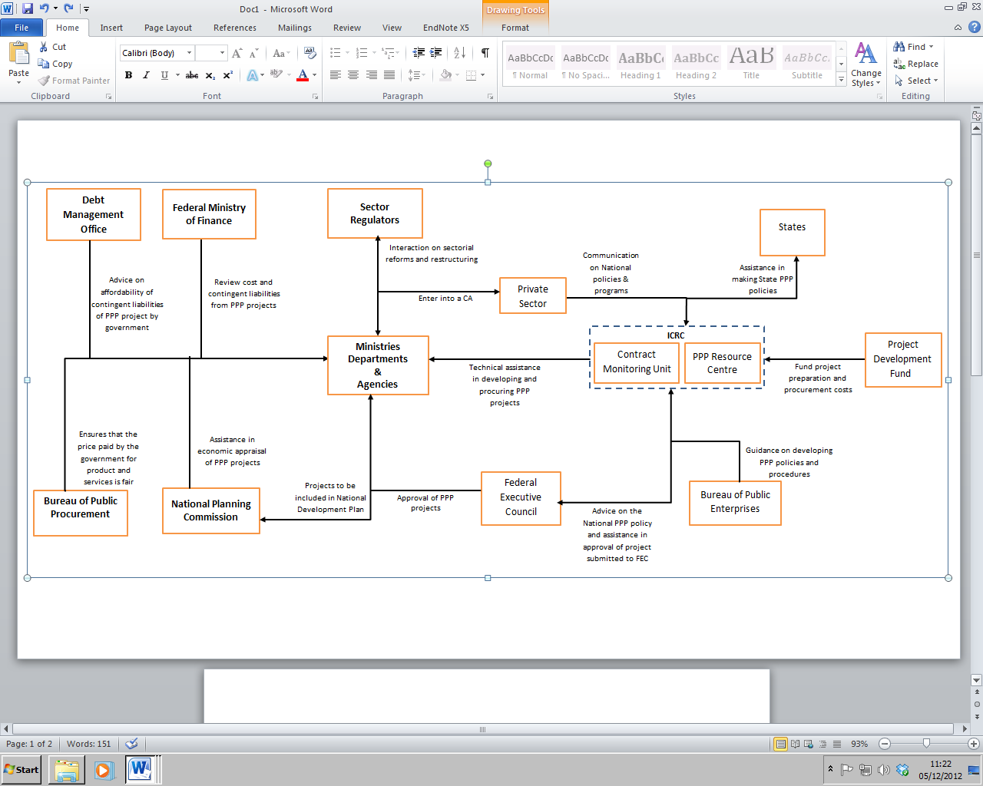

Fig 1: Nigeria’s PPPs Institutional Framework

(Source: ICRC PPP Manual for Nigeria, 2012)

3 RESEARCH METHODOLOGY

The paper conducts case studies on two PPP infrastructural projects in Nigeria, particularly the transport sector being the major beneficiary of PPP contract in Nigeria (Vetiva, 2011). The paper focuses on road and airport PPP project implementation, the concession of Murtala Mohammed Airport Terminal 2, Lagos and the concession of 105 KM Lagos –Ibadan expressway. The rationales behind the chosen of the two PPP projects are; the projects are first set of PPP infrastructure projects awarded by federal government, and the projects were awarded to indigenous concessionaires. The paper reviews documentary reports, project documents among others to identify the sequence of events as to the project unfold and to describe the process of project conception and delivery. The paper is primarily focuses on the main challenges from development stage to implementation stage of PPP cycle of the two case studies. The purpose of identifying the key challenges are to be used to address the challenges by stakeholders involved and safeguards the present and future PPP infrastructural projects with a view of encouraging and attracting private investors.

4 CASE STUDIES AND FINDINGS

4.1 Case Study One- Concession of Muratala Mohammed Airport Terminal 2
In 2003 the federal government chose to rebuild the old domestic airport terminal, that gutted by fire in 2000, through the PPP initiative. The contract was awarded to Bi – Courtney Aviation Services an indigenous company on a build, operate and transfer (BOT) basis. Table 1 reveals the findings from the concession of MMA 2.
Table 1: Concession of Muratala Mohammed Airport Terminal 2
Project name | PPP model | Year of award | Planned construction period (Months) | Concession period  (Years) | Estimated construction cost  (US$ million) | Year of commissioning | Status of project | Remark
MMA 2 | BOT | 2003 | 33 | 36 | 250 | 2007 | Operational | Successful
The BOT contract agreement between the Federal Airports Authority of Nigeria (FAAN) and concessionaire was originally signed in April 2003 (Ahmed, 2011; Lucas, 2011). A supplementary agreement was signed in June 2004 (mainly increasing construction period from 18months to 33months) and addendum agreement was signed on 2 February 2007 mainly extending concession period from 12 to 36 years (Ahmed, 2011; Lucas, 2012; International Centre for Investigative Reporting (ICIR), 2012). The concessionaire invested about US$250 million on the construction of MMA2 and most of the funding comes from a consortium of six local banks comprising Zenith, Oceanic, GTB, FCMB, Access and First Bank (ICIR, 2012). The construction Work on MMA 2 was completed and commissioned on 7 April, 2007 and flight operations commenced on 7 May 2007. Presently, MMA2 is the first BOT project of its magnitude in the area of infrastructure development which was completed successfully by a Nigerian company (Ahmed, 2011; Lucas, 2012). After the completion of MMA2, there has been a substantial improvement and increase in the number of passengers, aircraft movement, among others. Table 2 shows the statistics of passengers and aircraft movement for MMA 2 International airport between 2003- 2011.
Table 2: Statistics for MMA 2 International Airport between 2003- 2011
Year | Total Passengers | Total Aircraft Movements
2003 | 3,362,464 | 62,439
2004 | 3,576,189 | 67,208
2005 | 3,817,338 | 70,893
2006 | 3,848,757 | 74,650
2007 | 4,162,424 | 81,537
2008 | 5,136,920 | 77,472
2009 | 5,644,572 | 84,588
2010 | 6,273,454 | 96,919
2011 | 6,748,290 | 105,215
(Source: Wikipedia, 2012)

The table 2 shows the consistent increase on the total passengers, as the year increases, the total passengers in the MMA 2 international airport increases. The total passengers in 2011 are almost double the total passenger in 2003. The total aircraft movements also increase as the year increases but a decline in the year 2008. In the year 2009, the total aircraft movements started increases. The total aircraft movements increased substantially in the 2011. It can be deduced from the table that after the commission of the concession of BOT contract in the year 2007, the total passengers started increasing by almost a million in every year. There is also a significant increase in total aircraft movements in the year 2011.
4.2 Case Study two- Concession of Lagos-Ibadan Expressway
Lagos-Ibadan Expressway was originally constructed and commissioned in 1978; thousands of vehicles ply the express route daily. Thus, it is one of the busiest and accident-prone roads in Nigeria. The expressway has been neglected by past administrations, that there was no budgetary allocation for the rehabilitation and maintenance of the road. In 2009 the federal government awarded the reconstruction of existing 105 KM Lagos –Ibadan Expressway to concessionaire under a BOT deal, with 100 per cent funding by concessionaire that the investors cost and return on investment will be recovered via tolls. Table 3 shows the findings from the concession of Lagos-Ibadan Expressway.
Table 3: Concession of Lagos-Ibadan Expressway
Project name | PPP model | Year of award | Total length  (Km) | Number  of lanes | Planned construction period (Months) | Concession period  (Years) | Estimated construction cost  (US$ million) | Status of project | Remark
Lagos-Ibadan | BOT | 2009 | 105 | 4 | 48 | 25 | 593 | Construction not fully commenced | Failure
The concession period is 25 years, the road contract valued at US$593 Million and four faces (lane) of construction of the 105 KM road to last for four years (Ahmed, 2011; Ayeyemi, 2012; Bisiriyu, 2012). Three years after the concession agreement was signed between the federal ministry of works and Bi Courtney Limited (concessionaire), the construction has failed to take off (ICIR, 2012). The concession of Lagos –Ibadan Expressway is a failure; findings reveal that a lot of things are taking for granted by both government and the concessionaire. The officials of the government did not have enough knowledge about PPP project and does not employ the services of experienced legal/transaction consultants or technical advisers. Thus, the designing of the project was left entirely to the concessionaire who drew up an agreement that was entirely skewed in its favour (ICIR, 2012). The PPP experts believe that the Lagos/Ibadan road concession was structured to fail right from the beginning (ICIR, 2012).
5 DISCUSSIONS OF THE CASES

The failure and controversy in the concession of the two cases presented in this paper is an exemplar of the Nigerian experience in PPPs. Nigerians had hoped that the government would have learnt some lessons from the failure of previous PPP efforts and use the concessions of MMA2 and Lagos/Ibadan highway as a model for the development of Nigeria’s airports and roads infrastructure. However, the paper identified three main challenges in the concession of MMA 2, these include; inadequate experience of public (Ministries, Department, and Agencies that regulate PPP) and private sectors (concessionaire), political involvement at the implementation level, and inadequate project preparation. The paper further identified eight main challenges responsible for the failure of the concession of Lagos-Ibadan highway as follows, Inadequate knowledge, skills and capacity by participants both in public and the private sectors; poor evaluation, monitoring and due diligence by government; non-competitive bidding; signing of contract with no design and evidence of financing; difficulty in accessing credit facility from banks both locally and internationally; land acquisition problem; failure of risk allocations between the government and the concessionaire; and politicization of the concession. The key challenges identified from the two cases reviewed can be grouped as: financial, political, economic, legal, knowledge and cultural behaviours. The findings show that the government fails to make use the PPP advantages of competitive tendering and flexible negotiation, and to allocate risk on an agreed basis between the public and private sectors.

6 SUGGESTED STRATEGIES TO ADDRESS THE PPP IMPLEMENTATION CHALLENGES

In Nigeria, as federal and state government began to explore more private sector resources in the delivery and operation of public facilities through PPPs. The paper suggests some strategies needed to be carried-out by government to encourage the private investors and to enhance PPP infrastructure project implementations. Suggested strategies emanate from the main identified challenges of Nigerian PPP practise. These include:

- Development of an innovate financing model for PPP projects in order to attract private investors
- Establishment of pertinent PPP laws, regulations and guidelines in the development of efficient frameworks for best PPP practices.
- Organise continuous training, workshops and conferences for public sector employees in Infrastructure Concession Regulatory Commission (ICRC), Ministries, Departments, and Agencies (MDAs), Bureau of Public Enterprises (BPE), Bureau of Public Procurement (BPP) and National Planning Commission (NPC) in terms of planning, this includes, project appraisal, procurement, contract and project management, financial modelling, project whole life costing and risk management to broaden their PPPs knowledge.
- Public enlightenment, the stakeholders must inform, involve and include the public at very early stage of PPP cycle because of cultural behaviours of Nigerians.

7 CONCLUSIONS
The Nigerian government is looking to public-private partnerships (PPPs) to speedily improve the country’s infrastructure networks and enhance service delivery to the Nigerian people. The current deficit in infrastructure is the major constraint to achieving the national vision of becoming one of the 20 largest economies by 2020. PPPs have the potential to solve Sub-Saharan Africa's profound infrastructure and service backlogs especially in Nigeria where about 70 per cent of the 193,000 km of roads in the country is in a poor condition and 60 per cent of the population lacks electricity supply, over US$13 billion is spent annually on fuel generators. This paper identified the key challenges confronting PPP implementation in Nigeria and it can be grouped as: financial, political, economic, legal, knowledge and cultural behaviours. Having identified the PPP implementation challenges, it will help the stakeholders involved in implementing PPP to safeguard the present and future PPP infrastructure projects in Nigeria. The paper recommends that government must fundamentally improve their systems for dealing with the private sector to realise the efficiency and effectiveness gains that these partnerships promise.

REFERENCES

Ahmed, M (2011) PPP for infrastructure development: the Nigerian experience, available
at http://www.icrc.gov.ng/wp-content (Accessed 30 August 2012)
Akintoye, A and Liyanage, C (2011) Public private partnerships, proceedings of the CIB
TG72 /ARCOM doctoral research workshop, held at University of Central
Lancashire, Preston, United Kingdom, 12th October
Ayeyemi, D (2012) Reconstruction of Lagos-Ibadan expressway to commence before
December, the National Mirror, published on Tuesday November 6.
Bisiriyu, R (2012) Lagos-Ibadan expressway reconstruction to start from Ibadan by Bi
Courtney, the Punch, published on Friday January 27
English, L M (2006) Public private partnerships in Australia: an overview of their nature,
purpose, incidence and oversight. UNSW Law Journal, 29(3), 250-262
Frontier Market Intelligence (2011) Why PPPs should work in Africa, available at: http://www.tradeinvestafrica.com (Accessed 10 July 2012)
Infrastructure Concession Regulatory Commission (2012) PPP manual for Nigeria, available
at http://www.ppptoolkit.icrc.gov.ng (Accessed 31 October 2012)
International Centre for Investigative Reporting (2012) A failed romance: why PPP do not work in Nigeria, published on Wednesday, February 1st.
International Institute for Sustainable Development Report (2012), “Harnessing the power of public-private partnerships”: the role of hybrid financing strategies in sustainable development. Available at: http://www.iisd.org/2012/harnessing. (Accessed 10 October 2012)
Infrastructure Partnerships Australia (2007) Performance of PPPs and traditional procurement
in Australia, available at: http://www.infrastructure.org.au/content/ppp.aspx.
(Accessed 10 October 2012)
Jefferies, M C, Gameson, R and Rowlinson, S (2002), “Critical success factors of the
BOOT procurement system: reflections from the stadium Australia case study”.
Engineering, Construction and Architectural Management, 9(4), 352-61
Leiringer, R (2003) Technological innovations in the context of public-private partnership Projects, unpublished PhD thesis, Royal Institute of Technology, Stockholm
Li, B, Akintoye, A, Edwards, P J and Hardcastle, C (2005a) Critical success factors for PPP/PFI projects in the UK Construction Industry, Construction Management and
Economics, 23(5), 459-471.
Li, B, Akintoye, A, Edwards, P J and Hardcastle, C (2005b) The allocation of risk in PPP/PFI construction projects in the UK.. International Journal of Project Management, 23(1), 25–35.
Lucas, M (2011), Clouds over public-private partnership, the Tell, published on Thursday,
March 17th
Lucas, M (2012) How government scares investors, the Tell, published on Monday October
29.
Public Works Financing Newsletter (2010) International survey of public-private
partnerships, Vol. 253, available at: http://www.pwfinance.net/pwf_major_project.pdf.
(Accessed 10 October 2012)

Qiao, L, Wang, S Q, Tiong, R L K. and Chan, T S (2001) Framework for critical success
factors of BOT projects in China”, Journal of Project Finance, 7(1), 53- 61
Sanusi, L S (2012) The role of development finance institutions in infrastructure
development: what Nigeria can learn from BNDES and The Indian infrastructure
finance company, 3rd ICRC PPP stakeholders’ forum, held in Abuja, 18th July
Umar, I (2012) Nigeria to partner South Korea on rail sector revival, This Day newspaper, published on Friday 14 September 2012
Vetiva (2011) Construction industry report a haven of opportunities, available at
http://www.proshareng.com/admin/upload/reports/VetivResearchConstructioSectory2011.pdf
Accessed 15 October 2011)
Wikipedia (2012) Available at http://en.wikipedia.org/wiki/murtala (Accessed 30 October
2012)
Zhang, X and Kumaraswamy, M (2001) Procurement protocols for public-private
partnered projects. Journal of Construction Engineering and Management, 127
(5), 351–358.

