A proposal for a BIM performance framework for the maintenance and refurbishment of housing stock

1.0 Introduction

For many years Building Information Modelling (BIM) has been acknowledged as providing digital representation of projects’ complex physical and functional attributes. This goes beyond automated communication and documentation of structures and design: a strategic approach to BIM adoption needs to incorporate people, processes and technologies on an equivalent basis, and lead to capacity building through the managerial improvements (Arayici et al., 2011), coupled with industry implementation being driven through the specific govemental fiscal incentives such as the BIM task force in the UK for example (Gledson et al., 2012). BIM’s information delivery abilities are acknowledged by the building and construction industry worldwide. In recent years, researchers have investigated in depth the overall benefits of BIM in managing complex construction projects (Waterhouse and Philp, 2013;Yan & Damian, 2008), and how to measure these benefits with regard to the specific needs of stakeholders via integrated design processes (Barlish and Sullivan, 2012; Succar, 2009) . There have also been extensive studies conducted on green building performance such as thermal analysis, sustainability and evaluation tools (chiefly BREEAM and LEED), their benefits to buildings (Fox, 2010), and the facilitation of sustainable design (Alwan et al., 2015), with specific reference to BIM processes (Kim et al., 2015; Hope & Alwan, 2012; Building & Consumption, 2010). However, there has been relatively little discussion of the benefits of BIM with respect to the domestic housing sector; and even less research has been conducted on the potential adoption of BIM for the maintenance and refurbishment (M&R) of housing stock. Finally, despite targets in the implementation of BIM being set by the UK Government, its uptake has been generally modest at best (Motawa & Almarshad, 2013), with its employment varying significantly from one industry sector to another. This may be as a result of a reliance on traditional practice as well as a lack of education within the sector.
The aim of this research is therefore to evaluate the current state of BIM in relation to maintenance and refurbishment (M&R), and to propose conceptual and practical frameworks whereby BIM adoption can be usefully utilised as a strategic management tool for ageing housing stock, with a specific focus on sustainability issues.

2.0 Potential for maintenance and refurbishment in BIM

Park and Kim (2014) suggested the potential for BIM integration in the housing sector is difficult due to a fragmented construction sector and complicated stakeholder requirements. Coupled with this, the sector is under tremendous pressure in terms of updating an aging housing stock which suffers from structural faults. In the UK, for example, over 35% of housing predates 1945, and is likely to remain standing and in use over the next 30 years, resulting in high carbon footprint and increased energy consumption compared to new housing. The UK government has introduced one of the most stringent CO₂ reduction measures in the world, with 80% reduction by 2050 (DECC , 2008), and the housing sector currently accounts for a remarkable 27% of the total UK CO₂ emissions (Kelly, 2009), making it an obvious area to target for carbon cuts. Considering the importance of the situation there has been little focus on including existing housing stock in the carbon reduction process. This is significant gap in the BIM agenda in relation to M&R and carbon savings, and it remains underexplored. There is also an economic case for such an approach as there is a tendency in the UK among occupiers to prefer old housing stock, due to its location and generous floor area, and because of a lack of new house building initiatives.

4.0 A suggested framework

A framework is presented below which gives snapshot of M& R needs, revealing issues with building fabric and the need for thermal improvement interventions , and indicating how they can make a difference to both building fabric and living conditions for residents. and using different input methods to make the framework as flexible as possible to different needs

Without such as framework, performance measurement, suitable information structure and data exchanges are ignored and housing refurbishments becomes more of random rather than rational process. Two scenarios are presented of possible applications using BIM. The justification of using two levels, is because this is a long term process which requires stakeholders to set different goals and objectives with regards to their BIM capabilities and proficiency

- Theoretical level: what are the theoretical basis of running a model, parameters and the role of data collection in forming a model within a basic BIM limited environment. These include the practical implementation in terms of software use, data transfer and individual units of measurements such as heat loss, cost of material? These can be potential BIM scenarios not liked to actual BIM generated data. Basic BIM approach and converting 2D drownings

- Practical level: how can a conceptual model be developed and applied to the Architectural Engineering and Construction (AEC) industry, utilising the data and results developed within the case studies and real experiments . The foundation of a framework can be developed tested through a pilot scheme for example using Advanced BIM processes.

It is essential for M&R strategy that intents to adopt a BIM framework to start at a basic level, which addresses the needs and abilities of the sector and potential users, use of BIM protocols, AEC software, electronic data capture can be daunting to users not exposed to BIM.
In a housing information management structure client needs to manage / evolve data over time so that they can make use for future refurbishments. (Volk et al 2014)) refers to BIM functionalities as services or capabilities that are provided that depend on project requirements or stakeholder .e.g. in this case housing fabric, the U value/ lambda value , orientation, building fabric .external fabric, boiler rating, loft insulation etc.). There is possibility data might change but geometry may not. A good example of this can be future weather patterns might affect choice of technology, taking a holistic 50 years scenario for housing stock the level of insulation needed in the future might be affected by increased global temperature as a result of climate change. Therefore It is important at this stage to highlight what aspects of M&R needs to be assessed and measured before a graduation to a BIM advanced level . this can include actual, assessment of software types and technology used to capture data, physical surveys of asset needs, type of residents , age groups and

6.0 A possible BIM framework for the case study (practical) structure

One of the strongest arguments for the use of BIM is that data produced by the initial designers can be further reused downstream by a range of persons including engineers, quantity surveyors, contractors and finally as the basis for a facilities management handover. In this section we will highlight how practical BIM enabled framework can be used for M&R for advanced BIM capabilities to address issues such as areas of poor performance of housing fabric and heat loss. Issues to do with software compatibility and BIM protocols and responsibilities need to be addressed at this stage.

For domestic housing stock there needs to be a method for collecting appropriate data for up housing in terms of energy efficiency intervention and M & R in general. This needs to be above the current limited “drive by surveys”, and serious questions need to be asked about what are the methods for data collection interpretation and aggregation.

Capture of asset information requirement is somewhat rare with the main focus on new built developments as highlighted by (Love et al. 2014). Scenarios for asset management in relation to building performance from carbon savings have been addressed in a limited way. Recently (Gledson & Alwan 2015) found that specific Building Performance Attribute Data could be aggregated within a BIM model that could be used to greatly influence the delivery of effective facilities and asset management. In order to address these challenges a simple starting simplest point could be creating 3D geometry of basic “as build” housing types

Then one solution would be the making use of the as-built BIM model developed before and throughout the M&R process and updating with suitable data that could be ultimately transformed into working model.

For the purposes of this research, BIM concepts were developed and framework was presented compatible with existing house types , and was given a name HBRP. The Housing Building refurbishment Plan (HBRP) figure 1, which is specific to M&R activities and technological inputs and advances in both software and hardware in the AEC field.

Visualisation Laser Scanning BIM data input
IR thermography
Which BIM 1, 2, 3  Multiple software platform considerations  Agreeing scope of service  Refurbishment team strategy  Communications plan  Identification of stakeholders  Communication with stakeholders  Building in risk factors  Hardware Interoperability software issues |  |  | 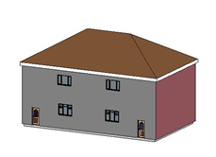
 |  | Link to FM  HBRP BIM Refurbishment protocol |  |  | Data input 2 D (CAD intelligent) /  3D Revit Architecture
Grade 4 | LOD 400 | Fabrication | Fabrication and assemble information incorporated
Grade 5 | LOD 500 | Facility Management | As-built digital information suitable for operation and maintenance purposes

Figure 1 HBRP protocol. BIM route and input schedule for creation of a BIM refurbishment protocol , demonstrating what data input method and initial steps with strong links to COBIE

What is crucial about the HBRP protocol is that it is adaptable enough to allow flexibility of different requirements by stakeholder and system ontology. For example data can be captured in variety of ways, and released in a BIM compatible fashion as well to manage an asset. .e.g. COBie. The term COBie (Construction-Operations Building information exchange) is widely used data and internationally recognised exchange standard for projects (East 2007). Such a systems gradually evolves and as a precursor to further consideration of what elements (both in inputs and outputs) can be utilised for housing asset management and a demonstration that current framework can fit into BIM.

Finally developing a full HBRP structure can take significant time and will require commitments from stakeholder to gain BIM knowledge and use of technical innovations to carry out data checks and validation, but will be very effective in the long term as it evolves gradually .

Technological inputs and construction of HBRP model components.

While the BIM process have become associated with high technological advanced in software , the application and linkage to other advancement in buildings assessment has been limited.
Figure 1 shows suggest various input methods, such as laser scanning , thermography which are currently standalone and not linked to BIM . This section highlights some of these methods and how they can be incorporated into M&R processes, and directly feed into the model described above. These examples are based on desktop research findings as well as case study examples gained from research projects at Northumbria University.

5.1 Construction of as built models for housing type within BIM environment

It is clear that more consideration taken in applying 3D modelling technology to build existing assets and their potential to be part of the BIM model Verify/validate correctness of information for refurbishment.

So the question presents itself can individual housing archetypes be developed, in a 3D environment and consequently feed into the HBRP model ? This will be a visualised concept model that can give stakeholders a perspective of what a live BIM model would look like, and how to integrative individual components. At present there are a variety of BIM visualisation tools such as Bentley SketchUp , ArchiCAD, and a host of Autodesk packages, used to model a wide spectrum of AEC projects. In figure 2 Revit Architecture 2014 was used in 3D modelling, the author applied it to demonstrate information flow and benefits for stakeholders of selecting different types of external wall insulation (EWI) and form the form one input into HBRP model. This tool is widely used in the architectural, engineering and construction (AEC) sector, but not applied widely for refurbishment assessment. In the example style prefabricated homes, which were built quickly and cheaply in the late 1940s to 1950s, was modelled, figure 2(a) gives possible options of improved thermal performance before and after EWI rigid insulation.

Basis of a “sustainability dashboard” figure 2 (b) of potential solutions can be presented in a drop down menu in terms of suitable interventions for M&R, clearly presenting thermal conductivity which is crucial in deciding suitable material for refurbishment in this case EWI.

 |  | 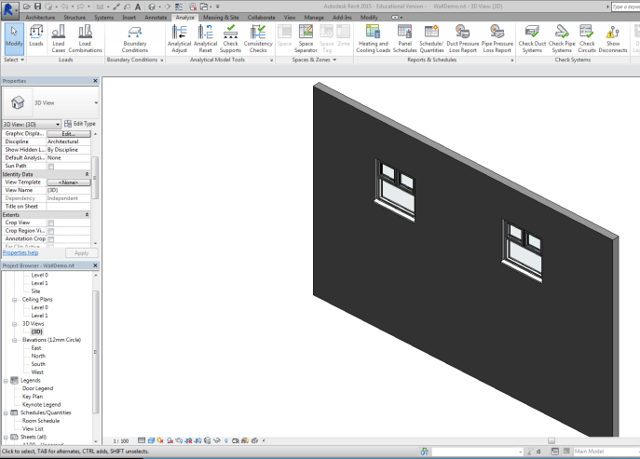
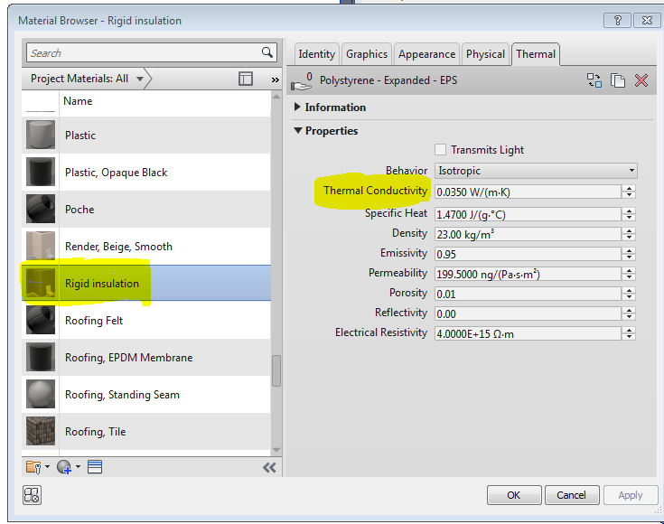 |  | 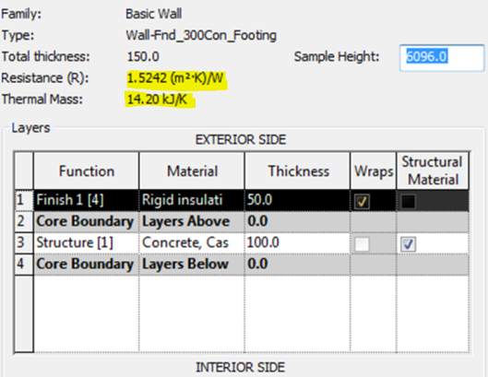
- Live dashboard for material selection |  | - Thermal conductivity analysis

Figure2: BIM framework allows components plug in relation to wall specification and greater choice of material, in relation to thermal properties

Over the long term to make this achievable there needs to be a mind set and culture change within the construction and housing management and refreshments sector in terms of domestic building refurbishments/operations, and hand over. In recent work (Sebastian et al 2007) applied BIM for small scale housing, and found that BIM facilitates proactive early collaboration amongst project participants, this can be applied to any HBRP model, as a better way of addressing buildings envelope problems and present it to stakeholders .

5.2 Infrared thermography applications

This section will give an example of how Infrared thermography( IR), currently used as a “snapshot” analysis tool can be added to the HBRP model.

In recent years specific attention was given to the thermal performance of specific parts of the components (e.g changing windows to double glazing) to improve comfort zones and reduce areas greatest heat loss. Infrared thermography is increasingly being used to diagnose pathologies in buildings, such as façade defects and heat loss analysis (Elton et al., 2015). This allows automatic spot recognition of temperature gradient in the walls and provided vital temperature recordings on the screen to show where heat loss occurred .Thermal imaging cameras can also identify areas of heat loss, such as thermal bridges, and allow overall assessment of the effectiveness of EWI in older properties undergoing M&R.

The technology works on the principle that all objects above zero degrees Fahrenheit (about 273°C) emit infrared radiation that cannot be seen by the human eye. An object coloured in red indicates heat loss or an inefficient building fabric, while a blue object indicates heat is retained (See figure 3), and their U value W/m²K is very high, leading to excessive heat loss (see figure 3 and 4 ) The gradient is the same weather you are external or internal in the building .
The images taken are of properties post-World War Two Airey, Dorran, and BISF (British Steel Frame) style prefabricated homes that had EWI added to them as part of M&R upgrade

High conductivity and excessive heat loss associated with such hard-to-heat properties can cause or be linked to problems such as high fuel bills, increased carbon emissions, health problems for occupants, damp and mould growth on or in walls.

Currently such information is used for one off analysis, it is by far more effective to integrate into the HBRP model in figure 2. Even more effective over the long term would be links to COBie as a effective method for M&R so that routinely images can be taken to monitor the performance of the housing stock , where problems can be identified and long term lack of thermal performance tackled at an early stage. Other structural issues can be identified as part of BIM process, in this case building envelope was thin, and at a structural level the concrete or steel columns with steel rod inserts had a tendency to let in water and, as the steel rusted, the concrete ‘spalled’ away (see figure 3, top left).

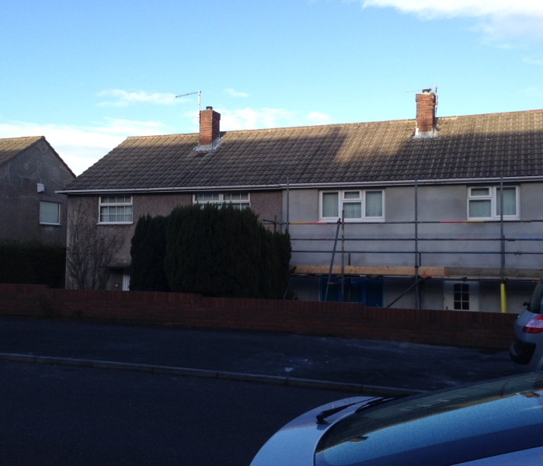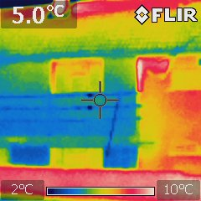
Two identical proprieties one undergoing in situ external insulation
Red colour indicating heat loss is much greater almost double from right hand side property on left had treatment

Figure 3: External images from thermography results before and after external rigid wall insulation

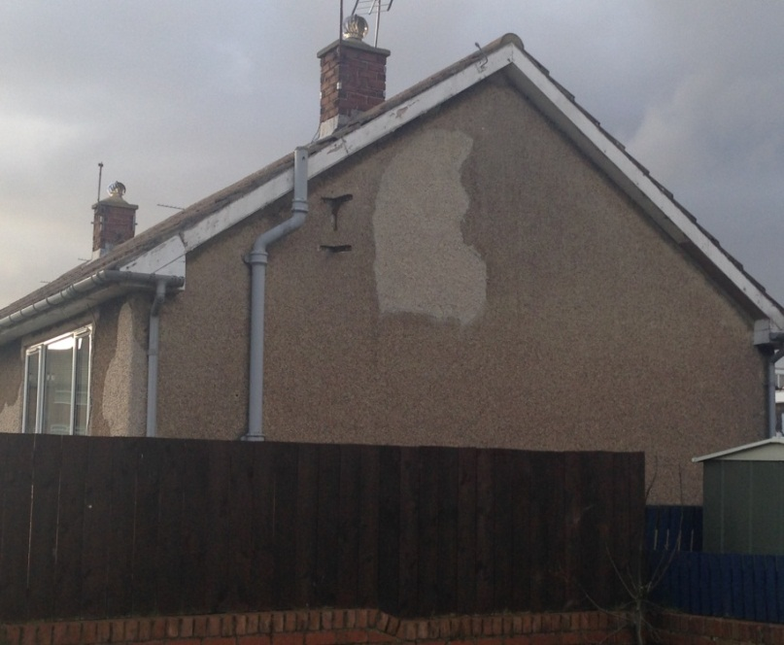 | 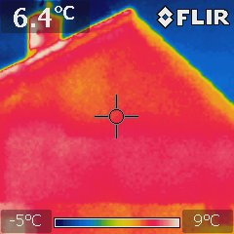
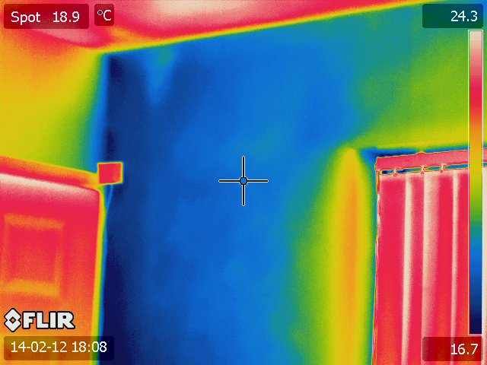  Surface temperature is much lower than average, likely to cause condensation and decay to building fabric | 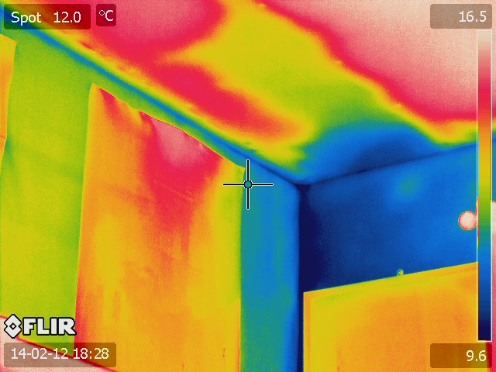

Figure 4: Internal and external images from thermography results before external rigid wall insulation

5.3Use of laser scanning and intelligent asset management
The manual generation of reliable 3D building models of housing types requires software training as well as ability run and operate software licences, which might be outside the range of housing and asset BIM capabilities . In addition the time taken to create 3D models, for several house archetypes can be a huge task. To bypass this process laser scanning technology can be used for M&R operations and generation of models in a fraction of the time. The generation of reliable and accurate models and building blocks from laser scanning is possible but requires outline extraction , roof shape and final model checking ( Dorininger & Pfeiter 2008) sensors . Furthermore such data extracted can be used and replicated for entire housing stock and used as part of an effective asset management structure.
There is potential in investing in BIM as part of effective and intelligent asset management of commercial and domestic buildings . Love et al 2014 offers a framework for value in investing in BIM for asset management , which has potential to cover performance management and change management . This can lead to realisation of greater capabilities of intelligent asset management, and give a unique and effective method of management housing asset undergoing refurbishment.This can be a future component of the HBRP model proposed and encourage technical and fault finding of building and its services to be more straightforward (figure 4)
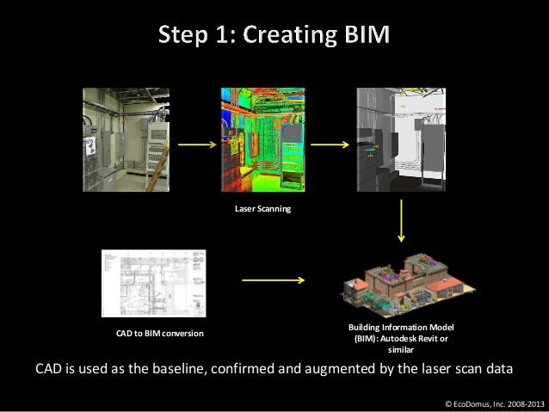
Figure 4: transformation and generation of a BIM model using laser scanning , courtesy of EcoDomus 2013

5.4 Population of the models with non-technical information

It has to be highlighted that while the above approaches have focused on realisation of approaches and inputs into the HBRP framework from a technical prospective. There are important societal and public attdiues towards M&R particaully housing , which can add more value to the BIM process.
The findings of a study involving a survey of 60 households by Taylor (2014) concludes that there is still a lack of understanding about refurbishment needs among both housing associations and private householders (see figure 5). This is mainly related to cost, but also, crucially, the lack of information about available and suitable technologies.

Figure 5 : Perceptions and attitudes amongst householders towards investigating in refurbishment technologies (Taylor, 2013)
Such fndings suggest that there is huge enthusiasm for housing M& R, and more specifically for consideration of carbon and sustainability potential, but it is the lack of information on provided which might stop or limit the uptate , while such measures are harder to quantify and integrate within BIM most of such attitudes seems to be outside the current BIM agenda. An example of this can be benefical would be to integrate payback on certain renewables into the HBRP model and greater information integration which could be used by householders or asset managers

6.0 A realisation of full benefits HBRP framework within BIM application
For a BIM framework to be effective as an M&R tool there is a need for a systematic methodology to monitor the behaviour of buildings, and to make critical decisions to ensure that the energy criteria of the design are met in practice. (Motawa & Carter, 2013) .The suggestions presented shows sufficient data capture before and after integration in a BIM system possible, coupled with the scenario of transfer to 3D asset management, can have significant long term benefits.

Also technology such as IR heat loss, laser scanning data added to a HBRP model is not straightforward (Volk et al 2014) provided an extensive literature review into BIM for existing buildings and found low levels of BIM implementation within existing buildings due to problems associated with data capture and management, remodelling of the existing physical building structure into a new BIM.

Other benefits can also be the case for interventions and upgrading of assets gradually . It was established through the suggestions for various inputs into the HBRP model , various inputs can assess energy and thermal efficiency points of view, but there are other factors which make the model suitable for replication and greater, and greater appeal from BIM perspective these include:

- Sufficient M&R data on energy performance: finding data on constructed assets , particularly housing important and relevant topics, can be captured through the use of technology and added to the BIM,
- Whole life approach to performance: Such model can enable the collection of data both before and after refurbishment. This is vital if we are to propose a BIM approach incorporating parametric modelling.
- Technology adoption: The use of IR camera and remote energy monitoring of properties can be integrated into a BIM platform.
- Stakeholder interest in long-term benefits BIM asset management: The housing associations involved can be interested in a cost analysis approach which investigated
- which types of intervention can save the most carbon and are most cost-effective.
- Transferring data management from file to electric format: there was a commitment to transfer information gained from this study from a paper format to a 3D Architectural visualization model to manage assets and consider potential roll out across the housing stock.
- Giving user greater awareness : as demonstrated that user do not realise long term benefits of refurbishments and lack of information is major hindrance , seeing real time time benefits on an evolving model gives better and greater ownership and long term engagement.

Conclusions

The findings revealed that effective housing stock M&R approaches using modern technology have large potential for inclusion within a BIM framework and can give greater options in terms of housing maintenance and performance measurements. Also the BIM applications need to change to adapt to a changing needs of users of existing buildings, and particularly domestic sector.

All new processes within the construction sector require time to be accepted and BIM is no exception. It is hoped that such a framework will be further developed and information sharing at refurbishing stage rather than design stage will be adopted and utilised.

Moreover , it is hoped will also overcome the gap between expected and actual physical performance of the stock which is currently underreported, and is a major concern to stakeholders, and asset managers .

Limitations of research and implications for framework

While the proposed HBRP has shown how different approaches to data entry points from technological approaches can be integrated into BIM refurbishment model , a prototype needs to developed for each property to identify functionality of the model. For example a flat would perform differently to house. In addition full implementation to assess its practicality in terms of real ease of use operations needs to be done

Greater consultations and input needed beyond BIM such as housing manager /contractor / QS /Architects) are not typically involved in BIM for refurbishment. Typically a housing association (housing manager) of a private tenant will have no access to the data generated by the BIM framework, and this needs to change for model to be effective and inclusive

References

Alwan, Z., Greenwood, D. & Gledson, B., (2015). Rapid LEED evaluation performed with BIM based sustainability analysis on a virtual construction. Construction Innovation Information, Process, Management, volumne 15 issue 2
Alwan, Z ., Gledson, B (2015) “Towards Green building performance evaluation
using Asset Information Modelling” Built Environment Project and Asset
Management; vol 5; issue 3

Y. Arayici, P. Coates, L. Koskela, M. Kagioglou, C. Usher, K. O'Reilly (2011)
BIM adoption and implementation for architectural practices, Structural Survey 2011 29:1 , 7-25
Barlish, K., & Sullivan, K. (2012). How to measure the benefits of BIM — A case study approach. Automation in Construction, 24, 149–159.
BREEAM 2009. BRE Environmental & Sustainability Standard, BRE Global Limited available at www.bre.co.uk
Becerik-Gerber, B. et al., 2012. Application Areas and Data Requirements for BIM-Enabled Facilities Management. Journal of Construction Engineering and Management, 138(3), pp.431–442.
Building, C. & Consumption, E., 2010. The Advantages of BIM-Enabled Sustainable Design for Improving Commercial Building Performance. Sustainable Development, (2009). Available at: http://www.unpei.org/what-we-do/pei-countries/lao-pdr.html.
East, E.W., 2007. Construction Operations Building Information Exchange (COBIE): Requirements Definition and Pilot Implementation Standard,
CRI, 2011. Industry structure UK Government projects to use BIM by 2016 : It’s official. Construction Research and Innovation, 2(3), p.28.
Dowson, M. et al., 2012. Domestic UK retrofit challenge: Barriers, incentives and current performance leading into the Green Deal. Energy Policy, 50, pp.294–305.
DCLG, 2012. 2012 consultation on changes to the Building Regulations in England 2012: Section two Part L (conservation of fuel and power),
DECC, 2010. The Green Deal. Secretary, p.22. Available at: www.decc.gov.uk/en/content/cms/what_we_do/consumers/green_deal/green_deal.aspx.
DECC, 2008. Climate Change Act 2008. Climate Change Act 2008 (c.27), 27, pp.1–108.
England And Wales, 2010. The Building Regulations 2010. Changes, (October). Available at: http://www.ebst.dk/bygningsreglementet.dk/forside/0/2.
Elton, B., Vasco Peixoto, F., Niubis, M., Eva, B. & Sara Stingel De, F. 2015. Infrared thermography – evaluation of the results reproducibility. Structural Survey.
Fox, K., 2010. Green BIM, Wiley Publishing, Inc. Available at: http://construction.com/market_research/FreeReport/GreenBIM/MHC_GreenBIM_SmartMarket_Report_2010.pdf.
Gledson, B., Bleanch, P. & Henry, D., 2012. Does size matter? Experiences and perspectives of BIM implementation from large and SME construction contractors. In 1st UK Academic Conference on Building Information Management (BIM) 2012. pp. 97–108. Available at: http://www.northumbria.ac.uk/sd/academic/bne/collaboration/enterprise/bimacademy/bi m_conf2012/?view=Standard.
Hope, A. & Alwan, Z., 2012. Building the Future: Integrating Building Information Modelling and Environmental Assessment Methodologies. In First UK Academic Conference on BIM. Available at: http://www.researchgate.net/publication/230719198_Building_the_future_integrating_building_information_management_and_environmental_assessment_methodologies/file/9fcfd504ef1a8abc84.pdf.
Hope, A.J. & Booth, A., 2014. Attitudes and behaviours of private sector landlords towards the energy efficiency of tenanted homes. Energy Policy, 75, pp.369–378. Available at: http://www.sciencedirect.com/science/article/pii/S0301421514005096 [Accessed January 28, 2015].
Kelly, M.J., 2009. Retrofitting the existing UK building stock. Building Research & Information, 37(2), pp.196–200.
Kim, J.B. et al., 2015. Developing a physical BIM library for building thermal energy simulation. Automation in Construction, 50, pp.16–28. Available at: http://www.sciencedirect.com/science/article/pii/S0926580514002222 [Accessed November 26, 2014].
Li, F. G. N., Smith, A. Z. P., Biddulph, P., Hamilton, I. G., Lowe, R., Mavrogianni, A., Oikonomou, E., Raslan, R., Stamp, S., Stone, A., Summerfield, A. J., Veitch, D., Gori, V. & Oreszczyn, T. 2014. Solid-wall U-values: heat flux measurements compared with standard assumptions. Building Research & Information, 43, 238-252.
Love, P.E.D. et al., 2014. A benefits realization management building information modeling framework for asset owners. Automation in Construction, 37, pp.1–10. Available at: http://www.sciencedirect.com/science/article/pii/S0926580513001568 [Accessed February 24, 2014].
McManus, A., Gaterell, M.R. & Coates, L.E., 2010. The potential of the Code for Sustainable Homes to deliver genuine “sustainable energy” in the UK social housing sector. Energy Policy, 38(4), pp.2013–2019.
Motawa, I. Almarshad, A., 2013. A knowledge-based BIM system for building maintenance. Automation in Construction, 29, pp.173–182. Available at: http://www.sciencedirect.com/science/article/pii/S0926580512001574 [Accessed November 13, 2014].
Motawa, I. & Carter, K., 2013. Sustainable BIM-based Evaluation of Buildings. Procedia - Social and Behavioral Sciences, 74, pp.419–428. Available at: http://www.sciencedirect.com/science/article/pii/S1877042813004448 [Accessed November 13, 2014].
Park, S, K. Kim, P, K., 2014. Essential BIM Input Data Study for Housing Refurbishment: Homeowners’ Preferences in the UK. buildings, 4(3), pp.467–487.
Sebastian, R., Haak, W. Vos, E., 2009. BIM application for integrated design and engineering in small-scale housing development: a pilot project in The Netherlands. Proceedings of International …, (November), pp.2–3. Available at: http://www.inpro-project.eu/media/R_SEBASTIAN_BIM_Application_for_Integrated_D_and_E_in_Small-Scale_Housing_Development_Pilot_Project.pdf.
Srinivasan, R.S. et al., 2011. Energy balance framework for Net Zero Energy buildings, IEEE. Available at: http://onlinelibrary.wiley.com/doi/10.1002/cbdv.200490137/abstract.
Succar, B., 2009. Building information modelling framework: A research and delivery foundation for industry stakeholders. Automation in Construction, 18(3), pp.357–375.
Swan, W. et al., 2013. Adoption of sustainable retrofit in UK social housing. Structural Survey, 31, pp.181–193. Available at: http://www.emeraldinsight.com/10.1108/SS-12-2012-0039.
Taylor, S 2014. Barriers to and Prospects for Domestic Solar Micro-Generation . Masters of Architecture disseration , unpulbished work
Waterhouse, R. & Philp, D., 2013. National BIM Report. National BIM Library, pp.1–28.
Volk, R., Stengel, J. & Schultmann, F., 2014. Building Information Modelling (BIM) for existing buildings - Literature review and future needs. Automation in Construction, (38), pp.109–127.
Yan, H. & Damian, P., 2008. Benefits and Barriers of Building Information Modelling. In 12th International Conference on Computing in Civil and Building Engineering. Bejing, China.
Yin, R.K., 2009. Case Study Research: Design and Methods L. Bickman & D. J. Rog, eds., SAGE Publications.
Dorninger, P., Norbert, P. (2008) A aompreheive Automaed 3D Approch for Building Extraction, Reconstruction, and Regularization from airborne Laser Scanning Point Clouds .Sensors 8(11), 7323-7343

