Influence of Change Management for Effective Outsourcing of Facilities Management Services
Pournima Sridarran∗ and Nirodha Gayani Fernando
Department of Building Economics, University of Moratuwa, Sri Lanka

Influence of Change Management for Effective Outsourcing of Facilities Management Services
Abstract
As a Facilities Management procurement option the partial or full outsourcing of operation and maintenance of buildings has been making enormous progress since the recent past. Outsourcing can bring about many changes and conflicts into the organisation due to many reasons such as services may be performed in different ways, some services may change in quality and rhythm, the employees may be asked to do things differently and the organisational culture may also have to change in doing so. In order to maintain the continuity of the operations, organisations need to adopt an intelligent approach to manage changes. Though, change management models have been developed for organisational changes, which include changes within the organisation and for total changes such as acquisition and merging, there is no specific or tailor made change management models that would combine the existing organisation and the outside outsourcing party. As such, the aim of this study is to develop a conceptual model for change management for outsourcing Facilities Management services effectively. For this study a comprehensive literature review was used as the research methodology. Major change management criteria which can affect the efficiency of outsourcing Facilities Management services were identified, and a conceptual model developed in order to offer a solution. It was suggested that through managing the change, the efficiency of outsourcing the Facilities Management services can be improved and the organisation can get the maximum benefit out of such outsourcing.
Keywords: Change Management; Facilities Management; Outsourcing.
- Introduction
Outsourcing has been advanced to the extent of being one of the most popular and widely adopted business strategies in this era of globalisation (Cigolini et al., 2011; Willcocks, 2010). Outsourcing is the act of transferring some of the organisation’s recurring internal activities and the right of decision making to outside providers as set forth by a contract (Greaver, 1999). Hence, it involves the transfer of responsibilities (Krell, 2006). In a competitive business environment, companies focus on core activities and outsource non-core functions to others (Kim and Won, 2007; Quinn and Hilmer, 1994). In the field of Facilities Management (FM), it involves the “contracting out” of FM services to an external provider (Atkin and Brooks, 2009; Barret, 2000). Up to now outsourcing has contributed immensely to the growth of FM as an industry and in the foreseeable future it is also likely to be the driving force of the industry (Best et al., 2003). According to the International Association of Outsourcing Professionals (cited Ikediashi et al, 2012), the global outsourcing industry is presently worth over $1 trillion annually with India capturing a lion share of the market closely followed by China.
The FM industry in Sri Lanka too uses outsourcing as one of their procurement strategies (Nadeeshani, 2006). Nadeeshani (2006) found that during the decision making process of procurement strategy in the FM industry in Sri Lanka, change management issues such as employee reactions, ethical and cultural impacts, willingness to manage possible discords that could arise out of contract in the future, were neglected or received the least of attention.
Andersen and Ankerstjerne (2011) stated outsourcing as a service creates many changes and possible disruptions to an organisation. Also, Atkin and Brooks (2009) theorise that, change is normal, but for the people affected by such change the consequences can be substantial. Therefore organisations need to adopt an intelligent approach to planning, coordinating and controlling the process of change that ensures continuity of operations (Atkin and Brooks, 2009; Gildner, 2006). The problems that may arise from unmanaged change in outsourcing are; cultural conflicts, loss of interest by employee, breakdown of communications regarding goals and commitments, non-corporation between the organisation and service provider (Andersen and Ankerstjerne, 2011). Moreover, the difficulties on the part of the employees to make even small changes to their work habits tend to be underestimated by the managers. Consequently, sometimes this may result in reluctance and resistance by employees as a result of which the managers often lose patience, and that could possibly lead to further antagonisms (Andersen and Ankerstjerne, 2011).
There is no universal template for a change management programme (Andersen and Ankerstjerne, 2011). However, Kotter’s (1996) 8-step model includes all the major elements of the process involving people in the process of change and can be used as a generic process template. Lewin’s (1958) 3-stage model also can be used for effective application of change management in the organisations. Though, these models are developed for organisational changes which include changes within the organisation and total changes such as acquisition and merging, there is no specific or tailor made change management models combining existing organisation and the outside outsourcing party. Hence we can assume that there is still a gap in the awareness regarding the impact of change when outsourcing of FM services.
The aim of this paper is to review the importance of incorporating change management during outsourcing of Facilities Management services and to develop a conceptual change management model for effective outsourcing.
2. Methodology
A comprehensive literature review was used as the research methodology for this paper. For this purpose, journals, books, articles, conference proceedings, unpublished dissertations and the internet were reviewed specifically in respect of outsourcing, change management, and the importance of integrating change management with outsourcing of FM services.
3. Nature of Outsourcing
Outsourcing is an act of moving some of a firm’s internal activities and decision making responsibilities to outside providers as defined by Chase et al. (2004). Furthermore it is a condition where an organisation contracts with another for the provision of a service that could well be provided by a person, unit or department within the same organisation that requested the service (Best et al., 2003; Barret, 1995; Barret, 2000). This defines that outsourcing is the process of assigning or transferring the non-critical business activities from an internal source to an external party. In order to achieve a long term competitive advantage a firm should concentrate more on its core activities. Therefore many organisations are of the view that outsourcing firms can carry out those non-core activities more effectively at a lower cost (Smith et al., 2000).
The main three subcategories in FM outsourcing are, the Managing Agent, who is appointed as a specialist to act as the client’s representative. This person (or organisation) is responsible for arranging the appointment of the service providers. Secondly the Managing Contractor, which as an organisation that has the responsibility to manage all service providers under one umbrella as though being part of one large contracting organisation. The contractor being paid a fee for providing such services, usually as a percentage of the value of the expenditure managed, and thirdly Total Facilities Management, where a single organisation is delegated the responsibility for providing services and for generally managing the facilities (Atkin and Brooks, 2009).
Organisations select outsourcing as a Facilities Management procurement option due to several reasons. The most common of the reasons for outsourcing are shown in Figure 1. Once the organisation decides to outsource, it should first develop a list of suppliers/vendors for consideration, and then appoint an Implementation and Governance team for the outsourcing process so that they could carry out an effective selection and monitoring of the process (Brown and Wilson, 2005). According to Nadeeshani (2006) in Sri Lanka, the FM industry gives priority for quality, flexibility, innovation and price during the process of vendor selection.

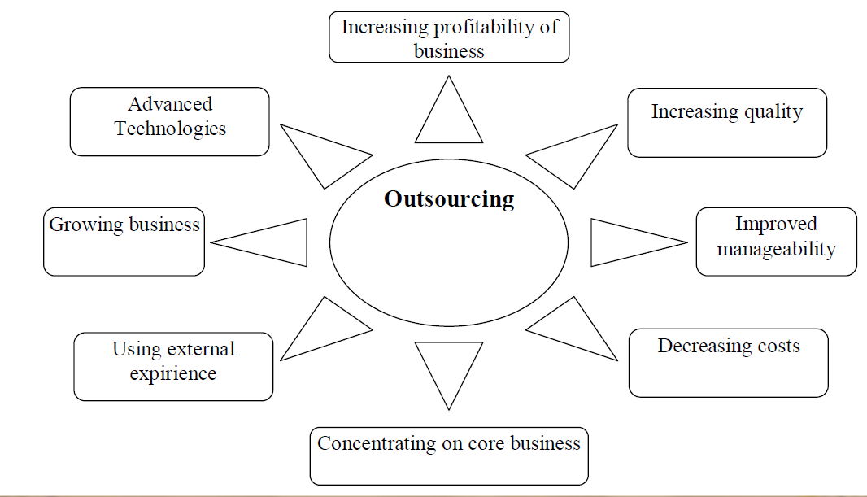

Figure 1: Reasons for Outsourcing (Adopted from: Borisova, 2011)
According to Brown and Wilson (2005) the outsourcing process is made up of six phases. At first is the Strategy Phase which defines the objectives and scope of the outsourcing process and also determines the feasibility of the process. Moreover, it includes the planning for the total effort in terms of time, budget, and the necessary resources required for the initiation of the process. Secondly the Scope phase which establishes the baselines and specifies the service levels required from the vendors. Furthermore in order to provide the proper interfaces between the two parties it clarifies the relationships between the functions to be outsourced and those functions that are to remain in house. Thirdly the Negotiation phase where negotiations proceed with the chosen vendor until a contract is drawn up and, signed by both parties. Fourthly the Implementation phase marks the transition of services provided from in house to outsource. Fifthly the Management phase where the relationship between organisation and vendor is to be managed. It includes the negotiation and implementation of any changes in the outsourcing relationship seen as necessary to ensure a successful outcome. Sixthly at the end of the contracting period will be the Completion or termination phase where organisation will make the decision either to negotiate another contract with the same vendor or to terminate that relationship and align with a new vendor in which case the cycle commences all over again. Sometimes the organization may decide to switch back into in-house system in this phase.
4. Impact of Change in Outsourcing Practices
Change is a movement from the present state of the organisation to a desired future state (Ramanathan, 2008). Different approaches can be adopted to manage change. Figure 2 presents a generic process model based on Lewin (1958) and Kotter (1996) that enables to understand the change process. It highlights the significance of following four components; contextual conditions prompting the change (external and internal factors), diagnosing the need for change and developing plans for implementation, followed by implementing such plan and then finally institutionalizing the change (Ramanathan, 2008). This generic process model can be used as a starting point for developing an outsourcing change management model.
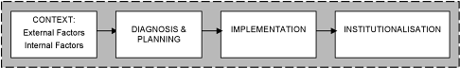

Figure 2: Generic Process Model of Change (Adopted from: Ramanathan, 2008)

Corporate culture and practices are unique to each organisation. This could be so to even those involved in the same industry. Outsourcing and admitting a vendor with an entirely different culture into the organisation can give rise to cultural clashes particularly if such organisations are not in a state of preparedness to accept the outsider. Organisations should not underestimate these differences (Brown and Wilson, 2005). Each organisation has its own established practices, principles and values which are well entrenched and hence initially may resist changes to the system that outsourcing forces upon them (Andersen and Ankerstjerne, 2011). There may be interruptions resulting from this which may affect the quality of the services and the entire productivity of the organisation. However, making change happen successfully is one of the most challenging tasks faced by the leadership and corporate management of the organisation. Therefore organisations should adopt a methodical approach in order to reduce the consequences of unmanaged change. The common issues which may arise from unmanaged change are discussed below.
4.1 No Support from Client Organisation Staff
Due to the different procedures adopted by the outsourcing provider in handling the services, the in-house staff may be reluctant to co-operate and participate in the activities carried out by the vendors. This can result in active or passive resistance against the entire outsourcing model. Due to lack of co-operation the vendor also will not be able to execute the functions in the best way that he seems fit. Later it may lead to dissatisfaction of top management and that would eventually affect industrial peace.
4.2 Poor Mutual Understanding
After signing the initial contract, both the client and service provider have multiple team members who would be responsible to manage the initial activities of implementation and ongoing operations. Following the changes in the organisation the client’s staffs are already emotionally charged and are beginning to just learn the details of the agreement. Hence there is a tendency for them to dictate terms to the vendor regarding what he should (and should not) perform (McCray, 2008). This state of friction may result in operational disruptions.
4.3 Poor accountability
In instances where both the in-house and the outsource parties are expected to work in co-operation and share responsibilities to complete a service, none of them would be willing to take accountability for any occurrence of downtime or productivity loss.
4.4 Cultural Clashes between Client and Service Provider
In terms of corporate culture, the client and the service provider may have different norms in terms of speed, style, decision making and organisational structure. The fact that outsourcing represents a commercial relationship between two separate entities that can hold on to extreme and inflexible positions also serves as another potential flash point (McCray, 2008).
5. Incorporating Change Management during Facilities Management Outsourcing Practices
Effective management of change during outsourcing process ensures maximum value for the organisation. For any manager involved in an outsourcing initiative the most daunting of challenges would be that of coping with the changes caused by outsourcing, both by the process and personnel (Brown and Wilson, 2005). Often these change related aspects are not addressed by traditional strategic planning (Worley et al., 1996). Organisations often ignore the fact that successful outsourcing is heavily dependent upon the attitudes of their workforce. The perspectives and responses of employees at all levels and positions have a significant impact on the successful implementation of strategic change processes (Mclvor, 2005).
So as to coordinate and negotiate the changes across the entire outsourcing process and for all groups and individuals involved, communication becomes the key factor. Therefore the organisation should involve the staff during the early stages of the plan for outsourcing. This will help to build their trust, which will make them more willing to accept the changes and lend their support. Moreover the employees should be educated about the fact that they will need to change along, in order that more attention can be paid to the core business and its success so that ultimately their future will be more secure in the competitive environment (Brown and Wilson, 2005). Since the Facilities Management involves machineries and equipment, the vendor is in a position to introduce new technologies. A change in the work process or work activities may be necessary if new technology or new maintenance techniques are to be introduced by the outsourced party (Griffin, 2008). In such a situation proper training and awareness should be given to the in-house employees. Likewise in each phase of outsourcing the potential changes should be identified and change management initiatives should be incorporated accordingly.
5.1 Change Management Process to be Incorporated with Outsourcing Process
The generic process model of change (Ramanathan, 2008) can be further modified to fit with outsourcing practices.
Step 1 - Context: The influence of internal and external business environment creates a need by the organisation to go in for outsourcing. External environment factors namely commercial, social, and particularly economic factors such as cost would force an organisation to go for outsourcing (Usher, 2003). Internal business environment includes corporate plan, resource constrains, business objectives, and management styles also have an impact on outsourcing decisions. These internal and external factors normally decide the organizational values, norms and culture. The manager should take these factors into consideration when deciding the extent to which he has to manage the change (Ramanathan, 2008). At the same time sub cultures and sub culture gaps can arise in the organisation that could lead to serious problems such as employees leaving the organisation, resistance towards implementation of outsourcing, and so on (Finnegan and Willcocks, 2006). In this particular step the organisation can carry out the following activities.
- Getting management support from the existing FM department
- Involving employees in outsourcing decision making
- Pre educating employees about their need to change
Step 2 - Diagnosis and Planning: In order to plan for change management, complete data regarding group and individuals should be collected, interpreted and analysed (Hayes, 2002). This will be helpful for the managers to find out about the current status of their organization. Further Hayes (2002) stated this diagnosis can be done through SWOT (Strength, Weaknesses, Opportunities and Threats) analysis or PEST (Political, Environmental, Social and Technological) analysis. Following this diagnosis, the plan for the change management should be done based on the data collected during the diagnosis phase. In this phase a set of targets and objectives will be developed for implementation. This plan should be effectively communicated to all the stakeholders by a management team with specific roles and responsibilities assigned to its members (Ramanathan, 2008). In this particular step the organisation can carry out the following activities.
- Collecting data from internal and external environment
- Analysing data from internal and external environment
- Developing the change management plan
- Forming a group to implement the plan
- Assigning roles and responsibilities among the management group
Step 3 - Implementation: The plan developed in the previous step will be executed in this step. According to Waldersee and Griffiths (cited Ramanathan, 2008) two major approaches can be adopted to implement the change management programme. One is the top down method and the other is the bottom up method. While the top down approach tends to be procedural, focusing on resource allocation and follow formal authority lines, the bottom up approach favours participative, and consultative techniques which targets the values, attitude and skills of the members in the organisation. Especially during outsourcing projects the ego issues arising from employees are likely to cause more resistance to change (McCray, 2008). Therefore implementation should be provided with a proper feedback system. In this particular step the organisation can carry out the following activities.
- Executing the plan
  - Conducting training
  - Allocating employees who are flexible with the outsourced team
  - Allowing time for cultural reconciliation
- Getting feedback from employees
Step 4 - Institutionalisation: This step anchors changes in the corporate culture and makes the employees accustomed to the change. According to Kotter (1996) change can be institutionalised in two ways. Firstly by demonstrating the success caused by the changed behaviour. Secondly by the leadership adopting the new behaviour and norms and introducing it in the organisation. This is the step which is important to sustain the change which leads to effective outsourcing. In this particular step the organisation can carry out the following activities.
- Motivating employees
- Demonstrating the success due to the changed attitude
5.2 Conceptual Change Management Model for Effective Outsourcing
Based on this literature survey, a conceptual change management model was developed by incorporating the seven phases of outsourcing, namely the strategy phase, the scope phase, the negotiation phase, the implementation phase, the management phase, and the completion phase. Along with this the steps of change management which includes, context, diagnosis and planning, implementation, and institutionalizing was also considered. Figure 3 illustrates the model. The model describes how the change management steps can be connected with outsourcing phases.
Accordingly when the outsourcing is in the strategic and the scope phase, the corresponding step for change would be context analysis. Once the outsourcing moves to the next phase of negotiation, the change management step would also change to diagnosis and planning. Subsequently, the implementation of outsourcing and the implementation of change management would occur at the same time for effective execution. Finally during the management phase of outsourcing, the change would be institutionalised. On reaching the completion phase the cycle commences all over again. By carrying out outsourcing and change management together, the conflicts which may arise from unmanaged change would be eliminated.

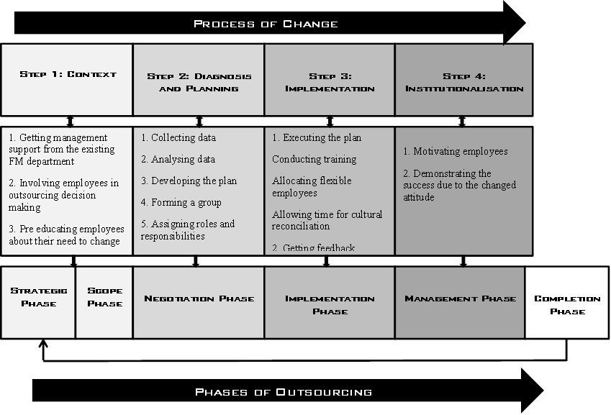

Figure 3: Conceptual Change Management Model for Effective Outsourcing
6. Conclusion
Outsourcing remains a powerful and an important strategic solution to the provision of a range of FM services. Since organisations need to concentrate more on their core business activities, they favour outsourcing the non-critical business activities to a third party. Outsourcing creates many changes that may affect the efficiency of the in-house as well as outsourcing parties. In order to avoid the disagreements that may result from outsourcing, organisations need to adopt a measured approach towards this change. The phases of outsourcing and the generic steps for change management were identified so that a feasible solution could be provided. By incorporating both of these, a conceptual model for effective outsourcing was developed. This model would be presumed to be a basis for the organisations to manage the change related conflicts that may arise during the process outsourcing and it would also help to sustain the outsourcing practices within the organization in an efficient manner.
7. References
Andersen, M.K. and Ankerstjerne, P., 2011. Working Change Management in Service Outsourcing. Denmark: ISS White Paper.
Atkin, B. and Brooks, A., 2009. Total Facilities Management. 3rd ed. New York: Wiley-Blackwell Publishers.
Barret, P., 1995. Facilities Management: Towards Better Practice. Oxford: Blackwell Science.
Barret, P., 2000. Achieving strategic facilities management through strong relationships. Facilities, 18(10), 421-426.
Best, R., Langston, C. and De Valence, G. eds., 2003. Workplace Strategies and Facilities Management. UK: Butterworth-Heinemann Publications.
Borisova, A., 2011. Perspectives of Facility Management Outsourcing Development in Russia. Thesis (Business Administration), Saimaa University of Applied Sciences.
Brown, D. and Wilson, S., 2005. The black book of outsourcing. New Jersey: Wiley & Sons.
Chase, R.B., Jacobs, F.R. and Aquilano, N.J., 2004. Operations management for competitive advantage. 10th ed. Boston: Irwin/McGraw-Hill.
Cigolini, R., Miragliotta, G. and Pero, M., 2011. A road-map for outsourcing facilities-related services in SMEs: Overcome criticalities and build trust. Facilities, 29(11), 445-458.
Finnegan, D. and Willcocks, L., 2006. Knowledge sharing issues in the introduction of a new technology. Journal of Enterprise Information Management, 19(6), 568-590.
Gildner, S., 2006. Change Management: a Key to Successful Outsourcing. HRO Today, June, 58.
Greaver, M.F., 1999. Strategic Outsourcing, A Structured Approach to Outsourcing Decision and Initiative. New York: AMA Publications.
Griffin, R.W., 2008. Management. 9th ed. USA: Houghton Mifflin Company
Hayes, J., 2002. The theory and practice of change management. New York: Palgrave Macmillan Limited.
Hillary, M.K., 2004. Outsourcing to India: The Offshore Advantage. New York: Heidelberg.
Ikediashi , D.I., Ogunlana , S.O. and Boateng, P., 2012. Analysis of Risks Associated with Facilities Management Outsourcing. Journal of Facilities Management, 10(4), 301-316.
Kim, G.M. and Won, H.J., 2007. HR BPO service models for small and medium enterprises. Business Process Management Journal, 13(5), 694-706.
Kotter, J. P., 1996. Leading change. USA: Harvard Business School Press.
Krell, E., 2006. What's wrong with outsourcing and how to fix it. Business Finance Magazine, 12(8), 18-27.
Lewin, K., 1958. Group Decisions and Social Change. New York: Rinehart & Winston.
McCray, S., 2008. The Top 10 Problems with Outsourcing Implementations. USA: Technology Partners International.
Mclvor, R., 2005. The outsourcing process: Strategies for evaluation and management. UK: Cambridge university press
Nadeeshani, W., 2006. Procurement Selection Criterion for Facilities Management in Sri Lanka. Unpublished dissertation, (BSc). University of Moratuwa.
Power, M.J., Desouza, K.C. and Bonifazi, C., 2006. The outsourcing handbook: how to implement a successful outsourcing process. London: Kogan Page Limited.
Quinn, J.B. and Hilmer, F.G., 1994. Strategic outsourcing. Sloan Management Review, 35(4), 43-55.
Ramanathan, T.R., 2008. The role of organizational change management in offshore outsourcing of information technology services. Florida: Universal Publishers.
Smith K.L., Smith D.A. and Stringer. C., 2000. Managing the outsourcing relationship. Australia: University of New South Wales press ltd.
Usher, N., 2003. Outsource or in-house facilities management: The pros and cons. Journal of Facilities Management, 2(4), 351-359.
Willcocks, L.P., 2010. The next step for the CEO: moving IT-enabled services outsourcing to the strategic agenda. Strategic Outsourcing: An International Journal, 3(1), 62-66.
Worley, C., Hitchen D., and Ross, W. 1996. Integrated strategic change: How OD builds competitive advantage. MA: Addison Wesley.

∗ Corresponding Author: E-mail- psridarran@gmail.com

