Figures
Figure 1 - PLS-DA of 16S bacterial profiles. Post discharge samples removed. A) Score scatter plot. B) Loadings plot

Figure 2 – Box plot of Shannon Diversity Indices. Significantly lower diversity occurred in during probiotic administration compared to controls and in all groups when compared to samples post discharge (PD).

Figure 3 - Boxplot of bacterial load determined by qPCR. *Asterisks represent the outliers, “a” or “b” represents the grouping by turkey’s family. A) Bifidobacterium bifidum. B) Lactobacillus acidophilus.
Figure 4 - PLS-DA of the metabolite profiles. Before probiotic and post discharge samples excluded. A) Score scatter plot showing the relationship of samples associated with each group (R2Y = 0.62, Q2 = 0.31). B) Loading plot of detected metabolites associated with each group following VIP removal of noise (R2Y = 0.80, Q2 = 0.56). Red metabolites associated with probiotic administration.

Supplementary Figures
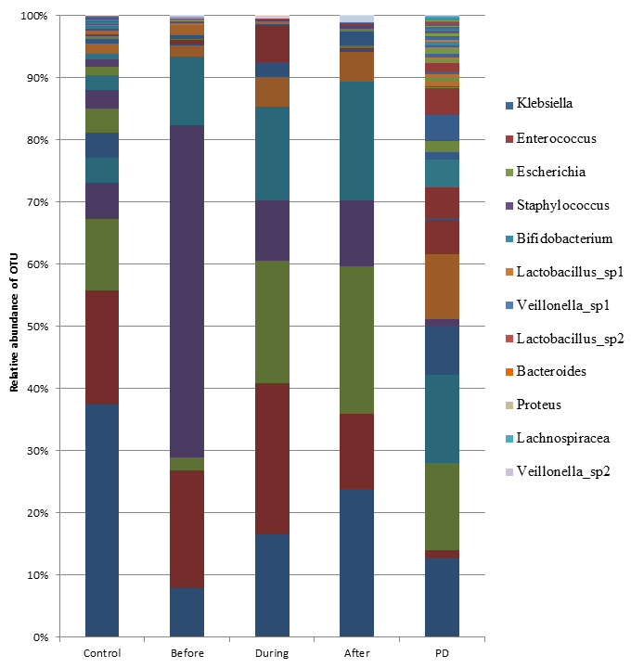
Supplementary Figure 1 - Relative abundance of bacterial OTUs. Sequences matching other less abundant OTUs are not shown on the legend

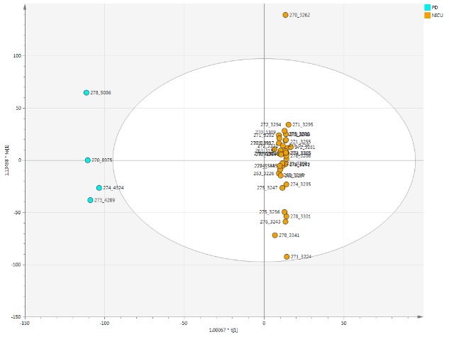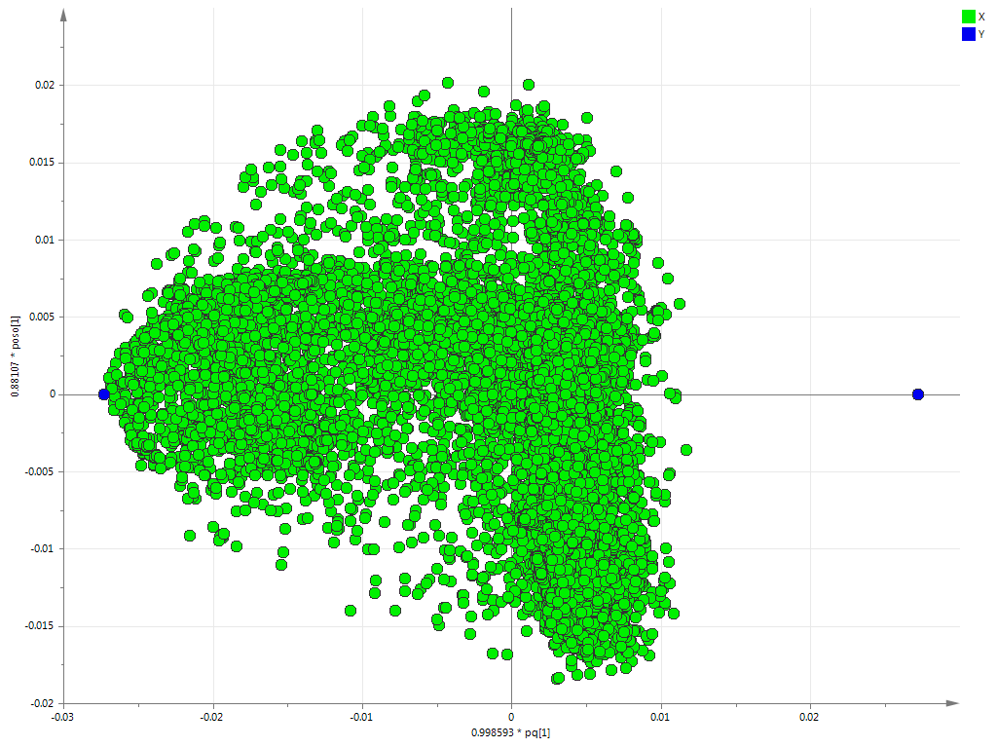
Supplementary Figure 2 – OPLS-DA of metabolite profiles comparing samples collected on the NICU and post discharge. R2Y = 0.99, Q2 = 0.8. A) Score scatter plot. B) Loadings plot.

