Digital Living: Understanding the Future of Cities and Public Services
Authors:
Kevin Muldoon-Smith, Paul Greenhalgh, Emine Thompson
Institution:
Northumbria University
Newcastle City Campus
2 Ellison Place
Newcastle upon Tyne
NE1 8ST
Traditionally, the challenge for local government surveyors and property managers has been the generation of meaningful and timely information that can be used to inform and improve the management of the public sector estate. Today, the challenge is no longer the timely generation of urban property data, rather, it is in relation to how so much information can be exploited and integrated successfully into contemporary public sector property management.
Central to this challenge is 'big data', the notion that society and its institutions can glean from huge digital information resources, insights about urban living that could not be grasped when we used small data sets. Researchers, such as Kenneth Neil Cukier and Victor Mayer Schoenberger, indicate that as recently as the year 2000 only 25% of the world's information was held in digital format, the rest remaining in analogue format. Fast forward 16 years and only 2% of the world's information is non-digital. Furthermore, on a daily basis, we produce 25 quintillion bytes of data through online activity. These stark figures describe the size of the digital opportunity, but also the concurrent challenge that its velocity, volume and variety presents in terms of data acquisition, management, ownership and access.
The urban data scientist is a relatively new role which has emerged to make sense of all this digital data and to move local government towards the ideals of the smart city. However, because of its infancy, data science skills are lacking in this ever expanding area. The skill deficit undermines the exploitation of information (both new and old), particularly the potential of using it to establish long term management solutions for cities and more efficient delivery and maintenance arrangements for the public sector.
Skill shortages exist in several areas, but primarily reside in Building Information Modelling (BIM), Geographic Information Systems (GIS), virtual city modelling, Space Syntax, the internet of things and the use of big data, especially its associated mining, analysis, visualisation and communication. This shortfall in knowledge (and experience) impedes the ability of local authorities to model their administrative domain, disaster management and climate change adaptation scenarios, energy systems and transport networks. Illustrating this situation, conduct a Google search of central and local government open data portals and assess the quality and usability of information. It is soon evident that few move beyond unstructured dumping grounds for older, so called dark data (operational data that is not being used); although, good examples do exist such as the Leeds Data Mill, Open Glasgow and Milton Keynes: Smart
All of these terms, big data, data science, and the smart and future city, remain ambiguous and ill defined. What is data and where does it come from? Why is it created, by whom and what does it seek to represent? How reliable, representative and relevant is the data? What types of data are available and useful to us? How should such data be deployed to contribute to smart and future city modelling and analysis? However, what does seem certain is the growing size and potential of the smart and future city, where Arup estimates that the global market for smart urban services will be $400 billion per annum by 2020. Illustrating this potential, relative modem activity has recently been used to map the extent of China's ghost cities (uninhabited locations built in the expectation of population growth and movement). This reveals the opportunity to use a similar methodology to understand and manage the performance of the local government estate, currently being road tested at Leeds City Council.
It is therefore important to note that the emergence of future and smart cities is not just an interesting subtext for the destiny of public services, or the provider of the next set of empty buzz words to be inserted into policy documentation (and consequently ignored); rather, the 'future' and 'smart' city focus should be entwined with the future of public services. Illustrating this situation, following the recent announcement of full business rate retention after 2020, the performance of the commercial built environment will be central to the on-going financial security of public services. To thrive in this new model of public finance, local authorities will have to cultivate and manage their commercial real estate assets. In order to do this they will need to secure, harness and exploit the power of local property, consumer demand and finance data.
In order to fill some of this deficit in knowledge, we are working on two ongoing projects in the Department of Architecture and Built Environment at Northumbria University, namely Geo-Visualising Commercial Real Estate Markets (GV-CREM) and Virtual NewcastleGateshead (VNG). The first project, Geo-Visualising Commercial Real Estate Markets (GV-CREM) has generated an experimental multi-criteria urban real estate model which seeks to understand the nature and vitality of commercial real estate markets in England and Wales. Initial modelling has focused on Newcastle upon Tyne (Tyne and Wear), Leeds and Croydon, all three of which exhibit large, mature commercial real estate markets and offer the potential for inter and intra-regional comparative analysis. The underlying data is non-geometric and rests upon a GIS dataset comprising physical characteristics of commercial and industrial floorspace, occupancy status and rental value information.
The UK wide source database contains approximately 5 billion sq.ft .of floorspace data (1bnsq.ft.of office, 1bn sq. ft. of retail and 3bnsq.ft.of industrial space) and has its origins in the National Summary Valuation Data Set and National Non Domestic Rating Returns created by the Valuation Office Agency (VOA). The model is also capable of incorporating user/occupier preference signals secured through internet search activity. The data model is intelligent, can be disaggregated to individual buildings or aggregated to the metropolitan or the functional economic area, and can be visualised in both 2D and 3D (with potential for 4D longitudinal analysis using time series data). The 3D representation in Figure 1 demonstrates the utility of this model, where the height of each tower indicates the quantity of floorspace in each location and the colour denotes the relative value of that floorspace while Figure 2 describes the spatial distribution of potential office, retail and industrial occupier search preference in Leeds.
Figure1. Topographical representation of commercial real estate stock in Tyne and Wear.
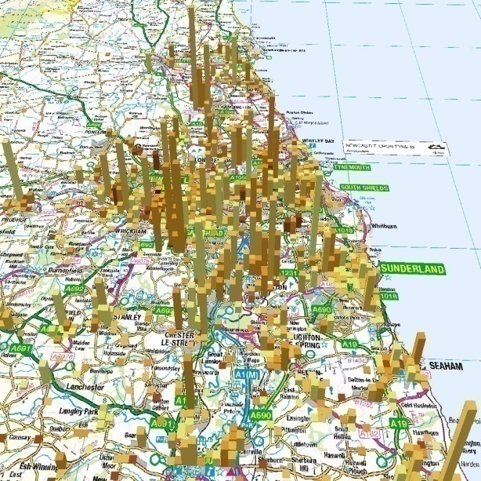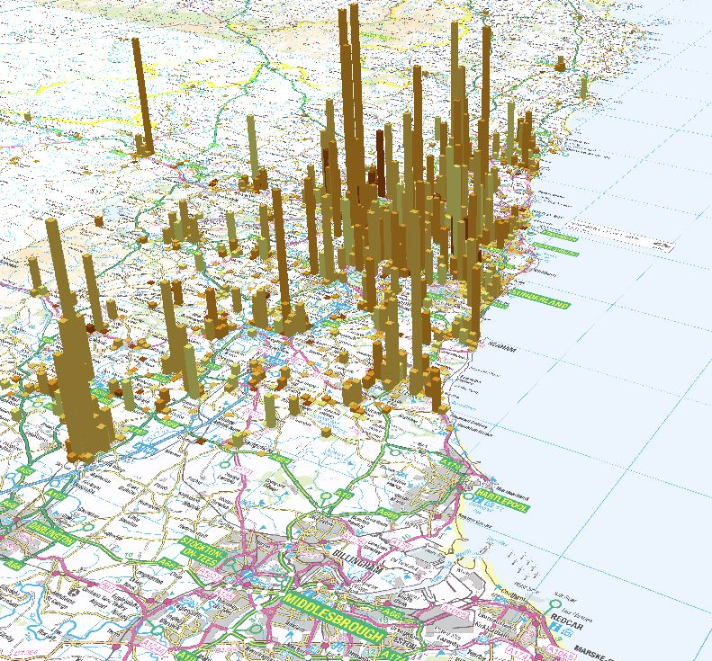
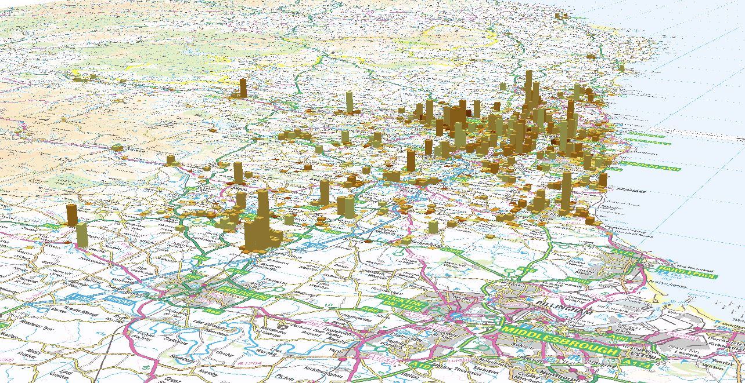
Figure 2. Potential occupier preferences in Leeds.
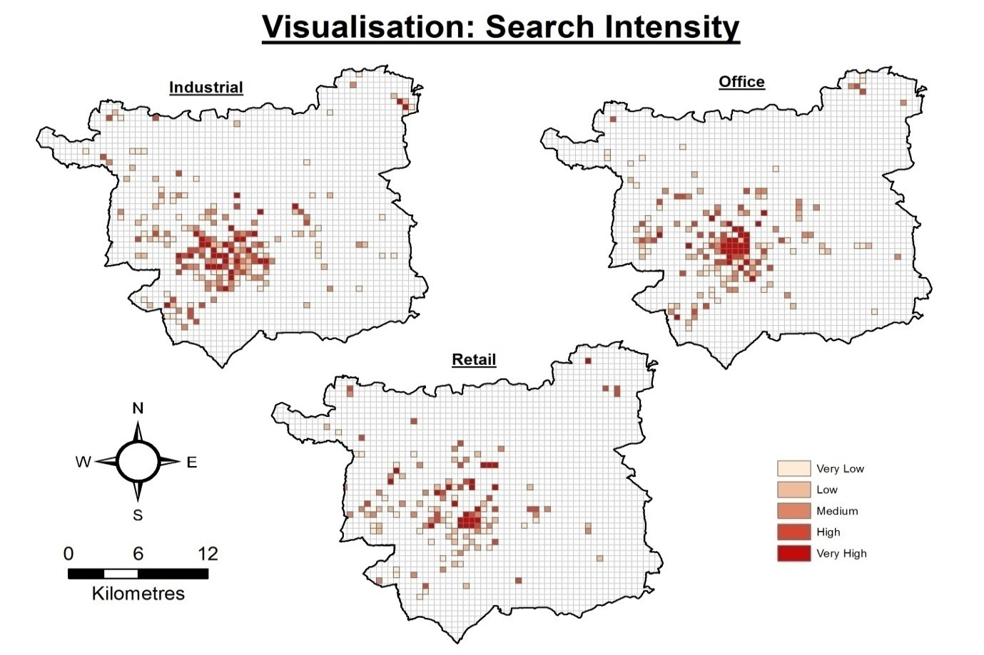
The intention is to use these urban search signals in the future to analyse the relationship (and potential mis-match) between the location of office, retail and industrial premises and where potential occupiers of these types of commercial and industrial floorspace actually want to locate.
The second project, Virtual Newcastle Gateshead (VNG) (Figure 3) is geometric and has been designed to visualise the urban fabric of neighbouring settlements of Newcastle upon Tyne and Gateshead in the North East of England. Initiated in 2008, in partnership with the two local authorities, the project provides a definitive, accurate, interactive city model that offers a cost effective stakeholder communication tool and a way of understanding the wider implications of planning applications. VNG is helping to streamline and increase the transparency of the planning process, supporting a number of research and enterprise activities and is allowing the University to engage with a number of local and national external parties and public groups.
Figure 3.Verification of accuracy of Virtual NewcastleGateshead Model. Source: Horne, 2009.
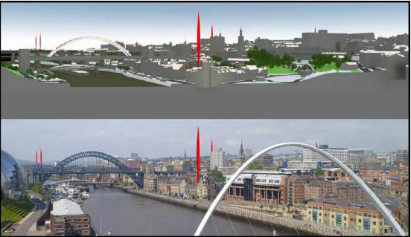
However, it soon became clear that both projects only touched the tip of the digital iceberg and that real change could only be brought about by practitioners during their daily working routines. This realisation has led to the creation of the new MSc in Future Cities at Northumbria University commencing in September 2016 in the Department of Architecture and Built Environment (https://www.northumbria.ac.uk/study-at-northumbria/courses/future-cities-dtffci6/#modules). The course includes modules on City Information Modelling, Future City Theories, Data Concepts and contemporary research methods, the continuing imperative for sustainability and the issue of mobility in future cities.
The focus is on up-skilling existing practitioners and educating the future generation of real estate surveyors and managers. Instead of focusing on the traditional pursuits of property valuation, management and redevelopment (although still important) we will be focusing on database development and coding, data mashing, wrangling, mining, analysis, visualisation and communication. The key tools of the trade will be Building Information Modelling (BIM), Geographical Information Systems (GIS), statistical programming languages like R, Python and SAS and database querying language such as SQL.
The entry requirement for the Future Cities MSc a Bachelor’s degree with Honours in any built and natural environment subjects or computer programming related subject area or equivalent qualification; for example: Architectural/Environmental Engineering, Architecture, City Planning, Computing, Geography, Landscape Architecture, Urban Design etc. Furthermore, equivalent professional experience (3 Years+) in the areas mentioned above is welcome as we seek to connect practitioners with the next generation of academic research. However, most importantly, we are looking for participants who have an interest in the future of cities and the importance of data within this pursuit.
For enquires about the new Future Cities MSc please contact the Programme Leader: Dr Emine Mine Thompson emine.thompson@northumbria.ac.uk
https://www.northumbria.ac.uk/about-us/our-staff/t/dr-emine-mine-thompson/
N.B. Elements of this article are based on the recently published journal paper Planners in the Future City: Using City Information Modelling to Support Planners as Market Actors, Urban Planning, 1(1), 79-94.

