The degradation of mechanical properties in halloysite nanoclay-polyester nanocomposites exposed to diluted methanol
Mohd Shahneel Saharudin^{1,2,} Rasheed Atif², Islam Shyha² and Fawad Inam²
- Universiti Kuala Lumpur Institute of Product Design and Manufacturing (UniKL IPROM), 56100 Cheras, Kuala Lumpur, Malaysia.
- Northumbria University, Faculty of Engineering and Environment, Department of Mechanical and Construction Engineering, Newcastle upon Tyne, NE1 8ST, United Kingdom.
Abstract
The degradation of mechanical properties in halloysite-nanoclay polyester nanocomposites
was studied after an exposure of 24 h in diluted methanol system by clamping test specimens across steel templates. The glass transition temperature (T_{g}), and storage modulus increased steadily with the increase of halloysite nanoclays before and after diluted methanol exposure. The addition of nano-fillers was found to reduce liquid uptake by 0.6% in case of 1 wt% reinforcement compared to monolithic polyester. The mechanical properties of polyester based nanocomposites were found to decrease as a result of diluted methanol absorption. After diluted methanol exposure, the maximum microhardness, tensile, flexural and impact toughness values were observed at 1 wt% of halloysite nanoclay. The microhardness increased from 203 HV to 294 HV (45% increase). The Young’s modulus increased from 0.49 GPa to 0.83 GPa (70% increase) and the tensile strength increased from 23 MPa to 27 (17.4% increase). The impact toughness increased from 0.19 kJ/m² to 0.54 kJ/m² in diluted methanol system (184% increase). Surprisingly, the fracture toughness of all types of nanocomposites was found to increase after exposing to diluted methanol due to plasticization effect. Scanning electron microscopic images of the fractured surfaces of tensile specimens revealed that the methanol increased the ductility of the matrix and reduced the mechanical properties of the nanocomposites.
Keywords
Halloysite nanoclay; Polyester; Methanol; Nanocomposites; Mechanical properties.
Introduction
The incorporation of halloysite nanoclay with tube-like morphology to resist degradation of mechanical properties of polymer nanocomposites, when exposed to diluted methanol is a novel area of research.¹ Albeit the clay based particles have been widely used to improve mechanical properties of polymers^{2,3}, the influence of halloysite nanoclay based materials on the mechanical properties of polymer nanocomposites after exposure to liquid media was always overlooked.^{4–8} Alamri and Low⁹ studied the effect of water on the mechanical properties of halloysite nanoclay reinforced epoxy. They observed that the incorporation of halloysite nanoclay was able to reduce water absorption and improve mechanical properties of the nanocomposites after water immersion. Based on this observation, more severe environments were produced to examine the resistance of halloysite nanoclay against more severe conditions. Some organic solvents, such as methanol, or a mixture of organic solvents may be considered as severe environments.
Methanol is a desirable choice as a transportation fuel due to its efficient combustion, ease of availability and distribution.¹⁰ Organic solvents, such as methanol, can significantly reduce the mechanical properties of polymers.^{11–16} For instance, Alimi et al. reported that tensile modulus of High Density Polyethylene (HDPE) decreased up to 64% when exposed to methanol.¹⁷ Arnold revealed the effects of diffusion on crack initiation in Poly(Methyl Methacrylate) (PMMA) and reported that the methanol had the highest diffusion rate and greatest degree of swelling compared to other solvents.¹⁸
Polyester resins are one of the most commonly used thermosetting polymers because of their low cost and versatility.^{19,20} These properties make them a potential candidate as a polymer matrix to produce composites for various applications. Most of the dinghies, yachts and workboats²¹ are built using composites based on various polyester resins. Polyesters are also used in coatings, construction, transportation, storage tanks, and piping.²² These applications expose polyesters to liquid media resulting in degradation of T_{g}, strength and modulus.²³ In addition, when used as a polymer matrix, the degree of crosslinking of polyester resins is a crucial factor to achieve desired mechanical properties, especially in the presence of nano-fillers as they can significantly influence the degree of crosslinking. In recent years, there has been an increasing interest for the incorporation of nano-fillers in polyester resins. Nano-fillers exhibit and impart a suit of remarkable properties²⁴ to polyester resins, as compared to other conventional micro or macro-sized fillers.²⁵ To improve the mechanical properties of polyester nanocomposites, layered materials of natural origin, such as clay-based compounds, have been widely used for decades.²⁶ Clay-polyester nanocomposites offer excellent improvement in a wide range of physical and engineering properties with low filler content.^{27–32} The major development in this field has been carried out over the last one and half decades.^{33–35}
Among the great variety of clays, the use of halloysite nanoclay is an interesting option not only because of the environmental and economic factors, but also the mechanical and chemical resistance that make it very useful as reinforcement for polymeric materials.³⁶ Nanoclays are nanoparticles of layered mineral silicates. Depending on chemical composition and nanoparticle morphology, nanoclay can be organized into several classes such as montmorillonite, bentonite, kaolinite, hectorite, and halloysite.^{37,38} In general, the additions of nanoclay can improve the tensile strength of the cured polyester resin as evident for other montmorillonite and bentonite based clays.^{29,39} Halloysite nanoclay on the other hand is a 1:1 aluminosilicate [Al₂Si₂O₅(OH)₄] clay mineral, and has a tube-like morphology and strong hydrogen interactions with low electrical and thermal conductivities. Halloysite nanoclays are nontoxic in nature and have wide range of applications in anticancer therapy, sustained delivery for certain agents and environment protection.⁴⁰
A considerable amount of literature has been published on the improvement in mechanical properties of polymer nanocomposites, especially reinforced with montmorillonite and bentonite.^{2,5,41–43} However, to the best of authors’ knowledge, there has been limited discussion on the mechanical properties of halloysite-nanoclay polyester nanocomposites in liquid media condition. According to Joussein et al., the dominant morphology of halloysite is tubular.⁴⁴ The tubules can be long and thin or short and stubby commonly derived from crystalline minerals like feldspars and micas.⁴⁵ Wilson et al. reported that this unique material has been used to produce bone china, fine china and porcelain products.⁴⁶
In certain applications of polymer nanocomposites, the contact with liquid environment is inevitable that can lead to failure.⁴⁷ The failure is caused by the swelling and degradation of the polymer matrix as it interacts with the penetrating liquid environment. However, the degree of swelling and degradation can be reduced by using nano-fillers such as nanoclay. Alamri and Low⁹ were able to reduce the water absorption and increase the mechanical properties of epoxy through uniformly dispersed clay.
Many researchers reported that the ideal clay reinforcement is below 1 wt% as dispersing higher weight fraction is difficult and agglomerated clay increases the liquid absorption and deteriorates the mechanical properties as the agglomerates act as stress concentration sites.^{6,32} In addition to that, Robeson¹⁵ also reported in his review that clay can improve gas and barrier properties.
The environment, to which the composites are exposed, can drastically limit their performance. For instance, the presence of humidity is pointed out as one of the main causes of the failure of polymeric composites as the polymeric matrices can be largely affected by the presence of liquid media.⁴⁸ Therefore, the knowledge of the limitations of the polymeric matrices and ageing mechanisms in the presence of various liquid media is significant to guarantee successful composites application. For example, water diffusion is well known to limit the use of fiber reinforced polymer composites.⁴⁹
The existing information is inadequate especially about the influence of nano-fillers on the mechanical properties of polymers when exposed to severe liquid media. Hojo et al. in their research confirmed that methanol can cause physical degradation of polyester resin.⁵⁰ In this research, the effect of liquid media, comprising of diluted methanol, on the mechanical properties of halloysite nanoclay-polyester nanocomposites has been studied.
This research emphasizes on the application of polyester where contact with methanol and water is possible, such as in automotive applications, which may lead to the degradation of the resin.⁵⁰ The influence of different weight fractions of halloysite nanoclay on the barrier properties of the nanocomposites has been investigated in terms of weight gain stemming from the liquid absorption.
The halloysite nanoclay-polyester nanocomposites were evaluated through dynamic mechanical analysis, microhardness, tensile, flexural, fracture toughness and impact properties. SEM has been used to investigate the morphology, microstructure, and failure modes of the produced nanocomposites.

Experimental section
Materials
Halloysite nanoclay was used as reinforcement and purchased from Sigma Aldrich. The diameter is between 30-70 nm with length 1-4 µm and has a tube-like morphology as shown in Figure 1. The density of halloysite nanoclay is 2.53 g/cm³ and surface area is 64 m²/g. It has low electrical and thermal conductivities and strong hydrogen interactions, on account of which the inner hydroxyl groups show greater stability than the surface hydroxyl groups in halloysite. The tube-like morphology, high aspect ratio, and low percolation make halloysite nanoclay a potential reinforcement for polyester and other polymers. The polyester resin of the NORSODYNE O 12335 AL was purchased from East Coast Fibreglass, UK. The resin has density of 1.2 g/cm³. The catalyst (hardener) was methyl ethyl ketone peroxide solution in dimethyl phthalate and purchased from East Coast Fibreglass, UK. The methanol (C.A.S number 67-56-1) of purity 99.9% (0.1% water) was purchased from Fisher Scientific, UK. To produce monolithic polyester samples, the resin (Norsodyne O 12335 Al) was mixed with catalyst (Butanox M-50) in a polyester: catalyst ratio of 98:2. Following thorough hand mixing for 10 minutes, vacuum degassing was carried out for 10 minutes. The mixture was poured into moulds and cured at room temperature for 24 h followed by post curing at 60 °C for 2 h according to a process described by Bonnia.⁵¹ Five different fractions of halloysite nanoclay (0 wt%, 0.1 wt%, 0.3 wt%, 0.7 wt% and 1.0 wt%) were used to reinforce the polyester. A mixture of methanol and water (2:1) was used as liquid media. In many studies, methanol was found to diffuse quickly into polymers leading to plasticization on the surface and decrease the modulus of elasticity.^{52,53}
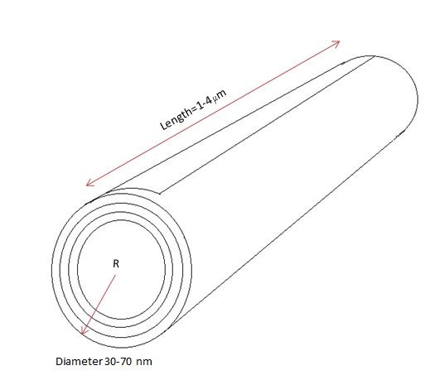
Figure 1. Schematic of halloysite nanoclay with tubular structure.

Characterisation
Dynamic Mechanical Analyzer (DMA 8000, Perkin-Elmer) was used to determine dynamic storage modulus (E’), and loss modulus (E’’) of the samples. The loss factor tanδ was calculated as the ratio (E’’/E’). The glass transition temperature (T_{g}) was taken as the temperature value at the peak of tanδ curves. Rectangular test specimens of dimensions 20 x 6 x 3 mm (Figure 2(a)) were used with a single cantilever clamp. All tests were carried out by temperature sweep method (temperature ramp from 30 °C to 130 °C at 5 °C min⁻¹) at a constant frequency of 1 Hz. The temperature applied was within the range used by Jawahar et al.⁵⁴ and Inceogul et al.⁵⁵ The maximum force of DMA was 10 N and applied during all DMA tests. Scanning Electron Microscopy (SEM) analysis using a FEI Quanta 200, was carried out of the fractured surfaces of tensile specimens to evaluate the fracture modes in the samples. The fractured portions were cut from the specimens and a layer of gold was applied using Emscope sputter coater model SC500A.
To measure the extent of liquid media absorption, rectangular specimens with dimensions 80 × 10 × 4 mm were clamped on 1 m steel template and immersed into the diluted methanol at room temperature. The weight was measured after 24 h immersion using 0.01 mg accurate weighing balance. Before weighing a specimen, any retained liquid was removed from its surface with an absorbent paper. The samples were kept at room temperature for 24 h and increase in weight was measured with respect to initial weight (before immersion) and final weight (after immersion and cleaning of the samples). The diluted methanol content in the sample was measured as % weight increase in the samples. Equation 1 was used to calculate the liquid absorption in the specimens where W_{t} is the weight of specimen at time t (i.e. after immersion in the liquid) and W_{o} is the initial weight of the sample, i.e. before placing in diluted methanol mixture. The effect of liquid absorption on the mechanical properties of halloysite nanoclay-polyester nanocomposites was investigated after placing the specimens in diluted methanol for 24 h at room temperature and compared with the same nanocomposites in dry conditions (without immersion in any liquid).
W_{c} = (W_{t}-W_{o}) × 100/W_{o ……………………..}(1) ⁵⁶
Vickers microhardness test was performed using the Buehler Micromet II for the monolithic polyester and its nanocomposites in air and after methanol exposure. The load applied was 200 g for 10 seconds and measurements were made according to standard ISO 178. Tensile, three-point bending and fracture toughness tests were performed using Instron Universal Testing Machine (Model 3382). Five specimens were tested for each composition and the displacement rate used was 1 mm/min. Tensile properties were carried out according to ISO 527 (Figure 2(b)) with specimen thickness of 3 mm. Three-point bending test was performed according to ISO 178 with dimensions 80 × 10 × 4 mm (Figure 2 (c)). A single edge notch three-point bending (SEN-TPB) was used to investigate mode-I fracture toughness K_{1C} according to ASTM D5045. The dimensions were 3 × 6 × 36 mm with crack length 3 mm (Figure 2 (d)). The notch was made at the mid of sample and tapped to sharpen by a razor blade. The K_{1C} was determined from the equation (2),
$K_{1C}$=$\frac{P_{max}f(\frac{a}{w})}{{BW}^{1/2}}$ …………. (2) ^{57,58}
$f\left(\frac{a}{w}\right)=\frac{[\left(2+\frac{a}{w}\right)\{0.0866+4.64\left(\frac{a}{w}\right)-13.32\left(\frac{a}{w}\right)-13.32({\frac{a}{w})}^{2}+14.72({\frac{a}{w})}^{3}-5.6\left({\frac{a}{w})}^{4}\right\}]}{(1-{\frac{a}{w})}^{\frac{3}{2}}}$ …………. (3)
Where, P_{max} is maximum load of displacement curve (N), f_{(a/w)} is constant related to the geometry of the sample and was calculated using equation 3, B is thickness of the sample, W is width (mm) and a is crack length (between 0.45 W and 0.55 W). Charpy impact tests were carried out according to ISO 179/1fU (edgewise). Rectangular specimens of dimensions 80 × 10 × 4 mm were used. The impact toughness was calculated using Equation 4,
Impact toughness = $\frac{mgh (\cos{β-\cos{α)}}}{wt}$ ……….(4) ⁵⁸
where m is mass of hammer (kg), g is standard gravity (9.8 m/s²), h is length of hammer arm (m), β is hammer swing up angle of fractured sample (rad), α is hammer lifting up angle (rad), w is sample width (mm), and t is sample thickness (mm).
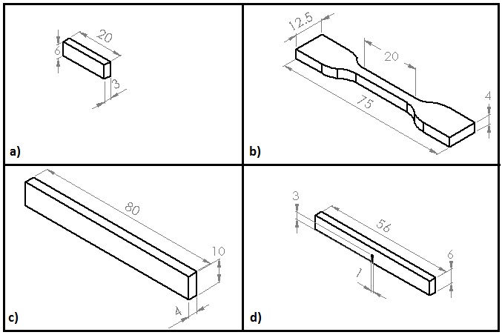
Figure 2. Schematics of specimens: (a) dynamic mechanical analysis (b) tensile, (c) flexural/impact toughness and (d) single-edge-nodge-three point bend (mode I fracture toughness K_{1C})
Results and discussion
The incorporation of halloysite nanoclay can produce two different results on the glass transition temperature of polymers. First possibility is a T_{g} decrease associated with the reduced entanglements and interactions among polymer chains and halloysite nanoclay thereby enhancing the motion of polymer chains.⁵⁹ Another possibility is the T_{g} increase caused by the restriction of the segmental motion of the polymers chain located near the halloysite nanoclay surface.⁶⁰
In this research, the addition of halloysite nanoclay increased the T_{g} as shown in Figure 3. Maximum increment was observed in case of 1 wt% reinforcement, where the T_{g} remarkably inreased from 79.7 °C to 85.2 °C. After liquid media exposure, the T_{g} values slightly decreased in all cases. Monolithic polyester recorded the lowest T_{g} with 77.1 °C. The highest T_{g} of nanocomposites exposed to diluted methanol was obtained in case of 1 wt% reinforcement with an average of 84.2 °C. In addition, the tanδ curves were also found shifted to the left after exposure to liquid media as evidenced from Figure 4(b). This can be attributed to the reduction in T_{g} due to the plasticization effect. The plasticization is caused by the presence of organic modifiers within organoclay as also reported by Ellis and Karasz.⁶¹ Polyesters based materials are also vulnerable to hydrolysis when exposed to moisture. This slowly reduces the strength and stiffness of the composites.⁶² The storage moduli of the nanocomposites in air and after methanol exposure are shown in Figure 5 (a) and 5 (b), respectively. The storage moduli increased with increasing clay loading as is normally observed in other polymer-clay system.^{35,63} A shift in storage moduli can be observed in all cases of reinforcement which can be attributed to the stiff nature of the clay fillers and also due to the combined effect of the high aspect ratio and fine dispersion of halloysite nanoclay.³⁵ As expected, diluted methanol exposure has reduced the storage moduli of the nanocomposites and increased the ductility of the polymer matrix due to plasticizing effect.⁴⁸ This phenomenon can be attributed to the methanol-water molecules entering through polymer chain and microvoids.⁶⁴ As a result, swelling occurs and causes a reduction in the structural integrity of the nanocomposites.

Figure 3. Glass transition temperature of nanocomposites in air and after methanol exposure.
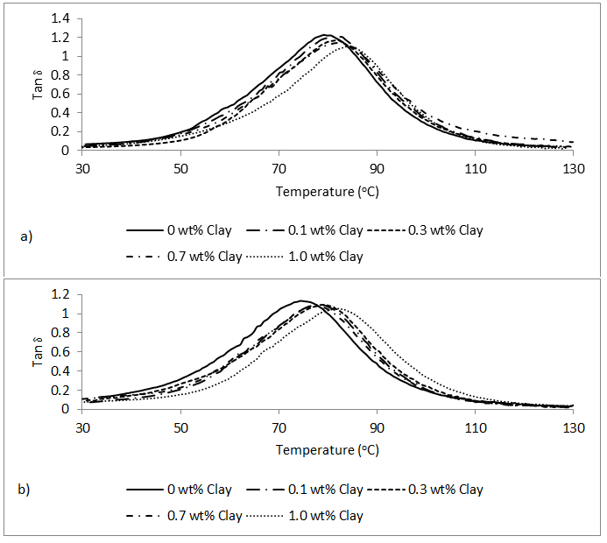
Figure 4. Tan δ of nanocomposites in air (a) and after diluted methanol exposure (b)
b)
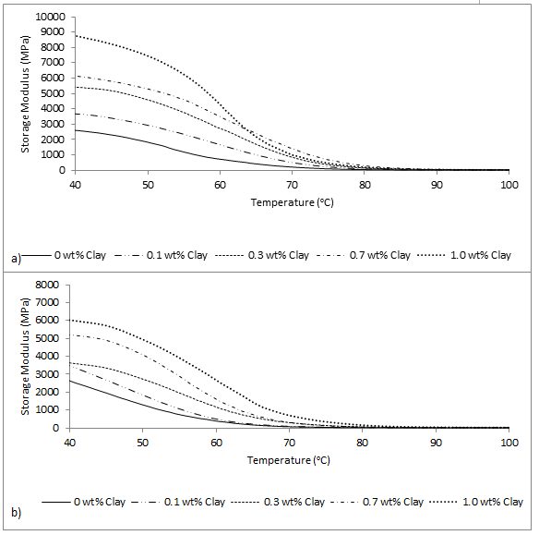
Figure 5. Storage modulus of nanocomposites in air 5(a) and after diluted methanol exposure 5(b)
Liquid absorption analysis is presented in Figure 6 (a) where monolithic polyester showed highest liquid absorption (1.48%) followed by 0.1 wt% halloysite nanoclay-polyester system (1.4%). In case of 0.3 wt% halloysite nanoclay, the absorption decreased to 1.36%. At 0.7 wt% halloysite nanoclay, the absorption of liquid was 0.95%. The lowest methanol absorption was observed in case of 1 wt% reinforcement with 0.9% absorption. Figure 6(b) shows the variation in Vickers microhardness before liquid media exposure. At 0.1 wt% halloysite nanoclay, the microhardness improved from 234 HV to 264 HV (13% increase). The maximum microhardness was observed in case of 1.0 wt% halloysite nanoclay (44% increase). After liquid media exposure, monolithic polyester recorded the lowest microhardness (203 HV). At 0.1 wt% halloysite nanoclay, the microhardness improved 8%. In case of 0.3 wt% halloysite nanoclay, 26% improvement in microhardness was observed. The 0.7 wt% nanoclay system showed 27% improvement after liquid media exposure compared to monolithic polyester. The maximum microhardness was observed in case of 1 wt% halloysite nanoclay reinforcement (45% increase). In both conditions (air and after diluted methanol exposure), halloysite nanoclay significantly improved the microhardness of polyester. The halloysite nanoclay tends to restrict the movement of polymer chains thereby increasing the microhardness.
The variation in Young’s modulus is presented in Figure 6 (c). The halloysite nanoclay improved the modulus compared to monolithic polyester in dry condition. At 0.1 wt% halloysite nanoclay, the Young’s modulus slightly increased from 0.59 GPa to 0.61 GPa (3.4% increase). An improvement of 48.6% was observed in case of 0.3 wt% nanoclaly. The highest improvement in Young’s modulus was observed in case of 1 wt% halloysite nanoclay where 75% improvement was recorded.
After diluted methanol exposure, the Young’s modulus dropped for all weight fractions of halloysite nanoclay. In case of monolithic polyester, the modulus was 0.49 GPa. In comparison with monolithic polyester exposed to liquid media, 37% increase was observed in Young’s modulus in case of 0.3 wt% reinforcement. At 1 wt% halloysite nanoclay, maximum improvement of the modulus was from 0.49 GPa to 0.83 GPa (70% increase).
The same trend of improvement was observed in the Ultimate Tensile Strength (UTS) as shown in Figure 6 (d). The minimum increase in UTS was from 26 MPa to 27 MPa (4% increase) in case of 0.1 wt% halloysite nanoclay. The maximum tensile strength was observed in case of 1 wt% halloysite nanoclay and UTS increased up to 38%. After methanol exposure, the maximum UTS was 27 MPa also in case of 1 wt% halloysite nanoclay reinforcement. The tensile strain was obtained as the % value corresponding to UTS as shown in Figure 6 (e). The results also indicate that tensile strain decreased with the addition of halloysite nanoclay. The maximum value in tensile strain was observed for monolithic polyester (11%). At 0.1 wt% reinforcement, the tensile strain observed was 10% followed by 9.8% and 8.2% in case of 0.3 wt% and 0.7 wt% halloysite nanoclay, respectively. Minimum tensile strain was observed in case of 1 wt% reinforcement with 7%. After diluted methanol exposure the tensile strain increased for all composites system. Monolithic polyester recorded the highest mean value of tensile strain (11.5%). At 1 wt% halloysite nanoclay reinforcement, the minimum tensile strain value was only 8.8%. Methanol exposure increased the mobility of the polymer chain resulting in an increase in tensile strain of the nanocomposites.⁶⁵ The flexural strength values of monolithic polyester and nanocomposites are shown in Figure 6 (f). The minimum increase of flexural strength was observed for 0.1 wt% reinforcement with 7.7% increase. Significant improvement was observed in case of 1 wt% halloysite nanoclay where the flexural strength increased up to 100%.
After diluted methanol exposure, the flexural strength slightly decreased. Monolithic polyester recorded the lowest flexural strength of 20 MPa while the highest flexural strength value was 41.3 MPa at 1 wt% halloysite nanoclay. The halloysite nanoclay was able to improve flexural strength from 19.4 MPa to 41.3 MPa (113% increase) in diluted methanol. It is observed that the mechanical behaviour of polyester and its composites differs considerably compared to dry state. After diluted methanol exposure, the hardness, strength and modulus dropped significantly. The degradation of mechanical properties can be associated with the diluted methanol absorption; however, the addition of filler fairly reduced the effect of degradation.
The critical stress intensity factor (K_{1C}) as a function of halloysite nanoclay loading is shown in Figure 6 (g). In this figure, K_{1C} linearly increased with increasing filler content up to 1.0 wt% reinforcement. The maximum increase in K_{1C} was from 0.18 MPa.m^{1/2} to 0.24 MPa.m^{1/2} in case of 1 wt% of halloysite nanoclay reinforcement. After methanol exposure, the K_{1C} values were found to increase due to the plasticizing effect caused by diluted methanol absorption. The plasticization on the resin matrix by diluted methanol appears to lower the yield stress and increase the size of plastic zone, thereby causing the observed increase in K_{1C} after diluted methanol exposure.⁶⁶ An increase in fracture toughness after liquid exposure also observed by Buehler et al.⁶⁷ and Alamri⁹ for epoxy based polymers.
The plasticization effect was reduced with the incorporation of halloysite nanoclay. The maximum K_{1C} after methanol exposure was observed in case of monolithic polyester with an average of 0.56 MPa.m^{1/2}. It was also noted that only 0.28 MPa.m^{1/2} fracture toughness was recorded in case of 1 wt% reinforcement.
The incorporation of halloysite nanoclay significantly improved the Charpy impact toughness of all produced nanocomposites as shown in Figure 6 (h). In dry condition, monolithic polyester recorded the lowest impact toughness of 0.23 kJ/m². In case of 0.1 wt% halloysite nanoclay, the impact toughness was slightly increased to 0.27 kJ/m². The impact toughness values at 0.3 wt% and 0.7 wt% nanoclay were 0.37 kJ/m² and 0.57 kJ/m² respectively. The impact toughness further increased to 0.75 kJ/m² at 1 wt% halloysite nanoclay. After diluted methanol immersion, the impact toughness decreased for monolithic polyester and nanocomposites. For monolithic polyester, the lowest value of impact toughness was observed (0.19 kJ/m²). An improvement of 8% was observed in case of 0.1 wt%. At 0.3 wt% nanoclay, an improvement of 40% was recorded. The highest value of impact toughness was observed at 1 wt% reinforcement where the impact toughness value was 0.54 kJ/m². Diluted methanol absorption caused the reduction in impact toughness due to the weak halloysite nanoclay-matrix interface.⁶⁸ The failures of the composites can be associated to the voids and porosity. The liquid diffused along the halloysite nanoclay-matrix interface through capillarity action after the composite matrix cracked and damaged.⁶⁹ The diluted methanol molecules actively attack the interface resulting in disentanglement of the fibre and the matrix which explains the reduction of the impact toughness after diluted methanol exposure.⁷⁰

Figure 6. Mechanical properties of halloysite nanoclay polyester nanocomposites (a) liquid absorption, (b) Vickers microhardness, (c) Young’s modulus, (d) tensile strength, (e) tensile strain, (f) flexural strength, (g) K_{1C} and (h) impact strength
SEM Images
The fractured surfaces of specimens were viewed in SEM to study the influence of halloysite nanoclay on the possible fracture modes in the nanocomposites. The monolithic polyester in dry condition is shown in Figure 7 (a). It can be observed that the image shows a very smooth surface as a result of very quick and straight crack propagation.^{65,71} Figure 7 (b) shows the fractured surface of 1.0 wt% reinforcement. The increase in surface roughness and fluted topography can be associated with the crack deflection by the halloysite nanoclay. This deflection increased the fracture path that increased the fracture toughness with the incorporation of halloysite nanoclay. The effect of methanol immersion can be seen in Figure 7 (c). The non-reinforced matrix is vulnerable to liquid diffusion. The plasticization of monolithic polyester occurs as a result of liquid media absorption and causes degradation in the mechanical properties. It can be seen that the liquid absorption was severe in monolithic polyester. Long river markings can be clearly seen for monolithic polyester as shown in Figure 7 (c). Figure 7 (d) shows the micro-cracks in 1.0 wt% nanoclay-polyester sample. The filler acted as a barrier for the liquid. The river markings were observed shorter and round-ended which correspond to higher resistance to crack propagation due to halloysite nanoclay.⁷¹ The swelling and plasticization effect of polymer matrix, however, were observed at all reinforcement fractions. On the other hand, short round-ended shape can also be seen indicating that the polyester chains got affected by the exposure to liquid media. The presence of halloysite nanoclay also evidently increase the surface roughness indicating crack deflection mechanism, which increases the absorbed energy of fracture. ⁶⁵ Figure 8 illustrates how diluted methanol molecules flow along the matrix interfaces and act as plasticizer thereby weakening the mechanical integrity of the nanocomposites. The diluted methanol also caused swelling and fibre-matrix debonding.

25µm
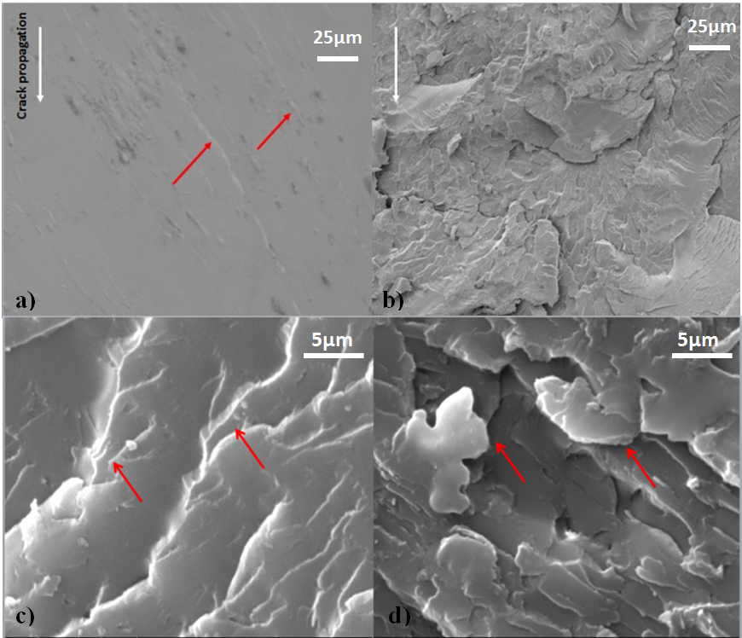
Figure 7. SEM images of fractured specimens: (a) Monolithic polyester in air (b) 1.0 wt% in air, (c) monolithic polyester in liquid, (f) 1.0 wt% in liquid
5µm
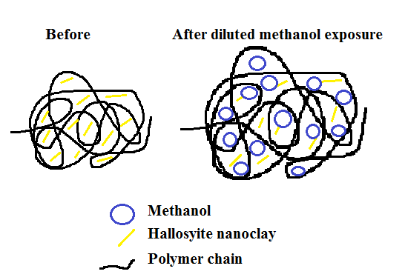
Figure 8. Schematic image of plasticized halloysite nanoclay-polyester nanocomposites before and after diluted methanol exposure

Conclusions
Nanocomposites of five different weight fractions of halloysite nanoclay reinforcement were successfully produced and the degradation of mechanical properties was studied after an exposure of 24 h in diluted methanol system by clamping test specimens across steel templates. Halloysite nanoclay has the ability to increase storage modulus and glass transition temperature (T_{g}) by increasing the stiffness of nanocomposites and restricting polymer chains. In this research, the addition of halloysite nanoclay strengthens the polyester matrix up to a concentration of 1.0 wt%. Halloysite nanoclay also improved the mechanical properties of produced nanocomposites compared to monolithic polyester exposed to diluted methanol. The plasticization effect caused by diluted methanol contributed to the detrimental effect on mechanical properties such as T_{g}, modulus and strength. After diluted methanol immersion, the maximum microhardness, tensile, flexural and impact toughness values were observed at 1 wt% of halloysite nanoclay. The microhardness increased from 203 HV to 294 HV (45% increase). The Young’s modulus increased from 0.49 GPa to 0.83 GPa (70% increase) and the tensile strength increased from 23 MPa to 27 MPa (17.4% increase). Likewise, the flexural strength also recorded an increase of 113% in diluted methanol system. The impact toughness increased from 0.19 kJ/m² to 0.54 kJ/m² in diluted methanol system (184% increase). Surprisingly, the fracture toughness of all types of nanocomposites was found to increase after exposing to diluted methanol due to plasticization effect. The maximum K_{1C} after methanol exposure was observed in case of monolithic polyester with an average of 0.56 MPa.m^{1/2}. However, in case of 1 wt% reinforcement, the K_{1C} mean value dropped to 0.29 MPa.m^{1/2}. This can be attributed to the liquid barrier property from the halloysite nanoclay reinforcement, where plasticization effect reduced with increasing nano-filler content. SEM images of the fractured surfaces of tensile specimens revealed that the methanol increased the ductility of the polyester matrix and reduced the mechanical properties of the nanocomposites. However, the halloysite nanoclay has the ability to improve the mechanical properties of polyester even when exposed to diluted methanol.
Acknowledgement
The authors wish to thank Majlis Amanah Rakyat (MARA) Malaysia for the financial support in this research project and Northumbria University for the research facilities provided.
References
1. Saharudin MS, Atif R, Shyha I, et al. The degradation of mechanical properties in polymer nano-composites exposed to liquid media – a review. RSC Adv 2016; 6: 1076–1089.
2. Chan ML, Lau KT, Wong TT, et al. Interfacial bonding characteristic of nanoclay/polymer composites. Appl Surf Sci 2011; 258: 860–864.
3. Rhim JW, Hong SI, Ha CS. Tensile, water vapor barrier and antimicrobial properties of PLA/nanoclay composite films. LWT - Food Sci Technol 2009; 42: 612–617.
4. Chan M, Lau K, Wong T, et al. Mechanism of reinforcement in a nanoclay/polymer composite. Compos Part B Eng 2011; 42: 1708–1712.
5. Sancaktar E, Kuznicki J. Nanocomposite adhesives: Mechanical behavior with nanoclay. Int J Adhes Adhes 2011; 31: 286–300.
6. Rull N, Ollier RP, Francucci G, et al. Effect of the addition of nanoclays on the water absorption and mechanical properties of glass fiber/up resin composites. J Compos Mater 2015; 49: 1629–1637.
7. Jumahat A, Soutis C, Mahmud J, et al. Compressive properties of nanoclay/epoxy nanocomposites. Procedia Eng 2012; 41: 1607–1613.
8. Liu W, Hoa S V., Pugh M. Water uptake of epoxy-clay nanocomposites: Model development. Compos Sci Technol 2008; 68: 156–163.
9. Alamri H, Low IM. Microstructural, mechanical, and thermal characteristics of recycled cellulose fiber-halloysite-epoxy hybrid nanocomposites. Polym Compos 2012; 33: 589–600.
10. Bromberg L, Cheng WK. Methanol as an alternative transportation fuel in the U.S.: Options for sustainable and/or energy-secure transportation. 2010.
11. Wright D. Failure of Plastics and Rubber Products. Rapra Technology Limited, 2006.
12. Saharudin MS, Shyha I, Inam F. The effect of methanol exposure on the flexural and tensile properties of halloysite nanoclay polyester. In: The IRES 17th International Conference, United Kingdom. London, 2015, pp. 40–44.
13. Arnold JC. The influence of liquid uptake on environmental stress cracking of glassy polymers. Mater Sci Eng A 1995; 197: 119–124.
14. Kjellander CK, Nielsen TB, Ghanbari-Siahkali A, et al. ESC resistance of commercial grade polycarbonates during exposure to butter and related chemicals. Polym Degrad Stab 2008; 93: 1486–1495.
15. Robeson LM. Environmental stress cracking: A review. Polym Eng Sci 2013; 53: 453–467.
16. Rahman M. Degradation of Polyesters in Medical Applications. Manitoba, Canada.: INTECH, 2012.
17. Alimi L, Chaoui K, Ghabeche W, et al. Short-term HDPE pipe degradation upon exposure to aggressive environments. Mat{é}riaux Tech 2013; 101: 701.
18. Arnold JC. The effects of diffusion on environmental stress crack initiation in PMMA. J Mater Sci 1998; 33: 5193–5204.
19. Fink JK. Unsaturated Polyester Resins. React Polym Fundam Appl 2008; 1–67.
20. Aziz SH, Ansell MP. The effect of alkalization and fibre alignment on the mechanical and thermal properties of kenaf and hemp bast fibre composites: Part 1 – polyester resin matrix. Compos Sci Technol 2004; 64: 1219–1230.
21. Munikenche Gowda T, Naidu a. CB, Chhaya R. Some mechanical properties of untreated jute fabric-reinforced polyester composites. Compos Part A Appl Sci Manuf 1999; 30: 277–284.
22. Bora C, Gogoi P, Baglari S, et al. Preparation of polyester resin/graphene oxide nanocomposite with improved mechanical strength. J Appl Polym Sci 2013; 129: 3432–3438.
23. Moghbelli E, Banyay R, Sue H-J. Effect of moisture exposure on scratch resistance of PMMA. Tribol Int 2014; 69: 46–51.
24. Saharudin MS, Jumahat A, Kahar AZ, et al. The Influence of Alumina Filler on Impact Properties of Short Glass Fiber Reinforced Epoxy. In: Applied Mechanics and Materials. 2013, pp. 88–93.
25. Bonnia NN, Ahmad SH, Surip SN, et al. Mechanical Properties and Environmental Stress Cracking Resistance of Rubber Toughened Polyester/Clay Composite. In: Advanced Materials Research. Trans Tech Publications, 2012, pp. 318–321.
26. Albdiry M, Yousif B, Ku H, et al. A critical review on the manufacturing processes in relation to the properties of nanoclay/polymer composites. J Compos Mater 2012; 47: 1093–1115.
27. Gao F. Clay/polymer composites: the story. Mater Today 2004; 7: 50–55.
28. Ruban Y, Mon S, Roy D. Chemical resistance / thermal and mechanical properties of unsaturated polyester-based nanocomposites. Appl Nanosci 2014; 233–240.
29. Jawahar P, Gnanamoorthy R, Balasubramanian M. Tribological behaviour of clay - thermoset polyester nanocomposites. Wear 2006; 261: 835–840.
30. Lewitus D, McCarthy S, Ophir a., et al. The effect of nanoclays on the properties of PLLA-modified polymers Part 1: Mechanical and thermal properties. J Polym Environ 2006; 14: 171–177.
31. Senthil Kumar MS, Mohana Sundara Raju N, Sampath PS, et al. Tribological analysis of nano clay/epoxy/glass fiber by using Taguchi’s technique. Mater Des 2015; 70: 1–9.
32. Bédoui F, Cauvin L. Elastic properties prediction of nano-clay reinforced polymers using hybrid micromechanical models. Comput Mater Sci 2012; 65: 309–314.
33. Paul DR, Robeson LM. Polymer nanotechnology: Nanocomposites. Polymer 2008; 49: 3187–3204.
34. Wildan MW, Mohd Ishak ZA, others. Preparation and properties of clay-reinforced epoxy nanocomposites. Int J Polym Sci 2013; 2013.
35. Pramoda KP, Liu T. Effect of moisture on the dynamic mechanical relaxation of polyamide-6/clay nanocomposites. J Polym Sci Part B Polym Phys 2004; 42: 1823–1830.
36. Ollier R, Rodriguez E, Alvarez V. Unsaturated polyester/bentonite nanocomposites: Influence of clay modification on final performance. Compos Part A Appl Sci Manuf 2013; 48: 137–143.
37. Zeng QH, Yu AB, Lu GQ, et al. Clay-based polymer nanocomposites: research and commercial development. J Nanosci Nanotechnol 2005; 5: 1574–1592.
38. Chang J-H, Jang T-G, Ihn KJ, et al. Poly(vinyl alcohol) nanocomposites with different clays: Pristine clays and organoclays. J Appl Polym Sci 2003; 90: 3208–3214.
39. Gabr MH, Phong NT, Abdelkareem MA, et al. Mechanical, thermal, and moisture absorption properties of nano-clay reinforced nano-cellulose biocomposites. Cellulose 2013; 20: 819–826.
40. Kamble R, Ghag M, Gaikawad S, et al. Review article halloysite nanotubes and applications : A review. J Adv Sci Res 2012; 3: 25–29.
41. Asadi J, Ebrahimi NG, Razzaghi-kashani M. Composites : Part A Self-healing property of epoxy / nanoclay nanocomposite using poly ( ethylene-co-methacrylic acid ) agent. Compos Part A 2015; 68: 56–61.
42. Zainuddin S, Hosur M V., Zhou Y, et al. Durability studies of montmorillonite clay filled epoxy composites under different environmental conditions. Mater Sci Eng A 2009; 507: 117–123.
43. Tomić MD, Dunjić B, Likić V, et al. The use of nanoclay in preparation of epoxy anticorrosive coatings. Prog Org Coatings 2014; 77: 518–527.
44. Joussein E, Petit S, Churchman J, et al. Halloysite clay minerals – a review. Clay Miner 2005; 40: 383–426.
45. Singh B, Gilkes RJ. An electron optical investigation of the alteration of kaolinite to halloysite. Clays Clay Miner 1992; 40: 212–229.
46. Wilson IR, de Souza Santos H, de Souza Santos P. Kaolin and halloysite deposits of Brazil. Clay Miner 2006; 41: 697–716.
47. Wang HT, Pan BR, Du QG, et al. The strain in the test environmental stress cracking of plastics. Polym Test 2003; 22: 125–128.
48. Lima Sobrinho L, Ferreira M, Bastian FL. The effects of water absorption on an ester vinyl resin system. Mater Res 2009; 12: 353–361.
49. Lee S-B, Rockett TJ, Hoffman RD. Interactions of water with unsaturated polyester, vinyl ester and acrylic resins. Polymer (Guildf) 1992; 33: 3691–3697.
50. Hojo H, Ogasawara K, Chang W., et al. Degradation behavior of unsaturated polyester resin in alcohols. Adv Compos Mater 1994; 3: 341–353.
51. Bonnia NN. Mechanical properties and environmental stress cracking resistance of rubber toughened polyester/kenaf composite. eXPRESS Polym Lett 2010; 4: 55–61.
52. Khodabandelou M, Razavi Aghjeh MK, Rezaei M. Fracture behavior and environmental stress cracking resistance (ESCR) of HIPS/PE blends and the effect of compatibilization on their properties. Eng Fract Mech 2009; 76: 2856–2867.
53. Borisova B. Investigations on Environmental Stress Cracking Resistance of LDPE / EVA Blends Dissertation. Martin-Luther-Universität Halle-Wittenberg, 2004.
54. Jawahar P, Balasubramanian M. Influence of nanosize clay platelets on the mechanical properties of glass fiber reinforced polyester composites. J Nanosci Nanotechnol 2006; 6: 3973–3976.
55. Inceogul AB, Yilmazer U. Mechanical properties of unsaturated polyester/montmorillonite composites. 2001.
56. Huang G, Sun H. Effect of water absorption on the mechanical properties of glass/polyester composites. Mater Des 2007; 28: 1647–1650.
57. Standard A. D5045, 2007. Stand Test Methods Plane-Strain Fract Toughness Strain Energy Release Rate Plast Mater ASTM Int West Conshohocken, PA 2007.
58. Atif R, Shyha I, Inam F. The degradation of mechanical properties due to stress concentration caused by retained acetone in epoxy nanocomposites. RSC Adv 2016; 6: 34188–34197.
59. Bhuvana S, Prabakaran M. Synthesis and Characterisation of Polyamide / Halloysite Nanocomposites Prepared by Solution Intercalation Method. Nanosci Nanotechnol 2014; 4: 44–51.
60. Guo B, Zou Q, Lei Y, et al. Structure and performance of polyamide 6/halloysite nanotubes nanocomposites. Polym J 2009; 41: 835–842.
61. Ellis TS, Karasz FE. Interaction of epoxy resins with water: the depression of glass transition temperature. Polymer (Guildf) 1984; 25: 664–669.
62. Creese R, Ganga Rao H. Polymer Composites II. Morgantown: CRC Press LLC, 2001.
63. Wu Z, Zhou C, Qi R, et al. Synthesis and characterization of nylon 1012/clay nanocomposite. J Appl Polym Sci 2002; 83: 2403–2410.
64. Fraga AN, Alvarez V a, Vazquez A, et al. Relationship Between Dynamic Mechanical Properties and Water Absorption of Unsaturated Polyester and Vinyl Ester Glass Fiber Composites. J Compos Mater 2003; 37: 1553–1574.
65. Alamri H, Low IM. Effect of water absorption on the mechanical properties of nano-filler reinforced epoxy nanocomposites. Mater Des 2012; 42: 214–222.
66. Indrani DJ, Cook WD, Televantos F, et al. Fracture toughness of water-aged resin composite restorative materials. Dent Mater 1995; 11: 201–207.
67. Buehler FU, Seferis JC. Effect of reinforcement and solvent content on moisture absorption in epoxy composite materials. Compos Part A Appl Sci Manuf 2000; 31: 741–748.
68. Athijayamani A, Thiruchitrambalam M, Natarajan U, et al. Effect of moisture absorption on the mechanical properties of randomly oriented natural fibers/polyester hybrid composite. Mater Sci Eng A 2009; 517: 344–353.
69. Dhakal H, Zhang Z, Richardson M. Effect of water absorption on the mechanical properties of hemp fibre reinforced unsaturated polyester composites. Compos Sci Technol 2007; 67: 1674–1683.
70. Marom G. The role of water transport in composite materials. In: Polymer permeability. Springer, 1985, pp. 341–374.
71. Vahedi V, Pasbakhsh P. Instrumented impact properties and fracture behaviour of epoxy/modified halloysite nanocomposites. Polym Test 2014; 39: 101–114.

