Adapt & Evolve 2015: East Asian Materials and Techniques in
Western Conservation. Proceedings from the International
Conference of the Icon Book & Paper Group, London 8–10 April
2015
https://icon.org.uk/node/4998

Modern machine-made washi and the implications for contemporary conservation practice
Jane Colbourne and Manami Hori

Copyright information: This article is published by Icon on an Open Access basis under a Creative Commons Attribution-NonCommercial-NoDerivatives License (CC BY-NC-ND) https://creativecommons.org/licenses/by-nc-nd/4.0/.
You are free to copy and redistribute this material in any medium or format under the following terms: You must give appropriate credit and provide a link to the license (you may do so in any reasonable manner, but not in any way which suggests that Icon endorses you or your use); you may not use the material for commercial purposes; and if you remix, transform, or build upon the material you may not distribute the modified material without prior consent of the copyright holder.
You must not detach this page.
To cite this article: Jane Colbourne and Manami Hori, ‘Modern machine-made washi and the implications for contemporary conservation practice’ in Adapt & Evolve 2015: East Asian Materials and Techniques in Western Conservation. Proceedings from the International Conference of the Icon Book & Paper Group, London 8–10 April 2015 (London, The Institute of Conservation: 2017), 158–67.

Adapt & Evolve 2015: East Asian Materials and Techniques in Western Conservation. Proceedings from the International Conference of the Icon Book & Paper Group, London 8-10 April 2015
Dr Jane Colbourne and Manami Hori
Modern machine-made washi and the implications for contemporary conservation practice

Introduction
During November 2014, UNESCO added Hosokawashi, from Saitama Prefecture, Honminoshi, from Gifu Prefecture, and Sekishubanshi, from Shimane Prefecture, to its Intangible Cultural Heritage list in a move to boost global awareness of Japanese traditional papermaking which over the years has witnessed a steady decline in favour of machine-made papers. Despite this incentive, the number of handmade paper mills are still decreasing and countless face economic difficulties.¹ Diminishing financial returns have forced many producers to make compromises in the choice and processing of materials, which has led to wider variations in quality. In contrast, commercial manufacturers are on the rise, having capitalized on the consistency and ability to replicate some of the innate characteristics of handmade papers, making distinction between the two challenging. The broad similarity of terms used by both sets of producers also create misunderstandings. For example, the term washi,² which to the majority of conservators signifies high-quality nagashizuki³ paper exclusively made from domestically grown bast fibres, cooked in wood ash to which neri is added,⁴ is now commonly used to describe any paper made in Japan, including those composed of chemically bleached,⁵ unspecified pulp formed on a machine or via the tamezuki method (Figs. 1 and 2).⁶ Similarly, it applies to paper made outside Japan, providing the mill broadly adopts domestic materials and techniques. In addition, names for papers can no longer be relied upon to indicate an entirely traditional, handmade, locally produced product. For example, sekishu,⁷ which owes its strength and beauty to the unique method of retaining the epidermis of the home-grown kōzo bark through careful cooking and hand beating, is just as likely to be composed of machine-beaten sulphite pulp and Thai kōzo, producing an altogether softer and less durable paper. Tengujo/tenjuto/tengucho/tengujoshi, an extremely thin handmade kōzo originating in Mino (Gifu) or Tosa (Kochi) Prefecture and much exported,
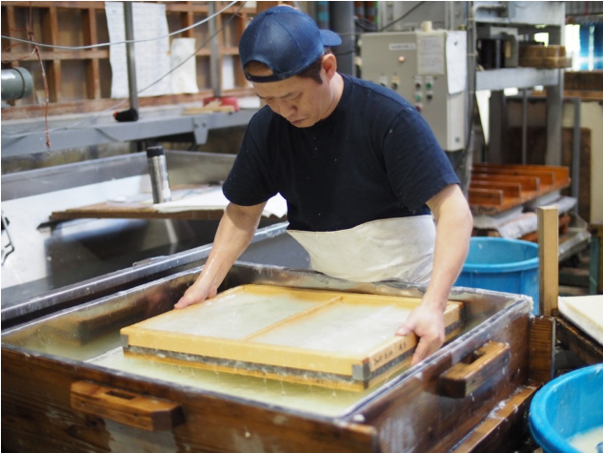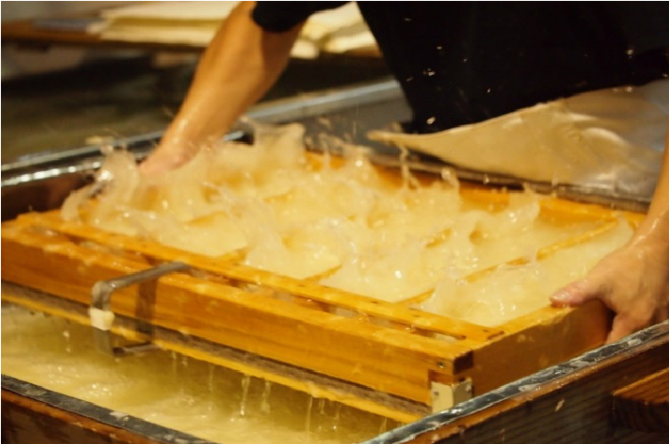
Fig. 1 Handmade tamezuki process, Awagami factory. To overcome the bias of causing fibres to orientate themselves parallel to the short side of the mould, the vatman shakes the screen between two perpendicular directions. This produces a sheet with no apparent directionality, in contrast to the nagashizuki method.
© 2017 Jane Colbourne and Manami Hori
- Institute for Future Engineering, A Survey on the Traditional Craft Industry [in Japanese] (Institute for Future Engineering, 2003): 1–21, http://www. ifeng.or.jp/wordpress/wp-content/ uploads/2012/06/CR-2002-10-6.pdf (accessed 20 November 2013).
- The word washi was first used in the Meiji period (1867–1912), when Westernstyle wood-pulp-based papermaking was introduced into Japan. To distinguish between the two forms, traditional Japanese paper was called washi and the Western-style paper was called youshi. S. Hughes, The World of Japanese Paper, 1st ed. (Japan: Kodansha International, 1978), 41–48.
- It involves the papermaker’s mould being charged several times and excess pulp ejected in a forward rapid motion. A technique exclusive to Japan and made possible by the use of neri.
- A generic term for the natural mucilage/formation aid, typically tororoo-aoi (Abelmoschus manihot (L.) Medic., previously Hibiscus manihot) or nori-utsugi (Hydrangea paniculata Sieb., a deciduous tree of the Saxifragaceae family). Other mucilages were also used, reference: Hyejung Yum, ‘Traditional Korean Papermaking: History, Techniques and Materials’ (PhD diss., Faculty of Arts, Design and Social Studies, Northumbria University, 2008).
- Chemical bleaching replaces the traditional kawazarashi (stream), yukizarashi (snow) or tenpizarashi (sunlight) bleaching.
- The major difference between nagashizuki and tamezuki lies in the former three-step sheet-forming process known as ubumizu, choshi and sutemizu. Sutemizu is regarded as the most important stage as it significantly affects the paper’s even thickness, texture and unique characteristics. The mould is tilted to an angle of 30 degrees so that the pulp slurry flows over the surface of the sheet and excess slurry is tossed off the end of the mould. This not only helps align the fibres in one direction but also serves to remove impurities floating on the surface vat such as dust, dirt and chiritori. Tamezuki is a method similar to Western-style handmade papermaking and a more direct adaptation of the ancient Chinese craft where formation aids or mucilages are absent. Fumihiko Onabe et al., Kami No Bunka Jiten [The Encyclopaedia of Paper] (Tokyo: Asakura Shoten, 2006), 327–28.
- Sekishu washi dates back to the Nara period (710–94). It was the standard paper of the age and made in three towns in the Shimane Prefecture. Good quality sekishu can still be found today made by the Sekishu Hanshi Technical Assembly, although kōzo may be substituted for mitsumata and gampi. All Japan Handmade Washi Association, Handbook on the Art of Washi (Tokyo: Wagami-do KK, 1991), 114.
- All Japan Handmade Washi Association, Handbook on the Art of Washi, 122.
- Hidakawashi have reported that they do not use any chemicals when making conservation papers. Hiroyoshi Chinzei, personal communication, 2015.
- 2014 statistics record the imported processed kōzo costs in the region of 1500 yen per kg, in contrast to homegrown high quality kōzo which averages 4000–4500 yen per kg.
- Japan Special Forest Product Promotion Association, Washi–Bunkazai Wo Iji Suru Tokuyou Rinsanbutsu, http://nittokusin.jp/wp/?page_id=34 (accessed 4 January 2014); Eiko Onda, ‘Structural Change of Mitsumata and Kouzo Production and Circulation’, Journal of Forest Economics 127 (1995): 191–96.
- Research Institute of Urbanization, Waga Kuni Washi Sangyou No Genjyou To Echizen Washi [The Present Situation of Washi Industry and Echizen Washi], http://www.riu.or.jp/document/ echizen_wasi.pdf (accessed 25 January 2014).
- Hiroyoshi Chinzei, personal communication, 2013.
- D.S. Keller, ‘Paper Drying in the Manufacturing Process’, in Paper and Water: A Guide for Conservators, ed. Gerhard Banik and Irene Brückle (London: Routledge, Taylor and Francis Group, 2012), 210.
is another case in point and could equally be made anywhere in Japan from 100% Manila hemp or machine-made ‘chlorine free’ bleached fibres.
Similar or alternative spellings, as noted in the case of tengujo, also adds to the confusion. For obvious reasons, the conservator would not wish to confuse sekushi of any type with sukushi, described typically as a partially de-inked, recycled paper.⁸ Whilst these subtleties in terminology may present few issues in the country of origin, conservators, unacquainted with the language, are less likely to be confident in their product knowledge, particularly with regard to machine-made papers whose working properties and long-term behaviour are relatively unknown, therefore access to clear and consistent information, via online or printed catalogues, is essential. This, however, relies on the cooperation of manufacturers and distributors, and their willingness to share and provide technical information in a competitive market. Whilst companies such as the renowned Awagami and Hidakawashi factories⁹ were open to discussion and helped enormously in understanding the complexities of machine-made papers, this was not always the authors’ experience. On the contrary, during other fieldwork visits significant opposition was met, to a point that releasing technical information into the public domain was expressly prohibited. Resistance was most keenly felt when discussing chemical sizes/formation aids, bleaches and other reagents added to improve high-speed production. Protecting novel commercial applications is understandable and the difficulties suppliers face in providing consumers with up-to-date information is acknowledged, but the absence in declaring important constituents that may have a bearing on the ageing of the paper is a genuine concern for professionals as, indeed, is the inaccessibility or dearth of published material relating to the impact the machine-made process has on the physical behaviour of washi. In an attempt to address this imbalance and help frame future research questions, an overview of current practices is presented which also takes into account some of the risks and benefits arising out of this relatively new innovation.

The machine-made papermaking process
- Fibre selection
For high quality machine-made papers, kōzo, mitsumata and gampi are employed much in the same way as traditionally produced washi. Since 1975, however, a growing number of alternative and imported bast fibres have been introduced, most of which form mid-range papers commonly exported abroad or used in Japan for repairing archive collections. This development was initially in response to domestic over harvesting and the importation of more competitively priced fibres from Thailand, the Philippines, Paraguay and China.¹⁰ Today, it is estimated that only 5% to 10% of the raw material is produced in Japan.¹¹ Imported kōzo often has different characteristics when compared with domestic varieties. For instance, Thai kōzo contains more gum and resin which has a tendency to aggregate and forms lumps on the surface of the sheet;¹² it also requires stronger alkalis in the form of cooking liquor to break down the fibres.¹³
Soft and hardwood pulps, hemp and other alternative fibres such as reeds and rice straw are now added with increasing regularity, to a point that papers contain less than 20% bast fibres, although still referred to as washi. Awareness of the fibre source is important to conservators as it can indicate aspects of the papers behaviour. Keller¹⁴ discusses the differences between ‘never dried’ wood pulps, which remain wet from tree through to pulping/ bleaching preparation, or ‘wet pulp lap’ which the mill receives as bales of wet sheets. In both cases, the fibres remain swollen and flexible, providing good bonding and sheet strength, but they also have high shrinkage potential. In contrast, when chemical pulps are dried, the pore structure collapses and internal hydrogen bonding occurs, making these papers notoriously difficult to rehydrate. Hornification, as it is known, is likely to impact on many conservation treatments where exposure to moisture, the release of internal stresses and the swelling of fibres due to exposure to moisture, is key to the process.
- Pulp preparation
The commercial processing/stripping of bast fibres in preparation for washi sheet formation commonly involves alkalis such as sodium hydroxide (caustic soda), sodium carbonate (soda ash) and calcium hydroxide (slaked lime) in favour of the traditional potash. This is due to their commercial viability, ease of preparation and increased ability to whiten fibres. These reagents are more caustic than potash and have a greater propensity to negatively affect fibre polymerization, resulting in an increase in oxidation and degradation.¹⁵ They also have a stronger influence on fibre swelling, water absorption and interaction with other alkaline agents applied during conservation treatments.¹⁶ In the case of chemical wood pulp, these alkalis, along with bleaching agents, are used in the cooking cycle to reduce the plant material to a fibrous mass and remove the high proportions of hygrophobic lignin and some of the hygroscopic hemicelluloses that connect fibre tissues together. As with traditional bast fibres, this significantly increases the fibres amorphous regions, alters the cation-activity of the fibre and generates new functional groups that influence the sheets reaction to water.¹⁷
- Bleaching
After cooking, the fibres are frequently chemically bleached to even out the natural tones of the material, making the paper more uniform in colour.
Hidaka, which manufactures tengu, the world’s thinnest kōzo washi (2.0 gm²), records on its informative website that most companies producing machine-made kōzo papers systematically bleach their fibres with chlorine.¹⁸ In response to this trend, and to avoid the adverse effects associated with this reagent, Hidaka has developed a new and sustainable method endorsed by the Shikoku Bureau of Economy, Trade and Industry.¹⁹ Like most pioneering techniques, this information has yet to reach the conservation domain. One hypothesis is the implementation of thiourea dioxide (TUDO), also known as formamidine sulfinic acid, which is a novel reducing bleach originally introduced to brighten textiles. In recent years TUDO has gained importance, particularly in Europe and China, in decreasing the yellowing in mechanical and chemical softwood pulps. Its advantages are that it performs well in alkaline conditions, is fast acting and has been shown to slow down celluloses photo-oxidation reactions.²⁰ Equally, Hidaka could be bleaching its fibres via the totally chlorine-free (TCF) sequence introduced in the mid-1990s. This involves treating pulp with oxygen (from hydrogen peroxide), then ozone, which is then washed with sodium hydroxide followed by an alkaline peroxide and sodium dithionite sequence. Oxygen bleaching has the advantage over chlorine in that it does not release highly carcinogenic dioxins into the environment and removes the threat of lingering chlorine molecules in the paper.²¹
- Optical brightening agents
Although seldom reported in connection with Japanese papers, fluorescent optical brightening agents (OAB) or fluorescent whitening agents (FWA) are occasionally encountered, adding to the overall chemical complexity of the paper. A pilot study at Northumbria University on the ultraviolet (UV) characteristics of Japanese papers revealed eight out of the 10 machinemade samples studied exhibited a distinct fluorescence or bright flecking in contrast to the high quality handmade sheets examined (for examples, see
- Gou Ching, ‘Tesukishi no Hozonsei Ni Oyobosu Seizouhou no Eikyo: Chugoku to Nikon no Siryo Wo Chushinni’ (PhD diss., Tokyo National University of Fine Arts and Music, 2004); Tanya T. Uyeda, Kyoko Saito, Masamitsu Inaba and Akinori Okawa, ‘The Effect of Cooking Agents on Japanese Paper’, Restaurator 20 (1999): 119–25; Masamitsu Inaba, ‘The Effects of Cooking Agents on the Permanence of Washi, Part 2’, Restaurator 23, no. 3 (2003): 133–44.
- Irene Brückle, ‘Effect of Pulp Processing on Paper-Water Interactions’, in Paper and Water, 140.
- Ibid., 130–35.
- Typically, sodium and calcium hypochlorite or chlorine dioxide is used. Fumihiko et al., Kami No Bunka Jiten, 430; Research Institute of Urbanization, Waga Kuni Washi Sangyou No Genjyou to Echizen Washi (accessed 25 January 2014). An account of brightness reversion and long-term adverse effects of bleaching on the cellulose can be found at W.H. Rapson and H. Spinner, ‘Brightness Reversion in Bleached Pulps’, in The Bleaching of Pulp, ed. R.P. Singh (Atlanta, GA: TAPPI Press, 1979), 357–91.
- Hidakawashi: http://japanesepaper.hidakawashi.com/background/ hidaka-villege.html (accessed 26 March 2015).
- C. Daneault, S. Robert and C. Leduc, ‘Formamidine Sulfinic Acid used as a Bleaching Chemical on Softwood TMP’, Chemical Intermediates 21, nos. 3–5 (1995): 521–33.
- C. Heitner, D. Dimmel and J. Schmidt, eds., Lignin and Lignans: Advances in Chemistry (USA: CRC Press, Taylor and Francis Group, 2010), 475–76.

Table 1 Sample 1: Straw, pulp and recycled machine-made washi with faux chain-lines (dandyroll). Sample 2: Machine-made usumino. Sample 3: Handmade mino from Otayahachirou studio. The UV appearance of the handmade sheet is characteristic of many sampled during the pilot study at Northumbria University. This is in contrast to the bright overall fluorescence and flecking exhibited by machine-made samples 1 and 2.

Sample 1: Machine-made Sample 2: Machine-made Sample 3: Handmade
(a) Transmitted light  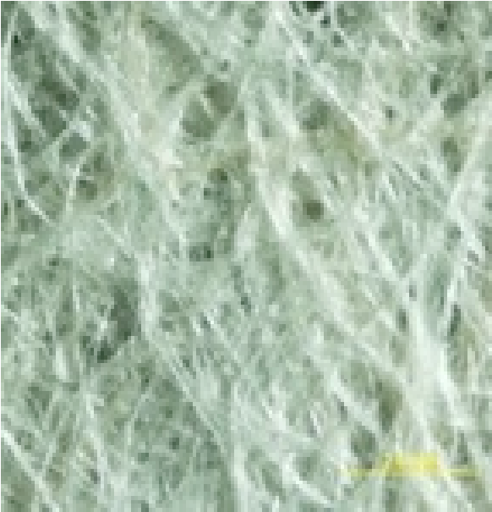 | 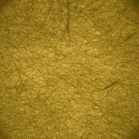  Transmitted light  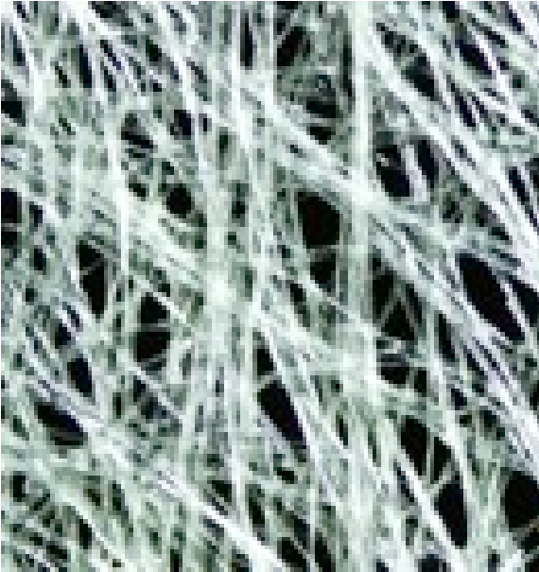 | Transmitted light  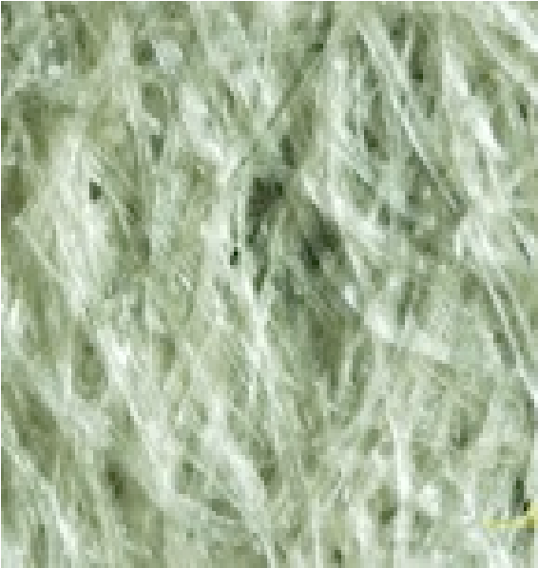
(b) Photomicrograph x40 mag. | Photomicrograph x40 mag.  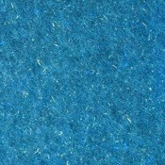 | Photomicrograph x40 mag.
(c) UV flouresecent photography | UV flouresecent photography | UV flouresecent photography

Table 1). This may be a simple indication that optical brighteners or other fluorescing agents are present (Table 1).
The most common OAB used in conjunction with papermaking are di- and tetra-sulfonated triazole-stilbenes and di-sulfonated stilbene-biphenyl. These chemical compounds absorb light in the ultraviolet region of the electromagnetic spectrum (340–70 nm) and re-emit light in the blue region typically 420–70 nm. Due to the formation of optically inactive stilbene cisisomers found at the centre of these molecules, excessive exposure to UV and oxygen will eventually result in fading, cancelling out the brightening affect it originally had on the paper.²² The long-term impact these relatively light reactive chemicals may have on the paper and artists’ materials has yet to be established.
5 Paper dyes
‘Natural’ or ‘toned’ papers are relatively common descriptive terms appearing in suppliers catalogues, and refer to papers made from unbleached fibres or derived from organic or synthetic organic dyes added after the pulping process. Depending on the type of colourant, they may exhibit differences in appearance from the norm when viewed under varying wavelengths of light, as in the case of Sample 4 (Table 2), another example from the Northumbria pilot study, which exhibits a strong absorption under UV indicative of a metal-based mordant dye.
Evidence of dyes being used is not surprising as there exists a long tradition in Japan of using substantive dyes—a compound that forms a direct chemical bond with the fibre—or mordanted dyes to colour paper. The most common mordant encountered in the East is alum (aluminium sulphate) or wood-lye (aku), although other metal ions such as tin (stannous chloride), chrome (potassium bi-chromate) and iron (iron acetate or ferrous sulphate) may be used. These form chelated complexes with the colourant, unlike substantive dyes which form direct chemical bonds with the fibres. Mordants can significantly affect the longevity of the paper, as revealed in a comprehensive study by Kazunari et al. (1999) which focused on the effects of thermal ageing of traditional paper dyes. The authors noted that alum retarded a drop in pH but all samples mordanted with iron acetate showed a significant decline and greater propensity to hydrolyse and discolour paper.²³ Whilst a few smaller mills may still use traditional colourants, cationic direct dyes, based on azo compounds, are more likely to be encountered due to their convenience, high concentration and improved
- J.C. Roberts, Paper Chemistry, 2nd ed. (London: Blackie, 1991), 184.
- The dyes included kihada, kariyasu, haze, fuyou, suou, indigo, cochineal and lac. Yoshida Kazunari, Saito Kyoko and Masamitsu Inaba, ‘Colour and Strength
Change in Dyed Kozo Paper by Wet-

Table 2 A machine-made paper described as ‘washi natural shade’. The relatively strong absorption under UV suggests the presence of a colourant.

Sample 4: Machine-made
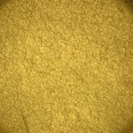  (a) Transmitted light | 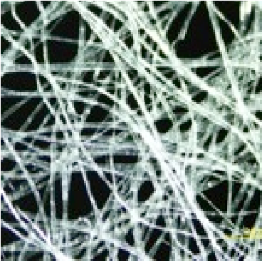  (b) Photomicrograph x40 mag. | (c) UV flouresecent photography

thermal Ageing’ [Original title and text in Japanese], Bunkazai Hozon-Syuhuku Gakkaisi 43 (ICCROM, 1999): 31–46.
- Kitty Nicholson and Susan Page, ‘Machine Made Oriental Papers in Western Paper Conservation’ (Conservation-Laboratory, NNPD National Archives, Washington, DC, AIC handout, 1 September 1988).
- Brückle, Paper and Water, 138–39.
- S. Lorenz, A. Rahm and M.
Lorenz, ‘Neri: Colloidal Ingredient in Traditional Japanese Paper Production’, Journal of Paper Conservation 13, no. 2 (2012): 8–16.
- Hughes, The World of Japanese Paper, 84.
- Saburo Inokawa, ‘Studies on the Mucilage of the Root of “Tororo-aoi”. Part 1: On the Characteristic Colloidal Nature of the Mucilage’, Bulletin of the Chemical Society of Japan 33 (1960): 1473.
- Shizuoka Prefecture Pulp and Paper Industrial Research Institute, ‘Studies on the Mucilaginous Material in Manufacture of Machine Made Paper (Part 3): Investigations of Acrylamide Polymer for Mucilaginous Material’, TAPPI 25, no. 10 (1971): 522–34.
- Conditioning/maturing machine-made papers is left to the discretion of the distributor who may or may not take advice provided by the manufacturer in recommending storing stock for upwards of two months: Hiroyoshi Chinzei, personal communication, 2015.
- Yukosya (c. 1872) is reported to be the first Western papermaking franchise in Japan producing European paper from imported wood-pulp.
- In 1875 Mita paper mills imported the first cylinder paper machine from America, and by the 1920s machinemade papers, made either on the cylinder or Fourdrinier, outstripped traditional handmade papers. In 1939 there were no less than 26 paper mills and 45 paper machines in operation, mostly located in Kouchi Prefecture. Ibe Kyoko, ’Washi into the Twenty-First Century’, Hand Papermaking 22, no. 1 (2007): 8–11.
health and safety record. The presence of dyes, which are rarely disclosed in suppliers’ catalogues, may have a tendency to migrate when wet, which might explain the release of a ‘bright yellow [colouring] matter’ witnessed by Nicolson and Page²⁴ during one of the few comparative studies published on the expansion and contraction of Oriental papers. This reaction occurred on a machine-made kōzo roll, two sheets of gampi and one sheet of handmade kōzo. Other anecdotal accounts relating to the movement of colourants in Japanese papers have also been observed during lining procedures by the current authors.
- Beating
Beating, now commonly performed using a Hollander, is a vital step in influencing the fibres’ plastic and elastic characteristics necessary for a good sheet formation. The shearing and compressive forces exerted on the fibres by the beater roll and stationary bedplate encourages faster interfibre bonding and the alignment of fibres within the sheet. Hollanders, however, are more aggressive, compared with traditional stampers or hand-beating techniques, resulting in an increase in dimensional instability and fibre reactivity to moisture. Chemical pulps are particularly affected. Overfibrillation also makes the paper more susceptible to environmental factors that contribute to accelerated ageing.²⁵
- Formation aid or neri
Making washi using long bast fibres is problematic for both machine- and handmade papers, so typically a formation aid is added to assist drainage and prevent fibres from entanglement.²⁶ It also serves to reduce the presence of shives, small bundles of fibres that have failed to separate completely during the pulping process. The traditional material known as neri, extracted from the roots of tororoo-aoi aogiri, ginbaiso or the bark of noriutsugi, remains an important ingredient in some commercial mills, although it is now commonly preserved in an agricultural disinfectant such as cresol soap (methyl phenol) or formalin.²⁷ Whilst convenient and available all year round, particularly during the hot summer months, the preserved neri’s viscosity, elasticity and its (positive) cross-linking abilities are understood to be adversely affected.²⁸ In response to this dilemma, chemical mucilages have been developed and widely adopted, including sodium polyacrylate, polymer phosphate and, more recently, the polyethyleneoxy acrylamide and polyacrylamide dispersion known as Acryperse®, patented by the Mitsubishi Rayon Company.²⁹ Whilst undoubtedly these agents offer producers reliability at competitive prices, the long-term effects on paper and artist materials remain unknown. There are also far fewer opportunities in a commercial setting to mature and condition papers over a period of time in an attempt to optimize the peak performance of the mucilage, which translates into increased durability and development of the desirable tone and patina associated with quality handmade papers.³⁰
- Forming and drying the sheet
There are several types of papermaking machines producing washi-style paper in Japan today, including the Fourdrinier,³¹ cylinder,³² Tanmo, Kensuishiki and Takaokashiki Kensuishiki—each an improvement on the last (Figs. 2 and 3). Although individually every machine produces subtly different styles of paper, all models consist of four independent units: the forming, press, dry-end operations and calendaring sections.
In the case of the Fourdrinier, the forming section begins by injecting pulp from a headbox onto moving wires. The type and composition of the wire significantly affects the grain direction of the fibres, directionality of the

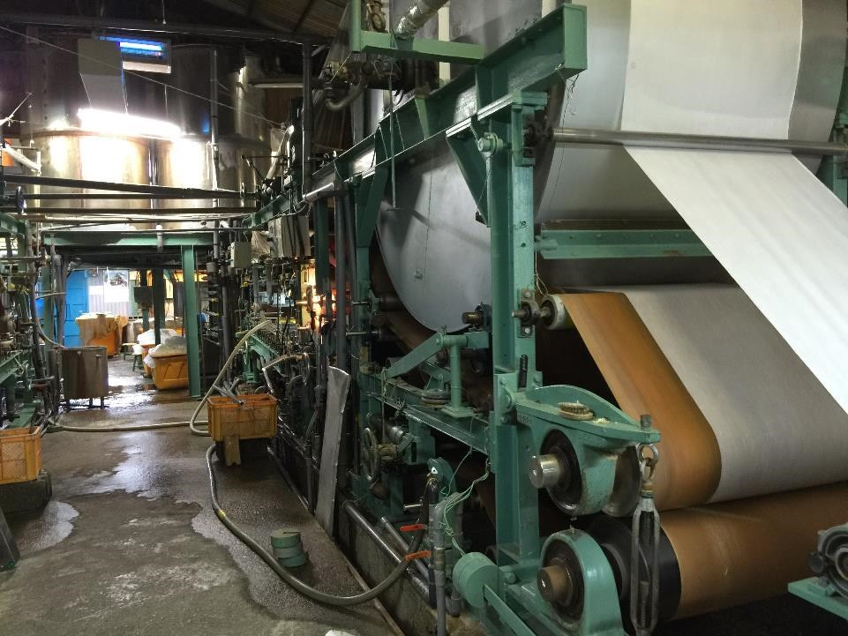
Fig. 2 Kensuishiki papermaking machine at the calendaring and drying section, Hidakawashi paper mill.
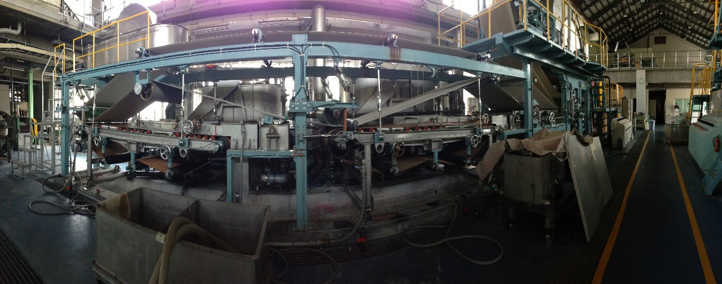
Fig. 3 A large Takaokashiki Kensuishiki paper machine capable of producing thousands of sheets per day. Image copyright Kochi Paper Technology Centre.
paper and ultimately its reaction to moisture. A single wire, for example, has a strong tendency to induce curl in a sheet when rewetted due to one side expanding more than the other.
Dewatering the continuous web of pulp is achieved through gravity, suction mechanisms and compression through felt-lined pressing rolls, all of which encourage internal hydrogen bonding and consolidation of the fibre structure. It also controls the bulk, stiffness, opacity, web strength and surface texture of the sheet, and reduces the moisture content by 50%. The paper web is then passed through the drying section, where multi-steam heated cylinders, heat radiation or blow-drying techniques are used to speed up the remaining water evaporation. When the desired moisture content is reached, the surface texture and properties of the paper are further improved through calendaring. The calendaring section involves passing the sheet through a stack of highly polished metal rolls. It completes the drying process, smooths and compacts the fibres and holds the sheet under tension. This process is significant in determining the expansion and contraction behaviour of the sheet of paper when rewetted and dried.
In contrast to the Fourdrinier, the cylinder machine comprises of a slowly rotating cylinder mould which picks up the paper stock from the vat. The paper is then deposited onto a continuously moving woollen felt. Fibres lie more randomly across the sheet, whereas Fourdrinier fibres tend to orientate themselves in one direction, making the sheet weakest in the machine direction (MD). Cylinder papers, as with all other machine-made papers, have two distinctly different sides, known as ‘felt’ and ‘mould’ sides.

- James P. Casey, Pulp and Paper Chemistry and Chemical Technology: Vol. 2: Papermaking (New York: Interscience, 1960), 810.
- Onabe, Kami No Bunka Jiten, 333.
- Introduced by Ushitaro Takaoka in 1955.
- Masamitsu Inaba, ‘Washi Kara Kino Shi e no Gijutsu Kakushin: Tokutei Ryo Iki Kenkyu’ [Technological Innovation from Washi to High Performance Paper], in Nihon no Gijutsu Kakushin — Keiken Chikuseki to Chishiki Kibanka [Japanese Technological Innovations — Compiling Experience and Forming a Knowledge Base] (2010), 13–17.
- http://rakushikan.com/en/ kikaisuki/#yoshi (accessed 29 June 2014).
- Keller, Paper and Water, 183–84.
- Inaba, ‘Washi Kara Kino Shi e no Gijutsu Kakushin’.
- Kochi Prefectural Paper Technology Center, 287-4 Hakawa, Ino-cho, Agawagun, Kochi Pref. 781-2128, Japan.
- Sue Beauman Murphy and Siegfried Rempel, ‘A Study of the Quality of Japanese Papers Used in Conservation’, The Book and Paper Group Annual 4 (1985), http://cool.conservation-us. org/coolaic/sg/bpg/annual/v04/ bp04-08.html (accessed 20 April 2013).
The ‘felt’ side corresponds to the upper surface of the paper, previously in contact with a natural or synthetic felt, and the ‘mould’ side refers to the surface in contact with the wire mesh. The ‘felt’ side is considered superior as it retains a more random pattern, whilst the ‘mould’ side has a more regular surface from the imprint of the wire mesh. The cylinder machine copes better with long, higher quality fibres, and as a consequence produces more durable papers with a reduced tendency towards web shrinkage both with and across the machine grain direction.
Advances in both Fourdrinier and cylinder models has resulted in a number enhancements. For example, developments to the Fourdrinier dewatering system allows for moisture to be removed evenly from both sides of the sheet, resulting in physical improvements and the ability to form thin papers. To the cylinder machine, the introduction of the Yankee Dryer significantly increases the strength of the paper, reduces rates of contraction and, in addition, very thin, smooth, glossy papers can be formed as a consequence of its chrome surface.³³ The Yankee Cylinder, along with the Multi Cylinder, another recent drying innovation, are the most common drying methods in Japan.
The compact Tanmo paper machine, invented by Kyuzou Sano in 1951, is an improvement of the earlier Fourdrinier model, the difference being the shaking action of the felt in the press section. By controlling speed and drainage, the difference between the front and back surfaces of the sheet is minimized and its texture is made to resemble more closely handmade washi. The advantage of the Tanmo is its reduced grain direction and reduction in expansion across the grain compared with earlier processes.³⁴
In the latest line of improvements is the Kensuishiki or Takaokashiki Kensuishiki³⁵ machine based on the Tanmo and Yankee Dryer. It is described as the first suspended system in which the whole wire or fibre web is swayed in a manner similar to sutemizu, the defining feature of nagashizuki washi. It is on these machines that high-end commercial washi is produced. Other major developments include the machine’s ability to remove unwanted shives, driving only well-dispersed fibres onto the wire.³⁶ These added functions produce a far superior quality product, described by one account as ‘so refined, that it is often mistaken for handmade paper’.³⁷
Understanding how machine-made paper is made is significant in understanding its response to liquid water or water vapour (humidification). Dry-end operations, for instance, optimize the mechanical strength of paper but they also serve to freeze stresses into the sheet upon cooling. Release of these internal strains through exposure to moisture during the course of conservation treatments not only results in the swelling of fibres, surface roughening and out-of-plane deformations (cockling/curling), but also induces significant dimensional changes particularly in the cross-grain direction.³⁸ This makes working with machine-made papers in an aqueous context more problematic when compared with handmade washi.

Properties and behaviour of machine-made paper
Despite the commonality and enduring application of Japanese papers, there have been very few investigations focusing on the chemical and physical properties of machine washi other than the seminal work by Inaba³⁹ and the ongoing research by the Kouchi Prefectural Paper Technology Centre, whose challenge is to analyse upwards of 1000 collected samples.⁴⁰
One of the few studies in English devoted to reviewing Japanese papers for conservation purposes is Murphy and Rempel’s 1985 article.⁴¹ Basing their findings on pH readings and fibre composition, 84 samples were surveyed, 14 of which were described as machine-made. Whist the authors agreed that the majority of the papers were of good quality, a number of interesting observations were recorded. In the group of papers identified

as 100% kōzo (amount not specified), many were reported to contain unwanted lignified shive material- debris naturally occurring in bast and other vascular plants. Twenty-three papers had wood fibre added, 19 of which contained treated soft (Douglas fir) and/or hardwoods, and four contained anywhere from 5% to 30% untreated softwood fibres. In three of the machine-made papers, pineapple leaf fibres and a form of Chinese miscanthus grass called ryususo, later confirmed by the distributor Paper Nao, were discovered. Unsurprisingly, the presence of wood fibres and the amount of lignified shives, which the authors linked to reduced efficiency in the beating and cooking, were highlighted as a concern and believed to be a threat to permanency.
In the slightly later article by Nicholson and Page,⁴² the tensile strength, moisture response and directionality of rolls of machine-made kōzo papers were compared with traditional handmade washi. The authors found that, on the first wetting, rolls of kōzo exhibited a noticeable expansion across the grain, yet corresponding contraction rates on first drying were both marked and varied. Some showed pronounced contraction with the cross grain, whilst others displayed greater similarities in both parallel and perpendicular directions to the grain. In response to this the authors recommended prewetting and drying machine-made papers before use, particularly in a lining context in order to minimize differential expansion and contraction rates. This was in complete contrast to their recommendations for handmade Japanese papers, which was not to pre-wet due to their continued propensity to contract during subsequent wetting and drying tests. Data relating to the tensile strength of the same set of papers also revealed that kōzo rolls in general had higher strength in both grain and cross-directions compared with handmade washi of a similar thickness, and medium-weight kōzo rolls were noteworthy in their high cross-direction strength, yet variations in their machine-direction strength. In addition, thin kōzo rolls had four times more machine-direction strength than cross-direction strength.
Although it is clear more work is needed in this area, conservators could consider the implications of this study more closely in supporting or controlling curl on artworks produced on wilful and damaged European machine-made papers by perhaps aligning their lining papers in a crossgrain direction, or by replacing handmade supports with much thinner machine-made papers due to their intrinsic strength which, weight by weight, exceed that of traditionally made washi.

In summary
The lack of consistency in nomenclature and transparency in disclosing information on synthetic forming aids, bleaching processes and other agents added to machine-made paper is of particular concern for practitioners. The implications these new processes have on the long-term physical and chemical behaviour of washi, its response to moisture, and their interactions with potentially sensitive artist materials, have resulted in a resistance, in some quarters, for conservators to include them positively in their treatments.
Although the apparent disadvantages are tangible, it is also important to note the unique advantages of machine-made papers and the close parallels some have with high-end handmade production. The industry is now capable of creating paper with many of the distinctive characteristics associated with nagashizuki but at an increased rate of production, meaning affordability, availability and ultimately more objects treated globally. The machine process can produce imperceptibly thin papers impossible to form by hand, which serves to reduce the bulk of linings and repairs whilst maintaining an object’s flexibility and structural integrity. Amongst other advantages are their closer directionality and expansion alignment with

42 Nicholson and Page, ‘Machine Made Oriental Papers’.
modern and contemporary art papers, and their unlimited length, which allows greater ease when working with oversized Western artefacts, maps and architectural drawings.
More research on their characteristics and independent quality checks are, however, needed, which will raise the consciousness of the conservation community and in turn pressurize manufacturers to disclose more information and simplify the ever-increasing confusing market of conservation supplies.

Acknowledgements
The authors would like to express their appreciation to the following people who generously shared their knowledge and time during the process of this research. They include: Hiroyoshi Chinzei from Hidakawashi Co. Ltd, Ms Kudou from the Awagami Factory, Mr Ariyoshi from the Kouchi Sangyou Gijyutsu Centre, Ms Morisawa from Papier: traditional hand-made washi studio, Mr Iijima and Ms Asanuma from the Conservation for Identity Company Saitama City, the All Japan Handmade Washi Association, retailer Kami No Ondo Co. Ltd, the international export trading company Moriki Paper, Professor Enomae and Professor Masamitsu Inaba of the Tokyo National University of Fine Arts.

Abstract
Japanese paper, commonly known as washi, is an important commercial commodity and intrinsic to both Western and Eastern conservation techniques due to its strength, transparency and excellent ageing properties. With modern technology and the slow decline in handmade papermaking, much of the paper produced in Japan today is machine-made—essentially a hybrid of traditional Asian techniques and European influences. How this paper is made and the materials used in its construction is often a closely guarded secret for obvious commercial reasons. Newly developed sizing agents, chemical treatments and the substitution of high quality bast fibres for inferior wood furnishes are a concern for the conservation profession with regard to possible changes to the paper’s long-term behaviour, and immediate physical alterations due to the fibre’s strong orientation towards the machine-grain direction. The article collates and compares the materials and methods used in producing hand- and machine-made washi, and considers the potential risks and benefits resulting from current innovations.
The study goes into the heart of paper production and distribution in Japan, and as a consequence provides new knowledge to Western audiences. It also serves to clarify certain key technical terms which are currently open to a wide variety of interpretations.

Biographies
Dr Jane Colbourne graduated in 1987 from the Gateshead Programme (now Northumbria University) in the Conservation of Works of Art on Paper. She worked for several years in South Africa for the Durban then Johannesburg Art Gallery before joining the Tate Britain in London. Since 1994 she has lectured full time on the MA Conservation of Fine Art Programme at Northumbria University and in 2011 she received her PhD in on the aqueous materials and techniques of Charles Henry Sims RA (1873-1928) a painter who represents a neglected body of early twentieth-century British artists who were responding to and assimilating new tendencies within early modernism. Other qualifications include Foundation Studies in Art and Design (Leicester University), BA (Hons.) in Fine Art (Belfast College of Art) and a PG-CUTL in University Teaching and Learning. She is also a HEFC Moderator, a Higher Education Academy Associate (2009) and an Accredited Member of Icon since June 2001. In addition to her teaching and role as Programme Leader which began in 2013, she is an active researcher and regularly delivers professional workshops both at home and abroad on various topics related to conservation and the history of artist materials. She is also currently involved in the recently established Northumbria Paper Studio developed to further research into the scholarship of paper in relation to fine art, conservation, archiving and the practice of papermaking. This is a unique facility in the UK in the context, expertise and focus that it provides.
Manami Hori received her Bachelor’s Degree in Information Technology in Design and Architecture from Nagoya City University, Nagoya, Japan in 2012. This was followed, in 2014, by her Master’s Degree (with Distinction) in the Conservation of Fine Art (Works of Art on Paper) from Northumbria University, Newcastle upon Tyne. It is at Northumbria that her research interests in modern Japanese papermaking began forming the topic of her final year dissertation. In addition to her academic achievements, during the summer of 2013 she completed two conservation work placements at the Victoria and Albert Museum and the Royal Botanic Gardens, Kew. After graduation, she was successful in securing a prestigious six-month internship at Nishio Conservation Studio in Washington

D.C., specialising in Asian art conservation techniques.

Contact address

Dr Jane Colbourne Manami Hori
Programme Leader MA Conservation of Fine Art Email: manamihori@icloud.com
Faculty of Arts, Design & Social Sciences
Room 001, Burt Hall
Northumbria University
Newcastle upon Tyne
NE1 8ST
United Kingdom
Email: jane.colbourne@northumbria.ac.uk

