Disrupting Leadership Focus by Facilitating Social Construction of Followership in the Classroom: Student Responses to a Visual Method Pedagogy.
Rachael Morris and Sandra Corlett
Newcastle Business School, Faculty of Business and Law

Rachael Morris is a Graduate Tutor and PhD Candidate at Newcastle Business School, Northumbria University, UK. Rachael’s research interests are centred on processes of following, as well as qualitative and visual research methodologies.

Sandra Corlett is a Principal Lecturer in Organisation and Human Resource Management at Newcastle Business School, Northumbria University, UK. Her research interests relate to identity, manager and follower learning and development, and qualitative research methods from a social constructionist perspective.

Correspondence should be addressed to Rachael Morris, Newcastle Business School, Faculty of Business and Law, Northumbria University, UK 0191 227 3357. Contact: Rachael.l.morris@northumbria.ac.uk

Abstract
When followership is incorporated into the classroom, it is often as an adjunct to leadership and its theories and, thus, opportunities for the social construction of followership are diminished. The paper provides insights into classroom practices used to develop students’ constructions of followership through reflective and visual teaching strategies, facilitating co-construction of meaning in the classroom. An agenda for increased focus on followership learning, underpinned by visual method pedagogy, is provided to inform and inspire others to apply this disruption in mainstream leadership programs across other academic (and corporate) institutions.
Keywords: Followership, Social Construction, Pedagogy, Reflection, Visual Teaching Methods, Education

Disrupting Leadership Focus by Facilitating Social Construction of Followership in the Classroom: Student Responses to a Visual Method Pedagogy
The followership field is gaining traction with academics focused on development and raising the profile of its theory and practice (e.g., Chaleff, 2009; Hurwitz & Hurwitz, 2015; Kelley, 2008; Koonce, Bligh, ‎Carsten, & Hurwitz, 2016). However, followership is still rarely included as a topic in leadership programs (Malakyan, 2014; Morris, 2014). As a result, students lack the opportunity to consider their understandings of followership and are not exposed to its many constructions other than those formed during their wider processes of socialization. Followership is not presented to students as something that they should aspire to do; rather, course content emphasizes developing and evidencing leadership skills to prepare for employment. Where followership is incorporated into study programs, it is offered as a side-line, covering basic and arguably out-dated theories, thus lacking a range of contemporary meanings.
Our approach to incorporating followership in study programs is based on understanding learning as a social constructionist process of meaning making (Corlett, 2012; Cunliffe, 2008). Learning is a social activity of making sense of our experiences through self-reflection and conversations with ourselves and others. Several studies have adopted a social constructionist approach to followership research (e.g., Carsten, Uhl-Bien, West, Patera, & McGregor, 2010; Jackson & Guthey, 2007; Morris, 2014). In the current paper, we extended such work by taking an explicit social constructionist approach in the classroom to facilitate followership learning.
Cunliffe (2008) highlights the importance of encouraging students to engage in self- and critical-reflexivity, i.e., to understand how they “construct multiple and emerging ‘realities’ and selves” through interactions and dialogue with others (p. 135). Such an approach also places emphasis on raising awareness of students’ use of language and encouraging critical examination of assumptions about ways of being and behaving as conveyed by ways of talking, including use of particular words and phrases (Corlett, 2012; Cunliffe, 2008). Founded on these premises of social constructionist learning, our study sought to facilitate and capture the multiple ways in which individuals construct following, acknowledging that such meanings are shaped by individual experiences and ways of talking. Our study recognized that understandings of followership may be overshadowed by leadership and, indeed, conventional approaches to leadership teaching. Therefore, we employed an underutilized visual method pedagogy involving drawing and discussing pictures (see also Ray & Smith, 2012).
A Visual Method Pedagogy Focused on Followership
Using drawings as a visual methodology in research may no longer be considered an innovative technique (e.g., Bryans & Mavin, 2006; Morris, 2015; Tracy & Redden, 2015). However, using drawings as a visual teaching methodology in leadership learning is uncommon. When combined with the unfamiliar concept of followership, it may disrupt more traditional methods of teacher-led definitions and discussions (Schyns, Tymon, Kiefer, & Kerschreiter, 2013). Schyns et al. (2013) argue that drawings can be a useful means not only to explore individuals’ understandings of concepts, but also to encourage groups to consider and share their understandings. It enables students to use their own experiences of, and reflections about, a concept as a starting point. This creative and innovative visual method pedagogy can also: (a) stimulate group discussion; (b) encourage the use of symbols and other depictions, and access stereotypes, metaphors, and other cultural representations; (c) be language independent by going beyond the expression of meanings as lists of characteristics and behaviors; and (d) add an emotional element. Like Schyns and colleagues, our aim in using a drawing exercise was to “encourage tacit knowledge to become explicit and the sharing of meaning” (p. 14). Discussing the drawings produced with the wider group encourages exploration of, and disruption to, assumptions, attitudes, beliefs, and values underpinning each student’s implicit beliefs. For example, students may consider how their own images and thinking fit with others and with mainstream theories or stereotypical views. Such discussions prompt them to question stereotypes and acknowledge alternative perspectives (Tracy & Redden, 2015), and to reconsider their own experiences of following (Schyns et al., 2013).
Seminar Design and Drawing as Learning Method
We now outline the design of two connected seminars on the topic of followership that included the use of a drawing exercise.
Session design. In the first session, students were asked to write down three words to describe leadership. They were then asked to write down three words describing what followership meant to them, and then to write them on the board to share with the class before discussing their reasons for choosing the words. Given the students’ lack of familiarity with followership, the first author presented and discussed theories of followership including traditional and contemporary perspectives.
In the second session approximately one month later, students were asked to draw pictures of themselves as followers using flip charts and pens, and then to present and explain these to the group. Thus, while the drawing exercise in the current study may have been unexpected and on an unfamiliar topic, it used familiar teaching tools of flip charts and pens with student presentation and discussion.
Student responses. The first task of writing down three words to describe leadership was straightforward for the students. They wrote down ideas instantly and were finished within a few minutes. When asked to share their thoughts with the group, they engaged actively, repeated words used by others, and reached group agreement on many ideas.
When the students were then asked to write down three words that they associated with followership, the first author observed puzzlement and/or deep thought, hesitancy in writing, and looking around at peers with what appeared to be expressions of uncertainty. As also noted in Grimes (2015), this part of the activity involved setting a tough task that caused confusion. It was designed to highlight to students their lack of awareness of the concept of followership. Allowing for a longer period of time to write down three followership-related words, the students were then asked to share these with the group (words included sheep, younger, takes orders, and inexperienced) and to discuss differences in their responses between the leadership and followership tasks.
Using the drawing tools provided in the second session, the same students were asked to draw pictures that depicted themselves as followers and present to the group. This activity encouraged students to reflect on their own experiences of following, and to explore the concept beyond the use of language and words/terms commonly associated with it. In this exercise, students demonstrated critical thinking through reflection (Harvey & Jenkins, 2014) by depicting and talking about how they might use situational factors to modify their followership behaviors, and how they might differ in terms of skills and feelings when “doing following” (Morris, 2015) as compared with doing leading (see also Figure 1). In addition to the drawings noted in Figure 1, students provided metaphors and symbols to convey meaning of followership such as the symbolic representations of “cutting through red tape” and “keeping your mouth zipped” (Figure 2).
The use of metaphors and symbols in the student’s drawings supports Schyns et al’s (2013) findings and, like their study’s inclusion of followers in depictions of leaders, the size and positioning of the follower in relation to the leader in our students’ drawings (as illustrated by Figure 1) raises questions about how leader-follower relationships are viewed.
Conclusion
This paper has provided an exemplar for student-led followership-focused learning, incorporating visual method pedagogy for teacher and practitioner use. We argue that the methods used in the current study disrupted students’ thinking and their assumptions about followership. Reflection, creative drawing, and discussion also enabled them to achieve “deep personal discovery of themselves as followers” (Harvey & Jenkins, 2014, p. 73). Furthermore, the additional focus on language provided students opportunity to (a) become aware of followership, (b) question dominant ways of thinking about followership, and (c) do followership. Given the lack of familiarity with followership as a (theoretical) concept, it is difficult for students to voice their understandings (Bryans & Mavin, 2006); the use of multiple forms of communication was an important aspect of the learning method design. Students need to be given space to view followership neutrally and as something potentially desirable with which to associate themselves while also ensuring that the learning is impactful to avoid falling back into assumption-based constructions of understandings.
The transfer of students’ changed constructions of followership from the classroom into workplace practices will facilitate a move away from out-dated assumptions about followership as subordination (Rost, 2008). Through sharing our experiences of facilitating the social construction of followership in the classroom, using visual method pedagogy, and the positive student responses we received, we hope that the current research provides inspiration for the on-going development of followership-focused learning.

References

Bryans, P., & Mavin, S. (2006). Visual images: A technique to surface conceptions of research and researchers. Qualitative Research in Organizations and Management: An International Journal, 1(2), 113-128. doi:10.1108/17465640610686370

Carsten, M. K., Uhl-Bien, M., West, B. J., Patera, J. L., & McGregor, R. (2010). Exploring social constructions of followership: A qualitative study. The Leadership Quarterly, 21(3), 543-562. doi:10.1016/j.leaqua.2010.03.015

Chaleff, I. (2009). The courageous follower: Standing up to and for our leaders (3rd ed.), San Francisco, CA: Berrett Koehler.
Corlett, S. (2012). Participant learning in and through research as reflexive dialogue: Being ‘struck’ and the effects of recall. Management Learning, 44(5), 453-469. doi: 10.1177/1350507612453429

Cunliffe, A. L. (2008). Orientations to social constructionism: Relationally responsive social constructionism and its implications for knowledge and learning. Management Learning, 39(2), 123-139. doi:10.1177/1350507607087578

Grimes, M. W. (2015). Teaching leadership through a cultural–psychological lens. Journal of Leadership Studies, 9(1), 63-72. doi:10.1002/jls.21348

Harvey, M., & Jenkins, D. M. (2014). Knowledge, praxis, and reflection: The three critical elements of effective leadership studies programs. Journal of Leadership Studies, 7(4), 76-85. doi:10.1002/jls.21314

Hurwitz, M., & Hurwitz, S. (2015). Leadership is half the story: A fresh look at followership, leadership, and collaboration. Toronto, Canada: University of Toronto Press.
Jackson, B., & Guthey, E. (2007). Putting the visual into the social construction of leadership. In B. Shamir, R. Pillai, M. Bligh, & M. Uhl-Bien (Eds.), Follower-centered perspectives on leadership, (pp. 167-186). Greenwich, CT: Information Age Publishing.
Kelley, R. E. (2008). Rethinking followership. In R. E. Riggio, I. Chaleff, & J. Lipman-Blumen, (Eds.) The art of followership: How great followers create great leaders and organizations. (pp. 5-16). San Francisco, CA: Jossey-Bass.
Koonce, R., Bligh, M., Carsten, M. K., & Hurwitz, M. (2016). Followership in action: Cases and commentaries. Bingley, England: Emerald Group Publishing Limited.
Malakyan, P. G. (2014). Followership in leadership studies: A case of leader-follower trade approach. Journal of Leadership Studies, 7(4), 6-22. doi:10.1002/jls.21306

Morris, R. (2014). Constructions of following from a relational perspective: A follower-focused study. Journal of Leadership Education, 13(4), 51-62. doi:10.12806/V13/I4/C7
Morris, R. (2015). Following authentically in the UK public sector: The importance of visibility, value and voice (Unpublished doctoral dissertation). Northumbria University, Newcastle upon Tyne, England.
Ray, J. L., & Smith, A. D. (2012). Using photographs to research organizations: Evidence, considerations, and application in the field study. Organisational Research Methods, 15(2), 288-315. doi:10.1177/1094428111431110

Rost, J. C. (2008). Followership: An outmoded concept. In R. E. Riggio, I. Chaleff, & J. Lipman-Blumen (Eds.), The art of followership: How great followers create great leaders and organizations (pp. 53-65). San Francisco, CA: Jossey-Bass.
Schyns, B., Tymon, A., Kiefer, T., & Kerschreiter, R. (2013). New ways to leadership development: A picture paints a thousand words, Management Learning, 14, 11-24. doi: 10.1177/1350507612456499

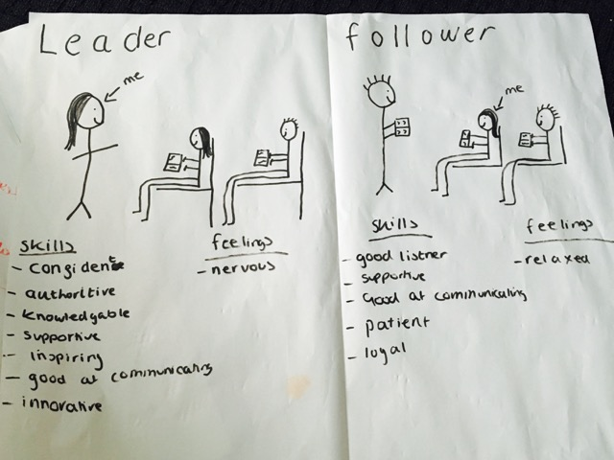

Figure 1. Self as a follower and as a leader. Drawing produced by a seminar student.

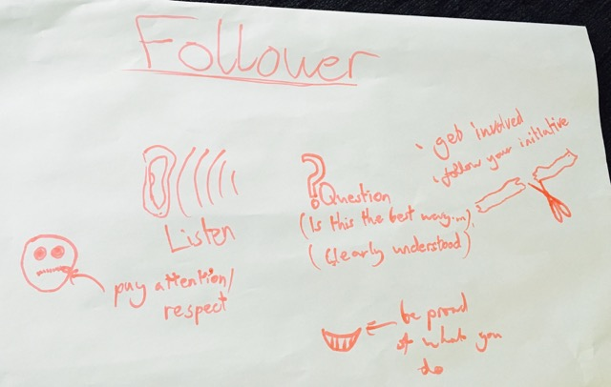

Figure 2. Symbols depicting a follower. Drawing produced by a seminar student.

