36th Cement and Concrete Science Conference
Cardiff, 5th & 6th September 2016
Paper Number 029

Atomistic Modelling for the Study of Dissolution and Carbonation of Lime

Richard J. Ball
BRE Center for Innovative Construction Materials, Department of Architecture and Civil Engineering - University of Bath, Bath, United Kingdom

Giovanni L. Pesce
Department of Architecture and Built Environment – Northumbria University Newcastle, United Kingdom

Marco Molinari, James Grant, Stephen C. Parker
Department of Chemistry - University of Bath, United Kingdom

Ian Fletcher
School of Mechanical and Systems Engineering, Newcastle University, Newcastle upon Tyne, United Kingdom

ABSTRACT

At the 35th Cement and Concrete Science conference, we provided an example of how advances in computing power make atomistic modelling a viable approach for the study of chemical processes relevant to the construction industry. This paper describes developments of this work and how the combination of stable isotopes, atomic force microscopy (AFM), secondary ion mass spectrometry (SIMS) and atomistic modelling can provide new insights into the dissolution and carbonation mechanisms of lime. In this research AFM and atomistic modelling were used to investigate the dissolution mechanism of nano-sized Portlandite (Ca(OH)₂) crystals. Experimental and computational results highlight differences in the solubility of {100}, {010} and {001} crystallographic faces. The {001} faces were shown to be the most stable. SIMS and Raman spectroscopy of ¹⁸O-labelled calcium hydroxide and computational techniques have allowed investigation of previously unknown details of the carbonation mechanism. Experimental results provide the first evidence of the theory proposed by Letolle and colleagues in 1990 regarding the formation of the carbonate ion (CO₃²⁻) by direct reaction of the hydroxyl ions (OH⁻) with carbon dioxide (CO₂) dissolved in water. New insights into the transformation of meta-stable carbonates into stable phases in the first few minutes of carbonation are also reported.

1. INTRODUCTION

Recent advances in computing power make atomistic modelling a viable approach for the study of chemical processes involved in a variety of applications of interest for the construction industry. This means that nowadays atomistic modelling has the potential to explain the mechanism of fundamental reactions in some of the most complex construction materials such as cement (Ball et al. 2014; Grant et al. 2016).
This paper seeks to highlight the potential of atomistic modelling applied to construction materials by investigating some of the most fundamental processes involved in the production and use of low carbon building materials such as lime. This is particularly relevant to the United Kingdom since, as the Department of Energy and Climate Change reports, the country is now committed to reducing its anthropogenic carbon dioxide (CO₂) gas emissions by at least 80% by 2050, relative to 1990 levels (Legislation.gov.uk, 2008).

Lime (calcium oxide and/or hydroxide) is a material that has been used for centuries in the construction industry (Kind-Barkauskas et al. 2002). It is produced at temperatures lower than Portland cement (Boyton 1966; Hewlett 1998) and re-adsorbs part of the CO₂ released during hardening. This makes lime one of the most sustainable inorganic binders currently available for construction. Furthermore, lime is widely recognized for its superior permeability (Forster 2002), flexibility and self-healing properties compared to cement (Jaroenratanapirom & Sahamitmongkol 2011), and it is commonly accepted that in terms of vapor permeability and flexibility lime has distinct advantages compared to Portland cement.

This study is of importance not only to the construction industry but also industries where carbonation of lime is an important process, including ground stabilization, carbon dioxide sequestration and production of precipitated calcium carbonate products. Dissolution of hydrous minerals and carbonation are of fundamental importance in applications such as the scrubbing procedures of solid waste incinerators and in the understanding of more complex materials such as serpentine, which is currently used for carbon capture and storage (CCS; Blamey et al. 2011; Zhao et al. 2010; Ruiz-Agudo et al. 2013).

This paper contains a concise description of an integrated approach to fundamental processes involved in the production and use of lime. In such an approach, experimental data from manufactured samples are used to inform atomistic models that, in turn, guide the development of new materials with optimized performance.

2. Dissolution of Portlandite crystals

Dissolution of Portlandite crystals (Portlandite is the only crystalline form of calcium hydroxide or Ca(OH)₂) is the first process involved in the use of lime, in particular when hydrated lime is the main binder. In this research the dissolution mechanism of nano-sized Portlandite crystals is investigated using atomic force microscopy (AFM) and atomistic modelling.
Topographic observations of commercial nano-sized Ca(OH)₂ crystals (CaLoSiL E25 from IBZ Salzchemie GmbH & KG, Freiburg, DE) were obtained in both, contact and tapping mode using a Veeco Multimode Nanoscope IIIa. Typical AFM images of the crystals are shown in Figure 1.

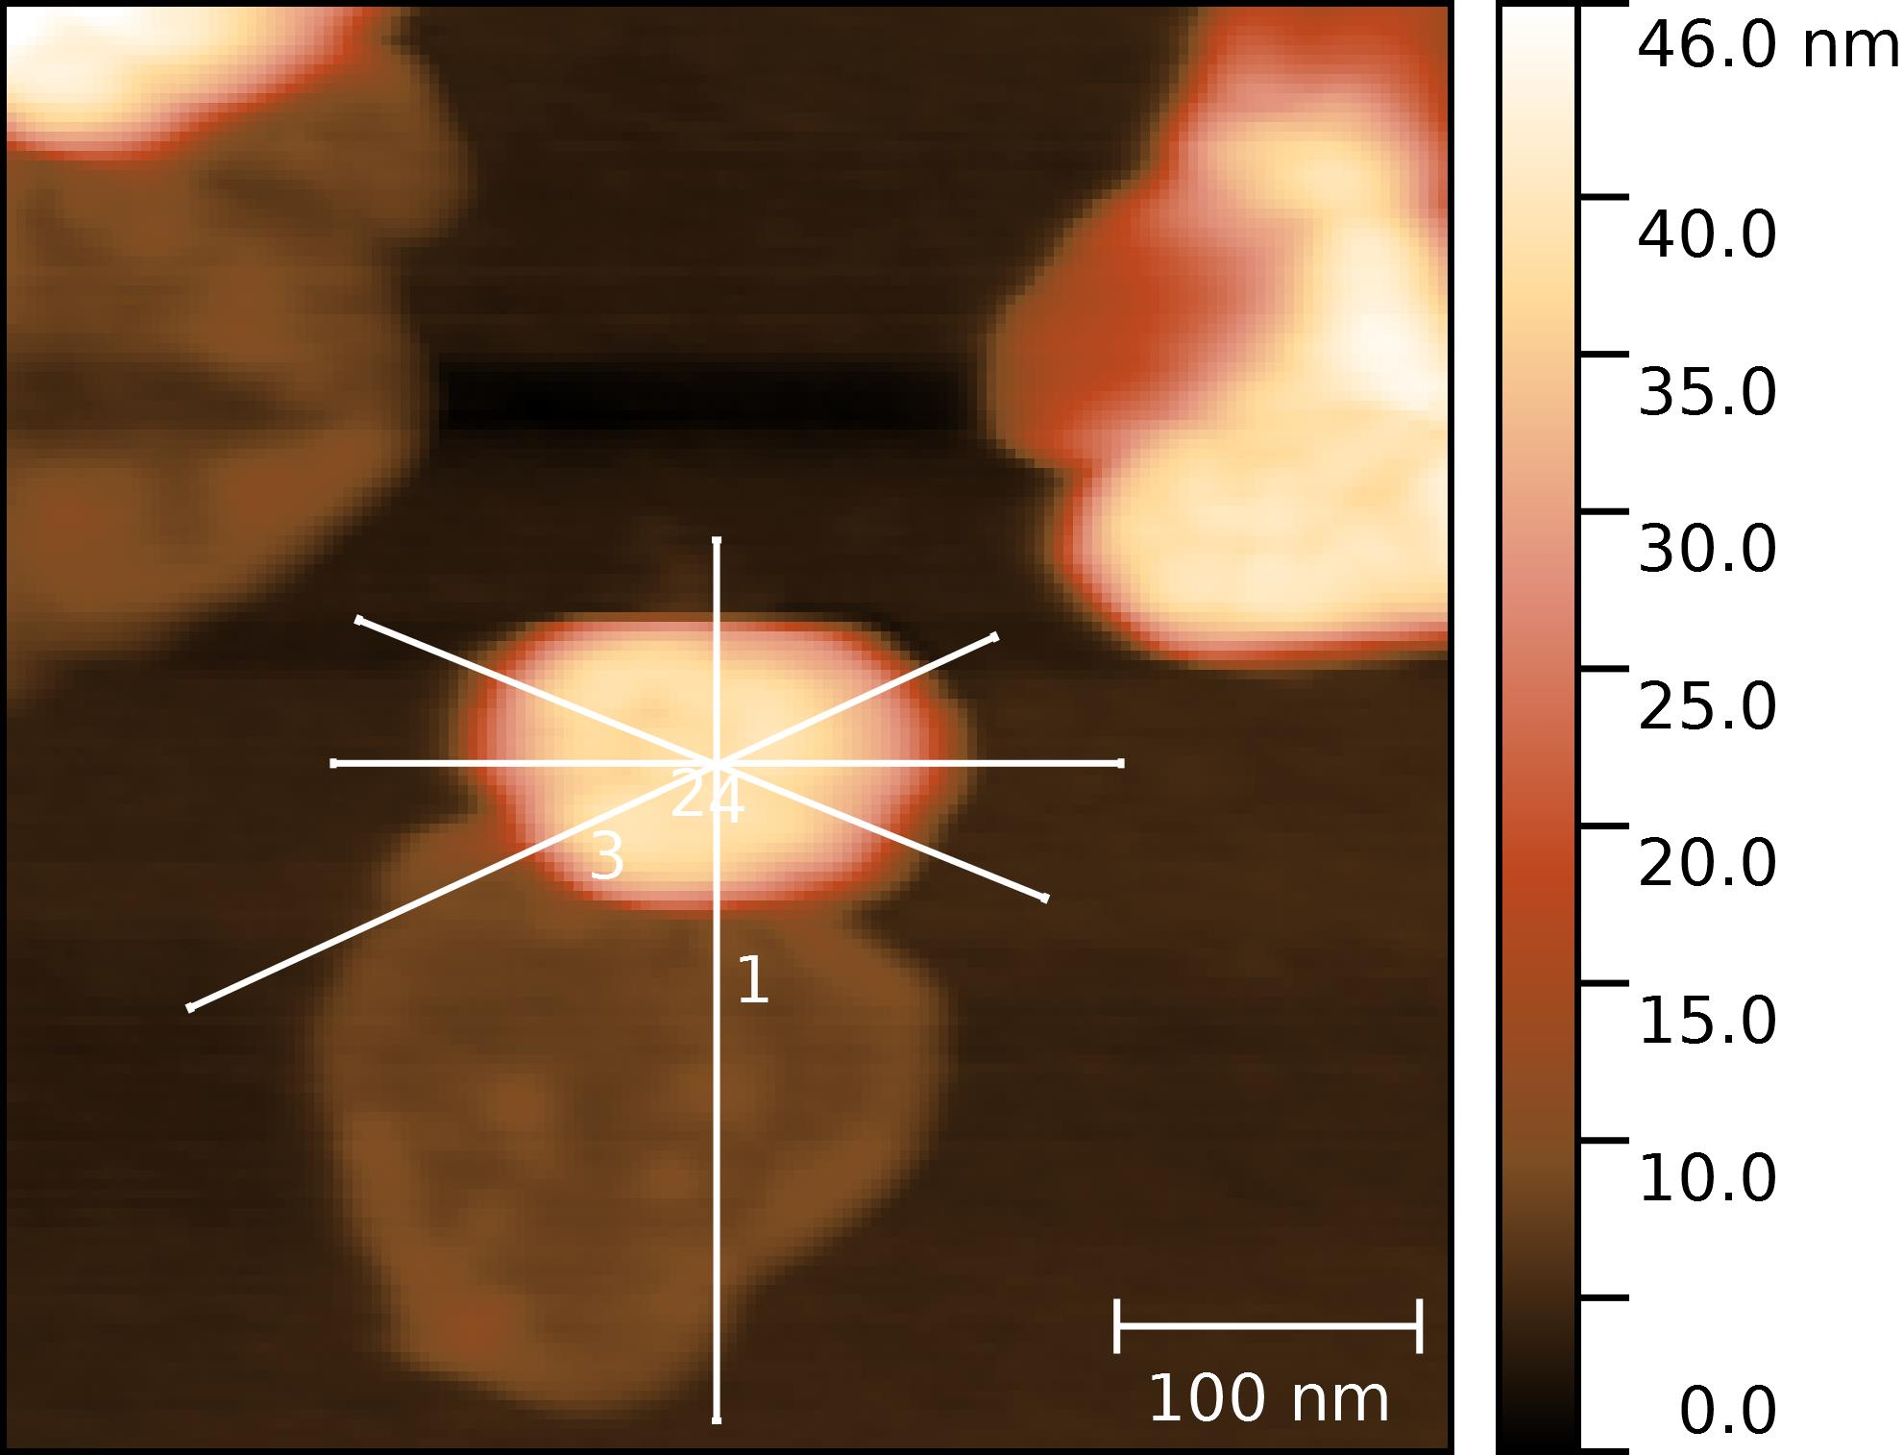
Figure 1 - AFM images of Portlandite crystals generated using the height channel in tapping mode. White lines intersecting the crystal centre identify traces of the extracted profiles (i.e. cross sections)

The microscope was equipped with a bespoke conditioning chamber (Figure 2) accommodating a CO₂ sensor and a temperature/ relative humidity (T/RH) sensor for environmental monitoring during the experiments.
Each experiment was carried out under dry and humid conditions. The dry condition was obtained by flushing dry nitrogen through the chamber and was undertaken at the beginning of the tests to locate the crystals and evaluate their stability in 0% RH and 0ppm CO₂. The dissolution mechanism of Ca(OH)₂, was investigated under humid conditions produced by introducing nitrogen at 30% RH and 0ppm CO₂ into the chamber.
AFM images of the same crystal taken at regular intervals over a period of several hours were used to highlight the geometrical changes in humid conditions.
To evaluate these changes, a number of profiles were extracted from the images of the same crystal taken at different times (Figure 3). Side-to-side and corner-to-corner profiles of each crystal were, then, used to evaluate the movement of the top face, left and right side, and top-right and top-left corner.

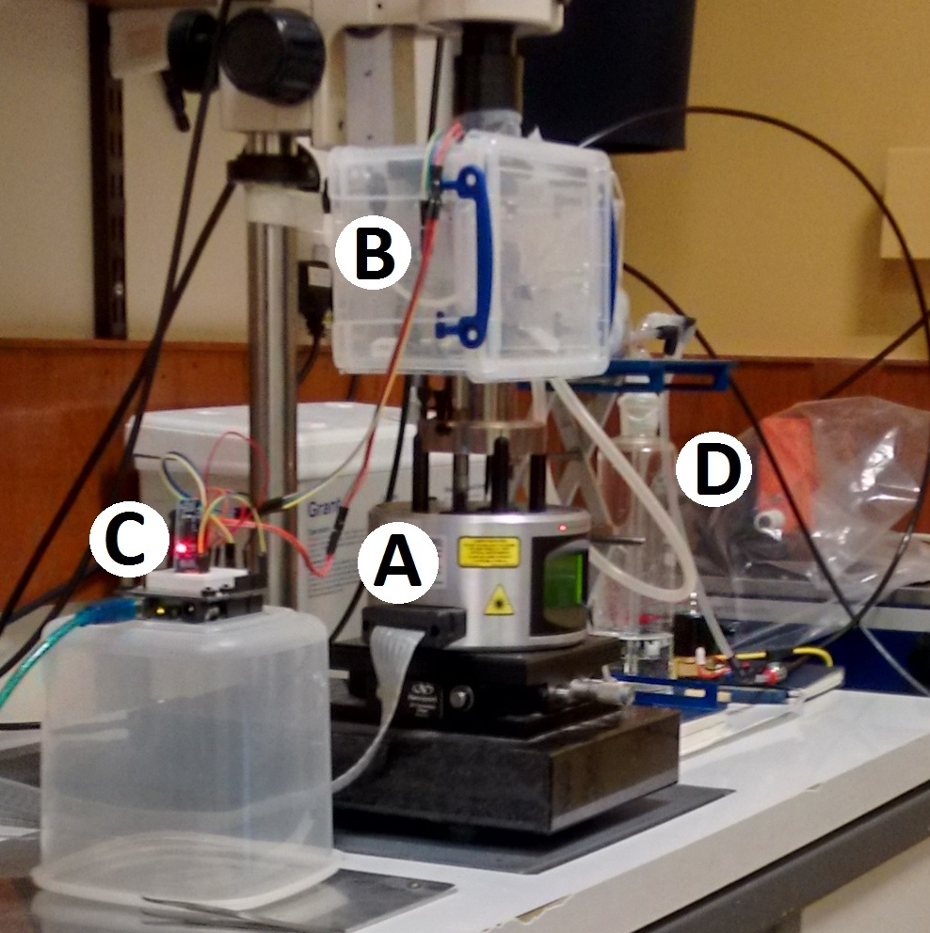
Figure 2 - Photograph of the AFM during the experiments. The microscope (A) is equipped with bespoke conditioning chamber (B) used to maintain the desired environmental conditions. The Arduino microcontroller (C) used to collect and record environmental data is shown. The bubbler (D) and part of the electronics used to humidify the gas before introduction into the chamber is also visible.

The computational work allowed creation of binary (CO₂/p_{H2O}) phase diagram for the different Portlandite faces. The insights of the Ca(OH)₂–H₂O-CO₂ system we obtained indicate that the {001} surfaces of Portlandite, show different behavior at 30% RH and 0ppm CO₂ compared to the edge surfaces. These findings are confirmed by AFM measurements, which show preferential dissolution of the edge surfaces and carbonation of the perfect cleavage {001}.

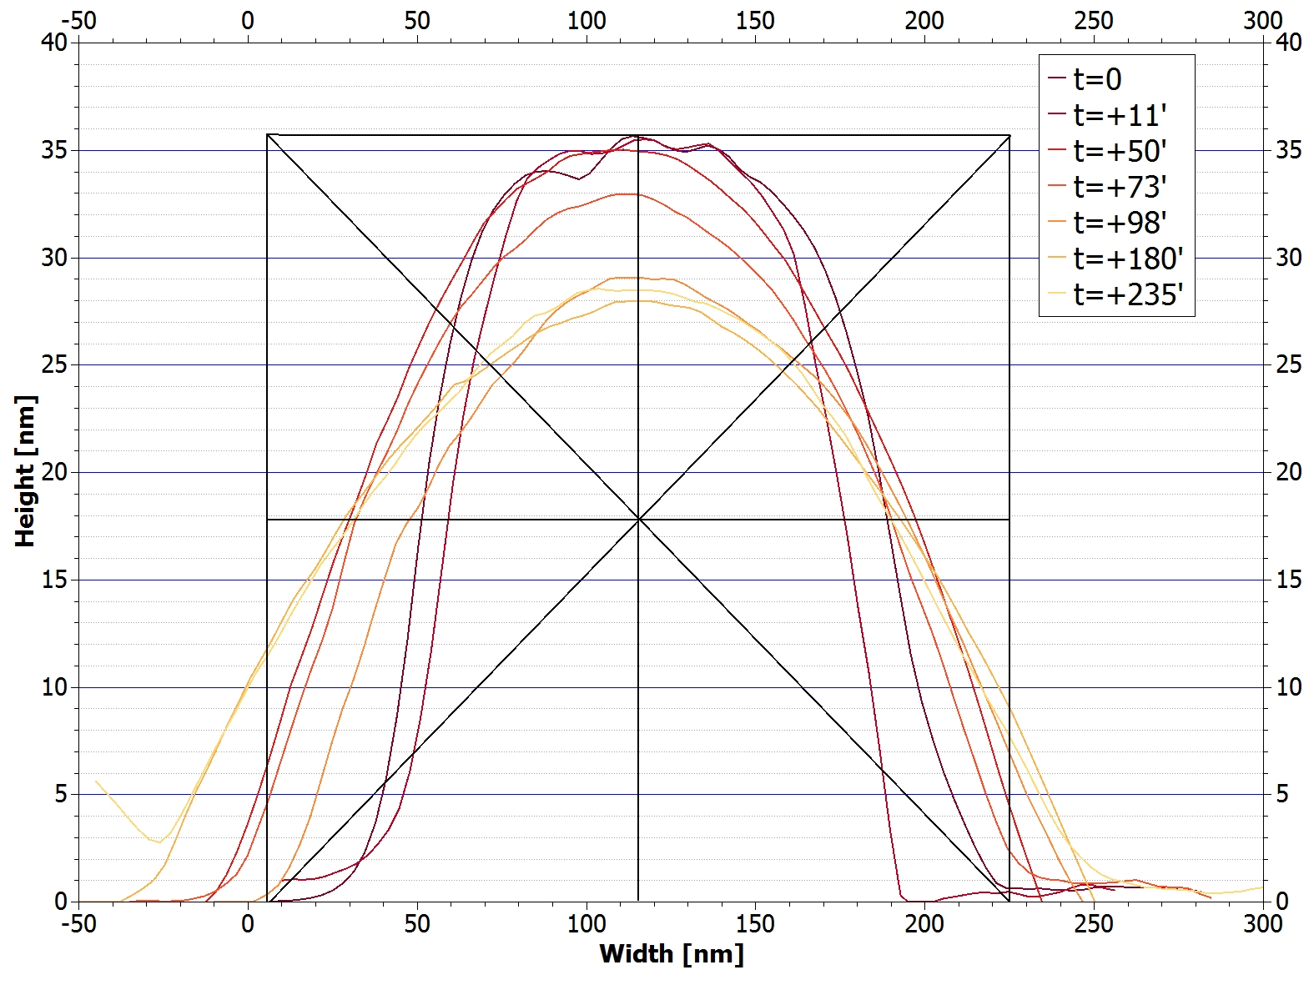
Figure 3 - Examples of the profiles extracted at different times in wet conditions (profile 2 from the crystal 1, test 3; time from 0 to 235 min). The rectangle overlapped to the profiles helps to sketch the directions along which the measurements were made

3. Carbonation mechanism

Carbonation occurs following the dissolution of lime, when this material is in an environment containing CO₂. Despite the importance of this process, the reaction mechanism is not yet fully understood. Some authors suggest that carbonation of Ca(OH)₂ at room temperature in a CO₂-rich environment is a solid-state reaction, whereas others suggest that the reaction occurs via a dissolution-and-precipitation mechanism catalysed by the water. Different reaction mechanisms entail different reaction steps and rates that can significantly affect use of the material.
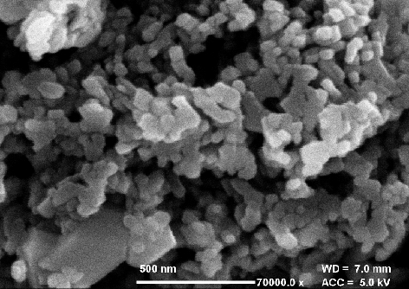
Figure 4 - SEM image of the Ca(18OH)2 produced

In our research we investigated the role of hydroxyl groups (OH⁻) produced by the dissolution of Ca(OH)₂ in the carbonation mechanism of lime. For this purpose, a Ca(OH)₂ containing >99% oxygen-18 (¹⁸O) was carbonated in air at 23°C and 50±10% relative humidity. Study of the isotopic concentration of the precipitated carbonates after 3 minutes, 1 day, 8 and 137 days carbonation allowed understanding the role of OH⁻ ions during carbonate precipitation. Scanning Electron Microscopy (SEM), Raman spectroscopy and Secondary Ion Mass Spectrometry (ToFSIMS) were used to characterize unreacted and reacted material. Computational procedures were used to validate the Raman spectra of reactants (Ca(¹⁸OH)₂) and reaction products (CaCO₃ containing ¹⁸O).
SEM images of the unreacted material (Figure 4) show that the Ca(¹⁸OH)₂ was mainly amorphous but comprised particles 70-150 nm wide and some hexagonal plate-like crystals 200-400nm wide.
Raman analysis (Figure 5) shows that some of the characteristic peaks of ¹⁸O-Ca(OH)₂ are shifted toward lower wavenumbers compared to the correspondent peaks of ¹⁶O-Ca(OH)₂. In particular, the peak at 356cm⁻¹ is shifted to 340cm⁻¹ and the peak at 251cm⁻¹ is shifted to 241cm⁻¹. Peaks of the carbonates formed during carbonation in air show evidence of amorphous calcium carbonate (ACC) and/or Ikaite (CaCO₃·6H₂O) in addition to ¹⁶O-calcite. Calcite peaks at lower wavenumbers (i.e. 153 and 270cm⁻¹) are shifted toward lower values compare to the typical peaks reported in the scientific literature. This suggests that the structure of calcite includes ¹⁸O atoms.
Computational work allowed simulation of Raman spectra for both, Portlandite and Calcite containing ¹⁸O and this helped evaluate the experimental results.
ToFSIMS results led to the calculation of the ¹⁸O:¹⁶O ratio for ions with both, positive and negative polarity. The isotope ratio for the Ca(¹⁸OH)₂ sample after 3’ carbonation was found to be 0.62 for the positive ions and 0.51 for the negative ions. The average value of 0.56 is very close to the ratio of 0.5 proposed by Letolle and colleagues in 1990 (Letolle et al. 1990) for the ratio O_{sourced from CO2}/O_{sourced from H2O} in the CO₃²⁻ ion. After 1 day exposure to atmospheric CO₂, a dramatic decrease in the isotope ratio ¹⁸O:¹⁶O was found. After 8 and 137 days exposure, the isotope ratio ¹⁸O:¹⁶O converged towards the same value of 0.05, which is approximately double the value for natural samples.
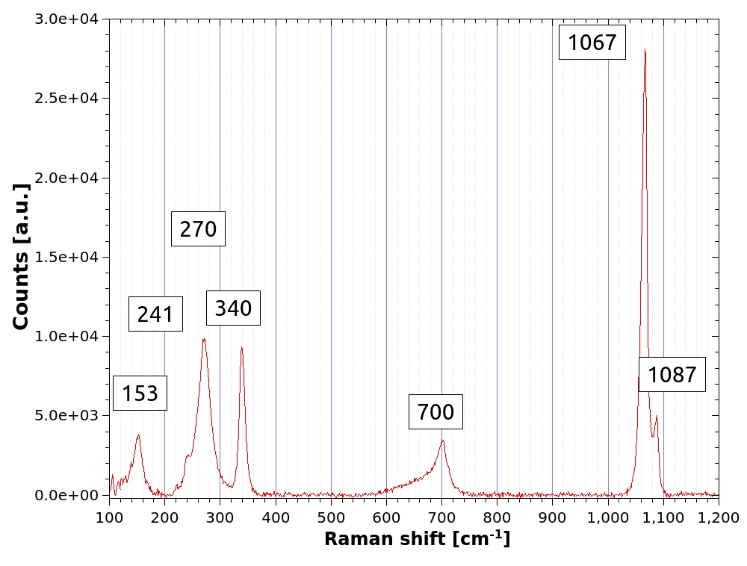
Figure 5 – Raman spectrum of the ¹⁸O-lime at the very beginning of carbonation reaction in air

Overall, these results suggest that after 3 minutes from the beginning of the carbonation, approximately 1/3 of the oxygen contained in the carbonates originated from the Ca(OH)₂. Within the initial 24 hours, almost all the ¹⁸O initially fixed in the carbonates was exchanged allowing a rebalance of the isotopic composition of carbonates.
To the best of our knowledge, these results provide the first independent experimental evidence of the theory proposed by Letolle and colleagues on the formation of the carbonate ion by direct reaction of the OH⁻ ions with the CO₂ dissolved in water. These results also provide further details of the mechanism suggested by Latolle by establishing that part of the oxygen is generated by the dissolution of Ca(OH)₂ in water rather than by the dissociation of water molecules. Finally, this paper provides new insights into the transformation of meta-stable carbonates into stable phases, which allows an isotope re-equilibration of the oxygen.

4. Conclusions

This study provides key data that can make a step change in building practise by undertaking a combined atomistic modelling and applied research approach.
Experimental and computational results on the dissolution of Portlandite crystals demonstrate that the {001} surfaces exhibit different behaviour compared to the {010} and {001} crystallographic faces. This is dictated by the atmospheric concentrations of H₂O when compared to the edge surfaces. The development of of binary (CO₂/p_{H2O}) phase diagram for the different Portlandite faces is a key output of the project.
Experimental and computational results on the carbonation mechanism suggest that:
- at the very beginning of the reaction, approximately 1/3 of the oxygen contained in the carbonates originates from the dissolution of Ca(OH)₂ whereas the remaining 2/3 originates from the CO₂ molecules;
- it is the oxygen generated by the dissolution of Ca(OH)₂ in water (and not the oxygen generated by the dissociation of water molecules, as suggested by Letolle) that takes part in the formation of carbonate ion;
- Within the initial 24 hours, almost all the ¹⁸O initially fixed in the carbonates is exchanged allowing a rebalance of the isotopic composition of carbonates.

References

Ball, R.J., Pesce, G.L., Parker, S.C., Grant, J., 2014. Lime based materials in construction. Experimental investigation for the development and validation of atomistic modelling. In: Mangangka I.R., Hendrata, L.A, International Conference on Environmentally Friendly Civil Engineering Construction and Materials. Creating and Adapting Sustainable Technologies, Manado, Indonesia, 13-14 November 2014, Manado:Civil Engineering Department Sam Ratulangi University.
Blamey, J., Lu, D. Y., Fennell, P. S., Anthony, E. J., 2011. Reactivation of CaO-based sorbents for CO2 capture: mechanism for the carbonation of Ca(OH)2. Industrial & Engineering Chemistry Research. 50(17):10329-10334.
Boyton, R.S., 1966. Chemistry and Technology of Lime and Limestone. New York:John Wiley & Son.
European Committee for Standardisation, 2010 BS EN 459-1. Building lime. part 1: Definition, specifications and conformity criteria.
Forster, A., 2002. An assessment of the relationship between the water vapour permeability and hydraulicity of lime based mortars with particular reference to building conservation materials science. Heriot-Watt University.
Grant, J.; Pesce, G. L.; Ball, R. J.; Molinari, M. & Parker, S. C., 2016. An experimental and computational study to resolve the composition of dolomitic lime, RSC Adv., The Royal Society of Chemistry, 6:16066-16072.
Hewlett, P. C. (ed), 1998. Lea's Chemistry of Cement and Concrete, Fourth Edition, Butterworth-Heinemann:Oxford.
Jaroenratanapirom, D., Sahamitmongkol, R., 2011. Self-crack closing ability of mortar with different additives. J. Met. Mater. Min. 21(1): 9-17.
Kind-Barkauskas, K., Kauheen, B., Polonyi, S., Brandt, J., 2002. Concrete Construction Manual. Basel (Switzerland): Birkhauser.
Legislation.gov.uk, 2008. Climate Change Act 2008. [online] Available at: http://www.legislation.gov.uk/ukpga/2008/27/contents [Accessed 21 March 2016].
Letolle, R., Gegout, P., Gaveau, B., Moranville-Regourd, M. 1990. Fractionnement isotopique de l’oxygène-18 dans la précipitation des carbonates a pH très élevé. Comptes Rendus de l'Académie des Sciences. 310:547-552.
Ruiz-Agudo, E., Kudlacz, K., Putnis, C. V., Putnis, A., Rodriguez-Navarro, C, 2013. Dissolution and carbonation of portlandite [Ca(OH)2] single crystals. Environmental Science & Technology. 47(19):11342-11349.
Zhao, L., Sang, L., Chen, J., Ji, Teng, H. H.,2010. Aqueous carbonation of natural brucite: relevance to CO₂ sequestration. Environmental Science & Technology. 44(1):406-411.

