High sensitivity temperature sensor based on a polymer filled hollow core optical fibre interferometer

Rahul Kumar,¹ Wai Pang Ng,¹ Yong-Qing Fu¹, Jinhui Yuan,² Chongxiu Yu,² Gerald Farrell,³ Yuliya Semenova,³ and Qiang Wu*
¹Faculty of Engineering & Environment, Northumbria University, Newcastle, NE1 8ST, UK
²State Key Laboratory of Information Photonics and Optical Communications, Beijing University of Posts and Telecommunications, Beijing 100876, China
³Photonics Research Centre, Dublin Institute of Technology, Kevin Street, Dublin 8, Ireland
ABSTRACT
A high-sensitivity temperature sensor based on a singlemode-multimode-polymer filled hollow core fibre-multimode-singlemode (SMHMS) fibre structure is proposed. This sensor was made from a short section of hollow core fibre filled with a high thermo-optic coefficient (TOC) polymer with a refractive index close to that of the fibre cladding, fusion spliced between two singlemode-multimode (SM) fibre structures. This sensor effectively improves the temperature sensitivity by over 200 times by comparison to a conventional singlemode-multimode-singlemode (SMS) fibre structure. In this report, we experimentally demonstrate that the proposed sensor provides a high temperature sensitivity of 2.16 nm/°C.
Keywords: Hollow core fibre, temperature sensor, SMS fibre structure.
- INTRODUCTION
Temperature sensors have a wide range of applications in both industry and research and often require high sensitivity and high accuracy. Optical fibre sensors provide the advantages of high sensitivity, wide dynamic range, multiplexing capability, remote sensing capability, freedom from electromagnetic interference and capability to operate in harsh environments.
Different types of optical fibre sensor structures have been developed including fibre Bragg gratings (FBG) [1, 2], long period gratings (LPG) [3], special fibres such as D-shaped fibres and photonic crystal fibres [4, 5], multimode fibres (MMF) [6,8], and multi-core fibres [9]. Grating-based temperature sensors are the most popular sensor type but they provide sensitivity in the range of only a few tenths of pm/ºC [10-12]. MMFs have also been used to create sensor structures based on the multimode interference (MMI) effect. One example of such a sensor is the single mode-multi mode-single mode (SMS) fibre structure that has been proposed and demonstrated as a strain and temperature sensor over the last decade [7, 8, 13]. However, the temperature sensitivity remains as low as -70 pm/ºC for a graded index MMF sensor and 18pm/ºC for a step index MMF sensor [13]. Apart from the conventional SMS, a singlemode-coreless-singlemode (SCS) fibre sensor was also reported with a higher temperature sensitivity of 1880 pm∕°C [14]. This sensor was based on surrounding a short section of coreless fibre with a liquid with refractive index of 1.43, but this structure and sensor suffers from the significant disadvantages of lower stability and difficulty in packaging for real applications.
In order to improve sensitivity, polymer coated fibre sensors have been proposed [2] such as a PDMS coated LPG and FBG. These techniques utilise polymer materials having a thermo-optic coefficient higher than silica. Such polymer materials are typically coated onto the surface of the cladding of optical fibres used as sensors, for example demonstrating improved sensitivities of 255.4 pm/ºC for the LPG sensor, which is more than four times higher than those of a conventional uncoated FBG sensor [2,3]. In our previous report [15], we investigated a singlemode-multimode-singlemode-multimode-singlemode (SMSMS) fibre structure. Our simulation results have shown that this new structure has a high sensitivity to refractive index, which is over 60000 nm/RIU (refractive index unit) [15]. In this report, we propose to use a polymer filled hollow core fibre (as opposed to surface coated fibre structure) to substitute the sandwiched SMF in the previous SMSMS fibre structure. Since the polymer material has a much higher thermo-optic coefficient (-1.83 × 10⁻⁴ /ºC) [16] as compared to that of silica (1.06 × 10⁻⁵ /ºC), a high sensitivity for temperature should be achieved experimentally.
- EXPERIMENTAL PROCEDURE
Figure 1 shows a schematic diagram of the proposed singlemode-multimode-hollowcore-multimode-singlemode (SMHMS), interferometer basedfibre structure. When the light is injected into the input multimode fibre (MMF-1) through an input singlemode fibre (SMF), multiple modes are excited and propagate across the MMF-1 section. These multiple modes will in turn excite multiple modes in the polymer filled hollow core (HC) fibre section. These modes will be highly dependant on the core refractive index of the hollow core fibre[15]. After being transmitted through the output multimode fibre (MMF-2), these modes will interfere with each other and eventually couple back to the output SMF, resulting in a transmission spectrum with characteristic interference dips. In our experiments, the singlemode fibre (SMF-28, Thorlabs) was fusion spliced to a short section of conventional multimode fibre with a 105/125 µm core/cladding diameter (AFS105/125Y, Thorlabs) to form a singlemode-multimode (SM) fibre structure. The hollowcore fibre has a 10 µm core diameter and 125 µm cladding diameter, was filled with polymer Norland Adhesive (NOA-84) by syringe, which has a refractive index of 1.46 and high thermo-optic coefficient compared to that of silica. When the NOA-84 was cured, a short section of the NOA-84 filled hollow core fibre was fusion spliced between two SM structures.
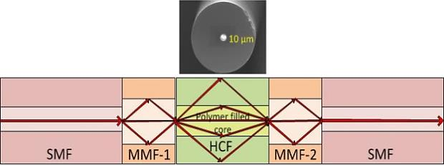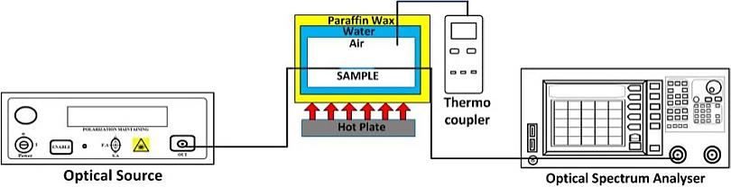
Figure 1:Schematic diagram of Singlemode-Multimode- Figure 2: Schematic diagram of the experimental setup to measure
Hollow core-Multimode-Single mode fibre structure. temperature sensitivity for SMHMS structure.

Figure 2 shows the schematic diagram of the experimental setup for measuring the temperature response of the sensor. Since the sensor has very high sensitivity to temperature, a special design is required for the temperature chamber, to achieve high-temperature stability. A thermocouple was inserted inside the temperature chamber, into the air layer where the fibre sensor was placed to measure the temperature.
- RESULTS AND DISCUSSION
In our experiments, both MMF-1 and MMF-2 have the same length. Two different lengths of 5 mm and 10 mm for the two MMFs and three different lengths of the hollow core fibre have been used to investigate the influence of the MMF and HCF lengths on the sensitivity of the temperature sensor. Figure 3 show the spectral response for three SMHMS structures with 10 mm length of MMFs, and 10, 15 and 20 mm lengths of the polymer filled HCF’s. It can be observed that as the temperature increases, the spectral responses shift towards shorter wavelengths monotonically for all the three samples. A similar response was observed for the SMHMS structures with 5 mm length of the MMF and a 10, 15 and 20 mm length of polymer filled HCF’s. Figure 3 also shows that a longer HC length (HC=20 mm) causes a large blue shift in the dip wavelength compared to that of shorter HC length (HC=10 and 15 mm).
Figure 4(a) shows the wavelength shifts vs. change in temperature for three SMHMS fibre structures with 10, 15 and 20 mm lengths of the NOA-84 filled HCF’s and a 5 mm length of MMF. For a fixed length of MMF, the longer the HCF, the higher the temperature sensitivity. The maximum sensitivity achieved in our experiments was 2.16 nm/°C. The repeatability of the six SMHMS fibre structures was also investigated by comparing the initial measurements on day one with those carried out on the 3rd and 7th days after the fabrication of the sensors. Figures 4(a) also shows that the wavelength shifts measured on the 1st, 3rd and 7th days after fabrication have good repeatability.
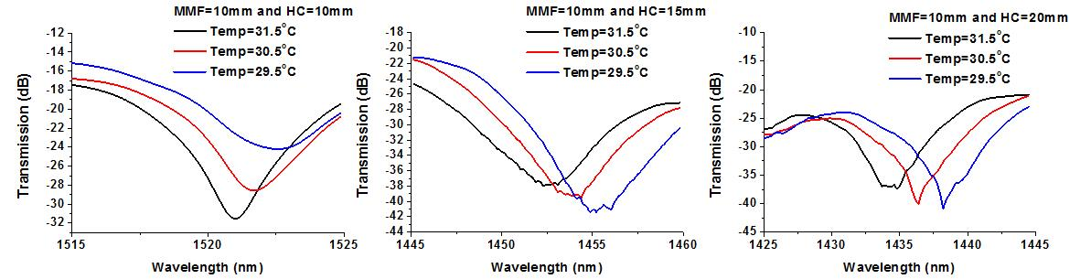
Figure 3: Spectral response for 10 mm of MMF and 10, 15 and 20 mm length of the polymer filled HCF in SMHMS structure.
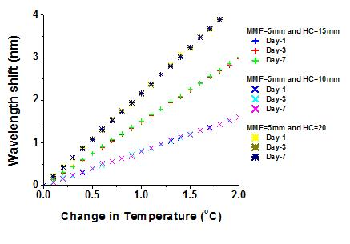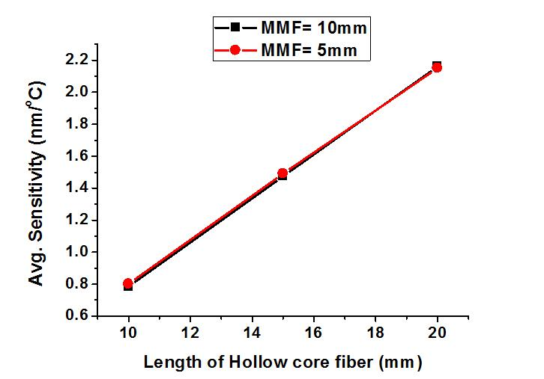
(a) (b)
Figure 4: Experimental results for (a) wavelength shift vs. temperature for SMHMS structure with a 5mm MMF length and various HC fibre lengths and (b) Temperature sensitivities for the sensors with two different MMF lengths as a function of different lengths (10, 15 and 20mm) for the polymer filled HCF
Figure 4(b) shows the temperature sensitivity for all the six sensors. The sensitivity values of the sensors with 10, 15 and 20 mm lengths of HCF and MMF of 5 mm and 10 mm lengths are listed in Table.1. It shows that the length of the MMF section has a limited influence on the sensitivity, however the sensor with a longer length of HCF has a higher temperature sensitivity.
Table.1 Comparision of change in average sensitivity, withincrease in length of MMF and polymer filled hollowcorefibre for SMHMS structure

Sr.No | Length of MMF-1  & MMF-2 (mm) | Length of Polymer filled Hollow Core (mm) | Average Sensitivity  (nm/ºC)
1 | 5 | 10 | 0.80
2 | 5 | 15 | 1.49
3 | 5 | 20 | 2.15
4 | 10 | 10 | 0.79
5 | 10 | 15 | 1.47
6 | 10 | 20 | 2.16
- CONCLUSION
In this report, we propose a highly-sensitive temperature sensor based on a polymer fillled HCF interferometer. This sensor was made by fusion splicing a short section of hollow core fibre filled with a high thermo-optic coefficient (TOC) polymer with a refractive index close to that of the fibre cladding, between two singlemode-multimode (SM) fibre structures. Experimentally we have demonstrated a maximum temperature sensitivity of 2.16 nm/°C which is 200 times higher than that of a tranditional SMS temperature sensor. The length of the MMF section has a negligible influence on the temperature sensitivity, but the length of the polymer filled HCF does have a significant influence on the sensitivity: that is: the longer the length of HCF, the higher the temperature sensitivity of the structure.
ACKNOWLEDGEMENT
This work was supported by Research and Development Funding, Northumbria University at Newcastle upon Tyne, U.K.and the Open Fund of IPOC (BUPT).
REFERENCES
[1] Reddy, P. S., Prasad, R. S., Sengupta, D., Kishore, P., Shankar, M. S., Narayana, K. and Tiwari, U., “Method for enhancing and controlling temperature sensitivity of fibre Bragg grating sensor based on two bimetallic strips,” IEEE Photonics Journal, 4, 1035-1041 (2012).
[2] Park, C.-s., Joo, K.-I., Kang, S.-W.and Kim, H.-R., “A PDMS-coated optical fibre Bragg grating sensor for enhancing temperature sensitivity,” Journal of the Optical Society of Korea, 15, 329-334 (2011).
[3] Wang, Q., Du, C., Zhang, J., Lv, R. and Zhao, Y., “Sensitivity-enhanced temperature sensor based on PDMS-coated long period fibre grating,” Optics Communications, 377, 89-93 (2016).
[4] Shi, W. H., You, C. J. and Wu, J., “D-shaped photonic crystal fibre refractive index and temperature sensor based on surface plasmon resonance and directional coupling,” Acta Phys. Sin., 64(22) (2015).
[5] Li, X. G., Zhao, Y., Cai, L. and Wang, Q., “Simultaneous Measurement of RI and Temperature Based on a Composite Interferometer,” IEEE Photonics Technology Letters, 28(17), 1839-1842 (2016).
[6] Yin, B., Li, Y., Liu, Z. B., Feng, S. C., Bai, Y. L., Xu, Y. and Jian, S. S., “Investigation on a compact in-line multimode-single-mode-multimode fibre structure,” Optics and Laser Technology, 80, 16-21 (2016).
[7] Wu, Q., Hatta, A., Wang, P., Semenova, Y. and Farrell, G., “Use of a bent single SMS fibre structure for simultaneous measurement of displacement and temperature sensing,” Electronics Letters, 46(16), (2010).
[8] Wu, Q., Semenova, Y., Hatta, A. M., Wang, P. and Farrell, G.,“Single‐mode–multimode–single‐mode fibre structures for simultaneous measurement of strain and temperature,” Microwave and Optical Technology Letters, 53(9), 2181-2185 (2011).
[9] Barrera, D., Hervas, J., Gasulla, I. and Sales, S., “Enhanced accuracy sensors using multicore optical fibres based on RFBGs for temperatures up to 1000 degrees C,” Proc. SPIE, 9916 (2016).
[10] Mamidi, V. R., Kamineni, S., Ravinuthala, L. S. P., Madhuvarasu, S. S., Thumu, V. R., Pachava, V. R. and Putha, K., “Fibre Bragg Grating-based high temperature sensor and its low cost interrogation system with enhanced resolution,” OpticaApplicata, 44(2), 299-308 (2014).
[11] Kersey, A. D., Davis, M. A., Patrick, H. J., LeBlanc, M., Koo, K., Askins, C., Putnam, M., and Friebele, E. J., “Fibre grating sensors,” Journal of Lightwave Technology, 15(8), 1442-1463 (1997).
[12] Shu, X., Zhang, L. and Bennion, I., “Sensitivity characteristics of long-period fibre gratings,” Journal of Lightwave Technology, 20(2), 255 (2002).
[13] Wang, P., Ding, M., Bo, L., Guan, C., Semenova, Y., Wu, Q., Farrell, G. and Brambilla, G., “Fibre-tip high-temperature sensor based on multimode interference,” Optics letters, 38(22), 4617-4620 (2013).
[14] Silva, S., Pachon, E. G., Franco, M. A., Hayashi, J. G., Malcata, F. X., Frazão, O., Jorge, P. and Cordeiro, C. M., “Ultrahigh-sensitivity temperature fibre sensor based on multimode interference,” Appl. Opt., 51(16), 3236-3242 (2012).
[15] Wu, Q., Yuan, J., Yu, C., Sang, X., Sun, L., Li, J., Guo, T., Guan, B., Chan, H., Chiang, K. S., Ma, Y., Wang, P., Semenova, Y. and Farrell, G., “UV exposure on a single-mode fibre within a multimode interference structure,” Optics letters, 39(22), 6521-6524 (2014).
[16] Sohn, K. R. and Peng, G.-D., “Mechanically formed loss-tunable long-period fibre gratings realized on the periodic arrayed metal wires,” Optics communications, 278(1), 77-80 (2007).

* Qiang.wu@northumbria.ac.uk

