Simultaneous measurement of both magnetic field strength and temperature with a microfiber coupler based fiber laser sensor

Fangfang Weiª, Arun Kumar Mallikª, Dejun Liuª, Wei Hanª, Xiaokang Lianª, Gerald Farrellª, Qiang Wu^{b}, Gang-Ding Peng^{c}, Yuliya Semenovaª
ªPhotonics Research Centre, School of Electrical and Electronic Engineering, Dublin Institute of Technology, Kevin St, Dublin 8, Ireland; ^{b} Department of Mathematics, Physics and Electrical Engineering, Northumbria University, Newcastle Upon Tyne, NE1 8ST, United Kingdom; ^{c} Photonics & Optical Communications, School of Electrical Engineering & Telecommunications, University of New South Wales, Sydney 2052, NSW, Australia

Abstract

In this paper we propose and investigate a novel magnetic field sensor based of a ring erbium-doped fiber laser combined with a fiber Bragg grating and a Sagnac loop containing a microfiber coupler and magnetic fluid. In addition to the magnetic field sensing capability, the proposed structure can simultaneously provide temperature information. Thanks to the dual-ring structure of the MFC-Sagnac loop and the FBG-assisted resonant cavity, the output has two distinct laser peaks. Experimentally demonstrated magnetic field sensitivity of one of the laser peaks is 15 pm/mT in the magnetic field range from 0 to 100 mT. The spectral position of the second laser peak is independent on the magnetic field but shifts towards long wavelengths with a sensitivity of 13 pm/°C.

Keywords: fiber laser sensor, magnetic fluid, fiber Bragg grating, microfiber coupler, Sagnac loop

INTRODUCTION
Magnetic field measurements play an important role in many areas such as information storage, environmental monitoring, hazard forecast and aeronautics¹⁻⁴. Fiber-optic sensors for magnetic fields have many advantages compared to their electronic counterparts, such as immunity to electromagnetic interference, high sensitivity, fast response and low power consumption. Among the range of possible fiber optic sensors, those based on fiber lasers have the additional advantages of high signal-to-noise ratio, narrow linewidth, and ease of interrogation, allowing for measurements with high resolusion⁵.
Optical microfiber couplers (MFCs) have become a topic of special interest in optical fiber sensing due to their excellent sensing properties^{6, 7.} If the two nearest ends of an MFC are connected together by a section of polarization maintaining fiber (PMF) to form a Sagnac loop, the interference between the clockwise and counterclockwise propagating beams in the PMF loop is strongly affected by the refractive index (RI) surrounding the MFC waist. Thus immersing the MFC waist in a magnetically susceptible fluid (MF), the RI of which is sensitive to magnetic fields, offers an opportunity to utilize such a structure for magnetic field sensing.
In this paper we propose and investigate a novel magnetic field sensor structure consisting of a ring erbium-doped fiber laser combined with a fiber Bragg grating (FBG) and an MFC based Sagnac loop In addition to sensing of magnetic fields the proposed structure is capable of simultaneously providing temperature information. The output spectrum of the proposed sensor contains two laser peaks, one of which comes from the FBG and its central wavelength position carries the temperature information, while the second peak is associated with the output of the Sagnac-MFC loop and its spectral position can be related to the value of the applied magnetic field, assuming a suitable calibration has taken place.

Operating principle and fabrication of the sensor
A schematic diagram of the proposed fiber laser sensor is shown in Figure 1(a). The structure includes a typical ring laser cavity with a 980 nm laser diode (LD) pump, coupled into the ring cavity through a wavelength selective coupler (WDM). A section of erbium doped fiber (EDF) with a length of 15 m absorbs the pump light at a 980 nm wavelength and emits light at 1550 nm with a simultaneous amplification forming the gain spectrum. The optical isolator (ISO) is used to ensure that the light circulation within the ring occurs in the clockwise direction only. Another branch of the loop (Part A in the figure) is formed by the circulator and the FBG (with a Bragg wavelength of 1559.86 nm and 3 dB bandwidth of 0.46 nm) coupled with the ring cavity by means of the 3 dB coupler (OCA). Part A of the structure functions as the wavelength selective element for the laser, since only the light reflected by the FBG will re-enter the ring cavity through the WDM port, via a second 3 dB coupler (OCB). Simultaneously, as the light at the resonance wavelength circulates within the cavity, it is also split into two beams by OCA. One beam enters the FBG loop and is eventually fed back into the cavity, another beam is launched into the MFC-Sagnac loop (Part B), whose output interference spectrum strongly depends on the RI surrounding the MFC waist. The resulting output of the proposed structure (monitored by the OSA) contains two laser peaks. The spectral position of the first peak is determined by the FBG, while the central wavelength of the second peak is associated with Part B of the structure (MFC-Sagnac loop).
The MFC-Sagnac loop, operating as the sensor’s head is shown schematically in Figure 1(b). One of the critical parameters of the MFC is its waist diameter since it determines both the coupling ratio of the MFC and its RI sensitivity⁸. In our experiment the MFC is fabricated by simultaneously fusing and tapering two standard single-mode fibers using a method known as the microheater brushing technique⁹. The waist diameter of the fabricated MFC was ~2.6 µm. It is possible to achieve a higher RI sensitivity by using an MFC with a smaller waist diameter, but in practice there is a trade-off between the sensitivity and mechanical stability of the coupler, since thinner waists are more fragile.
In order to improve the mechanical stability of the MFC in our experiment, polydimethylsiloxane (PDMS) material is used to package the MFC by encapsulating it in the center of a prefabricated slot with the opposite MFC ends immobilized by an UV curable glue (Figure 1(c)). The PDMS container has another function as it functions as a container for the magnetic fluid. The PDMS container is prefabricated in a shape of a cuboid with dimensions of 70 mm x 40 mm x 10 mm. A narrow slot with a cross-section of 4 mm x 4 mm was cut at the center of the cuboid along the 70 mm side to accommodate the MFC and MF. The MFC was positioned and fixed within the slot and then the surface of the slot was covered by a thin layer of PDMS and sealed with epoxy resin. Small holes in the top PDMS layer near the ends of the slot the injection of the MF and an exhaust for the air displaced by the MF. As result the MFC waist was fully immersed into the MF.
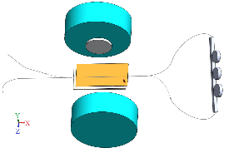
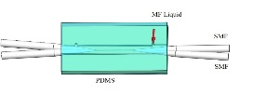
EDF
980nm LD
WDMM
ISO
PC
Circulator
FBG
1
2
3
MFC
PMF
3 dB OCA
OCB
OSA
Part B
Part A
(a)
(b)
(c)
3 dB

Figure 1. (a) Schematic diagram of the proposed sensor; (b) schematic diagram of the MFC-Sagnac loop interferometer placed within the electromagnet (Part B); (c) packaged MFC with its waist immersed in MF.
A section of PMF with a length of ~70 cm connects two output ports of the MFC to form a Sagnac loop. A polarization controller (PC) is inserted into the loop to control the light polarization. The output laser spectrum is observed using an optical spectrum analyzer (OSA) with a resolution of 10 pm. The MF (IO-A10-1, from Cytodiagnostics Inc.) was a stabilized water-based ferrofluid containing Fe₃O₄ magnetic nanoparticles with an average diameter of 10 nm at a concentration of 1 mg/ml. The RI of the MF in the absence of a magnetic field is 1.340. A magnetic field in the range from 0 to 200 mT was applied to the sensor using an electromagnet as shown in Figure 1(b).

Experimental reults
Figure 2(a) shows the interference spectrum of the MFC based Sagnac loop (Part B). As can be seen from the figure, the interference spectrum has an extinction ratio of ~14 dB and a free spectral range of 5.2 nm. Figure 2(b) illustrates the spectral shift of a selected interference dip (1544 nm) versus the applied to the MFC head magnetic field. An increase of the magnetic field strength from 0 to 200 mT results in an overall blue-shift of the interference dip by 4.6 nm.
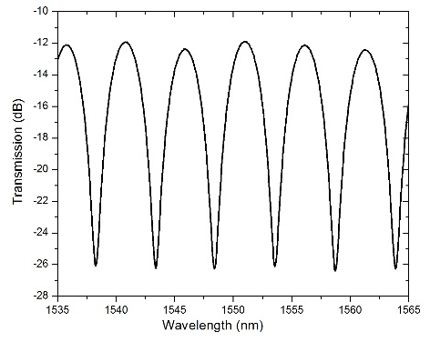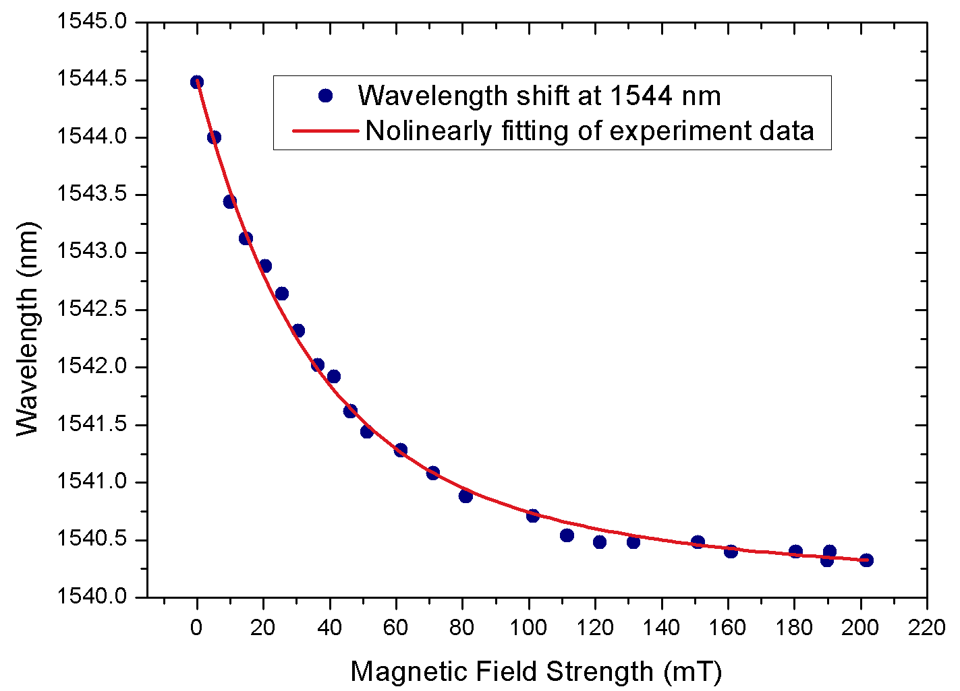
Figure 2. (a) Transmission spectrum of the MFC - Sagnac loop; (b) central wavelength of a selected interference dip (1544 nm) versus applied magnetic field in the range from 0 to 200 mT.
Figure 3(a) shows the laser output of Part A in the absence of Part B and Figure 3(b) illustrates the reflection spectrum of the FBG alone. The laser output in the absence of Part B occurs at the same wavelength as the Bragg wavelength (λ_{FBG} = 1559.86 nm) of the FBG. The extinction ratio of the output laser is 35 dB, and the 3 dB bandwidth is 0.26 nm.
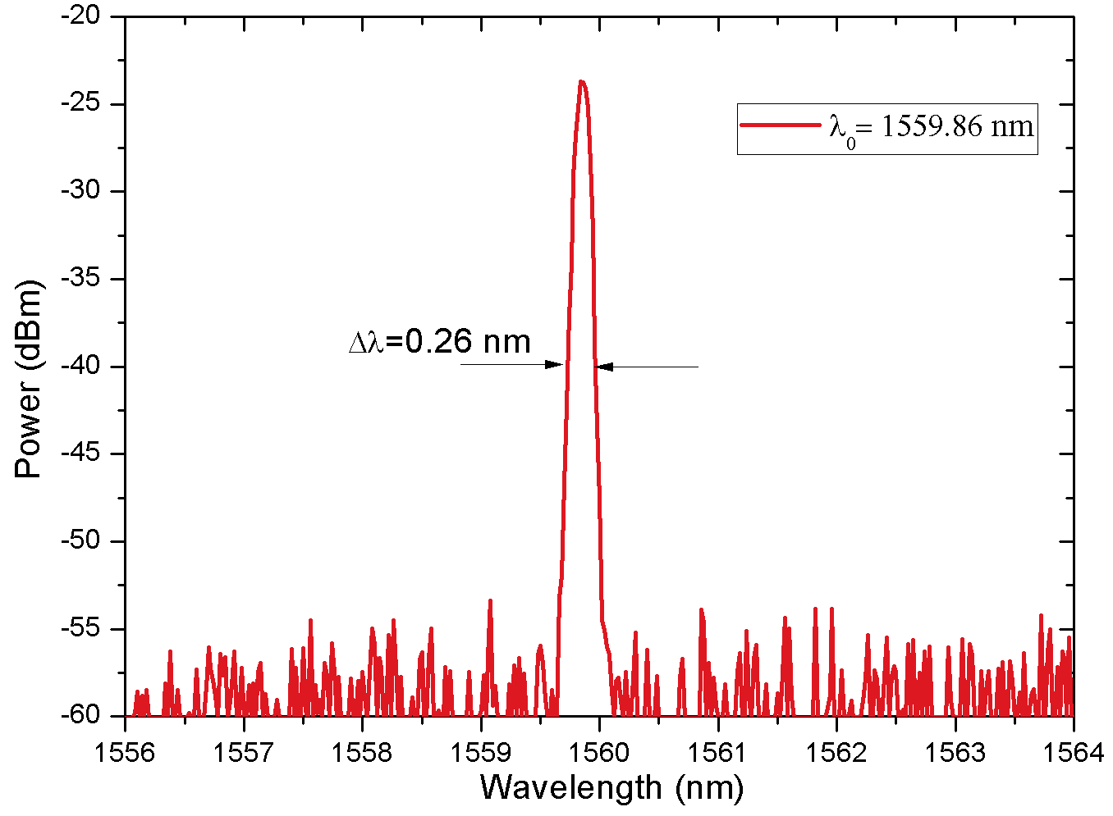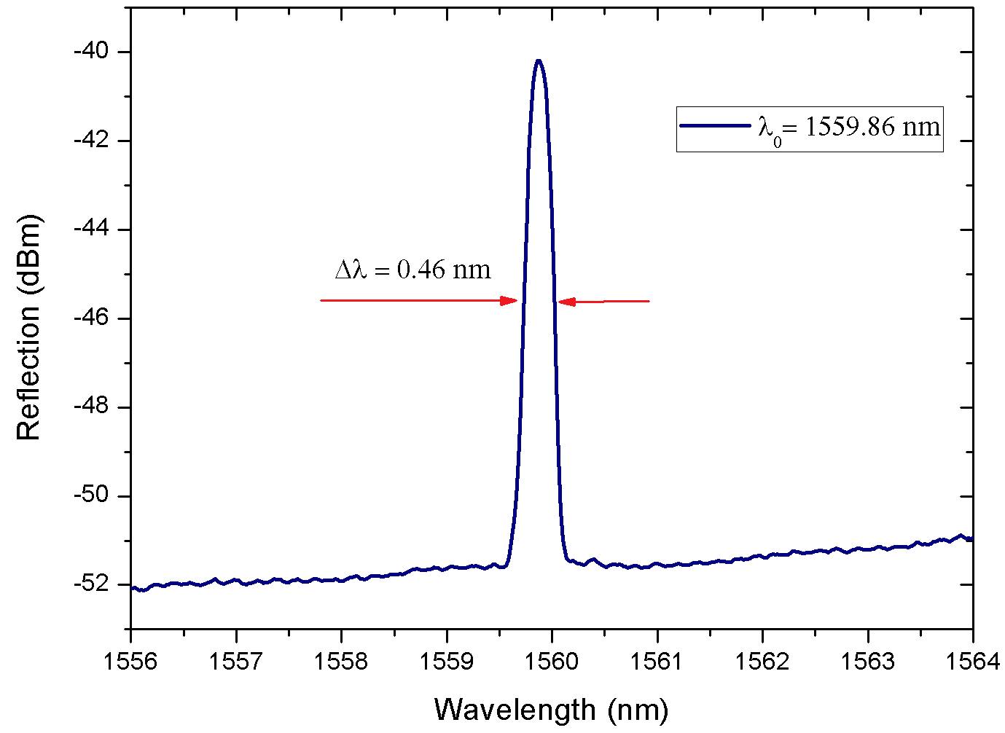
(a) (b)
Figure 3. (a) Laser output produced by the structure in the absence of Part B; (b) Reflection spectrum of the FBG.
When Part 2 is connected with the fiber laser cavity as shown in Figure 1(a), the output spectrum displays an additional laser peak λ_{i}, with a 3 dB bandwidth of 0.24 nm. This peak’s position λ_{i} depends on the value of the applied magnetic field. Figure 4(a) shows the relationship between the magnetic field and the laser peak wavelength λ_{i}. The peak associated with the FBG remains unchanged, while the wavelength produced by the MFC-Sagnac loop shifts towards shorter wavelengths by 1.5 nm when the magnetic field strength changes from 0 to 100 mT. The relationship between the magnetic field strength and the output laser peak is shown in Figure 4(b). The resulting magnetic sensitivity of the laser peak is 15 pm/mT.
The temperature response for the proposed sensor was also experimentally studied and the results are shown in Figure 5. As the temperature increased from 25°C to 44°C, λ_{FBG} red-shifted by 0.26 nm. The temperature dependence of the MFC- Sagnac peak was weaker, since λ_{i} shifted by 0.1 nm only within the same temperature range, possibly due to the combined effect of temperature induced change in the PMF RI, MFC RI and MF RI. However as the temperature is measured independently, it should be possible to calibrate out the temperature dependence of the MF RI.
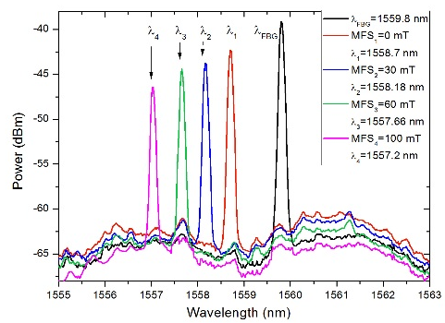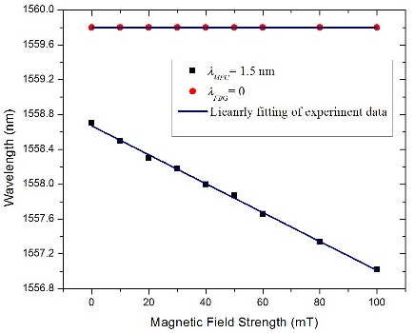
- (b)
Figure 4. (a) The laser output spectrum at different magnetic field values; (b) laser peak wavelengths versus magnetic field.
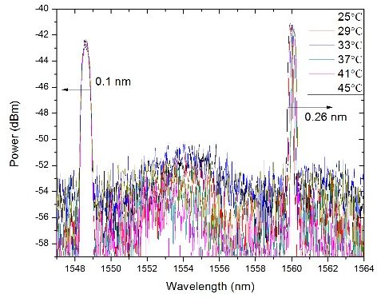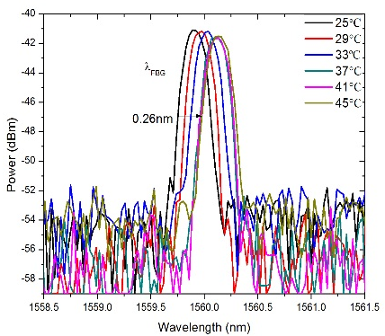
(a) (b)
Figure 5. (a) Temperature response for the two output wavelengths; (b) Enlarged graph of the FBG wavelength vs. temperature.

conclusion

A novel magnetic field sensor based on a ring erbium-doped fiber laser combined with an FBG and a Sagnac loop containing an MFC and magnetic fluid. In addition to the magnetic field sensing capability, the proposed structure can simultaneously provide temperature information. Thanks to the dual-ring structure of the MFC-Sagnac loop and the FBG-assisted resonant cavity, the output has two distinct laser peaks. The experimentally demonstrated magnetic field sensitivity of one of the laser peaks is 15 pm/mT in the magnetic field range from 0 to 100 mT. The spectral position of the second laser peak is independent of the magnetic field but shifts towards long wavelengths with a sensitivity of 13 pm/°C in the temperature range from 25°C to 44°C.

References
- M. Deng, D. Liu, W. Huang, T. Zhu, Highly-sensitive magnetic field sensor based on fiber ring laser," Opt. Express, 24, 645-651 (2016).
- Chen Y, Han Q, Liu T, et al. Optical fiber magnetic field sensor based on single-mode-multimode-single-mode structure and magnetic fluid, Opt. Lett., 2013, 38(20):3999-4001.
- Zu P, Chan C C, Lew W S, et al. Magneto-optical fiber sensor based on magnetic fluid, Opt. Lett., 2012, 37(3):398-400.
- Dai Y, Yang M, Xu G, et al. Magnetic field sensor based on fiber Bragg grating with a spiral microgroove ablated by femtosecond laser, Opt. Express, 2013, 21(14):17386-91.
- Gao R, Jiang Y, Abdelaziz S. All-fiber magnetic field sensors based on magnetic fluid-filled photonic crystal fibers, Opt. Lett., 2013, 38(9):1539-41.
- F. Wei, G. Farrell, Q. Wu, Y. Semenova. Utilising a loop structure to allow a microfiber coupler with larger taper diameters to be used for sensing, EWOFS - 2016, Limerick, Ireland.
- K. Li, T. Zhang, G. Liu, N. Zhang, M. Zhang, L. Wei, Ultrasensitive optical microfiber coupler based sensors operating near the turning point of effective group index difference, Appl. Phys. Lett., 109, 101101 (2016).
- Y. Jung, G. Brambilla, D. J. Richardson, Optical microfiber coupler for broadband singlemode operation, Opt. Express, 17 (7) (2009).
- B. Lin, Tapered Optical Microfibre Based Structures for Sensing Applications. Doctoral Thesis. Dublin Institute of Technology, (2015).

fangfang.wei@mydit.ie; phone +353 1 4024812; fax +353 1 402 4690; www.prc.dit.ie

