Miss-Represented? Mediating Miss World in Shrew Magazine
VICTORIA BAZIN

Abstract
This article argues that the mass mediation of the Miss World protest of 1970 has obscured the ‘messy particularities’ of grass-roots feminist activism. Reading Shrew magazine as it mediated the Miss World protests of 1969 and 1970 reveals the multiple, contingent and complex feminisms underpinning activism. Exploring the debates within the pages of Shrew makes visible a critique of white hegemonic femininity as well as a constant critical interrogation and testing of feminist ideas and practices. More specifically, the women producing Shrew recognised the intersections between race, social class and gender and explored the implications of intersectionality before the term became common currency within feminism; they also recognised that the mass media’s construction of the Women’s Liberation Movement as white and middle-class positioned white feminists in opposition to their black sisters. Reading Shrew alerts us to the everyday, messy and multiple feminisms that stimulated and sustained the production of the magazine itself as well as the activism associated with the Miss World protests.

Keywords
Feminist media, periodicals, grassroots activism, women’s liberation movement, Shrew, Miss World protests.

Biographical Note
Victoria Bazin is Senior Lecturer in American Literature at Northumbria University, UK. She is the author of Marianne Moore and the Cultures of Modernity (2013) and has published articles on The Dial, Lorine Niedecker, and Doris Lessing. She is currently working on a monograph entitled Editing Modernism: Marianne Moore and The Dial Magazine, to be published with Edinburgh University Press.

Contact Details
Department of Humanities
Northumbria University
Newcastle upon Tyne
NE1 8ST
+44 (0)191 2273474
victoria.bazin@northumbria.ac.uk

Miss-Represented?: Mediating Miss World: in Shrew Magazine
Turning the pages of Shrew magazine, from its inception in 1969 to its eventual demise in 1978, the reader encounters the debates of the Women’s Liberation Movement as they were emerging in print. As the publication attached to the London based Women’s Liberation Workshop, Shrew played an important strategic role in the organisation of the Miss World protest in 1970. Many of the women who contributed to Shrew were outside the Royal Albert Hall with placards declaring ‘Miss World Mis-Represents Women’ and ‘Women Demand Liberation’. Many of them were inside, carrying in their handbags flour bombs and eggs. It was this iconic event that stimulated the column inches, images and TV coverage that signalled the arrival of British feminism’s ‘second wave’.
This seminal moment in twentieth century feminist history, however, is in danger of becoming fetishized if it is allowed to stand alone, to exist merely as a visual spectacle, a staged performance featuring feminist ‘stars’. For instance, the women who produced Shrew in 1969, who were part of the Women’s Liberation Workshops set up in London the previous year, organized the first Miss World protest not in 1970 but in 1969. In 1969 the women carried placards claiming to be ‘Miss-Represented’ and ‘Mis-Laid’. It was in 1969 that in The Times Prudence Glynn referred to ‘a group of straggle-haired feminists’ initiating a media obsession with feminist hair styles (28 November, 1969: 2). The year between the two protests, as is evident in Shrew, was a year of intense debate concerning feminism and its mass mediation. By 1970, having reflected in print upon the action, the women decided to go one step further and, rather than simply protesting outside the Royal Albert Hall, they stole their way into the venue to stage a much more daring and spectacular protest. In a sense, the success and the sensation produced by that later more media oriented event has effectively erased the first event from history.
The following discussion focuses on what falls outside or between the Miss World protests, the interstices of feminism’s ‘history’ as it has been mass-mediated. Focusing on Shrew provides an account of the Miss World protests that reveals the ‘messy particularities’ of activism, the everyday, ongoing and contested nature of social protest (Olson cited in Green 2012: 480). In other words, as a material object, this low-fi, feminist magazine, turned the volume up on the dissonant and disjunctive voices between and within the feminist collectives producing each issue. If, as Barbara Green has pointed out, ‘a periodical makes meaning through its heterogeneity’ Shrew reflects and embraces that heterogeneity through its restless, unstable discursive identity (Green 2012: 462). The magazine highlights the micro-histories of the Women’s Liberation Movement, the traces of a history of grass-roots activism that develops out of collective and multiple feminist identities. Such a history reflects the fact that, as Ruth Lewis and Susan Marine point out: ‘Feminism is produced by those who write about it, but also by those who do it – activists, as well as writers’ (Lewis and Marine 2015: 124).
At the same time, the feminist periodical troubles the apparent distinction between ‘writing’ and ‘doing’, between words and deeds. As Laurel Forster suggests in Magazine Movements, ‘the very act of creating the magazine, writing copy, editing, funding the production demonstrates political commitment just as much as other forms of activism’ (Forster 2015: 211). In addition, magazines as media become the means by which activists engage in public debate, create communities of activism and contest dominant discourses. As Maria DiCenzo, Lucy DeLap and Leila Ryan point out in their introduction to Feminist Media History, ‘[social] movements use media to mobilize support and compete in struggles over meaning and interpretation both internally, within the movement, and externally, at the level of public discourse’ (DiCenzo 2011: 17). Even though Shrew only had a circulation of around three hundred in its first year, the networks within which it operated extended to the mass mediated public sphere of television, radio and newspapers. Shrew’s role in the Miss World protests makes visible a complex image of trans-medial exchange that takes place across media platforms and points to the significant role Shrew played not only in co-ordinating activism but in critiquing the mediation of that activism.
Retaining a sense of the magazine as a mediating object suggests the ways in which the histories of feminism cannot be extricated from its mediation. Or rather, the mediation of feminism is its history. According to Victoria Hesford, in Feeling Women’s Liberation, her analysis of the American Women’s Liberation Movement in 1970, ‘the moment the movement became ‘history’ – was taken note of and its events recorded – was also the moment when that history was formed through distortion and elision’ (Hesford 2013: 17). In other words, the movement itself figures as part of a narrative that subsumes difference and ignores the heterogeneity inherent within feminism. In the soul searching that has taken place in the wake of the fracturing of Women’s Liberation in both the U.S. and Britain, ironically, many overviews of its history have foregrounded its identity as a predominantly white, middle-class and heterosexual movement. As a result, according to Hesford, ‘the presence of other voices, groups, and political affiliations at the beginnings of the movement are elided and covered over in the attempt to account for the movement’s limitations and failures’ (Hesford 2013: 11). The ‘messy particularities’ of feminist activism have largely been lost in the attempt to explain feminism’s failures.
Reading Shrew as it circulated around the Miss World protests, not only recovers the ‘cacophony’ of voices that speak of everyday feminism and feminist activism at a grass-roots level (Powell 2011: 441); it at least partly explains how accounts of feminism’s histories have tended to overlook the movement’s diversity. As is evident in the pages of Shrew from 1969 to 1971, a mass-mediated image of feminism as a fashionable form of white femininity emerged in newspaper accounts of feminist protest. Through its activism on and off the page, Shrew was caught up in the complex inter-medial exchanges that put feminism into circulation. While it repeatedly countered the mass-mediated image of feminism through the debates and articles it featured, it also reflected on its own activist strategies, critically analysing the impact of the Miss World protests in the mainstream press. The visual spectacle of the feminist as activist competing for air space and column inches with the Miss World contestants troubled many of the activists themselves. Without control of the structures of representation, feminism was easily commodified as a new and improved version of hegemonic femininity reinforcing the privileges of social class and race.
This mass-mediated image of the Women’s Liberation Movement is now being challenged by a new wave of scholarship exploring engaged in research on grass-roots feminist activism. Eve Setch, Sarah Browne, Jeska Rees and Celia Hughes have all offered important correctives to some of the longstanding mythologies circulating around the women’s movement in Britain. Browne’s ground breaking study, The Women’s Liberation Movement in Scotland problematizes the notion that a lack of organizational structure and hierarchy limited feminist action and she dispels the idea that the collective nature of feminist activism was fatal to feminism itself, a notion circulated by David Bouchier in one of the first accounts of the British Women’s Liberation Movement. In Young Lives on the Left: Sixties Activism and the Liberation of the Self, Celia Hughes traces the formation of the Tufnell Park Women’s Liberation Workshop in London challenging the dominant narrative that the second wave operated in opposition to an unreconstructed, masculinist Left. Hughes explores the continuities as well as the tensions between the WLW and non-aligned left groups such as the Vietnam Solidarity Campaign and the Camden Movement for People’s Power. She supplements oral histories with articles from Shrew to explore activist individuals as ‘emotional or affective subjects in dialogue with their material and discursive environments (Hughes 2015:2). Eve Setch, however, is warier of using Shrew as archival evidence. In her history of the London Women’s Liberation Workshop, Setch suggests that Bouchier’s misreading is the result of his reliance on Shrew as an historical resource. She draws extensively from debates recorded in the London Women’s Liberation Workshop Newsletter rather than Shrew because the latter, Setch argues, was ‘identified as the publication that would represent Women’s Liberation ideas to women outside the movement’. Due to its ‘external focus’, Shrew at least partially ‘played down the heterogeneity of the organization’ (Setch 2002: 173).
The following discussion is indebted to the ground breaking research on the Women’s Liberation Movement already undertaken by Setch, Brown, Hughes and Rees but draws on methodologies developed in periodical scholarship to examine the magazine itself as a material object that is inherently heterogeneous. Reading feminist magazines as ‘feminist objects’ inscribed by the complex and contested identities and histories of feminism provides insights into the relation between writing and activism, between words and deeds (Green 2008: 66-7). It offers the opportunity to examine feminist activity and experience at the micro-level through textual analysis and at the macro-level through the histories of the movement and its mediation; it points to a form of everyday activism that falls outside the mass-mediated image of the Women’s Liberation Movement as it was circulated via the Miss World protests.
Miss-cellaneous: Shrew’s Multiple Feminisms
Shrew’s masthead is a declaration that the magazine will refuse to conform to normative models of bourgeois femininity embracing instead the characteristics associated with transgressive feminine behaviours. Shrew was produced on a shoe string budget; its home-made production values conveyed not only its resistance to glossy forms of femininity but also its alliance to the politics of the left. Sarah Browne helpfully positions the Women’s Liberation Movement in relation to the transformation of left politics in Britain in the late 1950s. The fragmentation of the Communist Party that led to the proliferation of left wing groups in the sixties. Released from the constraints of party dogma, The New Left became open to the cultural theory of Marcuse and Althusser and to relating politics to personal experience as well as social structures (Browne 2014: 12). This effectively opened up a space for women to begin to reflect on their own oppression. The ethos of collective, small group work was a strategy the Women’s Liberation Movement borrowed from the left, more specifically, the Camden Movement for People’s Power (CMPP), itself an off-shoot of the Camden Vietnam Solidarity Campaign. Celia Hughes has described the formation of the first Tufnell Park Women’s Liberation Workshop at the end of 1968 not as a rejection of left politics but rather as an extension of the work undertaken in those non-aligned left groups. It was Sheli Wortis and Karen Slaney, core members of the CMPP who established the first Tufnell Park Women’s Liberation Workshop. Hughes points to the support they received not only from their husbands but from many of the other men in the CMPP. As Wortis told Hughes in a recent interview, ‘The things I learned from CMPP I would pass on in terms of ways of interacting and establishing involvement of the people’ (Hughes 2015: 173).
As the debates within Shrew in the first few months of its publication reveal, the importance of small group discussion as a means of establishing policy and raising awareness was central to WLW practice and also to the production of the magazine itself. Writing in the October issue in 1969, the Tufnell Park group produces a transcript of a debate about the organisation of the workshops representing the variety of views on the subject. A shaky consensus concerning political priorities is reached only after extensive discussion. The traces of the practice of working in small groups are evident within the pages of Shrew. As one contributor puts it, ‘our first priority isn’t to get over information, but to know what everyone in the room thinks. We believe in getting people to interact, not to listen to experts’ (October 1969: 3). Repeatedly the magazine identifies this practice as being central to the feminist movement. As one contributor puts it, ‘we see the small group as a model for political work as a microcosm of a future good society’. (‘Additional Notes’ 1971: 3).
Wortis was one of many American women, including Sue O’Sullivan, Nan Fromer, Ellen Hammerschlagg, Karen Slaney and Caroline Roth living in North London in the late sixties who brought with them the experience of being politically active in the United States. Acutely aware of the intersections of race and gender, women such as Lois Graessle from Jacksonville, Florida had her consciousness raised through the Civil Rights movement. She had marched at Selma with Dr Martin Luther King and in 1969 was living with the president of the West Indian Students’ Union at SOAS. Graessle was invited to a Tufnell Park meeting by Janet Hadley who was also living with a first generation West Indian activist (Wandor 1990: 72). According to Graessle:
In the first few months of 1969, those of us in what we now call the Women’s Liberation Workshop, decided we needed a newsletter, so Janet Hadley and I composed the first newsletter and I typed it in the basement at University College after hours. That was the first issue of Shrew (Wandor 1990: 132).
Graessle was to be particularly important to Shrew magazine, giving up her degree in Latin American Studies and taking a City and Guilds course in offset printing in order to acquire the technical skills to produce the magazine. Its first incarnation was as an untitled newsletter in May 1969 followed by a second newsletter punningly called Harpies Bazaar in June 1969. The third newsletter, The Shrew came out in July of that year. Dropping the definite article in the next issue and displaying the image of paperchain women linked in solidarity on the front cover, a list of grievances signalled the magazine’s agenda: ‘Mis-Fortune; Mis-Judged; Mis-Directed; Mis-Laid; Mis-Governed; Mis-Used; Mis-Placed; Mis-Treated; Mis-Nomer; Mis-Quoted’. Some of these slogans were to appear on the placards the women carried at the first Miss World protest in December 1969.
Shrew was produced by a different collective each month originally moving between four London groups based in Tufnell Park, Belsize Land, W11 (Ladbroke Road) and Peckham Rye. This method of production ensured that even the discursive signature of the magazine was unstable. Each issue reflected the distinct identity of the collective producing it. Shrew adopted an aesthetic that deliberately resisted the glossy, slick, commercial image of mainstream women’s and girls’ magazines such as Honey, 17 and Woman’s Own. The restless, unsettled nature of the magazine was, in a sense, the only constant in its nine year publication history. Initially no more than a mimeographed newsletter, by October 1970 Shrew had adopted a visual rhetoric more in line with newspaper and magazine formats. The use of columns, by-lines and ‘call-out’ text signalled the magazine’s adoption of the compositional codes of periodical publication. Particularly in the first two years of publication, there is still a relatively low differentiation pattern; there is often only one or two stylistic attributes and columns are highly symmetrical and balanced. This typographic layout signals the magazine’s difference from its mass market competitors. Like many other radical publications, Shrew’s ‘raw and roughly hewn’ style suggests a sense of political urgency, an informality and an experimental ethos (Heller). In this sense, Shrew had much in common with many other low-tech, grass-roots publications in circulation at the time. Tessa Jordan describes this in terms of an ‘amateur aesthetic’ that was partly the result of economic constraints and partly because feminist periodicals ‘actively resisted conforming to an aesthetic that valued ‘gloss’ over substance’ (Jordan 2010: 81). In other words, Shrew’s non-commercial aesthetic relies as much upon its distinction from commercial magazines as it does upon the tradition of radical print culture. In August 1971 the front cover displays a bold line drawing of a laughing woman. The heavy lids, full lips and cascading curls signify the acceptable face of normative femininity. Re-titled, Shrew’s Own, contents include ‘All you need to know about menstruation’, ‘Princess Anne’s Favourite Recipes’ and promises to conclude ‘our gripping serial, “Passion’s Plaything”. The familiarity with the stylistic conventions of Woman’s Own suggests that many of the women involved in producing Shrew were also readers of mass circulation magazines. Shrew’s identity as a feminist magazine relies, therefore, on its readers’ awareness of the tropes of traditional femininity as they were circulated in these magazines. Shrew’s discursive identity is held in place not by its articulation of feminism (which is repeatedly contested and destabilised) but rather by its strident opposition to hegemonic femininity.
Even a cursory glance at the front covers of Shrew point to its unstable discursive identity. The formal characteristics of the periodical which are seriality and repetition are disrupted by the collective production method. Feminism itself as it is mediated in Shrew is produced through the internal dialogics of the magazine, through the conjunctions and dislocations within each issue. Thus while the Tufnell Park women share common concerns and experiences that allow them to mobilise effectively to organise a crèche, the issue they produce in September 1970 is riven with conflicting theories and fractured by radically different experiences of motherhood. As at least half of the Tufnell Park WLW were young mothers, it is hardly surprising that issues produced by this group tend to focus on what Nancy Chodorow would describe in 1978 as The Reproduction of Motherhood. In this issue, Sheli Wortis’s cogent critique of John Bowlby’s attachment theory (she was a trained psychoanalyst) sits alongside discussions of reproductive rights, the mass-mediation of motherhood and an article offering advice on how to cope with birth anticipating the introduction of the birth-plan that is now, for good or ill, common practice for expecting parents. The hand-drawn diagram on the front cover entitled ‘End of pregnancy, front view’ shows a foetus floating cross-legged and Buddha-like in the womb waiting for birth. Inside the baby, occupying the centre of the page are Nietzsche’s words: ‘Everything about Woman is a riddle, and everything about Woman has one solution --- That is, Pregnancy’. This essentialism is graphically represented as sitting within the woman’s body, a foetus-like image of her biological destiny as it was conceived in Western philosophy. Shrew’s remediation of motherhood, however, makes visible the tensions within even the more homogenous women’s groups. Articles in the September 1970 issue explore the first-hand experience of motherhood troubling maternal and feminist identities. The tensions and conflicts within and between individual subjects concerning the experience and performance of motherhood disrupt the codes regulating the maternal body. Such disparate voices and experiences, however, challenge the unified image of ‘woman’ as maternal subject. The image visualised on the front cover of this issue of Shrew figures the woman’s body as itself marked by the contradictions of a culture that links successful femininity to maternity. This production of what might be referred to as a ‘counter-cultural maternal aesthetic’, borrowing Imogen Tyler’s interpretation of the work of artist Lena Simic, is circulated through the visual and verbal articulations of these contradictions (Tyler 2011: 31).
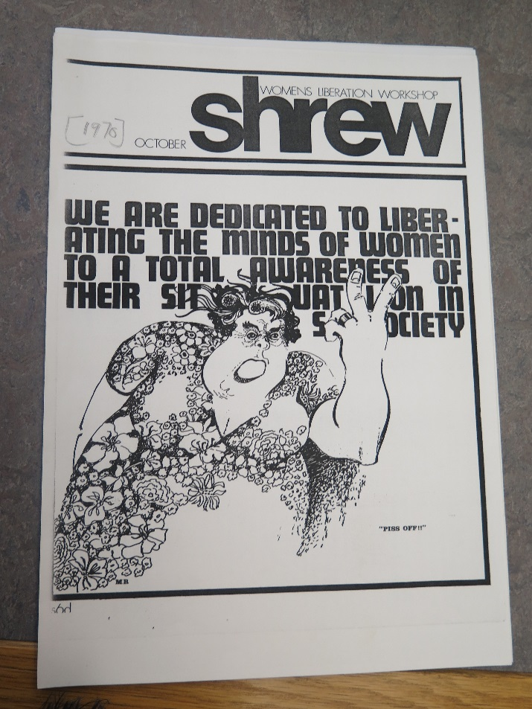
Figure 1. Front page from Shrew, (1970). Feminist Archive North, Special Collections, Brotherton Library, University of Leeds, U.K.
Repeatedly, the collectives producing Shrew recognise their own privileged positions as white, educated, middle-class women while at the same time questioning the normative boundaries of femininity. The October 1970 issue, produced by the Islington group, signals on its front cover a frustration with the limited and limiting class-bound character of the Women’s Liberation Movement (See Figure 1). The visually confident style of the cartoon is in contrast to the previous issue on motherhood with its hand-drawn sketch, its newsletter format and its relatively low production values. The October issue adopts columns and call outs and is printed rather than mimeographed. The cartoon image of a woman on its front cover is holding two fingers up and shouting ‘Piss Off!’ The use of borders, the typography and the varying typeface produce a highly differentiated layout that addresses the reader in visually confrontational terms. The woman is portly, middle aged, she has her hair set at a salon and wears a traditional feminine and flowery dress. Her old-fashioned frock, in other words, signals her difference from the women at Shrew who were in their twenties and thirties, who would have worn the signature styles of the dishevelled bohemian: long hair, trousers, boots and maxi coats. The woman’s large, muscular arms and hands obscure some of the writing behind her; writing that declares: ‘We are dedicated to liberating the minds of women to a total awareness of their situation in society’. Her dark, furrowed brow signals her fury; she is clearly a woman who has had enough of oppression. The comic content of this cartoon, however, concerns not the nature of her oppression but rather the nature of the feminist resistance to that oppression. While the words behind her earnestly declare the intention to enlighten, she is impatient with these words. This dynamic has its visual correlative in the contrast perceived between the woman’s physical presence, the weight and heft of her body and the delicacy of the flowers that pattern her dress. The tension within the Women’s Liberation Workshop is reflected in the juxtaposition of the explosive anger and the passive patterns of the floral dress. Using humour, the image conveys a sense of frustration with feminist words and also, implicitly, a sense of the movement’s detachment from ‘real’ women’s concerns. The working-class woman featured in this image is still locked within the confines of a post-war domesticity harbouring an anger that her younger sisters have yet to connect with. It is hardly surprising that this particular issue stresses the need for political action.
The front covers of Shrew are a showcase of the contrasting styles of feminism they are mediated in the magazine. For instance, in 1971 the March issue cover is in purple echoing the colour associated with the green, white and purple of the Women’s Social and Political Union. The familiar motif of the raised fist within the symbol signifying ‘woman’ is printed in bold black with the words ‘Women’s Liberation’ diagonally crossing the image at the top and the bottom of the page. Particularly resonant in the wake of Tommie Smith and John Carlos’s Black Power salutes at the Olympic Games in 1968, this image equates the liberation of Western women with Civil Rights and liberation groups struggling against colonial or post-colonial oppression such as the anti-Vietnam movement and movements in support of Palestine. On the left, occupying the right hand margin and running horizontally down the page is the magazine’s title, volume number, price and its production site: the ‘women’s liberation workshop’. The militant-style imagery, the bold graphics of the cover, the minimal information provided suggests both clarity and confidence concerning the meanings and motives of Women’s Liberation. Inside the issue activism takes many forms: from the continued struggle to set up a community play group, to action to support striking telephonists, a meeting with Betty Friedan and the organization of a ‘stop the cuts campaign’.
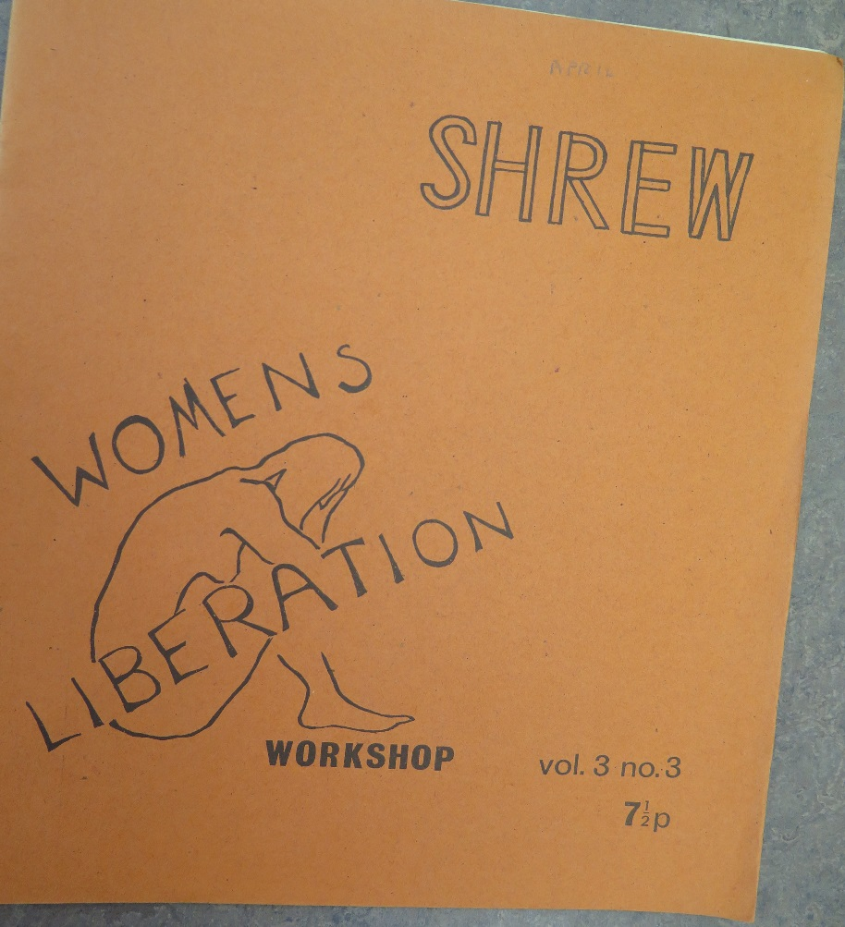
Figure 2. Front page of Shrew (1971). Feminist Archive North, Special Collections, Brotherton Library, University of Leeds, U.K.
This outward looking, community-based activism contrasts with a more introverted and reflective issue in April. The front cover is in mustard cover stock depicting a simple fine-line drawing of a naked woman sitting with her head in her hands in a gesture of despair (See Figure 2). Head bowed, hair falling forward on her face, the slightly tremulous line that traces the contours of her body signals an unsteady hand. The word ‘Women’s’ sits just above her bowed head, ‘Liberation’ cuts through her lower torso and legs and ‘Workshop’ sits just beneath her foot. Price and issue information occupy the right-hand corner and the masthead appears in outline rather than blocked print at the top right hand corner of the cover. The Battersea collective explains in the editorial the motivation, political and affective, underpinning this issue. Preoccupied with the difficulty of articulating clear political aims, the women begin with the tentative assertion: ‘[…] perhaps we don’t have anything nearly so coherent as a position’ (‘Confrontation’ 1971: 2). That lack of a ‘position’ is both worrying for the group but at the same time, somehow galvanizing in terms of its recognition of a shared set of gendered patterns of behaviour:
Assertive, aggressive argument and debate are modes of communication most of us regard as part of a very masculine world. […] We are often hung up about hurting or offending one another by being critical face to face. Taken to extremes, this inhibition can result in meetings in which the atmosphere is so cosily supporting that woolliness takes over and very little gets said or done. (‘Confrontation’ 1971: 2)
As the editorial goes on to suggest, ‘Trying to write about confronting other people seems to be a good way of bringing us up against our own assumptions’ (‘Confrontation’ 1971: 2). Repeatedly, as the covers of these early issues suggest, the women are engaged as much in interrogating their own assumptions as they are in challenging the assumptions of the dominant social order. While Shrew adopts a rough-hewn and restless aesthetic there is an underlying and fairly consistent critique of hegemonic femininity. Not only that, the women are engaged in examining their own role in the reproduction of racial and class-bound heteronormative femininity. Visual images convey most forcefully the tensions embedded within the Women’s Liberation Movement as it seeks to assert a unified and unifying voice while recognising the dangers of doing so.
Miss-Placed: Mediating the Miss World Protest (1969)
The November/December issue of Shrew for 1969 is dominated by extensive coverage of the first Miss World protest that took place on 27th November. Produced by the Tufnell Park WLW, the opening page begins not with ‘conclusive statements’ concerning the action but rather with a series of questions ‘on the general value of public demonstrations to W.L.W. and aspects of the Miss World contest in particular’ (November/December 1969: 2). Around fifty women picketed outside the Albert Hall, carrying placards, leaflets and sashes announcing the ‘collective existence’ of the WLM. There were women not only from London but also from Coventry and Essex. According to another report, ‘much to everybody’s astonishment the T.V. and Press turned up in numbers, with much snapping, popping and aggressive interview technique’. It was the attention of the media that was at once encouraging (‘hopefully we have begun to reach some of those women discontented with their traditional role’) and also disturbing ‘the delegated working party didn’t function properly and communications broke down, resulting in individuals being faced with last minute unilateral decisions’ (November/December 1969: 3). A number of women were interviewed and photographed by the press, a courting of publicity that had not been collectively agreed upon. As Graessle remembers:
At the time we had endless debates about the media. As a journalist I had a foot in both camps. Many women felt we should not talk to journalists because they distorted things, but one of the things I learned was that whenever there was something in the paper, however patronising in tone, what it did was give information to women. We used to get letters from little villages in rural Wales, and women would say, ‘In the Mirror today I saw a notice about this. What a relief it is, I felt I was crazy on my own here all these years.’ So it made me less ideologically pure than I think a lot of people were (Wandor 1990: 30).
It was Sally Reynolds’s reflections that captured the unease many of the women felt concerning the action: ‘I couldn’t understand why about half a dozen sisters stood and posed for a Mirror pressman’. According to Reynolds’s analysis, the ‘press is the voice box of the system’ which will inevitably distort feminism (Reynolds 1969: 4). As evidence, she refers to the racist assumptions implicit in Prudence Glynn’s hostile article on the protest in The Times describing the feminists’ ‘flesh pink banners’ (Glynn 1969: 2). Yet while Glynn’s article is misogynistic, it at least quotes the headlines on the feminists’ banners: ‘Equal pay, equal rights, equal jobs now’ even as it snidely questions the reasons for the protest: ‘It was a dark night but could their protests have been jealousy?’ Glynn also concedes that there is something ‘rather pathetic’ about the Miss World contestants ‘standing around wearing rosettes like cattle’. The feminist critique has been embedded within the article even as Glynn distances herself from the feminists themselves.
In the following issue of Shrew, Leslie Keith explains why she ‘posed’ for the cameras that night. Citing the article in The Times once more as evidence of ‘dubious’ publicity, she nevertheless goes on to defend her actions: ‘There were no winning smiles, or displays of leg and breast. And the only thing which motivated us was the desire to make a pictorial statement about why we were there.’ The press, she asserts, ‘can for the moment be used by us for the purposes of attracting membership and interest and opposition’ (Keith 1970: 12). Romola Guitan declares her strident opposition to the action itself in the same issue and also to courting the mass media. Through this type of high profile, mass-mediated action, feminists allow themselves:
to be used as Aunt Sallys, well-managed by T.V. comperes to provide light entertainment – after all, the spectacle of a woman taking herself seriously is still regarded as funny, which seems to be one of the reasons for much of the recent interest on the part of the media. […] Unless we write the reports or produce the programmes ourselves we can’t hope to put over what we have to say (Guitan 1970: 13).
Clearly Keith and Guitan were all too aware of the possibility that their images could be co-opted by the mainstream media, restyled as a form of ‘commodity feminism’ that continued to serve hegemonic interests. Here the mass-mediation of feminism transforms serious political protest into light-entertainment. Control over the means of media production, they argue, is the only way to prevent the fetishization of feminism. Their argument, however, raises interesting questions concerning the relation between feminism as it is mass mediated and Shrew itself as a printed, low-circulation feminist magazine. The assumption embedded within this discussion is that as the producers of their own magazine, the women have some control over their own representation and that the transmission of feminism through the medium of television and the press takes that control away. As has already been discussed, however, Shrew produces multiple and conflicting versions of feminism. The fractured contents of each magazine problematize, on every page, the idea of a singular feminist identity. What the writers of Shrew are resisting is what Todd Gitlin refers to as the ‘processed image’ of the movement (Hesford: 34). In other words, the women writing for Shrew want to keep multiple and contested feminisms in circulation rather than contributing to an image of feminism as unified, an image that necessarily occludes difference.
While the Women’s Liberation Workshop is preoccupied with its own mediation, at the same time, in the process of reflection and debate on the first Miss World protest what becomes visible is the complex intersection of race, class and gender within the WLM itself and the occlusion of that complexity in the mediation of the protest. Reynolds critiques The Times article for its ‘racist’ description of the pink sashes the women protestors wear as ‘flesh-coloured’ recognising how such assumptions construct an image of feminism as exclusively white. Her critique signals an awareness of how the movement is already being mediated as both white and middle-class. Crucially, the rhetorical move that figures feminist flesh as ‘pink’ denies the possibility of black feminist protest. Not only that, the emphasis on feminist flesh represents the protestors themselves as contestants competing for the attention of the ‘pressmen’. The Miss World protest exemplifies and amplifies the contradictions of a mediated feminist activism. For in order for the feminists to oppose the Miss World competition, they must enter the Miss World competition as it is mediated. They must compete for air space, for visibility, for media exposure in order to depose the outmoded forms of femininity parading on the stage of the Albert Hall.
As contributors to Shrew point out in the review issue of February 1970, media reports of feminist activism homogenise feminism through markers of racial and class difference. For instance, the visual economy circumscribing feminism in mass media reports repeatedly refer to feminists as ‘straggle-haired’ women marking them as white at the moment when the ‘black is beautiful’ message made the Afro hair-style fashionably modern and politically charged. This effect is reproduced in the extensive media coverage of the First Women’s Liberation Conference at Ruskin College, Oxford in February 1970. As the Tufnell Park group points out in its report on the mediation of the conference, most of the articles covering the conference highlighted feminist hairstyles rather than feminist politics. Embedded, however, within these descriptions of fashionable feminists is a whitening of feminism. The recurring image of women ‘with long hair and maxi coats’ is the dominant motif in all the accounts of the three-day event. Mary Holland, writing for the Observer describes conference attendees as ‘young, violent, radical, and very attractive with their long hair and maxi coats […]’. The journalist in the Oxford Times mentions ‘long hair, trousers and maxi coats’. Writing in the Spectator, Clayre Ridley describes a ‘struggling crowd of long hair and maxi coats, beards and babies’ (qtd. in ‘Bourgeois Press’ 1970: 2-3). The women themselves and some of their bearded partners are rendered slightly comical here, clone-like ‘trendies’ who express their politics more through style than political content. If politics enters into any of these reports it is not the politics of the women’s liberation movement but rather the political agendas of other more seemingly radical and subversive groups or ideologies. Thus while feminist debate is largely left unrecorded, Mary Holland points to the bookstalls at the conference, featuring publications by the Black Panthers, SCUM and Chairman Mao. Not only does this representational practice render feminism harmless, a fashionable reworking of bourgeois femininity, it also occludes and masks the differences within feminism that challenge the hegemonic status of that femininity.
Many of the issues raised within the pages of Shrew in its first few years of publication express a resistance to a white heteronormative femininity. As Hilary Rawlings writing in the February Shrew puts it: ‘I belong to the lowest form of life on this planet – the human female. The white western ‘Woman’s Own’ woman’ (Rawlings 1970: 13). In the discussions around the first Miss World protest Sally Reynolds provides her own first-hand account of the action acknowledging that she was initially uncomfortable when women who had travelled down to London from Warwick started to shout slogans and sing: ‘This was contrary to my idea of a ‘ladylike demo’ (November/December, 1969). These boisterous women, suggests Reynolds, are more liberated than she is; they are not hampered by a ‘bourgeois fear of authority’. She goes on to argue that the women’s liberation movement needs to ‘build a united front’ by reaching out to such women who are the ‘real revolutionary power in Women’s Liberation’ (Reynolds 1969: 4). Reynolds’s analysis of women’s liberation signals a critique within the movement of the dangers of becoming an ‘elite group’ whilst simultaneously drawing attention to the fact that the protest itself was by no means exclusively middle-class in terms of its social profile. In fact, if anything, ‘the women from Warwick’ suggests that feminist activism extended beyond the gentrified ghettoes of North London.
Miss-Judged: Mediating the Miss World Protest (1970)
Given the extensive debate concerning the first Miss World protest in Shrew, the second protest looks much less anarchic and much more media savvy. 24 million viewers were watching when the sound of a football rattle signalled the beginning of the disruptive action by feminists who stole their way into the venue. Several minutes of pandemonium ensued as flour bombs, rotten tomatoes and blue paint were launched at the stage. The compere, Bob Hope, who in opening comments had already referred to the competition as a cattle market, fled the stage in fright. Christopher Walker covered the event for the Observer and interviewed ’30-year-old South London housewife Mrs Janet Williams’ who declared: ‘The protest had been planned for a number of weeks. As far as we are concerned it was a great success’ (Walker 1970: 3). The careful planning of the protest is verified by Walker who points to the fact that the women were sitting in 3gn and 4gn seats. They spent a considerable sum of money to pay to get into the Hall (4 guineas is approximately £84.00 in today’s money). They were also dressed-up in order to fit in with the audience as Sally Alexander recalls in her recent account of the disruption (Alexander, 5 March 2014). No longer sporting the ‘long hair and maxi-coats’ identified in the press as the signifiers of feminism, the women protestors looked inconspicuous. Even though they were ‘unescorted’ and in spite of the heightened security that night, the women managed to get into the hall with no difficulty. This was what made the protest so spectacular and so successful. As one detailed account of the protest in Shrew indicates, the spectacle was significant because it disrupted the image of normative white femininity:
To take violent action, interrupting a carefully ordered spectacle, drawing attention to ourselves, inviting the hostility of thousands of people was something that we had all previously thought to be personally impossible for us, inhibited both by our conditioning as women and our acceptance of bourgeois norms of correct behaviour. It was also a revolt against the safeness of our lives, the comfort of continual contact with like-minded people.
As Walker’s article in the Observer reveals, however, the disruptive behaviour of the protesting women was condemned by the newly crowned Miss World, Jennifer Hosten (formerly Miss Grenada). As the first black woman to win the competition, Hosten was making her own history and so too was Pearl Jansen, Miss Africa (South), the runner up that year. Jansen, a machinist in a shoe factory, was the first non-white entrant from South Africa. When news of her success reached her home in Bonteheuwel, the ‘segregated Coloured township on the way to Cape Town’s airport […] the community went wild with delight’ (Walker 1970: 3). Jansen, however, was not the only contestant representing South Africa that year. Jillian Jessup represented white South Africa and it was she who claimed that the title of Miss World 1970 went to a black woman for political reasons. The competition was plagued with further controversy when it transpired that Mecca, the organisation behind the Miss World competition, wanted to open up a gambling casino in Grenada. It seemed no accident then that Eric Gairy, the Prime Minister of Grenada, was one of the judges that year and that Miss Grenada was crowned Miss World.
Reports of corruption continued to appear in the press as did the coverage of the trial of the five feminist protestors charged with assaulting a police officer, threatening behaviour, possessing offensive weapons and insulting behaviour (‘Miss World Row’ 1970:6). Shrew urged its readers to support the women by picketing outside Bow Street court (‘Trial for Miss World Demonstrations’ 1970: 31). Memories of alleged corruption that year have not lingered as long as the spectacle of white women protesting at an event that crowned the first black Miss World. The mass mediation of the Miss World protest in 1970 constructed an image of the Women’s Liberation Movement as an extension of a colonial form of white patronage. As Williams, one of the protestors, is quoted as saying, ‘We never intended to attack the girls […] We just wanted to show we were sorry for them’ (Walker 1970:3). The reports of the feminist action operated to reinforce white power and privilege at the expense of black women seeking to escape oppression and poverty. A similar structure of representation is evident in the mass mediation of the Miss America Pageant in 1968 where, as Georgia Page Welch suggests, ‘civil rights and feminism [were framed] as competing social movements with race and sex oppression as their nonintersecting domains, respectively’ (Welch 2015: 72). The women writing in Shrew were acutely aware of the ways in which their own actions might be ‘mis-represented’. They sought, instead, to interrogate the ‘privileging forces that constitute white female positionalities’ recognising how white femininity, particularly white middle-class femininity operated to reinforce racial and class hierarchies (Rowe and Lindsey 2012: 293). The women’s disruptive actions may well have been mediated to millions on that day in 1970 but so too were a set of troubling binaries that occluded the intersectional debates underpinning those actions. Shrew returns us to those debates about intersectionality before intersectionality had become embedded within feminist discourse and practice; Shrew reminds us of the ways in which women activists reflected critically on their own practices and positions and it alerts us to the everyday, messy and multiple feminisms that stimulated and sustained social activism.

Works Cited
‘Additional Notes on the Group as a Political Force’ (1971), Shrew, March, p. 3.
Banks, Ingrid (2000) Hair Matters: Beauty, Power and Black Women’s Consciousness,
New York: New York University Press.
‘Bourgeois Press’ (1970), Shrew, April, p. 2.
Alexander, Sally (5 March 2014), ‘’Miss World Protest’, available on the BBC News website
at http://www.bbc.co.uk/news/magazine-26437815 (viewed June 2016).
Browne, Sarah (2014), The Women’s Liberation Movement in Scotland, c. 1969-c. 1979,
Manchester: Manchester University Press.
Campbell, Beatrix (19 November 2010), ‘Another World’, available on the Guardian
website at http://www.theguardian.com/lifeandstyle/2010/nov/19/feminists-disrupted-miss-world-tv (viewed June 2016).
DiCenzo, Maria, with Lucy Delap and Leila Ryan (2010), Feminist Media History: Suffrage,
Periodicals and the Public Sphere, Basingstoke: Palgrave.
Forster, Laurel (2015), Magazine Movements: Women’s Culture, Feminisms and Media
Form, London: Bloomsbury.
Glynn, Prudence (1969), ‘Miss Austria Wins as Feminists Chant’, The Times, 28 November,
p. 2.
Green, Barbara (2008), ‘Feminist Things’, Transatlantic Print Culture, 1880-1940: Emerging
Media, Emerging Modernisms, ed. by Ann L. Ardis and Patrick C. Collier, Basingstoke and New York: Palgrave, pp. 66-82.
--- (2012), ‘Complaints of Everyday Life: Feminist Periodical Culture and Correspondence
Columns in the Woman Worker and the Freewoman’, Modernism/Modernity 19:3, pp. 461-85.
Guitan, Romola (1970), ‘Miss World Demonstration’, Shrew, January, p. 13.
Hesford, Victoria (2013), Feeling Women’s Liberation, Durham and London: Duke
University Press.
Hughes, Celia (2015), Young Lives on the Left: Sixties Activism and the Liberation of the Self,
Manchester: Manchester University Press.
Jordan, Tessa (2010), ‘Branching Out: Second-Wave Feminist Periodicals and the Archive of
Canadian Women’s Writing’, ESC: English Studies in Canada 36:1, pp. 63-90.
Keith, Leslie (1970), ‘A Reply to Sally Reynolds’, Shrew, January, p. 12.
Lewis, Ruth and Susan Marine (2015), ‘Weaving a Tapestry, Compassionately: Towards an
Understanding of Young Women’s Feminism’, Feminist Formations 27:1, pp. 118-140.
‘Miss World Row: Five Remanded’ (1970), Guardian, 23 December, p. 6.
Powell, Manushag N. (2011), ‘Afterword: We other periodicals, or why periodical studies?’,
Tulsa Studies in Women’s Literature 30:2, pp. 441-450.
Rawlings, Hilary (1970), Shrew, February, p. 13.
Rowe, Aimee Carrillo and Samantha Lindsey (2012), ‘Reckoning Loyalties: White
Femininity as “Crisis”’, in Mary Celeste Kearney (ed), The Gender and Media Reader, London and New York: Routledge, pp. 292-306.
Reynolds, Sally (1969), ‘Thoughts about the Miss World Action’, Shrew,
November/December, p. 4.
Setch, Eve, ‘The Face of Metropolitan Feminism: The London Women’s Liberation
Workshop, 1969-79’, 20th Century British History 13:2, pp. 171-90.
Shrew (1969), October.
--- (1970), October.
--- (1971), August.
--- (1971), September.
‘Special Review Issue’ (1970), Shrew, February.
‘Trial for Miss World Demonstrations’ (1970) Shrew, December, p. 31.
Tyler, Imogen (2011), ‘Pregnant Beauty: Maternal Femininities under Neoliberalism’ in
Rosalind Gill and Christina Scharff (eds), New Femininities: Postfeminism, Neoliberalism and Subjectivity, Basingstoke: Palgrave, pp. 21-36.
Walker, Christopher (1970), ‘Miss World Was Not Amused’, Observer, 22 November, p. 4.
Wandor, Michelene (1990), Once A Feminist: Stories of Generations, London: Virago.
Welch, Georgia Paige (2015), ‘“Up Against the Wall Miss America”: Women’s Liberation
and Miss Black America in Atlantic City, 1968’, Feminist Formations 27:2, pp. 70-97.

On the first page of the review issue of Shrew in February, 1969, the editors explained the significance of the front cover which carried the slogans featured on the banners of the protesters at the 1969 Miss World protest. ‘Special Review Issue’ Shrew February, 1970, p.1. Feminist Archive North, Special Collections, Leeds University Library.
Shrew (1969), November/December, p. 16.
This is also reproduced in the ‘Special Review Issue’ of Shrew, February 1970, p. 19.
For a description of the production process see Shrew, November/December, 1969, p. 15.
See the front cover of Shrew, August 1971.
See the front cover of Shrew, September, 1971.
See the front cover of Shrew, October 1970.
Ibid., p. 3.
Earlier that day the Angry Brigade had exploded a bomb in a car outside the Albert Hall. (http://www.nickelinthemachine.com/2010/07/the-royal-albert-hall-miss-world-and-the-angry-brigade-in-1970/).
Shrew Collective, ‘Miss World’, Shrew, December, 1970, pp. 16-18, 17. Jenny Fortune describes the event in similar terms with her emphasis on resisting the pressure to act and behave like a ‘nice middle-class girl’ (Campbell 19 November 2010). (http://www.theguardian.com/lifeandstyle/2010/nov/19/feminists-disrupted-miss-world-tv).
The five women remanded on bail were: Norma Jo Robinson, Catherine Mclean, Mair Twissell, Sally Alexander and Jennifer Fortune.

