101

SYNTACTIC STITCHING:
Towards a Better Integration of Cairo’s Urban Fabric
__________________________________________________________
ABSTRACT
This paper focuses on studying Cairo’s urban fabric, which is composed of a mixture of planned districts built by the government and private sector, and informal districts, self-generated to fulfil the needs of a rapidly expanding population. The case studies selected are continuous parts of the city that show variation in the urban fabric and a distinction between planned and informal districts. This paper argues that even though there is a high percentage of unplanned districts in close proximity to planned districts, the city as a whole functions and is connected. This indicates that there exists an underlying, naturally generated global structure, a super-grid, which can be used to better integrate between the different districts, both planned and informal (Peponis et al., 2015). The study will show variations between the selected districts in terms of emergence, morphology and syntactical structure. The study will analyse syntactically the selected districts as they currently exist both locally within the district and globally in the entire case study. A similar analysis was conducted on informal settlements in Santiago, Chile. One of the principle findings was that the more spatially integrated the existing settlement is on its edge boundary with the surrounding urban layout, in terms of vehicular movement and local accessibility, the higher the level of self-generated economic activity and community development (Hillier, Greene, & Desyllas, 2000). This paper aims to build upon that, by exploring ways in which the existing informal settlements can be better integrated with the surrounding urban form to benefit the entire community by harnessing the super-grid. The analysis indicates that the highway super-grid is based on the pre-existing canal system in Cairo, but it is incomplete and creates a boundary around informal settlements rather than becoming a connector. The analysis also indicates that the main roads in informal settlements have developed using the same canal system super-grid and that this can be used to reconnect them to the city. After the initial syntactical and morphological analysis of the existing fabric, different approaches to create ‘syntactic stitching’ between the districts are suggested following the previous analysis and underlying global structure. The focus is on adjusting the existing fabric, such as aligning existing streets, creating new thoroughfares to increase edge movement and consolidation into the main urban form.
KEYWORDS
Informal Settlements, Boundaries, Syntactic Stitching, Spatial Integration, Super-grid
- INTRODUCTION
This paper presents a case study on the western bank of the Nile in Cairo composed of a mixture of planned and informal settlements in close proximity, a pattern that’s repeated throughout Cairo. In this case study, the main transport highways form boundaries and overpass the informal settlements, creating a disconnection between the local neighbourhoods and the global city. These settlements have a coherent local structure but lack citywide connectivity. This increases segregation in the urban fabric and leads to lack of access to resources and services. It also increases densification within informal settlements, as they cannot grow outwards due to the highway hard edges, which leads to increased social segregation and lack of consolidation into the main urban form.

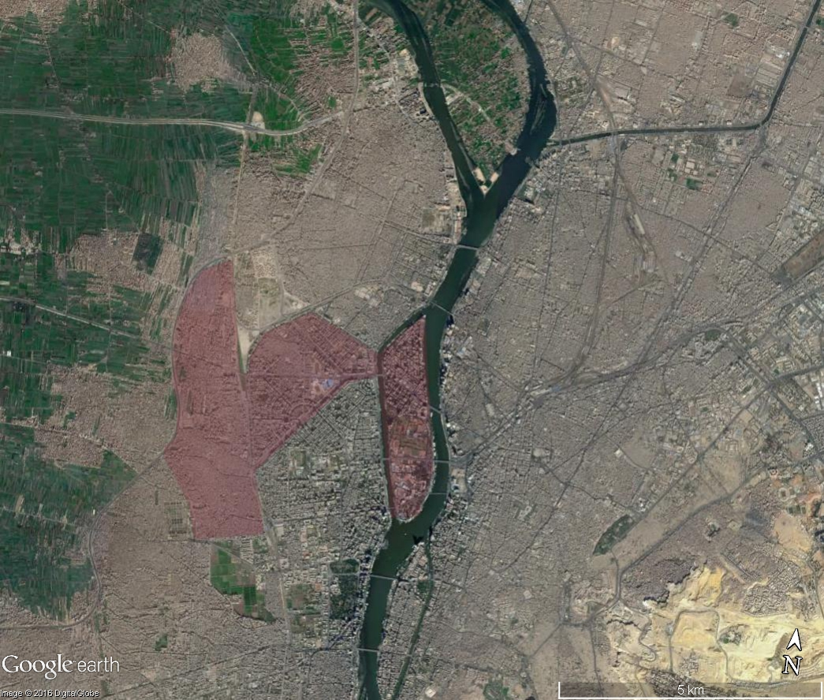
Figure 1: Satellite Imagery showing the case study highlighted in pink within the wider context of Cairo

1.1 Informality in Cairo: An Overview
The estimate from the Ministry of Housing is a quarter of Greater Cairo is informal settlements, but independent researchers have placed that figure at more than half, with some estimates reaching two-thirds, depending on their definition of “informal”. The richest of the citizens live in desert satellite cities and gated compounds while the majority live in deteriorated planned areas or illegal, informal settlements (Sims, 2010).

1.2 State Policy and Al-Majhud al-Dhati
In order to study informality, the state policies and laws that led to its growth must be examined. With the 1952, revolution came laws to change land ownership, known as the Land Reform Laws under Gamal Abdel Nasser’s Arab Socialism. Before the revolution, 3% of the population owned 80% of cultivated agricultural land, with farmers renting their land from the aristocracy at high prices and taking on debts. The laws aimed to increase land ownership by allowing farmers to pay off the land over 30 years and set a limit of 200 feddans (100 acres) to the land one family could own. Land that was confiscated from families that owned above the limit was redistributed to the landless farmers (fellaheen) which comprised approximately 20% of the population (Osman, 2010).
After a number of revisions, these laws were abolished in the 1980’s with the rise of neoliberalism, but the farmers that owned their land retained ownership. In the 1980’s there was a period of rapid urbanisation, with the state encouraging construction and self-reliance under the neoliberal ‘Infitah’ or Open Door Policy, which aimed to increase private investment but led to reduced state social spending on housing, education and healthcare. It was then informal settlements started to make an appearance (Singerman & Amar, 2006).
With citizens finding their needs not being met by the state they took matters into their own hands, building residences on their privately owned, agricultural land which eventually linked together to form coherent neighbourhoods. The residents linked these settlements to the utility and power networks, which was later formalised by the government. This gave rise to the concept of ‘Al-Majhud al-Dhati’, translated into ‘Self Reliance’, similar to the English phrase ‘pulling oneself up by the bootstraps’ (Ben Nefissa, 2011).

1.3 Space Syntax Analysis in Cairo – Segregation as a Way of Life
A study conducted in 2014 analysing Cairo’s urban structure and urbanisation process as a whole using space syntax methodology found that spatial segregation contributes to social segregation. The study also showed that the way in which new highways are constructed contribute to spatial segregation, separating neighbourhoods (A. A. Mohamed, et al, 2014) The main highway in Cairo, the Ring Road, is 8 lanes wide and 72km long. Part of the Ring Road passes through urbanised areas and agricultural land, creating an edge where neighbourhoods cannot expand and pedestrians cannot cross to reach other neighbourhoods, intensifying segregation. The type of settlement that emerge on agricultural land are usually informal, so this type of segregation disproportionately affects them.
As described by Hillier (2010) there exists a deformed wheel structure on a metropolitan level but this global network is poorly connected to local neighbourhoods (A. A. Mohamed et al., 2014). The deformed wheel is a semi-grid that forms in most cities, consisting of a central hub (core) of movement lines and a spatial rim, connected together by ‘spokes’ radiating from the core to the rim. This tends to indicate a more cohesive city and shows the public space structure in the city (Hillier & Stoner, 2010). On a global level in Cairo, this exists, but on the local level, the edge movement is not given a chance to form since the highways segregate neighbourhoods.
Another study undertaken in the city of Assiut in Upper Egypt again looked at the city as a whole, with findings making the case for interventions that would alleviate the city’s morphological issues, namely conflicting spatial patterns that led to segregation and high levels of congestion. This would increase integration, creating a more efficient grid on both the global and local scale (A. M. R. Mohamed & Brown, 2009). Both these studies support the need for integration and started investigation into a ‘super-grid’ that can have local grids integrated into it.

  - Space Syntax in Informal Settlements
One of the most significant studies using space syntax analyses in informal settlements was conducted in Santiago, Chile. One of the principal findings was that the more spatially integrated the existing settlement is on its edge boundary with the surrounding urban fabric, in terms of both vehicular movement and pedestrian accessibility, the higher the level of self-generated economic activity and community development. The spatial layout of the settlement and its relation to the wider urban context is one of the key factors in determining how well the settlement becomes consolidated within the larger urban fabric (Hillier et al., 2000). This gives an indication on why the informal settlements on the outskirts of Cairo are often considered less economically active, since they are not well consolidated in the urban form because the highways form a hard edge where the edge movement of that settlement should be.

A study conducted in 2007 in unplanned areas at the core of Jeddah, Saudi Arabia, indicates that limited physical interventions can enhance unplanned areas and contribute to the overall spatial integration of Jeddah. It presents similar a similar case to the urban fabric in Cairo; neighbourhoods that have a distinct local structure that doesn’t fit into the global structure (Karimi et al., 2007). The minor physical interventions proposed could be applied to Cairo, however the settlements in this paper are at the edge of the main city rather than at the core.

1.5 The Super-grid
The super-grid is a way of differentiating between scales in the street network; the super-grid itself consists of the primary road network, which then have local roads inserted into it. Another way of looking at it is to consider the primary road network as creating ‘super blocks’ and the local roads creating urban blocks. Within one super-block exists a neighbourhood, with the local streets either connecting to the super-grid of primary streets or forming a secondary network of minor streets. The super gird shows evidence of integration at the global scale; it starts with/includes to some extents the extension and peripheral streets of the deformed wheel. The super-grid and the local streets should be designed to interact with one another to promote connectivity, and there are four syntactical principles that can arise from the interaction of the super-grid with the local grid. Shortcut, which means that movement does not need to pass through the super-grid; Bypass, where the super-grid bypasses the local grid’s density, possibly resulting in faster movement; hierarchal, where the super-grid has fewest directional changes; and labyrinth, where the paths inside the local grid are shorter but the shortest route involves the super-grid. In general, the super-grid is more integrated than the system as a whole; however, the 2015 study deals with regular, linear grids (Peponis et al., 2015). In this paper it is proposed that there is a super-grid linking the neighbourhoods together that accounts for the apparent functioning of Cairo as a whole even with the major spatial and morphological differences between neighbourhoods. In this case study, the highway super-grid can be classified as bypasses, with the informal settlements containing shortcuts but with disconnection between the two.

- METHODOLOGY
2.1 Case Study Selection and Boundary Determination
The case studies selected are located in western Greater Cairo, where planned and informal settlements are in close proximity to each other. Boundaries were determined by using ‘apparent villages’ rather than official government boundaries, which are different from how people perceive the settlements. The types of boundaries encountered include highways, roads, and the Nile. Where an unclear boundary exists, as is the case with the Al-Mohandiseen and Al-Sahafiyeen district, the ‘street face’ of neighbouring districts was included in the analysis since that is what the district interacts with as an autonomous unit.

2.2 Syntactic Analysis
The axial maps were generated in DepthmapX and analysis ran for both global and local integration. Open spaces that were not used as part of the natural pedestrian movement (e.g. open fields in the case of the informal settlements, and private sporting clubs in the case of the planned settlements, see fig.2) were disregarded in the analysis. The informal settlements were analysed by drawing axial lines between parcels, since the proximity of the buildings means that passing between them is difficult, especially for non-residents. The informal settlements also do not follow the building code for setbacks or maximum height, so most buildings are built to the edge of the plot and the resulting streets are very narrow, usually less than 3m. The planned settlements were analysed by building since there are setbacks and both residents and non-residents can pass between buildings (Howeidy et al., 2009).
All the analyses were run using CAPMAS Egypt (Central Agency for Public Mobilisation and Statistics) map data from 2004, except for Ard El Lewa, which was updated using satellite imagery and analysed in 2004, 2010, and 2016. The other settlements were only analysed once because the change over the 12 years was not significant.

3. HISTORICAL DEVELOPMENT OF THE CITY’S URBAN MORPHOLOGY
3.1 Geography
The sample encompasses various types of urban forms: organic, planned and informal. A distinction is to be made between organic and informal. Both are non-planned but differently structured due to the rate of growth and different type of aggregation; informal settlements tend to grow at a higher rate than organic settlements. From a morphological perspective, they are different in that historical organic settlements, the buildings aggregate to form enclosed public space, similar to mediaeval Islamic cities (Bianca, 2000).

- Addition/Aggregation (Organic)
In this case, individual cells (buildings) cluster together over a long period to form public space, creating small, dense groups of buildings with no apparent pattern. This type of growth is driven by the building, with the streets formed by the left over space after the buildings have clustered.

- Infill (Informal)
This type of morphology is created when there is a pre-existing grid, in this case the grid of the agricultural land, and the buildings fill in the plots created by the grid. This type of growth is driven by the plots, and the streets are the edges of the plots, in this case the dirt paths used to access the agricultural land. This usually results in a very long block and narrow streets. The plot size and shape is a major influence on the buildings’ size and shape and the resulting streets.

- Setback on Parcel/ Subdivision (Planned)
This type is considered planned, the plots, buildings and streets are planned simultaneously, and streets form blocks that are split into parcels then have buildings built on the parcel with setback. The plot shape does not necessarily influence the building’s shape but there is usually a setback or height limit imposed by the planning authorities.

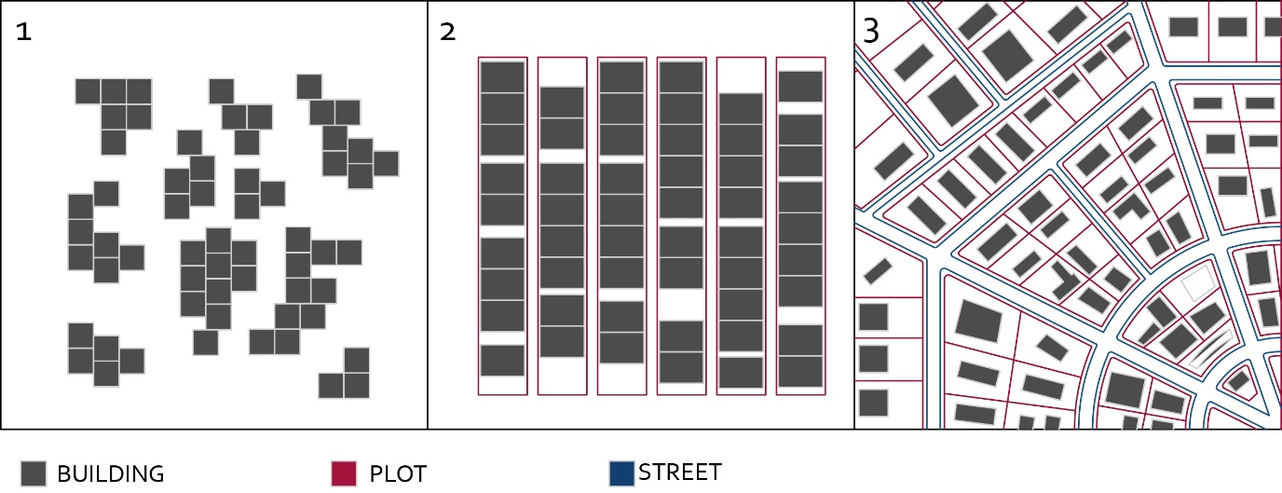
Each morphology creates distinctive syntactic configuration within the hard boundaries.

Figure 2: Three Morphological Types

 | Al-Mohandiseen | Al-Sahafiyeen | Ard El Lewa | Bulaq El Dakrour | Mit Uqaba | Zamalek
Date | 1949 | 1949 | Approx. 1980’s | 1560 | Approx. 1900’s | 1869
Area(km sq) | 2.92 | 1.16 | 3.08 | 3.75 | 0.47 | 2.46
Urban Morphology | Planned | Planned | Informal | Informal  /Organic | Organic | Planned
Residential Density | 35, 000 | 35,000 | Data not available | 49,000-250,000 | Approx. 75,000 | Approx.  20,000
3.2 Urban Morphology of Different Case Studies
Table 1: Showing the classification and statistical details of each settlement

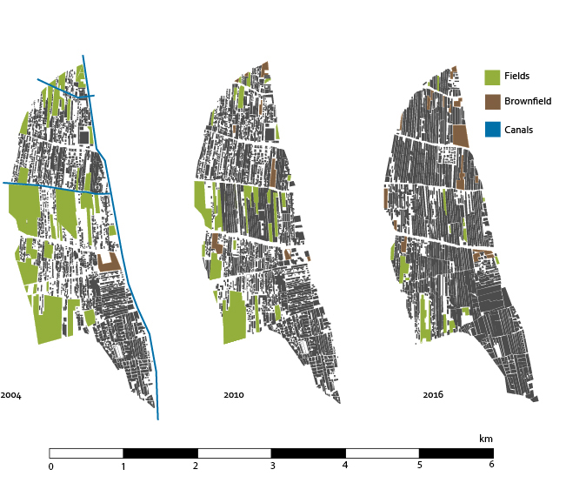
Ard El Lewa
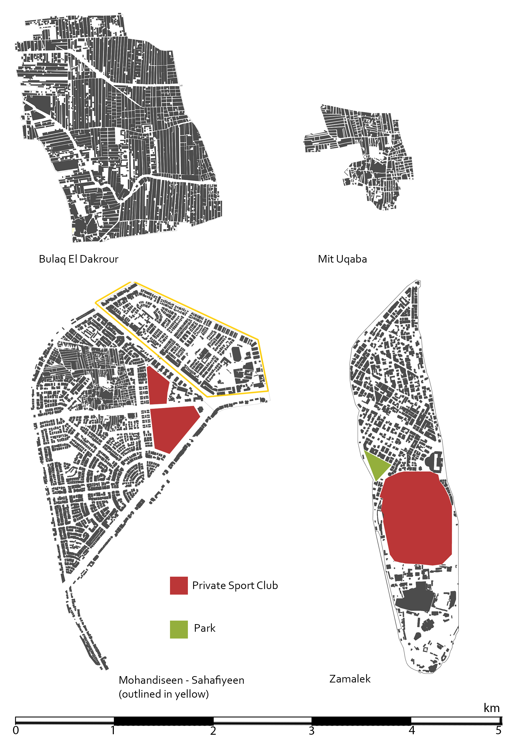

Figure 3: The urban morphology of the case studies

3.2.1 Ard El Lewa
Ard El Lewa became its own administrative unit in 1999, and since then the neighbourhood alliance has been conducting its affairs. The residents built their own access ramp to the 26th July corridor without government assistance to connect themselves to the wider urban network. The 26th July corridor flyover creates a boundary to the north of Ard el Lewa proper, and the upper part of the settlement is technically part of Imbaba. The syntactic axial analysis treats them as two distinct settlements because of the hard edge of the highway. As reflected by the actions of the residents, there exists a need to connect to the rest of Cairo and the surrounding urban fabric.
This is the only settlement to have experienced rapid growth in the past 12 years. The linear grid reflects land ownership – the linear pattern is in agricultural land and the plot size reflects the measurements used by Egyptian landowners (kirat, feddan). The dimensions of the average land parcel are 450m x 25 m, when split into plots of land is approximately equal to one kirat, or 175m2. This can be seen in figure 4, which shows the process of infill the settlement went through. Stage one shows the agricultural land as it originally was, split into plots with dirt paths and the canal system irrigating the land. Stage two shows the canals dried up and transformed into roads, with spare and random buildings. The final stage shows the urban fabric as it is now, fully densified with the local access between buildings not visible. In stage four, that shows the base grid, the initial dirt paths between the agricultural lands were perpendicular to the canal that irrigated that part of the land, which means that not all the paths are aligned. These T-junctions, rather than crossings, prevent the formation of long north-south axis in the informal settlements, which means that the dried up canals become the main movement thoroughfares.
3.2.2. Bulaq El Dakrour
Bulaq is the oldest settlement in this study, having been Cairo’s major port in 1560, and became an industrial district in the 19th century under Mohamed Ali’s rule. Over time, it has been the location of rapid urbanisation, with old housing and buildings being demolished to make way for high rise apartment blocks. Some areas retain the organic morphology while others have become informal (‘Bulaq | district, Cairo, Egypt’, n.d.).
Mit Uqaba, Al-Mohandiseen and Al-Sahafiyeen
Mit Uqaba is an historic village, which is situated in the middle of the Al- Mohandiseen neighbourhood. It is visible on the original Survey of Egypt maps from 1939 and the Al-Mohandiseen district was planned around it, starting in the 1950s as single storey villas and experiencing a building boom in the 1970s with high-rise apartment blocks being built and surrounding Mit Uqaba. In 1999, a large area of Mit Uqaba was demolished to build the 26th of July corridor, which resulted in splitting the village since there was no access to the corridor from the village and pedestrians could not cross it (Tadamun, 2013). Al-Sahafiyeen was built concurrently with Al-Mohandiseen, but is considered a different area since Al-Mohandiseen was originally planned to provide residence for Egypt’s engineers, and Al-Sahafiyeen was planned for journalists (ETH Studio Basel, 2008b).

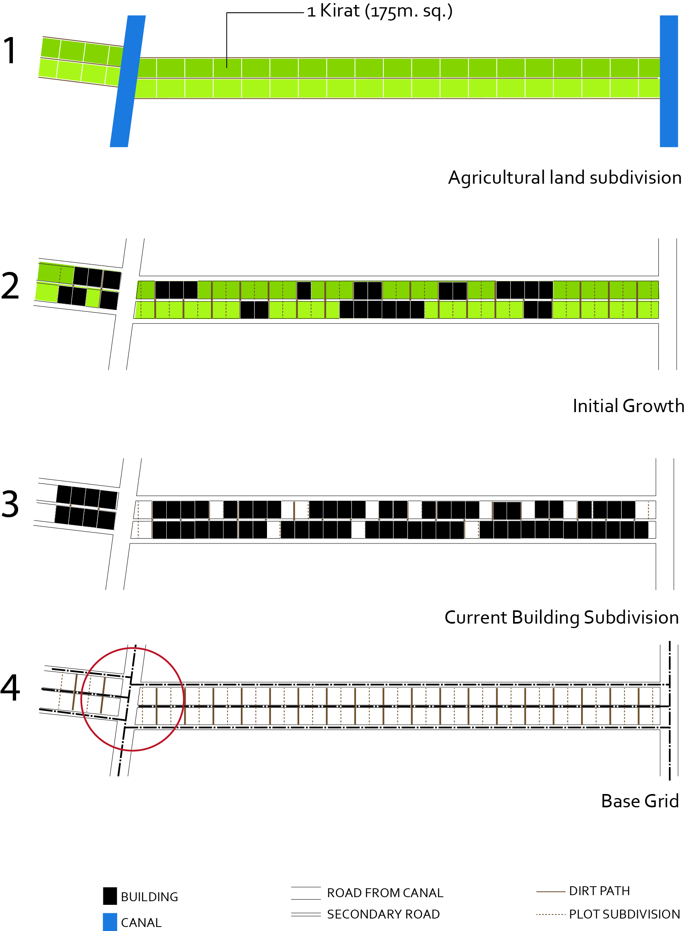
Figure 4: Showing the progression of land subdivision in Ard El Lewa to create its distinctive urban morphology, as well as the misalignment of streets that creates T-junctions rather than intersections (red circle).

3.2.3 Zamalek
Zamalek is situated on Gezira Island of the Nile and is one of the most affluent areas of Cairo. In 1863-79, it was a botanical garden under Khedive Ismail, and in 1890, a master plan drawn up that consisted of palaces for the rulers and nobility. In the 1940’s it began being known as Zamalek. It is divided into two sections, the upper affluent residential area and the lower are which contains the Gezira Sporting Club and Cairo Opera House (ETH Studio Basel, 2008a).
3.3 Cairo’s Highways and Canals
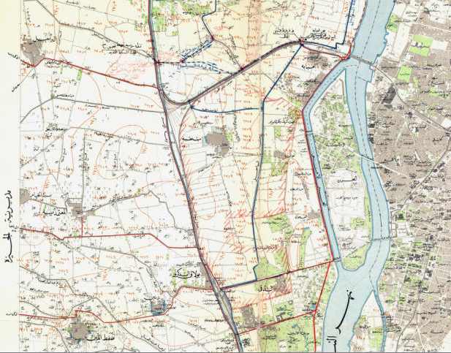
During the early 20th century, there existed a canal system stemming from the River Nile to irrigate the surrounding agricultural land. This was before the expansion of Cairo, when the majority of the population were farmers.

Figure 5: Map of the case study area in 1930 showing the majority of Cairo on the eastern bank of the Nile. The western bank is agricultural land with scattered villages (Mit Uqaba (red circle) and Bulaq el Dakrour (blue circle) are the notable ones) and the canals irrigating the agricultural land. (source: Survey of Egypt Maps, Rare Books and Special Collections Library; the American University in Cairo)

Looking at the urban fabric of Cairo today, it is evident that the layout of the canals and the agricultural land has influenced the resulting urban morphology of Cairo, creating a super-grid pattern that is followed by both planned and informal settlements. In Cairo, the super-grid manifests as the highway system, which, in theory, connects the neighbourhoods of Cairo together. The main roads in the highway system are the Ring Road, which was designed to limit the growth of Cairo, the 26th of July Corridor, Gesr El Suez, the Autostrad (El Nasr Road) and Salah Salem, which were designed to link the neighbourhoods of Cairo to each other and to the Ring Road. Together they create a complex system of roads, bridges and flyovers that span the entirety of the city. However, due to the lack of pedestrian movement by these highways and the fact that they are very difficult to cross means that they end up creating a hard edge around neighbourhoods, as well as overpassing informal settlements which then have no connection at all to the super-grid.
4. SYNTACTICAL ANALYSIS OF INDIVIDUAL SETTLEMENTS
Table 3: Local and Global Integration values of Ard El Lewa settlement over 12 years

Table 2: Local and Global Integration values of each settlement

 | Bulaq El Dakrour | Mit Uqaba | Al Mohandiseen | Al-Sahafiyeen | Zamalek | Ard El Lewa
Global Integration (n)
Maximum | 2.453 | 1.616 | 4.050 | 5.159 | 3.465 | 2.279
Average | 1.458 | 1.000 | 2.207 | 2.187 | 1.965 | 1.294
Minimum | 0.732 | 0.551 | 1.034 | 1.477 | 0.835 | 0.786
Standard Deviation | 0.269 | 0.199 | 0.428 | 0.552 | 0.398 | 0.241
Local Integration (n=3)
Maximum | 4.553 | 3.155 | 5.742 | 5.343 | 4.827 | 4.445
Average | 2.416 | 1.927 | 3.202 | 3.349 | 3.102 | 2.349
Minimum | 0.727 | 0.333 | 0.333 | 1.517 | 0.947 | 0.626
Standard Deviation | 0.629 | 0.482 | 0.760 | 0.527 | 0.588 | 0.618

Ard El Lewa
 | 2004 | 2010 | 2016
Global Integration (n)
Maximum | 2.441 | 2.059 | 2.279
Average | 1.449 | 1.310 | 1.294
Minimum | 0.679 | 0.633 | 0.786
Standard Deviation | 0.289 | 0.257 | 0.241
Local Integration (n=3)
Maximum | 5.344 | 4.937 | 4.445
Average | 2.722 | 2.581 | 2.349
Minimum | 0.566 | 0.689 | 0.626
Standard Deviation | 0.610 | 0.567 | 0.618

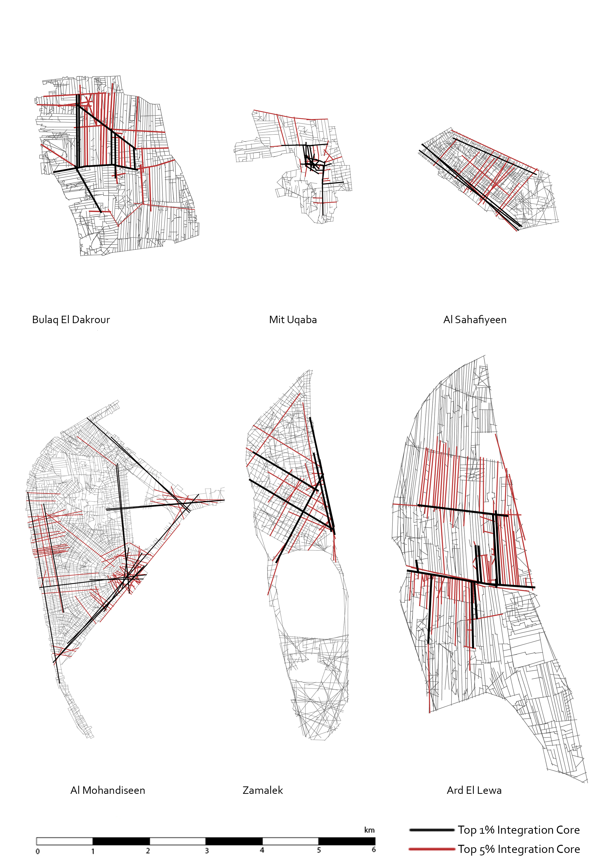
Figure 6: Axial Analysis of all the case studies in 2016

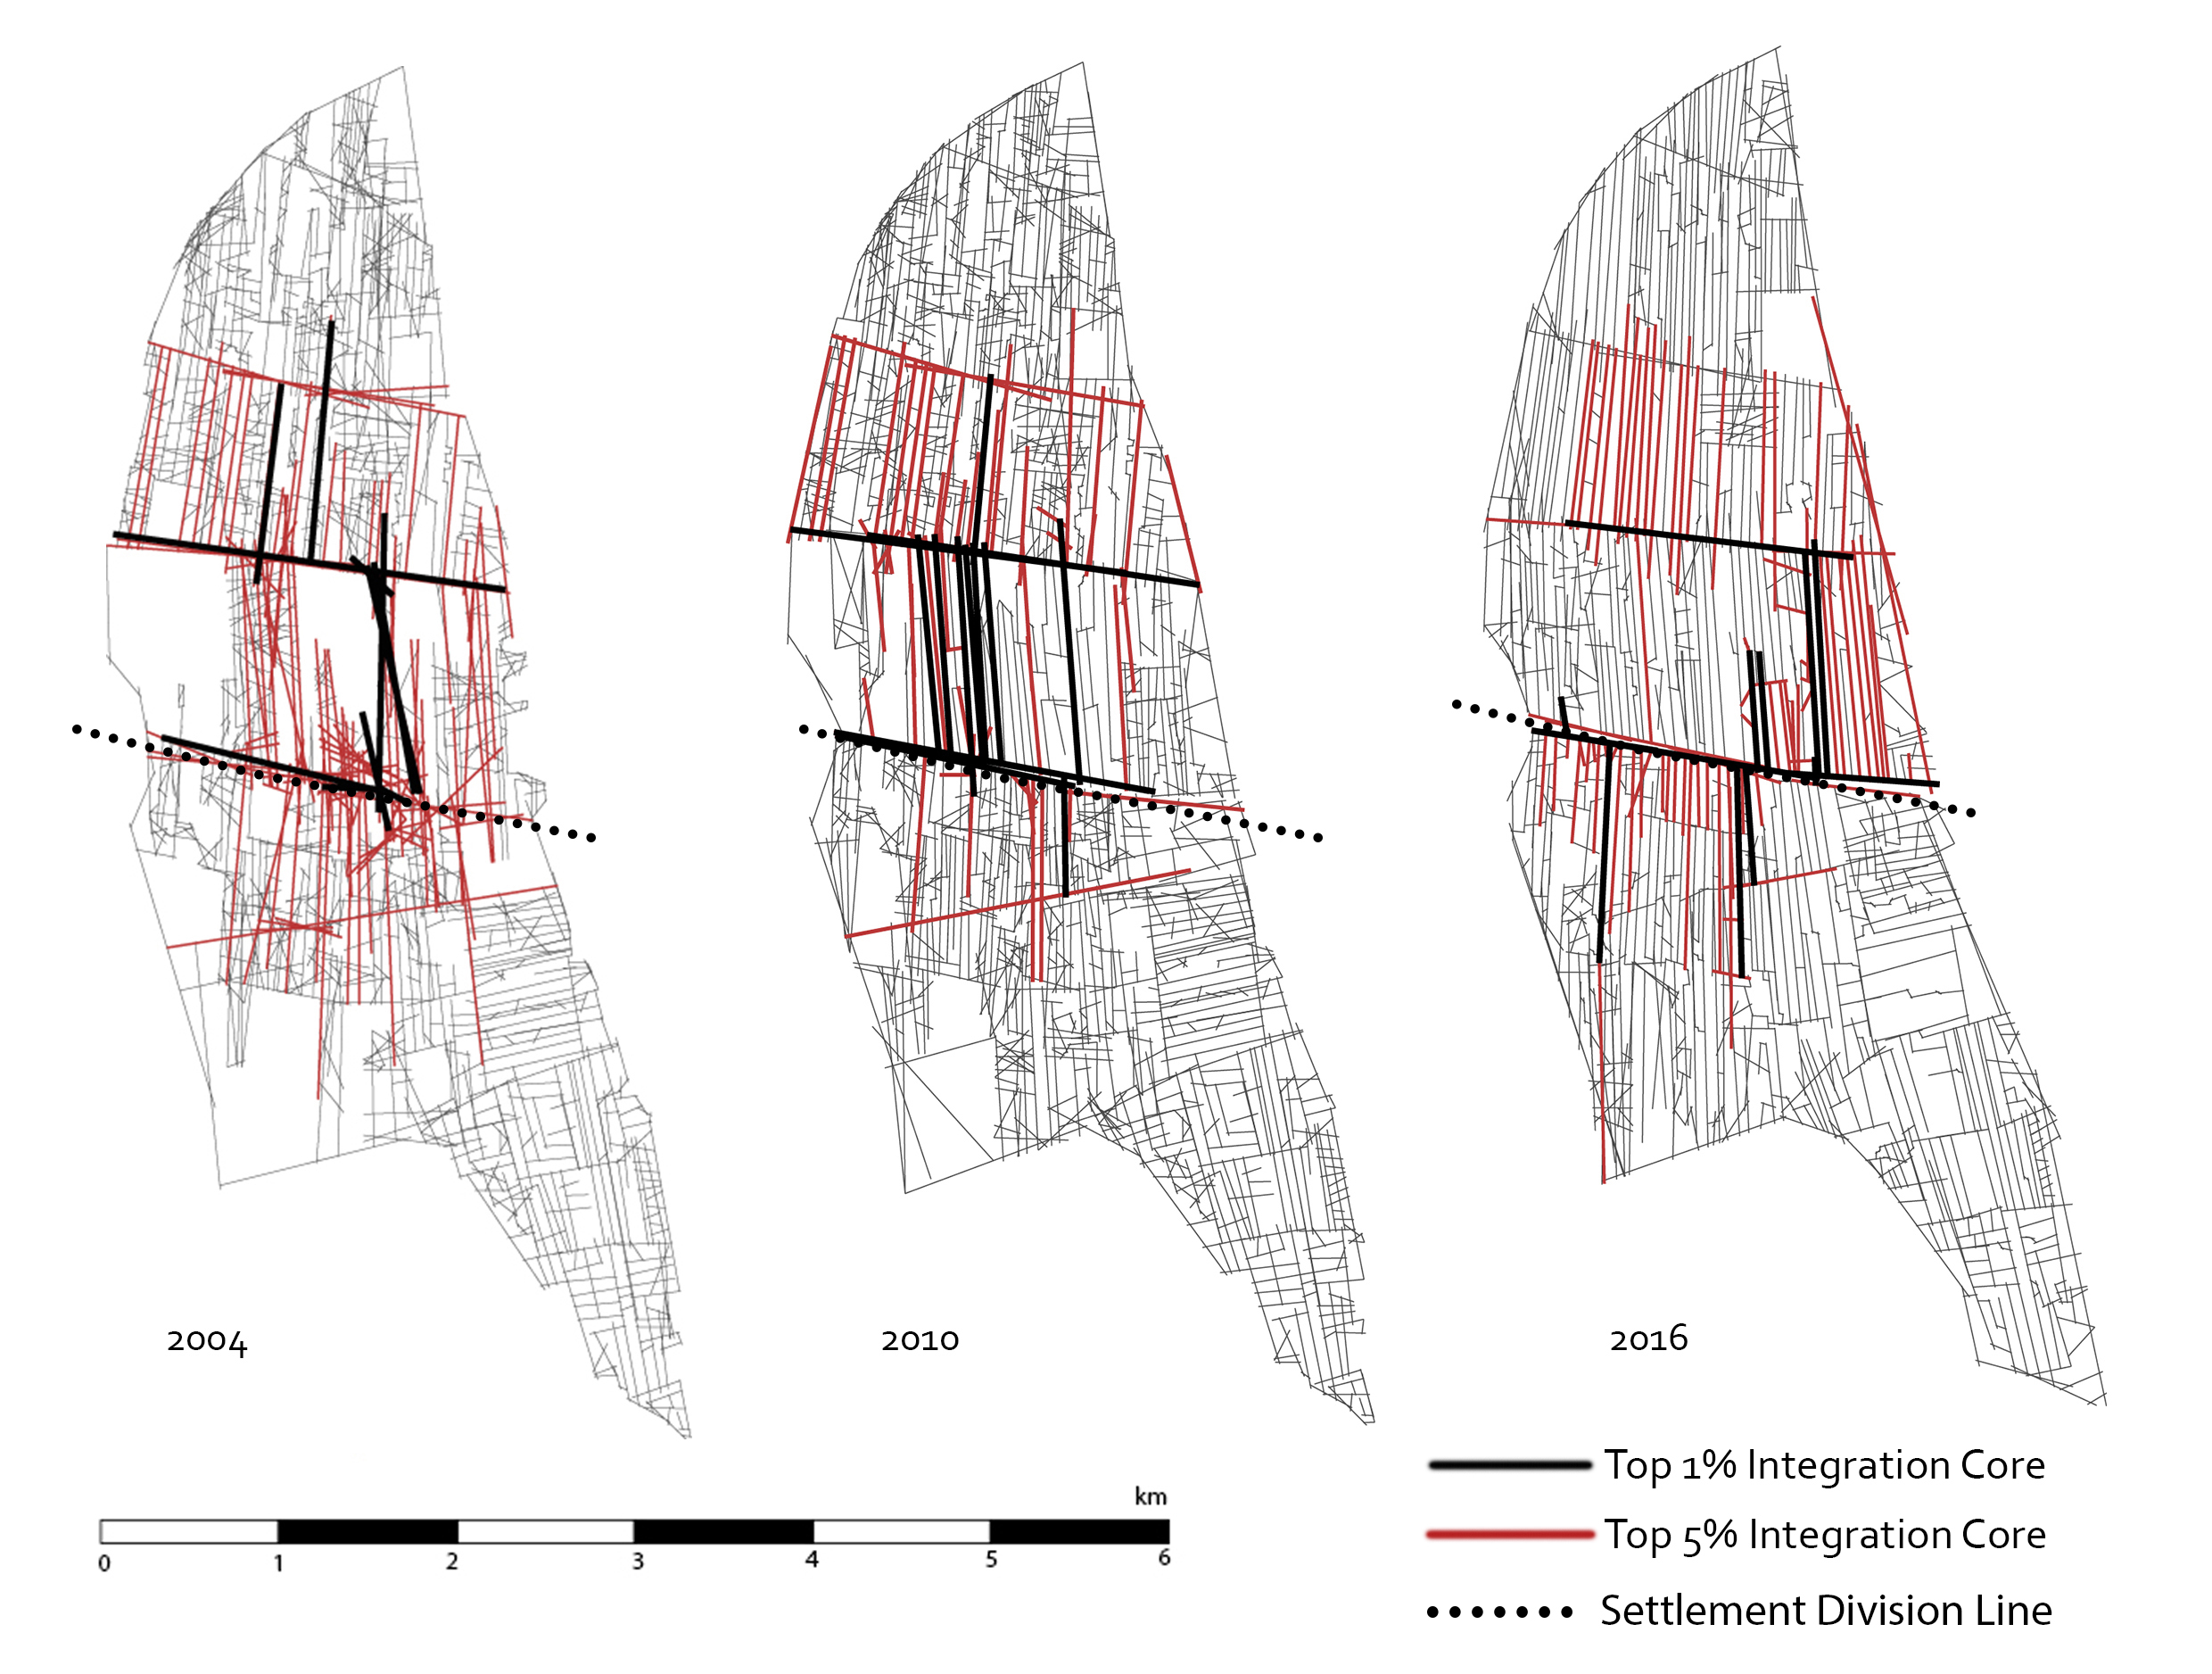
After completing the syntactical analysis, the results show different syntactical structures based on the original urban morphology. Planned settlements (Al Mohandiseen, Zamalek and Al Sahafiyeen) have more highly integrated movement thoroughfares but also a higher standard deviation, indicating that there are areas that have a high level of movement, and areas that experience a low level of movement and thus decreased integration with the rest of the neighbourhood. This increased integration could be because the planned settlements are connected to the highways so there is an opportunity for the edge movement to occur.
Figure 7: Axial Analysis of Ard El Lewa over 12 years
The organic settlement (Mit Uqaba) has the lowest level of global integration but also the lowest standard deviation in both local and global integration, indicating that the neighbourhood is integrated as a whole but the highway cutting through it and the lack of connection to Al Mohandiseen prevents it from being integrated into the wider urban fabric. The informal settlements are between the planned and organic settlements in terms of integration.
In terms of local integration, all the settlements have similar maximum integration and the standard deviation has increased, indicating that even in the informal settlements there are areas that are not well integrated into the neighbourhood. This is reflected in the syntactic structure of the different neighbourhoods. The informal and organic structure is more centralised and there is little movement on the edge of the neighbourhood, forming an incomplete deformed wheel structure. In contrast are the planned settlements, which have strong edge movement and spokes, connecting the edges together. In informal and organic settlements, the highways surrounding them become hard edges, disconnecting them from the city and supressing edge movement. In planned settlements (Al Mohandiseen, Zamalek and Al-Sahafiyeen), the highway acts as a connector since the settlements have access to the highway, promoting edge movement.
Looking at Ard El Lewa (fig. 7) shows the changes in the structure and integration that have taken place due to rapid growth. Due to the type of urban morphology, the growth was predictable, but rather than extending further outwards onto agricultural land, it is limited by the hard edge of the highway and so increases in density. In 2004 the structure was starting to extend outwards towards the edges, becoming more centralised in 2010 as the density started to increase and finally very centralised in 2016, the centre being the bridges that cross over the 26th July Corridor. While this may be the area that sees the most movement, it is also not a functional centre as technically it is where two edges meet.
As well as the changing structure, the integration is decreasing as time passes. This is due to the increasing density of the settlement, which leads to decreased legibility from a visitor’s point of view. The settlement becomes less permeable and therefore less integrated; there are fewer movement thoroughfares due to the extremely long, linear grid. However, the standard deviation is decreasing, indicating that the neighbourhood is becoming more integrated as a whole rather than scattered areas that are integrated and areas that are segregated.
5. THE CANALS AS SUPER-GRID
If compared with the image of the canals and roads it is clear that the highways are built where old roads and canals used to be. There are two interesting observations:
1 .The most integrated streets in the informal settlements (see fig 8) used to be canals
2. The most integrated streets in the planned settlements are ones that are connected to the highway system – which also used to be canals.
Following this analysis, it can be concluded that the canal system that existed in the early 20th century – used to irrigate the surrounding agricultural land – forms the basis of the “super-grid” that connects, or in this case disconnects, the city. This super-grid is reflected in both the planned highway system and the organically developed main streets in the informal settlements. Since the most integrated streets in the planned settlements are the ones that are connected to the super-grid, it can also be concluded that connecting the streets in the informal settlements to the highway grid (as was done in Ard El Lewa) will increase overall integration. Super-grids are usually created with the intention to create distinct neighbourhoods, only in this case the highways were created after the neighbourhoods with the intention to limit growth, becoming a boundary for separation rather than an interface for connection.
This creates an ‘incomplete’ super-grid that follows the pre-existing canal pattern but does not complete it, interrupting the connection between the local and primary streets (highways). The size of the super-block created by the highways super-grid varies between 1-1.6 km since the grid created by the highways is deformed and spaced at different intervals. Contrasting with this is the canal system in which there is more of a regular grid, on average 0.5km, since it is designed to connect all agricultural land to the water supply. However, the rural plots that form the streets are very narrow which would mean that there would be almost 65 local streets inserted into one super block as it stands now.

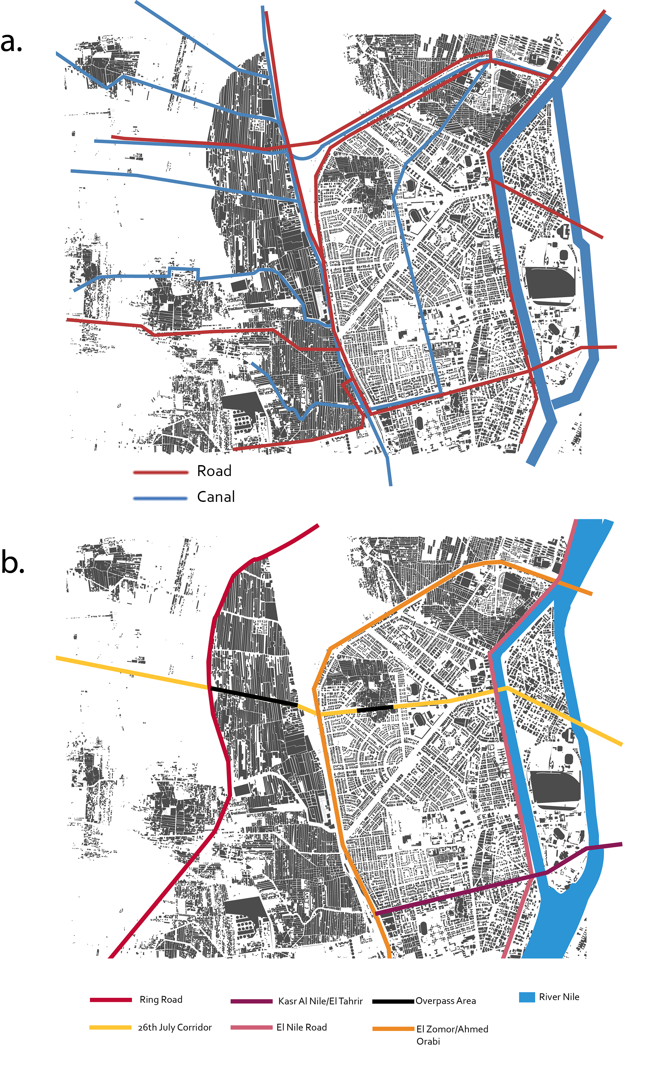
Figure 8: Map showing the Canals as they were in 1926 (a) (Source: Survey of Egypt) and the resulting highways in 2016 (b)
6. STITCHING APPROACHES
In this analysis, one stitching approach was tested. The 26th July Corridor was connected to the informal settlements (where it had previously overpassed) and a direct link created to the main Ard El Lewa Street that was formed from a canal. Minor adjustments were also made, the main streets in the informal settlements were also widened slightly so they can be represented by one axial line and more local streets were connected to the super-grid. These interventions were considered minor and theoretically feasible in a real life scenario.
Table 4: Integration values of the entire case study with and without the highway connection

 | No Highway Connection | Highway Connection
Max | 4.004 | 3.149
Avg. | 1.760 | 1.696
Min | 0.730 | 0.788
Std. Dev | 0.499 | 0.347
The results indicate that movement is spread throughout the neighbourhoods, instead of being concentrated in one planned settlement. The increase in integration is most noticeable in the informal settlements, which are seeing emergence of edge movement and a stronger connection to the planned settlements. There is also lower standard deviation, which indicates that there are fewer areas of extreme segregation. Figure 9 shows the increase in integration in informal settlements, and much higher integration in areas that were previously extremely segregated.
Figure 10 shows the changing syntactical structure of the neighbourhoods before and after connection. After connection, the centre of the neighbourhoods has shifted to an equal location and spokes have started to emerge into the informal settlements, indicating the potential for the deformed wheel structure to develop with further connection and intervention. While the changes are not major, there is significant change in both the syntactical structure and integration values of the neighbourhoods.
Another approach that was considered involved aligning the streets in the informal settlements, but this proved to be difficult due to the misalignment of the initial base grid and the formation of T-junctions (fig 4) that the settlement followed.
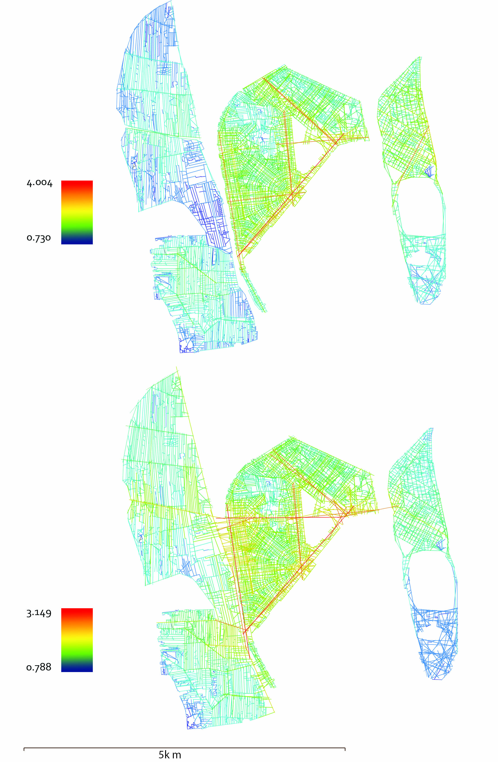Figure 9: Integration map after the addition of connecting highway (before – top, after-bottom)
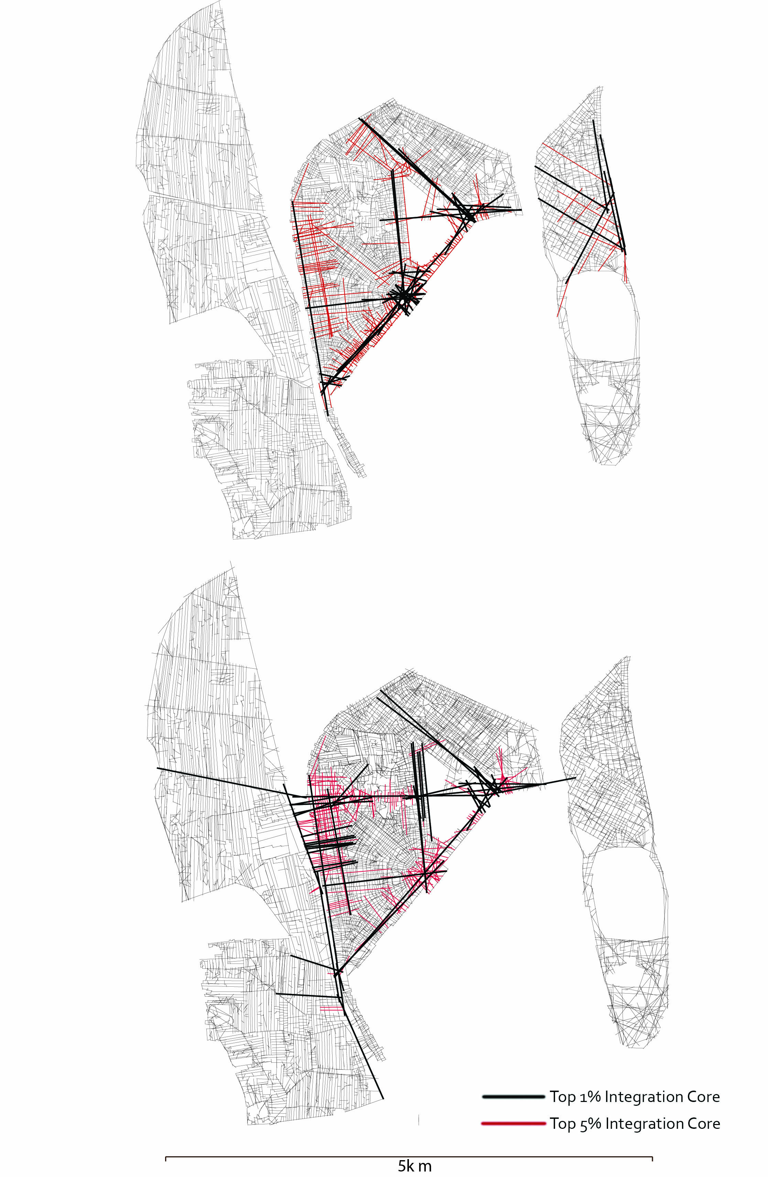Figure 10: Syntactic structure after the addition of the connecting highway
7. CONCLUSION AND DISCUSSION
The canal system in Cairo was designed to be connected to the Nile and the agricultural land and be an integrative, equal opportunities system, providing irrigation to the land. With the rapid expansion of Cairo during the 1950s, the canals started drying up and left paths where they used to exist. Due to political pressures and a negative view of informal settlements, some of these paths were used to build highways that overpassed informal settlements and created a hard edge around them to prevent growth and promote segregation. Edge movement, which is vital to consolidation into the main urban form, was supressed meaning that global integration and consolidation is not given an opportunity to form. The highways represent an ‘incomplete super-grid’ that does not create the necessary conditions for real superblocks to form, acting as a boundary to informal settlements and as a connector to planned settlements. In informal settlements, the main movement thoroughfares that emerged naturally are where the canals used to be, indicating that even though it was not planned, the canal system does in fact form the underlying global structure of this part of Cairo.

There are different approaches that can be taken to increase the integration of all settlements. The main approach would be completing the super-grid using the canal system that it’s based on, by using the main roads in informal settlements to link to the highway system, creating a regular super-grid and reducing the size of the super-blocks. Another approach would be promoting edge movement by increasing crossing points over the highways and incidence of local streets, tuning the relationship between the two grids as well as moving primary attractors to the edges. The super-grid can then be used to link the cores of the settlements and create edge movement, promoting a ‘deformed wheel’ global structure and increasing consolidation into the urban form, since syntactically they function well as discrete neighbourhoods. While one approach has been studied in this paper, further detailed study can be undertaken to determine the best stitching approach for different neighbourhoods. Further analysis is required before implementing such stitching approaches, and developing the Transformability index and route design (Karimi et al., 2007) has the potential for future scholarship.

The main limitation in this type of study is the accuracy and clarity of satellite imagery, especially historic imagery, which the analysis is based on. Care was taken to ensure that the maps are accurate and up to date in order to produce accurate results. Another limitation was the difficulty in analysing the super-grid because it is deformed and not spaced at regular intervals. This also means that it was not possible to compare it to similar super-grid analyses in other cities, but identifying the underlying structure of a deformed super-grid could be used to develop analysis tools to further the study of deformed, incomplete and naturally occurring super-grids. Using urban morphology as an analysis tool also highlights how super-grids can naturally occur, indicating that they are not just planned but rather can be an underlying system that actively shapes the morphology of the city.

The feasibility of implementing interventions should be considered, since prevailing negative attitudes against informal settlements means that it’s difficult to integrate socially between settlements, even though they may be physically connected. The nature of the highways may also need to be changed in order to connect them to the roads in the informal settlements, since they are designed for vehicular movement, not pedestrian. Thoroughfares that are parallel to the highways can be made, as well as increasing crossing points connecting the two sides together.
8. REFERENCES
Ben Nefissa, S. (2011). Cairo’s City Government: The Crisis of Local Administration and the Refusal of Urban Citizenship. In D. Singerman (Ed.), Cairo Contested: Governance, Urban Space and Global Modernity. American University in Cairo Press.
Bianca, S. (2000). Urban Form in the Arab World: Past and Present. vdf Hochschulverlag AG.
Bulaq | district, Cairo, Egypt. (n.d.). In Encyclopedia Britannica. Retrieved from https://www.britannica.com/place/Bulaq
ETH Studio Basel. (2008a). Islands of the Nile. In The Atlas of Cairo. Retrieved from http://www.studio-basel.com/assets/files/13_Atlas_IslandsOfTheNile_web.pdf
ETH Studio Basel. (2008b). Mohandessin. In The Atlas of Cairo. Retrieved from http://www.studio-basel.com/assets/files/files/08_Atlas_Mohandessin_web.pdf
Hillier, B., Greene, M., & Desyllas, J. (2000). Self-generated Neighbourhoods: the role of urban form in the consolidation of informal settlements. Urban Design International, 5(2), 61–96.
Hillier, B., & Stoner, T. (2010). SPACE SYNTAX －STRATEGIC URBAN DESIGN. City Planning Institute of Japan, Future of Urban Space and Humanity. Retrieved from http://www.cpij.or.jp/eng/file/hillier.pdf
Howeidy, A., Dina K. Shehayeb, Edgar Göll, Khaled Mahmoud AbdelHalim, Marion Séjourné, Mona Gado, … William Cobbett. (2009). Cairo’s Informal Areas: Between Urban Challenges and Hidden Potentials. (R. Kipper & M. Fischer, Eds.). Cairo: Participatory Development Programme in Urban Areas Framework. Retrieved from http://www.citiesalliance.org/sites/citiesalliance.org/files/CA_Docs/resources/Cairo’s%20Informal%20Areas%20Between%20Urban%20Challenges%20and%20Hidden%20Potentials/CairosInformalAreas_fulltext.pdf
Karimi, K., Amir, A., Shafiei, K., Raford, N., Abdul, E., Zhang, J., & Mavridou, M. (2007). EVIDENCE-BASED SPATIAL INTERVENTION FOR REGENERATION OF INFORMAL SETTLEMENTS. In Proceedings of the Sixth International Space Syntax Symposium, Istanbul: ITU Faculty of Architecture (pp. 034–1). Retrieved from http://www.spacesyntaxistanbul.itu.edu.tr/papers/longpapers/034%20-%20Karimi%20Amir%20Shafiei%20Raford%20Abdul%20Zhang%20Mavridou.pdf
Mohamed, A. A., Van Nes, A., Salheen, M. A., Khalifa, M. A., & Hamhaber, J. (2014). Understanding urban segregation in Cairo: The social and spatial logic of a fragmented city. In Proceedings of the 1st international conference of the CIB Middle East and North Africa Research Network‘ Smart, sustainable and healthy cities’, Abu Dhabi,(UAE), 14-16 December 2014. CIB Middle East and North Africa Research Network. Retrieved from http://repository.tudelft.nl/view/ir/uuid:8dd70034-c44e-4cb3-b54e-0650642d140b/
Mohamed, A. M. R., & Brown, F. E. (2009). The Urban Grid and its Consequences Assiut. In Proceedings of the 7th International Space Syntax Symposium. Stockholm, KTH. Retrieved from http://www.sss7.org/Proceedings/05%20Spatial%20Morphology%20and%20Urban%20Growth/077_Mohamed_Brown.pdf
Osman, T. (2010). Egypt on the Brink: From Nasser to Mubarak. Yale University Press.
Peponis, J., Feng, C., Green, D., Haynie, D., Kim, S. H., Sheng, Q., … Wang, H. (2015). Syntax and parametric analysis of superblock patterns. The Journal of Space Syntax, 6(1), 109–141.
Sims, D. (2010). Understanding Cairo: The Logic of a City Out of Control. American University in Cairo Press.
Singerman, D., & Amar, P. (2006). Cairo Cosmopolitan: Politics, Culture, and Urban Space in the New Globalized Middle East. American Univ in Cairo Press.
Tadamun. (2013). Mīt `Uqba. Retrieved from http://www.tadamun.info/?post_type=city&p=260&lang=en

