Reversible Tensile Strengthening of Full-Scale Timber Beams with Mechanically Attached GFRP Composite Plates

PUPSYS Tomas1,a\***,** CORRADI Marco2,b, BORRI Antonio3,c and AMESS Leon4,d

1 Dept. of Mechanical & Construction Engineering, Northumbria University, Wynne-Jones Building, NE1 8ST Newcastle Upon Tyne, United Kingdom

2 Dept. of Engineering, Perugia University, Via Duranti, 92 06125 Perugia, Italy and Dept. of Mechanical & Construction Engineering, Northumbria University, Wynne-Jones Building, NE1 8ST Newcastle Upon Tyne, United Kingdom

3 Dept. of Engineering, Perugia University, Via Duranti, 92 06125 Perugia, Italy

4 Dept. of Mechanical & Construction Engineering, Northumbria University, Wynne-Jones Building, NE1 8ST Newcastle Upon Tyne, United Kingdom

a pup.tomas94@gmail.com, b marco.corradi@unipg.it, cantonio.borri@unipg.it, dleon.amess@northumbria.ac.uk

* corresponding author

**Keywords:** Timber, Mechanical Testing, GFRP, composite materials.

**Abstract.** Results of bending tests aimed at improving the flexural behaviour of the timber beams reinforced with GFRP (Glass Fiber Reinforced Polymer) composite plates externally attached using mechanical joints are presented in this paper. Modest ratios of GFRP composite reinforcement can increase beam load-carrying capacity and manipulate failure mode from brittle tensile in the unreinforced beam to a more extensible failure in the strengthened timber beams. Application of mechanical joints presents a solution of reversibility, compatibility and durability for reinforced timber. The experimental campaign focuses on load-deflection relationship and failure modes in order to increase the loading capacity and stiffness of the timber beam. Oak beams with dimensions 145 x 145 x 2450 mm were reinforced with un-bonded pultruded GFRP plates. Speciality coach screws 16 mm diameter, 130 mm length, grade 8.8, were used to reversibly attach the reinforcement with fender washers having outer diameter 34 mm to distribute the load away from the screw position. All beams were tested until failure under the four-point bending arrangement. Experimental results demonstrate the effectiveness of the reinforcement method and ability to reversibly repair timber, representing a capability to be utilised in the new construction or restoration of timber structures.

Introduction

Timber has an important role in construction since ancient times. As a building material, it possesses desirable mechanical properties, such as tensile and compressive resistances and low material density. As a result of fast growth rates, timber is cheap and can be easily processed, enabling large production volumes. As a renewable material, it is extensively used for structural components, building constructions and a wide range of other engineered wood applications (e.g. bridges, floors, trusses etc.).

Nevertheless, the organic nature of timber may result in degradation of the mechanical properties during the life cycle, hence, it is expected to distort during seasoning. Biological attacks (fungi, insects, bacteria), natural defects (grain deviation, knots, etc.) and environmental conditions may also highly impact mechanical properties, thus reducing the tensile strength as much as 90 %.

Research on timber reinforcement is ongoing for many years. Reinforcement application is employed in new constructions and restoration of old timber constructions. In the last two decades, the use of composite materials to increase the bending capacity and stiffness received much attention [1-7]. Timbers repaired with Carbon Fiber Reinforced Polymer (CFRP) plates were analysed by D’Ambrisi et al. [8]. Two series of tests were carried out to determine the effectiveness of repair and flexural strengthening using CFRP reinforcement. Small grooves were made in the tension zone to insert CFRP plates, with different types of strengthening configurations.

An attempt in timber strengthening techniques was made by de la Rosa García et al. [9]. Basalt and carbon fiber composites were used to reinforce pine beams in single point load bending tests. “U” shape layout of fiber reinforcement was used to increase the capacity to absorb tensile stress and ductility. The study focused on the effect of different grammage and fiber distribution (unidirectional and bidirectional) of the composites.

Another investigation aiming to compare numerical analysis to the experimental work was conducted by Kim and Harries [10]. Unidirectional CFRP reinforcement was glued to the timber beam which was modelled to have orthotropic constitutive characteristics. The four-point bending scheme was implemented to study timber beam response to the stress resulting in beam deflection and failure. The application of composite sheets by bonding have been also investigated my numerous researchers [11-15].

Imperative issues in this field remain outstanding. For instance, the utilisation of FRP composites to strengthen timber beams without natural oil-based adhesives (e.g. epoxy resins) is less researched. A competitive technique using natural fibres with non-organic matrixes or mechanical shear connectors has been researched [16], which aimed at investigating the effect of the use of organic oil-based fibres (e.g. CFRP) or resins. However, adhesive loses bonding properties with age, it has poor temperature resistance and method is not reversible. The use of composite materials on historical constructions is highly constrained by governmental and local conservation bodies, which tend not to authorise the use of organic adhesives due to low reversibility [17]. Ethical guidelines for works on historical heritage specify minimal intervention and use of appropriate materials, implementing fully-reversible methods.

Sustainability is another positive aspect of the project. Preservation and use of timber are desirable for environmental impact [18]. Timber absorbs fifteen times as much CO2 as it emits to the atmosphere during the wood life cycle. Due to composition and nature of the timber, the disposal is environmentally friendly and the green building material is recyclable.

The solution of reversible Oak beam reinforcement with GFRP composite plates is presented in this paper. This work is the continuation of a similar investigation conducted on softwood (fir) beams reinforced with unbounded GFRP plates and presented in [19]. Distinct testing configurations were used for tension and lateral side reinforcements. Reinforcement can be removed if needed, since the strengthening plates were fixed mechanically, meeting ethical guidelines and requirements specified above.

Materials

Twenty full-scale Oak beams were tested to failure. Sixteen beams were pre-drilled and reinforced with GFRP pultruded plates. Lateral and tensile reinforcement configurations of pre-drilled GFRP plates were attached to the timber with metal coach screws applied in distinct geometrical arrangements.

Strength class D30 [20] Oak beams were 145 x 145 x 2450 mm in dimensions, with sharp corner edges (Fig. 1). Beams were found on the UK market and bought in May 2015. Hardwood is usually characterised by higher mechanical properties compared to softwood. However, uncertainties are usually more significant compared to softwood like fir, larch and pine woods. Grain deviation and dimensions of the knots are larger, but the density of the knots is usually lower.

The application of high ultimate tensile strength occupying pultruded GFRP profiles enhances flexural and loading capacities of relatively brittle materials. The current market price of grade E23 GFRP plates is approx. 6.4 €/m (for a cross section of 80 x 8 mm). The popularity of FRP reinforcement on timber is largely due to the economy in terms of material costs and human labour. Reinforcement installation is faster than alternative strengthening methods, it can be easily made on-site without removal of the pre-existing timber beams from service.

Galvanised coach screws grade 8.8 [21] (Fig. 2), 16 mm diameter, 130 mm length were used to connect the timber to the composite plate. Hardwood beams were retrofitted using four different reinforcement layouts (Fig. 3): one made of a single GFRP plate applied on the tension side (Fig. 3a) and the remaining using 2 GFRP plates (Fig. 3b,c,d). Four different screw arrangements on the GFRP plate were considered. According to the first arrangement (SC_1), two screws were attached at each end with a centre-to-centre distance of 80 mm. All screws were positioned 40 mm from plate’s edges and 50 mm from the end. The identical spacing arrangement was used in the second arrangement (SC_2) with 3 shear connector at each end. According to the third screw configuration (SC_3), 8 fasteners were applied in two rows, 4 at each end with 80 mm centre-to-centre distance. Screws rows were positioned 20 mm from the plate edges with 50 mm end distance. Fourth screw arrangement was used for lateral reinforcement on the sides of the beam. Six screws were attached along the plate with a centre-to-centre distance of 380 mm and 50 mm distance from the end (SC_4). Plates on each side were shifted by 95 mm from the timber centre line in opposite directions on opposite sides, leaving 190 mm distance between the holes in the timber.

|  |  |
| --- | --- |
|  | Fig. 2. 16 mm diameter, 130 mm length, grade 8.8. |
| Fig. 1. Oak (hardwood) beams. | a)  b)  c)  d) |

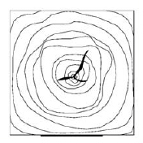

b)

d)

a)

c)



|  |  |
| --- | --- |
| Fig. 3. GFRP plate reinforcement layouts: a) Single-Tension, b) Double-Tension, c) Double-Side by side, d) Double-Side. | Fig. 4. Screws arrangements: a) SC_1, b) SC_2, c) SC_3, d) SC_4. |

Test Setup

Four series of physical tests were conducted on simply supported unreinforced and reinforced beams. Four-point bending tests were executed, following UNI EN 408 standard [22]. Timber beams were monotonically loaded until failure with 500 kN capacity having hydraulic actuator, containing a load cell which recorded the load applied. Controlled crosshead loading speed ensued displacement rate of 4 mm/min. Effective span length was set to be 2310 mm. The load from the actuator was distributed into two concentrated loads applied at 770 mm distance from each support with an H-shape steel beam acting as a load spreader. Local wood crushing was minimised with two square prism timber pads, having a cross-section of 65 x 65 mm.

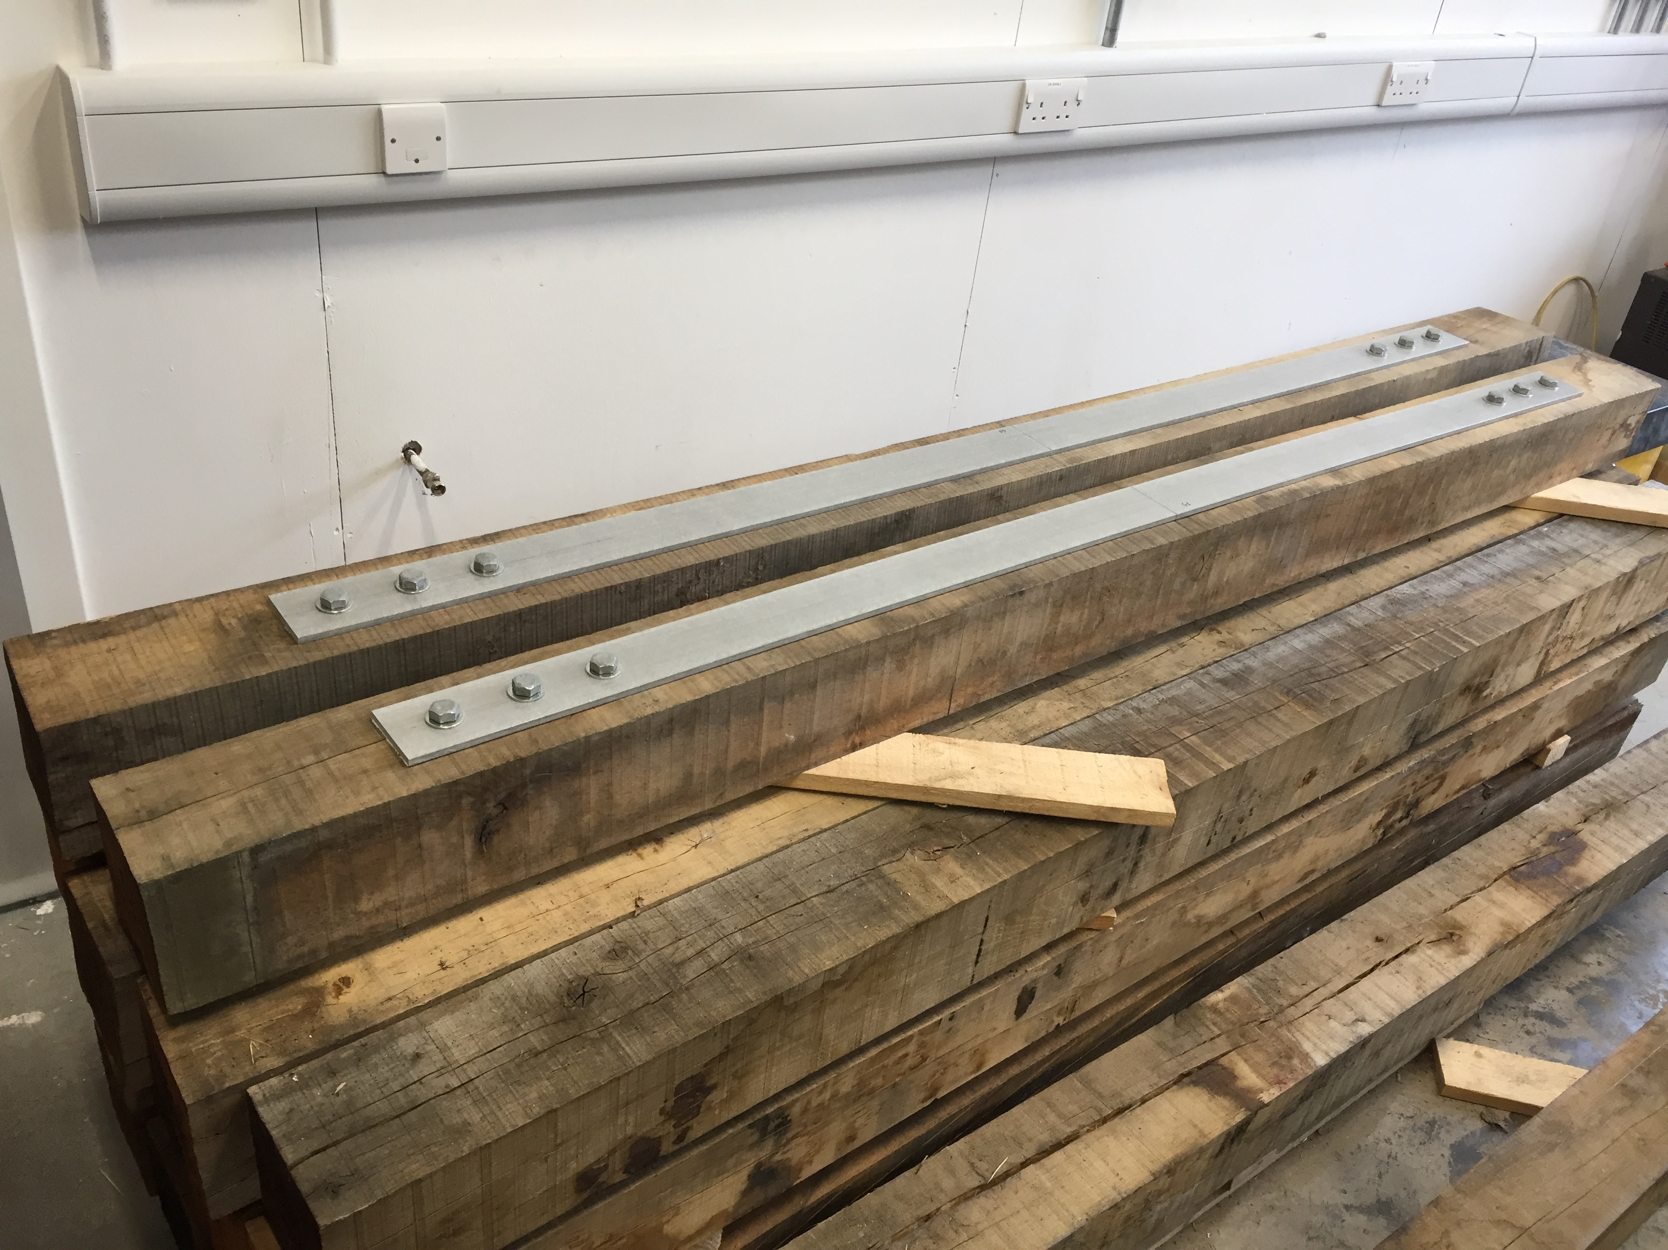The vertical displacement of the beams was recorded with Linear Variable Differential Transducers (LVDT). Two LVDTs were installed on each side of the beam near the neutral axis with L-shape metal brackets to obtain the deflection at the mid-span. The mean value of two vertical displacements at the mid-span on each side was determined.

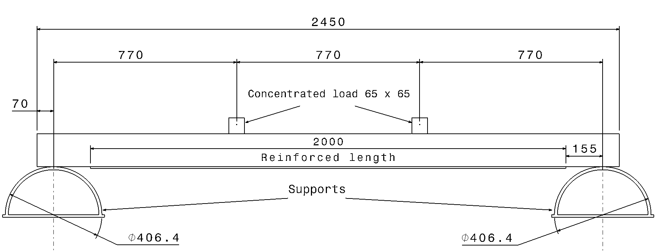

|  |  |
| --- | --- |
| Fig. 5. Four-point bending configuration (dimensions in mm). | Fig. 6. Reinforced beam. (screw configuration SC_2). |

Mechanical properties of the timber were partially evaluated according to ASTM D143 [23]. A parallel to the grain compressive strength of 31.7 MPa (Coefficient of Variation (CoV) = 7.9%) was measured from prismatic test specimens (20x20x60 mm). After an outdoor seasoning duration of twenty months, weight density was measured (833kg/m3, with a Standard Deviation of 63.9 kg/m3) before reinforcement application. Timber moisture content (14.10 %) was determined in accordance with EN 13183-1 standard [24].

Test Results

**Unreinforced beams.** Bending load was subjected on 4 unreinforced beams to study the bending behaviour and measure the mean flexural strength. Test results were processed and the bending strength, *fm* was determined with the formula:

 (1)

where *Fu* is the ultimate load (N), *a* is the distance between the point of the load and the nearest support (770 mm) and *W* is the resistance modulus of the section (= 1453/6 mm3) about the neutral axis. The average maximum (failure) load of un-reinforced beams was 43.52 kN, with a low CoV of 12.7 %. All results of unreinforced beam testing are given in Table 1. In this table, the results are reported in terms of a mean bending strength value (*fm*) and stiffness (Young’s Modulus). Initially, bending load and deflection relationship at the mid-span was linear. Increasing the load resulted in yielding in the compression region and the tensile failure occurred once the tensile strength was exceeded. Beam carrying loads and the failures mode were influenced by the grain deviation, knots, splits or cracks.

**Reinforced beams.** 16 timber beams were reinforced with fiberglass a 80x8x2000 mm (GFRP) pultruded plate (single or double), which comply with EN 13706 specifications for pultruded profiles [25]. Fiberglass composite weight density of 1873 kg/m3 was recorded. Mechanical characteristics of the GFRP were determined according to the procedure outlined in the ASTM Standard D3039 [26]: compressive strength 347.4 MPa, tensile strength 351.2 MPa. Pre-drilled 2 m length composite plates were fastened to the pre-drilled timber beams by hand. The consistent torque of 150 Nm was applied to each screw in all screw configurations. Bending test on reinforced beams were conducted according to the same testing arrangement as unreinforced beams.

Table 1. Results of bending tests.

|  |  |  |  |  |  |  |  |
| --- | --- | --- | --- | --- | --- | --- | --- |
| **Beam Index** | **Beam weight [kg]** | **Reinforcement Type** | **Max Load Fu [kN]** | **Deflection at failure [mm]** | **Bending Strength [MPa]** | **Young's Modulus [MPa]** | **fm,reinf /  fm,unreinf [-]** |
| UNR_1 | 41.4 | - | 67.23 | 44.91 | 50.95 | 11217 | - |
| UNR_2 | 41.4 | - | 47.42 | 45.73 | 35.93 | 7596 | - |
| UNR_3 | 49.1 | - | 46.88 | 31.99 | 35.52 | 9633 | - |
| UNR_4 | 44.6 | - | 64.37 | 30.71 | 48.74 | 12653 | - |
| UNR_5 | 41.1 | - | 55.42 | 45.45 | 42.00 | 7555 | - |
| Average | 43.52 | - | 56.26 | 39.76 | 42.63 | 9731 | - |
| RES_6SC_1 | 43.1 | Single - tension | 54.29 | 44.50 | 41.14 | 8233 | 0.97 |
| RES_7SC_1 | 48.3 | Single - tension | 85.70 | 55.51 | 64.94 | 13441 | 1.52 |
| RES_8SC_2 | 40.1 | Single - tension | 63.86 | 52.77 | 48.36 | 9723 | 1.13 |
| RES_9SC_2 | 44.0 | Single - tension | 102.72 | 60.41 | 76.55 | 13349 | 1.80 |
| RES_10SC_3 | 44.1 | Single - tension | 112.46 | 69.36 | 85.18 | 15384 | 2.00 |
| RES_11SC_3 | 46.9 | Single - tension | 58.10 | 37.85 | 44.02 | 9775 | 1.03 |
| Average | 44.84 | - | 79.52 | 53.40 | 60.03 | 11651 | 1.41 |
| RED_12SC_2 | 43.7 | Double - tension | 109.46 | 24.11 | 82.90 | 16085 | 1.94 |
| RED_13SC_2 | 40.4 | Double - tension | 82.62 | 44.48 | 61.43 | 13428 | 1.44 |
| RED_14SC_3 | 49.3 | Double - tension | 73.63 | 44.55 | 55.76 | 10932 | 1.31 |
| RED_15SC_3 | 45.8 | Double - tension | 83.01 | 63.22 | 58.65 | 11274 | 1.38 |
| RED_16SC_2 | 44.9 | Side by side - tension | 107.67 | 63.70 | 81.55 | 15620 | 1.91 |
| RED_17SC_2 | 44.1 | Side by side - tension | 90.23 | 61.19 | 67.72 | 13519 | 1.59 |
| Average | 44.70 | - | 91.10 | 50.21 | 68.00 | 13476 | 1.60 |
| REL_18SC_4 | 48.0 | Double Lateral - side | 76.84 | 54.46 | 58.18 | 11860 | 1.36 |
| REL_19SC_4 | 50.9 | Double Lateral - side | 81.25 | 70.04 | 61.53 | 14080 | 1.44 |
| REL_20SC_4 | 44.2 | Double Lateral - side | 96.78 | 74.66 | 73.31 | 13586 | 1.72 |
| Average | 47.70 | - | 84.96 | 66.39 | 64.34 | 13175 | 1.51 |

The application of a single GFRP plate on the beams’ tension side produced a capacity increment of 41% (Tab. 1) with a CoV of 14.2 %. Six timber beams were tested according to this reinforcement configuration. Negligible variations in the bending behaviour was recorded when different screw configuration were used (SC_1, SC_2 or SC_3) highlighting the fact that the failure does not initiate in the area around the screw for hardwood. Beam failure always occurred in the timber material on the tension side.

For beams reinforced using two GFRP plates on the tension side (overlapped for beams No. 12, 13, 14 and 15) or side by side (for beams No. 16 and 17) a further capacity increment was recorded (+60% compared with unreinforced beams). While the capacity increment (compared with single-plate reinforcement) was limited (from 79.52 kN to 91.1 kN), the stiffness increment was noticeable and of interest for reinforcement interventions where the reduction of the beam deflection under service loads is the main target.

Finally, for beams reinforced using two GFRP plates mechanically fixed on the beam lateral sides (Screw arrangement SC_4), a lower bending behaviour was recorded compared to a double-reinforcement applied on the tension side, both in terms of capacity and Young’s modulus.

The failure mode was not impacted by the screw configurations. In most of the cases, the failure occurred in the wood material, without attaining the ultimate tensile strength of the GFRP plate. When the failure of the reinforcing plate is neglected due to its high tensile strength, two distinct failure mechanisms are possible: failure of the wood in either tension or compression regions due to exceeded tensile and compressive strengths of the wood. The two stress limits were often attained consecutively: experimental tests showed that tensile timber failure was the most frequent failure mechanism, but this was preceded by a partial plasticization of the timber material at the compression region for both, unreinforced and reinforced beams.

The application of the FRP reinforcement resulted in a shifting of the neutral axis position towards the tensile region and an increase in the beam loading capacity, as shown in Fig. 7. The increment in the bending stiffness was also significant. Analysing the distribution of forces over the entire section, the effectiveness of the reinforcement applications was confirmed. The ultimate resisting moment was improved by the contribution of an additional tensile force (F3).



Fig. 7. Distribution of stress and strain on the cross section (single-tension reinforcement SC_1).

Furthermore, this reinforcement allowed a greater axial deformation in the compression region, as a result of the increase in the displacement of the wood fibers in compression. Reinforcement application may be especially effective for low-grade timbers with defects, for instance, for timber having an ultimate tensile to compressive stresses ratio approx. to 1. When timber yielded on the compression side, the values of forces F1, F2 and F3 were very high. However, the point of application of force F1 moved downward causing a decrease of the offset of internal forces. Force F3, generated by the FRP reinforcement, allowed an increase in the resisting moment.

The application of the composite reinforcement had several positive effects: 1) Bending capacity of the beam was significantly increased; 2) Reinforced beams exhibited a more ductile behaviour, as a higher degree of yielding was possible on the beams in compression.

It can be also noted that both, unreinforced and reinforced timber beams were tested over a 2310 mm span. This reduced the probability of the presence of a critical defect in timber, decreasing the uncertainty of timber beams, particularly when unreinforced. It is likely that with longer spans uncertainty of unreinforced beams will increase and the positive effect of the composite reinforcement should be even more noticeable.

By comparing these results with the ones reported in [9] for softwood beams reinforced with bonded composite sheets, it can be noted that the increments in the bending capacity were larger when the FRP reinforcement was bonded on the tension side with an epoxy adhesive. The role of the resin seems to be crucial in both the stress transfer (FRP-timber) and in confining local ruptures in the timber.

With regard to the flexural stiffness *r*, the application of a FRP reinforcement did cause a significant increase in the mean value of this mechanical property. Flexural stiffness was calculated from the bending load *F* and deflection ( graph by considering the slope of the secant line between *Fa =0.1 Fu* and *Fb =0.4 Fu*:

 (2)

where  and  are the deflection values corresponding to *Fa* and *Fb* respectively.

GFRP reinforcement also produced an increase of the flexural stiffness (*r* increment = approx. 19.7 %, 38.49 % and 35.39 % for the single, double and lateral reinforcements respectively) based on the fact that the reinforcement area fractions were very large.

Summary

The mechanical behaviour of a solid Oak (hardwood) beams strengthened with pultruded GFRP profiles was investigated in this paper. Metal coach screws were used to anchor the reinforcement at the tension side of the timber. Retrofitting method meets the requirements of the conservation bodies in terms of restricted intervention, high reversibility and limited alteration of the original pre-existing timber structure. Furthermore, reinforcement method described in this paper can be executed without removal of the pre-existing timber beams from service, facilitating the conservation of original historic structure, as only the tension or the neutral faces of the timber need to be processed for reinforcement operations. Reinforcement technique is economic and easy in relation to other strengthening methods employing epoxy adhesives. However, the higher effectiveness of reinforcement is achieved using epoxy adhesives, since perfect bonding throughout the length of reinforcement is achieved and two components (timber and GFRP plate) act as one.

The results of this test program indicate that the proposed strengthening method is able to increase both flexural stiffness and strength on unreinforced hardwood beams. Pultruded GFRP profiles enhanced the capacity of the hardwood beams, but reinforcement effectiveness is directly related to the configuration of the reinforcement. The design of the connection between the composite plate and the timber substrate is a major factor to the reinforcement performance. Slippage may easily compromise the effectiveness of the GFRP reinforcement preventing the transfer of the shear stresses from the hardwood beam to the fiberglass plate.

Acknowledgements

The authors acknowledge the support of the Structures Laboratory at Northumbria University (UK) for the use of the test equipment. This project was partially sponsored by the UoA15 of Northumbria University. The authors wish to record their appreciation to Prof. Ruth Dalton and Prof. Robert Dominy of Northumbria University. The authors are also grateful for continuing support from colleagues in the Mechanical & Construction Engineering Department.

References

[1] M. Corradi, A. Borri, Fir and chestnut timber beams reinforced with GFRP pultruded elements, Compos. Part B-Eng. 38 (2007) 172-181.

[2] G.M. Raftery, A.M. Harte, Low-grade glued laminated timber reinforced with FRP plate, Compos. Part B-Eng. 42 (2011) 724-735.

[3] C. Gentile, D. Svecova, S.R. Rizkalla, Timber beams strengthened with GFRP bars: development and applications, J. Compos. Constr. 6 (2002) 11-20.

[4] A. Borri, M. Corradi, A. Grazini, A method for flexural reinforcement of old wood beam with CFRP materials, Compos. Part B-Eng. 36 (2005) 143-153.

[5] F. Micelli, V. Scialpi, A. La Tegola, Flexural reinforcement of glulam timber beams and joints with carbon fiber-reinforced polymer rods, J. Compos. Constr. 9 (2005) 337-347.

[6] G.M. Raftery, C. Whelan, Low-grade glued laminated timber beams reinforced using improved arrangements of bonded-in GFRP rods, Constr. Build. Mater. 52 (2014) 209-220.

[7] L. Righetti, M. Corradi, A. Borri, Bond strength of composite CFRP reinforcing bars in timber, Materials 8 (2015) 4034-4049.

[8] A. D’Ambrisi, Focacci F, L. Raimondo, Experimental investigation on flexural behavior of timber beams repaired with CFRP plates, Compos. Struct. 108 (2014) 720-728.

[9] P. de la Rosa García, A. Cobo Escamilla, M.N. González García, Bending reinforcement of timber beams with composite carbon fiber and basalt fiber materials, Compos. Part. B: Eng. 55 (2013) 528-536.

[10] Y.J. Kim, K.A. Harries, Modeling of timber beams strengthened with various CFRP composites, Eng. Struct. (2010) 32 3225-3234.

[11] S. Hay, K. Thiessen, D. Svecova, B. Bakht, Effectiveness of GFRP sheets for shear strengthening of timber, J. Compos. Constr. 10 (2006) 483-491.

[12] J. Jasieńko, T.P. Nowak, Ł Bednarz, Baroque structural ceiling over the Leopoldinum Auditorium in Wrocław University: tests, conservation, and a strengthening concept, Int. J. Archit. Herit. 8 (2014) 269-289.

[13] D.W. Radford, D. Van Goethem, R.M. Gutkowski, M.L. Peterson, Composite repair of timber structures, Constr. Build. Mater. 16 (2002) 417-425.

[15] K.U. Schober, A.M. Harte, R. Kliger, R. Jockwer, Q. Xu, Chen JF. FRP reinforcement of timber structures, Constr. Build. Mater. 97 (2015) 106-118.

[16] A. Borri, M. Corradi, E. Speranzini, Reinforcement of wood with natural fibres, Compos. Part B-Eng. 53 (2013) 1-8.

[17] P. Munafò, F. Stazi, C. Tassi, F. Davì, Experimentation on historic timber trusses to identify repair techniques compliant with the original structural–constructive conception, Constr. Build. Mater. 87 (2015) 54-66.

[18] L. Wang, A. Toppinen, H. Juslin, Use of wood in green building: a study of expert perspectives from the UK, J. Clean. Prod. 65 (2014) 350-361.

[19] M. Corradi, A. Borri, G. Castori, E. Speranzini, Fully reversible reinforcement of softwood beams with unbonded composite plates, Compos. Struct. 149 (2016) 54-68.

[20] EN 338:2009. Structural timber - Strength classes.

[21] EN 14399:2005 High-strength structural bolting assemblies for preloading.

[22] EN 408:2010. Timber structures. Structural timber and glued laminated timber: determination of some physical and mechanical properties.

[23] ASTM D143:2009. Standard test methods for small clear specimens of timber.

[24] EN 13183-1:2002. Moisture content of a piece of sawn timber. Determination by oven dry method.

[25] EN 13706-1:2002. Reinforced plastics composites. Specifications for pultruded profiles. Designation

[26] ASTM D3039:2009. Standard test method for tensile properties of fiber-resin composites.