Consumption of Fish and Vascular Risk Factors: A Systematic Review and Meta-analysis of Intervention Studies

Alhassan A¹, Young J¹, Lean M², Lara J¹
¹ Department of Applied Sciences, Faculty of Health and Life Sciences, Northumbria University, Newcastle upon Tyne, UK
2 School of Medicine Dentistry & Nursing, Glasgow University, Glasgow Royal Infirmary, Glasgow, UK
Email addresses:
jose.lara@northumbria.ac.uk
aboorh_484@hotmail.com
Mike.Lean@glasgow.ac.uk
julie2.young@northumbria.ac.uk
Corresponding author:
Dr Jose Lara
Department of Applied Sciences, Faculty of Health and Life Sciences, Northumbria University, Ellison Building, Room A324, Newcastle upon Tyne, NE1 8ST, UK.

Abstract
Background and aims
Epidemiological evidence of the beneficial health effects of fish consumption is strong, but the evidence from intervention trials is less documented. Our aim was to evaluate the state of the evidence on the potential effects of fish consumption on vascular risk factors arising from intervention trials.
Methods
A systematic literature search was undertaken in OVID MEDLINE, Scopus, and EMBASE which were searched from inception to June 2017. A meta-analysis of intervention trials was performed to estimate the effect of fish consumption on vascular risk factors in adults (age >18 years). Primary outcomes included lipid biomarkers such as triglycerides, total cholesterol, HDL cholesterol and LDL cholesterol, and also novel biomarkers of vascular risk. Secondary outcomes were related to feasibility and acceptability aspects of these interventions. Random-effects models were used to determine the pooled effect sizes.
Results
14 trials, including a total of 1378 individuals, fulfilled the inclusion criteria for this study. Consuming oily fish was associated with significant reductions in plasma triglycerides (-0.11 mmol/L; 95%CI -0.18 to -0.04; P= 0.002). While a significant increase in HDL-cholesterol was observed (0.06 mmol/L, 95%CI 0.02 to 0.11; P= 0.008). No significant effect could be observed on other vascular risk factors.
Conclusion
This study showed that there is evidence indicating that consuming oily fish lead to significant improvements in two important biomarkers of cardiovascular risk, such as triglycerides and HDL levels. These results strongly support the important role for oily fish as part of a healthy diet.
Keywords: Fish Consumption, Cardiovascular Markers, Intervention, Systematic review, Meta-analysis

Introduction
Fish consumption is associated with cardiovascular disease (CVD) risk reduction in both observational and clinical intervention trials [1]. Fatty fish, such as salmon, tuna, herring, and mackerel are rich sources of omega-3 polyunsaturated fatty acids (n-3 PUFAs) which include eicosapentaenoic acid (EPA) and docosahexaenoic acid (DHA), both of which mediate the cardio-protective effects of fish [2]. It is commonly assumed that fish consumption is probably good for human health, especially because it provides high amounts of n-3 PUFAs, which lower triglycerides and, consequently, CVD [3]. In most previous experimental studies, which have investigated the effects of long-chain n-3 PUFAs on CVD risk, the doses of these fatty acids exceeded the amounts usually found in the diet. However, significant vascular benefits from modest fish consumption have been observed. In a prospective study, Yamagishi observed an inverse association between fish and n-3 PUFA consumption and the risks of mortality from heart failure (HF) and CVD [4]. The reduction in mortality associated with fish consumption is due to the positive effects on a number of cardiovascular risk factors. Fatty fish consumption can potentially modify both traditional and well-established markers, such as blood pressure, lipids and glucose; and novel markers such as adiponectin, leptin and inﬂammatory factors. Rajaram found that a diet rich in fish decreased serum triglyceride and increased HDL-cholesterol concentrations [5]. Consequently, adding oily fish to a daily diet decreased serum cholesterol and triglyceride concentrations, respectively, which affects CHD risk positively. Ramel observed that salmon consumption decreased diastolic blood pressure, similar to fish oil, and significantly more than lean fish. Among the most studied novel biomarkers are the inflammatory biomarkers and C-reactive protein (CRP) [6]. The use of novel biomarkers to increase standard risk algorithms has attracted increasing attention in recent years [7]. These biomarkers provide important prognostic information beyond that attainable with traditional cardiovascular risk factors in the setting of acute coronary syndrome [8]. Observational studies have consistently shown that higher plasma levels of CRP are linked with increased the risk of CHD and measurement of CRP has been suggested as a means of improving risk prediction [9]. Here, we systematically reviewed and meta-analysed available studies to evaluate the potential effects of fish consumption on vascular risk factors in randomised controlled trials (RCTs).

Methods
This systematic review was conducted according to The Cochrane [10] and the Centre for Reviews and Dissemination guidelines [11] and is reported according to PRISMA guidelines (Supplementary material: Table S1) [12]. The protocol has been registered with PROSPERO, the International Prospective Register of Systematic Reviews (Registration number CRD42016041288).
The search strategy for the identification of the studies is summarized in Figure 1 and we identified the evidence published until June 2017. We used three electronic databases, OVID MEDLINE, Scopus, and EMBASE, and these were searched from inception. The search strategy included the following terms: fish OR “oil-rich fish” OR salmon OR sardine OR mackerel AND trial OR intervention AND cardiovascular markers. The systematic review was restricted to articles published in English.
Two researchers (AA, JL) screened the titles and abstracts, selected the studies to be included in the review, and extracted the data. When screening the studies identified, the researchers decided whether the item was relevant or not, based on the title and abstract reading. If relevant, the referenced articles included in the item (review or meta-analysis) were passed to the list of potential articles to include in this review. When evaluating the clinical trials and RCTs, the researchers made an initial decision on the pertinence of the article and whether it should remain on the list based on the title and abstract reading, with the following inclusion and exclusion criteria:
• Inclusion criteria:
Clinical trials and RCTs, which directly assessed the effect of the intake of measured quantities of fish as a food on vascular risk factors, adult subjects >18 years of age, nutritional/dietary interventions and health-related outcomes.
• Exclusion criteria:
Articles written in languages other than English, subjects <18 years of age, non-interventional studies, non-nutritional dietary interventions and non-physical capability interventions.
Outcome measures
The following lipid biomarkers were selected as primary outcome measures (Triglycerides, total-, HDL-, LDL- and VLDL-cholesterol) and systolic blood pressure (SBP), diastolic blood pressure (DBP), glucose, insulin and Homeostasis-Model-Assessment-Insulin Resistance (HOMA-IR), in addition to the inflammation markers, such as C-reactive protein (CRP), Interleukin-6 (IL-6) and Intercellular Adhesion Molecule (ICAM). Secondary outcomes were related to feasibility and acceptability aspects of these interventions.
Data extraction
The two reviewers extracted data independently and disagreements were resolved by consensus through discussion. The collected data included the author’s last name, year of publication, country where the study was conducted, mean or range of age, mean of BMI, sample size, duration of follow-up, proportion of men and women, dose and frequency of consumption, retention rate, control, feasibility and acceptability of these interventions and baseline and after intervention plasma lipids levels. In studies reporting consumption of fish and supplements such as fish oils, only the data related with fish was extracted.
Statistical analysis
The Review Manager (RevMan Version 5.3 for Windows Copenhagen: The Nordic Cochrane Centre, The Cochrane Collaboration, 2011) was used to pool and analyse results from the individual studies reviewed. Pooled results were reported as mean differences with 95% CI and with two-sided P-values. A random effects model accounting for inter-study variation was used, thereby minimizing potential bias due to methodological differences between studies. As suggested by Higgins and Green [10], excessive weightings from “double counts” originating from the control group were controlled by splitting the sample size of the shared group into approximately equal smaller groups for the comparisons; the means and standard deviations were left unchanged. The results are presented as forest plots. Statistical heterogeneity was evaluated using the I² statistic, which is reported as a percentage; the 95% CI for I² was calculated using Higgins and Thompson’s method [13]. Where I² was >50%, the degree of heterogeneity was considered high. Evidence of publication bias was assessed by visual inspection of a funnel plot of effect size against the standard error (SE). Subgroup analysis was conducted according to sex, age, BMI, and health status of participants in the reviewed studies. Quality of studies was assessed using the Jadad score [14] which ranges from 0–5 focusing on randomization, blinding and description of dropout or withdrawals. Because in the interventios studied it is difficult to blind participants to consuming fish, we considered the blinding of the outcome assessors as a quality criterion.

Results
The initial search identified 4,126 potentially relevant articles (2,390 from OVID MEDLINE, 1,736 from Scopus and 1,500 from EMBASE). The articles became 3,459 after duplicates were removed. After an initial screening, based on titles and abstracts, 20 articles remained. After full-text assessment, 10 articles were excluded for various reasons and 7 additional articles were identified by other sources. Thus, the final set consisted of 17 articles reporting on 15 studies, which met our inclusion criteria and 13 studies provided data for the meta-analysis, while four studies did not report the effects of fish consumption on vascular risk factors (Supplementary material Figure S13).
Study inclusion and characteristics
The search identified seventeen studies published between 1990 and 2014 that met our inclusion criteria and these studies were designed with parallel (n=9) and cross-over (n=5) protocols (Table 1). Four studies originated from the United Kingdom [15-18]; two from the USA [5, 19], Norway [20, 21], China [22, 23] and Australia [24, 25]; one study from Sweden [26], Denmark [27] and Spain [28]; and a collaborative study from Iceland/Spain/Ireland [29, 30].
The pooled study populations included 1,378 participants who were, on average, followed-up for 9 weeks (follow-up range from 4 to 24 weeks). The sample size in the studies ranged from 9 to 324. The mean ages of the samples in these studies ranged from 23 to 70 years. Seven studies included mixed sex samples, while six studies involved men only and two studies involved women only. Eight studies reported a mean BMI ≥25 kg/m² at baseline thus including a significant proportion of overweight and obese participants, while mean BMI was ≤25 in seven studies, and two studies did not report BMI (Supplementary material: Table S1). The frequencies for consuming fish ranged from once a week to daily consumption, and the portion size of oily fish (most commonly, salmon) consumed on a given day ranged from 20 to 500 grams. All studies identified in this research required the fish to be consumed during the intervention. Seven studies involved healthy participants, three studies on overweight/obese, two studies involved patients with hyperlipidemia, one study on metabolic syndrome patients, one study on pregnant women and one study on CHD patients (Table 1). Various vascular risk factors (plasma lipids, inflammatory factors, and haemostasis) were evaluated in these studies. The overall percentage of subjects in RCTs who dropped out after randomization was small (7.5%).
Study quality and publication bias
The methodological quality and risk bias of the studies included in this review were assessed. The included studies were characterised as good quality on Jadad's Score, with most studies scoring ≥3 out of 5 total score. The average retention rate for the 14 RCTs was 92.5% for all studies and the reason for the dropouts were often not relative to the interventions themselves. Therefore, the majority of the included studies satisfied the criteria of the quality assessment tool. Blinding of participants and researchers delivering the intervention was generally not feasible in these interventions. In addition, these included studies provided an adequate description of methods and randomization procedures; thus, no studies were excluded from analysis based on quality assessment.
Meta-analysis of vascular risk factors
The meta-analysis of fourteen studies/subgroups, including 1,128 individuals (Figure 1), is shown in the forest plot displaying the 14 individual studies/subgroups, the weight allocated to each of these, and the overall effect size. The results show that interventions on oily fish consumption decrease the levels of triglycerides significantly (mean difference -0.11 mmol/L, 95% confidence interval [CI]: -0.18 to -0.04, P= 0.002) in comparison with the control groups; the levels of heterogeneity are low: I² = 0%. A funnel plot of the mean differences in triglyceride levels against standard error (SE) of all studies indicates lack of significant asymmetry suggesting an absence of publication bias (Figure S11).
In addition, meta-analysis of twelve studies, including 1,104 individuals (Figure 2), shows that interventions on oily fish consumption increased the levels of HDL-cholesterol significantly (0.06 mmol/L, 95%CI: 0.02 to 0.11, P= 0.008) in comparison with the control groups; the levels of heterogeneity are low: I² = 28%. A funnel plot of the mean differences in HDL levels against SEs of all studies indicates lack of significant asymmetry, suggesting the absence of publication bias (Figure S12).
Subgroup analysis of these studies indicated that fish consumption was associated with reductions of triglycerides and HDL cholesterol, independent of sex, age, BMI or health status of participants (Table 2).
Sensitivity analysis, investigating the influence of a single studies on the overall meta-analysis estimate was carried out (supplementary material tables S2 and S3). Results showed robustness remaining significant after exclusion of single studies. Results were characterised by low level of heterogeneity.
These studies did not show significant effects of fish consumption on other markers of vascular risk such as Total- or LDL-cholesterol, SBP, DBP, CRP, IL-6, ICAM, or insulin, glucose, or HOMA-IR (supplementary material Figures S1-S10).
Studies not in meta-analysis
In a 6-week intervention study [31], significant reductions of serum triglycerides (−0.50 mmol/L), were reported in CHD patients consuming 700 g/week of salmon fed with a fish oil-based diet, thus having a greater content of n–3 fatty acids (30.2% weight) than in volunteers fed with salmon fillets containing intermediate (20.5% weight) and lower (11.7%) concentrations of n–3 PUFAs. In addition, another study reported that 500 g of mackerel per week for 4 weeks reduced platelet-monocyte aggregates by 35% in comparison with a control group receiving no dietary intervention [17].
Discussion
Statement of principal findings
In the current meta-analysis of 14 published RCTs involving 1,378 adult participants, we found that consuming oily fish moderately (ranging from 20 g to 150 g per day) leads to a significant reduction in two important markers of cardiovascular risk, such as plasma triglycerides levels and an increase in HDL levels. We also found that fish consumption had no significant effect on total-, LDL-cholesterol, SBP, DBP, glucose, insulin, HOMA-IR, CRP, IL-6 and ICAM in both the short-to-medium term (4 to 12 months) and the longer term (>12 months). These findings support the beneficial effects of fish in reducing cardiovascular risk and highlight its important role as part of a healthy cardio-protective diet.

Strengths and limitations
To our knowledge, this report is the first systematic assessment through meta-analysis of the effectiveness of fish consumption on vascular risk factors among adult subjects >18 years of age within RCTs. We believe this review has several strengths. Firstly, this systematic review was conducted in adherence to standard guidelines and was based on three major electronic databases, namely, OVID MEDLINE, Scopus and EMBASE, which are considered to be the most relevant databases for this research topic. Secondly, there was a high retention rate (92.5%) among the selected studies for systematic review and meta-analysis (Table 1), which means that the majority of participants were satisfied with the fish-related diet they were given. In addition, this meta-analysis contains good quality studies reporting consistent results. Fourthly, the heterogeneity levels between the studies included in this meta-analysis were very low, in addition, the risk of publication bias was low, adding validity to the findings of this meta-analysis. Furthermore, the current meta-analysis only analysed data concerning fish consumption, thereby avoiding confounding factors, such as fish oil or other supplements as well as avoiding high heterogeneity. Sixthly, the amount of fish, which has been consumed in the studies, was provided to the participants to ensure that there was low variability in the serving size, as well as to reduce the dropout among the participants. Last, but not least, as most studies included in this analysis were performed in different populations (11 countries), the findings of this meta-analysis, therefore, are generalizable.
Conversely, this meta-analysis has some limitations. First of all, it is worth noting that studies published in languages other than English were not included, due to the lack of translation resources. In addition, given that most studies provided the fish to be consumed during the trial, it remains to be assessed whether people is able to increase fish consumption after receiving advice to do so. Follow-up in the trials was too short to investigate cardiovascular morbidity or mortality. Therefore, outcomes were limited to surrogate markers, such as cardiovascular risk factors.

Scientific analysis of findings
Research into the effectiveness of fish consumption on vascular risk factors is still limited. As far as we are aware, there is no other systematic review regarding the relationship between fish consumption and vascular risk factors. The current study is an addition to the literature in this topic.
The results of this systematic review suggest that the reduction of CVD mortality risk associated with the consumption of fish is likely to be related to the significant reductions in triglycerides and increases in HDL cholesterol. The epidemiological evidence suggests a strong association between fish consumption and lower risk of CVD [32, 33]. There is also some evidence suggesting that fish consumption is not related to myocardial infarction (MI) or stroke [34]. However, when pooling the epidemiological evidence together, several systematic reviews and meta-analyses of cohort studies indicate that fish consumption is associated with reductions in the risk for cardiovascular events [35-37].
This systematic review also examined the effects of fish consumption on other CVD outcomes (the primary outcomes in this study, including inflammatory markers), and the results suggest there is no association between fish consumption and inflammatory markers. However, Zampelas et al [38] found that fish consumption was independently associated with lower inflammatory markers levels (on average, 33% lower CRP, 33% lower IL-6 and 21% lower TNF-alpha) among those healthy adults who consumed more than 300 g of fish per week.

Implications for health
The results of this review have important public health implications. The effects of fish consumption on vascular risk factors supports the view that eating fish has positive effects on well-established vascular risk factors, such as triglycerides and HDL-cholesterol. Intake of n-3 fatty acids leads to a decrease in hepatic fatty acid output, as a result of increased fatty acid oxidation and decreased lipogenesis [39]. Some studies have evaluated the effect of feeding salmon with different types of diet in order to modify their omega-3 (n–3) PUFA content for human consumption showing significant reductions of serum triglycerides, VCAM, and IL-6 [20]. These findings highlight the possibility of adapting salmon farming practices to provide food with enhanced cardio protective properties. A lower intake of salmon with increased n–3 fatty acids concentrations might then be able to improve health outcomes.
The potential benefit of fish consumption could be attributed to various types of nutrients (and their interactions), which are found abundantly in fish. For instance, fish is a good source of vitamins D and B complex, which have been linked to inverse cardiovascular risk [40]. However, most interventional evidence has focused on fish oils, and most controlled experimental studies on the impacts of fish consumption on cardiovascular risk factors are small and few in number compared with ﬁsh oils. Investigation of fish consumption and its impact on both traditional and novel risk factors in one comprehensive study is lacking.
Animal studies suggest that fish consumption may increase levels of HDL-cholesterol, not only through the mechanism involving n-3 fatty acids, but also possibly through the effects exerted by fish proteins on lipid metabolism [41]. Fish protein is rich in essential amino acids and are easily digestible. Depending on the composition of the diet and the quantity of proteins, fish protein has reportedly promoted lipid secretion and slow absorption and synthesis of lipids [42].

Unanswered questions and future research
This work has focused on markers of CVD, therefore it remains to be answered if fish consumption improves overall global health. This study did not identify studies focusing on people over the age of 70 years old nor less than 18 years old. Therefore, future research should evaluate whether the health effects of fish consumption on vascular risk factors are relevant to people in these age groups. With an increasing prevalence of CVD, there is a need for larger and long-term RCTs of the effectiveness of fish consumption on vascular risk factors. Further ongoing studies with sufficient sample size, standardized dosing, and adequate follow-up duration are required to clarify the role of fish and seafood for the prevention of CVD.

Conclusion
This systematic review and meta-analysis included all known RCTs of the effectiveness of fish consumption on vascular risk factors, including triglycerides, cholesterol, blood pressure and inflammatory factors, which were evaluated by reviewing the available published intervention trials. Evidence from this systematic review shows that consuming oily fish (ranging from 20 g to 150 g per day) leads to a moderately significant reduction in plasma triglycerides levels and an increase in HDL levels. These findings suggest that fish consumption directly influences important markers of cardiovascular risk in humans.

Competing interests
The authors declare that they have no competing interests
Funding
This research did not receive any specific grant from funding agencies in the public, commercial, or not-for-profit sectors.
Author contributions
JL, JY, and ML conceived and designed the study. AA and JL performed searches, extracted data, and conducted meta-analyses. JY and ML oversaw the project. JL and AA wrote the first draft. All authors commented the study findings and critically reviewed and approve the final version before submission.

Legends

Figure 1. Studies reporting triglycerides level after consuming fish

Figure 2. Studies reporting HDL-cholesterol level after consuming fish

Table 1. Characteristics of interventions included in a systematic review of fish consumption on vascular risk factors

Table 2. Subgroup analysis for effects of fish on triglycerides and HDL cholesterol

References
1. Raatz, S.K., et al., Issues of fish consumption for cardiovascular disease risk reduction. Nutrients, 2013. 5(4): p. 1081-1097.
2. Belin, R.J., et al., Fish intake and the risk of incident heart failure: the Women's Health Initiative. Circ Heart Fail, 2011. 4(4): p. 404-13.
3. Domingo, J.L., Nutrients and Chemical Pollutants in Fish and Shellfish. Balancing Health Benefits and Risks of Regular Fish Consumption. Crit Rev Food Sci Nutr, 2016. 56(6): p. 979-88.
4. Yamagishi, K., et al., Fish, omega-3 polyunsaturated fatty acids, and mortality from cardiovascular diseases in a nationwide community-based cohort of Japanese men and women the JACC (Japan Collaborative Cohort Study for Evaluation of Cancer Risk) Study. Journal of the American College of Cardiology, 2008. 52(12): p. 988-996.
5. Rajaram, S., et al., Walnuts and fatty fish influence different serum lipid fractions in normal to mildly hyperlipidemic individuals: a randomized controlled study. Am J Clin Nutr, 2009. 89(5): p. 1657s-1663s.
6. Ramel, A., et al., Moderate consumption of fatty fish reduces diastolic blood pressure in overweight and obese European young adults during energy restriction. Nutrition, 2010. 26(2): p. 168-74.
7. Melander, O., et al., Novel and conventional biomarkers for prediction of incident cardiovascular events in the community. Jama, 2009. 302(1): p. 49-57.
8. Shlipak, M.G., et al., Biomarkers to predict recurrent cardiovascular disease: the Heart and Soul Study. Am J Med, 2008. 121(1): p. 50-7.
9. Elliott, P., et al., Genetic Loci associated with C-reactive protein levels and risk of coronary heart disease. Jama, 2009. 302(1): p. 37-48.
10. Higgins, J. and S. Green, Cochrane Handbook for Systematic Reviews of Interventions Version 5.1.0 [updated March 2011], J. Higgins and S. Green, Editors. 2011, The Cochrane Collaboration 2011.
11. Centre for Reviews and Dissemination, Systematic Reviews: CRD’s guidance for undertaking reviews in health care. 2008: Centre for Reviews and Dissemination, University of York, 2008.
12. Moher, D., et al., Preferred reporting items for systematic reviews and meta-analyses: the PRISMA statement. Bmj, 2009. 339: p. b2535.
13. Higgins, J.P. and S.G. Thompson, Quantifying heterogeneity in a meta-analysis. Stat Med, 2002. 21(11): p. 1539-58.
14. Jadad, A.R., et al., Assessing the quality of reports of randomized clinical trials: is blinding necessary? Control Clin Trials, 1996. 17(1): p. 1-12.
15. Moore, C.S., et al., Oily fish reduces plasma triacylglycerols: a primary prevention study in overweight men and women. Nutrition (Burbank, Los Angeles County, Calif.), 2006. 22(10): p. 1012-1024.
16. Lara, J.J., et al., Benefits of salmon eating on traditional and novel vascular risk factors in young, non-obese healthy subjects. Atherosclerosis, 2007. 193(1): p. 213-21.
17. Din, J.N., et al., Dietary intervention with oil rich fish reduces platelet-monocyte aggregation in man. Atherosclerosis, 2008. 197(1): p. 290-296.
18. Garcia-Rodriguez, C.E., et al., Plasma inflammatory and vascular homeostasis biomarkers increase during human pregnancy but are not affected by oily fish intake. J Nutr, 2012. 142(7): p. 1191-6.
19. Lindgren, F.T., et al., Effect of a salmon diet on the distribution of plasma lipoproteins and apolipoproteins in normolipidemic adult men. Lipids, 1991. 26(2): p. 97-101.
20. Seierstad, S.L., et al., Dietary intake of differently fed salmon; the influence on markers of human atherosclerosis. Eur J Clin Invest, 2005. 35(1): p. 52-9.
21. Kirkhus, B., et al., Effects of similar intakes of marine n-3 fatty acids from enriched food products and fish oil on cardiovascular risk markers in healthy human subjects. The British journal of nutrition, 2012. 107(9): p. 1339-1349.
22. Zhang, J., et al., Inclusion of Atlantic salmon in the Chinese diet reduces cardiovascular disease risk markers in dyslipidemic adult men. Nutrition research (New York, N.Y.), 2010. 30(7): p. 447-454.
23. Zhang, J., et al., Dietary inclusion of salmon, herring and pompano as oily fish reduces CVD risk markers in dyslipidaemic middle-aged and elderly Chinese women. British Journal of Nutrition, 2012. 108(8): p. 1455-1465.
24. Brown, A.J., et al., A mixed Australian fish diet and fish-oil supplementation: impact on the plasma lipid profile of healthy men. Am J Clin Nutr, 1990. 52(5): p. 825-33.
25. Brown, A.J. and D.C. Roberts, Fish and fish oil intake: effect on haematological variables related to cardiovascular disease. Thrombosis research, 1991. 64(2): p. 169-178.
26. Lindqvist, H.M., et al., Herring (Clupea harengus) intake influences lipoproteins but not inflammatory and oxidation markers in overweight men. British Journal of Nutrition, 2009. 101(3): p. 383-390.
27. Hallund, J., et al., The effect of farmed trout on cardiovascular risk markers in healthy men. The British journal of nutrition, 2010. 104(10): p. 1528-1536.
28. Vázquez, C., et al., White fish reduces cardiovascular risk factors in patients with metabolic syndrome: the WISH-CARE study, a multicenter randomized clinical trial. Nutrition, metabolism, and cardiovascular diseases : NMCD, 2014. 24(3): p. 328-335.
29. Gunnarsdottir, I., et al., Inclusion of fish or fish oil in weight-loss diets for young adults: effects on blood lipids. Int J Obes (Lond), 2008. 32(7): p. 1105-12.
30. Paulo, M.C., et al., Influence of n-3 polyunsaturated fatty acids on soluble cellular adhesion molecules as biomarkers of cardiovascular risk in young healthy subjects. Nutrition, metabolism, and cardiovascular diseases : NMCD, 2008. 18(10): p. 664-670.
31. Seierstad, S.L., et al., Influence of dietary lipid composition on cardiac pathology in farmed Atlantic salmon, Salmo salar L. Journal of Fish Diseases, 2005. 28(11): p. 677-690.
32. Owen, A.J., et al., Polyunsaturated fatty acid intake and risk of cardiovascular mortality in a low fish-consuming population: a prospective cohort analysis. Eur J Nutr, 2016. 55(4): p. 1605-13.
33. Larsson, S.C., J. Virtamo, and A. Wolk, Fish consumption and risk of stroke in Swedish women. The American journal of clinical nutrition, 2011. 93(3): p. 487-493.
34. Kuhn, T., et al., Fish consumption and the risk of myocardial infarction and stroke in the German arm of the European Prospective Investigation into Cancer and Nutrition (EPIC-Germany). Br J Nutr, 2013. 110(6): p. 1118-25.
35. Leung Yinko, S.S.L., et al., Fish consumption and acute coronary syndrome: a meta-analysis. The American journal of medicine, 2014. 127(9): p. 848-57.e2.
36. Larsson, S.C. and N. Orsini, Fish consumption and the risk of stroke: a dose-response meta-analysis. Stroke, 2011. 42(12): p. 3621-3.
37. Djoussé, L., et al., Fish consumption, omega-3 fatty acids and risk of heart failure: A meta-analysis. Clinical Nutrition, 2012. 31(6): p. 846-853.
38. Zampelas, A., et al., Fish consumption among healthy adults is associated with decreased levels of inflammatory markers related to cardiovascular disease: the ATTICA study. Journal of the American College of Cardiology, 2005. 46(1): p. 120-124.
39. Shearer, G.C., O.V. Savinova, and W.S. Harris, Fish oil -- how does it reduce plasma triglycerides? Biochimica et biophysica acta, 2012. 1821(5): p. 843-851.
40. Thomas, G.N., et al., Vitamin D levels predict all-cause and cardiovascular disease mortality in subjects with the metabolic syndrome: the Ludwigshafen Risk and Cardiovascular Health (LURIC) Study. Diabetes Care, 2012. 35(5): p. 1158-64.
41. Wergedahl, H., et al., Fish protein hydrolysate reduces plasma total cholesterol, increases the proportion of HDL cholesterol, and lowers acyl-CoA:cholesterol acyltransferase activity in liver of Zucker rats. J Nutr, 2004. 134(6): p. 1320-7.
42. El Khoury, D. and G.H. Anderson, Recent advances in dietary proteins and lipid metabolism. Current Opinion in Lipidology, 2013. 24(3): p. 207-213.
43. Brown, A.J., et al., A MIXED AUSTRALIAN FISH DIET AND FISH-OIL SUPPLEMENTATION - IMPACT ON THE PLASMA-LIPID PROFILE OF HEALTHY-MEN. American Journal of Clinical Nutrition, 1990. 52(5): p. 825-833.
44. Seierstad, S.L., et al., Dietary intake of differently fed salmon; the influence on markers of human atherosclerosis. European Journal of Clinical Investigation, 2005. 35(1): p. 52-59.
45. Lara, J.J., et al., Benefits of salmon eating on traditional and novel vascular risk factors in young, non-obese healthy subjects. Atherosclerosis, 2007. 193(1): p. 213-221.
46. Gunnarsdottir, I., et al., Inclusion of fish or fish oil in weight-loss diets for young adults: effects on blood lipids. International Journal Of Obesity (2005), 2008. 32(7): p. 1105-1112.
47. Lindqvist, H.M., et al., Herring ( Clupea harengus) intake influences lipoproteins but not inflammatory and oxidation markers in overweight men. The British Journal Of Nutrition, 2009. 101(3): p. 383-390.
48. Rajaram, S., et al., Walnuts and fatty fish influence different serum lipid fractions in normal to mildly hyperlipidemic individuals: a randomized controlled study. American Journal of Clinical Nutrition, 2009. 89(5): p. S1657-S1663.
49. Garcia-Rodriguez, C.E., et al., Plasma Inflammatory and Vascular Homeostasis Biomarkers Increase During Human Pregnancy but Are Not Affected by Oily Fish Intake. Journal of Nutrition, 2012. 142(7): p. 1191-1196.

Table 1. Characteristics of interventions included in a systematic review of fish consumption on vascular risk factors
(Author/ year) country of origin | Study design  (Jadad score) | Mean or Range Age (years) | Mean BMI  (kg/ m²) | Participants healthy status | Baseline sample size (sex % female) | Intervention length (dose and frequency of consumption) | Retention rate | Control | Feasibility and acceptability of these interventions
[43] [25] Australia | Randomised controlled trial (5) | 26 | 22.5 | Healthy participants | 12  (0%) | 6 weeks  (200g/d of lean Australian fish) | 12  (100%) | No fish diet | All participants showed a considerable interest in this study and they found no difficulty in eating their daily experimental meals.
[19] USA | Non-randomised trial (2) | 30-65 (range) | - | Healthy participants | 9  (0%) | 40 days  (Salmon diet) | 9  (100%) | No fish diet | No information was provided about feasibility and acceptability of the intervention.
[44] Norway | Randomised controlled trial (5) | 63 | 26-29 | (CHD) patients | 60  (13%) | 6 weeks  (3 groups consuming 700 g/wk of differently fed salmon) | 58  (96.6%) | No control | One patient was excluded because of non-adherence to the study protocol. Except for the excluded patients, all patients fulfilled the 6-week diet intervention according to the protocol.
[15] UK | Randomised controlled trial (5) | 35-65 (range) | 30-32 | Overweight and obese participants | 142  (65%) | 24 weeks  (2 portions of oily fish or white fish/wk) | 134  (94%) | No fish diet | 8 subjects were excluded for different reasons, which included changes in health/medication, geographic location, work and inability to tolerate a cannula.
[45] UK | Non-randomised trial (3) | 28 | 23 | Healthy participants | 48  (66%) | 4 weeks  (125 g/day of salmon) | 48  (100%) | Follow-up period without fish | Subjects reported being fond of fish and were willing to undertake a fish consumption period. However, 8 subjects did not undertake the on-fish period because they moved away after completing their academic grades.
[17] UK | Non-randomised trial (1) | 24 | 24 | Healthy participants | 28  (0%) | 4 weeks  (500 g of mackerel/wk) | 28  (100%) | No dietary intervention for a 4-week period | No information was provided about feasibility and acceptability of the intervention.
[46] [30] Iceland, Spain and Ireland | Randomised controlled trial (5) | 31 | 30 | Overweight and obese participants | 324  (75%) | 8 weeks  (150 g cod OR salmon 3 times/wk OR 6 fish oil capsules/day) | 262  (80%)  275  (84%) | 6 sunflower oil capsules per day, no seafood | Some subjects did not complete the study for two reasons: the subjects were unable to follow the prescribed diet and lack of time to maintain the schedule of clinical visits.
[47] Sweden | Cross-over Randomised controlled trial (3) | 48 | 28.3 | Overweight participants | 40  (0%) | 6 weeks  (150 g baked herring fillets 5 times/wk) | 35  (87.5%) | 150 g baked lean pork and chicken 5 times/wk | 35 subjects completed the study. 4 of these 35 subjects’ data was excluded in the TAG analyses due to having breakfast before sampling.
[48] USA | Randomised controlled trial (3) | 23-65 (range) | 24.8 | Healthy participants | 27  (44%) | 4 weeks  (113 g salmon twice/wk) | 25  (92%) | No fish diet | 2 subjects dropped out because of time conflicts.
[22] China | Randomised controlled trial (3) | 50 | 26 | Patients with hyperlipidemia | 100  (0%) | 8 weeks  (500 g of salmon/wk) | 92  (92%) | 100 g pork, chicken or beef 5 times/wk  OR 100 g hairtail or freshwater carp 5 times/wk | 8 participants did not complete the 8-week study because of non-adherence to the study protocol or other personal reasons.
[27] Denmark | Randomised controlled trial (3) | 55 | 25 | Healthy participants | 75  (0%) | 8 weeks  (150 g farmed trout/day) | 68  (90.6%) | 150 g pure vegetable diet/day OR 150 g chicken/day | 1 participant dropped out for personal reasons, 2 were dropped out due to illness during the study period, and 4 dropped out because they did not like the study meals.
[49] UK | Randomised controlled trial (3) | 29 | - | Pregnant women (<19 wk of gestation) | 123 (100%) | 18 weeks  (Two 150 g salmon portions/wk from 20 wk of gestation until delivery | 108  (87.8%) | Habitual diet  (low in oily fish) | 15 women were unable to complete the study for different reasons (preterm delivery, withdrawal due to fatigue, a busy schedule, or some sort of injury).
[21] Norway | Randomised controlled trial (3) | 44 | 24 | Healthy participants | 179  (69%) | 7 weeks  (34 g fish pate Or 500 ml fruit juice Or 3 capsules of fish oil/day) | 159  (88.8%) | No supplementation or food product | Before the baseline visit, 9 subjects were lost, whereas 11 subjects dropped out during the study period. 4 subjects did not manage to consume the product and 2 had clinical symptoms and 5 were lost to follow-up.
[23] China | Randomised controlled trial (3) | 35–70 (range) | 26 | Patients with hypertriacylglycerolaemia | 131 (100%) | 8 weeks  (80 g salmon, herring or pompano 5 d/wk) | 126  (96%) | 80 g meats (pork/chicken/ beef/lean fish) for 5 d/wk | 3 participants dropped out of the herring group for personal reasons. 1 participant dropped out of the salmon group because her husband was hospitalised after suffering a stroke, and 1 participant discontinued her participation in the control group because she moved away from the eating venue.
[28] Spain | Randomised controlled trial (3) | 57 | 33 | Metabolic syndrome patients | 273  (48%) | 8 weeks  (100 g/d of white fish) | 257  (94%) | No fish or seafood | 16 patients were lost to follow-up after the baseline evaluation and they desired not to go on with the protocol, although no adverse event was found in these patients. For the remaining participants, adherence was good and no violation of the pre-established protocol was found.

Table 2. Subgroup analysis for effects of fish on triglycerides and HDL cholesterol
Variable | Mean differences (95% CI) | P  (Z-test) | Chi²  (p-value) | Heterogeneity  I² %
Triglycerides
Sex
Men only (n=4) | -0.15 (-0.31, 0.02) | 0.09 | 3.19 (0.36) | 6
Mixed (n=5) | -0.11 (-0.21, -0.02) | 0.02 | 0.34 (0.56) | 0
Women only (n=2) | -0.45 (-0.80, -0.10) | 0.01 | 3.96 (0.41) | 0
Health status
Healthy subjects (n=10) | 0.09 (-0.16, -0.01) | 0.03 | 4.37 (0.89) | 0
Hyperlipidemia (n=2) | -0.53 (-0.84, -0.21) | 0.001 | 0.28 (0.59) | 0
BMI
Normal weight (n=4) | -0.09 (-0.20, 0.03) | 0.15 | 3.44 (0.33) | 15
Overweight/Obese (n=10) | -0.12 (-0.21, -0.03] | 0.01 | 7.88 (0.34) | 0
Mean Age category
≤ 30 years (n=3) | -0.14 (-0.27, -0.02) | 0.03 | 0.01 (0.93) | 0
>30 years (n=10) | -0.10 (-0.19, -0.00] | 0.04 | 11.44 (0.25) | 14
HDL-Cholesterol
Sex
Men only (n=4) | 0.10 (0.04, 0.16) | 0.001 | 1.44 (0.70) | 0
Mixed (n=5) | 0.04 (-0.03, 0.11) | 0.23 | 5.37 (0.37)
Women only (n=2) | 0.18 (0.06, 0.30) | 0.004 | 0.02 (0.90) | 0
Health status
Healthy subjects (n=10) | 0.05 (0.00, 0.10) | 0.05 | 6.43 (0.70) | 0
Hyperlipidemia (n=2) | 0.14 (0.07, 0.20) | 0.0001 | 0.64 (0.42) | 0
BMI
Normal weight (n=3) | 0.07 (-0.03, 0.17) | 0.14 | 2.87 (0.24) | 30
Overweight/Obese (n=10) | 0.06 (0.00, 0.12) | 0.04 | 8.09 (0.42) | 34
Mean Age category
≤ 30 years (n=2) | 0.16 (0.03, 0.29) | 0.01 | 0.01 (0.93) | 0
>30 years (n=9) | 0.05 (0.00, 0.10) | 0.03 | 9.45 (0.40) | 29

Supplementary material:
Figure S1. Studies reporting total cholesterol level after consuming fish
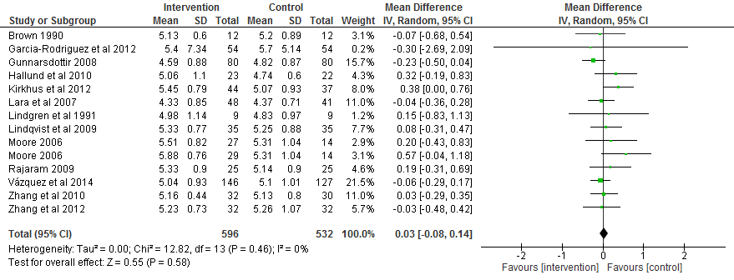

Figure S2. Studies reporting LDL-cholesterol level after consuming fish
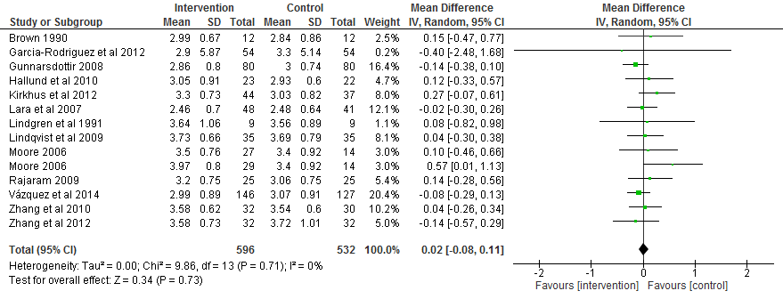

Figure S3. Studies reporting SBP level after consuming fish
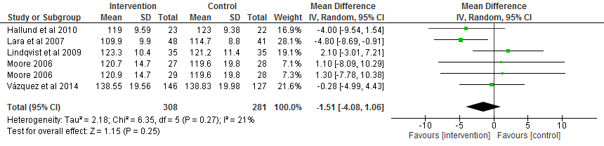

Figure S4. Studies reporting DBP level after consuming fish
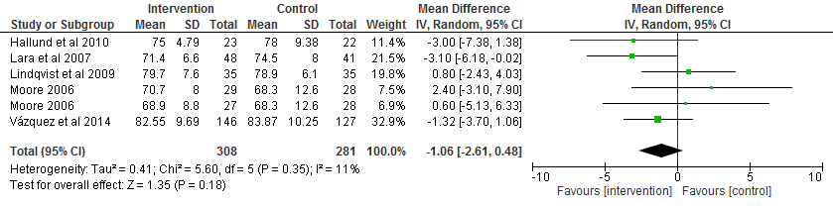

Figure S5. Studies reporting insulin level after consuming fish
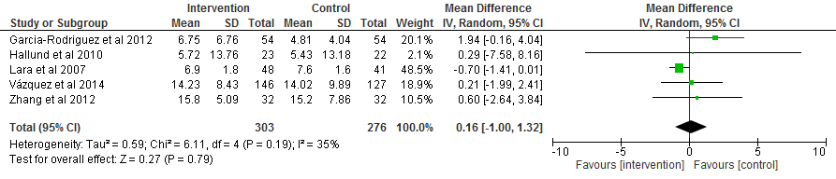

Figure S6. Studies reporting glucose level after consuming fish
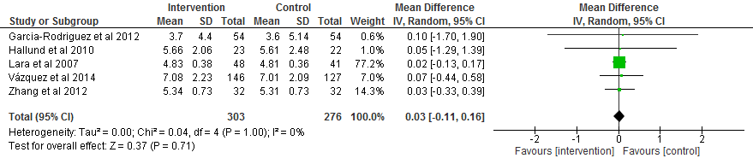

Figure S7. Studies reporting HOMA-IR level after consuming fish
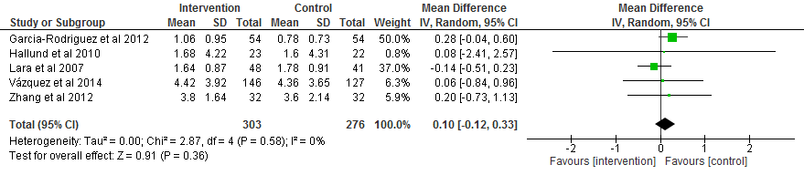

Figure S8. Studies reporting CRP level after consuming fish
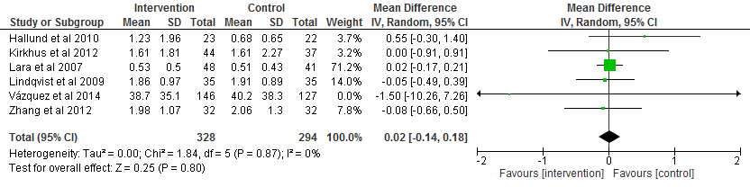

Figure S9. Studies reporting IL-6 level after consuming fish
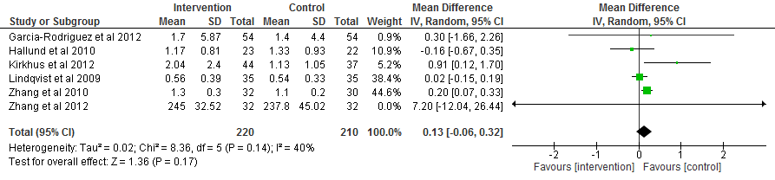

Figure S10. Studies reporting ICAM level after consuming fish
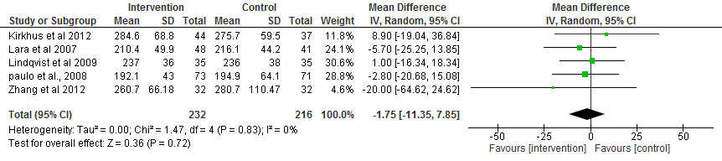

Figure S11. Funnel plot of Studies evaluating triglyceride levels after fish consumption.
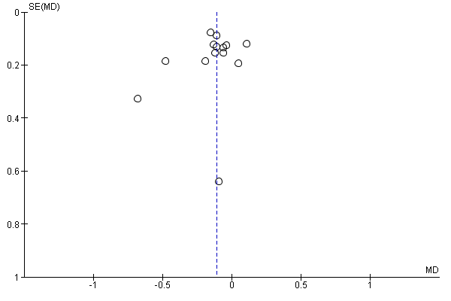

Figure S12. Funnel plot of Studies assessing HDL levels after fish consumption
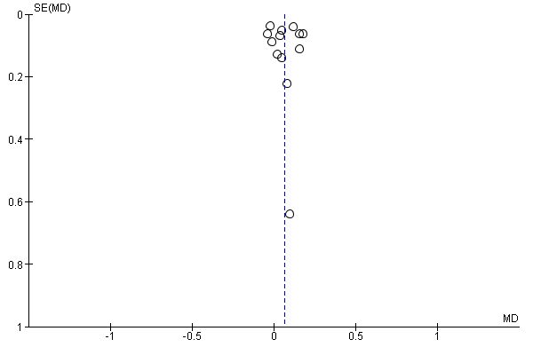

Figure S13. Flow diagram of selection of studies on fish consumption and vascular risk factors (PRISMA template)
Records identified through database searching OVID MEDLINE = (n=2390) Scopus = (n=1736) EMBASE = (n=1500) Total= (n=4126)

Identification

Records after duplicates removed (n=3459)
Screening
Full-text articles assessed for eligibility identified through searches (n=20) Total 20+7=27

Full-text articles excluded (n=10). Reasons for paper exclusion: Not in fish as a food (n=7). Have mixed food not in fish alone (n=2). Not in English language (n=1).

Records identified from additional sources (n=7)

Eligibility

Full-text articles meeting inclusion criteria (n=17)

Studies included in quantitative synthesis (meta-analysis) (n=13)
Included

Table S1. PRISMA guidelines
Section/topic | # |  | Checklist item | Reported on page #
TITLE
Title | 1 |  | Identify the report as a systematic review, meta-analysis, or both. | 1
ABSTRACT
Structured summary | 2 |  | Provide a structured summary including, as applicable: background; objectives; data sources; study eligibility criteria, participants, and interventions; study appraisal and synthesis methods; results; limitations; conclusions and implications of key findings; systematic review registration number. | 7
INTRODUCTION
Rationale | 3 |  | Describe the rationale for the review in the context of what is already known. | 8-13
Objectives | 4 |  | Provide an explicit statement of questions being addressed with reference to participants, interventions, comparisons, outcomes, and study design (PICOS). | 14
METHODS
Protocol and registration | 5 |  | Indicate if a review protocol exists, if and where it can be accessed (e.g., Web address), and, if available, provide registration information including registration number. | 15
Eligibility criteria | 6 |  | Specify study characteristics (e.g., PICOS, length of follow-up) and report characteristics (e.g., years considered, language, publication status) used as criteria for eligibility, giving rationale. | 15
Information sources | 7 |  | Describe all information sources (e.g., databases with dates of coverage, contact with study authors to identify additional studies) in the search and date last searched. | 15
Search | 8 |  | Present full electronic search strategy for at least one database, including any limits used, such that it could be repeated. | 15
Study selection | 9 |  | State the process for selecting studies (i.e., screening, eligibility, included in systematic review, and, if applicable, included in the meta-analysis). | 16
Data collection process | 10 |  | Describe method of data extraction from reports (e.g., piloted forms, independently, in duplicate) and any processes for obtaining and confirming data from investigators. | 17
Data items | 11 |  | List and define all variables for which data were sought (e.g., PICOS, funding sources) and any assumptions and simplifications made. | 17
Risk of bias in individual studies | 12 |  | Describe methods used for assessing risk of bias of individual studies (including specification of whether this was done at the study or outcome level), and how this information is to be used in any data synthesis. | 17
Summary measures | 13 |  | State the principal summary measures (e.g., risk ratio, difference in means). | 17
Synthesis of results | 14 |  | Describe the methods of handling data and combining results of studies, if done, including measures of consistency (e.g., I²) for each meta-analysis. | 17-18
Section/topic |  | # | Checklist item |  | Reported on page #
Risk of bias across studies |  | 15 | Specify any assessment of risk of bias that may affect the cumulative evidence (e.g., publication bias, selective reporting within studies). |  | 17
Additional analyses |  | 16 | Describe methods of additional analyses (e.g., sensitivity or subgroup analyses, meta-regression), if done, indicating which were pre-specified. |  | N/A
RESULTS
Study selection |  | 17 | Give numbers of studies screened, assessed for eligibility, and included in the review, with reasons for exclusions at each stage, ideally with a flow diagram. |  | 20
Study characteristics |  | 18 | For each study, present characteristics for which data were extracted (e.g., study size, PICOS, follow-up period) and provide the citations. |  | 20
Risk of bias within studies |  | 19 | Present data on risk of bias of each study and, if available, any outcome level assessment (see item 12). |  | 26-28
Results of individual studies |  | 20 | For all outcomes considered (benefits or harms), present, for each study: (a) simple summary data for each intervention group (b) effect estimates and confidence intervals, ideally with a forest plot. |  | 21-23
Synthesis of results |  | 21 | Present results of each meta-analysis done, including confidence intervals and measures of consistency. |  | 24-31
Risk of bias across studies |  | 22 | Present results of any assessment of risk of bias across studies (see Item 15). |  | 34
Additional analysis |  | 23 | Give results of additional analyses, if done (e.g., sensitivity or subgroup analyses, meta-regression [see Item 16]). |  | N/A
DISCUSSION
Summary of evidence |  | 24 | Summarize the main findings including the strength of evidence for each main outcome; consider their relevance to key groups (e.g., healthcare providers, users, and policy makers). |  | 35
Limitations |  | 25 | Discuss limitations at study and outcome level (e.g., risk of bias), and at review-level (e.g., incomplete retrieval of identified research, reporting bias). |  | 35-36
Conclusions |  | 26 | Provide a general interpretation of the results in the context of other evidence, and implications for future research. |  | 41
FUNDING
Funding |  | 27 | Describe sources of funding for the systematic review and other support (e.g., supply of data); role of funders for the systematic review. |  | N/A
N/A= Not applicable to this work
From: Moher D, Liberati A, Tetzlaff J, Altman DG, The PRISMA Group (2009). Preferred Reporting Items for
Systematic Reviews and Meta-Analyses: The PRISMA Statement. PLoS Med 6(7): e1000097.doi:10.1371/journal.pmed1000097
For more information, visit: www.prisma-statement.org.

Table S2. Sensitivity analysis excluding single studies on the effects of fish on triglycerides
Variable | Mean differences (95% CI) | P  (Z-test) | Chi²  (p-value) | Heterogeneity  I² %
Triglycerides
All studies | -0.11 [-0.18, -0.04] | 0.002 | 12.1 (0.52) | 0
Minus study 1 | -0.11 [-0.18, -0.04] | 0.003 | 12.1 (0.44) | 1
Minus study 2 | -0.11 [-0.18, -0.03] | 0.006 | 12.1 (0.44) | 1
Minus study 3 | -0.11 [-0.18, -0.03] | 0.004 | 12.1 (0.44) | 1
Minus study 4 | -0.13 [-0.20, -0.06] | 0.0005 | 8.5 (0.75) | 0
Minus study 5 | -0.10 [-0.18, -0.02] | 0.02 | 11.7 (0.47) | 0
Minus study 6 | -0.10 [-0.18, -0.03] | 0.004 | 11.9 (0.45) | 0
Minus study 7 | -0.11 [-0.18, -0.04] | 0.003 | 11.96 (0.45) | 0
Minus study 8 | -0.11 [-0.18, -0.04] | 0.003 | 12.0 (0.45) | 0
Minus study 9 | -0.11 [-0.18, -0.04] | 0.002 | 11.42 (0.49) | 0
Minus study 10 | -0.11 [-0.18, -0.03] | 0.004 | 12.09 (0.44) | 1
Minus study 11 | -0.10 [-0.17, -0.03] | 0.005 | 9.02 (0.70) | 0
Minus study 12 | -0.09 [-0.16, -0.02] | 0.01 | 7.88 (0.79) | 0
Minus study 13 | -0.11 [-0.18, -0.03] | 0.005 | 12.06 (0.44) | 1
Minus study 14 | -0.11 [-0.19, -0.04] | 0.002 | 11.79 (0.46) | 0

Table S3. Sensitivity analysis excluding single studies on the effects of fish on HDL-cholesterol
Variable | Mean differences (95% CI) | P  (Z-test) | Chi²  (p-value) | Heterogeneity  I² %
Triglycerides
All studies | 0.06 [0.02, 0.11] | 0.008 | 16.69 (0.16) | 28
Minus study 1 | 0.06 [0.01, 0.11] | 0.01 | 16.69 (0.12) | 34
Minus study 2 | 0.07 [0.03, 0.12] | 0.002 | 13.99 (0.23) | 21
Minus study 3 | 0.06 [0.01, 0.11] | 0.01 | 16.68 (0.12) | 34
Minus study 4 | 0.07 [0.02, 0.12] | 0.007 | 16.04 (0.14) | 31
Minus study 5 | 0.05 [0.01, 0.10] | 0.03 | 14.09 (0.23) | 22
Minus study 6 | 0.06 [0.01, 0.11] | 0.02 | 15.86 (0.15) | 31
Minus study 7 | 0.07 [0.01, 0.12] | 0.02 | 16.65 (0.12) | 34
Minus study 8 | 0.07 [0.02, 0.11] | 0.01 | 16.59 (0.12) | 34
Minus study 9 | 0.06 [0.01, 0.11] | 0.01 | 16.69 (0.12) | 34
Minus study 10 | 0.07 [0.01, 0.12] | 0.01 | 16.61 (0.12) | 34
Minus study 11 | 0.05 [0.00, 0.10] | 0.04 | 13.98 (0.23) | 21
Minus study 12 | 0.05 [0.01, 0.09] | 0.02 | 12.72 (0.31) | 13
Minus study 13 | 0.08 [0.04, 0.13] | <0.0001 | 10.98 (0.44) | 0

