Figure 1. Case study profiles

Profile | Case study LA1 | Case study LA2
Political complexion | All Labour apart from 1 independent | 80% Labour and 20% Lib Dem
Population (2016) | 149,400 | 201,600
Area (hectares) | 6,441 | 14,235
% workless households (2016) | 20.1% | 17%
% population claiming job seekers allowance/universal credit (2017) | 4.6% | 3%
Index of multiple deprivation  (2015) (rank of extent 1-302) | 23 | 73
Public libraries (2017) | 8 | 13
Community libraries (run by volunteers) (2017) | 0 | 4
Role of volunteers | Value added roles, including supplementary activities aimed at enhancing service delivery, such as supporting ‘Readers at home’ service, local history volunteers,  Summer Reading Challenge | Value added roles, in addition to replacement of paid staff to run 4 community managed libraries, instigated by austerity measures. All duties undertaken by volunteers.

Figure 2. Volunteering interrelationships in heritage attractions (Smith, 2002: p.12) The operating environment
Community
Heritage
property
Paid staff
Visitors
Visitors
B
D
Visitors
C
E
Visitors
Managers
A
Volunteers
F

Inter-relationships
A Volunteer to manager D Volunteer to visitors
B Volunteer to paid staff E Volunteer to property
C Between volunteers F Volunteer to community

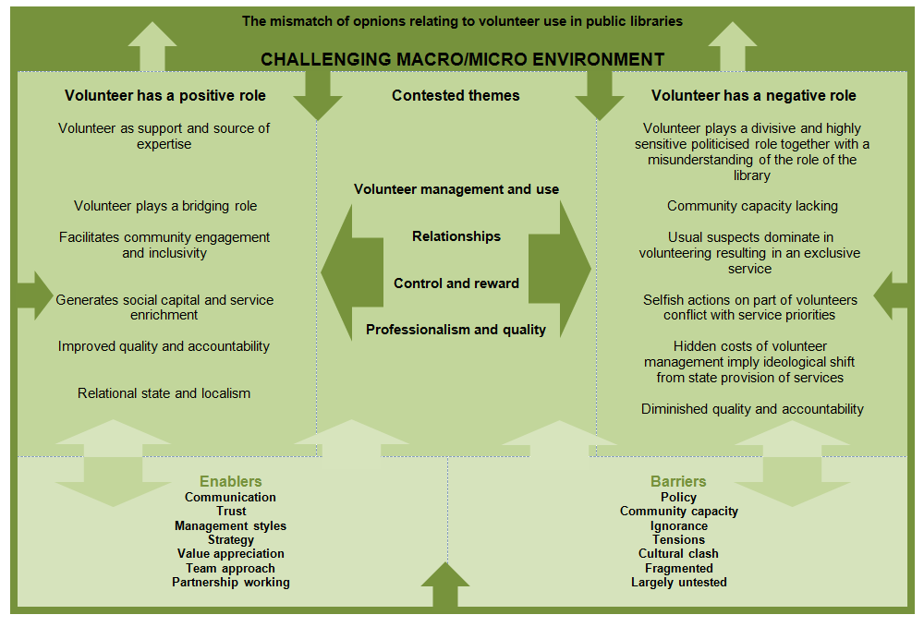
Figure 3. The mismatch of opinions relating to volunteer use in public libraries

