Title: Development of a workforce competency framework for enhanced health in care homes

Authors: Juliana Thompson (corresponding author)
Senior Lecturer in Adult Nursing
Northumbria University
Department of Nursing, Midwifery and Health
Faculty of Health and Life Sciences
Coach Lane Campus
Newcastle upon Tyne
United Kingdom
NE7 7XA
Tel: 0191 215 6497
Email: juliana2.thompson@northumbria.ac.uk

Sue Tiplady
Senior Lecturer in Adult Nursing
Northumbria University

Anne McNall
Associate Professor of Strategic Workforce Planning & Development
Northumbria University

Jane Murray
Senior Lecturer in Mental Health Nursing
Northumbria University

Glenda Cook
Professor of Nursing
Northumbria University

Phil Hodgson
Senior Research Assistant
Northumbria University

Lesley Bainbridge
Lead Nurse Care Home Vanguard Programme
NHS Newcastle Gateshead Clinical Commissioning Group

Title
Development of a workforce competency framework for enhanced health in care homes

Introduction
Newcastle Gateshead Clinical Commissioning Group commissioned Northumbria University to develop a workforce competency framework for enhanced health in care homes. This integrated framework covers the whole workforce from those providing essential care to specialist and advanced practice.
Key Points
- The whole health and social care workforce involved in the care of older care home residents needs to be highly competent and appropriately skilled.
- Newcastle Gateshead Clinical Commissioning Group commissioned Northumbria University to develop a workforce competency framework for enhanced health in care homes to address this need.
- The workforce competency framework is relevant to all staff from those providing essential care to specialist and advanced practice.
- The workforce competency framework requires the whole workforce to develop competencies in:
  - Values and attitudes
  - Workforce collaboration, co-operation and support
  - Leading, organising, managing and improving care
  - Knowledge and skills for care delivery
Abstract
Health and social care staff from a wide range of professions and organisations are involved in the care of older care home residents. In order to ensure seamless, quality care for the care home population, it is essential that the whole workforce is highly competent and appropriately skilled in the care of older people. Newcastle Gateshead Clinical Commissioning Group commissioned Northumbria University to develop a workforce competency framework for enhanced health in care homes that is standardised and integrated, specific to the needs of residents, and cover the whole workforce from those providing essential care to specialist and advanced level practice.
Background
The national Vanguard initiative was set up to identify and test new care models with the purpose of developing blueprints for the transformation of National Health Service (NHS) community and primary services in England (NHS England, 2017a). One of the five types of Vanguard is Enhanced Health in Care Homes (EHCH). The EHCH programmes recognise that care homes are caring for older people with increasing levels of frailty, disability and multi-morbidities; and who are highly dependent, have complex conditions including dementia, have limited functional reserve, and require end-of-life care (Salisbury et al, 2011; Barnett et al, 2012; Cornwell, 2012; European Commission, 2015). The EHCH programmes aim to make health services for care home residents more accessible, cost effective, and tailored to their needs, so that quality of life and quality of care is improved and unnecessary hospital admissions are avoided.
In recent years, the Gateshead Care Home programme has provided enhanced healthcare in care homes through integrated multi-sector working. This involves aligning general practitioner (GP) practices and older people nurse specialists (OPNSs) to care homes. This allows these care homes to access multi-disciplinary community virtual wards, and wider health and social care services. Locally, this multi-disciplinary approach is leading to improved quality of care, and reductions in avoidable hospital admissions. These positive outcomes led to the Gateshead Care Home programme becoming a Vanguard ‘Enhanced Health in Care Homes’ (EHCH) site, enabling it to build and develop this model of care (NHS England, 2017b).
The Gateshead EHCH model cuts across traditional health and social care boundaries and focuses on transforming the whole system. This involves developing new care pathways and systems/services for care delivery, so that high quality care for residents can be provided. This transformation requires a workforce that is highly competent, and appropriately skilled.
An initial research study was commissioned by Newcastle Gateshead Clinical Commissioning Group (CCG) in early 2016 (Cook et al, 2016). The aim of this study was to explore the experiences and competencies of the current Gateshead Care Home workforce team to inform workforce development for the delivery of the Gateshead EHCH service model. The findings of this study suggested a need for a workforce competency framework that is standardised and integrated, specific to the needs of residents, and covers the whole workforce from those providing essential care to specialist and advanced practice levels. As a consequence, Newcastle Gateshead CCG commissioned the development of a workforce competency framework for Enhanced Health in Care Homes (Thompson et al, 2017).

Development of the EHCH workforce competency framework
The emphasis on competency rather than on role allows the framework to be both standardised and flexible, enabling it to encompass and support the development of all health and social care personnel who provide services for residents, regardless of role, or employing organisation. The purpose of competency frameworks is to provide a system-wide coherent approach to: determining what competencies are required within the workforce; identifying ‘competency gaps’; identifying, commissioning, and providing training and education programmes and assessment processes to support competency development; developing clear career progression opportunities and pathways within and across organisations; facilitate the adoption of high quality practices; pursue innovative service strategies, and informing service users what competencies they should expect staff to have (Staron, 2008; Roche, 2009; McNall, 2012).
The most effective competency frameworks are co-produced by practitioners and educationalists/academics (Anema & McCoy, 2010). The EHCH framework was developed via a collaborative process involving academic staff from Northumbria University with expertise in the care of older people and workforce development, and practitioner stakeholders with expertise and experience in providing care for older people and care home residents with complex needs.
The study design consisted of two interrelated stages. Stage one involved the development of a draft workforce competency framework by a team of researchers from Northumbria University. This involved:
- review of existing workforce competency research literature relevant to care homes
- analysis of existing competency frameworks that have relevance to the care of older people
- discussions with the multi-disciplinary, multi-sector Care Home Vanguard ‘Pathways of Care’ (PoC) team from Gateshead and Newcastle localities to identify competencies required at each practice level (essential, specialist and advanced). The PoC team consists of representatives from a wide range of health and social care professionals and organisations. The aim of the team is to improve healthcare services for local care home residents and their families by identifying practice areas requiring improvement, then designing, implementing and evaluating new care delivery models to address these improvement needs.

Stage two involved a stakeholder workshop to discuss the draft framework, and to provide an opportunity for attendees to contribute their views on its further development. Attendees numbered 65 and represented a broad range of professions and service-users, and stakeholder groups from the NHS, private and voluntary care sectors.
The involvement of individuals from a range of groups ensured that many perspectives were brought to the discussions. This was important, as care homes are located at the intersection of health and social care, and public, private and voluntary sector care services – locations where cross-organisational working and the enabling of seamless transitions across services is essential.

Structure of the EHCH workforce competency framework
The framework consists of four inter-related domains, and each domain is comprised of sets and subsets of competencies:
A: Values and attitudes: Includes values and attitudes competencies; and also includes competencies requiring staff to be aware of their own values and attitudes, and acknowledge that residents and their families and friends will have their own sets of values and beliefs that influence their choices and decisions.
B: Workforce collaboration, co-operation and support
B1: Inter-professional and inter-organisational working and communication: Includes competencies requiring staff to engage in inter-professional and inter-organisational working and communication, and develop collaborative, co-operative working relationships with all members of the care team.
B2: Teaching, learning, and supporting competence development: Includes competencies requiring staff to acquire and maintain evidence-based knowledge and skills, and support others in the development of knowledge and skills on an ongoing basis in order to increase scope of practice and ensure a highly competent workforce.
C: Leading, organising, managing and improving care
C1: Leading, organising and managing care: Includes competencies requiring staff to use principles of leadership, organisation and management in order to facilitate provision of safe, effective and efficient practice. This involves engaging with care systems and clinical governance, and managing services and resources including staffing and skill mix. Staff also require competence to understand, negotiate and apply contractual and financial arrangements to maximise sustainability of services.
C2: Improving care: Includes competencies requiring staff to be committed to service improvement, by engaging with assessment, monitoring and evaluation of services, service improvement initiatives, evidence-based practice and research, and by early adaption and adoption of change.
D: Knowledge and skills for care delivery
D1: Communication with residents, families and friends: Includes competencies requiring staff to use a range of communication methods to support safe, quality care decisions that account for residents’ preferences and choices.
D2: Care process:
D2.1: Assessing, planning, implementing and evaluating care
D2.2: Pharmacology and management of medicines
Includes competencies requiring staff to engage in ongoing comprehensive assessment, planning, implementation and evaluation of individual resident’s health and care needs. This requires having in depth knowledge of common health problems within their own level of practice, and competencies in carrying out a range of diagnostic and clinical interventions, monitoring progress against expected outcomes, and amending care plans where necessary. The sub-domain highlights the requirement for competency in pharmacology relating to older people.
D3: Promoting health, wellbeing and independence
D3.1: Promoting and supporting independence and autonomy
D3.2: Promoting and supporting holistic health and wellbeing
Includes competencies requiring staff to promote residents’ health, wellbeing and independence by providing enriched environments which accommodate residents’ choices about their life, health and activities, and their decisions about end-of-life. Also included are competencies to facilitate equal access to health services, self-care, healthy lifestyle choices, and rehabilitation and reablement opportunities; and risk management, and effective utilisation of the Mental Capacity Act, best interest decisions, and safeguarding. The following sub-domains include additional competencies required to meet the specific needs of residents with particular problems:
D4: Management of dementia (these competencies are in addition to D1,2 and 3)
D5: Management of mental health (these competencies are in addition to D1,2 and 3)
D6: Management of frailty (these competencies are in addition to D1,2 and 3)
D7: End of Life care (these competencies are in addition to D1,2 and 3).
Although all domains and competencies are inter-related, findings from the literature review and analysis of the discussions from the PoC meetings highlighted that the ability of staff to deliver quality care very much depend upon a whole workforce ability to:
- Establish and maintain a culture of compassionate, relationship-centred values and attitudes.
- Work collaboratively, co-operatively and supportively.
- Lead, manage, organise and continuously improve systems of care, and sustain these improvements.

When developing the framework, the decision was made to emphasise these core workforce requirements by creating domains that comprise of competencies that specifically address these (domains A, B and C). These domains precede domain D because the study findings suggest they are prerequisites for the development of knowledge and skills for care delivery, and quality, seamless care delivery practice. In other words, having knowledge and skills in care delivery is not enough on its own. Practitioners need to have the right values, be able to work together, and lead and improve care if the care delivered is going to be effective.
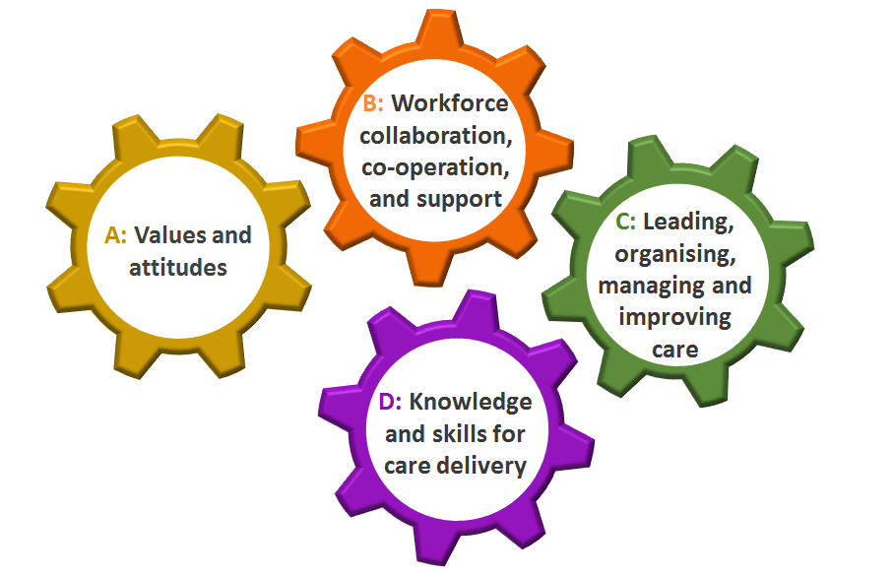
Figure 1: Competency domains for a care home workforce
Levels of practice
The framework includes three competency levels: essential practice, specialist practice and advanced practice. The competency levels are progressive and cumulative i.e. as levels advance, they integrate and expand upon competencies from the preceding level. Some individuals may have competencies from more than one level. For example, a registered nurse working in a care home may have all essential practice competencies and some specialist practice competencies; a care home manager, an OPNS or a GP may have most specialist practice competencies and some advanced practice competencies. By comparing existing competencies and competency levels with the framework, areas for development can be identified. On an individual basis, this knowledge can support personal development and career progression.
On a whole workforce basis, this knowledge can support understanding of workforce education and development needs and workforce planning.
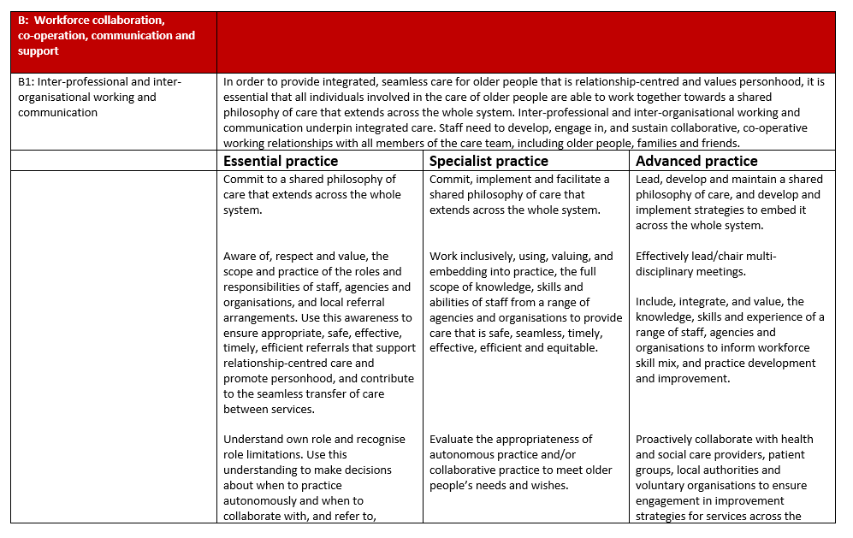
Figure 2: Example of a page from the framework
Next Steps
The EHCH workforce competency framework describes an end product - what does a competent health or social care professional looks like. The framework does not at this stage provide instructions, guidance or education, i.e. means of achieving the required competencies, or how they are to be assessed. Future work is therefore necessary to determine what needs to be developed and put in place to support achievement of the competencies.
In addition, it has become apparent when disseminating the framework, that it is relevant to the care of all older people with complex needs, not just those living in care homes. We are therefore in the process of adapting it to widen its use beyond the care home setting.
Conclusion
Due to the increasing levels of complex needs in the older care home population, it is essential to develop the right workforce. Providing care for this group requires the contribution of a number of professions, organisations and sectors effectively working together. Developing a competency framework that cuts across professional, organisational and sector boundaries, will promote a standardised high quality seamless service.

References
Anema M, McCoy J (2010) Competency-Based Nursing Education: Guide to Achieving Outstanding Learner Outcomes. Springer, New York.
Barnett K, Mercer SW, Norbury M, Watt G, Wyke S, Guthrie B (2012) Epidemiology of multimorbidity and implications for health care, research, and medical education: A cross-sectional study. Lancet 380(9836): 37-43.
Cook G, McNall A, Thompson J, Hodgson P (2016) Gateshead Care Home Workforce Competencies. Northumbria University, Newcastle.
Cornwell J (2012) The Care of Frail Older People with Complex Needs: Time for a Revolution. The King’s Fund, London.
European Commission (2015) The Ageing Report: Economic and Budgetary Projections for the 28 EU Member States (2013-2060). European Commission, Brussels.
McNall A (2012) An Emancipatory Practice Development Study: Using Critical Discourse Analysis to Develop the Theory and Practice of Sexual Health Workforce Development. Thesis submitted for the award of Professional Doctorate in Nursing, Northumbria University.
NHS England (2017a) New Care Models.https://www.england.nhs.uk/ourwork/futurenhs/new-care-models/ (accessed 3 October 2017).
NHS England (2017b) Newcastle and Gateshead Clinical Commissioning Group: The Vanguard and the People it Serves. https://www.england.nhs.uk/ourwork/new-care-models/vanguards/care-models/care-homes-sites/gateshead/ (accessed 3 October 2017).

Roche A. (2009) New horizons in AOD workforce development. Drugs, Education, Prevention and Policy 16(3): 193-204.
Salisbury C, Johnson L, Purdy S, Valderas JM, Montgomery AA (2011) Epidemiology and impact of multimorbidity in primary care: A retrospective cohort study. British Journal of General Practice 61(582): 12–e21.
Staron M (2008) Workforce Development: A Whole-of-System Model for Workforce Development. http://lrrpublic.cli.det.nsw.edu.au/lrrSecure/Sites/Web/13289/ezine/year_2008/sep/thinkpiece_whole_system_approach.htm (accessed 4 October 2017).
Thompson J, Tiplady S, McNall A, Murray J, Cook G, Hodgson P (2017) Workforce Competency Framework: Enhanced Health in Care Homes. Northumbria University, Newcastle.

