Characterization of CuInSe₂ material and devices: comparison of thermal and electrochemically prepared absorber layers

P J Dale ^{1,} , A P Samantilleke ¹, G Zoppi ², I Forbes ² and L M Peter ¹

¹ Department of Chemistry, University of Bath, BA2 7AY, UK
² Northumbria Photovoltaics Applications Centre, Northumbria University,
NE1 8ST, UK

Email: phillip.dale@uni.lu

Abstract
CuInSe₂-based absorber layers for photovoltaic devices have been fabricated using two different scalable processes, electrodeposition and sputtering, both followed by thermal annealing. The structural properties of the absorber layers were studied by SEM, XRD, and MiniSIMS. Sputtered absorber layers exhibit larger grain sizes than electrodeposited layers, but both types of film consist of randomly orientated crystallites. Electrodeposited layers appear to have a uniform composition with evidence of a MoSe₂ layer at the back contact, whilst sputtered layers show no evidence for a MoSe₂ layer. The external quantum efficiency spectrum of films and completed devices was measured, and the band gap and broadening parameters were obtained using electroreflectance spectroscopy. A device based on electrodeposited CuInSe₂ achieved an AM 1.5 efficiency of 6.6 %, whilst a device based on sputtered CuInSe₂ had an efficiency of 8.3 %. Impedance measurements were used to calculate doping densities of 2 ×10¹⁶ and 4 ×10¹⁵ cm⁻³ for the electrodeposited and sputtered devices, respectively.

PACS classification 81.05.Hd, 81.05.Dz
Journal of Physics D: Applied Physics

1. Introduction
Photovoltaic devices based on the Cu(In,Ga)(S,Se)₂ absorber layer have achieved high efficiencies. CuInSe₂ cells have reached 14.5 % [1] compared with 19.5 % for Cu(In,Ga)Se₂ [2]. Although the bandgap of CuInSe₂ is not optimal for terrestrial solar energy conversion, Coutts et al [3] have shown that it is a suitable absorber layer for the bottom cell in a tandem thin film device. Low cost industrially viable routes for the preparation of CuInSe₂ are therefore desirable. Two possible routes are electrodeposition and sputtering, both of which require subsequent annealing of the deposited precursor materials. Electrodeposition has been used by BP Solar to make semiconductor grade CdTe absorber layers in its Apollo® modules[4], and is also being actively pursued as a route to CIGS cells [5]. Sputtering is a widely used technique for depositing large area thin films, including CuIn(S,Se)₂ [6, 7].

In the present study, electrodeposition and sputtering were used to make absorber layers in devices in which the other layers were fabricated under the same conditions to allow comparison of the absorber layers. The electrodeposition process followed a protocol modified from the work of Calixto et al [8], in which the electrodeposited film was annealed in a mixture of elemental selenium vapour and a 90:10 mixture of nitrogen and hydrogen gas as an alternative to the H₂Se gas as used by Calixto et al. The sputtering process involved deposition of the multilayer metallic precursors followed by selenization. The structural properties of absorber layers were characterized and information on the optical and electronic properties of the films was obtained using photocurrent and electroreflectance spectroscopies as well as electrical impedance measurements.

2. Method
CuInSe₂ precursor films were electrodeposited at room temperature onto molybdenum-coated soda-lime glass slides from a stirred 250 ml pH 3 buffered aqueous solution containing 2.6 mM CuCl₂, 9.6 mM InCl₃, 5.5 mM H₂SeO₃ and 240 mM LiCl. All chemicals were 99.999 % pure, except for the LiCl which was 99.99 %, and supplied by Alfa Aesar or Sigma-Aldrich. The counter and reference electrode were a platinum foil and a silver/silver chloride (Ag|AgCl) electrode, respectively. The normal deposition procedure consisted of applying a potential of -0.476 V for one minute and then subsequently washing and drying the film before placing it back into the deposition bath, where deposition was continued for a further 70 minutes, during which a potential of -0.476 V was applied for the first 20 minutes, followed by -0.576 V for 50 minutes. Films were annealed in 10% H₂, 90% N₂ at 10 mbar atmosphere at 550 °C for 30 minutes in the presence of excess selenium. Electrodeposited and annealed films are referred to as ED-CuInSe₂.

For comparison with the electrodeposited material, CuInSe₂ films were also deposited by a 2-stage process that involved selenization of metallic Cu-In precursor films prepared by radio frequency magnetron sputtering onto molybdenum coated soda-lime glass slides. The films were prepared by alternate deposition of 180 single Cu and In layers to give a total thickness of ~600 nm. The unheated substrates were rotated to ensure uniform deposition. Selenium was then thermally evaporated onto the metal films to form an over-layer, and selenization was then carried out in a tube furnace in an Ar/Se atmosphere at 500ºC for 30 min. The final thickness of the CuInSe₂ film was ~1800 nm. Sputtered and selenised films are referred to as SP-CuInSe₂. Both types of films were completed into full devices at the Hahn Meitner Institute[9] with the addition of the following layers: chemical bath deposited CdS, radio frequency sputtered i-ZnO and Al:ZnO, and e-beam deposited Ni/Al contacts.

The phases present and structure of each phase were investigated by X-ray diffraction (XRD) using a Siemens D-5000 diffractometer (CuKα line). The surface morphology and topology of the films were observed using a FEI Quanta 200 scanning electron microscope (SEM), and semi-quantitative compositional analysis of the precursors performed using the energy dispersive X-ray analyzer (EDS) connected to the SEM. Depth-profiling and lateral uniformity of the layers were investigated using a bench-top Millbrook MiniSIMS system with a Ga⁺ primary ion energy of 6 keV, a crater area of 100 × 100 microns and a gating of 10%. Photocurrent spectra of the CuInSe₂ films were measured using an aqueous electrolyte contact consisting of 0.2 M europium nitrate (99.9%, Strem) in saturated potassium perchlorate (99.5%, Fluka) adjusted to pH 2 by addition of nitric acid. Annealed samples were etched in 5 wt% potassium cyanide (98%, Fluka) at room temperature for 90 s. Measurements were carried out in a three electrode configuration using a glass cell with a Ag|AgCl reference electrode and a platinum foil counter electrode. Photocurrent and electroreflectance spectra of films and whole devices were recorded using a tungsten lamp, monochromator, and chopper (Bentham), a purpose-built potentiostat and a lock-in amplifier (Stanford Research Systems). Spectra were recorded using chopped illumination with a frequency of 13 Hz or higher and normalized against calibrated silicon and germanium photodiodes.

Finished devices were characterised by current-voltage measurements under standard AM1.5 illumination (100 mW cm⁻², 25ºC) using a four probe configuration. Photovoltage measurements were made using a green light emitting diode (LED) with neutral Schott NG density filters and a high impedance voltage follower. Impedance measurements were made with a Solartron 1260 and Solartron 1287 interface using 5 or 10 mV peak to peak perturbation.

3. Results and Discussion
As-deposited ED-CuInSe₂ films had a reflective grey colour which grew darker and appeared rougher after annealing. Figures 1(a) and 2(a, c) show SEM images of the precursor and annealed layers respectively. The precursor film appears be very compact, with small circular grains and some larger growths emerging from the surface. The annealed grains do not appear to be significantly larger than the precursor grains (typically 50 nm in diameter), with protuberances from the main film remaining (figure 2(a)). Figure 2(c) shows that the thickness of the ED-CuInSe₂ film is 1.7 μm. By measuring the electrical charge passed during deposition, it is possible to calculate a theoretical layer thickness assuming 100 % plating efficiency. Comparison of this thickness with the thickness measured by SEM indicated a plating efficiency of 98 %, assuming no significant changes to the volume of the film occur during the annealing process. The ED-CuInSe₂ films are not as smooth as those described by Calixto et al [8], and the grain sizes are significantly smaller than the 2 μm reported by Guimard et al [10]. However, the annealing processes used by these authors differ slightly from those used in this work, and the composition of their films is also different (see below).
Figure 1(b) shows the sputtered multilayer Cu/In precursor film with a very compact underlying film, with a surface covered by In-rich particles (Cu/In < 0.6). The surface coverage of the film is dependent on the overall film composition with increasing particle coverage for lower Cu/In ratio [11]. After selenization, the annealed SP films (shown in figure 2(b, d)) exhibit large grains, some of which are over 2 μm in size and extend almost throughout the entire thickness of the film.
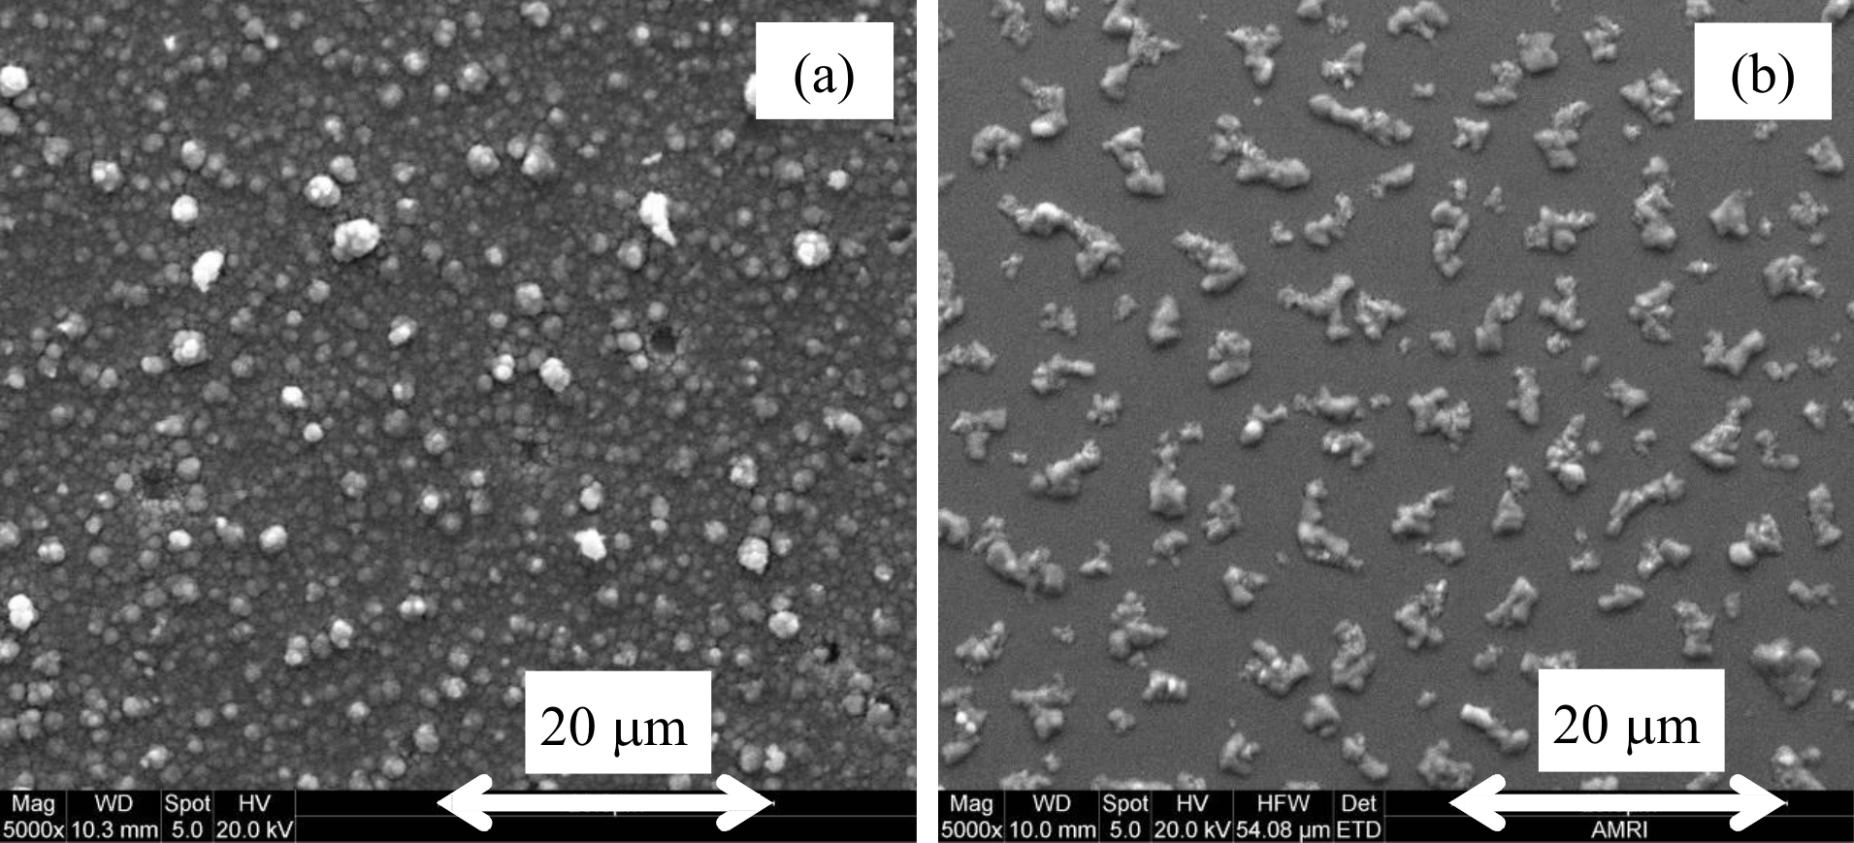

Figure 1. SEM images of (a) electrodeposited CuInSe₂ precursor and (b) sputtered Cu/In precursor layers.
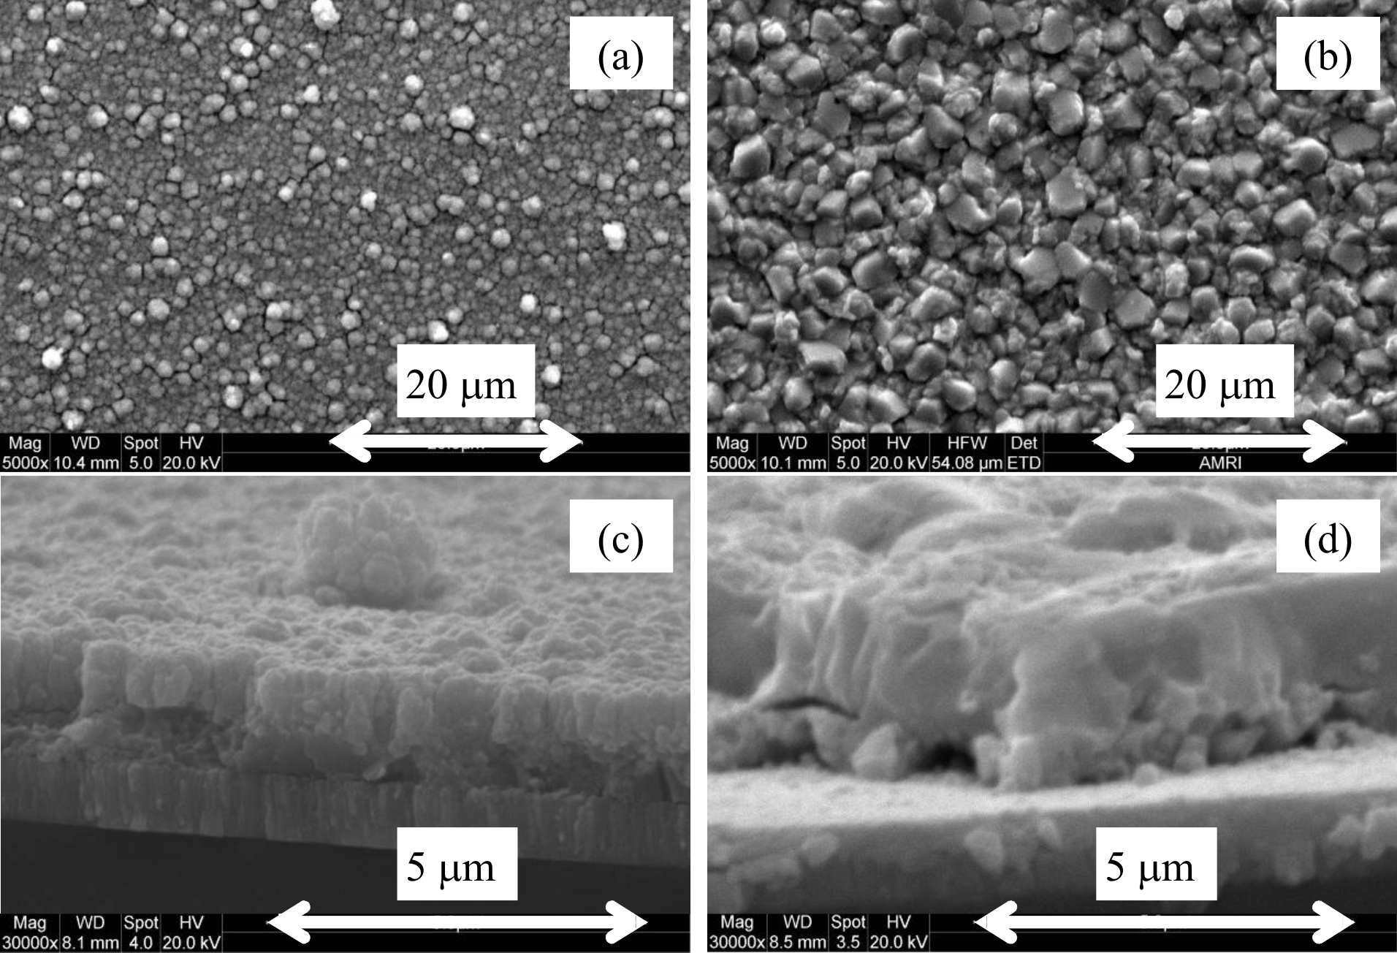
Figure 2. SEM images of annealed ED-CuInSe₂ (a,c) and annealed SP-CuInSe₂ (b,d) layers.

Compositional analysis data obtained by EDS are summarized in table 1 for both precursor and selenised films. The estimated error in the compositions is +/- 5 %. The ED-CuInSe₂ precursor was deliberately made indium-rich (Cu/In ratio of 0.72), as this is reported to produce the best performing devices [12]. Annealing increased the Cu/In ratio to 0.79, and the Se content decreased, probably as a result of In and Se evaporation. This observation agrees with previous work on the electrodeposition of CuInSe₂ films by Calixto et al [8], although the films prepared by these authors were slightly more Cu rich and the selenization was performed using H₂Se gas. Typically 2-3 % of oxygen was observed in the electrodeposited precursor films, but the oxygen content was negligible after annealing, suggesting that physically absorbed water is removed. By contrast with the ED films, the SP-CuInSe₂ films were grown closer to ideal stoichiometric composition, although still slightly In rich (Cu/In ratio of 0.95). This ratio was unchanged by selenization. This is attributed to Se over-layer, which may prevents loss of indium during the conversion process.

Although Cu-rich films produce larger grained structures, an optimum Cu/In ratio of 0.80-0.95 is required for efficient solar devices: to date, the best CuInSe₂ based devices deposited by co-evaporation have a Cu/In ratio of 0.85 [1], while devices with somewhat lower efficiencies also have Cu/In ratio less than unity [13],[14].

Table 1. Atomic composition of precursor and annealed layers determined by EDS.
Layer | Cu / atm % | In / atm % | Se / atm % | Cu / In | Se / (Cu + In)
ED precursor | 20.2 | 28.1 | 51.7 | 0.72 | 1.07
ED annealed | 22.5 | 28.5 | 49.0 | 0.79 | 0.96
SP precursor | 48.8 | 51.3 | N/A | 0.95 | N/A
SP annealed | 24.5 | 26.0 | 49.5 | 0.94 | 0.98

Figure 3(a) shows the XRD spectra of ED-CuInSe₂ films before and after annealing. The as-deposited material displays the three main CuInSe₂ peaks; (112), (220/204), and (312/116), although the peaks are rather broad and weak, indicating poor crystallinity. Annealing the ED-CuInSe₂ crystallizes the as-deposited structure resulting in well defined sharp peaks in the XRD spectra. All the peaks are identifiable and attributable to the CuInSe₂ chalcopyrite phase, except for two small peaks, which are attributable to MoSe₂. The MoSe₂ phase is formed during the annealing process when the temperature exceeds 450ºC [15].
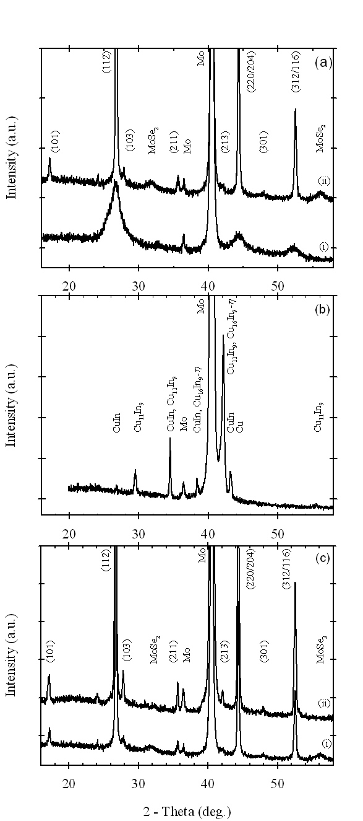

Figure 3(a). XRD spectra of (i) ED-CuInSe₂ precursor and (ii) ED-CuInSe₂ annealed, (b) XRD spectrum of SP precursor, and (c) XRD spectra of (i) ED-CuInSe₂ annealed and (ii) SP-CuInSe₂ annealed.

XRD analysis of the SP precursor layer (Cu/In = 0.95, thickness = 600 nm) is shown in figure 3(b) and reveals that the dominant phases present in the film are Cu₁₁In₉, and Cu₁₆In₉-η. CuIn₂, indicating good intermixing. The XRD patterns of the selenized SP-CuInSe₂ film and ED-CuInSe₂ films are compared in figure 3(c). All the peaks can be assigned to the Mo substrate and to the chalcopyrite phase of CuInSe₂. The SP films also exhibit a splitting of the (116/312) reflections which probably reflects their enhanced crystallinity compared with the ED-films. However, this splitting could also arise from the difference in film stoichiometry as noted by Zaretskaya et al [16]. No MoSe₂ peak is observed for the sputtered sample, which suggests that selenium diffusing from the top surface is entirely consumed in the formation of the CuInSe₂ layer on top of the molybdenum. Analysis of the XRD spectra using appropriate texture coefficients [17] indicated that both annealed films are randomly orientated.

MiniSIMS depth profiles for the annealed ED-CuInSe₂ and SP-CuInSe₂ films are shown in Figure 4. The ED-CuInSe₂ film is characterized by an almost constant concentration of all species throughout most of the absorber layer. The Se signal rises slightly close to the interface with the Mo substrate, which is consistent with the XRD evidence for formation of a layer of MoSe₂. The presence of Cu in the interface is more difficult to interpret, since no Mo-Cu-Se ternary structures were detected during the XRD analysis. However, Guillemoles et al [15] also observed Cu in the MoSe₂ phase using the SIMS technique, but found no evidence for copper containing phases in the XRD analysis.

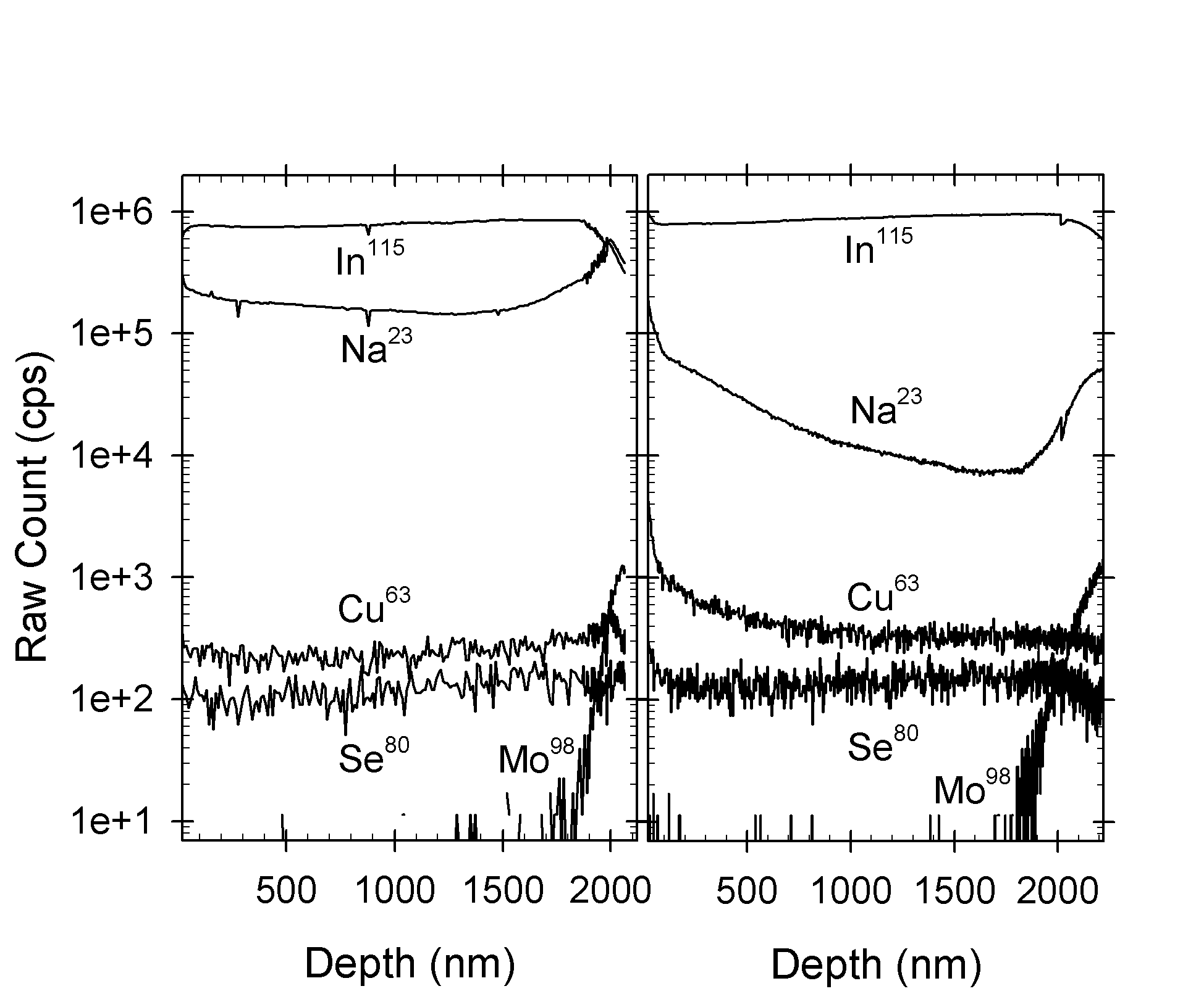

Figure 4. SIMS profiles for ED-CuInSe₂ (left panel) and SP-CuInSe₂ (right panel).

The MiniSIMS depth profiles of the SP-CuInSe₂ film show that the concentrations of In and Se are uniform throughout the main bulk of the film, before dropping sharply at the Mo interface. No formation of MoSe₂ is evident here, which is in agreement with the conclusions reached on the basis of the XRD data. There is a higher Cu concentration near the front surface than in the bulk, which may indicate formation of a Cu-rich phase, which is not observed in the ED-CuInSe₂ film.

Another difference between the two types of film is the sodium levels, which are systematically up to 40 times lower in the SP-CuInSe₂ film compared with the ED-CuInSe₂ film. The shape of the sodium profile for the SP film varied between samples, with some showing a more uniform distribution. It is known that the presence of sodium in CuInSe₂ films arises from diffusion from the soda-lime glass substrate during the film growth[18]. Sodium in the chalcopyrite absorber is known be benficial, enhancing grain growth [19], passivating grain boundaries [20] and decreasing absorber resistivity [21]. The difference in Na levels between the SP and ED samples may be due to different annealing conditions. Whereas the SP-CuInSe₂ film was annealed at 500 °C, the ED-CuInSe₂ film was annealed at 550 °C in a reducing atmosphere, which may promote sodium diffusion. Sodium diffusion may also be enhanced by the smaller grained structure of the ED-CuInSe₂ film, and sodium may also be incorporated into the ED films from the electrolyte.

The external quantum efficiencies (EQE) of the ED-CuInSe₂ precursor and annealed films were measured using an aqueous electrolyte contact, and both films demonstrated photoactivity, although the efficiency of the precursor film was low (figure 5). Annealing of the precursor film increased the efficiency leading to a maximum EQE of 50 %. The completed ED-CuInSe₂ device had a maximum EQE of 80 % and showed the typical ‘blue defect’ in the region where the CdS absorbs the incident light. The difference in the magnitude of the EQE between ED-CuInSe₂ layers in electrolyte and in complete devices is attributed to the poor collection of the carriers by the aqueous electrolyte and the possibility of the electrolyte short circuiting to the underlying molybdenum substrate through cracks in the CuInSe₂ film. The EQE spectrum of SP-CuInSe₂ layer shown in figure 5 exhibits a maximum value of 85 %, which is achieved without an anti-reflection coating.
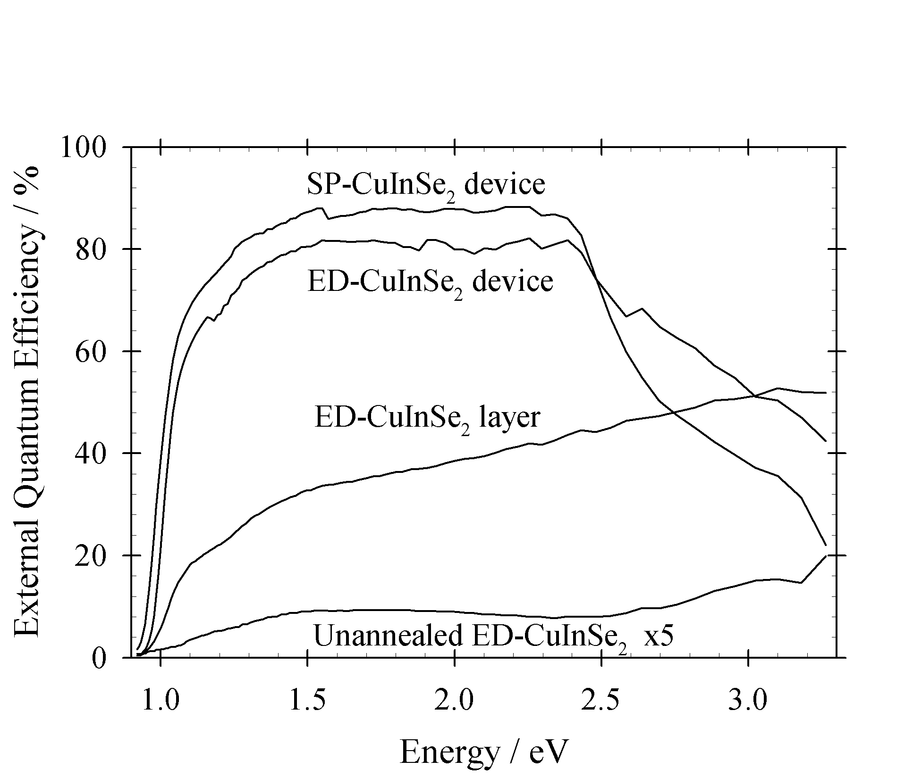
Figure 5. EQE spectra for electrodeposited precursor, and annealed ED-CuInSe₂ film (measured using an electrolyte contact) and EQE spectra of devices with electrodeposited and sputtered absorber layers.
From the EQE spectra, the band gaps of the devices were estimated to be 0.97 eV for ED-CuInSe₂ and 0.94 eV for SP-CuInSe₂. By contrast, Abushama et al. [1] derived an estimated band gap of 0.97 eV for the world record CuInSe₂ device that had a Cu/In ratio of 0.85. Both ED and SP films exhibit band tailing, indicating a high density of sub-band gap states [22].

Electroreflectance (EER) spectra were measured using unpolarized light for both ED and SP-CuInSe₂ devices, and the results are compared in figure 6 and table 2 along with spectra of single crystal CuInSe₂ with Cu/In ratios of 0.90 and 1.09 respectively taken from Shirakata et al [23]. The spectra were analysed using the generalized third derivative fit function given by Aspnes [24]
(1)
where R, C, θ, E_{g,}, Γ and m are the reflectance, amplitude, phase, energy, broadening parameter, and a parameter that depends on the type of transition, respectively. An m value of 5/2 representing a 3D critical point was used for all fits. The fitting of the EER spectra provides values of E_{g} and Γ. Γ can be higher than the value characteristic of the pure monocrystalline material as a consequence of structural disorder, stress and compositional inhomogeneity. In the investigated energy range, two valence band transitions to one conduction band are expected for CuInSe₂. The two transitions are centred around 1.0 eV and are separated by 1 - 5 meV [25, 26]. However, a clear separation of these two transitions has not been observed at room temperature using the electroreflectance technique, and is not observed here. It can be seen that both devices exhibit broader spectral features than either of the single crystal examples. The line fit to the ED-CuInSe₂ sample appears to be good for photon energies lower than 1.04 eV, whilst at high photon energies there are two other points of inflection at 1.08 and 1.14 eV, which cannot be fitted with a single transition. The low energy fit to SP-CuInSe₂ is less satisfactory, which suggests that there is more than one transition occurring at similar photon energies, which would lead to the peak broadening. This may indicate that several CuInSe₂ phases are present with slightly different Cu/In ratios. Comparing the spectra of the ED and SP-CuInSe₂ samples with the single crystal spectra, it is clear that they most closely resemble the spectrum for a Cu/In ratio of 0.9. Band gap energies of 0.99 and 1.01 were derived from the fits for the ED and SP-CuInSe₂ samples, respectively. Shirakata et al [23] have correlated band gap energy with composition and suggested that indium-rich CuInSe₂ has a lower transition energy than indium-poor material, which is also observed in our results. The values for E_{g} derived from EER measurements are higher than those estimated from the photocurrent spectra for both devices and the SP-CuInSe₂ device appears to have a larger band gap than the ED-CuInSe₂ device, but this may be due to the less satisfactory fit of the low energy derivative structure.
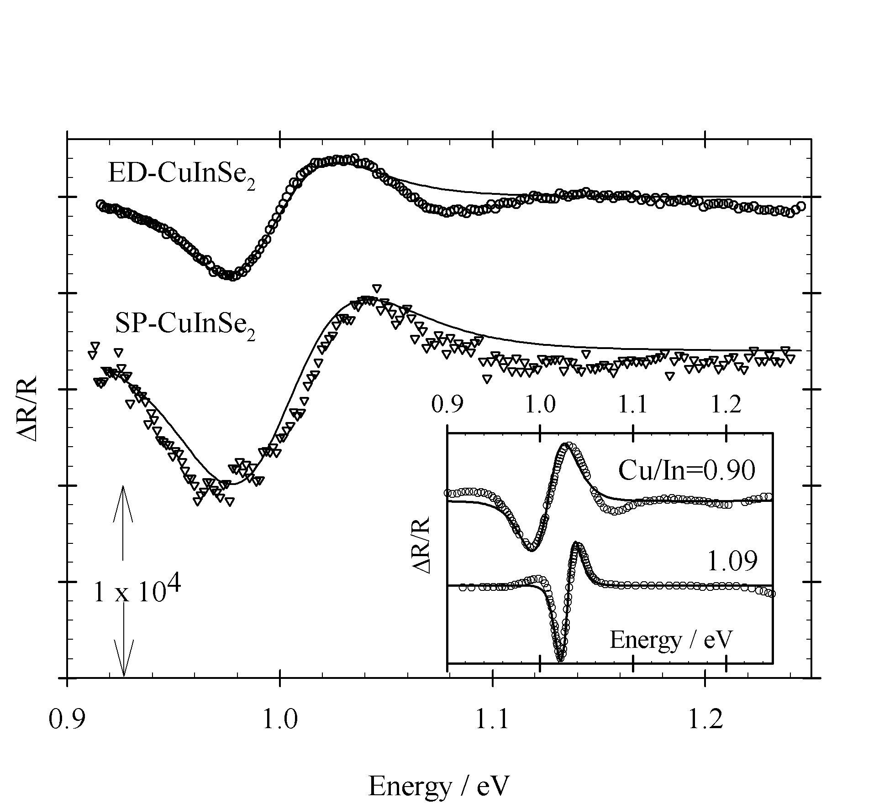
Figure 6. EER data for ED and SP-CuInSe₂ devices. Inset are two spectra of single crystal CuInSe₂ taken from Shirakata et al [23].

Table 2. Band gap and broadening parameter values extracted from electroreflectance spectra.
Sample | Cu / In | E_{g} / eV | Γ / meV
ED-CuInSe₂ | 0.79 | 0.99 | 65
SP-CuInSe₂ | 0.94 | 1.00 | 80
Single crystal | 0.90 | 1.01 | 45
Single crystal | 1.09 | 1.03 | 20

Figure 7 shows the current voltage curves for the best ED and SP-CuInSe₂ devices measured in the dark and under AM 1.5 conditions in both forward and reverse bias. The cell parameters summarised in table 3 were derived from fitting the single exponential diode equation

(2)
where J₀, A, R_{s}, R_{p}, and J_{L} are the reverse saturation current, diode ideality factor, series resistance, shunt resistance, and light generated current.

The total plated area of the ED-CuInSe₂ was 2.5 × 3 cm which was converted into eight 0.5 cm² devices which had an average efficiency of 5.5 % with a standard deviation of 0.6, showing the good uniformity of the process. The best ED-CuInSe₂ cell efficiency was 6.6 % which is the same value as reported by Calixto et al [8], who used using H₂Se, rather than elemental selenium in the annealing process. This is lower than the best value of 8.8% for an ED-CuInSe₂ device reported by Guimard et al [10], which had a slightly higher V_{oc} of 416 mV and better fill factor (FF) of 66 %, although the measured area was only 0.06 cm². The poor fill factor observed for our device is due in part to the high series resistance, which appears to depend on the illumination intensity, suggesting that at least one part of the cell is photoconductive. The best electrodeposited CuInSe₂ device has a reported series resistance of 0.8 Ω cm² [10] as compared to the 2 Ω cm² measured here. SP-CuInSe₂ has both a higher V_{oc} and J_{sc} than ED-CuInSe₂, and are 90 % of the world record values, but is let down by a relatively poor fill factor giving a device efficiency of 8.3 % as compared to the world record cell of Abushama et al of 14.5 % [1].
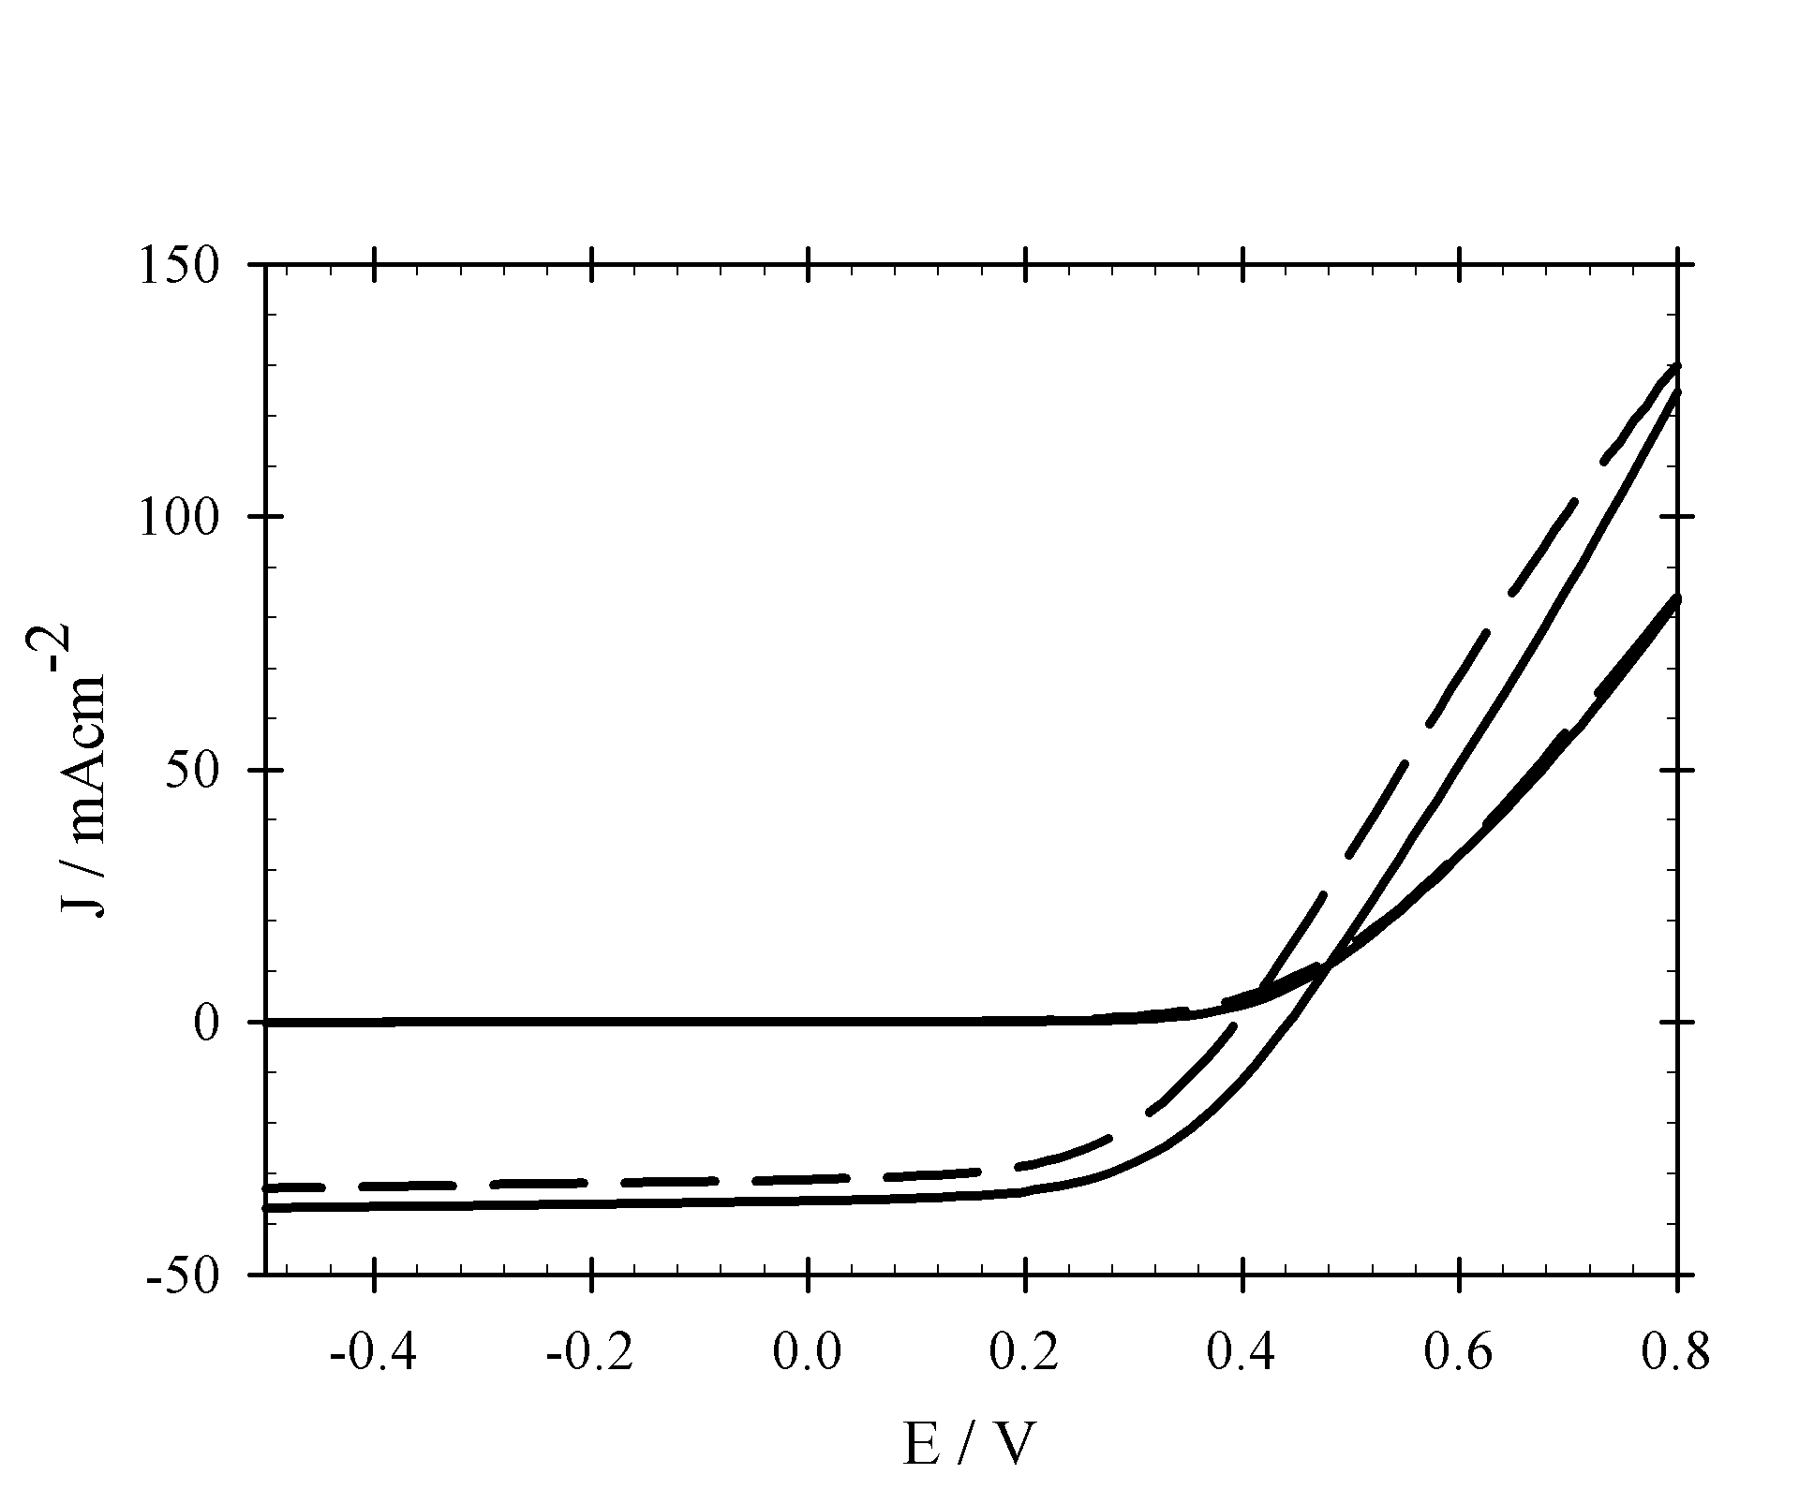
Figure 7. Current density – voltage (J-V) curves in the dark and under AM 1.5 illumination comparing best SP (full line) and ED-CuInSe₂ devices (dashed line), both having total device areas of 0.5 cm².

Table 3. J-V characteristics and calculated parameters of ED and SP-CuInSe₂ compared with the best known electrodeposited device of Guimard et al [10] and best evaporated device of Abushama et al [1]. Numbers in brackets indicate fitting to data obtained in the dark.
Device | V_{oc} / mV | J_{sc} / mAcm⁻² | FF /  % | η /  % | R_{p} /  kΩ cm² | R_{s} /  Ω cm² | J₀ /  μA cm⁻² | A | Total area / cm²
ED-CuInSe₂ | 395 | 31.2 | 52 | 6.7 | 0.29 (2.00) | 2.0 (2.9) | 12.0 (6.6) | 2.0 (2.3) | 0.51
Guimard | 416 | 32.7 | 66 | 8.8 | - | 0.8 | 1 | 1.7 | 0.06
SP-CuInSe₂ | 443 | 35.4 | 53 | 8.3 | 0.25 (10.00) | 2.3 (3.2) | 4.0 (0.8) | 1.8 (1.8) | 0.51
Abushama | 491 | 41.1 | 72 | 15.4 |  |  |  |  | 0.45

To investigate the shunt resistance of the devices further, the photovoltage was measured as a function of illumination intensity (530 nm LED). The data are shown in figure 8. For ED-CuInSe₂, a linear logarithmic relationship was observed with a gradient 105 mV/decade corresponding to a diode ideality factor of 1.8, which is lower than the 2.0 measured from the J-V analysis. The photovoltage of the SP-CuInSe₂ device is less ideal, with clear evidence of shunting at lower light intensities.
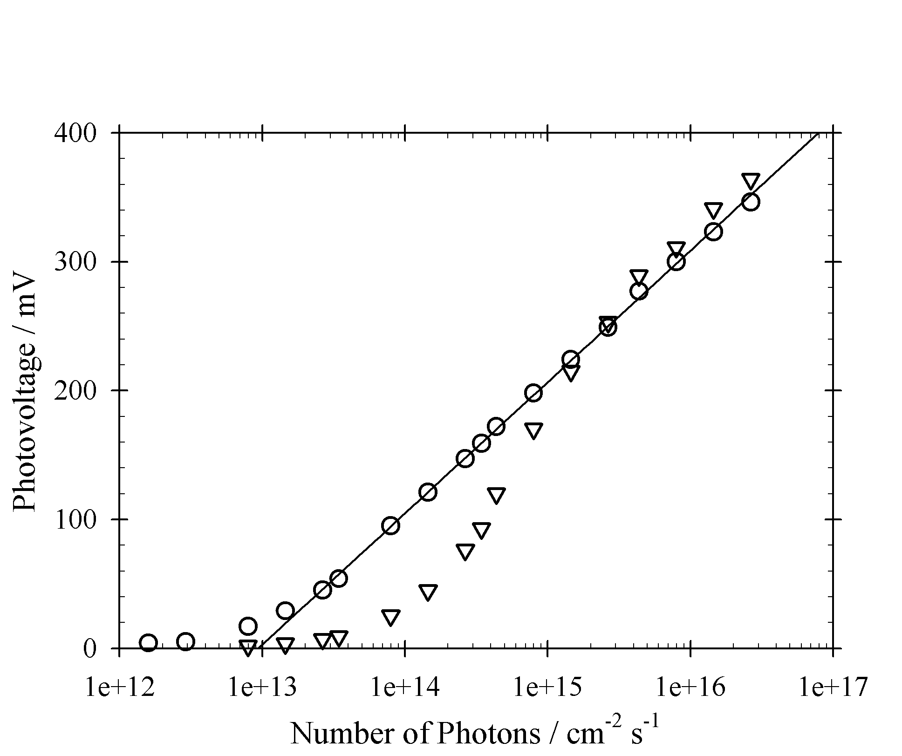

Figure 8. Photovoltage as a function of illumination intensity for ED-CuInSe₂ (circles) and SP-CuInSe₂ (triangles). Light source was an LED (530 nm).

The impedance of the ED and SP-CuInSe₂ devices was measured in the dark and under illumination and applied bias over a frequency range from 10⁰ to 10⁶ Hz. For the illumination measurements, the cell was first held at open circuit voltage in the dark, and then illuminated to achieve the required voltage. The data were fitted with two models: (1) a resistor in series with a parallel capacitor and resistor (R[RC]), and (2) the same as (1) but the capacitor replaced with a constant phase element (R[RCPE]). An example of the Bode plot fits is given in figure 9 for ED-CuInSe₂ in the dark at zero applied bias. The CPE gives a better fit to the data but does not have an easily extractible physical meaning. For this reason the R and C values obtained from the simple R[R,C] model were used in the subsequent analysis.
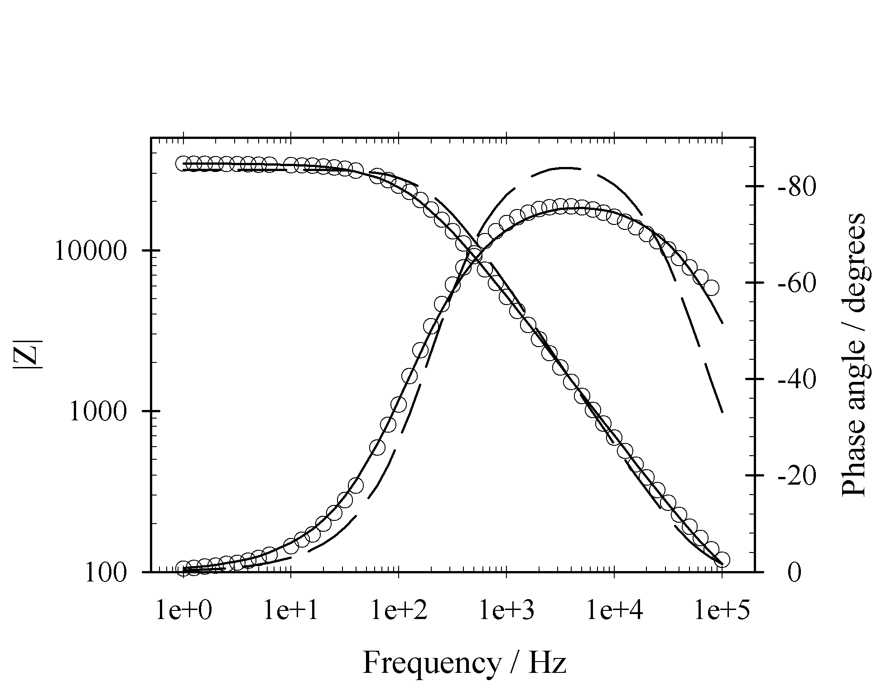
Figure 9. Example fit for 0 V applied bias on ED-CuInSe₂ device where the data is fitted using R[R,CPE] (full line) and R[R,C] (dashed line) circuit elements.

Figure 10 shows R_{s} and the diode resistance for the ED and SP-CuInSe₂ devices as a function of bias potential in the dark and under illumination (530 nm LED). The series resistance of the ED-CuInSe₂ device is approximately five times greater than for the SP-CuInSe₂ device, and appears to decrease in magnitude with applied bias. It should be noted that the impedance measurements were made with a two point probe rather than the four point probe used for the J-V analysis, which may explain the large difference in measured series resistance. The diode resistance is greater for the ED-CuInSe₂ than the SP-CuInSe₂ device, but under illumination, the diode resistances of both devices deviate from semi logarithmic behaviour, suggesting again that there may be some photoconductive effect. Nevertheless, reasonable linear fits were obtained from the diode ideality factors were derived for comparison with the diode factors estimated from J-V and photovoltage measurements (cf. table 4).
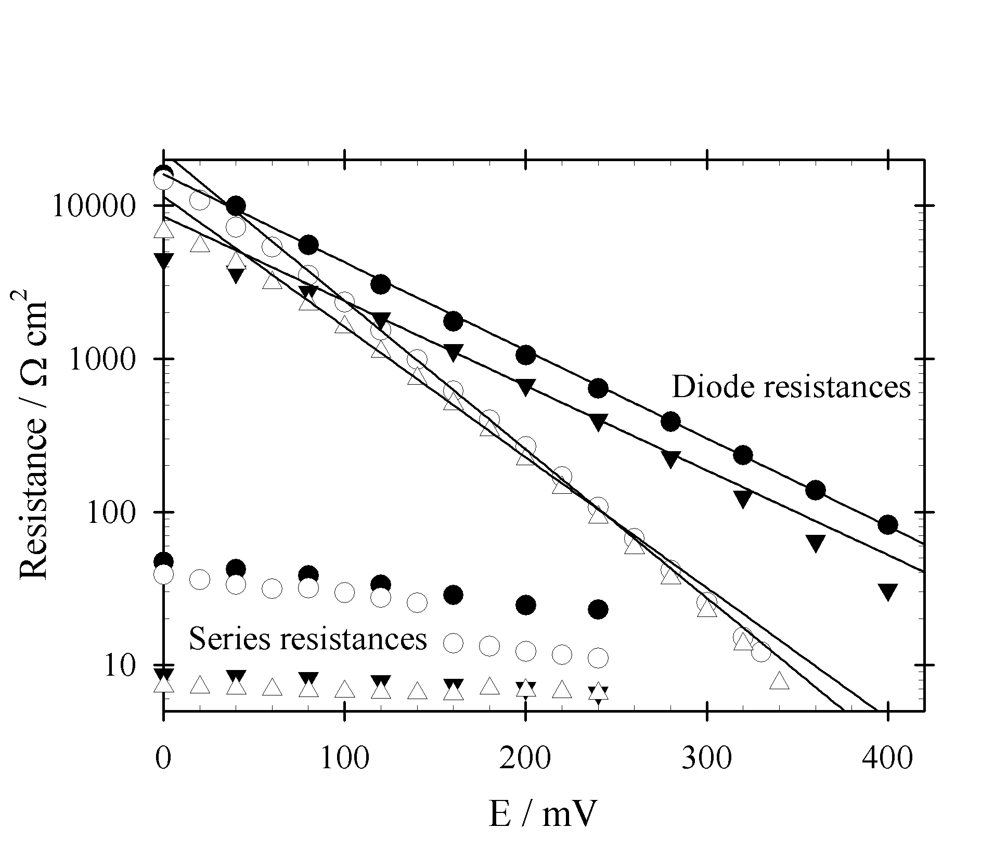
Figure 10. R_{s} and diode device resistances from R[R,C] fits for ED (circles) and SP-CuInSe₂ devices (triangles). Filled symbols were measured in the dark using an applied voltage bias, open symbols were measured using only light bias.

Table 4. Diode ideality factors extracted from three different measuring techniques. Numbers in brackets are values extracted in the dark.
Device | J-V | Photovoltage | Impedance
ED-CuInSe₂ | 2.0 (2.3) | 1.8 | 1.7 (3.0)
SP-CuInSe₂ | 1.8 (1.8) | - | 2.0 (3.1)

The capacitance values obtained from the fitting were used to construct Mott Schottky plots (figure 11) using the following equation
(3)
where C is the capacitance of space charge region, ε is the permittivity of CuInSe₂ [27],and V_{D} is the diffusion voltage.

The plots for the data obtained the dark are reasonably linear, and acceptor densities of 2 ×10¹⁶ cm⁻³ and 4 ×10¹⁵ cm⁻³ were derived from the slopes for ED and SP-CuInSe₂ devices respectively. The doping density in the electrodeposited device agrees well with values obtained by other groups [10, 15, 28], and the doping density for the sputtered device appear to be an order of magnitude lower than those found by Alberts et al [29]. The Mott Schottky plots for the devices under illumination give similar slopes.
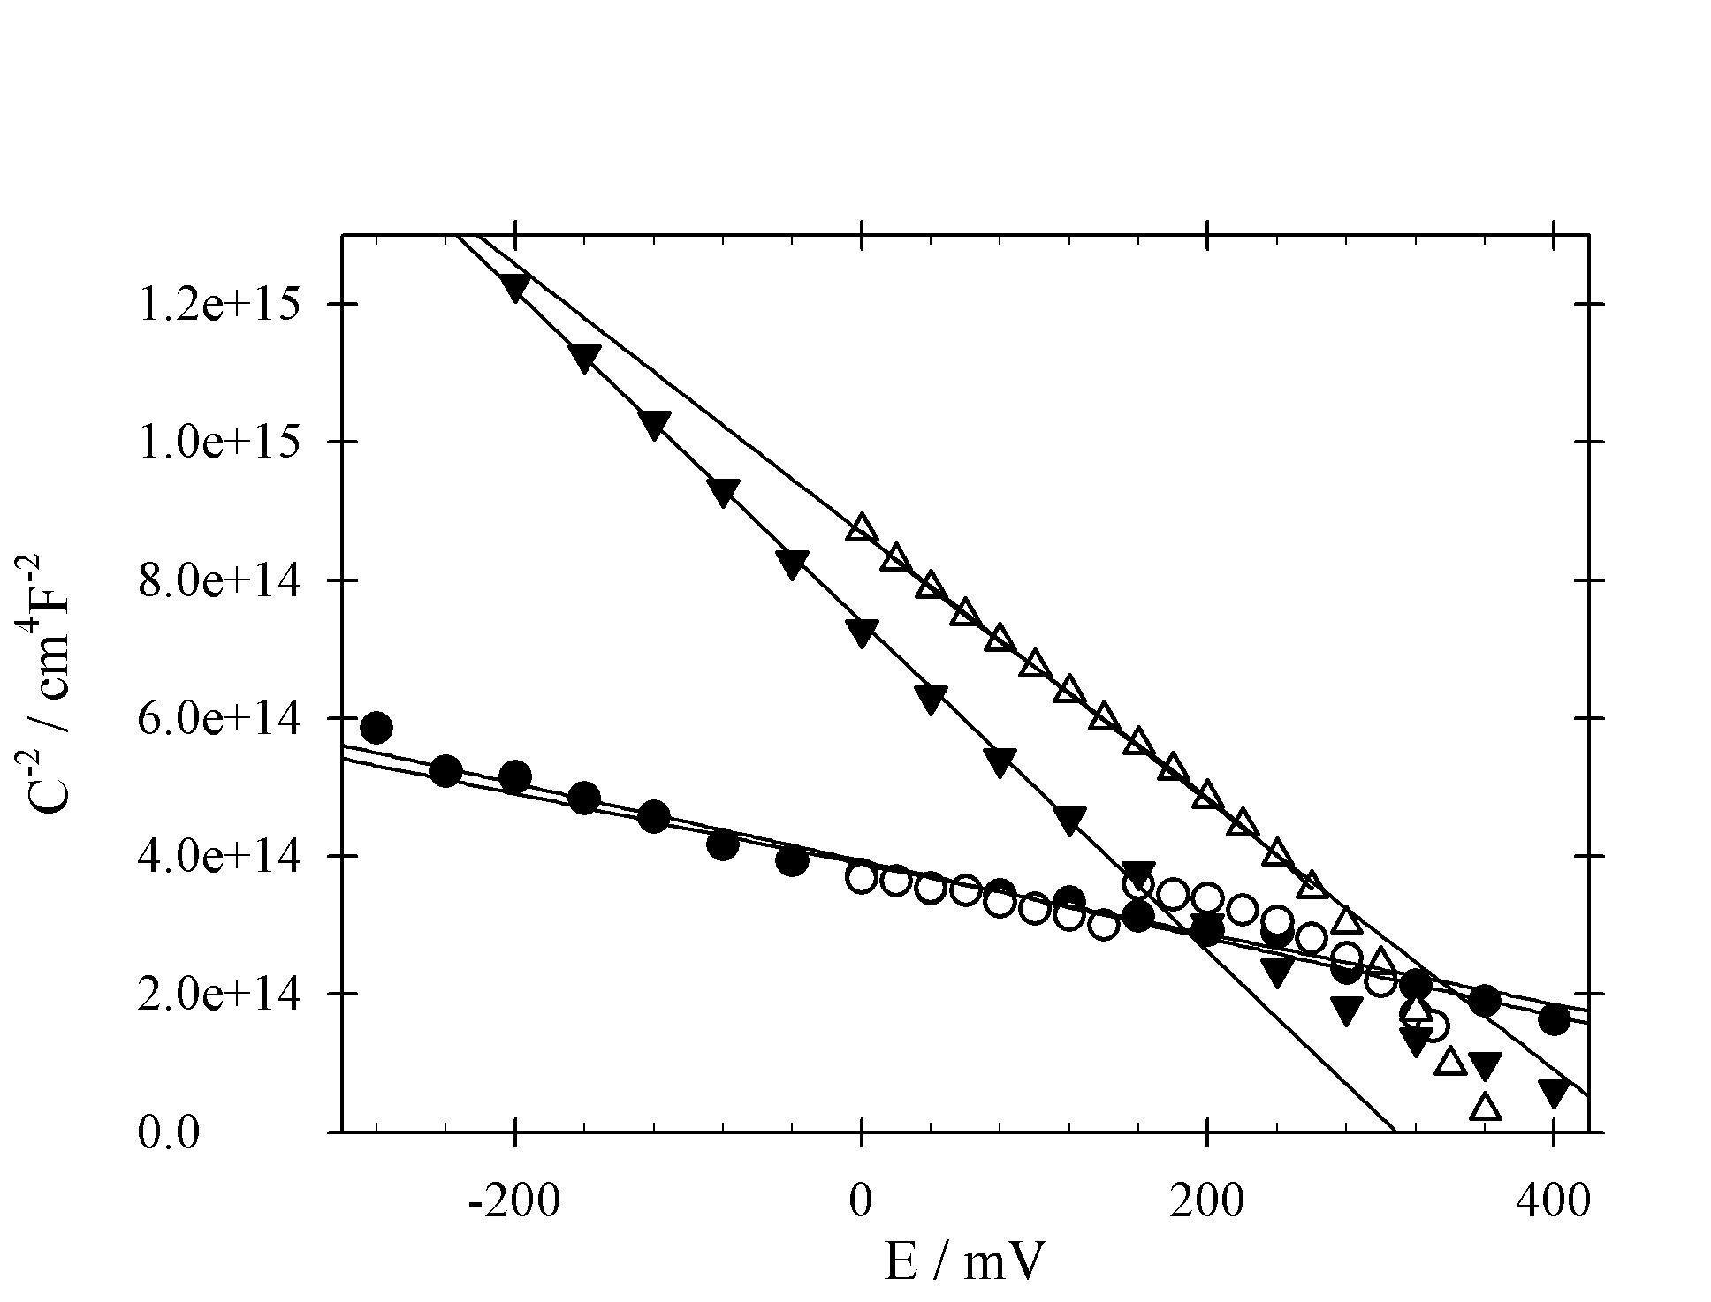
Figure 11. Mott Schottky plots derived from R[R,C] fits for ED (circles) and SP-CuInSe₂ devices (triangles). Filled symbols were measured in the dark using an applied voltage bias, open symbols were measured using only light bias.

The voltage intercept on the Mott-Schottky plots gives the band bending V_{D} which differs from the built in potential or barrier height V_{B} by the bulk Fermi energy: qV_{B} = E_{F}+qV_{D}. For thin film solar cells E_{F} can be 0.1-0.8 eV [30]. The differences in V_{D} observed between ED-CuInSe₂ and SP-CuInSe₂ suggests that there is an additional barrier in the electrodeposited device.

Table 5. Device parameters derived from impedance measurements made in the dark and photocurrent spectra measurements.
Device/ Method | N_{A} / 10¹³ cm³ | V_{D} / V | W / nm | L / nm
ED-CuInSe₂ | 1850 ± 62 | 680 ± 24 | 235 ± 6 | 143 ± 24
SP-CuInSe₂ | 433 ± 6 | 280 ± 4 | 312 ± 3 | 226 ± 39

The dependence of the EQE (corrected for reflection losses) Φ on the absorption co-efficient α, space charge width W, and minority carrier diffusion length L is given by the Gärtner equation [31].
(4)
The first term in brackets considers collection within the space charge region (SCR), and the second term in brackets considers collection by diffusion of charge carriers from the bulk into the SCR. The derivation of the Gärtner equation assumes that recombination in the SCR and at the interface can be neglected. The Gärtner equation was used to fit Φ to determine L using α values from Alonso et al [32] and values of W calculated from the measured doping densities. For the ED-CuInSe₂ device W (at zero bias) and L were calculated to be 235+/-6 nm and 143+/-24 nm, whilst the SP-CuInSe₂ had W and L values of 312+/-3 nm and 226+/-39 nm respectively. The lower value of L for ED-CuInSe₂ is reasonable due to the higher density of grains leading to a higher probability of recombination at grain boundaries.

The EQE of both cells was also measured at a reverse bias of -0.2 V, and a ratio was made with the EQE at zero bias. The ratio of EQE (-0.2V)/(0V) was independent of photon energy for the SP-CuInSe₂ device, but was found to be dependent at low photon energies for the ED-CuInSe₂ device, which again suggests that the diffusion length is smaller for the ED-based device.

4. Conclusions
This detailed comparison of the structural and optoelectronic properties of CuInSe₂ films prepared by sputtering (SP) and electrodeposition (ED) routes shows that improvement of the electron diffusion length in ED material is necessary in order to match the properties of SP material. The most obvious way to achieve this is to increase the crystallite size by using suitable methods such as rapid thermal annealing. Work is in progress to optimize and scale up the electrodeposition process and to improve the thermal post-treatment methodology.

Acknowledgements
The authors would like to thank Christian Kaufmann, Carola Kelch, and Michael Kirsch at the Hahn Meitner institute in Berlin for completing the devices. This work was supported by the EPSRC SUPERGEN programme. The authors thank other members of the SUPERGEN PV21 consortium for advice and encouragement.

References

[1] AbuShama J A M, Johnston S, Moriarty T, Teeter G, Ramanathan K and Noufi R 2004 Prog. Photovoltaics 12 39-45
[2] Contreras M A, Ramanathan K, AbuShama J, Hasoon F, Young D L, Egaas B and Noufi R 2005 Prog. Photovoltaics 13 209-16
[3] Coutts T J, Ward J S, Young D L, Emery K A, Gessert T A and Noufi R 2003 Prog. Photovoltaics 11 359-75
[4] Cunningham D, Rubcich M and Skinner D 2002 Prog. Photovoltaics 10 159-68
[5] Lincot D, Guillemoles J F, Taunier S, Guimard D, Sicx-Kurdi J, Chaumont A, Roussel O, Ramdani O, Hubert C, Fauvarque J P, Bodereau N, Parissi L, Panheleux P, Fanouillere P, Naghavi N, Grand P P, Benfarah M, Mogensen P and Kerrec O 2004 Sol. Energy 77 725-37
[6] Probst V, Palm J, Visbeck S, Niesen T, Tolle R, Lerchenberger A, Wendl M, Vogt H, Calwer H, Stetter W and Karg F 2006 Sol. Energy Mater. Sol. Cells 90 3115-23
[7] Klaer J, Klenk R and Schock H W 2007 Thin Solid Films 515 5929-33
[8] Calixto M E, Dobson K D, McCandless B E and Birkmire R W 2005 Conference Record of the Thirty-First Ieee Photovoltaic Specialists Conference - 2005, pp 378-81
[9] Kaufmann C A, Neisser A, Klenk R and Scheer R 2005 Thin Solid Films 480 515-9
[10] Guimard D, Grand P P, Bodereau N, Cowache P, Guillemoles J F, Lincot D, Taunier S, Ben Farah M and Mogensen P 2002 Conference Record of the Twenty-Ninth Ieee Photovoltaic Specialists Conference 2002, pp 692-5
[11] Kim S D, Kim H J, Yoon K H and Song J 2000 Sol. Energy Mater. Sol. Cells 62 357-68
[12] Alberts V, Zweigart S and Schock H W 1997 Semicond. Sci. Technol. 12 217-23
[13] Alberts V, Herberholz R, Walter T and Schock H W 1997 J. Phys. D-Appl. Phys. 30 2156-62
[14] Karg F, Probst V, Harms H, Rimmasch J, Riedl W, Kotschy J, Holz J, Treichler R, Eibl O, Mitwalsky A and Kiendl A 1993 Conference Record of the Twenty Third Ieee Photovoltaic Specialists Conference - 1993, pp 441-6
[15] Guillemoles J F, Cowache P, Lusson A, Fezzaa K, Boisivon F, Vedel J and Lincot D 1996 J. Appl. Phys. 79 7293-302
[16] Zaretskaya E P, Gremenok V F, Zalesski V B, Martin R W, Ivanov V A, Victorov I A, Yakushev M V, Ermakov O V and Kurdesau F V 2001 Polycrystalline Semiconductors Iv Materials, Technologies and Large Area Electronics, pp 287-92
[17] Zoppi G, Durose K, Irvine S J C and Barrioz V 2006 Semicond. Sci. Technol. 21 763-70
[18] Romeo A, Terheggen A, Abou-Ras D, Batzner D L, Haug F J, Kalin M, Rudmann D and Tiwari A N 2004 Prog. Photovoltaics 12 93-111
[19] Rudmann D, Bremaud D, da Cunha A F, Bilger G, Strohm A, Kaelin M, Zogg H and Tiwari A 2005 Thin Solid Films 480 55-60
[20] Rudmann D, da Cunha A F, Kaelin M, Kurdesau F, Zogg H, Tiwari A N and Bilger G 2004 Appl. Phys. Lett. 84 1129-31
[21] Granata J and Sites J R 1998 Proceedings of the 2nd World Conference on Photovoltaic Solar Energy Conversion, Vienna

[22] Shioda T, Chichibu S, Irie T, Nakanishi H and Kariya T 1996 J. Appl. Phys. 80 1106-11
[23] Shirakata S, Chichibu S, Isomura S and Nakanishi K 1997 Jpn. J. Appl. Phys. Part 2 - Lett. 36 L543-L6
[24] Aspnes D E 1973 Surf. Sci. 37 418-42
[25] Shay J L, Tell B, Kasper H M and Schiavon.Lm 1973 Phys. Rev. B 7 4485-90
[26] Alonso M I, Wakita K, Pascual J, Garriga M and Yamamoto N 2001 Phys. Rev. B 6307
[27] Li P W, Anderson R A and Plovnick R H 1979 J. Phys. Chem. Solids 40 333-4
[28] Qiu S N, Li L, Qiu C X, Shih I and Champness C H 1995 Sol. Energy Mater. Sol. Cells 37 389-93
[29] Alberts V, Swanepoel R and Witcomb M J 1998 J. Mater. Sci. 33 2919-25
[30] Hegedus S and Shafarman W N 2004 Progress in Photovoltaics: Research and Applications 12 155-76
[31] Gärtner W W 1959 Physical Review 116 84-7
[32] Alonso M I, Garriga M, Rincon C A D and Leon M 2000 J. Appl. Phys. 88 5796-801

Author to whom any correspondence should be addressed. New address: Laboratoire Photovoltaïque Université du Luxembourg L-1220 Luxembourg

