Research Fiction and Thought Experiments in Design.

  - Abstract
Any design process involves an imaginative act, a picturing of the world as other than it is. Fiction has long played a part in design research in the form of scenarios, personas, sketches, paper based prototypes, simulations, prototypes and speculative design. The term “design fiction” has been recently adopted to describe more elaborate and detailed representations of products and services that do not exist yet. Design fiction is an emerging practice and there are several competing definitions and forms. This article traces design fiction from the Italian radical design of the 1960s through British Art Schools in the late nineteen nineties to contemporary adaptations of the practice by companies like Google, Microsoft and Facebook. Design fiction is now produced regularly by individuals launching Kickstarter campaigns, corporations selling visions of future products and governments imagining new digital services. But there is little agreement about the status of such fictions: what constitutes a good fiction? How does fiction relate to research? In what sense does fiction contribute to existing knowledge? Although fiction can sometimes result in accurate prediction this is not its main value. It is rather the creation of ambiguous artefacts that help us think carefully about emerging technologies and their potential impact. Although fiction may seem to be the antithesis of empirical enquiry it is often employed in the form of “thought experiments” in Physics, Mathematics, Ethics and Philosophy. This article argues that design fiction can also be considered as a form of thought experiment. Excerpts from a fictional Wikipedia article about Valdis Ozols, a Lativian Historian and author writing design fiction in the 1940s precede each section as think pieces about the nature and value of fiction. The text is illustrated with pages from a fictional design workbook written in an invented language.

1 The Rise of Design Fiction
Valdis Ozols has been described as the Father of Design Fiction, a 2017 Wikipedia entry is reproduced here in three parts at the beginning of each subsection of this article to illustrate some of the problems around the creation and criticism of design fiction.

Valdis Ozols (1905 -1998)

Valdis Ozols (April 7th 1905 - February 9th 1998) was a Latvian Historian and science fiction writer. His historical work is now primarily studied as Soviet propaganda but there has been a revival of interest in his science fiction, which is now sometimes categorised as design fiction.
Contents [edit]

Life and Career.
Ozols’ Rediscovery
Ozols’ Personal Life
Fiction Writing Career
Translation
List of Works
Influence and Legacy

Life and Career [edit]

Ozols spent much of his working life as a Lecturer at the University of Latvia. He wrote two modern histories of Latvia dealing primarily with the Soviet occupation of Latvia. The Latvian Experience of Soviet Democracy (1945) is a pro Stalinist account of the early years of the occupation. The book is based largely on official Communist Party hagiographies of Stalin and is for the most part unremarkable but it was republished in the nineteen nineties as part of the Reading Propaganda series [citation needed]. The book ensured Ozols’ position at the University of Latvia when it became a standard text in the national curriculum for modern history. His second book appeared four years later offering an account of everyday life: Soviet Latvia Today and Tomorrow (1949). Again it was a largely uncritical account of Soviet policy in the region, taking a conservative line against nascent organisations like the Popular Front of Latvia (Tautas Fronte). This book has also been reissued as part of the Reading Propaganda series but it is no longer regarded as history.

During his academic career Ozols published several short stories under different pseudonyms. Latvian fiction was strictly censored during the Soviet occupation and Ozols tried only once to publish under his own name. His experience with the censors and the University’s bureaucracy was such that he decided never again to publish in Latvia and had his work translated for submission to various editors in Eastern Europe. He had most success with Polish publications in the nineteen fifties during the de-Stalinisation period when there was a great increase in freedom of expression [citation needed]. Several of his short stories took the form of academic papers and reports from fictional technology conferences. Some literary critics now believe that they influenced the work of the Polish science fiction writer Stanislav Lem in books like The Futurological Congress (1971) [citation needed]. In his later years Ozols complained bitterly that Lem had stolen his ideas and sought legal advice about suing him [citation needed]. Copyright was a recurring theme in Ozol’s work. One of his fake academic reports describes the development of a music machine which combines musical tones, times and tempos to simultaneously create and copyright billions of tunes. This story Infinite Music (1940) describes the total demise of the phonographic industry when an American corporation declares any possible future melody to be its intellectual property and copyright protected for a period of seventy-five years.

Although Ozols assiduously pursued a strict Communist party line in his academic work he became the victim of a purge in the university in the late nineteen forties. He was denounced as an American spy by his wife Iveta [see Ozols’ Personal Life] but the Ozols scholar Inga Baldois, has argued that he may also have been identified as the author of some of “counter revolutionary” short stories. After losing his job at the University Ozols disappeared and all records of his service in post were destroyed. His books were expunged from the curricula and any reference to them was removed from subsequent academic and administrative work. Ozols officially ceased to exist and soon after this the man himself disappeared. Some believe he was executed but Baldois claims that he fled the country and continued to publish short stories under pseudonyms.

Ozols’ Rediscovery [edit]

Ozols’ fictional work was almost entirely forgotten until a copy of Ozols’ self published book Technopedija was discovered in 1989 by Inga Baldois, a postgraduate researcher in Computer Science at Riga Stradins University. Inga came across a copy of the book in a storage space she had rented. It was Inga who identified the retroactive importance of the work and began to publish English translations online. She pursued Ozols’ fiction through obscure East European magazines and the list of stories in this Wikipedia article is mainly based on her research.

In 1993 Baldois claimed to have contacted Ozols and carried out an interview with him. He is evasive in most of his answers, especially about Soviet era Latvia and the charge that he denounced many people including his wife, her lover and the Head of Department; but the interview contains a section on design fiction which has been referred to as one of its earliest definitions:

Baldois: Do you consider yourself to be a science fiction writer?
Ozols: No, I never liked that term. For me this is bug eyed aliens and zap guns. I saw my fiction as an extension of history. Historians take fragments we find in the present and try to reconstruct the past, writers of future fiction do exactly the same thing but they are looking in the other direction, no? This has nothing to do with science but then, heh heh, history has nothing to do with science either. You might call it Engineering Fiction, you might call it Design fiction, It is about the choices we make and what those choices might mean. It is based not only on technological plausibility but also historical precedent.
(Balodis June 1993)

Baldois was accused of forging the interview and received a number of online threats that were taken seriously by Riga’s police. She took the transcript offline and has since left academic life and ungoogled herself, adding further support to those who argue that Ozols never existed [citation needed]. In 2017 she contacted Mark Blythe, an academic with an interest in design fiction, and told him her story under condition that her current location remain strictly confidential.

(Valdis Ozols: Wikipedia. Last Retrieved 18.02.2018)

Valdis Ozols is a fictional author but his imaginary biography raises questions around the emerging practice of design fiction. What if such a writer had existed? What would design fiction in the nineteen forties have looked like? What use would it have been? Valdis is a kind of thought experiment about design fiction and his story is threaded through this article in the form of extracts from a fake Wikipedia page, along with pages from an “imaginary design workbook” like the one in figure 1.
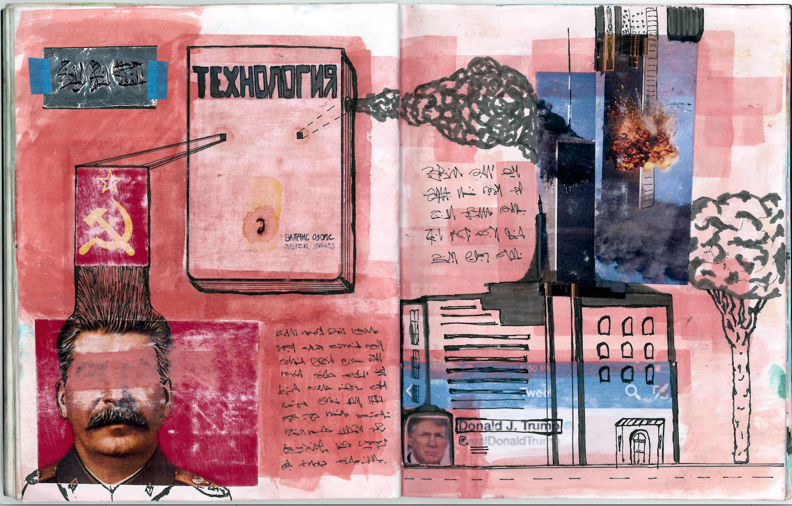

Figure 1: Valdis Ozols

Science fiction has always been somewhat disreputable. JG Ballard characterised mid twentieth century sci fi as “planet yarns” with “an American imperium colonising the entire universe which they turned into a cheerful, optimistic hell, a 1950s American suburb paved with good intentions and populated by Avon ladies in spacesuits” [4]. In the sixties writers like Harlan Ellison and Robert Heinlein attempted to rebrand their work as “speculative fiction” to indicate a more serious and science based approach. Nevertheless one of the greatest writers of the genre, Kurt Vonnegut, continued to complain that his work had been put into a “file drawer marked science fiction” which he wanted to get out of because so many critics mistook it “for a urinal” [122] Some critics have taken science fiction as seriously as any other form of literature, Frederic Jameson, for example described Philip K Dick as the Shakespeare of the genre and wrote a book length treatment of his work [67]. But technology developers have always recognised the value of this kind of writing. The earliest science fiction writers like HG Wells had an immediate influence on contemporary engineers and designers. The history of computing technology has been in part shaped by popular science fiction shows and film. If, as Shelley claimed, poets are the unacknowledged legislators of the world then science fiction writers are the unacknowledged inventors.

There has also been a long running if sporadic engagement between HCI academics and science fiction. In a comprehensive review Elisabeth Buie points out that “HCI has engaged with SF since at least 1992 when a CHI conference panel of HCI researchers and SF writers (Marcus, Norman, Rucker, Sterling and & Vinge 1992) discussed SF and HCI” [31]. The panellists at this event included Don Norman and Bruce Sterling and the event aimed to explore “future user interfaces, their technology support, and their social context” [87]. A decade later a CHI keynote was given by the The Hugo award winning science fiction writer David Brin. The future dystopias depicted in Anthony Burgess’ Clockwork Orange and of Orwell’s 1984 were pastiched for scenarios exploring emerging surveillance technologies in 2004 [22]. In 2011 a futurist at the Intel Corporation, David Brian Johnson, was characterising short stories, movies and comics as “SF prototypes” and positioning SF explicitly as a step in the development process [69]. In 2014 Bauman and colleagues imagined the CHI conference of 2039 through fictional abstracts to consider the “various visions guiding work in HCI” [8]. In the same year a paper called Research Through Design Fiction described “imaginary abstracts” that were not visions of the future but rather pastiches of contemporary Research Through Design projects; this paper went so far as to argue that fictional studies of prototypes that could be built might serve as a useful alternative to actually building them [15].

Although the relationship between science fiction and technology research is as old as either field the term “design fiction” seems to have caught the imagination in academia and industry alike. There is some confusion over where the term “design fiction” originates. It is sometimes attributed to Bruce Sterling’s 2005 book Shaping Things [109] and Julian Bleecker’s 2009 short essay on Design Fiction [10]. Sterling himself attributes the invention of the term to Bleecker [108] but there are earlier uses of the phrase. The first instance that Buie [31] finds occurs in a 2003 paper by Alex Milton, who then working for the school of Design and Media Arts at Napier University. Milton’s (2003) paper [89] is written as a script for a documentary and features commentary on Noam Toran’s Accessories for lonely men [119] a series of provocative objects designed to comfort and console men who were suddenly single and missing their former partners. This included a “sheet thief” which slowly winds a sheet off the sleeper (see figure 1) and a “heavy breather” speaker which played the sound of someone’s breath near a pillow. Toran also made a film called Objects for Lonely Men which was a black and white short film featuring a man so obsessed by a Jean Luc Godard movie that he has a tray of props to use while watching it. The props include a gun used in one of the scenes and a plastic head of an actress in the film.
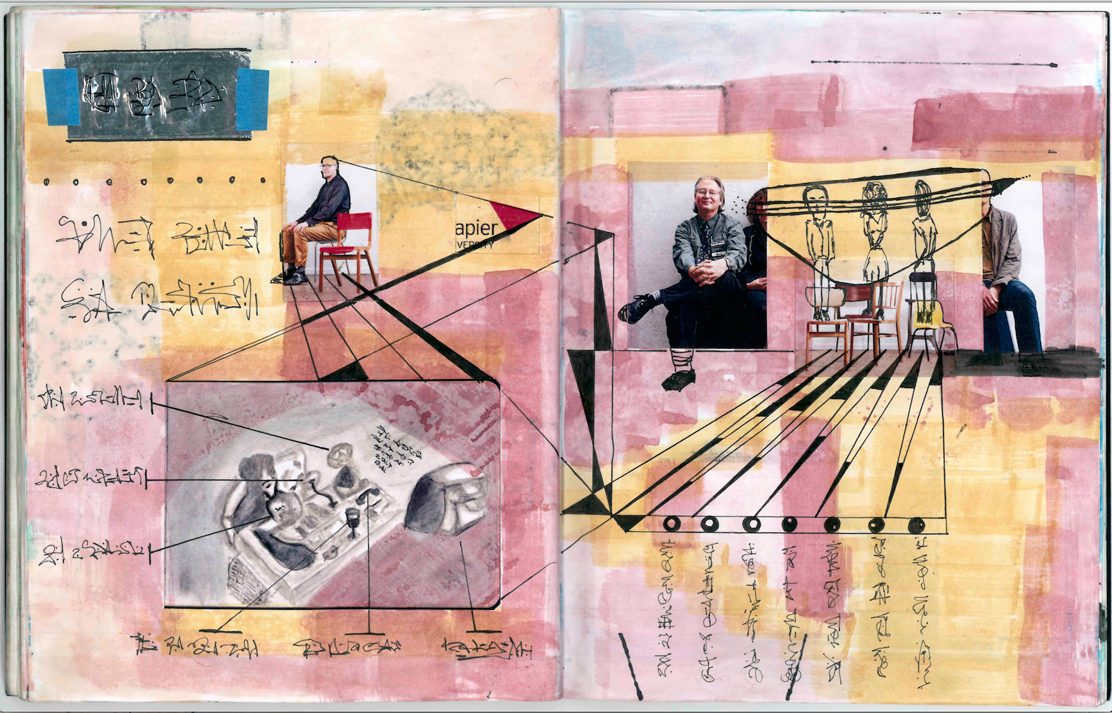
Figure 2: Noam Toran’s Objects for Lonely Men

Alex Milton declares that Toran’s work has:

“begun to explore the realms of design fiction through the medium of props and pseudo documentaries. Ron Arad suggests that ‘Noam tends to develop fictional histories for his objects, deceitfully creating individuals and inventions as if they already existed and he merely discovered them.’ [84]

It is more than likely that the words “design” and “fiction” collided in any number of texts before this one, however Milton uses the term more or less as it is used today. The designer whose work is described in in this way studied for an MA at the Royal College of Art between 1999 and 2001 at the time that Antony Dunne and Fiona Raby were teaching “critical design”.

Critical design seeks to challenge preconceptions about the role that products play in everyday life [52]. In Design Noir Dunne and Raby describe many ingenious examples. The ‘Compass Table’ for instance contains 25 compasses which ‘twitch and spin’ whenever a mobile phone, laptop or similar device is put onto it. The table may be either ‘sinister or charming depending on the viewer’s state of mind’ (ibid). Such objects are not merely things in themselves but provocations intended to cause the viewer to reflect on their own preconceptions and values. In this sense, the designed objects imply a critique, they make strange or defamiliarize the everyday and the taken for granted (ibid).

Antecedents to this work can be found in the Italian Anti Design movement and the Radical Design movement of the 1960s. Following the second world war Italian design became synonymous with chic and style in the home, in fashion and in automobiles [106]. But many designers became disillusioned with the intensifying consumerism their work supported and radical architectural groups began to produce challenging conceptual designs (ibid). Superstudio for example produced images of a “New New York “with a gigantic white grid laid over the top of its skyscrapers to create a new space
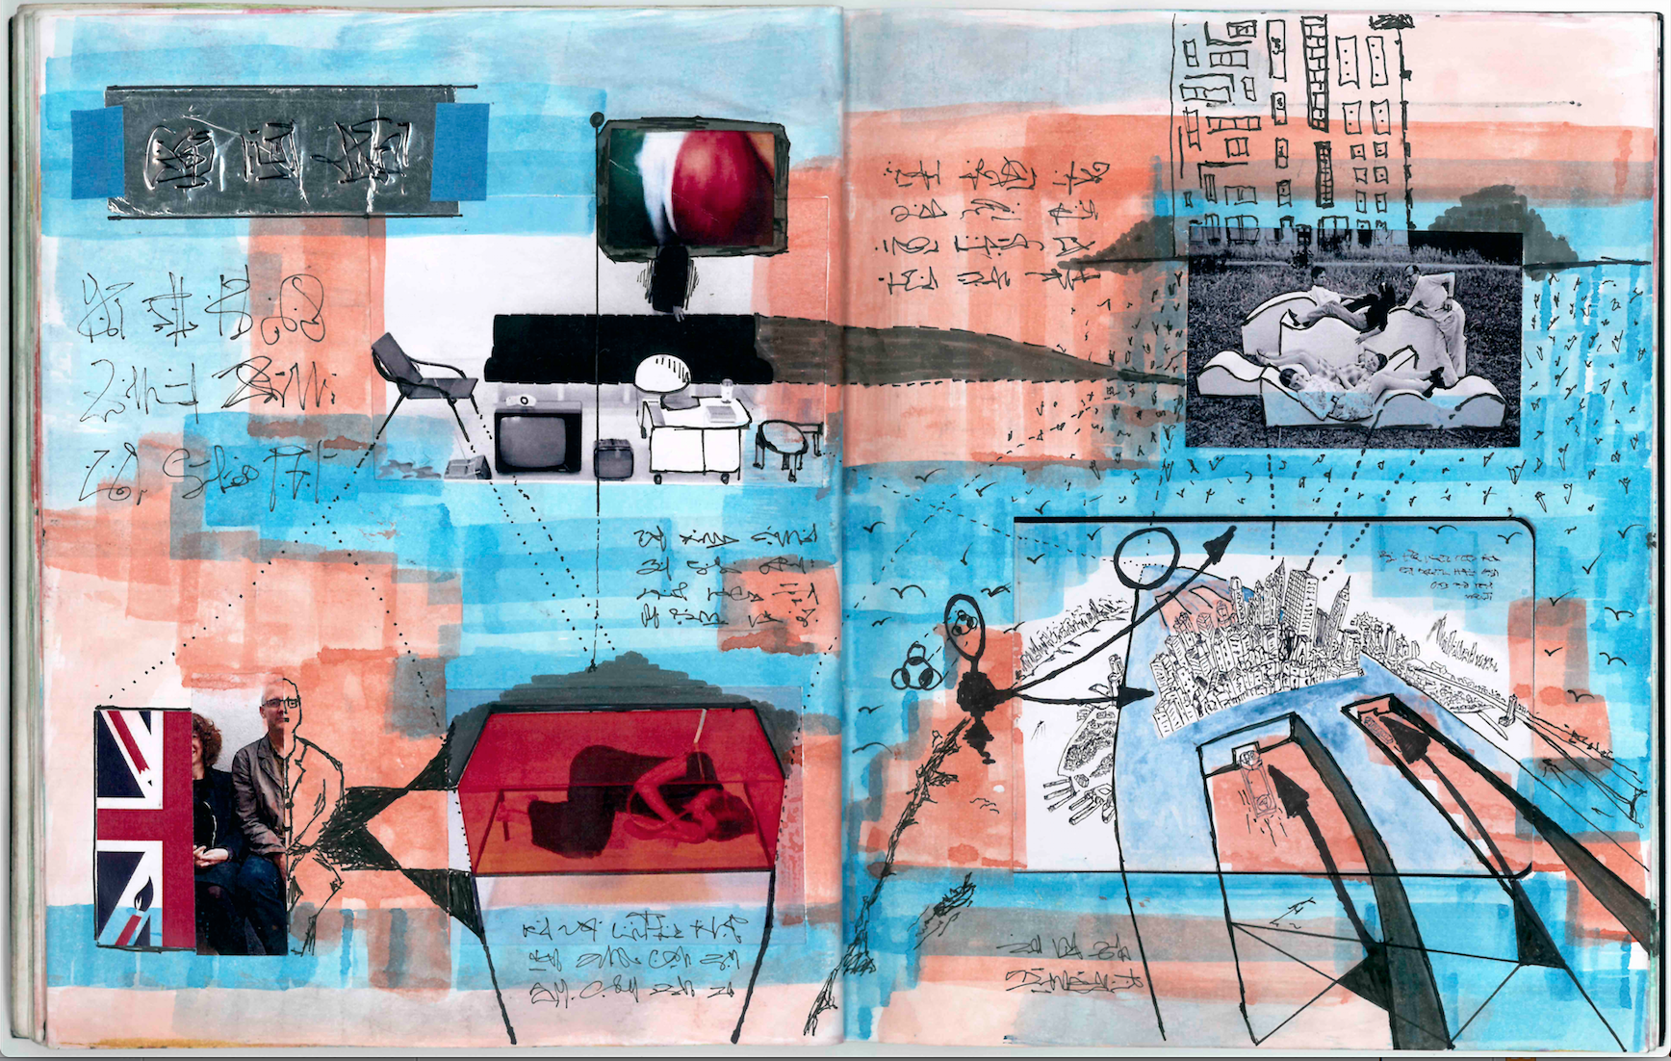
Figure 3: New New York. Superstudio

Similarly Archizoom Association’s “No Stop City” imagined a place where people “can live inside a shopping centre, where houses are already empty incubators”. The images of the “No Stop City” are repetitive grid like patterns in bleak, grainy black and white representing a “total commodification of products and life” [27].

Dunne and Raby’s Critical Design brought this sensibility to product design and later interaction design. It was ground breaking because it demonstrated that design need not be a solution to a set of requirements specified in response to a given problem or set of constraints. Design might also be a critique, like a political essay or satirical sketch. They saw academia as a place where such notions of design could be developed:

“proposals like these can really only exist outside the marketplace as a form of “conceptual design” – meaning not the conceptual stage of a design project, but a design proposal intended to challenge preconceptions about how electronics shape our lives.” [52]

Dunne and Raby and their students have continued to make intriguing and provocative designs but the term “critical design” is used less and less. The approach has been criticised because it positions designers as figures of knowledge / power who enlighten “cultural dopes”. The work is also criticised ad hominem because it is mainly produced in elite institutions like the RCA and usually addresses “first world problems”, [100]. Describing Dunne and Raby’s work as elistist is certainly unfair if not a deliberate misreading of the work but more recently they themselves describe their approach as “speculative design” or design fiction [53].

But the person who has done most to popularise design fiction is probably Bruce Sterling. Bruce Sterling is a science fiction writer, perhaps best known for collaborating with William Gibson on the early steampunk novel “The Difference Engine” which imagines a world where the digital revolution takes place at the same time as the industrial revolution. The novel borrows from Victorian fiction, cutting and pasting situations and characters into a world of steam driven computers. This is a plausible alternate history in that many historians agree that if Charles Babbage, the inventor of the difference engine of the title had managed to win the state funding he had sought for to make the “analytical engine” he would have succeeded in developing the computer that he and Ada Byron imagined. Sterling has spent a lot of time thinking seriously about design and he is deeply involved in design communities and conferences. In his non fiction book Shaping Things [109] he recasts work that would ordinarily be called science fiction as “design fiction”:

“The core distinction is that design fiction makes more sense on the page than science fiction does” (ibid).

He notes that most readers would not notice the difference between this and any other science fiction, the characteristic he stresses is plausibility. Sterling taught a course on design fiction at the European Graduate School and also wrote a recurring Wired magazine column under the same name. As part of his design fiction Sterling develops “fantasy prototypes” drawing on the work of consultancies like Superflux and Dunne and Raby’s “critical design”. He also champions the work of Julian Bleecker and indeed credits Bleecker with the term, perhaps because he was one of the first to clearly articulate the practice in a 2009 short essay on design fiction [10].

Bleecker wrote this piece for a special issue of Personal and Ubiquitous computing responding to the Dourish and Bell paper Resistance is Futile [49] This paper argued that, in some respects, TV shows like Blakes 7, the Hitch Hiker’s Guide to the Galaxy and Planet of the Apes had more interesting things to say about the ways that technology might impact society than the ubicomp literature ever did. They argued that what design scenarios typically leave unsaid is the implicit social and political context of a design (ibid). Although the journal was not published until 2014 the draft papers were in circulation from 2009 and Bleecker’s was available online. Here he argued for the importance of “diegesis”, a term borrowed from film studies used to indicate something that is part of a larger fictional world. For Kirby the props in movies like Minority Report are “diegetic prototypes” in that they functioned as a part, rather than the point of a story, often presenting the imagined technology as desirable or benevolent [75].

Bleecker characterised his design fiction as “materialised thought experiments” and emphasised “physical instantiation” over future plans shown in powerpoint [10]. Today, Julian Bleecker and the other members of the Near Future Laboratory are producing some of the most interesting design fictions in the form of the TBD magazine [52] featuring articles and advertisements for products and services that do not exist.
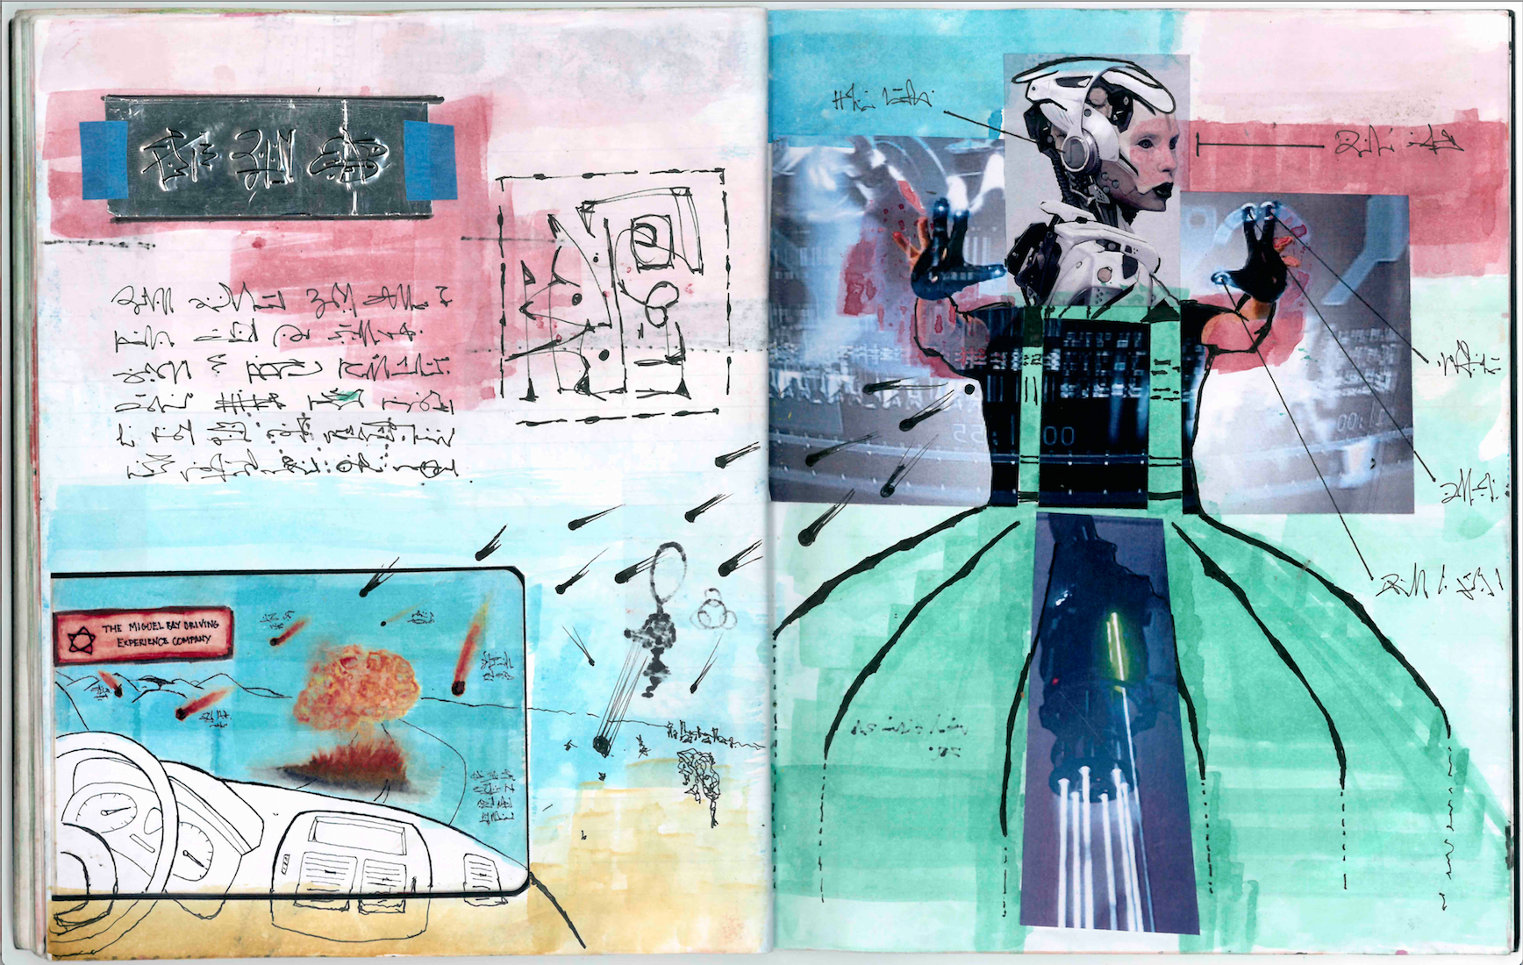
Figure 4: TBD and the Near Future Lab

The fake branding and image for the TBD “Miguel Bay Driving Experience” shows the view of a road from the inside of a luxury car familiar from numerous advertising campaigns, but on this otherwise empty road are realistic looking explosions of the kind encountered so often in Bond or Mission Impossible movies. The text frames the fiction in an imagined context where autonomous cars constitute 45% of journeys and drivers are bored on their daily commute, the company turn the window of the car into a game. The format of the glossy advertisement conveys the concept but also the implicit context of an industry built around driverless-car entertainment. Bleecker’s fictions present not just imaginary products but worlds for them to exist in. The TBD catalogue is primarily visual but the museum installation is also used to represent design fictions. Stuart Candy’s “nurture pod” shows a baby in a virtual reality pod, it is described as an “experiential prototypes” and visitors are encouraged to treat it like something they would find on a table in an Apple store [112].

In a 2013 NEXT keynote address Sterling warned that we would be seeing lots more design fiction because it was cheap and people had learned how to do it [111]. He suggested that the academics in the audience might usefully provide a taxonomy, categorising the varieties of design fiction that were emerging. Academics were already on the job: a 2013 special issue of the journal Digital Creativity sought to provide an introduction and partial taxonomy of design fiction [63]. This taxonomy includes near future science fiction with prescient novels like William Gibson’s “Pattern Recognition” as the paradigmatic example. The taxonomy included work which positions fiction as a design technique but also noted its use in corporate propaganda. Microsoft and Phillips have both presented design fictions in promotional films bearing, according to Gonzattoa and van Amstela, the implicit message – “don’t worry the future is safe in our hands” [60]. Sterling also discusses the corporate use of design fiction pointing to Google’s release of YouTube videos showing various fantasy scenarios of Google Glass in use. More recently IKEA worked with Mobile Life and the Near Future Lab to create a future technology catalogue. The Museum of Future Government Services a commission by the United Arab Emirates Government, is a collection of design fictions where “governments and society work together to create a more hopeful world”. And now Kickstarter campaigns seeking funds for innovative products often feature well produced videos presenting the concept they are hoping people will invest in. The qualities of the promotional video (the design fiction) is one of the most important factors in the success of the campaign [46].

At the Next 13 conference keynote Sterling offered a more formal definition of design fiction as: “the deliberate use of diegetic prototypes to suspend disbelief about change.” [111]. Following Sterling’s definition several others have been proposed. Josh Tanenbaum suggested this: “Design Fiction uses narrative elements to envision and explain possible futures for design” [115] Lindley and Coulton describe design fiction as: "(1) something that creates a story world, (2) has something being prototyped within that story world, (3) does so in order to create a discursive space", where 'something' may mean 'anything' [81]”. Blythe and Encinas got in on the competing definitions game with this rather wordy effort: “Design fiction is a malleable concept: it can take the form of text, image, audio, video, model, working prototype or event; it can be conceived as a plausible idea for a technology developed with “designerly thinking”, an eye for detail and practical concerns; it can be framed as a conceptual design placed within a broad cultural context focusing not just on product functionality but potential social consequences of use; it can be a tool for corporate propaganda or a means of expressing concern, dissent and critique.” [12]. To this burgeoning list we can add the fictional one by Valdis Ozols which retroactively predates them all.

The term design fiction has a rather strange trajectory. It emerges from British art schools in the late nineteen nineties as a practice that echoes the Italian radical design of the sixties. It becomes a tool for global corporations like Microsoft, Google and Facebook but it can also be found in crowd funding campaigns like those supported by kickstarter. Design Fiction begins as critique but ends as technique. But why has this rather old idea become so popular in the field of interaction design now?

  - 1.1. From Scenarios and Personas to Design Fiction
Short fiction in the form of scenarios have long played an important part in design and studies of Human Computer Interaction. Carroll defined scenarios as “stories about people and their activities” [17] He argued they were a tool for reflective practice: creating vivid descriptions of user experience and allowing for multiple viewpoints, (ibid). Perhaps the most influential scenarios in HCI appeared in Mark Weiser’s seminal 1990s article on “The Computer for the 21st Century” [124]. His “Sal” scenarios describe with astonishing prescience the technologies that now shape much of our working lives. Sal wakes up to coffee brewed by her alarm clock following a voice command; her windows show data indicating that her children are up; she reads an electronic newspaper and marks passages to send to work with a smart pen; a “foreview” mirror in her car warns her that she is heading towards a traffic jam and helps her to find a parking space; she collaborates on a document with Joe who she shares a virtual office with; Joe asks her if she remembers a woman at a meeting from the week before, she doesn’t but she searches previous meetings and finds the woman’s biography.

Critics of scenarios like these argued that the characters were two dimensional and stereotypical. Cooper’s book The Lunatics Are Running The Asylum [40] advocated the use of more richly imagined persona in scenarios. He argued that computer scientists were designing for themselves or at best the guy in the cubicle next to them. For Cooper scenarios with users that were little more than names like Harry or Sal were not adequate, there should also be demographics like age, occupation and ethnicity (ibid). For Lene Nielsen [90] this too was superficial. She argued for character driven scenarios taking European film as an inspiration. Blythe and colleagues suggested that scenarios might borrow from many cultural sources to develop richer scenarios [12, 13, 14]. Pastiche is an imitative form of writing which borrows style, setting and characters from source material to produce new texts. Pastiche scenarios, then, draw on existing sources in order to create richer and more resonant descriptions of users and technologies. The technique was used in the special issue around Dourish and Bell’s paper “Resistance is Futile’ to rewrite the Sal scenarios in the style of Douglas Adams and Philip K Dick [16].

Ubicomp scenarios are still, for the most part, written in the style of Weiser’s Sal story. Such scenarios resemble science fiction except for the omission of conflict, the basic foundation of all narrative [16]. The key difference between science fiction and ubicomp scenarios is the explicit acknowledgement of social conflict and struggle (ibid). Although scenarios and personas are primarily written forms there are many forms of fictional objects with also have a long history in design.

  - 1.2 Sketches, Prototypes and Epistemological Angst

Making paper based prototypes is a standard procedure for Interaction Designers. Early Graphical User Interfaces were planned using pieces of paper with drawings on them to represent the transition form one screen to another. The “Wizard of Oz” technique involves setting up a rudimentary model of the idea and having participants role play around it. This allows designers to think about whether a prototype is a good idea before going to the trouble and expense of actually making it [42]. Similarly a provotype is a provocative prototype used to explore a design space, it may function only partially and serve primarily as a discussion piece for participants in field or lab studies [24]. Concept designs sketching vague or abstract ideas have long been made in design workbooks and papers [e.g. 88,11,117,56]. Design workbooks are often kept as a kind of ideas journal throughout a project noting initial thoughts, vague concepts and collecting inspirational materials. Designers often cut and paste magazine articles or drawings into them and they look something like the imaginary workbook figures illustrating this article. While this kind of concept generation has always been part of a wider process of design these kinds of vague idea are increasingly framed as contributions themselves. This is of course controversial and upsets some people.

In the early days of HCI a computer scientist might develop some new system and frame the contribution to knowledge as – I have made this thing therefore such things can be made. Other prototypes might contrast one form of interaction with another, for example, one design of mouse against a slightly different one. Such prototypes would be measured against one another in usability tests such as - time on task, ease of use and ease of learning. These were measurable and comparable and so the value of the prototype was relatively clear. But as computing technology moved from the office to the home technology became less concerned with specific tasks. The goals of a design might be as amorphous as enjoyment or to give the user an interesting experience. Prototypes became more fanciful and their value less clear.

Zimmerman and Forlizzi [126] argue that making research artefacts allows researchers to address complex or “wicked” problems and evaluate how current and future technologies may effect people. They make it clear that the aim of such work is not to produce commercial products but rather to apply design practice to new problems in order to create knowledge (Ibid). However, they also claim that findings will be more acceptable to the academic community if there are agreed forms of “practice, evaluation and outcome” and suggest more systematic or scientific approaches to theory development (ibid). Other practitioners have taken issue with this stance. Khovanskaya et al discuss the ways in which critically orientated practitioners find themselves in a “double bind” having to adopt the language of evaluation at the same time as they subvert it [73]. Gaver [56] points out that taking a more scientific approach is not a straightforward proposition as there are conflicting accounts of what constitutes science. For him research through design is not repeatable, generalisable or indeed falsifiable because its claims are vague – sometimes ambiguity creates useful features, sometimes not. But he also points out that there are many points of agreement within the community (ibid). He ends the discussion with a call to traditions of annotation such as those accompanying the design catalogues of Dieter Rams. This last move is interesting because it calls not on traditions of science or social science but rather the Arts.

As HCI takes what is being described as a “cultural turn” it has begun to struggle with the same issues that have troubled the Arts for so long. Responses to art are inherently subjective, one person likes it and another does not. Increasingly evaluations of design prototypes look like this. Some people like this or that prototype but others do not like it at all. Such findings are inconclusive because the researchers do not seek to generalize. Why, then, ask anyone what they think of a prototype? Why make a prototype at all if no hypothesis is being tested? A standard answer, based on Schon [105] is that design is a material exploration of a problem. But what precisely is to be learned by such explorations? What purpose is served by deploying prototypes in field studies? Is it necessary to make prototypes at all?

The value of such prototypes is often conceptual rather than practical, and research fiction can make similar (though different) contributions. Following the fictional academic work of Sanislav Lem, “imaginary abstracts” describe studies that have not taken place of prototypes that do not exist. These abstracts explore research questions and attempt to examine what the value of making a prototype might be before any making takes place [16]. For example the following imaginary abstract was presented at an imaginary workshop along with five other imaginary papers on technologies to support religious and spiritual life.

Unworldy Goods: Supporting religious and spiritual practice through eBay Roulette

There is increasing interest in computing technologies which support religious or spiritual practice. This paper describes “Unwordly Goods”, a system designed to help affluent Christians follow the teaching that they should sell all of their possessions and give their money to the poor (Mark 10:17-31). It was also designed to support Buddhists who wish to turn away from the material world of Samsāra and free themselves from desire. To use Unwordly Goods, users enter a list of all of their possessions into a database; the system then makes a weekly selection from the list, places the item for auction on eBay and donates the money raised to a charity of the user’s choice. We recruited ten people who self identified as either Christian or Buddhist to use the system for one month. All but two dropped out of the trial before it ended. Like the rich man who “went away sad” after Jesus told him to sell his goods, six of the participants withdrew from the trial as soon as an expensive item was sold at auction. The duration of participation correlated with how long it took the system to select an item worth more than $100. Two participants gamed the system by listing only inexpensive items and both dropped out of the trial before the end. One participant completed the trial but argued that the system was simply a novelty which trivialized religious life. One participant was, however, extremely enthusiastic about the system and requested to continue using it after the trial ended. The paper argues that the challenge of designing apps to support religious practice are far from merely technical. [31]

Little would be gained by actually making a system like the one described and doing so would probably be unethical. Although it is not explicitly framed as a hypocrisy detector it could be presented as such. Making a system with this kind of rationale could be seen as offensive, trivialising religious belief by taking it entirely and only literally. It is of course deliberately provocative, it is a rhetorical idea and the value that it has would be lost were it to cease being a fiction.

Imaginary abstracts like this question the value of potential technologies before any making takes place. Rather than beginning with a technological possibility it first considers whether that possibility is worth realising or not. Lindley and Coulton [82] have produced entire papers which imagine complete studies and findings. Taking this to its logical conclusion Kirman et al [72] organized a fictional conference and produced a list of fictional proceedings with some forty-paper titles.

This flurry of Design Fiction is taking place partly because the sheer speed of technological change is difficult to keep up with any other way. But also partly because it is more and more possible to make the wildest technologies we can imagine. The real question becomes not whether we can do it or not but, as Jeff Goldblum asks in Jurrasic Park, whether we should.

2 The Uses of Fiction
Ozuls’ Personal Life [edit]

Valdis Ozols was born in Riga in 1902. His father was a doctor and his Mother was a teacher, facts which Ozols was careful to hide throughout his career. During his most successful years as an academic Ozols claimed that he was a “born proletarian” at a time when all other classes were suspect. Although he was in reality the child of middle class professionals, he denounced his Head of Department, Maris Jansens, as an enemy of the people because his parents had been local land owners. Although this had no basis in truth Ozols’ charge was upheld and when Jansens disappeared Ozols was immediately promoted [citation needed].

Ozols was himself denounced the very next year by his wife of 23 years. Ozols had married Iveta Petersen, a secretary in the History department in 1929. During their courtship Iveta had inadvertently encouraged Ozols in his writing and was instrumental in having one of his ideas committed to film. According to Baldois, Iveta’s mother, Sanita, was a film fanatic and collected Hollywood gossip magazines such as Variety. In 1928 she won a competition to take her family to California to attend the premier of the new Charlie Chaplin film at the Grauman’s Chinese Theatre. Baldois claims that Iveta took this opportunity to play a joke on Ozols by asking her Mother to walk past the cameras outside the Chinese Theatre speaking into a black notebook to demonstrate a technology Ozols had described in an early short story called Talking Rectangle (1927). A shot of Iveta’s Mother walking and talking into the notebook was discovered on a DVD extra of The Circus in 2010 and fuelled internet speculation about the possibility of time travel [citation needed]. According to Baldois Ozols saw the film of Iveta’s mother on a newsreel at the cinema. He was so enchanted by this materialisation of his idea that he proposed to her there and then. The marriage was long and bitter, Ozols would later claim that even before the wedding she was conducting an affair with Anna Eglitis, a secretary in the History department. In 1949 Iveta betrayed Valdis, alleging that he was a spy for the Americans. Such charges usually resulted in the immediate disappearance of the accused as well as his friends [citation needed]. Valdis duly lost his job but Iveta and Anna also disappeared from the university and all public records, Baldois speculates that Ozols had in turn denounced them as lesbians.

Little is known of what became of Ozols when he lost his position. Some of his University colleagues claimed to have seen him when visiting other Universities in central Europe but none of these sightings were confirmed. Although Ozols himself disappeared entirely, short stories continued to be written under the various pen names he had used, in particular Jozef Zaleski and Gustaw Adamczewo.

Fiction Writing Career [edit]

Because Ozols published his fiction only sporadically and in several East European languages, the authenticity of many of the stories attributed to him is difficult to ascertain. After his expulsion from the university a volume of short stories appeared that had previously been published in different languages under various pen names. This collection was called Technopedija (1959) and brought together much of the work now attributed to him. The book did not sell and most of the copies were lost or destroyed. It was not translated into English until the late nineteen nineties but Ozols published stories for many years prior to this.

Technopedija features two stories which scholars with an interest in design fiction have singled out for attention. Almost two decades before the first cell phone Ozols describes a young woman using a “Talking Rectangle” to conduct “mobile” conversations in order to organise a murder. The murder plot in the story is relatively uninteresting but it vividly describes a recognisable mobile phone and the story has been claimed as an early example of design fiction. But perhaps the most disturbingly prescient story is Ziņa no Prezidenta in English “Message from the President”. This describes a one way audio system that allows politicians to deliver ten second messages directly to every citizen of the state through the “talking rectangle” featured in the earlier story. In the un-named city where the story is set citizens must carry their talking rectangle at all times. It is used by an American President named Dimanta, a billionaire running an election campaign based on thinly veiled racism who wins with the support of the Soviet Union. It is believed that this story represents the first use of the term viltojums jaunumi in English “fake news” as the story describes deliberate campaigns of misinformation by President Dimanta to create a credulous populace that mistrusts the very idea of truth, facts or reality. Interest in this story intensified when it was revealed that in the nineteen eighties that Donald Trump, not normally an avid reader, spoke about the story to almost everyone he met, citing it as the best short story ever written (citation needed).

Despite the failure of Technopedija some of the stories have taken on retroactive importance as they appear to predict events like 9/11 though the authenticity and dating of many of these stories is disputed. Critics have also pointed out that many of Ozols’ other stories are not prescient at all. For example A New You, describes a form of therapy which allows patients to have conversations with various future selves from one timeline or another. The protagonist first speaks to a version of himself who gets divorced, then another that stays married. Other stories are prescient in some respects and utterly wrong in others. The Secret Policeman’s Map of Me for example imagines an electronic map full of flashing lights that indicate an individual’s friends, acquaintances and political allies. Citizens have to report each night to the Police station to update the map. Some critics argue that this story anticipates facebook and other social media.

(Valdis Ozols: Wikipedia. Last Retrieved 18.02.2018)

  - 2.1 Fiction vs Prediction

The prescience of Valdis Ozols may strain credulity but many writers have imagined technologies which have later come to pass. One of the most starling examples of this is the 1899 book “Wreck of the Titan or Futility” by Morgan Robertson, which describes the sinking of a vast ship that hits an iceberg fourteen years before this actually happened to the largest vessel ever built. Not only is the fictional Titan “the largest craft afloat and the greatest of the works of men” it is also said to be unsinkable:

“With nine compartments flooded the ship would still float, and as no known accident of the sea could possibly fill this many, the steamship Titan was considered practically unsinkable” [103]

This could be an example of be what Ozols meant when he suggested the term “engineering fiction” but It also satisfies the current definitions for design fiction. Not only does it give a plausible account of how such a craft would be made it also considers how it would be used within real social and legal frameworks:

“Unsinkable – indestructible, she carried as few boats as would satisfy the laws. These twenty four in number, were securely covered and lashed down to their chocks on the upper deck, and if launched would hold five hundred people. She carried no useless, cumbersome life rafts; but – because the law required it – each of the three thousand berths in the passengers, officers and crew’s quarters contained a cork jacket, while about twenty circular life buoys were strew along the rails.” [104]

The dimensions of the fictional ship are only 82 feet short of the real one that sank on its maiden voyage in 1912, Morgan’s fiction accurately predicted the catastrophe that befell Titanic although he underestimated the number of survivors, thirteen, as opposed to the seven hundred and five that lived through the actual catastrophe. The accuracy of the novel’s predictions have been described as uncanny and driven conspiracy theories that Titanic was deliberately sunk either to end the lives of particular passengers or cash in on insurance. But Martin Gardner the mathematician and popular science writer, who edited the reissue of the novel attributes the similarities between the fiction and reality to the author’s knowledge of shipbuilding and maritime trends. He points out that although there were no ships as colossal as Titanic when Robertson was writing his novel there were plans for such ships, In 1892 the New York Times announced the construction of a ship called “Gigantic” which was never built but may have informed Robertson’s book [36].

Robertson was not the only novelist of the machine age to pay close attention to the latest developments in engineering and achieve startling feats of prediction. In 1907 HG Wells published The War in the Air depicting not only flight but aerial warfare at a time when flying humans seemed no more likely to most people than they would have to the Ancient Greeks. And yet Wells foresaw warplanes and their use in aerial bombardment a full ten years before this happened in the First World War. More than this, after reading some fairly obscure scientific work on the behaviour of radium and strange particles Wells realized that if the energy described were to be harnessed then someone would make a bomb out of it. His novel, The World Set Free, written in 1913 predicted that humanity would develop an atom bomb by 1933. He thought that such a bomb would explode continuously for up to three days, he was wrong about the details of the explosion but he was just a few years off guessing when it would be used to destroy entire cities.

The influence of Wells’ work on politicians and engineers is well documented. In a short story published in 1903 called “The Land Ironcalds” Wells described an armoured vehicles on “pedrail wheels each about ten feet in diameter, each driving a wheel set and set upon long axles free to swivel around a common axis” [125]. Aside from this detailed description the story describes how they are used to break a deadlock in trench warfare giving vivid descriptions of the psychological effects of seeing these metal monsters for the first time:

They crawled to what they judged the edge of the dip and lay regarding the unfathomable dark.
For a space they could distinguish nothing, and then a sudden convergence of the searchlights of both sides brought the strange thing out again. In that flickering pallor it had the effect of a large and clumsy black insect, an insect the size of an ironclad cruiser, crawling obliquely to the first line of trenches and firing shots out of portholes in its back.
And on its carcass the bullets must have been battering with more than the passionate violence of hail on a roof of tin.
Then in the twinkling of an eye the curtain of the dark had fallen again and the monster had vanished. [125]

Winston Churchill played a crucial role in the development of tanks during the first world war and he corresponded with HG Wells when the first tanks were put into production. Churchill told Wells that he would be interested to see the success of the “land battleship idea” after “many many efforts” [68]. Developing the idea required political will as well a huge effort in engineering but Churchill’s letter to Wells emphasises the importance of the initial fictional idea. Shelley famously claimed that poets were the unacknowledged legislators of the world, if this is true then science fiction writers like Wells are the unacknowledged engineers.

There was a science fiction golden age in America in the 1950s and 60s, much of this was of the monster and ray gun type but there was also a boom in what Harlan Ellison called “speculative fiction”. Some of the most prescient science fiction of this era was written by Frederich Pohl. HIs 1955 story Gladiator at Law predicted not only bubble shaped houses but financial housing bubbles of the kind that resulted in the 2008 financial crash. Drunkard’s Walk in 1960 describes the rise of virtual teachers who broadcast to many thousands of students at a time in the first depiction of an online teacher as a star. The Age of the Pussyfoot in 1965 describes something very like a smartphone, it takes the form a sceptre but fulfils many of the functions now provided by the iPhone [96].

There is a well documented feedback loop between science fiction and technological research and development, HG Wells’s World Set Free was known to the physicists working on the atom bomb. In the documentary How William Shatner Changed the World a number of technology developers give direct credit to Star Trek for inspiring their real world inventions. The design of early mobile phones was inspired in part by the Communicators used by the crew of the Enterprise. Steven Perlman started working on QuickTime after watching an episode of Star Trek the Next Generation where Data walks into his quarters and asks the computer to play a particular piece of music [71] Such science fiction was always already design fiction whether the makers intended it as such or not. Robert Heinlein’s science fiction is perhaps most readily associated with space travel but his design thinking was recognised in a 1952 article in Popular Mechanics which asked what kind of house the captain of a space ship might live in while visiting earth. The article answers this question with examples’ from the home that the Heinlein’s built. Although the ideas are now commonplace they were at the time futuristic: sofas which turned into beds, an air conditioning system that used a minimum of power and a “commuting table” that slid in between the kitchen and the dining room [113]. Many science fiction writers were also scientists, most notably Arthur C. Clarke and Isaac Asimov. Clarke not only predicted satellite communication but guessed at how transformative this technology would be. Asimov predicted a network of computers that would form something very like the internet as well as formulating laws of robotics that many roboticists still take seriously today.

The notion that we are currently living in futures imagined by science fiction is a very old one. JG Ballard used it to argue that science fiction was the only kind of fiction that mattered in the twentieth century:

“We’re living in the year 1970, the science fiction is out there one doesn’t have to write it any more. One’s living science fiction. All our lives are being invaded by science, technology and their applications. So I believe the only important fiction being written now is science fiction.[..] A ton of Proust isn’t worth an ounce of Ray Bradbury” [3]

In the seventies Ballard went against the grain of mainstream thought to argue that the future of technology was not in space but rather in the home. He made many claims which at the time seemed highly unlikely: soon we would all be living in mini television studios and broadcasting the minutia of our lives to the world (ibid). Philip K. Dick was so convinced that he and his fellow science fiction writers were going to be right that he characterised late twentieth century sci fi writers as “pre-cogs” blessed or cursed with a pre-cognitive ability to see through time.

Ever since William Gibson coined the term cyberspace in his 1984 novel Neuromancer his work has been described as “prescient” but Gibson objects to this term, pointing out that science fiction writers make many, many guesses, most of which are wrong. Incorrect guesses are all forgotten if a writer get something right: Neuromancer did imagine a future where people spent a lot of time in a “collective hallucination” called cyberspace but as Gibson himself notes, it did not depict anyone using a mobile phone [59]. Reading the science fiction of the past there is always a great temptation to retroactively impose trajectories from hazy science fiction ideas to fully realized technological development.

In The Napoleon of Notting Hill [38] G.K. Chesterton described the game of “Cheat the Prophet” where people come up with outlandish predictions about what the future will look like and all the while Tomorrow quietly got on with doing something none of them had ever thought of. But soon so many people are playing the game that eventually some of the predictions turn out to be right. Zizek, following Bergson, argues that a true event retrospectively creates the conditions for its own possibility. What does this mean? Zizek is best known for his examples and he has a plethora of these to explain Bergson’s idea. For example before 9/11 an attack on New York of this kind was unimaginable, afterwards the wonder was not that it happened at all but that it had not happened sooner: suddenly the twin towers had been an obvious target all along. Similarly the collapse of Communism and the dismantling of the Berlin wall seemed impossible until the events actually occurred. Once these events had happened the historical landscape was viewed from another perspective and they suddenly seemed inevitable. Once an event has taken place a new pattern emerges in the mess of contingencies that precede it. From all of the tangled lines a single path emerges retrospectively:

“If - accidentally – an event takes place, it creates the preceding chain which makes it appear inevitable” (Zizek 2009).

In this sense the event creates the conditions of its own possibility. Although this retroactive framing of historical events can exaggerate the prescience of particular writers it is clear that science fiction can supply words and images to help us describe technologies which are in the process of becoming – Titanic, landships, cyberspace. This is not prediction but rather an enlargement of language and the imagination.

Whether a fiction is prescient or not can matter little to anyone except futurologists hoping to persuade investors to pay for their guesses. Prediction is not the main value of fiction. Fiction presents us with worlds we can enter into that are different to our own. It presents characters who are not like us, with lives that are other than ours. Fiction allows us to imaginatively enlarge our point of view. Ethnography also allows us to look at the world in different ways. IPierre Bourdieu argued that the first task of sociology was –

“to manage to think in a completely astonished and disconcerted way about things you thought you had always understood.” [26]

This is one of the main values of design fiction. Valdis Ozols is placed in a historical context different enough to our own to perhaps make us think in a disconcerted way about the technologies that currently shape our lives. Valdis’ design fiction was primarily text based but his wife Iveta made models of his ideas, fantasy prototypes, diegetic props. As noted in the Wikipedia article, one of them was serendipitously featured in a film when her Mother won a contest to be an extra in the Charlie Chaplin silent film The Circus. Like most fictions, this one is based on distorted elements of the

  - 2.2 The Ambiguity of Artefacts, Images and Film

In 2010 a film maker, George Clarke, posted a clip to YouTube that he found on a DVD extra of a Charlie Chaplin film called The Circus [23]. The clip shows a street scene outside the Chinese Theatre with a stuffed zebra in the foreground advertising Chaplin’s movie with passers by fading in and out of the shot. In the background a middle aged woman walks by holding something to her ear, she turns towards the camera, talking and laughing before she fades out of the scene.
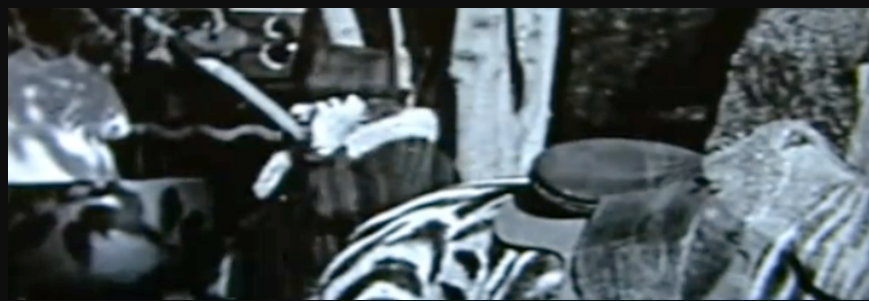
Figure 5: Still from the YouTube film of Charlie Chaplin’s DVD Extras

Clarke introduces this clip by explaining that because he is a film maker he pays particularly close attention to DVD extras and “making of” documentaries. He introduces the strange clip and edits the three second passage of the person across the screen to show it in slow motion. He describes the clip as mysterious and suggests that the woman may actually be a man in drag as she is quite “butch.” He concludes that this may be a time traveller talking into a mobile phone.

Clarke’s post went viral and currently has almost seven million views. Several articles were published “debunking” the clip. An article on TheAntlantic.com insists that the device is a hearing aid.

“If it's not a Siemens product that the woman in the video is using, then it could be another model of hearing aid developed by Western Electric in 1925. The Model 34A 'Audiphone' Carbon Hearing Aid measured smaller than 8 inches by 4 inches and could have easily been held in one hand as it weighed less than two pounds when fitted with batteries “ [66]

The author argues that the woman is clearly “well to do” as indicated by her top hat and claims that she would therefore easily have been able to afford the latest gadgets. But the hearing aid explanation does not account for her talking into it. A Quora post suggests that plenty of people talk to themselves but the person appears to be laughing. A Huffington Post article purports to solve the mystery of another (later) film that seems to show someone using a mobile phone in 1938. Someone claiming to be the grandchild of the person in this video says the Dupont company were experimenting with wireless telephones [9]. But this claim does not explain the 1928 film and the reporter speculates that the Chaplin woman is merely holding up her hand to avoid the camera though this is unconvincing, The hand is not fanned or cupped around the face, the fingers are positioned in a grip, she is holding something. A reporter for the Telegraph newspaper claims that the fade out technique had not been invented in the 1920s and argues that the film must then be a fake. But there is a famous dissolve in the 1921 Chaplin film The Kid [72] so this debunking can also be debunked.

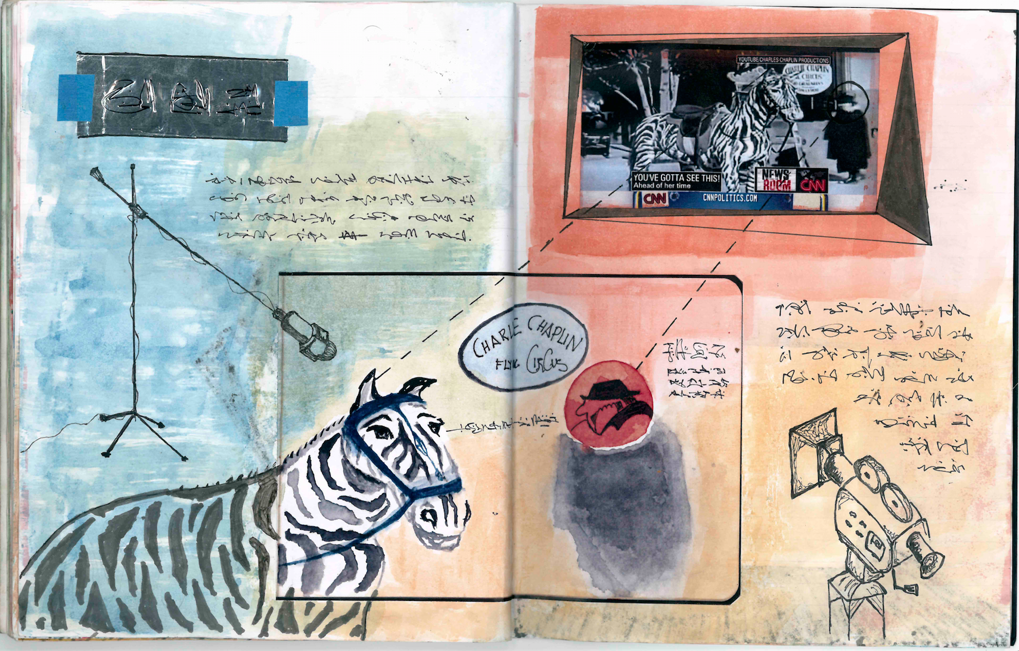

Figure 6: Ozul’s Talking Rectangle

The fundamental ambiguity of the object opens the clip to multiple interpretations. This is perhaps one of the greatest strengths of design fictions which take the form not of text but image, film or artefact. The notion that Ozols’ wife had made a model to illustrate his story and asked her Mother to cross the camera with it when she won a ticket to the premier is perhaps somewhat far fetched. But not more far fetched than the idea that this is a cross dressing time traveller. Marc Davis points out that the meaning of any cultural artefact (text, image, music) is a gestalt made up of the artefact and what the person experiencing brings to it [44]. This echoes a point made by the literary critic F. R. Leavis:

“you cannot point to the poem; it is “there” only in the re-creative response of the individual minds to the black marks on the page.” [78]

We are ready to read the black marks on the screen as someone talking on a mobile phone because we see this every day. Whatever is happening we will be predisposed to see it like that. If we are reading Frederich Pohl talking about a sceptre that allows for communication we will read it as a phone rather than a magic wand. Again: a true event creates the conditions for its own possibility. Once an event has taken place a new pattern emerges in the mess of contingencies that precede it.

From a future vantage point where mobile phones exist the image of someone holding something to their ear resonates in different ways. What would anyone have thought of this in 1928? Perhaps they would have assumed it was someone using a hearing aid while at the same time talking and laughing to themselves. Or perhaps they would have thought they were witnessing the birth of a communication device. Confirmation bias of one form or another leads us to seize on evidence that supports our world view. If we believe in the possibility of time travel then this kind of footage will be very compelling. In an age when social media and filtering algorithms present us with the kind of news and stories that we already like it is easier than ever to erase the boundary between fiction and reality [48].

  - 2.3 Design Fiction in the Age of Fake News and Alternative Facts

The rise of “fake news” as a central problem in political discourse puts design fiction in a troubling political perspective. This is echoed in Ozols biography. Valdis Ozols is a historian during the Soviet occupation of Latvia. The representation of Soviet history was closely monitored by the state under Stalin. The history of the October revolution was rewritten many times to give Stalin a more prominent role and to underplay the parts of others who had fallen out of favour [2]. In a sense then, historians of this era were engaged in manufacturing a certain kind of fiction which was presented as fact. For Hannah Arendt the totalitarian societies of the twentieth century were entirely new forms of human organisation: these regimes, whether fascist or communist, were built upon imaginary worlds, they were -

“woven around a central fiction – the conspiracy of the Jews, or the Trotskyites, or the 300 families, etc, - into a functioning reality, to build up, even under non totalitarian circumstances, a society whose members act and react according to the rules of a fictitious world” [2]

Arendt argues that fiction is so central to fascism that it erases the category of belief itself. The fictitious world is safeguarded through such consistent lying that every party member from the highest to the lowest develops a curious mix of credulity and cynicism:

“In an ever-changing, incomprehensible world the masses had reached the point where they would, at the same time, believe everything and nothing, think that everything was possible and that nothing was true” [2]

When everyone already suspects any political statement of being a lie nobody particularly objects to being deceived, rather than being angry with leaders who lied to them they would instead admire their statecraft and cleverness (ibid). The details of Ozols’ biography draw on real history. During the Stalinist purges comrades would regularly denounce one another, wives would denounce husbands in order to protect their children because if they did not then they and their children might themselves disappear also (ibid). Party officials would boast to one another about being pure “peasant stock” and therefore true Bolsheviks. Under Stalinism being a “born proletarian” was as important as being non Jewish in the Nazi state, all other class origins were suspect and scandalous. If someone was discovered to have bourgeois ancestors they would be immediately suspect. It was not uncommon then for ordinary people like Ozols to fictionalise their family histories (ibid). Historians of this era could not help but become writers of fiction. Soviet historians wrote solemn accounts of the Russian revolution in which Trotsky was not the commander of the Red army. Valids Ozols would have been compelled, if not directly then by obvious self interest to toe the party lie and write pro Stalinist history. It would only have been in an anonymous fiction that such a figure could ever tell the truth.

Arendt’s description of a gullible and at the same time cynical population resonates profoundly as social media filter bubbles subject us to news stories which reinforce our existing beliefs. The phrase “fake news” originated in educational programmes which aimed to help people differentiate between reliable and unreliable news sources. The terms was hijacked to discredit any news story that Donald Trump might wish to deny. Although the Ozols story which predicts Twitter might seem far fetched it is only the technological clairvoyance which distinguishes it from equally accurate predictions by the real writer Ted Allbuery. The 20th day of January [1] is a spy novel written by Allbeury in the early 1980s which describes a plot by the Kremlin to influence the US election. A recent podcast of Benjamin Walker’s Theory of Everything features an interview with Benjamin’s friend Josh Glenn, a “semiotic brand analyst” who runs hilobrow.com where he blogs about crime thrillers [121]. Josh attends spy novel book clubs and hears from many aficionados that this cult spy novel was Donald Trump’s favourite thriller during the 1980s. Although Trump is not known as much of a reader Josh hears from people all around the world that Trump, in his early years, talked up the book so enthusiastically that people would remember it decades later. The plot of the novel revolves around a Republican candidate, Logan Powell, who has no experience in politics and becomes President on a ticket to make the US and Russia friends. When it is discovered that Russia has plotted to have the man elected neither the CIA nor the Democrats want to investigate the matter:

“Every solution spelt disaster: deep depression for millions of people, all the words of 1776 made not. It was like working diligently to prove you had cancer: whatever happened was going to be bad for America.” [1]

Ozols’ short story “Message from the President” is no more prescient than this except in so far as it imagines a technology which many other science fiction writers have imagined. Josh goes on to describe the plot of the book: the President is a narcissist happy to co-operate with Russia because he cannot win otherwise but also because he is compromised by photographs the KGB possess of him having sex with a prostitute. The podcast host and guest describe a complex set of meetings and relationships linking Donald Trump to various Russian officials in the nineteen eighties. The conversation draws to its conclusion with this exchange around the rumour that the Russians do indeed possess a Trump sex tape:

Benjamin: That doesn’t exactly add up though because why would Trump let himself get caught on tape doing something shameful when that is exactly how the guy in the novel gets taken down.
Josh: Benjamin, Trump is an exhibitionist! He wants the world to know what a sexy beast he is. He performs better when he is being filmed than when he’s not being filmed.
Benjamin: So you’re saying Trump played for the cameras and beat the Russians? He’s not a puppet?
Josh: Think about it! The KGB gave Trump this book, they’re the ones who studied this novel. Remember, in the book, the CIA couldn’t stop Logan from taking office. Logan Powell committed suicide because of shame. In order to win, the Russians knew they would need a man who could over come shame.
Benjamin: I’m so confused.
Josh: Well think about Bruce Wayne in Batman Begins. Purposely getting himself thrown into prison in Bhutan so he could hone his fighting skills. Think about Rocky IV how the Soviets spend years training Ivan Drago to win the world heavyweight championship – I must break you.
Benjamin: What are you even saying?

Up until this moment Benjamin is taking the part of the bewildered listener, barely keeping up with the labyrinthine details of this baroque conspiracy theory, but now he takes on a different tone as the exchange reaches a climax:

Josh: After the fall of the Soviet Union with help from his ex KGB handlers Trump spent twenty five years in training purposely making a buffoon of himself!
Benjamin: You mean the apprentice?
Josh: Yeah!
Benjamin: Trump University?
Josh: Yep.
Benjamin: Lusting after his own daughter publicly?
Josh: Naturally.
Benjamin: Trump steaks?
Josh. You bet.
Benjamin: Birtherism?
Josh: Of course.
Benjamin: Grabbing women by the pussy!
Josh: Right!
Benjamin: The comb over!
Josh: Ah! The piece de resistance! In the Muscovian candidates quarter century long campaign to become the “post-shame” man.
Benjamin: So this whole “post truth” thing it’s just a red herring?
Josh: Classic spy novel plotting! Genius. We laughed at him, and that just made him stronger and now he’s become unstoppable. [121]

Did Trump really read The Twentieth of January? Did the KGB give Trump the book in 1986? Josh thinks so but who is Josh? He is introduced as Benjamin’s friend but we don’t know his last name. Walker regularly features fictions in his podcasts, is this one? The book exists and it is riding high in the Amazon charts because it does indeed appear to predict the rise of someone very like Donald Trump. So despite the somewhat staged final exchange of the podcast dialogue I find myself credulous and cynical at the same time. Whether the story is true or not is beside the point, like all conspiracy theories it cannot by definition be verified by any recourse to authoritative sources because it contains a logic that predicts that the sources we might check will lie (it’s bad news for America whether it’s true or not).

Many fictions present themselves as fact, some design fiction has also been presented in this way, either deliberately or accidentally. One of the earliest and best known incidents of this is James Auger and Jimmy Loizeau’s “smart tooth” produced in 2002 at the RCA for Dunne and Raby’s Masters course. The tooth was presented to journalists as real and New Scientist magazine among others featured quotes from the “inventors” saying “At the moment we’re looking at commercial uses […] From people who want to listen to stock information to traffic data and stock information.” [76]. The decline in paid journalism means it is easier than ever to place a fake news story in a national paper and from there have it forwarded around the world. Press releases from universities are routinely published without any investigation by reporters. But this might better be characterised as design deception than design fiction.

It would be possible to portray Valdis Ozols as a really existing character in online sources, though not in Wikipedia itself which would probably see through the deception more quickly than New Scientist, which is still archiving the 2002 article about the smart tooth. For me Valdis Ozols is a useful fiction because it declares itself as such and yet hopefully remains plausible enough to allow for the suspension of disbelief. The Valdis Ozols story contains within itself answers to potential objections like – why have we never heard of him? His existence cannot be verified because he disappeared from the University at a time when the disappearance of individuals through purges was common. Ozols’ biography is based on real historical events, his fictions are no more prescient than those of HG Wells, Frederich Pohl or many other twentieth century science fiction writers. The overarching story world of Valdis provides scope for other stories to be discovered both prescient and wrong. For these reasons I would claim Valids is a useful design fiction but this leads to a larger question: how do we know a good from a bad design fiction?

3 Design Fiction as Practice Based Research

Translation [edit]

The quality of Ozols’ writing is variable and much of the work suffers because it has been translated and re-translated with no original text to use as a reference point. The puns and wordplay which survive in the Latvian stories collected in Technopedija (1959) are absent in the Polish stories published throughout the fifties, sixties and seventies. These stories were later translated into Slovenian and these versions were in turn translated into English by Inga Baldois resulting in some very clumsy writing. For example, in A New You (a late Ozols story from the 1980s) a man has a video phone conversation with his future self. The dialogue involves colloquial terms for the penis. Idioms and slang for this term vary enormously in tone across languages. The resulting English extract below is the result of translation from Lativan, to Polish, to Slovenian, to English. The “original” Polish is more or less legible after multiple translations but the English text becomes somewhat incoherent:

"So we get divorce?"
"Yes. In about three weeks. And she gives a DTD."
"What?"
"The disease transmitted digitally. You did not notice it right away. A few weeks after she left you're looking through old photographs. Each head has been replaced by huge penis."
"What?"
"Yes, you become pink helmet. In every picture you're one-eyed purple-headed man in pink sweater."
"She photopaints them all?"
"No. It was virus facial recognition - you realize when you see the same thing is happening to your job profile and other photos of you in the world. But this is not the worst.”
"What is the worst?"
"When your name in print is replaced by "Dick Head". You almost lose your jobs. The children are teased at school and deny you-"
"You seems very matter of fact about it."
"Well, it was a long time ago. You realize at my age that nothing is important.”
(Nowe Państwo)

Some critics have argued that the problems with translation occasionally improve the original Latvian which is dismissed by some as clichéd and monotonous. [citation needed]

List of Works [edit]

Books

The Latvian Experience of Soviet Democracy (1945) Praeger Publishers
Soviet Latvia: Today and Tomorrow (1949 Praeger Publishers
Technopedija (1959) (self published)

Short Stories

Talking Rectangle (1927)
Conversations with No-one (1927)
The Table that Spoke (1928)
Turbine Languages (1928)
Electric Bombs Overhead (1931)
The man who died of Information. (1932)
The Day it Rained Lies (1932)
The Cure for the Common Cold (1932)
The Camera that Lied (1932)
Metal Flies (1934)
Valve Stalkers (1934)
DreamPlague (1934)
The Woman who wore Radiowaves (1938)
Electric Intercourse (1938)
Infinite Music (1941)
The Cornfields of Antarctica (1941)
The Secret Policeman’s Map of Me (1941)
A Plate of You (1943)
Hydraulicon (1943)
Those are Cameras that were his Eyes (1943)
Intelligence showers (1945)
The Boredom Epidemic (1946)
Chemical Tanks (1946)
The Anxiety Battery (1947)
The Everything Engine (1951)
The Day that Nobody was Watching Me (1952)
Every Question Answered for a Dollar (1952)
Thought ™ (1952)
Forever Shall Live my Opinion (1955)
The Annual Sex Robot Competition (1955)
The Island where Nothing Worked (1955)
The Last three Working Class People in the World (1957)
The Wet Machines (1957)
I am a Broadcasting Corporation (1957)
Everything Is Copyrighted (1959)
World Without Wind (1960)
The Future is a ReRun (1961)
We can Reach Anyone, Anywhere, Anytime (1961)
Facetracker (1961)
A Nuclear You (1964)
Dial-a-Slave (1964)
MeTV (1965)
The fastest Tree (1967)
I monitor (1967)
The Pan-Optician (1969)
The Passenger Jet Considered as a Missile (1970)
Gloria (1971)
The Houses that Floated Away (1971)
We don’t want those Doctors, Lawyers and Teachers over Here (1971)
All the News that’s Fit to Invent (1973)
Infomachia (1973)
New albums by Dead Rock Stars (1973)
The phone as philosopher (1973)
The Photomorphic Virus (1974)
The Mystic Microchip (1974)
Caring for Plastic Organisms (1980)
Dataslaves (1981)
A New You (1981)
God’s Telephone Number (1982)
The Missile with a Conscience (1982)
The American Occupation of Britain (1982)
Communism for Sale (1983)
Time and its Discontents (1983)
Infectious Automobiles (1983)
The Despair Processor (1985)
Computer Cancer (1985)
The Book of Everyone (1987)
The Assassin that Walked Through Walls (1987)
Holy Tech (1987)
Icoholics Anonymous (1988)
The Spider caught in its own Web (1989)
The five year old CEO (1989)
Your Dreams Tonight Will Be Sponsored By… (1990)
The Assassination of Bill Gates (1990)
I Pledge Allegiance to the United Stores of Walmart (1991)

(Valdis Ozols: Wikipedia. Last Retrieved 18.02.2018)

  - 3.1 Beyond Evaluation

How do we know a good design fiction from a bad one? What kind of knowledge does research through design produce? Some designers argue that knowledge is embedded in design artefacts, others claim that design knowledge should be articulated in an accompanying commentary.

“Is the knowledge outcome of an RtD object a special form of communication,
one that is superior in some sense to verbal discourse? Is it these objects’ job
to reveal true propositions about the world? To reveal the potential of design
materials? To reify design arguments? To express emotional or subjectively
felt experiences of the artificial world and its apparent trajectory? To critique
assumptions imbued in everyday designs? To reveal alternative ways of being
to motivate us to pursue them? [6]

Questions like these have long troubled other academics in Practice Based Research. There are, for example, strong echoes of these kinds of concern in debates amongst musicologists. Camdem Reeves’ argues that musicians engage in research by developing instrumental technique, dynamics and rhythm as well as new types of musical rhetoric [102]. He claims that many compositions make intrinsic contributions to knowledge outside of any textual discussion or interpretation, for example Stravinksy’s additive rhythmic technique in the ground breaking scores for Petrushka and The Rites of Spring. Another musicologist, John Croft argues contrariwise that “Composition is Not Research”

“Imagine, if you will, a research funding application from Schoenberg. Research question: ‘can I make music in which all pitch classes are played equally often?’. Answer: yes! Or one from Grisey: ‘can I make chords out of the pitches revealed by spectral analysis?’ Answer: yes!” [41]

This rather sarcastic formulae might also be applied to Research through Design (RtD) projects like the drift table [56]. This ingenious and beautiful design consists of a table with a porthole in the centre that shows aerial photography drifting below. The images move in the direction of any weight on the table top, so if a user puts a cup to the north the table, very slowly, drifts in that direction. This project could be framed as Croft frames Schoenberg - Can I make a table with a porthole that shows a landscape drifting below it? Answer: yes. Clearly Croft’s questions are caricatures (no question that can be answered with a yes or no would qualify as that rather enigmatic entity - the research question). But he goes on to modify the caricature in a way that also resonate across many RtD projects:

“Sometimes […] we insert an evaluative term: ‘can a coherent musical structure be developed from sonification of the human genome?’ Without the word ‘coherent’ the answer is of course yes. So we put something in to make it seem like the result is not a foregone conclusion. But of course it is a foregone conclusion, because what one generally means by such a question is ‘can I write convincing music with this technique?’ where the person to be convinced is … me!” [41]

The Drift table question above might be reconfigured so that the project is an exploration of some aspect of experience design. Indeed one of Croft’s later imagined research projects could well have been an RtD project addressing say sustainability:

“converting arctic ice cap data into sound files to be manipulated in real time in an internet-mediated free-improvisation event combining live programming, video projection, and social media” [41]

Croft points out that funders and reviewers of projects like this can sidestep difficult and subjective value judgements of whatever music might arise and instead focus on its originality:

“Who’s to judge the originality of musical material? It’s all ‘subjective’, isn’t it? But you can’t argue with the ground breaking nature of the polar-ice-based internet improvisation event – nobody’s ever done that before! This kind of activity is objectively ‘innovative’ in a way that you can tell in advance, without going to the trouble of a risky aesthetic judgment.” [41]

Evaluation has long been problematic in HCI. Greenberg and Buxton argued in 2008 that usability evaluation is harmful [62]. Usability evaluations focus on detailed measures rather than asking broader questions about whether the thing is worth doing at all: evaluation stresses usability rather than usefulness. Just as the polar ice based internet improvisation event might be judged on its originality alone, an app like SeeFood imagined in the HBO sitcom Silicon might be judged solely on accuracy rather than broader questions of whether it’s a good idea to have a “Shazam for food”.

Ian Pace writes another response to Croft - “Compositions Can be and Often Have Been Research” arguing that by performing repertoire he is able to learn from the achievements of others and discern new possibilities. Though he reproaches Croft for being glib he cannot resist adding this hefty dose of sarcasm to his own argument:

“my approach is far from uncommon, and in this sense the articulation of practice in research terms is a positive and productive activity It may be less spectacular than some of the wilder fringes of theatre and visual performance – such as Lee Miller and Joanne “Bob” Whalley’s joint PhD project, collecting of urine-filled bottles on the M6, replacing them with other detritus, renewing their wedding vows in a service station, then grounding this in the thought of Deleuze and Guattari, Bakhtin, dialogism, heteroglossia and semiotic multi-accentuality, deliberately framed in such a way as to frustrate Popper’s criteria of falsifiability - but is no less ‘research’ as a result.” [95]

Croft’s tone is entrenched and sarcastic because battles around research based practice have been raging for a long time in musicology. Both Pace and Croft make it clear that these arguments are not solely academic: they all have skin in the game. As funding for higher education is cut Universities must demonstrate “impact”, and in this brutally competitive environment many universities are closing down Music departments staffed by academic musicologists and conservatoires are giving up on research altogether to concentrate on training musicians. So these people are arguing not only about abstract matters of epistemology but their own ability to earn a living in a University.

Pace’s satirical account of the turn to critical theory is another aspect of the musicology debate that resonates with Research Through Design. Bardzell and Bardzell have argued that critical design echoes both the language and concerns of the critical theory that emerged form the Frankfurt School [5]. Pierce et al argue that the Bardzells place too much emphasis on theory and defend a space for artefacts unencumbered by commentary, echoing the composition as research in and of itself paper [98]. They insist on designerly ways of knowing, specialised forms of knowledge recognisable by designers in the way that musical problems are recognised by musicians. The debate in HCI may be more polite and less overtly partisan but the issues are similar. How are we to value the things we make? In and of themselves? Because they resonate with theory?

The problem is even more acute when applied to Design Fiction? Can I write a design fiction about an undiscovered Latvian author in the nineteen forties? Yes. Can I wrote a convincing fiction about this author when the person to be convinced is me? Also, yes. The problem here is the strong remnant of usability testing and metrics. The field wants to know if the thing that has been designed - prototype, fake or fiction, is any good, or any better than something else. And if so by what metric. As with music this is a very difficult question to answer without sticky aesthetic theory. Recently there have been some concerted efforts to import critical theory [e.g. 2] but this has been met with resistance [98]. Rather than ask a judgemental question like -is this any good, or an ontological question like – what is this, (critical design, speculative design, design fiction?) it may perhaps be more interesting to ask an epistemological question – does this help us to think or know anything new?

  - 3.2 Research Fiction as Thought Experiment

Fiction is a tool in many other research disciplines including Physics, Mathematics, Economics, Law, History, Psychology, Epidemiology, Computer Science, and Philosophy. The use of illustrative stories can be traced back to Ancient Greece, with Plato communicating philosophical ideas and indeed the idea of philosophy itself through story. Consider for example, the Philosopher’s Cave that Plato describes. Here most of the cave dwellers see only shadows thrown by a light through a chink in the wall, when one of them finds a way out and describes what he has seen outside, the other cave dwellers cannot understand him, having only ever seen shadows. The philosopher is the one that leaves the cave and in Ancient Greece the journey from darkness to light was made through story. The Philosopher’s cave has been seen as an early example of a “thought experiment” [29]
Karl Popper’s taxonomy of thought experiments categorises them in relation to theory: for Popper there are three kinds: critical (against a theory) apologetic (for a theory) or heuristic (illustrating a theory) [29]. Perhaps the best known thought Experiment in Physics is Isaac Newton’s Falling canon ball. This shows how the moon stays in orbit around the earth in the same way that a ball fired from a canon describes an arc before falling to earth. If the canon was powerful enough the arc would get larger and larger until it circled the planet.
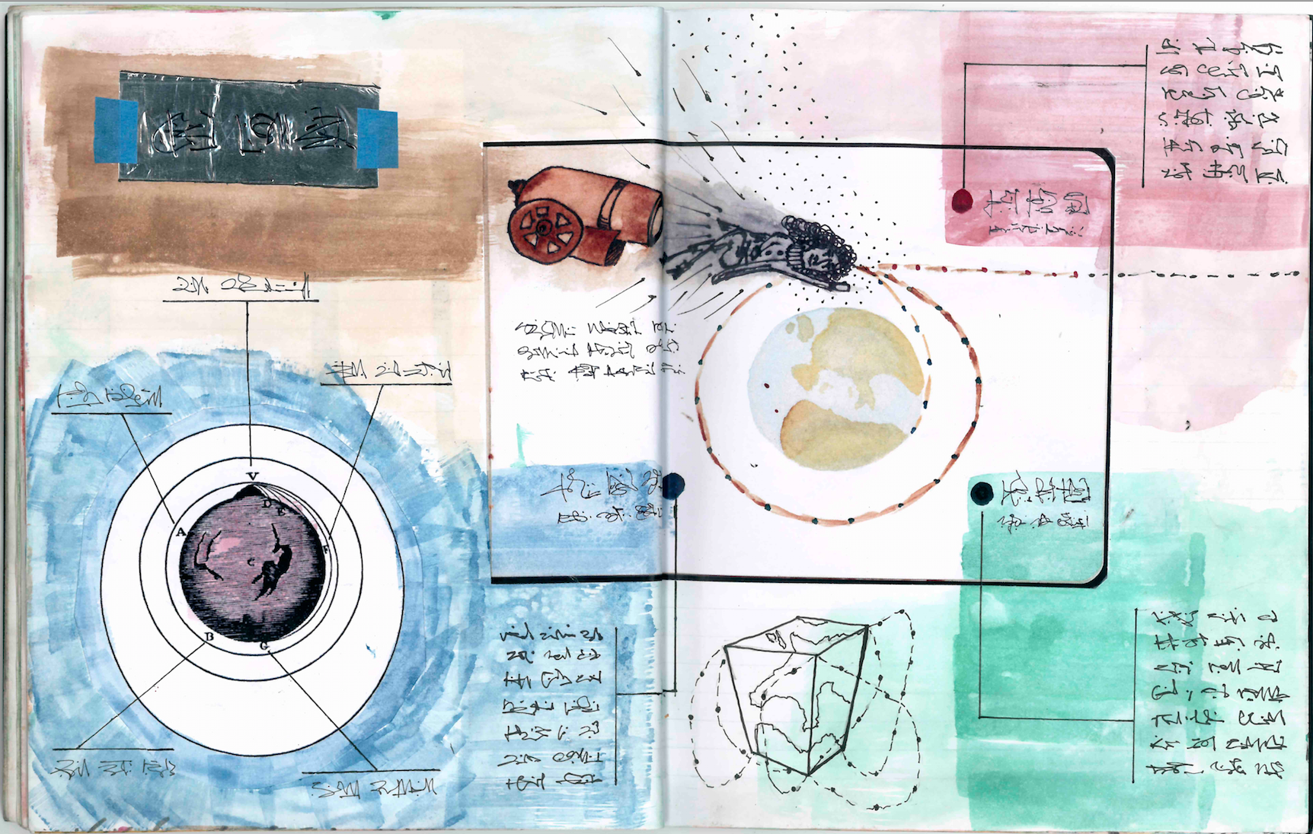
Figure 7. Newton’s Canon
The many illustrations of this famous thought experiment help us to understand what might otherwise be expressed in abstract equations. However unlikely such an enormous canon might be the story helps to illustrate the theory.
Shrodinger’s Cat is so entrenched in the culture that it is the punch line for a number of jokes in the Big Bang Theory sitcom. Like Newton’s canon it can be expressed very powerfully in visual ways but here is the textual description:
“A cat is penned up in a steel chamber, along with the following diabolical device (which must be secured against direct interference by the cat): in a Geiger counter there is a tiny bit of radioactive substance, so small, that perhaps in the course of one hour one of the atoms decays, but also, with equal probability, perhaps none; if it happens, the counter tube discharges and through a relay releases a hammer which shatters a small flask of hydrocyanic acid. If one has left this entire system to itself for an hour, one would say that the cat still lives if meanwhile no atom has decayed. The first atomic decay would have poisoned it. The q-function of the entire system would express this by having in it the living and the dead cat (pardon the expression) mixed or smeared out in equal parts.” Schrödinger 1935, p. 812; translation: Trimmer, 1980, p. 328 cited in [29}
Counter fictions might be imagined where the box also contains a video camera and then the cat is either dead or not. But this would miss the point: quantum particles must be thought of as being in all states at once until they are observed. The act of observation changes phenomena and “common sense” ideas like – a cat is either alive or dead, may not always accord with the way that the world works (ibid).
The examples so far have been more like scenarios than stories: they are more or less static pictures. But many famous thought experiments also involve more developed narratives including plot lines. EM Foster provides this memorable and brief definition of the difference between a story and a plot: the King died and the Queen died is a story, the King died and the Queen died of grief is a plot [55]. Einstein illustrated the idea of time dilation with a thought experiment about twins; one gets in a rocket ship and travels at great speed for two years according to the ship’s clocks; but when he returns he finds that his twin on earth is now thirty years older than he is. This time dilation has now been proved experimentally. In the 1970s atomic clocks were placed on two planes travelling in opposite directions and time was observed to pass differently when measured in nanoseconds; a nano second is to one second what one second is to thirty seven years and we do not live long enough or travel fast enough to notice time dilation [32] Buzzo and colleagues recently developed an app to illustrate the minute effects of time dilation during air travel (ibid). But Einstein’s thought experiment conveys the idea in a powerful and visual way through narrative.
Design Fiction rarely attempts to confirm or deny some existing theory. However research fiction considered broadly does attempt to delineate the possible applications of theoretical advances. Whenever increased speed and memory size have advanced sufficiently to make new computer applications possible they have been preceded by concept designs and scenarios. These could be considered as thought experiments of the positive kind. But other kinds of research fiction (critical design, speculative design and design fiction) might be thought of as negative thought experiments in Popper’s terms. Provocative designs from Dunne and Raby’s students ask difficult ethical questions. In one project picturing what lab grown meat might look like Dunne wonders he could grow meat from his own cells, throw a dinner party and serve himself as a canapé. These kinds of fiction have more in common with the ethical thought experiments common in philosophy.
One of the best known ethical thought experiments is called The Trolley Problem. Again the experiment is often conveyed visually:
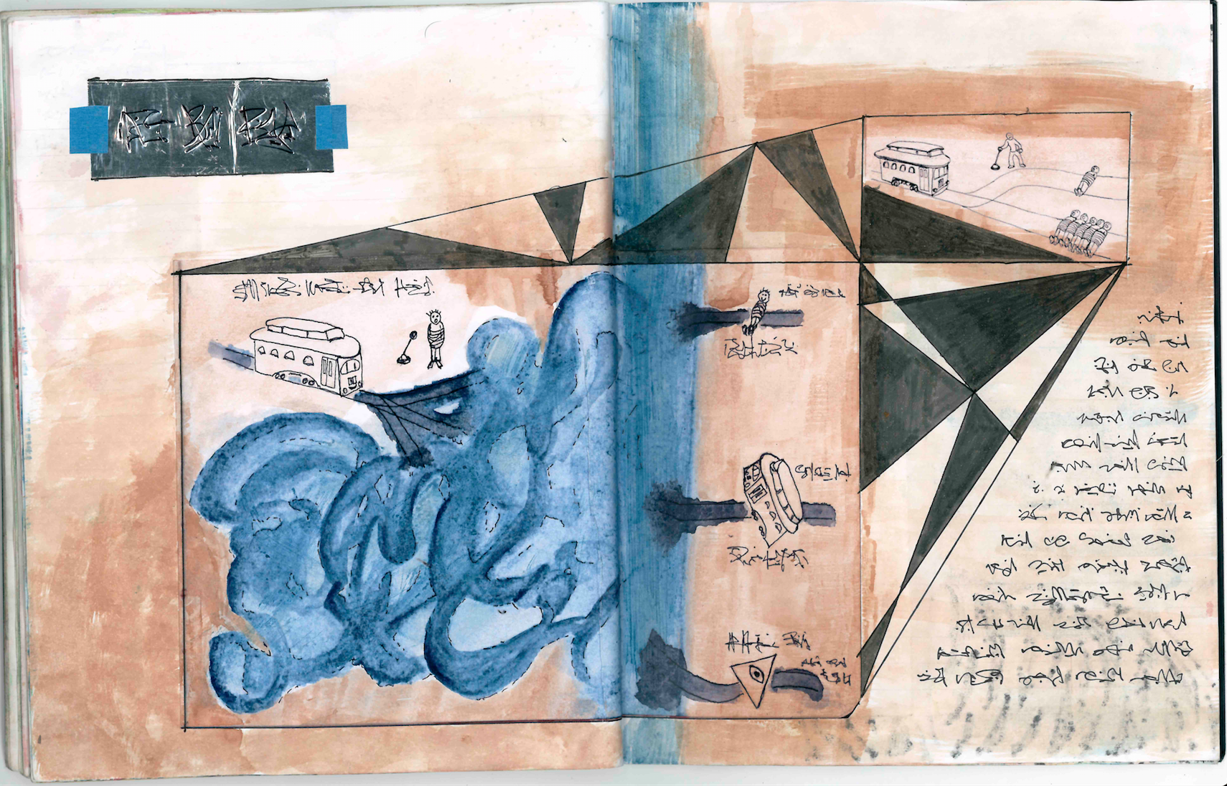
Figure 8. The Trolley Problem
Here a train is heading towards five people who will be killed unless someone throws a switch and sends the train towards a single man instead. They would save five lives by throwing the switch but in the process they would deliberately kill somebody, is this justified? A variation of this conundrum was recently applied to the design of self driving cars [90] with an additional twist: should a self driving car about to have an accident take action minimizing the loss of life even if that means killing the driver? And if so how many people would be willing to sign the necessary forms allowing their car to kill them if it deemed the sacrifice to be necessary?
Such ethical thought experiments seldom provide answers that are beyond dispute. They do not force logical conclusions bur rather surface ethical questions. Another famous example is the Experience Machine. In the 1970s Robert Nizick imagined a machine that would convey to the user an experience so vivid that it would be indistinguishable from real life. The machine would allow them to experience a great love affair, living for years in a monastery, writing the great American novel, or whatever it was they wanted to do. The Matrix uses “the experience machine” as its central premise. Thought experiments in Physics and Computer Science informed the writing of Ray Bradbury, Isaac Asimov and Arthur C Clarke. Other writers of science fiction have been inspired not only by Physics but History. Margaret Atwood argues that she did not put anything into The Handmaid’s Tale that has not happened somewhere at some point in human history. Similarly George Orwell’s 1984 adheres strictly to the principles of totalitarian organizations in his depictions of the ultimate surveillance society; his fiction added only extended technological capability.
Thought experiments can sometimes have unexpectedly practical results. Indeed the invention of the computer has been attributed in part to a thought experiment by the British mathematician and code breaker, Alan Turing. Turning was interested in the logical foundations of Mathematics and these were far less certain than had been hoped. Bertrand Russell had challenged Cantor’s set theory by pointing out a paradox that became almost as famous as him. Russell’s Paradox was related to the ancient Greek liar’s paradox that runs “everything I say is a lie, I am a liar”. Turning’s biographer, David Leavitt, points out that most of us today will have first come across this in an episode of Star Trek when Kirk uses it to make an aggressively logical robot explode. Russell applied it to set theory and the question of whether the set of all sets contains itself. This is illustrated with (what else) a story. A barber shaves all of the men in the town where he lives but only if they do not shave themselves. Does this barber shave himself? There is a contradiction if he does not (because he lives in the town) and if he does (because he shaves himself). The barber then has no logical alternative but to explode. This problem was one that Wittgenstein sought to solve by framing it as the wrong sort of “language game”. He would discuss such question in seminars where students sat on deck chairs often in complete silence waiting for the philosopher to ask a question. If one of them ventured an answer Wittgenstein might sometimes respond with little more than – no that’s no good.
One of Wittgenstein’s most fearless students was Alan Turing and he returned to mathematical thought experiments in a 1936 paper called “On Computable Numbers, with an Application to the Entscheidungsproblem”. The Entscheidungsproblem is a “decision problem” asking whether a statement is provable from its axioms. In the paper Turing imagines an a-machine (with the a standing for automatic) capable of manipulating symbols according to rules.
“We may compare a man in the process of computing a real number to a machine which is only capable of a finite number of conditions q1, q2, ..., qR which will be called “m-configurations”. The machine is supplied with a “tape”, (the analogue of paper) running through it, and divided into sections (called “squares”) each capable of bearing a “symbol”. At any moment there is just one square, say the r-th, bearing the symbol S(r) which is “in the machine”. We may call this square the “scanned square”. The symbol on the scanned square may be called the “scanned symbol”. The “scanned symbol” is the only one of which the machine is, so to speak, “directly aware”. However, by altering its m-configuration the machine can effectively remember some of the symbols which it has “seen” (scanned) previously. [120]
The machine would perform an algorithmic operation and produce a sequence of numbers. Turing then imagines a universal machine that “can be used to compute any computable sequence” (ibid). Leavitt is keen to point out that when Turing wrote this he was not thinking of a machine that would ever be built:
“The engineer in Turing would emerge later: when he wrote “Computable Numbers,” he intended his machine as a kind of literary device – the analogy, as it were, by means of which he could convey the central concept of the computable numbers most cleanly and economically.” [79 pp 59-60)
Turing is not trying to invent a computer, he is trying to solve a problem in logic: his thought experiment leads him to conclude that the entscheidungsproblem cannot be solved, a conclusion reached by Church slightly before Turing by different methods. Although Turing was beaten to the discovery his method was sufficiently interesting to justify separate publication and the paper had a profound influence on the development of computing technology. John Von Neuman’s 1945 proposal for the design of EDVAC (electronic discrete variable automatic computer) describes its memory as “one organ” in ways which are equivalent to the “tape” as described in Computable Numbers [79 p.201].
Turing’s thought experiment is in some respects quite different to thought experiments in Physics. Turing’s machine is a metaphor but it is also precisely defined in logical terms and leads to proof:
“Einstein's and Galileo's thought experiments lead to logical necessities but there is still a need to test because the real world doesn't necessarily play along. Turing's machine needs no further testing because it has passed into the realm of proof. For example, I could explain to you the equivalence of countable infinities by talking about Hilbert's Hotel but each of the the Hotelier's operations can translate into mathematical functions that demonstrate the equivalence in a precise way. The Hotel is a literary device but the mathematics is real (as real as maths gets).” (Paul Cairns pers comm)
The mathematics are real though they are expressed through a fiction. The term “thought experiment” then can refer to a great many different activities. This is particularly the case in design. Julian Bleecker’s short essay on design fiction describes the approach as a “materialised thought experiment” [10]. In Speculative Everything Dunne and Raby describe fictional worlds and thought experiments as methodological playgrounds. They note that their two favourite forms of thought experiment are the reductio ad absurdum (where a particular claim is taken to extremes in order to test it) and the counterfactual where a historical fact is changed to see what would have happened [53]. Brian David Johnson claimed that SF prototypes provided a similar platform to the thought experiments of Einstein [69]. But there are many different kinds of thought experiment. Buie argues that “imaginary abstracts” and some other design fictions satisfy Brown and Fehige’s (2016) four characteristics of thought experiments 1) visualise a situation 2) let it run 3) see what happens and 4) draw a conclusion [31]. She argues that if design fiction is to be useful as a thought experiment it must generate “possible answers whose credibility we can argue” (Ibid p 186-7).
Thought experiments are controversial in science and philosophy. For Norton they are simply forms of argumentation, but Brown argues that they are a means of discovering a priori knowledge of nature: Brown and Norton represent extreme positions – either they are a higher form of knowledge or they are no form of knowledge at all [29]. The “mental model” account argues that in thought experiments we manipulate a mental model rather than a physical model:
“the mental model account provides the opportunity to make mention of those proposals that place “literary fiction on the level of thought experiments.” (Swirski, 2007, p. 6 cited ibid)
This view would see 1984, the Handmaid’s Tale and Brave New World as “fully elaborated” thought experiments [43, 107]. The classic thought experiments from Physics and ethics are more like scenarios than fiction: there are no characters, there is no plot (in the literary sense of the term). The notion of literary fiction as an “elaborated thought experiment” might also help us develop notions of what design fiction might be. Swirski argues:
“the capacity of literary fictions for generating nonfictional knowledge owes to their capacity for doing what philosophy and science do–generating thought experiments.” (ibid)
Both Orwell and Huxley researched the historical and political precedents for their dystopian fictions. There is a good case then for design fiction in HCI to be considered if not as the kind of logical or ethical thought experiment developed in Physics and Philosophy then at least a cousin to elaborated thought experiments of this kind. What might design fiction look like when conceived of as this kind of thought experiment?
  - 3.3 The Secret Policeman’s Map of Me

In The Rise of Totalitarianism Hannah Arendt speculates about the shape of technologies that totalitarian secret police dream of:
“The Ohkrana, the Tsarist predecessor of the GPU, is reported to have invented a filing system in which every suspect was noted on a large card in the center of which his name was surrounded by a red circle, his political friends were designated by smaller red circles and his non political acquaintances by green ones; brown circles indicated persons in contact with friends of the suspect but not known to him personally; cross relationships between the suspects friends, political and non political and the friends of his friends were indicated by lines between the respective circles. Obviously the limitations of this method are set only by the size of the filing card, and theoretically a gigantic single sheet could show the relations and cross relations of the entire population. And this is the utopian goal of the totalitarian secret police […] Now the police dreams that one look at the gigantic map on the office wall should suffice at any given moment to establish who is related to whom and in what degree of intimacy. And theoretically this dream is not unrealizable although its technical execution is bound to be somewhat difficult. If this map really did exist not even memory would stand in the way of the totalitarian claim to domination. Such a map might make it possible to obliterate people without any traces, as if they had never existed at all.”
Arendt here presents a thought experiment of the classical kind. What if a totalitarian state had access to a map like the one she described?
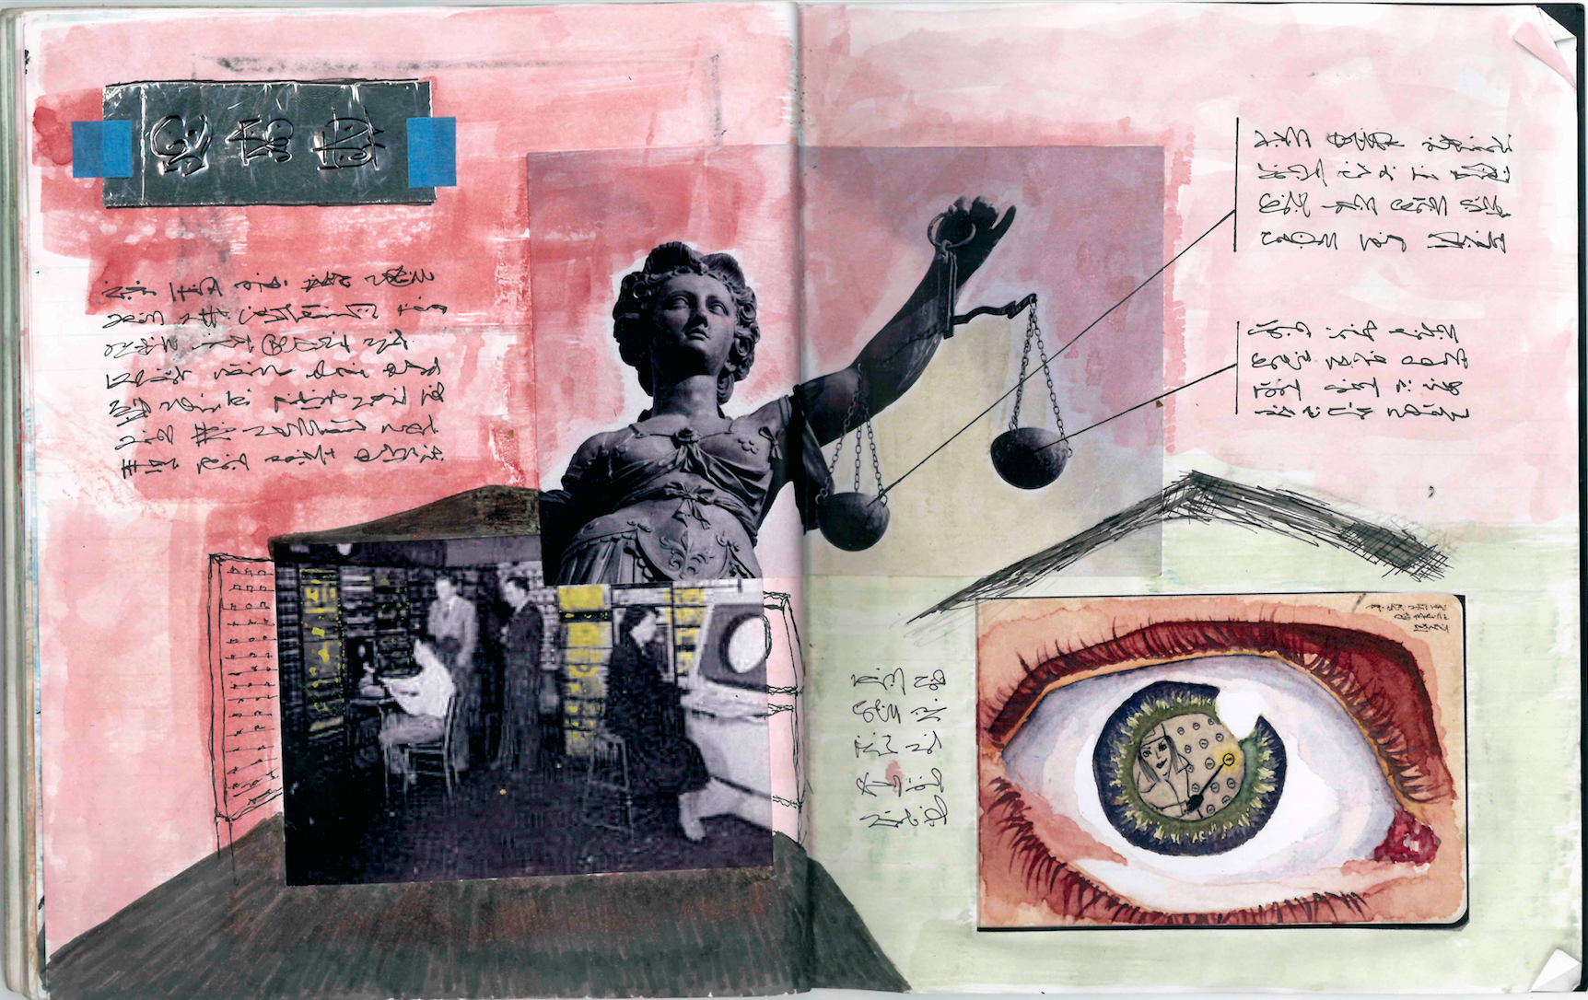
Figure 9: The Secret Policeman’s Map of Me
It might be the basis for many elaborations, to illustrate here is an extract from a Valdis Ozols story:
The Secret Policeman’s Map of Me
I wandered the city for many hours hoping to meet someone, anyone at all, but there was no-one to be found in the city. A dull twilight cast grey gloom over empty streets as I circled the Police station. I turned into a park and found a bench where I sat in despair and watched light fade. As the grey sky turned black an old woman sat down next to me.
“Good evening Comrade,” I lowered my head, “it’s beautiful evening is it not?”
“It is not!” she squinted at me, “it’s dank! It wants rain.”
“Oh yes, yes” I nodded “you’re quite right I’m sure of it. I often think that we do not make most of wisdom that our older comrades possess. Yes there is intelligence in your eye! I can see it and beauty too!”
“What’s your game?” she glared, “I’m a respectable woman! Who are you? What do you want?”
I showed her my identity card and she made a note of the number before showing me hers. I bid her good evening, thanked her again and headed towards the police station.

A cone of pale yellow light shone out of the dark building. The Sargent at Arms, Gregor greeted me and started laughing.
“I heard a good one today,” his double chin wobbled, “an old Polish wife is too tired to make love when her husband comes home from work. He is tired too but also horny so he asks if she will just suck him and swallow the sperm. She says “I’m too tired for that now, why don’t you just masturbate into a glass and I’ll drink it in the morning?” Gregor erupted into laugher. I laughed loudly as he led me to the room.

The map was switched off when we entered but he quickly fired it up, turning dials and flicking the switches to make wall of lights flicker. I read out my ID and he punched the numbers in, still laughing at his stupid joke. I tried not to look too nervous as the usual pattern emerged. I thanked God that the central ring of red lights denoting close friends had not changed. The next circle of colleagues was dispersed in the usual way and I began to think I was safe, at least for that night. Gregor scanned the array looking bored.
“Anything to report today?”
“No.”
“No reactionary opinions from your students this morning?”
“Oh yes,” I nodded hastily, “Vladimir Illyavich this morning made a counter revolutionary joke about Stalin.”
“A joke about Stalin?” Gregor frowned, “that’s serious. Which one?”
“Oh you know the one where comrades in the Politburo are arguing about whether there will be money under Communism or not. The leftists say “no” since money is needed only for private ownership. The rightists say yes because it will be needed for the exchange of goods as in any complex society. Finally Comrade Stalin intervenes rejecting both the left and right for higher dialectical synthesis. He says- “There will be money and there will not be money. Some will have money and others will not have it.”
“And that’s the punchline is it?” Gregor looked confused.
“Yes.”
“Well it’s not very funny is it?”
I shrugged, “Vladimir Illyavich often makes jokes like this I have mentioned it in previous reports”.
“You were right to bring this to our attention.” Gregor fiddled with the dials and Valdimir Illyavich’s light became brighter.
“No new contacts to report?” Gregor asked absently as he adjusted the dials.
“I don’t think so.”
“Then our business is concluded,” Gregor rubbed his eyes and yawned, “I’ll tell you a better joke. There was this Jew –“ he paused and squinted at the map, “but wait a minute, what’s this?” there was a new light flashing at the outermost circle, “you have an “unclassified”. What is this? A new ladyfriend eh?”
I laughed so loudly that Gregor jumped and stared at me.
“No! No!” I carried on laughing, I knew very well that this was not helping but somehow I could not help myself, “it’s probably just old woman I was talking to in the park just now – here is her number.”

Gregor punched the old woman’s ID into the machine and scratched his head.
“No that’s not it. Who else have you spoken to today?”
“Nobody.” I said shrugging.
“You’re absolutely certain?”
“Yes, there was nobody.” I started moving towards the door, “it’s probably just a glitch in the system. They happen sometimes don’t they? Boundary objects that’s technical term isn’t it?”
“That was a foolish mistake.” Gregor’s friendly demeanour vanished, “I told her that you would confess immediately and we would be able to sort it out in a moment. It is too late for that now.”

I turned around and saw her standing there in the doorway.
“Most men would know better than to try and hide something from the System,” she looked calm and professional, “Of course I should never have mentioned boundary objects to you. I will be reprimanded for that. But you!” she glared at me bitterly, “you have betrayed classified information upon first examination, this will not go well for you.”
“Darling I’m sorry! It’s not my fault that she said hello! I haven’t seen her in years – it meant nothing!”
“Then why try to hide it?”
“Because – “ I looked desperately at Gregor but his face was entirely impassive, “because of this! Because of the way you are! Your position here! You know how suspicious you can be! It was entirely innocent – ask her!”
“We have already interrogated her and she has been taken into protection, along with her inner and outer circles. She has reactionary friends of friends and I’m afraid this contaminates your profile very badly. Now you will be taken to your first struggle session.”
“NO!”
“I can’t make any exceptions.”
“But nothing happened! She recognised me from school! We said hello! That’s all!”

As the soldiers put their hands on my shoulders I saw something pass between Gregor and my wife that was as clear as if it had been flashed on the map behind them.
(Valdis Ozols 1942)

From the vantage point of Valdis’ future we know not only what such technology looks like but also what totalitarian states are capable of. Estimates vary on the number of Stalin’s victims but most historians agree on a rough round total of some twenty million. As Stalin himself said, one death is a tragedy but a million is a statistic. In the Ozols story the citizens of the unnamed city are compelled to make updates of the Secret Policeman’s map in nightly visits to the Police station. The idea that we would voluntarily update such a map minute by minute is too far fetched for Valdis or anyone living in a totalitarian state to have entertained for a moment. Valdis Ozols functions as a thought experiment which allows us to imagine counter factual histories: what would have happened if Google Circles or Facebook had existed in the nineteen forties? Death on an even more unimaginable scale and domination beyond even Stalin’s dreams.
The story is limited by Valdis’ abilities as an amateur writer, he was primarily an academic and wrote fiction only in short bursts. There is also the further problem of multiple translations which have resulted in this rather wooden prose. The fragment is unfinished and it is interesting to speculate on how it might have been developed into an elaborated thought experiment.
  - 3.4 Plot, Genre and Narrative

This Ozols fragment might be elaborated in any number of ways depending on plot and genre choices. Since Ancient Greece it has been said that there are only so many plots in the world and each new tale is just a variation on them. Booker calls this a teasing notion because nobody ever says exactly what these plots are [25]. Kurt Vonnegut described four dominant “story shapes” which he said were so simple they could easily be fed into a computer. One was Man in a Hole, where an average person gets into trouble and then gets out of it but as Vonnegut notes it needn’t be a man and it needn’t be a hole. Another was Boy Meets Girl, where someone gets something that they want, lose it and then get it back again. He also drew a Cinderella shape and a Kafka shape (the latter being a simple line curving downwards and off the graph [121]. Booker developed seven categories of plot: Overcoming the Monster (which corresponds to Man in the Hole) The Quest, Voyage and Return, Comedy, Tragedy and Rebirth. Most scenarios in HCI follow the Man in the Hole / Overcoming the Monster plot: an average person is confronted with some problem which they then overcome, usually with the aid of the new technology being imagined. Design Fiction more often takes the Voyage and Return form where someone (sometimes the reader or viewer) enters a new world and then comes back [21].
The Ozols fragment might take the form of Man in a Hole if the protagonist could contrive some way to escape. Perhaps the illicit relationship between his wife and Gregor could be developed into a plot point that would help reverse his fortunes. He may pass information to Gregor that compromise his wife and Gregor himself. Gregor might then become an ally who would help him redraw his map and escape. Or, more plausibly, the story might take the Kafka shape and end in the protagonist’s complete destruction as in the The Trial or 1984. Although plot descriptors like “man in a hole” or “overcoming the monster” can be criticized as reductive they can also be generative: what would this story look like if it became a rebirth plot?
The genre of most design fiction, whether it is text or artifact, is most often scientistic and rationalist. This kind of fiction is extrapolative, it takes as a starting point an emerging technology or trend and exaggerates it. [19]. This kind of procedure is best exemplified by the earlier examples from HG Wells, Frederich Phol, JG Ballard and William Gibson. It is also evident in artefacts like the Mobile Life Ikea collaboration. These picture plausible devices that do not quite exist yet [ibid]. The other most dominant genre of fiction in design is ironic critique. I Wanna Deliver a Shark by Ai Hasegawa for example describes humans acting as surrogate parents for endangered species rather then more humans of which there is no shortage. Such critical work can be thought of as a reduction ad absurdum. Other fictions take more ambiguous forms and some design fiction has attempted to draw on the magic realism genre to describe wonders without technology (ibid). The Ozula story as it begins is techno-rationalist describing plausible technologies with the benefit of hindsight. If an ironic and critical genre were adopted then perhaps the protagonist would be converted like Winston Smith in 1984. He could be so utterly crushed that he updates his timeline every moment, for fun, like facebook users today.
These categorizations by genre and plot may seem simplistic and of course in many ways they are. Such “structural” approaches to literary studies have long since been superseded by post structuralist accounts which focus more on narrative content than form. But Paul Ricour’s three volume Being and Narrative places narrative at the center of human understanding.
“narrative is the mental structuring process through which we define our existential relationship to the movements of our earth and the planets, stars and galaxies; to our linear perspective of time typified by the invention of the calendar; to events in the objective and subjective worlds, and to our sense of moving from past to future, through retrospection and anticipation, with the present as a continuing interaction point with both” [97]
Narrative is not simply a property of written texts or language, it is everywhere. Roland Barthes argued that narratives take forms as varied as: myth, novella, history, painting, stained glass, cinema, news and conversation [7]. Paul Ricoeur echoed the thought:
“we are confronted with an almost uncountable variety of narrative expressions (oral, written, drawn, acted) and of classes of narrative (myths, folklore, fables, novels, epics, tragedies, dramas, films, comic strips, to say nothing of history, painting, and conversation). [103]
Building on Ricouer the psychologist Jerome Bruner argued that narrative (as opposed to other representations like clocks or calendars) is the only way we have of describing time in terms of the way we experience it [30]. Going further he argues that not only does narrative imitates life but “life imitates narrative” for Bruner we make sense of our own lives in the same way that we make sense of a story. Our lives are constructed through active ratiocination; an autobiography does not simply relay what happens it is rather a cognitive or narrative achievement (ibid p. 692). Narratology is now a very large field which has influenced the way we characterize knowledge itself. There are many competing theoretical accounts and definitions of key terms. Brannigan’s definition of narrative includes not just structure but also judgment:
“narrative is a perceptual activity that organizes data into a special pattern which represents and explains experience. More specifically, narrative is a way of organizing spatial and temporal data into a cause-effect chain of events with a beginning, middle, and end that embodies a judgment about the nature of the events as well as demonstrates how it is possible to know, and hence narrate, the events.” [27]
A chain of events may be less obvious in a static picture but Barthes’ landmark article “The Rhetoric of the Image” showed how even seemingly flat and mundane images like a bag of shopping in an advertisement can imply narrative. The string bag in the Panzani spaghetti advertisement he discusses connotes shopping, not in a supermarket that would provide disposable plastic carriers, but rather a local market; the garlic and vegetables behind the tins and packets suggest freshness; the name Panzani itself conjures Italy although the pasta is made in America [3]. The image suggests not only a story (a sequence of events) but also a plot (linked events) and a broader narrative including judgment (someone goes shopping and buys products which are fresh and authentic).
Even static images then might convey narratives of one kind or another. But what about artifacts? The notion of an “affordance” in HCI articulates the ways that we consciously or unconsciously create narratives about how we expect everyday things to behave [94]. If there is a handle on a door this implies a chain of events: if I pull this handle then the door will open. If it is a “Norman handle” then this narrative will be incorrect and we will have to push the stupid door (ibid). But whether the implied narrative is correct or not artifacts can suggest a plot in the sense of a related sequence of events: cause and effect, if this then that. Some artifacts, especially, perhaps, those that have been made as provocations also convey judgment. For Paul Ricoeur the notion of a text is very broad and defined by the way it is framed:
“Marked by some frontier, a text is transformed into an integral unit of signals. The notion of closure is not far off. It is introduced by the notion of a "frame," which is related to this same concept in painting, the theater (the footlights, the curtain), architecture, and sculpture. In one sense, the beginning and the end of a plot only specify this notion of the frame, which is directly related to that of the text. There is no plot without a frame, that is, "the boundary separating the artistic text from the non-text"” [103]
There is clearly a difference between textual research fictions and those which are primarily image or object based. Image or artifact based fictions are likely to be far more ambiguous. And yet they may strongly imply both plot (related events) and narrative (judgment).
The careful analysis of the stories we tell has been developed into a counseling technique called “narrative therapy” where dominant stories are broken or challenged by new ones [97]. Here the therapist helps the patient to reshape and retell their stories by deconstructing the story that they come to therapy with. This process exposes taken for granted ideas which drive the socio cultural context (ibid). Just as Jane Austen’s novels can be deconstructed by considering what is left out of them – the slave trade that produces the wealth her characters enjoy - a patients’ account of marital problems might be reframed in terms of a context that is not immediately apparent in their initial account of recriminations and accusations (ibid). Narrative then is a tool for thought even though it is always partial and selective. Fiction can be a tool for reframing and questioning dominant narratives in our lives, our work and our theory.

4 Fictional Designers
Design workbooks are collections of resources and materials related to a project, they might include sketches of proposals, cuttings from magazines or books indicating moods, colours or textures. They are frequently used across many disciplines including HCI (e.g. [57). Imaginary design workbooks might represent fictional projects and fictional designers. To illustrate the ways in which fiction can be used to reframe and reposition new and emerging technologies we include the following examples from an imaginary design workbook called the “NoPlace Notebook”. This was a response to a request by Mozilla to run a design fiction workshop which would encourage creative thinking around routers [20]. Jofish Kaye asked us to explore the space of always on voice activated home systems like Alexa or Google Home in as imaginative a way as possible (ibid). Following on from the idea of Valdis Ozols, a fictional writer we imagined a fictional designer and a found document, initially we thought this might be plans from a rival company. Although the industrial espionage angle was interesting we found the idea of faking documents dissatisfying. The following Wattsapp dialogue is included to show how one fiction generated other fictions:
Mark: How about if we make a Chinese Valdis? Zhang Wei, a brilliant but reclusive designer who has never been photographed or interviewed. A notebook purportedly belonging to him has been found in an airport. It is full of semi legible sketches and drawings under the heading A Bestiary of Routers.” (several images follow)
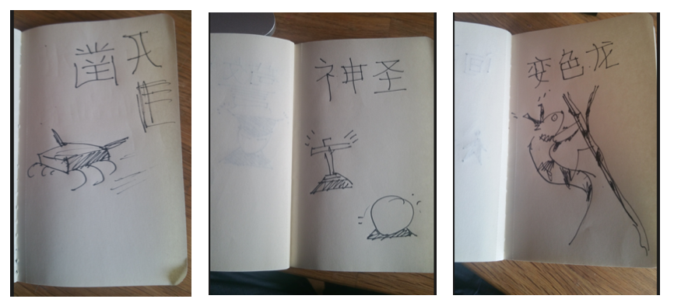
Figure 10: Zhang Wei’s Bestiary of Routers
“That kind of thing but detailed with odd diagrams and other codex stuff. What do you think?
Enrique: I love it! Much more than the spy version! The last one looks like a scrotum! The scrotum router!
(Pers Comm. Mark and Enrique. Wattsapp)
In a paper that could be regarded as an extended thought experiment the philosopher and sociologist of technology Bruno Latour takes on the pen name of Jim Morrison [70]. The paper describes a world without doors where we have to demolish and rebuild walls to get in and out of buildings. This device makes it clear what a clever piece of design a hinge is and goes on to talk about the difficulties of making sure a door is shut, especially when unreliable humans are opening and closing it. The move allows for a sociology of objects and machines and in a footnote Latour distinguishes between himself “The-author-in-the-flesh” and Johnson “the-author-in-the-text”. This author in the text does not exist and the author of the imaginary workbook is likewise imaginary. I (Mark) am the author-in-the-flesh of the text in this article while Enrique is the designer-in-the-flesh of the workbook pages that appear throughout. The designer-in-the-text is as imaginary as the author-in-the-text Valdis Ozols.
We took inspiration from the Codex Seraphinianus, a book written in an imaginary language by the artist and designer Serafini and beautifully illustrated with perplexing diagrams and images of bio mechanical objects and beings. Enrique developed an elaborate fictional design workbook including materials, found objects, many sketches and his own imaginary language. The following illustrations are reproduced to give a sense of the detail and depth of the artifact:

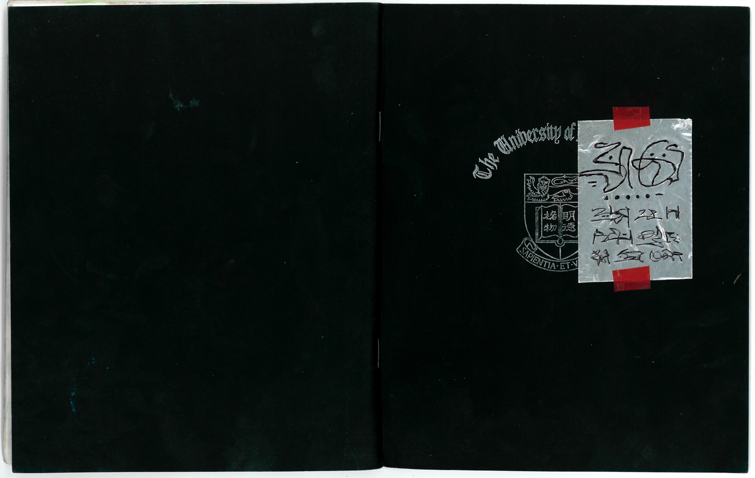
Figure 11: Imaginary Design Workbook Front Cover
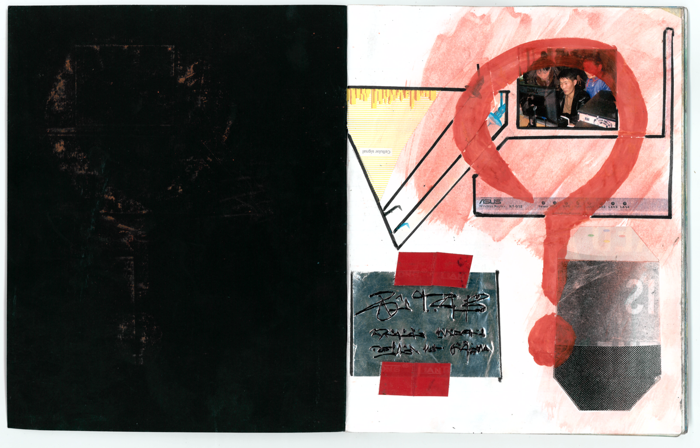
Figure 12: Page One
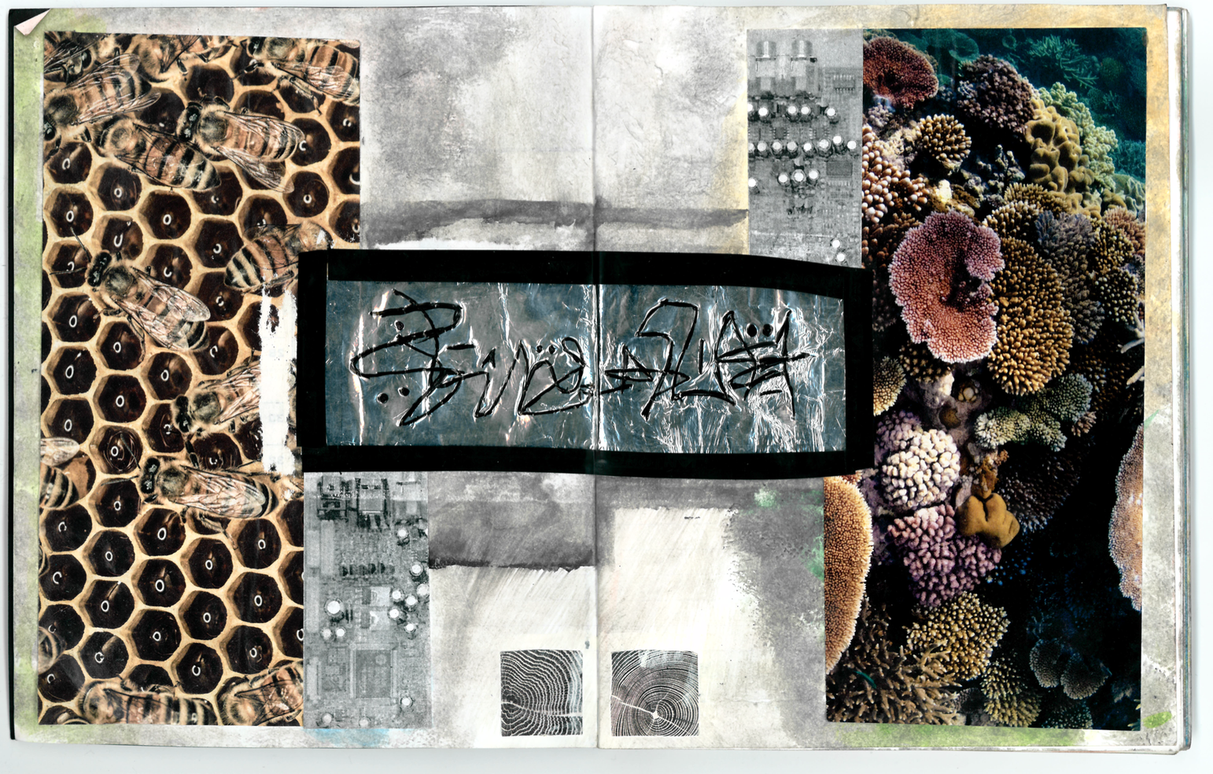
Figure 13: Section One
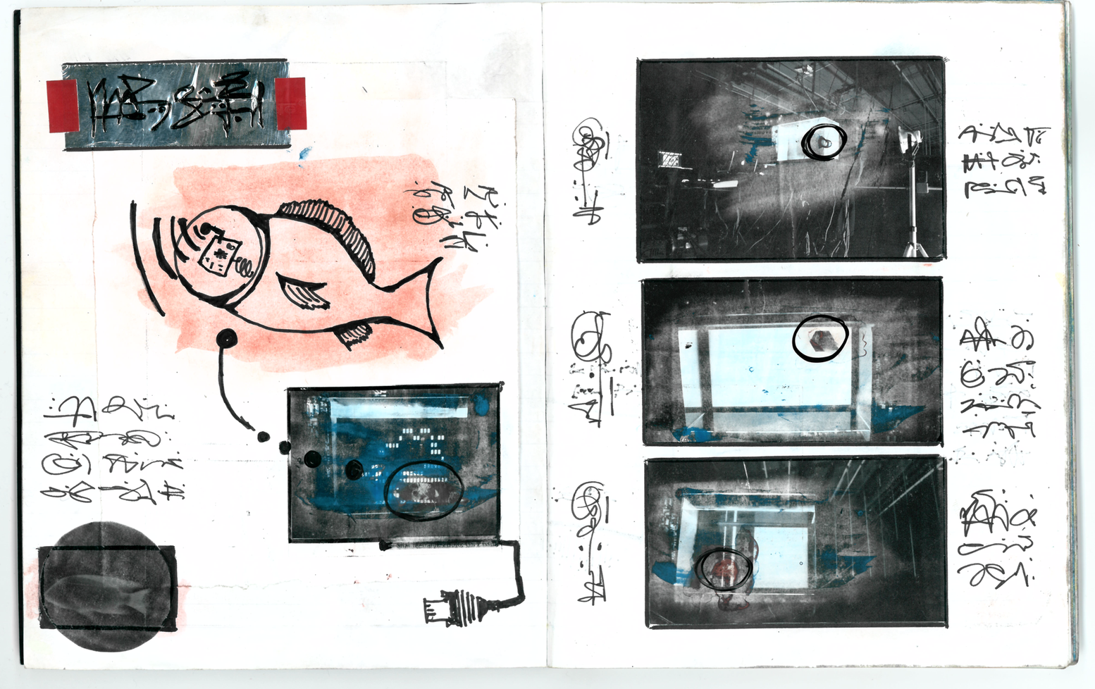
Figure 14: Section 1, example 1 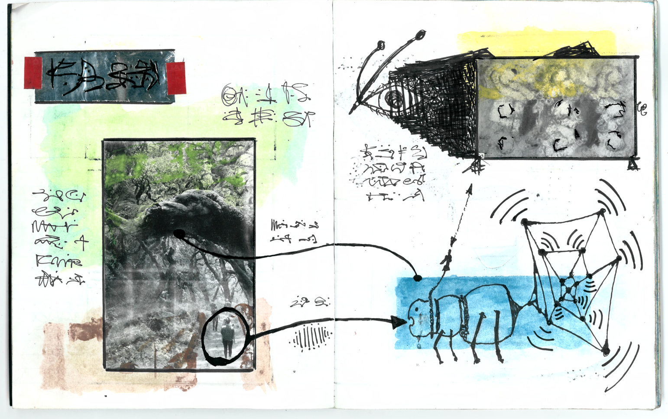
Figure 15: Section 1, example 2

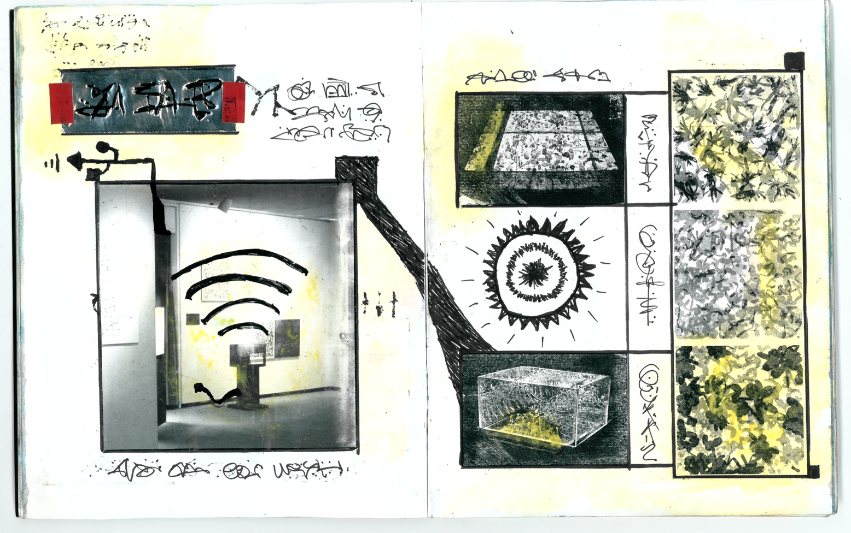
Figure 16: Section 1, example 3
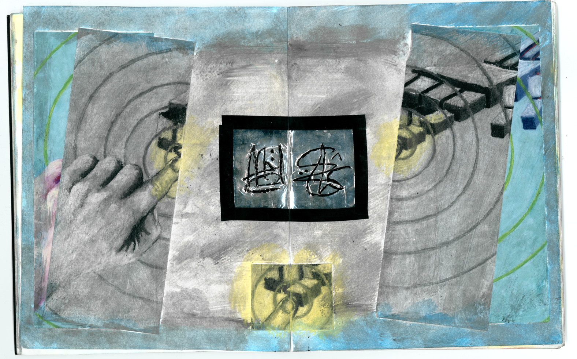
Figure 17: Section Two

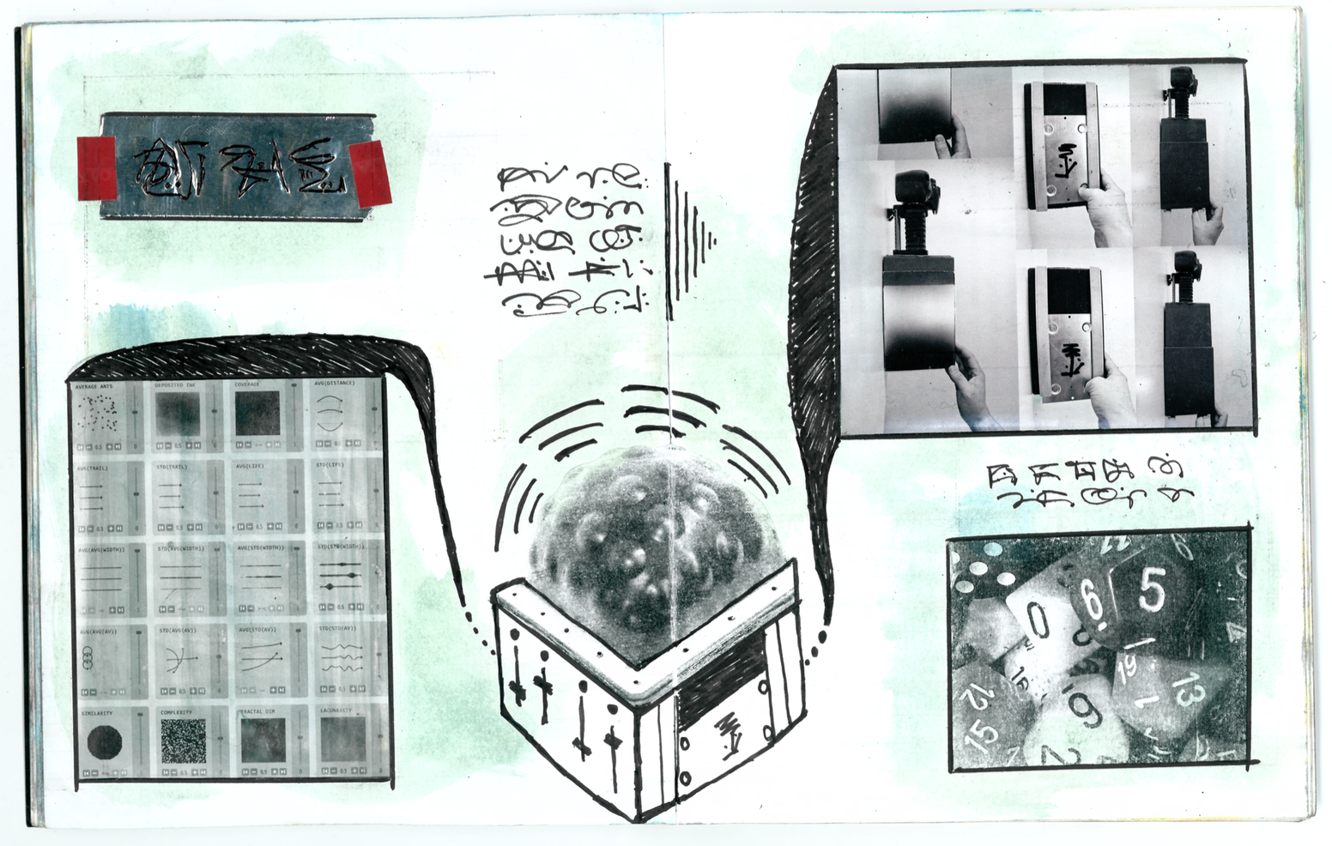

Figure 18: Section 2, example 1

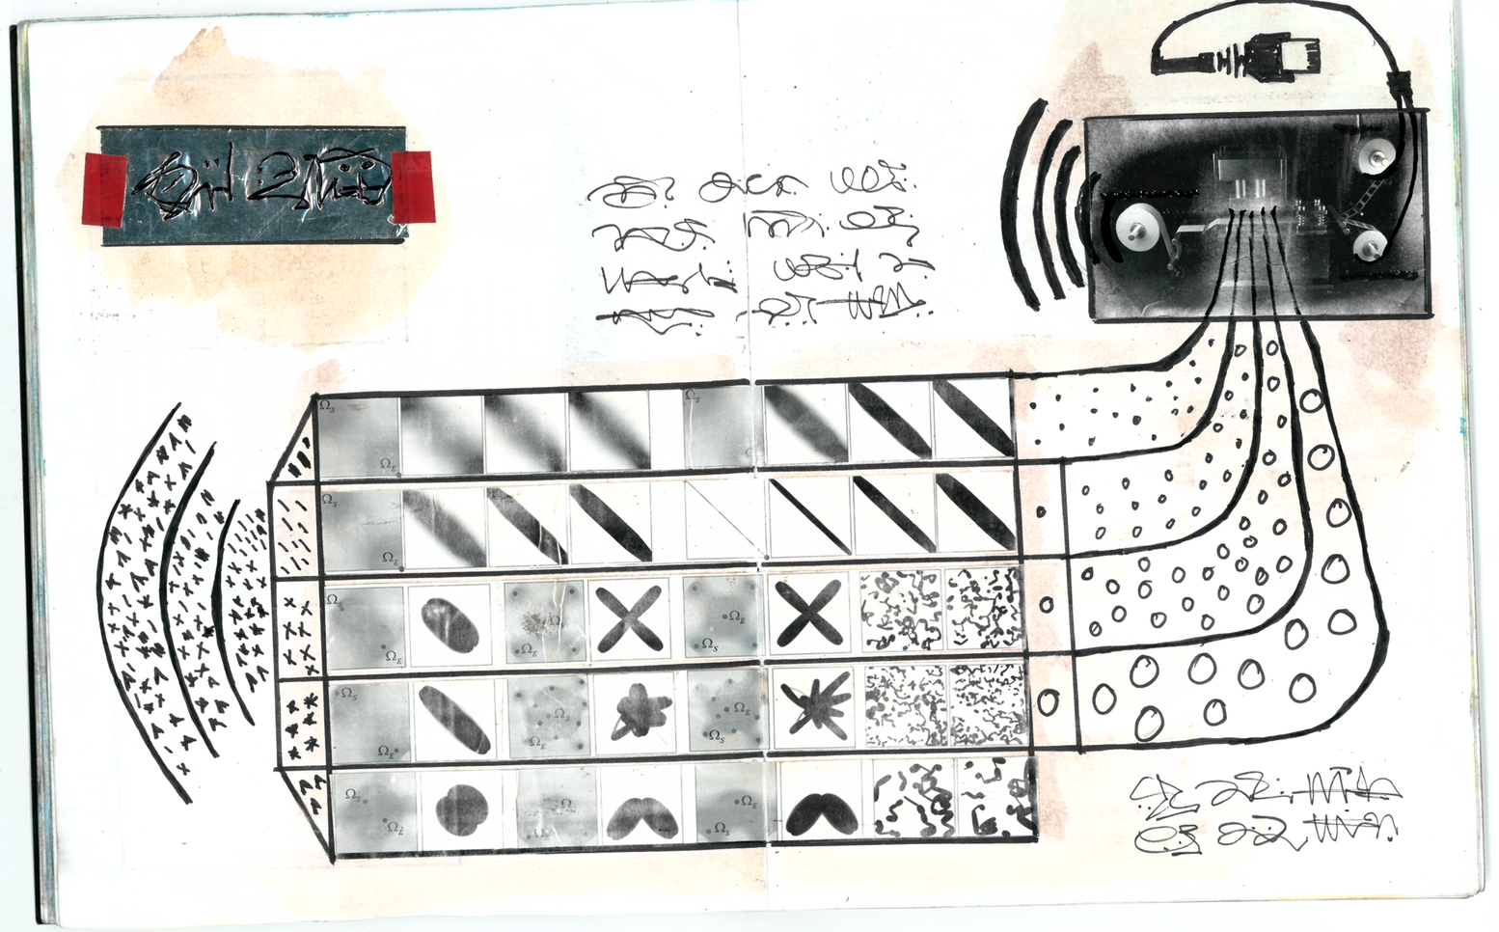
Figure 19: Section 2 example 2

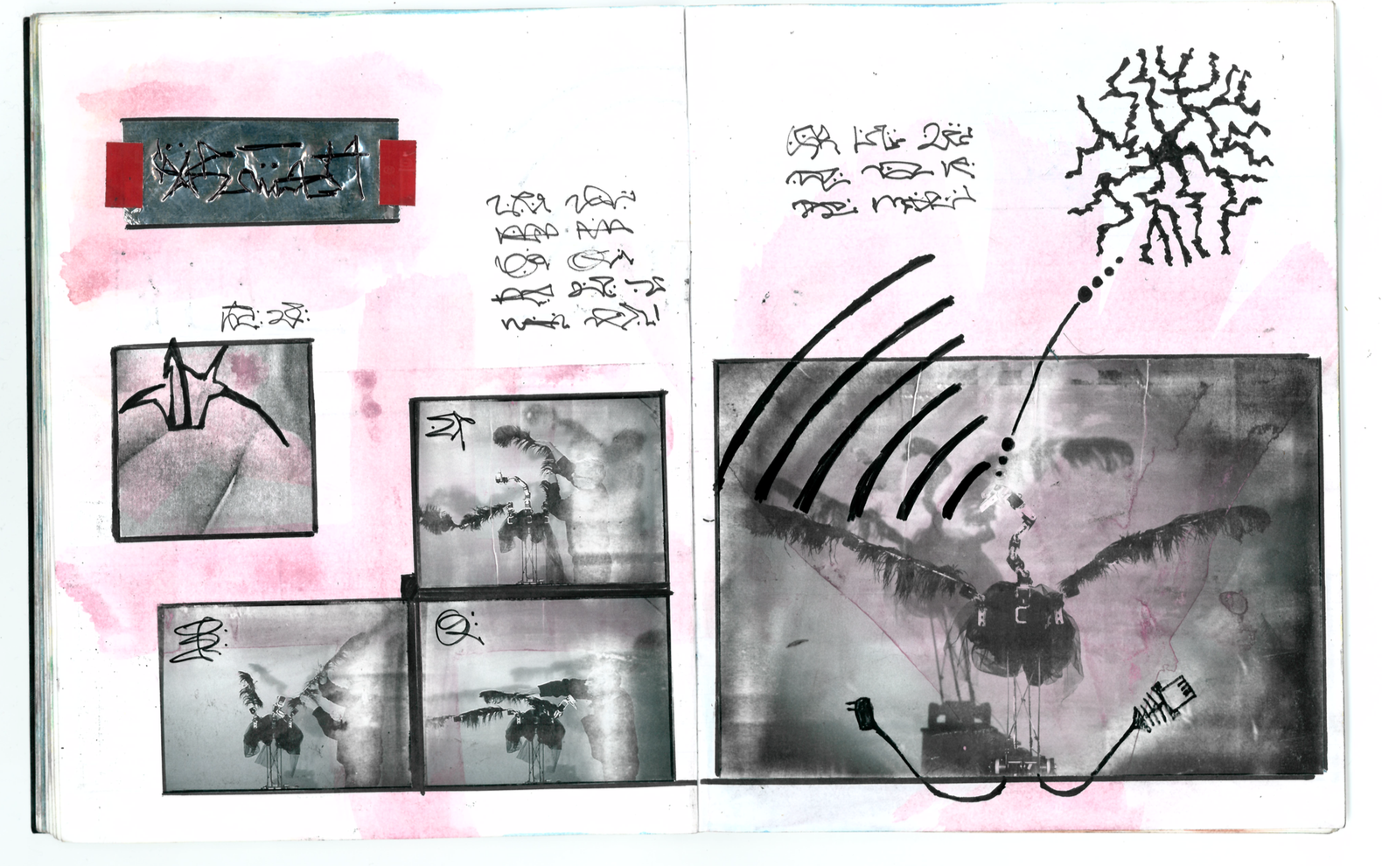
Figure 20: Section 2, example 3
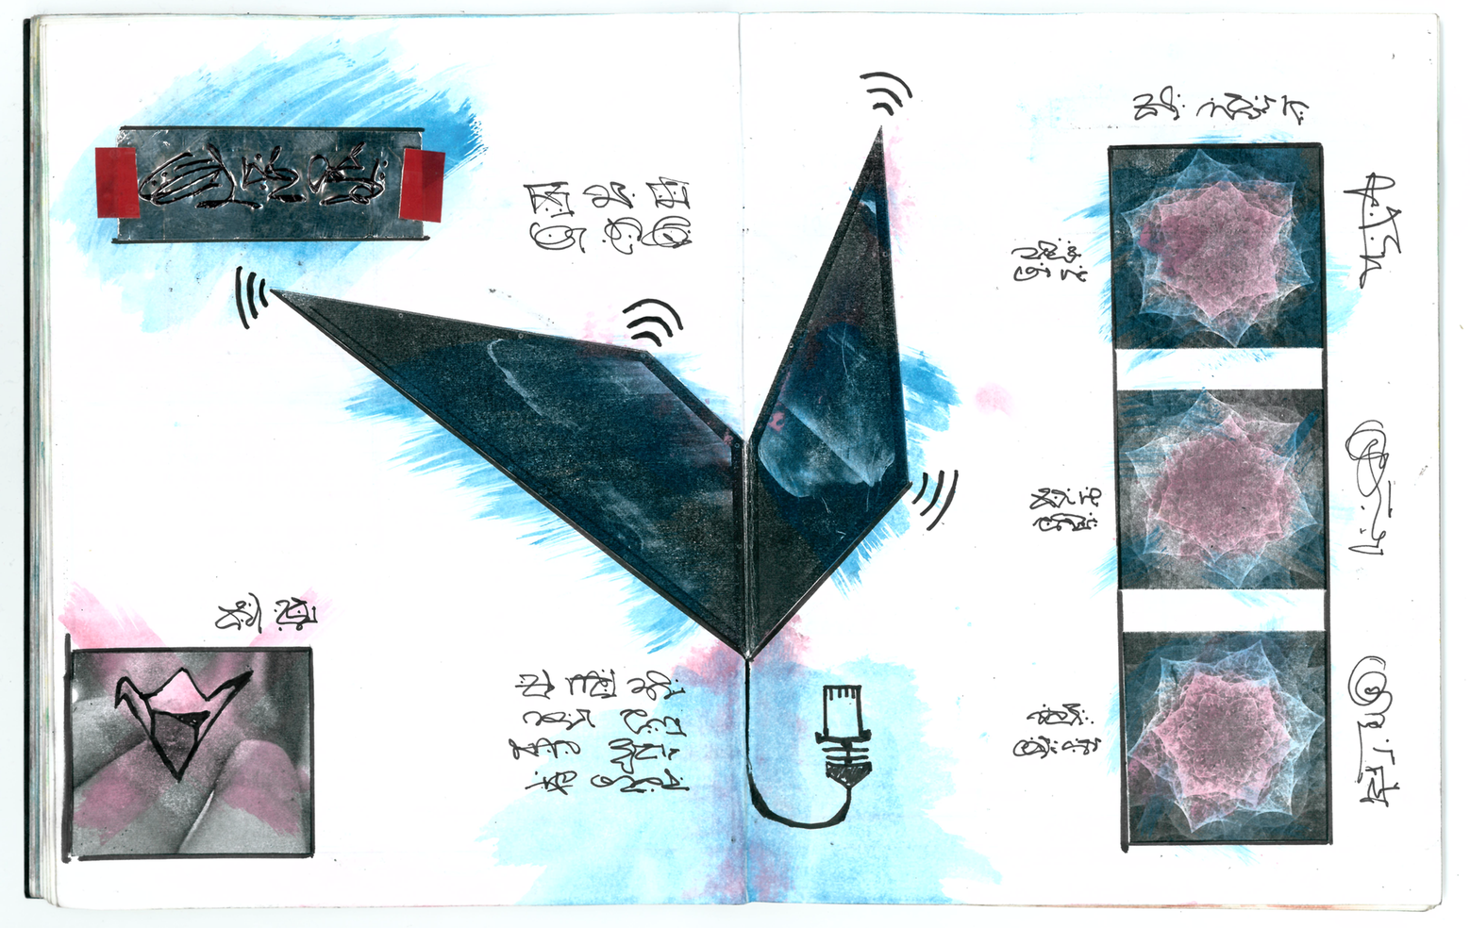
Figure 21: Section Two Example 4

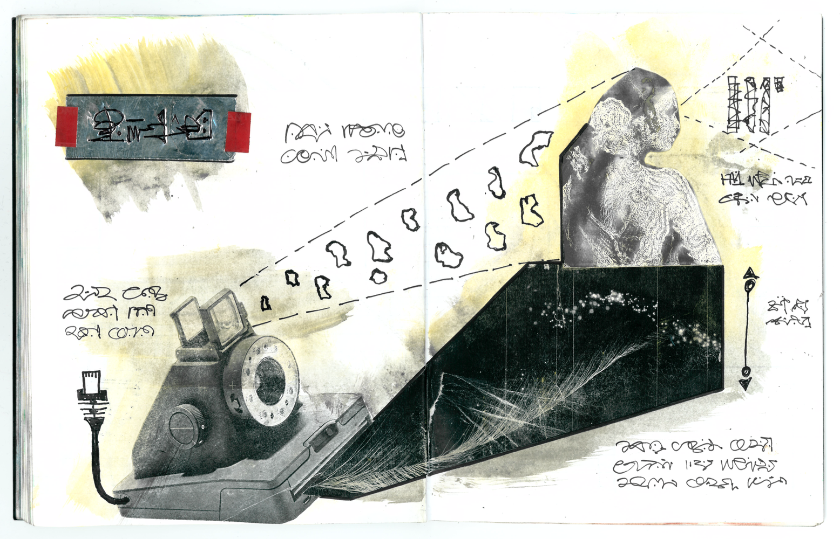
Figure 22: Section 2 Example 5
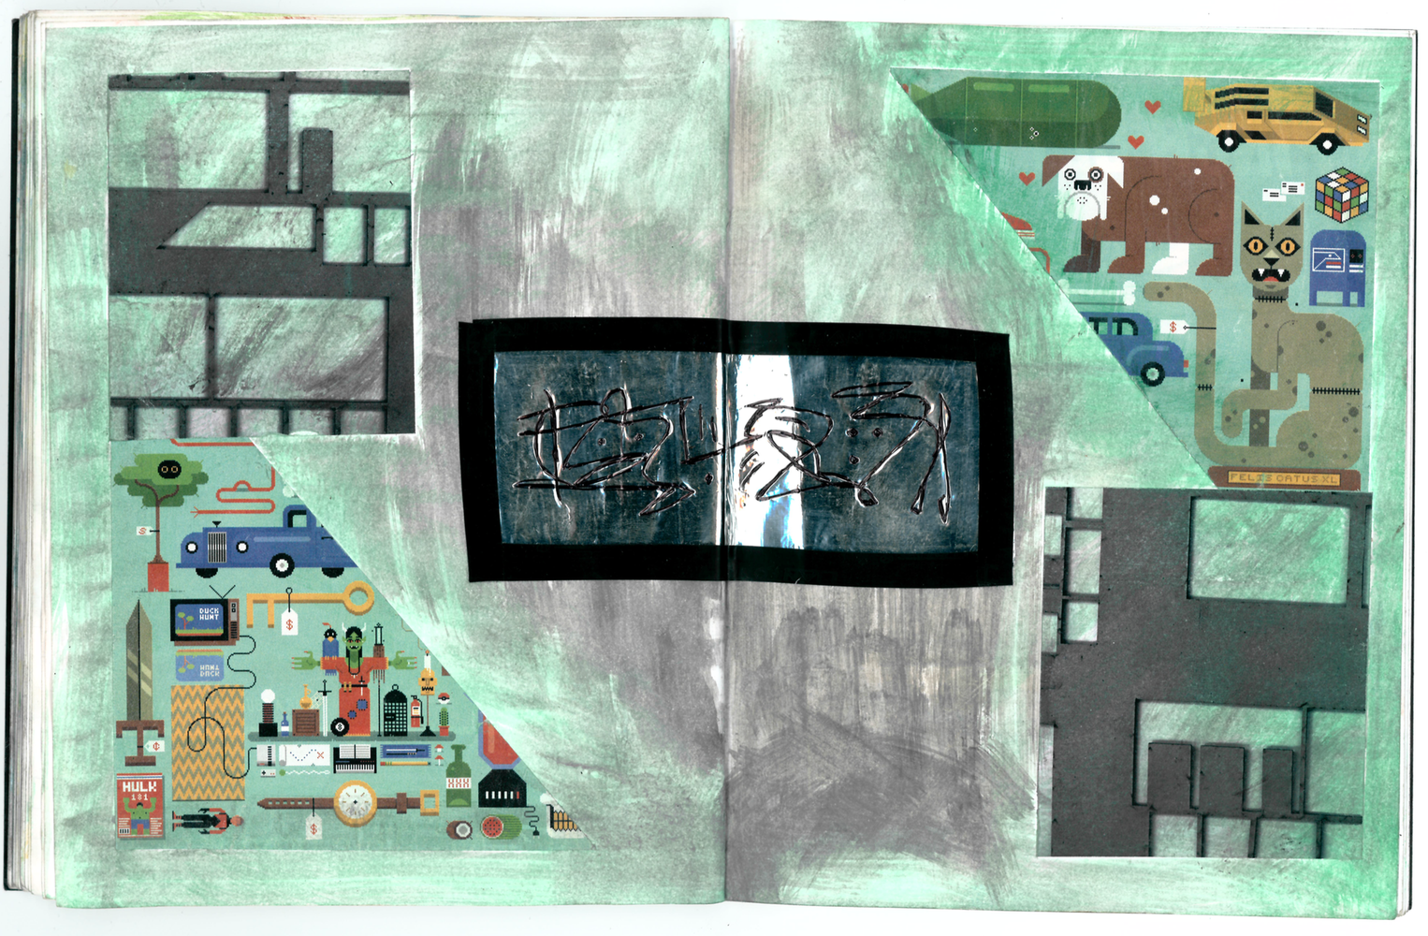
Figure 23: Section Three

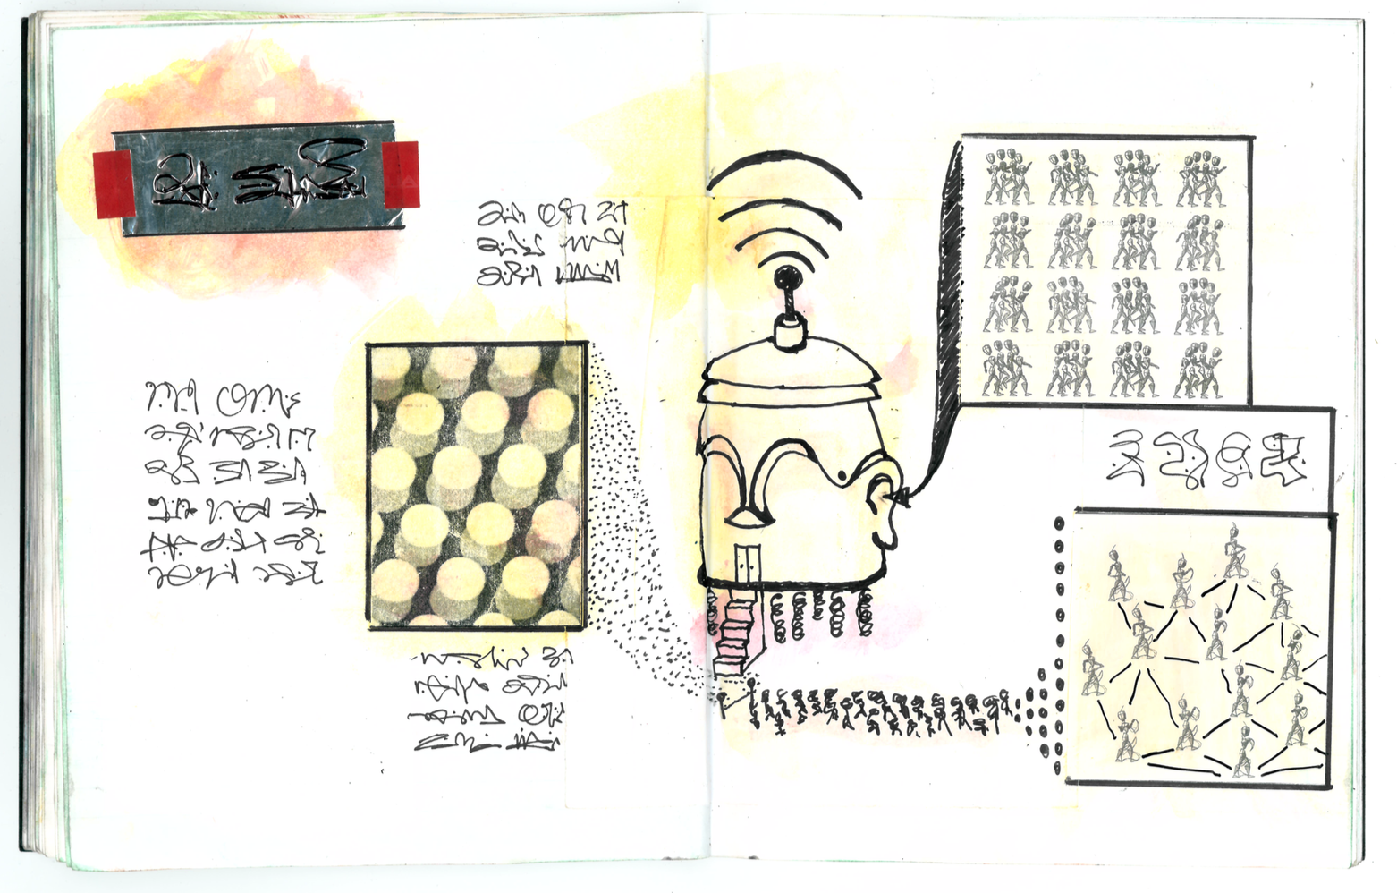
Figure 24: Section 3, example 1
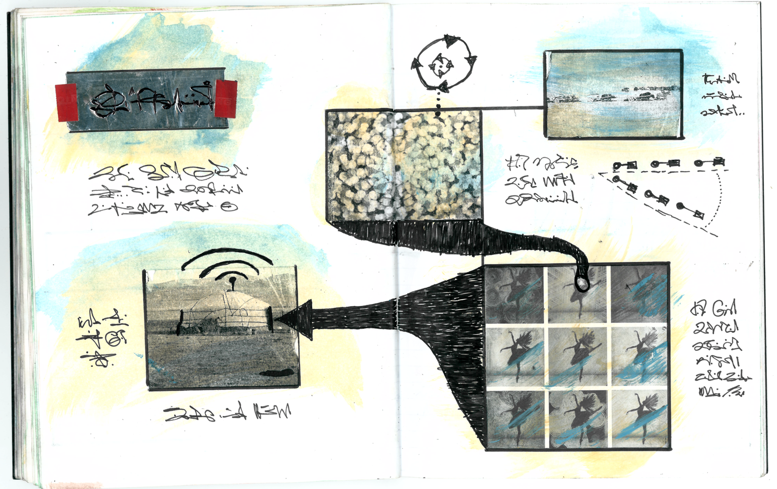
Figure 25: Section 3, example 2

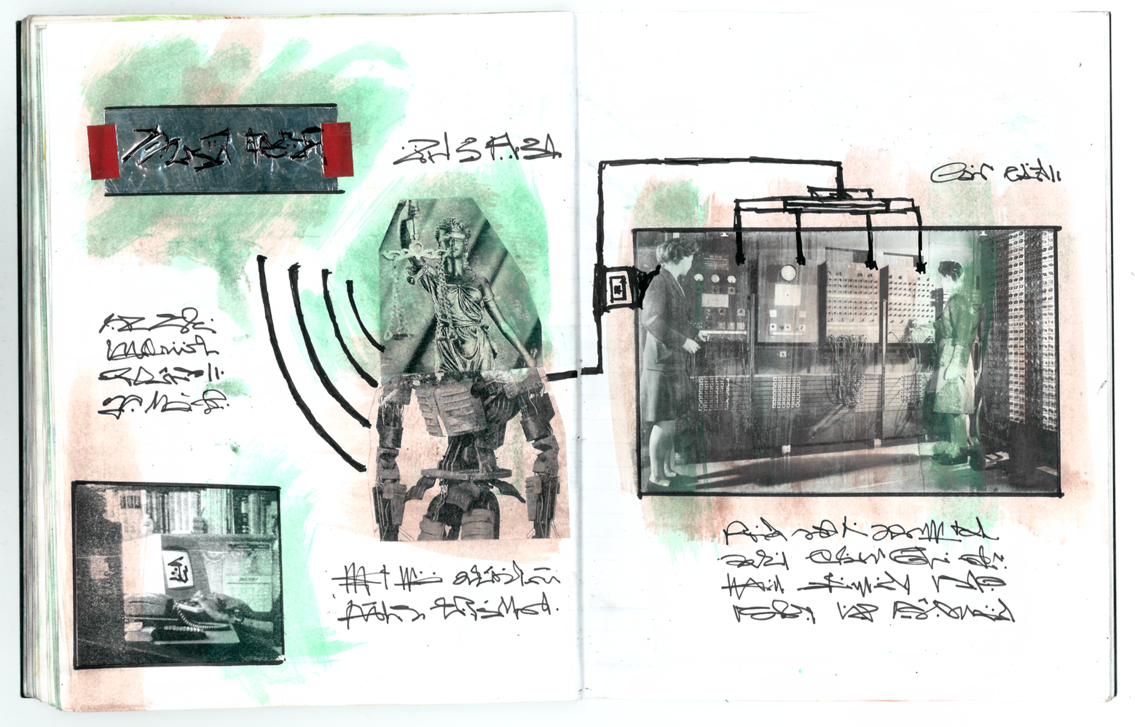
Figure 26: Section 3, example 3
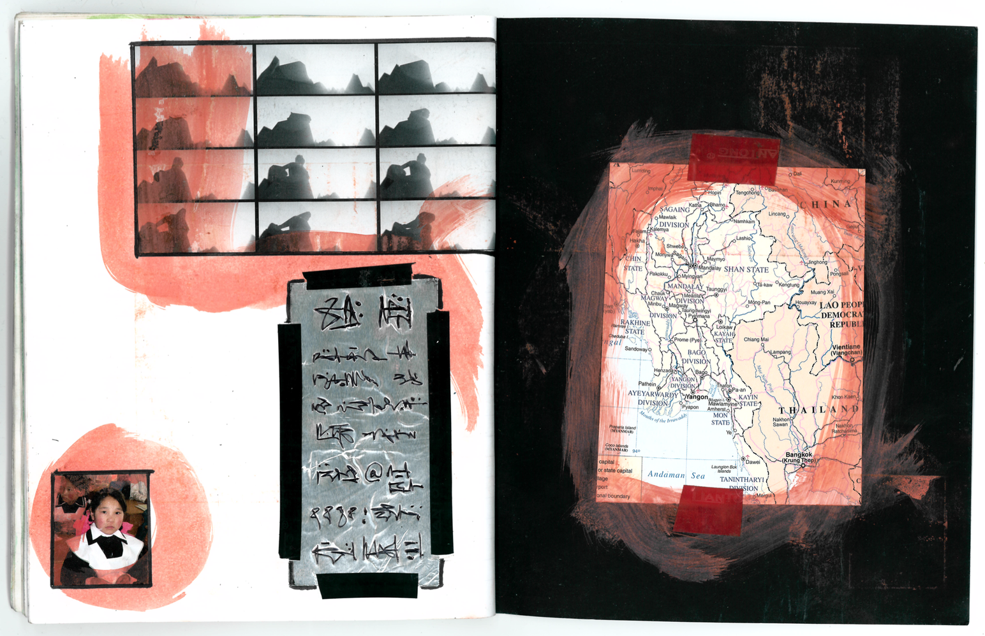
Figure 27: Final page and back cover

The notebook was printed as a thirty page booklet and distributed to the Mozilla team during the workshop. It was presented as a thought experiment –

“What if we found a designers notebook in a non place, like an airport. We know nothing about them, not even where they live or what language they speak. The notebook is written in an invented language. Could we make any sense of it” (Workshop notes)

The participants were invited to “suspend disbelief” and enter into the game by annotating the booklets with explanatory notes. The images were used as the jumping off point for a number of story making activities drawing on Vonnegut’s story shapes and Booker’s genres. In the afternoon the participants made their own “found notebooks” swapped them over and interpreted one another’s drawings. The workshop generated many spontaneous stories and one participant wrote one of her improvised narratives into a full story after the event [20]. Even though none of the participants could understand the images or the notes they were able nevertheless to make a kind of sense of them and use them as a resource.

Tom Stoppard dramatizes a thought experiment by Wittgenstein in a play called Cahoots Macbeth, in the introduction to the play he provides this succinct outline -

"A man is building a platform using pieces of wood of different shapes and sizes. These are thrown to him by a second man, one at a time, as they are called for. An observer notes that each time the first man shouts ‘Plank!’ he is thrown a long flat piece. Then he calls ‘Slab!’ and is thrown a piece of a different shape. This happens a few times. There is a call for ‘Block!’ and a third shape is thrown. Finally a call for ‘Cube!’ produces a fourth type of piece. An observer would probably conclude that the different words described different shapes and sizes of the material. But this is not the only explanation. Suppose, for example, the thrower knows in advance which pieces the builder needs, and in what order. In such a case there would be no need for the builder to name the pieces he requires but only to indicate when he is ready for the next one. So the calls might translate thus: Plank = Ready Block = Next Slab = Okay Cube = Thank you In such a case, the observer would have made a false assumption, but the fact that he on the one hand and the builders on the other are using two different languages need not be apparent to either party. " [114]

This thought experiment is drawn from the Philosophical Investigations where Wittgenstein argues that language acquires meaning by its use. Language is part of an activity or a form of life. It indicates the ways in which we can make sense of even invented languages like those of the Codex Serafinianus and the NoPlace Notebook. Meaning is not something inherent in a text but something that we make in a social context.

The Noplace Notebook is inherently ambiguous and yet the style of the sketches and shapes of the imaginary language give it a strong visual coherence and identity. There are three double spread section breaks made up of a collage of illustrations and photographs. Within each section are double spread pages, though the sketches vary there are structural repetitions: there are pastel water colour backgrounds behind pen and ink drawings, some sort of foil like reflective material is pinned to some of the pages with a red tape. (The same technique was used to make the illustrations for this article). When we hear a foreign language it is clear to us that it is a language and not just random sound because there are repetitions, patterns and rhythms. The visual world built up in the Noplace Notebook achieves a semblance of sense through the repetition of visual and stylistic motifs. Although each of the images are open to any number of interpretations they are not totally random, the arrows, figures and diagrams suggest some sort of idea even if it is unclear and puzzling. If a reader is willing to suspend disbelief and enter the world then it is possible to use the artefact to generate outlandish or even plausible ideas. While some of the images are surreal, particularly those of the first section, they are not totally unrelated to the real world, no fiction is.

Some of the workshop discussions focussed on the way that a listening system might provide emotional support for the residents of a home – changing lighting subtly in response to tension for example. There were of course immediate concerns around surveillance but the idea was very interesting to a friend who is a senior social worker running a new scheme for young offenders. We developed some scenarios around the notion of a digital social worker that might monitor sensors and audio in the home of a young offender as an alternative to the costly and ineffective programme of incarceration operating in the UK [20]. Clearly there are many disturbing aspects to such a concept and these are discussed more fully in another paper [20]. But many of the issues are reflected in this short story by Valdis Ozols.

The Stasi Godmother

He was able to understand his life only when it was almost at an end and the information he so badly needed was declassified. Long after the state had fallen, when the city had a different name and the files had at last been made public, Maris Berzins browsed through his Winston database and felt as if he were meeting another self from forty years ago. It was an experience common to anyone exposed to their Winston data and known by scholars as the Proustian effect, named after the madeleine biscuit dipped in tea that triggers the vivid childhood memories in the novelist’s remembrance of things past. Maris was surprised at how much of these data were absent from his own memories, either forgotten, half remembered or actively distorted. He looked through the information with a mixture of fondness, surprise, embarrassment and shame. Unlike the files compiled by humans he could attribute none of this to error, here it all indisputably was: exactly how long he slept, precisely when he got out of bed, what he took from the fridge and the cupboards, the exact amounts and consistency of the waste he expelled, the books he read, the shows he watched, the conversations he had. It was all there, every cross word and each bad joke.

He was a lone parent caring for a teenage boy and a young girl in a tiny apartment in Riga off Leriku Iela. Maris knew that he was under observation, as the former husband of a woman who had been disappeared it could not be otherwise. Clearly all of his phone calls would be monitored, along with who came to call, where he went, who he talked with and so on. But the sheer amount of data in his file was staggering – no life in human history could have been logged in such minute detail, no historical figure, no obsessive diarist. But this was not such a surprise, at one time everyone had a Winston file like this, the shock was finding out that he was the reason the programme was ever developed.

The notes from his case worker and future wife, Liga, were unusually detailed form the start. There were long and sympathetic descriptions of his difficulties with his boy, a troubled child who had suffered severely when his Mother was arrested. The boy had gotten into trouble with the local police on several occasions and one evening he got into a fight with someone who turned out to be a senior KGB officer. It was this that brought Liga into their lives. She was a sensitive and talented agent but her observations were not the usual broad descriptions of political activities. Her remarks drew on social and psychological theories of child development and almost from the beginning she began to intervene rather than just observe. Subtly she would interfere with the family diet, arranging for the wrong groceries to be delivered. When the atmosphere was tense she would remotely change the channel on the radio and note any soothing effects. If voices were raised she would dim the lights. When things were about to reach a breaking point and the boy looked as if he were about to start smashing the place up there would be a knock at the door and there Liga would be making a seemingly routine visit. According to her reports her interventions were having a positive effect on family life.

Maris had to learn an entirely new version of the story of his own life. Incidents that he had thought were happy co-incidences had been carefully planned by Liga. Discovering that they both liked the same music, literature and films were not the happy accidents that they had seemed, she had been studying him and presented an image of herself that she knew was perfectly suited to him. Their entire marriage had been for Liga, primarily, a research project, she had targeted his first wife for arrest because their family best matched the demographic she wished to study. She had seduced and married him in order to perfect the measures and sensors that Winston would later use on the rest of the population.

In the final pages of Liga’s observations Maris discovered that the failure of the Winston project also signalled the end of his marriage. The initial publicity for the programme had framed it as positive surveillance, the age of the state spying on its own citizens was now over. This was not a punitive regime, it was rather a service: a Stasi Godmother. Alexi would offer the best advice on childcare, supply parents with vital data about their children (what time they were going to sleep, how much they had eaten, whether they were taking drugs) and send professionals to help when they were needed. There were some early successes and the death of some vulnerable children was prevented through early detection of neglect. But Alexi’s advice was not consistent, some days she advised parents to place babies on their back to prevent cot death, other days she said put them on their side. Sometimes the advice was to replace butter with vegetable oil and sometimes the exact reverse. One day the enemy was saturated fat the next it was sugar. Then corrupt case workers began taking bribes so that Winston would give more favourable scores to one or another parent in divorce cases. Senior party officials began to blame the Winston programme for the rise of popular resistance and Liga was assigned elsewhere. She had told Maris she’d been having an affair and no longer loved him. It was time to stop lying she said, continuing to lie. Maris closed the file and, as was his hard won legal right, and erased the data.

Ozols names the system Winston in a nod to 1984 but there are also references to that other great twentieth century novel of dystopia Brave New World. For Orwell the future is a boot stamping on a human face forever. For Huxley it is a populace given what it wants in a world where unhappiness has been designed out of society. Genetically engineered citizens are conditioned to accept and enjoy their inescapable place in society and take “soma” to chemically alter their mood when it is low. The intention of the Winston system is benign and yet it remains oppressive. The reference to Proust is taken from Tim Garton’Ash’s account of reading his own Stasi file when it was made available many years after he had lived in East Berlin [20]. There are also echoes of the film The Life of Others, it is likely that Ozols would have suspected plagiarism had he lived to see the movie.

5 Discussion
In the opening pages of the Chinese Science Fiction novel “The Three Body Problem” there is an account of a “struggle session” during Mao’s Cultural Revolution where a Physics Professor is publicly humiliated by four teenage girls who accuse him of teaching counter revolutionary scientific theories like relativity. When the Physicist tells them that relativity is a foundational theory of modern Physics the girls call him a liar. They dismiss Einstein as a “reactionary academic authority” and beat the Professor to death with iron bats [84]. Although we are in a fictional world such struggle sessions were all too real and historians have recorded many eye witness accounts of Professors being humiliated and beaten by their own students [47, 37].

Writers seldom invent worlds from whole cloth. Even fantasies like The Lord of The Rings bear the traces of their times. Tolkien disliked allegory and denied interpretations of his work which equated the ring of power with nuclear weapons, and yet there are many strong resonances between the world he made and the one he lived in during the first two world wars when the work was written. Tolkien described the world building achieved in fantasy as “sub-creation” rather than creation, he distinguished worlds where the sun is green as “secondary” with our world as “primary”. He argued that however fantastic the secondary world may be there is some relationship to the primary one. [118] The Three Body Problem describes a world where the rules of Physics do not appear to be constant or universal. On the planet Trisolaris day follows night, as it does on the earth, for only a few generations. Sometimes the sun does not rise for years and years and then it rises so near that it boils the oceans and scorches all life from the world. However fantastic the cosmogony of the sub creation there are elements of our own world and history within the text. It would be an incurious reader who read the early scenes describing the “struggle session” of the cultural revolution and did not wonder whether there was some basis to this in fact.

Discussions of fiction are often framed in terms of the poet Samuel Taylor Coleridge’s idea of a “willing suspension of disbelief”. He uses the phrase in an 1817 text describing plans he made with Wordsworth for related poetical projects. Coleridge would treat supernatural and romantic subjects while Wordsworth made a poetry of every day life:
“it was agreed, that my endeavors should be directed to persons and characters supernatural, or at least romantic, yet so as to transfer from our inward nature a human interest and a semblance of truth sufficient to procure for these shadows of imagination that willing suspension of disbelief for the moment, which constitutes poetic faith. Mr. Wordsworth on the other hand was to propose to himself as his object, to give the charm of novelty to things of every day, and to excite a feeling analogous to the supernatural, by awakening the mind's attention from the lethargy of custom, and directing it to the loveliness and the wonders of the world before us; an inexhaustible treasure, but for which in consequence of the film of familiarity and selfish solicitude we have eyes, yet see not, ears that hear not, and hearts that neither feel nor understand” [39]
This agreement resulted in Wordsworth’s naturalistic poems like Lucy:
“ she dwelt among the untrodden ways
Beside the springs of Dove,
A maid whom their were none to praise
And very few to love”.
And Coleridge’s fantastic inventions like Kublai Khan
“In Xanadu did Kublai Khan
A stately pleasure dome decree;
Where Alph the sacred river, ran
Through caverns measurless to man
Down to a sunless sea.”
Although the methods of each poet were very different they both aimed to achieve a “poetic faith” to “awaken the minds attention from the lethargy of custom”. Wordsworth writes about ordinary people and things and requires that the reader look differently at the mundane and commonplace, even daffodils, so that they might wonder at them. Coleridge on the other hand required that they temporarily suspend their empirical knowledge about the world (there certainty that there was no stately pleasure dome in a cavern measureless to man) with the same aim of making us wonder at the world and our lives.
But to suspend disbelief is not to enter into a state of temporary credulity. It is not, to think for a moment that there really are phantoms, Orcs or TriSolarians. It is more like entering into a gamespace where the players assume a set of rules that may be more or less arbitrary. In Hamlet on the Holodeck Murray speaks of an “active creation of belief” [92] Mackey builds on this to argue that during games, films and novels we enter an “as if” space [85]. We experience hope and fear in fictional worlds as if they are real even when the outcome of a particular story is well known to us (Gerrig cited ibid). The players of games always know very well that the rules are arbitrary and yet they choose to abide by the rules (or premises) for so long as they play, as if they are real.
Gamestorming is a book listing games that people can play when they are trying to develop new ideas. It describes the structure of games in terms of opening, exploring and closing. Each of the three stages are important in creating a space to develop ideas. It is not possible to be creative and critical at the same time (this is a classic definition of writers block). For this reason it is a cliché of brainstorming that there are “no bad ideas” - of course there are plenty of bad ideas, it is estimated that you need about ninety nine bad ideas to produce one good one, but the game space suspends that judgment in the way that Coleridge talks about suspending disbelief.
“The first act opens up the world by setting a stage, introducing the players and developing the themes, ideas and information that will populate your world” [61]
After exploring the world the space is closed down and you see what you have got, having moved from one state to another. Thought experiments have this kind of structure with openings that suggest some new world: suppose you are travelling at the speed of light and you turn on your headlamps?
In this sense thought experiments can be thought of as a game, a “what if” experiment played by ethicists, lawyers, historians, physicists and mathematicians. When thought experiments are conducted in Design they often involve imagined devices depicted by text, images, models or even functioning prototypes. Thought experiments in design ask us to imagine what the world would be like if such devices existed or came into widespread use. The term fiction then is as misleading as the suspension of disbelief. It does not require us to become temporarily credulous, rather we are invited to accept a set of axioms or rules and enter a game space – where there may be unstable laws of physics, or self driving cars making ethical choices, or machines that will replay videos of your dreams.
The use of fiction in the form of provocative scenarios or stories is well established in other disciplines [29]. Design always involves some element of fiction: to picture the world as in some way other than it is to engage in sub-creation, an imaginative act. Despite this there is epistemological unease around the use of fiction – are we just making it up now? [82] Although thought experiments are often concerned with a priori arguments this does not put them outside of scientific traditions. The term “a priori” is often used to dismiss a spurious argument because it relies on presumption or prejudice. But this use of the term can obscure the more precise use of it within logic. A priori in this sense means reasoning without empirical evidence and it is central to much thought in logic, mathematics and other disciplines. For example the idea that two billion marbles plus two billion marbles makes four billion marbles is an a priori argument: it is not necessary to count all of the marbles in an empirical experiment to make sure that this is the case. Thought experiments often make use of this kind of a priori reasoning.
The world described in the Three Body Problem where the laws of Physics are not stable or universal may seem utterly fanciful, but it is based on another thought experiment (also used by Bertrand Russell) which demonstrates the limits of empirical observation:
“Two words suddenly floated into his consciousness: shooter and farmer. When the members of the frontiers of science discussed Physics they often used the abbreviation SF. They didn’t mean science fiction but the two words shooter and farmer. This was a reference to two hypotheses both involving the fundamental nature of the laws of the universe. In the shooter hypothesis a good marksman shoots at a target creating a hole every ten centimeters. Now suppose the surface of the target is inhabited by intelligent two dimensional creatures. Their scientists after observing the universe discover a great law: there exists a hole in the universe every ten centimeters. They have mistaken the result of the marksman’s momentary whim for an unalterable law of the universe. The farmer hypothesis on the other hand has the flavor of a horror story: every morning on a turkey farm the farmer comes to feed the turkeys, a scientist turkey having observed this pattern to hold without change for almost a year makes the following discovery: every morning at eleven food arrives. On the morning of thanksgiving the scientist announces this law to the other turkeys but that morning at eleven food doesn’t arrive, instead the farmer comes and kills the entire flock.” [84]
Although he language of the rooster parable takes the form of a children’s story it is deceptively simple and echoes a fundamental challenge to inductive reasoning first advanced by David Hume. In the seventeenth century. Hume argued that although bread had nourished him yesterday it did not follow that it would do so tomorrow:
"I shall allow, if you please, that the proposition may justly be inferred from the other: I know for a fact that it always is inferred. But if you insist that the inference is made by a chain of reasoning I desire you to produce that reasoning." [65]
The association of experience and expectation is a psychological rather than a logical process. The sun rose yesterday but it does not follow that it will rise tomorrow, indeed it may blow up one fine day. Repeatable experiments cannot verify observable data. Popper suggested that data can be falsifiable to achieve maximum probability, however Hume's challenge to scientific rationalism still stands. As Einstein's challenge to Newton's physics demonstrated - science does not discover laws, it creates systems -
"Theory cannot be fabricated out of the results of observation, but that it can only be invented." [85]
Calls for design research to be more “rigorous” and “scientific” are generally calls for design research to be more empirical and inductive [127]. Such calls display a naïve belief in the certainty of observable phenomena not shared by the hard sciences being emulated. Design, which seeks to speculate and explore ideas is sometimes dismissed as being merely “critical” while design research that seeks to solve particular well specified problems is lauded as “constructive” [54]. The dichotomy between critical and constructive is as false as the notion that observation and induction is properly scientific while speculation belongs solely to the Arts.
Speculation and thought experiment has a long history across disciplines. The best science fiction novels can be thought of as elaborated thought experiments in sociology (1984) psychology (Brave New World) and epistemology (the three body problem). Science Fiction is a literature of ideas. Design fiction can be seen as a similar exploration of ideas in material forms. These materials might be text, image, film, model or prototype. Although the forms may be new the practice of the thought experiment is very ancient indeed.
Alan Moore is one of the many writers who have lived to see their fictions invade the real. Not in the sense of an idea for a technology they had coming to be. But rather in a fictional character making an appearance in the world. In V for Vendetta Alan Moore imagined V as an anarchist in a distinctive Guy Fawkes mask. This mask was adopted by the Occupy movement and also Anonymous. It is often seen at demonstrations and has been adopted by groups whose politics are at odds with Moore’s own. Moore argues that the borders between reality and fiction are now entirely porous. Fictions, have real effects as JG Ballard noted fifty years ago:

“It’s becoming more and more difficult to distinguish between fiction and reality. More and more of our lives have been invaded and are now ruled by fictions of one sort or another. By fiction I mean anything invented to serve someone’s imaginative end, whether it’s an advertising agent or a novelist or a prostitute.” [64]

Narratives, like metaphors, are always partial, emphasising some aspect of experience and hiding others. Even narratives which we think of as true contain elements of fiction because they are inevitably selective. Fiction is central to our understanding of technology. As Dourish and Bell point out [50] technology is always in a process of becoming, we are continually looking ahead to what is coming next. The dominant narrative of fictions like the Internet of Things is that all objects will achieve “smartness” and this will make the world a better place. This is the modernist notion of technology as the tool of continual progress. More and more we doubt this story. Many of the proposals from both silicon valley and academia are criticised as “solutionist” either solving problems that do not exist or offering quick fix cure alls for complex social, political and environmental problems [91].
Re-storying the dominant narratives of the culture is increasingly important as fictions begins to dominate reality.

A recent episode of the RadioLab podcast described technologies currently in development at Adobe that allow speech recordings to be manipulated as easily as an image in Photoshop. A person’s voice can be copied and manipulated so that words they never spoke can be seamless inserted into a recording [101]. The podcast also describe “facial reneactment” technologies that allow one person to map facial expressions and movements onto videos of another person. Such systems allow an actor to use the image of a real person as a puppet, making it look as though they are saying whatever they want them to say. They interview Ira Kemelmacher-Schlizerman a computer scientist at the University of Washington who also works for Facebook. She is working on this kind of technology in order to create telepresence. She gives this example “my Mom lives in Israel and I’m here and wouldn’t it be cool if I could – it’s kind of crazy right? But if I could have some kind of hologram on my couch here and we could have a conversation”. This kind of domestic scenario focussing on a family and an older person is very common in the HCI literature. Yet Simon Adler, the presenter and producer of the podcasts, finds the technology being proposed terrifying and their exchange is worth quoting at length:

Simon: The timing of you guys making this thing, and then there’s this explosion of fake news. How do you guys think about how this could be used for nefarious purposes?
Ira: Ah it’s a good question [..] I feel like when every technology is developed then there is this danger of – with our technology you can create fake videos and so on, but I don’t want to call it fake videos but to create video from audio right?
Simon: But they are fake videos.
Ira: Yeah yeah but the way that I think about it is that scientists are doing their jobs in showing - in inventing the technology and showing it off and then we all need to think about the next steps, obviously. I mean people should work on that. And the answer is not clear, maybe it’s injunction maybe every video should come up with some code now like this is, this is like authentic video, authentic text and don’t believe anything else.
Simon: But like – maybe it was the timing more than anything. But I saw this video and I thought – oh my God America can’t handle this right now. Like we’re in a moment where truth seems to be an open - where what is true has become an open discussion. And this seems to be adding fuel on the fire of sort of competing narratives in a way that I find troubling. And I’m just curious that you don’t.
Ira: I think that if people know the technology exists then they will be more sceptical. My guess. I don’t know. But if people know that fake news exists, if they know that fake text exists, fake videos exist, fake photos exist then everyone is more sceptical in what they read and see.
Simon: But a man in North Carolina, I think he was from North Carolina, believed, from a fake print article, that Hilary Clinton was running a sex ring out of pizza parlour in DC which is like insane. This man believed it and showed up with a gun and if people are at a moment where they are willing to believe stories as ludicrous as that I don’t expect them to wonder if this is video is real or not.
Ira: [long pause]. Uhm so what are you asking?
Simon: I’m asking are you afraid of the power of this and if not why?
Ira: Just – I, I, I’m just giving my o- I don’t know – I’m answering your questions but I’m a technologist, I’m a computer scientist so – uhm. Not really. Because I know that this technology is reversible. There is not …. not … worried … too much. [101] 19.09 -22.28

The pause before Ira says “what are you asking?” is long and awkward. Clearly Ira’s motives are benign and her scenario describing a technology that would allow her to feel as if she was in the presence of her distant Mom is appealing on many levels, it is domestic, safe, focussed on supporting one of the most important relationships in anyone’s life. But this is not where Simon is coming from: he is imagining a world where the border between fact and fiction is totally erased, where we literally cannot believe our eyes or ears. Ira finds it difficult to connect with these concerns and distances herself from them “I’m a technologist, I’m a computer scientist” as if these possible applications are problems for someone else, problems for some other field, some other set of experts. These are questions for legislators perhaps, or sociologists or those that speculate about the future in literature or movies, not for computer scientists and technologists. Dystopian fictions about the possible abuse of this kind of technology are outside of her normal way of working. But there is another kind of fiction that is firmly within her way of working – the benign, short, conflict-free scenario about feeling present with a distant relative. Almost twenty years ago Cooper [40] pointed out that such scenarios cause technologists to focus only on people who are just like themselves. Today this kind of fiction is not only inadequate it is dangerous. In the age of fake news and alternative facts it is more important than ever to develop our understanding of the uses and abuses of fiction.

Influence and Legacy [edit]

Ozols’ work as a historian has been used as teaching material on courses about state propaganda. The historical distortions and hagiographic fawning to Stalin are so blatant that they make excellent teaching material [citation needed]. Ozuls’ work lays bare propaganda techniques that would be harder to spot when used more subtly by other historians and writers. Indeed Baldois has argued that Ozuls may have deliberately exaggerated his distortions for this reason: the propaganda is so central to his historical writing that it could almost be seen as a satire. Others claim this is too generous a reading and Ozols’ fiction makes it difficult to establish what his political views were. Sometimes the stories can be read as libertarian creeds, others appear as paeans to socialism. Like many writers Ozuls has been accused of many competing and contradictory political: fascism, sexism, racism, as well as communism, libertarianism and egalitarianism.

His fiction had little to no influence on his fellow writers or the culture more generally unless his claims about Stanislav Lem’s plagiarism are to be believed. Recently Ozuls work has begun to appear in HCI literature, Blythe and Encinas for example quote form his work extensively. But at the end of his life his legacy was uncertain.

Baldois: Are you bitter that your work was never recognised?
Ozuls: Of course not. If my work had been recognised I would have been sent to the gulag!
Baldois: How do you see your legacy?
Ozuls: Do you know what HG Wells wanted to have as his epitaph? “God damn you all I told you so you” What a – what’s the word? In Polish it is kołtuński.
Baldois: Smug?
Ozuls: Yes, thank you. What a smug prick. “I told you so”. No doubt he liked to imagine this epitaph being read by people standing in some apocalyptic wasteland wishing they had listened to him! C.S. Lewis wrote a very nice science fiction trilogy that he begins with a preface about Wells’ ethical position. Basically Wells wants to colonise outer space and Lewis, as a Christian apologist, finds this abhorrent– our fallen species spreading its spiritual poison throughout the universe: in the second book man becomes the new serpent, attempting to corrupt beings that live in some paradise on Venus. And Wells with this epitaph wants it both ways, he is a modernist through and through expounding advances through technological development and yet he stands aside from humanity – ah you didn’t pay enough attention to my warnings about the dangers and so on. No, I never wanted to be this kind of “visionary”. Who cares? And what is so impressive about prediction in fiction? Is there so much difference between facts and fiction? I am not so sure – sometimes fiction matters much more than facts, no? In the forties I read books by a computer scientist called Norbert Weiner. Even then he was talking about this new idea of virtual reality which is all the rage now, fifty years later. He was concerned that one day computers might be used to make a human Skinner box.
Baldois: A Skinner box?
Ozuls: Yes, you know Skinner, the behaviourist guy? He put rats into a box with a food dispenser and an electrified floor. He either feeds them or shocks them if they push this or that lever. In this way you can get a rat to do … I don’t know whatever you want a rat to do. Weiner thought maybe this happens with humans next also. With good sensors and feedback you put a waking human in a skinner box and they do not even know it. But he said to do this we would need to carry devices with us all the time, the devices would need to be attached to some kind of global communication network so – ha ha ha it’s is impossible. I like this kind of writer very much. Do you know his work?
Baldois: No, I’ve never heard of him.
Ozols: Well there we are then! All is vanity, no? What is my legacy? Absurd question: what is our legacy. A habitable world I hope but doubt.
Baldois: That sounds very pessimistic.
Ozols: Doubt is pessimistic? I don’t think so, only with doubt can there be hope.

(Valdis Ozols: Wikipedia. Last Retrieved 18.02.2018)

Acknowledgements
Thanks to the anonymous reviewers for their incredibly helpful suggestions. Thanks also to the Northumbria Practice Research Group and in particular Professor Michael Green for organising a seminar based on the musicology papers discussed here. And thanks to Elizabeth Buie and Paul Cairns for comments on earlier drafts. The jokes in The Secret Policeman’s Map of Me are taken from Zizek [129]. Ozols’ remarks about Robert Weiner are based on Lanier’s book [77] and an interview with him on the “intelligence squared” podcast.

References
- Allbeury T. (1981) The Twentieth Day of January. Grafton.
- Arendt H., The Rise of Totalitariansm. Kindle edition.
- Ballard. J.G. (2014) Extreme Metaphors. Eds. Sellars. S. O’Hara D. Kindle edition.
- Ballard J.G. (2008) Miracles of Life: An Autobiography. Harper Perennial.
- Bardzell J., and Bardzell S. 2013. What is "critical" about critical design?. In Proceedings of the SIGCHI Conference on Human Factors in Computing Systems (CHI '13). ACM, New York, NY, USA, 3297-330
- Bardzell, J., Bardzell, S., & Koefoed Hansen, L. (2015). Immodest Proposals:Research Through Design and Knowledge. In Proceedings of the 33rd Annual 102 ACM Conference on Human Factors in Computing Systems (pp. 2093–2102). New York, NY, USA: ACM. http://doi.org/10.1145/2702123.2702400
- Barthes R., (1993) Image, Music, Text. Fontana Press; New Ed edition.
- Eric P.S. Baumer, June Ahn, Mei Bie, Elizabeth M. Bonsignore, Ahmet Börütecene, Oğuz Turan Buruk, Tamara Clegg, Allison Druin, Florian Echtler, Dan Gruen, Mona Leigh Guha, Chelsea Hordatt, Antonio Krüger, Shachar Maidenbaum, Meethu Malu, Brenna McNally, Michael Muller, Leyla Norooz, Juliet Norton, Oguzhan Ozcan, Donald J. Patterson, Andreas Riener, Steven I. Ross, Karen Rust, Johannes Schöning, M. Six Silberman, Bill Tomlinson, Jason Yip (2014) CHI 2039: speculative research visions. Altchi CHI EA '14: CHI '14 Extended Abstracts on Human Factors in Computing Systems
- Bennet Smith M., (2013) Mystery of 1938 “Time Traveller” With Cell Phone Solved? http://www.huffingtonpost.com/2013/04/04/time-traveler-cell-phone-1938-video-woman-factory_n_3013996.html
- Bleecker, J.( 2009). “Design Fiction: A Short Essay on Design, Science, Fact and Fiction”. http://drbfw5wfjlxon.cloudfront.net/writing/DesignFiction_WebEdition.pdf
- Blythe M., and Monk A., Notes Towards an Ethnography of Domestic Technology. DIS 2002. London
- Blythe M (2004) Pastiche scenarios. interactions 11, 5 September 2004, pp51- 53.
- Blythe M., Wright P. (2006) Pastiche Scenarios: Fiction as a Resource for Experience Centred Design. Interacting with Computers. Volume 18, Issue 5, September 2006, pp1139-1164.
- Blythe M., Dearden A. (2009) Representing older people: towards meaningful images of the user in design scenarios. Universal Access in the Information Society. Vol 8. No. 1 2009 pp 21-32
- Blythe M. 2014. Research through design fiction: narrative in real and imaginary abstracts. In Proceedings of the SIGCHI Conference on Human Factors in Computing Systems (CHI '14). ACM, New York, NY, USA, 703-712
- Blythe M., 2014. The hitchhiker's guide to ubicomp: using techniques from literary and critical theory to reframe scientific agendas. Personal Ubiquitous Comput. 18,
- Blythe M and Buie E. 2014. Digital Spirits: Report of an Imaginary Workshop on Technologies to Support Religious and Spiritual Experience. Position paper for CHI’14 workshop on design fiction [83]
- Blythe M., Yauner F., Rodgers P., (2015) The Context of Critical Design: Exhibits, Social Media and Auction Houses. The Design Journal. 28 Apr 2015 pp 83-105
- Blythe M., and Encinas M., 2016. The Co-ordinates of Design Fiction: Extrapolation, Irony, Ambiguity and Magic. In Proceedings of the 19th International Conference on Supporting Group Work (GROUP '16). ACM, New York, NY, USA, 345-354
- Blythe M., Encinas E., Kaye J., Avery M., McCabe R., Andersen A., (2018) Imaginary Design Workbooks: Constructive Criticism and Practical Provocation. CHI 2018 Montreal.
- Blythe M., (2017) Research Fiction: Storytelling, Plot and Design CHI 2017 Denver Colorado.
- Mark A. Blythe, Peter C. Wright, and Andrew F. Monk. 2004. Little brother: could and should wearable computing technologies be applied to reducing older people’s fear of crime?. Personal Ubiquitous Comput. 8, 6 (November 2004)
- BBC (2010) Has Belfast Film Maker Found Time Travel Evidence? http://www.bbc.co.uk/news/uk-northern-ireland-11646933
- Boer L. and Donovan J. 2012. Provotypes for participatory innovation. In Proceedings of the Designing Interactive Systems Conference (DIS '12). ACM, New York, NY, USA, 388-397
- Booker C. The Seven Basic Plots. Kindle Edition.
- Bourdieu P., (1991) Language and Symbolic Power. Harvard University Press. Cambridge Mass
- Branigan E., (1992) Narrative Comprehension and Film. Routledge. London
- Branzi A. (1969) No Stop City- Archizoom Association. Hyx.
- Brown, James Robert and Fehige, Yiftach, "Thought Experiments", The Stanford Encyclopedia of Philosophy (Summer 2017 Edition), Edward N. Zalta (ed.), URL = https://plato.stanford.edu/archives/sum2017/entries/thought-experiment/
- Bruner J. (2004) Life as Narrative. Social research. Vol 71. No 3. Fall 2004 https://ewasteschools.pbworks.com/f/Bruner_J_LifeAsNarrative.pdf
- Buie E. A., (2018) Exploring Techno-Spirituality: Design Strategies for Transcendent User Experiences. PhD thesis. Northumbria University
- Buzzo D. and Jonas D. 2015. Designing for the impossible: creating a mobile application to track time dilation. In Proceedings of the Conference on Electronic Visualisation and the Arts (EVA '15). BCS Learning & Development Ltd., Swindon, UK, 106-112
- Campbell J., (2012) Hero of a Thousand Faces. New World Library.
- Carroll J.M. (1999) Five Reasons for Scenario Based Design. IEEE Proceedings of the 32nd Hawaii
- Camdem R. Composition as Research
- Cennin F. The Titanic Before the Titanic. http://digilander.libero.it/flavio.cenni/
- Chunjuan N., Wei, D. E. Brock (2012) Mr. Science and Chairman Mao's Cultural Revolution: Science and Technology in Modern China. Lexington Books 2012.
- Chesterton G.K. The Napoleon of Notting Hill.
- Coleridge. S.T., (1817) Biographia Literaria.
- Cooper A., (1999) The Inmates are Running the Asylum: Why High-tech Products Drive Us Crazy and How to Restore the Sanity Pearson Education
- Croft J., ‘Composition is not Research’, Tempo 69/272 (April 2015), pp. 6-11.
- Dahlbäck N., Jönsson A., and Ahrenberg L. 1993. Wizard of Oz studies: why and how. In Proceedings of the 1st international conference on Intelligent user interfaces (IUI '93), Wayne D. Gray, William E. Hefley, and Dianne Murray (Eds.). ACM, New York, NY, USA, 193-200
- Davenport, E. A., 1983, “Literature as Thought Experiment (On Aiding and Abetting the Muse)”, Philosophy of the Social SciencesPacific Philosophical Quarterly, 13: 279–306
- Davis M. (2003) Theoretical Foundations for Experiential Systems Design. ETP 03 2003 Berkeley, USA ACM pp45-52
- Dean J. (2010) Charlie Chaplin Time Traveller Spotted in Old Film. http://www.telegraph.co.uk/culture/film/film-news/8093913/Charlie-Chaplin-time-traveller-spotted-in-old-film.html
- Dey S., Duff B., Karahalios K., and Fu W. 2017. The Art and Science of Persuasion: Not All Crowdfunding Campaign Videos are The Same. In Proceedings of the 2017 ACM Conference on Computer Supported Cooperative Work and Social Computing (CSCW '17)
- Dikkoter F., (2017) The Cultural Revolution: A People’s History, 1962 – 1976 Bloomsbury Paperbacks
- DiFranzo D., and Gloria-Garcia K. 2017. Filter bubbles and fake news. XRDS 23, 3 (April 2017), 32-3
- Dourish, P., & Bell, G. (n.d.). "Resistance is Futile”. Reading Science Fiction Alongside Ubiquitous Computing. Personal and Ubiquitous Computing .
- Dourish, P., & Bell, G. (2007). Yesterday's Tomorrows: Notes on Ubiquitous Computing's Dominant VIsion. Personal and Ubiquitous Computing , 133-144.
- Dunne A. (1999) Hertzian Tales: Electronic Products, Aesthetic Experience and Critical Design. MIT Press
- Dunne, A. and Raby F. Design Noir: The Secret Life of Electronic Objects. p65 Springer Science & Business Media, 2001.
- Dunne T. & Raby F., (2013) Speculative Everything: Design, Fiction and Social Dreaming. MIT Press
- Forlizzi J., Koskinen I., Hekker P., Zimmerman J., (2017) Let’s Get Divorced: Constructive Design Research and Critical Design. IASDR 2017. https://www.dropbox.com/s/xd52hp4jw84db9r/CD_CDR_Divorce.pdf?dl=0
- Foster E.M. (2016) Aspects of the Novel. Kindle Edition.
- Gaver W., Bowers J., Boucher A., Gellerson H., Pennington S., Schmidt A., Steed A., Villars A., and Walker B.. 2004. The drift table: designing for ludic engagement. In CHI '04 Extended Abstracts on Human Factors in Computing Systems (CHI EA '04). ACM, New York, NY, USA, 885-900
- Gaver W. (2011) How Design Workbooks Work. CHI 100 Vancouver, Canada
- Gaver W., (2012) What Should We Expect from Research Through Design. CHI 2012 pp 937-946
- Gibson W. Distrust That Particular Flavor. Kindle edition
- Gonzattoa,R.F. van Amstela, F. Merkleb L. and Hartmann T., (2013) The Ideology of the Future in Design Fictions. Digital Creativity vol 24 no 1.
- Gray D., Brown S., Macanufo J., (2010) Gamestorming: A Playbook for Innovators, Rulebreakers, and Changemakers. O’ Reilly Media Inc.
- Greenberg S. and Buxton B. 2008. Usability evaluation considered harmful (some of the time). In Proceedings of the SIGCHI Conference on Human Factors in Computing Systems (CHI '08). ACM, New York, NY, USA, 111-12
- Hales D. Design Fictions an Introduction and Partial Taxonomy. Digital Creativity. Vol 24. Issue 1. 2013. Special Issue: Design Fictions 30 Apr 2013
- Hennessey, Brendan,1971: J.G. Ballard. Transatlantic Review no.39, Spring.
- Hume D., 1902: An Enquiry Concerning Human Understanding. Oxford, Clarendon Press.
- Jackson N., (2010) Debunking the Charlie Chaplin Time Travel Video https://www.theatlantic.com/technology/archive/2010/11/debunking-the-charlie-chaplin-time-travel-video/65486/
- Jameson F. (2007) Archaeologies of the Future: The Desire Called Utopia and Other Science Fictions. Verso books.
- Johnson B. (2015) The Churchill Factor: How One Man Made History. Hodder.
- Johnson B. D. (2011) Science Fiction Prototyping: Designing the Future with Science Fiction. Synthesis Lectures on Computer Science. Morgan and Claypole
- Johnson J., (1988) Mixing Humans and Non Humans Together: the Sociology of a Door Closer. Social Problems. Vol 35 No 3. June 1988
- Jones J (2005) How William Shatner Changed The World. Discover Channel.
- Kamin D (2008) The Comedy of Charlie Chaplin. Scarecrow Press
- Khovanskaya V., Baumer E., Sengers P (2015) Double Binds and Double Blinds: Evaluation Tactics in Critically Oriented HCI 5th Decennial Aarhus Conference on Critical Alternatives. August 17 – 21, 2015, Aarhus Denmark
- Kirman B. (2018) Playful Research Fiction: A Fictional Conference. In Funology 2 [eds] Blythe and Monk. Springer.
- Kirby D. (2010) The Future Is Now: Diegetic Prototypes and the Role of Popular Films in Generating Real-World Technological
Development Social Studies of Science 40(1):41-70 · February 2010
- Knight W., (2002) “Tooth-Phone” Provides Covert Chat. New Scientist. 20 June 2002
- Lanier J., (2017) Dawn of the New Everything: A Journey Through Virtual Reality. Kindle edition.
- Leavis F.R. 1972. Two Cultures. The Significance of Lord Snow. London. Chatton and Windus
- Leavitt D., (2006) The Man Who Knew Too Much: Alan Turing and the Invention of the Computer. Phoenix
- Le Guin U., (1981) Left Hand of Darkness. Orbit
- Lindley, J., Coulton, P,l (2015-01-01). "Back to the Future: 10 Years of Design Fiction". Proceedings of the 2015 British HCI Conference. British HCI '15. New York, NY, USA: ACM: 210–211
- Lindley J., and Coulton P. 2016. Peer Review and Design Fiction: "Great Scott! The quotes are redacted". In Proceedings of the 2016 CHI Conference Extended Abstracts on Human Factors in Computing Systems (CHI EA '16). ACM, New York, NY, USA, 583-595
- Linehan, C., Kirman B., Blythe M., Reeves S, Wakkary R, Desjardins A, and Tanenbaum J. 2014. Alternate Endings : Using Fiction to Explore Design Futures. In Extended Abstracts on Human Factors in Computing Systems (CHI EA '14),
- Liu C., (2016) The Three Body Problem translated Ken Liu. Kindle edition
- Mackay M., (2008) Stepping into the Subjunctive World of the Fiction in Game, Film and Novel. Loading… Vol 2. No 3 2008 http://journals.sfu.ca/loading/index.php/loading/article/view/46/42
- Magee. B., 1973: Popper. London, Fontana.
- Marcus, A., Norman D. A. Rucker R., Sterling B., and Vinge V. (1992) Sci-Fi at CHI: Cyberpunk novelists Predict Future User Interfaces in Proc CHI 1992 p435 – 437. Monteray CA USA
- Martin H., and Gaver B. 2000. Beyond the snapshot from speculation to prototypes in audiophotography. In Proceedings of the 3rd conference on Designing interactive systems: processes, practices, methods, and techniques (DIS '00), Daniel Boyarski and Wendy A. Kellogg (Eds.). ACM, New York, NY, USA, 55-65
- Milton A., (2003) Filmic Design – A Hitchcockian Design Strategy. European Academy of Design Conference, 28-30 April 2003, Barcelona, Spain.http://www.ub.edu/5ead/PDF/8/Milton.pdf
- MIT Technology Review (2015) Why Self-Driving Cars Must Be Programmed To Kill. Oct 22. 2015 https://www.technologyreview.com/s/542626/why-self-driving-cars-must-be-programmed-to-kill/
- Morozov E. (2013) To Save Everything Click Here: Technology, Solutionism and the Urge to Fix Problems That Don’t Exist. Kindle edition
- Murray J. H. (1998) Hamlet on the Holodeck. MIT Press.
- Nielsen L. (2002.) From user to character: an investigation into user-descriptions in scenarios. (DIS '02). ACM, New York, NY, USA, 99-104
- Norman D., (2013) The Psychology of Everyday Things. MIT Press
- Pace, I. (2016). Composition and Performance can be, and often have been, Research. Tempo, 70(275), pp. 60-70
- Page M., (2015) Frederich Pohl. University of Illinois Press
- Payne M (2006) Narrative Therapy. Second Edition. Sage
- Pierce J., Sengers P., Hirsch T., Jenkins T., Gaver W., and DiSalvo C. 2015. Expanding and Refining Design and Criticality in HCI. In Proceedings of the 33rd Annual ACM Conference on Human Factors in Computing Systems (CHI '15). ACM, New York, NY, USA, 2083-209
- Popper K. 1959, “On the use and misuse of imaginary experiments, especially in Quantum Theory”, in The Logic of Scientific Discovery, London: Hutchinson, 442–456
- Prado L., & Oliveira P. (2014) Futuristic Gizmos, Conservative Ideas: On Anachronistic Design. In Modes of Criticism 1. Francisco Laranjo Feb 11 2015.
- Radiolab (2017) Breaking News. July 27 2017 http://www.radiolab.org/story/breaking-news/
- Reeves, C. (2016). Composition, Research and Pseudo-Science. A Response to John Croft. Tempo, 70(275), 50-59.
- Ricoueur P., (1984) Time and Narrative Vol 1. Translated by Kathleen McLaughlin and David Pellauer.
- Robertson R (1898) The Wreck of the Titan or Futility. Kindle Edition
- Schön, D. A. (1992). Designing as reflective conversation with the materials of a design situation. Knowledge-Based Systems, 5(1), 3-14.
- Sparke P. (1988) Design in Italy 1870 to the present. Beville Press. New York
- Swirski, P., 2007, Of Literature and Knowledge: Explorations in Narrative Thought Experiments, Evolution and Game Theory, London & New York: Routledge.
- Sterling B. (2013) "Patently untrue: fleshy defibrillators and synchronised baseball are changing the future". Wired. 2013-10-11. Retrieved 2017-01-31.
- Sterling B. (2005) Shaping Things. MIT Press. Cambridge Massachusetts
- Sterling B. (2009) Design Fictions. Interactions. Vol 16. Issue 3.
- Sterling B. (2013) Fantasy Prototypes and Real Disruption. Keynote NEXT Berlin 2013. http://www.youtube.com/watch?v=2VIoRYPZk68
- Sterling B (2017) Design Fiction: Stuart Candy, “Nurture Pod”. Wired magazine. 07.06.2017 https://www.wired.com/beyond-the-beyond/2017/07/design-fiction-stuart-candy-nurturepod/
- Stimson T.E. (1952) A House To Make Life Easy Popular Mechanics. Vol 97. No 6.
- Stoppard T (1980) Dogg’s Hamlet, Cahoots Macbeth. Faber and Faber
- Tanenbaum J (2014) What is Design Fiction. Quora. https://www.quora.com/What-is-design-fiction
- Taylor R. (2005) Eisenstein Rediscovered Routledge
- Tohidi M., Buxton W., Baecker R., and Sellen A. 2006. User sketches: a quick, inexpensive, and effective way to elicit more reflective user feedback. In Proceedings of the 4th Nordic conference on Human-computer interaction: changing roles (NordiCHI '06), Anders Mørch, Konrad Morgan, Tone Bratteteig, Gautam Ghosh, and Dag Svanaes (Eds.). ACM, New York, NY, USA, 105-114
- Tolkien JRR On Fairy Stories, http://www.rivendellcommunity.org/Formation/Tolkien_On_Fairy_Stories.pdf
- Toran N (2001) Mixed Media. Accessories for Lonely Men. http://noamtoran.com/NT2009/projects/accessories-for-lonely-men
- Turing A., (1936) On Computable Numbers, With An Application To The Entscheidungsproblem https://www.cs.virginia.edu/~robins/Turing_Paper_1936.pdf
- Vonnegut K., On the Shapes of Stories. YouTube 2010. https://www.youtube.com/watch?v=oP3c1h8v2ZQ
- Vonnegut K., (2007) A Man Without A Country. Bloomsbury publishing.
- Walker B., Theory Of Everything. 20.01.2017
- Weiser M., (1991). The Computer of the 21st Century. Scientific American Special Issue on Communication, Computers and Networks
- Wells. H.G. The Land Ironclads. Collected stories of HG Wells. Kindle edition.
- Wikipedia. (2017) Thought Experiments. Accessed May 2017
- Zimmerman J., and Forlizzi J., The Role of Design Artifacts in Design Theory Construction. Human Computer Interaction Institute. Paper 37
- Zizek S. (2009) First as History then as Farce. Verso London
- Zizek S. (2014) Zizek’s Jokes: (Did you hear the one about Hegel and Negation) MIT Press Kindle edition

