Designing for All: Exploring Gender Diversity and Engagement with Digital Educational Games by Young People.

Opeyemi Dele-Ajayi
Fac. of Engineering and Environment Northumbria University Newcastle, UK
o.dele-ajayi@northumbria.ac.uk

Alison Pickard
Fac. of Engineering and Environment Northumbria University Newcastle, UK
alison.pickard@northumbria.ac.uk

Rebecca Strachan,
Faculty of Engineering and Environment, Northumbria University, Newcastle Upon Tyne, United Kingdom
rebecca.strachan@northumbria.ac.uk
Jonathan Sanderson
Faculty of Engineering and Environment, Northumbria University, Newcastle Upon Tyne, United Kingdom
jonathan.sanderson@northumbria.ac.uk

Abstract— Digital educational games development is an emerging area receiving attention from educators and researchers. Several studies have looked at their educational value, and some have established their usefulness as an effective pedagogical tool. However, few studies have examined the design process for digital educational games and how they can provide engagement experiences comparable to those found in entertainment games. Even fewer studies have specifically investigated how concepts of inclusivity and diversity can be built into games. This study explored gender diversity in digital educational games. The authors have worked with young people to create a digital game engagement framework, which identifies the most important factors that attract and engage young people in a digital game. The factors are: challenge, rewards, clarity of goal, feedback, visual appeal, social interaction, thematic appeal, creativity and immersion. Using a mixed methods approach and a ‘Diamond 9’ tool, young people were asked to rank the nine factors. The results indicate that while rewards ranked highly independent of gender, the importance of other factors (feedback, social interaction and clarity of goal) differed by gender. This study provides implications for designing inclusive digital educational games and calls for further research into diversity and inclusiveness in digital games.
Keywords—digital game; gender and diversity; engagement; educational game; game design; Diamond 9; STEM education.

Introduction
Digital games are one of the most popular tools for entertainment and leisure in the 21st century, with people playing more games than ever before [1]. According to [2] more than 150 million Americans play digital games, and 65% of American households are home to at least one individual who plays digital games at least three hours per week. Digital games have become so embedded in children and adolescents’ lives in the United States that up to 97% of them play for at least one hour per day [3]. The negative image that digital games had [4],[5] is also changing, with most parents stating digital games are a positive part of their child’s life, and an activity that they can do together with their child [2]. These statistics mirror the global outlook of the digital game sector. Globally, the digital game sector has surpassed both the music and video sectors in sales [6], with the global market expected to grow from $101 billion in 2016 to an estimated $128 billion by the end of 2020, with mobile gaming comprising 42% of that [7].
Given the increasing number of people that are playing digital games, games now hold and play and important role in the social and cultural setup of society [6],[8]. In addition to shaping thoughts and behaviors, researchers are exploring digital games as tools to improve students’ disposition towards science careers [9]–[11]. Due to their wide appeal, there is also increasing interest in using digital games to educate. Educators and researchers alike are using commercial casual games for pedagogical purposes, and some are developing specific digital games for the purpose of teaching particular curriculum content. The use of specifically designed digital educational games is popular especially in Science, Technology, Engineering and Mathematics (STEM) education [12]–[14].
This research-to-practice full paper presents results of a study to examine gender differences between elements that attract young people to digital games. Digital educational games are an emerging area receiving attention from educators and researchers. Some studies have looked at their educational value, and established their usefulness as an effective pedagogical tool. However, few studies have examined their design process and how they can provide engagement experiences comparable to those found in entertainment games. Even fewer studies have looked specifically into how inclusivity and diversity can be built into games. This study explored gender diversity in digital educational games. The authors have worked with young people to create an engagement framework, which identifies the most important factors that attract and engage young people in a digital game. The factors are: challenge, rewards, clarity of goal, feedback, visual appeal, social interaction, thematic appeal, creativity and immersion. Using a mixed methods approach and a ‘Diamond 9’ tool, young people were asked to rank the factors. The results indicate that while rewards ranked highly independent of gender, the importance of other factors differed by gender. This study provides implications for designing inclusive digital educational games and calls for further research into diversity in digital games.
There are a number of reasons for the interest in using digital games in education. Unlike traditional classroom teaching, digital games can adapt to the learning pace of the student, allowing for individuals to personalize and own their learning process [15]–[17]. Simulation, which is a form of game-based learning, has also been found to be particularly effective in teaching complex concepts in science, mathematics and engineering 11],[18]. Apart from its suitability to teach complex scientific information, a digital educational game offers learners some level of control and ownership of the learning process and therefore fosters better understanding and retention of concepts [19]. In simulations, learners learn by doing, and this allows them to relate to and understand complex concepts better [20]. Digital games also appeal to multiple sensory organs and so can provide information in more than one way to the learner suiting different learning styles [21], [22]. Finally, games are known to be intrinsically motivating to players, providing the opportunity for reluctant learners to improve their attitude towards particular subjects [23].
However, the use of digital educational games in formal and informal learning environments raises some concerns that have long been associated with digital games, namely inclusiveness and diversity. Brusk maintains that “having access to games and gaming culture is an important part of community belonging, and is also an important part of forming culture” [24]. He further explains that any group in the society that is excluded from the ‘gaming culture’ risks experiencing some form of alienation: they have less to talk about and less in common with others, and thus fewer opportunities to shape their cultural landscape.
Diversity and inclusiveness in digital games’ design has far-reaching implications beyond shaping cultural landscapes in the society, especially if they are to be used effectively in education. Researchers have called and continue to call for increased diversity within game content, particularly in stories and character representation [25]–[27], as games lacking in these areas may limit audience appeal and perpetuate stereotypes. According to a study by the International Game Developers Association, there is declining diversity in the industry’s workforce, despite the increased call among employees to hire more females and minorities [28]. The result of the survey they administered showed that 61% identified as white, 18% were east/south east Asian, and black/African American or African made up just 1% in terms of ethnicity. With respect to gender identity, 74% were predominantly male while only 21% identified as female. This lack of diversity in the digital games industry mirrors the lack of diversity in computing, digital technologies and engineering education. According to the National Centre for Education Statistics [29] the percentage of females studying engineering, computer and information sciences in the United States is 18%, in contrast to 58% studying health sciences. In the United Kingdom, data shows a decline in the numbers of people studying computer science at university [30].
Evidence from previous studies suggests that an explanation for continued low aspiration for engineering and computer science amongst females and ethnic minorities is the reinforcement of stereotypical representations that present these fields as not for ‘people like them’ [31],[32]. Although there are several aspects to diversity and inclusiveness, this paper focuses on gender diversity. It is built on the premise that females would have a greater interest and aspiration to have careers in the games industry if the games they played had greater gender diversity within them, and thus were more attractive to females. Fullerton et al. refers to this as the ‘virtuous cycle’: making games that appeal to women and girls attracts more women to work on games, resulting in the creation of more games that appeal to women and girls [33].

what does a gamer look like?
In the past, the stereotypical video game player was viewed as a young, white, heterosexual male [34]. More recently, there has been a shift in the digital games industry concerning this perspective and the understanding of the image of a gamer [25]. Over the last decade, the digital games industry has evolved with respect to the number of games, devices that games can be played on as well as the different genres of games. Alongside this revolution has been a growth in the number of females playing digital games. The most recent report of the Entertainment Software Association shows that females are the fastest growing group of digital game players. The report also shows that while the average gamer is 35 years old, females aged 18 and above represent a significantly greater percentage of the game-playing population than males under the age of 18 [2].
It is contradictory to note that even though males and females now play digital games in approximately equal numbers, gaming is still mostly associated with men [8],[35], [36]. This raises questions such as: what does a typical gamer look like? The most common explanation in literature to this contradiction is the distinction between ‘hard-core’ and ‘casual gamers’. Some research suggests that even though more females are playing games, they only play ‘inferior games’, and they play casually and less skillfully compared to males [36]–[38].
The lack of clarity in the understanding of digital game audiences can result in marginalized demographics of the non-typical game player. Chess et al. argues that while there might be diversity in the audiences that actually play digital games, those who play but do not belong to the typical game-playing population often end up playing in ways that hide their identities [25]. Marcotte [39] reports that girls are less likely to play digital games that require voice-chat, as it would reveal their identity. This stereotypical view of the digital game audience means that digital game technologies continue to be primarily designed by and for male audiences [25].

gender diversity in digital games
As noted earlier, despite the fact that almost 50% of the digital gaming population is female, only about 20% of the global workforce in the digital games industry is female [40]. In addition to that, research studies show that major differences with respect to frequency of play, motivations to play and self-identification as a gamer still exist [34],[41],[42].
Some research studies have attempted to explore the reasons for this seemingly difference between females’ gaming activity and their involvement in the industry. Bryce and Rutter suggest that the representation of females within digital games is consistently sexualized and stereotyped, thereby potentially reinforcing societal objectification of women and the use of sexual violence [43]. The popular and gender stereotypical portrayal of female characters in digital games as weak victims who are protected or rescued by powerful males may repel females from playing and impede their identification with these female characters [44]. Central to many of the findings that have been made is the issue of content in digital games.
Many popular digital games targeted at teens and adults contain an abundance of violent actions with an increasing degree of realism [45]. Females often tend to display low preference for observing or participating in conflicts and their resolution through violence. Hartmann et al. [46] suggest that many digital games do not satisfy females’ preference for non-violent content and the lack of suitable non-violent games may help explain women and girls’ low interest in such games. Research also suggests that the social aspects in a digital game tend to be more important for females as they tend to like games that are less competitive and more cooperative in their nature. On average, female players tend to value content that has a significant amount of meaningful dialogue and character interaction, and are less attracted by action-oriented formats where people largely ignore each other [47].
Research also shows that female roles in game storylines are mostly secondary in nature [41]. This is usually because in most digital games, the female characters (if there are any) are usually underdeveloped in personality or not developed at all. This is in contrast to the complex and well-developed personalities including attributes such as independence, strong will and strength that the male characters have. Digital game content, with respect to narratives, are also often male-centric. According to [48] “by primarily enlisting male-centric narratives, largely failing to provide female characters (particularly protagonists), and over-sexualizing the few female characters that are available, many video game developers contribute to the proliferation of the cliché that video games are primarily “boy’s toys”. These factors that promote stereotypical representation within digital games present barriers to females in terms of identifying with, participating and enjoying these games.
While the literature around diversity in entertainment/casual games is well developed, this is not the case with digital educational games. A literature search did not yield an established work on diversity in digital educational games.

aims, motivation and context of study
The field sites for this research were three primary schools in Ado-Ekiti, a rural town in southwest Nigeria. Mathematics education is under threat in primary education in Nigeria. Pupils consider mathematics a hard and boring subject, and teachers find it difficult to engage these reluctant learners in the classroom. This study forms part of a longer-term research project into how digital educational games can be used to support a more engaging experience in the classroom in developing countries [49]. The 30 young people (14 males; 16 females) played the digital educational game SpeedyRocket for two weeks as part of their regular mathematics lessons (Figure 1). They were drawn from primary 4 and 5 (age 8-11 years).

Amidst the call for more diversity in computer and engineering education, there is a challenge for research to move from the focus on perceptions regarding uninterested female gamers to more concerted efforts at understanding the needs and expectations of female gamers [25],[36],[37]. This starts with an understanding of the gaming preferences of females. The aim of this paper was therefore to explore gender differences in the ranking of a set of digital game engagement factors amongst males and females who were playing a mathematics digital educational game. This insight is useful as a starting point to unpack how diversity can be embedded into digital educational games’ design. It also has implications for diversity in game design careers and teams. According to [50] diversity in games and diversity in game design work are mutually self-constituting: more diverse teams create more diverse games, which in turn encourages more diverse participation in the workforce.

methods and instruments

Game engagement framework
The game engagement framework [51] presents components of the Diamond 9 tool used for this research (see Figure 2 and reference [51]). Rieber [52] and the authors of this study [51] both maintain that despite the fact that digital educational games are games with a purpose – i.e. learning – they still need to maintain their sense of ‘play’ and keep the ‘fun’ element. This is important if the games are to engage players, especially players who are used to playing fun and interesting casual games.

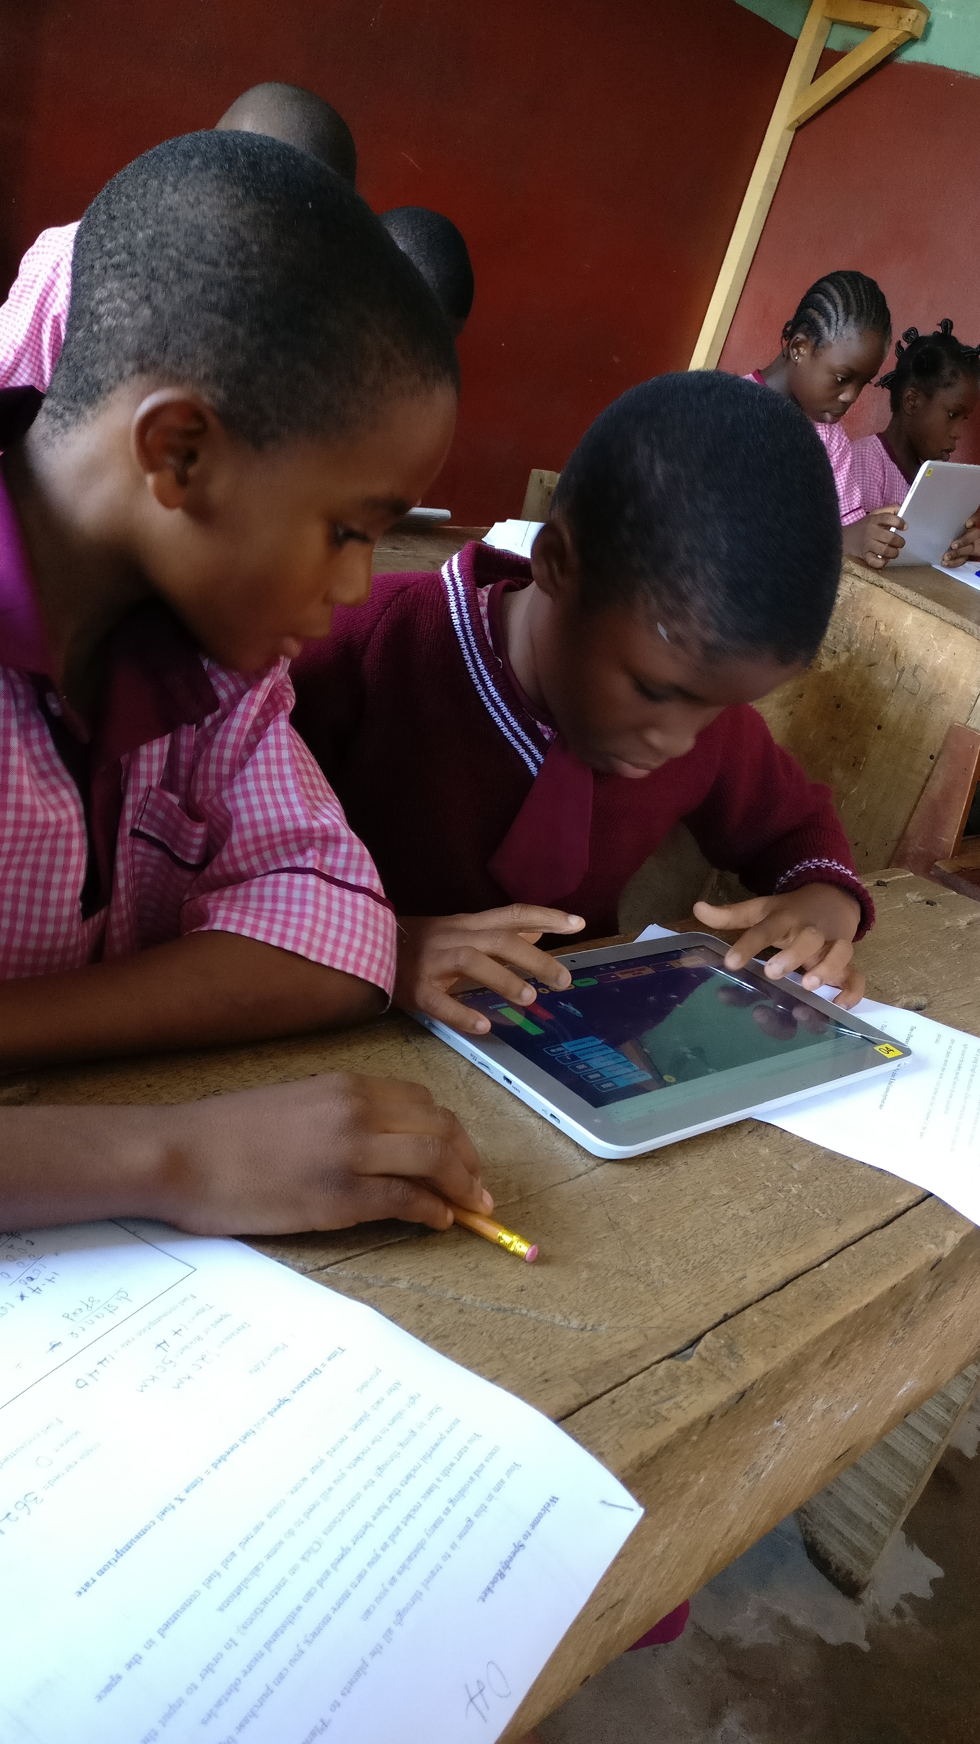
Fig. 1. Pupils playing SpeedyRocket in the classroom.

Using a combination of two data collection techniques: a questionnaire and an interview, the research team have explored the motivations of young people for playing casual games [51]. This provided information on how digital educational games could be made to be as fun and engaging as casual games. The responses of the young people involved in the research were examined for these motivations. The results showed that the following factors were viewed as important: clarity of goal; thematic appeal, visual appeal, rewards, feedback, social interaction; creativity; challenge; and immersion. These nine factors formed a game engagement framework.

Instruments

Diamond 9: SpeedyRocket was built using the set of game engagement factors identified above. Given the differences and stereotypes observed from the literature concerning the gaming industry and patterns of use by males and females, this study was keen to examine how young people ranked these factors by gender. In selecting a way to do this, consideration was given to an instrument that young people would find easy to use and be familiar with. The Diamond 9 is a classroom activity in which pupils are asked to rank concepts, statements, or images in a Diamond formation

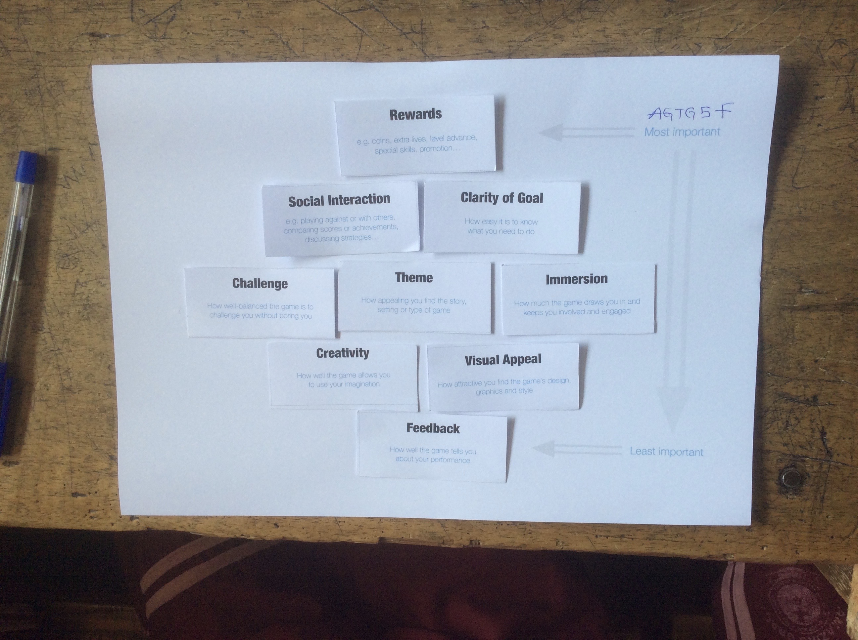
Fig. 2. Diamond 9 tool

[53]. It is a ranking tool commonly used in the classroom as a component of participatory research to explore an individual’s value positions, thoughts and feelings on a particular topic [54]. The tool is useful in examining the way individuals organise knowledge, describe their priorities and express their understanding of relationships amongst different concepts [55]. Each of the nine game engagement factors was printed on a card together with a short description of it. This was to ensure that the young people knew to what each factor was referring. The young people were then asked to rank each factor in a Diamond 9 format (see Figure 2).

SpeedyRocket: a digital educational mathematics game (Figure 3) was developed as part of the wider research project. It has some unique design requirements to ensure that it would be accepted by the teachers for use in their classrooms in Nigeria and that it would provide a good experience for the pupils. For the teachers, the authors drew guidance for the development of SpeedyRocket from their initial work on an extended Technology Acceptance Model (eTAM) [56] that sought to predict the acceptance or otherwise of digital educational games by teachers in the classroom. The main implications of the eTAM for the development of SpeedyRocket are highlighted below:

Usefulness: the usefulness of SpeedyRocket needed to be apparent to the teachers; the usefulness would be assessed by how well the game is linked to the curriculum and not just how fun it is. SpeedyRocket must therefore present educational gains to the players in such a way that teachers would not feel it is a waste of time and effort. The TAM also suggested that engagement and learning opportunities is a strong predictor of perceived usefulness.
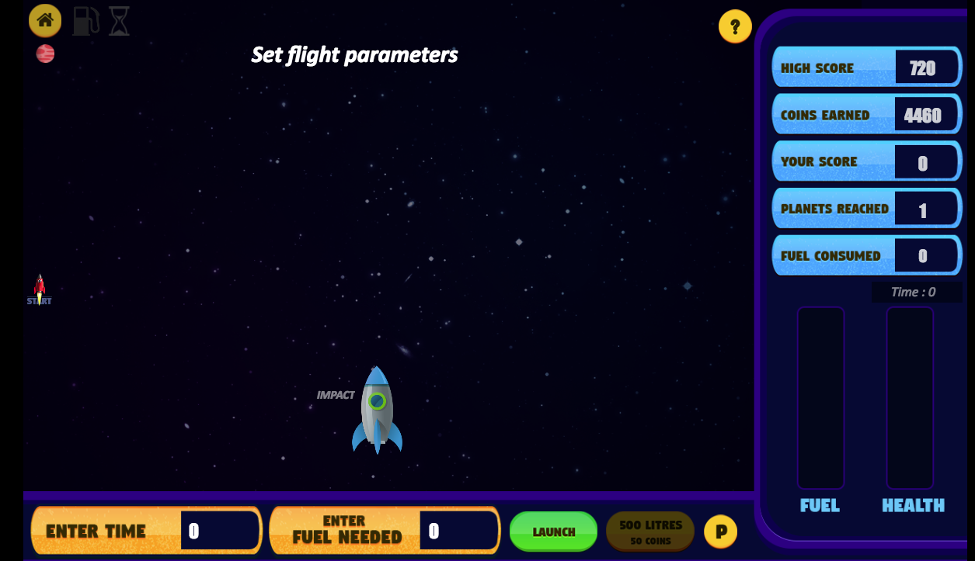
Fig. 3. SpeedyRocket

Ease of Use: To ensure ease of use of SpeedyRocket, the authors assumed a low level of self-efficacy and no experience for all the teachers. The requirement then was that SpeedyRocket must be straightforward, and not contain any unnecessary complexities that would require teachers spending a lot of time learning how to use it, and feeling overwhelmed when something goes wrong.

Enabling Environment: This is in respect to the time constraints, availability of devices, Internet and electricity, and the availability of support to deal with problems that may arise during gameplay. Many of the potential problems with enabling environment were addressed by the authors while considering the generic requirements for the development of SpeedyRocket. In addition and in order to address the concerns of the teachers about time constraints, SpeedyRocket would have to provide short playing sessions that can be completed within the time allocated for mathematics on the schools’ time tables.

To ensure that SpeedyRocket provided an engaging experience to the pupils, the authors built its design requirements around the factors of the game engagement framework:

Challenge: SpeedyRocket was designed to present seven levels of difficulty to the players. Following the recommendations of Denisova et al. [57] the challenges were designed to particularly push the problem solving capacities of the players. These were embedded in the seven different planets, players have to travel to. First, each new level/planet in SpeedyRocket presents more challenging arithmetic calculations for the player. Secondly, more obstacles are presented for their rockets to avoid as they journey to the destination.

Thematic and Visual Appeal: Two elements of this factor were built - the general look (visual appeal) and feel of the game and the game’s story (thematic appeal). The first step the authors took was to think about a story for SpeedyRocket. As established by the authors [51] engagement in games is sometimes due to players’ interests and personal preferences. This was a challenging one, as the game could not have been built to accommodate every player’s preferences but needed to be designed to be broadly appealing to this age range of children. After eliminating violent themes, and story lines that depicted sexualised female characters, the authors selected a balanced theme drawn on the back of a travelling story with the intention of appealing to both genders. The authors also spent some time thinking and reviewing the colours used in creating elements in the game. Research has shown that young people prefer bright and lively colours like yellow, blue and red as these are more interesting and stimulating [58]. The game was therefore themed blue and yellow. Although the authors wanted to incorporate avatars into the game, the time constraints as well as the limitations of the design platform did not allow this to be actually implemented. However, the “art and style” of the game was modeled in a way to mimic actual space, using dark skies, asteroids and stars. Sound effects that mirrored rocket travelling as well as collision sounds were added to provide the player with an experience that was as real as possible given the available tools.

Social Interaction: This factor was a challenging one for the authors. From the onset, the peculiarities of the research context posted some significant limitations of the features that could be built into SpeedyRocket. One of those is the lack of Internet access. Social interaction is one feature that is commonly built on network communications and the capability of the game to be played online. As these were not available in Nigeria, the authors decided to implement social interaction in how the game will be rolled out in the classroom using an open classroom combined with paper exercises/physical interaction between the children in the classroom

Rewards and Feedback: In order to make game players aware of their progress or otherwise while playing. Notifications and tips as well as rewards are all essential parts of a feedback system. In SpeedyRocket, as a player progresses in the game world, they earn coins on their way, while also avoiding obstacles. A scoring system for this reward was implemented, and the more coins the player earns, the more their score increases giving them a sense of accomplishment. This shows the amount of coins a player has earned, and what is left of it after making purchases of fuel or other rockets. Tips and information about formulas, and parameters were also embedded on the play area. Also, feedback on the progress of the player as they played is provided. This includes when the rocket is about to run out of fuel, or when the destination is being approached. There is also a map on the screen that gives an indication of how far the rocket is from the destination. All these were built in carefully to avoid disrupting the play.

Clarity of goal: This involves a description of what the game is about and what the player needs to do to achieve success. With digital educational games in particular, it should provide some information about the learning outcomes related to the work being done in the traditional classroom. Clear instructions are also important to maintaining overall clarity. They should not be cumbersome, confusing or contain other unnecessary information. With SpeedyRocket, an instruction tab was provided on the home screen. The goal of the game was made short and precise: “Navigate your rocket through space to reach its destination using the arrow keys!” It then goes further to provide more information on the input to the rocket. This simple goal was used to ensure that players know it is a game and not a ‘serious classroom activity’. However, more information was provided later that linked the gameplay to the educational value the game offers. The teachers were consulted to go over the instructions and comment on the choice of words and clarity to the pupils.

Creativity: This factor enables game players to be co-creators of the world they play in. In the adventure genre of games, avatars are mostly used to engender creativity. However, it is not only limited to that. Creativity can be presented in the form of allowing players to change the look of game assets and/or characters to depict their own preferences such as colour, look and feel, or names. In advanced games, it may include the provision for the player to extend functionalities or capabilities of the game. Although this is another key on-going engagement factor, design constraints meant that the authors were limited about how much creativity could be incorporated into the game. However, functionalities that enable players to customise the rocket by changing some elements of it including its shape, colour and name were included into the game design.

Immersion: Immersion is the ultimate experience of engagement. On the engagement framework, it describes expressions like “being lost in the game”, or “seeing one’ self in the game”. Given the way young people describe the way they feel, immersion unlike the other factors comes from playing the game on an ongoing basis for considerable periods of time [59]. In addition to this, going by the description of Jennett et al [60] there are three distinctive components of immersion: “lack of awareness of time, loss of awareness of the real world and involvement and a sense of being in the task environment”. Due to the time constraints in the classroom, the authors did not consider immersion a useful factor to include in the development of this game.

SpeedyRocket was developed using JavaScript, HTML5 and CSS, and can be supported by every browser that complies with the HTML5 standards. The researchers built the game around the mathematics concepts of fuel consumption, speed, distance and time (all in the curriculum for the period this research was carried out in the classroom). In this study, the game was played on Google Chrome. The development of the game went through 14 iterations (all versions available online at [61] with testing and evaluation carried out at each stage. The 14th version was used in this research study. In playing the game, participants were expected to navigate their way in space to reach their destination using the arrow keys. Before the rocket can launch, participants have to calculate the time and fuel values for flight based on the distance and rocket speed. Players should collect as many coins as they can to unlock other rockets with improved features, while avoiding obstacles that can destroy their rocket’s health. A 5% error is allowed for flight timings if values are higher or lower than the expected values. For example, if the expected flight time is 10 hours, then values between 9.5 and 10.5 hours are allowed.

The mathematical elements and formulas incorporated in the game are:
- Time = Distance/ Speed
- Fuel Needed = Time x Fuel Consumption Rate
Parameters of distance, speed and fuel consumption rate are supplied for each stage.

Some allowances for error are provided for the players with respect to calculations in the game, and a player’s rocket will still travel even if the calculations are wrong. However, not providing enough fuel means the rocket will not make it to its destination, and over-fueling it reduces the speed of the rocket, which also prevents it from getting to its destination. In order to create a good balance for the skills and challenge in SpeedyRocket, a player is first presented with very minor obstacles at slow speed, to get them used to dodging the obstacles quite easily and understanding the game environment. As they progress the game becomes increasingly complex, with more obstacles presented at faster speeds to ensure the player does not get bored.

Implementation of SpeedyRocket in the classroom
The study was conducted over 3 weeks in the second term of the schools’ 2016/2017 academic session in October 2016. School selection was done in February 2016 based on the ideal research site features described by [62] which include:
- Entry is possible
- There is a rich mix of the processes and people
- There is a possibility of building strong relations with the participants
- Ethical and political considerations are not overwhelming.
Consent forms were obtained from teachers prior to the week the study started; head teachers also signed the loco parentis consent forms. Diamond 9 activities were administered on the last day of the second week to participants, and the teachers’ focus group also took place on that day.

data analysis and results
This section focuses on the analysis and results from the ranking activity. Data from the Diamond 9 were collated and input into IBM SPSS Statistics 22 tool. The breakdown of the sample is presented below in Table 1. Frequency analysis was conducted for the collected data. The position of each word in the top two, middle and bottom three positions of the Diamond was tabulated, and a percentage appearance calculated.
- breakdown of sample
age | Frequency (%)
8 | 26
9 | 36 | gender | frequency
10 | 29 | Female | 53%
11 | 9 | Male | 47%

The results of the overall ranks in Table 2 show that young children’s motivation to play is consistent across gender. Females and males ranked rewards as the most important factor to them in the game although males ranked it higher than females. 77% of the males ranked rewards as one of the top three positions of the Diamond 9 while only 62% of females did the same thing. Apart from rewards, results show that young people ranked other factors differently. Both challenge and feedback appeared in the top three rankings for boys 46% while they appeared only 31% and 18% for females respectively. Thus two of the factors – rewards and challenge – were consistently ranked in the top three positions of the Diamond 9 across gender, although the percentages are higher for males.
- OVERALL ENGAGEMENT RANK
Overall rank for males | Overall rank for females
- Rewards | - Rewards
- Challenge | - Clarity of goal
- Feedback | - Social interaction
- Visual appeal | - Challenge
- Immersion | - Immersion
- Clarity of goal | - Visual appeal
- Creativity | - Thematic appeal
- Thematic appeal | - Creativity
- Social interaction | - Feedback

Results also show that females ranked clarity of goal higher on the Diamond 9 than males did. While clarity of goal appears in the top three positions 56% of the time for females, it appears only 31% of the time for males. Males (39%) also ranked Visual appeal in the top three more frequently than did females (26%). Creativity presented similar results to visual appeal. 31% of the males ranked it within the top three positions, while only 19% of the females did so.

Perhaps the most interesting results are on Social interaction and thematic appeal. While 31% of the females ranked Social interaction in one of the top three positions, none of the males did so. Frequency analysis shows that only 30% of the males included social interaction on the middle position, while 70% put it as the least important factor on engagement. Thematic appeal presented similar results. None of the males placed thematic appeal in the top three positions while 25% of the females did.

The Diamond 9 results show that while both genders are engaged by rewards and challenge, females were more likely to associate engagement with social interaction and clarity of goal while males appear to be more engaged by thematic appeal and feedback. These results are discussed in the following section.

discussion
Although research suggests that games can be intrinsically motivating [21], [23], [63]–[65], this has not been the case with many digital educational games, with players often reporting them as boring and not providing similarly engaging experiences as entertainment games [66]–[68]. One of the aims of this study was to see if a carefully designed game SpeedyRocket, based on an engagement framework and associated set of engagement factors, would generate interest and engagement amongst pupils playing the game. With SpeedyRocket, the researcher observed that both females and males enjoyed the game, although the Diamond 9 results show some differences in their motivations and by implication, their preferences within the game.

The results of this research indicate that males and females rank rewards as the most important engagement factor in the game. This suggests that young people irrespective of gender are motivated by rewards. The reward system in SpeedyRocket is based on coins that players need to pick up as they travel through space, enabling them to upgrade their rocket. This finding agrees with Ronimus et al.’s study of young people who played GraphoGame, a digital education game for reading [69]. The study argues that the reward system promoted engagement and encouraged the children to spend more time playing the game. However, even though males and females ranked rewards higher than other factors, a closer look at the numbers shows that males are more likely to rank rewards higher than females as shown by the relative percentages: 77% for males and 62% for females.

Furthermore, as the results indicate, one major difference that emerged from this research is the motivation of the young people to play the game. While males are motivated by the challenge the game presents and the desire to feel some achievement, females appear to be more motivated by clear and precise goals and the social interaction presented in the game. Research [70],[71] about females’ participation in STEM and how to improve it suggests that females generally like to know the goal of a task, the value it presents and the rationale behind committing to it. That submission agrees with the findings of this study. Females ranked clarity of goal in the game as the second most important factor towards engagement. Social interaction is the third most important factor by females. That suggests that the ability to build relationships and to interact with others within and outside of the game is a strong motivator for females to play digital games. Interestingly, social interaction is the factor that was ranked lowest by the male participants.

These findings suggest that males and females are likely to have different motivations for playing digital games, and also differ in their game engagement factors. The results suggest that by implication, females and males do prefer different styles of play. While males prefer to play games that are quite challenging and centred on achievement, competition and feedback, females are more interested in instructive games that provide clear aims and that allow them to interact socially and share their experience with others. It is therefore important for developers and educators to assess the digital educational games they are thinking of using in the classroom, to provide equal engagement opportunities to both males and females. However, it is not enough to just do this. The game industry needs to evolve and transform to an inclusive and diverse environment where consideration is given to creating games that are attractive to both females and males. This is particularly important in the design of digital educational games to improve the experience and engagement of females with STEM subjects. A conscious effort needs to be put into understanding the motivators and preferences of females in order to inform the design of games for learning so that the gender issues in entertainment gaming do not get passed on to digital educational games.

The findings reported in this paper are based on data from young people in one region of Nigeria who played educational games in their classroom. Although these findings provide an insight into gaming preferences of young people, the findings and implications should be interpreted with caution, as they may vary in other contexts. These findings are based primarily on self-reported data, and thus on what young people perceive to be the key engagement factors. This data may not reflect their actual preferences. Also, it is worthy of note that this work focused only on gender and not on other areas of equality and diversity such as ethnicity, disability and sexual orientation.

conclusion and future work
Digital games have the potential if designed correctly to be useful educational tools allowing a more inclusive and personalised journey. Inclusive digital educational game design is about designing with potential students in mind, taking into consideration their peculiarities and preferences. In building inclusive and gender-diverse games, careful planning is necessary to ensure they are free of gender stereotypes and sexism in story, content and characters among other factors. Whilst this should be the goal of every digital game development process, it is critical to consider this issue in designing digital games for education as these games usually need to appeal to a wide audience.

One area of future work would be to examine other aspects of diversity and inclusiveness such as ethnicity and disability with the engagement factors. It would also be interesting to explore these factors using qualitative tools in order to better understand the rationale behind the preferences and motivations of young people with respect to digital games.

References
[1] M. Barr, “Video games can develop graduate skills in higher education students: A randomised trial,” Comput. Educ., vol. 113, pp. 86–97, 2017.
[2] S. E. Siwek, “Video Games in the 21st century, Entertainment Software Association,” Tech. Rep, 2017.
[3] I. Granic, A. Lobel, and R. C. M. E. Engels, “The benefits of playing video games.,” Am. Psychol., vol. 69, no. 1, p. 66, 2014.
[4] R. Rosas et al., “Beyond Nintendo: design and assessment of educational video games for first and second grade students,” Comput. Educ., vol. 40, no. 1, pp. 71–94, 2003.
[5] C. A. Anderson, “An update on the effects of playing violent video games,” J. Adolesc., vol. 27, no. 1, pp. 113–122, 2004.
[6] T. Greitemeyer and D. O. Mügge, “Video games do affect social outcomes: A meta-analytic review of the effects of violent and prosocial video game play,” Personal. Soc. Psychol. Bull., vol. 40, no. 5, pp. 578–589, 2014.
[7] McDonald Emma, “The Global Games Market 2017 | Per Region &amp; Segment | Newzoo,” 2017. [Online]. Available: https://newzoo.com/insights/articles/the-global-games-market-will-reach-108-9-billion-in-2017-with-mobile-taking-42/. [Accessed: 01-May-2018].
[8] J. Fox and W. Y. Tang, “Women’s experiences with general and sexual harassment in online video games: Rumination, organizational responsiveness, withdrawal, and coping strategies,” New Media Soc., vol. 19, no. 8, pp. 1290–1307, 2017.
[9] M. Gilliam et al., “Alternate reality games as an informal learning tool for generating STEM engagement among underrepresented youth: A qualitative evaluation of the source,” J. Sci. Educ. Technol., vol. 26, no. 3, pp. 295–308, 2017.
[10] R. Greenaway and U. Terton, “Awakening Aspirations of Primary School Students: Where Will Your Dreams Take You?,” Int. J. High. Educ., vol. 6, no. 3, p. 116, 2017.
[11] L. F. Braghirolli, J. L. D. Ribeiro, A. D. Weise, and M. Pizzolato, “Benefits of educational games as an introductory activity in industrial engineering education,” Comput. Human Behav., vol. 58, pp. 315–324, 2016.
[12] O. Dele-Ajayi, R. Strachan, A. Pickard, and J. Sanderson, “Girls and science education: Exploring female interests towards learning with Serious Games: A study of KS3 girls in the North East of England,” in Proceedings of 2015 International Conference on Interactive Mobile Communication Technologies and Learning, IMCL 2015, 2015.
[13] R. Berta, F. Bellotti, E. van der Spek, and T. Winkler, “A tangible serious game approach to science, technology, engineering, and mathematics (STEM) education,” in Handbook of Digital Games and Entertainment Technologies, Springer, 2017, pp. 571–592.
[14] L. Freina, R. Bottino, L. Ferlino, and M. Tavella, “Training of Spatial Abilities with Digital Games: Impact on Mathematics Performance of Primary School Students,” in International Conference on Games and Learning Alliance, 2017, pp. 25–40.
[15] Y.-J. An and L. Cao, “The Effects of Game Design Experience on Teachers’ Attitudes and Perceptions regarding the Use of Digital Games in the Classroom,” TechTrends, vol. 61, no. 2, pp. 162–170, 2017.
[16] T. P. Falcão, F. M. de A. e Peres, D. C. S. de Morais, and G. da Silva Oliveira, “Participatory methodologies to promote student engagement in the development of educational digital games,” Comput. Educ., vol. 116, pp. 161–175, 2018.
[17] C. Patterson, M. Stephens, V. Chiang, A. M. Price, F. Work, and E. Snelgrove-Clarke, “The significance of personal learning environments (PLEs) in nursing education: Extending current conceptualizations,” Nurse Educ. Today, vol. 48, pp. 99–105, 2017.
[18] F. B. V. Benitti and L. Sommariva, “Evaluation of a game used to teach usability to undergraduate students in computer science,” J. Usability Stud., vol. 11, no. 1, pp. 21–39, 2015.
[19] N. S. Podolefsky, E. B. Moore, and K. K. Perkins, “Implicit scaffolding in interactive simulations: Design strategies to support multiple educational goals,” arXiv Prepr. arXiv1306.6544, 2013.
[20] V. Ramasundaram, S. Grunwald, A. Mangeot, N. B. Comerford, and C. M. Bliss, “Development of an environmental virtual field laboratory,” Comput. Educ., vol. 45, no. 1, pp. 21–34, 2005.
[21] S.-W. Chen, C.-H. Yang, K.-S. Huang, and S.-L. Fu, “Digital games for learning energy conservation: A study of impacts on motivation, attention, and learning outcomes,” Innov. Educ. Teach. Int., pp. 1–11, 2017.
[22] H.-Y. Sung, G.-J. Hwang, C.-J. Lin, and T.-W. Hong, “Experiencing the Analects of Confucius: An experiential game-based learning approach to promoting students’ motivation and conception of learning,” Comput. Educ., vol. 110, pp. 143–153, 2017.
[23] E. D. Mekler, F. Brühlmann, A. N. Tuch, and K. Opwis, “Towards understanding the effects of individual gamification elements on intrinsic motivation and performance,” Comput. Human Behav., vol. 71, pp. 525–534, 2017.
[24] J. Brusk, “Computer Game Development: Diversity and Inclusiveness,” 2016.
[25] S. Chess, N. J. Evans, and J. J. Baines, “What does a gamer look like? Video games, advertising, and diversity,” Telev. New Media, vol. 18, no. 1, pp. 37–57, 2017.
[26] K.-M. Lynn, C. Raphael, K. Olefsky, and C. M. Bachen, “Bridging the gender gap in computing: An integrative approach to content design for girls,” J. Educ. Comput. Res., vol. 28, no. 2, pp. 143–162, 2003.
[27] M. J. Mayo, “Video games: A route to large-scale STEM education?,” Science (80-. )., vol. 323, no. 5910, pp. 79–82, 2009.
[28] C. Campbell, “Game companies are failing on diversity, according to new report - Polygon,” 2018. [Online]. Available: https://www.polygon.com/2018/1/8/16855940/videogame-diversity-report-igda. [Accessed: 01-May-2018].
[29] National Centre for Education Statistics, “Digest of Education Statistics, 2015,” 08-Dec-2016. [Online]. Available: https://nces.ed.gov/pubsearch/pubsinfo.asp?pubid=2016014. [Accessed: 01-May-2018].
[30] U. K. Universities, “Patterns and trends in UK higher education 2017.” London: Universities UK. http://www. universitiesuk. ac. uk/facts-and-stats/data-and-analysis/Pages/patterns-and-trends-2017. aspx, 2017.
[31] S. Cheryan, A. Master, and A. N. Meltzoff, “Cultural stereotypes as gatekeepers: Increasing girls’ interest in computer science and engineering by diversifying stereotypes,” Front. Psychol., vol. 6, p. 49, 2015.
[32] R. Christensen, G. Knezek, T. T.-W.-C. in human behavior, and undefined 2014, “Student perceptions of Science, Technology, Engineering and Mathematics (STEM) content and careers,” Elsevier.
[33] T. Fullerton, J. Fron, C. Pearce, and J. Morie, “Getting girls into the game: Towards a ‘virtuous cycle,’” Beyond Barbie Mortal Kombat New Perspect. Gend. gaming, pp. 161–176, 2008.
[34] A. Shaw, Gaming at the edge: Sexuality and gender at the margins of gamer culture. Univ Of Minnesota Press, 2015.
[35] J. P. Gee, What video games have to teach us about learning and literacy. Macmillan, 2014.
[36] B. Paaßen, T. Morgenroth, and M. Stratemeyer, “What is a true gamer? The male gamer stereotype and the marginalization of women in video game culture,” Sex Roles, vol. 76, no. 7–8, pp. 421–435, 2017.
[37] D. Schultheiss, “‘From the Weaker Sex to Hardcore Gaming’: Female Gaming Patterns on the Internet,” Comput. Entertain., vol. 15, no. 2, p. 5, 2017.
[38] K. L. Gray, B. Buyukozturk, and Z. G. Hill, “Blurring the boundaries: Using Gamergate to examine ‘real’ and symbolic violence against women in contemporary gaming culture,” Sociol. Compass, vol. 11, no. 3, 2017.
[39] A. Marcotte, “Teen girls play video games, but they minimize their contact with other players. Boys, on the other hand, use games to socialize.,” 2015. [Online]. Available: http://www.slate.com/blogs/xx_factor/2015/08/18/teen_girls_play_video_games_but_they_minimize_their_contact_with_other_players.html [Accessed: 01-May-2018].
[40] H. Kiviranta, “Women as Video Game Consumers,” 2017.
[41] E. Behm-Morawitz, “Examining the intersection of race and gender in video game advertising,” J. Mark. Commun., vol. 23, no. 3, pp. 220–239, 2017.
[42] J. Jenson and S. De Castell, “Tipping points: Marginality, misogyny and videogames,” JCT, vol. 29, no. 2, p. 72, 2013.
[43] J. Bryce and J. Rutter, “Killing Like a Girl: Gendered Gaming and Girl Gamers’ Visibility.,” in CGDC Conf., 2002.
[44] T. Hartmann and C. Klimmt, “Gender and computer games: Exploring females’ dislikes,” J. Comput. Commun., vol. 11, no. 4, pp. 910–931, 2006.
[45] R. McGloin, K. M. Farrar, and J. Fishlock, “Triple whammy! Violent games and violent controllers: Investigating the use of realistic gun controllers on perceptions of realism, immersion, and outcome aggression,” J. Commun., vol. 65, no. 2, pp. 280–299, 2015.
[46] T. Hartmann, I. Möller, and C. Krause, “Factors underlying male and female use of violent video games,” New Media Soc., vol. 17, no. 11, pp. 1777–1794, 2015.
[47] D. Romrell, “Gender and gaming: A literature review,” in annual meeting of the AECT International Convention, Hyatt Regency Orange County, Anaheim, CA, 2014, pp. 11–22.
[48] R. Kowert, J. Breuer, … R. F.-65th annual convention of, and undefined 2015, “Women are from FarmVille, men are from ViceCity: The cycle of exclusion and sexism in video game content and culture,” researchgate.net.
[49] O. Dele-Ajayi, “How Can Digital Educational Games Be Used to Improve Engagement with Mathematics in the Classroom?,” PhD Thesis, 2018.
[50] R. N. Simons and K. R. Fleischmann, “The role of diversity in a video game design program,” Proc. Assoc. Inf. Sci. Technol., vol. 54, no. 1, pp. 800–801, 2017.
[51] O. Dele-Ajayi, J. Sanderson, R. Strachan, and A. Pickard, “Learning mathematics through serious games: An engagement framework,” in Proceedings - Frontiers in Education Conference, FIE, 2016, vol. 2016–Novem.
[52] L. P. Rieber, “Seriously considering play: Designing interactive learning environments based on the blending of microworlds, simulations, and games,” Educ. Technol. Res. Dev., vol. 44, no. 2, pp. 43–58, Jun. 1996.
[53] A. Padwick, O. Dele-Ajayi, C. Davenport, and R. Strachan, “Innovative methods for evaluating the science capital of young children,” in Proceedings - Frontiers in Education Conference, FIE, 2016, vol. 2016–Novem.
[54] R. Niemi, K. Kumpulainen, and L. Lipponen, “Pupils as active participants: Diamond ranking as a tool to investigate pupils’ experiences of classroom practices,” Eur. Educ. Res. J., vol. 14, no. 2, pp. 138–150, 2015.
[55] J. Clark, “Using diamond ranking as visual cues to engage young people in the research process,” Qual. Res. J., vol. 12, no. 2, pp. 222–237, 2012.
[56] O. Dele-Ajayi, R. Strachan, J. Sanderson, and A. Pickard, “A modified TAM for predicting acceptance of digital educational games by teachers,” in IEEE Global Engineering Education Conference, EDUCON, 2017.
[57] A. Denisova, C. Guckelsberger, and D. Zendle, “Challenge in digital games: Towards developing a measurement tool,” in Proceedings of the 2017 CHI Conference Extended Abstracts on Human Factors in Computing Systems, 2017, pp. 2511–2519.
[58] R. Pancare, “How Do Bright Colors Appeal to Kids?,” 2017. [Online]. Available: https://sciencing.com/do-bright-colors-appeal-kids-5476948.html. [Accessed: 15-Jul-2017].
[59] M. Cheng, Y. Lin, H. She, and P. Kuo, “Is immersion of any value? Whether, and to what extent, game immersion experience during serious gaming affects science learning,” Br. J. Educ. Technol., vol. 48, no. 2, pp. 246–263, 2017.
[60] C. Jennett, A. Cox, P. Cairns, S. Dhoparee, and A. Epps, “Measuring and defining the experience of immersion in games,” Int. J., 2008.
[61] O. Dele-Ajayi, “SpeedyRocket - A Digital Educational Mathematics Game,” 2016. [Online]. Available: http://www.ajayiopeyemi.com/research/speedyrocket/. [Accessed: 01-May-2018].
[62] G. Rossman and S. Rallis, Learning in the field: An introduction to qualitative research. 2011.
[63] M. V Birk, C. Atkins, J. T. Bowey, and R. L. Mandryk, “Fostering intrinsic motivation through avatar identification in digital games,” in Proceedings of the 2016 CHI Conference on Human Factors in Computing Systems, 2016, pp. 2982–2995.
[64] M. D. Hanus and J. Fox, “Assessing the effects of gamification in the classroom: A longitudinal study on intrinsic motivation, social comparison, satisfaction, effort, and academic performance,” Comput. Educ., vol. 80, pp. 152–161, 2015.
[65] J. O’Rourke, S. Main, and S. M. Hill, “Commercially available Digital Game Technology in the Classroom: Improving Automaticity in Mental-maths in Primary-aged Students.,” Aust. J. Teach. Educ., vol. 42, no. 10, p. 4, 2017.
[66] M. F. Young et al., “Our princess is in another castle: A review of trends in serious gaming for education,” Rev. Educ. Res., vol. 82, no. 1, pp. 61–89, 2012.
[67] C. Girard, J. Ecalle, and A. Magnan, “Serious games as new educational tools: how effective are they? A meta‐analysis of recent studies,” J. Comput. Assist. Learn., vol. 29, no. 3, pp. 207–219, 2013.
[68] A. Graesser, P. Chipman, F. Leeming, and S. Biedenbach, “Deep learning and emotion in serious games,” Serious games Mech., 2009.
[69] M. Ronimus, J. Kujala, A. Tolvanen, and H. Lyytinen, “Children’s engagement during digital game-based learning of reading: The effects of time, rewards, and challenge,” Comput. Educ., vol. 71, pp. 237–246, 2014.
[70] M. Levine, N. Serio, B. Radaram, S. Chaudhuri, and W. Talbert, “Addressing the STEM gender gap by designing and implementing an educational outreach chemistry camp for middle school girls,” J. Chem. Educ., vol. 92, no. 10, pp. 1639–1644, 2015.
[71] M.-T. Wang, J. Degol, and F. Ye, “Math achievement is important, but task values are critical, too: examining the intellectual and motivational factors leading to gender disparities in STEM careers,” Front. Psychol., vol. 6, p. 36, 2015.

