Researching Rural Housing: with an Artist in Residence

Menelaos Gkartzios¹ and Julie Crawshaw²

¹ Centre for Rural Economy, School of Natural and Environmental Sciences, Newcastle University, Newcastle upon Tyne, NE1 7RU, UK
² Department of Arts, Northumbria University, Newcastle upon Tyne, NE1 8ST, UK

Part of the Sociologia Ruralis Special Section ‘Doing Art in the Country’

Researching Rural Housing: with an Artist in Residence

Abstract
This paper presents a unique amalgam across artistic research and rural sociology. We draw on a collaborative art residence programme between a University and an arts organisation in England, which invited an artist to respond to a highly contentious topic in rural England: housing development. The ambition for the residency was, firstly, to provide new perspectives on rural housing research, and, secondly, to provide a space for engagement between the local community, planners and academics. Through our interdisciplinary collaboration, we explore how Sander Van Raemdonck’s artistic process worked towards these ambitions. The artistic practice involved a walk with the local community, a peripatos, in a post-industrial site proposed for housing development. Drawing on the artistic practice, the interdisciplinary team developed then a second walk, a ‘walkshop’, to mediate between housing/planning experts and reflect on the experience of the artistic practice. Following those artists and social scientists that already utilise walking as a method, we argue that the artistic peripatos can support a multi-sensory way of communicating, a way to get ‘under the skin of a place’. More critically, we argue that artists in residence programmes provide rich opportunity to develop interdisciplinary research with artists.

- Introduction

Although there is scant mention of artistic research in planning and development studies, the notion of art as research has taken hold within and beyond artistic disciplines (Sullivan, 2010). The visual, literary and performing arts are increasingly framed as modes of inquiry (Crawshaw, 2019), and this turn to research in the arts has nurtured interest from across social science disciplines including anthropology (e.g. Ingold, 2013) and human geography (e.g. Hawkins, 2013). In this paper we draw on such social science experiments with artistic practice, via a formal artist in residence programme in the North East of England. In particular we explore the opportunities that artistic practices might offer in rural housing and planning research. Therefore, in the context of a contested housing development, we ask what the artistic practice did. We see these opportunities not only in the context of offering new research questions and original conceptualisations of rural issues through the artistic practice, but also, in a wider context, mediating different forms of knowledge and providing epistemological insights for developing research projects in tandem with artists. We thus primarily aim, as afforded by the residency programme, to articulate the opportunity of artistic practice in social science research. Secondly, we offer insights on how the artistic practice might be utilised in planning consultation process.

The paper draws on an annual artist in residency which is offered for a period of 6 months between Newcastle University’s Centre for Rural Economy (CRE) and Berwick Visual Arts (BVA), a cultural organisation which is based in the town of Berwick-upon-Tweed in Northumberland. The region of Northumberland offers a unique context to attract artists interested in ‘socially engaged’ practice (i.e. work where artists focus more on working with people than making objects; see for example Bishop, 2012), due to the demise of its former industrial base, its large estates owned by the landed aristocracy and its varied but rugged landscapes (Murdoch et al., 2003). The countryside in Northumberland typified what Murdoch et al. (2003) termed as ‘the paternalistic countryside’ to describe rural areas with falling incomes, pressures to diversify economically, and where landowners hold the key to their development trajectories. In this insightful context for rural studies, the annual art residencies with the Centre for Rural Economy (starting in 2013) have aimed to provide new perspectives on rural social research, as well as an experimental space for engagement between the local community, artists and academics in line with the civic University ambition.

The birth of such artist in residence programmes is often attributed to the Artist Placement Group (APG) as conceived by Barbara Steveni in 1965 and established a year later by Steveni with John Latham and others. The Artist Placement Group is well known for their strategy of placing artists within organisations to work to an ‘open brief’. Following the ‘open brief’, artists were not required to produce tangible results during their placements (such as producing an artwork), as Steveni, Latham and others proposed that the engagement process itself produced benefits (http://www.ravenrow.org/exhibition/artist_placement_group/). Such programmes are now commonplace in urban contexts and increasingly in rural areas too: for example rural art residencies exist also in Kravín Rural Arts in the Czech Republic (http://kra.land/), Deveron Projects in Scotland (https://www.deveron-projects.com), Art Gene (http://www.art-gene.co.uk/) in Cumbria as well as in Allenheads Contemporary Arts (https://www.acart.org.uk/) and Visual Arts in Rural Communities (https://varc.org.uk/) both situated in Northumberland in England. Additionally, ‘Myvillages’ is an international artist initiative interested in the rural ‘as space for and of cultural production and the continuously evolving relationship between urban and rural practices, geographies and realities’ (http://www.myvillages.org/); ‘Art of the Rural’ is a US based organisation with a mission ‘to help build the field of the rural arts, create new narratives on rural culture and community, and contribute to the emerging rural arts and culture movement’ (http://artoftherural.org/). However, the collaboration between the academy (beyond art studies and fine art schools) and artists, as with the BVA-CRE residency programme, is relatively rare. This suggest that while these programmes are well discussed by artists and art professionals, there is little account of residency programmes in academic scholarship and little therefore that explores the research potential of residency programmes. Furthermore, the particular art residency programme between Berwick Visual Arts and the Centre for Rural Economy creates extra expectations in terms of who (and how) is meant to be ‘socially engaged’: the expectation here is not only with the communities of Berwick and wider Northumberland, but with academics too.

The ‘open brief’ in the 2016 residency drew on rural housing research, one of the most contested issues in England, linked with processes of counterurbanisation and gentrification, and resulting in characteristic inequalities in rural England well debated in rural sociological and planning research (Best and Shucksmith, 2006; Gkartzios and Ziebarth, 2016; Satsangi et al., 2016). This paper makes an original contribution by exploring how the artistic practice developed by the artist Sander Van Raemdonck during his placement in 2016 contributed to rural housing research. The paper is structured as follows: the next section reviews the literature on research with and of art. The methodology is then presented, before our results which focus on two walks: one developed by the artist, and one by the interdisciplinary team. The experimental nature of our paper is evidenced in the way that the methodology was not devised prior to Sander’s appointment; the methodology was developed with Sander, and was ‘in the making’ during the art residency.

- Beyond Creativity: Research with Art

In this paper we refer to contemporary art practice more specifically focused on engaging people than making ‘physical’ work, in line with the expectation of an art residency: that the artist will engage with communities of interest and/or geography. These practices are variously termed ‘new genre’ (Lacy, 1995), ‘participatory’ or ‘socially-engaged’ (Bishop, 2012).
Studies of art and creativity are increasingly common in rural social research. There are still, however, very few studies in the rural field that engage with art studies literature or recognise art as a mode of research itself. As Tim Ingold suggests, art can be understood as a mode of inquiry, reawakening our senses ‘to allow knowledge to grow from the inside in the unfolding of life’ (2013: 08). Inspired by Ingold and building from our previous work (Crawshaw, 2019; Crawshaw, 2018; Crawshaw and Gkartzios, 2016) this paper draws on experimental fieldwork developed with the artist in residence, Sander Van Raemdonck, who positions his practice within the inquiry process.
Questions of creativity are now commonplace in rural research and rural policy making, following debates in urban studies, which seek to apply ideas associated with the ‘creative city’ and art-led urban regeneration in rural contexts (see a review also by Bell and Jayne, 2010). Original conceptualisations of these ideas (Florida, 2002; Landry, 2001) largely ignored or dismissed ‘the rural’, adding to the parochial construction of rurality characterised sometimes as a cultural ‘rural cringe’ (Bell and Jayne, 2010) or not considered as part of the ‘new creative economy’ which is privileged in urban and major metropolitan areas (Rantisi et al., 2006). In reviewing this bias, Scott et al. (2018: 175-176) recently reported how idyllic views of the countryside ‘can engender a view of rural cultural life as inherently conservative or ‘middle of the road’, in direct contrast with the buzz of the creative city’.
However, even Florida (2018) recently acknowledged the creative claims of rural areas, following empirical evidence internationally (e.g. Waitt and Gibson, 2013). Woods for example (forthcoming) proposed three ways to consider creativity in rural areas. First, as part of a strategy for economic diversification by exploring cultural heritage and cultural influences in the locality; secondly, through promoting cultural entrepreneurship particularly in crafts, design and music and providing opportunities for young people to stay in rural areas; and, thirdly, through practices of art, literature, performance, poetry and story-telling as a means to understand the community and the changes they are experiencing.
Parallel to these developments in academic literature (see also a recent review by Argent, 2018), in rural policy discourse in the UK, art has been frequently promoted as a tool for creating jobs, attracting visitors and supporting rural businesses (e.g. Arts Council England, 2005). Formal policy statements make a specific commitment to support arts and culture in rural communities (e.g. Arts Council England, 2016), given that rural areas demonstrate greater engagement with art, although funding for creative practices remains more limited compared to urban areas (Arts Council England, 2015).
Much of the research has been on arts-based development, and how art and creativity might support economic growth, rural entrepreneurship, new networks and positive community transformations in support of sustainability (see also Balfour et al., 2016, Mahon et al., 2018). Sometimes this is contextualised within the context of Ray’s (2001) ‘cultural economy’ to highlight local distinctive resources (inclusive of visual arts, drama and crafts) as part of territorial development strategies that put art and culture at the heart of the development process. Herslund (2012) highlights opportunities for regional economies from artists and wider creative industries; however, Argent et al. (2013) argue that although creative workers are attracted to rural scenic locations (see also Markusen, 2006), their contribution to local employment and local business is of little influence.
More recently, the research has focused on wider community transformations beyond economic development (see Anwar McHenry et al., 2017). Gibson (2010: 8) for example has argued that deeper and more nuanced studies of creativity may reveal ‘the communitarian purposes to which creativity can be put’ beyond a profit-maximising activity for economic growth. In this context the research has highlighted opportunities for creating a sense of belonging (Waitt and Gibson, 2013) providing opportunities for social interaction critical for the wellbeing of rural communities (Anwar McHenry, 2011), and solving community problems (Markusen, 2006). Roberts and Townsend (2016) interview rural creatives (inclusive of artists) and argue that their formal and informal practices are associated with a series of effects including capacity building, economic diversification, demographic revival, improved sense of place and community identity. Scott et al. (2018) found that artistic practice in the context of two rural arts organisations can contribute to wellbeing and development, at least through employing Nussbaum’s Central Human Capabilities framework.
Something almost universal with this research in social sciences is how art and artists are positioned as objects of study, rather than a mode of inquiry – although scholarly explorations of the artistic practice can be found in the context of engaging communities (see for example Cowie, 2017). In our previous research (Crawshaw and Gkartzios, 2016, 2018) we set out to explore the role of artistic interventions in relation to Ruth Liepin’s framework of community. We started out as researchers of art, but ended up highlighting the potential of research with art by suggesting that the role of art can be understood as a ‘relational diagnostic’ or a mode of inquiry itself. So following from here, what if rural research is undertaken with artists? In the mode of understanding artistic practice as research, in this paper we offer a different approach: by doing research with an artist. Our approach therefore, is inherently interdisciplinary, which also addresses the focus of this special section on art in the countryside.

- Methodology ‘in the making’

In the rural region of Northumberland, Berwick-upon-Tweed is a regional town on the English-Scottish border. The town is known for its residency programmes, especially the International Berwick Gymnasium residencies (1993-2011), which supported international artists to live and work in the town. Since 2013, Berwick Visual Arts (BVA) continues to host residency programmes, including a six-month annual residency developed and hosted in partnership with Newcastle University’s Centre for Rural Economy (CRE), a University research centre committed to interdisciplinary rural social research (www.ncl.ac.uk/cre/). The programme is funded by Arts Council England and artists are selected by an interview panel consisting of art professionals and CRE academics.

As influenced by the Artist Placement Group, whilst ‘in residence’ in Berwick, artists of any discipline are invited to develop work to an ‘open brief’ in response to a broad research theme. In 2016 the theme was ‘Making Homes, Making Rural’, as shaped by Menelaos Gkartzios and James Lowther (Head of Visual Art, Berwick Visual Arts). Belgian artist, sculptor and printmaker, Sander Van Raemdonck was selected, and additional funds were raised from the Newcastle Institute for Social Renewal (NISR) to support Julie Crawshaw (then independent researcher) to develop ethnographic fieldwork with Sander, and together explore his response to the research theme. In exploring the contribution of Sander’s work to the research concerns of CRE, this paper is developed from a research collaboration – between the two authors with Sander Van Raemdonck and James Lowther.

Rather than positioning the artist in isolation, the specific artist in residency requires the artist to engage with their residency context – although we recognise that not all art residencies are expected to be ‘socially engaged’. For example in their original submission responding to the ‘open brief’ artists need to reflect on how they might engage with a community of interest as well as with the academics. In this paper we explore the potential of the artist in residency programme in support of rural planning research and practice. The idea of the artist as a researcher is common in art studies (e.g. Sullivan, 2010; see also the Journal of Artistic Research), but not often discussed as such in rural sociological studies. For example, for doctoral artistic research it is the exhibition, recital, performance (or other form of creative work) that constitutes the major research component, supported by written work that provides a discussion of the context, the methodological approach and findings. This constitutes a new paradigm of research (as opposed to social science methods and social science doctoral theses) that is ‘performative’ in character (Bolt, 2016: 131). As suggested by Boutet (2013: 30), this research paradigm ‘is not a thinking process where we find answers to questions, but rather where one contemplates and experiences situations, themes or feeling complexes’; in this regard, as following Dewey, the ‘data’ (in the sense of social science) is in and of the experience (Crawshaw and Gkartzios, 2016). As such, our interdisciplinary methodological approach was not fixed by research norms in advance of working with Sander, but was informed by the performative mode of his ‘artistic research’. This led to interactions between multiple forms of knowledge (Healey, 2008: 63) across artistic practice and social science methodologies.

In line with the residency theme of ‘Making Homes, Making Rural’, the fieldwork was informed by pragmatism, and the phenomenological pragmatism of John Dewey (1859-1952) in particular. A founding principle of classical pragmatism is to understand the world as ‘in the making’ (James, 1910); as a continuous process of co-constitution between humans, other beings, and the environment. Dewey particularly stresses that ‘developing knowledge of the world and acting in the world [are] all part of the same process of learning and discovering through experience’ (Healey, 2009: 280); and that the art experience provides particular opportunities for coming to know. In fact according to Dewey, the art experience is not about the final product; rather, the work takes place ‘when a human being cooperates with the product so that the outcome is an experience’ (1934: 223). We draw on Dewey's understanding of art as a process of doing or making, and we take this further to explore art as a process of researching (doing research) on rural housing. In our particular context, as discussed in the following sections, the artistic practice is the performative practice of walking.

- Rural housing research: with Sander Van Raemdonck

  - From ‘open brief’ to walking

The residency’s theme was informed by a long tradition of rural housing research in Britain. Rural housing frames one of the most political and debated issues of rural Britain consisting of inter-related issues such as: prolonged counterurbanisation and gentrification processes, limited housing supply (both private and social housing units) in the rural context due to a planning system hostile to housing development in rural areas, characterised by limited social housing supply in the rural context, NIMBY phenomena regarding new housing development, and resulting in housing affordability in the countryside and rural towns (Rural Housing Policy Review, 2015; Satsangi et al., 2010; Guardian, 2015). As an artist, and as somebody who has never lived in Britain, Sander (Van Raemdonck) was not familiar with the themes and issues of this scholarship; and this would be the first time he would be engaged in academic research. So how to start this research with Sander?

Menelaos (Gkartzios) first discussed some rural housing issues (based on selective English case studies in academic papers and the British press) with Sander, and Sander joined monthly research meetings at CRE and shared his work and ideas with rural social scientists. From here Sander’s first thought was that the way the research would work would be that he would ‘make material’ and the researchers (Gkartzios and Crawshaw) would ‘do the research’. After reflecting on this statement, however, Sander began to question the duality of his assumption: ‘[because] research of this kind doesn’t work that way’. So, how does this research work? As directed by this question, the paper is structured to explore how this research worked: as being designed with Sander’s walking practice to produce two walking events that resulted in engaging planning professionals in the role of art in planning practice. In doing so we also draw attention to the residency as being a ‘space’ that afforded this research collaboration.

The ethnographic process, undertaken by Julie (Crawshaw), began with discussing Sander’s practice and plans for the residency period and the possibilities of developing a collaborative project. As following his working process, Sander suggested these meetings should take the form of walks. From here Julie and Sander met on three occasions for around four hours walking through and around Berwick, which included visits to his studio.

During the residency, Sander developed two strands of work: firstly through walking, and secondly through making sculptures, graphic design and installation, eventually exhibited with Berwick Visual Arts (2015). There is much to explore around Sander’s sculptural work. In this paper, however, we focus on how his walking practice shaped our research project. To convey beginning to walk from here, we borrow from Ingold and Vergunst (2008: 3):

‘The first steps we take are tentative, even experimentaFl, and time passes slowly as we attempt them […]. It is only after quite a few steps, when the feet have found their rhythm and the body its momentum that we discover – without being aware of any moment of commencement – that we are already walking’.

Planning processes are oriented around dis-embodied objects (Abram, 2011: 39) in the sense that plans-in-use are largely disconnected from our experience as bodies-in-environment. Walking, of course, is bodily. Maybe then by walking, perhaps we can introduce bodies to planning? As following our reading of Dewey, for Ingold and Vergunst (2008: 5) ‘the movement of walking itself is a way of knowing’ (our emphasis). As for Dewey ‘developing knowledge of the world and acting in the world are all part of the same process of learning and discovering through experience’ (Healey, 2009: 280). From here we reject a ‘spectator view of knowledge’, and make a commitment to the notion of the body as ‘living organism’ – acting in the world (Crawshaw, 2017: 6). By doing so, we become aware of our body with and in the landscape. We notice the epidermis – not as a rigid border, but a crossing between things ‘outside’ the skin and ‘within’ it (Sullivan, 2001:13). In Deweyan vein, we recognise the way inner human materials (such as thoughts, feelings and emotions) are exchanged with outer physical materials (paint, rock, water, sun) (Dewey, 1934). So, from here we can argue that ‘this kind’ of research that we want to do is ‘bodily’: this research, as well as the co-production of knowledge are experienced; they are ‘in the making’, they are in the walking.

Walking (or peripatos in Greek) as a way of relating and experiencing the world, is not a new method of knowledge acquisition in either social sciences (e.g. Aoki and Yoshimizu, 2015) or art practice. In fact, many contemporary artists have incorporated walking strategies in their practices, as explored in ‘ROAM’ (Pink et al., 2010) and celebrated in the ‘Walk On’ collaborative exhibition which reflected on 40 years of art walking (Art Editions North, 2013):
“Artists walk in multitude of ways and different settings. Some trace their daily movements, sometimes aided by GPS devices, and others narrate, record, follow, photograph, make, paint, draw, drift, walk, guided by the wind or navigating in the dark; all devising extraordinary ways to record, annotate and translate their walks into art objects or experiences” (Morrison-Bell, Forward in Arts Editions North, 2013).
Two of the most prominent artists who have utilised walking in their work include Richard Long (www.richardlong.org) and Janet Cardiff (www.cardiffmiller.com). To offer routes towards corporeal ways of knowing, the ROAM walking art weekend in 2008 invited seven artist and artists-groups (namely: Active Ingredient, Claire Blundell Jones, Duncan Speakman, Tim Brennan, Mark Gwynne Jones, Lottie Child, and Tamara Ashley and Simone Kenyon) to develop a series of walking events in which participants wandered, hiked, shuffled and stalked across the town of Loughborough in the East Midlands, ‘seeing, hearing and feeling it in new ways’ (Pink et al., 2010: 01). Further examples of artists who walk in their work include: Katrina Palmer who created walking tours with audio commentary (‘The Loss Adjusters’) in her work at Portland Island in England (The Observer, 2015); poet Sarah Corbett and visual artist Zoe Benbow, who used a spring walk in the village of Grasmere in Cumbria in the footsteps of Dorothy Wordsworth as an inspiration of their collaborative work ‘Dorothy’s Colour’ (Lancaster University, 2017); and Andrew Kötting’s documentary film ‘Edith Walks’ which was inspired by a walk, ‘a journey by foot’ in memory of Edith Swan Neck, the first wife of King Harold (Observer, 2017).

The term peripatos that we use interchangeably in this paper, draws on the name of Aristotle’s school in Athens, because the main location for teaching was a covered walkway in the Lyceum (for the Peripatic School see Sharples, 1999). The peripatic tradition has been explored in humanities (see for example see Wallace, 1993; Solnit, 2001), and has offered a bodily experience for social scientists, particularly in ethnographic studies, to immerse themselves in particular places. For example Anderson (2004: 258) in employing walking in his research observed that:
“It was thus a form of bodily movement, that in ‘outgoing’ to the environment, new as well as old inscriptions of meaning could be created and, more interestingly for research, recounted.”
Of course, embodied methodologies have been explored in rural studies, particularly amongst feminist scholars involving interviews, ethnographies and focus groups using also sometimes visual and creative approaches (see an example and associated literature in Rodriguez Castro, 2018). However, the embeddedness of artistic practice as a method of doing research with social science described in this paper, has not been given much attention outside art studies.

  - The case study

Aside the ‘open brief’ requiring a response on rural housing, there was no other intervention as regards the mode of artistic response to the theme of ‘making homes, making rural’. Whilst walking to get familiar with Berwick, Sander talks to Julie of his interest in Spittal Point, a site in the small town of Spittal, just across the river from Berwick-upon-Tweed. As stated in the Design and Access Statement (2008: 3-4):
“Covering 3.7 hectares Spittal Point lies in a very prominent position on the southern bank of the River Tweed at the meeting of the river and the North Sea. It incorporates a mix of land use, mostly low-grade industrial and storage uses such as car body workshops and residential, predominantly terraced housing.”

The particular site, which offered a case study for this paper, has a long history of industrial and fishing-related industry, and this is reflected in the character of some of the buildings; there are also vacant sites that give the area a run-down appearance. A prominent chimney remains in the area formerly occupied by industrial buildings, and provides a distinctive landmark when viewed from many angles within Spittal, Tweedmouth and Berwick-upon-Tweed (Figure 1). In relation to the development of Spittal Point, the Design and Access Statement includes an Illustrative Masterplan with proposed terrace housing, refurbishment of existing buildings and a larger parking court; but these plans have not yet materialised. In 2012 some indication is given for the impasse, such as (Berwick Advertiser, 2012): opposition to the housing as ‘not appropriate’; risk of flooding to the car park area; and disagreement about the chimney being kept.

Insert Figure 1 somewhere here

In approaching the case study, Sander wrote to the land owner:

‘As I managed to find my way around town, I walked along this peculiar cleared out industrial site at Spittal Point. Initially I didn’t have a clue of what former industry had taken place at the site, why the site was cleared out and why a tall brick chimney was still standing. Since I was determined to find out, I undertook a survey to learn more about it. And eventually I discovered that the area is awaiting a future development but only progresses slowly in the direction of a renewed quarter. After some further digging I found out that you are the owner of the site […].

Not that I’m looking for a position in the process of development and actual building. I am attracted to the formal aspects of the debate (if we could speak of a debate) that is taking place at a very slow pace, and in a vaguely public atmosphere. As an artist I work with imagery to facilitate communication [our emphasis] and the exchange of ideas and concepts quite intensively, and I’m surprised that this kind of imagination hasn’t popped up in abundance when it comes to Spittal Point and its regeneration. I strongly believe that there could be a lively interaction among the many stakeholders of the site that would enable the constructive discussion, leading to a successful development’. (Van Raemdonck, 2015th, December 18th).

The letter was unable to be delivered as the addressee had ‘gone away’; but it helpfully outlines the way the resident artist understands his role as ‘facilitating communication’. In project documentation Sander writes that from here he continued to develop a ‘strong interest’ in the site and its ‘background story’. He researched available documents, spoke to local officials and attended neighbourhood planning consultations events. His strategy to facilitate communication developed into Guide the Guide.

  - Guide the guide

The first artistic practice developed by Sander was Guide the Guide (Van Raemdonck, 2016), a structured peripatos with invited residents in and around the chosen site of Spittal Point – ‘a call for participation’ in the words of Sander. Sander distributed invitations across Berwick for people to assemble at a car park at 2pm on March 12th 2016. Around 20 people attended, comprising residents and visitors as well as Menelaos, Julie and James and another academic from CRE. The peripatos lasted for more than 2 hours. Sander carried un umbrella throughout the event – like a guide. As discussed earlier, Guide the Guide follows the footsteps of artists using walking strategies (similarly to ethnographic disciplines). As the artist acknowledged, he was not particularly thinking of a methodology, data or ways to capture information (at least in the ways social scientists do): Guide the Guide was a strategy to meet the local community and together explore the site under investigation, ‘a provocation of informal knowledge of the participants’ (in his own words).

Sander gave everyone a ‘map’ with 22 images on it (Figure 2) and a list of their names which he referred to as ‘stops’ on the tour. The map constituted a mosaic of visually significant (i.e. the chimney) and insignificant (i.e. a corner, a street mast, a bench) planned stops. It included stops in warehouses and old buildings. Sander planted questions in every stop, inviting the community to share experiences, memories and ideas about the site. Afterwards he told us that his intention ‘wasn’t about telling everyone about what it was that he knew; but having it as an exercise to enable other people to talk’.

Insert Figure 2 somewhere here

At each stop, other people did talk (Figure 3). The event was photographed using a body warn camera with a wide angled lens, and the two researchers kept field notes. Departing from Sander’s script of open ended questions that acted as ‘triggers’, people talked about:
- how the chimney is a point of tension, equally loved and loathed, and whether it should been preserved, demolished or transformed into something else;
- the history of the site (i.e. landownership) and memories of an industry (fishing-related) now gone;
- the types of housing development that have been built in the area (e.g. some apartments have been built nearby) and the need to leave some space open, for the view: not to 'over-develop';
- the style of housing they would like to see in the area.

Insert Figure 3 somewhere here

In line with other artists using walking strategies such as those involved in ROAM (Pink et al., 2010) and others mentioned earlier, Guide the Guide was developed as a way for participants to experience the Spittal area of Berwick afresh. In his letter to the landowner, Sander introduces his role as one of ‘facilitating communication’. By thinking with Dewey we can consider Guide the Guide as a way to ‘common with’, to communicate; to fashion things in common. And, in the words of Anderson (2004: 259), ‘to access the relationship between people, place and time’. After considering ROAM, Pink et al. (2010) conclude their paper by asking whether walking practices (as utilised by artists and social scientists) can have ‘policy impact?’ (2010: 6). In the following section we aim to explore what might have been impact of the artistic intervention in planning the development of Spittal Point.

  - Walkshop

As inspired by Guide the Guide, from here the research team developed a second peripatos, rehearsing the walk developed by Sander – but this time with a different audience. We called this a ‘walkshop’ to highlight that it was a bodily acted workshop: through walking, as developed from Sander’s artistic practice. Our ambition was to ‘facilitate communication’ between planning professionals and academics, utilising the same ‘map’ as the previous group of participants (community members, visitors and academics). Our point was not to create a separation between the ‘local residents’ and the ‘experts’ – but to openly reflect on the qualities of Sander’s practice though particular knowledges, i.e. planning and art (Figure 4). It is this shift, from Guide the Guide to the ‘walkshop’, where Sander’s artistic strategy morphed into methodology. What we managed to do with the ‘walkshop’ was to meld artistic and social science methodologies, as afforded by the residency programme.

Insert Figure 4 somewhere here

When considering the particularity of artistic research, Bolt suggests art has a performative force that generates capacity to effect ‘movement’ in thought, word and deed in the individual and social sensorium (2016: 130). She suggests that this ‘performative paradigm’ operates according to repetition with difference (Bolt, 2010: 132). In this vein we repeat the walk - with a difference; in that the participants are changed to specifically include professional participants. Drawing on performance studies, Bolt suggests that the performative does not describe anything; it rather ’does things in the world’ (Bolt, 2010: 133). So, how can this collaborative walkshop do things in the world? What art does? How can our work together influence planning practice and policy?

The ‘walkshop’ was attended by the research team, plus: Peter, a planning officer at the Northumberland County Council; Annette, a building conservation officer also with the Northumberland County Council; Sally, a visiting artist who had come to find out and write about Sander’s work; and, Gabriel, an architect and academic who had developed a student project in Berwick-upon-Tweed a few years earlier. Being in the actual development site, walking and talking about Sander’s tour and the potential development of the site allowed us ‘to overcome traditional interviewer/interviewee power relations to forge something uniquely collaborative’ (Anderson, 2004: 258). In the following transcripts we follow some of the discussion taking place at the development site amongst participants. Sander first introduced us to the site and his ‘triggers’, which again constituted:
Sander: […] Just ideas on the table. It makes you wonder how this will be part of a new residential area.

Site diagnosis

First, the ‘walkshop’ revealed the value of understanding the site and its heritage by simply being there, than looking at (dis-embodied) plans. Participants talk about the site, its heritage, the noise and smells of the past. The diagnosis of the site is not simply verbal, but take place though bodily transaction:

Sander: I thought it would be interesting to stop [i.e. stop 3] here because it shows what is left of the actual industry. This shows for me that it is very hard to say what is the original industrial building, what they were like. This is the kind of warehouse buildings that have changed through time and there isn’t a consensus of something that needs to be designed elaborately. And there was this visitor that said they really liked it and thought it should be preserved as well. So it depends on what is appealing.

Peter: there aren’t very many brick buildings around here. So maybe you can see it as a utilitarian but significant building. I am warming to it! There are some aerial photographs from the 1930s that show a density too. And you don’t get a sense of that now. It has become a kind of non place.

Annette: and also the activity, the sheer number of people and the comings and goings. So when we were doing the character appraisal with Tweedmouth, people were saying they missed the sounds and the noise and the rhythm of life that industrial processes bring. And they want to see the docks used again because of that.

Peter: but it must have been horribly smelly.

Annette: it is interesting because when you do these type of consultations it is the sensory things that people convey to you. And smells often come up. That is what they describe to you.

Peter: there is a wider conversation to take place which is to do with the town’s relationship with the river. It has lost the strong maritime function, in terms of importing material. It has lost the salmon netting. And there is a desire to introduce more visitor activity and there have been a number of studies about mariners, and the sailing club is a potential partner. But the physical nature of the estuary and the way the river moves and the biodiversity mix, makes that incredibly difficult. In many respects Annette and I have had countless arguments with a lot of people, about whether it is appropriate to develop the quayside or whether it is appropriate to develop Spittal Point. In terms of it actually being a way to reconnect the town with the river instead of sitting as an empty space. Because this is an empty space.

Annette: It was a hive of activity, the comings and goings, the noise and activity. It is now sterile, as far as I am concerned.

Planning process

Furthermore, there was discussion about how the planning system ‘works’. Sander attended neighbourhood drop-in sessions and saw the consultation process which is criticised by almost everybody in the group. It is here that art practice is sometimes presented as an alternative to this consultation process:

Peter [to Sander]: I don’t understand how you felt about the neighbourhood plan drop in sessions. This notion that we will do what people tell us they want doing seems to be to be crazy. Because you cannot create a plan or vision with everyone’s… Someone has got to sit down and say this is where we are going to start. And this is the problem with this town. There is no leadership of that kind.

Sander: first of all it was very difficult being a neutral observer in these sessions. Some people already know me a bit and know what I am doing, so that was a bit difficult. It was not really the most efficient way of consultation. And the first session I witnessed was alright I think. But then the second session here in Spittal, I noticed that the presence of council men [officials] was really an obstruction. Because [of] … their non-verbal language and just because of [the fact that] they were there as a team.
…
Peter: People have a notion that someone will make development happen. Whereas that is not the reality. The reality is that it requires someone with a vision to drive development forward. Now, that may not be everyone’s choice. But is that better than just the sterile spaces becoming accidentally car parks? It is about language and understanding.
…
Peter: the conundrum in all of this is that, if you think about the outcome of a plan which might be a 20 year vision, we are not going to be around to see the outcome, but the people who will be affected and impacted are usually disenfranchised from that conversation because they are young.
…
Sally: But people get fed up of being asked [i.e. about development].

Annette: Exactly. But there was so much in that [i.e. consultation].

Sally: they don’t want to get engaged because they have been asked before, and before.

Peter: and that is our fault. Because we often suck up stuff like a sponge, and we will squeeze a little bit out of it, but there is never a kind of re-engagement and explanation about why some of that stuff has been squeezed out.
…
Annette: I assume [i.e. mistakenly] that people can read plans. But people can’t read plans and they can’t visualise. Whereas if you show an art project or through writing, poetry or film … ‘Oh, that’s when we had the fishing industry’. And their little stories. That narrative, that story-telling, but to actually look to the future that is not there, and what does that look like and what is it.

Knowledge

Finally the group did reflect on issues of knowledge, and how art might be mediating across different forms of knowledge – and, critically, how this knowledge exchange is different when it is performed in the open environment.

Peter: I don’t think that as a profession at the moment we have the skills to look and speak and say why something works or doesn’t. If you read development management reports that go to communities they are dry. It is a template.

Peter: because it is looking back and projecting that language forward. It is the only language you can use. What I was going to say is one of the things that could actually start to change that is in the learning institutions, and if you can start to build that; train planners to be more equipped to actually do their job in the future than the current cohort. I am damning them all. They are not all like that. But some of them are scared to actually properly explore space and buildings and art.

Menelaos: But maybe that is the problem. That we are teaching how to become an expert through a very particular language. We are not teaching how to become a non-expert, and how that can become a part of a professional asset, that you don’t understand everything.

Julie: and if you are an expert you own knowledge like it is a thing; whereas you are talking about making new ways of understanding places, which is not about cutting and pasting knowledge, it is a completely different perspective of a practice of getting to know.

Peter: it will always be subjective. Writing policy to the ‘n’th degree will always be a shame. Prescribed by what a development plan says. But the exercise of that subjective opinion, which is always a professional opinion and not a personal opinion. There will always be someone else who has a different subjective view of things and it is trying to negotiate the issue of subjectivity and that is where the language is of critical importance.

Annette: a bit of a leap of faith too. I do think it is interesting that your practice is all about walking. And now we are outside and walking, and we are having a different sort of conversation and it is good as us as a group doing that. Conversations are different when you have them in the environment.

You cannot just parachute in to a place, you need to get under the skin.

  - This kind of research

‘So, how does this research work?’ – we asked earlier. What these extracts from the ‘walkshop’ reveal are the following. First, the potential of the walk as art practice, in the words of Annette, to get ‘under the skin’ of a place. To get a sense of its history, its smells, its past and future potential, and to share these experiences in a sensorial way, as revealed both in Guide the Guide and the ‘walkshop’. In previous works we have argued how artistic practice offers a relational diagnostic of places (Crawshaw and Gkartzios, 2016) – a way to ‘read’ a community ‘in the making’ in support of enhanced and continuously transformative governance arrangements. Particularly in Guide the Guide we see this diagnostic opportunity again, a community experiences a place on its own terms, at its own pace, communicates and ‘commons with’: ‘To communicate with people is then to common with them in the participatory process of living together’ (Ingold, 2016, p. 15). The community walks, and the walk ‘makes’ a community.

Moving on from the relational diagnostic value of the walking practice, by engaging with planning and housing professionals, the walkshop reveals the potential of Sander’s intervention to do research about the development of Spittal Point. By engaging professionals in the mode created by and with Sander, we observe the quality of the artistic peripatos to construct new ‘bodily’ knowledge on planning across different agents. In our case, the extracts presented above highlight some of the problems of formal planning consultation processes (e.g. the ‘usual suspects’ taking part; young people being disassociated from such conversations; the intimidating presence of council men; the technical and exclusionary language of planning expertise). Cowie (2017: 401) describes this as “the dreaded ‘community consultation’ process” and much work in planning has highlighted deficiencies in consultation techniques in the era of collaborative planning (e.g. Cunningham et al., 2003; Shipley and Utz, 2012). What the walkshop conversations suggest is that the walking practice offered a new embodied language, a way of communicating across disciplines (inclusive of art) – and thus offering new imaginations for the use of art practices in planning processes. The heritage officer acknowledged ‘conversations are different when you have them in the environment’, when you walk out there. As Anderson (2004) observes:
“This practice of talking whilst walking is also useful at it produces not a conventional interrogative encounter, but a collage of collaboration: an unstructured dialogue where all actors participate in a conventional, geographical and informational pathway creation. As a consequence, the knowledge produced is importantly different: atmospheres, emotions, reflections and beliefs can be accessed, as well intellects, rationales and ideologies”.

Conclusion

This research is developed as ‘tandem’. That is, the project is designed to support art practice and social science to work alongside each other. So, as following Sander’s own reflection, the research is not designated to the social sciences alone, but positions artistic practice as a mode of inquiry in itself – as recognised across the fields of art and increasingly in social sciences too (Crawshaw, 2019). Describing the development of our ‘tandem’ methodology – as arising from Sander’s performative walking practice is our primary contribution. Our exploration demonstrates how artistic practice was morphed into methodology, from a strategy of communication to a method of doing research; how artistic performance (the walk) became a mode of inquiry itself, a method. Obviously, a social scientist could come up with a similar strategy of communication. However, the key point of our paper is to acknowledge that the work of artists can also be understood as a mode of research. What is innovative here is the way we expanded from what was initiated by Sander as an artwork (with performative aspects) into an interview with planning experts themselves – and as such we have melded artistic and social science disciplines, as afforded by the residency programme.

The immediate legacy of this research resulted in an invitation from Peter (Rutherford) and Annette (Reeves) for Sander to contribute to a two-day event called ‘New Ways of Seeing: Creating Pathways for Confident Market Towns’ for planners and heritage professionals (chaired by Julie) on 19th and 20th of October 2016. At the event Sander introduced Guide the Guide and also presented his sculptural work. From the research outlined in this paper and this subsequent professional event, Peter and Annette’s interest in the role of artistic practice in the rural planning context led to the development of a funded PhD with Northumbria University’s Department of Arts to explore artistic practice in the planning context of Berwick upon Tweed.

In addition to the abovementioned contribution, we have explored what the artistic peripatos might suggest for planning and housing policy itself. In this context we argue that the artistic practice has offered a way to ‘facilitate communication’ (in the words of the artist) as with the expectation of a formal planning consultation process (see also Cowie, 2017). Mediating different forms of knowledge was evidenced both in Guide the Guide where residents demonstrated a sensorial understanding of the development site, and also in the peripatos with the professionals where these exchanges acknowledged the inclusiveness of the peripatos compared to formal consultations processes.

Maurstad (2010: 39) reminds us that the common term ‘sea legs’ refers to balance: as our bodies’ response to handling the movements of the sea. Following from Berwick’s fishing heritage, we suggest that to ‘make homes, to make the rural’ requires bodies and some sort of balance. We argue here that the artistic peripatos, as experienced both in the Guide the Guide tour and the interdisciplinary walkshop, offered this balance, mediating knowledge with the community, with the environment (i.e. the development site) and with housing experts. We thus see walking as a multi-sensory way of communicating different knowledges; a way to ‘get under the skin’ of a place, in our case a site earmarked for housing development. We acknowledge of course that Sander has not introduced walking to rural sociology, but that the stops and starts of Guide the Guide offered punctuation that reminded us (in the walkshop) that conversation about development is not simply verbal. Our empirical material show how Sander’s walking intervention positioned the actual space of development at the centre of the discussion; how movement allowed a more nuanced understanding of the development site, compared at least to static planning meetings in fixed settings designed for ‘consultation’; and how critical reflection occurred regarding the process of knowledge exchange at these meetings.

We also observe that the artist did not pick up high political issues described in academic literature or the national press, when these were offered to the artist to unpack on his own terms. This is not uncommon with resident artists, who engage in unintended activities than high policy concerns (Rösler, 2015). However, the artist still created a physical and symbolic space for experimental research as well as for community reflection regarding a particular development. In the context of this experience, we too propose art residency programmes between cultural organisations and research institutes as fruitful opportunities for collaborations with exploring how to move forward with developing interdisciplinary inquiries. Like in our previous work, we also observe that the artistic practice has diagnostic qualities (of places, of communities, of knowledges). This is in the context of offering new and relational perspectives of places (in line with the ‘mobility turn’), but it does not necessarily suggest that art residencies can solve community problems or answer research questions - at least in the way these are conceptualised in academic and policy fora. The idea of a manual, a guideline on the parameters of this collaboration between artists and social scientists is not the purpose of this paper – neither do we believe that such a task would be beneficial per se. A good starting point is to acknowledge the different forms of knowledge across artistic research and social sciences. In our particular case, we observe that the residency’s ‘open brief’, which was purposely ambiguous, was helpful to stir a sensorial diagnosis about the development site, but more critically, to devise a new way of doing research.

Acknowledgements
This paper results from a collaboration between the authors with Sander Van Raemdonck and James Lowther. We are grateful for the permission to use materials from the ‘walkshop’ by the additional participants: Sally Lemsford, Annette Reeves, Peter Rutherford and Gabriel Tang. The fieldwork was supported by Arts Council England (for the art residence) and Newcastle Institute for Social Renewal (for the ethnographic fieldwork). Many thanks to the two reviewers and Bettina Bock for their constructive comments and to the community of Berwick for embracing our resident artists all these years.

References

Anderson, J. (2004) Talking while walking: a geographical archaeology of knowledge. Area, 36 (3) pp. 254-261
Anwar McHenry, J. (2011) Rural empowerment through the arts: the role of the arts and social participation in the Mid West region of Western Australia. Journal of Rural Studies 11 pp. 245-253
Anwar-McHenry, J., A. Carmichael and M.P. McHenry (2018) The social impact of a regional community contemporary dance program in rural and remote Western Australia. Journal of Rural Studies. doi: 10.1016/j.jrurstud.2017.06.011.
Aoki, J. and A. Yoshimizu (2015) Walking Histories, Un/making Places: Walking Tours as Ethnography of Place. Space and Culture 18 (3) pp. 273-284
Argent, N. (2018) Rural geography III: Marketing, mobilities, measurement and metanarratives. Progress in Human Geography. doi: 10.1177/0309132518778220
Argent, N., M. Tonts, R. Jones and J. Holmes (2013) A creativity-led rural renaissance? Amenity-led migration, the creative turn and the uneven development of rural Australia. Applied Geography 44 pp. 88-98
Arts Council England (2005) Arts in Rural England: Why Arts are at the Heart of Rural Life. Available at: http://webarchive.nationalarchives.gov.uk/20160204123524/http://www.artscouncil.org.uk/advice-and-guidance/browse-advice-and-guidance/arts-in-rural-england-why-the-arts-are-at-the-heart-of-rural-life
Arts Council England (2015) Rural Evidence and Data Review. Analysis of Arts Council England Investment, Arts and Cultural Participation and Audiences. Available at:
https://www.artscouncil.org.uk/sites/default/files/download-file/Rural_evidence_and_data_review_0.pdf
Arts Council England (2016) The Arts Council and communities living in rural England – a position statement. Available at:
https://www.artscouncil.org.uk/sites/default/files/download-file/Position_statement-The_Arts_Council_and_communities_living_in_rural_England_April_14.pdf
Arts Editions North (2013) Walk On. From Richard Long to Janet Cardiff. 40 Years of Art Walking (Manchester: Cornerhouse Publications)
Balfour, B., M.W.P. Fortunato and T.R. Alter (2016) The creative fire: An interactional framework for rural arts-based development. Journal of Rural Studies doi: https://doi.org/10.1016/j.jrurstud.2016.11.002
Bell, D. and M. Jayne (2010) The creative countryside: policy and practice in the UK rural cultural economy. Journal of Rural Studies 26 pp. 209-218
Berwick Advertiser (2002), Long Awaited Plans for Spittal Point Get All Clear’ (Saturday 10th March, 2012).
Berwick Visual Arts, 2015. Inclosure: Sander Van Raemdonck (23rd April – 5th June, 2015). Available at: http://www.berwickvisualarts.co.uk/whats-on/96/inclosure-sander-van-raemdonck
Best, R. and M. Shucksmith (2006) Homes for Rural Communities: Report of the Joseph Rowntree Foundation Rural Housing Policy Forum. (York: JRF)
Bishop, C. (2012) Artificial Hells (London: Verso)
Bolt, B. (2016) Artistic Research: A performative paradigm? PARSE Journal 3 pp. 129-142
Boutet, D. (2016) Metaphors of the Mind: Art Forms as Modes of Thinking and Ways of Being. In E. Barrett and B. Bolt eds., Carnal Knowledge: Towards a ‘New Materialism’ through the Arts (London, New York: I. B. Tauris)
Bowman, J.E. (2013) Esther Shalev-Gerz: the Contemporary Art of Trusting Uncertainties and Unfolding Dialogues (Gothenburg: Art and Theory Publishing)
Crawshaw, J. (2019) Art as Rural Planning Inquiry. In M. Scott, N. Gallent and M. Gkartzios eds., Routledge Companion of Rural Planning (London: Routledge)
Crawshaw, J. (2018) Island Making: Planning Artistic Collaboration. Landscape Research 43 (2) pp. 211-221
Crawshaw, J. and M. Gkartzios (2016) Getting to know the island: Artistic experiments in rural community development. Journal of Rural Studies 43 pp. 134-144
Crawshaw, J. and M. Gkartzios (2018) The Way Art Works: Insights for Community Development. Pp.177-192 in S. Kenny, B. McGrath and R. Phillips eds., The Routledge Handbook of Community Development: Perspectives from Around the Globe (New York: Routledge)
Cowie, P. (2017) Performing planning: understanding community participation in planning through theatre. Town Planning Review 88 (4) pp. 401-421
Cunningham, C.J., M.A. Jones and M. Dillon (2003) Children and Urban Regional Planning: Participation in the Public Consultation Process through Story Writing. Children’s Geographies, (1) 2 201–221
Design and Access Statement: Spittal Point, Berwick upon Tweed (2008) Royal Carlton Estates Ltd
Dewey, J. (1931/1963) Philosophy and civilization. Pp. 249–276 in J.J. McDermott ed., The philosophy of John Dewey (Chicago, IL: The University of Chicago Press)
Dewey, J. (1934) Art as Experience (New York: Perigree)
Florida, R. (2002) The Rise of the Creative Class (New York: Basic Book)
Florida, R. (2018) The Rise of the Rural Creative Class. Available at: https://www.citylab.com/life/2018/05/the-rise-of-the-rural-creative-class/559319/
Gibson, C. (2010) Guest Editorial – creative geographies: tales from the ‘margins’. Australian Geographer 41(1) pp. 1-10
Gkartzios, M. and A. Ziebarth (2016) Housing: A Lens to Rural Inequalities. Pp.495-508 in M. Shucksmith and D. Brown ed., International Handbook of Rural Studies. London: Routledge)
The Guardian, 2015. Affordable rural housing under threat, by Peter Hetherington Available at:
https://www.theguardian.com/society/2015/jan/13/affordable-rural-housing-new-threat
Hawkins, H. (2013) For Creative Geographies (London: Routledge)
Healey, P. (2008) Knowledge flows, spatial strategy making, and the roles of academics. Environment and Planning C 26 pp. 861–881
Herslund, L. (2012) The rural creative class: counterurbanisation and entrepreneurship in the Danish countryside. Sociologia Ruralis 52 pp. 235-255
Ingold, T. (2013) Making: Anthropology Archaeology, Art and Architecture (London and New York: Routledge).
Ingold, T. and J.L. Vergunst (2008) Ways of walking: Ethnography and practice on foot (Burlington, VT: Ashgate)
James, W. (1910) Pragmatism (Seaside: Watchmaker Publishing)
Kitagawa, F. (2015) Art Place Japan: The Echigo-Tsumari Triennale and the Vision to Reconnect Art and Nature (Princeton Architectural Press)
Lacy, S. (1995) Mapping the Terrain: New Genre Public Art (Washington, DC: Bay Press)
Lancaster University (2017) ‘Dorothy’s Colour’ on track at Lancaster University. Available at: http://www.lancaster.ac.uk/news/articles/2017/dorothys-colour/
Landry, C. (2001) The Creative City (London: Earthscan/Comedia)
Mahon, M., B. McGrath, L. Ó Laoire and P. Collins (2018) Artists as workers in the rural; precarious livelihoods, sustaining rural futures. Journal of Rural Studies doi: https://doi.org/10.1016/j.jrurstud.2018.04.001
Markusen, A. (2006) An arts-based state rural development policy. Journal of Regional Analysis and Policy 36 pp. 47-49
Mibourne, P. and L. Kitchen (2014) Rural mobilities: connecting movement and fixity in rural places. Journal of Rural Studies 34 pp. 326–336
Murdoch, J. P. Lowe, N. Ward, T. Marsden (2003) The Differentiated Countryside (London: Routledge)
The Observer, 25/6/2017, Edith Walks review – a walk on the wild side, by Wendy Ide. Available at:
https://www.theguardian.com/film/2017/jun/25/edith-walks-review
The Observer, 26/4/2015, Katrina Palmer: the artist who has mined a rich seam of nothingness, by Miranda Sawyer. Available at:
https://www.theguardian.com/artanddesign/2015/apr/26/katrina-palmer-artist-mined-nothingness-artangel-open
Pink, S. (2007) Walking with video. Visual Studies 22 (3) pp. 240-252
Pink. S., P. Hubbard, M. O’Neill and A. Radley (2010) Walking across disciplines: from ethnography to arts practice. Visual Studies 25 (1) pp. 1-7
Rantisi, N., D. Leslie and S. Christopherson (2006) Guest editorial. Placing the creative economy: scale, politics, and the material. Environment and Planning A 38 pp. 1789-1797
Ray, C. (2001) Culture economies: a perspective on local rural development in Europe. Centre for Rural Economy, Newcastle University. Available at:
http://www.ncl.ac.uk/media/wwwnclacuk/centreforruraleconomy/files/culture-economy.pdf
Roberts, E. and L. Townsend (2016) The contribution of the creative economy to the resilience of rural communities: exploring cultural and digital capital. Sociologia Ruralis 56 (2) pp. 197-219
Rodriguez Castro, L. (2018) The Embodied Countryside: Methodological Reflections in Place. Sociologia Ruralis 58 (2) pp. 293-311
Rösler, B. (2015) The case of Asialink’s arts residency program: towards a critical cosmopolitan approach to cultural diplomacy. International Journal of Cultural Policy 21 (4) pp. 463-477
Rural Housing Policy Review, 2015. Affordable Housing. A Fair Deal for Rural Communities. Available at:
http://www.acre.org.uk/cms/resources/afairdealforruralcommunitiesmainreport3-1.pdf
Satsangi, M., N. Gallent and M. Bevan (2010) The rural housing question: communities and planning in Britain’s countrysides (Bristol: Policy Press).
Scott, K., F. Rowe and V. Pollock (2018) Creating the good life? A wellbeing perspective on cultural value in rural development. Journal of Rural Studies 59 (1) pp. 173-182
Sharples, R.W. (1999) The Peripatic School. In D.J. Furley ed., Routledge History of Philosophy, vol II, From Aristotle to Augustine (London: Routledge)
Shipley, R. and S. Utz (2012) Making it Count: A Review of the Value and Techniques for Public Consultation. Journal of Planning Literature 27 (1) pp. 22-42
Solnit, R. (2001) Wanderlust: A History of Walking (Penguin Books)
Sullivan, S. (2001) Living Across and Through Skins: Transactional Bodies, Pragmatism and Feminism (Bloomington: Indiana University Press)
Van Raemdonck, S. (2016) Guide the Guide (Berwick upon Tweed, 12 March 2016).
Waitt, G and Gibson, C. (2013) The Spiral Gallery: non-market creativity and belonging in an Australia country town. Journal of Rural Studies 30 pp. 75-85
Wallace, A. (1993) Walking, literature and English culture (Oxford: Clarendon)
Woods, M. (forthcoming) Creative ruralities. Journal of Arts and Communities.

Figure 1: The chimney at Spittal Point. Photo: MG, 2016.
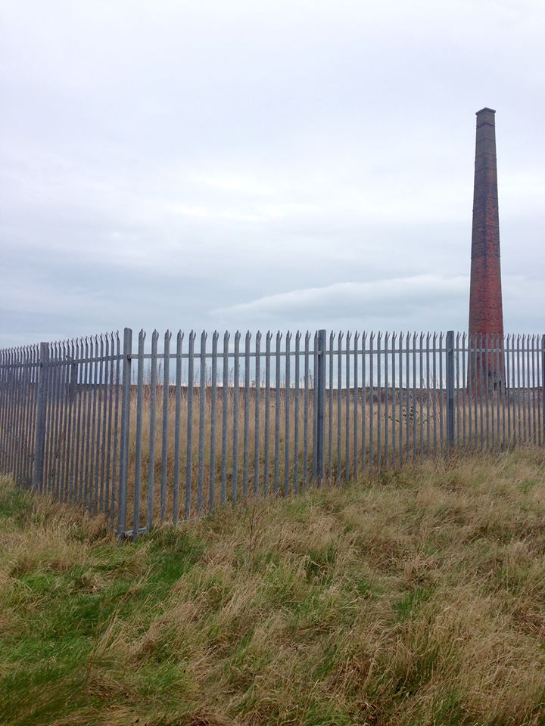

Figure 2: Guide the Guide map, by Sander Van Raemdonck, 2016.
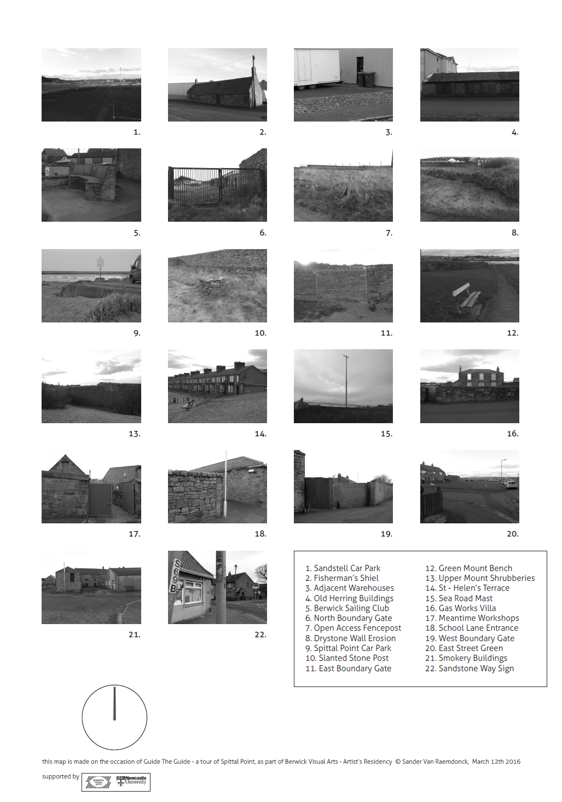

Figure 3: Guide the Guide (documentation of the performance). Photo: JC, 2016.
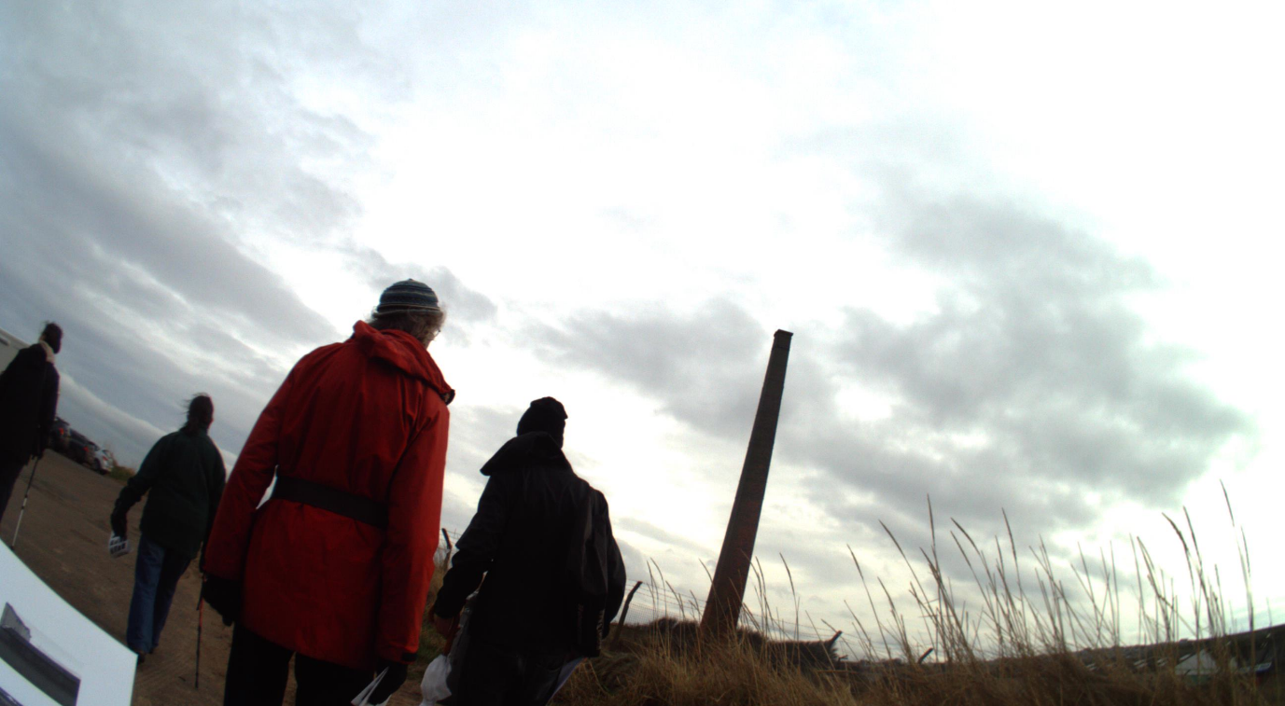

Figure 4: Walkshop (documentation). Photo: JC, 2016.
