Do red objects enhance sexual attractiveness? No evidence from two large replications

|  |
| --- |
| Thomas V. Pollet1,2, Joanne Costello1, Lotte Groeneboom1, Leonard S. Peperkoorn3, & Junhui Wu4 |
|  |
| 1 Leiden University |
| 2 Northumbria University |
| 3 Vrije Universiteit Amsterdam |
| 4 Beijing Normal University |
| 29/10/2018 |

Author note

Thomas V. Pollet, Department of Psychology, Northumbria University, Newcastle upon Tyne, UK (current) and Dept. of Social and Organizational Psychology, Leiden University, the Netherlands. Lotte Groeneboom & Joanne Costello, Department of Social and Organizational Psychology, Leiden University, the Netherlands. Leonard S. Peperkoorn, Department of Experimental and Applied Psychology, Vrije Universiteit Amsterdam, the Netherlands. Junhui Wu, Institute of Developmental Psychology, Beijing Normal University, China.

Correspondence concerning this article should be addressed to Thomas V. Pollet, NB 165, Northumberland Building, College Lane, NE18ST, Newcastle upon Tyne. E-mail: [thomas.pollet@northumbria.ac.uk](mailto:thomas.pollet@northumbria.ac.uk)

***\*\*This is a pre-print of a paper in press at Displays at https://doi.org/10.1016/j.displa.2018.10.008, there might be minor discrepancies between this preprint and published paper cite at your own risk.\*\****

Abstract

Color has been argued to exert a powerful effect on motivation and behavior. This has led researchers, most notably in social psychology, to examine the effects of color on perceptions of (sexual) attractiveness**.** Building on a body of work on the ‘romantic red effect’, Lin (2014) found evidence that the color of a laptop influenced ratings of a woman’s sexual attractiveness. If this holds true, then color effects could have profound importance for the marketing of consumer products such as laptops. Here we present two replications, one in the Netherlands and one in China, investigating whether red products increase perceived attractiveness. Across two studies, totaling 481 participants, we found no support for the claim that red products enhance sexual attractiveness. We discuss the implications for research on color and attractiveness and its implications for consumer research.

*Keywords:* Product marketing; Color; Perception; Colored products; Attractiveness; Red effect

Do red objects enhance sexual attractiveness? No evidence from two large replications

1. **Introduction**

Colors have been argued to influence a broad range of moods, cognitions, and behaviors (e.g., [1–3]). This also makes colors relevant and perhaps even an ideal tool for marketing and consumer science (e.g., [4–7]). One particular way in which marketeers could sway consumers is via biasing consumers’ perceptions, particularly through advertisements associating attractive and high-status models with the focal product [8]. In recent years, researchers, predominantly in social and evolutionary psychology, have tested whether color cues may indeed affect people’s perceptions of, and in particular their attraction to, the opposite sex [9–16]. This suggests that color could be used to influence perceptions of consumer products via their associations with attractiveness of the product holder. The leading framework for interpreting such color effects is color-in-context theory [10], which we briefly review next.

* 1. *Color-in-context theory*

To effectively study the influence of the color red on consumer choice, we must understand how color can carry different meanings in different contexts. Elliot and Maier [10] proposed color-in-context theory as an overarching theoretical account (also see [17,18]). It provides an explanatory framework for how color may affect human psychological functioning in the domains of affect (feelings and emotions), cognition (mental processing and perceptions), and behavior (approach or avoidance behavior). The theory consists of six core premises. First, color carries meaning. Beyond simple aesthetics, color is a visual stimulus that can convey meaningful information. For example, the color red is used on road signs to convey a universal message of warning [19]. Second, color can influence our evaluative processes and determine whether we tend to avoid or approach a stimulus contingent on the contextual significance of that color. For instance, during academic tasks, students from Western [20] and Eastern [21] countries are more likely to avoid red stimuli as social learning has taught them it represents failure. However, this effect reverses among Chinese stockbrokers because red represents a rise in stock value [22]. Third, color meanings are automatic and occur beyond our conscious awareness. In the example above, the students may not be consciously aware that the presence of red elicited an avoidance motivation and subsequently distracted them from their cognitive task. Fourth, color meanings, and their subsequent consequences on individuals’ responses, have two sources of origin: biological (evolved) and learned (classical conditioning). These sources are not mutually exclusive. For example, both black and red have been argued to act as a mediator in males’ perceptions of female attractiveness: black represents fashionableness (social learning) and red represents sexual receptivity (biological basis and social learning) [23]. Fifth, relations between color perception, affect, cognition, and behavior are reciprocal: one’s psychological state may in turn influence color perception [24]. Lastly, color meanings are determined by their contextual surroundings. Visual features, such as texture, motion, and shape, can elicit different approach motivations. For example, the texture might determine that a substance is strawberry jelly rather than blood, which in turn influences an individual’s motivations to taste it. Support for color-in-context theory has been found across a variety of domains and contexts (e.g., [2,25]). For example, Mentzel and colleagues found that words relating to dominance were processed faster and with fewer errors when presented in red as opposed to other colors [26]. Color-in-context theory provides a framework for social psychologists and has been key in studying the effects of color in various domains, including romantic attraction. Specifically, it has led researchers to argue that the color red influences perceptions of (sexual) attractiveness in men viewing women [9] and women viewing men [27].

* 1. *Support for color-in-context theory’s prediction of the romantic red effect*

Multiple studies have corroborated the romantic red effect (e.g., [23,28–30], reviews in [18,31]). In one of their early studies, Elliot and colleagues tested the romantic red effect on men viewing women and found that a woman pictured against a red background, as opposed to white, grey, and green, was rated as significantly more attractive and more sexually desirable [9]. Building on this, across seven experiments, Elliot and colleagues found that red, as opposed to white, grey, green, and blue, enhanced perceptions of attractiveness and sexual attractiveness in women viewing men [27]. Such effects have also been found by other research groups. For example, in a study on online dating, women wearing red in their profile picture received significantly more contacts from men than women wearing a different color [32]. In addition, although women presented in front of a red background received higher ratings on (sexual) attractiveness from men, this effect was not found when women rated these pictures of women [9]. Roberts and colleagues found male targets wearing red or black were rated as more attractive by either sex compared to the same targets wearing other colors [16]. Female targets wearing red or black were typically rated as more attractive by males. Moreover, targets who were initially photographed wearing red but later digitally altered to, for instance, a white shirt, were still perceived as more attractive than targets who wore white on the original photo. This therefore also suggested a wearer-effect whereby the model may behave differently depending on the clothing color. However, several studies have failed to find support for the romantic red effect [33–36]. Most notably, Peperkoorn and colleagues found no support for the romantic red effect across three studies totaling over 800 men [37]. In light of broader debates (e.g., [38–41]), it is therefore worthwhile to replicate published studies such as Lin’s [42] in order to assess how robust color effects are across independent labs.

* 1. *Replications of Lin (2014)*

In this paper, we present two replications of a study by Lin [42]. Informed by color-in-context theory, Lin examined the effect of a woman carrying a red laptop (in contrast to black, silver, and blue) on perceived attractiveness. In the first experiment, Lin recruited 80 male participants. These participants were randomly divided into four groups, each consisting of 20 participants. A picture of a woman carrying either a red, blue, silver, or black laptop was shown to each group. After looking at the picture, all participants were asked to fill out a questionnaire with the following questions: (1) How much does the woman in the photo attract you? (2) How strong is her sex appeal? (3) How strong is your desire to engage in sexual activity with her? (4) How assertive do you find her? (5) How healthy do you think she is? Lin found statistically significant red effects for the items relating to (sexual) attractiveness. However, no such effects were found with regards to assertiveness or health. Lin also collected a sample of 80 women. When the same experimental procedure was conducted, but this time with female participants rating pictures of a woman on these dimensions (excluding the item on the desire to engage in sexual behavior with the woman), no statistically significant red effects on attractiveness and sex appeal were found. He concluded that women using red products, in this case a laptop, are more (sexually) attractive to men. Given that Lin’s results have implications for the marketing of red products, it is particularly relevant to revisit those findings. We present two registered replication studies (one in the Netherlands and one in China) to examine this effect. We also ran an extension study to test if a different red product (a watch) worn by a man enhances the perceived sexual attractiveness of the model to women. These results are reported in the electronic supplementary materials as our main focus is on men rating women on attractiveness, in line with Lin’s (2014) findings [42].

1. Study 1
   1. *Participants*

The sample consisted of 273 men (*M*age= 22.26 years; *SD* = 4.32; age range: 16 to 47 years; one participant failed to report age). The majority were Dutch (86%). Participants were recruited from three campus buildings of Leiden University and one campus building of Hogeschool Leiden. The sample size was determined based on Simonsohn’s recommendation of 2.5 times the sample size in the original study [43].

* 1. *Design, materials, and procedure*

Participants were randomly assigned to one of four conditions: black (*n* = 68), blue (*n* = 68), red (*n* = 69), or silver (*n* = 68). One of the two authors (JC or LG) individually approached men on campus and asked if they wanted to participate in an experiment on person perception. After signing an informed consent form, participants were handed a questionnaire (Dutch or English) and asked to complete it based on their first impression. Participants filled out the questionnaire individually, or in small groups of two to three but were unaware of the others’ questionnaire content. Participants sitting in proximity were asked to shield their questionnaires. Once finished, each questionnaire was placed into an individual envelope and sealed. Participants could win one of ten cinema gift vouchers (€15) in exchange for their participation.

The questionnaires were printed on four pages of double-sided white A4 papers (four sides) and stapled (available at https://osf.io/sdjxm/). The first page included demographic measures of gender (male, female, other), age, nationality (Dutch, other), student status (yes, no), and sexual orientation (heterosexual, homosexual, bisexual, prefer not say, other). The second page was left blank. The third page showed a color photo of a woman with either a black, blue, red, or silver laptop. The photos used were generously provided to us by Lin [42] and were not altered. All questionnaires were printed from the same printer. The questions, Likert scale format, and the order in which the questions were presented in the current experiment were the same as those used by Lin [42]. One item measured perceived attractiveness (“how much does the woman in the photo attract you?”). Two items measured perceived sexual attraction (“how strong is her sex appeal?” and “how strong is your desire to engage in sexual activity with her?”). Perceived assertiveness (“how assertive do you find her?”) and perceived healthiness (“how healthy do you think she is?”) were both measured with one item. Participants answered on 5-point Likert scales (1= *not at all*, 2 = *not much*, 3 = *neutral*, 4 = *somewhat*, 5 = *very much*).

* 1. *Data analysis*

We used R [44] and the R-packages *BayesFactor* [45], *coda* [46], *coin* [47,48], *dplyr* [49], *ggplot2* [50], *ggpubr* [51], *knitr* [52], *magrittr* [53], *Matrix* [54], *metafor* [55], *papaja* [56], *psych* [57], *rcompanion* [58], and *survival* [59] for all our analyses. The data and analyses (analyses.html) for this project is on the open science framework (https://osf.io/sdjxm/). We present three one-way ANOVAs, as with the original study. We are only interested in replicating the findings on sexual attractiveness and therefore we do not present the non-significant findings on assertiveness and healthiness ratings in the main text, for which Lin [42] also found no significant effects (but see [60]).The analysis document contains these additional analyses (see https://osf.io/sdjxm/). Given that parametric assumptions could be violated, we also performed permutation tests [47,61], which corroborated our conclusions and can be found at <https://osf.io/sdjxm/>. We also include Bayes Factors [62–64] that allow us to qualify evidence for the null vs. alternative hypothesis, in this case an effect of color manipulation. Bayes Factors can be tentatively interpreted as follows: a factor of 3 provides weak support for one hypothesis over another, while a factor of 10 provides strong support for one hypothesis over an alternative hypothesis (e.g., [65,66]). For robustness checks, we also conducted analyses whereby we included only those who identified as heterosexual and/or those who identified the color (manipulation check). These three pre-specified additional checks corroborated our findings and are reported fully at https://osf.io/sdjxm/.

* 1. *Results and discussion*

None of the one-way ANOVAs on attraction, *F*(3, 269) = 1.02, *p* = .382, sex appeal, *F*(3, 269) = 1.60, *p* = .189, or sexual desire, *F*(3, 269) = 1.74, *p* = .159, supported an effect of color on perception. Bayes Factors favored the null hypothesis with a factor of 15.93, 7.63, and 6.39, respectively. The three ratings reliably formed a scale (Cronbach’s $α$ = .80, 95% CI [.76, .84]). Thus, for graphical illustration we chose to sum these into a scale representing ‘Attraction’. Figure 1 summarizes the findings of Study 1 in a violin plot.

The analysis document contains additional analyses further supporting our conclusion that there is no evidence for a significant ‘romantic red effect’ when performing permutation tests or applying various restrictions (sexual orientation, color check, or both).

\*\**Insert Figure 1 here*\*\*

Our first study established no evidence for a red effect on the attractiveness ratings of the woman in a Dutch sample. If anything, our results favored the null hypothesis. Since the ‘romantic red effect’ has been argued to be universal [29] and has been previously demonstrated in Western societies (e.g., [32]), there were good reasons to expect Lin’s result to replicate in the Netherlands. However, there might also be good reasons why it would not, as cultural associations with red have been argued to differ across cultures [4,67,68]. In addition, it is possible that the stimulus person used, an Asian woman, has led to different perceptions obscuring any (potential) color effect. Thus, one reason why our results could differ from Lin’s is that we conducted the study in the Netherlands and the stimulus material depicts an Asian woman. While our first study has established that a close replication of Lin does not support a red effect in the Netherlands, it is possible that such an effect would still exist in the cultural context of the original study. Therefore, we replicated Lin’s study with a Chinese sample, in order to ensure that our findings were not an artifact of conducting the study in a different culture.

1. Study 2
   1. *Participants*

We recruited 208 Chinese male participants between 17 and 31 years old (*M*age = 21.36 years, *SD* = 2.79, two participants did not report their age) from three different universities in Beijing, China. They were randomly assigned to one of four conditions: silver laptop (*n* = 52), red laptop (*n* = 52), black laptop (*n* = 52), or blue laptop (*n* = 52). Among all participants, 94.2% of them indicated their sexual orientation as heterosexual or bisexual (other categories include homosexual, prefer not say, or not sure), and 97.6% of them were students at the time of the data collection. Participants were paid CN¥5 for completing the survey. We aimed for a minimum of 2.5 times the sample size of the original study (200, [43]).

* 1. *Materials and procedure*

Participants were approached either individually on campus or in groups during a break between two lectures in prior agreement with the lecturer. They were first asked whether they would like to complete a short survey for a compensation of CN¥5. To guarantee anonymity, each survey, along with the informed consent form, was put in an envelope and distributed to participants. They were asked to complete the survey, put it in the envelope, and then to return it back to the researcher. After providing their informed consent, participants first provided their demographic information, including gender, age, whether they were currently a student, and sexual orientation. Afterward, they rated one of four photos (i.e., a roughly 11 cm by 10 cm photo of a woman carrying a laptop) placed centrally at the top of the second page, on perceived (sexual) attractiveness, assertiveness, and health by answering five questions presented in simplified Chinese on a five-point Likert scale (1 = *lowest*, 5 = *highest*). The photos and the questions were exactly the same as in Lin [42]. All questionnaires were printed from the same printer. Lastly, they were asked about the color of the laptop they had seen. After participants returned back the envelope with the survey, they were thanked and were paid CN¥5.

* 1. *Results and discussion*

The analyses are similar to Study 1 and more detail can be found on the [open science framework](https://osf.io/gq9dx/). We again report pre-specified additional analyses fully on https://osf.io/gq9dx/ (e.g., permutation tests and filters).

There was no significant effect of condition on attractiveness, *F*(3, 203) = 2.53, *p* = .059, sex appeal, *F*(3, 202) = 1.19, *p* = .312, or desired sexual activity, *F*(3, 203) = 0.44, *p* = .723. For attractiveness, where the effect was close to statistical significance, Tukey post-hoc contrasts, revealed that the effect was predominantly driven by the blue vs. silver contrast (mean difference+/-1SE: -0.425*±*0.168, *p* = .057; *p* > .11 for all other contrasts). Bayesian ANOVA analyses favored the null hypothesis with factors 1.85, 9.65, and 24.27 for attractiveness, sex appeal, and desired sexual activity, respectively. The three ratings formed a scale (Cronbach’s $α$ = .81, 95% CI [.77, .86]). Thus, for graphical illustration, we again chose to combine these in a scale representing ‘Attraction’. Figure 2 summarizes the findings in a violin plot.

*\*\*Insert Figure 2 here\*\**

The [analysis document](https://osf.io/gq9dx/) contains additional analyses further supporting our conclusion that there is no evidence for a significant ‘romantic red effect’ when performing permutation tests or applying various restrictions (sexual orientation, color check, or both).

Taken together, we found no evidence for a romantic red effect across two studies. Contrary to Lin [42], a woman with a red laptop was not rated as significantly more attractive, as opposed to holding a laptop in other colors (i.e., silver, blue, or black). Therefore, we conclude that our data from both the Netherlands and China do not provide evidence that the color of a consumer product, here a laptop, influences ratings of (sexual) attractiveness.

1. General discussion

Across two replication studies, we found no support for the claim that owning a red object would increase the sexual attractiveness of the assumed owner. Given our relatively large sample sizes, we were also able to qualify the evidence for the null hypothesis using Bayes Factors—with most of these favoring the null hypothesis. In order to fully summarize the evidence for the red effect, we also conducted a small meta-analysis of our own studies and Lin’s study. Given that the three items reliably formed a scale in our studies, we averaged the scores, also for Lin’s study. A random effect meta-analysis (*N* = 559) showed a small effect size and no robust evidence for a red object effect (Cohen’s *d* = 0.284, *Z* = 0.987, *p* = .324, 95% CI [-0.280, 0.847]. Fig. 3 presents the meta-analytic forest plot summarizing our findings (additional Bayesian analyses can be found at <https://osf.io/gq9dx/>.

\*\**Insert Figure 3 here*\*\*

In conclusion, if there were to be any effect of red products, such an effect would be small according to conventional standards of effect sizes [69]. This leads us to suggest that there is no strong evidence that color manipulations of objects reliably influence perceptions of (sexual) attractiveness. In a broader context, our study adds to the pool of non-replications of predictions derived from color-in-context theory [33–37]. There is now a sizeable number of studies which have failed to find support for a ‘romantic red effect’. Moreover, it has been argued that publication bias affects findings in this area [70]. While most of the studies on the romantic red effect have focused on red clothing effects [16,28,37] or background effects [27,71], here we attempted to replicate a study on red objects [42]. It is possible that an effect is less pronounced for such objects than for dress or background effects given that the surface area of red would be smallest in red objects such as technological devices or accessories compared to clothing items or even background scenes. Nonetheless, our meta-analysis of effect sizes shows that they are similar to other failed replications, albeit these focused mostly on clothing color [34,37].

One potential reason is that unmeasured moderators obscure the romantic red effect. Some authors have argued for moderators that could influence the existence of a romantic red effect, such as femininity [72] or baseline attractiveness [73]. At present, we cannot rule out such a scenario but we would argue that before moving to look for such moderators, it would be worthwhile to establish the existence of a robust main effect. This is in part given by the fact that it takes substantially larger sample sizes to discover such moderators than it does to establish main effects [74]. As researchers from different *independent* labs have failed to replicate original research findings, it would even be worth considering whether the ‘romantic red effect’ would not be better termed the ‘romantic red hypothesis’ until its existence is firmly established. If research in this area is to progress, we will need further pre-registered analyses of color effects, including those examining moderators, next to replications of original studies [40,75,76]. Ultimately, a comprehensive meta-analysis that synthesizes the effects of color and potential moderators on various different measures across paradigms is needed to move this field forward [77,78]. While we are sympathetic to applications of psychological theories to other fields, it appears that currently there is little evidence for the utility of a romantic red effect in marketing. We would therefore caution against using the ‘romantic red effect’ in marketing, sales, or advertising applications as red may not, after all, be the new black.

References

[1] O. Genschow, L. Reutner, M. Wänke, The color red reduces snack food and soft drink intake, Appetite. 58 (2012) 699–702. doi:10.1016/j.appet.2011.12.023.

[2] L. Reutner, O. Genschow, M. Wänke, The adaptive eater: Perceived healthiness moderates the effect of the color red on consumption, Food Qual. Prefer. 44 (2015) 172–178. doi:10.1016/j.foodqual.2015.04.016.

[3] N. Guéguen, The effect of glass colour on the evaluation of a beverage’s thirst-quenching quality, Curr. Psychol. Lett. Behav. Brain Cogn. (2003) 1–6.

[4] M.M. Aslam, Are You Selling the Right Colour? A cross‐cultural review of colour as a marketing cue, J. Mark. Commun. 12 (2006) 15–30. doi:10.1080/13527260500247827.

[5] A.E. Crowley, The two-dimensional impact of color on shopping, Mark. Lett. 4 (1993) 59–69. doi:10.1007/BF00994188.

[6] I. Kareklas, F.F. Brunel, R.A. Coulter, Judgment is not color blind: The impact of automatic color preference on product and advertising preferences, J. Consum. Psychol. 24 (2014) 87–95. doi:10.1016/j.jcps.2013.09.005.

[7] J. Ridgway, B. Myers, A study on brand personality: consumers’ perceptions of colours used in fashion brand logos, Int. J. Fash. Des. Technol. Educ. 7 (2014) 50–57. doi:10.1080/17543266.2013.877987.

[8] K.G. DeBono, R.J. Harnish, Source expertise, source attractiveness, and the processing of persuasive information: A functional approach., J. Pers. Soc. Psychol. 55 (1988) 541–546. doi:10.1037/0022-3514.55.4.541.

[9] A.J. Elliot, D. Niesta, Romantic red: Red enhances men’s attraction to women., J. Pers. Soc. Psychol. 95 (2008) 1150–1164. doi:10.1037/0022-3514.95.5.1150.

[10] A.J. Elliot, M.A. Maier, Color-in-context Theory, in: A. Devine, P. Plant (Eds.), Adv. Exp. Soc. Psychol., Academic Press, 2012: pp. 61–125. doi:10.1016/B978-0-12-394286-9.00002-0.

[11] N. Guéguen, Does red lipstick really attract men? An evaluation in a bar, Int. J. Psychol. Stud. 4 (2012) 206. doi:10.5539/ijps.v4n2p206.

[12] N. Guéguen, Color and women attractiveness: When red clothed women are perceived to have more intense sexual intent, J. Soc. Psychol. 152 (2012) 261–265. doi:10.1080/00224545.2011.605398.

[13] N. Guéguen, Color and women hitchhikers’ attractiveness: Gentlemen drivers prefer red, Color Res. Appl. 37 (2012) 76–78. doi:10.1002/col.20651.

[14] N. Guéguen, C. Jacob, Lipstick and tipping behavior: When red lipstick enhance waitresses tips, Int. J. Hosp. Manag. 31 (2012) 1333–1335. doi:10.1016/j.ijhm. 2012.03.012.

[15] P. Prokop, M. Hromada, Women use red in order to attract mates, Ethology. 119 (2013) 605–613. doi:10.1111/eth.12102.

[16] S.C. Roberts, R.C. Owen, J. Havlicek, Distinguishing between perceiver and wearer effects in clothing color-associated attributions, Evol. Psychol. 8 (2010) 147470491000800. doi:10.1177/147470491000800304.

[17] A.J. Elliot, M.A. Maier, Color psychology: Effects of perceiving color on psychological functioning in humans, Annu. Rev. Psychol. 65 (2014) 95–120. doi:10.1146/annurev-psych-010213-115035.

[18] A.J. Elliot, Color and psychological functioning: A review of theoretical and empirical work, Front. Psychol. 6 (2015). doi:10.3389/fpsyg.2015.00368.

[19] K. Pravossoudovitch, F. Cury, S.G. Young, A.J. Elliot, Is red the colour of danger? Testing an implicit red–danger association, Ergonomics. 57 (2014) 503–510. doi:10.1080/00140139.2014.889220.

[20] A.J. Elliot, M.A. Maier, M.J. Binser, R. Friedman, R. Pekrun, The effect of red on avoidance behavior in achievement contexts, Personal. Soc. Psychol. Bull. 35 (2009) 365–375. doi:10.1177/0146167208328330.

[21] J. Shi, C. Zhang, F. Jiang, Does red undermine individuals’ intellectual performance? A test in China, Int. J. Psychol. 50 (2015) 81–84. doi:10.1002/ijop.12076.

[22] T. Zhang, B. Han, Experience reverses the red effect among Chinese stockbrokers, PLoS One. 9 (2014) e89193. https://doi.org/10.1371/journal.pone.0089193.

[23] A.D. Pazda, A.J. Elliot, T. Greitemeyer, Perceived sexual receptivity and fashionableness: Separate paths linking red and black to perceived attractiveness, Color Res. Appl. 39 (2014) 208–212. doi:10.1002/col.21804.

[24] E. Bubl, E. Kern, D. Ebert, M. Bach, L. Tebartz van Elst, Seeing gray when feeling blue? Depression can be measured in the eye of the diseased, Biol. Psychiatry. 68 (2010) 205–208. doi:10.1016/j.biopsych.2010.02.009.

[25] B.P. Meier, P.R. D’Agostino, A.J. Elliot, M.A. Maier, B.M. Wilkowski, Color in context: Psychological context moderates the influence of red on approach- and avoidance-motivated behavior, PLoS One. 7 (2012) e40333. doi:10.1371/journal.pone.0040333.

[26] S. V Mentzel, L. Schücker, N. Hagemann, B. Strauss, Emotionality of colors: An implicit link between red and dominance, Front. Psychol. 8 (2017) 317. doi:10.3389/fpsyg.2017.00317.

[27] A.J. Elliot, D. Niesta Kayser, T. Greitemeyer, S. Lichtenfeld, R.H. Gramzow, M.A. Maier, H. Liu, Red, rank, and romance in women viewing men., J. Exp. Psychol. Gen. 139 (2010) 399–417. doi:10.1037/a0019689.

[28] A.J. Elliot, A.D. Pazda, Dressed for sex: Red as a female sexual signal in humans, PLoS One. 7 (2012) e34607. doi:10.1371/journal.pone.0034607.

[29] A.J. Elliot, J.L. Tracy, A.D. Pazda, A.T. Beall, Red enhances women’s attractiveness to men: First evidence suggesting universality, J. Exp. Soc. Psychol. 49 (2013) 165–168. doi:10.1016/j.jesp.2012.07.017.

[30] A.J. Elliot, T. Greitemeyer, A.D. Pazda, Women’s use of red clothing as a sexual signal in intersexual interaction, J. Exp. Soc. Psychol. 49 (2013) 599–602. doi:10.1016/j.jesp.2012.10.001.

[31] H.M. Rowland, R.P. Burriss, Human colour in mate choice and competition, Philos. Trans. R. Soc. B Biol. Sci. 372 (2017) 20160350. doi:10.1098/rstb.2016.0350.

[32] N. Guéguen, C. Jacob, Color and cyber‐attractiveness: Red enhances men’s attraction to women’s internet personal ads, Color Res. Appl. 38 (2013) 309–312. doi:10.1002/col.21718.

[33] V.M. Hesslinger, L. Goldbach, C.-C. Carbon, Men in red: A reexamination of the red-attractiveness effect, Psychon. Bull. Rev. 22 (2015) 1142–1148. doi:10.3758/s13423-015-0866-8.

[34] G.K. Lehmann, R.J. Calin-Jageman, Is red really romantic?, Soc. Psychol. (Gott). 48 (2017) 174–183. doi:10.1027/1864-9335/a000296.

[35] M. Lynn, M. Giebelhausen, S. Garcia, Y. Li, I. Patumanon, Clothing color and tipping: An attempted replication and extension, J. Hosp. Tour. Res. 40 (2016) 516–524. doi:10.1177/1096348013504001.

[36] L.A. Williams, T.P. Schofield, T.J. Whitford, Romantic red: Testing the characteristics of color–attraction effects in a novel paradigm, Collabra Psychol. 3 (2017) 10. doi:10.1525/collabra.54.

[37] L.S. Peperkoorn, S.C. Roberts, T.V. Pollet, Revisiting the red effect on attractiveness and sexual receptivity, Evol. Psychol. 14 (2016) 147470491667384. doi:10.1177/1474704916673841.

[38] M. Bakker, A. van Dijk, J.M. Wicherts, The Rules of the Game Called Psychological Science, Perspect. Psychol. Sci. 7 (2012) 543–554. doi:10.1177/1745691612459060.

[39] C. Chambers, The Seven Deadly Sins of Psychology A Manifesto for Reforming the Culture of Scientific Practice, Princeton University Press, Princeton, NJ, 2017.

[40] G. Francis, The psychology of replication and replication in psychology, Perspect. Psychol. Sci. 7 (2012) 585–594. doi:10.1177/1745691612459520.

[41] B.A. Nosek, G. Alter, G.C. Banks, D. Borsboom, S.D. Bowman, S.J. Breckler, S. Buck, C.D. Chambers, G. Chin, G. Christensen, M. Contestabile, A. Dafoe, E. Eich, J. Freese, R. Glennerster, D. Goroff, D.P. Green, B. Hesse, M. Humphreys, J. Ishiyama, D. Karlan, A. Kraut, A. Lupia, P. Mabry, T. Madon, N. Malhotra, E. Mayo-Wilson, M. McNutt, E. Miguel, E.L. Paluck, U. Simonsohn, C. Soderberg, B.A. Spellman, J. Turitto, G. VandenBos, S. Vazire, E.J. Wagenmakers, R. Wilson, T. Yarkoni, Promoting an open research culture, Science (80-. ). 348 (2015) 1422–1425. doi:10.1126/science.aab2374.

[42] H. Lin, Red-colored products enhance the attractiveness of women, Displays. 35 (2014) 202–205. doi:10.1016/j.displa.2014.05.009.

[43] U. Simonsohn, Small telescopes: Detectability and the evaluation of replication results, Psychol. Sci. 26 (2015) 559–569. doi:10.1177/0956797614567341.

[44] R Development Core Team, R: A language and environment for statistical computing, (2008).

[45] R.D. Morey, J.N. Rouder, T. Jamil, M.R.D. Morey, Package ‘BayesFactor,’ URL〈 Http//Cran. r-Project. Org/Web/Packages/BayesFactor/BayesFactor. Pdf〉(Accessed 10.06. 15). (2015).

[46] M. Plummer, N. Best, K. Cowles, K. Vines, CODA: Convergence diagnosis and output analysis for MCMC, R News. 6 (2006) 7–11.

[47] T. Hothorn, K. Hornik, M.A. van de Wiel, A. Zeileis, Implementing a class of permutation tests: The coin Package, J. Stat. Softw. 28 (2008) 1–23. doi:10.18637/jss.v028.i08.

[48] T. Hothorn, K. Hornik, M.A. Van De Wiel, A. Zeileis, A Lego system for conditional inference, Am. Stat. 60 (2006) 257–263.

[49] H. Wickham, R. Francois, dplyr: A grammar of data manipulation, (2017). http://dplyr.tidyverse.org/.

[50] H. Wickham, ggplot2, Springer New York, New York, NY, 2009. doi:10.1007/978-0-387-98141-3.

[51] A. Kassambara, ggpubr:“ggplot2” Based Publication Ready Plots, R Packag. Version 0.1. 2 (2017).

[52] Y. Xie, Dynamic Documents with R and knitr, CRC Press, 2015.

[53] S.M. Bache, H. Wickham, magrittr: A forward-pipe operator for R, R Packag. Version. 1 (2014).

[54] D. Bates, M. Maechler, Matrix: Sparse and dense matrix classes and methods, R Packag. Version 0.999375-43, URL Http//Cran. r-Project. Org/Package= Matrix. (2010).

[55] W. Viechtbauer, Conducting meta-analyses in R with the metafor package, J. Stat. Softw. 36 (2010) 1–48.

[56] F. Aust, M. Barth, papaja: Create APA manuscripts with R Markdown, (2016).

[57] W. Revelle, psych: Procedures for personality and psychological research, R Packag. (2016).

[58] S.S. Mangiafico, An R companion for the handbook of biological statistics, Available: Rcompanion. Org/Documents/RCompanionBioStatistics. Pdf.(January 2016). (2015).

[59] T.M. Therneau, T. Lumley, Package ‘survival,’ R Packag. Version. (2017) 2–41.

[60] A. Gelman, H. Stern, The difference between “Significant” and “Not Significant” is not itself statistically significant, Am. Stat. 60 (2006) 328–331. doi:10.1198/000313006X152649.

[61] P. Good, Permutation tests: A practical guide to resampling methods for testing hypotheses, Springer Science & Business Media, New York, NY, 2013.

[62] R.E. Kass, A.E. Raftery, Bayes factors, J. Am. Stat. Assoc. 90 (1995) 773–795.

[63] Z. Dienes, How Bayes factors change scientific practice, J. Math. Psychol. 72 (2016) 78–89. doi:10.1016/j.jmp.2015.10.003.

[64] J.N. Rouder, R.D. Morey, P.L. Speckman, J.M. Province, Default Bayes factors for ANOVA designs, J. Math. Psychol. 56 (2012) 356–374. doi:10.1016/j.jmp.2012.08.001.

[65] H. Jeffreys, The Theory of Probability, Oxford University Press, Oxford, UK, 1939.

[66] A. Etz, J. Vandekerckhove, A Bayesian perspective on the reproducibility project: Psychology, PLoS One. 11 (2016) e0149794. doi:10.1371/journal.pone.0149794.

[67] L. Jacobs, C. Keown, R. Worthley, K.-I. Ghymn, Cross‐cultural colour comparisons: Global marketers beware!, Int. Mark. Rev. 8 (1991) 02651339110137279. doi:10.1108/02651339110137279.

[68] C. Taylor, A. Clifford, A. Franklin, Color preferences are not universal., J. Exp. Psychol. Gen. 142 (2013) 1015–1027. doi:10.1037/a0030273.

[69] J. Cohen, Statistical power for the social sciences, LEA & associates, Hillsdale, NJ, 1988.

[70] G. Francis, Publication bias in “Red, rank, and romance in women viewing men,” by Elliot et al. (2010)., J. Exp. Psychol. Gen. 142 (2013) 292–296. doi:10.1037/a0027923.

[71] A.J. Elliot, M.A. Maier, The red-attractiveness effect, applying the Ioannidis and Trikalinos (2007b) test, and the broader scientific context: A reply to Francis (2013)., J. Exp. Psychol. Gen. 142 (2013) 297–300. doi:10.1037/a0029592.

[72] F. Wen, B. Zuo, Y. Wu, S. Sun, K. Liu, Red is romantic, but only for feminine females: Sexual dimorphism moderates red effect on sexual attraction, Evol. Psychol. 12 (2014) 147470491401200420–147470491401200420. doi:10.1177/147470491401200404.

[73] S.G. Young, The effect of red on male perceptions of female attractiveness: Moderation by baseline attractiveness of female faces, Eur. J. Soc. Psychol. 45 (2015) 146–151. doi:10.1002/ejsp.2098.

[74] G.H. McClelland, C.M. Judd, Statistical difficulties of detecting interactions and moderator effects., Psychol. Bull. 114 (1993) 376–390. doi:10.1037/0033-2909.114.2.376.

[75] Y. Amir, I. Sharon, Replication research: A “must” for the scientific advancement of psychology., J. Soc. Behav. Personal. 5 (1990) 51–69.

[76] C.J. Ferguson, M. Heene, A vast graveyard of undead theories: Publication bias and psychological science’s aversion to the null, Perspect. Psychol. Sci. 7 (2012) 555–561. doi:10.1177/1745691612459059.

[77] H. Cooper, L. V Hedges, J.C. Valentine, The Handbook of Research Synthesis and Meta-Analysis, Russell Sage Foundation, New York, 2009.

[78] J. Koricheva, J. Gurevitch, K. Mengersen, Handbook of Meta-Analysis in Ecology and Evolution, Princeton University Press, Princeton, NJ, 2013.

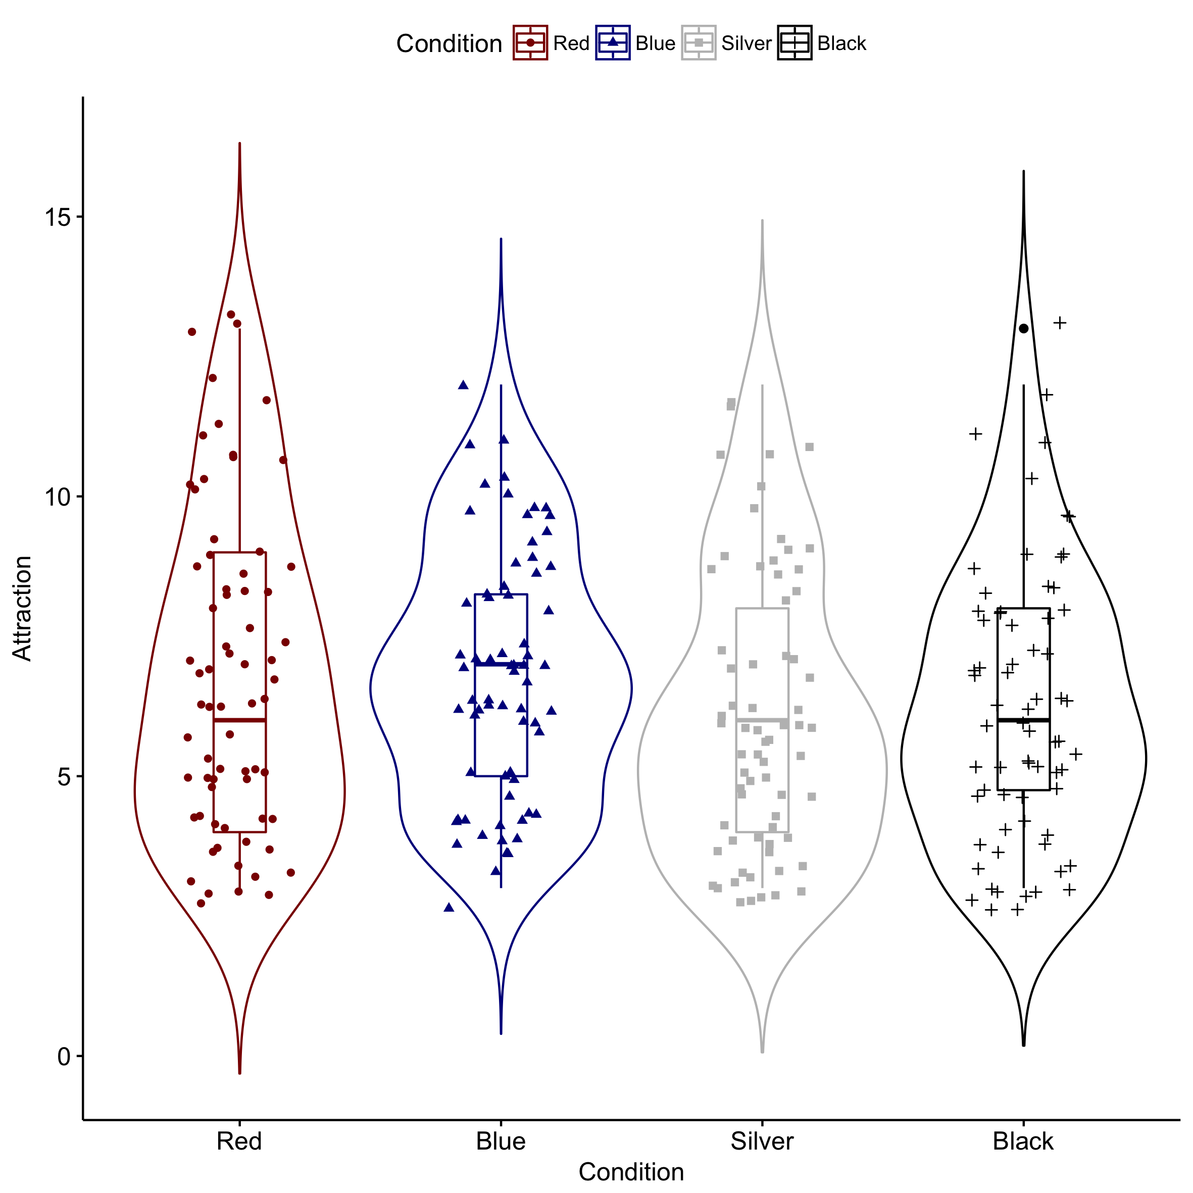

Figure 1 Violin Plot for Study 1, Attraction is the sum score of attractiveness, sex appeal, and sexual desire.

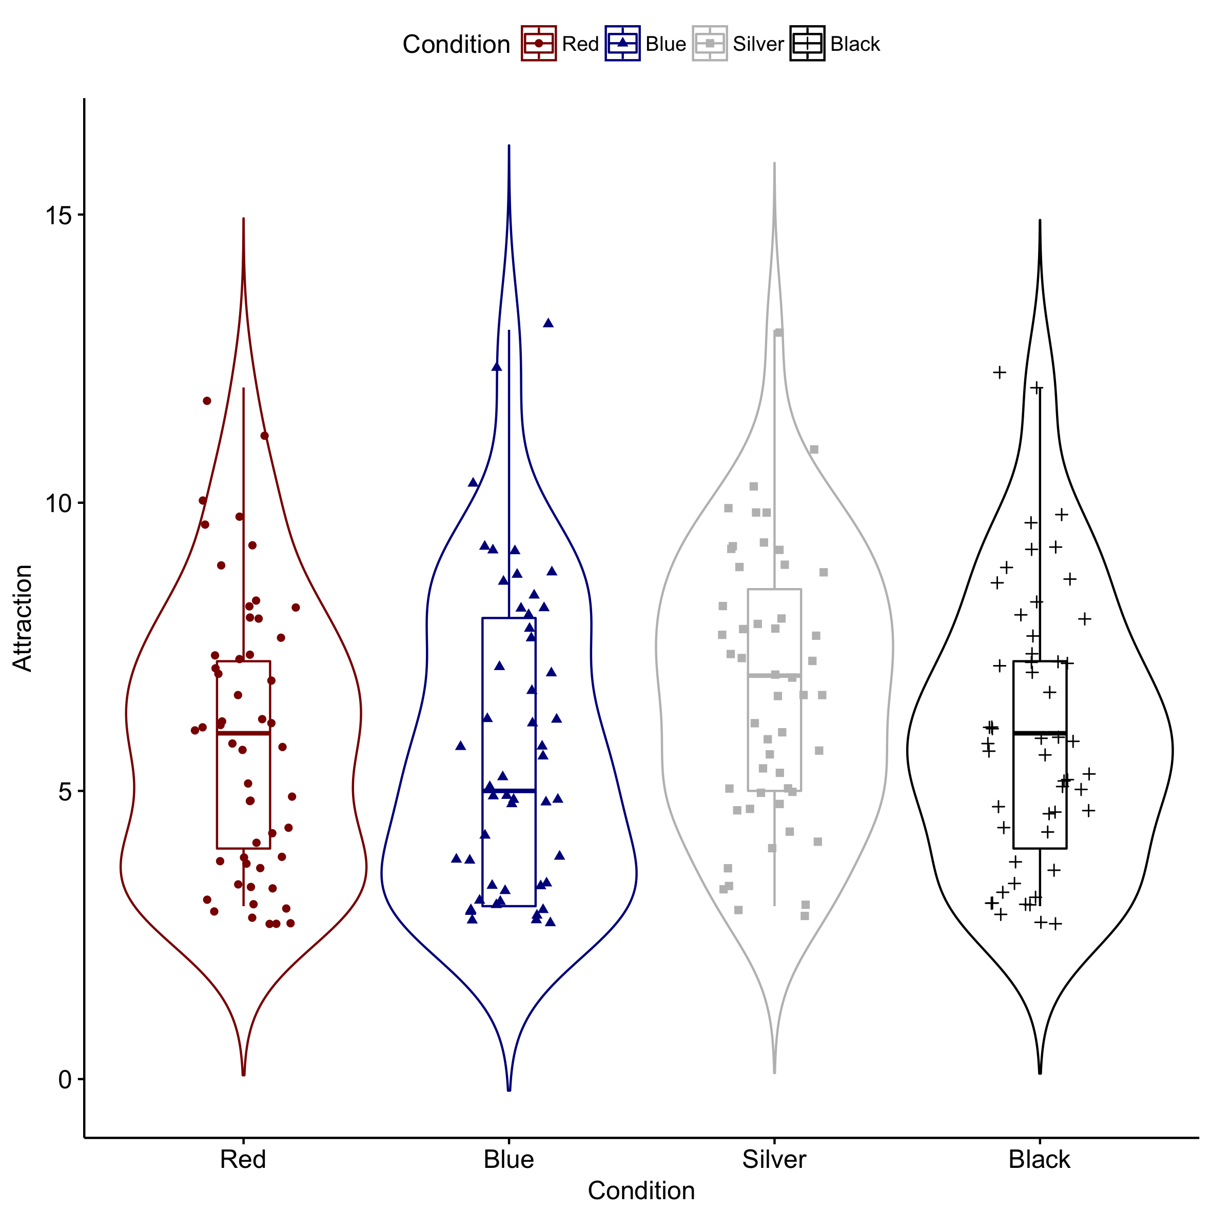

*Figure 2 Violin Plot for Study 2. Attraction is the sum score of attractiveness, sex appeal, and sexual desire.*

*Figure 3 Forest Plot. Diamond represents the random effects model summary.*