Emotion recognition from body movement and gesture in children with Autism Spectrum Disorder is improved by situational cues

**Authors**

Dale Metcalfe1, Karen McKenzie1, Kristofor McCarty1, Thomas Pollet1

1(Department of Psychology,) Northumbria University, UK

**Corresponding author**

Dale Metcalfe, Department of Psychology, Northumbria University, Northumberland Building, Newcastle-upon-Tyne, NE1 8ST, UK.

Email: [dale.r.metcalfe@northumbria.ac.uk](mailto:dale.r.metcalfe@northumbria.ac.uk)

## Abstract

**Background:**  Research shows people with Autism Spectrum Disorder (ASD) have poorer emotion recognition (ER) compared to their typically developing (TD) peers. However, it is not known whether this is the case when stimuli are limited to gesture and posture, and lack facial expressions.

**Method:** Fifty-four children with (*n* = 27) and without (*n* = 27) ASD, matched on age and gender, completed an ER task, that used dynamic stimuli. Processing style bias, Autistic-like-traits and empathy were also measured. With ER as the outcome variable, a multilevel logistic model was created.

**Results:** Children with ASD were found to be significantly less accurate in identifying emotions, compared to the control group. Presence of situational cues aided both groups. Autistic-like-traits and empathy were found to correlate too highly with the diagnosed condition to use in the multilevel model. Processing style did not significantly impact ER ability.

**Conclusions:** This study supports previous research which finds ER ability in people with ASD to be poorer than that of TD peers and that situational cues can aid ER ability. Importantly, the latter is true for people with ASD. The implication of these findings are programmes that aim to improve ER should consider using cues. Limitations of the study are discussed.

**What this paper adds?**

## The current study furthers the understanding of factors that affect emotion recognition in children with Autism Spectrum Disorder (ASD). While there is evidence that indicates children with ASD have poorer emotion recognition, these findings may be due to the type of stimuli used and a focus on emotion recognition from the facial cues. This study is one of the few to use emotion stimuli that are both (depicting body movement, posture and gesture, created using motion capture and animation software) and that are devoid of many potentially influential factors such as facial features and expressions, background and sound. The study also adds to the sparse existing literature in respect of the role of situational cues and processing style in emotion recognition. Our results, using new and well controlled emotion stimuli, support previous research, finding poorer emotion recognition ability in children with ASD. In addition, situational cues were found to improve emotion recognition for both groups. Processing style did not significantly influence emotion recognition, however, the study makes recommendations about how to better measure this in future research.

**Keywords:** autism spectrum disorder; emotion recognition; situational cues; processing style

**Conflict of interest**

No authors of this paper have any conflicts of interest that may have influenced this work.

**Funding**

This research did not receive any specific grant from funding agencies in the public, commercial or not-for-profit sectors.

**Highlights**

* CGI gesture and posture stimuli, devoid of facial expressions, conveyed emotions
* Supports previous findings of poorer emotion recognition in people with ASD
* Situational cues aid both people with and without ASD correctly identify emotions

## 1.0 Introduction

Autism Spectrum Disorder (ASD) is a developmental disorder that is characterised by, and diagnosed on the grounds of, social-communication deficits and repetitive stereotyped behaviour (Mandy, Charman, Puura, & Skuse, 2014). Emotion recognition (ER) difficulties are considered to be common in many people with ASD (Frith & Happé, 2005) and this presents a challenge, as understanding emotions helps people to act in a socially salient manner (Haxby, Hoffman, & Gobbini, 2002). Emotions can be identified from a variety of sources of information, including facial expressions, tone of voice and body posture (Adolphs, 2002).

The ER of people with ASD from stimuli depicting faces has been investigated extensively, with both a review (Harms, Martin, & Wallace, 2010) and meta-analysis (Uljarevic & Hamilton, 2013) showing an overall impairment in ER ability. There are, however, some studies which have found no effect (e.g. Harms et al., 2010). This inconsistency may be due to individual factors such as symptom severity, empathy and processing style of participants as well as methodological factors such as the nature of the stimuli used and available situational cues.

ASD symptom severity is thought to affect ER (Tardif, Lainé, Rodriguez, & Gepner, 2007), with people with higher levels of autistic like traits (ALT) being found to perform worse on ER tasks (Humphreys, Minshew, Leonard, & Behrmann, 2007). ALTs are quantifiable using the Autism-Spectrum Quotient (Baron-Cohen, Wheelwright, Skinner, Martin, & Clubley, 2001) and have previously been used as a proxy measure for symptom severity (Anholt et al., 2010). Research suggests that there is a wide range of ALTs in both people with ASD (e.g., Frith and Happé, 2005; Spiker et al., 2002) and typically developing (TD) individuals (e.g. Constantino and Todd, 2003, 2005; Ronald et al., 2006).

It has also been suggested that some people with ASD may also have more difficulty with ER due to reduced empathy, which results in lower accuracy when judging complex emotions that require intuition about another person’s mental state (Blair, 2005). Research has indicated that low empathy scores are correlated with low ER scores (Sucksmith, Allison, Baron-Cohen, Chakrabarti, & Hoekstra, 2013). Both empathy and ALTs, therefore, need to be considered when exploring the ER ability of people with ASD.

Processing style describes the way a person perceives the world around them and is thought to operate on a continuum of global to local processing (Happé & Frith, 2006). Global processing involves viewing an object as a whole, while local processing involves a focus on an object’s constituent elements. It is hypothesised that people with ASD have a preference for local processing (Happé & Frith, 2006). This has since been supported in a review by Van der Hallen et al. (2015) that found that, whilst people with ASD can process visual stimuli both globally and locally with equal accuracy, they are quicker to process information locally. While these differences may lead to advantages such as superior systemising (Baron-Cohen, 2002, 2008), there may be a relationship between processing style and ER ability (see: Harms et al., 2010).

Studies of TD individuals (Fallshore & Bartholow, 2003) and those with an intellectual disability (Scotland, McKenzie, Cossar, Murray, & Michie, 2016) indicate that global processing may facilitate the correct identification of emotions. However, research in this area with people with ASD is still limited. One study which included children with ASD and with other developmental disorders found that those with ASD were more likely to respond to stimuli in a local manner and were significantly less accurate at recognising emotions (Gross, 2005). One of the aims of the present study is to explore the relationship between processing style and ER in people with ASD further.

An additional factor that may be influential, is situational cues. These contextual features can include information from the background or objects in emotion stimuli that provide relevant information about the emotion being portrayed, for example a woman getting out of a car and tearing up ‘L-plates’ while looking happy (example taken from: Wright et al., 2008). Such information has been found to improve ER in TD individuals (Barrett, Mesquita, & Gendron, 2011) and people with an intellectual disability (Matheson & Jahoda, 2005; Mckenzie, Matheson, McKaskie, Hamilton, & Murray, 2001). The influence of contextual information on the ER of people with ASD is not well studied. Wright et al. (2008) found no influence of context on ER, however, in this study static rather than dynamic stimuli were used.

The ER stimuli that are used can impact the results, as people with ASD may view static and dynamic stimuli differently. Speer et al. (2007) showed that people with ASD and TD participants viewed static images of faces (depicted in stills from a film) in the same way, but differently when dynamic stimuli (clips from the same film) were used. In the latter case, those with ASD spent significantly less time attending to inner facial regions compared to control participants. However, this finding may differ in dynamic stimuli, which is more ecologically valid (Rutherford & Towns, 2008), as there is a wealth of evidence that those with ASD have impaired ER when viewing dynamic stimuli (e.g. Rump et al., 2009; Tardif et al., 2007).

The content of the stimuli may also have an influence. Most TD people view the eyes most frequently when attending to facial emotion stimuli (Dahl, Wallraven, Bülthoff, & Logothetis, 2009), but people with ASD appear to avoid this region (Jones, Carr, & Klin, 2008; Klin, Jones, Schultz, Volkmar, & Cohen, 2002; Pelphrey et al., 2002). Instead they attend more to people’s bodies, objects present, and the background of a stimulus (Rice, Moriuchi, Jones, & Klin, 2012; Shic, Bradshaw, Klin, Scassellati, & Chawarska, 2011; Speer et al., 2007). This may contribute to the ER difficulties experienced by many people with ASD, as the eyes are considered to be important sources of information about emotion (Back, Ropar, & Mitchell, 2007). Indeed, Grossman and Tager-Flusberg (2008) found that compared to their TD peers, people with ASD have poorer ER ability when viewing a whole face, but not when the eyes are obstructed.

Much of the existing research in this area has focused on facial cues of emotion; studies that involve both static and dynamic *whole body expression* (which use body posture and gesture) are much less common, with de Gelder (2009) estimating that 95% of ER research is specific to the face, with whole body expressions making up the smallest proportion of studies. Research with TD participants using videos of people with blurred faces, found that emotions could be accurately categorised into anger, fear, happiness and sadness (Beatrice de Gelder & Van den Stock, 2011). The limited research with people with ASD provides mixed results. Hobson (1986) asked participants to match drawn and photographed facial expressions to gestures and found a global impairment in those with ASD. By contrast, Prior et al. (1990) asked people with ASD to match facial emotions to gestures and found the performance of participants with ASD to be equivalent to that of controls. Both studies, however, included the use of facial expressions, thereby not removing the eyes from the stimuli.

The present study aimed to explore ER ability of children with and without ASD by using standardised avatars (virtual CGI characters) without facial expressions, and with and without situational cues. The role of processing style, ALTs and empathy in ER was also investigated. Three research questions were proposed:

1. How do people with and without ASD compare in terms of ER ability when facial cues are absent? No direction is hypothesised for this, given it is an under researched area.
2. What effect do situational cues have on ER ability and how do the two groups compare? Based on the results of research with TD and intellectual disability populations, it is expected cues will aid ER ability.
3. In addition to ASD diagnosis, to what extent does processing style, empathy and autistic-like-traits predict ER ability?

## 2.0 Method

***2.1 Design***

This study used a between groups design, with the ‘ASD Group’ reporting a diagnosis of ASD and the ‘Control Group’ having no reported diagnosis of ASD.

***2.2 Participants***

In total 54 individuals participated. The group reporting a diagnosis of ASD comprised 27 participants (Male=26, Female=1; Mean age = 10.9 years, *SD*=3.0). Diagnosis of ASD was provided by the parents and confirmed by the child’s school or organisational records. Seven children had an additional condition: One Wolf Parkinson (white heart), one ADHD, one sensory processing disorder, two ADHD and dyspraxia, one Nystagmus, one dyspraxia and Hypomobility, and one intellectual disability. The Control group (N=27; Male=26, Female=1) had no reported or recorded diagnosis of ASD. The mean age was 10.9 years (*SD*=3.0). One child was reported as having difficulty with fine motor skills. All participants were White British and recruited in the North East of England. Participants were excluded if they were visually impaired to the extent that they could not see the tasks, if they were unable to understand the tasks, or if participation was anticipated to cause distress. As research suggests that both age (e.g. Kuusikko et al., 2009; Thomas et al., 2007; Vicari et al., 2000) and gender (e.g. Hall and Matsumoto, 2004; Montagne et al., 2005) impact ER, participants were matched on these factors as closely as possible.

***2.3 Materials***

Parents/guardians were asked to complete the following questionnaires about their child, alongside providing their child’s age, gender, ethnic origin and diagnosis.

2.3.1 Autism-Spectrum Quotient (AQ) Adolescent Version(Baron-Cohen, Hoekstra, Knickmeyer, & Wheelwright, 2006). This is an informant measure, which performs similarly to the original AQ (Baron-Cohen et al., 2006). The informant is asked to indicate the extent to which they agree with 50 statements in respect of their child (e.g. ‘S/he is fascinated by numbers’) on a four-point scale (definitely agree/slightly agree/slightly disagree/definitely disagree). The scale is marked dichotomously with half of the items being reverse scored. Each response which indicates an ALT, either mildly or strongly, is scored as 1. There is a possible range of 0-50, with higher scores indicating more ALTs and therefore higher symptom severity.

2.3.2 The Questionnaire of Cognitive and Affective Empathy (QCAE) (Reniers, Corcoran, Drake, Shryane, & Völlm, 2011) encompasses both cognitive and affective empathy. Validation of the measure shows an acceptable goodness of fit and a good correlation with measures of empathetic anger, impulsivity, aggression, psychopathology and Machiavellianism. It has strong positive correlations regarding convergent validity for both cognitive (*r* = .62, *p* < .001) and affective (*r* = .76, *p* < .001) empathy (Reniers et al., 2011). It was adapted as an informant measure in the present study, by changing ‘I’ and ‘my’ to ‘s/he’ and ‘his/her’ accordingly. The informants were asked to indicate the extent to which they agreed with 31 statements in relation to their child (e.g. ‘S/he can tell if someone is masking their true emotion’). Agreement was measured on a four-point Likert scale (strongly agree/slightly agree/slightly disagree/strongly disagree) with scores of 4, 3, 2, 1 respectively. Four items are reverse scored, giving a possible range between 31 and 124, with higher scores indicating that the person has a higher level of empathy.

The participating children were asked to complete the tasks below:

2.3.3 Emotion Processing Task: This was designed for the purpose of the study. The task used avatars, based on one male actor, to depict eight emotions through body language and gesture: anger, boredom, disgust, fear, happiness, sadness, surprise and worry. Videos were recorded using a motion capture system and 3D models of a standardized, non-identifiable avatar were created using AutoDesk MotionBuilder 2015. The avatar had no facial cues or clothing visible and the video was devoid of background and sound (see Figures 1 and 2). The videos were piloted with 59 participants (mean age = 31.95 years, *SD*=13.01), of whom 40 were employed, 10 were students, 6 were retired and 3 were unemployed. Participants were asked to identify the emotion being depicted. Based on the results of this pilot, sixteen videos were retained which depicted the target emotion best. This represented two videos for each of the eight emotions, one with and one without situational cues. For example, fear was depicted by the avatar shaking with anxiety (no situational cues- see Figure 1) or shaking with fear while being chased by an insect (situational cue- see Figure 2).

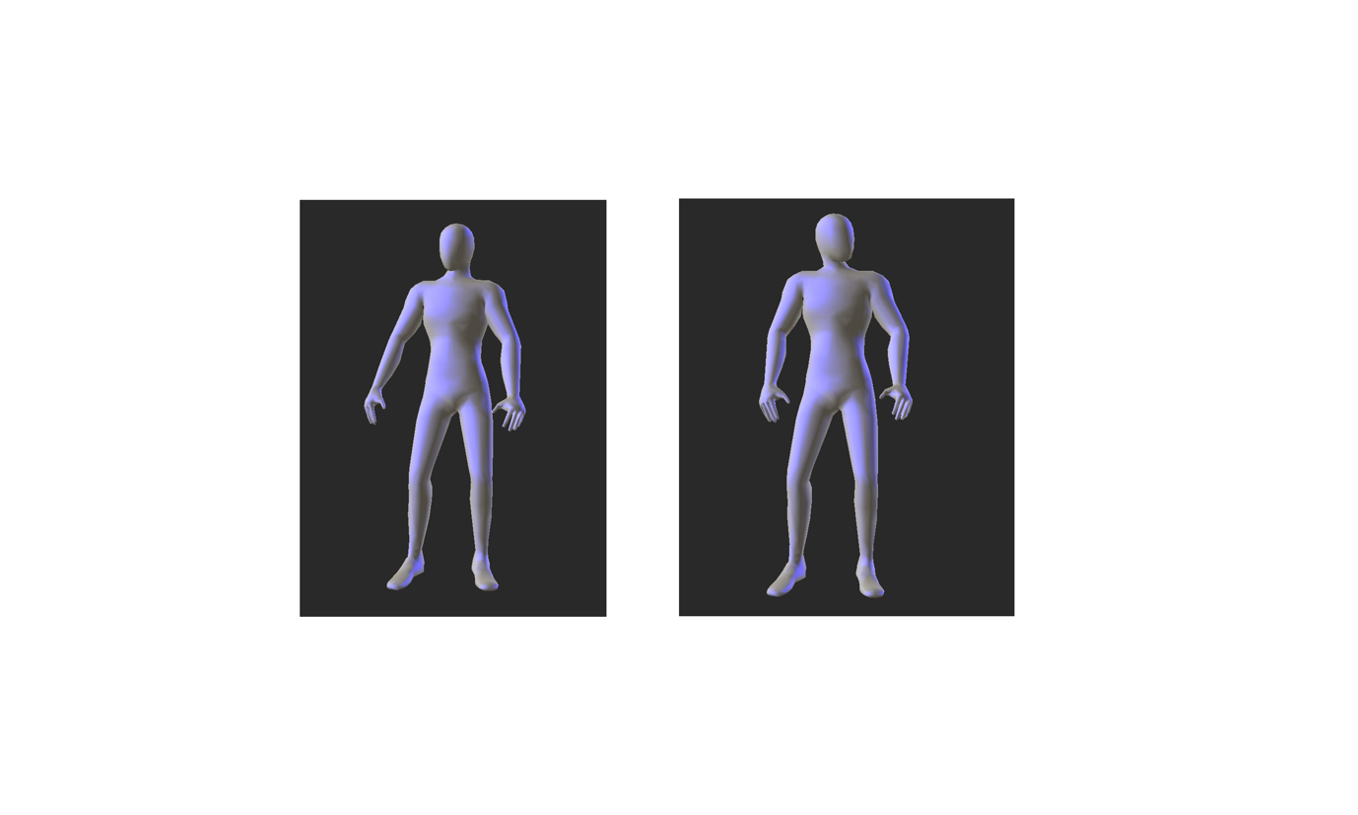

Figure 1: Example stills from ‘fear’ without cues video clip. For video see: <https://www.youtube.com/watch?v=kxVcFe1n7dg>

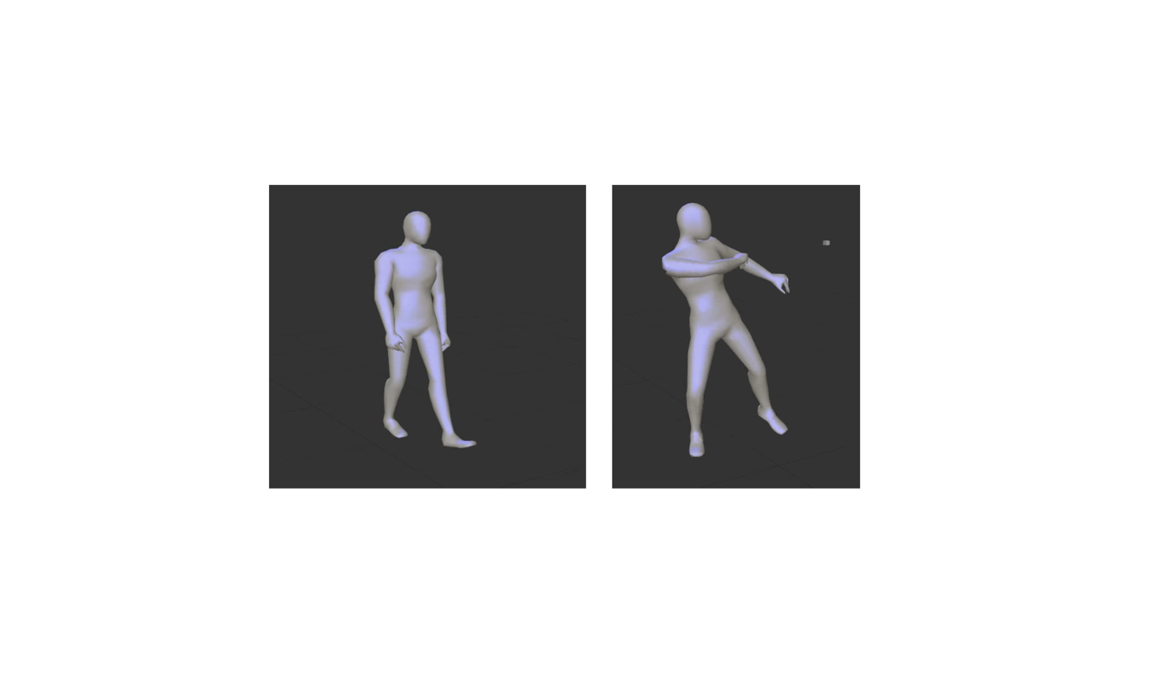

Figure 2: Figure 2: Example stills from ‘fear’ with cues video clip. For video see: <https://www.youtube.com/watch?v=r4Vr1VZtoBI>

The video clips were hosted online. For each video, the researcher asked the child, ‘What emotion is this person showing?’, and recorded the child’s response. A naming task was chosen as this is thought to be a more accurate measure of ER ability than a matching task where a person chooses a response from a number of pre-defined labels. The latter allows for compensatory mechanisms to aid judgement (Uljarevic & Hamilton, 2013). A scoring matrix was created, with each response being scored 1 (correct) or 0 (incorrect or no response). Scores could range from 0 to 16, with higher scores indicating more accurate ER ability.

2.3.4 Processing Style Task: Based on previous research that indicates that people with ASD have a bias towards local processing, rather than a deficit in global processing (Van der Hallen et al., 2015), this computer based task was designed for the study to ensure that local and global processing were not in competition with each other. The task was influenced by one developed by Scherf et al. (2008)but our task measured each style of processing independently and focused on reaction time, rather than accuracy, given the findings of a review on processing style (Van der Hallen et al., 2015). The task was hosted online and written in JavaScript using the jsPsych libraries (de Leeuw, 2015).

The participants viewed two arrays of shapes and were asked to press a button that indicated if the arrays were the same or different. Following an instruction section, which explained the task and gave examples, participants were randomly assigned to either the global task, followed by the local task or vice versa. In the global trials, the overall shape of the stimuli differs, e.g. for a ‘global different trial’ one array is a triangle made of squares and the other is a cross made of squares. In the local trials, the stimuli differ in their constituent elements, e.g. for a ‘local different trial’ one array is a cross made of circles and the other is a cross made of squares (see Figure 3 for examples). Participants are shown two example trials followed by 32 timed trials comprising of 16 paired arrays, each displayed twice to reduce the effects of chance. Each array is visible for a maximum of 10 seconds, with a 1 second break between each trial, followed by a fixation cross for half a second in the centre of the screen. The participants were given a short break between the global and local blocks.

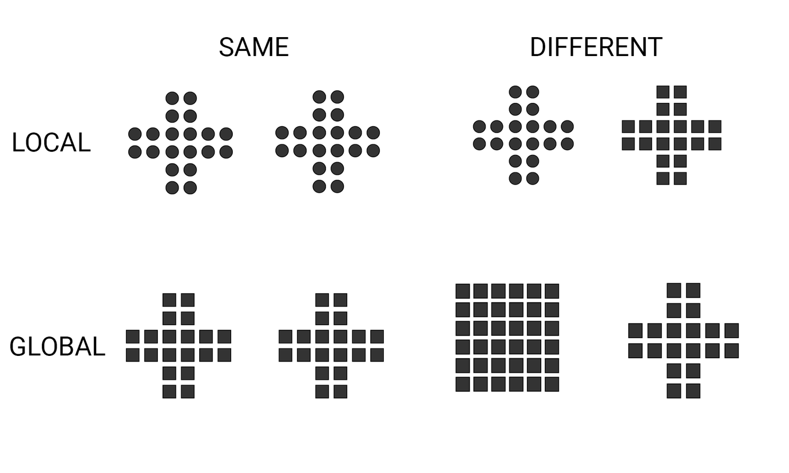

Figure 3: Example arrays from the processing style task.

For the purposes of the study the participants’ processing style bias score was used. This represents the person’s mean reaction time (RT), in milliseconds, to correctly identified global trials subtracted from the RT to correctly identified local trials. A negative score indicates a global bias, and a positive score indicates a local bias, with the greater the score in either a positive or negative direction, indicating a greater local or global bias respectively.

***2.4 Procedure***

Ethical approval was obtained from the first author’s university. Participants were recruited from local schools (primary and secondary) and charitable organisations. Parents/guardians of potential participants were provided with information about the study. Those agreeing to take part completed consent forms and the informant questionnaires. Following this, arrangements were made to assess the children at either the charity or school premises. Children completed the task individually in a quiet location with support from a researcher in terms of providing instructions and recording responses to the emotion task. The children recorded their own responses to the processing style task by pressing the button corresponding to their answer.

***2.5 Analysis strategy***

The main analysis involved conducting a multilevel logistic model that predicts ER ability. This allows for modelling variability of numerous factors for each participant, which can reduce the chance of Type 1 error in comparison to other analyses (Baguley, 2012; Judd, Westfall, & Kenny, 2012). Variables were entered incrementally and were removed if they did not significantly improve model fit (Burnham & Anderson, 2002). The outcome variable was total ER score, explanatory variables included age, gender, diagnosis, processing style bias, total AQ score and total QCAE score. The analyses were run in R 3.4.1 with the lme4 package (Bates, Maechler, & Bolker, 2012; R Development Core Team, 2008). Full and supplementary analyses can be found at <https://osf.io/s2zta/>.

## 3.0 Results

For all participants, Table 1 shows the mean scores and standard deviations for, and correlations between, age, diagnosis, AQ score, QCAE score, processing style bias and number of correctly identified trials. This shows diagnosis highly correlates with AQ, QCAE and number of correct trials, and that AQ is highly correlated with QCAE. It would, therefore, be ill-advised to enter diagnosis, AQ and QCAE scores into a multilevel model together (O’Connell & McCoach, 2008). With diagnosis being the variable of greatest interest, AQ and QCAE will not be investigated during the modelling process. It can be concluded that AQ and QCAE add little explanatory value beyond diagnosis. Table 2 shows the number of trials responded to incorrectly on the processing style task. This shows that for both the group with ASD and the Control group in all conditions (global, local and overall), there was a low number of errors. Differences in number of errors between groups were tested using t-tests and then applying false discovery rate corrections (Benjamini & Hochberg, 1995), results showed that differences were statistically non-significant after applying corrections.

|  |  |  |  |  |  |  |  |
| --- | --- | --- | --- | --- | --- | --- | --- |
| Table 1: Means, standard deviations, and correlations with confidence intervals | | | | | | | |
| Variable | *M* | *SD* | Age | Diagnosis | AQ | QCAE | Bias |
|  |  |  |  |  |  |  |  |
| Age | 10.96 | 2.97 |  |  |  |  |  |
|  |  |  |  |  |  |  |  |
| Diagnosis | 0.50 | 0.50 | .00 |  |  |  |  |
|  |  |  | [-.27, .27] |  |  |  |  |
|  |  |  |  |  |  |  |  |
| AQ | 23.86 | 12.32 | .12 | .87** |  |  |  |
|  |  |  | [-.15, .38] | [.79, .92] |  |  |  |
|  |  |  |  |  |  |  |  |
| QCAE | 71.29 | 19.26 | .12 | -.73** | -.79** |  |  |
|  |  |  | [-.16, .37] | [-.83, -.57] | [-.87, -.67] |  |  |
|  |  |  |  |  |  |  |  |
| Bias | -47.87 | 260.17 | -.20 | .17 | .09 | -.23 |  |
|  |  |  | [-.45, .07] | [-.10, .42] | [-.18, .35] | [-.47, .04] |  |
|  |  |  |  |  |  |  |  |
| Correct | 0.43 | 0.15 | .14 | -.37** | -.32* | .41** | -.09 |
|  |  |  | [-.14, .39] | [-.58, -.11] | [-.54, -.06] | [.16, .61] | [-.35, .19] |
|  |  |  |  |  |  |  |  |
| *Note.* * indicates *p* < .05; ** indicates *p* < .01. *M* and *SD* are used to represent mean and standard deviation, respectively. Values in square brackets indicate the 95% confidence interval for each correlation. The confidence interval is a plausible range of population correlations that could have caused the sample correlation (Cumming, 2014). | | | | | | | |

|  |  |  |  |  |  |  |  |  |
| --- | --- | --- | --- | --- | --- | --- | --- | --- |
| Table 2: Number of errors committed on the processing style task, by group and condition. T-tests were run between groups. | | | | | | | | |
|  | Group with ASD  (*N*=27) | | Control group  (*N*=27) | | t-test | | | Effect size |
| Number of errors | *M* | *SD* | *M* | *SD* | *df* | *t* | *p* | *Cohen’s d [95% CI]* |
|  |  |  |  |  |  |  |  |  |
| Local | **3.81** | **5.01** | **1.63** | **2.04** | 52 | 2.10 | .041 | 0.56 [0.02, 1.11] |
| Global | **3.56** | **5.00** | **1.67** | **1.80** | 52 | 1.85 | .069 | 0.51 [-0.04, 1.04] |
| Overall | **7.37** | **9.85** | **3.30** | **3.39** | 52 | 2.03 | .047 | 0.55 [0,01, 1.10] |
| *Note.* * on *p* value indicates that the critical *p* value (0.05) threshold has been reached *after* correcting for multiple testing. Effect sizes are not corrected for multiple comparisons. | | | | | | | | |

***3.1 Modelling Outcome***

Change in model fit was judged on change in fit criteria (AIC/BIC). The modelling procedure showed that, compared to the null model, the inclusion of diagnosis significantly improved model fit and that the addition of situational cues, further improved fit. However, the inclusion of an interaction between diagnosis and situational cues did not improve model fit. Similarly, the inclusion of processing bias did not improve fit. See Table 3 for model summaries.

Table 4 shows the odds ratios for selected models. A diagnosis of ASD decreases the odds of correctly identifying an emotion by a factor of 1.6 (1 / 0.628). The presence of situational cues improves the odds of correctly identifying an emotion by 1.23. Figure 4 summarizes the key findings: having an ASD diagnosis and judging emotions with no situational cues present are associated with lower ER ability.

|  |  |  |  |  |
| --- | --- | --- | --- | --- |
| Table 3: Model summaries of multilevel models | | | | |
|  | Correct | | | |
|  | (1) | (2) | (3) | (4) |
|  | | | | |
| Autism Diagnosis |  | -0.466** | -0.471** | -0.700* |
|  |  |  |  |  |
| Cue |  |  | 0.206** | 0.152 |
|  |  |  |  |  |
| Autism Diagnosis * Cue |  |  |  | 0.113 |
|  |  |  |  |  |
| Constant | -0.289*** | -0.057 | -0.469** | -0.361 |
|  |  |  |  |  |
| *N* | 864 | 864 | 864 | 864 |
| Log Likelihood | -587.775 | -583.856 | -579.538 | -579.218 |
| AIC | 1,179.549 | 1,173.712 | 1,167.077 | 1,168.435 |
| BIC | 1,189.072 | 1,187.997 | 1,186.123 | 1,192.243 |
|  | | | | |
| *\*p* < .05; *\*\*p* < .01; *\*\*\*p* < .001 | | | | |

|  |  |  |
| --- | --- | --- |
| Table 4: Odds ratios for selected models | | |
|  | Correct | |
|  | (1) | (2) |
|  | | |
| Autism Diagnosis | 0.628** | 0.624** |
|  |  |  |
| Cue |  | 1.229** |
|  |  |  |
| *N* | 864 | 864 |
| Log Likelihood | -583.856 | -579.538 |
| AIC | 1,173.712 | 1,167.077 |
| BIC | 1,187.997 | 1,186.123 |
| \**p* < .05; *\*\*p* < .01; *\*\*\*p* < .001 | | |



Figure 4: Multilevel model key findings.

## 4.0 Discussion and implications

Overall, the results show that people with ASD are significantly worse at identifying emotions based on whole body movement and that the presence of situational cues aids participants with and without ASD. The former outcome is consistent with, and adds to, the growing evidence base that people with ASD, show an ER deficit when dynamic stimuli are used as compared with their typically developing peers (Bal et al., 2010; Tardif et al., 2007). One proposed explanation for this ER deficit is that it because people with ASD avoid looking at eyes (Tanaka & Sung, 2016), thereby missing out on valuable social information that informs emotion recognition (Back et al., 2007). The eye avoidance hypothesis implies that when the eyes are not present in ER stimuli, individuals with ASD may perform at an equivalent level to their TD peers. However, this was not found in the present study, as the avatars used had no facial features. Previous research has consistently indicated that people with ASD avoid the eyes of stimuli and look elsewhere (Bal et al., 2010; Pelphrey et al., 2002; Shic et al., 2011). This may indicate a general social deficit (Klin et al., 2002), with more severe social deficits in people with ASD being linked to poorer ER ability (Bal et al., 2010). This may indicate that avoidance of the eyes is a proxy for social deficits, which may be a true influence on ER ability.

The results in relation to situational cues are also consistent with those found in previous research with TD individuals and people with intellectual disability, that contextual cues are helpful when identifying emotions (Barrett et al., 2011; Matheson & Jahoda, 2005; Mckenzie et al., 2001; Scotland et al., 2016). There was no support in the present study for an interaction effect, suggesting that both people with and without a diagnosis of ASD benefit to the same extent from these situational cues. This has potential implications for the provision of school based programmes that aim to promote the development of socio-emotional skills of children. These are commonly universal programmes (see: Connolly et al., 2016) which must take account of the difficulties and related needs of all children, including those with ASD. Such provision must consider that children with ASD appear to have particular difficulties with ER, compared with their TD peers, but that both children with and without ASD can benefit from having situational cues when learning to recognise emotions.

To the authors’ knowledge, only one previous study has investigated the impact of context on the ER of people with ASD (Wright et al., 2008). This study found no difference between the effect of context on those with and without ASD. It also found, however, that the participants did not show a deficit in ER, a result that is at odds with the general findings of research in this area (Harms et al., 2010; Uljarevic & Hamilton, 2013). Future research in this area is required to further our understanding of the impact of situational cues on ER, for example the type of cues that are optimal for promoting ER and whether these differ depending on the specific emotion and the impact on the ER of adults with ASD. There is also a need to understand how situational cues affect ER ability when facial expressions, particularly eyes, are present, thereby creating a more ecologically valid assessment of ER in the real world.

The results of the study could also help inform interventions to improve ER in people with ASD. As situational cues aid ER, including intervention strategies that help people with ASD to focus on relevant situational as well as emotional cues in real life, may increase their accuracy at identifying how others are feeling. This may also have benefits for social interactions as the person with ASD may be more aware of the context within which the interaction is occurring as well as emotional responses that are typically associated with it. Previous research has identified the importance of ER ability to social interactions (see: Haxby et al., 2002), therefore improving ER may help people with ASD to act in a more socially salient manner.

ALTs and level of empathy were found to be highly correlated with diagnosis and, as such, were not included in the model as it was thought unlikely that they would explain anything beyond diagnosis. The findings also indicated that processing style had no influence on ER ability, which is contrary to previous work which indicates that global processing contributes to accurate ER ability (e.g. Fallshore and Bartholow, 2003; Gross, 2005). This may be attributable to limitations with the processing task used in the present study. The low mean error rate (see Table 2) suggests a ceiling effect and that the task may not have been sufficiently complex to identify any processing bias. This may also explain the fact that no significant correlation was found between processing bias and diagnosis, indicating no significant differences in processing style between the two groups. This is at odds with previous research (Happé & Booth, 2008; Scherf et al., 2008; Van der Hallen et al., 2015). As such, future research should aim to measure processing style with a more complex and difficult measure to identify these potential differences more accurately.

A further potential limitation of the study is the adaptation of the QCAE as an informant measure. The QCAE is a valid and reliable tool (Reniers et al., 2011) and the adaptations were minimal, however the impact of these on the psychometric properties of the measure are unknown. Another limitation of the study is gender ratio of the sample. While males are more commonly diagnosed with ASD than females (Werling & Geschwind, 2013), only one girl with ASD participated in the study, meaning that the impact of gender on ER could not be accurately determined. Similarly, the sample in this study is relatively small and therefore may not be representative of people with ASD as a whole. Lastly, IQ was not investigated in this study. Research generally finds people with higher IQ scores in ASD have more accurate ERA (see Harms et al., 2010) and in some studies where IQ is matched people with and without ASD perform equally to each other (e.g. Grossman, Klin, Carter, & Volkmar, 2000). In this study, all participants were considered high-functioning but the actual IQ profiles were unknown, due to cost implications of IQ testing. Therefore, the specific role of IQ in this sample is not known.

Overall the study extends previous research by indicating that children with ASD have greater difficulty than their TD peers in recognising emotion from body movement and gesture stimuli, when faces are not present and that situational cues aid recognition of emotions in people with and without ASD. This study provides a good step in investigating dynamic stimuli, future work should build upon this to yield a more cohesive understanding of ER ability in people with ASD.

## References

Adolphs, R. (2002). Neural systems for recognizing emotion. *Current Opinion in Neurobiology*, *12*(2), 169–177. https://doi.org/10.1016/S0959-4388(02)00301-X

Anholt, G. E., Cath, D. C., van Oppen, P., Eikelenboom, M., Smit, J. H., van Megen, H., & van Balkom, A. J. L. M. (2010). Autism and ADHD symptoms in patients with OCD: Are they associated with specific OC symptom dimensions or OC symptom severity? *Journal of Autism and Developmental Disorders*, *40*(5), 580–589. https://doi.org/10.1007/s10803-009-0922-1

Back, E., Ropar, D., & Mitchell, P. (2007). Do the eyes have it? Inferring mental states from animated faces in autism. *Child Development*, *78*(2), 397–411. https://doi.org/10.1111/j.1467-8624.2007.01005.x

Baguley, T. (2012). *Serious Stats: A guide to advanced statistics for the behavioral sciences*. Basingstoke: Palgrave Macmillan.

Bal, E., Harden, E., Lamb, D., Van Hecke, A. V., Denver, J. W., & Porges, S. W. (2010). Emotion recognition in children with autism spectrum disorders: Relations to eye gaze and autonomic state. *Journal of Autism and Developmental Disorders*, *40*(3), 358–370. https://doi.org/10.1007/s10803-009-0884-3

Baron-Cohen, S. (2002). The extreme male brain theory of autism. *Trends in Cognitive Sciences*, *6*(6).

Baron-Cohen, S. (2008). Autism, hypersystemizing, and truth. *The Quarterly Journal of Experimental Psychology*, *61*(1), 64–75. https://doi.org/10.1080/17470210701508749

Baron-Cohen, S., Hoekstra, R. A., Knickmeyer, R., & Wheelwright, S. (2006). The Autism-Spectrum Quotient (AQ) - Adolescent version. *Journal of Autism and Developmental Disorders*, *36*(3), 343–350. https://doi.org/10.1007/s10803-006-0073-6

Baron-Cohen, S., Wheelwright, S., Skinner, R., Martin, J., & Clubley, E. (2001). The Autism-Spectrum Quotient (AQ): Evidence from asperger syndrome/high-functioning autism, males and females, scientists and mathematicians. *Journal of Autism and Developmental Disorders*, *31*(1), 5–17. https://doi.org/10.1023/A:1005653411471

Barrett, L. F., Mesquita, B., & Gendron, M. (2011). Context in emotion perception. *Current Directions in Psychological Science*, *20*(5), 286–290. https://doi.org/10.1177/0963721411422522

Bates, D., Maechler, M., & Bolker, B. (2012). lme4: Linear mixed-effects models using S4 classes. Retrieved from http://lme4.r-forge.r-project.org/

Benjamini, Y., & Hochberg, Y. (1995). Controlling the false discovery rate: A practical and powerful approach to multiple testing. *Royal Statistical Society*, *57*(1), 289–300. https://doi.org/https://www.jstor.org/stable/2346101

Blair, R. J. R. (2005). Responding to the emotions of others: Dissociating forms of empathy through the study of typical and psychiatric populations. *Consciousness and Cognition*, *14*(4), 698–718. https://doi.org/10.1016/j.concog.2005.06.004

Burnham, K. P., & Anderson, D. R. (2002). *Model selection and multimodel inference: A practical information-theoretic approach*. New York, NY: Springer.

Connolly, P., Miller, S., Mooney, J., Sloan, S., & Hanratty, J. (2016). Universal school-based programmes for improving social and emotional outcomes in children aged 3-11 years: A systematic review and meta-analysis. *The Campbell Collaboration*. Retrieved from https://goo.gl/gkjH8a

Constantino, J. N., & Todd, R. D. (2003). Autistic traits in the general population: A twin study. *Archives of General Psychiatry*, *60*(5), 524–530. https://doi.org/10.1001/archpsyc.60.5.524

Constantino, J. N., & Todd, R. D. (2005). Intergenerational transmission of subthreshold autistic traits in the general population. *Biological Psychiatry*, *57*(6), 655–660. https://doi.org/10.1016/j.biopsych.2004.12.014

Cumming, G. (2014). The New Statistics. *Psychological Science*, *25*(1), 7–29. https://doi.org/10.1177/0956797613504966

Dahl, C. D., Wallraven, C., Bülthoff, H. H., & Logothetis, N. K. (2009). Humans and macaques employ similar face-processing strategies. *Current Biology*, *19*(6), 509–513. https://doi.org/10.1016/j.cub.2009.01.061

de Gelder, B. (2009). Why bodies? Twelve reasons for including bodily expressions in affective neuroscience. *Philosophical Transactions of the Royal Society B: Biological Sciences*, *364*(1535), 3475–3484. https://doi.org/10.1098/rstb.2009.0190

de Gelder, B., & Van den Stock, J. (2011). The Bodily Expressive Action Stimulus Test (BEAST). Construction and validation of a stimulus basis for measuring perception of whole body expression of emotions. *Frontiers in Psychology*, *2*(181), 1–6. https://doi.org/10.3389/fpsyg.2011.00181

de Leeuw, J. R. (2015). jsPsych: A JavaScript library for creating behavioral experiments in a Web browser. *Behavior Research Methods*, *47*(1), 1–12. https://doi.org/10.3758/s13428-014-0458-y

Fallshore, M., & Bartholow, J. (2003). Recognition of emotion from inverted schematic drawings of faces. *Perceptual and Motor Skills*, *96*(1), 236–244. https://doi.org/10.2466/pms.2003.96.1.236

Frith, U., & Happé, F. (2005). Autism spectrum disorder. *Current Biology*, *15*(19), 786–790. https://doi.org/10.1016/j.cub.2005.09.033

Gross, T. F. (2005). Global-local precedence in the perception of facial age and emotional expression by children with autism and other developmental disabilities. *Journal of Autism and Developmental Disorders*, *35*(6), 773–785. https://doi.org/10.1007/s10803-005-0023-8

Grossman, J. B., Klin, A., Carter, A. S., & Volkmar, F. R. (2000). Verbal bias in recognition of facial emotions in children with Asperger syndrome. *Journal of Child Psychology and Psychiatry*, *41*(3), 369–379. https://doi.org/10.1111/1469-7610.00621

Grossman, R. B., & Tager-Flusberg, H. (2008). Reading faces for information about words and emotions in adolescents with autism. *Research in Autism Spectrum Disorders*, *2*(4), 681–695. https://doi.org/10.1016/j.rasd.2008.02.004

Hall, J. A., & Matsumoto, D. (2004). Gender differences in judgments of multiple emotions from facial expressions. *Emotion*, *4*(2), 201–206. https://doi.org/10.1037/1528-3542.4.2.201

Happé, F., & Booth, R. D. L. (2008). The power of the positive: Revisiting weak coherence in autism spectrum disorders. *Quarterly Journal of Experimental Psychology*, *61*(1), 50–63. https://doi.org/10.1080/17470210701508731

Happé, F., & Frith, U. (2006). The weak coherence account: Detail-focused cognitive style in autism spectrum disorders. *Journal of Autism and Developmental Disorders*, *36*(1), 5–25. https://doi.org/10.1007/s10803-005-0039-0

Harms, M. B., Martin, A., & Wallace, G. L. (2010). Facial emotion recognition in autism spectrum disorders: A review of behavioral and neuroimaging studies. *Neuropsychology Review*, *20*(3), 290–322. https://doi.org/10.1007/s11065-010-9138-6

Haxby, J. V, Hoffman, E. A., & Gobbini, M. I. (2002). Human neural systems for face recognition and social communication. *Biological Psychiatry*, *51*(1), 59–67. https://doi.org/10.1016/S0006-3223(01)01330-0

Hobson, R. P. (1986). The autistic child’s appraisal of expressions of emotion. *Journal of Child Psychology and Psychiatry*, *27*(3), 321–342. https://doi.org/10.1111/j.1469-7610.1986.tb01836.x

Humphreys, K., Minshew, N., Leonard, G. L., & Behrmann, M. (2007). A fine-grained analysis of facial expression processing in high-functioning adults with autism. *Neuropsychologia*, *45*(4), 685–695. https://doi.org/10.1016/j.neuropsychologia.2006.08.003

Jones, W., Carr, K., & Klin, A. (2008). Absence of preferential looking to the eyes of approaching adults predicts level of social disability in 2-year-old toddlers with autism spectrum disorder. *Archives of General Psychiatry*, *65*(8), 946. https://doi.org/10.1001/archpsyc.65.8.946

Judd, C. M., Westfall, J., & Kenny, D. A. (2012). Treating stimuli as a random factor in social psychology: A new and comprehensive solution to a pervasive but largely ignored problem. *Journal of Personality and Social Psychology*, *103*(1), 54–69. https://doi.org/10.1037/a0028347

Klin, A., Jones, W., Schultz, R., Volkmar, F., & Cohen, D. (2002). Visual fixation patterns during viewing of naturalistic social situations as predictors of social competence in individuals with autism. *Archives of General Psychiatry*, *59*(9), 809–816. https://doi.org/10.1001/archpsyc.59.9.809

Kuusikko, S., Haapsamo, H., Jansson-Verkasalo, E., Hurtig, T., Mattila, M.-L., Ebeling, H., … Moilanen, I. (2009). Emotion recognition in children and adolescents with autism spectrum disorders. *Journal of Autism and Developmental Disorders*, *39*(6), 938–945. https://doi.org/10.1007/s10803-009-0700-0

Mandy, W., Charman, T., Puura, K., & Skuse, D. (2014). Investigating the cross-cultural validity of DSM-5 autism spectrum disorder: Evidence from Finnish and UK samples. *Autism*, *18*(1), 45–54. https://doi.org/10.1177/1362361313508026

Matheson, E., & Jahoda, A. (2005). Emotional understanding in aggressive and nonaggressive individuals with mild or moderate mental retardation. *American Journal on Mental Retardation*, *110*(1), 57–67. https://doi.org/10.1352/0895-8017(2005)110<57:euiaan>2.0.co;2

Mckenzie, K., Matheson, E., McKaskie, K., Hamilton, L., & Murray, G. C. (2001). A picture of happiness. *Learning Disability Practice*, *4*(1), 26–29. https://doi.org/http://dx.doi.org/10.7748/ldp2001.05.4.1.26.c1451

Montagne, B., Kessels, R. P. C., Frigerio, E., de Haan, E. H. F., & Perrett, D. I. (2005). Sex differences in the perception of affective facial expressions: Do men really lack emotional sensitivity? *Cognitive Processing*, *6*(2), 136–141. https://doi.org/10.1007/s10339-005-0050-6

O’Connell, A. A., & McCoach, D. B. (2008). *Multilevel modeling of educational data*. Greenwich, CT: Information Age Publishing.

Pelphrey, K. A., Sasson, N. J., Reznick, J. S., Paul, G., Goldman, B. D., & Piven, J. (2002). Visual scanning of faces in autism. *Journal of Autism and Developmental Disorders*, *32*(4), 249–261. https://doi.org/10.1023/A:1016374617369

Prior, M., Dahlstrom, B., & Squires, T.-L. (1990). Autistic children’s knowledge of thinking and feeling states in other people. *Journal of Child Psychology and Psychiatry*, *31*(4), 587–601. https://doi.org/10.1111/j.1469-7610.1990.tb00799.x

R Development Core Team. (2008). *R: A language and environment for statistical computing* (Vienna, Au). R Foundation for Statistical Computing.

Reniers, R. L. E. P., Corcoran, R., Drake, R., Shryane, N. M., & Völlm, B. a. (2011). The QCAE: A Questionnaire of Cognitive and Affective Empathy. *Journal of Personality Assessment*, *93*(1), 84–95. https://doi.org/10.1080/00223891.2010.528484

Rice, K., Moriuchi, J. M., Jones, W., & Klin, A. (2012). Parsing heterogeneity in autism spectrum disorders: Visual scanning of dynamic social scenes in school-aged children. *Journal of the American Academy of Child and Adolescent Psychiatry*, *51*(3), 238–248. https://doi.org/10.1016/j.jaac.2011.12.017

Ronald, A., Happé, F., Price, T. S., Baron-Cohen, S., & Plomin, R. (2006). Phenotypic and genetic overlap between autistic traits at the extremes of the general population. *Journal of the American Academy of Child and Adolescent Psychiatry*, *45*(10), 1206–1214. https://doi.org/10.1097/01.chi.0000230165.54117.41

Rump, K. M., Giovannelli, J. L., Minshew, N. J., & Strauss, M. S. (2009). The development of emotion recognition in individuals with autism. *Child Development*, *80*(5), 1434–1447. https://doi.org/10.1111/j.1467-8624.2009.01343.x

Rutherford, M. D., & Towns, A. M. (2008). Scan path differences and similarities during emotion perception in those with and without autism spectrum disorders. *Journal of Autism and Developmental Disorders*, *38*(7), 1371–1381. https://doi.org/10.1007/s10803-007-0525-7

Scherf, K. S., Luna, B., Kimchi, R., Minshew, N., & Behrmann, M. (2008). Missing the big picture: Impaired development of global shape processing in autism. *Autism Research*, *1*(2), 114–129. https://doi.org/10.1002/aur.17

Scotland, J. L., McKenzie, K., Cossar, J., Murray, A., & Michie, A. (2016). Recognition of facial expressions of emotion by adults with intellectual disability: Is there evidence for the emotion specificity hypothesis? *Research in Developmental Disabilities*, *48*, 69–78. https://doi.org/10.1016/j.ridd.2015.10.018

Shic, F., Bradshaw, J., Klin, A., Scassellati, B., & Chawarska, K. (2011). Limited activity monitoring in toddlers with autism spectrum disorder. *Brain Research*, *1380*, 246–254. https://doi.org/10.1016/j.brainres.2010.11.074

Speer, L. L., Cook, A. E., McMahon, W. M., & Clark, E. (2007). Face processing in children with autism. *Autism*, *11*(3), 265–277. https://doi.org/10.1177/1362361307076925

Spiker, D., Lotspeich, L. J., Dimiceli, S., Myers, R. M., & Risch, N. (2002). Behavioral phenotypic variation in autism multiplex families: Evidence for a continuous severity gradient. *American Journal of Medical Genetics*, *114*(2), 129–136. https://doi.org/10.1002/ajmg.10188

Sucksmith, E., Allison, C., Baron-Cohen, S., Chakrabarti, B., & Hoekstra, R. A. A. (2013). Empathy and emotion recognition in people with autism, first-degree relatives, and controls. *Neuropsychologia*, *51*(1), 98–105. https://doi.org/10.1016/j.neuropsychologia.2012.11.013

Tanaka, J. W., & Sung, A. (2016). The “Eye Avoidance” hypothesis of autism face processing. *Journal of Autism and Developmental Disorders*, *46*(5), 1538–1552. https://doi.org/10.1007/s10803-013-1976-7

Tardif, C., Lainé, F., Rodriguez, M., & Gepner, B. (2007). Slowing down presentation of facial movements and vocal sounds enhances facial expression recognition and induces facial–vocal imitation in children with autism. *Journal of Autism and Developmental Disorders*, *37*(8), 1469–1484. https://doi.org/10.1007/s10803-006-0223-x

Thomas, L. A., De Bellis, M. D., Graham, R., & LaBar, K. S. (2007). Development of emotional facial recognition in late childhood and adolescence. *Developmental Science*, *10*(5), 547–558. https://doi.org/10.1111/j.1467-7687.2007.00614.x

Uljarevic, M., & Hamilton, A. (2013). Recognition of emotions in autism: A formal meta-analysis. *Journal of Autism and Developmental Disorders*, *43*(7), 1517–1526. https://doi.org/10.1007/s10803-012-1695-5

Van der Hallen, R., Evers, K., Brewaeys, K., Van den Noortgate, W., & Wagemans, J. (2015). Global processing takes time: A meta-analysis on local–global visual processing in ASD. *Psychological Bulletin*, *141*(3), 549–573. https://doi.org/10.1037/bul0000004

Vicari, S., Reilly, J. S., Pasqualetti, P., Vizzotto, A., & Caltagirone, C. (2000). Recognition of facial expressions of emotions in school- age children: The intersection of perceptual and semantic categories. *Acta Paediatrica*, *89*(7), 836–845.

Werling, D. M., & Geschwind, D. H. (2013). Sex differences in autism spectrum disorders. *Current Opinion in Neurology*, *26*(2), 146–153. https://doi.org/10.1097/WCO.0b013e32835ee548

Wright, B., Clarke, N., Jordan, J., Young, A. W., Clarke, P., Miles, J., … Williams, C. (2008). Emotion recognition in faces and the use of visual context in young people with high-functioning autism spectrum disorders. *Autism*, *12*(6), 607–626. https://doi.org/10.1177/1362361308097118