Analysis of Mortar Samples from the Church of the Saints Sergius and Bacchus at Umm as-Surab (Jordan)
Piero Gilento¹, Cecilia Pesce², Giovanni Pesce²
(1) University Paris 1 Panthéon-Sorbonne, UMR7041, ArScAn, France, piero.gilento@univ-paris1.fr (P.G.)
(2) Department of Architecture and Built Environment, Northumbria University, Newcastle upon Tyne, UK, cecilia.pesce@northumbria.ac.uk (C.P.), giovanni.pesce@northumbria.ac.uk (G.P.)
Abstract
This study presents the results of some XRD and SEM analyses carried out on mortar samples from the church of the SS. Sergius and Bacchus, in the village of Umm as-Surab, Northern Jordan. The analysis aimed at providing useful information on the building materials and technologies used in the construction of the church and adjacent rooms. Building archaeology methods and techniques were used to highlighting the complex stratigraphy of the remains and, in such context, the analyses allowed a detailed investigation of the differences between the various parts of the complex. Results suggest that during the Byzantine period mortars were produced using lime as a binder, whereas during the Islamic period mortars with decorative function were produced using a mixture of lime and gypsum as a binder. These information allow a more precise investigation of the chronology of the building and contributes to broaden our knowledge of the material culture in the Ḥawrān region.
Introduction
Northern Jordan has a complex system of ancient villages almost entirely built using basalt as a construction material which, thanks to particular historical, cultural, geological and environmental convergences, survived until today in fairly good conditions. This built landscape is located at the border between the steppe and the desert areas called Ḥawrān. This is an area that for centuries has been part of a network of important communication routes between the Mediterranean Sea and the Arabian Peninsula (Figure 1). Because of this, the area was the melting pot of various cultures such as Nabatean, Roman, Byzantine, Sassanid, and Islamic. In such rich cultural context, the architecture reflects the cultural variety and becomes a fundamental source of information not only of the local material culture but also for the study of the social and cultural phenomena behind some crucial historical changes that happened especially in the Late Antiquity and in the Middle Ages.
Because of the complexity of the built environment of the area, an archaeological approach was used to unlock the information contained in it. It is general knowledge that the most advanced archaeological approach to the historical development of buildings and structures is the Building Archaeology [1, 2]. This discipline applies the basic principles of horizontal stratigraphy to the standing structures allowing the unravelling of the complex sequence of construction and demolition phases common to a large number of historic buildings. Such complex sequence is often difficult to identify because of the reuse of building materials and/or the continuity in the use of some construction techniques.
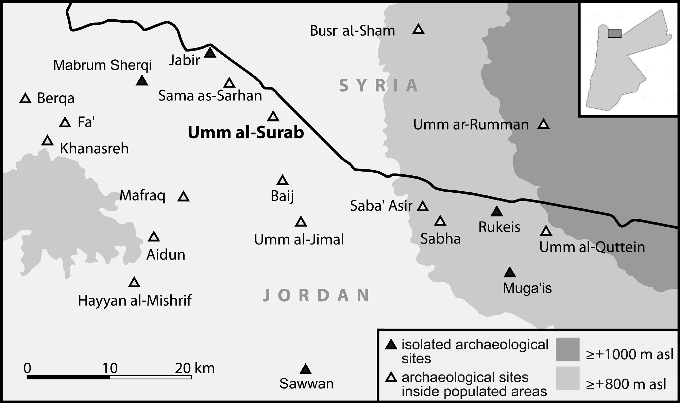
Figure 1. Localization of the village of Umm as-Surab in the context of the Jordanian Ḥawrān. (from: Anastasio, Gilento, Parenti 2016 [3]).
The village of Umm as-Surab, in Northern Jordan, is a site of about 17 ha that lies about 13 km north-east from Mafraq and 80 km north from Amman. In this village the building archaeology was applied to a religious complex, identified as Topographical Unit 28 (hereafter TU28), that includes the church of the Saints Sergius and Bacchus, founded in 489 AD, and some rooms adjacent to the north side of the religious building, interpreted as a monastery (Figure 2).
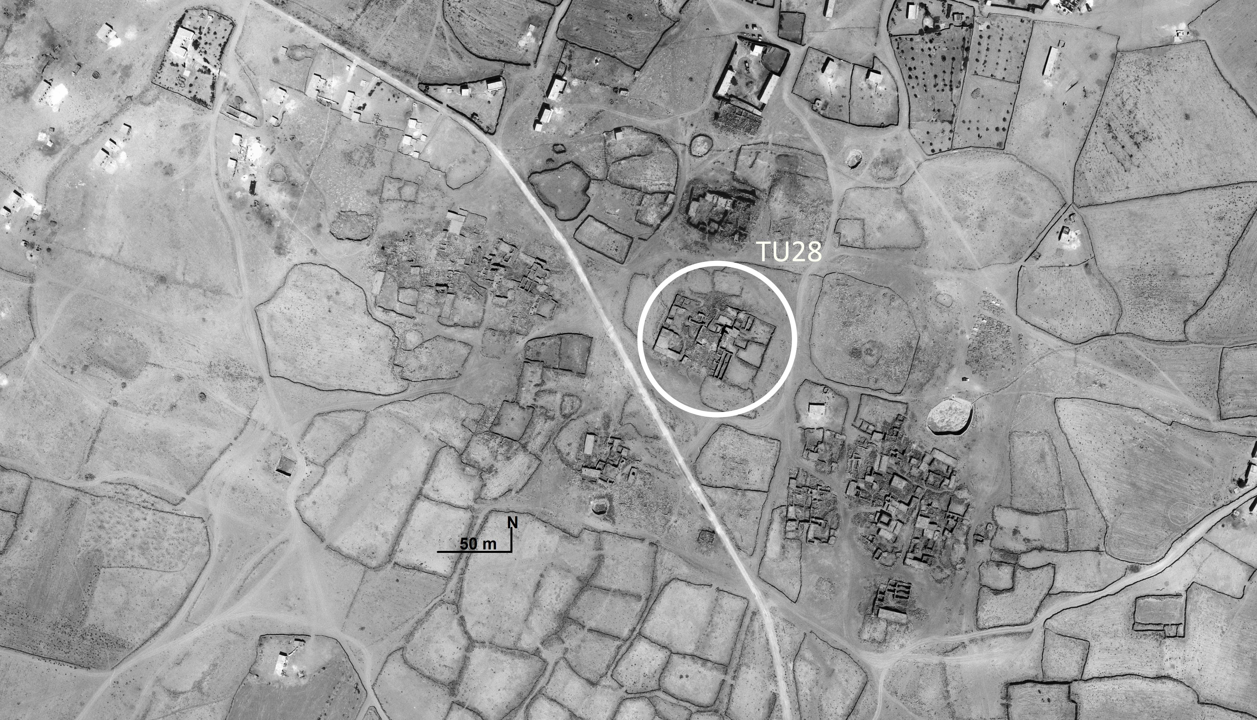
Figure 2. Aerial view of the village of Umm as-Surab with the localisation of TU28. Image by the Spanish Archaeological Mission in Jordan, flight 1978 (credit by Antonio Almagro).
The investigation is part of a wider research project on the building techniques used in the past centuries in the Mediterranean area (i.e. ACTECH project, G.A. 703829, founded by a Marie Skłodowska-Curie fellowship) and was focused on the characterisation and analysis of the mortars used in the religious complex. The research aimed at answering various research questions regarding the construction technologies and the history of the buildings. In particular, the investigation focused on the study of the bedding mortars in the church of the two Saints and in the adjacent rooms with the aim to acquire useful information for an absolute chronology of the structures. A further aim was to broaden the knowledge on the historical use of the building materials in Jordanian Ḥawrān, which so far has only been studied in the nearby village of Umm al-Jimāl [4, 5]. This information will help creating chronologically organised typologies for the mortars at regional level, that can be used for both, dating and conservation purposes.
Historical-constructive evolution of the church of Saints Sergius and Bacchus

The first systematic study of the village of Umm as-Surab was carried out by the American scholar Howard Crosby Butler between 1904 and 1905 when, leading the Princeton Archaeological Expedition to Syria, he visited and recorded the entire area of southern Ḥawrān [6]. On that occasion a measured survey of the church of the Saints Sergius and Bacchus was carried out, together with a precious photographic shot of the interior.

In the 1980’s the English researcher G.R.D. King carried out a new detailed survey of the village, producing a new plan of the church and a detailed architectural study of the complex, for which he suggested new interpretations [7]. Moreover, he identified other two apsidal buildings, only mentioned by Butler, which were definitively interpreted as churches.
The church of Saints Sergius and Bacchus has an east-west orientation and a basilica plan subdivided into three naves supporting galleries on both sides with Doric and Ionic columns. An apse 4 m deep, occupies the centre of the east side and is flanked to the north and south by two quadrangular rooms, respectively, the prothesis and diachonicon. A tower built above the prothesis in the north-eastern corner of the church, dominates the whole building and strongly marks out its overall appearance (Figure 3). Butler suggested that the tower was built together with the church in 489 AD and also highlighted some changes to the fabric of the building that date back to the Islamic era [6]. Subsequently, King confirmed that the church was subjected to important changes in the Islamic era and suggested that the tower and the wall closing the apse were part of an Islamic-era remodelling. According to this interpretation, the tower was probably used as a minaret and not as a bell tower [7].
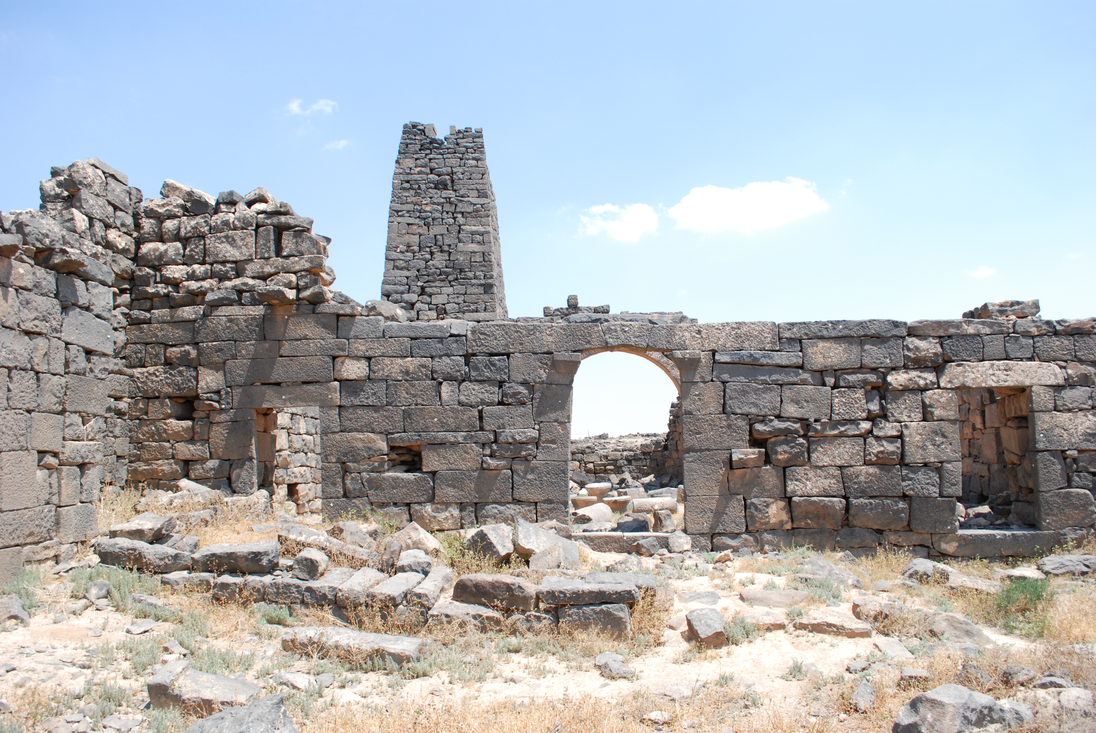
Figure 3. The façade of the church of SS. Sergius and Bacchus (photo by Piero Gilento, 2017).
The stratigraphic analyses of the standing remains, carried out between 2009 and 2012, led to the identification of at least 7 construction phases as highlighted in Figure 4 and described in Table 1 [3, 8]. Substantial modifications to the buildings were probably made after the Islamic conquest. These affected the entire volume of the complex and included the construction of the tower-minaret [9]. In the Islamic period, the church was transformed into a mosque with a high tower for the call to prayer. Significant evidence of this change in the cult are the wall closing off the apse, a possible blocking of the western entrances, and the opening of a new entrance on the northern side of the apse via the courtyard [3, 9].
Table 1. List of the construction phases identified for the church of the SS Sergius and Bacchus.
Construction phase | Chronology | Characteristics
1 | Late Roman / Early Byzantine | Prior the construction of the church, a previous structure existed. Its traces are still visible, especially in the northern court of the complex
2 | Byzantine / Late Byzantine | The two main building elements (BE) of TU 28 were built: the church of the Saints Sergius and Bacchus (BE 1) and another building on the south-western corner (BE 2)
3 | Byzantine / Late Byzantine | The northern court and part of the façade were renewed
4-5 | Islamic | Significant modification to the church of the Saints Sergius and Bacchus: a large part of the north-eastern side of the church and the prothesis were demolished (or collapsed), and a tower (BE 4) was built
6 | Modern | Several construction activities were carried out, corresponding to the Druze occupation
7 | Contemporary | Recent conservation works were carried out by the Department of Antiquities
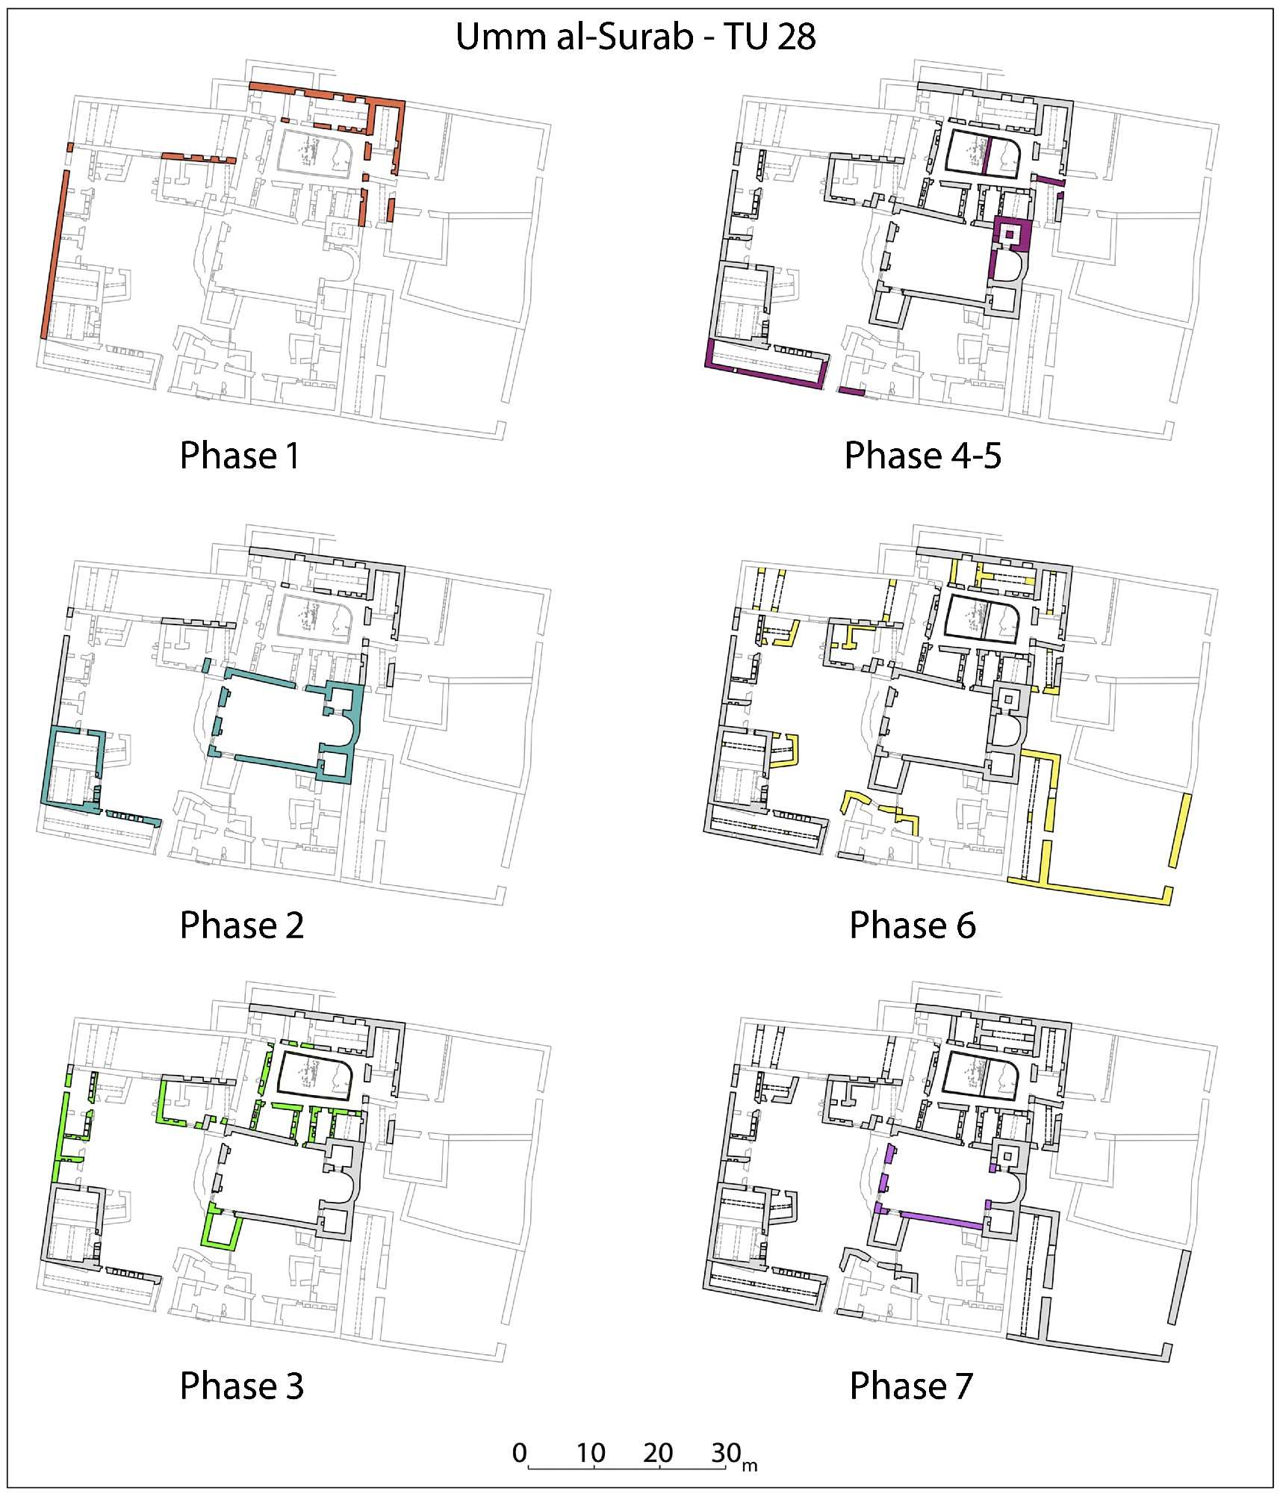
Figure 4. The seven building phases of TU28 (Anastasio, Gilento, Parenti 2016 [3])
Mortar analysis
To further investigate the above mentioned construction phases and provide an initial description of the construction materials and technologies used in the various phases, seven mortar samples were collected and sent to Northumbria University for chemical and mineralogical analysis. The samples included bedding and coating mortars from both, the church and the adjacent rooms. A list of samples is provided in Table 2 whereas the sampling points are highlighted in Figure 5. The sampling was based on the stratigraphic analysis of the different construction phases of the walls and of the buildings. Combination of the results of the archaeometric analyses with the results of the stratigraphic analysis allows us to obtain significant data associated to the historical evolution of the fabric.
Table 2. List of the seven mortar samples analysed and related information.
Sample | Construction phase - Chronology | Feature
S_M_28_1 | Phase 2 - Byzantine | Mortar between the two lintels of the door on the second level above room 9
S_M_28_3 | Phase 3 - Late Byzantine / Islamic | Room 15, eastern door jamb
S_M_28_2 | Phase 4-5 - Islamic | Room 15, east wall, mortar filling the joints
S_M_28_4 | Phase 4-5 - Islamic | Mortar between the joints of the voissoirs of the pointed arch n.2 of the cistern in the court n. III
S_M_28_5 | Phase 4-5 - Islamic | Plaster on the southern part of the arch n.3 of the cistern in the court n. III
S_M_28_6 | Phase 4-5 - Islamic | Mortar in the central pillar of the staircase of the tower-minaret
S_M_28_7 | Phase 4-5 - Islamic | Plaster on the exterior eastern wall of the tower-minaret
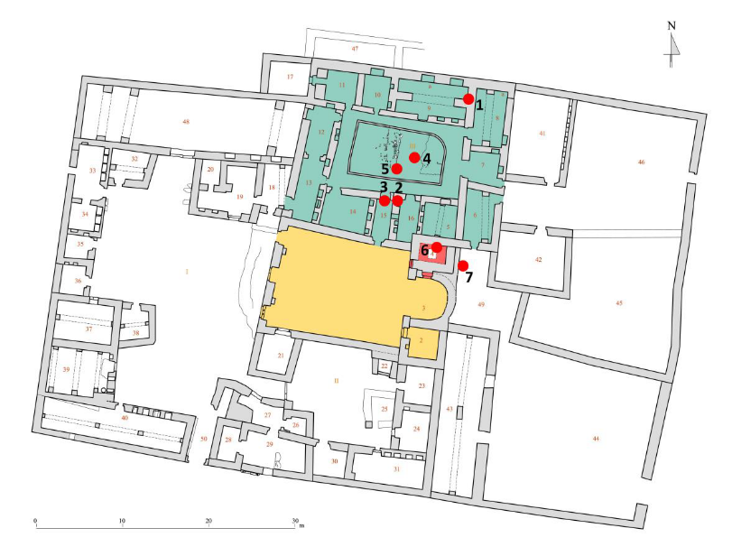
Figure 5. Plan of Topographical Unit 28 in yellow the church and in green the monastery and the localisation in red spots of the seven mortar samples (modified by Piero Gilento and Sara Peñalver Martin, 2018).
Materials and methods
The macroscopic characteristics of the samples were investigated by observing the samples as received and fresh fractures under a Leica S6 D stereomicroscope equipped with a Leica digital camera, at low magnification (i.e. 10x) using incident visible light.
Micro-morphological characterisation of the binder and aggregate in each sample was carried out using a Tescan Mira 3 Scanning Electron Microscope (SEM) in high vacuum mode, equipped with an Energy-Dispersive X-ray spectrometer (EDX) for elemental analysis. A fresh broken surface of each sample was observed. Prior to analysis, the surface was coated with a 5nm-thick Platinum layer.
Mineralogical characteristics of the mortars were investigated using the X-Ray Diffraction analysis (XRD). Each sample was grinded using an agate mortar and pestle and sieved to obtain a powder of <250 µm diameter particles. The samples were, then, analysed with a Siemens D5000 diffractometer with Cu-K_{α} radiation as X-ray source, 2-ϑ range of 2-70 degrees with an increment of 0.02/step and scan speed of 1 sec/step, at 40 KV and 40 mA. Interpretation of diffractograms for qualitative analysis was carried out using the reference included in the EVA software database and in the RRUFF mineral database [10]. A quantitative analysis was carried out on sample SM-28-6, which was prepared as described above and subsequently mixed with 10%w/w of ZnO powder, used as internal standard. Quantification of compounds was performed through software Profex and the optimised fit was accepted when a value of χ² < 1.6 was obtained [11].
Results and discussion
Macroscopic characteristics
At the optical microscope the samples showed very different characteristics (Figure 6). Sample SM-28-1 (Figure 6a) exhibited a grey-brownish porous matrix. This appeared inhomogeneous, with white, grey and dull red ochre areas with no clear border between each other, suggesting that the mortar was produced with different mixtures, mixed together while still fresh. The natural aggregate is made of sub-rounded particles of ~1 mm Ø. Black particles with irregular shape and size from 0.1 mm to 1.5 mm Ø are visible. Sample SM-28-2 (Figure 6b) showed a more compact white matrix and sub-rounded aggregate with particles size between 0.1 mm and 1.5 mm. In Figure 6c a fresh fractured of the SM-28-3 is showed highlighting the red vivid matrix. At a higher magnification, it was observed that the matrix is homogeneous and that the red colour is not due to the addition of a specific pigment, but it is likely to be due to the binder itself, possibly because of the nature of the lime used in the mortar. Several charcoals particles of various size (0.1-2.5 mm Ø) were observed in the sample. Sample SM-28-7 (Figure 6d) showed a white compact matrix with very few aggregate particles with size between 0.1 mm and 0.5 mm. Red coloured fragments embedded in the sample showed the characteristics of a mortar sample, probably crushed and reused as aggregate. Several organic fibres embedded in the mixture are highlighted by the red arrows in Figure 6d. Sample SM-28-4 (Figure 6e) showed a white-brownish matrix, sub-angular natural aggregate and sub-rounded particles, probably fragments of an older mortar that was crushed and reused as an aggregate. SM-28-6 (Figure 6f) showed a similar matrix to SM-28-4. The samples is characterised by sub-rounded aggregate particles of 0.1mm-3 mm Ø.
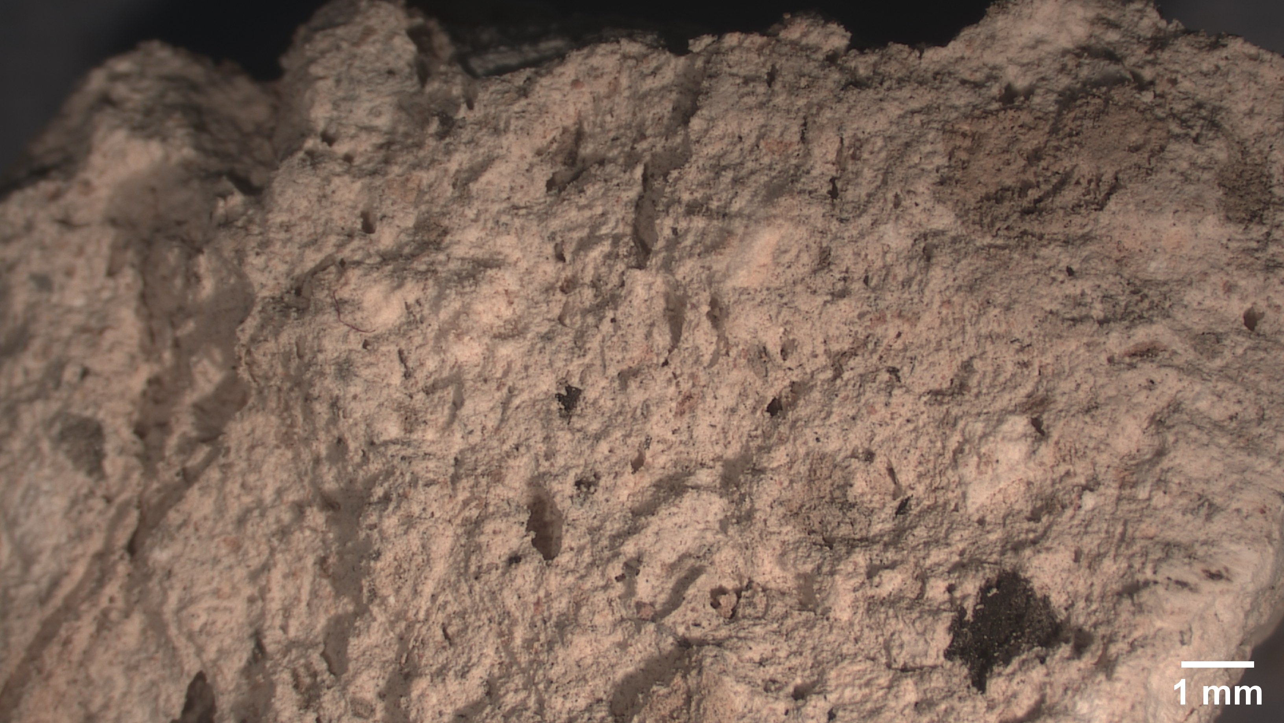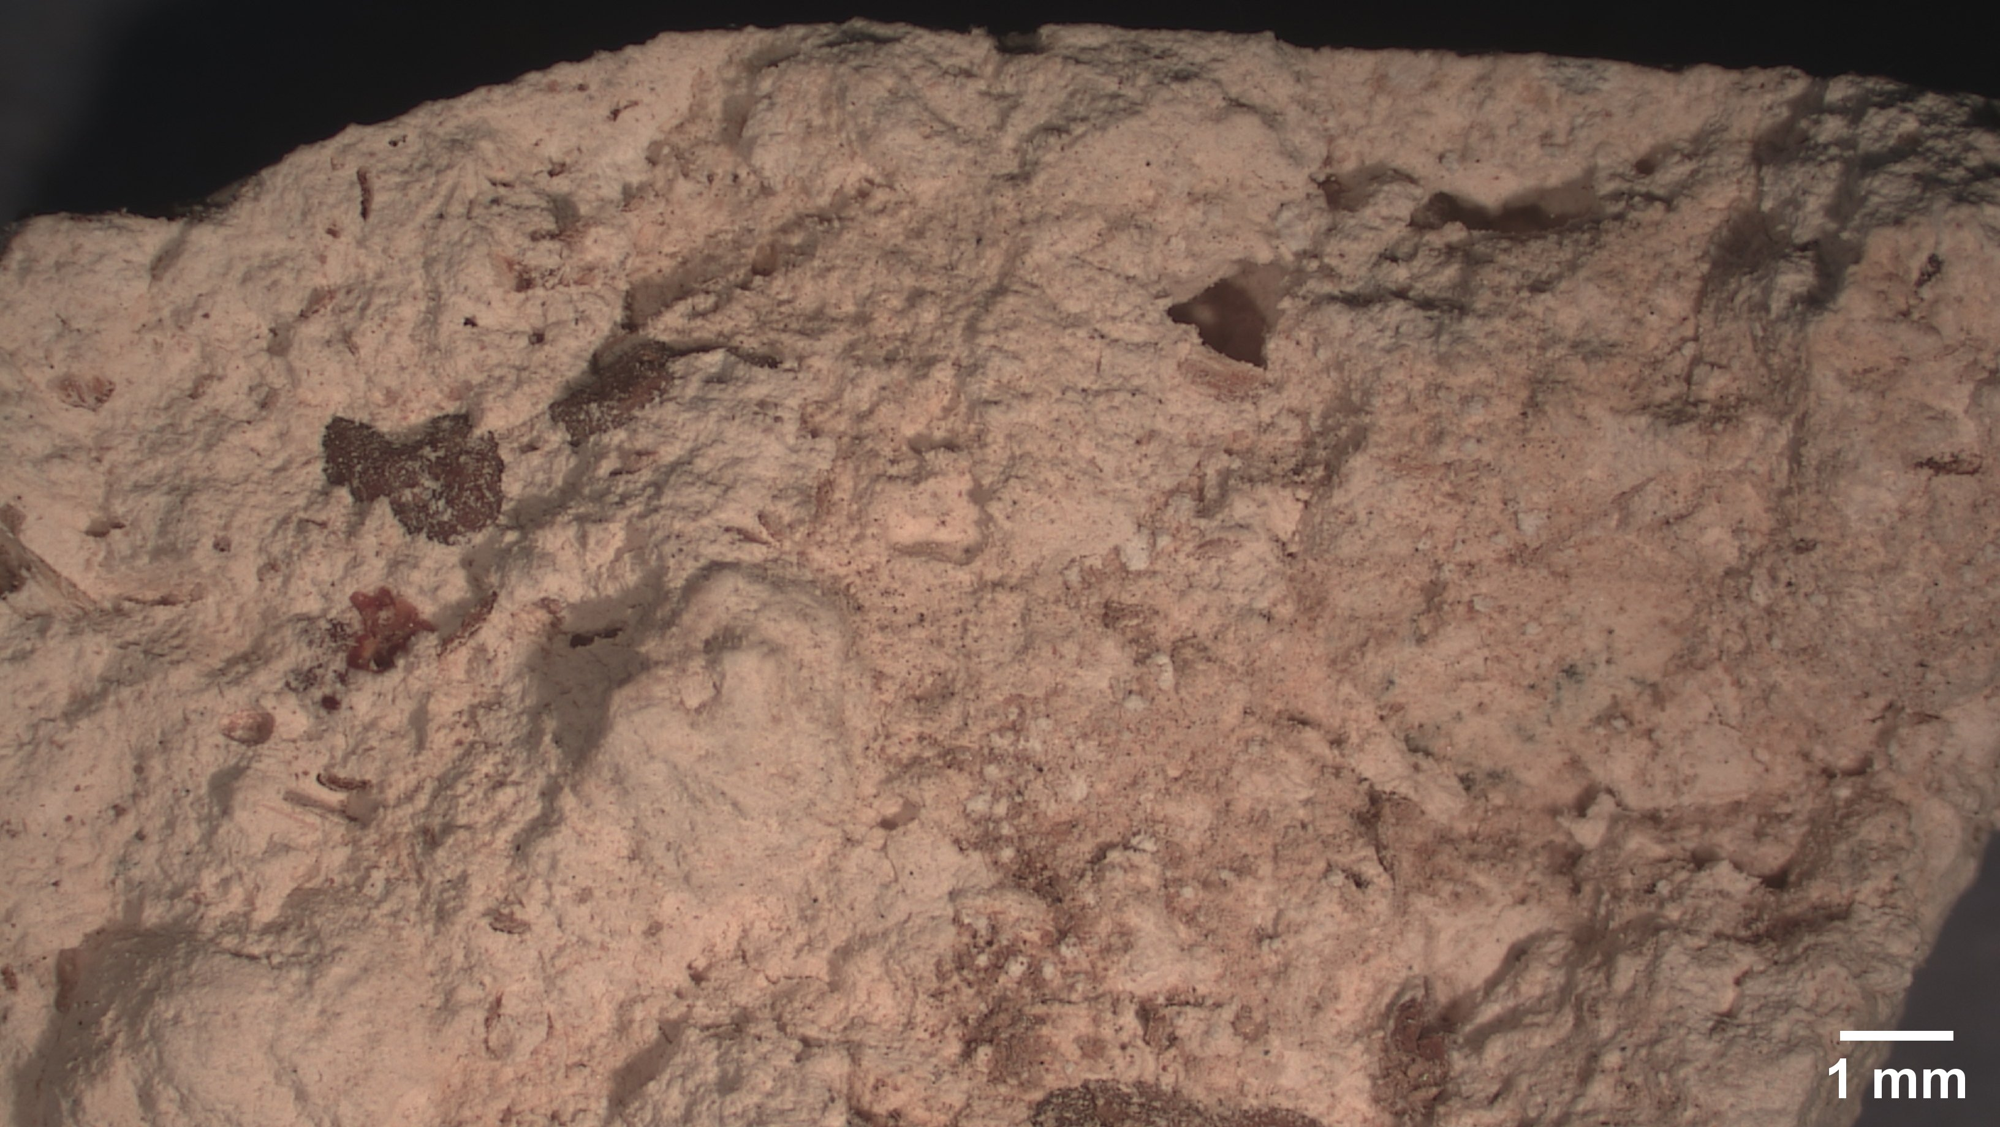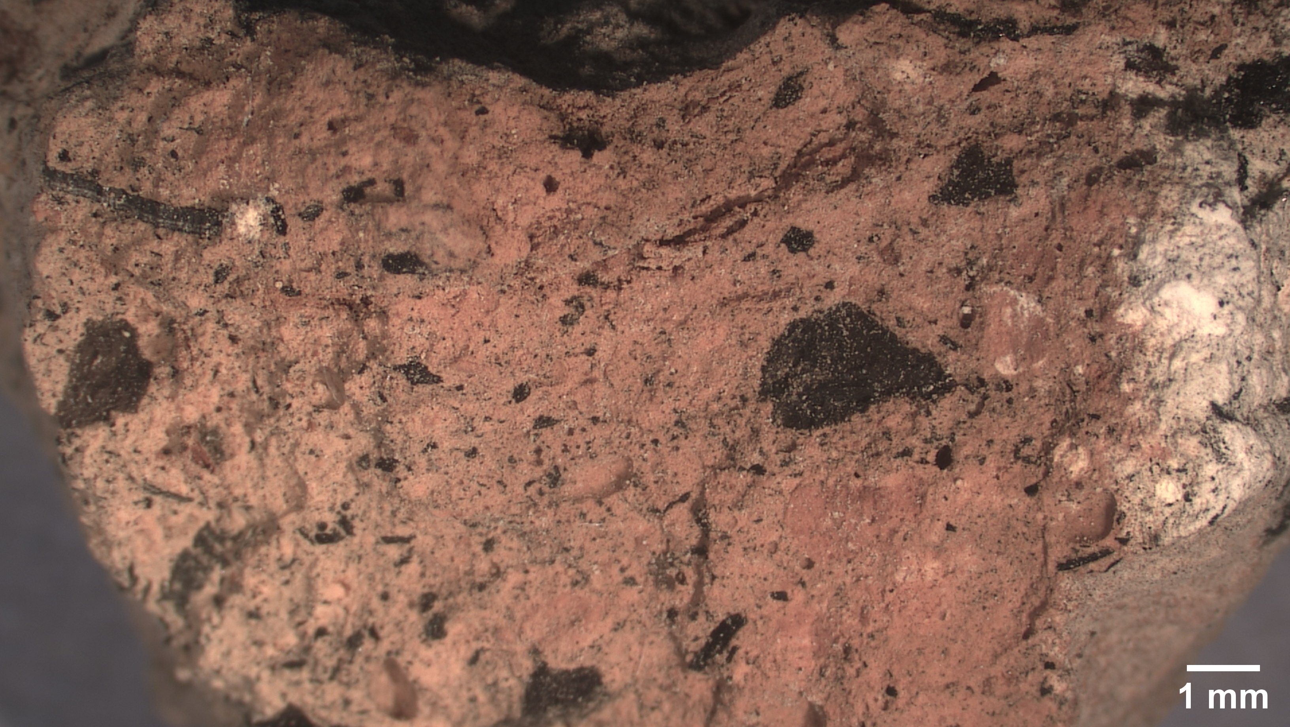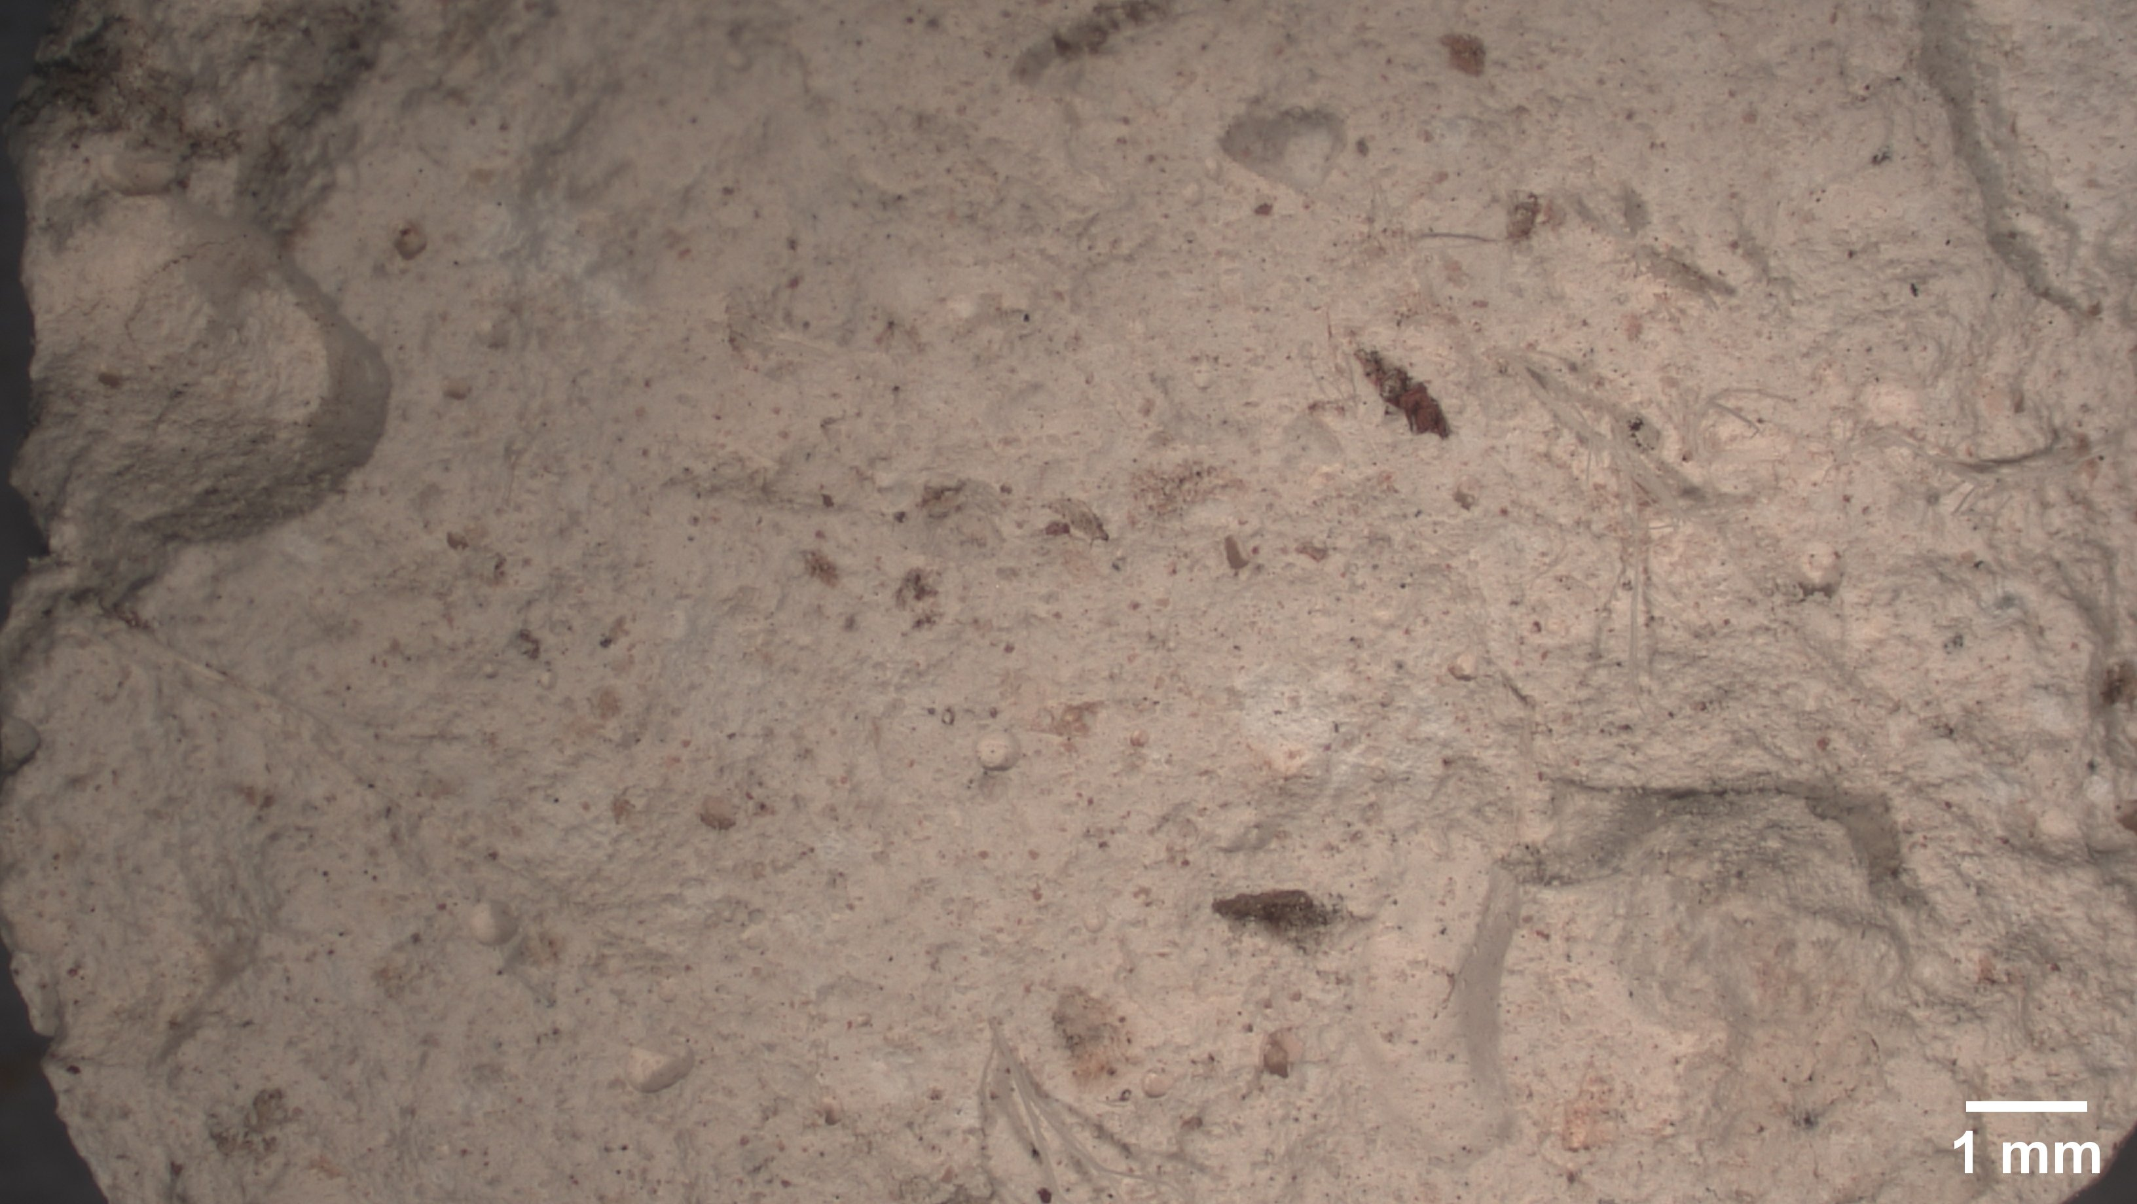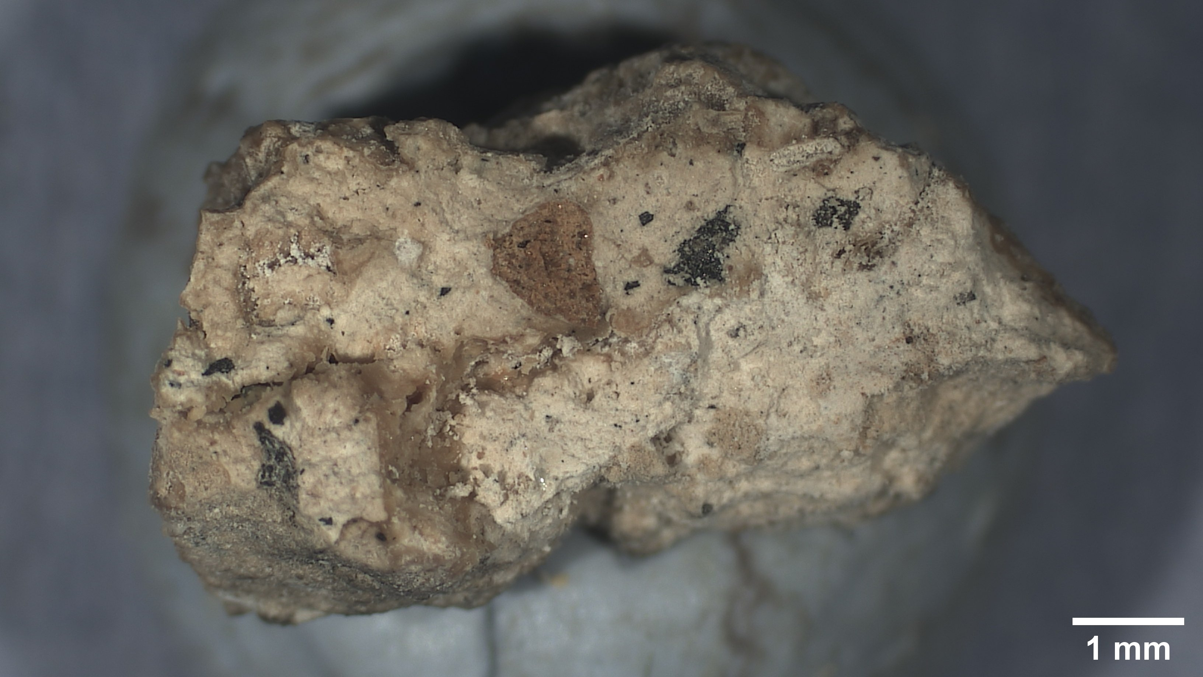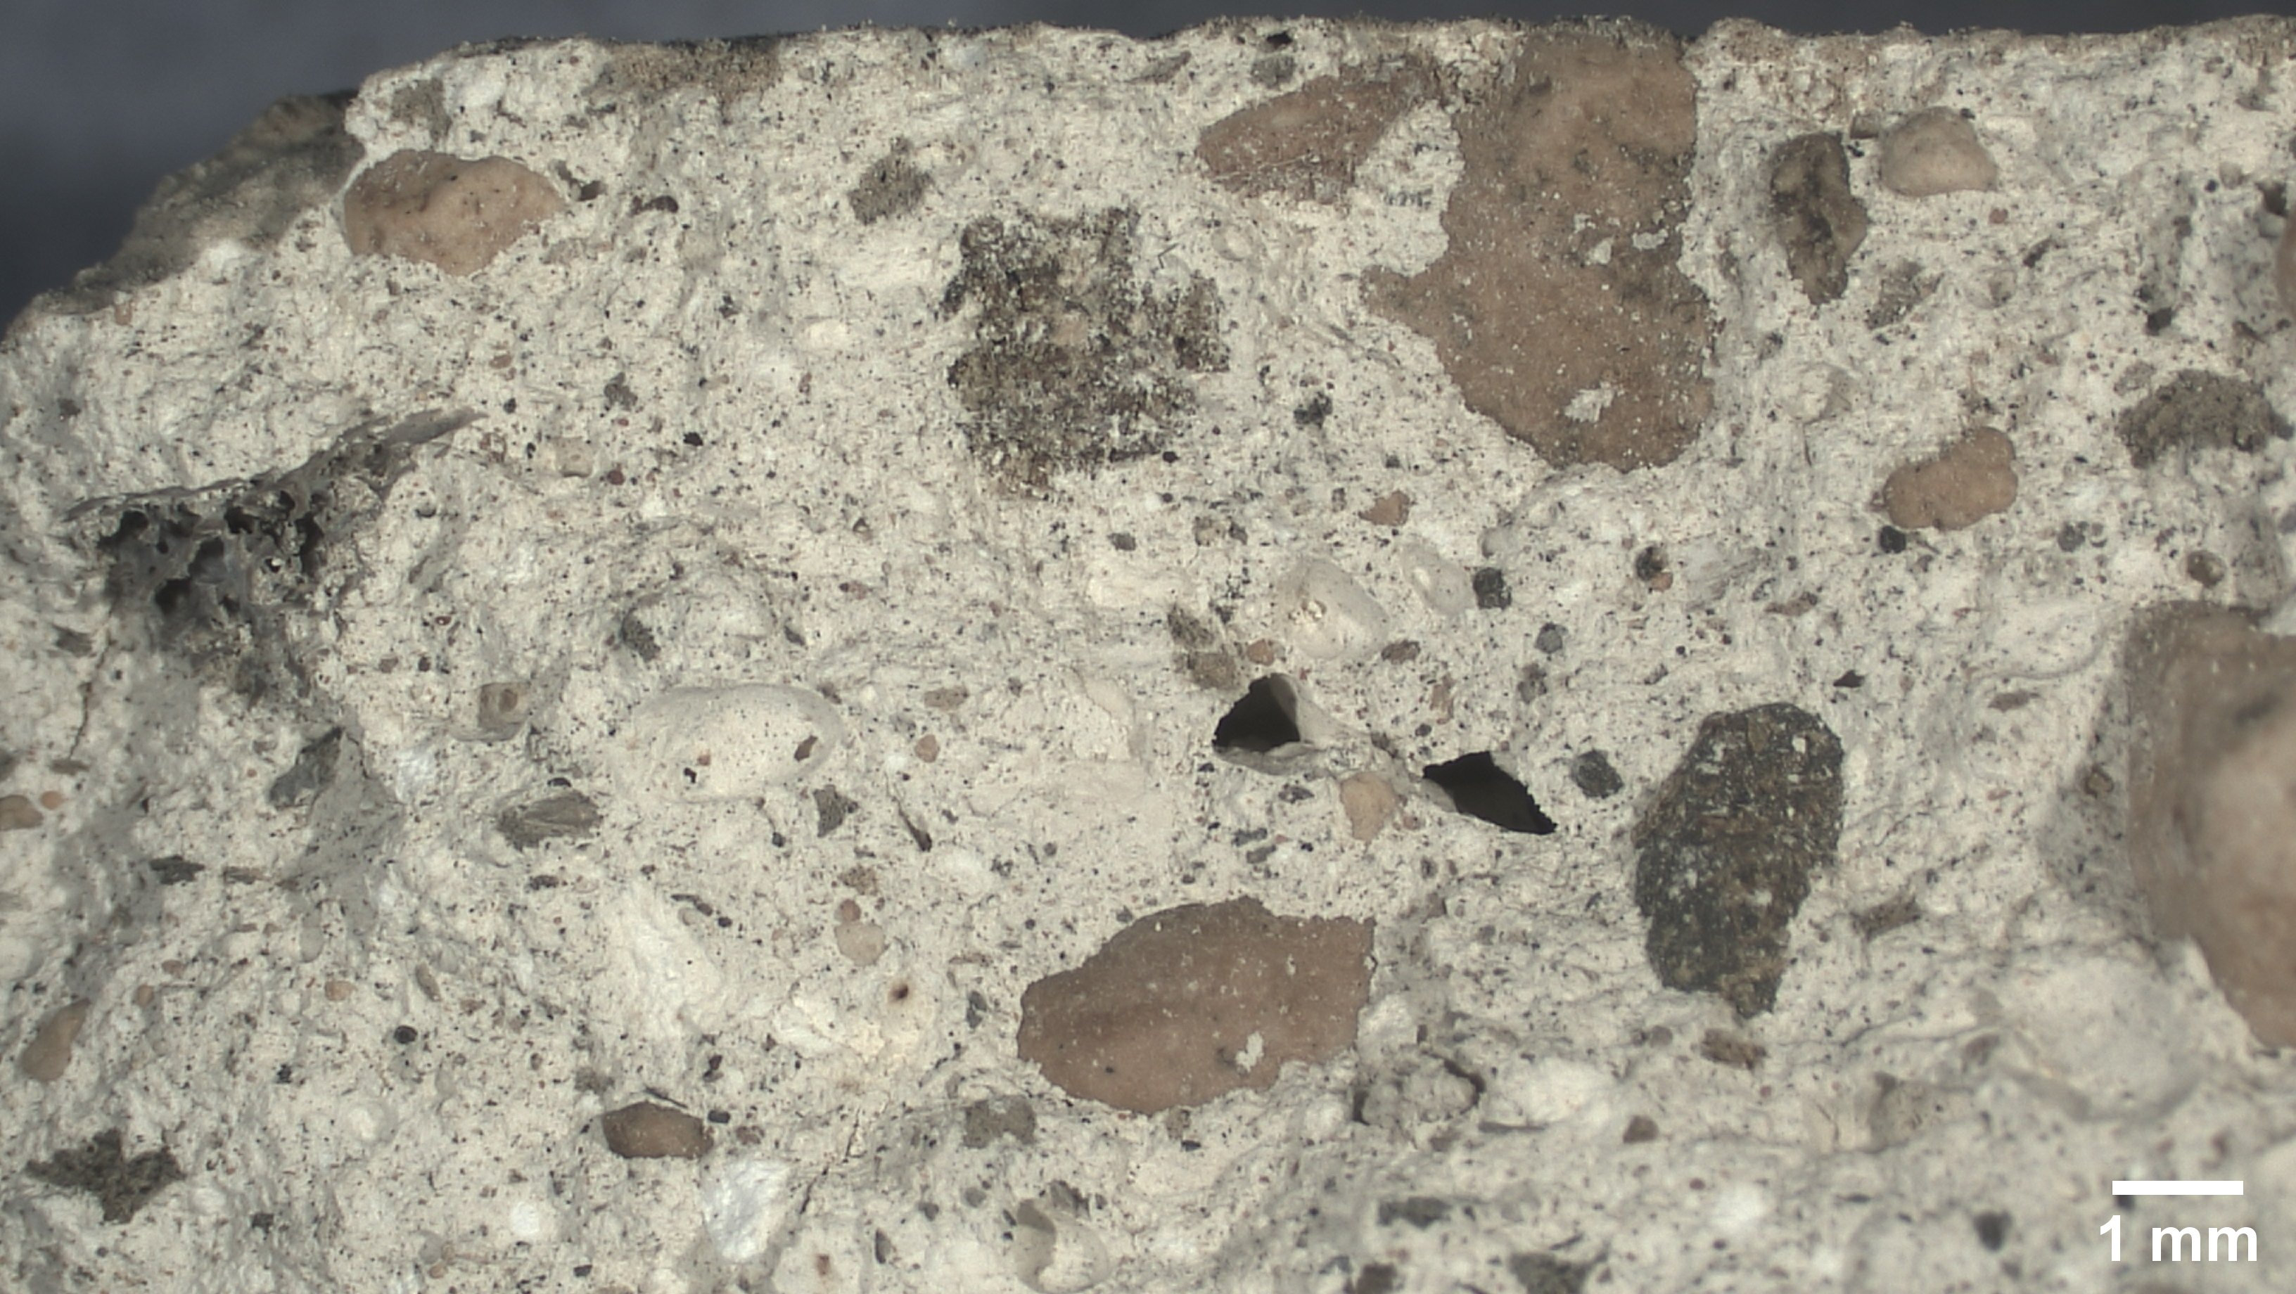
b
c
d
e
f
a
Figure 6. Stereomicroscope images of fresh surfaces of the samples SM-28-1 (a), SM-28-2 (b), SM-28-3 (c), SM-28-7 (d), SM-28-4 (e), and SM-28-6 (f).
X-Ray Diffraction analyses
Results of the X-ray diffraction analysis are summarised in Table 3 where the main mineralogical phases are listed with the related estimated amount based on the relative peak height. Calcite was the dominant crystalline phase in all samples, suggesting that all mortars were produced using lime as main binder. Gypsum was identified in samples SM-28-2, SM-28-3, and SM-28-7, either as binder and/or as aggregate. The presence of gypsum as binder might explain the more compact appearance previously observed at the stereomicroscope of these samples compared to sample SM-28-1 [12]. Quartz was found in samples SM-28-1, SM-28-3, SM-28-4 and SM-28-7, and only in traces in SM-28-2. The lack of quartz in the latter sample might support the hypothesis of use of gypsum as binder, since gypsum-containing mortars are characterised by a reduced shrinkage upon setting compared to lime-based mortar. Therefore the addition of aggregate to these mortars held no further benefit [13, 14]. Halite was found in samples SM-28-2, SM-28-3, and SM-28-4. This mineral is commonly associated with the presence of gypsum (although gypsum was not detected in all samples containing halite) [15]. Aragonite was found abundant in SM-28-7 and in traces in SM-28-6. Its formation could have been fostered by the high concentration of sulphates in the sample [16]. Results of the quantitative analysis on sample SM-28-6 are illustrated in Table 3. The main mineral phase is calcite (60%) with subsequent aragonite (11.62%), quartz (2.63%) and halite (0.16%). A significant amount of amorphous phase has been identified, which can be due to various reasons such as a microcrystalline fraction and charcoal fragments.
Table 3. Results of the X-Ray diffraction analysis with an estimation of the abundance of the mineralogical phases based on the relative peak height. Key: +++ = dominant; ++ = abundant; + = present; traces; — = absent
Sample | Calcite | Quartz | Gypsum | Halite | Aragonite
SM-28-1 | +++ | ++ | — | — | —
SM-28-2 | +++ | traces | + | + | —
SM-28-3 | +++ | + | + | + | —
SM-28-4 | +++ | + | — | + | —
SM-28-6 | +++ | + | — | traces | +
SM-28-7 | +++ | + | ++ | — | ++

Table 4. Amount of minerals found in sample SM-28-6 by XRD.
Mineral | %w/w | SD
Calcite | 60 | 2
Quartz | 2.63 | 0.28
Aragonite | 11.62 | 0.73
Halite | 0.16 | 0.13
Amorphous phase | 25.6 | 2.4
SEM-EDX analyses
Results of the analyses with the SEM and EDX suggest a substantial presence of calcium carbonate. Other elements such as Si, Al, Mg, Na, Cl, Fe and K are also detected. In SM-28-1, point analysis on the binder shows a dominant signal of O, Ca and C, followed by Si, Mg, Al, K, Na, and traces of Fe, which might be accountable for the slight ochre colour of the binder. In the same sample, glassy inclusions made of almost exclusively Si and O were found embedded in the binder, along with silico-aluminates fragments. In SM-28-3 the several black fragments observed at the optical microscope (Figure 6c) were confirmed to be charcoal by both its microstructure (Figure 7) and by the EDX spectrum, which showed C as dominant element (Figure 8) [17]. Within the lime binder, sulphur-rich areas were found with micritic, aligned laminar crystals ascribable to gypsum [18].
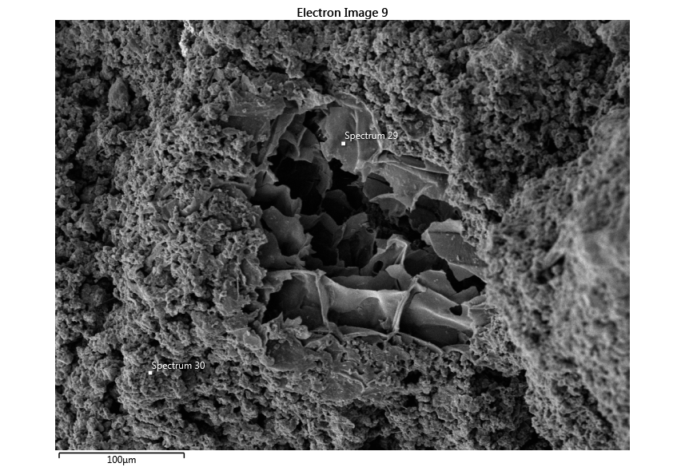
Figure 7. SEM image of a charcoal aggregate embedded in the carbonate-based binder of sample SM-28-3.
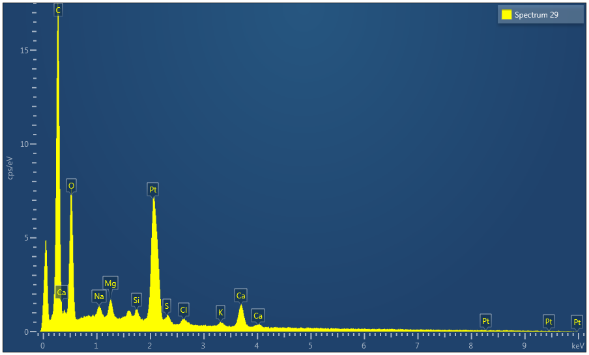
Figure 8. Point EDX measurement of a charcoal fragment in sample SM-28-3.
In samples SM-28-2 and SM-28-7 pseudo-prismatic gypsum crystals (1-10 µm sized) were found within the carbonate-based binder (Figure 9). Gypsum crystals were bigger than CaCO₃ crystals, most likely as a consequence of their higher susceptibility to dissolution and recrystallization processes during long-term weathering, due to their higher solubility with respect to CaCO₃ [19].
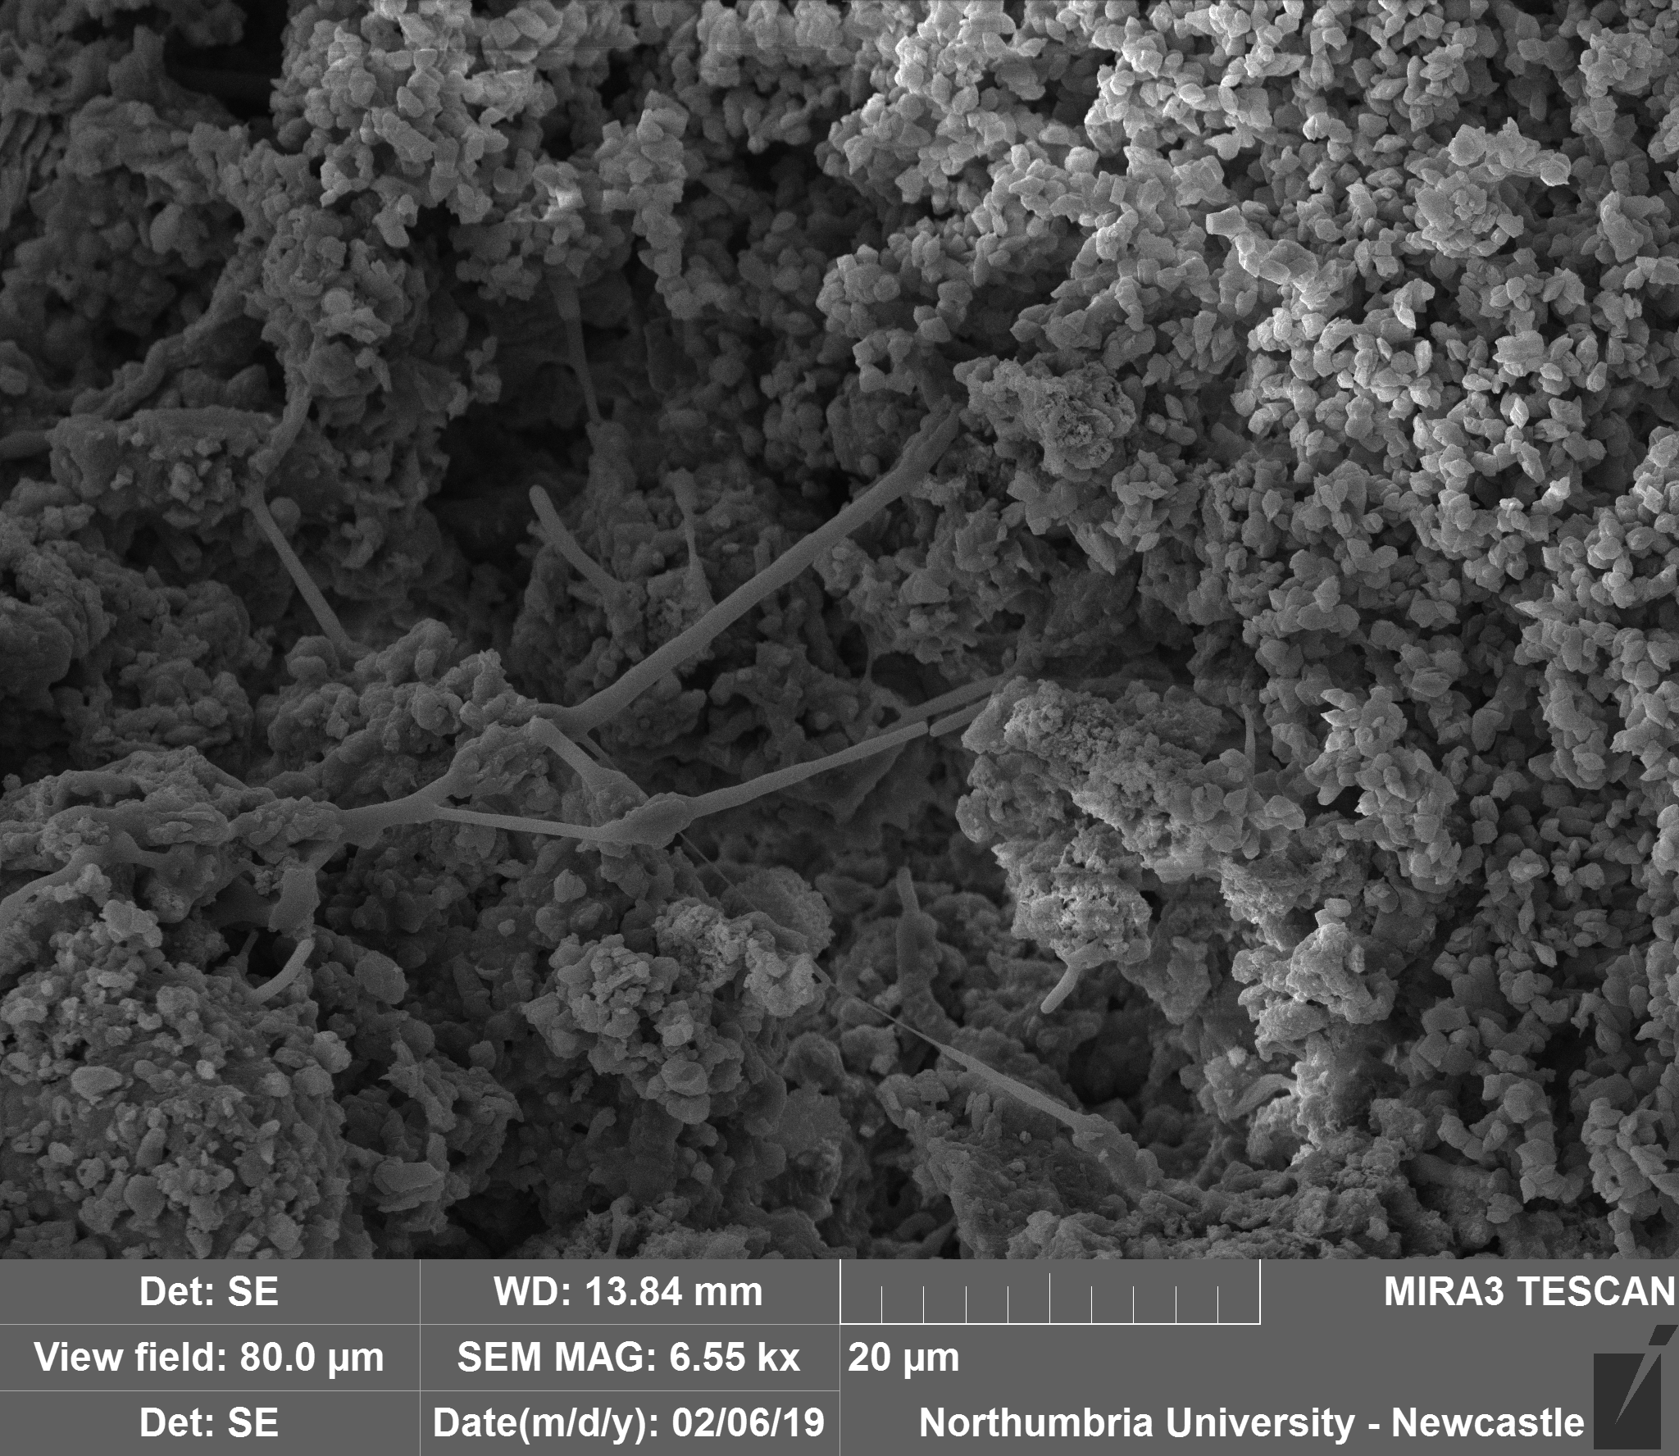
Gypsum
CaCO₃
Figure 9. SEM image of the binder in sample SM-28-2.
In sample SM-28-7, abundant acicular crystals embedded in the binder were found (Figure 10.). Point EDX investigations on such crystals showed similar peaks to those of the surrounding binder, i.e. mainly O, C, and Ca, suggesting that these crystals are aragonite, a polymorph of CaCO₃ that can precipitate along with calcite in Mg²⁺ and SO₄²⁻ -rich solutions [16, 20].
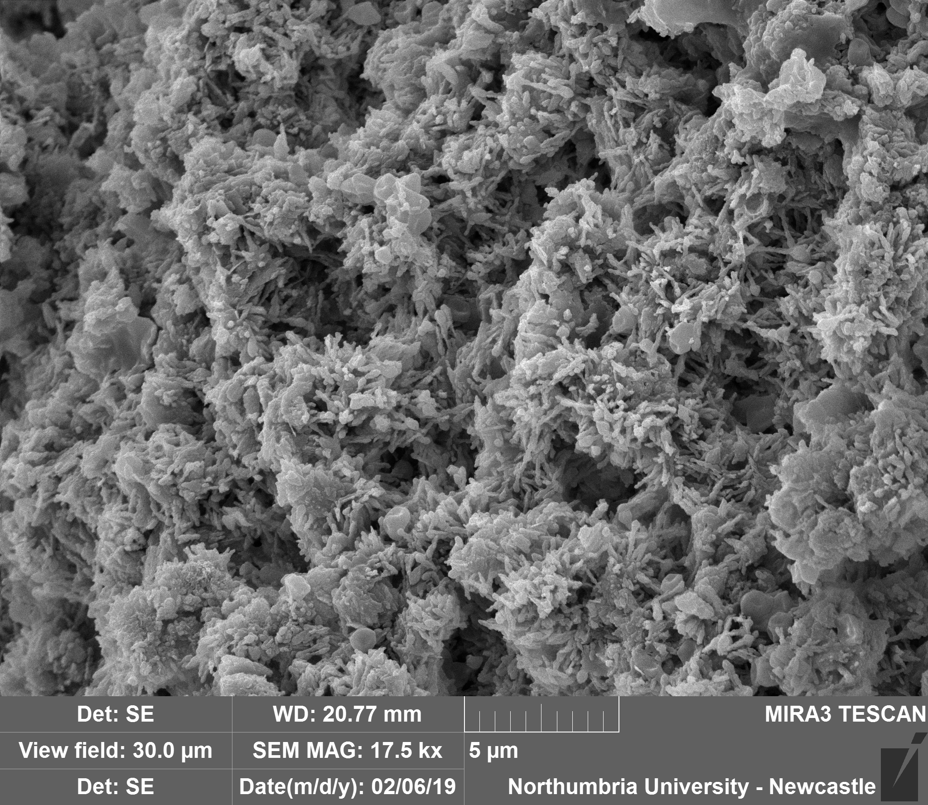
Figure 10. SEM image of the binder of sample SM-28-7. Needle-like crystals of aragonite are found within rombohedral calcite crystals.
Conclusions
Based on the results of both, the stratigraphic analysis and the laboratory analyses, the mortar samples described in this paper could be divided into 4 groups, detailed in Based on the results of both, the stratigraphic analysis and the laboratory analyses, the mortar samples described in this paper could be divided into 4 groups, detailed in Based on the results of both, the stratigraphic analysis and the laboratory analyses, the mortar samples described in this paper could be divided into 4 groups, detailed in Based on the results of both, the stratigraphic analysis and the laboratory analyses, the mortar samples described in this paper could be divided into 4 groups, detailed in Error: Reference source not found. Group I (sample SM-28-1), considering its provenance within the religious complex, can be defined as the most ancient of all analysed samples. It dates back to the byzantine period, during which the church and the adjacent rooms were built. The mortar is characterised by a lime-based binder with a high content of siliceous aggregate, as typical of the byzantine tradition [4, 21, 22]. Groups II and III include mortars produced in a later period and based on a mixture of lime and gypsum. In group II (SM-28-3), which dates back to the late byzantine/Islamic period, the mortar is part of a doorframe and is characterised by a red-coloured binder based on a mixture of lime, gypsum and abundant charcoal. Group III (SM-28-2, SM-28-7) dates back to the Islamic period and, considering the provenance of the sample (), the mortars had a decorative function that seems to be reflected by their composition. Both mortars, in fact, are characterised by a binder made of a mixture of lime and gypsum, and by a very low content of siliceous aggregate. Group IV (SM-28-4, SM-28-6) also dates back to the Islamic period. The mortars of this group have a structural function and are based on lime as a binder, with inclusions of siliceous sand and mortar fragments as aggregate.. Group I (sample SM-28-1), considering its provenance within the religious complex, can be defined as the most ancient of all analysed samples. It dates back to the byzantine period, during which the church and the adjacent rooms were built. The mortar is characterised by a lime-based binder with a high content of siliceous aggregate, as typical of the byzantine tradition [4, 21, 22]. Groups II and III include mortars produced in a later period and based on a mixture of lime and gypsum. In group II (SM-28-3), which dates back to the late byzantine/Islamic period, the mortar is part of a doorframe and is characterised by a red-coloured binder based on a mixture of lime, gypsum and abundant charcoal. Group III (SM-28-2, SM-28-7) dates back to the Islamic period and, considering the provenance of the sample (Table 2), the mortars had a decorative function that seems to be reflected by their composition. Both mortars, in fact, are characterised by a binder made of a mixture of lime and gypsum, and by a very low content of siliceous aggregate. Group IV (SM-28-4, SM-28-6) also dates back to the Islamic period. The mortars of this group have a structural function and are based on lime as a binder, with inclusions of siliceous sand and mortar fragments as aggregate.. Group I (sample SM-28-1), considering its provenance within the religious complex, can be defined as the most ancient of all analysed samples. It dates back to the byzantine period, during which the church and the adjacent rooms were built. The mortar is characterised by a lime-based binder with a high content of siliceous aggregate, as typical of the byzantine tradition [4, 21, 22]. Groups II and III include mortars produced in a later period and based on a mixture of lime and gypsum. In group II (SM-28-3), which dates back to the late byzantine/Islamic period, the mortar is part of a doorframe and is characterised by a red-coloured binder based on a mixture of lime, gypsum and abundant charcoal. Group III (SM-28-2, SM-28-7) dates back to the Islamic period and, considering the provenance of the sample (Table 2), the mortars had a decorative function that seems to be reflected by their composition. Both mortars, in fact, are characterised by a binder made of a mixture of lime and gypsum, and by a very low content of siliceous aggregate. Group IV (SM-28-4, SM-28-6) also dates back to the Islamic period. The mortars of this group have a structural function and are based on lime as a binder, with inclusions of siliceous sand and mortar fragments as aggregate.. Group I (sample SM-28-1), considering its provenance within the religious complex, can be defined as the most ancient of all analysed samples. It dates back to the byzantine period, during which the church and the adjacent rooms were built. The mortar is characterised by a lime-based binder with a high content of siliceous aggregate, as typical of the byzantine tradition [4, 21, 22]. Groups II and III include mortars produced in a later period and based on a mixture of lime and gypsum. In group II (SM-28-3), which dates back to the late byzantine/Islamic period, the mortar is part of a doorframe and is characterised by a red-coloured binder based on a mixture of lime, gypsum and abundant charcoal. Group III (SM-28-2, SM-28-7) dates back to the Islamic period and, considering the provenance of the sample (Table 2), the mortars had a decorative function that seems to be reflected by their composition. Both mortars, in fact, are characterised by a binder made of a mixture of lime and gypsum, and by a very low content of siliceous aggregate. Group IV (SM-28-4, SM-28-6) also dates back to the Islamic period. The mortars of this group have a structural function and are based on lime as a binder, with inclusions of siliceous sand and mortar fragments as aggregate.
Table 5. Clustering of samples with common characteristics.
Group | Sample | Phase-Period - Building Archaeology | Localisation | Binder colour | Gypsum | Type of aggregate | Organic fibers
I | SM-28-1 | Byzantine | Mortar between the two lintels of the door on the second level above room 9. | Light brownish grey with darker spots | Absent | Sub-rounded silica-aluminates fragments (very abundant) | Absent
II | SM-28-3 | Late Byzantine / Islamic | Room 15, right side of the doorframe. | Red | Present | Charcoals (dominant) and silica-aluminates fragments (abundant) | Absent
III | SM-28-2 | Islamic | Room 15, wall east, pointing mortar. | White | Present | Sub-rounded silica-aluminates fragments (scarce) | Absent
III | SM-28-7 | Islamic | Plaster on the exterior eastern wall of the minaret. | White | Abundant | Sub-rounded silica-aluminates fragments and mortar fragments (both scarce) | Abundant
IV | SM-28-4 | Islamic | Bedding mortar of the voissoirs of the pointed arch n.2 of the cistern in the court n. III | Light grey | Absent | Sub-rounded silica-aluminates fragments and mortar fragments (both abundant) | Absent
IV | SM-28-6 | Islamic | Mortar in the central pillar of the staircase of the minaret. | Light grey | Absent | Rounded silica-aluminates fragments (very abundant) | Absent
Overall, these results provide an initial description of the materials and technologies used in the church of the Saints Sergius and Bacchus and adjacent rooms, in the village of Umm as-Surab (Northern Jordan). In particular, the analyses confirmed that the complex was built in various periods using a variety of materials, and, at the same time, provided an insight in the cultural and historical context in which the religious complex was built. The results suggest that during the Byzantine period mortars were produced exclusively using lime as a binder, whereas during the Islamic phases mortars with decorative function were produced using a mixture of lime and gypsum as a binder. These information allow a more precise investigation of the chronology of the building and contributes to broaden our knowledge of the material culture in the Ḥawrān region in the past centuries.
References
- Boato A (2008) L’ Archeologia in Architettura. Misurazioni, stratigrafie, datazioni, restauro. Marsilio, Venezia
- Brogiolo GP, Cagnana A (2012) Archeologia dell’ Architettura. Metodi e interpretazioni. All’Insegna del Giglio, Firenze
- Anastasio S, Gilento P, Parenti R (2016) Ancient Buldings and Masonry Techniques in the Southern Hauran, Jordan. Journal of Eastern Mediterranean Archeology and Heritage Studies 4.4:299–320
- Al-Bashaireh K (2016) Use of lightweight lime mortar in the construction of the west Church of Umm el-Jimal, Jordan: radiocarbon dating and characterization. Radiocarbon 58-3:583-598
- Dunn E, Rapp G (2004) Characterization of Mortars and Pozzolanic Materials from Umm al-Jimal. Studies in Conservation 49-3:145-160
- Butler HC (1909) The Southern Haurân. Part 2 Southern Syria. Section A Ancient Architecture in Syria. Princeton University Archaeological Expeditions to Syria in 1904–1905 and 1909 Publications 2. Brill, Leiden
- King GRD (1983) Two Byzantine Churches in Northern Jordan and Their Re-Use in the Islamic Period. Damaszener Mitteilungen 1:111–136
- Gilento P (2014) La Chiesa dei Santi Sergio e Bacco, Umm as-Surab (Giordania). Risultati storico-costruttivi dall’analisi archeologica degli elevati. Arqueología de la Arquitectura 11. doi: http://dx.doi.org/10.3989/arq.arqt.2014.015
- Parenti R (2011) Minareti e campanili. Arkos 24:58–62
- Lafuente B, Downs R T, Yang H, Stone N (2015) The power of databases: the RRUFF project. In: Highlights in Mineralogical Crystallography, T Armbruster and R M Danisi, eds. Berlin, Germany, W De Gruyter, pp 1–30
- Döbelin N (2015) First Steps: Basic Refinement. PROFEX - Open Source XRD and Rietvield Refinement. http://profex.doebelin.org/?page_id=404. Accessed 1 Dec 2018
- Ingham J (2013) Geomaterials Under the Microscope. Mortar, plaster, and render. Academic Press
- Sánchez JA, Barrios J, Barrios A et al (1997) The shrinkage in lime mortars. Materiales De Construcción 47:17–28
- Doleželová M, Krejsová j, Vimmrová A (2018) Influence of fine aggregate on some properties of gypsum mortars. IOP Conf Ser Mater Sci Eng 379
- Boggs S (1987) Principles of Sedimentology and Stratigraphy. Pearson Prentice Hall
- Bots P, Benning LG, Rickaby REM et al (2011) The role of SO4 in the switch from calcite to aragonite seas. Geology 4:331–334
- Kawiak T (1991) Gypsum Mortars from a Twelfth-Century Church in Wiślica, Poland. Stud Conserv 36:142–150
- Bonny S, Jones B (2003) Microbes and mineral precipitation, Miette Hot Springs, Jasper National Park, Alberta, Canada. Can J Earth Sci 40:1483–1500
- Middendorf B (2002) Physico-mechanical and microstructural characteristics of historic and restoration mortars based on gypsum: current knowledge and perspective. Geol Soc 205:165–176
- Lubelli B, Nijland TG, Van Hees RPJ (2011) Self-healing of lime based mortars: Microscopy observations on case studies. Heron 56:81–97
- Freidin C, Meir IA (2005) Byzantine mortars of the Negev Desert. Constr Build Mater 19:19–23
- Bakolas A, Biscontin G, Moropoulou A et al (1998) Characterization of structural byzantine mortars by thermogravimetric analysis. Thermochim. Acta 321:151–160

