Challenging the Primacy of Text: the Role of the Visual in Legal Education
Clare Sandford-Couch
Introduction
It has been suggested that, ‘western thought has traditionally conceived of images as inferior and deceptive substitutes for written communications’ (Were 2005: 659). Arguably, this statement finds clear application in relation to legal education. Law is often seen, indeed often presents itself, as an image-less, completely rational language, a text-based discourse. Most students, if asked, would probably tend to regard law as a text-based subject, referring to textbooks, statutes, case reports etc. And yet the culture outside the ideal world of the legal text is relatively saturated with images (Wagner and Penack 2006). Arguably, in contemporary society, the dominant media or technology of communication is increasingly visual. Contemporary attitudes of and towards the law are often shaped by its representation in film and television. Rarely do those representations or images accord with the experiences of legal professionals, or those engaging with law on an academic level. Law students may well have absorbed these images of law and lawyers and have had their understanding both reflected and shaped by popular culture, without necessarily making a connection between such images and the written sources of law they meet in the course of their studies. Students today may engage more readily and more comprehensively with images, such as graphs and other visuals, than texts: ‘They enhance the classroom experience for students that have grown up in a multi-media environment and seem to be less receptive to black and white text than former generations’ (Berger-Walliser and Haapio 2010). There may be, inherent in the manner of much legal education, a disconnect between the impression of the law students gain from everyday life and from their studies.
Within the space available, this essay aims to explore some of the reasons why legal education may be so resistant to the use of images, to consider some of the arguments in favour of doing so, and to address possible examples of how this might be achieved. Part 1 attempts to consider some of the reasons why legal education generally does not make use of images, and also offers possible reasons why it should. Part 2 considers some alternative approaches to a ‘text-only’ experience for students; it looks at the role film and television may have to play in legal education, and explores concepts of legal visualisation and the use of digital games in learning. Part 3 offers several case studies to explore how images have been incorporated in the law classroom. Finally, in Part 4, I offer some suggestions as to how images could be relatively painlessly included into the early years of an undergraduate law degree. A study of the English Legal System, for example, could provide a suitable forum to encourage students to go beyond text, by considering what we can learn of the law from looking at legal architecture and the image of justice. In this essay, I express the view that incorporating or referencing aspects of visual culture in legal education may encourage students to reflect critically upon legal and moral issues. Studying and unpacking images of justice, or of law, lawyers or lawyering, for example, may enable students more readily to explore complex notions such as the connection of law and society, or their understanding of concepts of ‘right’ and ‘wrong’ and the moral dimension of law. Further, in utilising the creative effects of intersections between law and visual culture we may also acknowledge the role of imagination in learning, for ‘imagination is that which allows us both to express and to understand ideas’ (Warnock 1976).
Why Legal Education does not Make Use of Images, and Why It Should
The packed curriculum of today’s Qualifying Law degree and the increasing pressures upon providers of higher education mean that there are undoubted practical difficulties to taking such steps to encourage creative thinking in law students, such as increased staff workloads, or staff reluctance to change their teaching, or departmental reluctance to move away from tried and tested teaching methods; class sizes, contact time, and the availability of suitable resources will also be contributory factors. These should be considered also in light of the difficulties one must acknowledge in attempting to engage with students’ moral imagination; many would agree that ‘a discussion of the moral content of law in a world in which religious and other metaphysical certainties are no longer so self-evidently persuasive is… an uphill struggle’ (Gurnham 2009: 1).
Also, perhaps the general reluctance to incorporate the visual into the teaching of law could be attributed to the legal education of our legal educators, which is likely to have been heavily text-based; or, perhaps the reluctance may lie partly in a lack of confidence in their value as sources, and yet, studies suggest that ‘visual data does not have more problems to do with trustworthiness than does text-based data’ (Cousins 2009: 213). Perhaps it may be attributable to a fear of the unknown: lawyers, legal academics and law students are so used to the primacy of text that the visual may seem to be at best a source of ‘illustration’ rather than ‘explanation’, but to see images only as ornaments to text-based sources is overly reductive. Images remain underused, despite the fact that they have intrinsic qualities which should make them a valuable resource in legal education: it appears that ‘unlike language and writing, visual forms access parts of our brains which have been in gear since we appeared on the earth’ (Cousins 2009: 214). Possibly for this reason, anthropology in particular has made extensive use of and studies into visual sources of data, which suggest that thinking through images is a process that ‘evidently relates to the way in which people formulate and shape concepts about their world’ (Were 2005: 660): ‘much of the way we learn – as well as the intuitive means by which we form conclusions or solve problems – involves thinking through images’ (Were 2005: 659). It would seem that these skills – to form conclusions and to solve problems - are of particular relevance to legal education. It is possible that the general reluctance to include images in legal education may in fact be failing to make use of a resource which could help students to learn.
Many studies have raised a concern that the ways in which we teach (and in many cases are possibly, because of financial considerations, constrained to teach) are not ones under which students flourish and learn to become active and independent learners. When considering some of the desirable even essential skills required for ‘self-learning, competent lawyers and citizens for life’ – those whose reasoning abilities will promote ‘courage, humility, curiosity, independence, stability, order, faith, fair-mindedness and other attributes of a responsible and wise citizenry’, academics have identified analytic reading; conceptualizing; critical reasoning, and energetic and creative thinking (Miller and Charles 2009-2010). It is perhaps this notion of creative thinking which may be of especial interest in relation to the arguments surrounding the use of images in legal education.
A 2006 research report, Facilitating Creativity in Higher Education: the Views of National Teaching Fellows found that ‘Most National Teaching Fellows believe that the capacity to be creative helps people to be successful and that developing students’ creativity is important. Most National Teaching Fellows see creativity as a capacity that can be developed rather than as a rare gift’ (Fryer 2006a). Given that the concept of ‘creative thinking’ is capable of many definitions the survey suggested that, ‘the four aspects of creativity most congruent with the National Teaching Fellows’ definitions of creativity are: ‘imagination’, ‘seeing unusual connections’, ‘original ideas’ and ‘combining ideas’ ’(Fryer 2006a). Arguably, encouraging law students beyond traditional text-based sources maybe more likely to lead to greater originality or the ability to forge unusual connections. And yet, it would seem unreasonable to expect greater creativity of students if those involved in legal education are not prepared to similarly embrace greater creativity in teaching. Again, the views of National Teaching Fellows in the survey would appear to support this: ‘creativity is integral to the self-identity of most NTFs and there is a widely held belief that creative teaching facilitates creative learning’ (Fryer 2006a).

For if ‘the mind is excited by the necessity to overcome obstacles in thinking’ (Warnock 1976: 39) innovative teaching methods may provoke creativity in learning. When we consider how students learn, it seems that ‘learning occurs when the student is confronted with something new or different from what they have known before’ (Grantham 2005). Further, it has been argued that ‘the degree of brain activity is directly related to the level of stimulation in the learning environment’ (Grantham 2005). Studies into positive impacts on student learning have suggested that most innovations have positive effects on student achievement (Hattie 2009). This evidence would suggest that there may be benefits for those involved in legal education – both students and academics - to embrace the new or unexpected. This may also be the best means of developing the moral imagination of students, for in attempting to do so we must appeal beyond intellectual responses alone; whilst legal texts may appeal to reason, images or aspects of visual culture may appeal also to the senses or the emotions. Encouraging refection on those responses may help to bridge the gap between intelligible thought and emotion, leading students towards a deeper, more nuanced understanding or appreciation of the moral aspects of the law. If one accepts the philosophical view that, ‘it is the representational power of the imagination, its power actually to form images, ideas or likenesses in the mind, which is supposed to contribute to our awareness of the world’ (Warnock 1976: 33), it is at least arguable that the issue of incorporating images in legal education in developing a wider engagement with legal and moral issues is worthy of further consideration.

Alternative Approaches to a ‘Text-Only’ Experience for Law Students
Suggestions to expand the horizons of legal education are legion, in the face of what many regard as an increasingly narrow technical, legal practice emphasis in legal education. Many current social, political and economic trends may have combined to produce a more systemic legal environment, and those factors may have also encouraged the same restrictions in the field of legal education (Slorach 2007). It is likely that the educational environment may well become more restrictive if current trends continue. As well as the increasing financial pressures facing higher education, legal education in particular is facing calls to include a study of legal ethics into the qualifying law degree syllabus, to aid the development of more ethically-aware legal practitioners. This has prompted criticism that it could be seen as taking a law degree a further step away from a liberal education.
The view that it is time to see law as an interdisciplinary subject requiring an interdisciplinary approach taps into the debate surrounding the notion of a law degree forming part of a liberal education. ‘Contextualising’ law is capable of several meanings, but can generally be taken as attempts to set the law within a wider agenda, looking into historical, socio- economic and political considerations. While this is not a novel approach - indeed there is now perhaps a presumption that much legal education would attempt to encourage students into debate and analysis on issues falling outside the narrow scope of legal ‘rules’ - conceptualizing can be taken further in what can be termed ‘law +’ courses, which combine law with some other aspect of the humanities or social sciences. One example is the connections between law and literature; even so, relatively few UK law schools offer law and literature as part of their law degree, a situation which may be attributable, at least in part, to a narrowing of focus. It would appear even less has been done in the field of law and poetry (Lister 2007), say, or law and music (Levinson and Balkin 1991).

Film and Television
The primacy of the text has been challenged in some degree programmes which require students to engage with the debate on the representation of law in film and television. Considering what can be learned of the law from how it looks has been explored in connection with political science; for example, at the University of Massachusetts – Amherst, a course in Political Science entitled Visualizing Law addresses ‘images in/and law’ (Brigham 2007). In the US, many university law degrees offer courses on law + film/television, and so address this nexus between law and image. At Griffith University in Queensland Law School an elective course entitled Legal Fictions: Representations of Law in Cinema, Literature and Philosophy investigated the ways in which the various images of law in high and popular culture depict, distort and critique the legal process and lawyers. The course aimed to introduce students to a range of literary, cinematic, televisual and philosophical representations of the law in popular culture, and to equip law students with the necessary techniques of close textual analysis to enable them to ‘read’ a popular cultural text—whether film, TV or literature—as a kind of legal fiction, to enrich their understanding of both cultural studies and law, developing an interdisciplinary approach to their study. In the UK, the University of Greenwich offers a Law through Film and Literature option to final year students on its LLB (Honours) degree. Those running the course sought: ‘to show how law-related film and literature can be a useful tool in the legal classroom’ (Pawlowski and Greer 2009). Student feedback indicated many felt they had gained a wider perspective on law, lawyers and justice from the course (Pawlowski and Greer 2009: 60). The objectives of such courses would appear to address many of the concerns about the need to broaden legal education, and the possibilities of non-traditional sources to stimulate greater creativity in students.
In fact, it is possible to use film and television to explore the application of the law in an innovative way without necessarily making it the subject of an entire module or course. Some interesting work has been done on this. Many courses make reference to films such as To Kill a Mockingbird (dir. Robert Mulligan 1962), but one could expand this to include films such as My Cousin Vinny (dir. Jonathan Lynn 1992). There is an analysis of the number and variety of laws broken by Ferris Bueller in the 1986 film Ferris Bueller’s Day Off (dir. John Hughes 1986); colleagues at Northumbria University have encouraged students into a close analysis of the variety of legal issues raised throughout the film Shrek (dir. Andrew Adamson 2001) and, in a similar vein, students in one US law school conducted a mock trial of the Dr Seuss character, Yertle the Turtle (Joseph 2000). Students at Sheffield University even produced a silent movie, Mrs Carlill and her Carbolic Smokeball Capers.
Encouraging law students to engage with such images of law, lawyers and lawyering, may act as a necessary corrective to the impressions gained from an unmediated consumption of these notions in popular culture, but may also act to stimulate learning; the more such images are incorporated into legal education, the more it may be possible to encourage a questioning attitude. In this way, incorporating aspects of visual culture into legal education could provide a means of encouraging critical thinking.
Legal Visualisation
There may also be interesting possibilities in ‘visualisation’, using ‘visual communication tools to convey information in a way that makes the information easily accessible and understandable for the intended audience’ (Haapio 2010). One possibility is perhaps to draw upon the stylings of comics and graphic novels. This is a notion which has been used in the field of medicine, to explain medication or treatments in accessible form to patients and their families. There are a number of adult-themed graphic stories which address medically relevant themes and even an interdisciplinary conference on Graphic Medicine: Visualizing the Stigma of Illness (Williams 2011). The medium of comics and graphic novels has also been used to share medical experiences; for example a webcomic Mom’s Cancer was intended by its creator, Brian Fies, to convey the experiences of his family following his mother’s diagnosis and treatment, in part to help their assimilation of their experiences, but also to share those experiences for the benefit of others. His reasoning for doing so in comic form is interesting in the context of the discussion over the inclusion of images in legal education: ‘something about the combination of one picture with a few words told more than either the picture or the words alone would have been able to.’ At Northumbria University, the possibility of extending this use of an approach drawn from the comic strip or graphic novel into legal education has been explored by students in the Student Law Office, which focuses on clinical legal education as part of an exempting degree programme; for example, deploying a comic-style format to offer prison inmates advice on their legal rights. The fact that the stories in many comics and graphic novels have as their sub-text a battle between good and evil, or relate someone’s struggle to achieve justice or to right some wrong, may suggest that these formats could be particularly effective media for adaptation for use in legal education.

Although visualisation is a relatively new area, there are further possibilities of using it in relation to law; for example, it has been explored in connection with attempts to make contracts in business more readily understood (Haapio 2010; Berger-Walliser and Haapio 2010). In Central Europe visualising legal information has developed into a research field in its own right. The legal profession is also increasingly prepared to acknowledge and harness the power of visual rhetoric. Some have even argued that lawyers may face competitive disadvantage if they do not utilize the effect visual tools may have on their audiences’ perceptions, thoughts and emotions (New York Law School 2011). One such example is the use, particularly in the US in personal injury cases, of ‘Day-In-The-Life’ films as victim impact evidence; a further example aims to improve client well-being by integrating multisensory law and therapeutic jurisprudence into lawyer/client relations (Brunschwig 2011); another field is the use of strategic graphics and other visual communication tools in courts and other areas of legal practice to supplement traditional methods of legal reasoning (Hoogwater 2011).
The notion of ‘legal visualisation’ could be incorporated into education, drawing upon innovative and visual approaches to help explain or explore legal concepts, or make complex legal rules more accessible. The Visual Persuasion project of New York Law School has been exploring how to integrate new visual tools into more traditional legal approaches to legal analysis. Encouraging visual literacy, or critical visual intelligence, could appeal to part of students’ imaginations that may not have otherwise been engaged by their legal education, encouraging fresh insights, including greater critical engagement with legal and moral issues.
‘Gamification’
Another possibility for including visual culture into education may be that of ‘gamification’: the term, pithily described as ‘as elegant as a teenager jawing a mouthful of bubble gum’ (Corcoran 2010), refers to a relatively new concept of using on-line gaming, social and location-based digital games and game-like mechanics and systems to increase engagement and motivation in teaching and learning (Annetta et al. 2006). Its proponents suggest its advantages may include providing instantaneous feedback, encouraging competition and allowing for progress to be rewarded; the possibilities may be indicated by this response to an article on using gamification in education:
What if kids were proud of their A's in school and they wanted to earn more of them because they'd unlock the next level? What if teachers could engage students in quests to study a chapter and unlock secrets instead of giving them boring homework? You would see completion of homework increase and just like a game they'd want to solve every problem and unlock every secret. I've been dreaming about this ever since I was a kid ….
However, there are certain drawbacks inherent in this approach, partly resource-based, but also the varying appeal of gaming to different student groups.
But while these are interesting possibilities, they do not address the fundamental fact that images should not need words to add depth. So, for this reason, I would suggest that while including film and television, etc. in legal education, or making use of comic strip style formats are interesting and creative means of moving beyond the traditional text-based sources used in legal education, they may not go far enough. Text remains present, via the script or dialogue or even a soundtrack. Legal education should challenge students to attempt to move ‘beyond text.’
Further ‘Beyond Text’?
The Beyond Text in Legal Education project sought to examine how the visual and movement arts could help in promoting the ethical imagination and creativity needed when law and lawyers encounter certain situations. Many scholars have commented on what has been termed, a ‘moral vacuum in the law curriculum’. How to integrate and encourage ethical awareness is of particular interest at Northumbria University, given its emphasis on clinical legal education. However, it is an area which may also be of wider interest, given the current thinking of professional bodies towards requiring an element of education on legal ethics to be an essential part of a qualifying law degree. The possibility of using the visual and movement arts to promote ethical imagination seems to resonate with the notion that the visual may connect with an emotional dimension that the text-based often does not; if ‘images evoke deeper elements of human consciousness than do words’ (Cousins 2009: 213), it is at least arguable that incorporating aspects of visual culture into legal education may help to develop awareness of an emotional or ethical dimension beyond that which text-based sources may reach. However, the Beyond Text in Legal Education project envisaged consciousness-raising exercises taking place outside the law classroom, either in an art gallery, or in a properly equipped open-space. The question is whether it may be possible to extend a ‘beyond text’ approach to the law classroom, at least to some extent?
One possibility is to focus on the non-verbal aspects of law and lawyering. The Learning in Law Conference 2009 heard a paper from academics at the University of Warwick on how a ‘critical issues in law and management’ module had adopted an interdisciplinary approach to helping law and business students develop both their critical thinking and interpersonal skills. This involved, amongst other sessions, a ‘presence and presentation’ workshop by a theatre director/tutor which considered non-verbal communication and the reading of still images (Heron, Lambert, and Palmer 2009). Currently, the Law School at Northumbria is investigating collaborations with the University’s Department of Performing Arts to look at the non-verbal aspects of law and lawyering, and to explore the possibilities of ‘forum theatre’ to enhance students’ appreciation of the issues raised in certain famous trials.
Alternatively, one could consider the possibilities offered by a study of the connection between law and art. Sir Basil Markesinis sought to explore this in his extended essay Good and Evil in Art and Law (Markesinis 2007), which looked at how each area understood these notions. In part this was motivated by his concern that, in a time of increased and increasing demand for specialised knowledge, few students have time to undertake wider reading, even where this could enhance their understanding of the law and society generally (Markesinis 2007: 7). However, it is noticeable that even he found more to discuss in connection with literature than pictorial art. And yet, there may be good reasons why incorporating artistic images into legal education may be a means of encouraging critical engagement with legal and moral issues; there is a view that imagination and understanding are made to work together when we look at a single object and concentrate on its form, how it looks (Warnock 1976, 48-9), which would suggest the intersections between law and images should be further explored. Although comparatively little has been written on the interconnection of law and art, a key text is Law and the Image: The Authority of Art and the Aesthetics of Law (Douzinas and Nead 1999), which looked at the diverse relationships between law and the artistic image. The possibilities of connections between law and art were further explored in Law and Art: Ethics, Aesthetics and Justice (Ben-Dor 2011), where the intention was to take an interdisciplinary approach to address the relationship between law and art in many areas, including literature and poetry as well as film, theatre, music and fine art. It suggested the uneasy relationship which exists between art and law may be attributable at least in part to the increasing specialisation of legal expertise. I would suggest that this in turn impacted upon legal education, leading to the primacy of the text we recognise today. Further, I would suggest, this is an unnecessary restriction on legal education, and one which can be challenged. Markesinis criticised much interdisciplinary work for its failure to show ‘in concrete terms and by means of specific examples how the study of one branch of intellectual creativity can aid the work of the others’ (Markesinis 2007: 9). I will attempt to avoid such criticism by considering some examples of how images can be included in legal education.
Case Study: Teaching Students to Compare and Contrast Cases through Art
Recognition that some students may find visual comparisons easier than word or concept comparisons led one academic at New York Law School to use fine-art imagery to explain to first year students how to compare and contrast cases. The method involved comparing and contrasting two portraits, and using this process to guide students through the similar process they undertake in relation to legal cases. Although not effective for all students, the exercise suggested that ‘the use of art gives some students an ability to ‘see’ what is happening in the law school classroom for the first time’ (Gross 1999).
Case Study: Teaching Property through Art
At the School of Law, Indiana University, William C. Bradford sought to expand his teaching methods by encouraging property law students to discuss their responses to an original piece of art created by his wife, a professional artist, as her interpretation of a seminal US case in property law (Bradford 2004). The optional exercise went sufficiently well for him to commission his wife to produce paintings illustrating several further themes, cases and doctrines addressed by the syllabus. The student responses to the artworks and the teaching approach were enthusiastic, leading Bradford to conclude the use of art to teach property was enhancing student interest and participation in their legal education; these impressions were largely confirmed by student feedback at the end of the semester. While he acknowledges his was not an exercise from which it is easy to draw general conclusions, it is interesting that some students saw the exercise as an opportunity to express their own ethical, moral and legal judgments.
Case Study: the Trials of Christ
In the context of specific examples, I should like to consider my experiences of using visual images in an undergraduate module of the trials of dissenters at Northumbria University. The intention was not to explore the nexus of art and law; rather, it was to encourage active engagement with artistic images – painting, sculpture, photography, etc. – during legal education. In the module, students study the trials of those accused of various types of dissent; following a presentation which introduced the particular trial or type of dissent to be discussed, students are then encouraged to independently research the area to prepare and deliver their own presentations on their findings. In the context of a discussion of Christ as a religious or political dissenter, students were encouraged to consider how His trials had been represented in art and sculpture, and how they too could use artistic images in the context of that module. In the case of each image students were encouraged to try to set it in its context: who commissioned it? When? Where? Why? What contemporary social, cultural or political factors could have influenced how the trials were depicted?
Clearly few if any law students would have had any grounding in reading visual images etc. However, I am not advocating that such an in-depth approach is necessary; the quality of the visual analysis is almost immaterial. What the approach sought to achieve was to widen the scope of the students’ appreciation of the trials they studied by encouraging them to access sources which might provoke new levels of understanding or enquiry. The aim was that this could be an effective means of increasing or enhancing their understanding of the law and the legal process and its application to the trials of political and religious dissenters. In addition, a further aim was to try to encourage students to think beyond the usual sources. I think there is educational value in including images in their own right but there may also be a parallel benefit, in that it may help students with the interpretation of other, possibly more traditional legal texts; the new experience of studying artistic images may provoke or stimulate new or unusual connections for the students. So, for this reason and to help students find a way into an approach many seemed to find challenging, simply because in many cases they had not encountered artistic images in the course of their legal studies previously, students were introduced to the notion that images of the trials could be read as a form of ‘text’ and so subjected to a form of the type of close textual analysis with which they were already familiar. Comparing the visual interpretations of the trials of Christ could be helpful in making students aware of the need to contextualise their sources; and, as with written texts, reinforce the need for students to be alive to the possibilities of bias in those sources. By this means, studying images could also reinforce students’ research skills. It was probably significant that the students realised that the many differing representations of the trials of Christ came from the same limited sources to which they had access – largely, the Biblical accounts and two non-Christian accounts – and so the images were clearly the result of a process of interpretation. This may have encouraged an appreciation that a level of scepticism may be in order when using a source, which is a valuable lesson for those engaging in research. Hopefully, this type of awareness should inform their methodologies when undertaking larger scale research projects, such as final year dissertations.
There are many artistic treatments of the trials of Christ to which students could be referred. For example, students addressed themselves to an image of a fourth century Roman sarcophagus, and were encouraged to consider the impression they gained from the image of the trial faced by Christ before Pilate. The consensus among the students was that the scene appeared to depict an ordered, calm procedure. In fact, it appeared difficult to see who was on trial at first glance. The students noted that the judge, in this case, Pontius Pilate, appeared to adopt an attitude of contemplation, entirely suitable for one in a judicial role. To raise the issue of context, or to alert the students to the possibility that this may be a biased impression, students were made aware that the sarcophagus was commissioned by or for a Roman who had held a similar governmental position to Pilate; also, given the date, this was commissioned by or for an early Roman convert to what had previously been a persecuted religion; factors which could lead students to consider whether this might have affected the style of depiction of the trial of Christ before Pilate.
Another image discussed was from a sixth century illuminated manuscript, again of the trial before Pilate . Students could note how the impression the artist sought to give was of a procedurally correct judicial hearing: there even appears to be a stenographer! But there were also differences from the previous image to note; for example, students were asked to consider the gestures of the surrounding crowd, and the fact that Christ as the accused was guarded at sword-point. This was then contrasted with a fourteenth-century image from a chapel in Padua, northern Italy, which showed a different trial, that before the Jewish High Priests . The impression given of the trial in this image could not be more different: in a chaotic and claustrophobically crowded room, the accused, bound and huddled, cowers from imminent physical attack and faces a judge, Caiaphas, who rends his clothing in a traditional gesture of anger. By offering the students a brief summary of the contemporary social and political background to the artwork, which addressed the impact of the Inquisition and a rise in anti-semitism in Italy at the time, students were encouraged to consider what may have led the artist to depict the trial in this way or why his patron chose this trial to be depicted, as well as considering what impression they gained of the type of trial and the type of prisoner being depicted.
The approach revealed quite a lot about how initially reluctant law students seemed to be to engage with visual sources, and of the need to create an environment in which they feel sufficiently comfortable to offer their suggestions. What do I think the students learned? This is probably quite difficult to quantify. After their initial reluctance - subsequent feedback interviews suggested that they had felt what almost seemed to be ‘culture shock’ at having been asked to consider visual images when they had not previously addressed or thought of these in connection with the study of law - students seemed to engage with the approach. Interestingly, some students subsequently used visual images in their presentations in relation to other trials studied in the module (Mercer, Rogers and Sandford-Couch 2011). Also, the approach served to encourage awareness in students of the wealth of sources available beyond written media when studying the law, legal systems, legal history, etc. I think this is important – it is too easy to see law and the legal process as a body of words, and to overlook the ways in which visual images can be seen to engage with legal norms, notions of justice and injustice, of right or wrong. Studying images may reveal these issues to students in different ways, including a moral or ethical dimension, encouraging discussion of the interconnectedness of law and society and increasing awareness of the moral aspects of law.
Incorporating Images into Legal Education – Some Suggestions
However, some of the above examples are relatively limited in their application. What is needed – I think – is the incorporation of images, whether sculpture, painting or photography, into core elements of a qualifying law degree. If introduced in the early years of undergraduate study, students may more readily access and utilise images throughout their course of study. This may also help to alleviate the possible (over)emphasis in first-year courses on learning legal rules, or case method and analytical thinking which can stultify imagination and marginalise moral reasoning, as discussed in the essay by Randy Gordon in this volume (Gordon 2011). Perhaps, therefore, an introductory module on the English legal system could provide an ideal forum. Might students’ appreciation of aspects of the legal profession, the role of the judiciary and juries and the civil and criminal justice systems, or their willingness to discuss the same, be enhanced by some form of visualisation? This may inspire and encourage development of their moral imagination and may provide them with skills they could take with them into legal practice; in addition, in a multi-media age, when many receive news and information from television and the internet, an ability to reach a more nuanced appreciation of the images appearing on screen may be seen as a valuable tool for life, not just legal education.
Legal Architecture
A possibility of referencing the visual in legal education is to look at legal architecture. Linda Mulcahy has done much work in this area, including her book Legal Architecture, which addresses how the environment of the trial can be seen as a physical expression of our relationship with ideals of justice (Mulcahy 2010). In part, her motivation was to move away from what she describes as ‘lawyers’ obsession with the word (Mulcahy 2010: 3). In her book, she explores how ‘legal architecture can associate law with tradition and conservatism or can equally well symbolise a commitment to change and innovation.’ Her aim was to ‘explore what the use of space in the courthouse and courtroom tells us about the respect afforded to participants and the social order of the courthouse over time’ (Mulcahy 2010: 5). Interestingly, given earlier comments about the increased and increasing specialisation of law, she notes the gradual containment of the public, and the increasing amount of space allocated to advocates. Such an approach could be utilised and adapted; for example, by encouraging students to locate images of courtrooms and courthouses – whether collected in person or from an internet search - and to subject them to a visual analysis. The tutor could frame the discussion around certain set questions, or could prefer to encourage students to offer their own critiques. At Northumbria, students in the first year of an undergraduate law degree are expected in their own time, and in a location of their choosing, to undertake a court visit and to prepare a report on their visit, addressing certain questions. Many students comment without prompting upon the clothing or postures of those in the court, or the room layout, and it should then be possible by the nature of follow up questions to encourage students to consider in greater detail the implications of not only the court proceedings, but also their visual impressions.
Image of Justice - Justitia
A further possibility is a visual analysis of the image of Justice. Much interesting work has been done into the image of Justice, for example, by US academics, Judith Resnik and Dennis Curtis (Resnik and Curtis 2011; Curtis and Resnik 1987). It is unlikely that many law courses do not include some consideration of the image of Justice, but possibly more could be drawn from the image. For the purposes of legal education, students may find conducting a visual analysis of the image of justice a relatively painless introduction to the notion of referring to images, as well as to certain fundamental legal concepts, including the evolving relationship between law and morality.
The image of Justice from the Old Bailey in London seems to offer all the attributes one would expect of such an image. By encouraging students to visually analyse the image, it may be possible to encourage discussion about the principles or values underpinning a justice system. One could, for example, consider its location, a point which could be further explored by looking at the use of images of justice in other locations. Or, worthy of reflection with or by students is how far the representation of Justice as a woman is emblematic of our current justice system; this may raise many interesting questions. The attribute of the sword is also capable of analysis. In the Old Bailey image, for example, the sword is raised and unsheathed, which could be interpreted as Justice ready to act in the interests of society. It is double-edged, traditionally supposed to symbolise the power of Reason and Justice. Yet, the raised sword also carries with it the unspoken implication that justice must be prepared to administer punishment. Perhaps this implicit threat of violence inherent in the image is often overlooked, but it remains nonetheless. One could compare this to other, older images of justice, which make this aspect more explicit, and consider why that might be so.
Also, one could compare such images with those where the sword is either non-existent or hidden, or where the sword points towards the ground; might these images offer differing meanings of the contemporary notion of justice? Or, one could visually analyse an image which shows justice not only as incorporating punishment via the sword but also a concept of reward. As we seem to have lost the notion of reward as the counterpoint to punishment in contemporary interpretations of the image of justice, this may require students to engage their moral imagination to discuss interesting questions, on the interrelationship of right and wrong, or what society expects of its citizens. In this way, an older image may also possibly reveal something of our contemporary notion of justice.
Another aspect of the justice imagery, the scales, or balance, offers much scope for unpacking the image. The link between justice and a balance is an old one – it can be traced back at least as far as the ancient Egyptian goddess Ma’at – and yet this attribute of Justice goes to the heart of how images can be seen to engage with legal norms. For the purposes of legal education, this could encourage students to engage with notions of justice and injustice, or right and wrong. So, for example, that the scales are empty may suggest that Justice is ready to serve society, for example; it also carries an implication of impartiality. Similarly, the scales held in equilibrium can convey a potent statement of the underlying values of a justice system: that all who appear before Justice will receive a fair trial, each case judged on its merits. Through these features, the image carries meaning, indicative of the understanding of the contemporary notion of justice in a society. However, a discrepancy in the angle of the pans of the scales could convey a substantially different meaning. This type of analysis can lead students to discussions on the nature of justice operative where and when the image was created or more specifically as revealing contemporary perceptions of the state of the justice system. Or, taking another angle, what does the fact that the image of Justice is blindfolded convey? This could suggest a reassuringly principled message of impartiality (Jay 1999: 24). Or could the lack of sight seem to be a negative quality? Many earlier images of the personification of Justice do not feature a blindfold, and the Old Bailey Justice similarly lacks this feature. When did this change occur? And, a question of more possibly interest to those teaching law students: why?
Putting these attributes together in one image conveys a powerful message. Clearly, the image of Justice can play an active role in propagandizing for a particular viewpoint; for example, as in a six metre statue of Justice erected on Clerkenwell Green, London, which wore thigh high boots and a gown, open to the waist, revealing a thong and a garter with a dollar bill. Its presumed creator, Banksy, described it as ‘the most honest depiction of British justice currently on display in the capital’ (BBC 2009). The reception of an image can also reveal contemporary attitudes to the notion of law and justice; the Banksy image was removed within days by local authorities. Also, if an image is attacked or defaced, the specific nature of the graffiti can be revealing. When a fourteenth century image of justice was defaced, the images of those receiving punishment were attacked, while the personification of Justice remained intact. Compare this to the obliteration of the face of Saddam Hussein depicted as the personification of Justice to reveal more modern views of the notion of justice prevalent in a society.
Much like changing the wording of a document, a change to the iconography of an image can convey a significantly different meaning. It may be possible to encourage law students to discuss whether such significant and intentional changes in iconography can be linked to the ideology of the period – whether the change in iconography was prompted by changes in society, which in turn influenced what that society sought from its justice system. In this sense, images of justice may actively engage with socio-political and socio-legal issues; so, in this way the image of Justice may convey to law students as much about expectations of a justice system and its relationship to a society as any other legal text. Imaginative engagement with the image can lead to a critical engagement with legal and moral issues. A simple internet search can reveal many images of justice, both ancient and modern, for use in legal education. Encouraging students to study the image of justice, or other images or aspects of visual culture, could be as useful as many texts to improve or enhance students’ perception of the law and how legal systems work. Situating artworks, or other images or aspects of visual culture like film or TV, plays, graphic novels or comics, photographs, drawings or plans, in their wider context can be revealing of the society and the times in which they were created; this in turn could help to develop critical awareness and moral imagination in law students. By accessing visual culture, students could be encouraged towards more nuanced, multi-layered appreciation of the law – developing their critical awareness of the possibility of a ‘disconnect’ between the ‘ideal, textual world of law’ and the world outside (Wagner and Pencack 2006: 269), offering a different perspective for understanding the interrelationship of law with a society’s culture and beliefs or to encourage a greater awareness of the connection between law and society, or social values, or people’s perceptions of the justice on offer. Visual analysis could be a means of encouraging students to engage with what are relatively complex concepts.
Conclusions
Although the educational environment may become more restrictive if current trends continue, that does not mean the notion of encouraging greater creativity or expanding horizons in legal education should be abandoned. Those in legal education should not be afraid to cross or challenge disciplinary boundaries and explore new areas of enquiry. Encouraging law students beyond traditional text-based sources could lead to greater creativity or the ability to forge unusual connections. Referencing or studying artistic images may improve or enhance students’ perception of the law and how legal systems work, offering a different perspective for understanding the interrelationship of law with ideology, culture and society. In utilising the creative effects of intersections between law and culture, for example, we may also acknowledge the role of imagination in learning. Mary Warnock discussed a concept of imagination as ‘that which creates mental images’ (Warnock 1976: 10); incorporating some level of visual imagery may provide a possible means of encouraging law students out of their comfort zone of text towards more creative and imaginative thinking, by new sources and aspects of visual culture. The inclusion of the visual in legal education may benefit students, particularly those who prefer graphic to text-based material or whose learning style responds more readily to the visual (Grantham 2005; Bradford 2004); and perhaps at a time when there are concerns over the literacy and language skills of many students, greater engagement with visual sources would appear to be of increased relevance. It may also meet at least some of the concerns raised about the increasingly specialised direction in which legal education seems to be moving: an interdisciplinary approach connecting law with the liberal arts could help develop students’ appreciation of and skill with language and broaden their cultural awareness; imaginative engagement with the arts and humanities could enhance legal education. If ‘lawyers are trained to be good with words, not pictures’ (Wagner and Pencack 2006: 269); now may be the time to challenge why that should be so, when there appear to be so many reasons why legal education should be prepared to adapt to and embrace the opportunities offered by the visual.
References
Annetta, L. et al. 2006. Serious games: incorporating video games in the classroom. Educause Quarterly, Volume 29(3), 16-22. [Online] Available at: http://www.educause.edu/EDUCAUSE+Quarterly/EQVolume292006/EDUCAUSEQuarterlyMagazineVolum/157419
BBC. 4 August 2009. Guerilla Artist in Statue Stunt. [Online]. Available at: http://news.bbc.co.uk/1/hi/3537136.stm [Accessed: 12 September 2011]

Barthes, R. 1993. Camera Lucida: Reflections on Photography. London: Vintage

Ben-Dor, O. (ed.) 2011. Law and Art: Ethics, Aesthetics and Justice. London: Routledge-Cavendish.

Berard, T. J. 2009. The relevance of the social sciences for legal education. Legal Education Review volume 19, 189-216

Berger, J. 1990. Ways of Seeing. London: Penguin

Berger-Walliser, G. and Haapio, H. 2010. Promoting Business Success through Proactive Contracting and Visualization, paper to the Academy of Legal Studies in Business (ALSB) Conference: 2010 Annual Conference, Richmond, Virginia, 5 August 2010
Boon, A. and Webb, J. 2008. Legal education and training in England and Wales: Back to the Future? Journal of Legal Education, 58, 79 – 121
Bradford, W.C. 2004. Reaching the visual learner: teaching property through art. The Law Teacher, Fall 2004, 12-13. [Online]. Available at: http://lawteaching.org/lawteacher/2004fall/lawteacher2004fall.pdf [accessed: 25 September 2011]
Bradney, A. 2008. Elite values in twenty-first century UK law schools. The Law Teacher, 42: 291-301..
Bradney, A. and Cownie, F. 1998. Transformative Visions of Legal Education. Oxford: Blackwell Publishers
Brigham, J. 2007. Visualizing Law. [Online]. Available at: http://works.bepress.com/john_brigham/17/ [accessed: 27 September 2011]
Brunschwig, C. 2011. Enhancing client well-being, integrating multisensory law and therapeutic jurisprudence. [Online] Available at: http://www.rwi.uzh.ch/oe/zrf/abtrv/brunschwig/NYpresentation2009 [accessed: 21 September 2011]

Burnett, R. 2005. How Images Think. Cambridge, Mass.: MIT Press.
Cane, P. and Conaghan J. (eds.). 2008. The Oxford Companion to Law. Oxford: Oxford University Press

Cartwright, L. 2001. Practices of Looking: An Introduction to Visual Culture. Oxford: Oxford University Press.

Corcoran, E. 2010. The 'gamification' of education. [Online]. Available at: http://www.forbes.com/2010/10/28/education-internet-scratch-technology-gamification.html [accessed: 22 March 2012]
Curtis D., and Resnik J. 1987 Images of justice. The Yale Law Journal, 96(8), 1727-1772.
Cousins, G. 2009. Researching Learning in Higher Education. London: Routledge.
De Freitas, S. and Maharg, P. (eds). 2011. Digital Games and Learning. London: Continuum.
Douzinas, C. and Nead, L. 1999. Law and the Image: The Authority of Art and the Aesthetics of Law. Chicago: University of Chicago Press.
Fryer, M. 2006a. Facilitating creativity in higher education: the views of National Teaching Fellows. Higher Education Academy. [Online]. Available at: http://www.heacademy.ac.uk/resources/detail/resource_database/id589_facilitating_creativity_in_he_ntf_views [accessed: 12 September 2011].
Fryer, M. 2006b. Facilitating creativity in higher education: a brief account of National Teaching Fellows’ views, in Developing Creativity in Higher Education: an Imaginative Curriculum, edited by N.J. Jackson et al. London: Routledge-Falmer.
Gordon, R. 2011. Truth in context: sketching a (new) historicist legal pedagogy, in Beyond Text in Legal Education, Volume II: The Moral Imagination and the Legal Life, edited by Z. Bankowski and M. Del Mar.
Grantham, D. 2005. Understanding Student Learning Styles and Theories of Learning, paper presented at the UK Centre for Legal Education event on enhancing academic practice [Online] Accessible at: http://www.ukcle.ac.uk/resources/teaching-and-learning-practices/grantham2
Gross, K. 1999. Visual imagery and law teaching. The Law Teacher [Online], 7(1), 8. Available at: http://lawteaching.org/lawteacher/1999fall/lawteacher1999fall.pdf [accessed: 25 September 2011].
Gurnham, D. 2009. Memory, Imagination, Justice: Intersections of Law and Literature. Aldershot: Ashgate.
Haapio, H. 2010. Visualising contracts and legal rules for greater clarity. The Law Teacher, 44 (3), 391-394.
Hattie J. 2009. Visible Learning; a Synthesis of over 800 Meta-analyses Relating to Achievement. London: Routledge.
Heron, J., Lambert, C. and Palmer, G. 2009. Helping Law Students via Spaces and Performance, paper presented to the Learning in Law Annual Conference: Concepts of Culture in Legal Education, University of Warwick, 23-24 January 2009. Available at: http://www.ukcle.ac.uk/resources/teaching-and-learning-practices/palmer [Accessed 12 September 2011]
Hoogwater, S. ‘Legal visuals’ [Online] http://www.legalvisuals.nl [accessed: 21 September 2011]
Jay, M. 1999. Must justice be blind? The challenge of images to the law, in Law and the Image: The Authority of Art and the Aesthetics of Law, edited by Douzinas, C. and Nead, L. Chicago: University of Chicago Press, 19-35
Joseph, P. R. 2000. Law and pop culture: teaching and learning about law using images from popular culture. Social Education [Online], 64(4), 206-11.
Available at: http://m.jezebel.com/5810927/the-criminal-lessons-of-ferris-bueller [accessed: 28 August 2011].
Kift, S. 2008. 21st Century climate for change: curriculum design for quality learning engagement in law. Legal Education Review, 18, 1 – 30.
Knowles, H. J. 2008. Cases, costumes, and civil concepts. Journal of Legal Education, 58(2), 290-311.
Levinson, S. and Balkin, J.M. 1991. Law, music and other performing arts. University of Pennsylvania Law Review,139, 1597.
Lister, R. 2007. Law and Literature and the LLB: an Apology for Poetry in the Curriculum, Learning in Law Annual Conference, 4-5 January 2007, University of Warwick.

Maharg, P. 2007. Transforming Legal Education: Learning and Teaching in the Early Twenty-First Century. Aldershot: Ashgate.

Manguel, A. 2001. Reading Pictures: A History of Love and Hate. London: Bloomsbury
Markesinis, B.S. 2007. Good and Evil in Art and Law: an Extended Essay. Wein [Vienna]: Springer.
Mercer, S; Rogers, C; Sandford-Couch, C. July 2011. Teaching dissent in the law school: have students learned to disagree? Liverpool Law Review [Online], 32(2), 135-148. Available at: http://www.springerlink.com/openurl.asp?genre=article&id=doi:10.1007/s10991-011-9094-0 [Accessed: 20 August 2011].
Miller, N. and Charles, B. 2009-2010. Meeting the Carnegie Report’s challenge to make legal analysis explicit – subsidiary skills to the IRAC framework, Journal of Legal Education, 59, 192 – 220.

Mirzoeff, N. 1998. The subject of visual culture, in The Visual Culture Reader, 2nd Edition, edited by N. Mirzoeff. Routledge, 3-23.

Mitchell, W.J.T. 1986. Iconology: Image, text, ideology. Chicago: University of Chicago Press.
Mulcahy, L. 2010. Legal Architecture. London: Routledge.
New York Law School. 2011. Visual Persuasion Project. Available at: http://www.nyls.edu/centers/projects/visual_persuasion [accessed: 21 September 2011].
Nussbaum, M. 2006. Reply to Amnon Reichmann. Journal of Legal Education, 56 (2), 320-329.
Oblinger, D. 2006. Games and learning. Educause Quarterly [Online], 29(3), 5-7. Available at: http://www.educause.edu/EDUCAUSE+Quarterly/EQVolume292006/EDUCAUSEQuarterlyMagazineVolum/157419
Osborn, G. 2001. Borders and boundaries: locating the law in film. Journal of Law and Society, 28(1), 164-175.
Pawlowski, M. and Greer, S. 2009. Film and literature in the legal classroom. The Law Teacher, 43(1), 49-61.
Posner, R.A. 2009. Law and Literature. 3rd Edition. Cambridge, Mass.: Harvard University Press.
Reichmann, A. 2006. Law, literature and empathy: between withholding and reserving judgment. Journal of Legal Education, 56(2), 296-319.
Resnik J. and Curtis, D. 2011. Representing Justice: Invention, Controversy, and Rights in City-States and Democratic Courtrooms. New Haven: Yale University Press.
Sam Banks, N.K. Pedagogy and ideology: teaching law as if it matters. Legal Studies, 19(4), 445-467.
Slorach, S. 2007. Breaking the system? Creativity in contemporary legal education, Learning in Law Annual Conference, 4-5 January 2007, University of Warwick.

Sturken, M. and Cartwright, L. 2001. Practices of Looking: an Introduction to Visual Culture. Oxford: Oxford University Press.
Twining, W. 1997. Law in Context: Enlarging a Discipline. Oxford: Clarendon Press.
Van Belle, D.A., and Mash, K.M. 2010. A Novel Approach to Politics. Washington, D.C.: CQ Press.
Wagner, A. and Pencack, W. 2006. Images in Law. Aldershot: Ashgate.
Warnock, M. 1976. Imagination. London: Faber and Faber.
Were, G. 2005. Thinking through images; Kastom and the coming of the Baha’is to northern New Ireland, Papua New Guinea. The Journal of the Royal Anthropological Institute, 11(4), 659-676.

Williams, I. 2011. Graphic Medicine [Online]. Available at: http://graphicmedicine.org [accessed: 12 September 2011]

1997-2006 Picturing Justice: the Online Journal of Law and Popular Culture [Online]. Available at: http://usf.usfca.edu/pj// [accessed: 22 March 2012]

Table of Images
Column sarcophagus of Junius Bassus. Christ is led before Pilate (detail). marble relief, 359, Museum of S. Peter’s Basilica, Vatican, Rome.
Codex Purpureus Rossanensis. Folio 8v, Christ before Pilate. Illumination, c550-575, Diocese Museum, Rossano Cathedral, Italy
Giotto di Bordone, Christ before Caiaphas, fresco, c.1306, Scrovegni Chapel, Padua
Ambrogio Lorenzetti, Justice, detail of The Good Government, 1337-40, fresco, north wall, Sala dei Nove, Palazzo Pubblico, Siena
Ambrogio Lorenzetti, Distributive Justice, detail of The Good Government, 1337-40, fresco, north wall, Sala dei Nove, Palazzo Pubblico, Siena

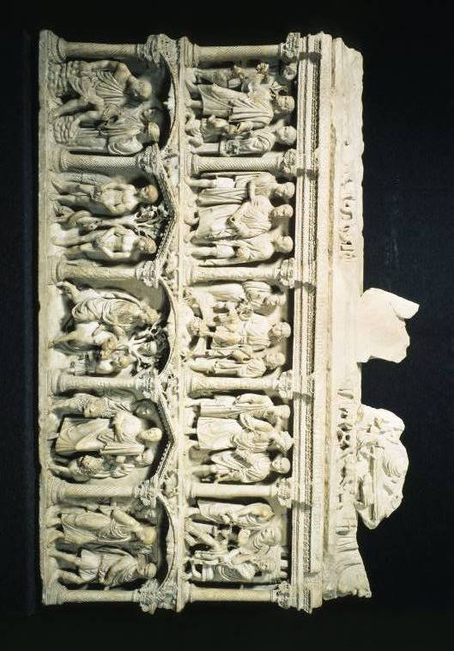

Column sarcophagus of Junius Bassus, marble relief, 359, Museum of S. Peter’s Basilica, Vatican, Rome.


Column sarcophagus of Junius Bassus. Christ is led before Pilate (detail). marble relief, 359, Museum of S. Peter’s Basilica, Vatican, Rome.

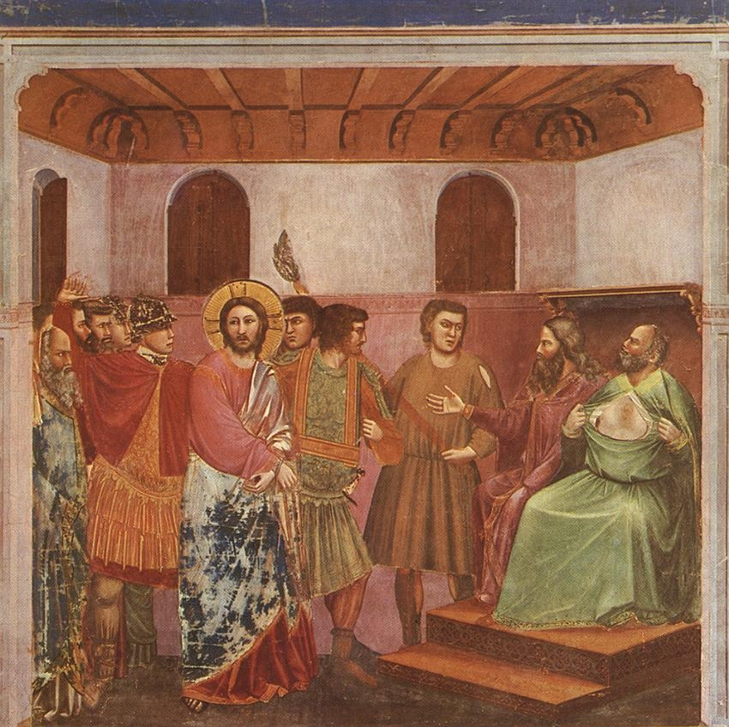

Giotto di Bordone, Christ before Caiaphas, fresco, c.1306, Scrovegni Chapel, Padua

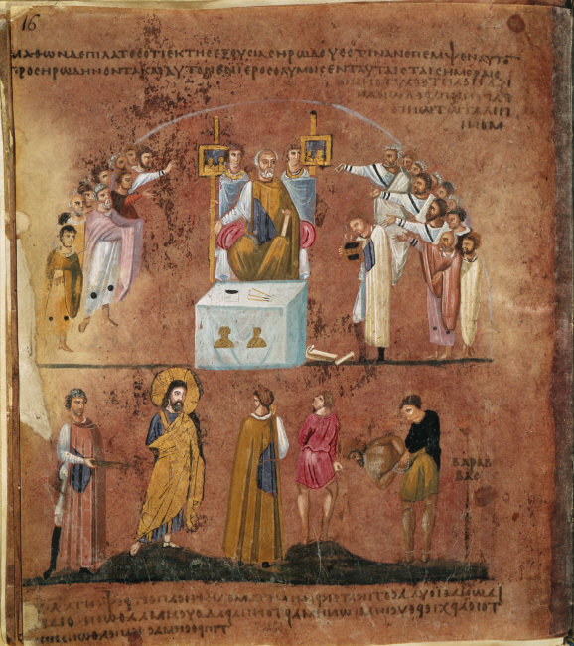

Codex Purpureus Rossanensis. Folio 8v, Christ before Pilate. Illumination, c550-575, Diocese Museum, Rossano Cathedral, Italy
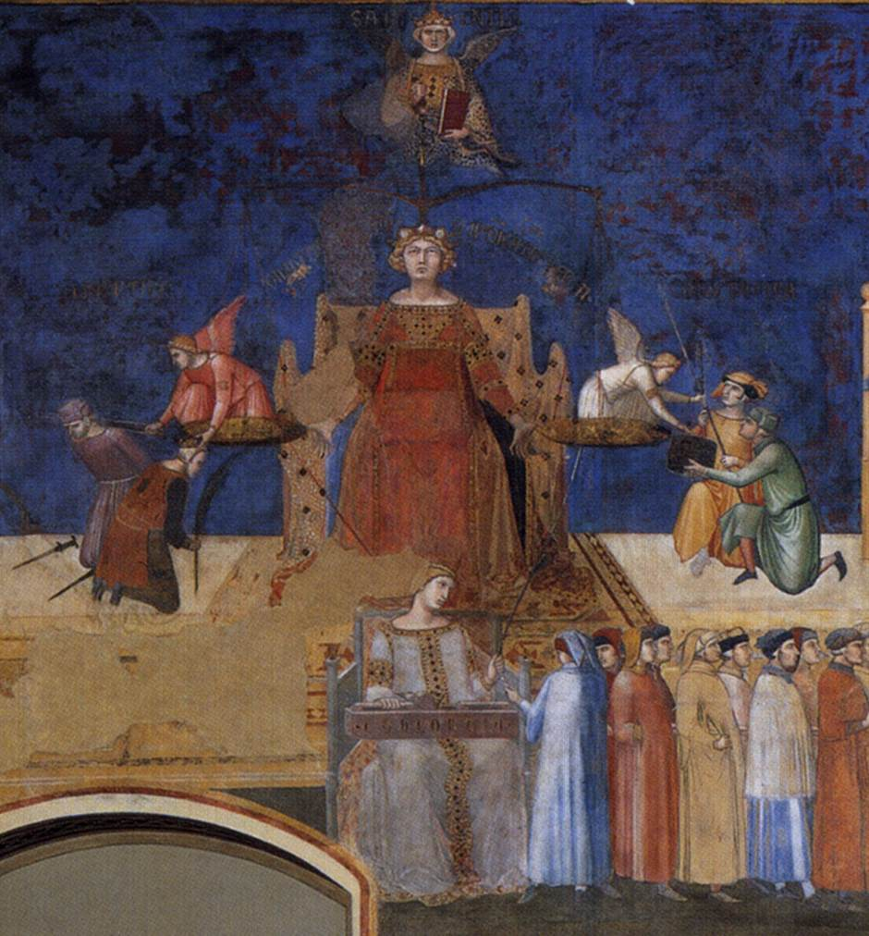

Ambrogio Lorenzetti, Justice, detail of The Good Government, 1337-40, fresco, north wall, Sala dei Nove, Palazzo Pubblico, Siena
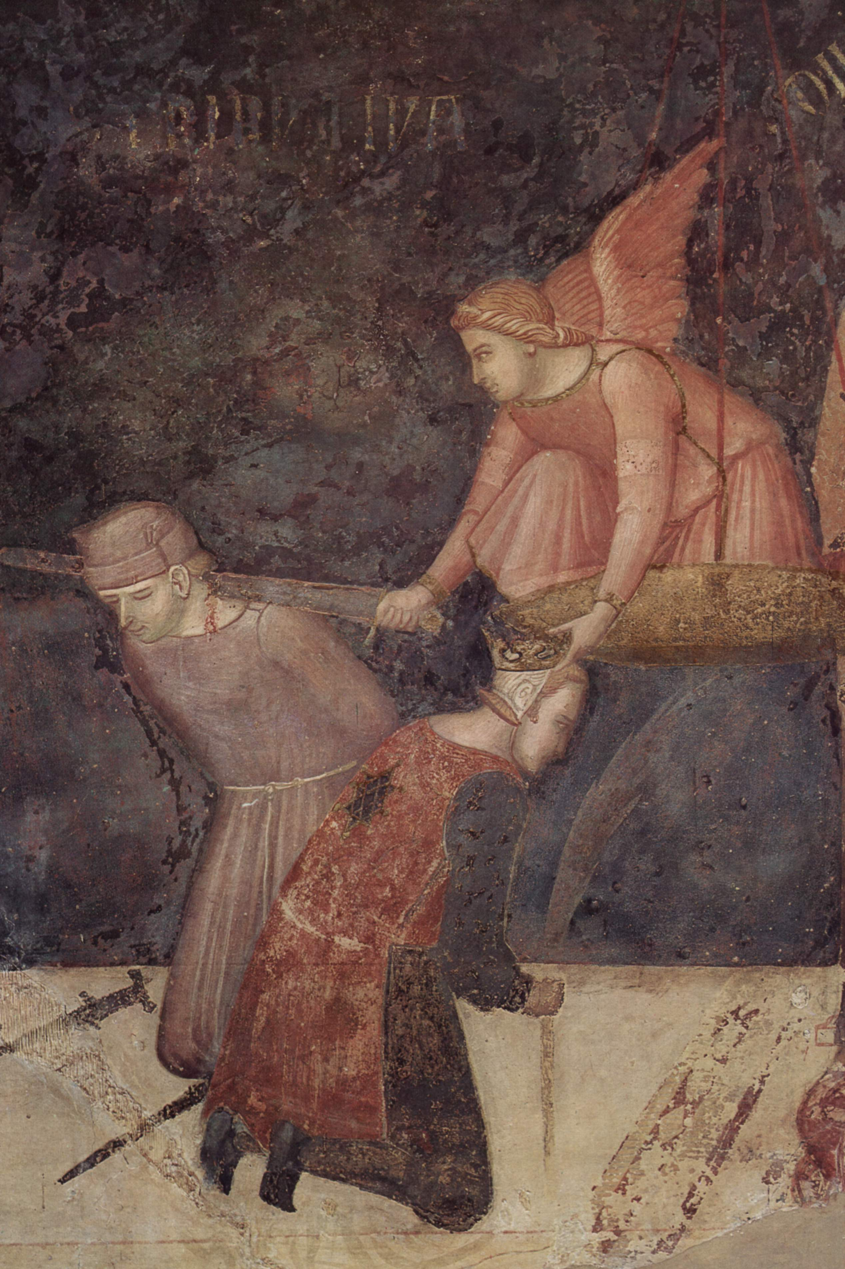
Ambrogio Lorenzetti, Distributive Justice, detail of The Good Government, 1337-40, fresco, north wall, Sala dei Nove, Palazzo Pubblico, Siena

Earlier versions of aspects of this paper were delivered at the SLS Annual Conferences in 2010 and 2011. I am grateful to those participants at the conferences for their comments and suggestions, especially Fiona Cownie, who encouraged me to further research this area. I should also like to thank my PhD supervisor at the University of Edinburgh, Dr. Claudia Bolgia, for her on-going patience.
These issues, amongst many others, were explored by articles posted to ‘Picturing Justice The Online Journal of Law and Popular Culture’, which ran from 1997-2006. Its archives are still accessible at http://usf.usfca.edu/pj//
. Perhaps judges seek to tap into this innate human ability to think through images, and the fact that images may well provoke a more emotional response than words alone could achieve, when their judgments involve an, often quite lyrical, verbal creation of an image. I am grateful to Geoffrey Samuel for this observation.
‘University education in its widest sense is a whole-person process, where the focus is not so much on the teaching and learning of specific skills or training as it is on the cultivation of personal autonomy, intellectual independence and the development of life-long critical perspectives’ (Sam Banks 1999).
http://www.heacademy.ac.uk/resources/detail/resource_database/id589_facilitating_creativity_in_he_ntf_views . Now see also Fryer 2006b.
http://www.ukcle.ac.uk/resources/teaching-and-learning-practices/grantham2
Much has been written on the notion of a law degree as part of a liberal education, and the tensions between those advocating a narrower professional, skills-based focus as opposed to a broader conception of higher education; see for example (Bradney 1996); (Bradney and Cownie 1998); (Maharg 2007) http://www.transforming.org.uk/. Further examples include for the UK: (Boon and Webb 2008); and (Sam Banks 1999); for the US: (Miller and Charles 2009-2010); and for Australia: (Kift 2008).
On interdisciplinarity, see for example (Berard 2009). On law as part of a liberal education, see footnote [4] above.
For discussion of this point (Twining 1997). See also entries on 'Law and Literature', 'Law and Film', 'Law and Television' (Cane and Conaghan 2008).
On Law and Literature, see, for example (Posner 2009). See also the journal Law and Literature by the Cardozo School of Law, Yeshiva University. For a discussion of the benefits of the study of literature for legal education (Reichmann 2006 and Nussbaum 2006).
The issue of law and film was the subject of Journal of Law and Society March 2001. Volume 28 (1).
http://works.bepress.com/john_brigham/17/. See also (Van Belle and Mash 2010), which aims to introduce political science through books, movies and popular culture, and addresses courts and law through the same media.
[Online]. Available at: http://www.griffith.edu.au [Accessed 12 September 2011]
The emergence of law and film in the curricula of UK law schools was examined in (Osborn 2001). See also (Knowles 2008) on the role of video.
Available at http://m.jezebel.com/5810927/the-criminal-lessons-of-ferris-bueller [accessed 5 September 2011]
Available at http://www.youtube.com/watch?v=ABZeKvAIyEc&feature=related [accessed 27 September 2011]
Graphic Medicine. [Online]. Available at: http://graphicmedicine.org
Details of the webcomic, and the interview with its creator are available at:http://www.guardian.co.uk/science/blog/2010/jul/14/medical-comics-patients [accessed: 28 August 2011]
There is a growing awareness of the possibilities offered by comics studies; for example, a conference on Interdisciplinary Methodology: The Case of Comics Studies October 2011 at the University of Bern. A useful resource is the website run by Dr. M. Gibson of Northumbria University. [Online]. Available at: http://www.dr-mel-comics.co.uk
I should like to thank Helena Haapio for bringing to my notice several references in this area.
See, for example, the work of Dr. Colette R. Brunschwig at the Legal Visualisation Unit of the Department of Law at the University of Zurich.
The ‘Visual Persuasion project’ of New York Law School, [Online] http://www.nyls.edu/centers/projects/visual_persuasion [accessed 21 September 2011]
[Online] accessible at http://www.rwi.uzh.ch/oe/zrf/abtrv.html
[Online] http://www.legalvisuals.nl
[Online] http://www.nyls.edu/centers/projects/visual_persuasion
For further discussion, see Oblinger 2006 and Annetta et al. 2006: [Online] http://www.educause.edu/EDUCAUSE+Quarterly/EQVolume292006/EDUCAUSEQuarterlyMagazineVolum/157419; De Freitas and Maharg 2011http://tinyurl.com/3h3fdvy
[Online] http://www.forbes.com/2010/10/28/education-internet-scratch-technology-gamification.html
http://www.forbes.com/2010/10/28/education-internet-scratch-technology-gamification.html
[Online] http://www.ukcle.ac.uk/resources/teaching-and-learning-practices/palmer
The issues were also discussed in a symposium Law and Art: Ethics, Aesthetics and Justice. 23 March 2010, Tate Modern, London.
[Online]. Available at http://lawteaching.org/lawteacher/1999fall/lawteacher1999fall.pdf
[Online]. Available at http://lawteaching.org/lawteacher/2004fall/lawteacher2004fall.pdf
This module has been developed by colleagues in the School of Law at Northumbria, Sarah Barbour-Mercer and Chris Rogers. The module and the feedback obtained from students are discussed at (Mercer, Rogers, and Sandford-Couch 2011). [Online]. Available at: http://www.springerlink.com/openurl.asp?genre=article&id=doi:10.1007/s10991-011-9094-0
For grounding in visual theory there are number of sources, including (Mitchell 1986); (Berger, 1990); (Barthes 1993); (Mirzoeff 1998); (Cartwright 2001); (Manguel 2001); and (Burnett 2005).
The selected images referred to here are available online on Wikimedia Commons. Accessible at: http://commons.wikimedia.org/wiki/Category:Pictures_and_images
marble relief, 359, Rome. Column sarcophagus of Junius Bassus. Christ is led before Pilate.
Rossano Gospels, c550-575. Illumination, Christ before Pilate
Giotto, Christ before Caiaphas, c.1306, Scrovegni Chapel, Padua
Pomeroy, Frederick William. (1900-1907). Justice, Old Bailey, London.
For example, one might consider Ambrogio Lorenzetti, Distributive Justice, detail of The Good Government, 1337-40, fresco, north wall, Sala dei Nove, Palazzo Pubblico, Siena, a complicated allegory in which justice is revealed using the sword to decapitate a wrongdoer.
Ambrogio Lorenzetti, Distributive Justice, detail of The Good Government, 1337-40, fresco, north wall, Sala dei Nove, Palazzo Pubblico, Siena, where justice uses the sword to decapitate a wrongdoer but simultaneously places a crown on the head of another individual.
See, for example, Giotto di Bondone, Justitia c.1306, fresco, south wall, Scrovegni Chapel, Padua.
Discussed at (Jay 1999).
BBC. 4 August 2009. Guerilla Artist in Statue Stunt. [Online]. Available at http://news.bbc.co.uk/1/hi/3537136.stm
Giotto di Bondone, Justitia c.1306, fresco, south wall, Scrovegni Chapel, Padua.
New York Times, April 27, 2003. Photograph: Mural of Saddam Hussein with the Scales of Justice
Copyright-free images can be accessed from certain databases, including Corbis Images, Google Images, Creative Commons, Flikr, etc.

