A Sheep in Synthetic Wolf’s Clothing:
Creating a Hybrid of Natural and Man-Made Materials
to Combine Protection and Aesthetics in a Cold Climate.

Abstract

Fiona Kitchman
Northumbria University
Newcastle upon Tyne
NE1 8ST UK
fiona.kitchman@northumbria.ac.uk

Sarah Morehead
Northumbria University
Newcastle upon Tyne
NE1 8ST UK

sarah.morehead@northumbria.ac.uk

For thousands of years, humans have experimented with methods of joining materials, not only to create objects for practical use but also to satisfy their desire for decoration and embellishment.
This research project aims to combine a man-made technical textile with sheepskin (one of mankind's oldest protective clothing materials), in order to investigate the potential of creating an aesthetically pleasing garment that also offers high performance. This concept is an inversion of the recent trend for mimicking nature in textile construction.
In this paper the processes explored will include the rationale for material selection, as well as construction methods such as bonding, welding and minimal seaming, together with ergonomic pattern cutting. Aspects of aesthetics will also be investigated. By combining these materials, processes and fabrications into a female-specific hybrid jacket, the intention of the research is to resolve the tension between garment aesthetics and the need for thermal regulation in a cold climate.

Author Keywords
Aesthetics; joining materials; man-made; natural; sheepskin; technical textiles.

Research Imperatives
This concept is an inversion of the recent trend for bio-mimicry or imitating nature in textile construction.
For example, since the 1970s, synthetic fleece knitters have been developing “fleece” that shares some of the properties and performance of wool, yet is faster drying, less bulky and offers higher warmth to weight ratio.
It is from this inversion of the trend for bio-mimicry that this paper draws its title– a sheep in synthetic wolf’s clothing. The intention, then, is to create a post-modernist play on the usual discourse of highly technical performance wear.
By using a natural material to replace the manmade textiles that are the norm for this type of garment, we intend to create a different aesthetic, both visual and tactile, improving comfort and fit for the wearer. In choosing sheepskin, a sustainable product, for the inner of the jacket, the environmental impact may also be reduced.

Figure 2. For captions apply style: RTD-Caption

Figure 2. For captions apply style: RTD-Caption

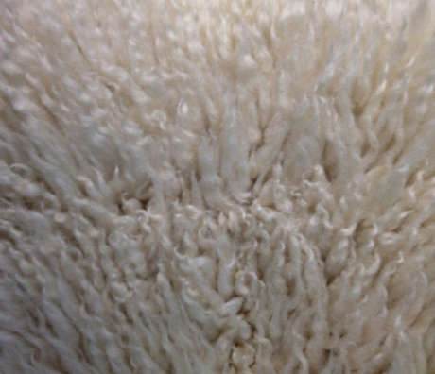
Figures 1 & 2.
Combining the best of ancient and modern materials.
Wool’s unique structure and crimp creates a “buffer zone’” keeping the wearer warm and dry.
A durable water repellant finish to the synthetic textile prevents the sheepskin from wetting out.

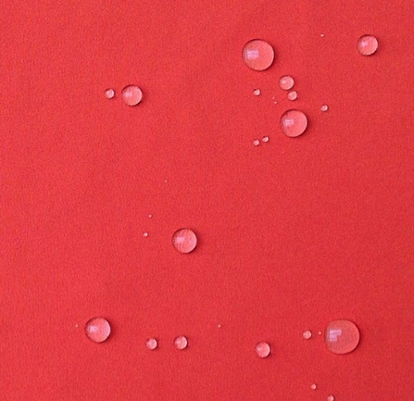

Sheepskin will be combined with a technical, synthetic textile. The anticipated benefits will be:
- to apply a durable water repellent finish to the outer surface to prevent the sheepskin “wetting out”;
- to improve abrasion-resistance;
- and to provide a vehicle for colour.
This concept is an inversion of the recent trend for bio-mimicry or imitating nature in textile construction.
For example, since the 1970s, synthetic fleece knitters have been developing “fleece” that shares some of the properties and performance of wool, yet is faster drying, less bulky and offers higher warmth to weight ratio.
It is from this inversion of the trend for bio-mimicry that this paper draws its title– a sheep in synthetic wolf’s clothing. The intention, then, is to create a post-modernist play on the usual discourse of highly technical performance.

Research Process
The research process embraced three distinct phases: material selection; experimentation with pattern cutting and construction methods; and investigation of aesthetic qualities.
Material Selection
Sheepskin was chosen because it is naturally thermostatic, with a warm feel that is enjoyable to touch and wear. Crucially, it acts as a “buffer zone”, able to absorb moisture of up to 35% of its weight without feeling wet. The exterior cells of wool have a waxy coating, making it water repellent, but microscopic pores allow water vapour to pass through into the inner core where it is absorbed. This buffer zone is key to the comfort of the garment: as the wool absorbs the moisture it produces heat, so that the moisture is passed through the outer fabric as vapour. Thus, perspiration can be absorbed until it is transported through the outer layer thus keeping the wearer’s skin drier (and hence warmer).
The structure of the inner cells also gives the wool its flexibility and crimp allowing the fibres to trap insulating air.
Three potential synthetic textiles were considered:
- woven 100% polyamide;
- woven 100% polyester with a waterproof and breathable membrane;
- recycled mechanical stretch woven polyester with
a protective backer.
The latter was selected because it is lightweight (circa 170 grammes per square metre), has a long-lasting water repellant finish and provides a vehicle for colour.
With both warp and weft stretch, it also drapes well and moves with the body. This type of fabric is often used in combination with a fleece backer for technical outdoor performance garments known as “softshells”.
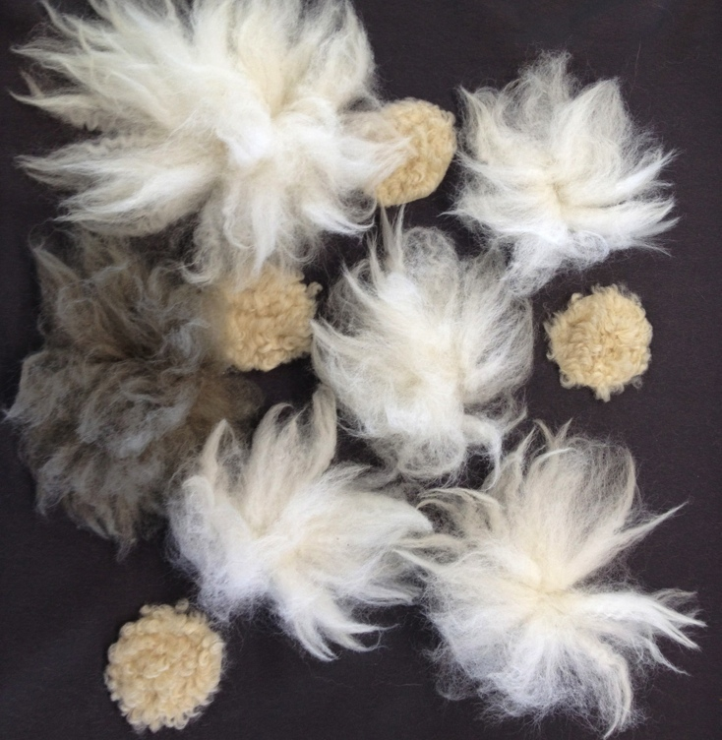
Figure 4. Sheepskin shapes bonded to adhesive prior to trimming.
Construction Experimentation
We established that sheepskin and woven polyester could be bonded successfully using sheet adhesive. However, the result was very stiff and reduced drape. Laser-cutting small holes in the sheet helped counter this and also improved breathability without affecting adhesion.
Subsequently, we discovered using smaller sheepskin shapes rather than complete panels further improved drape. Rounded shapes were more successful than those with points, in terms of both adhesion and aesthetics.
Experimentation also showed that wool, unlike synthetic fleece, retains its loft after being in the hot press. Its crimp means that it can spring back, enabling the use of different heights of pile to create textural/thermal effects.
A number of seam types were also explored. Lapped seams were welded using adhesive tape. But the pressure of the wheel caused seams in the stretch fabric to wave, so were unacceptable. Cross-over seams were created with ultra sonic laser, however these were not strong enough and easily pulled apart. Finally, by using offset T-joint seams, pull strength and visual effect were improved.
Aesthetic Investigation
Aspects of aesthetics were also investigated, with design improvements incorporated as part of an iterative process.
It was found that sheepskin shapes could be bonded across joints, eliminating the need for panel shapes to be dictated by areas of differing insulation.
This allowed some of the seams to be eliminated, resulting in a cleaner design.
Figure 5. T-jointing to improve seam pull strength.

At concept stage, it had been intended to close the jacket by inserting a zip by laser cutting/bonding. However, as the textile edges sealed successfully when laser cut, it was decided that zips were unnecessary. Instead, we opted for horn buttons with laser cut buttonholes and pocket mouths - this was considered more in keeping with the desired look of the jacket.

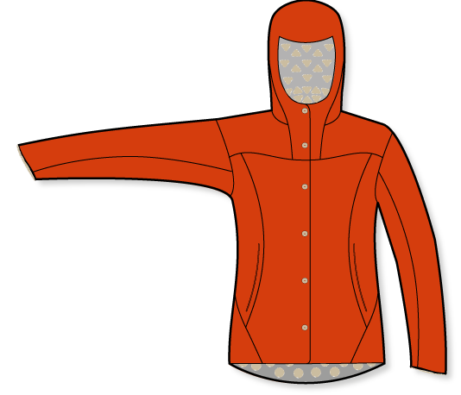
Research outcomes
This research project set out to combine a hybrid of traditional and synthetic materials, utilising contemporary fabrications and technologies (Jones and Stylios, 2013).
A number of outcomes emerged during the design process. During the material selection phase, it became clear that visual and tactile aesthetics do not have to be compromised to create a garment that performs in a cold climate. Sheepskin and stretch woven polyester offer the best of both ancient and modern, with each contributing complementary strengths.
Secondly, we were surprised to learn how
well sheepskin adapts to processes such as hot press bonding, literally bouncing back. This suggests that other materials that have come to be regarded as old-fashioned may be worthy of further investigation, to take advantage of their intrinsic qualities in twenty first century applications.
While we do not expect that a hybrid garment of this kind would compete at the most technical end of the market, there may also be scope for further research into its thermal performance.
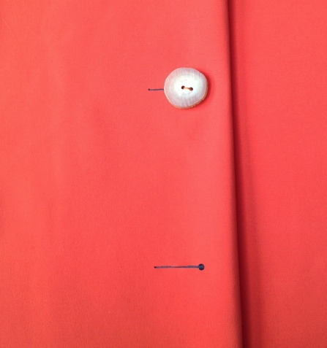Figure 6. Jacket closed with laser cut buttonholes and horn buttons.

Figure 7. Pocket mouths take advantage of laser cutting to seal textile edges.
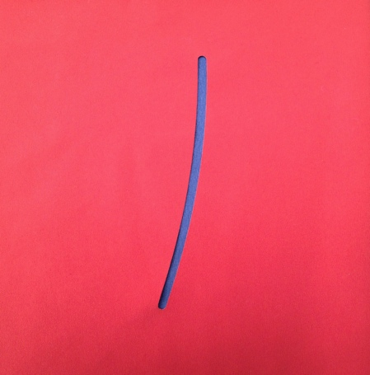
Finally, the project demonstrated one of the key aspects of practice-based research. Our final design sketch reveals considerable development since our initial ideas. Although concepts and hypotheses can provide avenues to explore, it is in the doing and making that experiential learning occurs.

References
- Harris, S. et al (2010) Cloth Cultures in Pre-Historic Europe Archaeology International, Issue No. (Volume 12.). pp 22-26
- Jones, I. and Stelios, G. K. (2013) Joining Textiles: Principles and Applications, Woodhead Publishing: Cambridge

Figure 8. Sketch of final design developed through making and doing.

