The Problem of Representation of 3D Isovists

Abstract

This paper tests the dictum that 3D isovists are easy to generate but hard to represent. In the first section of the paper, we review eleven past attempts to represent 3D isovists, ranging from 1996 to 2014. We attempted to select the widest range in terms of approach, novelty and significance to the field of spatial analysis. In the next section of the paper we introduce three new 3D isovist representations, termed the ‘Contour Isovist’, the ‘Tri-planar Isovist’ and the ‘Circumvoluted Isovist’. In the final section we evaluate these new 3D isovist representations using an online questionnaire, aiming to compare the representations and to determine their clarity, information-content and simplicity. We invited an expert set of participants (resultant n=20), all of whom were familiar with the use of 2D isovists for research purposes, to take part in the questionnaire. The result of the evaluation was that two of the isovists, the ‘Contour Isovist’, the ‘Tri-planar Isovist’, we deemed to be relatively successful and hence have potential for future development. The contribution to this paper is twofold. First, the two successful 3D isovist representations are a contribution to the field and, second, the method of evaluation. We conclude that insufficient research has been conducted into the efficacy of space syntax representations.

Introduction

Around 1996, whilst working on the Intelligent Architecture Project (Penn et al., 1996; 1997) with Alan Penn, he made a thought-provoking observation, which has stayed with me over the subsequent years; he claimed that the initial generation or production of fully three-dimensional isovists (as opposed to the typical 2D planographic representations) was relatively easy to do; the hard part was how to represent the resultant data in any clear and meaningful way (c. 1996). A complementary sentiment was expressed around the same time by Thiel who criticised that “A major problem up to now has been the lack of any simple, two-dimensional graphic means for the 360° comprehensive, metrical mapping of environments in [an] ego-centered, phenomenological mode…. The consequences of this technical deficiency are that at best a subjective visual ‘peepholing’ is encouraged, with an implicit neglect of the peripheral context.” (1997). Despite the fact that in recent years the computational side of producing 3D isovists has become even easier, further supporting Penn’s original contention, e.g. with open-source, 3D isovist code now freely available for Grasshopper® (a graphical algorithm editor for the 3D modelling software Rhino) has the academic community made equivalent progress on the representational aspect of 3D isovists? This paper initially seeks to determine if this earlier lack of a good three-dimensional representation has now been remedied, and, if not, what are the problems hindering such a representation.

This is a paper in three sections, the first section will review attempts over the years to do precisely this, to represent the full, three-dimensional vista-space, via the medium of a simple two-dimensional representation. We will discuss the various attempts to represent three dimensional vista-space and, in particular, comment on their clarity, or how clear and understandable they are as representations, their meaningfulness, or their ability to convey substantial amounts information, and their simplicity, or the degree to which they are able to present complex spatial information in a simple and straightforward manner. In the second part of the paper, the authors will introduce three new representations of three-dimensional isovists, namely the ‘Contour Isovist’, the ‘Tri-planar Isovist’ and the ‘Circumvoluted Isovist’. Finally, in the last section of the paper, we will present the results of a questionnaire survey evaluating these new representations.

Isovist representations

Two dimensional isovist representations

Clearly, in order to understand three-dimensional isovists, we first need to introduce the two-dimensional isovist, which is essentially a simple, two-dimensional polygon representing the totality of all visible and potentially visible space from a specific location (i.e. the full 360° view, experienced sequentially if a person rotated slowly on the spot). Isovists are typically planar, constructed at eye-height and are parallel to the floor plane. The term was coined by Tandy, who focussed on the natural landscape (Tandy, 1967) and was subsequently introduced into built environment analysis by Benedikt, who, in turn, devised many of the isovist measures still in use today (Benedikt, 1979). The next innovative step in two-dimensional isovist analysis was to move from the single isovist to a grid of isovist locations, similar to Benedikt’s isovist fields, but to consider the visible relationship between locations, utilising space syntax measures, which was pioneered by Turner et al. (Turner et al., 2001).

Three dimensional isovist representations

In this next section we will consider how researchers have moved beyond two-dimensional isovist representations. We do not intend this next section to be an exhaustive review of all three-dimensional isovists, however, we have attempted to select the widest range in terms of approach, novelty and significance to the field of spatial analysis.

Thiel’s notations for Space-Establishing Elements, 1997

Thiel had a vision of producing an entire notational system for representing all aspects of the experience of someone moving through the built environment, of which the visual experience was only one part (Thiel, 1961; 1997). This overarching notational system would function rather like orchestral sheet music with each sensory input (or instrument in his analogy) being represented as a section on the ‘score’. With respect to the visual sense he attempted to create a notation-like representation that was a “Simple, two-dimensional graphic” for mapping our visual experience in an “ego-centered, phenomenological mode”. His starting point was the hemispherical projection, or HP representation, being an approximation of the 180°-horizontal and 135°-vertical field of view of human vision. The view from a single location is therefore depicted as a circle with the horizon-line passing through its centre and any occluding surfaces (or space-establishing elements, SEEs in Thiel’s terminology) are indicated as solid white truncated-segments of the circle. Unlike 2D isovists, these HP notations are unidirectional, but clearly two used in conjunction could represent the full 360° view. This was, however, clearly not simple enough for Thiel, who stated, “The HP may be used for spaces of any degree of explicitness and any form type. However, there is a more abstract mode of space notation that is particularly adapted to the convenient and accurate representation of… buildings and… urban environments. Since this notation indicates the position of the space-establishing elements it is called a space-establishing element position indicator or SEEPI for short.” See figure 1 for the complete set of HP and SEEPI notations.

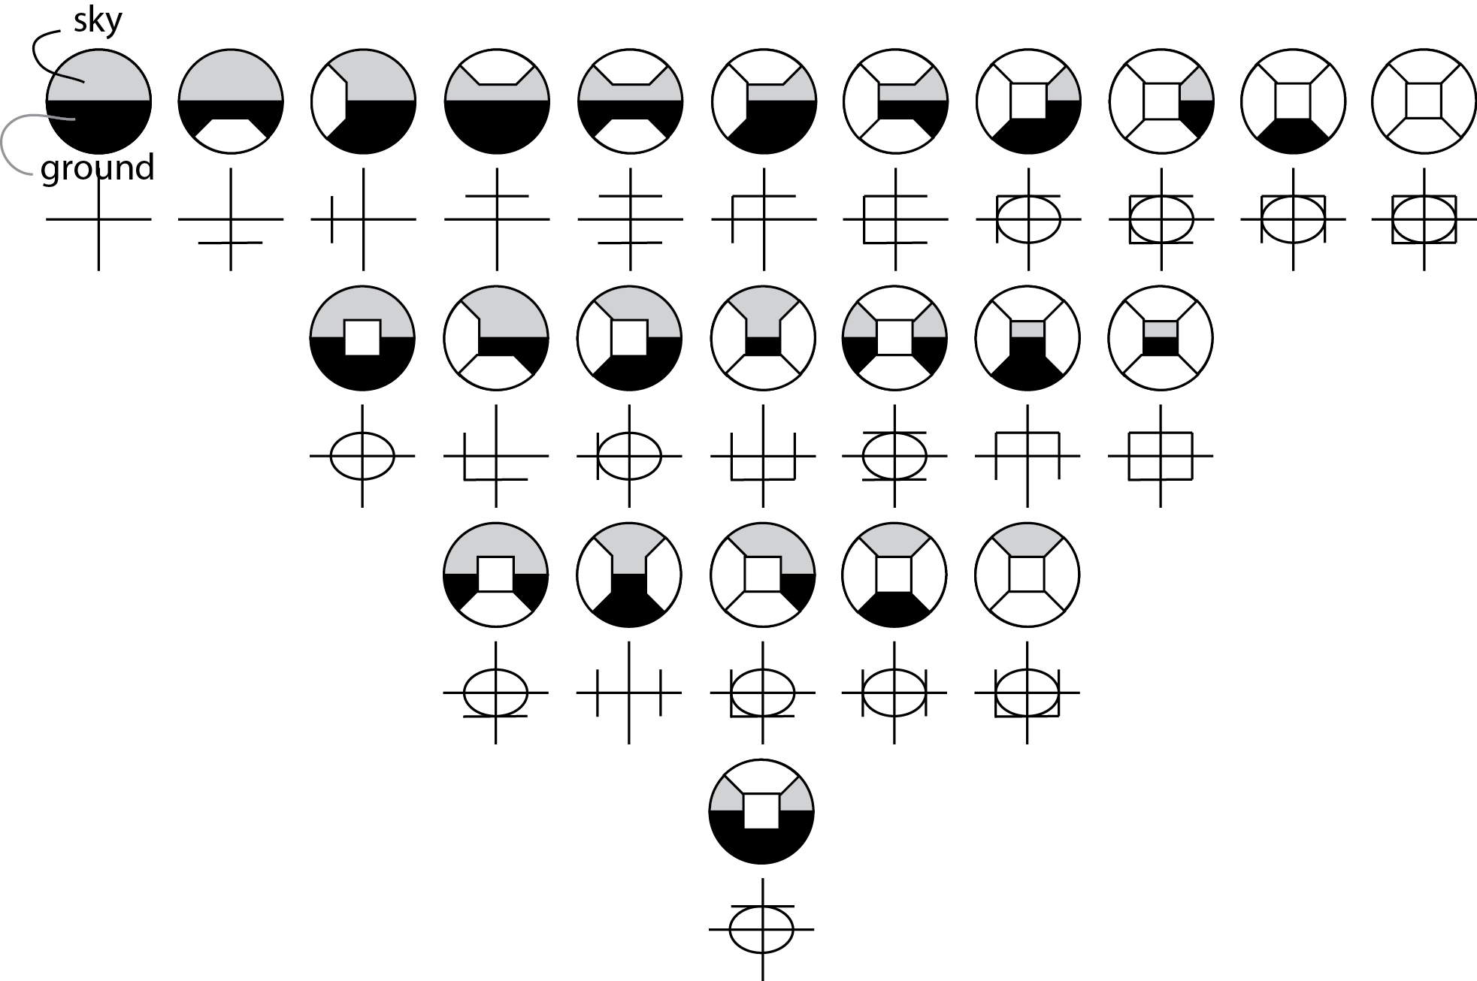
Figure 1 Thiel's HP (hemi-spherical) representations, above, with their corresponding SEEPI representations immediately below (source: redrawn, after Thiel, 1997)

We include Thiel’s representations in this paper, as they are the simplest and most abstract of all and the ones closest to a notational system (even if neither the HP or SEEPI codes fulfil the criteria of Goodman's Theory of Notation as they would fail on both syntactic and semantic grounds (Goodman,1969)). In terms of clarity and simplicity they would score highly, and, with familiarity, could serve to be relatively meaningful. It should, however, be questioned how either notation could be used to represent more spatially complex environments, as the examples given are relatively simple.

Dalton’s scripted IsoCam (in Pangea), 1996

Pangea (Penn et al., 1996) was an intuitive 3D modelling environment for architects, in which objects could be scripted, in real-time, with intelligent behaviours. As part of the project Conroy Dalton scripted a number of different types of ‘isovist cameras’ (IsoCam) that could be inserted into any 3D world. One of these was the 3D IsoCam, which produced a representation based on a cluster of radial lines emanating from the generating location, where the colour of the line corresponded to its length. This was the representation that prompted Penn’s comment that generating 3D isovists was easy but representing them in any meaningful manner was the hard part. Unfortunately no images appear to have survived of Dalton’s 3D IsoCam.

Teller’s spherical metric, 2003

Hemispherical photography dates back to the 1920s and early applications were used to study cloud formation or to estimate the amount of visible sky, for example, when studying forest canopy openings (Evans and Coombe, 1959). Using such techniques for the study of the built environment appears to emerge around the late-1990s/early-2000s (i.e. Bosselmann, 1998; Teller, 2003; Fisher-Gewirtzman & Wagner, 2003). One of the first to suggest an analytic method and representation was Teller’s 2003 paper, in which he notes that, in terms of extending space syntax spatial measures into the third dimension, “Such extensions are usually neither developed nor tested.” He goes on to suggest that, “The method of isovist fields could probably be generalised at the third dimension… The application of isovist fields to the three-dimensional analysis of urban configurations would… require an arbitrary height limit for unbounded open space… A different approach has been adopted… in order to enable a three-dimensional analysis of unbounded configurations.” (2003). Teller consequently developed a spherical projection depiction, as shown in figure 2, and then uses this calculation to produce ‘sky opening maps’, indicating the proportion of visible sky from an array of locations. It is, however, his initial stereographical projection that is of more interest from a representational point of view. This was included in our review as it is the least abstract of all the representations, although clearly echoes Thiel’s HP representations. As a representation it is clear and informative, as it contains information on building heights and formal massing. However, it is not particularly simple. Other noteworthy papers have also been based upon spherical projections and spatial opening indices (Fisher-Gewirtzman & Wagner, 2003; Suleiman et al., 2011; 2013).

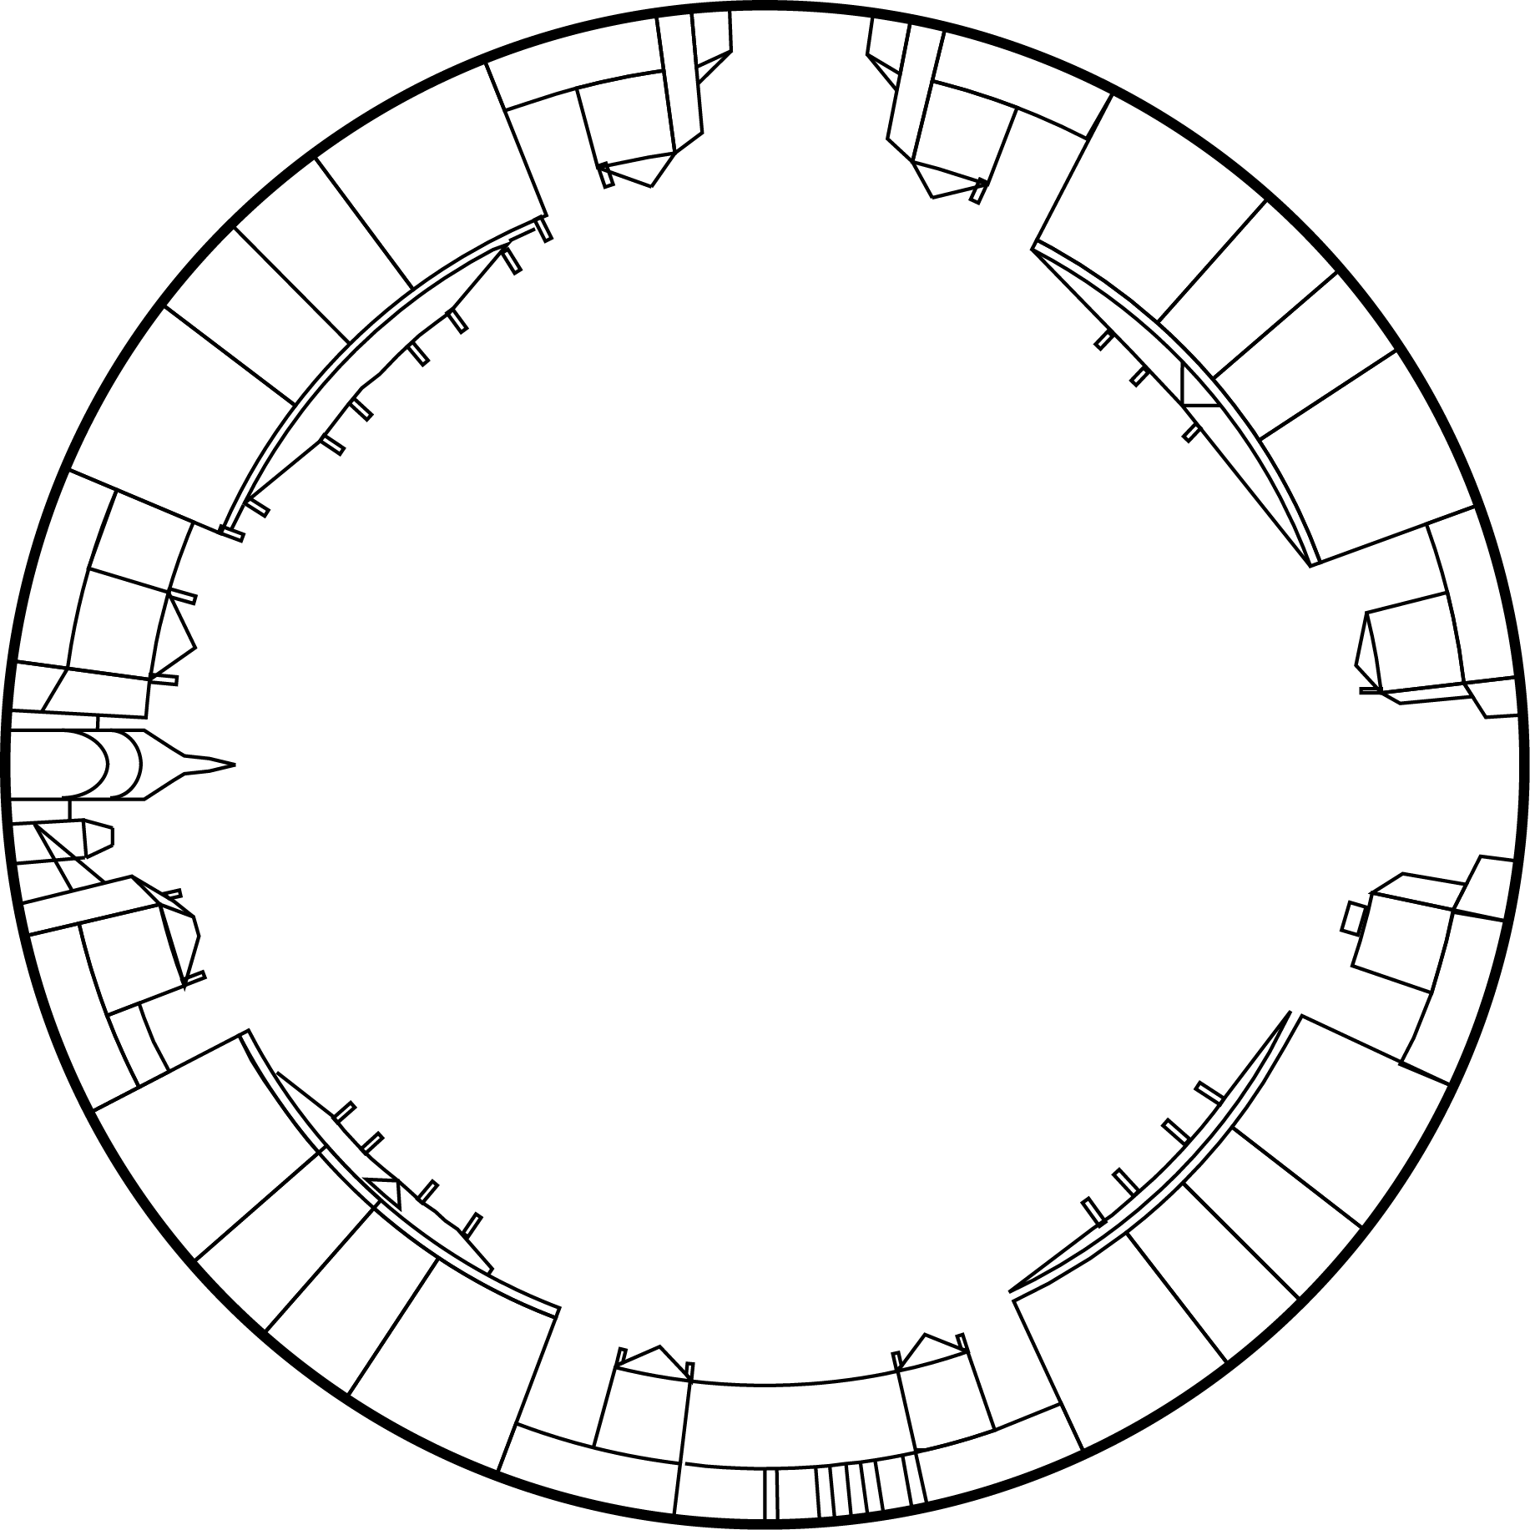
Figure 2 Teller's Example of a Stereographical Projection (Amalienborg Plads, Copenhagen) (source: redrawn, after Teller, 2003)

Derix et al.’s polyhedral volumes/data fields, 2007

In 2007 a set of computational tools were developed for 3D isovist analyses by Aedas’ R&D Group led, at the time, by Derix (Derix et al. 2007; 2008). Essentially the first step of the analysis was to construct a Polyhedral Volume, which is essentially a 3D isovist volume enclosing all visible points from a single location. These can be produced using a number of different algorithms, which were explored and discussed in a report (ibid), and are typically represented as 3D wireframe volumes, or solids with some degree of transparency. A second group of representations are the Polyhedral Field Data: visible space is filled with a 3D array of points which can be varied in size or colour to represent attributes of that point, for example its integration value or volume size. The directionality (or ‘Drift’ as it is termed in 2D isovist space: Conroy Dalton, 2001; Conroy Dalton & Dalton, 2001) can be represented as a field of floating arrows representing the directional relationship between the isovist’s generating point and its geometric centroid. Derix et al. term these ‘force and direction’ diagrams. See figure 3 for an example of two of these representations.

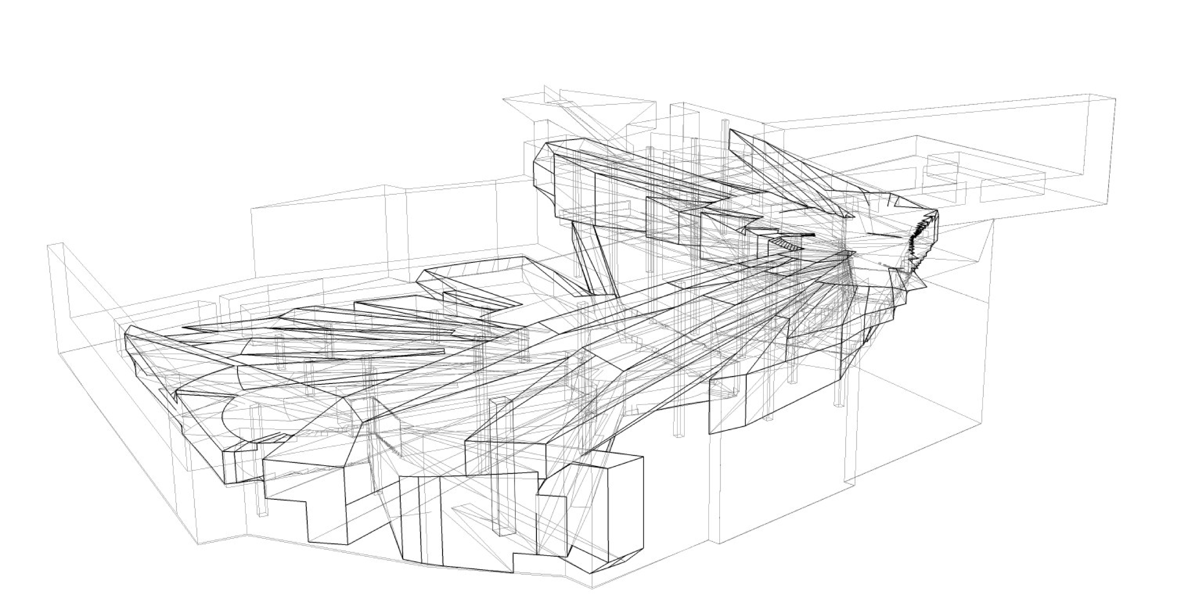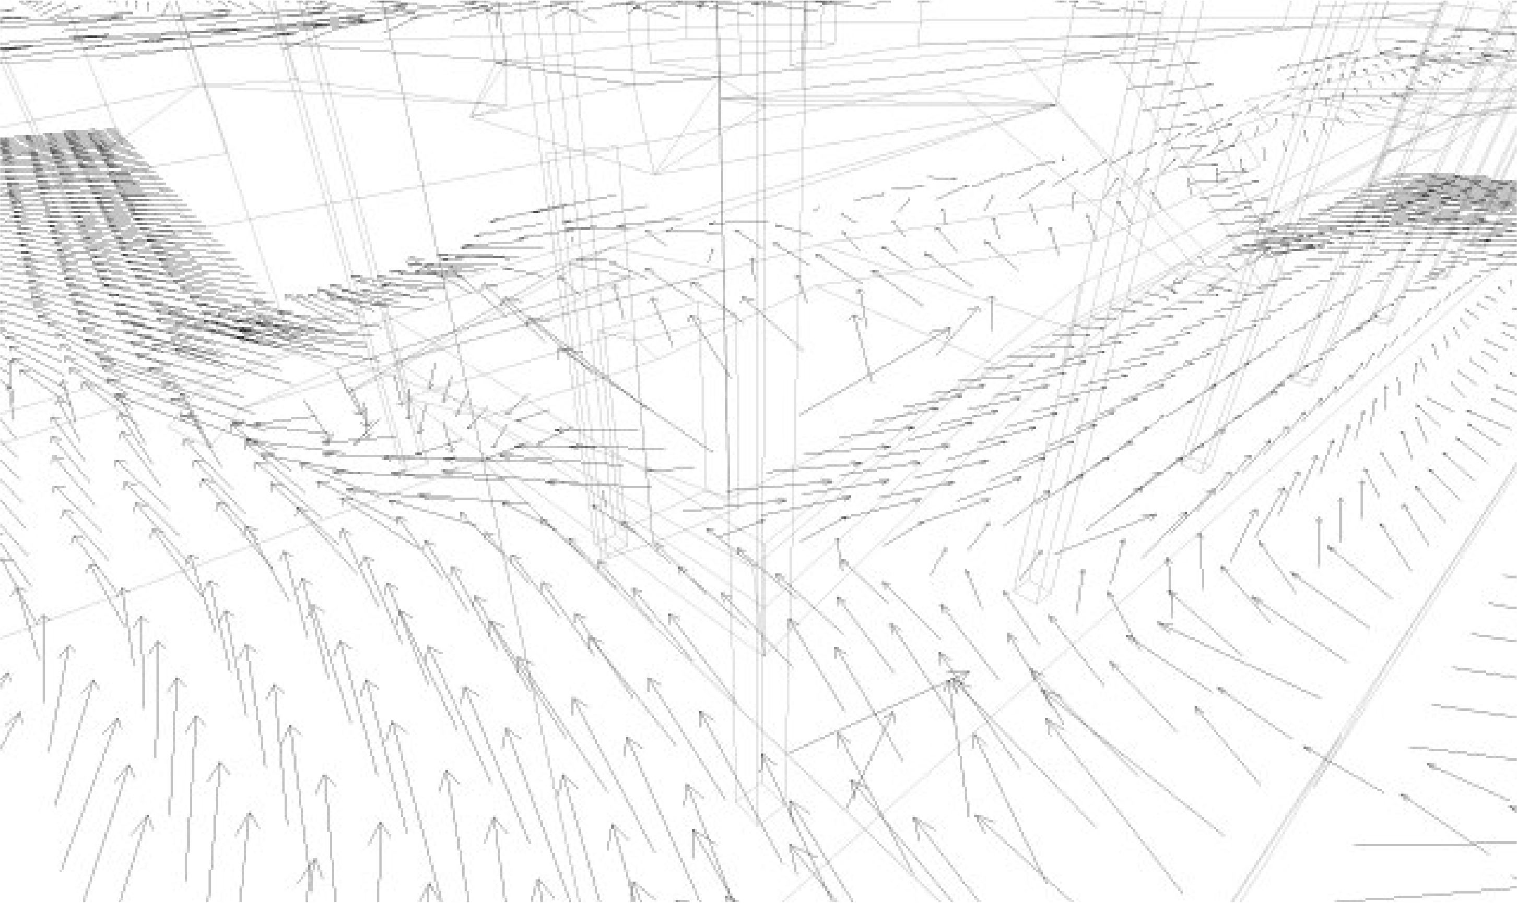Figure 3 Derix et al.'s Representations of Polyhedral Volumes (above) plus a Force and Direction Diagram (below)

Ratti and Morello’s 3D isovist and ‘isovistmatrix’, 2009

Ratti and Morello developed a method for producing three-dimensional isovists using digital elevation models (DEMs). Using line-of-sight analysis, they determine which the voxels are visible from a single location (these can be visualised in 3D as a point cloud). The isovistmatrix is a way of constructing a 3D array of points, in the same way that Derix et al. did, and every point in this 3D matrix is then assigned a value that represents how visible it is from street-level. Naturally, this is hard to visualise (the point of this paper) and so they suggest that a useful method of visualisation is to cut 2D slices/sections through the isovistmatrix and, using a colour scale, indicate how visible individual voxels from street-level.

Varoudis and Psarra’s 3D VGA, 2014

In 2014 Varoudis and Psarra presented an implementation of Turner’s visibility graph analysis (VGA) extended into three dimensions. They filled the visible volume with an array of points and constructed a 3D visibility graph, in which any two mutually visible points are connected by edges in a meta-graph representation, resulting in two values that can be visualised, ‘3D connectivity’ and ‘3D visual integration’. Where this differs from Derix’s earlier work, is that 3D isovists are never employed as an intermediate stage (and therefore perhaps this approach should not be included in this paper), and that in the construction of the meta-graph they use directed graphs, rather than undirected ones, allowing a distinction to be made between locations that are inhabitable and locations that are visible but not accessible. In some respects this can been held as combining Ratti’s isovistmatrix (where he focussed on whether locations were visible from street-level, but not the other direction) but without performing any integration analysis and Derix’s work, where he implemented a three-dimensional isovist array of data points, and used these to represent configurational measures, but in a non-directed manner. In terms of representations, Varoudis and Psarra employ either 3D arrays of coloured balls or collapse data to two-dimensional floor-level maps, once again, showing the difficulties of 3D representations.

In the following table we summarize the characteristics of the 3D isovist representations reviewed in this section. At the bottom of the table are included the new representations presented in this paper, which will be introduced in the next section.

Table 1 Comparison of three-dimensional types of isovist representation
Notation | Year | Horizontal degree | Vertical degree | Notation 2D/3D | Single View/Array | Colour/Monochrome
Dalton’s Scripted 3D IsoCam (Pangea) | 1996 | 360° | 180° | 3D projection | Single | Colour
Thiel’s HP | 1997 | 180° | 180° | 2D | Single | Monochrome
Thiel’s SEEPI | 1997 | 180° | 180° | 2D | Single | Monochrome
Teller’s Stereographical Projection | 2003 | 360° | 180° | 2D | Single | Monochrome
Teller’s Sky Opening Map | 2003 | 360° | 180° | 2D map | Multiple | Monochrome
Derix et al.’s Visual Volumes/Polyhedra | 2007 | 360° | 180° | 3D projection | Single & Multiple | Monochrome
Derix et al.’s Polyhedral Field Data | 2007 | 360° | 180° | 3D projection | Multiple | Colour
Derix et al.’s Direction & Force Arrows | 2007 | 360° | 180° | 3D projection | Multiple | Monochrome
Morello & Ratti’s 3D isovist | 2009 | 360° | 180° | 3D projection | Single & Multiple | Colour
Morello & Ratti’s Isovistmatrix Slice | 2009 | 360° | 180° | 2D (slice) | Multiple | Colour
Psarra & Varoudis’ Directed 3D-VGA | 2014 | 360° | 180° | 3D projection & 2D map | Multiple | Colour
Dalton & Dalton’s Contour Isovist | 2015 | 360° | 180° | 2D | Single | Monochrome
Dalton & Dalton’s Tri-planar Isovist | 2015 | 360° | 180° | 2D | Single | Monochrome
Dalton & Dalton’s Circumvoluted Isovist | 2015 | 360° | 180° | 3D projection | Single | Monochrome
Dalton & Dalton’s Circumvoluted Isovist Line Graph | 2015 | 360° | 180° | 1D (linear) | Single | Monochrome

Introducing three new representations of 3D isovist

The aims of the new representations were to try and describe a single, 3D isovist, generated from a single location, and to try to design as simple a representation as possible – i.e. to convey the most information with the least number of lines. We were keen to keep the representation strictly two-dimensional and for it to be reproducible in grey-scale print, rather than having to rely on colour to represent data (colour could be optional but not mandatory). The resultant three types are termed the ‘Contour Isovist’, the ‘Tri-planar Isovist’ and the ‘Circumvoluted Isovist’.

The Contour Isovist

If isovists are typically constructed at eye-height, a ‘Contour Isovist’ can be thought of as a series of corresponding isovists, all generated from the same x,y location in space, but calculated at differing heights, one of which is eye height. These different heights are then collapsed into a single, 2D representation, in the same way that a contour map can represent different terrain heights on a single drawing. In order to help ‘read’ the different contours, a thick/bold solid line indicates the conventional ‘eye-height’ isovist. Those contours below eye-height are drawn as thin solid lines and those contours above eye-height are shown as thin dotted lines. A vertical interval of 0.4m is suggested as being optimal, with ‘eye-height’ being assumed as being 1.6m above floor level. Naturally, if there is no variation in the vertical plane, all the different height contours will be coincident, and therefore only the thick/bold eye-height isovist will be discernible. Examples of Contour Isovists are shown in figure 4.

The Tri-planar Isovist

A ‘Tri-planar Isovist’ can be held to consist of one traditional isovist (generated in the horizontal place) shown in conjunction with two additional isovists constructed in the vertical place (or sectional isovists). All three isovists are generated at eye-height, from the same point in space, but in three different planes. In this representation the plan-isovist is shown with one sectional isovist positioned above it and one sectional isovist rotated and to the right of the plan-isovist. The corresponding eye-heights are indicated as a set of dotted lines. The sectional isovists are not true building sections, as they only depict space visible from the generating location. Examples of Tri-planar Isovists are shown in figure 5.

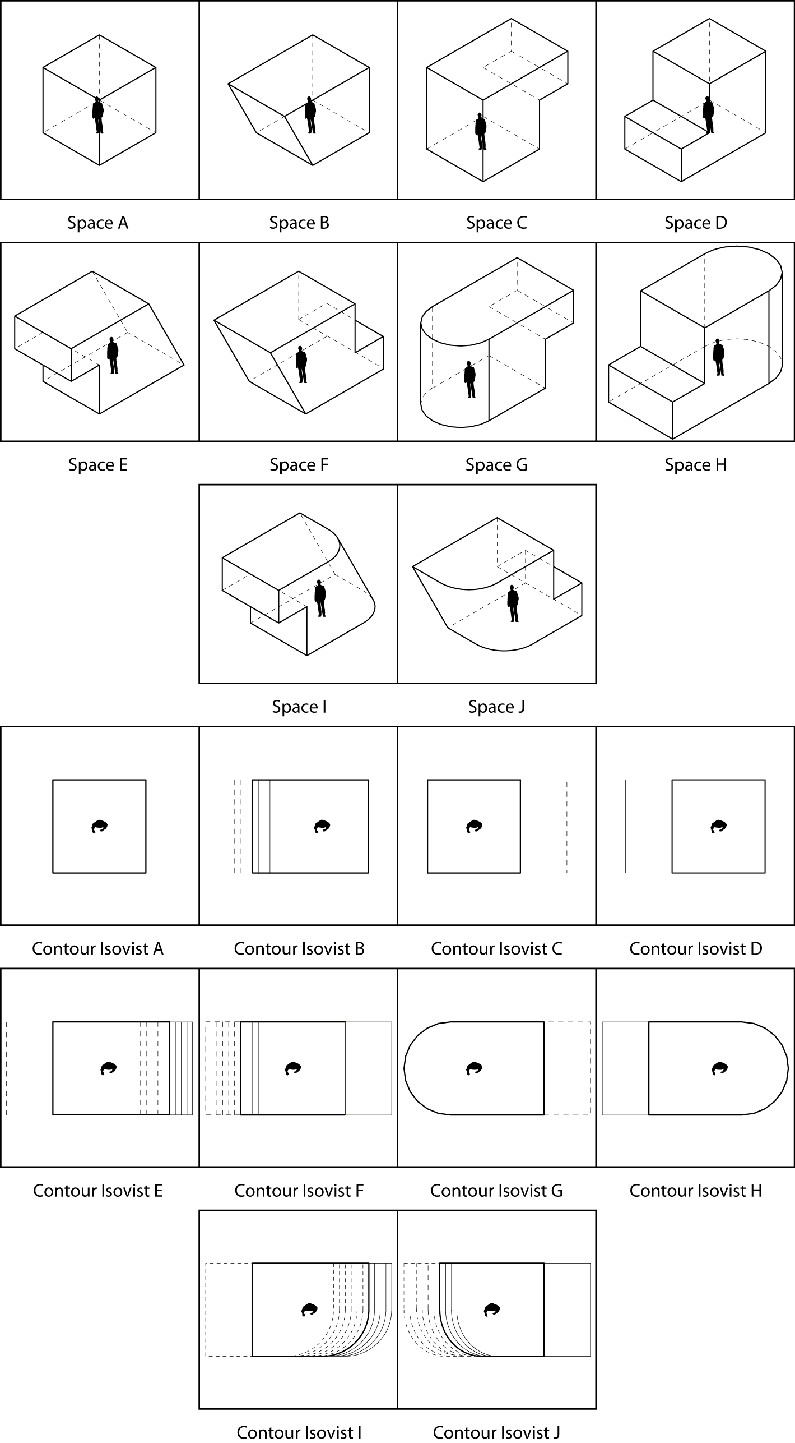
Figure 4 Examples of Contour Isovists for Ten Simple Volumetric Spaces

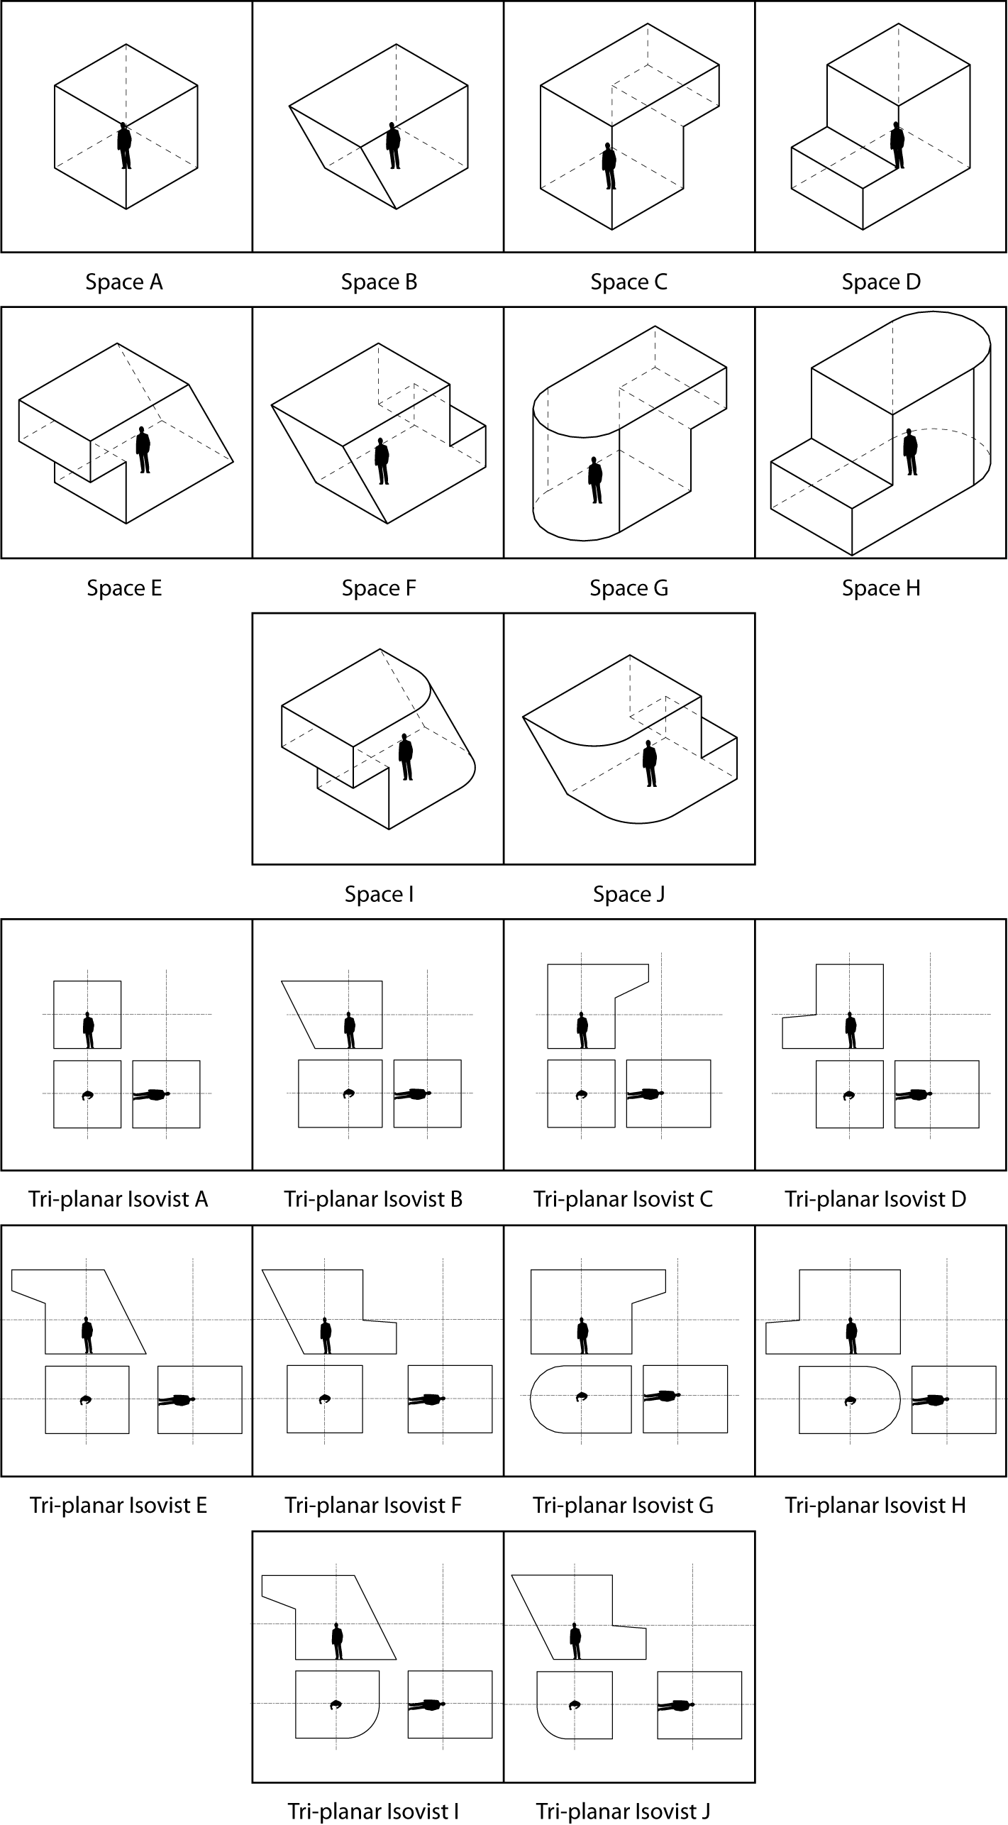
Figure 5 Examples of Tri-planar Isovists for Ten Simple Volumetric Spaces

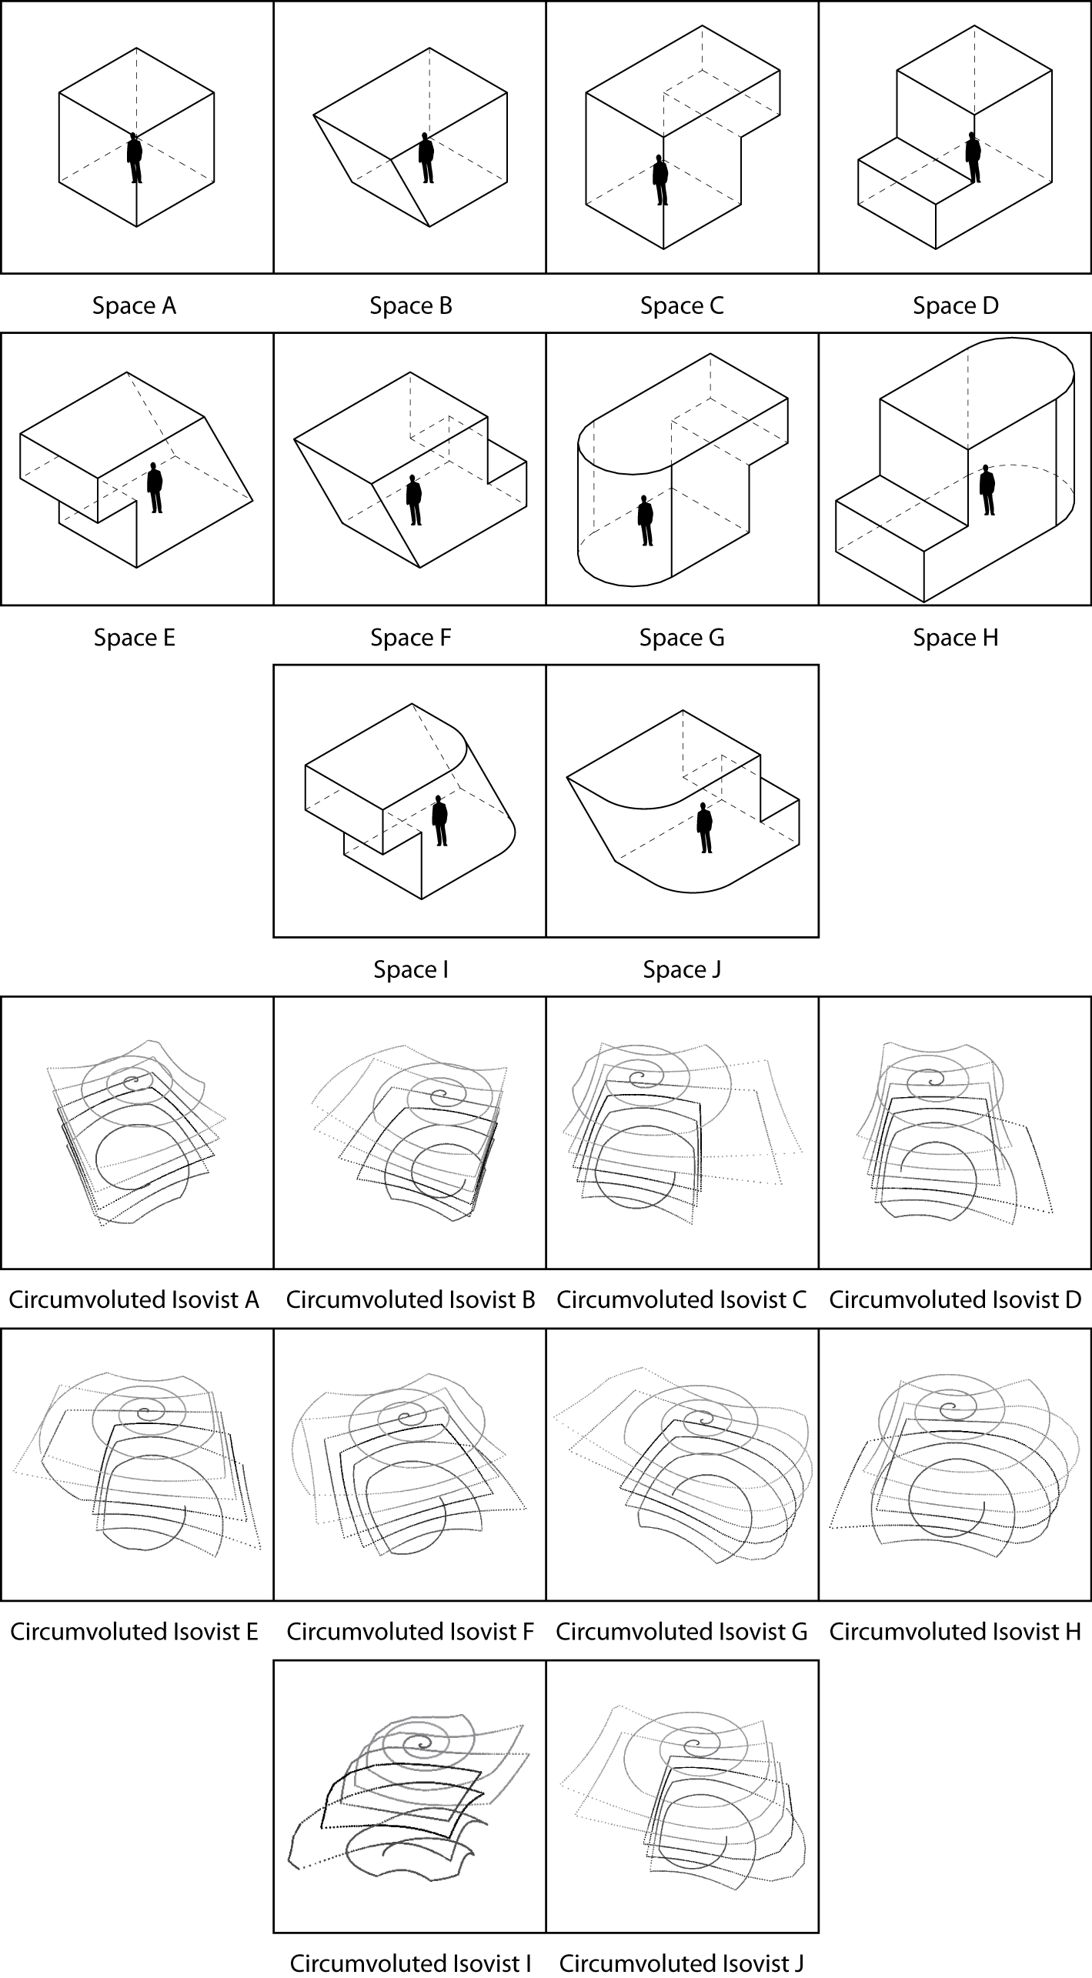
Figure 6 Examples of Circumvoluted Isovists for Ten Simple Volumetric Spaces

The Circumvoluted Isovist

The Circumvoluted Isovist is a radically different way of representing visible space. Imagine that the three-dimensional space visible from a specific point forms a fully enclosed, continuous (no holes or gaps) volume. Then imagine ‘unpeeling’ that volume, as if unpeeling an apple, starting at the top (the point on the ceiling immediately above a person’s head) and gradually spiralling down, until the whole space has been ‘unpeeled’ and ending with a point on the floor beneath their feet. In this way a single, sinuous line can capture a large proportion of the characteristics of the visible envelope. This single spiralling line is known as a Circumvoluted Isovist and examples are shown in figure 6.

There are some interesting mathematical properties of the circumvoluted isovist, as it is essentially a single line, i.e. strictly speaking it is a one-dimensional representation, being used to capture some aspects of three-dimensional space. As it is a linear representation, it can be plotted as a single linear graph, as can be seen in figure 7.

You can easily see the periodicity of the spiralling sampling method, as the periodic oscillation of the line graph. The area under the graph represents the isovist volume and the length of the line approximates the surface area (obviously the smaller the sampling interval, the closer this line will approximate the surface area). The area-to-perimeter ratio of the approximated volume can therefore be determined by the ratio of the area under the line/ line-length. The frequency of the oscillation relates to the number of major occluding surfaces (in a perfect cube maxima are generated every 90° turn). The rate of change of the line-graph corresponds to the type of occluding surface and rapid increases in the rate of change of the line indicates the presence of an occluding radial. The range of values on the y-axis relates to the maximum and minimum radial length of the 3D isovist. The variance of the y-values relate to the skewness or eccentricity of the isovist. The other useful aspect of the linear representation is that it is possible to easily compare a number of different 3D isovist locations, simultaneously and simply on the same graph, see figure 7.

Figure 7 Graph of Circumvoluted Isovists

Evaluation

How do you evaluate a representation? There are surprisingly few papers published on how to evaluate representations. Having introduced the new 3D isovists, we needed to evaluate them. In order to do this we designed an online questionnaire, with the aim of comparing the three representations and to determine their clarity, information-content and simplicity. We designed a set of simple volumetric spaces, which could be held to represent simple rooms, labelled A to J and, for each representation in turn, we asked participants to try to match the correct isovist representation to its corresponding volumetric space. This was intended to test the overall effectiveness of the representation. Naturally, if we found a high error rate of people matching the isovist to the correct volumetric space, then the overall efficacy of the representation must be questioned. These tasks were followed by some simple rating-questions on clarity, information-content and simplicity. Participants were also asked to rank the representations in terms of personal preference. Finally we solicited general feedback on each representation.

We invited an expert set of participants (resultant n=20), all of whom were already familiar with the use of 2D isovists for research purposes, to take part in the questionnaire. This was not intended to be a ‘lay’ or novice survey. As Scaife and Rogers describe, “It is often hard to separate general claims about graphical representations per se from factors that have to do with individual differences in ability in the subject or understanding of the domain-specific genre of the diagrams involved.” (1996). It was for this reason that we attempted to reduce variation due to expertise as much as possible.

Results of the questionnaire: data results

The accuracy of matching the correct representation to the correct volumetric space, if we consider all 10 judgements made by all 20 experts, i.e. n=200 attempts to match the representation to the space, for the Contour Isovist, 95.50% of all judgements were correct, for the Tri-planar Isovist, 96.84% of these were correct and finally for the Circumvoluted Isovist, only 59.47% of attempts to match the 3D isovist to the space were correct. In other words, on the basis of cumulative judgements made, the Tri-planar isovist was the most accurate.

Each isovist representation can be considered individually to determine the accuracy per task. For the Contour Isovist, some isovists were correctly identified by 100% of people, and the most challenging matching tasks were still correctly matched by 85% of all people taking the questionnaire and so the range between the most- and least-well completed task was 15%. For the Tri-planar Isovist, some tasks were also successfully completed by all participants, i.e. there was 100% success rate. The least successful matching task, for the Tri-planar isovist was successfully completed by 89.47% of people, and so the range between the easiest and most challenging tasks was 10.53%, making the Tri-planar Isovist the more accurate of the two. In contrast to these, the Circumvoluted Isovist matching task that had the greatest number of people selecting the right answer, had 94.74% of people getting it right, which is comparable to the 100% for the two other representations. However, for one task, only 5.26% of people identified which volumetric space was being represented. The range, therefore, between the easiest and hardest tasks’ success rate, for the Circumvoluted Isovist was 89.47% and therefore we can conclude that there is greater consistency in matching the representations to the spaces for the Contour and Tri-planar Isovists, compared to the Circumvoluted Isovist, which appears far more erratic in its efficacy.

Another way that we can also look at the same data set is to consider how many experts managed to achieve 100% accuracy in all ten of the tasks, for each isovist representation. For the Contour Isovist, 75% of participants managed to achieve a 100% success rate over the full range of ten tasks, this compares to 73.68% of people attaining this level of accuracy for the Tri-planar Isovist. Both of these results are in stark contrast to the Circumvoluted Isovist’s tasks; there was not a single expert-participant, taking part in the questionnaire, who successfully managed to match all of ten of the Circumvoluted Isovists to the correct volumetric space.

After the matching task, participants were asked to rate each of the isovist representations for the properties of clarity, meaning and simplicity (where 5 is high and 1 is low).

Figure 8 Clarity, Meaning and Simplicity Ratings for the Isovist Representations

The Contour Isovist scored the highest mark on the basis of clarity, scoring 4.4, on average, out of a possible score of 5.0, this compares to the score for the Tri-planar Isovist of 4.1 and 1.9 for the Circumvoluted Isovist. Therefore, on average, most of the experts judged both the Contour and Tri-planar Isovists to be highly clear and understandable. This pattern is mirrored for the question on meaning, in which the Contour Isovist scored 3.9, marginally higher than the score of 3.8 given, on average, to the Tri-planar Isovist and finally the Circumvoluted Isovist scored only 2.2, meaning that, in terms of the information it contained, or the meaning which it communicated, its usefulness was judged to be relatively low by the participants. For the attribute of simplicity, both the Contour Isovist and the Tri-planar Isovist were judged to be equally simple, both receiving a score of 3.9. Once again, the Circumvoluted Isovist scores a far lower average rating of just 1.7, suggesting that rather than being a simple representation it was actually surprisingly difficult to comprehend, see figure 8.

Figure 9 Cumulative Preference Rankings for the Isovist Representations

Finally participants were asked to rank the three representations in terms of their preference. Joint rankings were permitted, i.e. it was possible to rank one representation first and two joint second. The Contour Isovist was clearly the most favoured representation, as it is accorded first preference by 42.11% of people; 31.58% chose the Tri-planar Isovist as their most preferred representation, and a surprising number of people, 4 out of the 20, or 20%, chose the Circumvoluted Isovist as their favourite representation, despite its inaccuracy and perceived failings in terms of its qualities of clarity, meaning and simplicity. Despite the fact that the Contour Isovist was identified as their preferred choice by more people, it was also selected as second choice by most people as well (52.63% people chose it as their second choice), an artefact of the ability to jointly rank representations. The Circumvoluted Isovist was clearly the least popular of all, being placed in third position by more than half, or 52.63%, of all people.

The accuracy of matching the representation to the space does not necessarily match people’s preference, as the Tri-planar Isovist was the most accurate, but the Contour Isovist was the most popular, this is perhaps because the Contour Isovist marginally outperformed the Tri-planar Isovist in terms of perceived qualities of clarity, meaning and simplicity, and it was the quality of clarity where the perceptual difference between them was greatest. Since people were unaware of the outcome of their performance on the matching task, it is perhaps not surprising that the accuracy of this task does not predict preference as much as these perceived qualities. Since the differences between the Contour Isovist and the Tri-planar Isovist were marginal, would knowledge of their own performance metrics in the matching-task have altered their final preference?

In general, the Tri-planar Isovist was found to be more accurate, the Contour Isovist was judged to be clearer and more meaningful and both representations were judged to be equally as simple. Overall the Contour emerges as the preferred represention. The Circumvoluted Isovist clearly does not perform as well as the other two on any metric, either objective (the matching task) or subjective (perceived qualities). In the next section the feedback left by the experts on the different representations will be discussed.

Results of the questionnaire: comments

Please note that the request to comment on or leave feedback on the representations was purely optional and therefore not all of the twenty participants chose to leave written feedback.

The Contour Isovist

On the preference and the ranking questions, this was the preferred representation and the following comments might shed some light on why. Some participants generally thought that the representation was easy to read, saying it was, “Intuitive, especially for those who got (sic) architectural education.” And “Familiarity with the rules of architectural or engineering drawing could help a lot in understanding of the representation.” Other people found it more difficult, stating, “Although a clear graphic representation of space, the Contour Isovist requires a level of thought in order to reconstruct the actual volumetric space in my mind.” And “[It’s] too hard to interpolate back to three dimensions.” But most of the comments focussed on the attributes of the lines used for the above-eye-height and below-height-isovists. One person commented, “These are easy to understand, but I needed to go back to the explanation more than one time to remind [me] whether the dotted or the solid line represent high and low eye-levels.” Another said “I think that it would make more sense if the dotted lines represented contours below eye height and thin, solid lines represented contours above eye height.” And finally there was a suggestion to use colour rather than line-style, “Colour-coding might help to differentiate more than just above and below.”

The Tri-planar Isovist

To reiterate, this representation scored only marginally less than the Contour Isovist on the evaluation. There were some positive comments, for example,“[It was] really easy to handle after I saw the first representation of a shape. Also it is easier to see which parts of the shape can not be seen by the person than in the other two representations.” Another positive comment was that it was generally an “Interesting approach”. Once again, there were a number of people who thought that this representation favoured those from an architectural or engineering background, saying, “Familiarity with the rules of architectural or engineering drawing could help a lot in understanding of the representation.” Another said, “Fine for architects.” And, in a similar vein, “[A] clear method of representation for those used to reading orthographic drawings such as plans, sections and elevations. Corresponding volumes where instantly recognizable from the sectional drawings.”

Other people found it a little more difficult than the Contour Isovist, saying, “[It] takes more time to brain-process compared with Contour Isovist.” There were a few people for whom the rotated sectional isovist was particularly hard to read declaring, “I think that this one was okay, but it was a little difficult to use the information that was represented sideways. It may be easier if the views from the side were always shown with the viewer oriented normally.” Another was in agreement, claiming, “[The] shifted orientation of the bottom-right plane was confusing to me.”

Then there were some people for whom the Tri-planar isovist is clearly just too reductionist a representation and they felt that information could easily be missed: “Has too many ‘blind spots’… Also too hard to interpolate back to three dimensions.” Another commented, “I think sometimes a few more planes could help to understand complex geometry.” And, “Although they capture space in a somewhat intuitive way… they left me with the feeling that they did not actually capture the essence of a 3D environment or would allow me to understand space from this point of view very well.” So in general it seems that the Tri-planar isovist was not quite as straightforward and intuitive as the Contour Isovist and furthermore the risk of missing information was too great. Although it was judged to be simple, it was perhaps too simple for many people.

The Circumvoluted Isovist

This was the representation that people found the most difficult to match back to the corresponding volumetric space and which scored lowest on all measures of preference. It is easy to see why from the following comments. For some people these representations were simply too confusing, saying “This one made absolutely no sense to me.” Another participant said, “I got the impression that [the] Circumvoluted Isovist does not possess a logical representational methodology.”

For many people it was clearly the spiralling nature of the circumvoluted line, which prompted the most perplexity, for example, “The beginning and ending are rather confusing. The spiral is ambiguous to me, I haven’t figured out if it symbolizes a rounding of the top of the space or just the beginning of the spiral-shaped cut.” Another comment read, “[It] was hard to recognize because of the spiral at the top and bottom, and because edges were not sharp.” Yet another said, “I find these really unintuitive. I got a feeling for the 3D volume from them, which I did not get from the other two representations. But the spiralling parts in the line add a lot confusion, which made it hard for me to match them to the real shape fast.” And, yet another observed, “The rounded lines at the beginning and at the end make the reading… difficult to imagine.” And finally, “[This is] difficult to read, the spiralling line is confusing when there are curved faces in the volumes. Decisions were based on educated guesses.”

There were some people who either liked the representation or, at least, aspects of it (and it should be remembered that 4 of the 20 people participating in the questionnaire expressed a preference for the Circumvoluted Isovist in the ranking question). For example, one person stated, “This is the isovist I liked the most for the good idea behind the representation and the rather lossless (compared to the other two) representation of the room. But it is difficult to cope with the ever-changing angular properties of each point in the room. Wouldn’t a combination of the contour and the Circumvoluted Isovist make the most sense, unrolling layer after layer instead of circling around. Maybe planes parallel to the contour planes could be represented semi-transparent so this information is not lost, too.”

There were some for whom the difficulties inherent in the representation were partially offset by the fact that it gave them a strong sense of the 3D space. For example, “[This was] the opposite to Tri-planar Isovists. [They were] hard to read, especially in the beginning, and even for the simple shapes. However, they appear to capture best the actual 3D space.” Another said, “Despite being the least clear it feels quite ‘intuitive’ with a higher potential for representing ‘the feel’ of space.” So the results for the Circumvoluted Isovist represent an interesting evaluation, with some people finding that it gave them a good feel for the space, whilst a large majority stating they simply found them confusing and that, in particular, the spiralling nature of the line contributed to this confusion.

Conclusion

Very little work has been done in the area of testing the efficacy and utility of scientific diagrams; most of the research, where it has been done, has tended to focus on the fields of graph-representations and map-design. For a good review on the cognition of diagrams, please refer to the excellent 2011 paper by Hegarty (Hegarty, 2011). To the best of our knowledge no work has ever been done on evaluating space syntax diagrams, despite the fact that, as a field, we draw heavily on the need to communicate via diagrams/maps and numerous representations of space, and that our audience can be both expert but also lay people (for example in planning reviews or public participatory events).

So far, in the space syntax field, like many other academic fields, we have tended to produce representations, as and when we have needed them. For the most part, we've done this using our intuition, which can be a powerful guide, but it can also be wrong. Hegarty also makes this point in her paper when she says, “While people often have strong intuitions about the effectiveness of displays, these are not always in line with actual effectiveness, so there is a clear need to evaluate display designs empirically and continue to develop cognitive models that will allow us to predict the effectiveness of displays a priori.” (Ibid).

Although we are suggesting caution about relying on our intuition, the other aspect to making new representations is that by creating or formulating new depictions, it allows us to think about existing problems in new ways. This is related to literature on the concept of external cognition (Scaife and Rogers 1996), which suggests that the use of effective diagrams permits us to reduce the amount of cognitive effort or load needed to solve a problem. It also allows us to initiate conversations and discussions around the existing problems. So we should not stop trying to produce new representations in space syntax. However, if we do produce a new representation we should attempt to justify its existence, as Hegarty says in her quote above, “There is a clear need to evaluate display designs empirically”. We would also like to suggest that we, as researchers, whilst not curbing our drive to innovate, also have a duty not to flood our discipline with an ever-increasing number of spurious representations.

In terms of this paper, we have offered up three new representations to the field and we have rigorously tested them with a group of expert users. The results were unequivocal; two of the representations appear to be fit for purpose, with one, the Contour Isovist, emerging as the preferred representation by a small margin. The third representation however, despite having some extremely interesting mathematical properties, was clearly ineffective in assisting people to match the representation to a volumetric space. The Circumvoluted Isovist can therefore be happily relegated to a footnote in the history of space syntax representations. Future work in the area of 3D isovist representations can now be focussed on developing the Contour Isovist and attempting to employ it in more complex, real buildings. Another conclusion of this paper is that Penn was probably correct in saying that 3D isovists are simply quite hard to represent. The problem with representing 3D isovists is essentially that of a trade-off between information and simplicity: representations that are clear and simple run the risk of being too reductionist and information is missed, whereas those representations that contain sufficient information to be useful and meaningful, are frequently too complex to ‘read’ properly.

So the major contributions of this paper are the two new representations themselves and the method of testing a new representation. We would like to end this paper with a plea for future research into the diagrams and representations used in space syntax. This echoes an earlier plea made by Scaife and Rogers, when, in identifying a lack of research in this area, they also stated, “We need insight into how people read and interact with diagrams.” (Scaife & Rogers 1996).

Acknowledgements

Thank you to Christian Derix et al. for permission to reproduce images from their unpublished report on the World Trade Centre Memorial Museum. To the ‘experts’ who took the time to fill in the questionnaire: your comments were invaluable, thank you.

References

Benedikt, M. L. (1979). To take hold of space: isovists and isovist fields. Environment and Planning B, 6(1), 47-65.

Bosselmann, P. (1998). Representation of places: reality and realism in city design. Univ of California Press.

Conroy-Dalton, R. (2001). Spatial navigation in immersive virtual environments (Doctoral dissertation, University of London).

Conroy Dalton, R., & Dalton, N. (2001). Omnivista: An application for isovist field and path analysis. In Proceedings of the 3rd International Space Syntax Symposium, Atlanta, USA.

Derix, C., Gamlesæter, Å., Carranza, P. M. & the Aedas R&D Computational Design and Research [CDR] Group (2007). World Trade Centre Memorial Museum: Computational Analysis & Development Report. Unpublished report. Compiled and submitted on 31st July 2007.

Derix, C., Gamlesæter, Å., & Carranza, P. M. (2008). 3d Isovists and Spatial Sensations: Two methods and a case study. Movement and Orientation in Built Environments: Evaluating Design Rationale and User Cognition, 67-72.

Evans, G. C., & Coombe, D. E. (1959). Hemisperical and woodland canopy photography and the light climate. The Journal of Ecology, 103-113.

Fisher-Gewirtzman, D., & Wagner, I. A. (2003). Spatial openness as a practical metric for evaluating built-up environments. Environment and Planning B, 30(1), 37-50.

Goodman, N. (1969). Languages of Art. Oxford University Press.

Hegarty, M. (2011). The cognitive science of Visual‐Spatial displays: Implications for design. Topics in cognitive science, 3(3), 446-474.

Penn, A., Treleavan, P., Hillier, B., Bull, L., Conroy-Dalton, R., Dalton, N., & Turner, P. A. F. (1996). Pangea V2.1b CD and Pangea User Manual.

Penn, A., Conroy-Dalton, R., Dalton, N., Dekker, L., Mottram, C., & Turner, P. A. F. (1997). Intelligent architecture: new tools for the three dimensional analysis of space and built form.

Scaife, M., & Rogers, Y. (1996). External cognition: how do graphical representations work? International journal of human-computer studies, 45(2), 185-213.

Suleiman, W., Joliveau, T., & Favier, E. (2011). 3D urban visibility analysis with vector GIS data. GISRUK 2011.

Suleiman, W., Joliveau, T., & Favier, E. (2013). A New Algorithm for 3D Isovists. In Advances in Spatial Data Handling (pp. 157-173). Springer Berlin Heidelberg.

Tandy, C. R. V., (1967). The isovist method of landscape survey. In Murray, A. (ed.) Symposium: Methods of Landscape Analysis. May 1967, London, England, Landscape Research Group, 9–10.

Thiel, P. (1961). A sequence-experience notation. Town Planning Review, 32(1), 33.

Thiel, P. (1997). People, paths, and purposes: Notations for a participatory envirotecture. Seattle: University of Washington Press.

Turner, A., Doxa, M., O'Sullivan, D. & Penn, A. (2001). From isovists to visibility graphs: A methodology for the analysis of architectural space. Environment and Planning B: Planning and Design, 28(1), 103-121.

Varoudis, T., & Psarra, S. (2014). Beyond two dimensions: Architecture through three-dimensional visibility graph analysis. The Journal of Space Syntax, 5(1), 91-108.

