Rubber Crumb used in Concrete to Provide Freeze -Thaw Protection
Alan Richardson (corresponding author)
Northumbria University, Engineering and Environment, Newcastle upon Tyne, UK.
Alan.richardson@northumbria.ac.uk

Kathryn Coventry,
Northumbria University, Engineering and Environment, Newcastle upon Tyne, UK email Kathryn.coventry@northumbria.ac.uk

Eli Dias
Northumbria University, Engineering and Environment, Newcastle upon Tyne, UK.
E.Diaz@northumbria.ac.uk

Abstract: This research has examined the use of rubber crumb, used as an additive to concrete that would provide maximum freeze-thaw protection to concrete. The rubber crumb as used in the paper was divided into five batches, with increasing particle size, graded in increments of 0.5mm, from <0.5 to 2.5mm. The primary properties of the concrete investigated were; freeze-thaw durability and compressive strength. These were tested using standard test methods.
The range of tests used were conclusive in that the <0.5 the rubber crumb particle size, provided the greater degree of air entrainment. The freeze-thaw cycle results suggested that rubber crumb provided freeze/thaw protection, as the plain concrete deteriorated compared to the concrete with rubber crumb additions. There was no definitive correlation between the compressive strength and the rubber crumb particles size, although the rubberised concrete had an average strength loss of 5.24% after 28 days. This research indicates that rubber crumb graded up to <0.5mm is the optimum size to use, when rubber crumb granules are used to provide freeze/thaw protection in concrete.
Key words: Optimum rubber crumb particle size, freeze/thaw, durability, sustainability, recycling.

1. Introduction
Freeze/thaw deterioration of concrete is responsible for damage to structures and is a major cost to an aging infrastructure. Waste “rubber” tyres are a serious disposal problem and this work investigates the symbiosis between these two key problems to suggest an environmentally viable solution. The purpose of this research was to examine the freeze/thaw performance of rubber crumb in concrete with regard to particle size, and determine if there was an optimum particle size of rubber crumb, to provide freeze/thaw protection. The rubber crumb used within the test was divided into five different sized particle batches. A single concrete mix design was used with a pre-determined fixed rubber crumb content by mass. The rubber crumb was added to the concrete mix in sieved size increments of 0.5mm. The range of rubber crumb used was between <0.5 to 2.5mm. The primary properties of the concrete investigated were; air content, freeze-thaw durability using pulse velocity, mass lost and compressive strength.

1. 1 Background
Vehicle tyres are made from a chemically improved rubber, and are designed to last for long periods of time. These specific chemical properties pose difficult questions once the tyres have reached their end of life as they contain environmentally toxic substances, which in landfills break down very slowly and when they are incinerated, they produce dangerous pollutants (Siegle, 2006) The European Union identified this concern and took action by setting environmental legislation banning whole tyres from landfills from July 2003 and shredded tyres from July 2006 (Evans and Evans 2006) Elbaba and Williams (2013) highlighted the severity of waste tyres as they suggest Europe and the USA combined produce approximately 8.3 million tons of waste tyres annually.
Since the early 1990’s research has been carried out by many authors into the use of recycled rubber from vehicle tyres within concrete. Authors suggesting the greatest characteristic benefits are: improved toughness, reduced density, greater sound absorption, increased ductility and reduced water absorption (Fattuhi, and Clark, 1996), (Segre,and Joekes, 2000), (Khallo et al 2008), (Bravo, and Brito, .2012), (Mohammed, et al 2012.) Furthermore, rubber incorporated into concrete has been proven to enhance the resistance to freeze-thaw deterioration (Paine, and Dhir, 2010), (Richardson, Coventry, Dave, Pineaar, 2011), and (Richardson, Coventry, and Ward, 2011).
It is believed rubber crumb has similar qualities to traditional air-entraining agents, which create minuscule pores (gel pores) that are so small, temperatures can fall to -78ºC without the formation of ice crystals. These pores allow for the release of pressure and therefore protection from freeze-thaw forces (Neville, and Brooks, 2010). Benazzouk et al (2006) highlighted the ability of rubber crumb particles to ‘artificially entrap air’. Khaloo, Dehestani and Rahmatabadi (2008) suggest this entrapment of air is due to the non-polar rough surfaces of the rubber particles, which entrain air, thus providing freeze-thaw protection.
Additionally, Benazzouk (2007)studied the hydraulic behaviour of rubber particles and discovered that “rubber additives tend to restrict water propagation and reduce water absorption.” Laźniewska-Piekarczyk (2013) explains that this water repellent characteristic “will dramatically improve the durability of concrete exposed to moisture during cycles of freezing and thawing,” thus aiding the protection of concrete from freeze-thaw damage.
It is well recognised that for every additional percent of entrained air added through air-entrainment agents, the compressive strength decreases by about five to six percent. Similarly, since research started investigating the use of rubber within concrete it has been accepted that there is a compressive strength loss. The overall consensus is the greater the quantity of rubber the larger the reduction in compressive strength (Topcu, 1994), (Li, et al 1998), (Khatib, and Bayomy, 1999), Zheng, Huo,. and Yuan, 2008), (Ganjian,, Khorami, and Maghsoudi, 2009) and (Atahan, and Yücel, 2012). However it must be noted, that the majority of this research has used rubber crumb as a substitute for fine or coarse aggregate.
The necessity to examine the rubber crumb particle, was recognised by Fattuhi and Clark (1996) who recommend that there is a need to investigate the rubber in terms of ‘origin, size and shape’ and to determine the effect each parameter has on concrete properties. Relatively little research has been carried out into these parameters, although Paine and Dhir (2010) suggested the freeze-thaw resistance increases as the rubber particle sizes decrease. Zhu et al (2011) recognised that “the size of crumb rubber has an influence on the freeze-thaw resistance of concrete,” although this research introduced rubber as a sand replacement rather than additive.
This research was informed by previous work (Richardson et al 2010) who determined that the optimum quantity of rubber crumb content for the most effective freeze-thaw protection was 0.6% by weight.

2. Methodology
2.1 Mix design
The mix design was influenced by the cube size, as well as being a commonly used commercial strength. 100mm cubes were chosen for reasons of sustainability and this was due to using significantly less material than a 150mm cube which would use 3.38 times more materials. The handling and moving of the cubes also caused health and safety concerns, as each 150mm cube weighed on average 5.2 kg more than the 100mm cubes. Furthermore the surface area to volume ratio for the 100mm cube is 0.67 times greater than the 150mm cube which provided a more severe testing regime.
The 30C characteristic test mix, as displayed in Table 1, was designed to enable the concrete to be compacted into the 100mm cubes more effectively, with a relatively low water cement ratio for additional freeze/thaw protection. The coarse aggregate was composed of washed and graded marine sandstone gravel.
Table 1 – Mix design
Material | Quantities per m³ (kg)
Cement (CEM 1- 42.5 N/mm² ) | 403
Fine aggregate - Sand (0 - 4 mm) | 837
Coarse aggregate (4 - 10 mm) | 336
Coarse aggregate (10 - 20 mm) | 621
Water content (ratio) | 177.3 (0.44)
Rubber crumb (where applicable) | 14.25 (0.6% of weight)
The rubber crumb was graded into five particle sizes, increasing in instalments of 0.5mm, from < 0.5 to 2.5mm. The graded rubber crumb was added to each concrete mix at 0.6% by weight. The cubes were batched in accordance with BS 1881 : Part 108 : 1983. All cubes were cured for an initial 48 hours in their moulds, covered with LDPE sheet before being removed from the moulds and placed in a water-curing tank at a temperature of 19ºC.
2.2 Test Programme
The key elements for examination were: freeze-thaw performance, compressive strength and rubber crumb distribution. These tests were based upon the British Standards Institution (BS) and American Society for Testing and Materials (ASTM).
2.2.1 Density
The density of concrete can be used to determine the air content (Neville and Brooks 2010). The test was carried out in accordance with BS 12390-7 density of hardened concrete.
2.2.3 Freeze/thaw
A combination of ASTM C 666 and BS CEN/TR 15177:2006 were used to establish the principles of the freeze-thaw cycle. Time was a constraint with this research, so the initial decision was to follow the BS that recommended 56 cycles compared to the ASTM which states “300 cycles or until its relative dynamic modulus of elasticity reaches 60% of the initial modulus.”
Procedure B ‘Rapid Freezing in Air and Thawing in Water’ taken from ASTM C 666 was the chosen method of research. A pilot study established the optimum duration of each freeze/thaw cycle. Pulse velocity is an established method used to assess the internal structure of concrete. This test measures the time taken for ultra sound waves to travel through the concrete. Freeze-thaw cycles create surface micro cracks, these initiate damage and through repeated freeze/thaw cycles, the crack propagation creates internal damage to the concrete, which in turn slows the ultra sound waves, thus increasing the transmission time. This test was carried out every 7 cycles in accordance with BS CEN/TR 15177 and BS EN 12504-4 [28].
The pulse velocity measurements were used to determine the relative modulus and breakdown of the concrete when subject to freeze-thaw cycles. The durability factor was calculated at the end of cycle 56 and cycle 70, to discover if the modulus of elasticity had reached 60% of the initial modulus at which point the test would be terminated due to a significant failure occurring. The Equations 1 and 2 are displayed in the ASTM C666 – 97, standard 9.1 and 9.2, as displayed below.
Durability factor Equation [1]
$DF= \frac{PN}{M}$ (1)
DF = durability factor of the test specimen
P = relative dynamic modulus of elasticity at N cycles (%)
N = number of cycles at which P reaches the specified minimum value for discontinuing the test or the specified number of cycles at which the exposure is to be terminated, whichever is less
M = specified number of cycles
P is calculated using the Equation [2];
$P=\left(\frac{n_{1}^{ 2}}{n^{2}}\right)× 100$ (2)
P = relative dynamic modulus of elasticity after c cycles of freezing and thawing (%)
n = fundamental transverse frequency at 0 cycles of freezing and thawing
n₁ = fundamental transverse frequency after c cycles of freezing and thawing
c = number of freeze/thaw cycles carried out
Mass lost per cube, was used to determine the degree of freeze-thaw action.. Furthermore, this test gave a greater insight into the changes each cube was subject to throughout the entire test period. The unfrozen cubes were weighed every 7 cycles, immediately before the pulse velocity test.
2.2.4 Compressive strength
This research measured the compressive strength of the concrete at three separate occasions. The first occasion was after 3 days, at the same time the cubes started the freeze/thaw cycle, this was to obtain an initial control strength pre freeze thaw. The second occasion was after 28 days, this was to establish the effect the addition of rubber particle size had on the strength of the concrete. The third and final occasion was post freeze thaw cycles, and this was to measure the strength reduction following the freeze-thaw action and to identify which batch performed most effectively
2.2.5 Rubber crumb distribution

The rubber distribution was examined using the principles outlined in TR 32 (Concrete Society 1989). It was essential that the rubber crumb was evenly distributed within the concrete to ensure a uniform freeze/thaw protection. There was the possibility the rubber could either group together or rise to the top of the cube during compaction, which would be due to the rubber being less dense than the concrete mixture. The combination of the tests provided a holistic overview of rubber crumb performance when used in concrete

3. Results and Discussions
3.1 Slump and consistency
The BS EN 12350 – 2 slump test was used to monitor consistency and the test results are within the range, 60 to 70mm for all batches. The plain concrete had the slightly higher slump when tested.
3.2 Density
The density of concrete can be used to indicate the air content (Neville and Brooks, 2010). Figure 1 indicates the smaller the rubber crumb particle, the greater the air entrainment, and consequently the authors recommend the particle size < 0.5mm as offering the greatest potential for freeze-thaw protection.
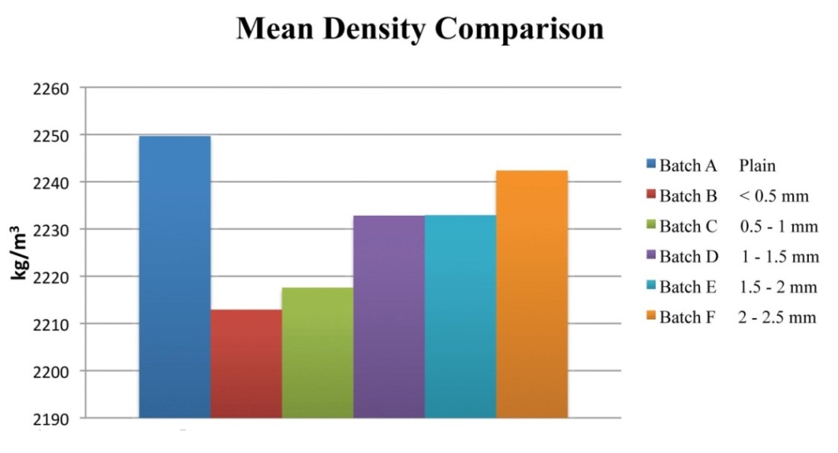
Figure 1 – Mean Density Comparison
3.3 Freeze/thaw, Pulse velocity
At the conclusion of the planned 56 freeze/thaw cycles, the plain concrete cubes had not failed, as the modulus of elasticity, measured using pulse velocity, had not yet reached 60% of the initial modulus, therefore the test was extended for a further 14 cycles, to provide further potential for freeze/thaw deterioration of the cubes. The pulse velocity for all batches over the test period can be seen in Figure 2. It is evident that the pulse velocity for all batches consistently increased over the first 42 cycles. The pulse velocity increasing during curing is due to an increase in compressive strength during the freeze/thaw programme. To provide an accelerated test programme, the cubes started the freeze-thaw cycle after 3 days, and they continued to cure and increase in strength. However the most notable aspect of this test is the decrease in the plain cubes pulse velocity from cycle 42 to cycle 70, where for the same period the cubes with rubber crumb were relatively stable. Seventy freeze/thaw cycles provided an insight as to what may be expected in the longer term with regard to freeze/thaw durability.

Figure 2 – Mean Pulse Velocity Comparison
3.4 Mass lost
During the freeze-thaw cycles, all batches experienced a mass loss, although at different rates. The plain concrete cubes had the greatest loss of -0.6%. Batch B lost -0.07%, batch C -0.11%. batch D -0.35%, batch E -0.39%, and batch F -045.
3.5 Compressive strength
The full comparison of compressive strength illustrated in Figure 3, is a graphical representation comparing the individual cubes at various stages of the test programme. The increase of strength from the start of the freeze-thaw cycle at three days to the post freeze-thaw cycle strength reveals the concrete has continued to cure during at least part of the freeze-thaw cycles. The strength of the 28 day old cubes is higher than the post freeze-thaw strength, which displays the effects of the freeze/thaw action and temperature on the curing process.

Figure 3 – Total compressive strength comparison
The <0.5mm rubber crumb additive achieved the best performing freeze/thaw performance as displayed in Figure 4.

3.6 Durability factor
The durability factor shows that the cubes continued to cure during the freeze/thaw programme, hence the values achieved exceeding 100%. What is evident from this test, is that Batch A, the plain concrete, has the lowest durability factor (101.3%). Batch E marginally provides the best durability factor (105.2%). All of the concrete samples containing rubber crumb outperformed the plain concrete with regard to freeze/thaw durability.
3.7 Rubber crumb distribution
The cubes were cut and split centrally using a water cooled masonry saw to expose a cross section, displaying the rubber crumb distribution. When all of the cubes were examined there was an equal distribution of rubber crumb through the section, and this equal spacing of the rubber crumb is essential to provide an even freeze/thaw protection to the cubes.
3.7.1 Rubber crumb detail
Figure 4 displays the irregular nature of the <0.5mm rubber crumb surface finish when viewed at x500 magnification. The irregular surface will entrap air and create an air void system for freeze/thaw protection and the displays fibrous materials attached to and within the <4mm rubber crumb granules viewed at 500x magnification. The fibrous materials may provide further freeze/thaw protection.
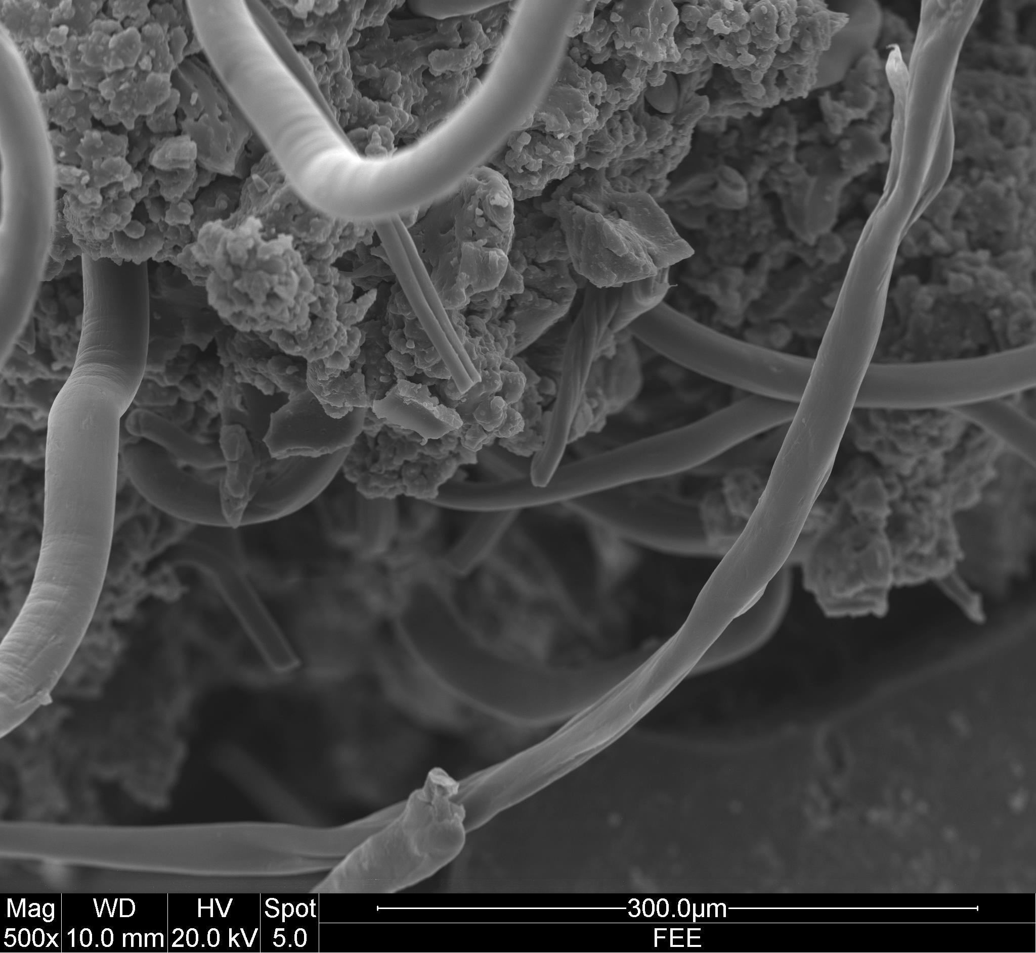
Figure 4 – rubber crumb and fibrous materials

4. Conclusion
When all of the results were analysed, there was a notable improvement in freeze/thaw resistance between plain and rubber crumb concrete. The optimum rubber crumb particle size that performed best was <0.5mm. There was no definitive correlation between the compressive strength and the rubber crumb particles size, although the rubberised concrete had an average strength loss of 5.24% after 28 days.
It was established that the rubber crumb had non-polar rough surfaces, which supported the theory claiming this is how air is entrained. Consequently, the smaller the particle size the greater the surface area for the same mass of rubber and thus, the greater the opportunity to entrain air. This premise was supported by the use of an air entrainment pressure test, which discovered that the batch with rubber smaller than 0.5 mm entrained 3.3%, compared to plain concrete of 1.9%. The density test also suggests that the smaller the particle size, the greater the air entrained, and this provides freeze-thaw protection. The quality of the concrete used was relatively freeze/thaw resistant without any additives and this was thought to be due to the low water cement ratio using during the batching process. Low water cement ratio equates to low pore sizes and spacing and low permeability.
The compressive strength, post freeze-thaw cycles reveal the plain concrete had the weakest strength, supporting the evidence that the addition of rubber crumb provides freeze-thaw protection. Furthermore, the post freeze-thaw compressive strength test found the concrete with the rubber crumb smaller than 0.5 mm had the highest strength, indicating this batch had the least amount of structural damage.
The rubber crumb was distributed evenly throughout all batches, generating an even distribution of entrained air and therefore an even protection. This research indicates that a rubber crumb particle size smaller than 0.5mm is the optimum size to afford maximum freeze/thaw protection in concrete when using a waste product within the concrete supply chain.
The benefits of this research illustrate a potential means of reducing the environmental impact of waste tyres whilst improving the concrete product and lowering the life cycle costs.

5. References
American Society for Testing and Materials (2008) C666 – 97 Standard Test Method for Resistance of Concrete to Rapid Freezing and Thawing. Pennsylvania: American Society for Testing and Materials.
American Society for Testing and Materials, C 672 _C0672M-03 Test Method for Scaling Resistance of Concrete Surfaces Exposed to De-icing Chemicals, Pennsylvania: American Society for Testing and Materials.
Atahan, A. O. and Yücel, A. Ö. (2012) ‘Crumb rubber in concrete: Static and dynamic evaluation’ Construction and Building Materials, 36, pp. 617-622.
Benazzouk, A., Douzane, O., Mezreb, K. and Queneudec, M. (2006) ‘Physico-mechanical properties of aerated cement composites containing shredded rubber waste’ Cement & Concrete Composite, 28, pp. 650-657.
Benazzouk, A., Douzane, O., Langlet, T., Mezreb, K., Roucoult, J. M. and Queneudec, M. (2007) ‘ Physico-mechanical properties and water absorption of cement composite containing shredded rubber wastes’ Cement & Concrete Composites, 29, pp. 732-740.
Bravo, M. and Brito, J. D. (2012) ‘Concrete made with used tyre aggregate: durability-related performance’ Journal of Cleaner Production, 25, pp. 42-50.
British Standards Institute (2006) PD CEN/TR 15177:2006 Testing the freeze-thaw resistance of concrete — Internal structural damage. London: British Standards Institute.
BS EN 12350 – 2: 2009 Testing Fresh Concrete – Part 2. Slump Test
BS EN 12504-4:2004. Testing concrete. Determination of ultrasonic pulse velocity
BS 1881 : Part 108 : 1983, Testing concrete. Method for making test cubes from fresh concrete
BS 12390-7:2009 Testing hardened concrete. Density of hardened concrete
BS EN 12350-7:2009 Testing fresh concrete. Air content. Pressure methods
Concrete Society, (1989), TR 32, “Analysis of Hardened Concrete, a guide to test procedures and interpretation of results”, Report by a joint working party of the Concrete Society and the Society of the Chemical Industries, UK.
Elbaba, I. F. and Williams, P. T., (2013) ‘Hydrogen production from the pyrolysis-gasification of waste tyres with a nickel/dolomite catalyst’, Fuel, 103(April, 2013), pp. 528-536.
Evans, A. and Evans R, (2006) UK waste tyre management best practice: Handling of post-consumer tyres – collection & storage, Oxon: The waste & resources action programme.
Fattuhi, N. I. and Clark, L. A. (1996) ‘Cement-based materials containing shredded scrap truck tyre rubber’ Construction and Building Materials, 10(4), pp. 229-236.
Ganjian, E., Khorami, M. and Maghsoudi, A. A. (2009) ‘Scrap-tyre-rubber replacement for aggregate and filler in concrete’ Construction and Building Materials, 23, pp. 1828-1836.
Khallo, A. R., Dehestani, M. and Rahmatabadi, P. (2008) ‘Mechanical properties of concrete containing a high volume of tire-rubber particles’ Waste Management, 28, pp. 2472-2482.
Khatib, Z. K. and Bayomy, F. M. (1999) ‘Rubberized Portland cement concrete’, Journal of materials in civil engineering, 11, pp. 206-213.
Laźniewska-Piekarczyk, B.(2013) ‘The type of air-entraining and viscosity modifying admixture and porosity and frost durability of high performance self-compacting concrete’ Construction and Building Materials, 40, pp. 659-671.
Li, X., Li, F. and Li, J. S. L. (1998) ‘Properties of concrete incorporating rubber tyre particles’ Magazine of concrete research, 50, pp. 297-308.
Mohammed, B. S., Hossain, K. M. A., Swee, J. T. E., Wong. G and Abdullahi, M. (2012) ‘Properties of crumb rubber hollow concrete block’ Journal of Clean Production, 23, pp 57-67.
Neville, A. M. and Brooks, J. J. (2010) Concrete Technology. 2nd Ed. Essex: Pearson.
Paine, K. A. and Dhir, R. K. (2010) ‘Research on new applications for granulated rubber in concrete’ Construction Materials, 63(February), pp. 7-17, doi: 10.1680/coma.2010.163.1.73.
Richardson, A., Coventry, K. and Ward, G, (2011) ‘Freeze/thaw protection of concrete with optimum rubber crumb content’, Journal of Cleaner Production, 23(1, March 2012), pp. 96-103. doi: 10.1016/j.jclepro.2011.10.013
Richardson A.E., Coventry K., Dave U, Pineaar J, (2011), “Freeze/thaw protection of concrete using granulated rubber crumb”, The Journal of Green Building, Vol 6, Number 1, Winter, USA, pp 83 -92 doi/abs/10.3992/jgb.6.1.83
Siegle, L (2006) Recycle the Essential Guide. London: Black Dog Publishing
Segre, N and Joekes, I. (2000) ‘Use of tire rubber particles as addition to cement paste’ Cement and Concrete Research, 30, pp, 1421-1425.
Topcu, I. B. (1994) ‘The properties of rubberized concretes’ Cement and Concrete Research, 24(2), pp. 304-310.
Zheng, L., Huo, X. S. and Yuan, Y. (2008) ‘Strength, Modulus of Elasticity, and Brittleness Index of Rubberized Concrete’ Journal of Materials in Civil Engineering, 20, pp. 692-699.
Zhu, X., Miao, C., Liu, J. and Hong, J. (2011) ‘Influence of crumb rubber on frost resistance of concrete and effect mechanism’, Procedia Engineering, 23(2012), pp. 206-213.

