Density Functional Theory Study of Diffusion of Lithium in Li-Sn Alloys
Jianjian Shi,¹ Zhiguo Wang,^{1*} Y.Q. Fu^{2*}
- School of Physical Electronics,, University of Electronic Science and Technology of China, Chengdu, 610054, P.R. China
- Department of Physics and Electrical Engineering, Faculty of Engineering and Environment, University of Northumbria, Newcastle upon Tyne, NE1 8ST, UK

*Corresponding author. E-mail: zgwang@uestc.edu.cn; richard.fu@northumbria.ac.uk

Abstract
Diffusion of Li in Li_{x}Sn alloys was investigated using a density functional theory in order to fully understand the lithiation process in these types of Li ion batteries. Variation of the calculated open circuit voltages of the Li_{x}Sn alloys was found to agree well with experimental results. Diffusion coefficients of the Li in the Li_{x}Sn alloys were calculated to be in the range between 6.6×10⁻⁸ cm²s⁻¹ to 5.6×10⁻⁷ cm²s⁻¹ at room temperature, which is within the range between 8.0×10⁻⁸ cm²s⁻¹ to 5.9×10⁻⁷ cm²s⁻¹ obtained from the experimental measurement.

Key words: Density functional theory, Li_{x}Sn alloys, Voltage, Diffusion, Molecular dynamics

- Introduction
Lithium ion batteries (LIBs) with a high energy density operated at a high power are being widely investigated as rechargeable energy storage devices for electric vehicles, smart grids, and medical apparatus [1,2]. Further increasing the energy density of the LIBs can be realized through increasing the capacity or the open circuit voltage (OCV) of electrode materials [3]. Li_{x}Sn alloys have been received great attention recently owing to their large Li storage capacities (e.g., with a theoretical capacity value of 994 mAhg⁻¹ for Li₂₂Sn₅) [4]. Sn anode materials synthesized using an electrodeposition method showed an initial discharge capacity of 757 mAhg⁻¹ [5], and those synthesized using an electron-beam evaporation method showed a discharge capacity of about 800 mAhg⁻¹ [6]. Whereas those synthesized using a magnetron sputtering technique showed an initial discharge capacity over 800 mAhg⁻¹ [7]. Although these experimentally obtained discharge capacities of the Sn anode materials prepared using different methods are less than their theoretical maximum reading, they are much higher than those reported for the LIBs using graphite (372 mAhg⁻¹) as anode materials [8,1]. However, currently the Sn anodes have not been commercialized due to their poor cyclic performances because of their huge volume expansion/contraction during lithiation/delithiation processes, which causes mechanical disintegration of the Sn anode electrode materials [9,6,10]. Various methods have been applied to improve the cyclic performances of the Sn anodes, such as using nanostructured Sn or Sn-based anode materials (i.e., nano-crystallized Sn-based intermetallic alloys, Sn nanoparticles/C nanotubes, Sn nanoparticles, SnO₂ nanoparticles) [11-17], and Sn-M (M=Fe, Co, Ni, Li) alloys [18,19].
There are six types of Li_{x}Sn alloy phases according to the literature: i.e., LiSn, Li₇Sn₃, Li₅Sn₂, Li₁₃Sn₅, Li₇Sn₂ and Li₂₂Sn₅ [20]. These intermetallic phases of the Li_{x}Sn alloys formed upon lithiation process have been investigated using electrochemical techniques in literature for potential LIB applications [21-23,20,24]. The OCV?? Open circuit voltage and diffusion coefficient of Li ions in these Li-Sn alloys are important parameters if the Sn is to be used as an anode for the LIBs, since larger OCVs represent a larger energy density, and a larger diffusion coefficient indicates that the anode materials can be charged/discharged with a higher rate. Experimental results and theoretical calculation showed that the plateau potentials (vs Li/Li⁺) of the Li_{x}Sn alloys were in the range of 0.3~0.8 V [22,25]. Diffusion barriers of an isolated lithium atom in the α-Sn and β-Sn were reported to be 0.21 eV and 0.39 eV, respectively [26]. The diffusion barrier of Li in Sn also showed a dependence on the Li content, and those for the Li diffusion paths with or without the influence of an adjacent Li ion were calculated to be 0.33 or 0.39 eV, respectively [27]. The diffusivity value of the Li⁺ ion in a nano-crystallized Sn anode prepared using a laser-assisted vapor deposition was measured to be 4.15×10⁻⁸ cm²s⁻¹ [28]. Whereas the reading for a thin film Sn/Cu₆Sn₅ anode prepared using an electron-beam evaporation deposition was 1.91×10⁻⁷ cm²s⁻¹, which is much higher than those of pure Sn and nano-crystallized Sn because of the significantly reduced crystal sizes of Cu₆Sn₅ [6]. Simulation results from Genser et al. [27] showed that the diffusivity values of Li in the LiSn and Li₄Sn alloys were 3.7×10⁻⁵ cm²s⁻¹ at 765K and 1.21×10⁻⁴ cm²s⁻¹ at 1040 K, respectively. Xie et al. [29] reported that the Li diffusivity values in the Sn films prepared by radio frequency magnetron sputtering were in a range between 10⁻¹⁶ and 10⁻¹⁴ cm²s⁻¹, which shows a large difference compared with experimental results of other groups discussed above.
Clearly, the previously mentioned simulation work has been focused on diffusion behavior of an isolated Li ion in the Sn anode, but the results cannot predict the lithiation process at higher Li concentrations. Also systematic studies of the Li⁺ ion diffusion in the Li_{x}Sn alloys with varied Li concentrations are urgently required in order to fully understand the lithiation process. In this work, a first principle simulation based on density functional theory (DFT) was used to systemically study the OCVs of lithiation/delithiation processes in the Li_{x}Sn alloys and the diffusivity of Li in the Li_{x}Sn alloys with varied concentrations of Li from 0.4 to 3.5.

- Computational details
The average voltages of two neighboring elements of Li_{x}Sn (x=0, 0.4, 1, 2.33, 2.5, 2.6, 3.5) alloys and their diffusion kinetics were calculated using the SIESTA (Spanish Initiative for Electronic Simulations with Thousands of Atoms) code [30] based on the DFT [31,32]. The exchange-correlation energies were described using a generalized gradient approximation (GGA) with the Perdew-Burke-Emzerhof (PBE) function. Numerical atomic orbits were described using a double zeta basis set. An energy cut-off of 150 Ry was used for the Fourier expansion of the density and the Monkhorst Pack of special k points was used for sampling Brillouin zone for the Li_{x}Sn alloys with different unit cell dimensions as listed in Table 1. Conjugate gradient algorithm was used in geometric relaxations to obtain converged results until the force on every atom was smaller than 0.02 eV/Å. It should be noted that during calculating the average voltage, a dense Brillouin zone sampling was applied to obtain the convergent values.
The average voltage was calculated from the energy difference of two neighboring phases of Li_{x}Sn alloys by neglecting the volume and entropy effects.
(1)
where F is Faraday constant.
(2)
where are the cohesive energies of the and the metallic, respectively.
The diffusion kinetics were calculated using ab initio molecular dynamics (MD) simulations with the canonical (NVT) ensemble [33], in which numbers and values of atoms, volume and temperature were kept as constant values. Temperature was controlled using a Nose-Hoover thermostat. A special k-point sampling with 2×2×2 k-grid with the Monkhorst-Pack scheme for the Li_{x}Sn (x=0.4, 1, 2.33, 2.5, 2.6, 3.5) alloys was used for the Brillouin zone sampling. A denser Brillouin zone sampling of 4×4×4 k-grid was also tested for the Li_{x}Sn alloy at 1100 K, and results from the mean square displacements (MSDs) with such a denser Brillouin zone sampling were overlapped with those with a k-grid of 2×2×2, indicating that a 2×2×2 k-grid is enough for the ab initio MD simulations. In simulation, the Li_{x}Sn alloys were firstly annealed at 3000 K for 3000 steps with a time step of 1.0 fs, and then rapidly quenched to 300 K with a cooling rate of 1.0 K/fs. The structural evolution of the crystalline structure for the Li_{x}Sn (x=0.4, 1, 2.33, 2.6, 3.5) alloys after quenching was characterized using a pair-distribution function (PDF) (, where and are the average number densities of atoms at the distance r and the number density of atoms in the Li_{x}Sn system, respectively. The PDF is a pair correlation representing the probability of finding atoms as a function of distance r from an average center atom. The quenched structure was used as a start model and the atom positions were relaxed at temperatures between 700 and 1200 K for 15 ps with a time step of 1.0 fs. The atom positions were recorded upon the relaxation, and the readings of MSDs for the Li and Sn atoms as a function of time were calculated in order to obtain the diffusion coefficients at different temperatures. The obtained data were then extrapolated to acquire the diffusion coefficients at room temperature according to the Arrhenius equation: [34], where is the temperature, is the diffusion energy barrier and is the Boltzmann constant.
The diffusion coefficients () from the MD simulation is dependent on the Einstein relation:
(3)
where is diffusion time of atom . is initial position of the atom and is the position of the atom at , respectively. The item of represents the MSDs.

- Results and discussions
The OCV is an important parameter which can be used to characterize how large the driving forces to attain an equilibrium between the cathode and anode once they are connected. A larger value of the OCV is preferred for high power-consuming devices [35]. The OCV of a lithium cell is determined by the difference of Li chemical potentials between the cathode and anode materials [36]. The average voltages of two neighboring Li_{x}Sn alloy phases calculated using equation (1) are shown in Fig. 1 along with two experimentally obtained charge/discharge curves from references of [25,37]. The calculated curves agree well with the experimental ones. As x value of the Li_{x}Sn alloy is smaller than 1.0, a higher average voltage was obtained. Whereas as x is in the range between 1.0 and 2.6, a voltage plateau appears. When x is increased to a value large than 2.6, the average voltages are reduced suddenly and much less than those of Li-deficient Li-Sn alloys.
The diffusivity of Li in the Li_{x}Sn is an important parameter which can reveal if Sn can be efficiently used in high-power applications. The experimental results showed that the diffusivity values of Li in the Li_{x}Sn at room temperature are in a wide range between 8×10⁻¹⁶ and 5.9×10⁻⁷ cm² s⁻¹ [6,23,38,24,19]. The diffusivity of the Li in the Li_{x}Sn (x=0.4, 1, 2.6, 3.5) was studied using ab initio MD. The PDF values characterizing the structural evolution of the Li_{x}Sn (x=0.4, 1, 2.6, 3.5) alloys in both crystalline structure and after melting/quenching at 300 K are shown in Fig. 2. In Fig. 2, the data from left to right in a sequence represent the PDFs of Li₂Sn₅, LiSn, Li₁₃Sn₅ and Li₇Sn₂; and those from top to bottom represent the PDFs of Li-Li, Sn-Sn, Li-Sn and Li_{x}Sn alloys; whereas the sharp curves and smooth curves represent the PDF values of the crystalline Li_{x}Sn and the Li_{x}Sn after quenching, respectively. Sharp peaks can be clearly observed for the crystalline Li_{x}Sn alloys, and that at 3.16 Å in the crystalline Li₂Sn₅ for Li-Li bonds represents the nearest neighbors of Li-Li. After the samples were annealed at 3000 K and quenched to 300 K, the sharp peaks disappear except for the first one. This indicates that the long-range order disappears, and the crystalline Li_{x}Sn (x=0.4, 1, 2.6, 3.5) alloys were transformed into amorphous phases.
The positions r_{i}(t) of all atoms as a function of time t were recorded for all the amorphous phases as they became relaxed at a given temperature. The MSDs of Li in amorphous Li_{x}Sn (x=0.4, 1.0, 2.6, 3.5) alloys as function of time are shown in Fig. 3. For all the alloys, the slope of the MSDs increases with increasing the simulation temperature, which demonstrates that the Li diffuses much faster at a higher temperature. The diffusion coefficients calculated using equation (4) are plotted in Fig. 4 (a). Those of the Li in the Li_{x}Sn at room temperature were then extrapolated using the Arrhenius equation based on the data obtained at high temperatures, and obtained results are 5.6×10⁻⁷, 3.3×10⁻⁷, 6.6×10⁻⁸ and 5.1×10⁻⁷ for the Li_{x}Sn alloys with x=0.4, 1.0, 2.6 and 3.5, respectively. The obtained diffusion coefficients as a function of Li content are shown in Fig. 4 (b), along with the reported experimental results. Our calculated results are within the range between 8.0×10⁻⁸ cm²s⁻¹ to 5.9×10⁻⁷ cm²s⁻¹ obtained from the previous experimental work [6,23,38,24,19].

- Conclusions
A systematic study of the Li⁺ ion diffusion behavior in the Li_{x}Sn alloys with varied Li concentrations was performed in order to fully understand the lithiation process of Sn for the Li ion batteries. The average voltages and diffusion coefficients of the Li in the Li_{x}Sn alloys were calculated using the density functional theory. The variation trends of the calculated average voltages agreed well with those from the experimental observations. The diffusion coefficients of Li in Li_{x}Sn were calculated to be in the range between 6.6×10⁻⁸ cm²s⁻¹ to 5.6×10⁻⁷ cm²s⁻¹ at room temperature, and these agreed with the experimental measurement results.

Acknowledgement:
This work was financially supported by the National Natural Science Foundation of China (11474047). Funding support from from the UoA and CAPEX funding from Northumbria University at Newcastle upon Tyne, Royal academy of Engineering UK-Research Exchange with China and India is acknowledged. This work was carried out at National Supercomputer Center in Tianjin, and the calculations were performed on TianHe-1(A).

Compliance with Ethical Standards:
Funding: This study was funded by National Natural Science Foundation of China (11474047) and Royal academy of Engineering UK-Research Exchange with China and India.
Conflict of Interest: The authors declare that they have no conflict of interest.

References:
1. Zhang H, Sun X, Zhang X, Lin H, Wang K, Ma Y (2015) High-capacity nanocarbon anodes for lithium-ion batteries. Journal of Alloys and Compounds 622:783-788. doi:10.1016/j.jallcom.2014.10.188
2. Eom K, Jung J, Lee JT, Lair V, Joshi T, Lee SW, Lin Z, Fuller TF (2015) Improved stability of nano-Sn electrode with high-quality nano-SEI formation for lithium ion battery. Nano Energy 12:314-321. doi:10.1016/j.nanoen.2014.12.041
3. Kiziltas-Yavuz N, Bhaskar A, Dixon D, Yavuz M, Nikolowski K, Lu L, Eichel R-A, Ehrenberg H (2014) Improving the rate capability of high voltage lithium-ion battery cathode material LiNi0.5Mn1.5O4 by ruthenium doping. Journal of Power Sources 267:533-541. doi:10.1016/j.jpowsour.2014.05.110
4. Zhang W-J (2011) A review of the electrochemical performance of alloy anodes for lithium-ion batteries. Journal of Power Sources 196 (1):13-24. doi:http://dx.doi.org/10.1016/j.jpowsour.2010.07.020
5. Kim R, Nam D, Kwon H (2010) Electrochemical performance of a tin electrodeposit with a multi-layered structure for Li-ion batteries. Journal of Power Sources 195 (15):5067-5070. doi:10.1016/j.jpowsour.2010.01.069
6. Hu RZ, Zeng MQ, Zhu M (2009) Cyclic durable high-capacity Sn/Cu6Sn5 composite thin film anodes for lithium ion batteries prepared by electron-beam evaporation deposition. Electrochimica Acta 54 (10):2843-2850. doi:10.1016/j.electacta.2008.11.021
7. Zhao LZ, Hu SJ, Ru Q, Li WS, Hou XH, Zeng RH, Lu DS (2008) Effects of graphite on electrochemical performance of Sn/C composite thin film anodes. Journal of Power Sources 184 (2):481-484. doi:10.1016/j.jpowsour.2008.04.074
8. Hu R, Liu H, Zeng M, Liu J, Zhu M (2012) Progress on Sn-based thin-film anode materials for lithium-ion batteries. Chinese Science Bulletin 57 (32):4119-4130. doi:10.1007/s11434-012-5303-z
9. Chou C-Y, Kim H, Hwang GS (2011) A Comparative First-Principles Study of the Structure, Energetics, and Properties of Li–M (M = Si, Ge, Sn) Alloys. The Journal of Physical Chemistry C 115 (40):20018-20026. doi:10.1021/jp205484v
10. Robert F, Lippens PE, Fourcade R, Jumas J-C, Gillot F, Morcrette M, Tarascon J-M (2006) Mechanosynthesis and characterisation of the Li–Sn system. Hyperfine Interactions 167 (1-3):797-801. doi:10.1007/s10751-006-9360-z
11. Nithyadharseni P, Reddy MV, Nalini B, Kalpana M, Chowdari BVR (2015) Sn-based Intermetallic Alloy Anode Materials for the Application of Lithium Ion Batteries. Electrochimica Acta 161:261-268. doi:10.1016/j.electacta.2015.02.057
12. Nithya C, Gopukumar S (2013) Reduced Graphite Oxide/Nano Sn: A Superior Composite Anode Material for Rechargeable Lithium-Ion Batteries. Chemsuschem 6 (5):898-904
13. Zhang HK, Song HH, Chen XH, Zhou JS (2012) Enhanced Lithium Ion Storage Property of Sn Nanoparticles: The Confinement Effect of Few-Walled Carbon Nanotubes. Journal of Physical Chemistry C 116 (43):22774-22779. doi:Doi 10.1021/Jp308571p
14. Li Y, Wu J, Chopra N (2015) Nano-carbon-based hybrids and heterostructures: progress in growth and application for lithium-ion batteries. J Mater Sci 50 (24):7843-7865. doi:10.1007/s10853-015-9429-7
15. Jiang H, Ge Y, Fu K, Lu Y, Chen C, Zhu J, Dirican M, Zhang X (2015) Centrifugally-spun tin-containing carbon nanofibers as anode material for lithium-ion batteries. J Mater Sci 50 (3):1094-1102. doi:10.1007/s10853-014-8666-5
16. Qiao H, Zheng Z, Zhang L, Xiao L (2008) SnO(2)@C core-shell spheres: synthesis, characterization, and performance in reversible Li-ion storage. J Mater Sci 43 (8):2778-2784. doi:10.1007/s10853-008-2510-8
17. Szabo DV, Kilibarda G, Schlabach S, Trouillet V, Bruns M (2012) Structural and chemical characterization of SnO2-based nanoparticles as electrode material in Li-ion batteries. J Mater Sci 47 (10):4383-4391. doi:10.1007/s10853-012-6292-7
18. Wang XL, Han WQ, Chen J, Graetz J (2010) Single-crystal intermetallic M-Sn (M = Fe, Cu, Co, Ni) nanospheres as negative electrodes for lithium-ion batteries. ACS Appl Mater Interfaces 2 (5):1548-1551. doi:10.1021/am100218v
19. Zhang PP, Ma ZS, Wang Y, Zou YL, Lei WX, Pan Y, Lu CS (2015) A first principles study of the mechanical properties of Li-Sn alloys. Rsc Adv 5 (45):36022-36029
20. Wen CJ, Huggins RA (1981) Chemical diffusion in intermediate phases in the lithium-silicon system. Journal of Solid State Chemistry 37 (3):271-278. doi:http://dx.doi.org/10.1016/0022-4596(81)90487-4
21. Nimon ES, Churikov AV (1996) Electrochemical behaviour of Li-Sn, Li-Cd and Li-Sn-Cd alloys in propylene carbonate solution. Electrochimica Acta 41 (9):1455-1464. doi:10.1016/0013-4686(95)00394-0
22. Winter M, Besenhard JO (1999) Electrochemical lithiation of tin and tin-based intermetallics and composites. Electrochimica Acta 45 (1-2):31-50
23. Machill S, Rahner D (1995) In-Situ Electrochemical Characterization of Lithium-Alloying Materials for Rechargeable Anodes in Lithium Batteries. Journal of Power Sources 54 (2):428-432
24. Wang J, Raistrick ID, Huggins RA (1986) Behavior of Some Binary Lithium Alloys as Negative Electrodes in Organic Solvent‐Based Electrolytes. Journal of The Electrochemical Society 133 (3):457-460
25. Courtney IA, Tse JS, Mao O, Hafner J, Dahn JR (1998) Ab initio calculation of the lithium-tin voltage profile. Physical Review B 58 (23):15583-15588
26. Jianjian Shi WS, Wei Jin, Guangqiang Yin (2015) Diffusion of Lithium in α-Sn and β-Sn as Anode Materials for Lithium Ion Batteries. International Journal of ELECTROCHEMICAL Science and Technology of Advanced Materials 10:4793 - 4800
27. Genser O, Hafner J (2001) Structure and bonding in crystalline and molten Li-Sn alloys: A first-principles density-functional study. Physical Review B 63 (14). doi:Artn 144204
Doi 10.1103/Physrevb.63.144204
28. Zhang T, Fu LJ, Gao J, Wu YP, Holze R, Wu HQ (2007) Nanosized tin anode prepared by laser-induced vapor deposition for lithium ion battery. Journal of Power Sources 174 (2):770-773. doi:DOI 10.1016/j.jpowsour.2007.06.231
29. Xie J, Imanishi N, Hirano A, Takeda Y, Yamamoto O, Zhao XB, Cao GS (2010) Li-ion diffusion behavior in Sn, SnO and SnO2 thin films studied by galvanostatic intermittent titration technique. Solid State Ionics 181 (35-36):1611-1615. doi:DOI 10.1016/j.ssi.2010.09.006
30. Soler JM, Artacho E, Gale JD, Garcia A, Junquera J, Ordejon P, Sanchez-Portal D (2002) The SIESTA method for ab initio order-N materials simulation. Journal of Physics-Condensed Matter 14 (11):2745-2779
31. Legrain F, Malyi O, Manzhos S (2015) Insertion energetics of lithium, sodium, and magnesium in crystalline and amorphous titanium dioxide: A comparative first-principles study. Journal of Power Sources 278:197-202. doi:10.1016/j.jpowsour.2014.12.058
32. Legrain F, Malyi OI, Manzhos S (2014) Comparative computational study of the energetics of Li, Na, and Mg storage in amorphous and crystalline silicon. Computational Materials Science 94:214-217. doi:DOI 10.1016/j.commatsci.2014.04.010
33. Kim H, Chou C-Y, Ekerdt JG, Hwang GS (2011) Structure and Properties of Li−Si Alloys: A First-Principles Study. The Journal of Physical Chemistry C 115 (5):2514-2521. doi:10.1021/jp1083899
34. Janz GJ, Kerbs U, Siegenthaler H (1972) Molten Salts: Volume 3 Nitrates, Nitrites, and Mixtures: Electrical Conductance, Density, Viscosity, and Surface Tension Data. J Phys Chem Ref Data 1
35. Manthiram A, Chemelewski K, Lee ES (2014) A perspective on the high-voltage LiMn1.5Ni0.5O4 spinel cathode for lithium-ion batteries. Energy & Environmental Science 7 (4):1339-1350
36. Aydinol MK, Kohan AF, Ceder G, Cho K, Joannopoulos J (1997) Ab initio study of lithium intercalation in metal oxides and metal dichalcogenides. Physical Review B 56 (3):1354-1365
37. Winter M, Besenhard JO (1999) Electrochemical lithiation of tin and tin-based intermetallics and composites. Electrochimica Acta 45 (1–2):31-50. doi:http://dx.doi.org/10.1016/S0013-4686(99)00191-7
38. Anani A, Crouch-Baker S, Huggins RA (1987) KINETIC AND THERMODYNAMIC PARAMETERS OF SEVERAL BINARY LITHIUM ALLOY NEGATIVE ELECTRODE MATERIALS AT AMBIENT TEMPERATURE. Journal of the Electrochemical Society 134 (12):3098-3102

Table 1 The average voltage of the Li_{x}Sn alloys between two neighboring phases.

# | Δx | Space group | K points | U/V
Li | - | Im3m | 11×11×11 | -
Sn | 0.00 | I4/amd | 11×11×11 | -
Li₂Sn₅ | 0.40 | P4/mbm | 5×5×11 | 0.9925
LiSn | 0.60 | P2/m | 11×11×5 | 0.7585
Li₇Sn₃ | 1.33 | P21/m | 9×11×9 | 0.4839
Li₅Sn₂ | 0.17 | R-3m | 11×11×2 | 0.4905
Li₁₃Sn₅ | 0.10 | P-3m1 | 11×11×2 | 0.5383
Li₇Sn₂ | 0.90 | Cmmm | 5×3×11 | 0.1792

Lists of figure captions:

Figure 1 The average voltage of Li_{x}Sn alloys between two neighboring phases.

Figure 2 Total and partial pair distribution functions for Li_{x}Sn (x=0.4, 1.0, 2.6, 3.5) alloys, where the sharp and smooth lines represent the PDF of the crystal Li_{x}Sn and the quenched Li_{x}Sn, respectively.

Figure 3 MSD of Li as a function of simulation time in Li_{x}Sn alloys with (a) x=0.4, (b) x=1.0, (c) x=2.6, and (d) x=3.5.

Figure 4 (a) Diffusion coefficients of Li in Li_{x}Sn alloys as a function of the inverse of temperature. The value of diffusivity at 300K is extrapolated using an exponential fit. (b) The diffusion coefficients of Li in Li_{x}Sn alloys as function of lithium content.

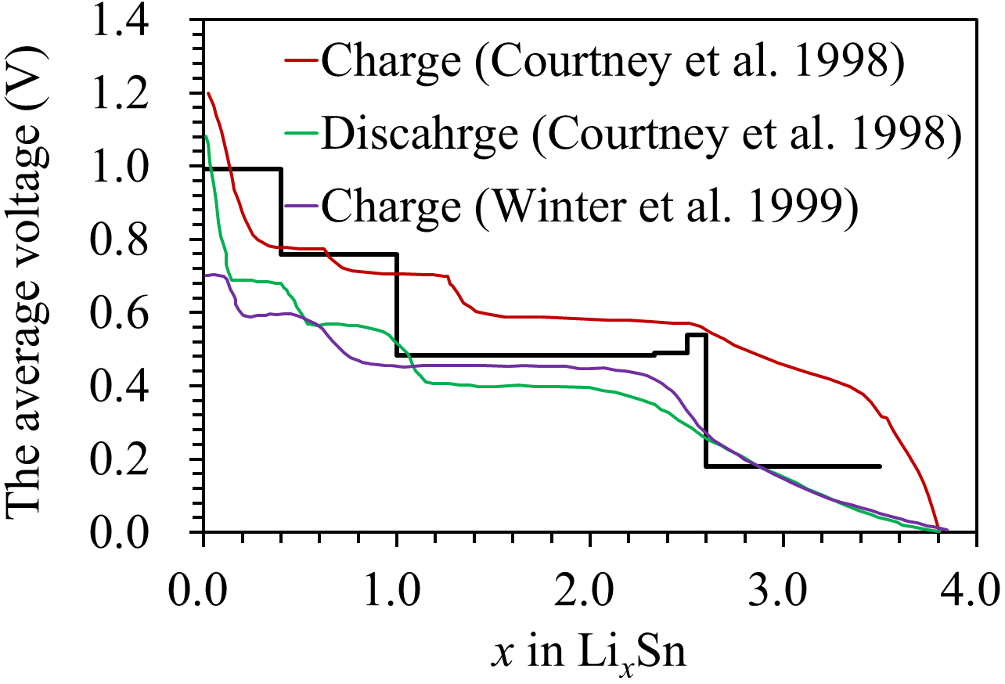
J.J. Shi et al. Figure 1

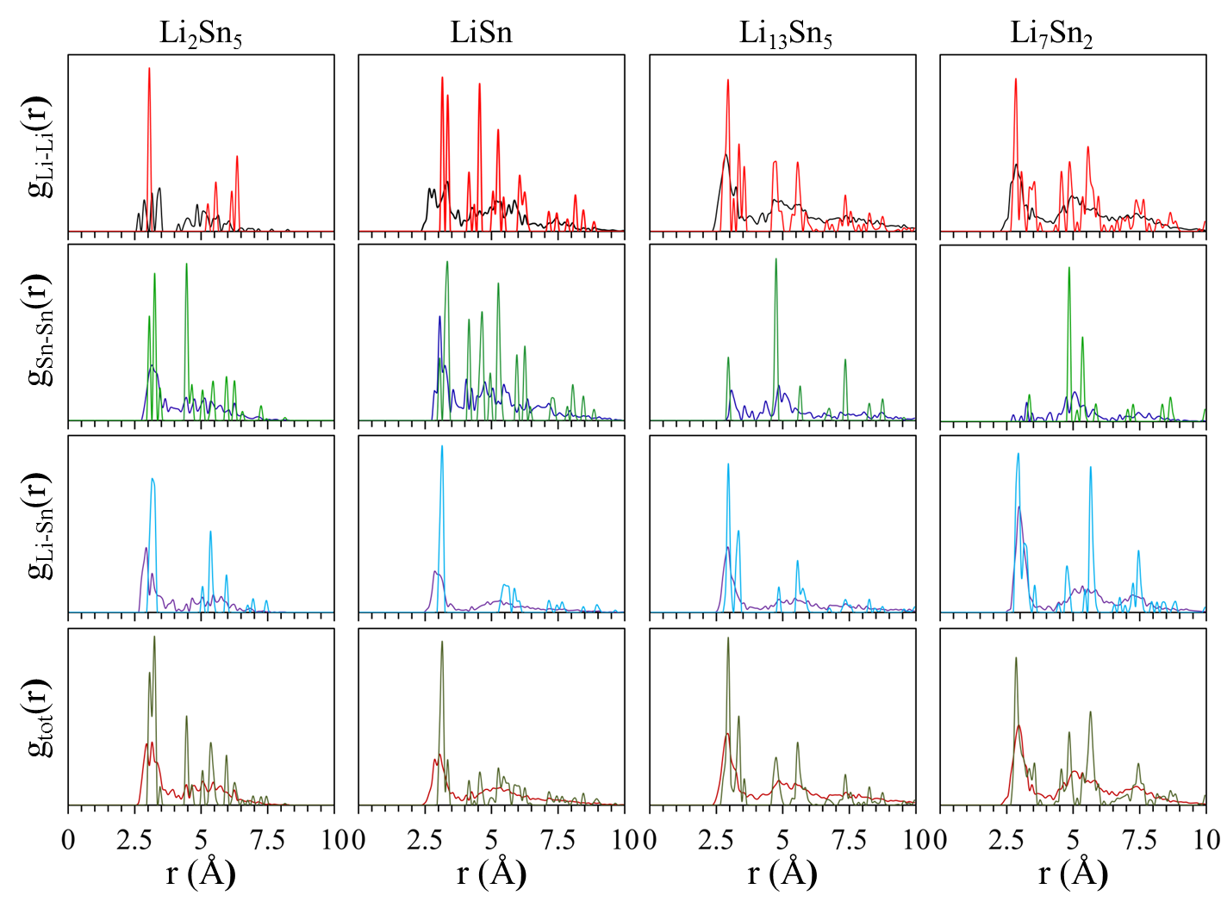
J.J. Shi et al. Figure 2

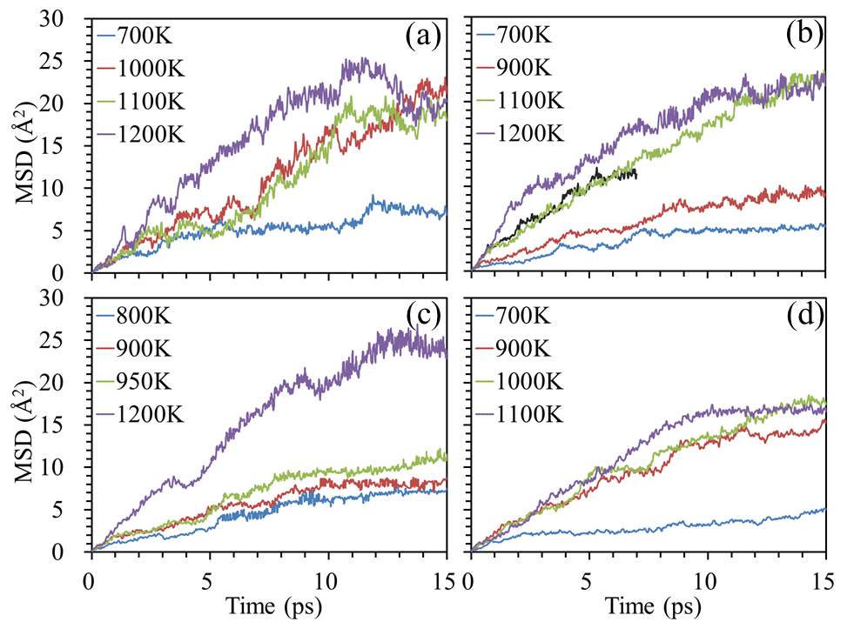
J.J. Shi et al. Figure 3

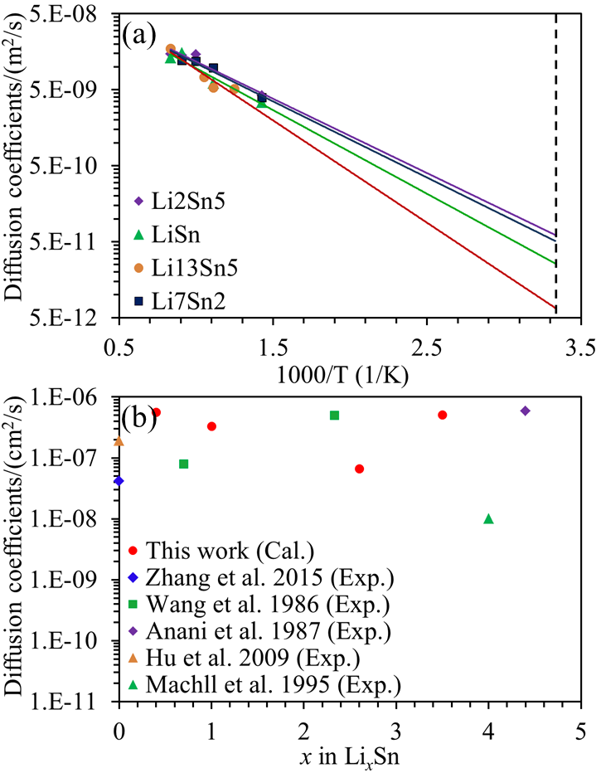
J.J. Shi et al. Figure 4

