**The addition of synthetic fibres to concrete to improve impact/ballistic toughness**

**Authors:**

Alan Richardson

Northumbria University, Newcastle upon Tyne, NE1 8SA, UK.

Email: [alan.richardson@northumbria.ac.uk](mailto:alan.richardson@northumbria.ac.uk) Telephone: 044 191 243 7305

Thomas Lamb, Northumbria University, Newcastle upon Tyne, NE1 8SA, UK.

David Mackenzie, Northumbria University, Newcastle upon Tyne, NE1 8SA, UK.

**Introduction**

Concrete is weak in tension and requires some form of reinforcement. Steel rebar is often used in order to cater for tensile and compressive forces. Millard et al. (2009) suggests that when concrete is subject to blast forces, failure occurs at the surface of a concrete wall, and the presence of conventional steel reinforcement will generally not prevent the wall from material spalling. An explosion near to a concrete wall causes a high speed pressure wave to load the front face of the wall (Millard et al., 2009). A small proportion of this energy will be reflected back, while a significant proportion of the energy will travel through the wall as a compressive stress wave (Millard et al., 2009). The reflection of the compressive stress wave within the concrete causes a tension rebound from the back face; it is this tension rebound that can cause the back face to spall (Millard et al., 2009).

Impact by a high speed point load, such as a bullet, has similarities with a small standoff blast (Millard et al., 2009). Back face spall is an important consideration for protecting the public against fragmentation due to impact on concrete structures and this article investigates fibre concrete performance.

Synthetic fibres may offer additional protection with regard to energy absorption; the fibres are dispersed throughout the mix during batching and this can provide additional toughness of the concrete, especially between the rebar spacing.

This research investigates the use of Type 1 micro synthetic fibres, Type 2 macro synthetic fibres and steel fibres used as reinforcement in concrete samples when subject to various forces. The purpose of this test programme was to compare each of these fibre types against a plain concrete control sample. The tests subjected the specimens to flexural bending, single point loading impact and shot gun fire. The parameters of the test were: compressive strength, flexural strength including load deflection analysis, energy absorption and impact resistance using a drop hammer, and a shotgun fire performance test. The test specimens were modelled using Finite Element Analysis (FEA) in order to predict the damage on the slabs from the shotgun fire performance test and inform the apriori slab design.

The overall test programme is displayed in Figure 1. Although many tests were carried out, the shotgun test is the main focus of this article.

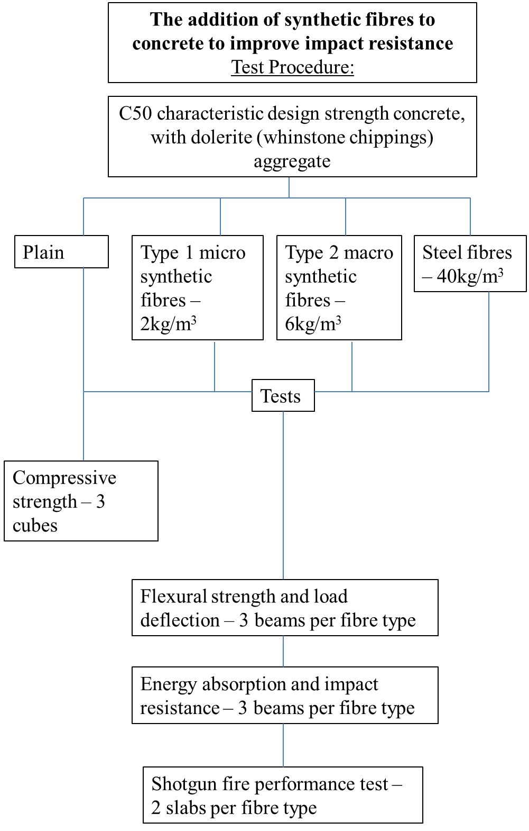

**Shotgun fire performance test**

Two slabs of each sample type were tested. One slab of each type received one shot centrally; the unbroken slabs received multiple shots until failure. This was to compare how the slabs performed after only one shot. For the multiple shots, comparisons can be made on how each of the sample types failed, thus ascertaining the performance of the fibre types. The plain slab receiving one shot broke into four pieces after this shot; the slab was pieced back together in order to record the results. The plain and Type 1 micro synthetic fibre slabs which received multiple shots were also pieced back together to obtain the results.

A diameter measurement was recorded on the impact hole at the surface, centre, and the exit hole at the rear of slab The detailed results are displayed in Table 1.

The plain samples suffered the most damage and this is shown in Figure 1. The plain samples completely failed after only one shot, with the bullet penetrating through the slab. This plain slab offered little protection from the shotgun.

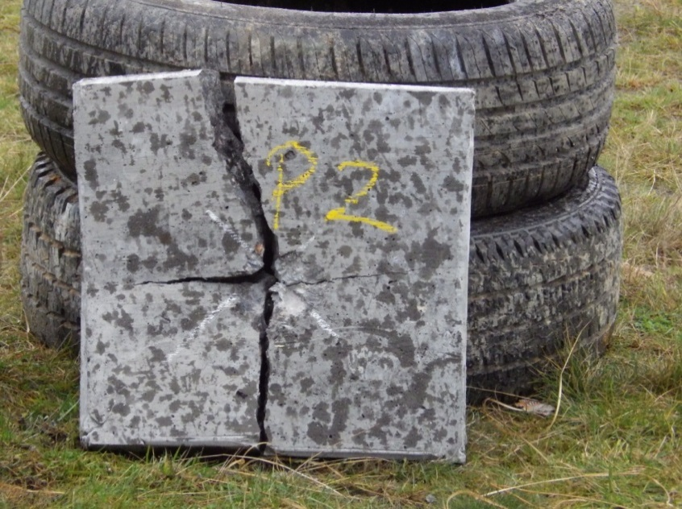

**Figure 1 – Plain slab after one shot**

**Table 1 – Shotgun fire performance test results** 

The Type 1 micro synthetic fibre slabs performed similarly to the energy absorption and impact resistance tests. In the impact tests, the beams exhibited very little damage after the first impact, damage less than any of the other samples. After the second and third impacts however the beam completely failed, with little warning the beam was going to shear straight through. This was also observed with the slabs. The Type 1 micro synthetic fibre slab which received one shot exhibited little damage, almost equal to the steel fibre sample.

After three shots, the Type 1 micro synthetic fibre slab completely shattered, again giving very little warning the sample was going to fail after this shot. This is very different to how the steel and Type 2 macro synthetic fibre samples performed, with the damage to the slab progressively worsening as more shots were fired. This is also supported by the difference in the time from the initial impact to break and break to total failure as displayed in Table 1.

The slabs containing the Type 2 macro synthetic fibres offered the highest degree of containment of the concrete after multiple shots. Figure 10 shows the rear face of the Type 2 macro synthetic slab which received 5 shots; the Type 2 macro synthetic fibre slabs offered a large degree of containment of the concrete. The fragments of concrete were loose and would not offer further protection from impact, however the fibres held the concrete fragments together and prevented them from being ejected out around the rear face of the slab. The crack pattern matrix of the fibre concrete compared to the plain concrete shows the steel fibres and Type 2 macro synthetic fibres altered the shear path of the cracks. The plain and Type 1 micro synthetic concrete samples exhibit a relatively uniform crack pattern matrix at right angles; the Type 2 macro synthetic and steel fibre samples show a bridging effect is present across the concrete and as such the cracks are less uniform but more dispersed as shown also in Figure 2

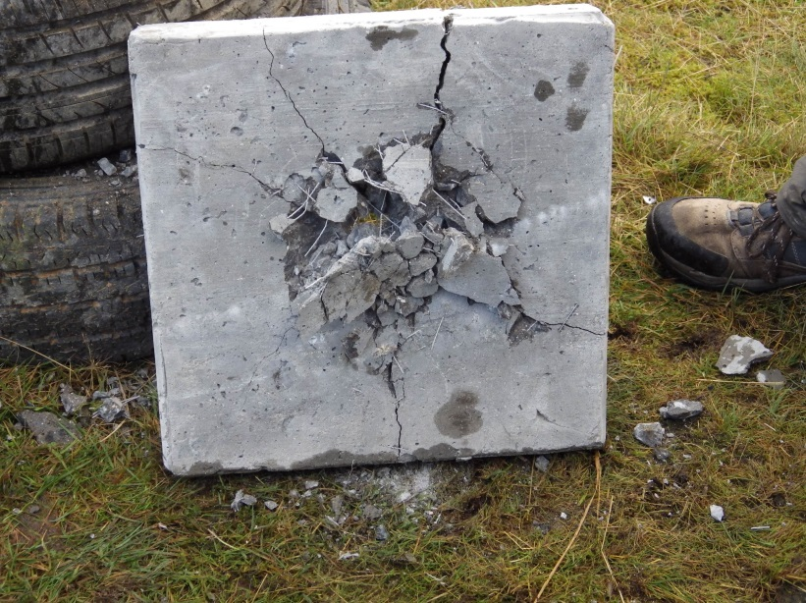

**Figure 2 – Rear face of the Type 2 macro synthetic slab receiving multiple shots**

The steel fibre slabs did not perform as well as the Type 2 macro synthetic fibre slabs in terms of the degree of containment of the fragments from the rear face. As shown in Figure 3, there is a clean hole through the slab, unlike the Type 2 macro synthetic fibre slab. There are also a number of pieces of concrete fragmented around the slab. The steel fibre slabs have not offered as much protection against spalling concrete as the Type 2 macro synthetic fibre slabs. Both slabs received 5 shots.

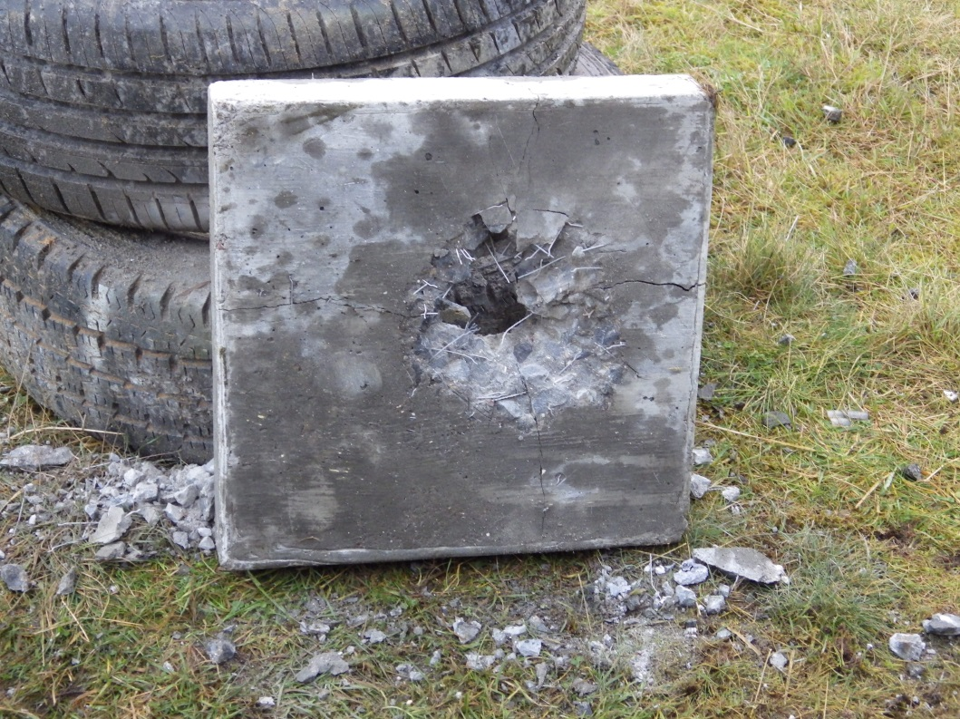

**Figure 3 – Rear face of steel fibre slab**

The relationship between the impact and shotgun failure was remarkably similar as displayed in Figure 4.

**Figure 4 – Comparison between impacts to failure for shotgun and impact resistance test**

,

The results show that Type 2 macro synthetic fibres offered the overall greatest toughness when compared with the other fibre types and they offered the greatest protection from back face spall of the concrete, which was the main consideration with regard to the shotgun fire performance test. A large degree of containment was measured after the ballistic test.

**Reference**

Millard, S.G., Molyneaux, T., Barnett, S. And Gao, X., (2009), ‘Dynamic enhancement of blast-resistant ultra-high performance fibre reinforced concrete under flexural and shear loading’ *Department of Engineering, University of Liverpool,* Elsevier Ltd