ABSTRACT: This paper investigates the sealing and healing properties of micro-induced calcite precipitation with regard to, surface finish and sealing cracks in cementitious materials.

Sporosarcina pasteurii has been used to effectively precipitate calcium carbonate in order to seal porous media. The bacteria are fed a nutrient broth mix to create conditions where microbiologically induced calcite precipitation (MICP) can be effectively used. The tests carried out, assessed the effect of MICP on a sample of twenty-four concrete cubes and to what extent the surface has been consolidated. Weight gain was measured and a MOHs hardness test was used to evaluate the surface condition of the treated surface. In addition, three fibre reinforced concrete beams were micro-cracked to evaluate Sporosarcina pasteurii’s ability to seal cracks that are common in concrete structures globally. Calcite deposits were observed to be effective at sealing cracks and consolidating the surface finish of the concrete. The treatment is an organic remedial method that has industrial applications.
.

Keywords: Micro-induced calcite precipitation, Sporosarcina pasteurii, concrete, cracking, remedial methods, bacteria.

Authors: Alan Richardson, Kathryn Coventry and Jack Pasley of the Engineering and Environment Faculty at the Northumbria University.

Reader: Alan Richardson is a member of RILEM and carries out research into cementitious materials and has approaching 100 publications in the field of concrete technology and sustainable construction.

Director of Programmes: Kathryn Coventry has a wide range of research interests

Jack Pasley contributed towards the operational aspects of this work

1.0 Introduction
Concrete is an inherent part of our built environment, but it is not without its long term durability problems. As with any building material, deterioration is an expected occurrence with regards to the service life of structures. Both stone and concrete are susceptible to weathering; a breakdown of the mineral matrix leads to increased porosity of the surface and with it brings numerous issues [1]. The lack of a cost-effective, eco-friendly repair method is a cause for concern: ‘In the United States of America, for instance, the annual direct costs for maintenance and repair of concrete highway bridges due to corrosion of the reinforcement is 4 billion dollars’ [2]. Steel corrosion is one consequence of moisture penetration resulting from a variety of factors.

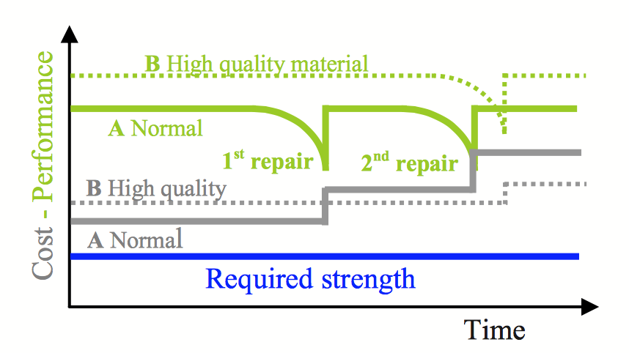
Figure 1 depicts the interactions between normal and high quality materials used in infrastructure, and the associated cost and strength performance over a period of time. If natural MICP can be used as a repair agent, lower cost materials can be maintained to an acceptable performance standard.

Figure 1 - Quality of Infrastructure Materials [3]

With more extreme weather now common place, concrete structures within our built environment are subject to forces which in turn lead to micro scale propagation damage. The porosity of concrete permits micro-cracks to propagate and damage the material. This in turn provides an easy path for the transportation of liquids and gasses that potentially contain harmful substances which may damage the structure [4]. Micro cracks are commonplace in concrete structures, and Eurocode 2 permits design cracks widths up to 0.3mm. Micro cracks need to be sealed in order to stop them propagating and leading to costly repairs. Cracks under 0.05mm are not deemed problematic as concrete can repair itself through swelling of the cement paste, hydration of the remaining un-hydrated cement, precipitation of calcium carbonate (CaCO₃) crystals, and crack filling by impurities in water or by debris from the crack surface [5]. The life cycle costs of buildings are under more scrutiny than ever; buildings need to require less maintenance and have longer life spans to become more eco-friendly [6] and in this vein MCIP provides and alternative repair, sealing and reinstatement method using natural eco friendly component parts.

1.1 Causes of deterioration and transport mechanisms
The durability of concrete is fundamentally dependent on the ease, or difficulty it can repel fluids in either liquid or gas form from permeating its surface. Concrete is a porous material and the number, type and size of its pores influence its durability [7]. Deterioration of a concrete surface happens in three, chemico-physical stages [8].
- Initiation
- Propagation
- Deterioration
These processes occur due to a variety of mechanisms leading to deterioration.
Reinforced concrete is expected to exhibit cracking of up to 0.3mm in normal service conditions [9]. It is susceptible to deterioration in the form of water infiltration, as cracks on both a macro and microscopic level develop under mechanical loading and sorption/desorption cycles [10]. Moisture ingress mechanisms are displayed in Table 1:

Table 1 - Moisture Transfer [7]

Method of Transfer | Description
Diffusion | The movement of ions, liquid or gases from an area of high concentration to one of low concentration and is a result of the random motion of ions or molecules in solution.
Absorption | Concrete is able to intake a fluid which is dictated by the available space in the microstructure.
Permeability | The ease with which a fluid passes into and through the body of the concrete under the influence of a pressure differential.

1.2 Traditional remedial methods
The majority of traditional remedial methods available are largely based on environmentally unfriendly materials such as epoxy systems, acrylic resins or silicone-based polymers [11].
Traditional inorganic coatings consist of calcium-silicate compounds, which exhibit a composition similar to cement [12].
Requirements for the repair of concrete structures are outlined in BS EN 1504. Figure 2 outlines the stages in the repair of a defective concrete structure.
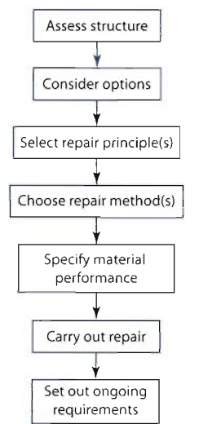
Figure 2 - Repairing Concrete Structures (Adapted from BS EN 1504)

The repair of concrete structures falls into three basic categories:
- Structural
- Semi-Structural
- Cosmetic
In the context of this investigation, it is only anticipated to provide solutions to the cosmetic element of remedial works, which is described by The Concrete Society, [13]. as when holes do not surpass the reinforcement with the repair materials used based on lightweight solutions; either a cementitious or polymer binder. These solutions are unlikely to possess the same qualities as the original concrete in terms of elastic modulus, creep and shrinkage [13].

2.0 Materials and Bacteria
The mix designs used in this paper are displayed in Table 2. The change in water cement ratio provided varying porosity and surface finish to provide different surface conditions. A steel float finish was provided to the test surface and this was lightly trowelled to provide a textured surface.

Table 2 – Mix design

0.8 WCR | Constituent | 0.4 WCR
170kg/m³ | Cem 1 52.2 (R) | 337kg/m³
652kg/m³ | Sand < 4mm | 482kg/m³
1522kg/m³ | Gravel < 20mm | 1526 kg/m³
136 l/m³ | Water | 134.8L/m³

When the bacterial broth is applied to the cubes and beams, it will need to pool on the concrete surface and not run off, a silicone bead was applied around the edge of the cubes to ensure the mixture stays within the desired surface area. Similarly, a retaining bead of silicone will be applied around the induced cracks on the beams to contain the mixture and on the sides to contain the bacterial broth.

2.1 Bacteria
Bacteria are abundant, incredibly diverse and conduct precipitation of mineral carbonates across a spectrum of natural environments [14]. The majority of bacteria are either spheres and known as cocci or rod shaped and referred to as bacilli [14].

2.1.1 – Bacteria calcite precipitation
In nature, it is common for microbial mineral plugging to occur in porous media. Bio-calcification or microbiologically induced calcite precipitation (MICP) is a phenomenon concerning the urease enzyme [15]. Microbial CaCO₃ has wide scope, as it has a varied range of environmentally friendly applications. It can consolidate damaged materials, especially ones bearing cracks [16]. MCIP is a natural phenomenon which is associated with a range of bacteria species given the right conditions, in particular, an alkaline environment rich in Ca2⁺ ions [17]. The calcite deposition is able to consolidate media and potentially reduce moisture ingress.

2.1.2 - Ureolytic activity
Bacteria that hydrolyse with urea are the most investigated with regard to calcite production. The following sequence of reactions adapted from Siddique and Chahal [14], demonstrates the process:
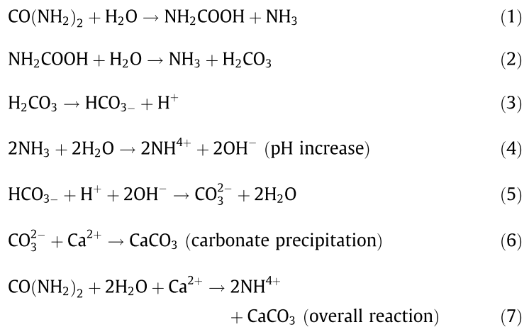

Equation 1 - Hydrolysis of Urea [14]

One molecule of urea is hydrolysed intracellularly to 1 molecule of ammonia and 1 molecule of carbonate (Eq 1), which then spontaneously hydrolyses to form an additional molecule of ammonia and carbonic acid (Eq 2). In water, the products then form bicarbonate, 2 molecules of ammonium, and 2 molecules of hydroxide ions Eqs. (3) and (4).
The overall reaction is demonstrated in Eq 7 [14]. It is mentioned by Zamarreño et al. [18]. that a correct temperature of between 22°C and 32°C is required to catalyse the process.

2.1.3 – Microbiologically induced precipitation
A more complex pathway to derive calcite precipitation is through microbiologically induced precipitation [14]. It relies on bacteria such as Sporosarcina pasteurii, urease and a high pH level. The enzyme catalyses and hydrolysis of urea occurs to produce CO₂ and ammonia, which, in turn, increases both the pH and carbonate concentration in the bacterial environment [19]. This is chemically expressed as:

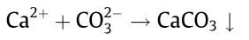
Equation 2- MICP [14]

2.1.4 – Bioremediation
A bacterial cell surface can provide a nucleation site to non-specifically induce mineral deposition due to its variety of ions [14]. Bacteria have the largest surface area to volume ratio of any life form [20]. Therefore they are able to harbour calcium carbonate formation as shown in Figure 3:

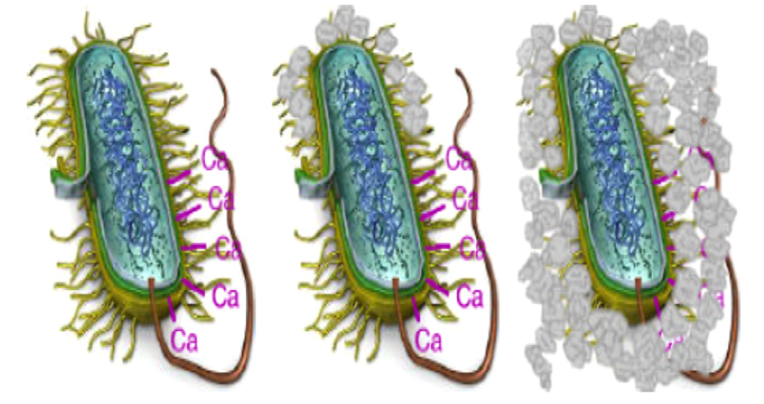
Figure 3 - Simplified Ureolysis Calcite Precipitation [1]

2.1.5 – Calcite precipitation in concrete
Numerous studies have being conducted to assess the effectiveness of calcite precipitation in concrete. As discussed, Stocks-fischer et al. [21] outlined that such precipitation can plug porous media.
Sporosarcina pasteurii (Previously Bacillus pasteurii), is able to aid in the urease production which, in turn, hydrolyses urea to ammonia and CO₂. Such urease production from Sporosarcina pasteurii (S. pasteurii) was witnessed by Sarda et al., [15], stating among the other microbial cultures S. pasteurii NCIM 2477 was able to produce the most urease (Figure 4) .
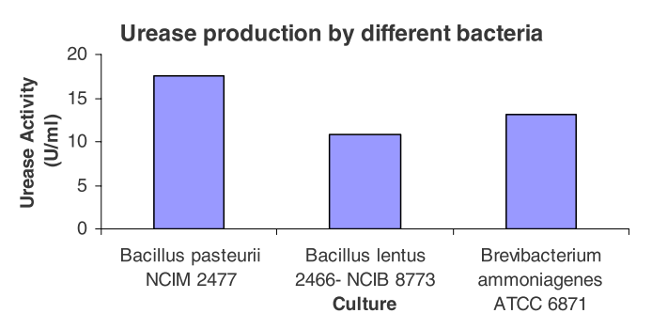
It is concluded by Siddique and Chahal (2011) that microbial mineral precipitation is a promising technique with regard to improvements in the compressive strength, permeability, lesser water absorption and reduced chloride ingression.
Figure 4- Urease Production by Different Bacteria [15]
Wiktor and Jonkers [22] support this conclusion; their bio-chemical healing agent consisting of bacterial spores (Bacillus alkalinitrilicus, an alkali resistant soil bacterium) and calcium lactate was able to void cracks whilst being submersed in tap water for 100 days. The deposits were then tested using energy dispersive spectroscopy. The results verified the anticipated CaCO₃ production as the deposits were a combination of calcium, oxygen and carbon atoms as displayed in Figure 5.
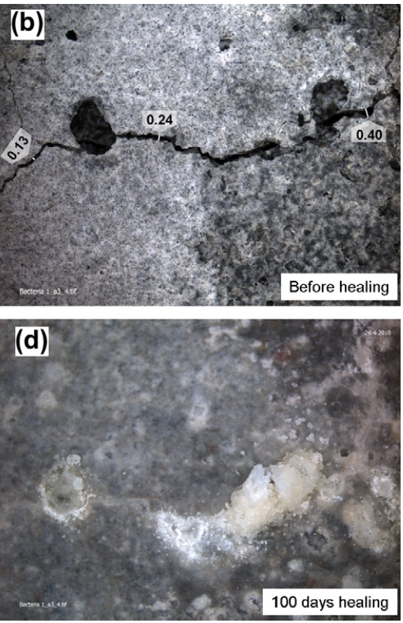

Figure 5 - Bio-chemical crack healing ability [22]

S. pasterurii is conveyed as consistently being able to produce urease, which is of paramount importance with regards to CaCO₃ precipitation. It is apparent, Sporosarcina pasteurii appears to be the bacteria of choice throughout the various studies by Bang, Galinat, & Ramakrishnan [23] and Achal & Pan ([17] and will subsequently be the bacteria to be used in this study.

3.0 Methodology
To assess any changes to surface finish, twenty-four, 100mm concrete cubes were produced. The sample included two water cement ratios (WCR) and different surface finishes in equal numbers (six each). To quantify the calcite deposition, the comparable weights of the dry cubes pre and post treatment were recorded. Three fibre concrete beams were cast and once fully cured, they were cracked under a three point bending system, then a bead of silicone was applied around the cracked area to provide a reservoir to retain the liquid whilst the bacteria fed upon the food source, thus creating calcite as a repair agent.
The process outlined was repeated a total of three times, at 24 hour intervals and this layering effect gave the mixture time to be absorbed by the beams. Once the bacteria and the nutrient broth were mixed together, there was calcite formed almost immediately and this is a key finding in terms of an application process. This effect was noted in an earlier test [24].

3.1 Bacterial preparation and application
The S. pasteurii cultures were suitably incubated in an orbital incubator at 37° C at a rate of 200 rpm. The cultures were then measured at OD₆₀₀ to see if the cell density is within the desired range (Approx. 0.9-3). A higher OD will provide more nucleation sites for calcite formation.

Once the culture was prepared a100ml aliquot containing the bacterial cultures was added to a 900ml Duran container of nutrient broth with 50ml CaCl₂ (calcium chloride) at a concentration of 1g/ml. Immediately after mixing the solution, it was applied to the 3 beam sections and cubes. 15ml of solution per cube was applied followed by 1.5ml of urea to catalyse the reaction and help support the bacteria’s hydrolysis, leading to a higher calcite yield.

4.0 Results
The bacterial residue was examined at the surface (foreground) and at the intersection between the calcite and the concrete (background), using an Energy Dispersive Spectroscopy (EDS) image analysis technique and the chemical component parts are displayed in Table 3 and Figure 6.
 | Oxygen (%) | Carbon (%) | Calcium (%)
Background | 58.0 | 17.5 | 24.5
Foreground | 60.6 | 13.4 | 26.0

Table 3 – Chemical component parts of calcite deposit

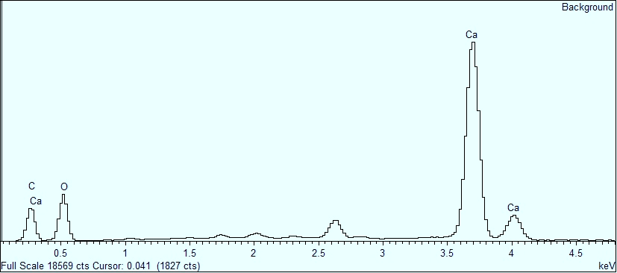
Figure 6 - Energy Dispersive Spectroscopy (EDS) image

The Energy Dispersive Spectroscopy (EDS) results were tested alongside a MOH’s hardness test and hydrochloric acid test which showed the calcite formation was within normal hardness associated with the formation of calcite and the acid test showed the material to be of an alkaline nature.

Following the treatment, an average oven dry weight increase of 3.6g was recorded. The WCR ratio of the cubes did not effect the average weight gain for the resepctive samples. The surface treatment levelled the cube face and bound loose particles together .

4.1 Crack sealing
The effectiveness of the MICP crack healing properties are displayed in Figures 3 and 4
.
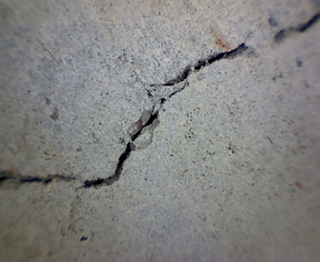
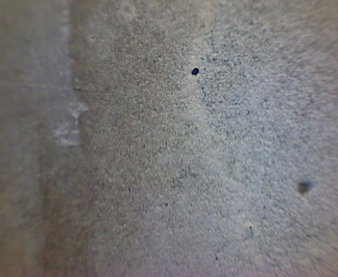
Outline of Consolidated Micro-Crack
Figure 3 – Above cracked fibre beam and below MICP sealing the crack
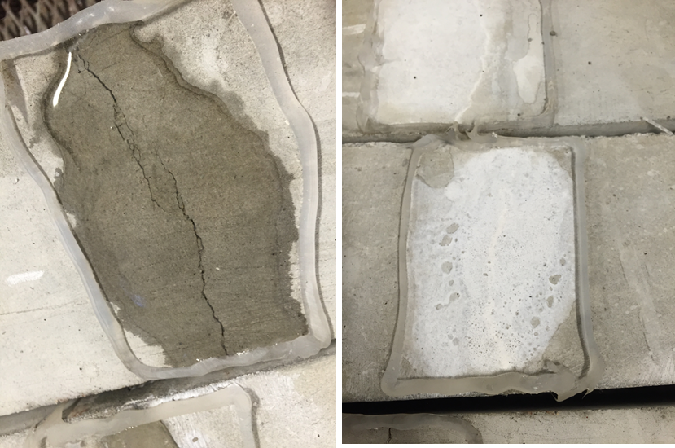
Figure 4 – Cracked concrete beam on left and healed concrete beams to the right.

This study has demonstrated the potential S. pasteurii and consequently MICP holds in improving the integrity of finish to concrete, without the use of chemical based sealants.

5.0 Conclusion
By reaching an average OD₆₀₀ of 2.1 over the three applications, adequate nucleation sites were provided for MICP to occur. The investigation has hereby acted as a ‘proof of concept’ in that MICP can perform as an organic repair alternative for concrete structures, especially in a time where heavy emphasis is placed on environmentally sustainable building solutions. The layering effect provided visible results on both the cubes and beams which had bonded with the concrete cube surface.

Although the MICP did not penetrate the cube surfaces, the bacteria successfully filled the majority of imperfections and voids on the samples.

Uneven concrete surfaces can also be smoothed using this treatment; although the colour of calcite (white) may not be deemed aesthetically pleasing and therefore require suitable pigmentation additives.

The results, with regard to depth of calcite penetration, demonstrated the near 100% consolidation of the micro cracks to a depth of approximately 20mm. The use of the treatment in such a way could be plausible on a commercial scale as the cracks house the NBU, in turn pooling the solution and leading to MICP. This reduces the reliance on surface pooling which was needed with the cube samples.

The cube surface scans gave a thorough analysis of the calcite formations build up. The comparable scans showed a surface mass increase and a reduction in surface structure deviation, effectively fusing the cubes’ surface with the CaCO₃. With lessened surface porosity, in theory, the rate of deterioration would slow in a real world application. However, this is reliant on further porosity testing.

6.0 Referenced work
1 De Muynck, W., De Belie, N. and Verstraete, W. (2010) “Microbial carbonate precipitation in construction materials.” Ecological Engineering, 36(2) pp. 118–136.
2 Sierra-Beltran, M. G., Jonkers, H. M. and Schlangen, E. (2014) “Characterization of sustainable bio-based mortar for concrete repair.” Construction and Building Materials, 67, Elsevier Ltd, pp. 344–352.
3 Schlangen, E. and Sangadji, S. (2013) “Addressing infrastructure durability and sustainability by self healing mechanisms - Recent advances in self healing concrete and asphalt.” Procedia Engineering, 54, Elsevier B.V., pp. 39–57.
3 Van Tittelboom, K., De Belie, N., De Muynck, W. and Verstraete, W. (2010) “Use of bacteria to repair cracks in concrete.” Cement and Concrete Research, 40(1), Elsevier Ltd, pp. 157–166.
4 Stuckrath, C., Serpell, R., Valenzuela, L. M. and Lopez, M. (2014) “Quantification of chemical and biological calcium carbonate precipitation: Performance of self-healing in reinforced mortar containing chemical admixtures.” Cement and Concrete Composites. Elsevier Ltd, 50 pp. 10–15.
5 Srinivasan, R. S., Ingwersen, W., Trucco, C., Ries, R. and Campbell, D. (2014) “Comparison of energy-based indicators used in life cycle assessment tools for buildings.” Building and Environment. Elsevier Ltd, 79, September, pp. 138–151.
6 Basheer, P. A. M. and Barbhuiya, S. A. (2010 “Pore Structure and Permeability,” pp. 1-2.
7 Lambert, P. (2002) “Reinforced concrete - history, properties and durability,” Corrosion Prevention Assosciation.
8 BRE (2000) “Corrosion of steel in concrete - durability of reinforced concrete structures,” Digest 444(Part 1) pp. 2–9.
9 Rouchier, S., Woloszyn, M., Foray, G. and Roux, J.-J. (2013) “Influence of concrete fracture on the rain infiltration and thermal performance of building facades.” International Journal of Heat and Mass Transfer. Elsevier Ltd, 61, June, pp. 340–352.
10 Sierra-Beltran, M. G., Jonkers, H. M. and Schlangen, E. (2014) “Characterization of sustainable bio-based mortar for concrete repair.” Construction and Building Materials, 67, Elsevier Ltd, pp. 344–352.
11 De Muynck, W., Debrouwer, D., De Belie, N. and Verstraete, W. (2008) “Bacterial carbonate precipitation improves the durability of cementitious materials.” Cement and Concrete Research, 38(7) pp. 1005–1014.
12 The Concrete Society (2009) "Repair of Concrete Structures with Reference to BS EN 1504."
13 Siddique, R. and Chahal, N. K. (2011) “Effect of ureolytic bacteria on concrete properties.” Construction and Building Materials, 25(10) Elsevier Ltd, pp. 3791–3801.
14 Sarda, D., Choonia, H. S., Sarode, D. D. and Lele, S. S. (2009) “Biocalcification by Bacillus pasteurii urease: a novel application.” Journal of industrial microbiology & biotechnology, 36(8) pp. 1111–5.
15 Wang, J. Y., Soens, H., Verstraete, W. and De Belie, N. (2014) “Self-healing concrete by use of microencapsulated bacterial spores.” Cement and Concrete Research, 56, Elsevier Ltd, pp. 139–152.
16 Achal, V. and Pan, X. (2011) “Characterization of urease and carbonic anhydrase producing bacteria and their role in calcite precipitation.” Current microbiology, 62(3) pp. 894–902.
17 Zamarreño, D. V, Inkpen, R. and May, E. (2009) “Carbonate crystals precipitated by freshwater bacteria and their use as a limestone consolidant.” Applied and environmental microbiology,75(18), pp. 5981–90
18 Chahal, N., Siddique, R. and Rajor, A. (2012) “Influence of bacteria on the compressive strength, water absorption and rapid chloride permeability of concrete incorporating silica fume.” Construction and Building Materials. Elsevier Ltd, 37, December, pp. 645–651
19 Fortin, D., Davis, B. S. and Beveridge, T. J. (1996) “Mineralization of bacterial surfaces,” Chemical Geology 132.
20 Stocks-fischer, S., Galinat, J. K. and Bang, S. S. (1999) “Microbiological precipitation of CaCO₃” Soil Boilogy and Biochemistry, pp. 31.
21 Wiktor, V. and Jonkers, H. M. (2011) “Quantification of crack-healing in novel bacteria-based self-healing concrete.” Cement and Concrete Composites, 33(7), Elsevier Ltd, pp. 763–770.
22 Bang, S. S., Galinat, J. K. and Ramakrishnan, V. (2001) “Calcite precipitation induced by polyurethane-immobilized Bacillus pasteurii.” Enzyme and Microbial Technology, 28(4-5) pp. 404–409

23 Richardson A E, Coventry KA, Forster A, Jamison C , (2014) "Surface consolidation of natural stone materials using microbial induced calcite precipitation", Structural Survey, Vol. 32 Iss: 3, pp 265-278

