revised

19th March 2010

CuInSe₂ Precursor Films Electro-Deposited Directly onto MoSe₂

Charles Y. Cummings ª, Guillaume Zoppi ^{b}, Ian Forbes ^{b}, Phillip J. Dale ^{c}, Jonathan J. Scragg ª, Laurie M. Peter ª, Gabriele Kociok-Köhn ª, and Frank Marken*ª

ª Department of Chemistry, University of Bath, Claverton Down,
Bath BA2 7AY, UK
^{b} Northumbria Photovoltaics Applications Centre, Northumbria University,
NE1 8ST, UK
^{c} Laboratoire Photovoltaïque, Université du Luxembourg, Campus Limpertsberg,
BS 1.1.7, 162a, avenue de la Faïencerie, L-1511, Luxembourg

To be submitted as Communication to J. Electroanal. Chem.
Proofs to F. Marken
Email F.Marken@bath.ac.uk

Abstract

Mo/MoSe₂ thin film electrodes formed by selenisation of molybdenum are investigated as chemically robust substrates for the electro-deposition of InCu precursor layers for CuInSe₂ (CISe) solar cell absorber films. Exposure of molybdenum films to selenium vapour at 550 ºC produces thin and chemically robust heterostructures of Mo/MoSe₂. These films exhibit the characteristics of a degenerate semiconductor and provide close to metallic electrical conductivity for electro-deposition processes in both acidic and alkaline aqueous media. The Mo/MoSe₂ films are characterised by cyclic voltammetry for the reduction of Ru(NH₃)₆³⁺ in aqueous 0.1 M KCl, for the reduction of 0.1 M In³⁺ in aqueous 0.5 M LiCl pH 3, and for the reduction of 0.1 M Cu²⁺ in aqueous 3 M NaOH with 0.2 M D-sorbitol. In all three cases well-defined and reversible voltammetric responses are observed. For the formation of CISe films initially In³⁺ is deposited potentiostatically followed by electrodeposition of Cu²⁺ and selenisation at 550 ºC in selenium vapour. Mechanically stable CISe films are produced and preliminary photo-electrochemical data demonstrate the effects of changing the stoichiometry.

Keywords: Copper indium diselenide, CISe, CIS, solar cells, molybdenum, electro-deposition, MoSe₂, molybdenum diselenide

1. Introduction
The transition metal dichalcogenide molybdenum diselenide, MoSe₂, is a versatile semiconductor material. In crystalline form MoSe₂ contains layers of Se-Mo-Se covalently bonded together with weak Se-Se van der Waals interactions. The presence of a gap between layers of Se-Mo-Se allows the intercalation of other atoms []. Indeed, excess selenium can reside within this space to give the resulting semiconductor material n-type characteristics. Also p-type doping can be achieved by creating selenium deficient crystals [,]. Both n-type [] and p-type [] MoSe₂ materials have been reported and studied. Single crystals of n-type MoSe₂ have been studied and shown to give photo-electrochemical efficiencies of ca. 10 % []. MoSe₂ has also been studied in nanoparticate form [,] and as polycrystalline thin films [Error: Reference source not found]. Films of MoSe₂ have been used as substrates for the electrodeposition of silver [] and for the oxidation of methanol []. Here, the electro-deposition of metallic In and Cu precursors onto a Mo/MoSe₂ substrates is demonstrated for the production of a film of photoactive semiconductor, copper indium diselenide (CISe).

CISe is an attractive p-type semiconductor for use in solar cells with a strong direct band gap adsorption, ca. 10⁵ cm⁻¹, and a favourable band gap energy of 1.03 eV []. Flexible thin film photovoltaic materials based on CISe have been suggested to be long-term economically competitive with the currently dominating silicon-based devices []. Electro-deposition has been suggested as one potentially promising method for large scale deposition of thin films of CISe based on safety, cleanliness, efficiency, and the availability of high through-put technology. However, considerable technical problems still need to be overcome. Originally, Bhattacharya pioneered the electro-deposition of photoactive CISe [] in a one-step electrodeposition of metal selenides and subsequent annealing. This methodology has been further developed and optimised with device efficiencies reaching 7.5% [,]. An alternative CISe deposition methodology has been proposed based on the selenisation of electro-deposited films of CuIn alloys [,]. For the electro-deposition of CuIn alloys there are two potential technical disadvantages: (i) a change in stoichiometry of the film during the annealing process and (ii) poor mechanical adhesion of the CISe films to the substrate due to thermal stresses after the selenisation step [Error: Reference source not found]. An alloying step pre-selenisation has been suggested to improve the adhesion []. The preferred substrate used in the electro-deposition of CISe films is Mo sputtered on soda-lime glass. During selenisation, selenium will diffuse through the film and react to the underlying Mo layer to produce p-type MoSe₂. This MoSe₂ layer is advantageous because it improves adhesion, stops Se further reacting with Mo, reduces recombination, and creates a low resistivity ohmic contact between the substrate and CISe film [].

Mo metal has similar lattice constants to those of CISe, however, Mo is not chemically inert and it undergoes degradation/oxidation when immersed in aqueous solutions. This causes considerable problems with reproducibility in particular for larger substrates. MoSe₂ on Mo metal films has been proposed as an alternative substrate material for the physical vapour deposition of Cu(In,Ga)Se₂ photovoltaic absorbers [19]. The sub-layer of MoSe₂ was shown to provide an ohmic rather than Schottly contact and it improved adhesion.

The MoSe₂ film is studied here as an alternative for bare Mo metal films for the electro-deposition processes. It is shown that thin films of nanocrystalline MoSe₂ produced by selenisation of sputter-coated Mo films provide excellent substrates for electrodeposition. The Mo/MoSe₂ heterostructure is chemically robust and electrochemically active. Irreproducibility problems encountered when using Mo-metal films can be avoided. Degenerate semiconductor properties and reversible voltammetric responses are observed in the potential range where copper and indium are plated. Films of indium and copper are sequentially electrodeposited and converted into a photoelectrochemically active CISe layer. The new methodology will be beneficial in particular for the scale up of CISe electrodeposition.

2. Experimental Methods
2.1. Reagents
Copper(II) sulfate (99.999 %), indium(III) chloride (99.999 %), lithium chloride (99.99%), sodium hydroxide (99.99 %), hexaammine ruthenium(III) chloride (99.9+%), potassium chloride (ACS), D-sorbitol (98%), europium nitrate (99.999%), potassium cyanide (ACS, 96.0%), and selenium powder (99.999%) were purchased from either Sigma Aldrich or Alfa Aesar and used without further purification. Filtered and demineralised water was taken from a Thermo Scientific water purification system (Barnstead Nanopure) with a resistivity of not less than 18.2 MOhm cm.

2.2. Instrumentation
For voltammetric and impedance studies a microAutolab III potentiostat system (EcoChemie, Netherlands) was employed with a Pt foil (4 cm × 2 cm) counter electrode and a saturated calomel (SCE) reference electrode (Radiometer, Copenhagen). The working electrode was soda-lime glass sputter-coated with an approximately 1 μm thick Mo layer. PTFE tape was used to delineate the deposition area. All electrochemical experiments were conducted in open air without inert atmosphere (to mimic industrial electro-deposition conditions) and the temperature during experiments was 22 ± 2 ºC.

X-ray diffraction (XRD) data were obtained at Northumbria University using a Siemens D-5000 diffractometer (Cu Kα line, scan parameters: 15⁰ to 75⁰, 0.02⁰ step size, integration time 2 s/step). The surface morphology and topology of the films were observed using a JEOL JSM6480LV scanning electron microscope (SEM). Qualitative compositional analysis was performed using energy dispersive x-ray analysis (EDX). Elemental analysis for HNO₃-dissolved deposits was performed by Butterworth Laboratories (Teddington, Middlesex) based on inductively coupled plasma optical emission spectroscopy, ICP-OES. For Photo-electrochemical experiments a flashing green LED (Farnell, UK) was employed.

2.3. Selenisation of Molybdenum Films
Prior to selenisation, Mo films were cleaned by sonication in (i) 5% Deconex (Borer Chemie) and (ii) ethanol for one minute each followed by drying in a stream of nitrogen. The selenisation of Mo coated glass slides took place inside a custom-made graphite box (Carbon Lorraine UK) with dimensions 10 cm × 7 cm × 1.6 cm within a sealed quartz tube. A horizontal tube furnace (Elite) was used with a constant flow of nitrogen (10 cm³ min⁻¹). An excess of elemental selenium was employed (15 mg placed with the sample into the graphite box). The sample was heated with a ramp rate of 15 ºC min⁻¹ until 550 ºC and held at this temperature for 1 hour and then allowed to cool to room temperature at a rate of 0.5 ºC min⁻¹. The Mo/MoSe₂ films were stored in air. Mo/MoSe₂ films were tested for photo-electrochemical responses but did not show photo-effects consistent with a very thin and electrically conducting film.

2.4. Electro-deposition of InCu Films and CISe Formation
Electrical contacts for electro-deposition were made directly to the Mo substrate. Mo/MoSe₂ electrodes of 1 cm² were employed. Prior to electrochemical experiments substrates were cleaned by dipping into aqueous 1M HCl for 10 seconds, rinsing, and drying. The electro-deposition of indium thin films was performed in an aqueous solution of 0.1 M InCl₃ and 0.5 M LiCl at pH 3 (adjusted with HCl) []. Deposition of indium metal occurred at -0.9 V vs. SCE in chronoamperometry mode. The electrode was then rinsed with water and dried in nitrogen. Copper plating was performed in 3.0 M NaOH, 0.2 M D-sorbitol, and 0.1 M CuSO₄ and at a deposition potential of -1.105 V vs. SCE [] in chronoamperometry mode. After plating the electrode was rinsed with water and dried in a stream of nitrogen. Selenisation and annealing were performed by using the same programme and conditions as described above for the selenisation of Mo. The overall process is summarised in Scheme 1.

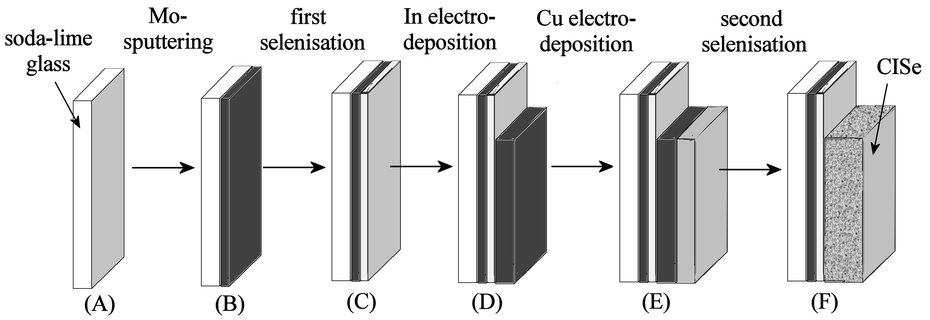
Scheme 1. Diagram summarising the deposition and processing steps for the formation of CISe absorber films.

2.5. Photoelectrochemical Characterisation of CISe Films
Prior to photoelectrochemical measurements the Mo/MoSe₂/CISe films were immersed in a conventional etch solution of potassium cyanide (5%w/w). Photoelectrochemical measurements were carried out in a 3-electrode cell where the CISe film, platinum wire counter, and SCE reference electrode were immersed in aqueous 0.2 M Eu(NO₃)₃. Samples were held at a potential of -0.36 V vs. SCE for 10 seconds in the dark. Then an LED pulsed green light (ca. 530nm) at the film electrode and photocurrents were measured [].
3. Results and Discussion
3.1. Characterisation of Degenerate Mo/MoSe₂ Film Electrodes I.: Ru(NH₃)₆³⁺ Reduction
Molybdenum film electrodes are sensitive to exposure to aqueous alkaline and acidic electrolyte environments and readily form oxide coatings. Therefore, when Mo substrates are employed in the electro-deposition of semiconductor films, there can be reproducibility problems. In this study the pre-selenisation of Mo to MoSe₂ is investigated as a methodology to avoid these problems. Bulk MoSe₂ usually exhibits n-type semiconductor properties [2] but very thin films could be suitable for metal plating and other redox processes. Mo-coated glass slides exhibit (110) and (200) XRD signals consistent with crystalline molybdenum []. From in situ XRD studies it is known that MoSe₂ formation in selenium atmosphere commences at ca. 440ºC []. The resulting MoSe₂ layer may be regarded as a passive film protecting the metallic Mo layer from chemical attack without significantly impeding electrochemical activity (vide infra). Reported thicknesses for MoSe₂ produced under selenisation conditions are typically 100 nm [Error: Reference source not found].

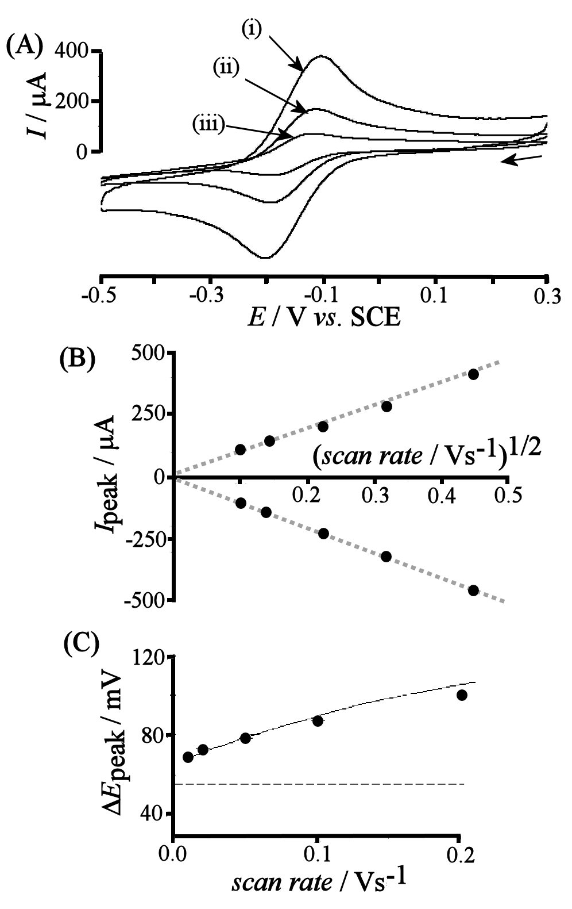
Figure 1. (A) Cyclic voltammograms (scan rate (i) 0.2, (ii) 0.05, and (iii) 0.01 Vs⁻¹) for the reduction of 1 mM Ru(NH₃)₆³⁺ in aqueous 0.1 M KCl at a 1 cm² Mo/MoSe₂ electrode. (B) Plot of the peak currents for reduction and re-oxidation versus square root of scan rate. (C) Plot of the peak to peak separation ΔE_{peak} versus scan rate. The dashed line shows the expected separation for a reversible voltammogram and the fitted line corresponds to a heterogeneous standard rate constant of k_{s} = 6 × 10⁻⁵ m s⁻¹ (see text).

Figure 1A shows cyclic voltammograms for the one-electron reduction of Ru(NH₃)₆³⁺ in aqueous 0.1 M KCl (see equation 1). Both the reduction of Ru(NH₃)₆³⁺ and the re-oxidation of Ru(NH₃)₆²⁺ are facile processes.

Ru(NH₃)₆³⁺(aq) + e⁻  Ru(NH₃)₆²⁺(aq) (1)

The plot of the peak current versus square root of scan rate (see Figure 1B) confirms diffusion controlled voltammetric responses. The rate of electron transfer is fast and the heterogeneous standard rate constant k_{s} = 6 × 10⁻⁵ m s⁻¹ can be estimated from the peak-to-peak separation (see Figure 1C) by fitting based on equation 2 [].

 (2)

From the quasi-reversible voltammetric characteristics it is inferred that the Mo/MoSe₂ film electrode is behaving like a degenerate semi-conductor. Additional impedance measurements (not shown) in aqueous 0.1 M KCl suggest simple ohmic-capacitive (RC) behaviour with a resistance of ca. 50 Ω and a capacitance of ca. 250 μF cm⁻² constant over a potential range from 0 to -1 V vs. SCE.

3.2. Characterisation of Degenerate Mo/MoSe₂ Film Electrodes II.: In³⁺ Electrodeposition

The electro-deposition of In metal can be achieved in aqueous 0.5 M LiCl at pH 3 [Error: Reference source not found]. MoSe₂ coated Mo film electrodes appear inert under these conditions. A background cyclic voltammogram is shown in Figure 2A. In the presence of 0.1 M InCl₃ (see Figure 2B) the reversible deposition and stripping of indium metal (see equation 3) are observed with E_{rev} = -0.66 V vs. SCE consistent with the value reported by Muñoz and co-workers for the deposition onto carbon [20].

In³⁺(aq) + 3 e⁻ In(metal) (3)

The indium deposition and stripping processes are efficient (the charges under reduction and re-oxidation peaks are almost identical) and consecutive cyclic voltammograms show essentially identical features (not shown).

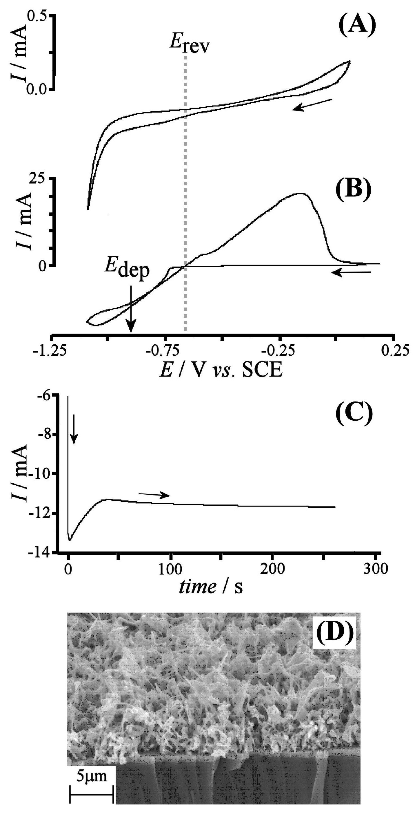
Figure 2: (A,B) Cyclic voltammograms (scan rate 0.02 Vs⁻¹, area 1 cm²) obtained at a Mo/MoSe₂ electrode immersed in aqueous 0.5 M LiCl at pH 3 without (A) and with (B) 0.1 M InCl₃. The deposition potential E_{dep} and the reversible potential E_{rev} are indicated (C) Chronoamperogram for the electrodeposition of In metal onto a Mo/MoSe₂ coated Mo film electrode with applied deposition potential -0.9 V vs. SCE. The cut-off of charge was 3.04 C. (D) SEM image for an In metal deposit on Mo/MoSe₂.

The electro-deposition of indium metal was carried out in potentiostatic mode at a potential of E_{dep} = -0.9 V vs. SCE (see Figure 2C). A cut off value of 3.04 C was chosen to produce an indium film of 1.6 μm theoretical thickness (assuming 100% current efficiency). The deposition current remains relatively constant at ca. 12 mA cm⁻². A SEM image of a typical deposit is shown in Figure 2D. EDX analysis (not shown) is consistent with In metal deposit. XRD analysis (not shown) shows lines characteristic for In metal. A porous high surface area indium film is formed with fiber-like features 100 to 200 nm in diameter.

3.3. Characterisation of Degenerate MoSe₂ Film Electrodes III.: Cu²⁺ Electrodeposition
For the deposition of copper metal, alkaline conditions (cyanide-free) were chosen following a procedure developed recently [21]. The Mo/MoSe₂ electrode was immersed into aqueous 3 M NaOH with 0.2 M D-sorbitol and the open circuit potential monitored. No erosion or dissolution was observed after 5 to 10 minutes. Cyclic voltammetry experiments were conducted in the absence and in the presence of 0.1 M CuSO₄ (see Figure 3A and B, respectively). Over the potential window investigated (-0.4 to -1.4 V vs. SCE) the MoSe₂ film electrode was stable. A broad reduction response commencing at -0.7 V vs. SCE can be attributed to the reduction of oxygen (all experiments were conducted in air). In the presence of 0.1 M CuSO₄ (copper(II) under these conditions is probably in the form of cuprate Cu(OH)₄²⁻ [] or as D-sorbitol complex [21]) a reduction and re-oxidation response are observed (see Figure 3B) consistent with the formation of copper metal (equation 4).

Cu(OH)₄²⁻ + 2 e⁻ Cu(metal) + 4 OH⁻(aq) (4)

During the first potential cycle a nucleation of copper on the Mo/MoSe₂ film electrode is observed at ca. -0.65 V vs. SCE. During the second potential cycle this process is not observed probably due to remaining copper nuclei on the electrode surface. A deposition potential of -1.105 V vs. SCE was chosen and chronoamperometry experiments conducted. Figure 3D shows typical chronoamperomentry data with a deposition current of ca. 1 mA cm⁻².
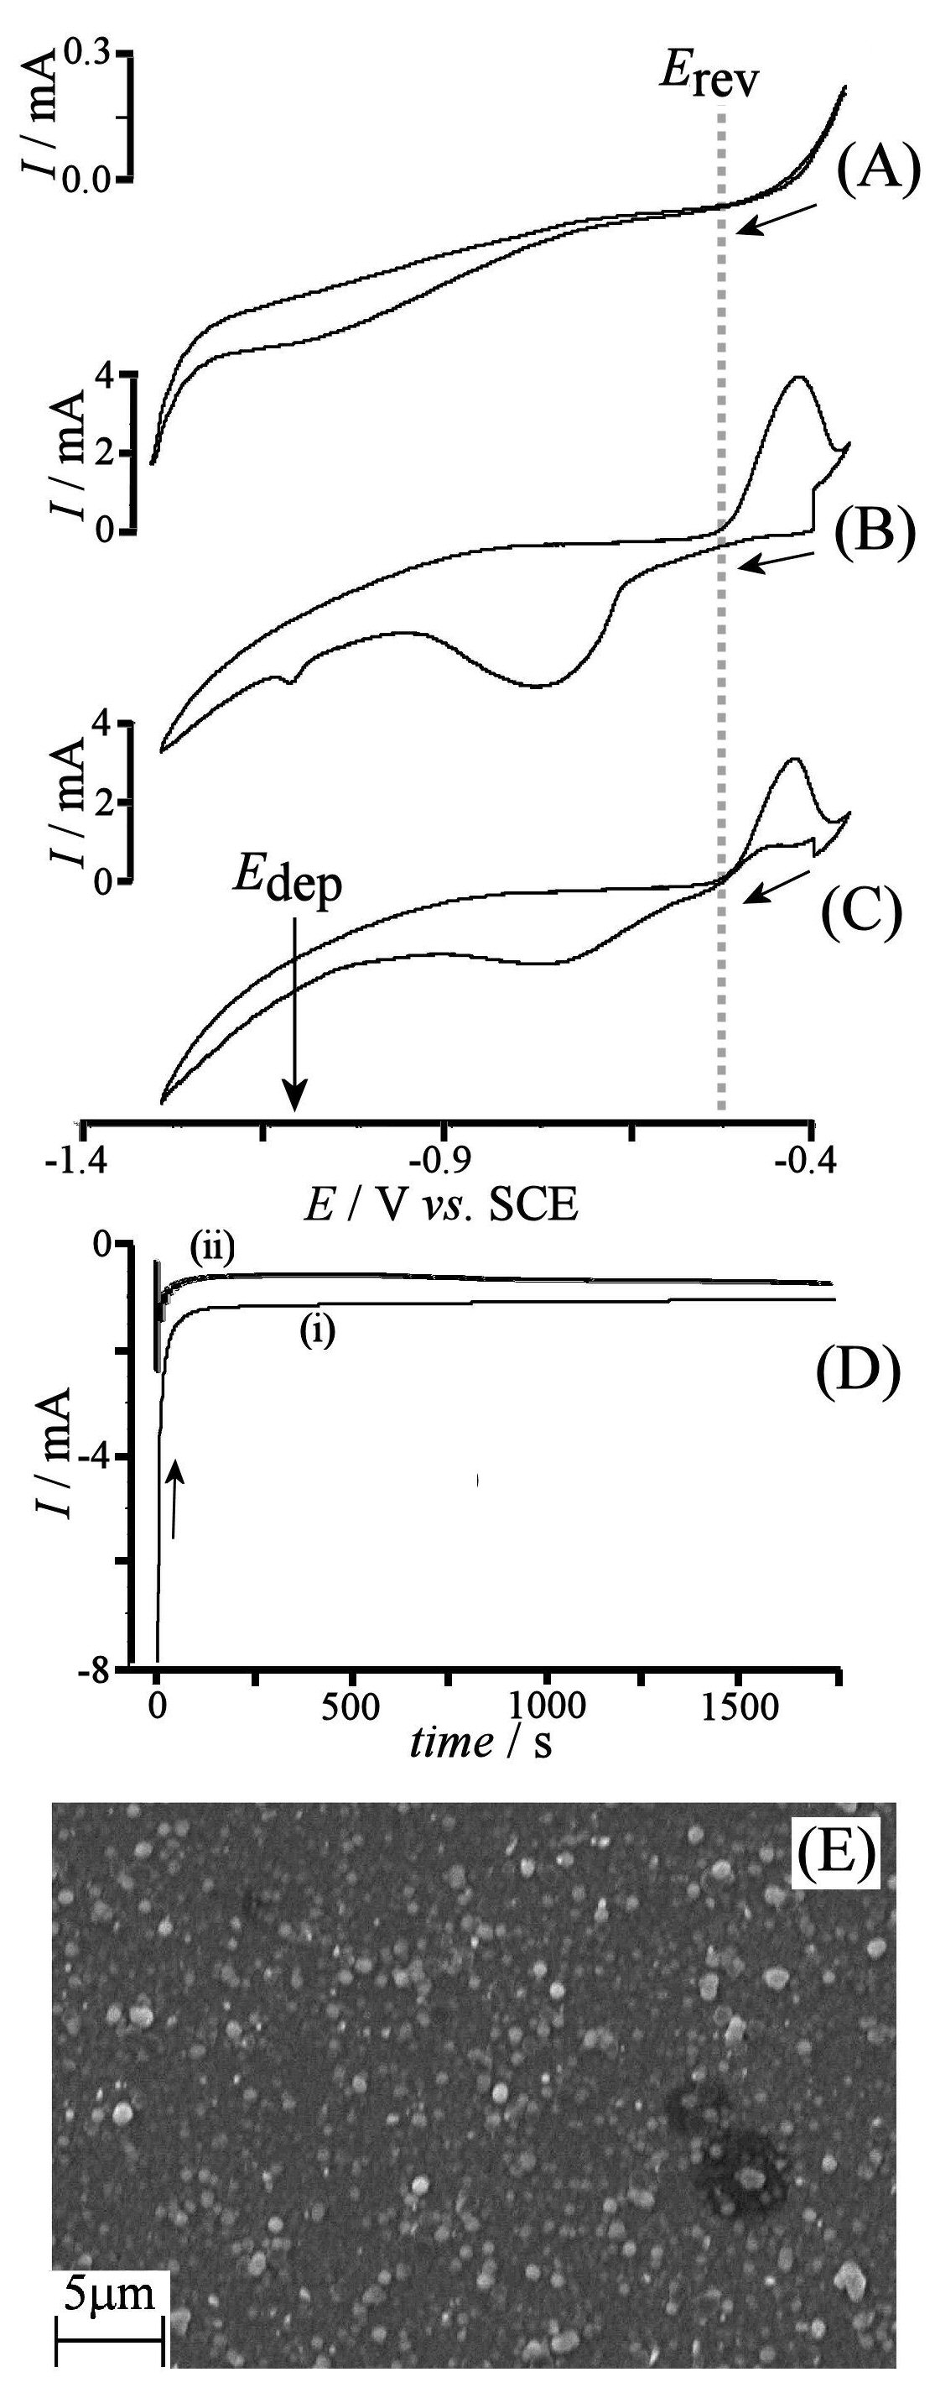
Figure 3. (A,B,C) Cyclic voltammograms (scan rate 0.02Vs⁻¹) for Mo/MoSe₂ electrodes immersed in aqueous 3 M NaOH containing 0.2 M D-sorbitol without (A) and with (B,C) 0.1 M CuSO₄ (shown in (B) 1st cycle and in (C) 2nd cycle). (D) Chronoamperogram for the electro-deposition of copper metal (i) onto Mo/MoSe₂ with a deposition potential of –1.105 V vs. SCE and a cut-off charge of 2.03 C and (ii) onto Mo/MoSe₂/In with a deposition potential of –1.105 V vs. SCE. (E) SEM image for a copper deposit on a MoSe₂ coated Mo film electrode.

An SEM image of a copper film deposited under these conditions (a cut-off value of 2.03 coulombs was set which corresponded to an average film thickness of 0.75 μm, confirmed by SEM) is shown in Figure 3E. A nodular deposit with features ca. 1 μm in size is observed. EDX data (not shown) clearly reveal the presence of Cu. XRD data (not shown) are consistent with Mo (two diffraction peaks corresponding to the (110) and (200) lattice planes), MoSe₂ reflections for (100) and for (105) lattice planes [14,24], and XRD peaks for copper metal (at 43.5º and 50.6º which are attributed to (111) and the (200) planes []).

3.4. Characterisation of Degenerate MoSe₂ Film Electrodes IV.: CuIn Electrodeposition, Selenistaion, and Preliminary Photoelectrochemistry
In order to form CuIn deposits as CISe precursor, there are two possible strategies: (i) first plating the more noble copper film and second plating indium or (ii) first plating indium followed by copper plating. The former strategy failed due to the formation of a white product, possible indium oxide, when plating indium onto copper. However, the deposition of copper onto indium was successful. The indium and copper metal layers are known to slowly inter-diffuse and form alloys already at room temperature [].

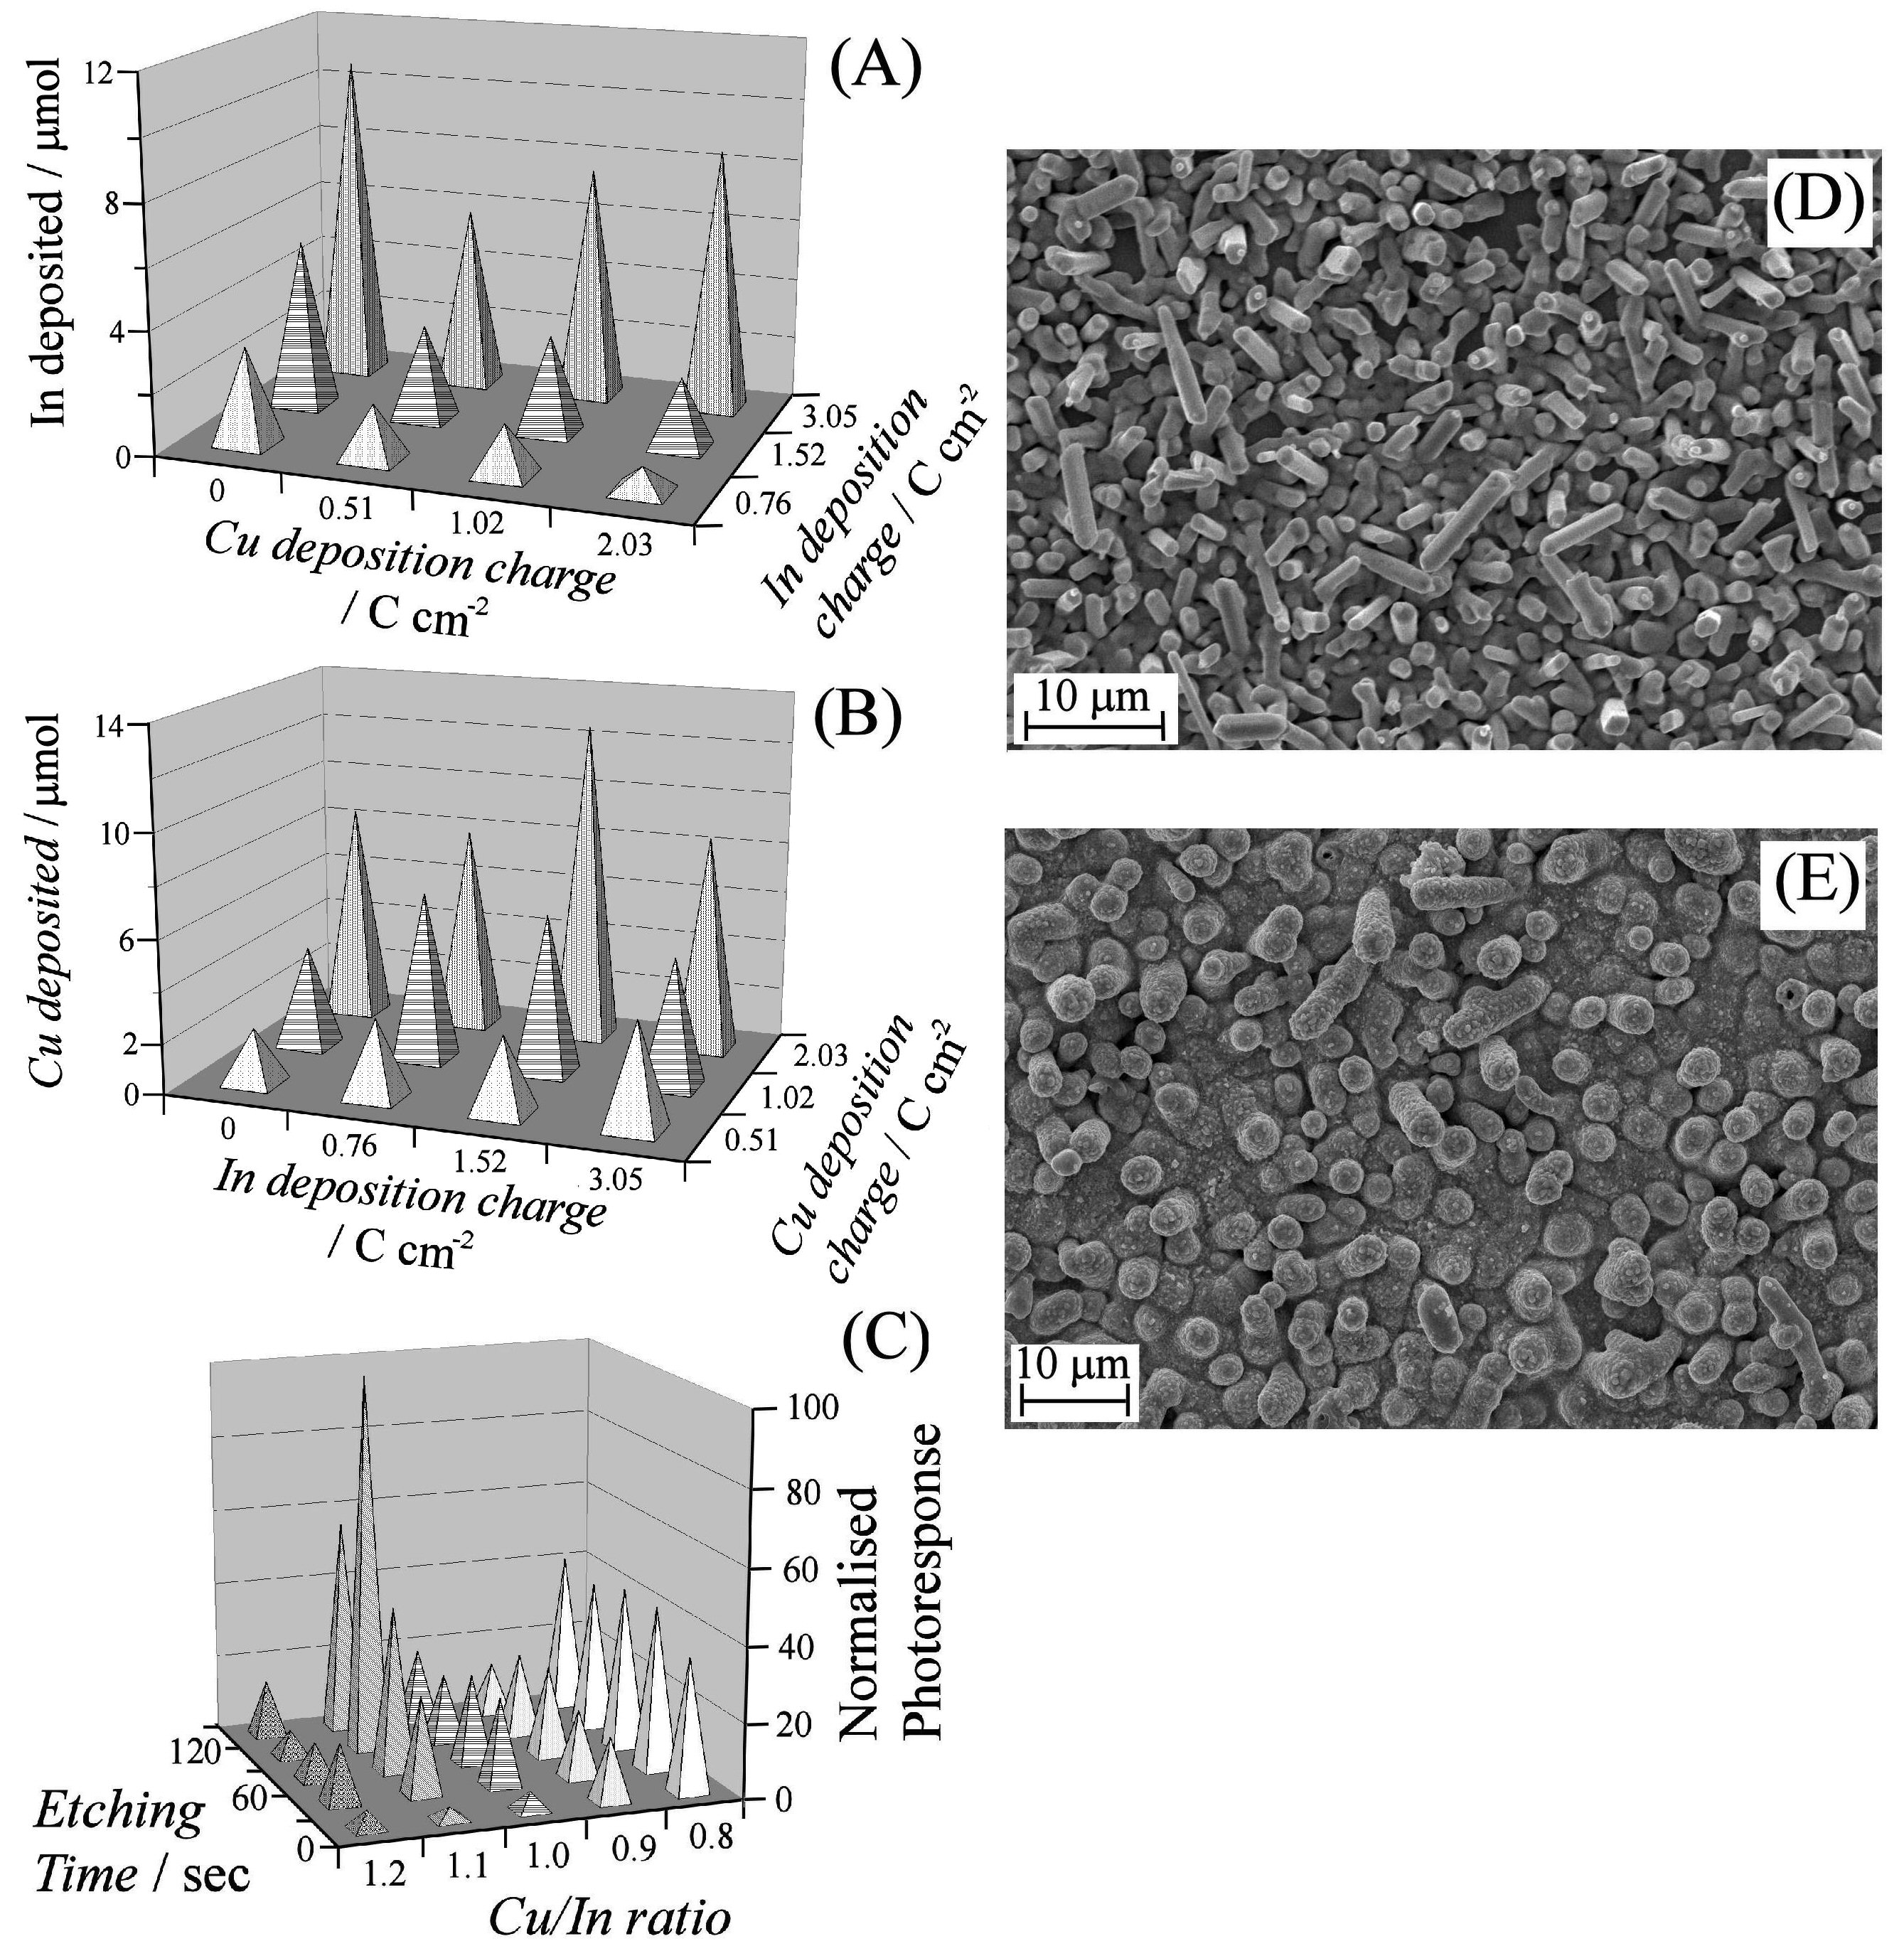
Figure 4. (A) The amount of electro-deposited In (by elemental analysis) and (B) the amount of electro-deposited Cu (by elemental analysis) present in 1 cm² InCu films as a function of deposition charge. (C) Preliminary photocurrents of CISe films as a function of theoretical Cu/In ratio and etching time. Data were recorded for CISe films immersed 0.2 M Eu(NO₃)₃ with an applied potential -0.36 V vs. SCE and a pulsed 530 nm light source.. (D) SEM image for an as-deposited InCu film. The theoretical ratio of Cu to In is 1:1 with a theoretical thickness of the Cu layer as 0.75μm. (E) The InCu film after annealing in Se.

Chronoamperometry data for the deposition of copper onto indium are shown in Figure 3Dii. In comparison to data for the deposition of copper on Mo/MoSe₂ the deposition current appears to be reduced which may indicate a slower rate of plating on indium compared to the process on MoSe₂. SEM images and EDX data (not shown) for the resulting composite film (see Figure 4D) suggest successful formation of a mixed InCu film deposit. XRD data suggest partial alloying at room temperature with remaining In and Cu. In the SEM image rod-like features dominate. Elemental analysis of deposits (after dissolution in concentrated nitric acid) suggests reasonable reproducibility (see Figures 4A and B). Typical plating efficiencies of 90% and 80% were observed for In and Cu, respectively. There appears to be a trend towards lower In levels when Cu is electro-deposited and a partial loss of In during this process cannot be ruled out and would make sense based on their reduction potentials. Also, interfering oxygen reduction processes may somewhat lower the current yields but this could be tolerated. SEM images taken after InCu was deposited revealed a rod like morphology. Thickness measurements were taken by imaging a cross section of the porous film (not shown) and revealed an overall film thickness of ca. 4-5 μm.

The selenisation process (selenium vapour at 550 ºC, see Experimental) is known to lead to CISe and it results in some morphological change (see Figure 4E) with most deposits fusing to form a continuous film with circular grains of the order of 1-3 μm. Rod like features are present with lengths of ca. 5-7 μm. XRD peaks consistent with the CISe material [] are observed. Some pinholes can also be observed in particular after the KCN etch. The photo-response of the resulting CISe films were examined using a photo-electrochemical method with electrodes immersed into aqueous 0.2 M Eu(NO₃)₃ [22]. A green LED light source was employed to generate electron-hole pairs in the semiconductor and photo-generated electrons reduce Eu³⁺ at the semiconductor – electrolyte junction (equations 5).

Eu³⁺(aq) + e⁻ + hv  Eu²⁺(aq) (5)

Preliminary data in Figure 4C show that un-etched CISe films produce a low photocurrent of < 5 μA cm² presumably due to the detrimental presence of some Cu_{2-x}Se. Un-etched CISe films with a higher concentration of In show a better photo-response, probably due to less Cu_{2-x}Se. However, because these CISe films are indium-rich the photo-response is not significantly improved even after etching. Films with a higher Cu/In ratio are more responsive to the potassium cyanide etch. In general, the gradual etching process was found to provide the highest observed photocurrent (14.9 μA cm⁻²) for a Cu/In ratio of 1.1. Further etching is likely to create pinholes which may reach down to the underlying MoSe₂. Then recombination occurs and the photo-current decreases. Further improvements will be possible by employing larger substrates, better electrodeposition solutions, and more well-defined hydrodynamic conditions.

4. Conclusions
Chemically robust and electronically degenerate Mo/MoSe₂ thin film electrodes have been produced and employed for the formation of CISe solar cell absorber films. In contrast to the chemically highly sensitive bare molybdenum surface, the Mo/MoSe₂ electrode surfaces exhibit chemically robust characteristics in acidic and in alkaline aqueous media. Films of CISe were formed by sequential electrodeposition and selenisation. The resulting CISe films were tested for their photo-electrochemical performance. The new methodology based on MoSe₂ coated Mo film electrodes is amendable to scaling up. With improved mass transport control during the electro-deposition process, it will be possible to tune the thickness, flatten the precursor metal film morphology, and to further improve the photo-electrochemical properties.

5. Acknowledgements
The authors are grateful for financial support from the EPRSC (Supergen: Photovoltaic Materials for the 21st Century EP/F029624/1). We thank Ann O'Reilly (Department of Physics, Bath) for help with SEM imaging.

References

[?] W. Sienicki, Mat. Chem. Phys. 68 (2001) 119.
[?] M. Zoaeter, A. Conan, D. Delaunay, Phys. Stat. Sol. 41 (1977) 629.
[?] C. K. Sumesh, K. D. Patel, V. M. Pathak, R. Srivastava, Chalcogenide Lett. 5 (2008) 170A.
[?] A. M. Chaparro, P. Salvador, A. Mir, J. Electroanal. Chem. 418 (1996) 175.
[?] T. Ohmori, C.R. Cabrera, Langmuir 14 (1998) 3723.
[?] V. M. Pathak, K. D. Patel, R. J. Pathak, R. Srivastava, Sol. Ener. Mat. Sol. Cells 73 (2002) 117.
[?] J. M. Huang, D. F. Kelley, Chem. Mat. 12 (2000) 2825.
[?] S. Bastide, C. Levy-Clement, A. Albu-Yaron, A. C. Boucher, N. Alonso-Vante, Electrochem. Sol. State Lett. 3 (2000) 450.
[?] T. Ohmori, R. J. Castro, C. R. Cabrera, Langmuir 14 (1998) 6755.
[?] H. Bolivar, S. Izquierdo, R. Tremont, C. R. Cabrera, J. App. Electrochem. 33 (2003) 1191.
[?] J. L. Shay, B. Tell, H. M. Kasper, L. Schiavon, Phys. Rev. B 7 (1973) 4485.
[?] M. Pagliaro, R. Ciriminna, G. Palmisano, ChemSusChem, 1 (2008) 880.
[?] R. N. Bhattacharya, J. Electrochem. Soc. 130 (1983) 2040.
[?] P. Dale, A. P. Samantilleke, G. Zoppi, I. Forbes L. M. Peter, J. App. Phys. D 41 (2008) 8.
[?] A. Kampmann, J. Rechid, A. Raitzig, S. Wulff, R. Mihhailova, R. Thyen, K. Kalberlah, Proceeding of the MRS Spring Meeting, 2003, San Francisco.
[?] T. P. Gujar, V. R. Shinde, J. W. Park, H. K. Lee, K. D. Jung, O. S. Joo, J. Electrochem. Soc. 155 (2008) E131.
[?] D. Cahen, G. Hodes, Ternary Adamantine materials for low cost solar cells Tech. Rep. SERT IL5-04132-1, Solar Energy Res. Inst., Golden, CO.
[?] G. Hodes, D. Cahen, Solar Cells 16 (1986) 245.
[?] T. Wada, N. Kohara, S. Nishiwaki, T. Negami, Thin Solid Films 387 (2001) 118.
[?] A.G. Muñoz, S.B. Saidman, J.B. Bessone, J. Electrochem. Soc. 146 (1999) 2123.
[?] L. L. Barbosaa, M R. H. de Almeidab, R. M. Carlosa, M. Yonashiroa, G. M. Oliveiraa, I. A. Carlosa, Surf. Coat. Tech. 192 (2005) 145.
[?] J. J. Scragg, P. J. Dale, L. M. Peter, Thin Solids Films 517 (2009) 2481.
[?] A. W. Hull, W. P. Davey, Phys. Rev. 17 (1921) 571.
[?] P. B. James, M. T. Lavik, Acta Cryst. 16 (1963) 1183.
[?] F. Scholz, Electroanalytical methods, Springer, Berlin, 2005, p. 77.
[?] D.T. Richens, The chemistry of aqua ions, Wiley, New York, 1997, pp. 517.
[?] W. L. Bragg, Phil. Magazine 28 (1914) 255.
[?] Z. Bahari, E. Dichi, B. Legendre, J. Dugue, Thermochim. Acta. 401 (2003) 131.
]?] J.S. Wellings, A.P. Samantilleke, S.N. Heavens, P. Warren, I.M. Dharmadasa, Solar Energy Mater. Solar Cells 93 (2009) 1518.

