The Value of Design in an Enterprise Cloud Solution
The purpose of this paper is to examine the value of design in a product development organization named C4C whose offering is targeted to large enterprises looking for a cloud offering to better run their businesses.
There is a general sense that design is important at C4C, but no attempts have been undertaken to formalize and quantify that value in one place.
A Case Study approach has been used to collect evidence surrounding design team’s contribution to the organization. Design management theory and tools have been applied to validate the findings and reach the conclusion.
The findings of this paper clarify and shed light on the design team’s undeniable contributions to the success of the product and quantify the value of design. The paper concludes by interlinking the four main findings; one, percent of top line revenue; two, balancing ‘the triad’; three, increasing the design influence; and, fourth, the cloud influence.

Keywords: cloud; enterprise; value of design; user experience

Introduction
Design is notoriously difficult to define, tough to measure, hard to isolate as a function, and tricky to manage, making it challenging for many non-designers to comprehend (Jeneanne, 2013).
The ambiguity surrounding the value of design in the organizations creates several concerning issues for design. Organizations seem to lack the evidence that could demonstrate the impact of the design team on the development of their product. Consequently, leading to low or no future investment in the design teams and an inability of taking the design team seriously by other recognized functions within organizations. At least this was the case evident in the chosen organization (C4C) for this piece of investigation.
The authors appreciate the challenges associated with design, nevertheless they have divulged into conducting an investigation that would clarify designs position where the primary author is based as a principle designer. We believe that by quantifying, documenting and analyzing the role of design we can circumvent and set aside any doubts on the positive role design plays in the success of the product.
The paper attempts to answer questions such as; Is design considered a cost center? Or is it a value creation engine? What are concrete examples of its role in the success of the product? Can this value be quantified as a percentage of the top line revenue? Or is the value of design baked into the process that it would be impossible to represent in a simplified single value?
This piece of investigation attempts to conclude that, at least for C4C, the value of design is clear and can be quantified.

Background
C4C is a cloud CRM (customer relationship management) solution which brings together marketing, sales, commerce, customer service, and social interactions.
Although C4C is part of a larger software company, it’s a young product that began as a whitepaper idea, and in four years has become the most successful organically built cloud product in the company’s history. C4C consists of 400 members with a design team of fifteen user experience designers. The lead author leads a number of other user experience designers.
This investigation is part of the primary author’s Masters course in MA Design Management with one of the leading universities in UK. The intention behind beginning this journey was to solidify the primary author’s own understanding on the value of design within his current practice. In collaboration with the academic at the university (second author), the fifteen years of value brought by the lead author was identified, reflected upon and documented. In broader sense this investigation also attempted to clarify how design relates to other teams, and its impact on top line revenue within C4C.
This investigation does not just demonstrate the value of design within a technology led organization but adds substantial evidence towards the value of design management education and design management practice. Whilst this investigation has equipped the primary author with the tools and resources to confidently discuss, defend and champion the importance of design in any organization, it has also extended the knowledge of design management for the future of design management education.

Literature review

Design in Tech
It is interesting to realize that large tech companies have been quietly acquiring design firms in the last few years (Figure 1).

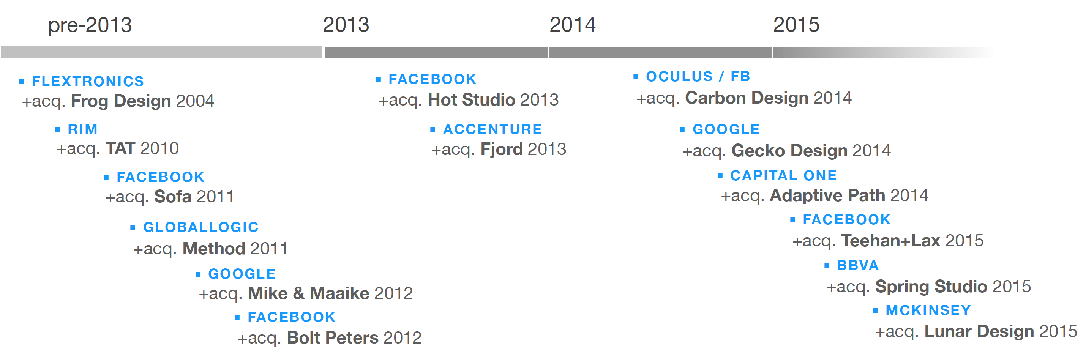
Figure 1. Timeline showing the merger and acquisition activity of tech companies buying design firms. (Maeda, 2015)

Tech giants have also been acquiring tech start-ups cofounded by designers (Figure 2).
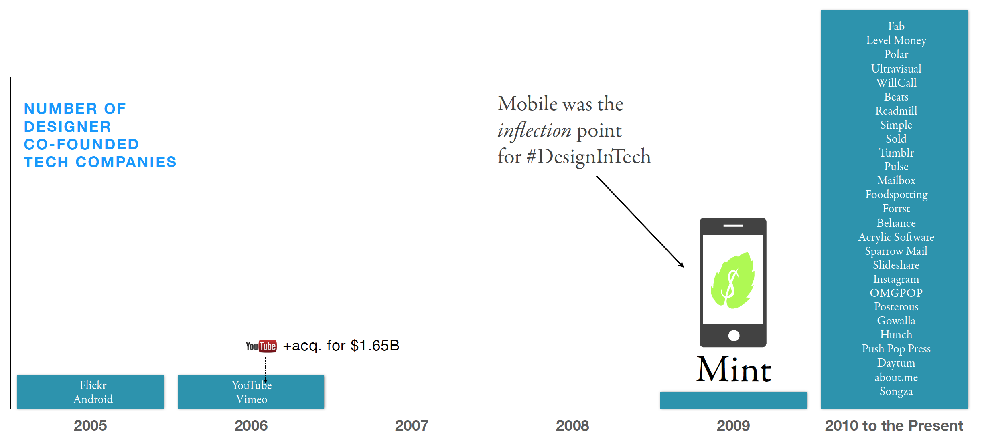
Figure 2. Timeline showing the number of tech acquisitions with at least one design cofounder. (Maeda, 2015)

These numbers are impressive and indicate that large tech giants have now begun to recognize that design provides a strategic advantage and is not merely an add-on. As a result of such exemplary statistics tech firms feel the immediate need for design talent and are willing to pay a premium. Nevertheless, these companies are also realizing that it is extremely difficult and slow for their organizations to build such design teams internally, so for them to acquire a company with its existing design talent is a quick solution.
If there is evidence demonstrating that giant tech firms are included design in their day-to-day work, why is not there enough reports on design’s impact and value?

Value of Design
A number of attempts have been made to quantify the use of design at micro (firm level) and macro (economic level). In fact researchers in the field of design and design management urge for investigations focused towards better articulation of design’s impact, but such reports are usually confidential and not published.
Work conducted by Mozota (2006) in providing frameworks to measure the value of design within specific fields has also led to some interesting revelations. Her work shows real life case studies identifying the contributions made by design for each case.
The Design Council in the United Kingdom published its fact finder report (Design Council, 2007), which outlines the applications of design by small and medium size firms in the Great Britain. Whilst painting a positive picture on application of design the report hinted towards the need for improvement in identifying and exploring the true value of design for commercial endeavors from all the sectors. Further, in 2015 the design council published another riveting report quantifying the economic value of design in the United Kingdom using gross value added (£71.7bn equivalent to 7.2% of total GVA) relating to productivity, employment and exports of goods and services (Design Council, 2015). Whilst the economic report also illustrates a growth in value generated by design, there seems to be a number of significant firms that avoid design as a strategic tool.

Design Centric Index
The design management institute’s effort at measuring the value of design across design led organizations is also an eye opening study (Jeneanne, 2013). The index measured the stock performance of fifteen US companies over ten years compared to the S&P500 (Figure 3).

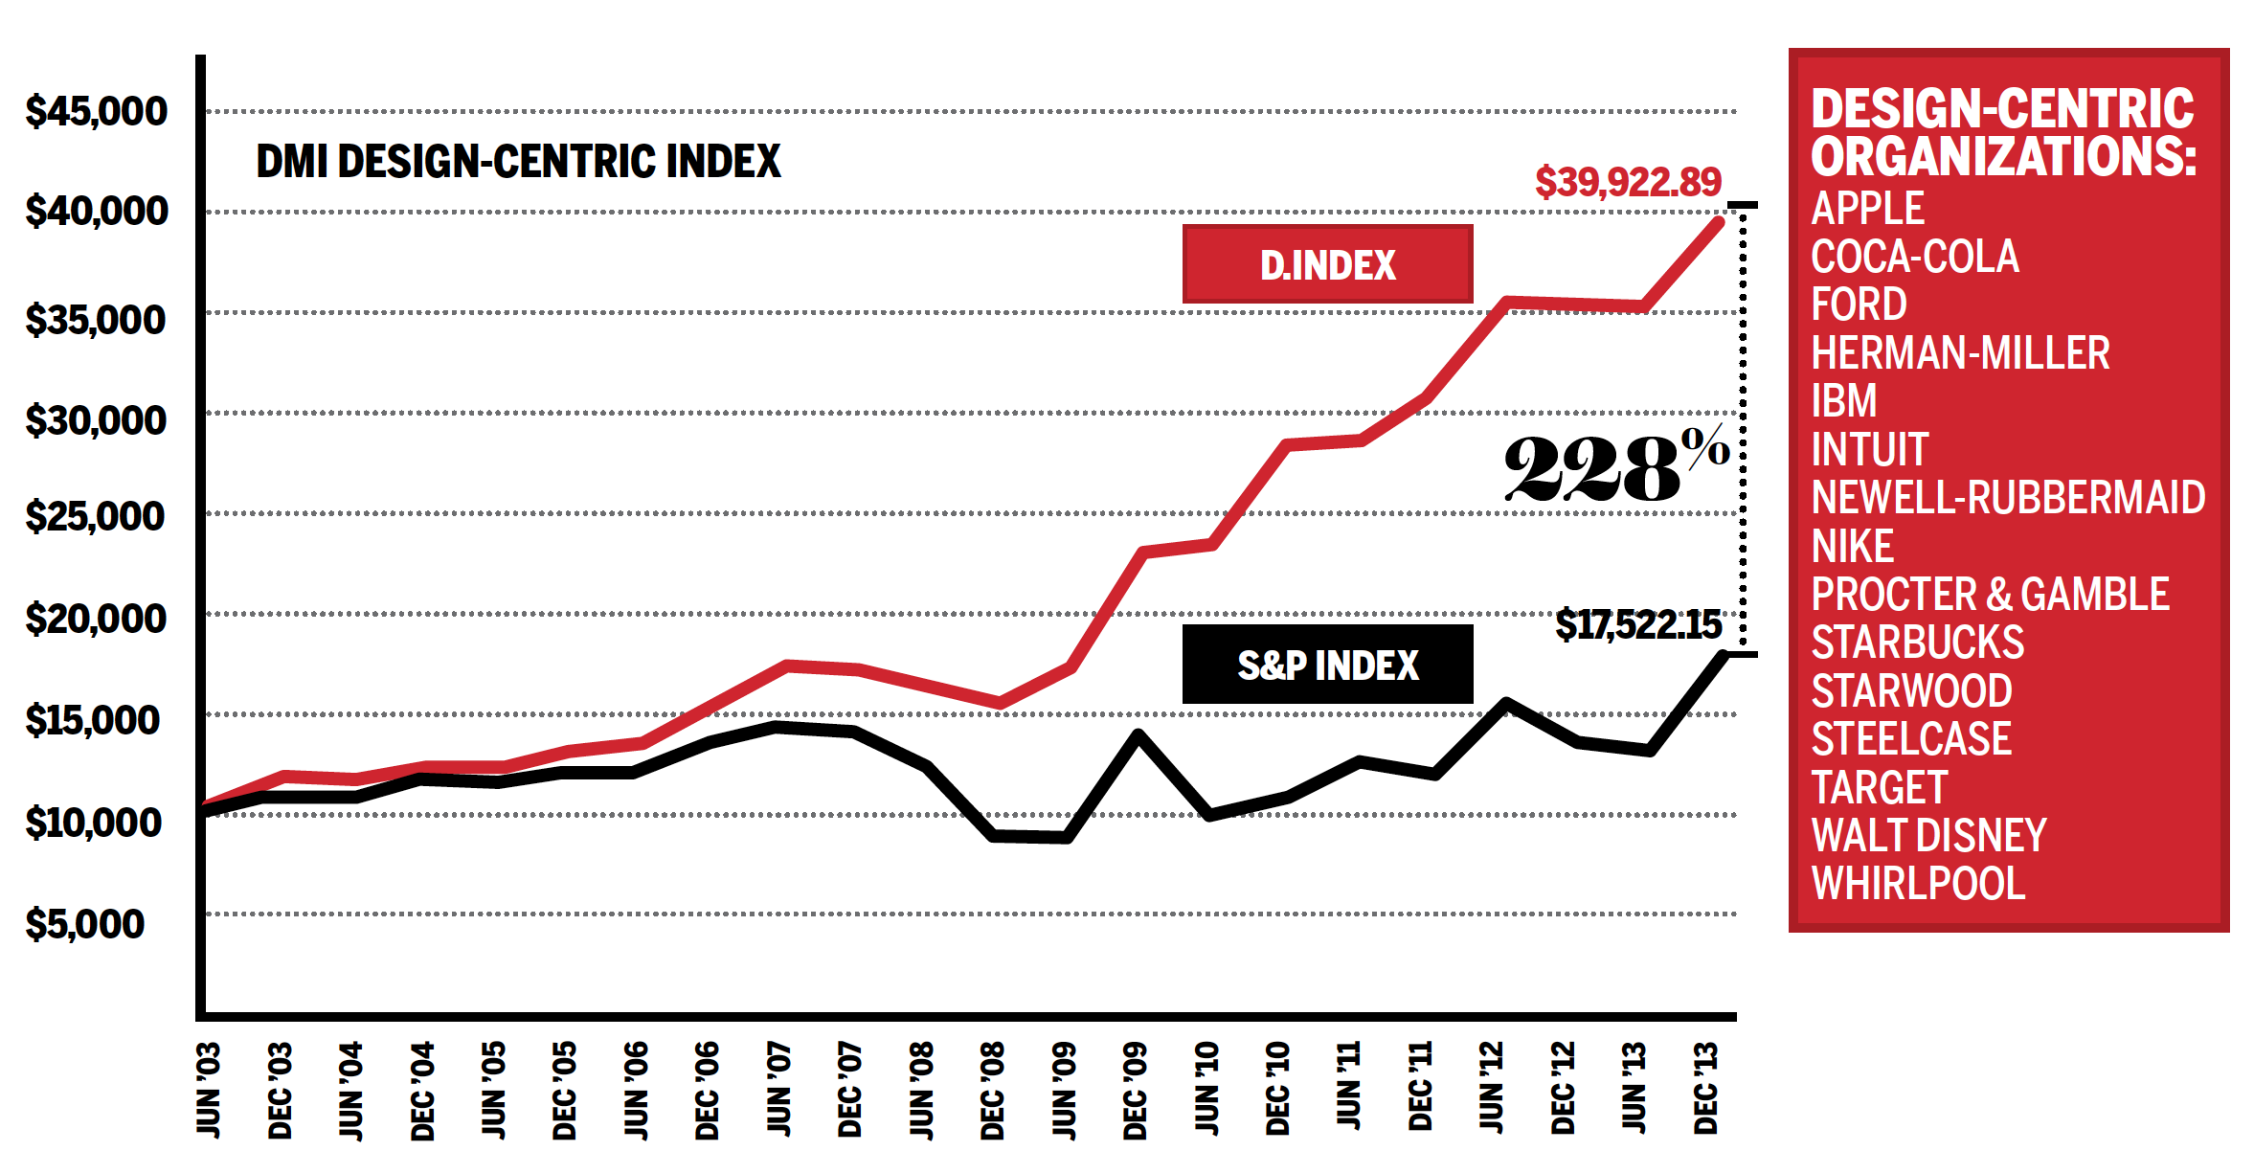
Figure 3. The stock performance of design centric organizations compared to the S&P index. (Source: Jeneanne, 2013)

This clearly shows that companies that integrate design on all levels see a significant increase in their market valuation. These organizations use design: first as a service, second as a catalyst for organizational change, and third as a strategic ‘design thinking’ resource to reframe business models and markets.’ (Westcott, Deb, Vanka, & Bilson, 2013).
The method of choosing which companies to include in the index was a result of their performance on the ‘design maturity’ scorecard. The DMI created this scorecard to help measure ‘how and where design creates value in an organization’. There are five main levels of design maturity where design is used for development and delivery, organization and strategy (see Figure 4).
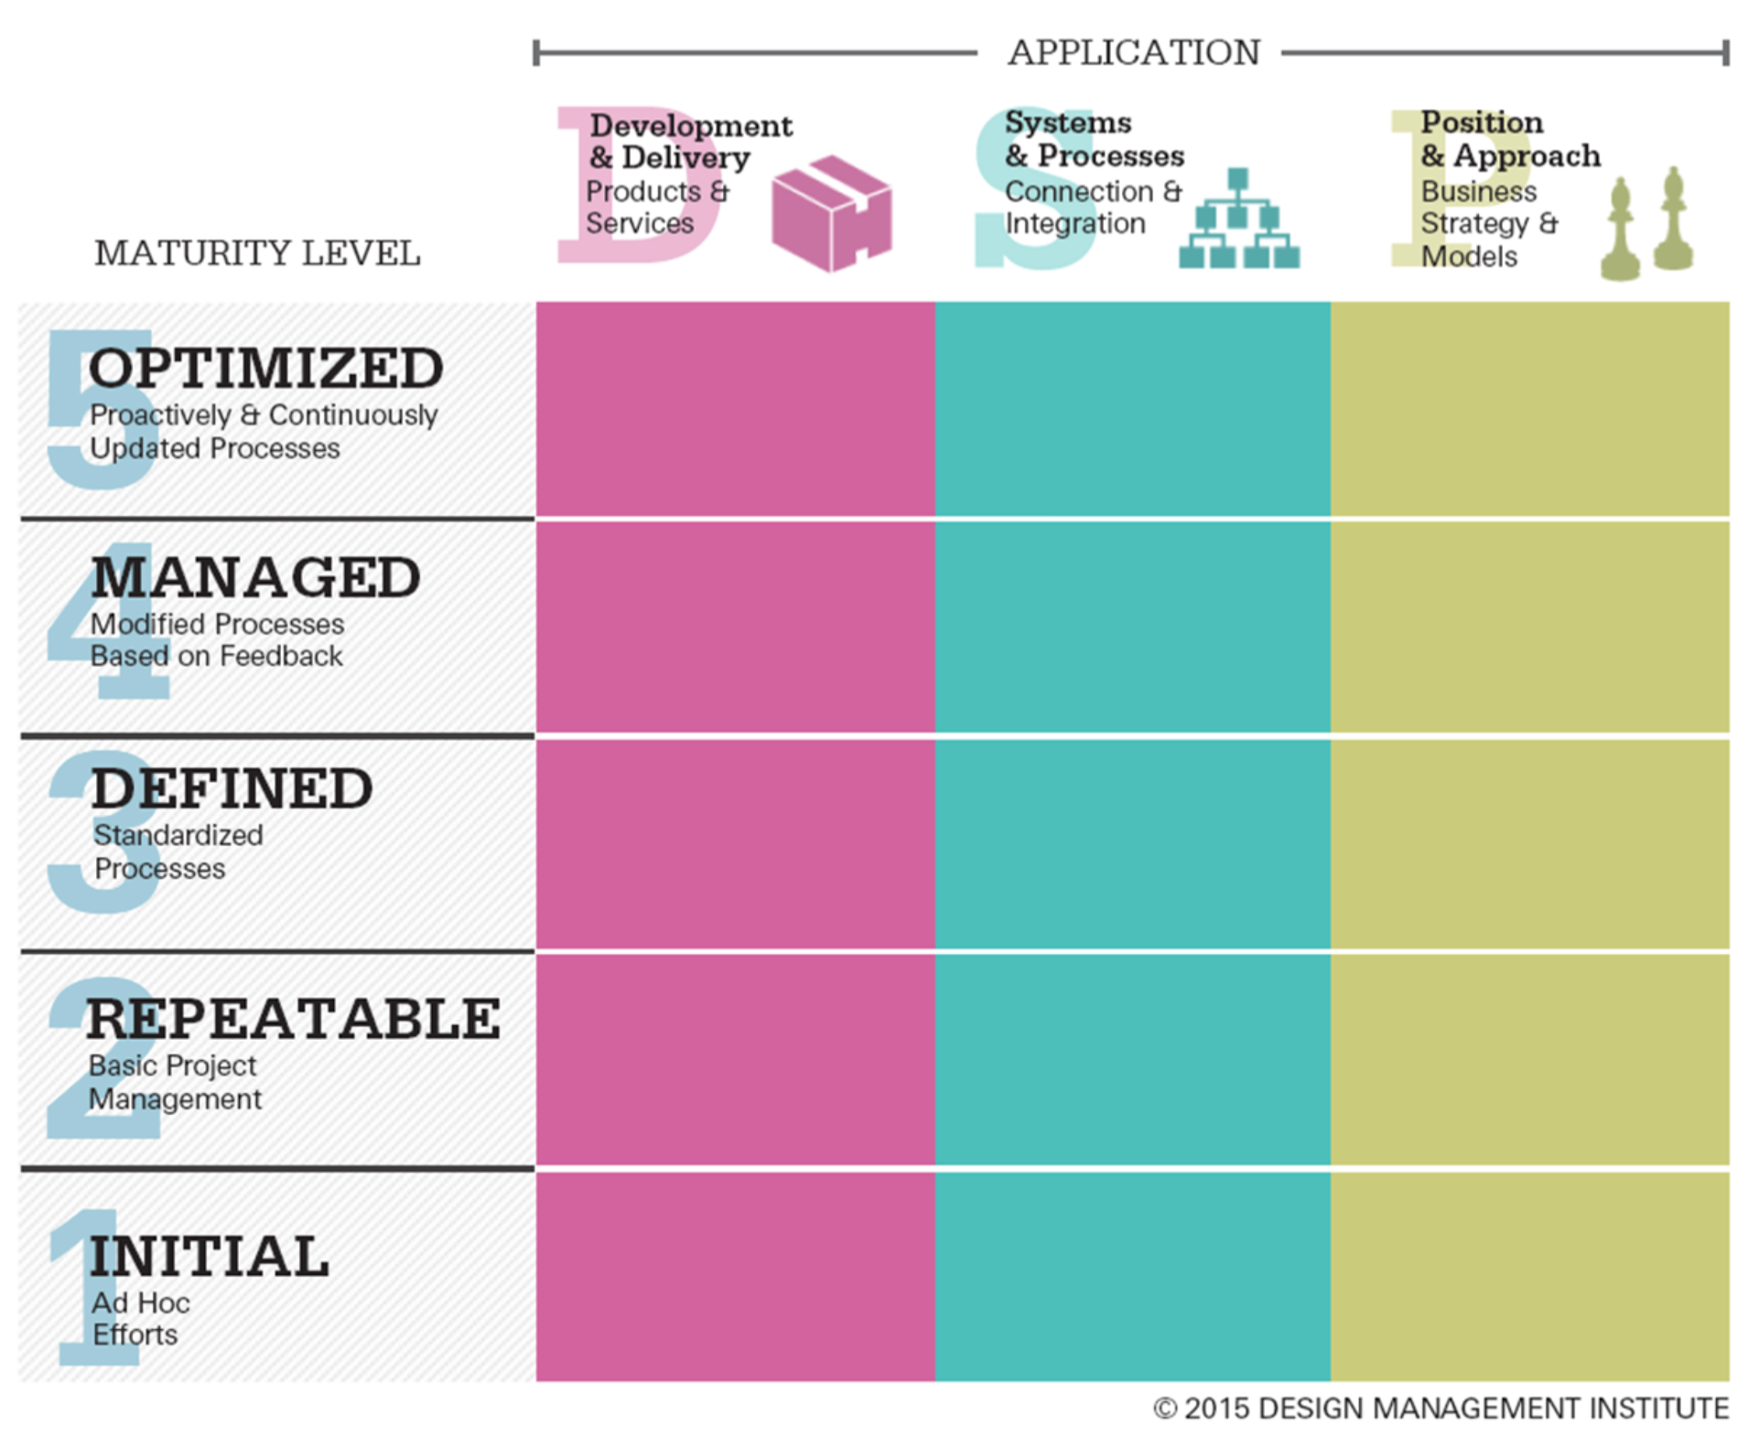
Figure 4. The DMI: Design Maturity Matric. Horizontally (from left to right), the design team will have broader influence and impact. Vertically (from bottom to top), the design group will be more productive, improve quality, reduce risk and waste.

The three main application areas can be further described in the following way (Figure 5):
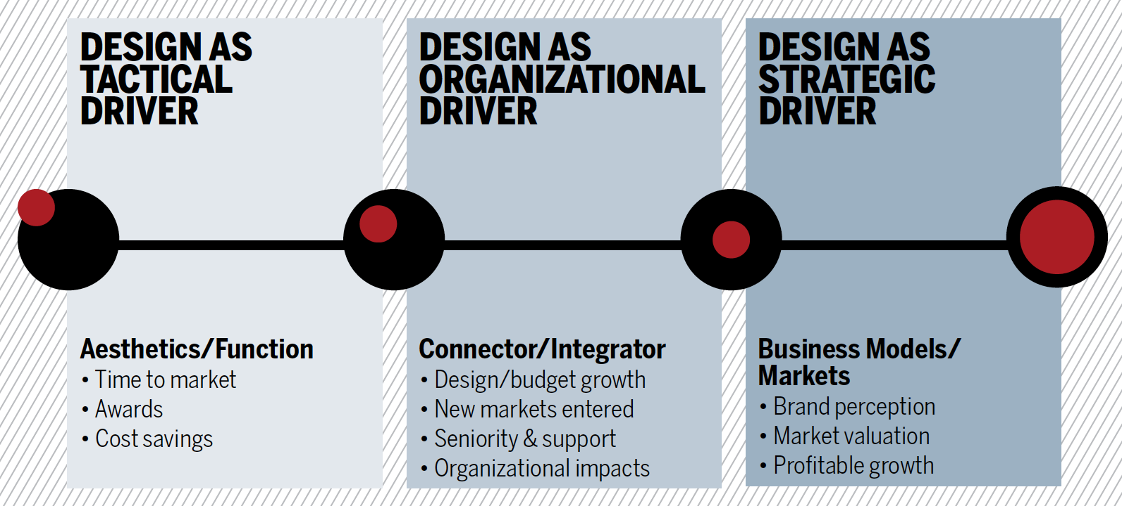
Figure 5. This model, inspired by Sabine Junginger’s work, helps the study of best practices in design organizations.

Customer Centric
One way to think about design in an organization is to think about the user experience. In other words, design is the method to instill empathy towards the user across all teams (New & Kimbell, 2013).
Design is not only a technical function (what designers do), but a way of thinking that puts the customer in the center of the decision making process. Also, evidence demonstrates design’s ability to be a strategic leader for multinationals (Gilsing & Gardien, 2013). ‘The ultimate goal therefore is not to create a great design, but to develop a great product / service that solves a problem and that the customer is willing to pay for’ (Maeda, 2015). Thinking about what the end user needs rather than a list of ‘must have’ features. The designers are the most well trained and skilled to provide that unique vantage point to help other teams keep the focus on the user.
So, what value does the design teams have on the overall achievement of the organization when they integrate with the technical functions of the firms? Anonymised (2013)’s doctoral thesis describes strategic level design intervention in a multinational research and development team to be one of the effective ways to recognize design’s contribution. Additionally, the sections below will shed light on another endeavor of design within C4C.

Data collection & analysis
Unstructured interview served as the main method of data collection for this case study. Each stakeholder brought in a unique perspective on the value of design in C4C. Triangulation (Olsen, 2004) was incorporated, and representatives from all the major teams, including top management, engineering, product management and sales were interviewed. During the sessions, open ended questions were asked, simultaneously the outcomes were put on an integrated mind map on a large wall as part of the multiple perspective problem solving approach (English, 2010). As the investigation was qualitative in nature, the mind map gave each interviewee a reference point and a visual aid to connect different thoughts and finally come up with a cohesive conclusion that added value to the investigation research and gave them previously unrecognized insights.
Qualitative analysis of the interviews was done to form a well rounded and comprehensive understanding of the product. The results were plotted on the design maturity model (Gilsing & Gardien, 2013) across the three main application pillars (Figure 6).

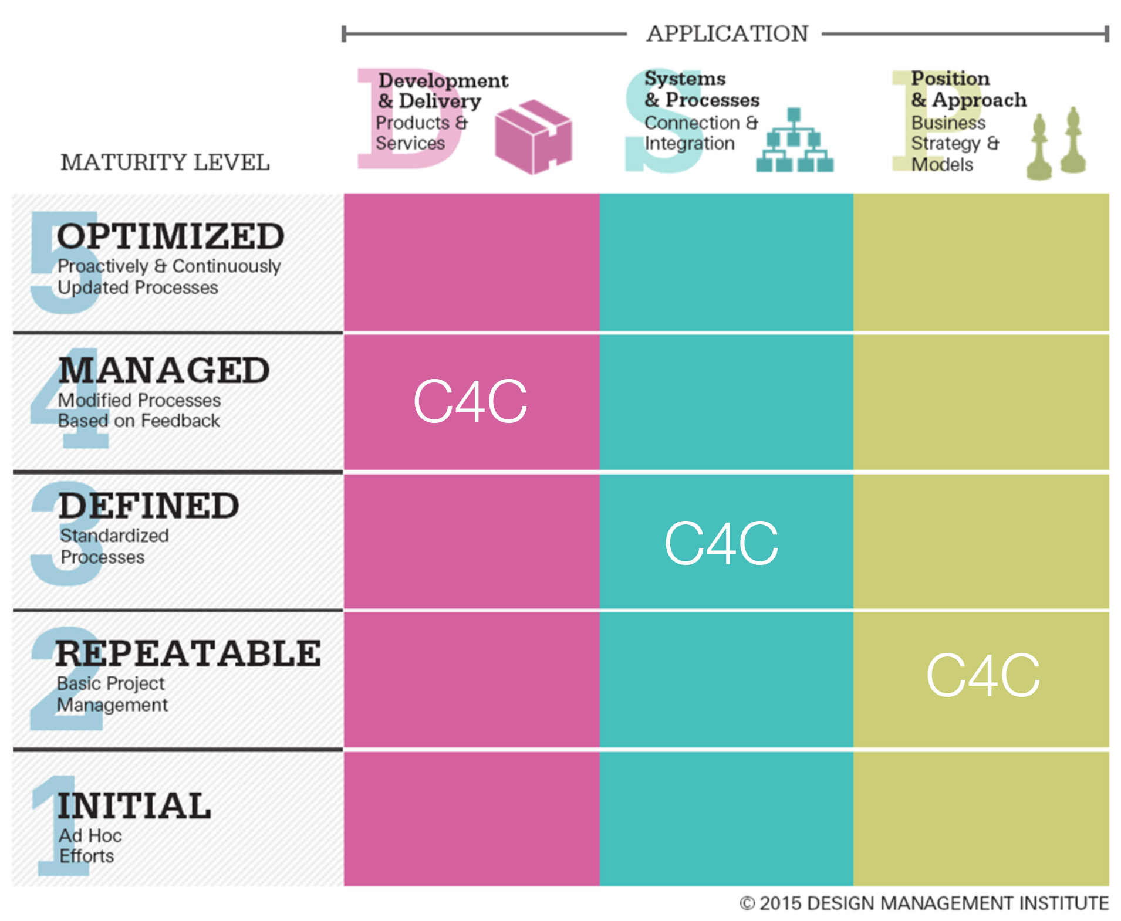
Figure 6. DMI Design maturity level of C4C after conducting interviews and analyzing the data.

Using a more simplified method devised by The Danish Design Center (Pietro, 2011), C4C was ranked at a 2.8 on a scale of 4 (Figure 7).

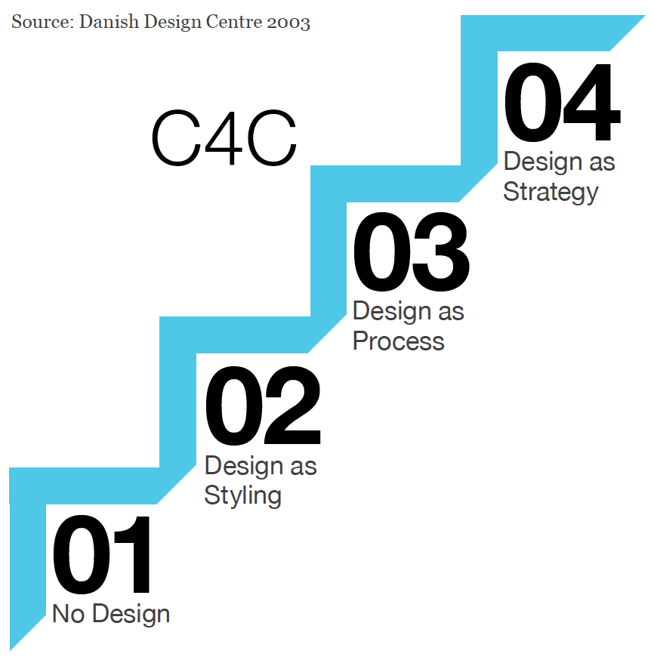
Figure 7. An alternative method in measuring the design maturity of an organization. (Pietro, 2011)

The authors appreciate that the there is room for improvement and robustness in the use of both frameworks, nevertheless, plotting of data on the existing frameworks provided a level of generalizability to the findings.

Findings & Revelations
The methods employed above clarified that there has been substantial investment in the ‘development and delivery’ pillar. This is understandable, since this pillar focuses on what the user sees: visual aesthetics and user interface. Historical evidence also concluded that the design team at C4C had made significant growth over the past year, which is reflected through the appreciation of top management.
The other two pillars are harder to grasp since their fruits are not immediately recognizable. These also require some internal reorganization and ‘design thinking’ training across all teams. With this comes extensive education of management on the value and role that design plays in delivering real life results.
Bettering the score on across all pillars has to be the responsibility of the design team, led by the director of design. There is no other team with the incentive and the knowledge required to push this change throughout the organization.
Additionally, the analysis of the interviews highlighted several high level themes, as in contributions made by design, which is seen to be an important variable in identifying the value of design within C4C. These themes were:
- Offline demos. These are prototypes showcasing the future vision of the product. They play a crucial role in closing new deals. They are produced by the design team.
- Usability as a competitive advantage. More usable software leads to more efficient users, and customers see great value in running a simple and efficient workforce. Designers play a key role in making the product a usable and enjoyable experience.
- Growth. At the company, the design team traditionally focused only on user interface, but its more impactful to concentrate on the ‘product experience’ as a whole. These are areas of untapped value and growth.
- Emotions. The end user needs to feel respected and happy while using the product. Designers are the most well prepared to understand and apply user empathy.
- Strategic vs Reactive modes. Another revelation was that the closer a product was seen to the strategic mode, the bigger was the role of design. Whilst C4C began as a strategic mode product with heavy emphasis on design, through the years, it slowly drifted into a reactive product. This deviation corresponded with a clear decrease in design quality that has negatively impacted the product.

Point 5 can be further explained by the illustration below (Figure 8) which indicates that a cloud product can be run in two main ways. First, in a strategic mode, meaning the top level goals guide the day to day activities and decisions on a long term trajectory. Second, in a reactive mode, relying heavily on the feedback from the market and the customers in making those decisions.

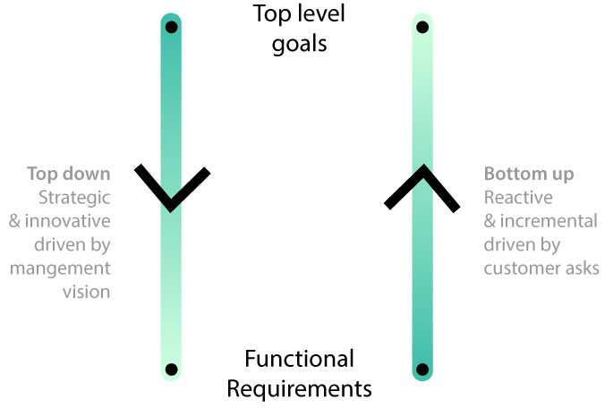
Figure 8. Different modes of running an organization.

At the strategic level more time was given to the topics, including the crucial time for design thinking and design processes. Whereas, in a reactive mode, things were created in a hurry without sufficient thinking. This lead to inconsistencies and insufficient time to think holistically. It is pertinent that C4C takes a top down approach to project planning and management so that design could be applied well in all its projects.

Conclusion
The investigation reached three conclusions that offer the most valuable argument in favor of the value of design within C4C. These are discussed in detail below.
- Percent of top line revenue
According to the head of the organization and the head of sales, there are four equally important factors (25% each) that entice customers to pay for C4C:
- Credibility. This is where the company’s brand plays a big role. Forty years building reliable, secure and quality software.
- Financials. The price compared to the competition.
- Trust. Can we deliver on what we promise? This is where testimonials from existing and high profile customers play a large part.
- Emotions. This is a result of what the customer sees and experiences when using the software.

Emotions are invoked when the software is delightful, user centric and intuitive. This is, on a high level, the mandate of the design team at C4C. Therefor, we can state that the design team directly contributes ~25% of top line revenue.
It is worth noting here that the head of sales had another method of calculating the value, but also arrived at a ~25% range. This was a survey of a random group of customers and their top reasons for renewing their C4C subscription. Among the possible answers was ‘usability’. The results where then weighted based on the deal size and duration.
C4C’s 2015 revenue is ~$200 million. That translates to design contributing ~$50 million to the top line revenue. The team consists of 13 designers with a resulting productivity of ~$3.8 million per person per year.
Looking at this from a different angle, the market valuation for a cloud product like C4C with similar revenue would be ~$1 billion. Using the same equation above, we can state that the C4C design team contributed to the value creation of ~$250 million for the company.
These are impressive and substantial achievements that the design team should be proud of, and the primary author confirms that none of the designers had predicted such numbers at C4C prior to this investigation.
It would be very interesting to start tracking this value on a quarterly basis, and adjust it depending on the detailed activities in that period. Can this be one of the measured goals in the financial reports? Can the incentives and bonuses across the organization be partially linked to this indicator, similar to total revenue, number of customers, etc.? This is something that is part of future research.
- Balancing ‘the triad’
The three corners of the triad represent: design, product management and software development. The ‘triad balance’ describes the current state of the organization at a certain point in time in relation to its proximity to a certain corner of the triad (Figure 9).
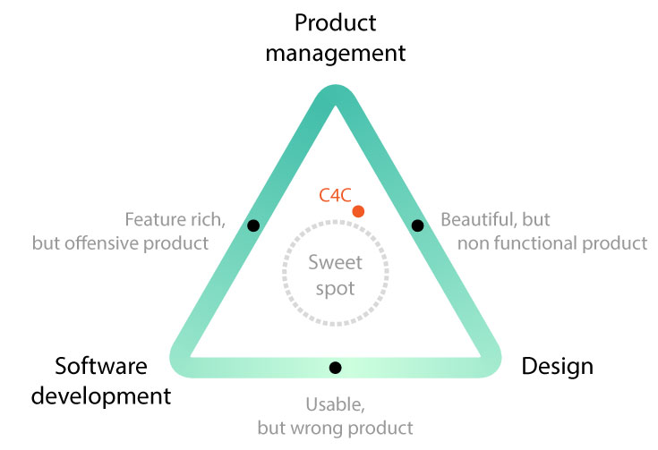
Figure 9. The triad showing the current state of C4C. It is clear that the product is moving away from the software development corner. Users are starting to complain that the product looks good and is feature rich but suffers from long loading times. This is an indication that the software development teams did not focus on performance over the past year, and as a result, the product drifted away from the sweet spot area.

The primary driver of this balance lies in the hands of the product management team. They bridge all teams and guide the feature list. They have the power to tilt the balance of the triad, which naturally becomes more difficult to ascertain as the product matures and the teams becomes bigger.
The current risk is that in following the competition, product managers pile on more and more features without giving enough time and focus on usability and design. This results in a product that is feature rich, but offensive and unusable.
The placement of the product within this triad also depends on the maturity level over time, but the ideal placement is in the middle for optimum customer success and satisfaction. The limited resources force an organization to make hard choices and the product starts to lean in one direction at the expense of the other two.
It is the job of the design team to relentlessly push back and remind everyone of the importance of maintaining this balance.
- Influence of cloud on design
The emergence and growth of the cloud has fueled several key factors that accentuate the need for strong design teams. Users have become accustomed to high levels of design excellence thanks to the cloud. It is hard to find an example of a successful cloud service that does not rely heavily on a strong design language and user experience. This has trickled up the enterprise world, and now large customers require consumer grade design experiences from their vendors.
The company has traditionally shipped sub par user experience and design since it relied on third party consultants to custom build the final user facing interface. Needless to say, this was an expensive proposition with a very lengthy deployment timeline. In the cloud era, this is not acceptable any longer, prices need to be very competitive, and the service needs to be available immediately. The middle man has been cut off, and the company is now forced to offer a cloud offering with impeccable user experience that rivals any other consumer app. The company is now expected to invest in a design experience similar to Apple, Google or Facebook. The cloud shifted design from a nice-to-have add on to a competitive necessity.
The closer the end user is to the buying decision; the more important design becomes. The shift, over the past 10 years, from on premise software to cloud solutions, changed the buying process in significant ways. For decades, the buying decision was made in the IT department. This meant that their priorities trumped the needs of the end user (technical functionality was more important than usability). With the advent of cloud software (instant availability, freemium model), end users inside large organizations started to experiment with solutions on their own and injected themselves into the buying process. As a result, there was a clear shift in power, and the end user’s satisfaction and adoption become one of the highest priorities.
Therefore, it can be argued that the rise of the cloud has made design critical to the success of an enterprise software organization, and hence more valuable than ever.
Final Thoughts
It all began with the proliferation of the cloud and the pressure on enterprise software to catch up to the consumer apps in terms of usability and design. That resulted in investments in design teams and processes, which helped in balancing the product management/software development triad. Once balanced, the product became more user centric and usable, which increased adoption and positively impacted the top line revenue. That impact can be valued today at ~25% of C4C’s yearly revenue. This connection is represented in the figure 10 below.

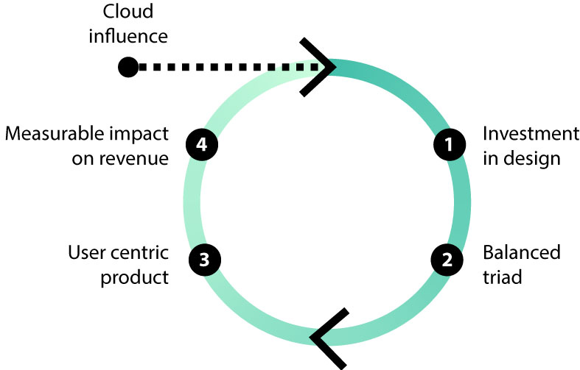
Figure 10. A unified findings diagram explaining the value of design in C4C.

Designers are so consumed with the continuous back and forth with various teams that they loose focus on the long term impact they are making on the product. This stands true not just for C4C but most large size organizations. This, combined with their lack of business acumen, puts them at a disadvantage when attempting to internalize their valued input in the entire process.
Upper management needs tangible return on investment in design teams and processes. Without such a metric, no matter how inaccurate, future investments will be at risk. Moreover, if other teams don’t see the value and contributions of the design team, more and more decisions will be taken without consulting the design team. And this will make us go back to where we are coming from, a world full of hateful apps!

Implication
Increasing the design influence
It was apparent that the design team’s impact on the product is already substantial, even though C4C scored average in the design maturity index. The next logical question would be ‘what would be the financial impact if C4C performs better on the design maturity index?’ A list of extra responsibilities was then identified that the design team could take on to increase the design maturity of C4C:
- In house user research
- In house visual design
- Future design concepts and strategy
- One unified UI for all users
- Onboarding experience design
- Ownership of custom built user interfaces
- Marketing support (videos and collateral)
- Website
- Customer support touch points
- Disseminate design thinking across the organization
- Measure and present the impact of the design team every quarter
- Branding
Maybe the team should be renamed ‘product experience design team’ instead of ‘user experience design team’, reflecting a shift in focus from the user to the entire product. The above points can be summed up in two questions: “How does the end to end user journey look like?” and “How do we instill design thinking across C4C?”

Future work
For C4C’s internal use a white paper report for this investigation is being created for internal publication purposes. A competitor analysis will be conducted to see how other major players in this space use design to their advantage. A report will identify the lessons learnt from their successes and failures. The discussions and findings will also be shared with the chief creative officer of the company to see how much of these can be applied on a wider scale.
Additionally, this research has quantified a value for design’s contribution in a firm heavily loaded with user experience designers. The spread of design in C4C might not match up with other firms that do not involve design in most of their day to day business activities. This investigation has opened a pandora’s box of critical questions on the relevance of design management practice. Is design value worthy of being represented in the financial reports of the firms? If so, then how can firms identify/calculate this value? And, are their any significant internal barriers to accomplish this? Further research in form of collaborative PhD’s and short project schemes need to be conducted to make sure that more such revelations are published across the field, to benchmark and document design’s impact as a quantifiable value.

References
Anonymised (2013). Design as a functional leader: A case study to investigate the role of design as a potential leading discipline in multinational organisations. PhD, Northumbria University, Newcastle Upon Tyne. Retrieved from http://nrl.northumbria.ac.uk/id/eprint/13320
Design Council. (2007) The Value of Design Factfinder Report. pp. 1-119. Retrieved 1 April, 2016, from http://www.designcouncil.org.uk/sites/default/files/asset/document/TheValueOfDesignFactfinder_Design_Council.pdf
Design Council. (2015) The Design Economy Report. pp. 1 - 200. Retrieved 1 April, 2016, from http://www.designcouncil.org.uk/resources/report/design-economy-report
English, S.G. (2010). Multiple perspective problem framing. How do designers think about situations to reveal hidden opportunities. Ph.D thesis, Northumbria University. Newcastle, UK.
Gilsing, F. & Gardien, P. (2013). Walking the walk: Designing the Next Generation Design Organization. Paper presented at The Design Thinking Conference, Santa Monica. Retrieved 15 Jan, 2014, from www.dmi.org/dmi/html/conference/designthinking13/s_gardien_gilsing.htm
Jeneanne, R. (2013). What is the real value of design? DMI: design management institute. Retrieved 10 Dec, 2015, from http://www.dmi.org/?page=13244RAE30
Maeda, J. (2015). Design In Tech Report. Kleiner Perkins Caufield Byers venture capital firm. Retrieved 8 Dec, 2015, from http://www.kpcb.com/blog/design-in-tech-report-2015
Mozota, B. B. d. (2006). The Four Powers of Design: A Value Model in Design Management. Design Management Review, 17(2), 44-53.
New, S., & Kimbell, L. (2013). Chimps, Designers, Consultants and Empathy: A “Theory of Mind” for Service Design. Paper presented at the Second Cambridge Academic Design Management Conference, Cambridge.
Olsen, W. (2004). Triangulation in social reserach: Qualitative and quantitative methods can realy be mixed. Developments in Sociology. Retrieved 5 Sep, 2012, from www.ccsr.ac.uk/methods/festival2004/programme/.../Olsen_000.doc
Pietro, M. (2011). Leading Business by Design. Warwick Business School on behalf of Design. Retrieved 8 Dec, 2015, from http://www.designcouncil.org.uk/resources/report/leading-business-design
Westcott, M., Sato, S., Mrazek, D., Wallace, R., Vanka, S., Bilson, C. & Hardin, D. (2013). DMI design value scorecard. DMI: design management institute. Retrieved 22 Dec, 2015, from http://c.ymcdn.com/sites/www.dmi.org/resource/resmgr/Docs/DMI_DesignValue.pdf

