Detection of L-alanylaminopeptidase activity in microorganisms using chromogenic self-immolative enzyme substrates
Marie Cellier,ª the late Arthur L. James,^{b,d} Sylvain Orenga,ª John D. Perry,^{c} Ari K. Rasul^{b} and Stephen P. Stanforth^{b*}
ª Research & Development Microbiology, bioMérieux SA, 3 route de Port Michaud,
38 390 La-Balme-les-Grottes, France.
^{b} Department of Applied Sciences, Northumbria University, Newcastle upon Tyne, NE1 8ST, UK.
^{c} Department of Microbiology, Freeman Hospital, Newcastle upon Tyne, NE7 7DN, UK.
^{d} Deceased, May 2014

Abstract: Three potential chromogenic enzymatic probes, each possessing a self-immolative spacer unit, were synthesised for the purpose of detecting L-alanylaminopeptidase activity in microorganisms. An Alizarin-based probe was the most effective, allowing several species to generate strongly coloured colonies in the presence of metal ions.
Keywords: chromogenic enzyme substrates, L-alanylaminopeptidase detection, microorganisms.
Molecules that possess a self-immolative spacer unit have been studied and utilised in several areas of chemical science including drug delivery systems, prodrug design, chemical sensors and enzyme sensors.¹ In one theme of self-immolative spacer chemistry, molecules of general structure 1 have been constructed around a para-aminobenzyl alcohol (PABA) core for the purpose of enabling the detection of protease enzyme activity as outlined in Scheme 1. This system is designed so that protease-induced fragmentation of compounds 1 results in the release of a fluorescent phenolic derivative 4 and hence the presence of protease activity results in an increase in fluorescence. Thus, the protease substrates 1 are hydrolytically cleaved resulting in the formation of the intermediates 2 which subsequently fragment with concomitant liberation of the imine 3 and the fluorescent phenolic derivative 4. A sensor for the detection of penicillin G acylase,^{2,3} a probe for determining Caspase-3 activity,² an assay for monitoring the activity of the autophagy-initiating enzyme ATG4B⁴ and a Resorufin-based fluorogenic/chromogenic substrate for the detection of proteases in biological matrices⁵ are recent examples of the application of self-immolative spacers of general structure 1. We have recently described⁶ the synthesis and evaluation of a series of novel fluorogenic self-immolative enzyme substrates based on the general structure 1 (AA = L-alanyl) for the detection of L-alanylaminopeptidase activity in a panel clinically important Gram-negative and Gram-positive microorganisms, an area of importance in diagnostic microbiology.⁷ Several of these substrates enabled the detection of L-alanylaminopeptidase activity in Gram-negative microorganisms in Columbia agar media because L-alanylaminopeptidase activity is frequently abundant in Gram-negative microorganisms whereas it is generally less pronounced in the Gram-positive microorganisms.^{8,9} The growth of many of the panel of Gram-positive microorganisms in Columbia agar was frequently inhibited by these fluorogenic substrates, and hence fluorescent microorganism colonies were not observed except in a few cases where some growth had occurred.⁶ A fluorogenic, self-immolative substrate designed for the detection of β-alanylaminopeptidase activity has recently been reported.¹⁰

Scheme 1. Self-immolative spacers for protease detection.
In this Letter, we describe the synthesis and evaluation of some novel chromogenic self-immolative enzyme substrates for the detection of L-alanylaminopeptidase activity in microorganisms. The core molecules (equivalent to compound 4) chosen for study were cyclohexenoesculetin 5 (CHE) and Alizarin 11 (Scheme 2) because both of these molecules are annulated catechol derivatives and as such, they are known to form coloured chelates in the presence of selected metal ions. For example, the 7-β-D-glucoside derivative of compound 5 in the presence of ammonium iron(III) citrate produced black colonies with microorganisms that exhibited β-D-glucosidase activity.¹¹ The 2-β-galactoside derivative of Alizarin 11 produced either violet or pink coloured colonies in the presence of ammonium iron(III) citrate or potassium aluminium sulphate respectively with microorganisms that displayed β-galactosidase activity.¹² The benefit of the work described in this Letter would be that L-alanylaminopeptidase activity might be detected through the formation of highly coloured metal chelates of catechol-type molecules.
The synthesis of the required substrates is shown in Scheme 2 (see supplementary information for experimental details). Treatment of heterocycle 5 with compound 6⁶ under basic conditions afforded a mixture of the mono-substituted product 7 (22%) and the di-substituted compound 8 (38%) which were separated by column chromatography. Compound 8 (84%) was also prepared from heterocycle 5 using 2 equivalents of the benzylic chloride 6. De-protection of these individual compounds 7 and 8 with hydrogen chloride produced the hydrochloride salts of the substrates 9 and 10 respectively. In a similar process, Alizarin 11 reacted with compound 6 under basic conditions giving the mono-substituted product 12 from which the required substrate 13 was obtained by removal of the Boc protecting group.
Scheme 2. Synthesis of the substrates 9, 10 and 13. Reagents and conditions: (i) 6 (1 equiv.), Cs₂CO₃ (1 equiv.), DMF, 90 ºC, 3-5 h; (ii) HCl/EtOAc, rt, 1-2 h; (iii) 6 (2 equiv.), Cs₂CO₃ (2 equiv.), DMF, 90 ºC, 5 h.
Each substrate (100 mgL⁻¹) was evaluated in Columbia agar media (37 ºC in air for 18 hours) on a single plate against 20 clinically important microorganisms including 10 Gram-negative bacteria, 8 Gram-positive bacteria and 2 yeasts (see Figure 1, top diagram). Also added to the media was either ammonium iron(III) citrate (500 mgL⁻¹) or aluminium potassium sulphate dodecahydrate (500 mgL⁻¹). The substrate concentration and the selection and optimal concentration of metal ions were extrapolated from previous work with glycosides of CHE 5 and Alizarin 11 as documented in previous studies.¹¹⁻¹³ The growth of the microorganisms was compared to control plates in which no substrate or metal salt was present. Control plates were also prepared containing metal ions (500 mgL⁻¹) without substrate. All microorganisms grew well on all control plates without inclusion of the two substrates and there was no inhibition caused by the incorporation of metal salts. When substrates 9 and 10 were evaluated as indicators of L-alanylaminopeptidase activity in the presence of ammonium iron(III) citrate, only moderately intense, grey-coloured colonies were observed with most of the panel of Gram-negative microorganisms (data not shown) and these substrates were not examined further. In contrast, with the Alizarin derived-substrate 13, several species produced intense, purple-coloured colonies in the presence of ammonium iron(III) citrate and intense, pink-coloured colonies in the presence of aluminium potassium sulphate dodecahydrate with all of the selection of Gram-negative microorganisms tested (Table 1, Figure 1). Less intensely coloured colonies were also produced with two of the Gram-positive microorganisms, Enterococcus faecium and Enterococcus faecalis. The growth of the other Gram-positive bacteria and also the yeasts was inhibited by the substrate/media combination. Any potential toxicity of these substrates is most likely to arise from the released chromophore or its chelate and these are common to both the previously described glycosides and the peptidase substrates described here.

 |  | 13 with ammonium iron (III) citrate |  | 13 with aluminium potassium sulphate dodecahydrate
 | Microorganism / Referenceª | Growth^{b} | Colour^{c} | Growth^{b} | Colour^{c}
 | Gram-negative microorganisms
1 | Escherichia coli NCTC 10418 | ++ | ++ purple | ++ | ++ pink
2 | Raoultella planticola NCTC 9528 | ++ | ++ purple | ++ | ++ pink
3 | Providencia rettgeri NCTC 7475 | ++ | ++ purple | ++ | ++ pink
4 | Enterobacter cloacae NCTC 11936 | ++ | ++ purple | ++ | ++ pink
5 | Serratia marcescens NCTC 10211 | ++ | ++ purple | ++ | ++ pink
6 | Salmonella typhimurium NCTC 74 | ++ | ++ purple | ++ | ++ pink
7 | Pseudomonas aeruginosa NCTC 10662 | ++ | ++ purple | ++ | + pink
8 | Yersinia enterocolitica NCTC 11176 | ++ | ++ purple | ++ | ++ pink
9 | Burkholderia cepacia NCTC 10743 | ++ | ++ purple | ++ | ++ pink
10 | Acinetobacter baumannii NCTC 12156 | ++ | ++ purple | ++ | ++ pink
 | Gram-positive microorganisms
11 | Streptococcus pyogenes NCTC 8306 | - | - | - | -
12 | Staphylococcus aureus (MRSA) NCTC 11939 | - | - | + | -
13 | Staphylococcus aureus (MSSA) NCTC 6571 | - | - | - | -
14 | Staphylococcus epidermidis NCTC 11047 | - | - | - | -
15 | Listeria monocytogenes NCTC 11994 | + | Tr. | + | -
16 | Enterococcus faecium NCTC 7171 | + | + purple | + | + pink
17 | Enterococcus faecalis NCTC 775 | + | +/- purple | + | + pink
18 | Bacillus subtilis NCTC 9372 | - | - | - | -
 | Yeasts
19 | Candida albicans ATCC 90028 | Tr. | - | Tr. | --
20 | Candida glabrata NCPF 3943 | Tr. | - | Tr. | -
ªNCTC: National Collection of Type Cultures; ATCC: American Type Culture Collection; NCPF: National Collection of Pathogenic Fungi.
^{b} ++ strong growth, + moderate growth, +/- weak growth, Tr. trace of growth, - no growth.
^{c} ++ strong colour, + moderate colour, +/- weak colour, Tr. trace of colour, - no colour.

Table 1. Evaluation of the chromogenic substrate 13.

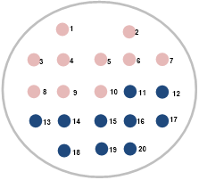
Arrangement of microorganisms on the plate. Microorganisms are numbered in the sequence shown in Table 1. Pink spots represent Gram-negative bacteria, blue spots represent Gram-positive bacteria and the yeast species.
With ammonium iron (III) citrate (500 mgL⁻¹) | With aluminium potassium sulphate dodecahydrate (500 mgL⁻¹)

Figure 1. Representative Columbia agar plates depicting the colour produced by substrate 13 (100 mgL⁻¹) against a panel of 20 microorganisms (inoculum 100,000 colony forming units (CFU)/spot).
Figure 2 depicts Columbia agar plates inoculated with a representative Gram-negative microorganism, E. coli, in the presence of substrate 13 at two concentrations with two metal salts (both salts at 500 mgL⁻¹). A bacterial suspension was prepared with a turbidity equivalent to 0.5 McFarland units. We then cultured 10 µL of this suspension and spread the plate to obtain isolated bacterial colonies. The inoculum was approximately 10⁶ CFU/plate. With substrate 13 at a concentration of 100 mgL⁻¹, a strong pink colouration is produced by E. coli whereas at a lower substrate concentration (50 mgL⁻¹) the depth of colour is diminished but colonies are still clearly visible against the background. When E. coli was inoculated onto medium containing substrate 13 at 100 mgL⁻¹ in the presence of ammonium iron (III) citrate, highly coloured purple colonies were generated and this substrate remained effective at a concentration of 50 mgL⁻¹. With both metal salts, there was a good contrast between the colour of bacterial colonies and the background colouration. Figure 3 shows four microorganisms (at the same inoculum as the plates depicted in Figure 2) in the presence of substrate 13 and aluminium potassium sulphate dodecahydrate (500 mgL⁻¹). The two Gram-negative microorganisms (top row) produced coloured colonies whereas in contrast, the growth of the two Gram-positive organisms was completely inhibited in the presence of the substrate and hence no colouration was produced.
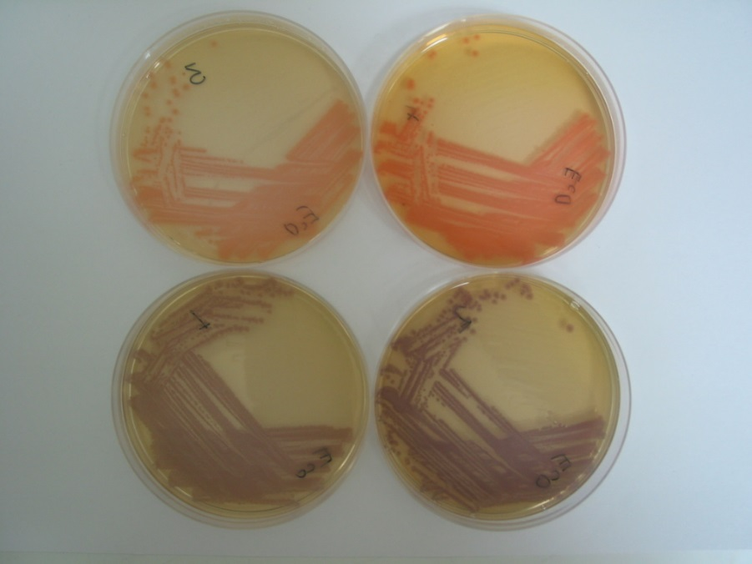
Figure 2. Detection of L-alanylaminopeptidase activity in E. coli with substrate 13. Top row: substrate 13 at 50 mgL⁻¹ (left) and 100 mgL⁻¹ (right) with aluminium potassium sulphate dodecahydrate (500 mgL⁻¹), bottom row: substrate 13 at 50 mgL⁻¹ (left) and 100 mgL⁻¹ (right) with ammonium iron (III) citrate (500 mgL⁻¹).

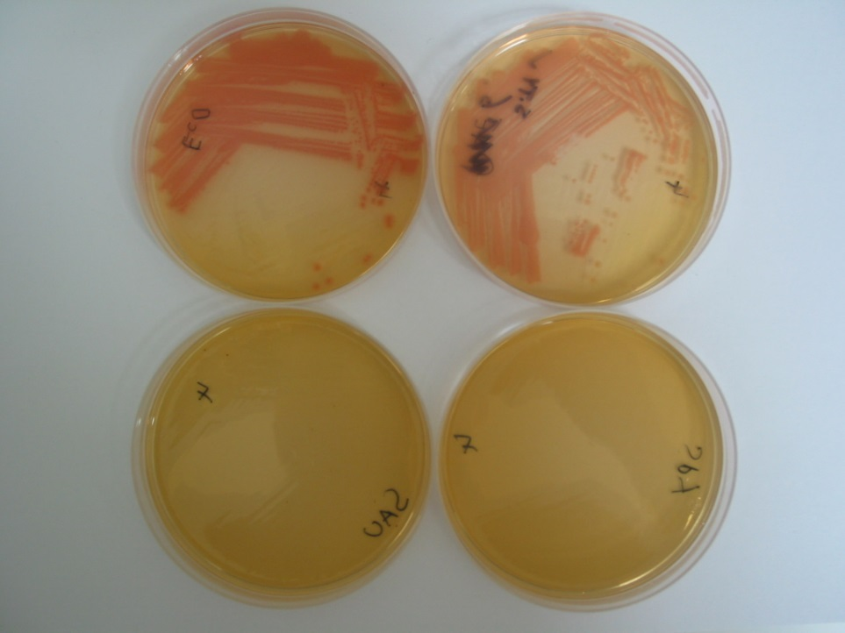

Figure 3. Substrate 13 (100 mgL⁻¹) and aluminium potassium sulphate dodecahydrate (500 mgL⁻¹) with: E. coli (top left); S. typhimurium (top right); S. aureus (MSSA) (bottom left) and S. pyogenes (bottom right).
In conclusion, substrate 13 enabled effective detection of L-alanylaminopeptidase activity in all Gram-negative bacteria tested here. The chromogenic substrate showed high sensitivity at a relatively low concentration (50 mgL⁻¹), with no diffusion of the coloured chelate into the surrounding agar. Lack of diffusion is important as it allows colonies to be distinguished with polymicrobial cultures. Most Gram-positive bacteria were inhibited by the substrate’s toxicity which may be an advantage or a disadvantage depending on the desired application. The synthesis and evaluation of other amino-acyl derivatives of Alizarin could be of interest to target other peptidase enzymes that allow taxonomic differentiation between species of interest.
Acknowledgements
We thank bioMérieux SA for generous financial support and the EPSRC UK National Mass Spectrometry Facility at Swansea University for high resolution mass spectra.
References
1. For recent reviews see: Alouane, A.; Labruère, R.; Le Saux, T.; Schmidt, F.; Jullien, L. Angew. Chem. Int. Ed. 2015, 54, 7492; Gnaim, S.; Shabat, D. Acc. Chem. Res. 2014, 47, 2970; Chen, L.; Li, J.; Du, L.; Li, M. Med. Res. Rev. 2014, 34, 1217.
2. Richard, J.-A.; Meyer, Y.; Jolivel, V.; Massonneau, M.; Dumeunier, R.; Vaudry, D.; Vaudry, H.; Renard, P.-Y.; Romieu, A. Bioconjugate Chem. 2008, 19, 1707.
3. Meyer, Y.; Richard, J.-A.; Delest, B.; Noack, P.; Renard, P.-Y.; Romieu, A. Org. Biomol. Chem. 2010, 8, 1777.
4. Vezenkov, L.; Honson, N. S.; Kumar, N. S.; Bosc, D.; Kovacic, S.; Nguyen, T. G.; Pfeifer, T. A.; Young, R. N. Bioorg. Med. Chem. 2015, 23, 3237.
5. Arian, D.; Harenburg, J.; Kramer, R. J. Med. Chem. 2016, 59, 7576.
6. Cellier, M.; James, A. L.; Lowe, J.; Orenga, S.; Perry, J. D.; Rasul, A. K.; Stanforth, S. P. Bioorg. Med. Chem. 2016, 24, 4066.
7. Orenga, S.; James, A. L.; Manfi, M.; Perry, J. D.; Pincus, D. H. J. Microbiol. Methods 2009, 79, 139.
8. Anderson, R. J.; Groundwater, P. W.; Huang, Y.; James, A. L.; Orenga, S.; Rigby, A.; Roger-Dalbert, C.; Perry, J. D. Bioorg. Med. Chem. Lett. 2008, 18, 832.
9. Carlone, G. M.; Valadez, M. J.; Pickett, M. J. J. Clin. Microbiol. 1982, 16, 1157.
10. Váradi, L.; Hibbs, D. E.; Orenga, S.; Babolat, M.; Perry, J. D.; Groundwater, P. W. RSC Adv. 2016, 6, 58884.
11. James, A. L.; Perry, J. D.; Ford, M.; Armstrong, L.; Gould, F. K. J. Appl. Microbiol. 1997, 82, 532.
12. James, A. L.; Perry, J. D.; Chilvers, K.; Robson, I. S.; Armstrong, L.; Orr, K. E. Lett. Appl. Microbiol. 2000, 30, 336.
13. Perry, J. D.; Morris, K. A.; James, A. L.; Oliver, M.; Gould, F. K. J. Appl. Microbiol. 2007, 102, 410.

