THE CORE VALUE COMPASS: VISUALLY EVALUATING THE GOODNESS OF BRANDS THAT DO GOOD

Running head: The Core Value Compass
Vignesh Yoganathan, Northumbria University
Fraser McLeay, Northumbria University
Victoria-Sophie Osburg, University of Hull
David Hart, Northumbria University

ABSTRACT
Brands that do good for the society as well as for themselves are motivated by the core values they espouse, which necessitates a better understanding of what qualities a true core value must possess. The inherent tension within brands that do good, between commercial interests to increase competitiveness, and societal interests that are closely linked to the brand’s authenticity, has largely been overlooked. Hence, we develop and demonstrate a relatively easy-to-apply visual tool for evaluating core values based on a set of ‘goodness’ criteria derived from extant theory. The Core Value Compass adopts a paradox-based, evolutionary perspective by incorporating the inherent tensions within true core values, and classifying them according to their temporal orientation. Thus, we contribute towards a better understanding of underlying tensions of core values, and provide a practical tool that paves the way for improved, and indeed ethical, corporate branding strategies. Furthermore, we demonstrate the Compass’ application using the case of a public sector brand, which is a quintessential brand that does good. Thereby, we also contribute to the nascent theoretical discourse on public sector branding. This paper therefore adds to the notable attempts to bridge the gap between theory and practice in core values-based corporate branding.

KEYWORDS
Core-value-compass, corporate-branding, core-value-tensions, branding-framework, brand-values

INTRODUCTION

Core values and inherent tension in brands that do good
Core values are a small set of deeply-rooted principles that underlie the defining characteristics of leading corporate brands, and serve as a brand’s driving-force for navigating and exploiting challenges (Barchiesi and La Bella, 2014; Manohar and Pandit, 2014; Urde, 2003, 2009). In Roper and Fill’s (2012) view, modern corporate brands are expected to do good for the society as well as for themselves. Commercially successful brands, John Lewis from UK (department store) and Deichmann from Germany (shoes and sportswear), exemplify how core values espoused within the organisation can fuel a commitment to forming ethical and egalitarian relationships with stakeholders, including the wider public. On the other hand, nominal core values that exist only in corporate propaganda can quickly become irrelevant, resulting in inter-departmental conflict and cynicism among employees, as well as external backlash from customers and shareholders (Balmer et al., 2011; Cushen, 2009; Palazzo and Basu, 2007). In order to find the roots of the ‘goodness’ in brands that do good, we must therefore look to the true core values they espouse. Nevertheless, previous research has not sufficiently examined how core values can be evaluated, so as to benefit theorists and practitioners seeking to develop brands that do good. Hence, this paper seeks to integrate the somewhat paradoxical defining-characteristics of core values into a strategic framework: the Core Value Compass (herein referred to as the Compass).
Moreover, various tensions arising from a plurality of views and competing interests among stakeholders, are known to be influential in the formation of true core values underlying corporate brands that strike a good balance between commercial success and societal responsibilities (Ind, 2007; Ind and Bjerke, 2007; Sataøen and Wæraas, 2015). Core values are said to evolve over time, moulded by such tensions (Urde, 2009). Yet, such formative tensions remain underappreciated in existing literature, although recent studies have added much to our understanding of core values-based corporate branding (e.g. Santos et al., 2016; Urde and Greyser, 2016). Hence, our framework, the Compass, devotes specific attention to four pairs of formative tensions and incorporates an evolutionary hierarchy of core values. To our knowledge, the Compass represents the first attempt to crystallise the multidisciplinary, yet somewhat abstract and paradoxical, discourse surrounding core values into a practical brand management tool.

The public sector and brands that do good
Doing good for the society is certainly not a matter of neglecting commercial interests, as no brand exists in a vacuum that is devoid of market-forces. A case in point being public sector organisations, which are driven to brand themselves in an attempt to achieve higher customer awareness and satisfaction, often closely linked to their raison d'être, and develop unique identities to help increase revenue streams (Hariff and Rowley, 2011; Sargeant et al., 2008; Wæraas, 2008; Whelan et al., 2010). The core values of public sector brands are forged in the struggle to generate societal benefits whilst, at the very least, maintaining commercial viability (Sataøen and Wæraas, 2015), in an environment increasingly characterised by political austerity (Ahrens and Ferry, 2015).
Nevertheless, public sector branding remains a fledgling area of scholarship, and existing literature has yet to fully appreciate the role of core values in relation to public sector brands. Hence, this paper utilises a public sector case study to illustrate the application of the Core Value Compass. Accordingly, we apply the Compass to evaluate the core values of a large UK city council’s brand, which has undergone a two-year employee-driven process to articulate its core values. We thereby contribute to the theoretical discourse on the core values-based corporate brand development for public sector organisations (see: Sataøen and Wæraas, 2015; Wæraas, 2008).
With a view to expanding on the aforesaid themes, the remainder of the paper is structured as follows. We begin by examining extant literature to develop a set of ‘goodness’ criteria for core values, based on four sources of tension that give rise to true core values, and a hierarchy of core values based on their temporal orientation. These goodness criteria are used as the foundation for the Compass, as a visual framework for evaluating a corporate brand’s core values. From here, we provide commentary on how the Compass can be applied, via the case study of a public sector organisation facing the dual-challenge of doing good whilst retaining commercial viability. Subsequently, we provide interpretation on the results to show how the Compass can inform both future theoretical work, as well as corporate brands seeking to better understand their core values.

LITERATURE REVIEW

‘Goodness’ criteria for core values
Several theorists have underscored the gradual and reiterative nature of the process by which core values are developed and articulated (Alloza, 2008; Sullivan et al., 2002; Urde, 2009). However, there is some ambiguity in terms of the rules of thumb that should guide organisations in following such a process of developing core values. Literature on corporate branding and organisational studies identifies several defining characteristics of core values. These include standing-out as clear guiding principles, having intrinsic meaning to employees and relevance to the challenges they face at work, but also if they represent the current mind-set of an organisation as opposed to future aspirations or its past (Ind, 2007; Lencioni, 2002; Urde, 2009). Together, these characteristics can be used for evaluative purposes, and therefore represent the ‘goodness’ of a corporate brand’s core values, as illustrated in values-based branding literature (see: Collins and Porras, 1996; Ind, 2007; Urde, 2003, 2009). The ‘tension’ arises from the conflict between the opposing perspectives that these goodness criteria represent. Conflict between perspectives is desirable, so as to avoid group-think (where consensus dominates), but also wishful thinking (over-ambitiousness). Whilst the tension might be dialectical in relation to developing true core values, such apparent inconsistency makes it difficult to actualise theoretical insights. This situation is counterproductive for effective branding, as a corporate brand’s essence needs to be simple, obvious, and memorable for employees (Ind, 2007).
To develop a better understanding of what a good core value should be, by building on extant literature, we develop and examine several ‘goodness’ criteria for core values in the following way: a) in four pairs of opposing or competing perspectives, each represented at the extremities of a spectrum that captures the tension between them (based on, inter alia: Lencioni, 2002; van Rekom et al., 2006; Ind, 2007); and b) in a hierarchy that reflects the present mind-set of an organisation, its future aspirations, and its past foundations (based on: Urde, 2003; 2009). Combining the four pairs of perspectives and the hierarchy of core values gives rise to the Compass, a framework for evaluating the goodness of a corporate brand’s core values. We begin by focusing on the four pairs of contrasting perspectives, which form an integral part of the Compass. These are namely: 1. Primary cause vs. Stand-out; 2. Intrinsic meaning vs. External interface; 3. Everyday Work-realities vs. Market-leading Impetus; and 4. Heritage vs. Withstanding Challenges.

1. Primary cause vs. Stand-out
The first source of tension concerns the observability of core values: they are underlying primary causes, yet they clearly stand-out.
Core values tend to be subtle and underlying, and consequently difficult to identify (McDermott and O'Dell, 2001; van Rekom et al., 2006). Not all values within an organisation will influence its character and behaviour to the same extent; core values take primacy in this respect, as deep-rooted beliefs in the organisation’s mind-set (Pant and Lachman, 1998; Urde, 2009).
In contrast, core values should also stand out as clear, overarching guiding principles that reach across organisational levels and divisions (Ind, 2007; Urde, 2009). They are easily recognisable as the central characteristics of the world’s most well-known, leading corporate brands (Barchiesi and La Bella, 2014; Manohar and Pandit, 2014). Thus, they serve as a foundation for differentiation, driving brands to stand out from their competition (de Chernatony, 1999; Lencioni, 2002). As such, core values should be established as primary causes, and in addition stand out as clear overarching guiding principles (Collins and Porras, 1996).

2. Intrinsic Meaning vs. External Interface
The second source of tension comes from the contrast between internal moorings of core values and their external interface.
Theorists have strongly argued that core values require no external justification as they have intrinsic meaning to employees (Collins and Porras, 1996; Lencioni, 2002; van Rekom et al., 2006). Core values that exist only in rhetoric and are not in the least meaningful to employees have been described as hollow (Urde, 2009), and come to be ignored at best in actual operational circumstances and interactions with customers (Cushen, 2009, 2011; Lencioni, 2002).
However, brands that focus on the internal meanings of their core values risk becoming too inward-looking and fall prey to strategic drift (Ind and Bjerke, 2007; Johnson, 1992). Indeed, previous studies have pointed out that core values lie at the interface between internal and external stakeholders; they are shaped by customers’ preferences over time that allows them to be translated into Customer Perceived Value (Barchiesi and La Bella, 2014; Urde, 2003, 2009).

3. Everyday Work-realities vs. Market-leading Impetus
The third source of tension in core values comes from the conflict in representing everyday work-realities of employees, whilst providing futuristic market-leading impetus; one perspective focuses on the current state of affairs, whereas the other looks towards a desirable future state.
As fundamental tenets of an organisation’s culture, core values should reflect the everyday operational environment that employees work within; the challenges it represents, and the conventional modi operandi (Lencioni, 2002; McDermott and O'Dell, 2001). This allows employees to instinctively incorporate core values into their interactions with other stakeholders, thereby delivering the brand promise (Ind, 2007; Mitchell, 2002). As previous studies have shown, core values that do not reflect employees’ actual experiences at work, are all but ignored and scoffed at, because they elicit little affinity or emotional engagement from employees (Cushen, 2009; Murphy and Davey, 2002; Russell, 2011).
On the contrary, core values fuel the motivational energy that is at the heart of leading corporate brands (Barchiesi and La Bella, 2014; Manohar and Pandit, 2014). Consequently, they must be forward-looking and aspirational to provide a corporate brand with market-leading impetus, to drive the competition in their industries instead of following, to prosper by pioneering (Aaker, 2010; Ind, 2007).

4. Heritage vs. Withstanding Challenges
The fourth and final source of tension concerns the importance given to a corporate brand’s heritage: to accept without question the heritage that makes the brand unique, or question and challenge the heritage as part of a shifting brand-zeitgeist.
When core values represent an organisation’s history, they become an integral part of developing a unique identity of the brand based on its heritage (Urde et al., 2007). Such a heritage can become an asset to a brand, standing it in good stead during challenging times and serving as a foundation for building stronger relationships with stakeholders (Balmer, 2011a; Leigh et al., 2006; Wiedmann et al., 2013).
Core values that are part of a strong brand-heritage are less likely to be disputed or questioned by employees or top management (Ind, 2007; Urde et al., 2007). However, the ability to withstand internal and external challenges is a desirable quality in core values, thus they become truly enduring tenets that instil a brand-oriented mind-set in employees (Collins and Porras, 1996; Ind, 2007; Urde, 2009). Core values that go unchallenged may not be firmly held or well-understood by employees, thus difficult to enact in times of ambiguity or environmental challenge (Collins and Porras, 1996; van Rekom et al., 2006).
The four sources of tension discussed so far can be visually represented along four axes as shown in Figure 1.

Hierarchy of core values
True core values emerge out of the tension between perspectives, but they also evolve over time (Urde, 2009). In addition to the four sources of tension already identified, core values can be classified in a hierarchy based on their temporality; some core values are enacted in the present, some yet to be realised, and others are vestiges from a corporate brand’s past.
Those core values that are ready to be externally communicated and turned into Customer Perceived Value, are active (Urde, 2009). Similarly, forward-looking parts of an organisation may aspire to espouse currently unrealised core values, which are referred to as latent core values (ibid). Values that are deemed vestiges from the organisation’s past, and are all but obsolete, belong to the void (ibid), which an organisation may gradually divest. A hierarchy of core values emerges in this respect; whereby Active and Latent values are more important than those in the Void. Core values that are Active should be the focus of an organisation’s current internal and external branding activities, whereas Latent values need periodic attention and may become more important at a future stage depending on market conditions.

THE COMPASS: FORMATION, FOUNDATION, AND KEY COMPONENTS
In the preceding sections, we identified four sources of tension that give rise to true core values, and a hierarchy of core values predicated on their past, present, or future orientations. The Compass framework can now be developed by combining the sources of tension with the hierarchy, as shown in Figure 3.

Basis for managing paradox and evolution in corporate branding
The Compass is based on the same principles as the Competing Values Framework (CVF) (Quinn and Rohrbaugh, 1983), which is a well-established model for evaluating organisational effectiveness and leadership-styles based on two contrasting pairs of perspectives: flexibility vs. control, and internal focus vs. external focus. Akin to the CVF, the Compass’ axes that represent the four sources of tension are not independent; for example, core values may have intrinsic meaning for employees by being relevant in everyday work-related situations, or they may provide the brand with market-leading impetus by having an external interface (and vice versa in both cases). The four axes should also not be viewed as dimensions of a theoretical construct (i.e. the result of factor analytical models); rather they are conceptual facets of core values that represent their goodness (for the differences between constructs and concepts, see: Kerlinger, 1999; Markus, 2008). Quinn and Rohrbaugh’s (1983) CVF represents a management tool that captures the underlying paradoxes within an organisation, which are a form of inherent tensions that result from how employees and management perceive their environment and act upon it (Arsenault and Faerman, 2014; Lewis, 2000). Similarly, the Compass is a framework for managing (i.e. controlling and directing) a corporate brand whilst simultaneously appreciating, and building upon, the underlying tensions vis-à-vis core values.
In addition to the axes representing the sources of tension, the Active, Latent, and Void fields provide an evolutionary perspective to core values based corporate branding. Theorists have underscored the need for a corporate brand’s core values to evolve over time (Urde, 2003, 2009), and called for a dynamic perspective in corporate brand management (Melewar et al., 2012). Whilst, the Active field reflects those core values that should readily form the essence of a corporate brand’s external positioning, core values in the latent field are significant in terms of the brand’s vision for the future and its true potential. Keller (2015) notes that many brands have latent potential, which remains unrealised due to the inability of organisations to “consider what the brand could and should become in the broadest sense” (p. 703). The Latent field can help corporate brands identify the core values that reflect this hidden potential, thus leading to a stronger brand vision that mobilises the commitment of employees.
Similarly, the Void can help identify elements from the corporate brand’s history that continue to hinder its modernisation, or indeed, adoption of an ethical outlook. Take the case of The Honourable Company of Edinburgh Golfers (better known by association to where the club is based, Muirfield), it had lost the right to host one of the world’s foremost Golf championships (The Open) by refusing to accept female members to this day (BBC, 2016). This subsequently forced the prestigious golf club of more than 270 years, to reverse its decision and accept women players (The Guardian, 2017), emphasising the need for core values to evolve. Outmoded core values from a corporate brand’s past that are an impediment to the brand’s progress and whose significance to employees is declining, ought to be classed as Void. Thus, the Compass framework adopts a paradox-based, evolutionary perspective for evaluating the core values of a corporate brand that does, or seeks, to do good.

The two halves of the Compass: brand authenticity and brand competitiveness
There are two broadly competing interests at play within any brand that does, or seeks to, do good: the innate urge for authenticity in staying true to their purpose on the one hand, and the inescapable need to develop competitiveness on the other (Liu et al., 2014; Sargeant et al., 2008). This is reflected in the Compass in the following way: the internally focused right half of the Compass represents the authenticity of a corporate brand, and the externally focused left half addresses its competitiveness (see Figure 4). The Compass’ internally focused facets of core values (e.g. having intrinsic meaning, reflecting everyday work-realities, reflecting the brand’s heritage) represent the authenticity of a corporate brand. In contrast, the externally-oriented facets (e.g. withstand challenges from the environment, provide market-leading impetus, having an external interface) are aimed at developing a corporate brand’s competitiveness in the market.
Authenticity, reflects the congruence, genuineness and originality that stakeholders ascribe to a brand (Eggers et al., 2013; Fine, 2003; Napoli et al., 2014), and hence the degree to which a brand’s true identity is presented (Schallehn et al., 2014). The crucial role of authenticity derives from its linkages with several important outcomes, such as brand trust, credibility, growth, and the creation of a stronger brand (Alexander, 2009; Eggers et al., 2013; Schallehn et al., 2014). Brand theorists including Aaker (1996, 2010), and Fournier (1998) have long since argued that developing an authentic brand identity, based on an organisation’s attributes and its personality (embodied in its core values), is a vital pre-requisite in forging strong, emotionally-connected external relationships with, for example customers.
True core values are very closely related to authenticity; they are about the beliefs that an organisation’s employees truly and passionately hold and reflect, not just in rhetoric but in actions (Collins and Porras, 1996; Ind, 2007; Lencioni, 2002). Brands that truly do good, enhance their corporate reputation by being authentic in their commitment to Corporate Social Responsibility (CSR) initiatives, rather than limiting themselves to little more than CSR-related rhetoric (Middlemiss, 2003). Further, Dowling and Moran (2012) explicate that CSR approaches are more successful if they truly reflect an organisation’s strategy. These “build in” approaches can provide competitive advantage since the organisation acts in conformity with its core objectives. In contrast, “bolted on” approaches, such as donations, or non-core CSR initiatives, tend to conflict with the actual mission of the organisation.
For many brands that do good, such as those from the charity or public sector, doing good for society is part of their core purpose, which is something that clearly differentiates them from commercial brands (Luoma-aho, 2007). For such brands therefore, to be authentic is to remain true to their purpose. However, public and charity sector organisations have been facing increased commercialisation of their operating environment, which forces them to become more competitive and market-oriented (Davies, 2011; Whelan et al., 2010). This results in a struggle between authenticity and competitiveness, which is borne out in the recent rise in the public’s scepticism towards charities (YouGov, 2015), and the continuing scrutiny and criticism of public sector management (BBC, 2014; The Guardian, 2014).
On the other hand, corporate brands that steadfastly adhere to their core values amidst challenges, tend to clearly stand apart from their competition, even in the most competitive of markets (Ind, 2007; Lencioni, 2002). They can achieve sustainable competitive advantage through an ingrained core values-based mind-set within the organisation, which is inimitable (Urde, 2009). Notably, public sector and charity brands have also benefited by becoming more competitive and strengthening their brands (Hariff and Rowley, 2011; Liu et al., 2015; Liu et al., 2014). Hence, brands that do good should strive to achieve a balance between developing their competitiveness in the marketplace, and retaining their authenticity by staying committed to their core purpose. To this end, the Compass can help visually evaluate the extent to which a corporate brand has managed to balance authenticity and competitiveness. What follows is a step-by-step guide that allows corporate brands to integrate the Compass into their core values appraisal process.

Guide to the application of the Compass
There are five stages in the application of the Compass in order to evaluate a corporate brand’s core values. First, adopting a participatory approach to corporate brand-building (Ind and Bjerke, 2007), an organisation should consult its employees in a reiterative process to identify and articulate what they believe their brand truly stands for. Employee workshops can be held across organisational divisions and hierarchy in order to identify values that are not only deep-rooted, but also shared.
Based on views and knowledge gathered from employee workshops, a decision can be made as to whether core values are Active, Latent, or Void, and if they satisfy the other eight ‘goodness’ criteria for core values represented on the axes of the Compass. This is the second stage.
In the third stage, a pre-designated set of numerical values can be assigned to each candidate core value based on whether it satisfies the eight ‘goodness’ criteria laid out in the four axes of the Compass, and if it belongs to the Active, Latent or Void fields. Table 1 sets-out the guide to assigning numerical values, and Figure 5 illustrates where each numerical value lies on the Compass. As shown in Figure 5, the numerical values are located on places where each of the four axes intersect the borders of the three layers. The values of 3, 2, and 1 represent the Active, Latent, and Void layers respectively. The value of zero, at the point of origin, should not be confused with the Void layer; although it appears to lie within it. The point of origin is reserved for when a core value does not satisfy a particular ‘goodness’ criterion on one of the four axes. For example, let us assume core value X does not have an “external interface” (perhaps because the value is not shared by customers), but satisfies all other goodness criteria. Then X will be assigned zero on the axis that represents “external interface”, but can be Active, Latent, or Void (i.e. score 1, 2, or 3 respectively) on any of the other seven criteria depending on whether they represent the present, future, or past orientations of the organisation.
In the fourth stage, using the numerical values-assigned, a Compass should be drawn for each candidate core value (using Figure 5 as a guide to plot the numerical values assigned). It is unrealistic to expect that every core value identified will be Active on each criterion along the four axes. Individually, some core values may be Latent on certain criteria; insofar as they are not Void, these core values may still be relevant to the organisation. What is more important is that, collectively, the core values of a corporate brand represent all eight ‘goodness’ criteria along the four axes, and in the Active or Latent fields.
Obtaining such a collective picture is the fifth stage of the process of applying the Compass. To evaluate the combined strength of all the core values that underpin a corporate brand, an overall Compass should be drawn by super-imposing individual compasses on each other. Thus, a collective view of an organisation’s corporate brand can be developed. This is because no single core value can be expected to represent all of the goodness criteria. Some values will invariably be, for example, more internally focused than externally. It is the collective goodness of the core values that an organisation should look to, when seeking to address all goodness criteria. When all the eight ‘goodness’ criteria on the axes of an overall Compass are located in the Active field, a corporate brand’s core values can be said to provide a 360° coverage of its internal and external environments, revealing an authentic and competitive brand.

METHODOLOGY
This study adopts an in-depth single case study method following the example set by notable works in the corporate branding literature that have utilised this method, particularly in the early stages of theoretical development (e.g. Balmer, 2011a, b; Balmer et al., 2011; Urde, 2003; Urde and Greyser, 2016). We opted for an in-depth examination of a single case over short descriptions of multiple cases, because it illustrates in detail how the Compass can be applied. A detailed understanding of the Compass’ application is vital, given that this is a new, and potentially the first, strategic tool to visualise and evaluate the formative tensions surrounding a corporate brand’s core values. The single case method is particularly suitable for applied fields of enquiry (i.e. the application of the core value compass) (Donmoyer, 2000), and can provide reliable insights at an aggregate level, especially when a case is carefully chosen to represent a rich and archetypal setting (Flyvbjerg, 2006). Accordingly, our choice of case study organisation represents a modern brand that exists to do good, although simultaneously facing many commercial pressures, resulting in the increased attention on brand-development. Moreover, since the case study organisation is one of the largest employers in the region, and hundreds of employees’ views were incorporated in the brand-development process, the findings can justifiably be considered from a much broader theoretical perspective (Baxter and Jack, 2008; Flyvbjerg, 2006).
In addition, we have taken an abductive approach (Dubois and Gadde, 2002), by using theoretical insghts to guide brand-development processes within the organisation and using the outcomes of these processes to advance the current theoretical understanding in a reitertaive and didactical manner. As such, the analysis of the outcomes of the brand development process were reviewed by the researchers in collaboration with key groups of employees involved in the process, including senior and mid-level managers. The interpretation of the various characteristics (as well as meanings) attached to specific core values were examined and deliberated upon by academics from multiple disciplines (organisational behaviour, HRM, and marketing). Thus, we ensured that the analysis was representative and reflective of the practical context as well as the theoretical grounding. The substantial part of our research strategy revolves around three sequential phases, as summarised in Table 2.
In the first phase, we identified a set of ‘goodness’ criteria for core values from extant literature, and integrated them into a single framework. We then sought to test the Compass by applying it to the case of a large UK city council (referred to as “SCC”).
The second phase was aimed at understanding SCC’s core values and their development process in relation to the compass. SCC’s core values were articulated through participatory staff consultation workshops, as recommended by Ind and Bjerke (2007). The authors served as external facilitators for this process, particularly for six workshops with the Image Group, a cross-functional team set-up to spearhead the core values development process across the organisation, as recommended in change management literature (Ghosn, 2002). During these workshops, several approaches documented in extant literature were used, including aspects of the ‘laddering technique’ (van Rekom et al., 2006) for identifying ingrained assumptions amongst employees on how the organisation functions, and using imagery and adjectives for personifying the organisation’s brand (Aaker, 1997; Boatwright et al., 2009).
In the third phase, further to observing and facilitating the staff workshops, we conducted five focus groups with managerial and operational staff, and three in-depth interviews with senior management. We followed previous researchers (Gordon, 2013; Roper, 2005), and also reviewed a range of organisational documents/media including official publications on- and off-line. Based on the outcomes of these workshops, interviews, focus groups and document-analysis, we applied the Compass to SCC’s core values and evaluated the overall strength of its corporate brand.

ANALYSIS AND FINDINGS: APPLICATION OF THE COMPASS TO SCC
SCC is the local authority for a region in northern England that has a population of around 275,000 inhabitants, and has the highest proportion of public sector jobs in the UK. Due to the far-reaching consequences of the decline of British manufacturing industries, many regions and cities, especially in northern England have had to adapt themselves towards a more service-based economy. Over the past two decades, city councils have had to take on the responsibility for ‘branding’ their regions or cities in a bid to increase revenues through tourism and investment (Hankinson, 2001). SCC’s attempts to articulate its core values was driven also by the motivation from its CEO and senior executives to develop an identity-based brand that would represent the values of its staff and its citizens:
“…branding is about building this sense of trust and connectivity [with stakeholders]” – CEO of SCC
Place branding theorists have made arguments in favour of this identity-based approach as means of developing a brand that embodies the sense of who we are as a community, and therefore conjures strong emotional connections amongst its stakeholders (see: Kavaratzis and Hatch, 2013). This is reflected in SCC’s case, as the CEO of a large car manufacturing plant in the city stated:
“It isn’t the place, the technology or the robots here. It’s the people, their innovation speed and energy. They’re brilliant”
In a long process of reiterative and participatory consultation with employees, SCC deployed a variety of internal communication methods:
“We do things like, what we call pulse surveys where we identify small number of people that we ring and then do like a five to ten-minute telephone conversation to ask them specific questions….We do quarterly postcards….We also used an internal magazine.” – Internal Communications Manager, SCC.
Based on the consultation with employees, SCC’s Image Group identified four core values: Proud, Decent, Together, and Ambitious. However, the last value, ‘Ambitious’ was somewhat contentious in that some members of the Image Group and the senior management of SCC expressed doubts as to whether it was an accurate representation of the organisation’s current mind-set and culture. This led to some further consultation amongst Image Group members and the wider employee populace of SCC. From this, it emerged that ‘Ambitious’ did not have as much traction with employees across the organisation, although salient for employees in some parts of the organisation that were more aspirational and future-oriented about the SCC brand:
“In the end we decided not to include it [Ambitious] because we felt, having heard & listened within the organisation, that people didn’t feel comfortable with it” – SCC’s CEO
Moreover, whilst it might form part of SCC’s future vision, ‘Ambitious’ was not found to be representative of the current state of the SCC brand. Hence, the Image Group decided to exclude ‘Ambitious’ from the set of current core values, although appreciating that it may form part of a future brand identity as an aspirational value. Consequently, the core values of ‘Proud’, ‘Decent’ and ‘Together’ were chosen by SCC to collectively give rise to the organisation’s brand identity. We nevertheless decided to apply the Compass to evaluate ‘Proud’, ‘Decent’ and ‘Together’, and also ‘Ambitious’, in order to provide a more comprehensive assessment of SCC’s corporate brand
Based on the outcomes of the staff workshops and the knowledge we gained from our analysis of the SCC case, we categorised SCC’s core values into Active, Latent or Void. Three core values: Proud, Decent, and Together were deemed Active. For example, forced to undergo an organisational restructure amidst government cuts to public sector spending, SCC created an internal pool of 350 staff for retraining and redeployment called SWITCH (Staff Working In Transition and Change) and froze external recruitment. Whilst some of these staff eventually lost their jobs, the alternative of immediate redundancies and hiring of contract-staff would have had a more adverse impact on staff.
However, ‘Ambitious’ was futuristic and aspirational, therefore representing a Latent core value:
“[Ambitious] was taken out because at the time it was felt that it was too…aspirational, and the council wasn’t at the right place to take that on” – Internal Communications Manager, SCC
Although many peripheral values had been discarded in the early stages of the core values development process, none of these emerged to be particularly distinct as the cause of significant debate. Therefore, no Void values were identified.
All four values stood-out as broad guiding principles and primary causes based on the information available on SCC’s brand development process. Except for Ambitious, the core values had intrinsic meaning for SCC employees.
“The image group came up with…people [staff] could identify with them, they felt real to them. There were come comments about the descriptor-behaviour of the values, but this was integrated into the story behind the values and clarified in the roll-out” – Internal Communications Manager, SCC
As an aspirational value, Ambitious was more of an adopted value than one which reflected a broadly shared meaning. However, none of these values could be said to have a particularly strong external interface based on available evidence, since all participants in the research were SCC staff. Further research with SCC’s external stakeholders is necessary to gain a better perspective in this regard. Except for Ambitious, all the core values also reflected every-day work realities of SCC employees. Conversely, only Ambitious seems to possess a reasonable level of market-leading impetus, since it is more of a futuristic, aspirational value. Better involvement of external stakeholders in the brand development process would have added support to Proud, Decent, and Together in terms of their potential for market-leading impetus. Nevertheless, these three core values (excluding Ambitious) have withstood considerable internal and external challenges, especially given that city councils in this region have faced major funding cuts from the central government in recent years. Moreover, they reflect the heritage of a public sector organisation operating in a region with a strong working-class ethos. As for Ambitious, it neither reflects the heritage of the organisation as more of an aspirational value, and nor did it manage to withstand internal challenges.
Accordingly, we assigned numerical values for the four core values (see Table 3) and produced a Compass for each of the four core values. The Compass’ for Proud, Decent, and Together were identical, given that they had the same characteristics (as discussed previously), which is shown in Figure 6. The Compass for Ambitious is different, since it is a Latent core value, and that it did not represent the internal (authenticity-related) aspects of the Compass (see Figure 7). Finally, we developed an overall Compass (see Figure 8) by superimposing the individual Compasses (Figures 6 and 7).
As the overall Compass for SCC illustrates, the Active core values (Proud, Decent, and Together) are lacking in terms of two key aspects of core values: market-leading impetus and external interface. On the other hand, ‘Ambitious’ compensates for these drawbacks in the other three core values. As Figure 5 shows, SCC’s brand appears to be stronger with the inclusion of Ambitious in that it satisfies all goodness criteria except for ‘external interface’, and all core values are either in the Active or Latent fields. What is more, SCC’s brand appears to be more competitive with inclusion of ‘Ambitious’, although this is a Latent core value, and as such reflects SCC’s unrealised potential for improving its competitiveness. Nevertheless, based on the results, SCC emerges as an authentic brand owing to its strong internal focus.

DISCUSSION AND IMPLICATIONS
Thus far, we have met our stated aims of bringing together extant literature to develop the Compass, and utilising a public sector case study to demonstrate how the Compass can be implemented and interpreted to assess core values of brands that do good. Our contributions focus on three main areas: 1. We encapsulate the multidisciplinary and rather paradoxical literature on core values into a single framework for core values-based brand management; 2. In aid of brands that do good, which experience skills and resource shortages, we provide an easy-to-apply and theoretically grounded tool for visually evaluating core values; 3. We address the need for further research on corporate branding in the public sector context through the case study of a city council. Moving forward, we expand on our contributions to offer theoretical and managerial implications.

Theoretical implications
Multiple disciplines have pointed to the existence of tensions in the formation of values in general, including organisational behaviour and leadership (Arsenault and Faerman, 2014; Lewis, 2000), consumer behaviour (Borg et al., 2016; De Groot and Steg, 2008), as well as values-based corporate branding (Cushen, 2011; Ind, 2007). Interestingly, there is a dearth in corporate branding frameworks that have specifically considered such formative tensions, whereas well-established frameworks exist in this respect in other subject disciplines: e.g. the Competing Values Framework (Quinn and Rohrbaugh, 1983), the Schwartz Value Circumplex (Schwartz, 1992). Our presentation of the Core Value Compass and its application addresses this gap in the corporate branding literature.
The four pairs of tension, represented in the Compass’ axes, build upon the ‘goodness’ criteria derived from existing literature, and provide the basis for visualising and managing the paradoxes surrounding core values-based corporate branding. Further, two halves of the Compass, authenticity and competitiveness, help categorise the sources of tensions, thus allowing for prioritisation of the corporate brand’s orientation and management. Gaps or ‘dents’ in a corporate brand’s overall Compass point out areas for improvement in the organisation’s corporate branding strategies. Core values that are deficient in the internally focused aspects of the Compass (the right half of the Compass) simply lack the authenticity to engage external stakeholders and build a unique identity (Urde, 2009). In such cases a participatory, employee-driven approach to identifying and articulating core values is required (often referred to as an 'inside-out' approach; Ind, 2007; Ind and Bjerke, 2007). On the other hand, when a brand lacks in externally focused aspects (the left half of the Compass), its competitiveness is affected, and better appreciation for views of external stakeholders needs to be developed. In this respect, it is essential to engage frontline employees in identifying and articulating the core values, as they are best placed to understand the preferences of customers and other external stakeholders (Berry, 2000; Ind, 2007).
Identifying and articulating core values has been highlighted in existing literature as a necessary step in building corporate brands that are authentic as well as competitive (Ind, 2007; Urde, 2009; Urde et al., 2007). What has been lacking however, is a practical tool for evaluating the outcomes of such a process. Having identified core values, an organisation can use the Compass to assess their ‘goodness’ based on internally and externally focused criteria represented by the Compass’ axes, and the Active, Latent, and Void fields. Notably, the Compass also responds to calls for a more dynamic perspective in corporate brand management (Melewar et al., 2012) via the Active, Latent, and Void fields, which provide an evolutionary perspective to the foundations of a corporate brand.
It has been argued that public sector brands, as quintessential brands that do good that face particular tensions between competitiveness and authenticity, may have to develop different brand-positions to suit a broad range of stakeholder-expectations (Hariff and Rowley, 2011; Sataøen and Wæraas, 2015; Wæraas, 2008). The Compass can help achieve this by pointing out which core values are stronger (Active) and on which aspects. For example, core values that are in the Active field for ‘market-leading impetus’, or ‘withstand challenge’ should be emphasised in brand communications aimed at investors. Similarly, customers who have been loyal to a brand over time are likely to respond to communications that emphasise the brand’s heritage. In this regard, our study also adds to the evolving discourse surrounding public sector branding in the context of internal and external tensions they face (see: Sataøen and Wæraas, 2015).

Managerial implications
The ideal scenario for a corporate brand is when all the eight ‘goodness’ criteria on the axes of its overall Compass are represented by values in the Active field, together with at least one value in the Latent field to reflect future aspirations. Thus, the core values collectively provide the brand with 360○ degree coverage, but also maintain the motivation to evolve over time owing to the Latent value(s). To achieve such a state, corporate brand managers should first appreciate that core values cannot simply be prescribed to employees (Cushen, 2009; Russell, 2011). For a brand to do any good for either itself or for the society, it must secure the commitment of its employees. Employee groups that play a key role in uncovering and articulating core values can use the Compass to assess each identified core value as well as obtain an overall assessment by superimposing individual Compasses. The process of classifying the candidate core values, and assigning corresponding numerical values can be carried out by cross-functional teams, overseen by strategic steering committees comprising managers and operatives (see: Ghosn, 2002).
For example, SCC’s lack of ‘external interface’ can be a risky strategy if unaddressed, and may lead to its external stakeholders’ loss of trust (for citizens/customers) and salience (for investors, the media etc.) in the brand. It is advisable that SCC conducts consultation workshops with customers and investors in the region to see if the same values (Proud, Decent, Together, and Ambitious) gather traction with them as well as with employees. Put differently, do the external stakeholders see the brand as employees do? If not, then external branding activities may be needed to raise the brand’s profile and communicate its values. Conversely, if the core values are not linked well to everyday work situations, then internal branding strategies need to educate employees on how core values can be embedded into stakeholder interactions and operational decisions.

LIMITATIONS AND FURTHER RESEARCH AGENDA
We illustrated the Compass by a single case study in the public sector; this approach allowed us to obtain detailed information for a first attempt at developing an evaluative framework. We acknowledge that our study needs to be replicated in other organisational contexts, to which end we trust this paper will serve as a springboard. Nonetheless, the Compass is potentially useful for various organisations across different industries to evaluate their corporate brand vis-à-vis authenticity and competitiveness. In the first instance, application of the Compass to alternative UK public sector bodies (that may face different geographical, political and economic challenges) would offer greater commentary on the usefulness of the Compass to effectively assess the core values of brands that do good.
Further studies should be conducted to evaluate the impact of core values on the actual performance of a wide variety of corporate brands. For instance, what impact do different configurations of overall Compasses have on the respective brands’ performance? Do corporate brands from different sectors, industries or cultural contexts differ in their actual brand performance despite having the same configuration of an overall Compass? It is worth noting that the performance of brands that do good can be measured using ‘hard’ metrics such as Corporate Brand Value (Peterson and Jeong, 2010) and the Interbrand rankings, but also ‘soft’ metrics such as Ethisphere Institute’s The world’s most ethical companies list (Ethisphere, 2016), which is an annual honouring of brands from around the world for doing good for the society as well as for themselves. Researchers should therefore look into both the ‘hard’ and ‘soft’ performance of brands that do good in relation to the evaluation of their collective core values using the Compass.
We also recommend that future research examines how employees and organisations engaged in core values-based brand building utilise the Compass. For example, research may address issues such as: how easy is the Compass for various types of employees to understand and apply, and what is the impact of the Compass on the identification of core values and subsequent brand-communication strategies? Further research may develop insights into how brands that do good achieve a balance between authenticity and competitiveness, having articulated their core values and evaluated them using the Compass.
The goodness criteria in the Compass apply to core values of corporate brands; product brands are a case apart, as different evaluative criteria would apply to these. Notwithstanding, researchers may apply the same theoretical principles behind the Compass to develop adapted versions of it for product, place, and personal brands.

REFERENCES
Aaker, D.A. (1996) Building strong brands. New York: Free Press.
Aaker, D.A. (2010) Building strong brands. London: Pocket.
Aaker, J.L. (1997) Dimensions of Brand Personality. Journal of Marketing Research, 34(3): 347-356.
Ahrens, T., & Ferry, L. (2015) Newcastle City Council and the grassroots: accountability and budgeting under austerity. Accounting, Auditing & Accountability Journal, 28(6): 909-933.
Alexander, N. (2009) Brand authentication: creating and maintaining brand auras. European Journal of Marketing, 43(3/4): 551-562.
Alloza, A. (2008) Brand Engagement and Brand Experience at BBVA, the Transformation of a 150 Years Old Company. Corporate Reputation Review, 11(4): 371-379.
Arsenault, P. & Faerman, S.R. (2014) Embracing Paradox in Management: The Value of the Competing Values Framework. Organization Management Journal, 11(3): 147-158.
Balmer, J.M.T. (2011a) Corporate heritage brands and the precepts of corporate heritage brand management: Insights from the British Monarchy on the eve of the royal wedding of Prince William (April 2011) and Queen Elizabeth II's Diamond Jubilee (1952-2012). Journal of Brand Management, 18(8): 517-544.
Balmer, J.M.T. (2011b) Corporate heritage identities, corporate heritage brands and the multiple heritage identities of the British Monarchy. European Journal of Marketing, 45(9/10): 1380-1398.
Balmer, J.M.T., Powell, S.M., & Greyser, S.A. (2011) Explicating Ethical Corporate Marketing. Insights from the BP Deepwater Horizon Catastrophe: The Ethical Brand that Exploded and then Imploded. .Journal of Business Ethics, 102(1): 1-14.
Barchiesi, M.A. & La Bella, A. (2014) An Analysis of the Organizational Core Values of the World's Most Admired Companies. Knowledge and Process Management, 21(3): 159-166.
Baxter, P. & Jack, S. (2008) Qualitative case study methodology: Study design and implementation for novice researchers. The qualitative report, 13(4): 544-559.
BBC (2014) Councils 'wasting millions' ignoring government IT cloud, http://www.bbc.com/news/business-27618218, accessed 24 May.
BBC (2016) Muirfield to lose right to host Open after vote against allowing women members, http://www.bbc.com/sport/golf/36331270, accessed 25 May.
Berry, L.L. (2000) Cultivating service brand equity. Journal of the academy of Marketing Science, 28(1): 128-137.
Boatwright, P., Saltiel, A., Kapur, D., & Cagan, J. (2009) A step-by-step process to build valued brands. Journal of Product & Brand Management, 18(1): 38-49.
Borg, I., Dobewall, H., & Aavik, T. (2016) Personal values and their structure under universal and lexical approaches. Personality and Individual Differences, 96: 70-77.
Collins, J.C. & Porras, J.I. (1996) Building Your Company's Vision. Harvard Business Review, 74(5): 65-77.
Cushen, J. (2009) Branding employees. Qualitative Research in Accounting & Management, 6(1-2): 102-114.
Cushen, J. (2011) The trouble with employer branding: resistance and disillusionment at Avatar. In: M.J. Brannan, E. Parsons, and V. Priola (eds.) Branded Lives: The Production and Consumption of Meaning at Work: Cheltenham: Edward Elgar Publishing, pp. 75-89.
Davies, S. (2011) Outsourcing, public sector reform and the changed character of the UK state-voluntary sector relationship. International Journal of Public Sector Management, 24(7): 641-649.
De Chernatony, L. (1999) Brand Management Through Narrowing the Gap Between Brand Identity and Brand Reputation. Journal of Marketing Management, 15(1-3): 157-179.
De Groot, J.I. & Steg, L. (2008) Value orientations to explain beliefs related to environmental significant behavior how to measure egoistic, altruistic, and biospheric value orientations. Environment and Behavior, 40(3): 330-354.
Donmoyer, R. (2000). Generalizability and the Single-Case Study. In R. Gomm, M. Hammersley & P. Foster (Eds.), Case Study Method (pp. 45-68). London: Sage.
Dowling, G. & Moran, P. (2012) Corporate Reputations: Built In or Bolted On? California Management Review, 54(2): 25-42.
Dubois, A. & Gadde, L.-E. (2002) Systematic combining: an abductive approach to case research. Journal of Business Research, 55(7): 553-560.
Eggers, F., O’Dwyer, M., Kraus, S., Vallaster, C., & Güldenberg, S. (2013) The impact of brand authenticity on brand trust and SME growth: A CEO perspective. Journal of World Business, 48(3): 340-348.
Ethisphere (2016) World's most ethical companies, http://worldsmostethicalcompanies.ethisphere.com/honorees/.
Fine, G.A. (2003) Crafting authenticity: The validation of identity in self-taught art. Theory and Society, 32(2): 153-180.
Flyvbjerg, B. (2006). Five misunderstandings about case-study research. Qualitative inquiry, 12(2), 219-245.
Fournier, S. (1998) Consumers and their brands: Developing relationship theory in consumer research. Journal of consumer research, 24(4): 343-373.
Ghosn, C. (2002) Saving the Business Without Losing the Company. Harvard Business Review, 80(1): 37-45.
Gordon, R. (2013) Unlocking the potential of upstream social marketing. European journal of marketing, 47(9): 1525-1547.
Hankinson, G. (2001) Location branding: a study of the branding practices of 12 English cities. Journal of Brand Management, 9(2): 127-142.
Hariff, S. & Rowley, J. (2011) Branding of UK public libraries. Library Management, 32(4/5): 346-360.
Ind, N. (2007) Living the brand: how to transform every member of your organization into a brand champion. London: Kogan Page.
Ind, N. & Bjerke, R. (2007) Branding Governance: a participatory approach to the brand building process. Chichester: John Wiley.
Johnson, G. (1992) Managing strategic change— strategy, culture and action. Long Range Planning, 25(1): 28-36.
Kavaratzis, M. & Hatch, M.J. (2013) The dynamics of place brands: An identity-based approach to place branding theory. Marketing Theory, 13(1): 69-86.
Keller, K.L. (2015) Commentary: Designing and implementing brand architecture strategies. Journal of Brand Management, 21(9): 702-715.
Kerlinger, F.N.L., H.B. (1999) Foundations of behavioral research. Boston: Wadsworth Publishing.
Leigh, T.W., Peters, C., & Shelton, J. (2006) The Consumer Quest for Authenticity: The Multiplicity of Meanings Within the MG Subculture of Consumption. Journal of the Academy of Marketing Science, 34(4): 481-493.
Lencioni, P.M. (2002) Make Your Values Mean Something. Harvard Business Review, 80(7): 113-117.
Lewis, M.W. (2000) Exploring paradox: Toward a comprehensive guide. Academy of Management Review, 25(4): 760-776.
Liu, G., Chapleo, C., Ko, W.W., & Ngugi, I.K. (2015) The Role of Internal Branding in Nonprofit Brand Management: An Empirical Investigation. Nonprofit and Voluntary Sector Quarterly, 44(2): 319.
Liu, G., Eng, T.-Y., & Sekhon, Y.K. (2014) Managing Branding and Legitimacy: A Study of Charity Retail Sector. Nonprofit and Voluntary Sector Quarterly, 43(4): 629-651.
Luoma-aho, V. (2007) Neutral Reputation and Public Sector Organizations. Corporate Reputation Review, 10(2): 124-143.
Manohar, S.S. & Pandit, S.R. (2014) Core Values and Beliefs: A Study of Leading Innovative Organizations. Journal of Business Ethics., 125(4): 667-680.
Markus, K.A. (2008) Constructs, Concepts and the Worlds of Possibility: Connecting the Measurement, Manipulation, and Meaning of Variables. Measurement: Interdisciplinary Research and Perspectives, 6(1): 54-77.
McDermott, R. & O'Dell, C. (2001) Overcoming cultural barriers to sharing knowledge. Journal of Knowledge Management, 5(1): 76-85.
Melewar, T.C., Gotsi, M., & Andriopoulos, C. (2012) Shaping the research agenda for corporate branding: avenues for future research. European Journal of Marketing, 46(5): 600-608.
Middlemiss, N. (2003) Authentic not cosmetic: CSR as brand enhancement. Journal of Brand Management, 10(4/5): 353-361.
Mitchell, C. (2002) Selling the Brand Inside. Harvard Business Review, 80(1): 99-105.
Murphy, M.G. & Davey, K.M. (2002) Ambiguity, ambivalence and indifference in organisational values. Human Resource Management Journal, 12(1): 17-32.
Napoli, J., Dickinson, S.J., Beverland, M.B., & Farrelly, F. (2014) Measuring consumer-based brand authenticity. Journal of Business Research, 67(6): 1090-1098.
Palazzo, G. & Basu, K. (2007) The Ethical Backlash of Corporate Branding. .Journal of Business Ethics, 73(4): 333-346.
Pant, P.N. & Lachman, R. (1998) Value Incongruity and Strategic Choice. Journal of Management Studies, 35(2): 195-212.
Peterson, R.A. & Jeong, J. (2010) Exploring the impact of advertising and R&D expenditures on corporate brand value and firm-level financial performance. Journal of the Academy of Marketing Science, 38(6): 677-690.
Quinn, R.E. & Rohrbaugh, J. (1983) A spatial model of effectiveness criteria: Towards a competing values approach to organizational analysis. Management Science, 29(3): 363-377.
Roper, J. (2005) Organisational identities, identification and positioning: learning from political fields. Public Relations Review, 31(1): 139-148.
Roper, S. & Fill, C. (2012) Corporate reputation: brand and communication. Harlow, England: Pearson.
Russell, S. (2011) Internalizing the brand? Identity regulation and resistance at Aqua-Tilt. In: M.J. Brannan, E. Parsons, and V. Priola (eds.) Branded Lives: The Production and Consumption of Meaning at Work: Cheltenham: Edward Elgar Publishing, pp. 90-107.
Santos, F.P., Burghausen, M., & Balmer, J.M. (2016) Heritage branding orientation: The case of Ach. Brito and the dynamics between corporate and product heritage brands. Journal of Brand Management, 23(1): 67-88.
Sargeant, A., Hudson, J., & West, D.C. (2008) Conceptualizing brand values in the charity sector: the relationship between sector, cause and organization. The Service Industries Journal, 28(5): 615-632.
Sataøen, H.L. & Wæraas, A. (2015) Branding without Unique Brands: Managing similarity and difference in a public sector context. Public Management Review, 17(3): 443-461.
Schallehn, M., Burmann, C., & Riley, N. (2014) Brand authenticity: model development and empirical testing. Journal of Product & Brand Management, 23(3): 192-199.
Sullivan, W., Sullivan, R., & Buffton, B. (2002) Aligning individual and organisational values to support change. Journal of Change Management, 2(3): 247.
Schwartz, S.H. (1992) Universals in the content and structure of values: Theoretical advances and empirical tests in 20 countries. Advances in experimental social psychology, 25: 1-65.
The Guardian (2017) Muirfield golf club to allow women to join for the first time, https://www.theguardian.com/sport/2017/mar/14/muirfield-golf-club-to-allow-women-to-join-for-the-first-time, accessed 31 April.
The Guardian (2014) NHS wastes over £2bn a year on unnecessary or expensive treatments, http://www.theguardian.com/society/2014/nov/05/nhs-wastes-over-2-bn-on-unnecessary-treatment, accessed 23 May.
Urde, M. (2003) Core value-based corporate brand building. European Journal of Marketing, 37(7/8): 1017-1040.
Urde, M. (2009) Uncovering the corporate brand's core values. Management Decision, 47(4): 616-638.
Urde, M. & Greyser, S.A. (2016). The corporate brand identity and reputation matrix–The case of the nobel prize. Journal of Brand Management 23(1): 89-117.
Urde, M., Greyser, S.A., & Balmer, J.M.T. (2007) Corporate brands with a heritage. Journal of Brand Management, 15(1): 4-19.
van Rekom, J., van Riel, C.B.M., & Wierenga, B. (2006) A Methodology for Assessing Organizational Core Values. Journal of Management Studies, 43(2): 175-201.
Wæraas, A. (2008) Can public sector organizations be coherent corporate brands? Marketing Theory, 8(2): 205-221.
Whelan, S., Davies, G., Walsh, M., & Bourke, R. (2010) Public sector corporate branding and customer orientation. Journal of Business Research, 63(11): 1164-1171.
Wiedmann, K.P., Hennigs, N., Schmidt, S., & Wuestefeld, T. (2013) Brand Heritage and its Impact on Corporate Reputation: Corporate Roots as a Vision for the Future. Corporate Reputation Review, 16(3): 187-205.
YouGov (2015) Negative charity stories have affected public sentiment, https://yougov.co.uk/news/2015/08/11/negative-charity-stories-have-affected-public-sent/, accessed 25 May

FIGURES
Figure 1: The four sources of tension
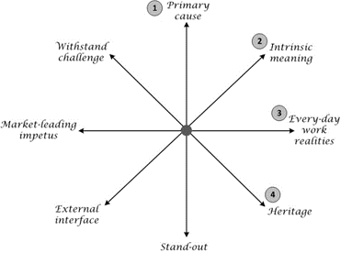
Figure 2: The core-value hierarchy
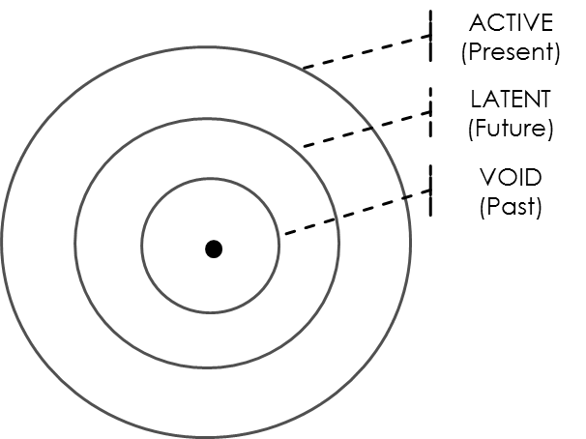

Figure 3: Combining the sources of tension and core-value hierarchy to form the Compass
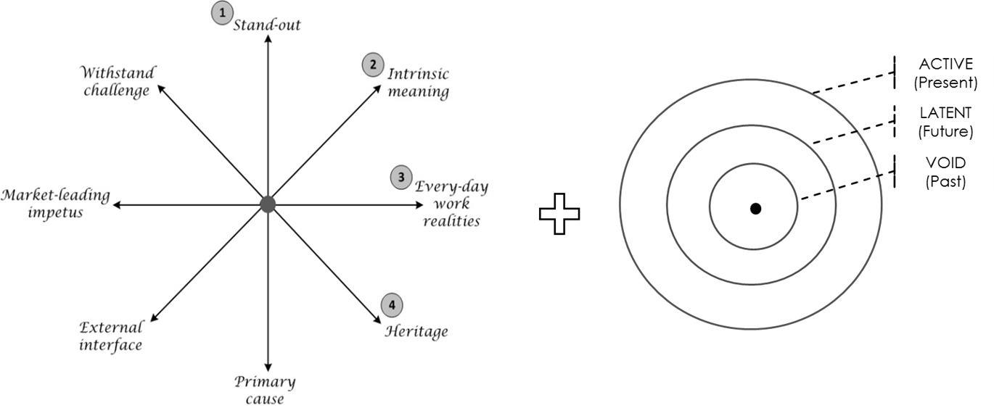
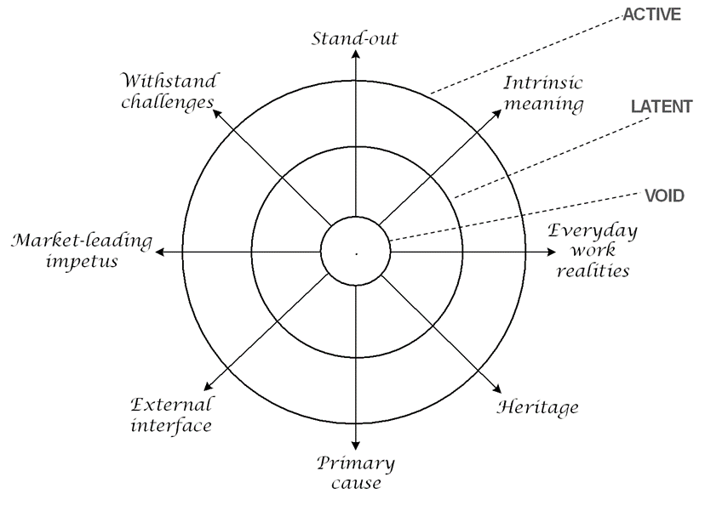

Figure 4: The Compass’ two halves, brand authenticity and brand competitiveness
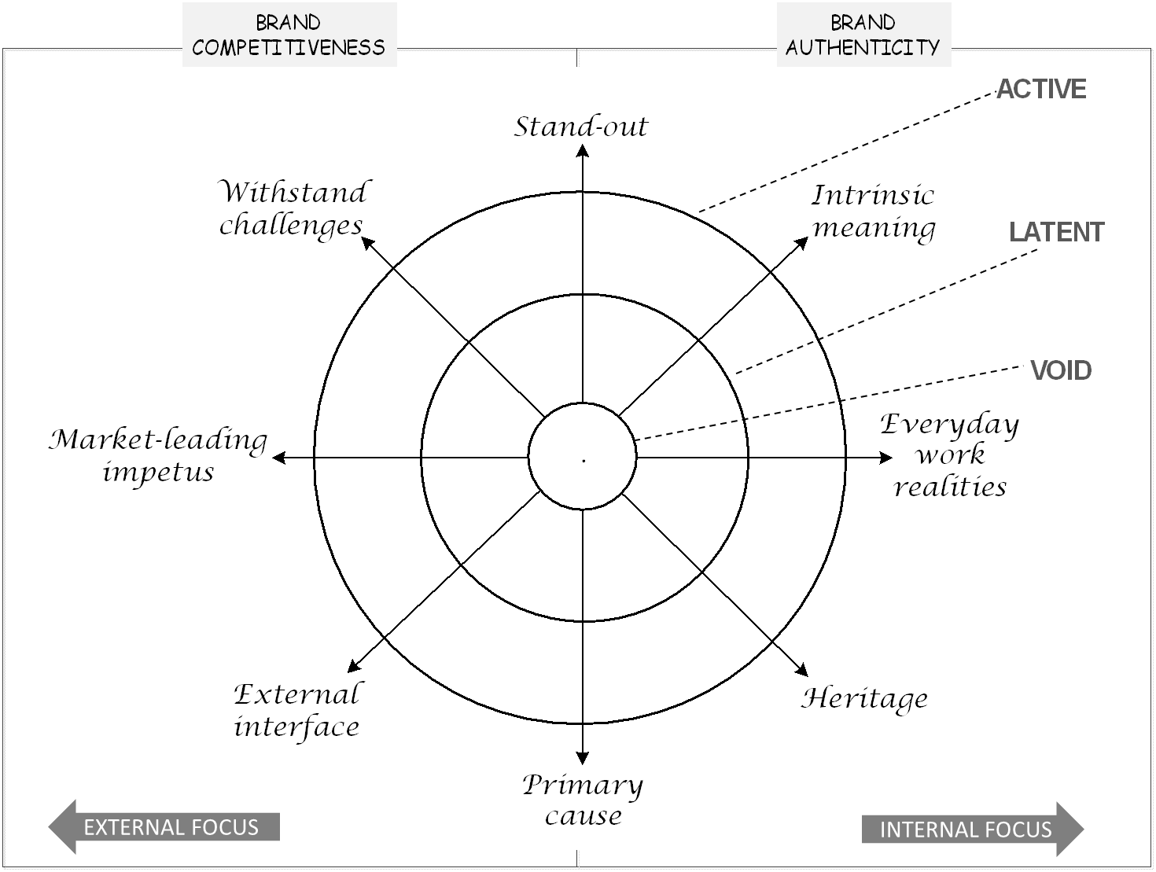
Figure 5: Corresponding numerical values on the Compass
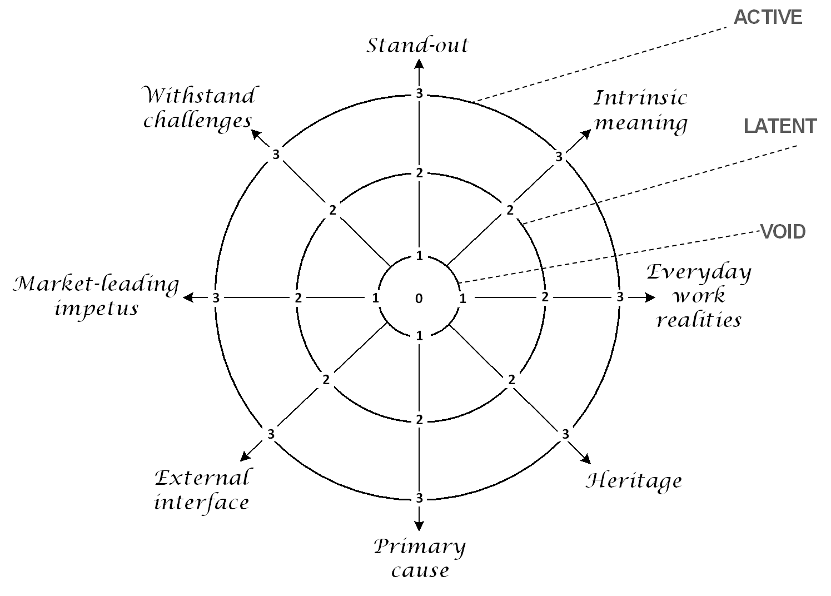
Figure 6: The Compass for ‘Proud’, ‘Decent’, and ‘Together’
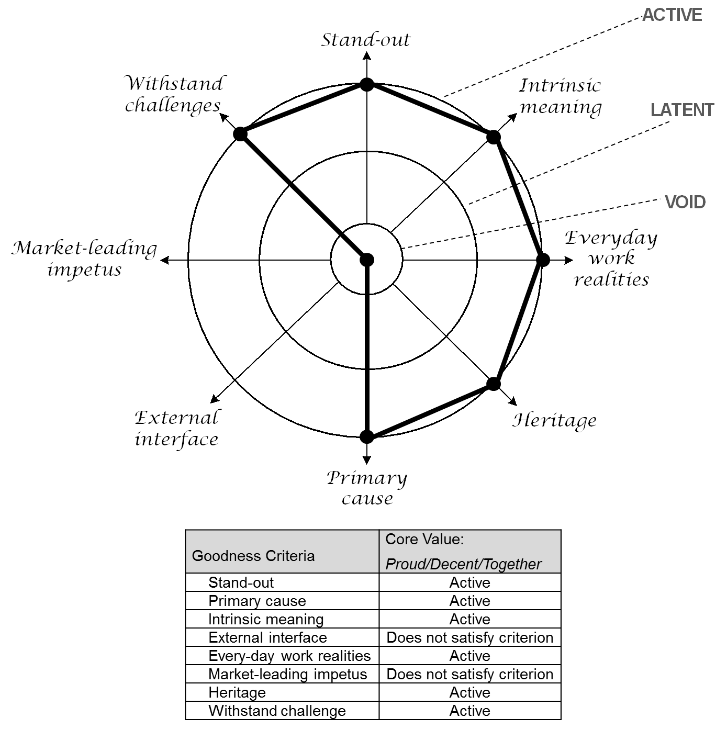

Figure 7: The Compass for ‘Ambitious’
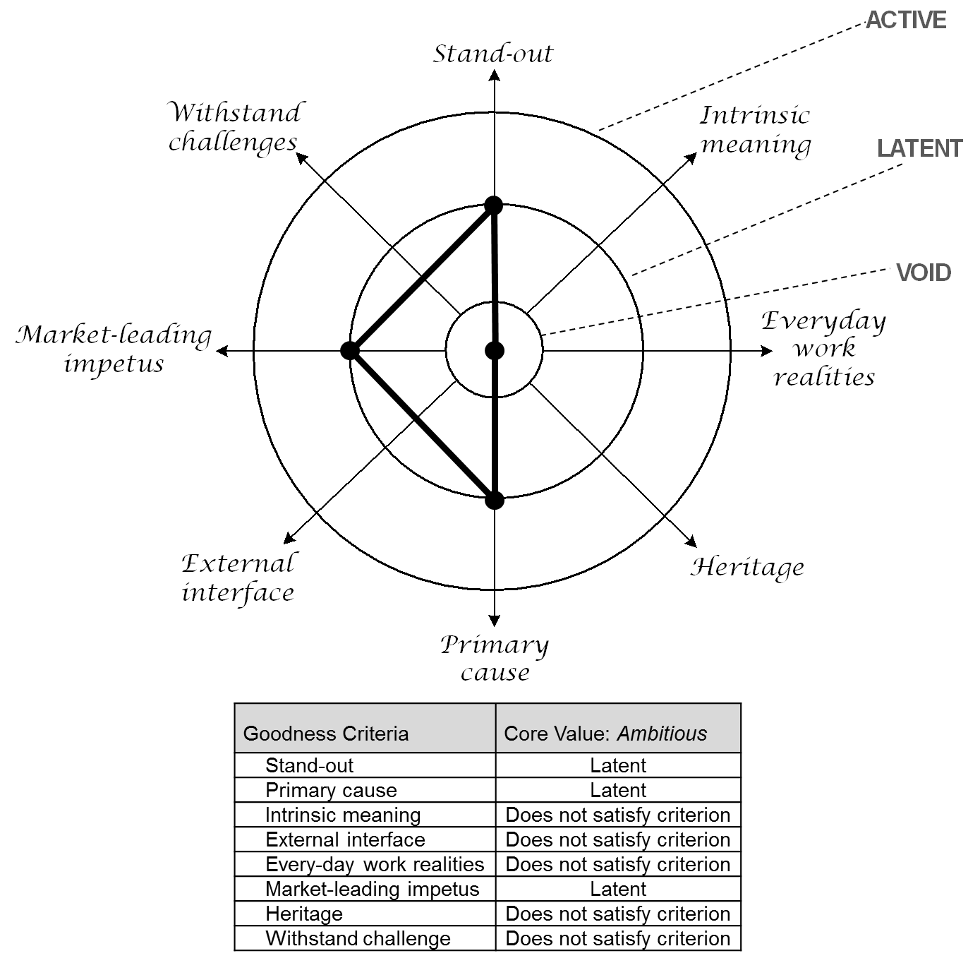

Figure 8: SCC’s overall Compass
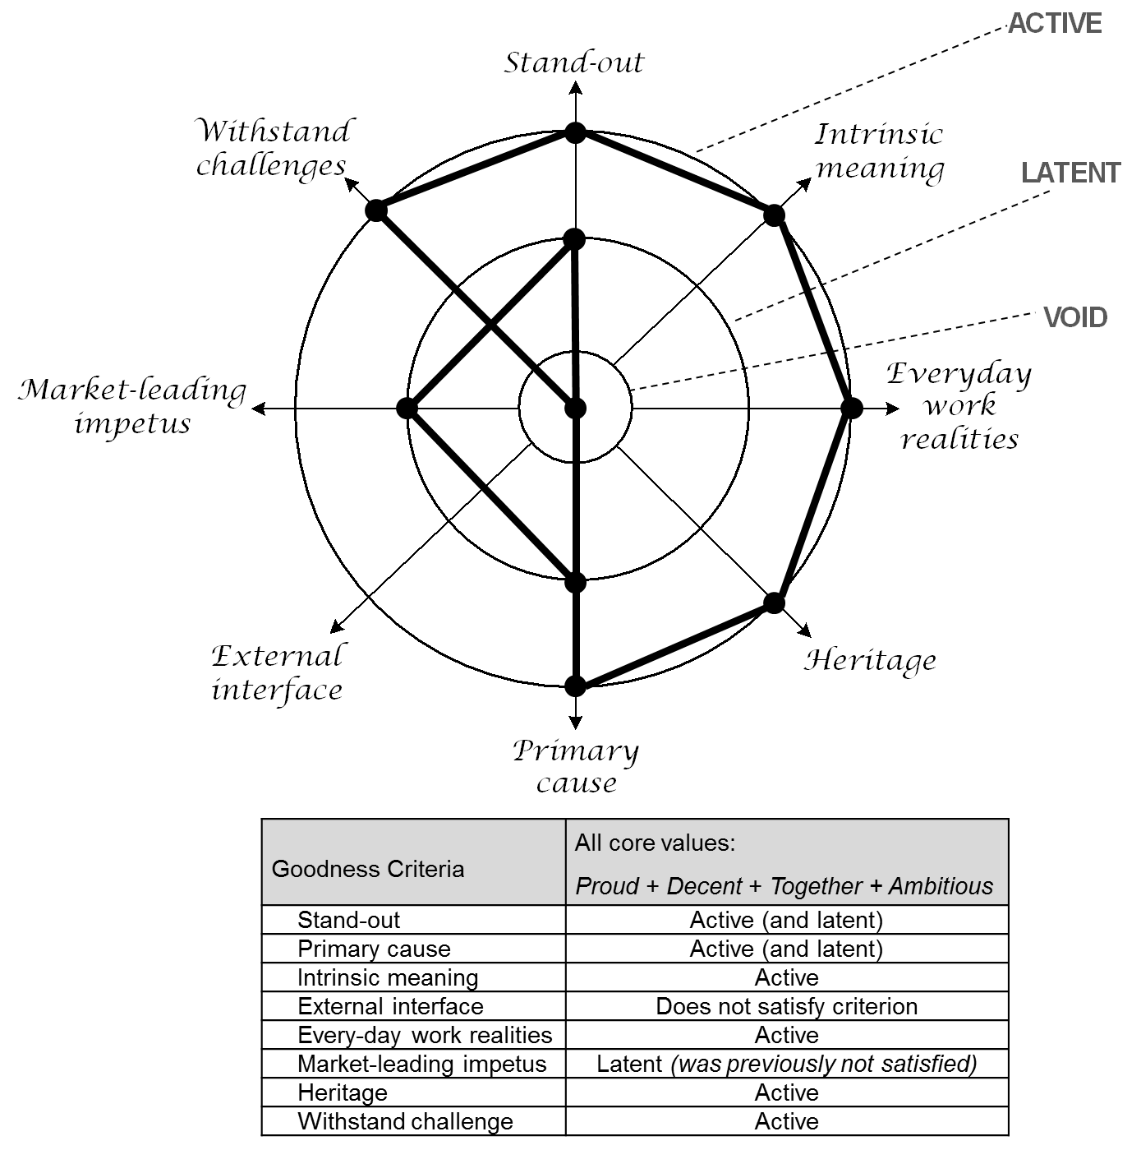

TABLES
Table 1: Guide for assigning numerical values to candidate core values
Does the candidate core value satisfy relevant goodness criteria on the axes of the Compass? (check each criterion) | Numerical values to assign according to core value hierarchy:
 | Void | Latent | Active
Yes | 1 | 2 | 3
No | 0 | 0 | 0

Table 2: Sequential phases in the research strategy
Phase 1 (Year 1): Developing the goodness criteria for core values. | Development of ‘goodness’ criteria for core values from extant literature, and integrate them into a single framework.
Phase 2 (Year 1): Six staff workshops with the Image Group. | Each workshop consisted of 20 participants on average, each lasting between two and five hours. Participants were members of the Image Group (chosen by the organisation), all senior departmental managers.
Phase 3 (Year 2): Five focus-groups, three in-depth interviews, and document analysis. | - Focus group 1: School-crossing patrol staff; 12 participants; aged 40-50; even number of males and females.  - Focus group 2: Operational staff from the City Services department; six participants, aged 20-40; all males.  - Focus group 3: Operational staff from the City Services department (different depot); five participants, aged 20-40, all males.  - Focus group 4: Administrative staff at head-office; four participants, aged 25-40, all females.  - Focus group 5: Managerial staff at head-office; two senior-level and three mid-level managers; aged 30-50; three female and two males.  - Interview 1: SCC HR Director (male) 90 minutes.  - Interview 2: SCC Internal Communications manager (female) 90 minutes.  - Interview 3: CEO of SCC (male) – 60 minutes.  - Documents analysed: SCC website, Internal Magazines and flyers.

Table 3: SCC core values with corresponding numerical values
Goodness Criteria | CANDIDATE CORE VALUES  (and corresponding numerical value)
 | Proud | Decent | Together | Ambitious
1. Stand-out | 3 | 3 | 3 | 2
Primary cause | 3 | 3 | 3 | 2
2. Intrinsic meaning | 3 | 3 | 3 | 0
External interface | 0 | 0 | 0 | 0
3. Every-day work realities | 3 | 3 | 3 | 0
Market-leading impetus | 0 | 0 | 0 | 2
4. Heritage | 3 | 3 | 3 | 0
Withstand challenge | 3 | 3 | 3 | 0
Note: of the 4 values, none were void; only ‘Ambitious’ was classed as latent.

