The British corporate network, 1904-1976: revisiting the finance-industry relationship

The relationship between finance and industry in Britain has received substantial attention, largely focusing on the role played by clearing banks as lenders to industry. This article, through the use of a unique dataset detailing the composition of the British corporate network, aims to investigate the corporate connectivity of industry to banks but also, importantly, highlight the increasing presence of financial institutions other than banks in British business. Additionally, the position of these financial institutions within the network reflects the changes in patterns of ownership of British business through this period as institutional investors’ share of British companies increased. This changing position is further articulated by an analysis of network density over the period, providing critical insights into wider patterns in British business between 1904 and 1976.

Introduction
Since the publication of the Macmillan report in 1931, the impact of British financial institutions on corporate performance has received substantial and largely critical attention, not least from business and banking historians. The core issue has centred on the so-called ‘bank-industry divide’, while more recently the debate has spread to assessing the nature and extent of support provided by British financial institutions generally for domestic industry. The critique of banks was prompted by the deep slump in activity across many of the older industries after 1921 that precipitated a decline in Britain’s position in the global business landscape. Since commercial banks maintained the closest relationship to domestic industry, they came under scrutiny for the role they ought to play in this scenario. Based on these contemporary perceptions of ‘industrial malaise’ and the perceived responsibility of banks, numerous committees, reports and policies were convened and released to offer solutions. The Macmillan report was just one of many which aimed to rectify the so-called ‘divide’ and control financial sector behaviour. Although later in the twentieth century Lindgren noted that ‘the functional and organizational boundaries delimiting banks on the one hand and manufacturing industry on the other, are becoming indistinct’, numerous historical evaluations have been conducted which provide varied explanations for the perceived and actual extent of the links between financial institutions and industrial investment and strategy. The recent work of Turner, Acheson et al. and Higgins et al. also demonstrates that the discussion of the shifting relationship between financial institutions and industrial companies is still highly relevant to the study of British business in the twentieth century.
This article will provide fresh perspectives on the debate about finance-industry relations by using a novel methodology of studying the inter-organisational relationships and corporate networks. Covering a period which started just after the concentration of British banking and finishing when financial institutions generally were regarded as highly influential within the British corporate network, and by using a database of board directors across the top 250 British companies based on net assets (200 non-financial and 50 financial, both listed and unlisted), it will be possible to demonstrate the level of contact between and within sectors. Four benchmark years (1904, 1938, 1958 and 1976) have been chosen, allowing the network to be viewed at different critical periods of change and development in British business. The data also allows for centrality measurement using the Freeman degree (which is the sum of the shortest paths from a singular node), indicating which companies were most connected within the network as a whole, as well as an examination of the composition of connections and what this might indicate about their inter- and intra-organizational activity.
Starting with some insights into the methodology and data employed in this analysis, the article then outlines the role of a board of directors and potential impact of interlocking directorships. The article will then provide brief contextual material on the evolution of Britain’s major financial institutions and their changing relationship with the rest of the top 250 firms. These sections will highlight a series of questions that will be addressed when examining each sample year, demonstrating how this research differs from other work on finance-industry links. Specifically, it is essential to explain how historians’ previous preoccupation with clearing banks needs to be moderated by incorporating an analysis of the many other financial institutions which participated in the British corporate network. Additionally, because these varied financial institutions were participating in British business as a collective and the networks they possessed through board-level interlocks dictated the movement of resources, both tangible and intangible, they became increasingly essential participants in British business, thus warranting further analysis. Secondly, these changes need to be linked with a significant shift in the patterns of ownership of major British business. Thirdly, one must assess the density and quality of connections within the British corporate network over time, identifying any changes that took place and the reasons behind them. Importantly, what this study provides is a unique survey of corporate connectivity across all sectors which can provide deep insights into inter- and intra-sectoral connectivity over most of the twentieth century. Through network graphs, this study offers the opportunity to visualise lines of communication and flows of resources across boards, industries and British business as a whole, something that has not been done before. More specifically, we highlight occurrences of regional clustering, recurring and ongoing relationships, cartelisation and industry preference amongst interlocks. At the centre of our study is a focus on finance-industry relationships; by isolating the connections of each financial company in the network for each year, we are able to identify wider trends related to financial sector linkages and isolate potentially unique relationships for further study. While further research is required at the micro- level in order fully to understand the nature and impact of these changes on individual firms and the economy as a whole, this article provides a solid foundation on which to develop fresh perspectives on a range of issues related to the evolution of British business in the twentieth century.

Methodology and Dataset
In this work, we adopt network visualisation and characteristic analysis as a novel approach to studying inter-organisational relationships. Understanding the shape, form and function of networks is important in understanding a host of characteristics of relationships which cannot be explained through other forms of organization (that is, markets, hierarchies or other empirically-based forms of analysis). Networks help one understand relationships which are not purely formalized, which cannot be predicted and which are likely to change over time. As there are different categories of relationships and indeed networks, certain networks provide answers to queries which others cannot. Networks can help us visualise lines of communication, relational contracts, syndicates/cartels/clusters and centres of influence. Visualising networks through graphs provides a whole picture which can be interpreted in numerous ways. Relationship characteristics can also be inferred from networks; aspects of relationships such as trust, commitment and reputation become clearer when visualising a node’s quantity and quality of connections. Networks visualised on a large scale also allow for the identification of potentially significant relationships for further investigation or case-study creation.
Using aspects of network theory for an examination of inter-organisational networks is a tested method. John Scott, Mark S. Mizruchi and Beth A. Mintz and Michael Schwartz have shown the value in engaging in this sort of analysis and the opportunity it provides to isolate unique network features and distinctive trends. As Scott and Griff argue, ‘an adequate understanding of social networks … concerns itself with features of the network as a whole, rather than simply with direct contacts of a social agent’. Corporate networks from a national perspective have tended to favour examinations of the American or German systems. While Scott’s work on the British corporate network adds much to our understanding on inter-organisational relationships, his focus has primarily been on the post-war period (1950s-1980s) and on banks as the principal financial player within these networks. Our study intends to build on much of Scott’s work by extending the period of examination back to 1904, highlighting changing inter-sectoral links and focusing in on all financial institutions, rather than just banks.
The dataset used in this study has been compiled partially from pre-existing datasets, published sources such as Who’s Who in British Business, as well as archival sources such as stock-exchange yearbooks, commercial providers and annual reports. Any micro-level primary data presented has been collected from a number of banking and industrial archives, where available. We have utilised the network software Pajek to gauge centrality measurements and visualise network shape and structure. The selection and spread of benchmark years allows us to achieve a broad perspective on evolving trends in British inter-organisational relationships outside of conflict years, while also providing indicators of the changing business landscape. For example, 1904 reflects a period of growing bank concentration as well as the persistence of small Victorian firms. The second sample point, 1938, provides an example of a transitory period for the staple industries and one which may reflect the impact of the Macmillan report. The first post-war year, 1958, illuminates the British corporate network in a period of restrictive banking practices, but also during the beginnings of the market for corporate control. Finally, 1976 presents our data amidst an uncertain post-crisis period where policy was quickly changing and new financial players were taking on a greater role in British business. These sample years allow us to assess the network before and after stages of instability, crisis and transformation (i.e. merger waves, policy implementation, etc.), thereby revealing the impact of some of these events. In addition to this, selecting the top 250 companies by net assets allows us to view connectivity amongst the largest players in British business who had the status and capital to shape much of the business landscape through the twentieth century.
We examine several different characteristics of the network. Firstly, the Freeman degree is used, allowing us to measure centrality and network density. This can indicate highly connected companies as well as the level of integration within the network as whole. In instances of high connectivity, it also allows us to determine the presence of a so-called ‘big linker’, that being an individual who held many board seats often in what is termed a ‘figurehead’ role. Secondly, we have also isolated the ties of each financial institution in the network to determine how integrated they were in the network as a whole, as well as determine the nature of their connections, viz., were they largely inter- or intra-sectoral? Did they connect with many companies in the same industry? Were they connected to regionally significant companies, and finally, did these connections repeat in multiple benchmark years? These connections and the accompanying analysis provide a view of major changes in British business through an alternate and unique perspective, while also highlighting the opportunity for further research into particularly interesting clusters and other networked relationships.
Role of the board and interlocks
As this article will be focusing on large British companies, it is important from the outset to establish that the board of directors represented the key mechanism for corporate control. The key board functions included management, oversight and service. Consequently, its composition will reveal the company’s mode of control and whether this is shaped by what Scott refers to as a ‘constellation of interests’, namely, senior executives, financiers, shareholders and non-executives from other industries. In the early-twentieth century context, at a time when as a direct result of merger activity many large-scale firms experienced significant growth, and board size was growing considerably, its role was brought into sharp focus. Quail has demonstrated that while the 1908 Companies Act provided greater clarification about the role of directors, and specifically recognised the existence of a managing director, boards were ‘increasingly becoming self-perpetuating oligarchies’. At the same time, share ownership in the largest companies was already highly dispersed, minimising the potential influence of owners, while shareholder attendance at company meetings was in decline. This resulted in the emergence of a ‘proprietorial’ structure which was intrinsically hierarchical, with the board of directors controlling all aspects of a company’s activities, even though they owned a tiny fraction of its equity. Moreover, these characteristics persisted well into the twentieth century. Hannah has described the inter-war era as ‘the golden age of directorial power’, while up to the 1970s only superficial changes took place in this respect, given the extensive adoption of a holding company structure across many sectors. This reinforces our earlier claim that an analysis of board composition provides a deep understanding of the nature of British corporate decision-making over the period 1904-76, given the dominant role played by directors in fashioning corporate structure.
While Cassis rightly argues that the impact of particular directors (and notably bank directors) on the boards of other companies varied and needs to be handled on an individual basis, by looking at the corporate network as a whole it is nevertheless possible to draw some conclusions. As an interlock represents an interest between two companies, it is safe to assume in most cases that when the director who works for a financial institution sits on the board of an industrial company this relationship was either a ‘capital relation’ or a ‘personal relation’, where personal includes figurehead directors who hold multiple seats and do so because of status and often access to important personal contacts. On the other hand, links between two financial companies are potentially even more complex, as they could either reflect financial interests or directors could have been placed there to monitor corporate behaviour, or again to act as a figurehead. Although boards impact on strategic decisions, determine capital flows and monitor the decisions of top management, the emphasis on each could shift depending on the board members’ prerogative. Board decisions could also determine objectives and ensure business operations are focused on achieving these objectives. Furthermore, as Brayshay et al. argue: ‘Examination of interlocks provides an initial basis for analyses of how social networks may have influenced company activity’. Other directorships held by so-called ‘big linkers’ had the potential to influence the mode of decision-making or the accumulated knowledge they brought to a particular board. The various roles of directors and accrued benefits that come as a result of experience, contacts and access to capital could also be analysed within a resource-based view. Toms, Wilson and Wright, for example, examine the way in which inter-organisational networks in the private equity sector and beyond help corporations and boards to accrue ‘rents’ such as human capital and other resources. Outside of the interlock network, a director’s informal links to the business world via friendships, club membership, family associates and similar relationships also played a significant role in shaping their influence on a given board. In our sample, we discover a number of individuals identified as ‘big-linkers’ and whose presence on a given board would pertain primarily towards increasing status and visibility of the company. Table 1 details the individuals with the highest number of board seats for each of the sample years, demonstrating that most were individuals with particularly high status in Britain.
Table 1. ‘Big-linkers’ in each of the sample years

From a non-figurehead perspective, Holmes and Ploeckl have shown that outside directors had the ability to submit proposals on subjects as diverse as restructuring, financial requirements, and mergers. For example, banks interlocked with one or more steel firms had the ability to propose amalgamation if one or all of the firms to which they were connected ran into problems, and especially those which accumulated excessive bank debt. Significantly, they argue that ‘networking between a bank’s clients and interlocking directorates with steel firms were two important conduits British banks could have used to shape industry concentration’. The proximity of banks to industry (particularly commercial banks and later other financial institutions) made a board-level connection between the two a seemingly natural move. In an ideal situation, this would allow banks and other financial institutions to monitor advances and gain an understanding of firm capital requirements. In addition, as certain financial institutions started to act as financial advisors to industry in the post-war period, this relationship experienced a distinct intensification. This was especially true for London-based banks, because they knew little about the company to which they were loaning money, or indeed the industry as a whole. One of the ways directors sought to be actively involved in industrial firms was by acting as ‘delegated monitors’, which required as much information-gathering on the company as possible, while alternatively financial institutions could seek to appoint a non-executive director to the board of a given industrial company. For example, Lloyd’s did this with Consett Iron Co. in 1959. While most boards still reflected the ‘club atmosphere’ entrenched in the organisations centred on the City of London, the extent of the interlocks between financial and industrial companies increased significantly up to the 1970s, highlighting the need to examine the nature of this relationship and the cross-sectoral linkages.
Finance and Industry in the twentieth century
Before going on to conduct a detailed analysis of the database, however, and although an abundant literature exists to outline key developments, it would be useful briefly to provide a broader financial context in which the corporate networks operated. In particular, it is important to emphasise how by the start of the twentieth century the bulk of British financial activity was centred on the City of London. While provincial stock exchanges in Manchester and Glasgow continued to operate for several decades, once the banking sector had been centralized in London and the London Stock Exchange came to dominate the market for corporate ownership, British financial activities were largely controlled by the City of London. As British business was also increasingly dominated by merger activity, resulting in the creation of ever-larger firms in all sectors of the economy, it was apparent that as Foreman-Peck and Hannah and Acheson et al. have shown, ownership was highly dispersed and separated from managerial control. While the many railway companies, clearing banks and utilities that dominated the Top 250 firms had since their origins been characterised by a divorce between control and ownership, the extensive merger activity in such areas as cotton textiles, engineering and steel resulted in similar trends.
A number of studies, including Acheson et al. and Cheffins, have demonstrated the dispersion of share-ownership in Britain prior to 1914. Shares were held by a broad spectrum of individuals, founding families and directors, as well as company customers or suppliers who maintained individual links to a given firm. From the inter-war era, it is noticeable that while individuals continued to own the bulk of traded shares, some types of financial institutions increased their holdings in UK companies. For example, insurance companies’ involvement in the corporate sector increased from 3% in 1913 to 20% by 1980, while pension funds held 28% by the latter date, providing them with the opportunity to claim a seat on other firms’ boards. This trend had earlier been prompted by declining investment opportunities abroad during the interwar years, while after 1945 the Bank of England and Treasury severely limited overseas activities, leading financial institutions to turn their attention to domestic business and stimulate the new issues market. Over this period, there was a significant transformation in individual holdings of the leading firms’ equity, a trend which accelerated from the 1960s. By 1980, individual holdings had fallen to 28% of quoted British equities, compared to 55% just fifteen years earlier. Although no succinct data exists for the whole of the twentieth century, research mentioned above on particular groupings of investors clearly indicate a move from dispersed share-ownership by individuals and small investors to more concentrated ownership in the hands of financial institutions. As a direct result of these changes, institutional investment vehicles such as pension funds, insurance companies and old players such as merchant banks who were taking on new roles as investment advisors were becoming increasingly embedded in British business boardrooms, while investment activity in domestic industry by financial institutions other than banks was growing across the financial sector.
The debate relating to the impact of this relationship has raged throughout the twentieth century. On the one hand, as many financial institutions had failed to develop deep relationships with British industry, their capacity to influence strategy was limited. Tilba and McNulty have also emphasised the disengagement that characterised the relationship between institutional investors and the firms in which they invested millions of pounds. From the inter-war era, given the acute difficulties experienced by staple industries such as textiles, coalmining, steel and shipbuilding, this led many to believe that British industry was in need of major restructuring. Specifically, there was a growing clamour in favour of financial institutions offering not only funds, but also advice and knowledge. The Macmillan committee set up to encourage bank involvement in the industrial sector and aid in its restructuring was but the most prominent of these voices. It is apparent, however, that while banks had actually been lending large amounts to industry in the form of overdrafts and other short-term instruments, little in the way of effective rationalisation occurred in the 1930s. As Garside and Greaves note, while there was some evidence of bank-led merger activity in Britain, the implementation of industrial rationalisation across industries suffering from decline (particularly cotton, coal and shipbuilding) was more evident in official documents than in practice. This lack of actual rationalisation activity re-enforced Hilferding’s thesis regarding the divergent interests of financial institutions and the needs of manufacturing industry. Indeed, as this paper will show, while financial institutions and industrial customers were increasingly involved in each other’s companies through board interlocks, there is little evidence of a deep understanding of respective needs.
As the general economic environment changed markedly after the 1940s, the post-Second World War era was characterised more by a considerable deepening of the relationship between the financial and other sectors. Although between 1939 and the 1970s the Bank of England and Treasury placed strict requirements on banks regarding their liquidity, thereby constraining lending activity, their connections with British firms increased significantly over this period. For example, manufacturing took an increasingly large proportion of bank advances to industry in this period, rising from around 25% just after the war to 40% in 1966. Of course, much of this came as a result of lending controls put in place to promote stability and encourage domestic growth. At the same time, Thomas notes that industrial profits as a source of finance declined from 72% (1952-55) to 45% (1971-76), while external corporate funding grew from 12% to 20% between 1948 and 1976. As we have already noted, institutional investors were also investing an increasing proportion of their growing funds in British equities, significantly altering relationships across various sectors. Of course, given the continued debate about the alleged failure of British financial institutions to support domestic firms, it remains a matter of conjecture whether this deeper relationship resulted in improved performance, at a time when international competition was intensifying and technology was advancing rapidly in a wide range of industries. It is consequently necessary to examine the evidence on board interlocks in order to provide a useful indicator of the nature of this relationship, and especially assessing how the extent of these links changed over time.
The corporate network, 1904-1976
- 1904
The relationship between financial institutions and other large-scale companies changed through the twentieth century, mainly as a result of concentration in banking and later in other sectors, alongside the influx of new financial players and a significant decline in the importance of foreign investment from the 1910s. At the start of the century, while a number of large centralised banks and transport companies had emerged, many companies still held on to the typical structure of a Victorian small-scale regional firm. This is further illustrated in the network diagram for 1904 (Figure 1), where although it is evident that some firms were interlocked, approximately 30% of the top 250 firms were isolated from the network. These peripheral firms included a number of smaller rail companies, brewers, textile manufacturers and dyers and many family-owned companies (for example, J & J Colman, Lever Brothers and Lipton Ltd.). This indicates that no particular industry was less likely to interlock at that time, or that it was merely family-held businesses that did not adopt this practice. Although financial institutions also appear on the periphery, only 14% had failed to build ties to the network, with non-bank financial institutions such as Royal Exchange and North British and Mercantile proving to be amongst the most connected (Table 1). The propensity for financial institutions to interlock compared to other companies appears to be linked to the monitoring of investments and loans as the principal motivation behind this activity, facilitated by the increase in board size arising from amalgamations. From figure 1, it is also apparent that there is a high number of marginal firms, those which possess limited ties to the network (one or two links); these firms make up approximately 34% of the network.

Figure 1. Corporate Network (Top 250 firms) in 1904
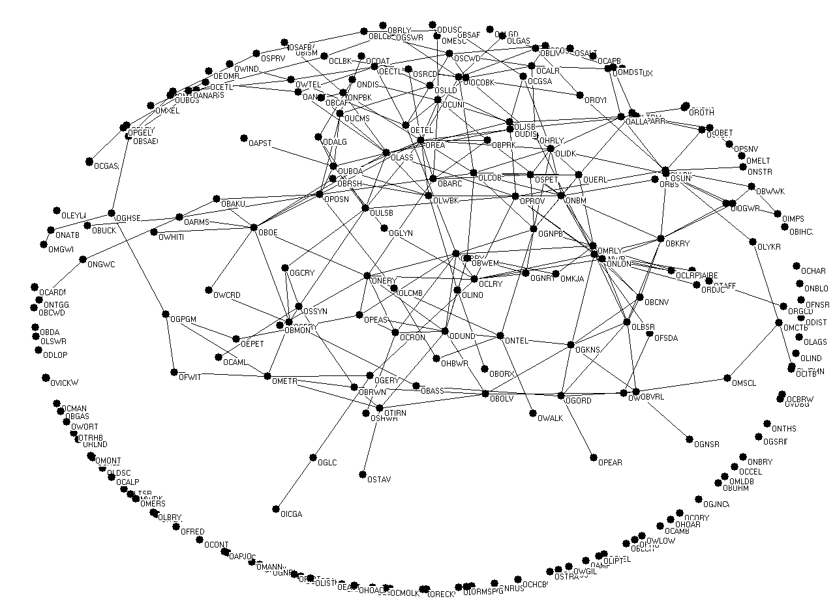

In terms of network centrality (see Table 2), the core of the network was occupied mainly by insurance companies (Royal Exchange Assurance, North and British Mercantile and London Assurance). Although bank concentration had already occurred, insurance companies appear in the network far more frequently, with interlocks concentrated in London. For example, North British and Mercantile were linked to a number of London rail, dock and financial companies, largely as a result of the growth of the insurance business in conjunction with the UK’s international shipping focus. This is further confirmed by the industrial concerns with which the most central insurance companies were interlocked, which were mainly shipping, dock and rail companies. Insurance companies were also largely interlocked with other financial companies, largely as a result of the long-established relationship between banks and insurance companies.
Table 2. Top 25 most central companies in 1904 (according to Freeman Degree)
Company name | Freeman Degree
Royal Exchange Assurance | 13
London & North Western Railway | 12
North British and Mercantile | 11
Forth Bridge Railway | 10
London & India Docks Company | 10
Sunderland Iron Ore | 9
London Assurance | 9
North Eastern Railway | 9
North London Railway | 9
London and County Bank | 9
Great Northern and Piccadilly | 9
Guest Keen Nettlefolds | 9
Peninsular & Oriental Steam Navigation | 8
Birkenhead Railway | 8
Union Bank of Australia | 8
Provincial Bank of Ireland | 8
Central London Railway | 8
Underground Electric Railways Company of London | 7
London Joint Stock Bank | 7
Union of London and Smith's Bank | 7
Cunard Steamship | 7
London, Brighton & South Coast Railway | 7
Scottish Widows Fund Life Assurance Society | 6
Schibaeff Petroleum | 6
London and Westminster Bank | 6

The most central banks in the 1904 network included London and County Bank, Union Bank of Australia and Provincial Bank of Ireland, again centring mainly on transport and dock companies. Beyond transport companies, a number of financial institutions maintained links with British colonial companies such as Consolidated Gold Fields of South Africa, La Capital Traction and Electric of Buenos Aires and South African Breweries. Given this geographic spread, it is consequently not surprising to note that they were also linked to dock, steam-shipping and telegraph companies. These trends appear to be largely in line with the international focus of the British economy at this time. Colonial banks were also linked to many large companies located in Imperial territories. For example, the Union Bank of Australia was interlocked with Australian-based companies such as Dalgety and Australian Pastoral. Individual directors played a significant role in the internationalisation of interlocks. In some cases, individual players bound boards together, such as Stanley Christopherson of London Joint Stock Bank, who was a director at Consolidated Gold Fields of South Africa and had significant ties to that region. Other interests in Africa were associated with local opportunities which sparked the interest of London bankers, for example, the mining boom in South Africa at the turn of the century.
In the network as a whole, many financial institutions still appear to have had a regional focus to their interlocks. For example, the Commercial Bank of Scotland was linked to Scottish Widow’s Fund, Caledonian Railway, Highland Railway and Eastern Telegraph (whose chairman was the Glaswegian John Pender). Bank of Liverpool was tied to Liverpool-based Royal Insurance, Salt Union, Liverpool United Gas Light and Cunard Steamship. This trend is in line with recent findings regarding the geographic spread of shareholders and the continuation of region-specific, bank-industrial relationships, something which the more centralised City banks were unlikely to possess. On the other hand, Cassis argues that despite bank amalgamations, bankers from provincial banks involved in large-scale mergers managed to retain these regional links. For example, John Spencer Phillips, chairman of Lloyds, was on the Board of Directors of Shrewsbury Gas Light Co due to a previous relationship formed when he had been a banker at Shrewsbury-based Beck & Co. (absorbed by Lloyds in 1880). Despite the continued absorption of smaller or private banks by the larger commercial banks through the first half of the twentieth century, many of the networks created by these smaller enterprises proved to be resilient.
Although the financial sector appears to have been the most interlocked, many of these interlocks remain intra-sectoral and primarily between banks and insurance companies. The presence of bankers on insurance boards, and vice versa, was symptomatic of an old-established relationship as the two industries had been linked for over a century. This board-level relationship allowed for a channel of advice regarding investments and technical issues connected to more practical, insurer-client relationships. As both banks and insurance companies continued to indulge in intense merger waves over the course of the twentieth century, these interlocks also multiplied, creating an intimate community within the City of London. On the other hand, it was not until later in the century that substantial links between City-based financial institutions and domestic industrial concerns emerged, especially with regard to staple industries such as coalmining, textiles and steel, largely because the latter continued to rely on regional sources of capital and they were slow to adopt amalgamated corporate structures.
- 1938
Amalgamations across all industries increased into the interwar period; in 1918 especially, many financial institutions which appeared in the network in 1904 were taken over by larger banks; Parr’s Bank was amalgamated by London and Westminster, Capital and Counties Bank by Lloyds and London Joint Stock Bank by Midland. The Colwyn committee, convened in the same year, aimed to prevent the ‘Big Five’ from continuing this activity. However, in later years significant mergers still occurred amongst the smaller banks, for example, Manchester and Country Bank merged with District in 1934. As regional banks were absorbed into the City-based institutions, banks increasingly lost touch with their local industrial customers. At the same time, as Figure 2 reveals, there had been an increase in the overall number of interlocks in the corporate network by 1938. Brayshay et al confirm this trend by demonstrating an increase in interlocking between 1900 and 1929-30, resulting in a growing ‘mesh of intercorporate linkages between a small number of key directors’. According to the corporate network data, only 19% of the top 250 companies remained disconnected from the network (down from 30% in 1904), with the major clearing banks taking on a much more central role. Lloyds, Midland and Westminster noticeably increased their number of interlocks, significantly surpassing insurance companies which once occupied the core of the network. Although less dramatically, the percentage of marginal firms (those with one or two links) also decreased from 35% to 26%. The 1938 network graph (figure 2) while illustrating the persistence of isolated and marginal nodes, clearly shows a distinct move towards move towards network integration when compared with figure 1. The core of the network itself was also considerably denser than it had been in 1904, with an average Freeman degree of 16.5, compared with an average of 8.9 in 1904. While some of this can be explained by the increase in average board size, it would appear that across the network banks were pursuing interlocks with numerous companies, especially in non-financial sectors, as a direct result of the need to monitor more closely the financial performance of their clients at a time of acute economic uncertainty. On average, the distance between ties decreased considerably from 1904 and 1938, meaning fewer paths connected one firm to the next and there was a greater occurrence of nodes which connected multiple paths (in other terms, the betweenness centrality percentage is the highest in this year). Unsurprisingly, in this year we have the largest percentage of so-called ‘big-linkers’ with 5.07% of all directors being considered as such. Increased concentration in the network could also have come as a result of particular shifts within the banking sector influenced by the aims of the Bank of England. Turner suggests that in the inter-war period the Bank of England encouraged a close-knit, non-competitive banking environment which created a highly cartelised structure amongst the City-based institutions. This trend also continued over the following three decades, with the Bank of England purposely limiting competition and restricting speculative investment activity.

Figure 2. Corporate Network (Top 250 firms) in 1938
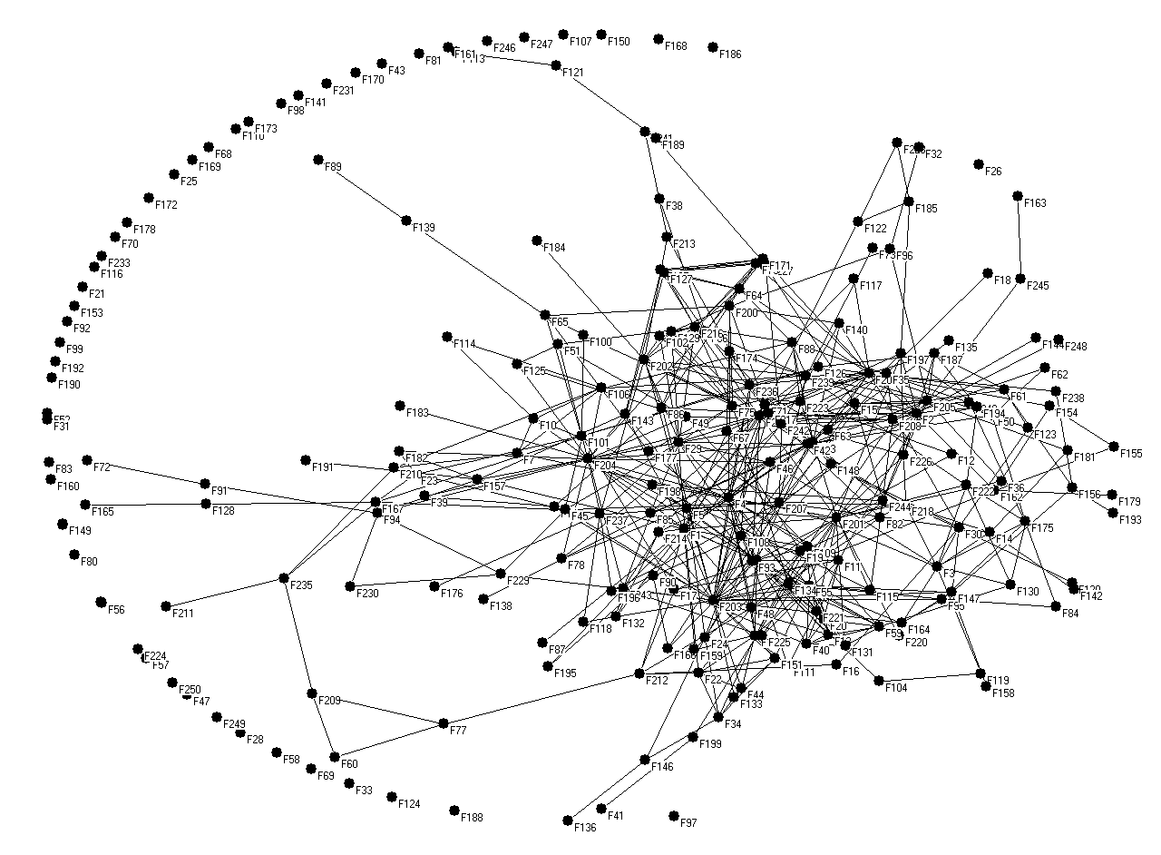

Table 3. Top 25 most central companies in 1938 (according to Freeman Degree)
Company name | Freeman Degree
Lloyds Bank | 33
Midland Bank | 28
London, Midland and Scottish Railway | 24
"Shell" Transport and Trading | 22
Great Western Railway | 22
Westminster Bank | 18
London and North Eastern Railway | 18
Venezuelan Oil Concessions | 17
Sun Insurance Office | 16
Cunard White Star | 16
Barclays Bank (Dominion, Colonial, and Overseas) | 15
National Provincial Bank | 14
Barclays Bank | 14
Commercial Union Assurance | 14
Royal Exchange Assurance | 14
Peninsular and Oriental Steam Navigation | 13
Martins Bank | 13
London and Lancashire Insurance | 13
Baldwins | 12
Guest Keen Baldwins Iron and Steel | 12
Southern Railway | 10
Associated Electrical Industries | 10
Imperial Chemical Industries | 10
Imperial Smelting Corporation | 10
District Bank | 10

After the early-1930s crisis, it appears that many banks sought to monitor their industrial companies much more closely, particularly those which had been encountering difficulties. While in 1904 Lloyds was interlocked with both a small number of financial institutions, as well as railway companies and a utility (Bristol Waterworks), by 1938 it was interlocked with twenty-six non-financial companies, including some shipping and rail concerns and British Aluminium, Consett Iron, ICI, Welsh Associated Collieries, Imperial Smelting Corporation and two of the large Powell Duffryn companies (Steam Coal and Associated Collieries). The principal cause for this dramatic change in board connectivity, apart from the general increase in board size resulting from intense merger waves, was Lloyds’ continued absorption of regional banking companies. In 1910, Lloyds entered the south-west region through a merger with Devon and Cornwall Bank and acquired as many as 400 new branches in their merger with Capital and Colonies Bank in 1918. Midland was also interlocked with many more industrial firms, such as ICI, English Sewing Cotton and Mitchells & Butlers, a prominent brewing company. Even less connected banks such as District Bank and Union Bank of Scotland were linked with industrial companies such as Colvilles, Lancashire Steel Corporation and Stewart & Lloyds, manufactures of steel tubes.
While we have already noted the significance of merger activity in certain industrial sectors, and especially in cotton textiles, steel and coalmining industries, it is also important to add that financial institutions actually played a significant role in stimulating amalgamations. In the case of steel, Holmes and Ploeckl have demonstrated that banks played a much larger role in rationalisation than previously thought. They argue that non-executive bank directors on industrial boards often exercised decisive influence over corporate decision making. For example, Lord Pirrie of Midland Bank, who sat on the board of John Brown and Co. and Colvilles, submitted a scheme for amalgamation to the board. Beyond this, what the corporate network demonstrates is that by 1938 banks were playing a much larger role in many industrial sectors, and especially those considered to be in decline. While this interlocking activity could have been a direct response to the Macmillan Report, it is more likely that banks which had been lending large amounts to industrial companies would have wanted to protect and monitor their financial commitments. Board minutes from Lloyds in later decades detail the accounts of industrial customers, along with special reports concerning company performance, demonstrating not only the importance of industrial lending to commercial bank business, but also the level of contact at board level between financial and industrial sectors.
Of course, not all companies interlocked as readily as the large banks and some of their industrial customers. Most family-dominated firms were less likely to interlock in great numbers, or even at all. For example, in 1938 the family-owned firms of J & J. Colman (which was not interlocked at all in 1904), Rowntree, F. W. Woolworth and John Lewis & Co. possessed no link to the corporate network. Newly-emerged building societies also had limited or no connections to the network, aside from Leeds Permanent Building Society and Halifax Permanent Building Society, both of which possessed links to London and North Eastern Railway, National Provincial and Halifax-based knitted yarn company, Pattons & Baldwins. This disconnect was largely due to building societies being primarily lenders of capital for home-ownership, rather than lenders to industry.
c.1958
In the post-war years, despite remaining integrated, the network’s core became slightly less dense, with an average Freeman degree of 13.8 and the percentage of firms with no connection to the network increasing to 25% (Figure 3 and Table 4). One of the main reason behind this decline was the late-1940s nationalisation programme which saw two of the most networked industries (railways and coal) up to 1938 (Tables 2 and 3) come under public ownership. In spite of being briefly in public ownership (1949-51), the steel industry was much better represented in the core than in previous years, with the inclusion of Vickers, John Brown & Co. and Steel Company of Wales. The positioning of Steel companies in the network suggests the privatisation of this industry along with the growing market for corporate control had direct implications for their connectivity in the network. In terms of sector-specific interlocks, John Brown & Co. shared ties to five financial institutions (all banks), Vickers to six (four banks and two insurance companies) and the Steel Company of Wales to three (all banks). This data also highlights the increased extent to which banks and insurance companies maintained their position as some of the most well-connected in the network. Related to this trend, the graph in figure 3 also demonstrates the increase in the number of marginal firms (up to 30% of the total), which consisted predominantly of non-financials and was directly correlated to the propensity of financials in this year to maintain intra-sectoral ties.

Figure 3. Corporate Network (Top 250 firms) in 1958
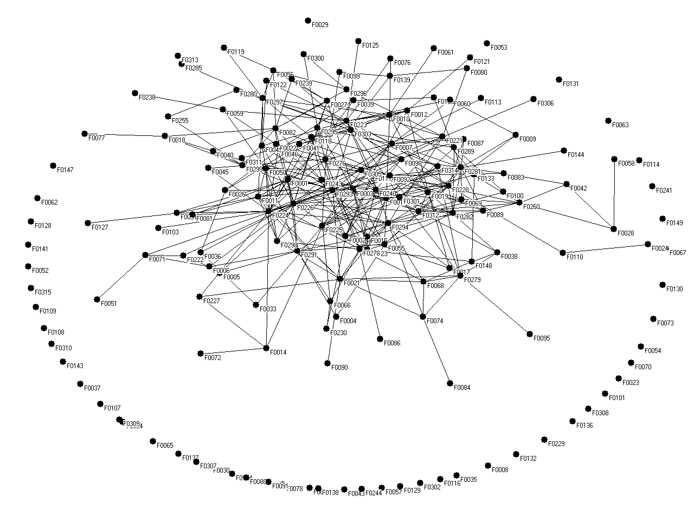

Table 4. Top 25 most central companies in 1958 (according to Freeman Degree)
Company name | Freeman Degree
Midland Bank Ltd | 22
Royal Exchange Assurance | 22
National Provincial Bank Ltd | 21
Lloyds Bank Ltd | 20
Vickers | 15
Barclays Bank Ltd | 15
Union Discount Company of London Ltd | 15
Westminster Bank Ltd | 14
Williams Deacon's Bank Ltd | 14
Royal Insurance Company | 14
P. & O. Steam Navigation Company | 14
Royal Bank of Scotland (The) | 13
Yorkshire Bank Ltd | 13
Bank of London & South America Ltd | 13
Cunard Steamship Company | 12
Dunlop Rubber Company | 12
District Bank Ltd | 12
Associated Electrical Industries | 11
Brown (John) & Co. | 11
National Commercial Bank of Scotland Ltd | 11
English, Scottish & Australian Bank Ltd | 11
Hudson's Bay Company | 10
Imperial Chemical Industries | 10
Steel Company of Wales | 10
Commonwealth Development Finance Company | 10

In terms of financial institutions’ aggregate number of links within the network, over the 1940s and 1950s there was an increase in the number of intra-sectoral ties, especially amongst smaller banks, trusts and insurance companies. Legal and General had ties to five financial institutions and only one industrial firm, while National Bank Ltd had ties to two financial institutions and no industrial links. Although it seems surprising that Yorkshire Bank had ties to thirteen financial institutions, including most of the ‘Big Five’ clearing banks, this arose from its recurring liquidity crises, prompting the Bank of England to encourage a syndicate of financial institutions to provide long-term support. The trend toward intra-sectoral connectivity can also be observed in the activities of the larger banks, and especially National Provincial, which while maintaining plentiful ties to industrial firms, in 1958 had ten links to other financial institutions, compared to four in 1938. The propensity to increase intra-sectoral links came from a distinct upward domestic turn in economic activity in the 1950s, encouraging a much more inward-looking, cartelised form of corporate behaviour. At the same time, it is also vital to remember that banks did not abandon their industrial sector links, because even though the bulk of industrial investment was sourced from profits in the early to mid-1950s, it was still important to monitor liquidity issues. Furthermore, increased intra-sectoral connectivity amongst financial institutions led to greater collaborative activity between financials which on occasion was used facilitate capital flow to struggling industrials. Thomas has also demonstrated that bank advances to industry, in particular to manufacturing, increased from the late-1950s, rising at an even greater rate in the 1970s, highlighting the vital importance of this relationship. This was especially essential in high-technology family firms such as Ferranti, which had provided a directorship for its principal banker since a liquidity crisis in 1903.
Banks also appear to have maintained links to some of the same companies in 1938 and 1958, suggesting a long-term relationship. Lloyds was linked with both Consett Iron and British Aluminium in these years, Westminster was linked with United Steel Corporation and British Match Company, and District Bank was linked to Turner & Newall and Lancashire Steel Corporation in both years. The board minutes for Turner Brothers Asbestos Limited provide detail of an ongoing and significant relationship with District Bank. This sustained interlock was undoubtedly a result of the long-term bank-industrial client relationship the two companies pursued. District Bank provided numerous accountancy and wage-related facilities to Turner Brothers which exemplify the intimate day-to-day relationship the two companies maintained. Additionally, Sir Walker Shepherd who sat on the board of District Bank was a shareholder in Turner Brothers and thus had a vested interest in the company’s performance. Furthermore, Barclays, which had possessed a largely international focus in the inter-war years, in 1958 was tied to a number of British manufacturing firms such as Vickers and several financial institutions. This also undermines Coates’ claim that banks sustained a largely international focus and neglected domestic industry. Despite growing intra-sectoral links across the financial sector, it appears in the post-World War II era that banks had not abandoned their industrial board ties, maintaining a close relationship with a number of sectors such as steel, chemicals, textiles and tobacco.
- 1976
As the need for external finance increased in the 1970s, largely because of intensifying international competition and a challenging domestic macro-economic climate which included rising inflation, a secondary banking crisis and a collapse in property values, financial institutions increased their interlocked relationship with industrial companies. By 1976, the core of the network had nearly returned to its pre-war density, with an average Freeman degree of 15.4, even though the number of financials in the core had declined from sixteen to thirteen. It is also clear from Table 5 that, with the exception of National & Commercial Banking and Bank of Scotland, banks in 1976 possessed more ties to industrial companies than other financial institutions, Lloyds, Midland, National Westminster and Barclays, accounting for four of the top five most-connected firms. Indeed, despite major changes in the financial sector in this decade, the role of commercial banks in the corporate economy remained relatively unchanged. That said, major instability within British business appears to have resulted in greater integration through the network as a whole. Although it is evident in the network graph in figure 4 that isolated firms persist, the number of marginal firms occupies a much smaller percentage of overall firms. The passing of the 1967 Companies Act and major economic crises of the early-1970s had impacted upon many of the newer financial companies, prompting them to extend their links with other parts of the business world in order to monitor more closely their investments. At the same time, the introduction of Competition and Credit Control in 1971 removed restrictions on lending, stimulating an increase in advances by clearing banks to industry. Despite significant changes to banking and monetary regulations, as well as several post-War government reports on banking practice, commercial banks in these last three benchmark years (1938, 1958 and 1976) appeared willing to connect and interact with industrial companies at board level.
Having noted this significant conclusion, it is nevertheless essential to stress that the biggest change to the finance-industry relationships at this time was the increasing presence of institutional investors as stakeholders in industrial companies, with pension funds, insurance companies and investment trusts significantly increasing their holdings of British equities. As we noted earlier, holdings by individuals had been in decline since the1950s, while by 1975 institutional investors owned over 50% of quoted British equities. In the network, along with new institutional investors such as Hill Samuel Group and significant financing house, United Dominions Trust, the older insurance companies Legal & General and Royal Insurance increased their non-financial ties significantly. Moreover, these non-bank financial institutions were more entrenched in the financial sector than banks by the 1970s. Another interesting development is the presence in the network of merchant banks (N. M. Rothschild and Lazard Bros.) and building societies (Abbey National and Woolwich Equitable Building Society), which developed primarily inter-sectoral ties to domestic industrial companies such as Northern Foods and Babcock & Wilcox.

Figure 4. Corporate Network (Top 250 firms) in 1976
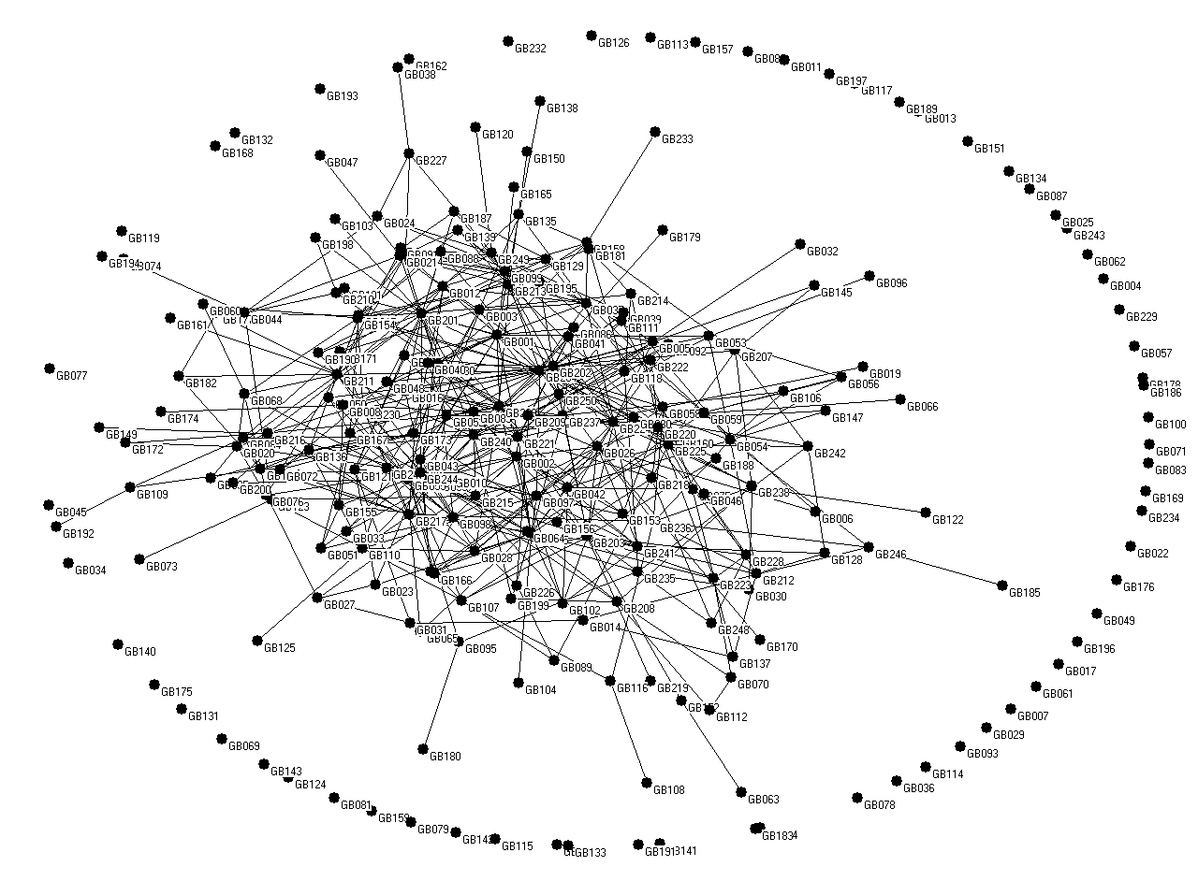
Table 5. Top 25 most central companies in 1976 (according to Freeman Degree)
Company name | Freeman Degree
Lloyds Bank | 28
Midland Bank | 21
British Petroleum | 19
National Westminster Bank | 18
Barclays Bank | 18
Commercial Union | 18
Finance For Industry | 17
Hill Samuel Group | 16
Delta Metal | 16
Tube Investments | 15
Imperial Chemical Industries | 15
Shell Transport & Trading | 14
Standard Chartered Bank | 14
Rank Organisation | 14
Eagle Star Insurance | 14
Royal Insurance | 13
Guardian Royal Exchange Insurance | 13
P & O Steam Navigation | 12
Lazard Brothers | 11
General Accident, Fire & Life Assurance | 11
Lucas Industries | 11
Dunlop Holdings | 11
British Leyland | 10
Fisons | 10
Hawker Siddeley Group | 10

Conclusion
This novel visual analysis of a unique corporate networks database has revealed several fresh aspects to the changing relationship between financial institutions and the rest of the top 250 British firms. Returning to the three issues highlighted in the introduction, it is firstly clear that business and banking historians need to broaden their ambit when assessing this relationship, in that a preoccupation with clearing banks fails to include the many different types of financial institution that became involved in the provision and management of corporate finance over the course of the twentieth century. As Ranald Michie’s latest book examining British banking in the long-run emphasises, it is essential to examine the complexity and variety of financial institutions within broad contexts. Of course, it is worth noting that in certain cases, such as Lloyds and Consett Iron, Westminster and United Steel Corporation and District Bank and Turner and Newall, the connections between clearing banks and other large-scale firms spanned multiple benchmark years, suggesting a long-term and strategically insightful relationship. Similarly, one should always remember that in the period covered by this article clearing banks provided the bulk of working capital for British business. On the other hand, increasingly institutional investors and other financial actors such as merchant banks (who acted as financial advisors to industry) became deeply involved in the corporate network, taking an increasing number of directorships. This process was undoubtedly linked with an analysis of the second issue, in that the ownership of the top 250 companies moved from the preserve of individuals to a situation in which institutional investors such as insurance companies, pension funds and investment trusts dominated the scene. Although as we have just noted that in 1976 clearing banks were the most central companies (see Table 5), by that time institutional investors owned over half of the quoted equity, compared to 28% for individuals.
Having linked the first two issues, perhaps the third issue relating to the changing density of the British corporate network highlights a series of issues worthy of further research. Table 6 summarises these changes, indicating a tendency towards increased density. In this context, however, 1938 stands out as an aberration, with the lowest proportion of disconnected firms and highest Freeman index. Of course, in 1904 the corporate network had not developed very extensively, in spite of the extensive divorce between control and ownership amongst Britain’s largest firms. Nevertheless, it is still surprising to note that both indicators of density were higher in 1938 than any other sample year. This revelation can only be explained by both the acute interwar uncertainties affecting especially the staple industries (cotton textiles, coalmining, steel and shipbuilding) and the depth of the 1929-31 economic crisis, persuading the clearing banks especially to increase their links with large-scale firms (see Table 3). Moreover, as Tables 4 and 5 indicate, these links were sustained up to the 1970s. On the other hand, it is also noticeable that although institutional investors were relegated down Table 3, each of them had more interlocking directorships than in 1904. In certain respects, while this was certainly influenced by growing board size, when we highlight the actual composition of these ties they reveal the much closer relationship that financial institutions generally developed with large industrials from the 1920s. Another factor to bear in mind when emphasising the aberrant nature of the 1938 data in Table 6 is that as a direct result of the late-1940s nationalisation programme affecting coalmining and railways especially, some of the most connected sectors of the early-twentieth century were eliminated from the corporate network.

Table 6: The changing density of the British corporate network, 1904-76.
 | Disconnected firms (%) | Disconnected Financial Firms (as % of whole network) | Average Freeman index
1904 | 30% | 3.20% | 8.9
1938 | 19% | 2.80% | 16.5
1958 | 23% | 2.10% | 13.8
1976 | 24% | 1.20% | 15.4

Another important dimension of the changing density of the British corporate network is the nature of the linkages, in that Table 6 fails to indicate whether the links were intra- or inter-sectoral. While considerable attention has been placed on the connections between financial institutions and other large-scale British firms, it is worth remembering that the former were just as interested in extensive intra-sectoral linkages. As we noted earlier, there had since the early-nineteenth century been strong links between provincial clearing banks and insurance companies, largely because they were created and owned by similar groups of entrepreneurs. By the 1950s, however, most sectors within the financial sector had developed strong intra-sectoral links, at least partially stimulated by the Bank of England’s desire to create a highly cartelised structure that was regarded as more stable, a policy that remained in place until the early-1970s. At the same time, there is only limited evidence of intra-sectoral linkages in other industries, even though between the 1930s and 1960s many British companies were signatories to extensive trade association arrangements.
The overriding conclusion from this research, however, is that there was an increasingly close relationship between financial institutions and the rest of the top 250 firms, as manifested in both changing ownership patterns, intra-sectoral support clusters and larger numbers of interlinking directorships. Moreover, these manifestations were directly connected, given the desire of clearing banks and other significant financial players to monitor the ever-larger sums of money that had either been lent or invested. As Sue Bowden suggests in a study of the crisis at Rolls Royce in the late 1960s, while shareholder exit was certainly apparent in this case, the community of financial institutions including merchant bank Lazards were instrumental in coercing change at this company. One must consequently regard financial intra-sectoral links as just as significant as finance and industry links to the shape and structure of British business. Of course, it is difficult at this stage to assess what lessons historically we can learn from the actions and relationships of financial institutions, given the need for more extensive micro-level research in order fully to understand the nature and impact of these changes on individual firms and the economy as a whole. While the general impression arising from the literature on bank-industry relationships is largely negative, it would be essential to analyse the extent to which firms relied on this relationship, the nature of the advice provided by financiers sitting on their boards, and the impact these had on corporate performance. Network analysis and graph visualisations has allowed for the novel drawing out of some of these important relationships which could have significant implications for future research paths. This foundation has also allowed for the illumination of significant trends, for example, long-term industry-finance relationships, regional clusters and the prevalence of overseas companies in the network. By highlighting these relationships and trends, one can pinpoint areas in which archival research should be undertaken. Given the vast spread of business records through the UK and rest of the world, using the network to highlight firms, groups of firms or key relationships which were potentially significant can aid in narrowing archival searches. Additionally, it also provides indicators of industry-specific connectivity and change; while we have focused on industry-finance links in this article, further studies may focus on specific sectors within the wider context of the network, such as retail, pharmaceuticals or automotive industries.
Furthermore, this article has opened the door for further studies of other benchmark years, including those that stretch back in time and forward into more recent decades, providing an even broader context for changing patterns in British business. Given the significant changes which have occurred in the British financial sector to the present date and the recent publications by John Turner and Ranald Michie, it might be timely to examine the corporate network in more current year. This article has laid important groundwork for a discussion of corporate connectivity, board-level interactions and the wider implications of inter-sectoral relationships, opening the door for future research into the intricate relationships between directors at board level and what implications these had for company strategy and performance over the short- and long-run.

Bibliography
Acheson, G.G., Campbell, G., Turner, J.D. and Vanteeva, N. “Corporate ownership and control in Victorian Britain.” The Economic History Review, 68, no. 3 (2015): 911-936.
Acheson, G.G., Campbell, G. and Turner, J.D. “Active Controllers or Wealthy Rentiers? Large Shareholders in Victorian Public Companies.” Business History Review, 89 (2015): 661-691.
Bainbridge, Stephen M. Corporate governance after the financial crisis. (Oxford: Oxford University Press, 2012).
Baker and M. Collins. “The Asset Portfolio Composition of British Life Insurance Firms, 1900-1965.” Financial History Review, 10 (2003): 137-164
Best, M.H. and Humphries, J. “The city and industrial decline.” In B. Elbaum and W. Lazonick, eds. The decline of the British economy, (Oxford: Oxford University Press, 1986), pp. 223-239.
Billings, M. & Capie, F. “Financial Crises, Contagion and the British Banking System between the world wars.” Business History 53 (2011):193-215.
Boleat, M.J., Building Society Industry (RLE Banking and Finance)(Vol. 3). (Abingdon: Routledge, 2012).
Bowden, S. "Ownership responsibilities and corporate governance: the crisis at Rolls Royce, 1968-71." Business History 44 (2002): 31-62.
Bowden, S. and Higgins, D.M. “British industry in the interwar years.” In R. Floud (ed). The Cambridge Economic History of Modern Britain, Vol. 2, (Cambridge: Cambridge University Press, 2004), pp.1860-1939.
Boyns, T. and Wale, J., 1996. “The Development of Management Information Systems in the British Coal Industry, c. 1880–1947.” Business History, 38, no. 1 (1996): 55-77.
Brayshay, M., Cleary, M. and Selwood, J. “Social networks and the transnational reach of the corporate class in the early-twentieth century.” Journal of Historical Geography, 33, no. 1 (2007): 144-167.
Briston, R. and R. Dobbins, Institutional Investors (London, 1978).
Burk, Kathleen, Morgan Grenfell: The Politicians, the City and the Denationalisation of Steel (London: The Historians Press, 1988).
Burk, Kathleen, The First Privatisation: The biography of a merchant bank (Oxford: Oxford University Press, 1989).
Capie, F., and Mark Billings. "Evidence on competition in English commercial banking, 1920–1970." Financial History Review 11, no. 01 (2004): 69-103.
Capie, F. & Collins, M. Have the Banks Failed British Industry? (London: Institute of Economic Affairs, 1992).
Capie, F. and Collins, M. “Banks, Industry and Finance, 1880–1914.” Business History, 41, no. 1, (1999): 37-62.
Carnevali, F. Europe's advantage: banks and small firms in Britain, France, Germany, and Italy since 1918. (Oxford: Oxford University Press, 2005).
Cassis, Y. Management and Strategy in the English Joint Stock Banks 1890–1914. Business History, 27 no. 3 (1985): 301-315.
Cassis, Y. City Bankers, 1890–1914. (Cambridge: Cambridge University Press, 1994).
Cheffins, Brian R. "Mergers and the evolution of patterns of corporate ownership and control: the British experience." Business History 46, no. 2 (2004): 256-284.
Coates, D. The question of UK decline: state, society and economy. (New York: Harvester Wheatsheaf, 1994).
Collins, M. (1991), Banks and Industrial Finance in Britain, 1880-1939, Macmillan.

Collins, M. "English bank development within a European context, 1870–1939." The Economic History Review 51 (1998): 1-24.
Collins, M. and Baker, M. Commercial banks and industrial finance in England and Wales, 1860-1913. (Oxford: Oxford University Press, 2003).
Cottrell, P.L. “Finance and the germination of the British corporate economy”. Cottrell, P.L, Alice Teichova and Takeshi Yuzawa (eds), Finance in the Age of the Corporate Economy, (Aldershot: Ashgate, 1997).
Cottrell, P. L., Hakan Lindgren and Alice Teichova (eds). European Industry and Banking between the Wars. (London: Continuum International Publishing Group, 1992).
Davis, Gerald F., Mina Yoo, and Wayne E. Baker. "The small world of the American corporate elite, 1982-2001." Strategic organization 1.3 (2003): 301-326.
Del Angel, G.A. The nexus between business groups and banks: Mexico, 1932–1982. Business History, 58 no. 1 (2016): 111-128.
District Bank, Annual Report, 20 Jan 1959, Guildhall Library
Elbaum, B. and Lazonick, W. “An institutional perspective on British decline.” In B. Elbaum and W. Lazonick, eds. The decline of the British economy, Oxford: Oxford University Press, 1986), pp.1-17.
Fama, Eugene F., and Michael C. Jensen. "Separation of ownership and control." The Journal of Law & Economics 26, no. 2 (1983): 301-325.
Fama, Eugene F. "Banking in the Theory of Finance." Journal of monetary economics 6, no. 1 (1980): 39-57.
Filatotchev, Igor, and Steve Toms. "Corporate governance, strategy and survival in a declining industry: A study of UK cotton textile companies."Journal of Management Studies 40, no. 4 (2003): 895-920.
Florence, P. Sargant. The Logic of British and American Industry. (Abingdon: Routledge, 1953).
Foreman‐Peck, James, and Leslie Hannah. "Extreme divorce: the managerial revolution in UK companies before 19141." The Economic History Review 65, no. 4 (2012): 1217-1238.
Foreman-Peck, James, and Leslie Hannah. “Some Consequences of the Early Twentieth Century British Divorce of Ownership from Control.” Business History 55(4) (2013): 543-564.
Franks, Julian, Colin Mayer, and Stefano Rossi. "Spending less time with the family: The decline of family ownership in the United Kingdom." Randall K. Morck (ed), A history of corporate governance around the world: Family business groups to professional managers (Chicago: University of Chicago Press, 2005), pp. 581-612.
Garside, William R., and J. J. Greaves. "Rationalisation and Britain's industrial malaise: the interwar years revisited." Journal of European Economic History 26.1 (1997): 37-68.
Gourvish, Terence R. "British business and the transition to a corporate economy: entrepreneurship and management structures." Business History 29, no. 4 (1987): 18-45.
Hannah, L. "The National Grid and the Reform of Power Generation." In Electricity before Nationalisation. (Palgrave Macmillan UK, 1979), pp. 105-149.
Hannah, L. The Rise of the Corporate Economy, (York: Methuen, 1980).
Hannah, L. Inventing Retirement (Cambridge: Cambridge University Press, 1986).
Higgins, David, Steven Toms, and Igor Filatotchev. "Ownership, financial strategy and performance: the Lancashire cotton textile industry, 1918–1938." Business History 57, no. 1 (2015): 97-121.
Hilferding, R. Das finanzkapital: eine studie ü ber die jü ngste Entwicklung, des Kapitalismus. (Ignaz Brand Verlag: 1910).
Holmes, Simon C., and Florian Ploeckl. "Bank on steel? Joint-stock banks and the rationalization of the British interwar steel industry." European Review of Economic History (2014): 1-20.
Jones, G. British multinational banking, 1830-1990. (Oxford: Oxford University Press, 1995).
Kennedy, W.P. Industrial structure, capital markets and the origins of British economic decline. (Cambridge: Cambridge University Press, 1987).
Koenig, Thomas, and Robert Gogel. "Interlocking corporate directorships as a social network." American Journal of Economics and Sociology 40.1 (1981): 37-50.
Kogut, Bruce, and Gordon Walker. "The small world of Germany and the durability of national networks." American sociological review (2001): 317-335.
Larson, Mitchell J., Karen Ward, and John F. Wilson. "Banking from Leeds, not London: regional strategy and structure at the Yorkshire Bank, 1859–1952." Accounting, Business & Financial History 20, no. 2 (2010): 117-133.
Lloyds Bank, Annual Report, 31 Dec 1904, Lloyds Bank Limited, Guildhall Library.
Lloyds Bank, Annual Report, 31 Dec 1938, Lloyds Bank Limited, Guildhall Library.
Lloyds Bank, Annual Report, 31 Dec 1958, Lloyds Bank Limited, Guildhall Library.
Lloyds Bank, Annual Report, 31 Dec 1976, Lloyds Bank, Lloyds Archive.
Lloyds Board Minutes Memorandum, 12 Feb 1959. Lloyds Bank.
Michie, Ranald, British Banking: Continuity and Change from 1694 to the Present (Oxford: Oxford University Press, 2016).
Mintz, Beth, and Michael Schwartz. "Financial interest groups and interlocking directorates." Social Science History 7 (1983): 183-204.
Mizruchi, M. S. The American corporate network, 1904-1974. (New York: Sage Publications, Inc, 1982).
Mizruchi, M. S. "What do interlocks do? An analysis, critique, and assessment of research on interlocking directorates." Annual review of sociology 22 (1996): 271-298.
Munn, C.W. Clydesdale Bank: the first one hundred & fifty years. (London: HarperCollins, 1988).
Musacchio, Aldo, and John D. Turner. "Does the law and finance hypothesis pass the test of history?." Business History 55.4 (2013): 524-542.
Newton, L. “English Banking Concentration and Internationalisation: Contemporary Debate, 1880-1920.” In Kinsey, S. and Newton, L. eds. International banking in an age of transition: globalisation, automation, banks and their archives. (Aldershot: Ashgate, 1998), pp. 57-89.
Office for National Statistics, Analysis by Beneficial Ownership, Share-ownership: A report for ownership of UK shares as at 31 Dec 2006.
Quail, J. ‘The proprietorial theory of the firm and its consequences’, Journal of Industrial History, 2 no. 1 (2000):1-28.
Roberts, Richard, Schroders: Merchants & Bankers (London: Macmillan Press, 1992).
Ross, D. “Bank advances and industrial production in the United Kingdom during the inter-war years: a red herring?” in P. L. Cottrell, Hakan Lindgren and Alice Teichova (eds), European Industry and Banking between the Wars: A Review of Bank-Industry Relations, (Leceister: Leicester University Press, 1992).
Ross, D. “Industrial and Commercial Finance in the inter-war years.” in R. Floud and P. Johnson (eds), The Cambridge Economic History of Modern Britain, Vol. II: Economic Maturity, 1860-1939. (Cambridge: Cambridge University Press, 2004).
Rubio-Mondéjar, Juan A., and Jósean Garrués-Irurzun. "Economic and Social Power in Spain: corporate networks of banks, utilities and other large companies (1917–2009)." Business History 58 (2015): 858-79.
Rutterford, Janette, and Dimitris P. Sotiropoulos. "The Rise of the Small Investor in the US and the UK, 1895 to 1970." Enterprise & Society (2016): In-Press.
Saville, R. Bank of Scotland: a history, 1695-1995. (Edinburgh: Edinburgh University Press, 1996).

Schisani, M.C. and Caiazzo, F. “Networks of power and networks of capital: evidence from a peripheral area of the first globalisation. The energy sector in Naples: from gas to electricity (1862–1919).” Business History,58 no. 2 (2016): 207-243.
Schnyder, G. & J. Wilson. “The Structure of Networks: The transformation of UK business,1904 – 2010.” in T. David, G. Westerhuis (eds.). The Power of Corporate Networks: A Comparative and Historical Perspective. (London: Taylor & Francis, 2014).
Scott, J. "Transformations in the British economic elite." Comparative Sociology 2.1 (2003): 155-173.
Scott, J. Corporate business and capitalist classes. (Oxford: Oxford University Press, 1997).
Scott, J. "Corporate control and corporate rule: Britain in an international perspective." The British Journal of Sociology 41, no. 3 (1990): 351-373.
Scott, J. Capitalist property and financial power: a comparative study of Britain, the United States and Japan. (New York: Harvester Wheatsheaf 1986).
Scott, John, and Catherine Griff. Directors of industry. (Polity Press; B. Blackwell, 1984).
Scott, P. “Towards the ‘cult of equity’?” Economic History Review, 55 (2002), 78-104
Stapledon, G. P. Institutional shareholders and Corporate Governance. (Wotton-under-Edge: Clarendon Press, 2010).
Stiles, P. & Taylor. B. (2001), Boards at Work: How Directors View Their Roles and Responsibilities, Oxford University Press.
Stovel, Katherine, and Mike Savage. "Mergers and Mobility: Organizational Growth and the Origins of Career Migration at Lloyds Bank." American Journal of Sociology 111, no. 4 (2006): 1080-1121.
The Stock Exchange Official Year Book (Part I, Volume 30; Part VI, Volume 108-110), Guildhall Library Archives, London.
Thomas, W.A. The Finance of British Industry, 1918-1976. (York: Methuen, 1978).
Tilba, A. and T. McNulty, “Engaged versus Disengaged Ownership,” Corporate Governance, 21 (2013), 165-82.
Tilba, A. and J.F. Wilson, “Vocabularies of Motive and Temporal Perspectives: Examples of Pension Fund Engagement and Disengagement”, British Journal of Management, forthcoming 2017.
Tolliday, S. Business, Banking and Politics: The Case of Steel, 1918-1936, (Cambridge, Mass: Harvard University Press, 1987).
Toms, S., Wilson, N., & Wright, M. (2015). The evolution of private equity: corporate restructuring in the UK, c. 1945–2010. Business History, 57(5), 736-768.
Turner Brothers Asbestos Limited. Banking Arrangements Report, 6 Sep 1955, Minutes of the Meeting of Directors of Turner Brothers Asbestos Limited.
Turner, J.D. Banking in crisis: the rise and fall of British banking stability, 1800 to the present. (Cambridge: Cambridge University Press, 2014).
Who’s Who (A & C Black, 1904, 138, 1958 & 1976).
Wilson, John F. British Business History, 1720-1994. (Manchester: Manchester University Press, 1995).
Wilson, John F. Ferranti. A History. The Emergence of a Family Business, 1882-1973. (Lancaster: Carnegie Publishing, 2000).

1. Billings and Capie, “Financial Crises”, 193-215; Billings and Capie, “Evidence on competition”, 69-103; Ross, “Bank advances and industrial production”, pp. 183-201; Tolliday, Business, banking and politics; Thomas, The finance of British industry; Cottrell, “Finance and the germination”, pp. 5-36; Wilson, British Business History.
. Billings and Capie, “Financial Crises”, 193-215.
. Garside and Greaves, “Rationalisation”, 37-68.
. Collins, “English bank development”, 1-24.
. Thomas, Finance of British Industry, pp. 116-121; Collins, Banks and Industrial Finance.
. Lindgren, “Introduction” p. 2.
. Turner, Banking in Crises; Acheson et al., “Active Controllers or Wealthy Rentiers?”, 661-669; Higgins et al., “Ownership, financial strategy”, 97-121.
. Rubio-Mondéjar and Garrués-Irurzun, “Economic and social power”, 1-22; Scisani and Caiazzo, “Networks of Power”, 207-243; Del Angel, “Nexus between business groups”, 111-128; Mizruchi, “What do interlocks do?”, 271-298.
. Scott, Corporate business and capitalist class; Scott, “Corporate control and corporate rule”, 351-373; Scott and Griff, Directors of Industry.
. Schnyder and Wilson, “The Structure of Networks”, pp. 48-65.
. Mizruchi, “What do interlocks do?” 271-298; Mintz and Schwartz, “Financial Interest Groups”, 183-204; Scott, “Corporate control and corporate rule”, 351-373
. Scott and Griff, Directors of Industry, p. 17.
. Mizruchi, “What do interlocks do?” 271-298; Davis et al, “The small world of the American corporate elite”, 301-326; Kogut and Walker, “Small world of Germany”, 317-335.
. Koenig and Gogel, “Interlocking corporate directorships”, 37-50.
. Fama and Jensen, "Separation of ownership and control", 301-325; Fama, “Banking in theory of finance”, 39-57.
. Bainbridge, Corporate Governance.
. Scott, Corporate business and capitalist class, p. 58.
. Mizruchi, “What do interlocks do?” 271-298.
. Wilson, British Business History, pp. 102-103.
. For example, Lloyds board in 1904 was comprised of eighteen memebers. By 1938, Lloyds board had grown to include 35 members (a size that remained consistent throughout the following benchmark years) Lolyds Annual Report (1904, 1938, 1958, 1976). See also Scott, “Transformations”, 155-73.
. Quail, “The proprietorial theory”, 1-28.
. Ibid., 1-28; Foreman-Peck and Hannah, “Extreme divorce”, 1217-1238.
. Hannah, “The national grid”, pp. 105-149; Quail, “The proprietorial theory”, 1-28.
. Cassis, City Bankers, pp. 150-161.
. Scott and Griff, Directors of Industry, p. 17.
. Filaltochev and Toms, “Corporate Governance”, 895-920.
. Boyns and Wale, “Development of Management Information Systems”, 55-77; Holmes and Ploeckl, “Bank on Steel?” 88.
. Brayshay et al., “Social Networks”, 146.
. Stiles & Taylor, Boards at Work, p. 116.
. Toms et al, “The evolution of private equity”, 736-68.
. Holmes and Ploeckl, “Bank on Steel?” 1-20.
. Ibid., 88.
. Evidence shows persistence links between financials and industrial firms through much of the twentieth century. Given the protection allocated to bank investment and/or lending, many still appeared to be motivate to maintain these links which suggests motivations beyond protection of investment and toward concern with unlocking value and ongoing engagement. Musacchio and Turner. "Does the law and finance hypothesis pass the test of history?", 524-542.
. Ross, “Industrial and commercial finance,” pp. 403-27.
. Lloyds Board Minutes Memorandum, 12 Feb 1959.
. Thomas, The finance of British industry; Cottrell, “Finance and the germination”, pp. 5-36.
. Capie and Collins, Have Banks Failed British Industry.
. Michie The London Stock Exchange,
. Hannah, Rise of Corporate Economy; Wilson, British business history, pp. 164-65.
. Acheson et al., “Active Controllers or Wealthy Rentiers?”, 661-669; Foreman-Peck and Hannah, “Extreme divorce”, 1217-1238.
. Foreman-Peck and Hannah, “Extreme divorce”, 1217-1238.
. Acheson et al., “Corporate ownership and control”, 911-936; Rutterford and Sotiropoulos. "The Rise of the Small Investor,” In-Press; Cheffins, “Mergers and evolution”, 256-84; Franks et al., “Spending less time with the family,” 581-612.
. J. Scott, “Towards the ‘cult of equity’?” 78-104; M. Baker and M. Collins, ‘The Asset Portfolio Composition,” 137-164; Hannah, Inventing Retirement, pp. 73-77.
. Bowden, “Ownership responsibilities and corporate governance”, 31-62; Schroders also acted as advisors for many mergers and takeovers in the 1960s and 1970s, Roberts, Schroders, pp. 431-34. Others such as Morgan Grenfell also moved toward investment management in this period. Burk, Morgan Grenfell, pp. 202-204.
. Capie and Collins, Have Banks Failed British Industry, pp. 92-97; Ross, “Industrial and commercial finance,” pp. 403-27.
. Tilba and McNulty, “Engaged versus Disengaged Ownership,” 165-82. See also Tilba and Wilson, “Vocabularies of motive”.
. Bowden and Higgins, “British industry”, pp. 1860-1939.
. Holmes and Ploeckl, “Bank on Steel?” 91.
. Ross, “Industrial and commercial finance,” pp. 403-27.
. Cottrell, “Finance and the germination”, pp. 5-36.
. Garside and Greaves. "Rationalisation and Britain's industrial malaise”, 37-68.
. Hilferding, Das Finanzkapital.
. Turner, Banking in Crises, pp. 174-177.
. Capie, The Bank of England, p. 3 & 12.
. Thomas, Finance of British industry, pp. 91-97 and 312-13.
. Carnevali, Europe’s Advantage, pp. 15-16.
. The prevalence of foreign companies, especially in the early years, calls into question many aspects of ownership and management of free-standing companies. While not examined fully in this article, this interesting aspect of corporate connectivity revealed by the corporate network offers much potential for future research which would add greatly to our understanding of British business abroad.
. Cassis, City Bankers, p. 173.
. However, interlocked Scottish-based companies remain a feature of the network for much of the twentieth century.
. Acheson et al., “Active Controllers or Wealthy Rentiers?”, 661-669.
. Cassis, City Bankers, p. 144.
. Newton, “English Banking Concentrations”, pp. 57-89.
. Cassis, City Bankers, pp. 175-76.
. Cottrell, “Finance and the germination”, pp. 5-36; Thomas, Finance of British Industry P. 65; Acheson et al, ‘Who financed the Victorian equity market?’ 1-31.
. In terms of altogether exit from the network, for the financials much of this seems to be as a result of merger rather than a decrease in net assets. Certainly many of the isolated and/or marginal firms were taken over by larger banks. This was related both to size as well as connectivity. In terms of correlations between connectivity and network exit due to decreasing net assets, that is something we are not able to cover in this article but have a view to pick up in later research. Turner, Banking in Crisis, pp. 42-46.
. Grossman, "Rearranging deck chairs”, 323-349; Thomas, Finance of British Industry, pp. 55-56.
. Brayshay et al., “Social Networks”, 155.
. Turner, Banking in Crises, pp. 174-177.
. Stovel and Savage. "Mergers and Mobility”, 1080-1121.
. Boyns and Wale, “Development of Management Information Systems”, 55-77; Saville, Bank of Scotland; Munn, Clydesdale Bank; Holmes and Ploeckl, “Bank on Steel?” 88.
. Holmes and Ploeckl, “Bank on Steel?” 1-20.
. Lloyds Board Memorandum, Feb 1959.
. Boleat, Building Society Industry.
. Burk, Morgan Grenfell, pp. 177-86; see also Burk, The First Privatisation.
. Wilson, Larson and Ward, “Banking from Leeds”, 117-33.
. Florence, Logic of British and American Industry, p. 327; Thomas, Finance of British Industry, p. 307.
. Bowden, “Ownership Responsibilities and Corporate Governance”, 31-62.
. Thomas, Finance of British Industry, pp. 200-01.
. Wilson, Ferranti, p. 28.
. They also added Lancashire Cotton Corporation to their interlocks in 1958.
. Banking Arrangements Report, 16 Sep 1955, Minutes of the Meeting of Directors of Turner Brothers Asbestos Limited.
. Annual Report, 20 Jan 1959, District Bank, Guildhall Library.
. Coates, The question of UK decline.
. Capie, Bank of England, p. 547
. Turner, Banking in Crises, p. 89.
. Ibid., p. 189-90; Thomas, Finance of British Industry, p. 199.
. Beneficial ownership of UK quoted shares, Office of National Statistics; Briston and Dobbins, Institutional Investors, pp. 13-14.
. United Dominion Trust’s connections to non-financials could be linked to their role in the ‘life boat’ programme which was designed to aid struggling banks. Perhaps they embedded themselves into the network further being a part of this group and thus established mire formal links with the network; Capie, Bank of England, pp. 547-8.
Michie, British Banking, pp. 1-4.
. Acheson et al., “Corporate ownership and control”, 911-936; Foreman-Peck and Hannah, “Extreme divorce”, 1217-38.
. The Rolls-Royce case is indeed an interesting one and the corporate network illustrates major changes in the company’s financial connectivity. In 1958, seven out of the nine links it possessed within the network were to financials; this number dropped to 1 in 6 in 1976. Given the assistance Rolls Royce, received from a cluster of financial institutions during the crisis, it appears we can find the roots of this in their connectivity which, once the problems were resolved, were no longer necessary. Bowden, “Ownership Responsibilities and Corporate Governance”, 31-62.
Michie, British Banking and Turner, Banking in Crises.

