Skills Developments of Labourers to Achieve the Successful
Project Delivery in the Sri Lankan Construction Industry

P.G.D. Fernando , Nirodha Gayani Fernando and M.A.C.L.Gunarathna Department of Building Economics, University of Moratuwa

Abstract
Construction industry can be identified as a labour intensive industry which carries heavy reliance upon the skills of labourers. Skilful labour force is one of the vital elements for the continuity and successful implementation of construction projects. It has been identified that the performance of labourers neither been measured quantitatively nor qualitatively in the Sri Lankan construction industry. Hence, there is no standard to recruit labour with a perfect understanding of their level of performance and consequently, the industry will face many difficulties in identifying the right crew to complete the project as per the required standard within specified time and money. Hence, this study attempts to address the problems associated with skills of labourers in building projects. Accordingly, the aim of this research is to develop a framework to enhance the skills of labourers to enable the successful project delivery in the Sri Lankan construction industry.The survey approach was selected as the most suitable research approach due to the quantitative nature of the study. Thirty questionnaires and ten semi-structured interviews were conducted by random selection of project managers, quantity surveyors, site engineers for the interviews and labourers for questionnaire survey. Content analysis was used to analyse data collected from interviews and the data collected from questionnaires were analysed using statistical methods such as binomial test and Relative Importance Index (RII). Based on the analysis, the conclusions were drawn and recommendations were put forward.The findings of the study revealed that less guidance, less motivation on labourers and poor examination of their skills are the major hindrances for the skills development. Migration, technology innovation and poor image on employment condition were identified as the root causes of the skilled labour shortage. Moreover, the study revealed that unskilled labourers are working as skilled labourers due to the existing shortage of skilled labourers and it will negatively affect the quality and standard of the outcomes, cause high material wastage and spend long time for project completion. By considering the aforementioned facts, the research ultimately introduced a framework to develop skills of labourers to achieve the successful project delivery in Sri Lankan construction industry.
Keywords: Construction Industry; Labourers; Skills Development; Successful Project Delivery.

1.0 Introduction
Sri Lankan construction industry is on an upward trend due to the end of the ethnic war in the country (Information and Credit Rating Agency [ICRA], 2011). Construction is a labour intensive industry, which places heavy reliance upon the skills of its workforce (Chan, Chiangn, & Wong, 2006). According to the ICRA (2011), less than five percent of the workers in Sri Lanka have been systematically trained and carried certificates that are indicative of their skills. Construction labourers within the industry will continue to move away from large and medium sized firms to small firms and working proprietors (Green & Owen, 2003). ICRA (2011) mentioned that the “high demand for skilled labourers in many countries and low level of salaries in Sri Lanka has resulted in a flight of skills” (p.16). Thus, construction projects inherit more risky environment if compared to other business activities. Most studies (Haskel & Martin, 1993; Bosworth, Dutton, & Lewis, 1992) focus on a shortage of the appropriately skilled person, rather than a deficiency in skill level in the existing workforce. However, skills shortages are not being perceived in a uniform way by all employers (Green, Machin, & Wilkinson, 1998). Moreover, there is an increase in time and cost of projects and decrease in quality which refers to unsuccessful project delivery due to insufficient skills of labourers.
Construction industry faces challenges with regard to problems associated with the successful project delivery and the problems related with skills of labourers in the construction industry (Pribadi, Soekiman, Soemardi, & Wirahadikusumah, 2007). Among them, shortage of construction skilled workers has become worldwide issue. Similarly, there is a shortage of skilled labourers in Sri Lanka. The industry lacks skilled masons, carpenters and plumbers which make deceleration of construction activities by increasing the total cost of project, posing a major challenge to the industry. Therefore, the aim of the study is to develop a framework for skills developments for labourers to enable the successful project delivery in the Sri Lankan construction industry. The study is limited to skilled labourers who are currently working as masons, carpenters and plumbers in building projects due to the profusion of such projects.

2.0 Construction Industry
Construction works engage a variety of skills ranging from specialised professionals to operatives (Kikwasi, 2011). The industry faces challenges with regard to problems associated with productivity and the problems are usually linked with skills of labourers (Pribadi et al., 2007). Further to author, skills of labourers are affected by many factors and are usually linked to the performance of time, cost, and quality. The industry is not investing in training; as a result the industry depends on the informally trained workforce (Loosemore, Danity, & Lingard, 2003).
Sri Lankan construction industry contributes to about 70% of the Gross Domestic Fixed Capital
Formation and about 8% to the country’s Gross Domestic Product (GDP) since 2003 (ICRA, 2011). Furthermore, ICRA (2011) emphasised that the Sri Lankan construction industry is on an upward trend and expected to trigger a construction sector boom in Sri Lanka with growth in GDP of 8-9%.
A major part of construction workers cannot survive with the pace of technological changes in terms of construction materials and methods (Kikwasi, 2011). Further, Kikwasi (2011) explained that this has headed to some of the works in progress and finished works presenting poor quality. This problem is also similar to Sri Lankan construction industry.

2.1 Successful Project Delivery
A construction project is usually acknowledged as successful when it is completed on time, within budget, and in accordance with specifications and to stakeholders’ gratification. Meeting the client’s requirements of cost, time and quality of the work depends significantly on the performance of skilled labourers and their training and skills acquired (Praveen, Niththiyananthan, Kanarajan, & Dissanayake, 2010).
Time is always one of the most important criteria of successful project management (Hoai & Lee, 2009). Normally, construction projects undergo delays. Delays occur in every construction project and the magnitude of these delays varies extensively from project to project. Some projects are only a few days behind schedule; some are delayed by over a year.
According to Alaghbari et al. (2007) a successful construction project should be within the budget. Most of the construction projects undergo cost overrun in Sri Lankan construction industry. Construction project cost is increased due to the wastage resulted from low skilled labourers employed (Takim & Akintoye, 2002). The project cost can be maintained within the budget, when there are systematically trained skilled labourers by reducing wastage and defects.
Destructive competition, both at the local and international level, has imposed higher quality levels in almost all business activities and sectors. In order to ensure their position in the emerging market, construction firms are actively engaged in achieving internationally accepted quality (Arditi & Lee, 2003). According to Kanji and Wong (1998) quality in construction is defined as meeting expectations of the customer. McKim and Kiani (1995) defined the quality as, reduced rework or defects. Ultimately quality is a critical factor for a successful project delivery.

2.2 Skilled Labour Force in Construction Industry
Labour is one of the important elements in the continuity and implementation of construction projects (Henny & Moh, 2012). Furthermore, Henny & Moh (2012) explained that availability of skilled labourers is a key factor to get a quality product. The Sri Lankan construction industry relies on informal unsystematic training in educate and train its workforce.
The industry faces the challenge of acquiring sufficient labour as well as retained skill labourers to respond the high demand of skilled workers due to rapid development (Zaki et al., 2012). Furthermore, Zaki et al. (2012) explained that skilled workers formed from vocational training are not meeting industry’s needs. Some of them left the industry, even after going through a training provided by construction training organisations.
The skilled labour shortage is not a new issue to the industry. Its effects have been felt for decades. The construction industry obtained a tremendous growth while continuously struggling with significant workforce challenges (Whyte & Greene, 2009). According to Weddikkara (2006) there are about 500,000 workers directly employed in the local construction industry of which only five percent are skilled. A past study on training needs of construction workers revealed that the current programmes are turning out inadequate number of workers annually in comparison to the anticipated growth in the construction jobs (Praveen et al., 2010). Furthermore, Praveen et al. (2010) argued that as a result, there is a short supply in middle level and highly skilled categories. Hence a need arises for the creation of highly trained workers. Shortages of skilled workers cause bottlenecks in construction industry and lead to huge cost overruns, time overruns and low quality that have an adverse effect on the industry.
According to (ICRA, 2011), migration of Sri Lankan construction workers to neighbouring countries and Middle East is identified as a big threat for the Sri Lankan construction industry. A problem, due to a vacuum created in the skilled labour supply caused by migration of competent labourers, resulting in low efficiency and poor quality, has been identified in the industry (Pathirage, 2008).
Recently, the level of technology related to the construction industry is improving largely. The level of skills, updated knowledge about recently introduced techniques and technology are important matters to be considered along with the shortage of skilled labourers (Praveen et al., 2010). Technological change also seems to be leading to locate labourers in outside the quality (Kikwasi, 2011).

2.3 Skills Development of Construction Labour Force
One of the approaches to address the shortage is to improve labour productivity (Dai & Goodrum, 2012). Therefore, it is important to understand what impedes craft workers’ ability to be productive. Development is different from growth and it implies broader concept than growth. Growth occurs because of an increase in inputs at a constant production function but development occurs through a change in the production function (Colander, 1994). The effort to develop labourers’ skills is done by six substitute activities, namely research, clearinghouse, coordination, awareness, training and certification.
Research activities are needed to support the government to make policy. At the same time research is also needed to learn the skills standards set by other countries, so that the construction labourers who are working in construction industry can improve themselves.
Information about the skills required by service users is very important to know for the organisations who develop skills of labourers which they already possess (Henny et al., 2012). Further to authors, it is necessary to make the standards and skills training in accordance with user’s needs.
Coordination is one of the important activities. The term co-ordination is identified as the amalgamation, combination, harmonization of the efforts of group members so as to provide unity of action in the pursuit of common goals. Efforts should be made to coordinate between government agencies involved and the construction labourers’ skills developing institutions (Henny et al., 2012).
An awareness strategy for construction labours on the importance of having skills for getting their wages increased and improving competitiveness needs to be carried out. Awareness is made in the form of campaigns and socialization. The strategy that should be done is to do with the socialization of labourers’ certification at the time of recruitment of construction labourers and provide an explanation of the standard of skills required by the user (Henny et al., 2012).
Labourers, who are from less-skilled jobs such as helpers or labourers, may enter the industry without any formal classroom training. Also there is no procedure to test their skills, standardize them before recruitment. They acquire the skills while they work. After a few years these labourers become skilled labours. Preparation of standards based on job title, skills in construction is necessary for implementing construction training programmes properly (Henny et al., 2012). Moreover, Henny et al. (2012) contended that strategies should be done on standards and training aspects to review the training curriculum.
It is quite obvious that to improve skills of labourers, measuring it at the outset is necessary. According to Cahyono (as cited in Henny et al., 2012) it is the strategy of certification which is the assessment process to obtain recognition of competence and ability of a person, to meet regulatory requirements through competency testing. The purpose of certification is to ensure of skills, quality and workability of construction labour, so as to produce construction products that are established quality standards. Craft certification refers to any certification that is recognized by the construction industry that qualifies workers to perform at the initial level (Hewage, Gannoruwa, & Ruwanpura, 2011).

2.4 Hindrance to Develop Skills of Labourers

2.4.1 Subcontracting
It is evident from many countries that the directly employed permanent labourers has declined in recent years while the proportion of labour employed through subcontractors and intermediaries on temporary and casual terms has increased (ILO, 2001). Similarly, subcontracting in Sri Lanka has been on the increase. Main contractors heavily rely on sub-contractors. But most of the subcontractors’ labourers are short-term labourers (Attanayake, 2012). Since they are not permanent labourers, contractors are not much concerned about skill development of their labourers.

2.4.2 Low social recognition
Social recognition is argued to be of fundamental importance for employees, as it contributes to perceptions of self-worth and identity (Bjarnason, 2008). It has been noticed that, reluctance on the part of younger generation such as school leavers to find occupation in skilled trades in construction sector (Pathirage, 2008). Lack of social recognition in the traditional society, despite better financial gains, is believed to be the main cause behind the problem.

2.4.3 Non-permanent status of labourers
In general, the workforce of contractors is highly mobile. Because of that, individual employers will not get any benefit through developing skills of those labourers. The whole society will be benefited by training labourers. But contractors are generally reluctant to invest capital on those who may be soon someone else’s employees (Allmon, et al., 2000).

3.0 Research Method
Survey approach was used as the most suitable research approach for this study. Survey Approach tends to relate to positivism and seek to gather genuine data and to study relationships between facts and how such facts and relationships in accordance with theories and the findings of any research achieved previously (Kraemer, 2002). Accordingly, data was gathered through 10 semi structured face to face interviews and a questionnaire survey with the sample size 30. Content analysis was used to analyse the data collected through the interviews and questionnaire data were analysed by using Relative Importance Index (RII) and Binomial Test. The following formula was used to calculate the RII value for the grading of work sections which have skill shortage in masonry, carpentry and plumbing trades.

RII = Σ (Vi x Fi) x 100
Wxn

Where;

Vi | : Rating of each Factor
Fi | : Frequency of responses
W | : Highest weighting
n | : Total number of responses
The profile of the respondents of semi structured interviews are shown in table 1. All respondents were in managerial level since they are the professionals who responsible about the decision making of skills development and performance evaluation of the labourers. Since the research scope is limited to masonry, carpentry and plumbing trades in building construction industry, the sample includes similar proportions from each trade. The proportions are presented below in Figure 1.

Table 1: Classifications of respondent
Respondents | Designation | ICTAD Grading
Interviewee 01 | Senior Quantity Surveyor | C1
Interviewee 02 | Project Manager | C1
Interviewee 03 | Deputy General Manager (Housing) | C1
Interviewee 04 | Project Manager | C2
Interviewee 05 | Project Co-ordinator | C1
Interviewee 06 | Site Engineer | C4
Interviewee 07 | Project Manager | C1
Interviewee 08 | Human Resource Manager | C3
Interviewee 09 | Project Manager | C1
Interviewee 10 | Site Engineer | C1

Type of trade Type of contractor
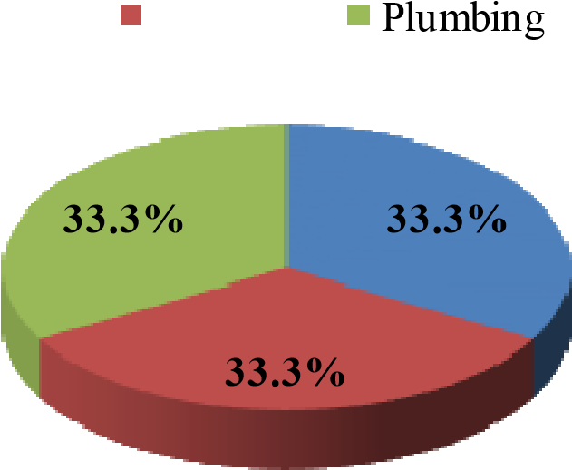
Masonry Carpentry Sub contractor Main contractor
4
5
4
5
Masonry
Carpentry
Pumbing
6 6

Figure 1: Sample proportion of the questionnaire survey

4.0 Data Analysis and Research Findings (Qualitative Data Analysis) 4.1 Current Status of the Sri Lankan Construction Industry
The findings of semi structured interviews revealed that there is a delay in the project due to various reasons. Majority of the respondents (86%) identified that there is a strong impact from labourers to the delay in projects. However, respondent 03 mentioned that “with high rates for skilled labourers, we can attract spirit of labour force for our projects to complete on time even though there is less number of highly skilled labourers”. Furthermore, 90% of respondents stated that currently they are experiencing shortage of skilled labourers in their ongoing projects. Among them, 77% of respondents identified masons and carpenters and 67% of respondents identified plumbers, as the trades which have shortage of skilled labourers. A few respondents revealed that, barbender as a trade that has a shortage. Moreover, respondent 05 stated that “they don’t like to join with companies, because they can earn more than companies’ rate by working individually”. These findings confirm the fact that there is a skill shortage in the industry and skills of labourers should be developed through training programmes for a successful project delivery. Moreover, the majority of the respondents emphasized that they could be satisfied with the workmanship of current labourers up to a limited extent, however, not 100%. Therefore, a huge demand for skilled labour is rooted in the construction sector.

4.2 Strategies to skills development of labour force
Most of the respondents (80%) revealed that, they do not test skills of labourers before they are recruited. However, respondent 01 stated that; “we closely supervise them during first few days on the job. After that we decide whether they can continue or not. If not we categorise them as helpers or semi-skilled labourers”.
Most of the respondents agreed respondent 01 by confirming that close supervision during first 2-3 weeks is very important to identify the skill level of the labourers. Moreover, their organisations consider about previous work experience of the labourers and the recommendations provided by their former employers. However, respondent 09 had a different perspective. He stated that, when recruiting skilled labourers, they consider the vocational training and their past experience and ask some critical questions from them to get an idea about their knowledge on construction technology. Similarly, respondent 06 stated that, “we give them to plaster about 3-4 m² of external wall of the site office or any other temporary structure as a sample. Then we measure time, quality and wastage and determine their skill level. This procedure is applicable only for recruiting direct labourers”. By considering the aforementioned facts it can be decided that there is no systematic skill determination and performance measurement criterion in the industry. Therefore, a proper skills measurement criterion should be introduced to develop skills of labourers.
The findings revealed that though there are many advantages from performance evaluation, most of the organisations not following a proper performance evaluation procedure for labour force. However, they believe that they can enhance the skills of labourers through performance evaluation process and speedup the progress of the project with a good quality. A combination of all suggested methods to evaluate and promote labourers is presented in Figure 2.
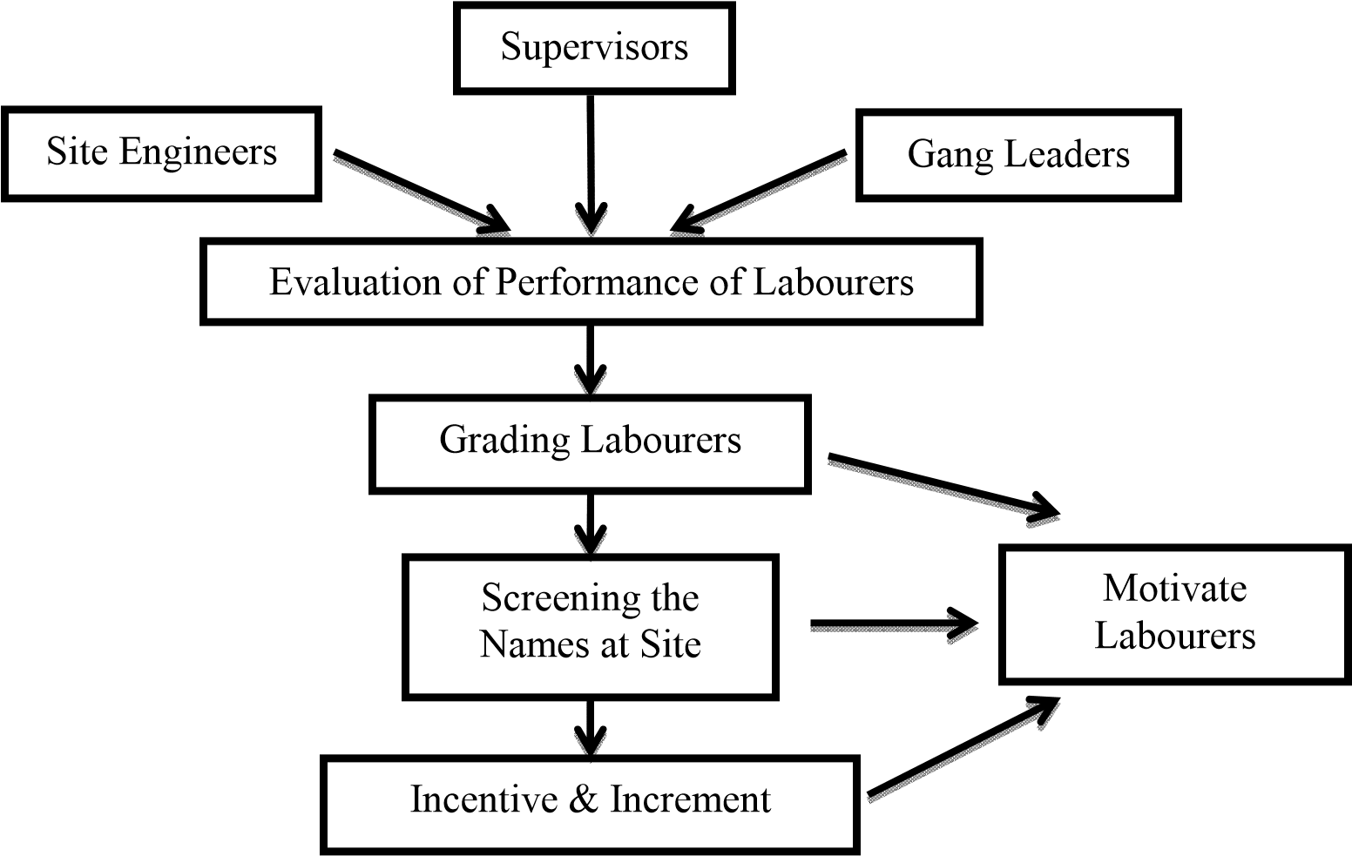
Figure 2: Motivation through performance evaluation
According to figure 2, the supervisors, site engineers and gang leaders should follow a proper effective performance evaluation criterion and then grade the labourers with incentives and increments in order to motivate them. Then, their performance level can be kept in a high level.
Most of the respondents (90%) stated that, the employment condition is at a satisfactory level in their organisations. They believe that, the industry can maximise the efficiency and effectiveness of the labourers by enhancing the employment condition to get maximum output from the labourers. Their suggestions to enhance the employment condition are listed below in Figure 3.
Most of the respondents stated that; good employment condition helps to attract the labourers and motivate them to develop their skills. Therefore, the employment condition should be maintained by giving sanitary facilities, safety equipment, and comfortable accommodations within the organisation as a motivation factor to develop skills of labourers.

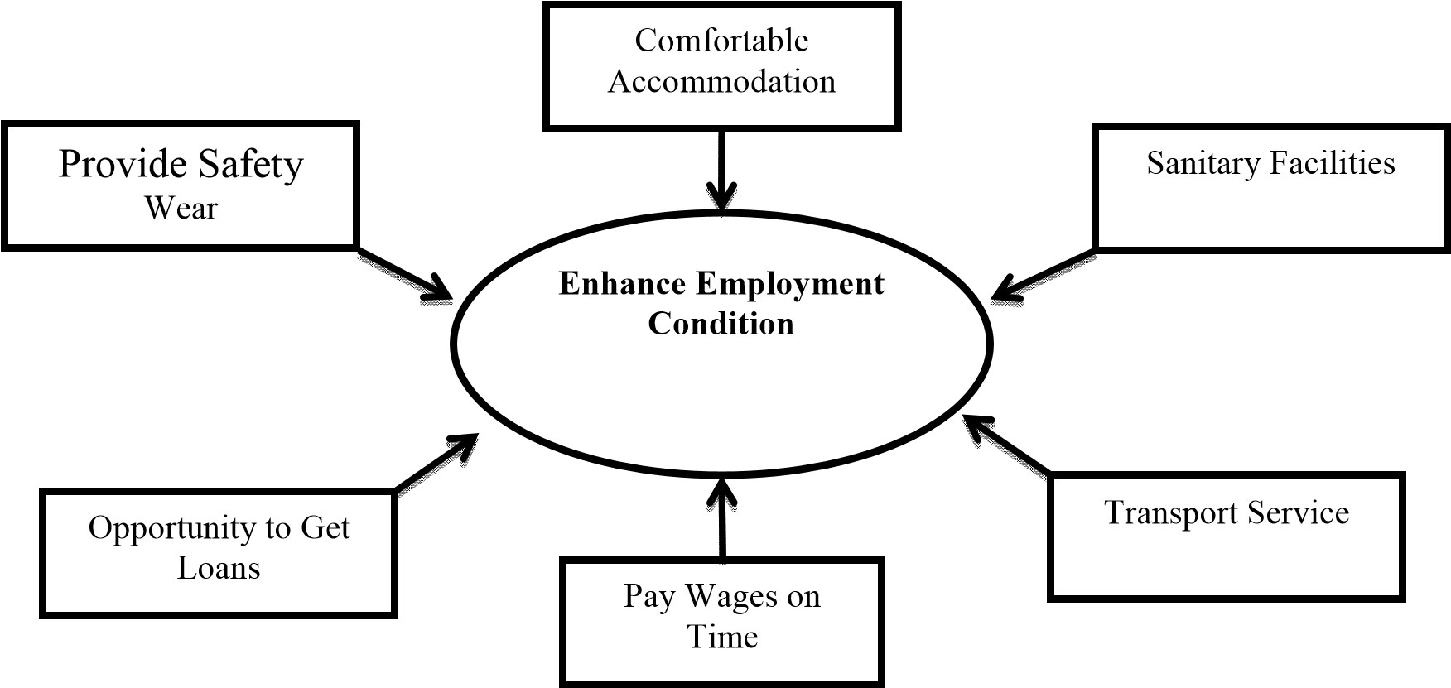
Figure 3: Respondents’ Suggestions to enhance employment condition
All respondents stated that; organisations can increase their profit through development of skills of labourers. Most of them stated that, the benefit which would receive from skills development is a long term benefit. Respondents 08 mentioned that; “Management does not consider much about skill development since it takes a long time and labourers are not permanent. The labourers are circulating among organisations time to time”.
Most of the respondents stated that the labourers are normally trained through on job training. Furthermore, a few respondents revealed that, they use labourers with expert skilled labourers as gangs. As a result, they inherent a proper job training. Nevertheless, respondent 03 revealed that, giving them a specific time to train is not possible within the tight time schedules and it is an extra cost to the organisation.

4.3 Hindrance to develop skills of labourers
90% of the respondents’ organisations do not provide in-house training opportunities for their labourers. With their tight time schedule, they do not have time to train their labourers with specific training programmes. Nonetheless, respondent 03 stated that “we improve labourers’ awareness on construction technology by giving them opportunities to work with excellent skilled labourers and then supervise them through supervisors”.
80% of respondents stated that they do not provide Out-Sourced training opportunities for their labourers. One of the respondents who provide training revealed that, if there are any short courses or workshops available, they send labourers spending company’s money and get them trained and through them, provide on job training for others and rate the success of the programme through performance evaluation. However, the effectiveness of this procedure is not in an acceptable level. The main reason behind this situation was the subcontracting and less direct labour involvement. Since the labourers are hesitant, management doesn’t tend to provide training opportunities and improve their skills. However, the respondents agreed that to develop skills through in-house and out-sourced training should be given to labourers.
All respondents except one agreed that migration affects to the skill shortage in the industry. In addition, respondent 09 said that “major reason for skill shortage is migration. Most of skilful labourers are recruited by the foreign companies and pay them high salaries. Semi-skilled labourers are remaining here. Then they are working as skilled labourers in Sri Lankan construction industry”. Furthermore, several respondents revealed that, labourers are getting job opportunities from outside of the country, after organisations develop their skills. Then the balance will remain here as low-skilled labourers. Therefore, migration heavily affects to the skill shortage in the industry. All identified hindrances for development of skills are shown in figure 4.

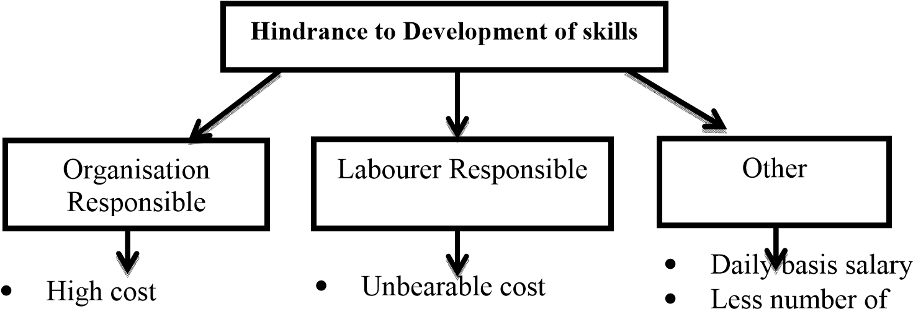

• •  • | Less guidance  Tight time schedule Less resources | • • • • •  • | Less concern  Less commitment  Traditional Thinking  No time to spend Poor educational background  Poor communication | •  • | training institute Less government cooperation No standard procedure
Figure 4: hindrances to development of skills

5.0 Data Analysis and Research Findings (Quantitative Data Analysis)
The findings of the survey were analysed by using RII method. During the analysis, the categories which have been obtained RII score of less than 70% were recognised as the skill categories that have to be developed. 7080% was recognised as medium level scarce categories and the rest of them are selected as non-scarce categories. Further, RII value was used as skill level of the each category for illustration and decision making purposes. As per the literature and the semi structured interviews, it was revealed that skills development is highly required for masonry, carpentry and plumbing. Therefore, each category is separately considered in the analysis.

5.1 Masonry
Masonry
Skill Categories | RII value | Rank
Brickwork | 90% | 2
Plastering | 98% | 1
Tiling | 68% | 3
Masonry trade skill categories such as brickwork (laying, finishing), Plastering (wall, soffit, reveal) and tiling (floor, wall) ranked based on RII values. The results are shown in table 2 and figure 5. Table 2: Ranking of masonry trade skill categories

Masonry Trade Skill Level
90
%
98
%
Bricklaying
68% Plastering
^{40%}Tiling
Bricklaying Plastering Tiling

Figure 5: Skill level of masonry trade categories
According to the RII value, the lowest ranked (most scarce) skill category in the masonry trade was tiling. It was in the skill level that should be developed according to the categorisation introduced by the researcher. Other two categories were identified as non-scarce skill categories as per the selected sample.

5.2 Carpentry
Carpentry trade skill categories such as roof work (roof structure, ceiling, facia board), door/window (planning, making frame and sash, fixing sash to frame) and formwork (fixing and levelling) were ranked based on RII values. The results are shown in table 3 and figure 6.
Table 3: Ranking of carpentry trade skill categories
Carpentry
Skill Categories | RII value | Rank
Roof Work | 75% | 2
Door/Window | 43% | 3
Formwork | 100% | 1

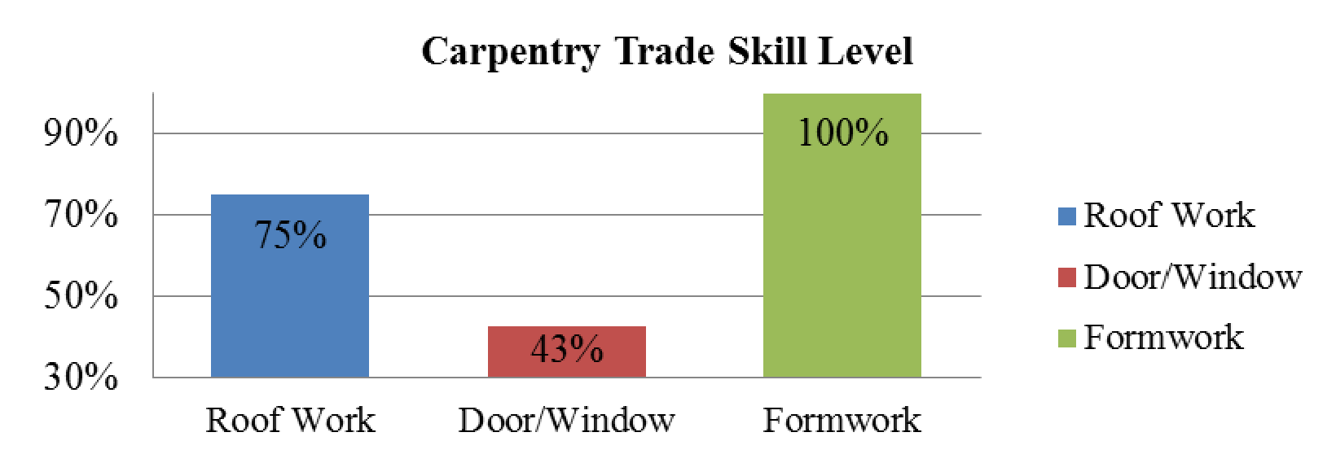
Figure 6: Skill level of carpentry trade categories
According to the RII values, the lowest ranked (most scarce) skill category in the carpentry trade was door and window. It was in the skill level that should be developed (below 70%). Roof work category was in the medium scarce level (between 70-80%). Formwork was identified as non-scarce skill category since 100% of RII obtained.

5.3 Plumbing
Plumbing trade skill categories such as pipe fitting (jointing pipes, laying pipes, connecting to accessories and determining the laying path), sanitary fittings (fixing wash basin, water closet and cistern), and plant installation
(water pump and hot water geezer) were ranked based on RII values. The results are shown in table 4 and figure 7.
Table 4: Ranking of plumbing trade skill categories
Plumbing
Skill Categories | RII value | Rank
Pipe Fitting | 90 | 1
Sanitary Fittings | 60 | 3
Plant Installation | 67.5 | 2

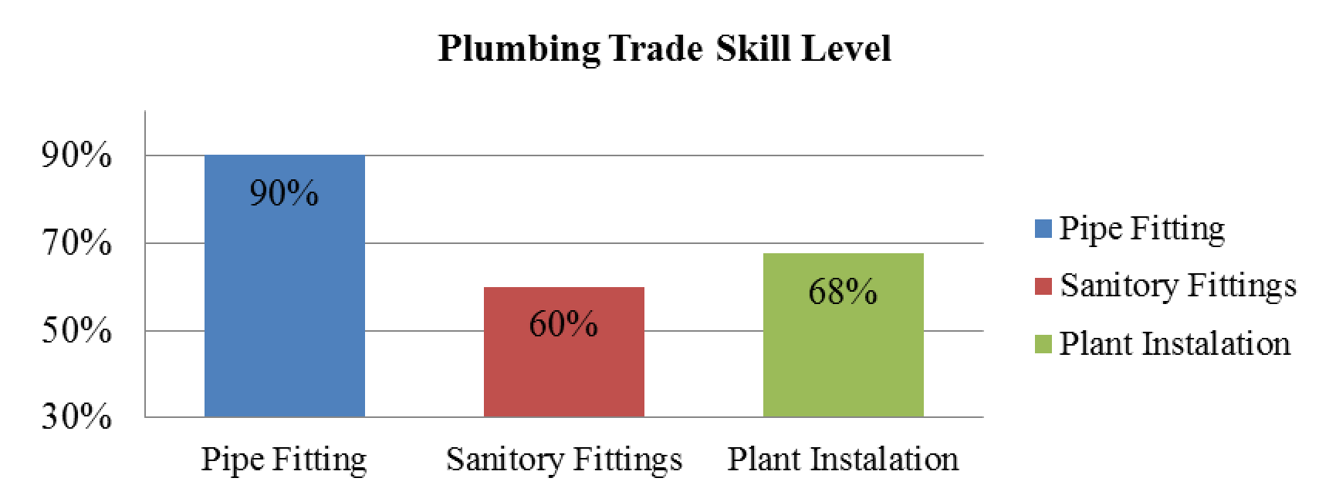
Figure 7: Skill level of plumbing trade categories
According to the RII value, sanitary fitting was the lowest ranked (most scarce) skill categories in the plumbing trade. Sanitary fittings and plant installation were in the level that should be developed (below 70%). Pipe fitting category was in the non-scarce level (not less than 80%).
As per the findings, the trades that highly demand a skills development are tiling, doors and windows related carpentry and sanitary fittings installation. Other than that, roof work and plant installation are also need to be developed.

5.4 Attitudes towards Skills Development
Most of the labourers in the industry are willing to develop their skills and they demand training since they believe that they can obtain salary increments, incentives, good recommendations for future job opportunities and secure their job. According to the respondents of the questionnaire survey, majority of the labourers never attended any training programmes. In addition, they think they can increase the speed and quality of the work and minimise the cost through reducing wastage and rectifications if they obtain a proper training.

5.5 Advantages of Skills Development
The strategies to develop skills which identified in the semi structured interviews will definitely spend a considerable amount from the company’s money. Therefore, prior to implement them, an analysis is required to see whether the particular expenditure will provide considerable benefits. Hence, the advantages were found with regard to speed, quality and minimising wastage.

5.5.1 Increasing the speed of work through skills development
Here the purpose is to find out the respondents’ thought on whether they can increase the speed of work with the use of new methods after attending a skill development programme. Figure 8 and 9 demonstrate the findings of the survey.
25 | 5

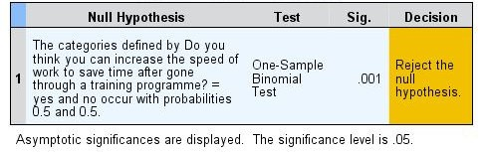
0
%
20
%
40
%
60
%
80
%
100
%
Yes
No

Figure 8: Ability to increase speed of work

Figure 9: Hypothesis test summary for ability to increase speed of work
According to the binomial test, the obtained significant level was 0.001(<0.05). Indication here is that; at an assurance of 95%, “Yes” or “No” with the given definition do not occur with the same probability. The answer is biased to “Yes” since 83% of the respondents say “Yes”. This reveals majority of labourers in building construction industry have the vision that they can speed up the work after learning new methods through skills development programme.

5.5.2 Minimising wastage through skills development
This analysis was carried out to check whether the respondents are thinking that they can minimise the wastage after going through a skill development programme. Figure 10 and 11 demonstrate the findings of the survey.

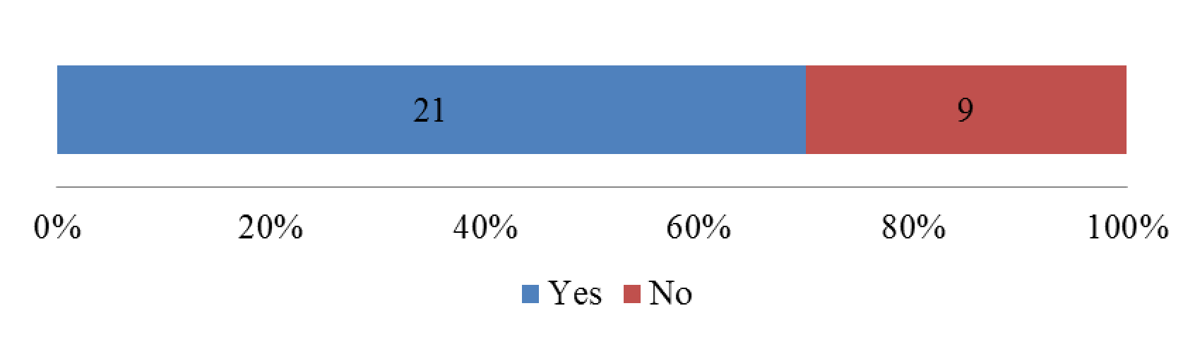
Figure 10: Ability to minimize wastage
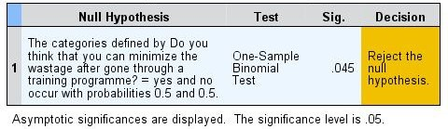
Figure 11: Hypothesis test summary for ability to minimise of wastage
According to the binomial test, the obtained significant level was 0.045(<0.05). Indication here is that; at an assurance of 95%, “Yes” or “No” with the given definition do not occur with the same probability. The answer is biased to “Yes”, since 70% of the respondents say “Yes”. This reveals majority of labourers in building construction industry have the vision that they can minimise the wastage after going through a skills development programme.

4.4.3 Increasing the quality of the work through skills development
Under this question, the intention is to identify whether the respondents have the vision that they can increase the quality of the work after going through a skills development programme. Figure 12 and 13 demonstrate the findings of the survey.
21 | 9

0% 20% 40% 60% 80% 100%
Yes No
Figure 12:
Ability to Increasing the quality of the work
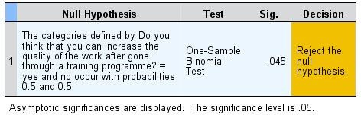
Figure 13: Hypothesis test summary for ability to increase quality of the work
According to the binomial test, the obtained significant level was 0.045(<0.05). Indication here is that; at an assurance of 95%, “Yes” or “No” with the given definition do not occur with the same probability. The answer is biased to “Yes” since 70% of the respondents say “Yes”. This reveals majority of labourers in building construction industry have the vision that they can increase the quality of the work after going through skills development programme.
Based on the above mentioned facts, a framework has been developed to develop skills of labourers as presented in figure 14. According to figure 14, the skills development process is clearly identified. In addition, the factors to be affected during each stage were clearly shown and the strategies to develop were given considering each stage and the related factors. Therefore, it can be recommended that by using this proposed framework, the management of the project can enhance and uphold the performance of the labourers and consequently have a better outcome when compared to the current situation.
Further to the framework, quality, quantity and skill category of the labourer should be taken into consideration during the investigation of skill shortage and scrutinizing the need of the industry as the first two steps of skills development process. Effective research and cleaning house can be used as the strategies to successfully implement above mentioned two stages. Then, a proper motivation should be given to the labourers by considering the facts such as performance evaluation, grading at site, screening the grade at site, increment for grade, enhance employment condition, guidance and good communication. A proper awareness should be there to proceed this step since the motivation can be properly done only if there is a good understanding of the labourer’s performance.
Design standards and training programmes can be successfully done with proper coordination of both employees and employers. The designed programmes should be successfully implemented in terms of exhibitions, workshops, seminars, short courses, video clips and close supervision. Subsequently, an effective skills measurement criterion should be designed and implemented by considering speed of work, wastage, quality of work, experience and qualification. Finally, the labourers can be graded properly.

6.0 Research Findings and Discussion
Most of the projects were behind the master programme and the delay was depending on the type of project. As mentioned in literature, normally construction projects undergo delays. Delays occur in every construction project and the magnitude of these delays varies extensively from project to project (Hoai & Lee, 2009). In addition, a construction project is usually acknowledged as successful when it is completed on time (Takim and Akintoye, 2002).
According to the responses, organisation can improve the quality, reduce the cost of project and save the valuable time indirectly through development of skills of labourers. As mentioned in literature, meeting the client’s requirements on cost, time and quality of the work depends significantly on the performance of skilled labourers and their training and skills (Praveen, Niththiyananthan, Kanarajan, & Dissanayake, 2010). So the analyses of interviews also confirm the situation identified in literature.
Most of the construction companies were experiencing a shortage of skills due to the boom in the construction industry. As mentioned in literature, the skilled labour force in Sri Lanka may be insufficient considering the expected development in the construction projects (ICRA, 2011). Furthermore, some construction organisations were mitigated this issue with high wage rate which attract the spirit of the labour force in the industry.
According to the analysis, most of the labourers in construction industry were not participated any skill development programme previously. Also they think that, they can increase the speed of work, minimise the wastage and enhance the quality of the work through a skill development programme. As mentioned in literature, Meeting the client’s requirements of cost, time and quality of the work depends significantly on the performance of skilled labourers and their training and skills acquired (Praveen et al., 2010).
Interviewees revealed that the direct labour employment is very less in current projects. Almost it was below 20% of the project labour force. As mentioned in literature, there is evidence from many countries that the permanent directly employed labour has declined in recent years while the proportion of labour employed through subcontractors and intermediaries on temporary and casual terms has increased (ILO, 2001). So the analyses of interviews also stabilize the situation.
Most of the respondents commented on poor sanitary facilities for labourers. Ultimately, according to their point of view the employment condition of labourers is in a satisfactory level. But in the literature, according to Clarke & Wall (1998) and Leitch (2006) poor employment condition and pay is there in the industry.
It was found that the majority of contracting organisations in the industry do not provide in-house or out-sourced training opportunities for their labourers. As discussed in literature, less concern on the current labourers’ skills development by the employer organisations is also a critical issue to the development of skills of labourers (Pathirage, 2008).
As found in the analysis, barriers to development of skills were traditional thinking of labourers, less government involvement, less effort by the organisations, unavailability of time for both organisations and labourers. As defined in literature, barriers which would affect to the development of skills are, poor image of the industry, less job satisfaction/wage, less concern by the employer organisation, Subcontracting. So the analyses of interviews also stabilize the situation identified in literature.

7.0 Conclusions and Recommendations
Throughout this research, it is investigated that, whether projects are delivered successfully by developing skills of labourers and found strategies to develop skills. There are labourers who have fewer skills currently in the industry and they are working as skilled labourers since skilled labour shortage is there in the industry. Mainly, there are skill shortages in Masonry (tillers), Carpentry (door/window) and Plumbing (sanitary fitting) trades. This issue will indirectly lead to poor quality of the final outcome, extra cost for rectifications and wastage and more time for completion. No systematic procedures were found from the industry to develop labourers’ skills in order to mitigate these issues. Since direct labour employment is less in the industry, in-house or out-sourced training opportunities were not provided by the employer organisations to subcontractor’s labourers.

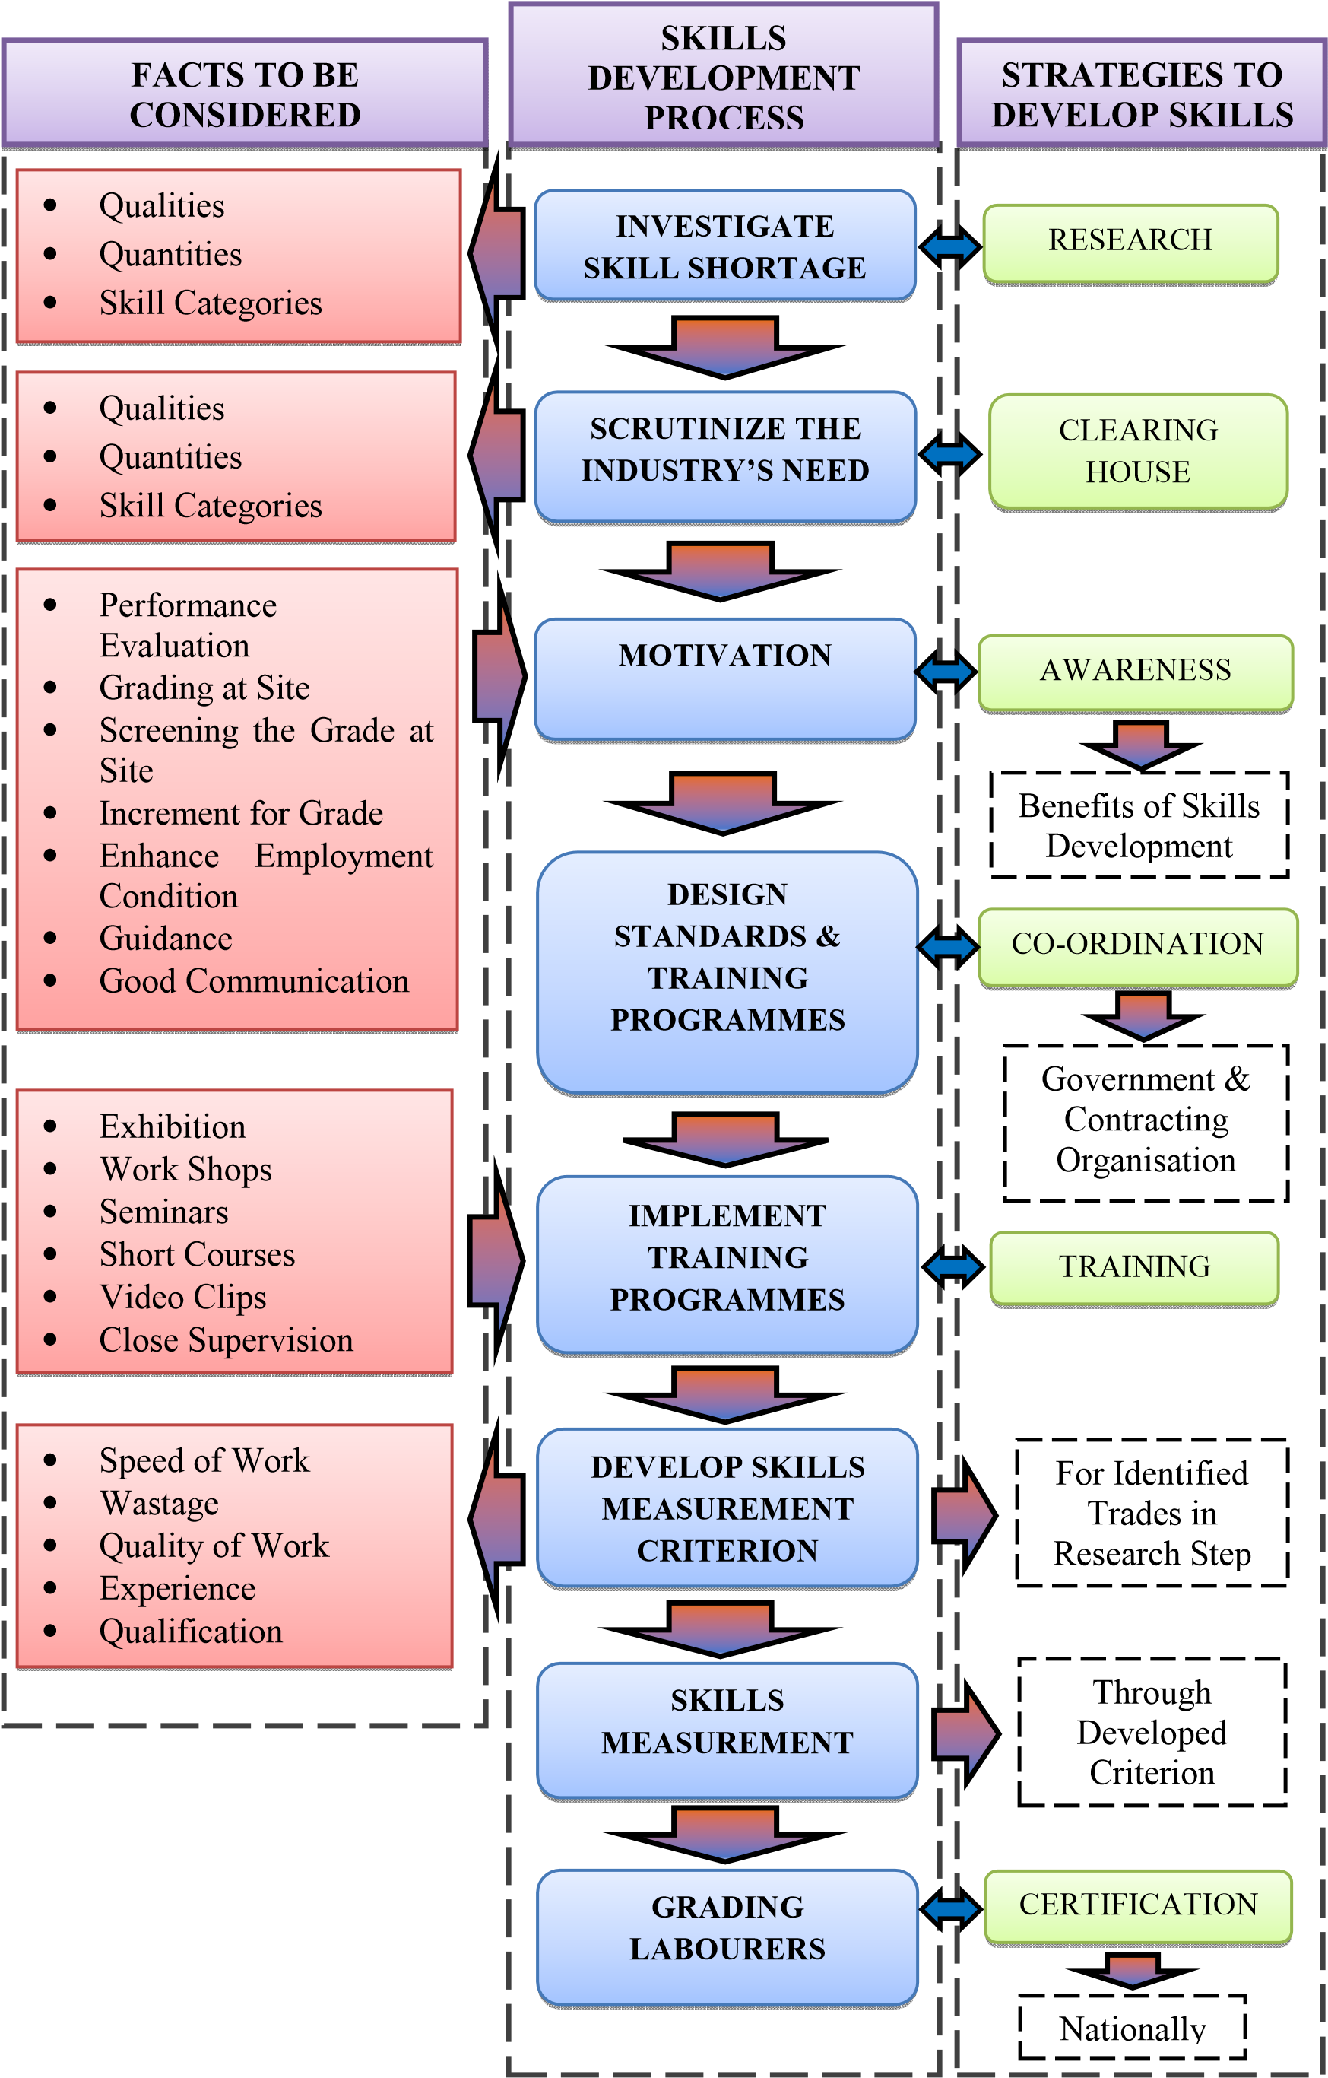
Figure 14: Framework to develop skills of labourers No systematic procedure was found from the industry to determine the skill level of the labourers or categorize them nationally in a systematic way. With the help of categorization/grading system, the skill level of each labourer is determined before they recruited and labourers are motivated towards the development of their skills through a grading system. Grading of labourers is done through a performance evaluation process. Migration has an impact to the skilled labour shortage and technology advancement has an impact to the skill shortage in the industry. Since both the employer organisation and labourers have less commitment on the development of skills of labourers, skill shortage is there in the industry. Most of the skill labourers who are working in the industry have acquired skills through informal training from senior skilled labourers. In that way they cannot learn the technology behind the works. So it is concluded that; labourers and contracting organisations should be motivated towards the development of skills of the labourers.
Labourers always think that they can speed up the work, minimise the wastage and defects and enhance the quality of the end product after gone through a skill development programme. However, the labourers don’t have any guidance on developing their skills. Awareness of labourers about the training institutes is also less in the industry. Eventually it is concluded that; labourer should be guided towards the development of skills. The best way to develop the skills of labourers is educate them on the benefits which can be obtained from the development of skills and conduct skills development programme. This training programme should be very short and economical for the labourers as well as to the organisation. If the government can involve in this process, it will be a great advantage to the industry. Since there are inadequately trained labourers in the industry, it is recommended through this research for contracting organisations to develop a framework to develop skills of labourers or use the given framework of this study. It is also recommended to conduct performance evaluation procedure at site continuously for labourers to get maximum output from them.

8.0 Reference
Alaghbari, W., Kadir, M. R. A., Salim, A., & Ernawati, (2007). The significant factors causing delay of building construction projects in Malaysia. Engineering, Construction and Architectural Management, 14(2), 192-206.
Allmon, E., Haas, C. T., Borcherding, J. D., & Goodrum, P. M. (2000). U. S. Construction productivity trends. Journal of Construction Engineering and Management, 126(2), 97-104.
Arditi, D., & Lee, D. (2003). Assessing the corporate service quality performance of design-built contractors using quality function deployment. Construction Management and Economics, 21(2), 175-185.
Attanayake, A. M. C. (2012). Factors affecting performance quality of subcontracting in Sri Lankan construction industry (Unpublished bachelor’s dissertation). Department of Building Economics, University of Moratuwa, Sri Lanka.
Bjarnason, T. (2008). Social recognition and employees’ organizational support: The impact of social recognition on organizational commitment, intent to stay, service effort, and service improvements in an Icelandic service setting [Adobe Digital Editions version]. Retrieved from
https://gupea.ub.gu.se/bitst ream /2077/19676/1/gupea_2077_19676_1.pdf
Central Bank of Sri Lanka. (2012, December). Annual report-2012. Colombo: Central Bank of Sri Lanka.
Chan, A. (2004). Factors affecting the success of a construction project. Journal of Construction Engineering Management, 130(1), 153-155.
Chan, A.P.C., Chiangn, Y.H., & Wong, J.M.W. (2006). The changing construction labour market: a case of Hong Kong. Journal of Engineering, Design and Technology, 4(1), 1–17.
Colander, D. C. (1994). Economics (2nd ed). London: Irwin publications.
Dai, J., & Goodrum,P. M. (2012). Generational differences on craft workers’ perceptions of the factors affecting labour productivity. Canadian Journal of Civil Engineering, 39, 1018-1026. doi:10.1139/L2012-053 Green, E.A., & Owen, D. (2003). Skills shortages: local perspectives from England. Regional Studies, 37(2), 123-34.
Henny, P. A., & Moh, F. N. (2012). Improving skill’s strategies of Indonesian construction labours to have global competitiveness. International Journal of Civil and Structural Engineering, 3(1), 150-157.
Hewage, K. N., Gannoruwa, A., & Ruwanpura, J. Y. (2011). Current status of factors leading to team
performance of on-site construction professionals in Alberta building construction projects. Canadian Journal of Civil Engineering, 38, 679–689. doi:10.1139/L11-038
Hoai, L. L., Lee, Y. D. (2009). Time-cost relationships of building construction project in Korea. Facilities, 27(14), 549-559.
Information and Credit Rating Agency. (2011, September). Construction, Retrieved from http://www.icralanka.com/Sri%20Lanka%20Construction%20%20 Sept% 2015%20final.pdf
International Labour Organization. (2001). The construction industry in the twenty-first century: its image employment prospects and skills requirements. Retrieved from
http://www.ilo.org/public/english/standards/relm/gb/docs/gb2 83/pdf/tmci tr.pdf
Kanji, G., & Wong, A. (1998). Quality culture in the construction industry. Quality Management, 9(5), 133–140.
Kikwasi, G. J. (2011). An evaluation of construction skills in Tanzania. Engineering, Construction and Architectural Management, 18(2), 127-139.
Kraemer, L. K. (2002). Survey research methodology in management information systems: an assessment. Working paper on graduation of management of school, University of California, California.
Loosemore, M., Danity, A. & Lingard, H. (2003). Human Resources Management in Construction Project: Strategic Operational Approaches. London: NY.
McKim, R.A., & Kiani, H. (1995). Applying total quality management to the North American construction. Cost Engineering, 37(3), 24-28.
Pathirage, A. (2008). Sri Lanka country report. In Proceedings of 14th Asia Construction Conference, (pp. 1011).
Praveen, R., Niththiyananthan, T., Kanarajan, S., & Dissanayake. P. B. G. (2010). Understanding and Mitigating the Effects of Shortage of Skilled Labour in the Construction Industry of Sri Lanka. Unpublished manuscript, Department of Civil Engineering, University of Peradeniya, Sri Lanka.
Pribadi, K. S., Soekiman, A., Soemardi, B.W., & Wirahadikusumah, R.D. (2007). Factors relating to labour productivity affecting the project schedule performance in Indonesia. Unpublished manuscript, Department of Civil Engineering, Parahyangan Catholic University, Indonesia.
Takim, R., & Akintoye, A. (2002). Performance indicators for successful construction project performance (Unpublished master’s thesis). University of Northumbria, Newcastle, UK.
Weddikkara, C. (2006, November 8). Sri Lanka faces skilled worker shortage to meet construction boom. Lanka
Business Online. Retrieved from http://www.Lanka businessonline.com/news/Sri_Lanka_faces_skilled_worker
_shortage_to_meet_construction_boom/1322729967
Whyte, D. & Greene, S. (2009, December). The Skilled Workforce Shortage. The National Center for
Construction Education and Research. (11-15) Retrieved from
https://www.google.lk/url?sa=t&rct=j&q=&esrc=s&source=web&cd=8
&ved=0CGcQFjAH&url=http%3A%2F%2Fwww.hrpwa.org%2Ffile%2Fnews%2Fskilled-workforceshortage.pdf
Zaki, S. B. A., Mohamed, S. F., & Yusof, Z. M. (2012). Construction skilled labour shortage –the challenges in malaysian construction sector. International Journal of Sustainable Development, 4(5), 99-108.

