27th International Conference on Flexible Automation and Intelligent Manufacturing, FAIM2017, 27-30 June 2017, Modena, Italy
Optimisation of Additive Manufactured Sand Printed Mould Material for Aluminium Castings
Dr P Hackneyª, Dr R Wooldridgeª, Dr C Connorª
ªDept. of Mechanical and Construction Engineering, Northumbria University, Newcastle upon Tyne, NE18ST, UK
Abstract
The sand casting process is utilised for over 70% of all castings, the traditional this process requires a disposable sand mould, A pattern the shape of the product to be manufactured, plus manufacturing features is used to create the cavity. Additive Manufacturing processes have been used to generate the sand mould tools directly without patterns, hence reducing the lead time and manufacturing design constraints. This paper focuses on optimising the characteristics of the 3D Sand Printing process to traditional produced Furan mould tools, cumulating with an automotive turbo charger case study, to validate the build parameters optimisation process.

© 2017 The Authors. Published by Elsevier B.V.
Peer-review under responsibility of the scientific committee of the 27th International Conference on Flexible Automation and Intelligent Manufacturing.
Keywords: Rapid Casting Technology; 3D Sand Printing; Sand Casting.
- Introduction
  - Background

The foundry industry provides near net shape metal casting for a wide range of industries, producing castings in ferrous and non-ferrous metals from miniature items as small as zips to large castings such ships’ propellers.
The sand casting process has changed little over centuries, except for incremental improvement in materials and mechanisation of the process, the fundamental process being that of sand compacted around a pre manufactured mould pattern, which is then removed to cast the metal. For mass production stage this is both efficient and economical, however during development and prototyping production stages, the requirement for mould production tooling, the design constrained production method often means this stage is often a major bottleneck in new product development.
Additive manufacturing has been used to manufacture sand moulds for metal sand casting using laser sintering and sand bonding process without the need for tooling.
The approach taken in this research is to evaluate characteristics of casting produced and relates to the permeability, dimensional accuracy, tensile and compressive crush strength, density, impact strength and high temperature resistance of the mould tool produced. These properties are required to compare the 3D Sand Printing (3DSP) process to traditional Furan based casting sand mixtures.
This research would be of interest to designers and manufacturing engineers wishing to take advantage of the implications of having new design freedom, tool-less manufacturing with short lead times in a wide range of materials using fundamentally tried and tested foundry industry casting techniques, an automotive turbo charger casing was used to validate the build parameters optimisation process.

Traditional casting techniques for high temperature melting alloys are normally always manufactured by a disposable one off ceramic or silica mould capable of withstanding the high temperatures and other casting requirements. Once the mould is produced, the pouring/deposition and solidification is accomplished in seconds or minutes, with carefully controlled mould production, casting and cooling techniques then accurate, reliable and predictable component quality and dimensional accuracy can be achieved.
Additive Manufactured (AM) sand mould production has the ability to produce rapid bespoke moulds that can be used with traditional production metal casting techniques, providing the user with key commercial and strategic advantages []. Additive Manufacturing [] is a group of technologies with the ability to generate parts and mould tools without patterns, providing new design freedom (and different design constraints) with the advantage of reduced lead time directly from 3D CAD data. It can allow the innovative design engineer to manufacture products not achievable using traditional casting methods, negating the requirement to consider split lines, undercuts and the inclusion of draft angles, a requirement to extract patterns and cores during mould manufacture.

  - State of the Art

There are three main sand cast mould tool additive manufacturing techniques currently commercially available; Direct Metal Laser Sintering (DMLS), ZCast and 3D Sand Printing (3DSP); each with their own characteristics, however only the 3D Sand Printing System can produce the size of moulds required by many automotive manufacturers.
Direct Laser Sand Sintering (DLSS) is a well-established technique using a similar process to direct metal laser sintering and melting (SLS, DMLM), the same inherent process characteristics of long warm up and cool down stages, and limited build zone. The sinter pool hence production rate, is a function of the laser spot size (0.3 mm), laser travel speed (50-100 mm/s), laser power, layer thickness, conductivity of bed and process settings, such as step over (1/2 beam width), heat and cool down periods.
ZCast is a process capable of generating mould tools developed by ZCorp, which is relatively fast and cheap for the direct printing of complex moulds with a proprietary mould material (ZCast501). The process ZCast Direct Metal Casting, has three different approaches, direct pour method, shell method, and production intent casting method. The tolerances and surface finish of castings obtained using ZCast are consistent with sand casting []. The Zcast build volume is 450* 300 by 400 mm, material non-porous and suitable for non-ferrous casting
The 3D Sand Print (3DSP) Process is similar to the ZCast process in that it is a cold process requiring only a post-production off machine de-powdering. A deposition head uses a 150 mm wide multi-jet print head travelling at 60-80 mm/s to deposit a binder to sand mixed with activator in 0.28 to 0.5 mm layers. The process utilises traditional sand casting materials of sand activator and furan binder to bond the silica sand grains, each layer taking 40-60 seconds to produce each layer of the sand mould tool [].
The build deposition rate of 60-85,000 cm³/hr or 96 kg/hr is achieved in a near skip size (1.8 * 1.0 * 0.7 metres) build chamber; the industrial scale sand build chamber has been developed on rails to enable quick change over and transportation to the off line de-powdering station.

  - Why the Need?
Sand casting is the most common (90%) production method for metal castings [], it is used extensively in the automotive industry to produce structurally strong net shape parts, and requiring minimal machining post cast. Aluminium alloys are used extensively for weight and cost reasons, with the purpose to manufacture light weight and fuel efficient vehicles. One automotive manufacturer alone currently produces 1,215,000 sand castings per year for powertrain use to support the production of 81,000 vehicle sales per annum within Europe.
Traditionally this process requires expensive inflexible tooling with large lead times, costing between £10k to £100k and taking many months to manufacture and test before final release for production.
The rapid rise of manufacturing capacity in previously third world countries such as India, China and Southern Africa has led to a major change to the UK manufacturing base. The UK is increasingly becoming a knowledge led design based economy with manufacturing being outsourced on a global scale. This is the evolution of Globalisation, predominately due to inflexible high cost manufacturing process, however AM provides a technique whereby low volume production is again commercially viable in the West at the point of sale. The comparison of the traditional to AM based Rapid Casting Technology (RCT) route from design to cast metal part is shown in Figure 1, reducing process steps and time.

  - Properties of Sand Pattern Materials
The types of sand can vary considerably and are dependent upon the location of source. Sand quality greatly affects casting quality and should have the following characteristics;
- Strength: The ability of the sand to maintain its shape once formed.
- Permeability: The ability of gas to pass through the sand. Gas porosity found in castings is reduced by having higher permeability; also better finishing of surface is gained by having lower permeability. It is determined by the sand grain shape, size and bond area.
- Thermal Stability: The ability of resisting damage by heat such as cracking and distortion.
- Collapsability: The sands ability to collapse or compress during casting solidification. In the mould, castings that cannot shrink freely may result in casting hot tear, cracks or distortion [].
- Reusability: The sands ability to be recycled for future use for environmental and economic reasons.
  - The 3D Sand Printing Process
The 3D Sand Printing Process (3DSP) can be used to create a core or mould via the Rapid Casting Technology (RCT) method. This method of printing uses selectively delivered micro-droplets of the foundry grade resin binder into a fine thin layer of permeable casting sand premixed with activator. In this process the components produced are extremely accurate, and the machines have high build rates []. The lower gas content allows the system to be readily used for high end use automotive components such as cylinder heads.
The method is fast compared to Sand Sintering with a multi-jet nozzle traversing across the build in strips of 100 mm or more, therefore the production of single casting can be achieved in a short period of time directly from the 3D design data [].
The method to manufacture a single or production casting is typically as illustrated in Figure 1 left hand pathway, which can take between 2-6 weeks to achieve a cast part to evaluate, depending upon the complexity and therefore the number of mould tool components to manufacture. Rapid Casting Technology (RCT) route uses the shorter right pathway.
Furan binder systems account for approximately 38% of the UK chemical binder market. Furan is a popular binder system due to it being easy to control, having generally the lowest material costs, excellent strength with low addition levels and a high mechanically reclaimed sand re-use level [].
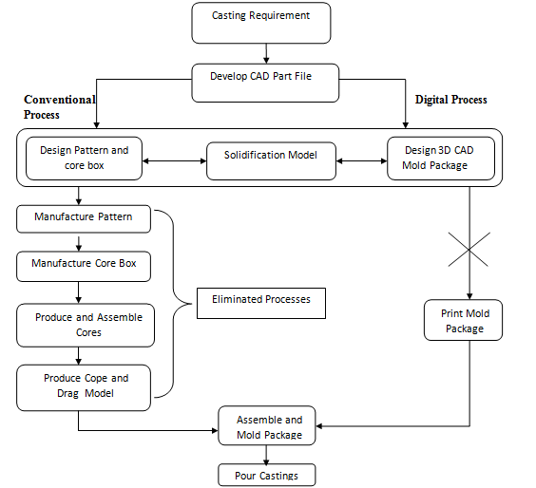
24-48 hours
14- 28 days
24- 48 hours
Fig. 1 - Conventional versus RCT process Flow chart
2. Experimentation Methodology
2.1 Experimentation Plan

The investigation focused upon the 3DSP process parameter optimisation, subsequently applied to a complex automotive casting application of a turbo charger casing.

Stage 1 - investigated the relationship between key build parameters, such as print resolution, z-height, binder and activator ratios on sand part casting ability characteristics. Each test build was repeated three times with the binder and actuator combinations for consistency and robustness of data generated.

Tests were carried out to investigate;
- Dimensional accuracy of the tensile test dumb bells, cylinders and geometric features
- Material properties
    - Tensile tests of the tensile test dumb bars
    - Compression tests of cylinders
    - Burn out test to establish rigidity at elevated temperatures
    - Impact strength
    - Permeability
After the materials and build characteristics were determined, the key performance parameters were found from surveying casting companies to use their expertise to develop the best materials combinations. These rankings were used to select 4 casting settings to develop and cast the turbo-charger. The ratio of binder, Resolution and Z step were controlled as per table 1 with the activator at 0.32% for all trials.

Stage 2 – This stage of casting trials of aluminium turbo charger casing, using the developed data from Stage 1, these were analysed for geometric accuracy and metrology evaluated for casting defects.

Three turbocharger body castings were manufactured in aluminium for all four box settings of the ExOne machine totaling 12 parts for experimentation. This requires moulds and cores being printed for each box setting subsequently followed by casting and heat treatment of the turbo parts as shown in Figure 2.

Table 1- Fourteen box settings

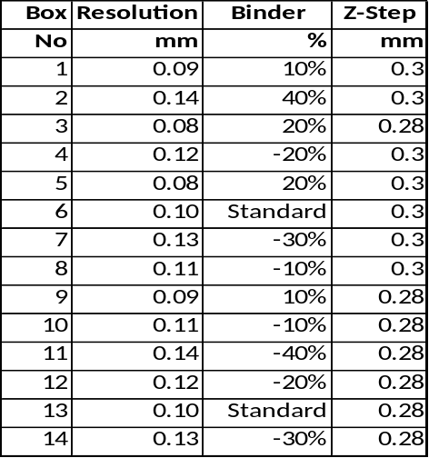

TECHNICAL SPECIFICATIONS

ExOne S-PrintTM Furan machine, with a build volume of 1800 * 1000 * 700 mm, Build speed 60 - 85 L/h Layer thickness 280–500 µm, Print resolution X/Y/Z 100.0 µm External dimensions l 3270, w 2540, h 2860 mm, Silica Sand size (280, 380, 500 µm), file type STL, A global shrinkage allowance of 2% has been applied to parts.

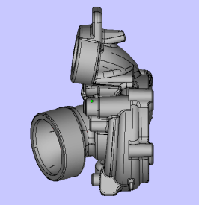
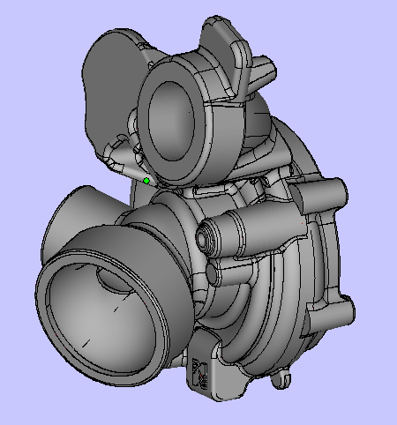
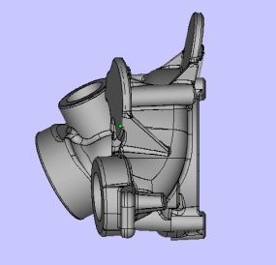
Fig. 2 – Magic software renders of turbocharger part
2.2 Results
Stage 1 – The test work was combined into a single results table as shown in Table 2b. Based on discussions with casting companies regarding the relative importance of each mould characteristics were ranked as shown in Table 2a, with 1 least important and 5 most important feature. In the case of a difference in opinion, a rounded average value was used.
Compression strength and dimensional accuracy are the most important parameters followed by rigidity (strain), impact and permeability to degas the moulds.
The results were collated from five results from every sample test. A table 2b was developed to show which box had the best settings, using a scoring system where 5 was the best result and the 1 was the lowest.

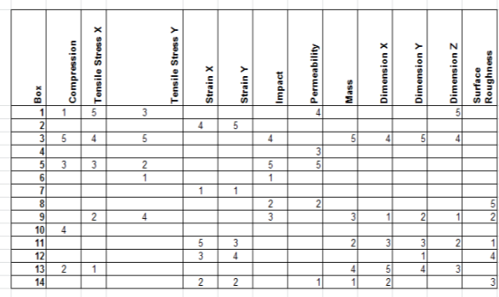
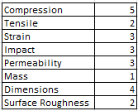
Table 2a - Mould feature characteristics Ranking Table 2b - Top 5 results of each experiment

Once the ratings were developed for each experiment, another table was constructed using the values from table 2a and multiplying by the rankings as shown in table 2b to form the overall scoring matrix shown in table 3. From table 3 it can be clearly seen that box setting 3 has highest total sum which suggests that this box has the optimum settings for the sand patterns.
Sample 3 has a resolution of 0.08, binder quantity of 20% more than standard, Z step 0.30 mm and an activator of 0.32%. The box with the least number is box 6 which was the standard machine setting with a resolution of 0.10, binder quantity is standard, Z step 0.30 mm and an activator of 0.32%.
These scores were then used to select the operating criteria for the turbo charger castings. Four settings were then selected to be used to generate the turbo charger castings, box setting One, Three, Six (machine default setting) and Eleven.

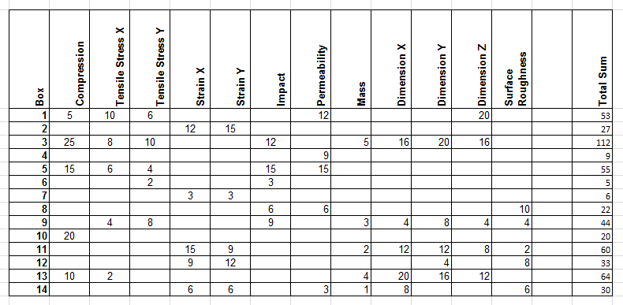
Table 3 - Ranked results

Stage 2 – Casting and Evaluation
The turbocharger castings were delivered as shown in Figure 3a. After being heat treated, the heat treatment would not affect the cast defects investigated in this study. An initial visual inspection of each part was undertaken to validate that the parts were of suitable casting quality. The inspection takes into account all aspects of the casting including; integrity surface finish, flash and waste material.

- Setting 1 - Good quality, although there was a small sink on the main inlet which could be a quality concern. Surface finish was generally of an acceptable quality.
- Setting 3 - Produced the lowest quality castings out of all settings. These parts could be considered extremely poor as all parts had major integrity issues where the mould had either not de-gassed or the casting material had failed to flow. This suggests that using a higher binder percentage in the build material of the mould and core system makes for a failed casting in terms of quality.
- Setting 6 – Default Setting - Parts produced using setting six were of a good quality in terms of structural integrity. Surface finish of these parts was also good. Turbo 6C. Was of the same quality as part 6-B although there was a small hole in an outlet similar to parts of box setting 1. apart from this defect the part could be considered a good casting.
- Setting 11- Highest quality parts, which suggests that using less binder produces a higher quality part. The downside of this is that the moulds and cores are significantly weaker and more susceptible to damage. The parts produced at this setting had the highest quality and surface finish. Structural integrity and surface finish was excellent for all of these parts. The amount of flash produced by the parting line of the drag and cope of the mould was minimal. These parts passed the quality assurance test and are shown in figure 3b and 3c.

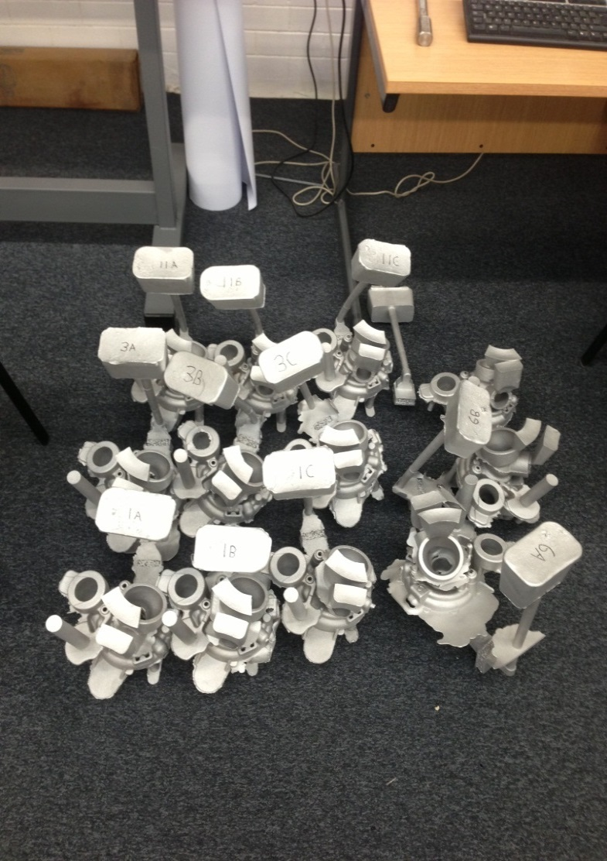
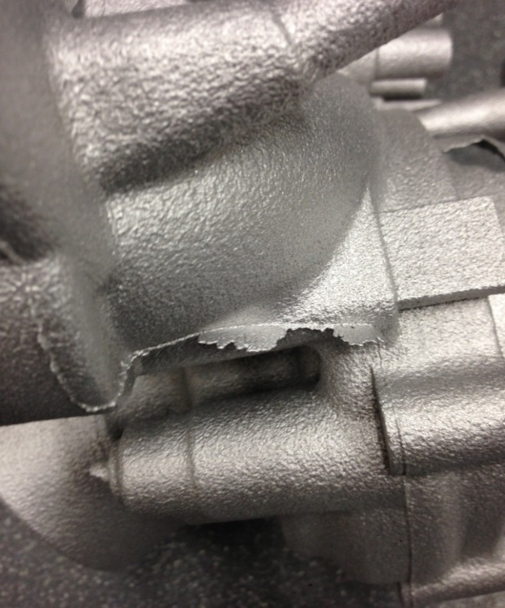
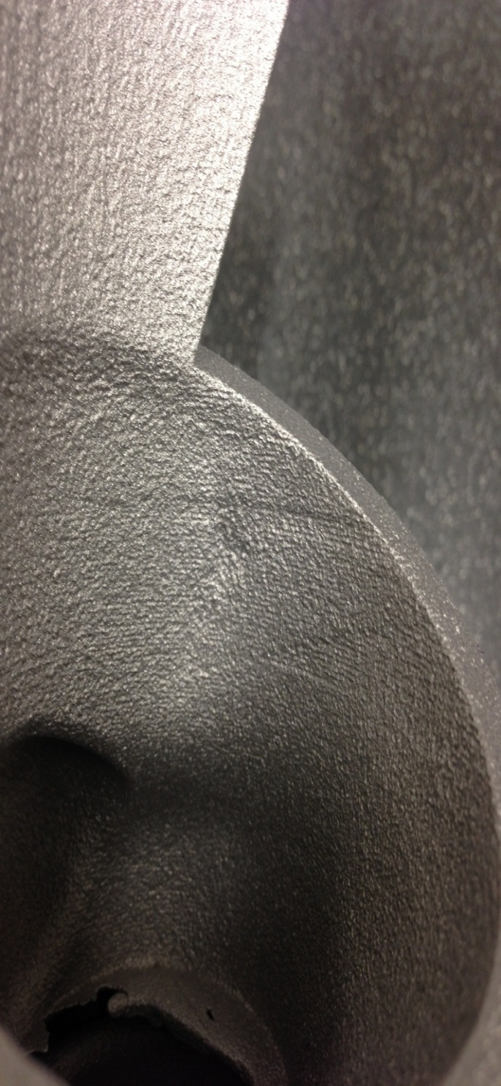
a
b

c

Fig.3. (a) Castings as delivered, (b, c) Example of casting quality on the housing of part 11-B representative of both 11B and 11C
3. Conclusions
In conclusion to the experimental procedure that was designed to identify which sand pattern characteristics were most important for producing quality castings. Five types of experimentation were applied to the process which were tensile, compressive and accuracy tests on printed sand parts and also visual analysis and CMM testing on the turbocharger component. A selection matrix was used to calculate which box setting is the most appropriate for rapid casting.

As box setting six performed consistently well in all tests and it is the standard setting of the S-max machine it has been used as a reference to rate the experimental box settings.
- Box setting One under-performed by 17.1 % than the default setting, concluding this setting inappropriate for rapid casting.
- Box setting Three under-performed by 12.2% compared to six; to improve the result given by this parameter a re-design of the moulding process must be undertaken to provide higher permeability could improve casting quality.
- Box setting Eleven performed 2.4% better than six overall therefore making this setting the most suitable for rapid casting. Although this box setting provides the weakest mould due to its low binder content the castings produced are accurate and highly repeatable.
- A proposed offset, regarding the increase in diameter of internal bores by 0.1 mm to allow for bleed compensation is appropriate for all box settings would improve accuracy of mould tools produced.

Taking these conclusions into account it can be suggested that the 3D Sand printing systems (i.e. the 3DSP process) are appropriate for use in the rapid casting process. A production quality turbocharger part, suitable for practical use can be produced with a reduced lead time and cost. The utilisation of this system, rather than using traditional sand casting methods, can be viewed as a beneficial modernisation of an age-old manufacturing processes providing product design and production flexibility without lead time and cost overheads. The benefits to adopters of the RCT is the ability to rapidly changes their manufacturing tools to meet market (new product) demands, with the reduced lead time and added design freedoms additive manufactured mould can provide.

References

Krouth, T.J. (2002), “Foundry tooling and metal castings in days”, Proceedings from International Conference: Worldwide, Advances in Rapid and High-performance Tooling, EuroMold, Frankfurt/M, Germany.
ASTM F2792-1011 (2010), “Standard terminology for additive manufacturing technologies”, www.astm.org/Standards/F2792.htm, accessed 20/7/16
Bak, D. (2003), “Rapid Prototyping or Rapid Production? 3D printing processes move industry towards the latter”, Assembly Automation, Vol. 23 No. 4, pp. 340-5.
ZCast501 (2004), Direct Metal Casting, Design Guide, ZCorporation, September, available at: www.zcorp.com, accessed 20/7/16
Shi, Y & Wang, L, Sand casting precision technology based on non-occupying Coating Technology, Int Conf on Computer design and Applications (2010)
Parkes, W. B. Clay-bonded foundry sand. London: Applied Science Publishers, 1971.
http://www.exone.com/en/materialization/what-is-digital-part-materialization/sand, accessed 20/7/2016
Wang, X.H., Fuh, J.Y.H., Wong, Y.S. & Tang, Y.X. (2003) "Laser Sintering of Silica Sand – Mechanism and Application to Sand Casting Mould", International Journal of Advanced Manufacturing Technology, vol. 21, no. 12, pp. 1015-1020.
No-Bake Binder Developments, Andrew Busby, ICME West Midlands, Coventry and Birmingham Branch Technical Meeting, 4 October 2010. http://www.icme.org.uk/news.asp?ID=354, accessed 14/02/17.

