**Lycopene and Tomato and risk of cardiovascular diseases: A systematic review and meta-analysis of epidemiological evidence**

**Ho M Cheng1, Georgios Koutsidis1, John K Lodge 1, Ammar W Ashor2, Mario Siervo2, Jose Lara1**

**1 Department of Applied Sciences, Faculty of Health and Life Sciences, Northumbria University, Newcastle upon Tyne, UK**

**2 Human Nutrition Research Centre, Institute of Cellular Medicine and Newcastle University Institute for Ageing, Newcastle University, Newcastle upon Tyne, UK**

**Email addresses:**

[ho.m.m.cheng@northumbria.ac.uk](mailto:ho.m.m.cheng@northumbria.ac.uk) [georgios.koutsidis@northumbria.ac.uk](mailto:georgios.koutsidis@northumbria.ac.uk) [john.lodge@northumbria.ac.uk](mailto:john.lodge@northumbria.ac.uk)

[a.w.ashor@newcastle.ac.uk](mailto:a.w.ashor@newcastle.ac.uk) [mario.siervo@newcastle.ac.uk](mailto:mario.siervo@newcastle.ac.uk) [jose.lara@northumbria.ac.uk](mailto:jose.lara@northumbria.ac.uk)

**Short title: Lycopene and Tomato and risk of cardiovascular disease**

**Corresponding author:**

Dr Jose Lara

Department of Applied Sciences, Faculty of Health and Life Sciences, Northumbria University, Ellison Building, Room A324, Newcastle upon Tyne, NE1 8ST, UK.

Word count (journal requirements): Abstract 248 (250); manuscript 3500 including tables and legends;

Refs 50; Tables 1; Figures (5 total); supplementary material

# Abstract

**Background and aims:** Worldwide, cardiovascular diseases (CVDs) remains as the main cause of mortality. Observational studies supports an association between intake of tomato products or lycopene with a reduced CVDs risk. Our aim was to undertake a systematic review and meta-analysis of the evidence on the topic.

**Methods:** Medline, Web of Science, and Scopus were searched from inception until July 2017. We included longitudinal and cross-sectional studies reporting associations between lycopene and tomato consumption and cardiovascular morbidity and mortality among adult subjects. Random-effects models were used to determine the pooled effect sizes.

**Results:** Twenty-eight publications met our inclusion criteria and 25 studies provided quantitative data for meta-analysis. Results showed that individuals in the highest consumption category of, or with the highest serum concentration of, lycopene had significantly lower risk of stroke (hazard ratio (HR) 0.74, 0.62-0.89, *p*=0.02; *I2*=32) and CVDs (HR 0.86, 0.77-0.95, *p*=0.003; *I2*=0). In addition, individuals categorised in the highest serum concentration of lycopene also had significantly lower risk of mortality (HR 0.63, 0.49-0.81, *p*<0.001; *I2*=46). Lycopene was not significantly associated with myocardial infarction, while scarce evidence on the association of lycopene with atherosclerosis, congestive heart failure, or atrial fibrillation was evident. Evidence from three studies suggested that higher intakes of tomato were associated with non-significantly lower stroke, CVDs and CHD.

**Conclusions:** This comprehensive meta-analysis suggests that high-intake~~s~~ or high-serum concentration of lycopene are associated with significant reductions in the risk of stroke (26%), mortality (37%) and CVDs (14%).

**Keywords:** tomato; lycopene; cardiovascular disease; mortality, systematic review, meta-analysis

# Introduction

Low intakes of fruit and vegetables are important global risk factors that contribute to accelerated ageing, morbidity and early mortality, (Forouzanfar et al., 2015). A number of epidemiological studies of disease endpoints provide strong and consistent evidence for a beneficial effect of fruit and vegetables, combined or separately, on cardiovascular health (Mozaffarian et al., 2011). Fruit and vegetables intakes in the range commonly recommended (e.g. >5 servings) are associated with 21 to 26% reductions in the risk of stroke (He et al., 2006; Hu et al., 2014), and with 17 to 25% reductions in the risk of coronary heart disease (CHD) (Dauchet et al., 2006; He et al., 2007; Ness and Powles, 1997).

In addition, epidemiological studies have shown that specific fruit and vegetables individually are significantly associated with reductions for different types of cancer. On this area, recent systematic reviews and meta-analyses of epidemiological studies have reported that high consumption of tomato products is significantly associated with reduced risk of gastric cancer (27%) (Yang et al., 2013). Tomato is a rich source of lycopene, a major carotenoid in human plasma with strong antioxidant properties (Mein et al., 2008). Both higher consumption of, and higher blood levels of, lycopene, are also associated with a lower risk of prostate cancer (Chen et al., 2013; Chen et al., 2015; Etminan et al., 2004). These findings have triggered an interest on the effects of lycopene and tomato consumption on health outcomes.

A recent systematic review of interventions trails by our group has shown that tomato or lycopene supplementation successfully improved important cardiovascular risk factors including LDL-cholesterol, interleukin-6, flow mediated dilation (FMD), and systolic blood pressure (SBP) (Cheng et al., 2017). In addition, observational cohort studies seem to add support by reporting positive associations between higher tomato and/or lycopene intake or status and lower risk of cardiovascular diseases (CVDs) (Jacques et al., 2013).

A previous meta-analysis on the association of lycopene and stroke reporting a reduction in risk of stroke (19.3%) (Li and Xu, 2014). However this work is now 4 years old and further evidence is likely to be available. Therefore, here we present an updated systematic review of the literature and meta-analysis on the associations between lycopene or tomato consumption and CVD risk and mortality in epidemiological studies. In addition we aimed to explore the impact of important covariates as potential sources of heterogeneity in studies.

# Methods

This systematic review was undertaken following standard guidance by the Cochrane collaboration (Higgins and Green, 2011) and the Centre for Reviews and Dissemination (University of York, 2009). This manuscript is reported according to the PRISMA guidelines (Moher et al., 2010) (Figure 1 and Table S1). The systematic review protocol was registered in PROSPERO, the International Prospective Register of Systematic Reviews (CRD42016049526).

In July 2017, three databases including Medline, Web of Science, and Scopus were searched from inception. In addition, reference lists of identified publications were screened in an attempt to identify further relevant studies.

The searches included the following terms/keywords related to the exposures and outcomes of interest: tomato, lycopene, cardiovascular disease (CVD), coronary heart disease (CHD), myocardial infarction (MI), stroke, atherosclerosis, atrial fibrillation (AF), congestive heart failure (CHF), sudden cardiac death, mortality, and morbidity. The terms related to outcome measures thus included a number of conditions under the umbrella of CVDs, as well as associated disorders such AF. Data for each of these outcomes was extracted if explicitly reported in the original papers. The present systematic review was restricted to articles published in English.

Two authors (HMC, JL) screened articles independently for eligibility. The decision to include/exclude studies was hierarchical and consisted on screening firstly the titles and abstracts of studies; if the authors were unable to reach decision at this stage, then the full-text of the article was evaluated.

## Inclusion/exclusion criteria

The following specific inclusion criteria were used to identify eligible articles: 1) Study Design: longitudinal and cross-sectional studies; 2) Subjects: Adult subjects >18 years of age; 3) Exposure: data related to tomato or lycopene dietary intakes or serum concentration; 4) Outcomes: CVD morbidity and associated disorders and mortality outcomes (CVD, CHD, MI, stroke, atherosclerosis, AF, CHF, sudden cardiac death, mortality) expressed as Hazard Ratio (HR), Relative Ratios (RR), and Odd Ratios (OR) with 95% confidence interval (CI).

Exclusion criteria included: 1) Study Design: Non-epidemiological studies; 2) Subjects: Subjects <18 years of age; 3) Exposure: different exposures; 4) Outcomes: risk factors, non-CVD related outcomes.

## Data extraction

Extracted information included: study design (country, assessment of tomato and/or lycopene intake, serum lycopene concentrations, cohort name, follow-up length); participant characteristics (sample size, population, mean age, body mass index and ethnicity); outcome measures (CVDs and associated disorders, and mortality, as stated above); adjustment for covariates.

Information related to the outcomes of interest was extracted and analysed as reported in the original papers. If studies reported associations of tomato or lycopene with CVD, but also reported associations for specific CVDs such as stroke or CHD, all these were extracted and analysed separately. This procedure was adopted in order to provide differential associations between the exposures and specific outcomes of interest.

## Outcome measures and exposures

Primary outcomes of interest were risk of stroke, CVD, CHD, MI, atherosclerosis, AF, CHF, all-cause mortality, cardiovascular mortality and sudden cardiac death.

We were interested in studies associating these outcomes with exposures such as intakes of lycopene or tomato products, and lycopene concentrations in blood or any other body tissues such adipose tissue.

## Statistical analysis

Meta-analysis of results was undertaken using the Review Manager (RevMan Version 5.1 for Windows Copenhagen: The Nordic Cochrane Centre, The Cochrane Collaboration, 2011). Random effects models, accounting for inter-study variation and minimizing potential bias due to methodological differences between studies, were used.

Results are informed as HR or OR with 95% confidence intervals (CI) and two-sided P-values. In this meta-analysis, five studies evaluated multiple arms of cardiovascular diseases and associated disorders. Meta-regression analysis was undertaken to explore the association of effect size with continuous variables such as age and BMI of study participants, or length of follow up. In addition, we undertook subgroup analysis to explore the impact of variables such as sex, or country of origin.

Statistical heterogeneity was evaluated using the *I2* statistic (Higgins and Green, 2011; University of York, 2009), with *I2* values greater than 50% representing high levels of heterogeneity. Publication bias was assessed by inspecting the funnel plot of effect size against the standard error (SE), with asymmetry assessed formally with Egger’s regression test (Egger et al., 1997).

# Results

A total of 3970 articles were identified (**Figure 1**). Twenty-eight articles fulfilling our inclusion criteria (Ascherio et al., 1999; Ford et al., 2014; Hak et al., 2004; Hak et al., 2003; Han and Han, 2016; Han et al., 2016; Hirvonen et al., 2000; Iribarren et al., 1997; Ito et al., 2006; Jacques et al., 2013; Kabagambe et al., 2005; Karppi et al., 2013a, b; Karppi et al., 2012a; Karppi et al., 2012b, 2013c; Karppi et al., 2012c; Klipstein-Grobusch et al., 2000; Kohlmeier et al., 1997; Mayne et al., 2004; Osganian et al., 2003; Rissanen et al., 2001; Sesso et al., 2004, 2005; Sesso et al., 2003; Street et al., 1994; Tavani et al., 2006; Wood and Johnson, 2004) were included in this review (**Table 1**), and 25 of these provided quantitative results for meta-analysis (Ascherio et al., 1999; Ford et al., 2014; Hak et al., 2004; Hak et al., 2003; Han et al., 2016; Hirvonen et al., 2000; Iribarren et al., 1997; Ito et al., 2006; Jacques et al., 2013; Kabagambe et al., 2005; Karppi et al., 2013a, b; Karppi et al., 2012a; Karppi et al., 2012b, 2013c; Karppi et al., 2012c; Klipstein-Grobusch et al., 2000; Kohlmeier et al., 1997; Mayne et al., 2004; Osganian et al., 2003; Rissanen et al., 2001; Sesso et al., 2004, 2005; Sesso et al., 2003; Tavani et al., 2006).

* 1. **Characteristics of studies**

Twenty-five of the included studies assessed lycopene alone (Ascherio et al., 1999; Ford et al., 2014; Hak et al., 2004; Hak et al., 2003; Han and Han, 2016; Han et al., 2016; Hirvonen et al., 2000; Iribarren et al., 1997; Ito et al., 2006; Kabagambe et al., 2005; Karppi et al., 2013a, b; Karppi et al., 2012a; Karppi et al., 2012b, 2013c; Karppi et al., 2012c; Klipstein-Grobusch et al., 2000; Kohlmeier et al., 1997; Mayne et al., 2004; Osganian et al., 2003; Rissanen et al., 2001; Sesso et al., 2004, 2005; Street et al., 1994; Tavani et al., 2006), and three studies assessed both lycopene and tomato (Jacques et al., 2013; Sesso et al., 2003; Wood and Johnson, 2004).

These studies varied according to length of follow up (2 to 17.5 years), sample size (range: 37 to 73286 participants), mean age (45 to 71y), and mean BMI (24 to 28). Overall, the mean serum concentration of lycopene were 0.15 μmol/l (lowest categories) and 0.41 μmol/l (highest categories); mean intakes of lycopene were 1.85 mg/d (lowest categories) and 9.81 mg/d (highest categories). The studies included in this review originated from USA (15), Finland (8) and single studies from Costa Rica, Italy, Japan and Netherland, and a multicentre European study. According to sex, 12 studies included only men and three included only women, while 13 studies were including mixed sex.

* 1. **Meta-analysis: Lycopene and cardiovascular diseases**

Twenty-five studies, including 211704 participants, evaluated the association between lycopene and a number of cardiovascular diseases reported below (Ascherio et al., 1999; Ford et al., 2014; Hak et al., 2004; Hak et al., 2003; Han et al., 2016; Hirvonen et al., 2000; Iribarren et al., 1997; Ito et al., 2006; Jacques et al., 2013; Kabagambe et al., 2005; Karppi et al., 2013a, b; Karppi et al., 2012a; Karppi et al., 2012b, 2013c; Karppi et al., 2012c; Klipstein-Grobusch et al., 2000; Kohlmeier et al., 1997; Mayne et al., 2004; Osganian et al., 2003; Rissanen et al., 2001; Sesso et al., 2004, 2005; Sesso et al., 2003; Tavani et al., 2006).

* + 1. **Stroke**

Eight studies, including 119322 participants, evaluated intake or serum concentration of lycopene and incidence of stroke (Ascherio et al., 1999; Hak et al., 2004; Hirvonen et al., 2000; Ito et al., 2006; Jacques et al., 2013; Karppi et al., 2012c; Rissanen et al., 2001; Sesso et al., 2003). Overall, meta-analysis showed that high intake or serum concentration of lycopene were significantly associated with reduced incidence of stroke (HR 0.74, 0.62-0.89, *p*=0.001). Heterogeneity levels assessed by the *I2* test were low at 32% (**Figure 2A**). Results from studies evaluating intake of lycopene showed that higher intake was significantly associated with reduced incidence of stroke (HR 0.79, 0.64-0.97, *p*=0.02) (Ascherio et al., 1999; Hirvonen et al., 2000; Jacques et al., 2013; Sesso et al., 2003). Heterogeneity levels assessed by the *I2* test were low at 44% (**Figure 2A**). Similarly, there was strong evidence that high serum concentration of lycopene was associated with lower risk of stroke (HR 0.61, 0.40-0.92, *p*=0.02) (Hak et al., 2004; Ito et al., 2006; Karppi et al., 2012c; Rissanen et al., 2001). Heterogeneity levels assessed by the *I2* test were low at 31% (**Figure 2A**).

Visual inspection of the funnel plot and calculation of the Egger’s regression test indicated no publication bias (*p*=0.70) (**Supplementary material S1**) (Egger et al., 1997).

In addition, meta-regression analysis on the association between high intake or serum concentration of lycopene and incidence of stroke showed no significant associations with the length of follow-up, age or BMI (**Supplementary material S2 to S4**).

Subgroup analysis (**Table 2**) showed that four studies originating from Japan and Finland reported significant reduction in incidence of stroke with high intake and serum concentrations of lycopene (HR 0.63, 0.48-0.82, *p*<0.001; *I2*=30%); while four studies from the USA reported non-significant lower risk of stroke (HR 0.88, 0.71-1.07, *p*=0.20; *I2*=0%). Between-group comparison of these results according to geographical origins were not significantly different between (*p*=0.06).

Subgroup analysis according to sex showed that high intake and serum concentrations of lycopene were significantly associated with reduced incidence of stroke in studies including men only (HR 0.71 0.51-0.99, *p*=0.04; *I2*=56%) and studies including both sexes (HR 0.75, 0.58-0.98, *p*=0.03; *I2*=7%). One study including women only showed that high intake of lycopene was non-significantly associated with reduced incidence of stroke (HR 0.91, 0.57-1.45, *p*=0.69). The between group comparisons according to sex was not significantly different (*p*=0.69).

Subgroup analysis by follow-up time showed that in studies with ≤8y follow-up, high intake or serum concentration of lycopene were associated with non-significant reductions in the risk of stroke with high heterogeneity levels (HR 0.75, 0.54-1.05, *p*=0.09; *I2*=62%). In studies with a follow-up >8y, high intake or serum concentration of lycopene were associated with significant reductions in the risk of stroke with low heterogeneity levels (HR 0.75 0.60-0.95, *p*=0.02; *I2*=0%). Between-group comparison of these results according to length of follow-up were not significantly different between (*p*=0.98).

Subgroup analysis according to age showed that in studies with mean age ≤55y, high intake of lycopene was associated with non-significant lower risk of stroke (HR 0.85, 0.65-1.12, *p*=0.26; *I2*=0%); however, studies with mean age >55y, high intake or serum concentration of lycopene were associated with significantly lower risk of stroke (HR 0.66, 0.56-0.77, *p*<0.001; *I2*=0%). In addition, two studies in which mean age was not reported showed that high intake of lycopene was associated with non-significant reduction in the risk of stroke with high heterogeneity levels (HR 0.52, 0.12-2.29, *p*=0.39; *I2*=77%).

Subgroup analysis by BMI showed that in studies with mean BMI <26, high intake or serum concentration of lycopene were associated with non-significant lower risk of stroke (HR 0.90, 0.70-1.16, *p*=0.44; *I2*=0%), while in studies with mean BMI ≥26, high intake or serum concentration of lycopene were associated with significant lower risk of stroke with low heterogeneity levels (HR 0.64, 0.48-0.86, *p*=0.003; *I2*=44%). In addition, one study not reporting mean BMI showed that high serum concentration of lycopene was associated with non-significant lower risk of stroke with high heterogeneity levels (HR 0.78, 0.51-1.19, *p*=0.25; *I2*=77%).

* + 1. **CVDs**

Seven studies, including 121651 participants, evaluated intake or serum concentration of lycopene and incidence of CVDs (Ito et al., 2006; Jacques et al., 2013; Mayne et al., 2004; Osganian et al., 2003; Sesso et al., 2004, 2005; Sesso et al., 2003). Overall, meta-analysis showed that high intake or serum concentration of lycopene were significantly associated with a reduced incidence of CVDs (HR 0.86, 0.77-0.95, *p*=0.003). Heterogeneity levels assessed by the *I2* test were low at 0% (**Figure 2B**).

Results from studies evaluating intake of lycopene showed that higher intake was significantly associated with reduced incidence of CVDs (HR 0.88, 0.78-0.99, *p*=0.03) (Jacques et al., 2013; Osganian et al., 2003; Sesso et al., 2003). Heterogeneity levels assessed by the *I2* test were low at 0% (**Figure 2B**). In addition, studies evaluating serum lycopene concentrations showed that high concentration was associated with non-significant lower risk of CVDs (HR 0.78, 0.63-0.98, *p*=0.03) (Ito et al., 2006; Mayne et al., 2004; Sesso et al., 2004, 2005). Heterogeneity levels assessed by the *I2* test were low at 0% (**Figure 2B**).

Meta-analysis of four studies (Ito et al., 2006; Jacques et al., 2013; Mayne et al., 2004; Osganian et al., 2003), including 81741 participants, indicated that there was strong evidence that high intake or serum concentration of lycopene were associated with lower incidence of CHD (HR 0.81, 0.67-0.98, *p*=0.03). Heterogeneity levels assessed by the *I2* test were low at 26% (**Supplementary material S5**).

* + 1. **Mortality**

Five studies, including 6249 participants, evaluated serum concentration of lycopene and risk of mortality (Ford et al., 2014; Han et al., 2016; Karppi et al., 2012b, 2013c; Mayne et al., 2004). Overall, meta-analysis showed that high serum concentration of lycopene was significantly associated with a reduced risk of mortality (HR 0.63, 0.49-0.81, *p*>0.001). Heterogeneity levels assessed by the *I2* test were low at 46% (**Figure 2C**).

In addition, two studies assessing mortality were not included in meta-analysis. One study not included in meta-analysis because the results were based on the use of a different reference group, reported that high serum concentration of lycopene was associated with non-significant lower risk of CHD mortality (HR 0.42, 0.14-1.30, *p*=0.42) (Mayne et al., 2004). The second study reported that among people with lupus erythematosus, high serum concentration of lycopene were associated with a lower mortality rate (5.3%) while the group with low serum lycopene concentration had a mortality rate of 33% (Han and Han, 2016).

* + 1. **Others cardiovascular-related disorders**

One study evaluating CHF, including 1031 participants, indicated that there was strong evidence that high serum concentration of lycopene was associated with lower incidence of CHF (HR 0.24, 0.10-0.56, *p*=0.001) (**Supplementary material Figures S6**) (Karppi et al., 2013b). In addition, Wood and Johnson (2004) evaluating CHF reported that lower lycopene levels was associated with non-significant reduction of CHF among individuals with periodontitis (HR 0.65, 0.21-2.03) and without periodontitis (HR 0.59, 0.15-2.24) (Wood and Johnson, 2004). One study by Karppi et al. (2013) evaluated AF and reported that high serum concentration of lycopene was associated with significant increased risk of AF (HR 0.45, 0.26-0.78, *p*=0.004) (**Supplementary material Figures S6**) (Karppi et al., 2013a).

Meta-analysis of five studies, including 7825 participants, indicated that there was not strong evidence that high serum concentration (Hak et al., 2003; Karppi et al., 2012a), or either adipose tissue (Kabagambe et al., 2005; Kohlmeier et al., 1997) or intake (Tavani et al., 2006) of lycopene was associated with lower incidence of MI (OR 0.84, 0.57-1.23, *p*=0.37) (**Supplementary material Figures S7**). In addition, another study on MI that was not included in meta-analysis because the results were based on the use of a different reference group, reported a non-significant higher risk of MI with lower serum lycopene concentration (OR 1.33, CI not provided, *p*=0.54) (Street et al., 1994).

Meta-analysis of two studies, including 679 participants, indicated that high serum concentration of lycopene were associated with a non-significant reduction in the risk of incidence of atherosclerosis (OR 0.79, 0.60-1.04, *p*=0.09). Heterogeneity levels assessed by the *I2* test were low at 0% (**Supplementary material Figures S7**) (Iribarren et al., 1997; Klipstein-Grobusch et al., 2000).

* 1. **Meta-analysis: Tomato and cardiovascular diseases**

Three studies, including 49110 participants, evaluated the association between consumption of tomato products and CVDs reported below (Jacques et al., 2013; Sesso et al., 2003; Wood and Johnson, 2004).

Jacques et al. (2013) and Sesso et al. (2003), evaluated intake of tomato and incidence of stroke and CVDs (Jacques et al., 2013; Sesso et al., 2003). Meta-analysis of these studies, including 43580 participants, showed that high intake of tomato was associated with non-significant reductions in stroke (HR 0.53, 0.12-2.42, *p*=0.41), and non-significant reductions in CVDs (HR 0.91, 0.77-1.07, *p*=0.26) (**Supplementary material S8**).

Jacques et al. (2013) including 5135 participants, evaluated tomato product intake and incidence of CHD (Jacques et al., 2013). Higher intake of tomato product was significantly associated with a reduced incidence of CHD (HR 0.91, 0.83–0.99, *p*=0.03).

Sesso et al. (2003), including 38445 participants, reported that high intake of tomato based product was non-significantly associated with reduced risk of MI (RR 0.39, 0.12-1.30, *p*=0.13) (Sesso et al., 2003) (**Supplementary material S8**).

In addition, Wood and Johnson (2004) reported that lower consumption of tomato were associated with significant increased risk of CHF among individuals with periodontitis (HR 5.10, 1.67-15.57) and without periodontitis (HR 1.68, 0.60-4.76) (Wood and Johnson, 2004).

# Discussion

* 1. **Principal findings**

This systematic review and meta-analysis of epidemiological studies revealed that there is strong evidence indicating that lycopene intake or serum concentrations were associated with significant reductions of 26% in stroke, 14% in CVDs; while high serum lycopene concentration were associated with significant reduction of 37% in mortality. In addition, subgroup analysis of the studies evaluating stroke revealed that the association of high intakes of lycopene and lower risk of stroke were particularly significant among older and overweight individuals; studies with longer follow-up were also more likely to report significant associations. This systematic review revealed a dearth of evidence on the associations with other cardiovascular outcomes such as atherosclerosis, MI, CHF, AF. Scarce evidence also indicated that high dietary and plasma lycopene, or high intakes of tomato were not associated with significant reduction of stroke, CVDs, CHD, MI and CHF. These results have important public health implications given the high prevalence of CVDs globally.

* 1. **Scientific analysis of findings and implications for health**

A focus on the health impacts of dietary patterns, as a whole, has been emphasised over the past couple of decades (Hu, 2002), and the important health benefits of major dietary patterns, such as the Mediterranean dietary pattern, are well documented (Estruch et al., 2013). However, it is evident that the impact of dietary patterns is a result of the additive effects of different food groups and previous evidence highlights this relative contribution of specific food groups to dietary patterns (Trichopoulou et al., 2009).

CVDs are the leading cause of death, followed by cancer (Wang et al., 2016). In addition, results from the Global burden of disease collaboration (Forouzanfar et al., 2016), indicates that metabolic risk factors such as high blood pressure (1st) and blood cholesterol (7th), and behavioural risk factors such as low fruit (13th) and vegetable (20th) intakes are among the top 30 leading causes of death and disability. This meta-analysis showed that high lycopene consumption and serum concentrations were associated with significant reductions of 37% in mortality, 26% in stroke, and 14% in CVDs. Our results on the association of lycopene and stroke are in line with those from a previous meta-analysis reporting a reduction in risk of stroke (19.3%) (Li and Xu, 2014). In addition, a recent meta-analysis on 14 studies reporting significant reductions of stroke (RR: 0.83, 0.69-0.96), CVD (RR: 0.83, 0.76-0.90), and CHD (RR: 0.87, 0.76-0.98) with higher lycopene intake (Song et al., 2017). Compared with these previous meta-analyses, our systematic review identified 28 studies and 25 of those were meta-analysed on the association of lycopene and tomato and CVD and mortality. Here we also explored the impact of important covariates such as age, and BMI as sources of heterogeneity by means of meta-regression and subgroup analysis.

Taken together, the results of this study and the results from our previous systematic review and meta-analysis on the impact of interventions on tomato and lycopene consumption on cardiovascular risk factors (Cheng et al., 2017), provide reasonable and consistent evidence supporting the health benefits and important role of tomato products and lycopene as part of a healthy cardio-protective diet. This is an important and reassuring finding given the criticism to which observational evidence is sometimes subjected (Taubes, 1995; Young and Karr, 2011).

Inadequate consumption of fruit and vegetable contributes to 2.6 million deaths per year around the world, and increasing fruit and vegetable to 600 g/day could reduce 1.8% of total global burden of disease (Lock et al., 2005). Diets with high consumption of fruits and vegetables provide vitamins, minerals and fibre, as well as phytochemicals which contribute significantly to improvements in several risk factors, including blood pressure (BP), lipid levels, insulin resistance, inflammatory biomarker levels, endothelial function, and weight control (Mozaffarian et al., 2011). Tomatoes are one of the most consumed vegetable and vegetable products, just below the consumption of potatoes, lettuce and vegetable salads, and onions (FAOSTAT, 2014). Tomatoes are the primary source of lycopene, the most powerful antioxidant, and are therefore likely to lower oxidative stress induced by reactive oxygen species, inflammation and platelet aggregation, decrease lipid peroxidation and reduced low-density-lipoprotein (Bohm, 2012). All these factors play critical roles in development of atherosclerosis and CVD. Our results should encourage the development of well-designed randomised controlled trials, which may potentially have important implications in primary and secondary prevention of cardiovascular mortality and the global burden of disease.

* 1. **Strengths and limitations**

The strengths of this study include the consistency of findings across the studies which is reflected by low levels of heterogeneity surrounding our findings. In addition, the validity of the results is strengthened by a comprehensive search of the literature adhering to pre-specified criteria.

The potential limitations of these findings merit consideration. These are associated with the widely acknowledged limitations of self-reported intakes of lycopene according to food frequency questionnaire (FFQ) relying on dietary intakes assessed many years before the occurrence of the outcome, which allow for unavoidable changes in dietary habits. The uncertainty associated with the assessment of dietary exposure are unavoidable because of the lack of accurate information and are likely to affect the results (Prentice, 2010). Usual intakes and their distribution in a given population are difficult to ascertain given the inaccuracy of data collected by dietary methods. Sources of uncertainty associated with dietary methods such as FFQ, used by most studies reviewed in this paper, include measurement error such as portion sizes used to calculate amounts, frequency and duration of consumption (exposure), the levels and frequency of occurrence of compounds in foods, and the relationship between these variables and those unidentified. Recent studies on the evaluation of uncertainty in dietary intakes suggest that uncertainty in portion sizes may vary in relation with different food groups (Souverein et al., 2011).

Dietary underreporting is a conspicuous and pervasive problem to most dietary studies, thus affecting the relationship between dietary variables and health outcomes (Rosell et al., 2003). Uncertainty therefore results in the overestimation or underestimation of risk. Significant debate exist over the value of self-reported methods traditionally used in nutritional epidemiology (Dhurandhar et al., 2015; Satija et al., 2015). Therefore, growing interest in identifying objective biomarkers of food intake is a priority in the field of nutrition and health to overcome some of these limitations (Fave et al., 2011).

Another potential limitation might be our decision to pool findings from studies using dietary intakes and studies using plasma/serum concentrations of lycopene since high serum lycopene levels might not necessarily mean high lycopene/tomato intakes. In addition tomatoes also contain other anti-oxidants such as vitamin C which has also been associated with potential cardio protective effects in some individuals (Ashor et al., 2016). Bioavailability and absorption of lycopene might be affected by the degree of processing and preparation as well as on the composition of the food or diet an individual consumes. However, in order to ensure clarity of our findings results are presented as subgroups in the forest plots. In addition, most studies included in the systematic review originated from the USA and their applicability to other populations and other ethnic groups is uncertain. Although we undertook meta-regression analysis, we were not able to conduct subgroup analysis to explore the impact of important factors such as ethnicity.

# Conclusions

Current evidence from epidemiological studies support the hypothesis that lycopene and tomato may play a beneficial role in preventing cardiovascular diseases and early death. These results complement previous findings by our group on intervention trials indicating that lycopene and tomato supplementation significantly reduced important CVD risk factors. The current systematic review revealed that there is a limited number of studies assessing cardiovascular disorders such as MI, CHF, AF and atherosclerosis; the associations between lycopene and tomato consumption and these disorders need to be investigated in future studies. Overall, these results should encourage the development of promising individualised nutritional strategies to tackle CVD risk factors and diseases.

# Competing interests

The authors declare that they have no competing interests

# Financial support (if applicable)

This study had no financial support

# Author contributions (mandatory)

JL, GK, JKL, AA, MS and HMC conceived and designed the study. HMC and JL performed searches, extracted data, and conducted meta-analyses. GK and MS oversaw the project. JL and HMC wrote the first draft. All authors reviewed the study findings and critically reviewed and approve the final version before submission.

# References

Ascherio, A.*, et al.* (1999). Relation of consumption of vitamin E, vitamin C, and carotenoids to risk for stroke among men in the United States. *Ann Intern Med*.**130**: 963-970.

Ashor, A. W.*, et al.* (2016). Systematic review and meta-analysis of randomised controlled trials testing the effects of vitamin C supplementation on blood lipids. *Clin Nutr*.**35**: 626-637.

Bohm, V. (2012). Lycopene and heart health. *Mol Nutr Food Res*.**56**: 296-303.

Chen, J.*, et al.* (2013). Lycopene/tomato consumption and the risk of prostate cancer: a systematic review and meta-analysis of prospective studies. *J Nutr Sci Vitaminol (Tokyo)*.**59**: 213-223.

Chen, P.*, et al.* (2015). Lycopene and Risk of Prostate Cancer: A Systematic Review and Meta-Analysis. *Medicine (Baltimore)*.**94**: e1260.

Cheng, H. M.*, et al.* (2017). Tomato and lycopene supplementation and cardiovascular risk factors: A systematic review and meta-analysis. *Atherosclerosis*.**257**: 100-108.

Dauchet, L.*, et al.* (2006). Fruit and vegetable consumption and risk of coronary heart disease: a meta-analysis of cohort studies. *J Nutr*.**136**: 2588-2593.

Dhurandhar, N. V.*, et al.* (2015). Energy balance measurement: when something is not better than nothing. *Int J Obes (Lond)*.**39**: 1109-1113.

Egger, M.*, et al.* (1997). Bias in meta-analysis detected by a simple, graphical test. *Bmj*.**315**: 629-634.

Estruch, R.*, et al.* (2013). Primary prevention of cardiovascular disease with a Mediterranean diet. *N Engl J Med*.**368**: 1279-1290.

Etminan, M.*, et al.* (2004). The role of tomato products and lycopene in the prevention of prostate cancer: a meta-analysis of observational studies. *Cancer Epidemiol Biomarkers Prev*.**13**: 340-345.

FAOSTAT (2014). Crops Primary Equivalent FOOD AND AGRICULTURE ORGANIZATION OF THE UNITED NATIONS.

Fave, G.*, et al.* (2011). Development and validation of a standardized protocol to monitor human dietary exposure by metabolite fingerprinting of urine samples. *Metabolomics*.**7**: 469-484.

Ford, E. S.*, et al.* (2014). Associations between antioxidants and all-cause mortality among US adults with obstructive lung function. *Br J Nutr*.**112**: 1662-1673.

Forouzanfar, M. H.*, et al.* (2016). Global, regional, and national comparative risk assessment of 79 behavioural, environmental and occupational, and metabolic risks or clusters of risks, 1990–2015: a systematic analysis for the Global Burden of Disease Study 2015. *The Lancet*.**388**: 1659-1724.

Forouzanfar, M. H.*, et al.* (2015). Global, regional, and national comparative risk assessment of 79 behavioural, environmental and occupational, and metabolic risks or clusters of risks in 188 countries, 1990-2013: a systematic analysis for the Global Burden of Disease Study 2013. *The Lancet*.**386**: 2287-2323.

Hak, A. E.*, et al.* (2004). Prospective study of plasma carotenoids and tocopherols in relation to risk of ischemic stroke. *Stroke*.**35**: 1584-1588.

Hak, A. E.*, et al.* (2003). Plasma carotenoids and tocopherols and risk of myocardial infarction in a low-risk population of US male physicians. *Circulation*.**108**: 802-807.

Han, G. M., and Han, X. F. (2016). Lycopene reduces mortality in people with systemic lupus erythematosus: A pilot study based on the third national health and nutrition examination survey. *J Dermatolog Treat*.**27**: 430-435.

Han, G. M.*, et al.* (2016). Higher levels of serum lycopene are associated with reduced mortality in individuals with metabolic syndrome. *Nutr Res*.**36**: 402-407.

He, F. J.*, et al.* (2007). Increased consumption of fruit and vegetables is related to a reduced risk of coronary heart disease: meta-analysis of cohort studies. *J Hum Hypertens*.**21**: 717-728.

He, F. J.*, et al.* (2006). Fruit and vegetable consumption and stroke: meta-analysis of cohort studies. *The Lancet*.**367**: 320-326.

Higgins, J., and Green, S. (2011). Cochrane Handbook for Systematic Reviews of Interventions Version 5.1.0 [updated March 2011]. **In:** Cochrane Database Syst Rev.

Hirvonen, T.*, et al.* (2000). Intake of flavonoids, carotenoids, vitamins C and E, and risk of stroke in male smokers. *Stroke*.**31**: 2301-2306.

Hu, D.*, et al.* (2014). Fruits and vegetables consumption and risk of stroke: a meta-analysis of prospective cohort studies. *Stroke*.**45**: 1613-1619.

Hu, F. B. (2002). Dietary pattern analysis: a new direction in nutritional epidemiology. *Curr Opin Lipidol*.**13**: 3-9.

Iribarren, C.*, et al.* (1997). Association of serum vitamin levels, LDL susceptibility to oxidation, and autoantibodies against MDA-LDL with carotid atherosclerosis. A case-control study. The ARIC Study Investigators. Atherosclerosis Risk in Communities. *Arterioscler Thromb Vasc Biol*.**17**: 1171-1177.

Ito, Y.*, et al.* (2006). Cardiovascular disease mortality and serum carotenoid levels: a Japanese population-based follow-up study. *J Epidemiol*.**16**: 154-160.

Jacques, P. F.*, et al.* (2013). Relationship of lycopene intake and consumption of tomato products to incident CVD. *Br J Nutr*.**110**: 545-551.

Kabagambe, E. K.*, et al.* (2005). Some dietary and adipose tissue carotenoids are associated with the risk of nonfatal acute myocardial infarction in Costa Rica. *J Nutr*.**135**: 1763-1769.

Karppi, J.*, et al.* (2013a). Low levels of plasma carotenoids are associated with an increased risk of atrial fibrillation. *Eur J Epidemiol*.**28**: 45-53.

Karppi, J.*, et al.* (2013b). Serum beta-carotene concentrations and the risk of congestive heart failure in men: a population-based study. *Int J Cardiol*.**168**: 1841-1846.

Karppi, J.*, et al.* (2012a). Low serum lycopene and beta-carotene increase risk of acute myocardial infarction in men. *Eur J Public Health*.**22**: 835-840.

Karppi, J.*, et al.* (2012b). Low beta-carotene concentrations increase the risk of cardiovascular disease mortality among Finnish men with risk factors. *Nutr Metab Cardiovasc Dis*.**22**: 921-928.

Karppi, J.*, et al.* (2013c). Serum beta-carotene and the risk of sudden cardiac death in men: a population-based follow-up study. *Atherosclerosis*.**226**: 172-177.

Karppi, J.*, et al.* (2012c). Serum lycopene decreases the risk of stroke in men: a population-based follow-up study. *Neurology*.**79**: 1540-1547.

Klipstein-Grobusch, K.*, et al.* (2000). Serum carotenoids and atherosclerosis. The Rotterdam Study. *Atherosclerosis*.**148**: 49-56.

Kohlmeier, L.*, et al.* (1997). Lycopene and myocardial infarction risk in the EURAMIC Study. *Am J Epidemiol*.**146**: 618-626.

Li, X., and Xu, J. (2014). Dietary and circulating lycopene and stroke risk: a meta-analysis of prospective studies. *Sci Rep*.**4**: 5031.

Lock, K.*, et al.* (2005). The global burden of disease attributable to low consumption of fruit and vegetables: implications for the global strategy on diet. *Bull World Health Organ*.**83**: 100-108.

Mayne, S. T.*, et al.* (2004). Low plasma lycopene concentration is associated with increased mortality in a cohort of patients with prior oral, pharynx or larynx cancers. *J Am Coll Nutr*.**23**: 34-42.

Mein, J. R.*, et al.* (2008). Biological activity of lycopene metabolites: implications for cancer prevention. *Nutr Rev*.**66**: 667-683.

Moher, D.*, et al.* (2010). Preferred reporting items for systematic reviews and meta-analyses: the PRISMA statement. *Int J Surg*.**8**: 336-341.

Mozaffarian, D.*, et al.* (2011). Components of a cardioprotective diet: new insights. *Circulation*.**123**: 2870-2891.

Ness, A. R., and Powles, J. W. (1997). Fruit and vegetables, and cardiovascular disease: a review. *Int J Epidemiol*.**26**: 1-13.

Osganian, S. K.*, et al.* (2003). Dietary carotenoids and risk of coronary artery disease in women. *American Journal of Clinical Nutrition*.**77**: 1390-1399.

Prentice, R. L. (2010). Dietary assessment and the reliability of nutritional epidemiology research reports. *J Natl Cancer Inst*.**102**: 583-585.

Rissanen, T. H.*, et al.* (2001). Low serum lycopene concentration is associated with an excess incidence of acute coronary events and stroke: the Kuopio Ischaemic Heart Disease Risk Factor Study. *Br J Nutr*.**85**: 749-754.

Rosell, M. S.*, et al.* (2003). Associations between diet and the metabolic syndrome vary with the validity of dietary intake data. *Am J Clin Nutr*.**78**: 84-90.

Satija, A.*, et al.* (2015). Objective measures are complementary to, rather than a replacement for, self-reported methods. *Int J Obes (Lond)*.**39**: 1179.

Sesso, H. D.*, et al.* (2004). Plasma lycopene, other carotenoids, and retinol and the risk of cardiovascular disease in women. *Am J Clin Nutr*.**79**: 47-53.

Sesso, H. D.*, et al.* (2005). Plasma lycopene, other carotenoids, and retinol and the risk of cardiovascular disease in men. *Am J Clin Nutr*.**81**: 990-997.

Sesso, H. D.*, et al.* (2003). Dietary lycopene, tomato-based food products and cardiovascular disease in women. *J Nutr*.**133**: 2336-2341.

Song, B.*, et al.* (2017). Lycopene and risk of cardiovascular diseases: A meta-analysis of observational studies. *Mol Nutr Food Res*.

Souverein, O. W.*, et al.* (2011). Uncertainty in intake due to portion size estimation in 24-hour recalls varies between food groups. *J Nutr*.**141**: 1396-1401.

Street, D. A.*, et al.* (1994). Serum antioxidants and myocardial infarction. Are low levels of carotenoids and alpha-tocopherol risk factors for myocardial infarction? *Circulation*.**90**: 1154-1161.

Taubes, G. (1995). Epidemiology faces its limits. *Science*.**269**: 164-169.

Tavani, A.*, et al.* (2006). Dietary intake of carotenoids and retinol and the risk of acute myocardial infarction in Italy. *Free Radic Res*.**40**: 659-664.

Trichopoulou, A.*, et al.* (2009). Anatomy of health effects of Mediterranean diet: Greek EPIC prospective cohort study. *Bmj*.**338**: b2337.

University of York (2009). Systematic reviews: CRD’s guidance for undertaking reviews in health careYork, UK.

Wang, H.*, et al.* (2016). Global, regional, and national life expectancy, all-cause mortality, and cause-specific mortality for 249 causes of death, 1980–2015: a systematic analysis for the Global Burden of Disease Study 2015. *The Lancet*.**388**: 1459-1544.

Wood, N., and Johnson, R. B. (2004). The relationship between tomato intake and congestive heart failure risk in periodontitis subjects. *J Clin Periodontol*.**31**: 574-580.

Yang, T.*, et al.* (2013). The role of tomato products and lycopene in the prevention of gastric cancer: a meta-analysis of epidemiologic studies. *Med Hypotheses*.**80**: 383-388.

Young, S. S., and Karr, A. (2011). Deming, data and observational studies. *Significance*.**8**: 116-120.

**Figure 1. PRISMA flow diagram of selection of studies on lycopene or tomato consumption and cardiovascular diseases.**

**Records identified through database searching**

Medline (n=1471)

Scopus (n=1989)

Web of science (n=1645)

Total (n=5105)

**Duplicates removed**

(n=1135)

**Full-text articles assessed for eligibility identified through searches**

(n=24)

**Full-text articles excluded** (n=6)

***Reasons for paper exclusion:***

***2 articles: Provide outcome out of interest***

***3 articles: outside the scope of this review***

***1 article: Mixture of supplementation***

**Records identified from additional sources**

(n=10)

**Full-text articles meeting inclusion criteria**

(n=28)

**Studies included in quantitative synthesis (Meta-analysis)**

(n=25)

**Identification**

**Eligibility**

**Screening**

**Included**

**Records screened**

(n=3970)

**Records excluded**

(n=3946)

**Figure 2. Forest plots of epidemiological studies evaluating associations between high serum level/intake of lycopene and risk of (A) stroke; (B) CVDs and (C) mortality.**

1. Stroke

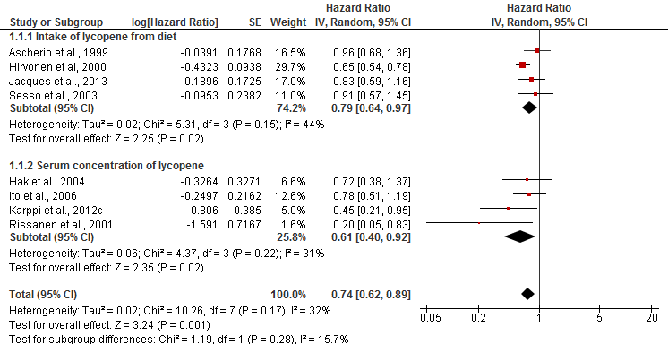

(B) CVDs

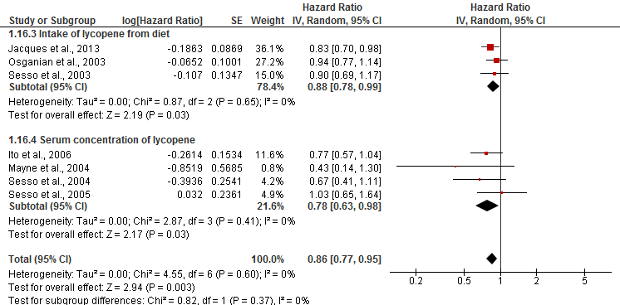

(C) Mortally

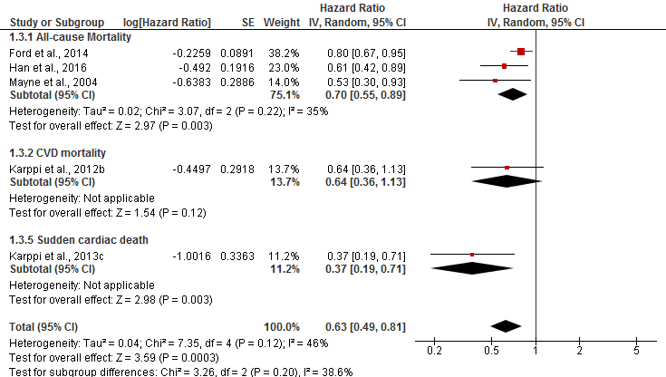

The forest plots shows individual studies, the weight allocated to each of them, and shown in the form of black diamonds, the subgroups and overall effect size as hazards ratios with 95% confidence intervals.

CI, confidence interval; df, degrees of freedom; SD, standard deviation; *I2*, Heterogeneity levels.

**Table 1. Characteristics of studies with exposure tomato/lycopene included in systematic review.**

| **Ref (Country of origin)** | **Exposure** | **Study design (Cohort name)** | **Sample size (Sex)** | **Mean length of follow up (years)** | **Mean Age±SD (Range)** | **BMI (kg/m2)** | **Effect size (95% confidence intervals)** | **Confounders adjusted for** | **Ethnicity** |
| --- | --- | --- | --- | --- | --- | --- | --- | --- | --- |
| **Lycopene associations** | | | | | | | | | |
| Ascherio et al. (1999) (USA) | Intake of lycopene from diet  Food frequency questionnaire | Prospective study  (The Health Professionals Follow-up Study) | 43738 (Male) | 8 | 40-75 | 25.5 | Total Stroke   RR 0.96 (0.68, 1.36) Highest (Median value 18798 μg/d) and lowest (Median value 3442 μg/d) (Ref) quintiles for intake of lycopene | Total energy intake, smoking, alcohol consumption, history of hypertension, parental history of MI, profession, and quintiles of BMI and physical activity, age | N/A |
| Ischemic Stroke  RR 1.01 (0.65, 1.57) Highest (Median value 18798 μg/d) and lowest (Median value 3442 μg/d) (Ref) quintiles for intake of lycopene |
| Hemorrhagic Stroke  RR 1.04 (0.52, 2.07)  Highest (Median value 18798 μg/d) and lowest (Median value 3442 μg/d) (Ref) quintiles for intake of lycopene |
| Ford et al., (2014) (USA) | Serum level of lycopene | Prospective study (National Health and Nutrition Examination Survey III) | 1429 (Mixed Sex) | 14 | 55.7 (20-79) | 26.5 | All-cause Mortality   HR 0.8 (0.67, 0.95) (inverse association) for serum level of lycopene as continuous variable (Mean±SE, for total participants 0.45±0.01 μmol/l) | Age, sex, race, ethnicity, education, smoking, alcohol consumption, leisure-time physical activity, use of vitamin or mineral supplements, SBP, HDL-cholesterol, non-HDL-cholesterol, BMI, CRP, albumin: creatinine ratio, health status, diabetes, history of MI and history of stroke | White: 83.5%; Black American: 7.5%; Other: 6.8%; Mexican American: 2.2% |
| Hak et al., (2003) (USA) | Plasma level of lycopene | Prospective nested case-control  (Physicians’ Health Study) | 1061 (Male) | 13 | 58±8.5 | 25.2 | MI  OR 1.43 (0.87, 2.35) Highest (Median value 578.8 ng/ml) and lowest (Median value217.7 ng/ml) (Ref) quintile for plasma of lycopene | Age, smoking, BMI, total and HDL-cholesterol, history of hypertension, diabetes mellitus, and parental history of MI < age 60, physical activity, alcohol consumption; multivitamin use, and assignment to aspirin or β-carotene treatment or placebo | N/A |
| Hak et al. (2004) (USA) | Plasma level of lycopene | Prospective nested case-control  (Physicians’ Health Study) | 594 (Male) | 13 | 60.5 (40-84) | 25.3 | Ischemic stroke  OR 0.72 (0.38, 1.37) Highest (Median value 606.8 ng/ml) and lowest (Median value 216.4 ng/ml) (Ref) quintiles for plasma level of lycopene | Age, smoking, BMI, total and HDL-cholesterol, history of hypertension, diabetes mellitus, and parental history of MI < age 60, physical activity, alcohol consumption, multivitamin use, and assignment to aspirin or β-carotene treatment or placebo | N/A |
| Han and Han (2016) (USA) | Serum level of lycopene | Prospective study (National Health and Nutrition Examination Survey III) | 37 (Mixed Sex) | 17.5 | 45±16.8 | 26±7 | Mortality rate for low lycopene level group 33%.  Mortality rate for high lycopene level group 5.3% | N/A | non-Hispanic white: 43%; non-Hispanic black: 30%; Mexican American: 27% |
| Han et al. (2016) (USA) | Serum level of lycopene | Prospective study (National Health and Nutrition Examination Survey) | 2499 (Mixed Sex) | 5-10 | Three aged group (20-39; 40-59; ≥60) | Three groups (<24.9; 25-29.9; ≥30) | All-cause Mortality   HR 0.61 (0.42, 0.89)  Highest (Mean value 0.626 μmol/l) and lowest (Mean value 0.204 μmol/l) (Ref) tertile for serum level of lycopene | Race, sex, age, BMI, smoking, alcohol consumption, physical activity, fruit consumption, vegetable consumption, and cancer | non-Hispanic white: 55.9%; non-Hispanic black: 13.5%; Mexican American: 23.9%; Other: 6.7% |
| Hirvonen et al. (2000) (Finland)) | Intake of lycopene from diet  Food frequency questionnaire | Prospective study  (The Alpha-Tocopherol, Beta-Carotene Cancer Prevention (ATBC) Study) | 26593 (Male) | 6.1 | 57 (50-69) | 26.6 | Cerebral Infarction  RR 0.74 (0.59, 0.92) Highest (Median value 1.45 mg/d) and lowest (Median value 0.14 mg/d) (Ref) quartile for intake of lycopene | Age, supplementation group, SBP, DBP, total and HDL-cholesterol, BMI, height, smoking, number of cigarettes daily, history of diabetes or CHD, alcohol consumption, and education | N/A |
| 26.8 | Intracerebral Hemorrhage   RR 0.45 (0.24, 0.86) Highest (Median value 1.45 mg/d) and lowest (Median value 0.14 mg/d) (Ref) quartile for intake of lycopene |
| 26 | Subarachnoid Hemorrhage  RR 0.63 (0.33, 1.20)  Highest (Median value 1.45 mg/d) and lowest (Median value 0.14 mg/d) (Ref) quartile for intake of lycopene |
| Iribarren et al. (1997) (USA) | Serum level of lycopene | Case-control  (the Atherosclerosis Risk in Communities (ARIC) study) | 462 (Mixed sex) | N/A | 59±5 | 27.3 | Asymptomatic Carotid Atherosclerosis   OR 0.81 (0.60, 1.08) Per 1-SD increase in serum lycopene (Mean value 0.44 μmol/l) | Age, blood storage time, total cholesterol, triglycerides, education level, smoking, BMI, alcohol consumption, hypertension, diabetes mellitus and vitamin supplementation use | White: 90%; Black: 10% |
| Ito et al. (2006) (Japan) | Serum level of lycopene | Prospective study | 3061 (Mixed sex) | 11.9 | 39-80 | N/A | CVDs   HR 0.77 (0.57, 1.04) Highest and lowest (Ref) serum level of lycopene per each logarithmically transformed value of serum | Age, sex, smoking, alcohol consumption, BMI, SBP, total cholesterol, triglyceride and alanine transaminase activity | Japanese population |
| Stroke  HR 0.78 (0.51, 1.19) Highest and lowest (Ref) serum level of lycopene per each logarithmically transformed value of serum |
| CHD  HR 0.74 (0.48, 1.13) Highest and lowest (Ref) serum level of lycopene per each logarithmically transformed value of serum |
| Jacques et al. (2013) (USA) | Intake of lycopene from diet  Harvard semi-quantitative food frequency questionnaire | Longitudinal (Framingham Heart Study) | 5135 (Mixed sex) | 9 | 54 (26-79) | 27.2 | CVDs  HR 0.83 (0.70, 0.98) 75th and 25th (Ref) percentiles intake of lycopene (Mean 7.9 mg/d) | Age, sex, SBP, total and cholesterol/HDL ratio, BMI, smoking, hypertension treatment, diabetes, energy intake and intake of saturated fat, β-carotene, flavonol, vitamin C and vitamin E | N/A |
| 9 | Stroke  HR 0.82 (0.59, 1.16) 75th and 25th (Ref) percentiles intake of lycopene (Mean 7.9 mg/d) |
| 11 | CHD   HR 0.74 (0.58, 0.94) 75th and 25th (Ref) percentiles intake of lycopene (Mean7.9 mg/d) |
| Kabagambe et al. (2005) (Costa Rica) | Lycopene level in adipose tissue | Case-control | 2912 (Mixed sex) | 9 | 58±11 | N/A | MI  OR 0.91 (0.67, 1.24) Highest (Median value 1.47 μmol/kg) and lowest (Median value 0 μmol/kg) (Ref) quintiles for intake of lycopene | Smoking, alcohol intake, history of diabetes, history of hypertension, abdominal obesity, physical activity, income, intake of saturated fat, polyunsaturated fat, trans-fat, total energy, and dietary fibre | Hispanic Americans |
| Intake of lycopene from diet  Semi-quantitative food-frequency questionnaire | MI  OR 1.05 (0.78, 1.42) Highest (Median value 0.62 μg/g) and lowest (Median value 0.11 μg/g) (Ref) quintiles for intake of lycopene |
| Karppi et al. (2012a) (Finland) | Serum level of lycopene | Prospective study (Kuopio Ischemic Heart Disease Risk Factor (KIHD) cohort) | 1031 (Male) | 11.5 | 56.2±6.6 | 27.5 | Acute MI  RR 1.55 (1.05, 2.30) Lowest (<0.08 μmol/l) and highest (>0.19 μmol/l) (Ref) tertiles for serum level of lycopene | Age, examination year, BMI, SBP, smoking, alcohol intake, LDL-cholesterol, years of education, physical activity, symptomatic CHD or CHD history, diabetes, antihypertensive medication, drug for high cholesterol and any b-adrenergic blocking agent | Finnish |
| Karppi et al. (2012b) (Finland) | Serum level of lycopene | Prospective study (Kuopio Ischemic Heart Disease Risk Factor (KIHD) cohort) | 1031 (Male) | 15.9 | 56.4±6.5 | 27.4 | CVD mortality  HR 1.51 (0.86, 2.67) Lowest (≤0.03 μmol/l) and highest (>0.22 μmol/l) (Ref) quartile for serum level of lycopene | Age, examination year, BMI, SBP, smoking, alcohol consumption, physical activity, years of education, LDL-cholesterol, symptomatic CHD or CHD history, use of antihypertensive drugs, use of any b-blockers, serum hs-CRP and diabetes | Finnish |
| Karppi et al. (2012c) (Finland) | Serum level of lycopene | Prospective study (Kuopio Ischemic Heart Disease Risk Factor (KIHD) cohort) | 1031 (Male) | 12.1 | 56.2 (46-65) | 27.5 | Stroke   HR 0.45 (0.21, 0.95)  Highest (>0.22 μmol/l) and lowest (≤0.03 μmol/l) (Ref) quartile for serum level of lycopene | Age, examination year, BMI, SBP, smoking, LDL-cholesterol, diabetes, and stroke | Finnish |
| Karppi et al. (2013a) (Finland) | Plasma level of lycopene | Prospective study (Kuopio Ischemic Heart Disease Risk Factor (KIHD) cohort) | 1847 (Mixed sex) | 2.8 | 71.1 (61-82) | 27.4 | AF  HR 1.21 (0.68, 2.13) Lowest (≤0.05 μmol/l) and highest (>0.11 μmol/l) (ref) tertiles for serum level of lycopene | Age, examination year, gender, education, SBP, smoking, alcohol consumption, diabetes and the use of antihypertensive medication, CHF, recurrent AF, prevalent CHD and baseline prevalence of MI | Finnish |
| Karppi et al. (2013b) (Finland) | Serum level of lycopene | Prospective study (Kuopio Ischemic Heart Disease Risk Factor (KIHD) cohort) | 1031 (Male) | 17.8 | 56.2±6.6 | 27.6 | CHF  HR 1.99 (0.83, 4.77) Lowest (≤0.03 μmol/l) and highest (>0.22 μmol/l) (Ref) quartiles for serum level of lycopene | Age, examination year, BMI, years of education, smoking, alcohol consumption, physical activity, serum hs-CRP and serum LDL cholesterol, diabetes, hypertension with antihypertensive medication, prevalent CHD and HF at baseline examination | Finnish |
| Karppi et al. (2013c) (Finland) | Serum level of lycopene | Prospective study (Kuopio Ischemic Heart Disease Risk Factor (KIHD) cohort) | 1031 (Male) | 15.9 | 56.2 (46-65) | 27.5 | Sudden cardiac death  HR 1.93 (0.92, 4.04) Lowest (≤0.08 μmol/l) and highest (>0.19 μmol/l) (ref) tertiles for serum level of lycopene | Age, SBP, waist circumference, smoking, alcohol consumption, years of education, LDL-cholesterol, CRP, diabetes, prevalent CHD and CHF | Finnish |
| Klipstein-Grobusch et al. (2000) (Netherland) | Serum level of lycopene | Case-control (Subsample of the Rotterdam Study) | 217 (Mixed sex) | N/A | 66.8 (7.2) | 26.4 | Atherosclerosis   OR 0.66 (0.29, 1.49) Highest (>0.166 μmol/l) and lowest (<0.058 μmol/l)) (ref) quartiles for serum level of lycopene | Age, sex, cholesterol, season, waist-to-hip ratio, pack-years smoked, alcohol consumption | N/A |
| Kohlmeier et al. (1997) (USA) | Lycopene level in adipose tissue | Case-control  (EURAMIC study) | 1379 (Male) | N/A | 54 | 26.3 | MI  OR 0.42 (0.25, 0.7) Highest (Median value 0.62 μg/g) and lowest (Median value 0.11 μg/g) (Ref) quintiles for intake of lycopene | Age, BMI, smoking, maternal, paternal history of disease, history of high blood pressure, study site and α-tocopherol intake | N/A |
| Mayne et al. (2004) (USA) | Plasma level of lycopene | Longitudinal study (Yale University cancer prevention trial) | 259 (Mixed sex) | 7.5 | 61.8 (20-79) | N/A | All-cause Mortality   HR 0.53 (0.30, 0.93) Above versus below (Ref) Median plasma level of lycopene (Median value 280 μg/l) | Age, gender, treatment arm, time-dependent smoking, baseline plasma cholesterol, study site | N/A |
| CHD Mortality  HR 0.42 (0.14, 1.30)  Above versus below (Ref) Median plasma level of lycopene (Median value 280 μg/l) |
| Osganian et al. (2003) (USA) | Intake of lycopene from diet  Semi-quantitative food-frequency questionnaire | Longitudinal study (Nurses’ Health Study) | 73286  (Female) | 12 | 50 (30-55) | 25 | Coronary artery disease  RR 0.93 (0.77, 1.14) Highest (Median value 15830 μg/d) and lowest (Median value 3570 μg/d) (ref) quintiles for serum level of lycopene | Age, smoking, postmenopausal hormone use, parental history of MI, history of high blood pressure, history of high cholesterol, diabetes, BMI, physical activity, aspirin use, alcohol consumption, total energy intake and intake of saturated fat, polyunsaturated fat, trans unsaturated fat, cereal fiber, folate, dietary glycaemic load, and vitamin B-6 | N/A |
| Rissanen et al. (2001) (Finland) | Serum level of lycopene | Prospective study (Kuopio Ischemic Heart Disease Risk Factor (KIHD) cohort) | 725 (Male) | 4 | 46-64 | 27 | Acute coronary events or Stroke  HR 3.3 (1.7, 6.4) Lowest quarter (≤0.07 μmol/l) versus every other quarter of serum level of lycopene (≥0.08 μmol/l) (Ref) | Age, examination years, SBP and three nutritional factors (serum b-carotene, folate and plasma vitamin C) | Finnish |
| Acute coronary events  HR 2.8 (1.4, 5.4) Lowest quarter (≤0.07 μmol/l) versus every other quarter of serum level of lycopene (≥0.08 μmol/l) (Ref) |
| Sesso et al. (2003) (USA) | Intake of lycopene from diet  Semi-quantitative food-frequency questionnaire | Prospective study (Women’s Health Study) | 38445 (Female) | 7.2 | 54.0±7.0 | 26 | CVDs   RR 0.90 (0.69, 1.17) Highest (Median value 16741 μg/d) and lowest (Median value 3326 μg/d) (Ref) quintiles for intake of lycopene | Age, randomized aspirin, randomized vitamin E, randomized β-carotene, BMI, exercise, smoking, postmenopausal hormone use, parental history of MI < age 60, diabetes, hypertension, high cholesterol, and the intake of fruit and vegetables, alcohol, fiber, folate, nonsupplemental vitamin E and saturated fat | N/A |
| Stroke  RR 0.91 (0.57, 1.45) Highest (Median value 16741 μg/d) and lowest (Median value 3326 μg/d) (Ref) quintiles for intake of lycopene |
| MI  RR 0.69 (0.41, 1.15) Highest (Median value 16741 μg/d) and lowest (Median value 3326 μg/d) (Ref) quintiles for intake of lycopene |
| Sesso et al. (2004) (USA) | Plasma level of lycopene | Nested case-control (Women’s Health Study) | 966 (Female) | 4.8 | 58.8±8.4 | 26.6 | CVDs   RR 0.67 (0.41, 1.11) Highest (≥21.0 μg/dl) and lowest (<11.7 μg/dl) (Ref) quartiles for plasma of lycopene | Age, smoking, adjusted for randomized aspirin treatment, randomized vitamin E treatment, randomized β-carotene treatment, plasma cholesterol concentration, BMI, physical activity, postmenopausal hormone use, parental history of MI < age 60, diabetes, hypertension, high cholesterol, alcohol, fiber, folate, saturated fat, and fruit and vegetable intakes | N/A |
| Sesso et al. (2005) (USA) | Plasma level of lycopene | Nested case-control (Physicians’ Health Study) | 499  (Male) | 2.1 | 69.7±8.1 | 24.5 | CVDs   RR 1.03 (0.65, 1.64)  Highest (>12.7 μg/dl) and lowest (≤6.4 μg/dl) (Ref) quartiles for plasma of lycopene | Age, smoking, adjusted for randomized aspirin treatment, randomized vitamin E treatment, randomized β-carotene treatment, plasma cholesterol concentration, BMI, physical activity, postmenopausal hormone use, parental history of MI < age 60, diabetes, hypertension, high cholesterol, alcohol, fiber, folate, saturated fat, and fruit and vegetable intakes | N/A |
| Street et al. (1994) (USA) | Serum level of lycopene | Nested case-control | 369 (Mixed sex) | 14 | 23-58 | N/A | MI  OR 1.33 Lowest and highest (Ref) quintiles for serum level of lycopene | N/A | N/A |
| Tavani et al. (2006) (Italy) | Intake of lycopene  Food-frequency questionnaire | Nested case-control | 1442 (Mixed sex) | 9 | 50-70 | N/A | Acute MI  OR 1.19 (0.82, 1.70) Highest and lowest (Ref) quartile for intake of lycopene (Mean lycopene intake 7189.5 μg/d) | Age, sex, study site, education, smoking, alcohol consumption, coffee, non-alcohol total energy, BMI, physical activity, cholesterol level, diabetes, hyperlipidemia hypertension, and family history of acute MI in first degree relatives | N/A |
| Wood and Johnson (2004) (USA) | Serum level of lycopene | Cross-sectional analysis  (Third National Health and Nutrition Examination Survey (NHANES III)) | 4087 with periodontitis (Mixed Sex) | N/A | 47.7 (SEM 0.4) | 23.9 | CHF  RR 0.65 (0.21, 2.03) Lowest (≤14 μg/dl) and highest (>29 μg/dl) (Ref) quartiles for serum level of lycopene | Age, race, gender, BMI, waist to hip ratio, serum CRP, WBC count, smoking, history of diabetes, hypertension, socioeconomic status, and education level | Caucasian, African-American, Other |
| 1443 without periodontitis (Mixed Sex) | 47.7 (SEM 0.6) | 23.6 | CHF  RR 0.59 (0.15, 2.24) Lowest (≤14 μg/dl) and highest (>29 μg/dl) (Ref) quartiles for serum level of lycopene |
| **Tomato associations** | | | | | | | | | |
| Jacques et al. (2013) (USA) | Intake of tomatoes and tomato-based products  Harvard semi-quantitative food frequency questionnaire | Longitudinal study (Framingham Heart Study) | 5135 (Mixed sex) | 9 | 54 (26-79) | 27.2 | CVDs  HR 0.94 (0.878, 0.995) 75th and 25th (Ref) percentiles for intake of tomatoes and tomato-based products (Mean 4.4 servings/wk) | Age, sex, SBP, total cholesterol, total cholesterol/HDL ratio, BMI, smoking, hypertension treatment, diabetes, saturated fat, β-carotene, flavonol, vitamin C and vitamin E intakes and energy intake | N/A |
| 9 | Stroke   HR 0.99 (0.90, 1.10) 75th and 25th (Ref) percentiles for intake of tomatoes and tomato-based products (Mean 4.4 servings/wk) |
| 9 | CHD  HR 0.90 (0.83, 0.99) 75th and 25th (Ref) percentiles for intake of tomatoes and tomato-based products (Mean 4.4 servings/wk) |
| Sesso et al. (2003) (USA) | Intake of tomato based product  Semi-quantitative food-frequency questionnaire | Prospective study (Women’s Health Study) | 38445 (Female) | 7.2 | 54.0±7.0 | 26 | CVDs  RR 0.71 (0.42, 1.17) Highest (12 servings/wk) and lowest (1.4 servings/wk) (Ref) quintiles for intake of tomato based product per week | Age, randomized aspirin, randomized vitamin E, randomized β-carotene, BMI, exercise, smoking, postmenopausal hormone use, parental history of MI <60 y, diabetes, hypertension, high cholesterol, and the intake of fruit and vegetables, alcohol, fiber, folate, nonsupplemental vitamin E and saturated fat | N/A |
| Stroke  RR 0.20 (0.05, 0.84) Highest (12 servings/wk) and lowest (1.4 servings/wk) (Ref) quintiles for intake of tomato based product per week |
| MI  RR 0.39 (0.12, 1.30) Highest (12 servings/wk) and lowest (1.4 servings/wk) (Ref) quintiles for intake of tomato based product per week |
| Wood and Johnson (2004) (USA) | Intake of tomato  Semi-quantitative food-frequency questionnaire | Cross-sectional analysis  (Third National Health and Nutrition Examination Survey (NHANES III)) | 4087 with periodontitis (Mixed Sex) | N/A | 47.7 (SEM 0.4) | 23.9 | CHF  RR 5.10 (1.67, 15.57) Lowest (≤3) and highest (>17) (Ref) quartiles for monthly tomato consumption | Age, race, gender, BMI, waist to hip ratio, serum CRP, WBC count, smoking, history of diabetes, hypertension, socioeconomic status, and education level | Caucasian, African-American, Other |
| 1443 without periodontitis (Mixed Sex) | 47.7 (SEM 0.6) | 23.6 | CHF  RR 1.68 (0.6, 4.76) Lowest (≤3) and highest (>17) (Ref) quartiles for monthly tomato consumption |

Ref, Reference; CVDs, Cardiovascular diseases; CHD, Coronary heart disease; CHF, Congestive heart failure; AF, Atrial fibrillation; Intima-media thickness, IMT; HR, Hazard ratio; RR, Relative ratio; OR, Odd ratio; BMI, Body mass index; MI, Myocardial Infarction; SBP, Systolic blood pressure; DBP, Diastolic blood pressure; HDL, High density lipoprotein; LDL, Low density lipoprotein; CRP, C-reactive protein; WBC, White blood cell; d, Day; wk, week

**Table 2. Subgroup analysis of risk of stroke reporting the consumption/serum of lycopene.**

|  |  |  |  |  |
| --- | --- | --- | --- | --- |
| Variable (Number of studies or subgroups) [Reference numbers] | HR (95% CI) | P (Z-test) | Heterogeneity *I2*% | Between group comparisons |
| **Geographical origins** |  |  |  |  |
| USA (n=4) (Ascherio et al., 1999; Hak et al., 2004; Jacques et al., 2013; Sesso et al., 2003) | 0.88 (0.71, 1.07) | *p=*0.20 | 0 | *p*=0.06 |
| Japan and Finland (n=4) (Hirvonen et al., 2000; Ito et al., 2006; Karppi et al., 2012c; Rissanen et al., 2001) | 0.63 (0.48, 0.82) | *p*<0.001 | 30 |
| **Sex** |  |  |  |  |
| Men (n=4) (Ascherio et al., 1999; Hak et al., 2004; Hirvonen et al., 2000; Rissanen et al., 2001) | 0.71 (0.51, 0.99) | *p*=0.04 | 56 | *p=*0.69 |
| Mixed (n=3) (Ito et al., 2006; Jacques et al., 2013; Karppi et al., 2012c) | 0.75 (0.58, 0.98) | *p*=0.03 | 7 |
| Women (n=1) (Sesso et al., 2003) | 0.91 (0.57, 1.45) | *p*=0.69 |  |
| **Follow-up time** |  |  |  |  |
| ≤8y (n=4) (Ascherio et al., 1999; Hirvonen et al., 2000; Rissanen et al., 2001; Sesso et al., 2003) | 0.75 (0.54, 1.05) | *p*=0.09 | 62 | *p=*0.98 |
| >8y (n=4) (Hak et al., 2004; Ito et al., 2006; Jacques et al., 2013; Karppi et al., 2012c) | 0.75 (0.60, 0.95) | *p*=0.02 | 0 |
| **Age** |  |  |  |  |
| ≤55y (n=2) (Jacques et al., 2013; Sesso et al., 2003) | 0.85 (0.65, 1.12) | *p=*0.26 | 0 | *p=*0.25 |
| >55y (n=4)(Hak et al., 2004; Hirvonen et al., 2000; Ito et al., 2006; Karppi et al., 2012c) | 0.66 (0.56, 0.77) | *p*<0.001 | 0 |
| N/A (n=2) (Ascherio et al., 1999; Rissanen et al., 2001) | 0.52 (0.12, 2.29) | *p*=0.39 | 77 |
| **BMI** |  |  |  |  |
| <26 (n=3) (Ascherio et al., 1999; Hak et al., 2004; Sesso et al., 2003) | 0.90 (0.70, 1.17) | *p*=0.44 | 0 | *p=*0.23 |
| ≥26 (n=4) (Hirvonen et al., 2000; Jacques et al., 2013; Karppi et al., 2012c; Rissanen et al., 2001) | 0.64 (0.48, 0.86) | *p=*0.003 | 45 |
| N/A (n=1) (Ito et al., 2006) | 0.78 (0.51, 1.19) | *p=*0.25 |  |

**Supplementary material**



**Figures S1. Funnel Plot of standard error for the association between stroke and serum level/intake of lycopene.**

Egger’s test *p*=0.70



**Figures S2. Meta-regression on the effect of follow-up duration on the association between stroke and serum level/intake of lycopene.**

Slope=0.025; Q=0.81, d.f.=1, *p*= 0.37



**Figures S3. Meta-regression on the effect of age on the association between stroke and serum level/intake of lycopene.**

Slope=-0.056; Q = 1.52, d.f.=1, *p*= 0.22.



**Figures S4. Meta-regression on the effect of BMI on the association between stroke and serum level/intake of lycopene.**

Slope=-0·19; Q=3.14, d.f.=1, *p*=0.076.

.

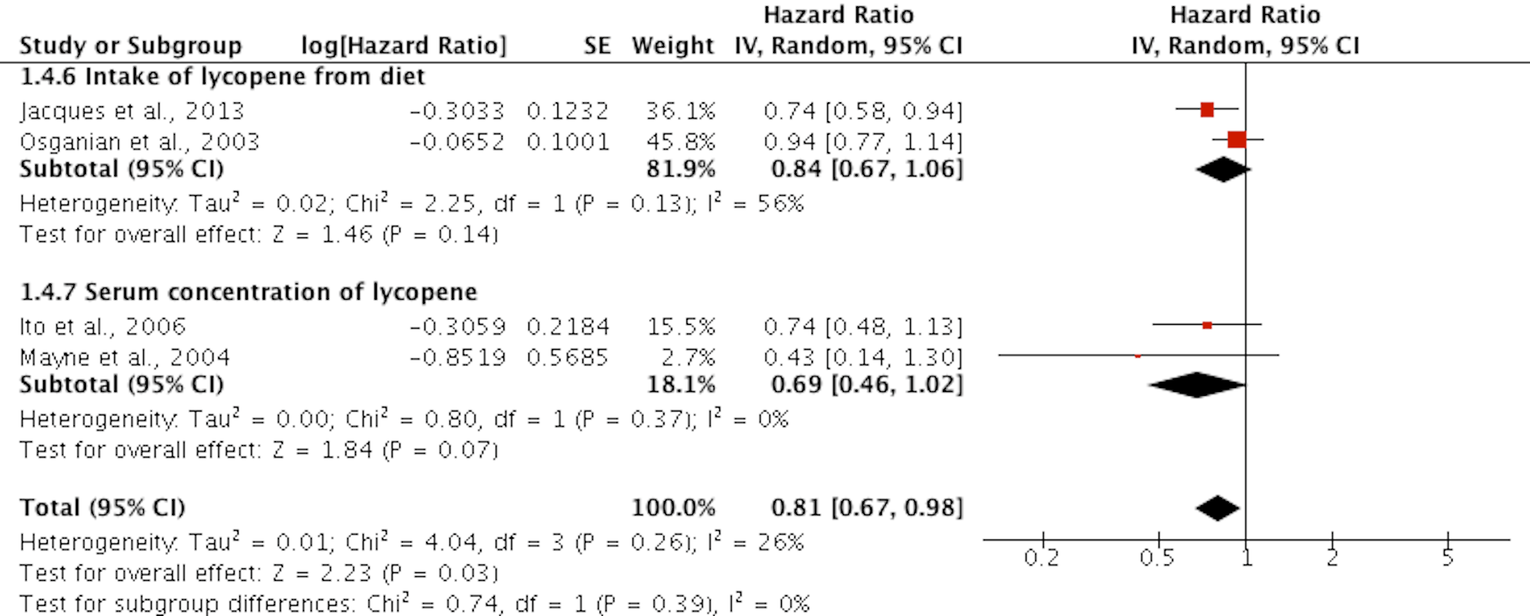

**Figures S5. Forest plot of the association between high serum level/intake of lycopene and risk of CHD.**

CI, confidence interval; df, degrees of freedom; SD, standard deviation.

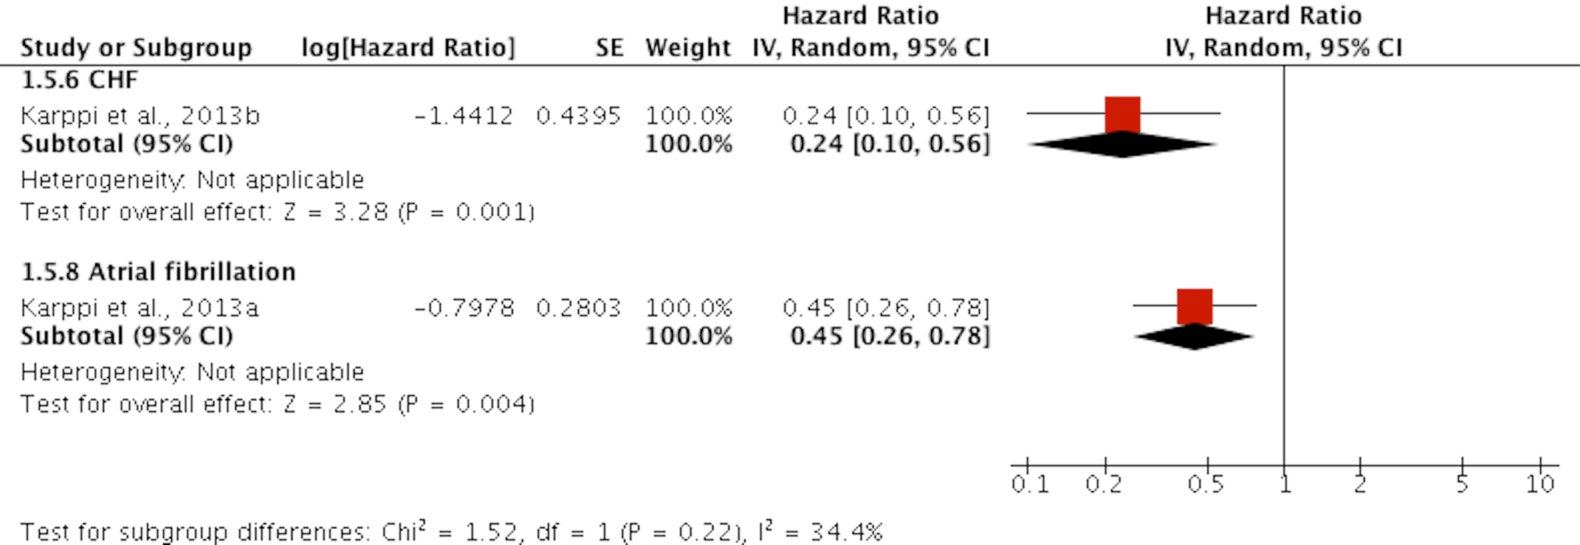**Figures S6. Forest plot of the association between high serum level/intake of lycopene and risk of CHF and AF.**

CI, confidence interval; df, degrees of freedom; SD, standard deviation.

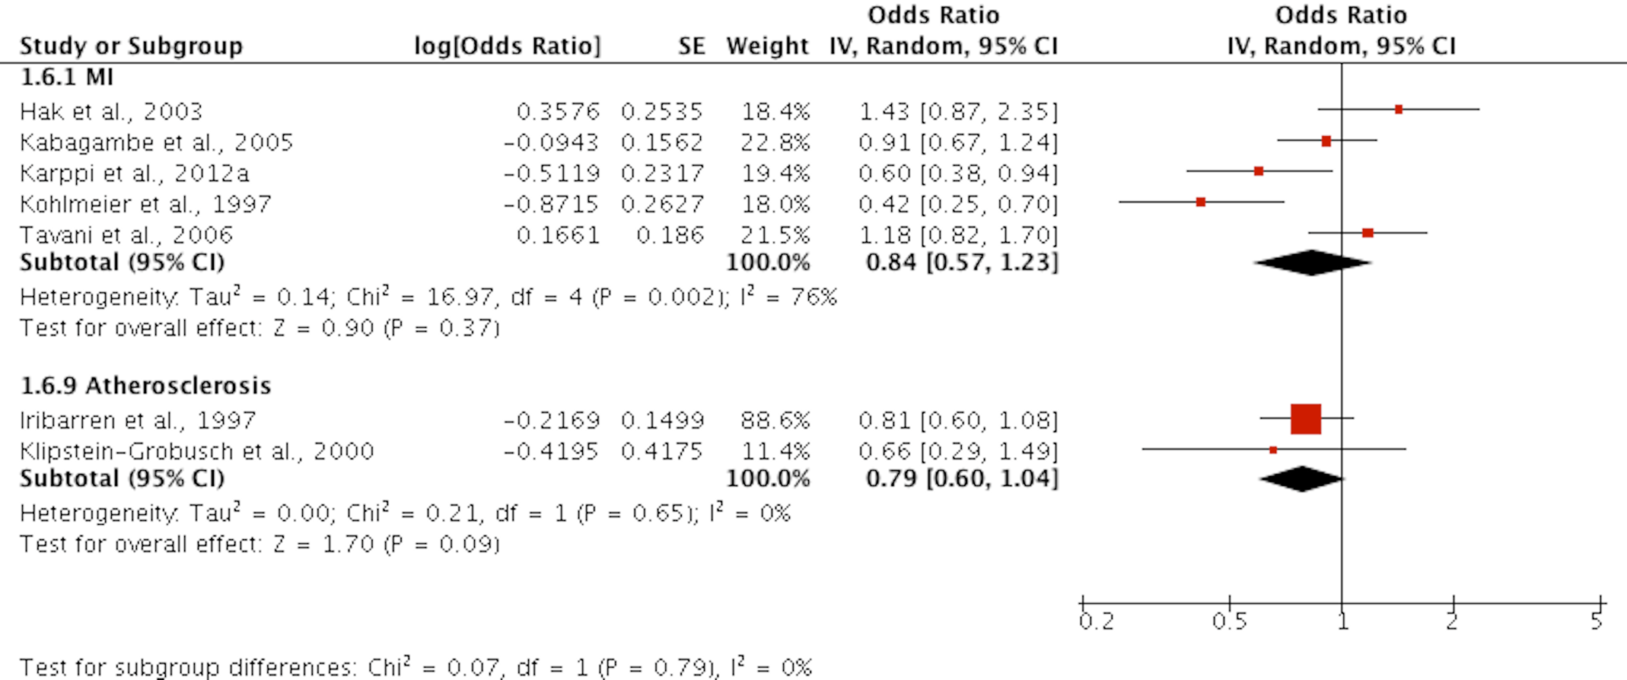

**Figures S7. Forest plot of the association between high serum level/intake of lycopene and risk of MI and atherosclerosis.**

CI, confidence interval; df, degrees of freedom; SD, standard deviation.

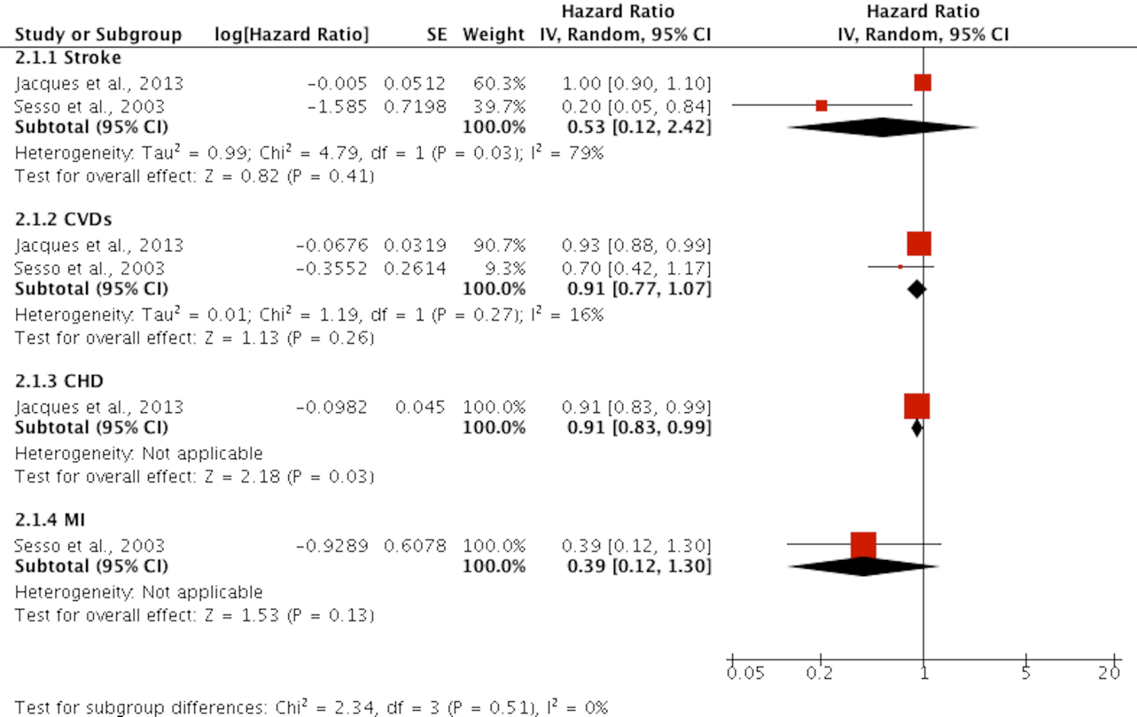

**Figures S8. Forest plot of the association between high intake of tomato and risk of CVDs events.**

CI, confidence interval; df, degrees of freedom; SD, standard deviation.

Table S1. PRISMA checklist

|  |  |  |  |
| --- | --- | --- | --- |
| **Section/topic** | **#** | **Checklist item** | **Reported on page #** |
| **TITLE** | | |  |
| Title | 1 | Identify the report as a systematic review, meta-analysis, or both. | 1 |
| **ABSTRACT** | | |  |
| Structured summary | 2 | Provide a structured summary including, as applicable: background; objectives; data sources; study eligibility criteria, participants, and interventions; study appraisal and synthesis methods; results; limitations; conclusions and implications of key findings; systematic review registration number. | 2 |
| **INTRODUCTION** | | |  |
| Rationale | 3 | Describe the rationale for the review in the context of what is already known. | 3-4 |
| Objectives | 4 | Provide an explicit statement of questions being addressed with reference to participants, interventions, comparisons, outcomes, and study design (PICOS). | 3-4 |
| **METHODS** | | |  |
| Protocol and registration | 5 | Indicate if a review protocol exists, if and where it can be accessed (e.g., Web address), and, if available, provide registration information including registration number. | 5 |
| Eligibility criteria | 6 | Specify study characteristics (e.g., PICOS, length of follow-up) and report characteristics (e.g., years considered, language, publication status) used as criteria for eligibility, giving rationale. | 5-6 |
| Information sources | 7 | Describe all information sources (e.g., databases with dates of coverage, contact with study authors to identify additional studies) in the search and date last searched. | 5 |
| Search | 8 | Present full electronic search strategy for at least one database, including any limits used, such that it could be repeated. | 5 |
| Study selection | 9 | State the process for selecting studies (i.e., screening, eligibility, included in systematic review, and, if applicable, included in the meta-analysis). | 5 |
| Data collection process | 10 | Describe method of data extraction from reports (e.g., piloted forms, independently, in duplicate) and any processes for obtaining and confirming data from investigators. | 6 |
| Data items | 11 | List and define all variables for which data were sought (e.g., PICOS, funding sources) and any assumptions and simplifications made. | 6 |
| Risk of bias in individual studies | 12 | Describe methods used for assessing risk of bias of individual studies (including specification of whether this was done at the study or outcome level), and how this information is to be used in any data synthesis. | 5-6 |
| Summary measures | 13 | State the principal summary measures (e.g., risk ratio, difference in means). | 6-7 |
| Synthesis of results | 14 | Describe the methods of handling data and combining results of studies, if done, including measures of consistency (e.g., I2) for each meta-analysis. | 5-7 |