Educating for Entrepreneurship – the application of threshold concept theory
(Keynote speech given at the 31st Annual Businet Conference, November 8th – 10th 2017, Vilamoura, Portugal)
I am going to talk to you today about educating for entrepreneurship through the application of threshold concept theory. Let me give you a little of my personal background and the context for my interest in entrepreneurship.
I studied Mechanical Engineering, Manufacture and Management. On graduation, I was recruited by Procter & Gamble and worked in Production Management, before gravitating towards Training and Management Development. Although I loved working at Procter & Gamble, a career in Engineering or Human Resources didn’t appeal to me, so I left to join a Management Consultancy. This helped me develop my sales skills and gave me experience of working in a small, owner-managed business. I can remember the day I started to appreciate what entrepreneurship was all about (although I doubt I would have labelled it as such at the time). I had just finished my first big project and had nothing to do. The owner of the business came up to me and said, “Well, what would you do if this was your business?” And I realised I needed to stop waiting for work to come to me – and go and find it.
I got a taste for business development and autonomy, so decided to leave and establish my own consultancy business which I ran for a couple of years very successfully. However, I realised that fundamentally I am more interested in learning and teaching than money, so I took the opportunity to become an academic at Northumbria University. I gave up my business and returned to University 17 years after graduating.
In my current role at Newcastle Business School I am Programme Leader for the full time undergraduate programme “Entrepreneurial Business Management”. I have been leader of this programme since we started running it in 2013. To date, we have had 31 graduates and at the moment there are 59 students on the programme across all 3 years. We were one of the first two Universities in the UK to develop this type of immersive experiential business programme inspired by the Finnish Team Academy model. Team Academy is celebrating its 25th anniversary in 2018. On Team Academy programmes, students learn entrepreneurship in coached teams by starting up and running their own real businesses. We don’t use case studies or simulations – everything’s real. A type of venture creation programme, the Team Academy concept has spread to 12 countries.
Today, I will set out my research questions and reflect on the various approaches to entrepreneurship education and linkages to educational philosophy. I will go on to explain the relevance of threshold concept theory in this context and explain the design of my research study, then I will share my emergent findings. Finally I will set out the future direction of my research and conclude.
When I started working at Northumbria University I initially had responsibility for a more traditional undergraduate business programme focusing on business leadership and corporate management. When I moved to take on the Team Academy programme I knew the programme was very different, but on open days I found it very difficult to explain the differences clearly to prospective students and their parents – especially when it came to content. I became bothered by the fuzziness surrounding the differences between the more traditional business studies programmes, and my entrepreneurial business one. Were we just delivering the same content with an entrepreneurial twist using a different pedagogy? What was it that made it entrepreneurial? What was distinctive about it? Other programmes were experiential. Other programmes were claiming to teach students about entrepreneurship. What was different about mine? How could I be sure it was doing what it was meant to do? And what, in fact, was it meant to do?
The need to answer these questions gave me the incentive to embark on my doctorate, a journey that I am now just over 2 years into. I was lucky enough to be based near Durham where Professor Ray Land was based and thrilled when he and Dr Nicola Reimann accepted me as a PhD student.
My research questions are;
- What does it mean to think as an entrepreneur?
- What do students need to learn in order to think as entrepreneurs?
- How do we develop curricula that enables students to think as entrepreneurs?
Today I would like to share with you the first findings from my research into entrepreneurship education and the application of threshold concept theory.
But first I would like to step back a little and consider the various approaches to entrepreneurship education.
In a business school, entrepreneurship is likely to be compared to more traditional and functional subject areas such as finance or marketing – and treated as another academic subject. That’s where I was struggling to differential the entrepreneurial degree from the main business programmes.
Outside of the business school, entrepreneurship is more likely to be considered an extension of employability with utility beyond graduation – and treated as a process, without subject specific knowledge content.
Paul Hannon (2005) divided approaches to entrepreneurship education into three types:
- Entrepreneurship education which is about entrepreneurship. Educators adopting this approach create programmes of study where students learn about entrepreneurship as an academic study – perhaps most common in business schools. The success of this approach is measured in terms of academic success.
- Entrepreneurship education which is for entrepreneurship. Educators adopting this approach create programmes of study which aim to create entrepreneurs and offer opportunities to create new ventures. The success of this approach is measured in terms of number and sustainability of new start-ups.
- Entrepreneurship education which is through entrepreneurship. Educators adopting this approach embed the core capabilities of entrepreneurship in programmes of study of subjects other than business or management. The success of this approach is measured in terms of employability and the destination of leavers.
When I realised that approaches to entrepreneurship education could be differentiated like this, I realised how my entrepreneurship programme was different from other programmes in the business school. If the standard business programme could be said to be teaching students a little bit about entrepreneurship, my programme could be said to be teaching through and for entrepreneurship as well as about it. And the tension I was feeling was because the programme was based in the business school where entrepreneurship was compared to other academic subjects with the corresponding subject specific content. I wasn’t sure we had any subject specific content. Which gave me concern as I was not used to delivering programmes that were not differentiated by their subject matter.
As entrepreneurship educators, our own personal preferences for one or more of these approaches is likely to emanate from our own beliefs concerning the purpose of Higher Education. It’s important to be conscious of our own educational philosophy as entrepreneurship educators, as regardless of our approach and how we promote our programmes, it will affect the role we adopt and consequently the congruency of our initiatives.
If we believe that the purpose of higher education is…. | Then we a likely to believe the purpose of entrepreneurship education is… | And the role of the educator is …
Liberalist – to convert information into knowledge and knowledge into wisdom | Is to develop understanding of and insights into the world of entrepreneurship | The Guru: providing access to leading experts and successful entrepreneurs for transmitting knowledge and insight
Behaviourist – to meet the needs of society or industry – to define the desired behaviours and produce people who behave in these ways | Is to acquire a predetermined set of entrepreneurial capabilities at a specified standard of application | The Controller: monitoring and directing learners towards achieving intended entrepreneurial capabilities
Progressive – to focus on practical knowledge and skills that enhance individual effectiveness in society, promoting life-long learning, focusing on the needs of the learner | Is to fulfil individual potential within an entrepreneurial society and economy | The Guide: creating entrepreneurial, experiential learning environments and processes
Humanistic – personal growth and self-actualisation | Is to develop and achieve personal growth and development | The Helper: facilitating a co-learning process with peers and entrepreneurs
Radical – catalyst for fundamental change in society | Is to exploit entrepreneurship as a tool for socio economic and political change | The Coordinator: Learning through collective action: equality between the learner and the educator
Adapted from Hannon’s (2005) Inventory
I think one can map the about, through, and for approaches to the frameworks of philosophies of adult education. Liberalist and Behaviourist might be said to map onto the About approach; Progressive and Humanist might map onto the Through approach; and a Radical philosophy might map onto the For approach. Each have their utility but require the educator to be aligned with the approach and the curriculum design.
We may find responsible for an entrepreneurship initiative designed to enable students to achieve a predetermined set of competencies – but if we believe that the purpose of HE is about personal growth and self-actualisation we might feel frustrated and conflicted.
We may find ourselves responsible for an entrepreneurship initiative that is designed to develop understanding of and insights into the world of entrepreneurship, but if we believe that the purpose of HE is to be a catalyst for fundamental changes in society we would again feel stifled and constrained.
I found myself responsible for a Team Academy programme which was designed to focus on the needs of the learner and promote growth and self-actualisation, when I only knew of programmes that were about academic excellence and meeting the needs of society. I had been raised in a liberalist and behaviourist context, and found myself in a progressive, humanistic and radical new world! I couldn’t make sense of it by looking at it through my old eyes – I needed new eyes and a new philosophy of education.
I was not familiar with developing a curriculum in this new scenario.
However, by understanding the underpinning philosophical frameworks of a range of entrepreneurial educational initiatives, I felt things were becoming a little bit less conflicted.
Where do Threshold Concepts figure in all of this you might ask?
Well, as you might already be thinking, most courses and programmes in entrepreneurship don’t fit neatly into just one approach.
Rather than being categorised like this:
They are more likely to be like this:
About
Through
For
About
Through

For

On my Entrepreneurial Business Management programme students are learning about entrepreneurship for example in lectures and through their own independent and self-directed study. They are learning through entrepreneurship for example when they reflect in their team coaching sessions about the successes and failures of their business projects. And they are learning for entrepreneurship for example as they start up their own businesses and present themselves as nascent entrepreneurs to the local business community.
The learning outcomes and competency frameworks that I was more familiar with are closely linked to learning about entrepreneurship, emanating from the behaviourist and liberal traditions - and they don’t seem to be sufficient when learning through or for entrepreneurship.
Running programmes that blend all three approaches seems to present a particularly tricky problem in Business Schools.
Perhaps it’s because the legitimacy of Business as an academic discipline is still fairly recent and learning outcomes and competency frameworks are proof of distinct knowledge content. Also, it has to be said, that teaching about is just easier. Students like being told what they need to know and their knowledge is then easily tested in examinations.
There is also an assumption in Business Schools that a primary value of Higher Education lies in the provision of a clear route to employment or self-employment for its graduates. Perhaps because the very premise of the business school is about economic impact and work readiness – a clearly progressive educational philosophy – business schools are also keen on emphasising employability and enterprise skills? And teach through entrepreneurship.
Where business schools seem to struggle the most however, is teaching for entrepreneurship. Numbers of start ups by business graduates is among the lowest of all the faculties, and several studies have found that entrepreneurial intention in students has actually been reduced by attending a business school.
The measurement of the impact of Entrepreneurship initiatives in terms of number of start-ups is problematic, as start-up rates may lag graduation by some considerable period.
We also need to consider the preferred approaches of the individual educators. If my preference is to be a controlling guru – I am best suited to a programme that teaches about entrepreneurship. If I would rather be a helper or guide – then I am best suited to programmes that teach through entrepreneurship. If my preference is to be a co-ordinator then I should concentrate on new venture creation programmes.
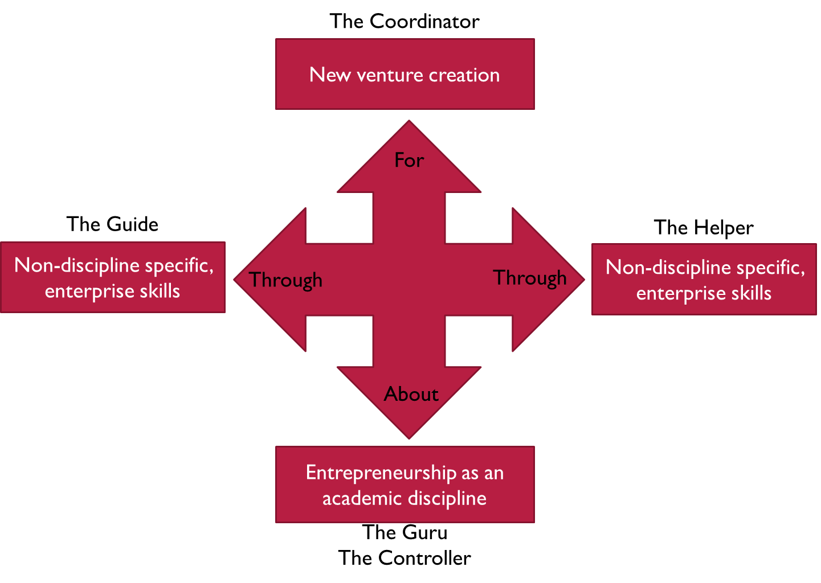
Immersive, experiential programmes that are educating about, through and for entrepreneurship call for a new and different framework for the design and development of the curricula and the assessment of students. One that reflects the liberalist, progressive, behaviourist, humanistic and radical philosophical frameworks.

Threshold Concepts might offer one such way forward – a theory for curricula design and development in entrepreneurship education that can inform all educational approaches.
Objectives of Entrepreneurship Education
If I want my students to learn about, for and through entrepreneurship I need to be clear about the fundamental building blocks they need to understand. Once I am clear about that, then I know the purpose of my interventions and how to measure their effectiveness.
So what is it that students need to “get” in order to “get” entrepreneurship? How can we develop their entrepreneurial thinking? How do entrepreneurs think and is it distinctive and unique to entrepreneurs?
I set out to gather a consensus of expert opinion on the concepts critical to thinking as an entrepreneur, so I could understand better what the purpose of entrepreneurship education might be and thereby enhance the quality of my entrepreneurship education interventions.
The concepts which are critical to thinking as an entrepreneur, and consequently to entrepreneurship, can be called “threshold concepts” (Meyer and Land, 2003, Meyer and Land, 2005).
Threshold concepts may be described as ‘conceptual gateways’ or ‘portals’ that lead to previously inaccessible ways of thinking about something – particularly in the context of academic disciplines (Meyer and Land, 2005). These conceptual gateways may be recognised by their transformative, irreversible and integrative characteristics. In transforming the learner, they change the learner’s perceptions, subjectivities and world-view. There is a ‘repositioning of the self’ (Meyer and Land, 2005); an ontological as well as a conceptual shift. This can often be uncomfortable and is sometimes resisted, so a threshold concept may also be characterised as troublesome. Mastery of a threshold concept simultaneously changes an individual’s idea of what they know and who they are (Cousin, 2009). Such changes are likely to be irreversible, and are unlikely to be forgotten or unlearned. They are integrative in that they expose how other things can be related to each other. When individuals master threshold concepts, they can see the relationships between other important concepts in the subject discipline. Examples of threshold concepts have included precedent in Law, depreciation in Accounting, pain in Physiology, irony in Literary Studies and entropy in Physics (Meyer and Land, 2005).
A threshold concept is also likely to be bounded in that ‘any conceptual space will have terminal frontiers, bordering with thresholds into new conceptual areas’ (Meyer and Land, 2006, p. 6). In recognising the threshold concepts in a subject area such as entrepreneurship, individuals appreciate how it is qualitatively different to other subjects areas and disciplines such as Management or Design (Donovan, 2017). A threshold concept can be a form of disciplinary property (Cousin, 2006) and offers a useful way of identifying and distinguishing a discipline, subject, profession or field of study. Land, Meyer & Smith (2008) suggest they may define the boundaries of academic territories.
Threshold concept theory offers a means of distilling the essence of entrepreneurship in a way that may be usefully applied in any educational context and threshold concepts in entrepreneurship education form the basis of my research.
I set out to identify the threshold concepts of entrepreneurship education and I am now going to move on and tell you about how I went about doing that. I hope that both the method and the findings will be of use and interest to you and of relevance to your own teaching, learning and research.
The study was designed in stages using an approach called transactional curriculum inquiry (Cousin, 2009) to identify ways to potentially redesign a curriculum. For each stage I am using different methods including a modified Delphi technique (Rescher, 1998) to identify threshold concepts. The participant samples at the various stages of the study include entrepreneurs, entrepreneurship educators and entrepreneurship students.
I’ll describe stage 1 in more detail today. Stage 2 is partially complete and I’ve not start stage three yet.
A shared understanding of threshold concepts is important and a level of consensus, such as that achieved by the Delphi method, is invaluable to the identification of threshold concepts in any field or discipline (Barradell, 2013). The term “Delphi” has been extended over the years to cover a wide variety of types of group interaction (Linstone and Turoff, 1975). Most involve a group where the goal of the exercise is information (i.e. the exercise is an inquiry), the information being sought is uncertain in the minds of the group and some pre-formulated systematic procedure is followed to obtaining a group output
A Delphi study is a way of gathering expert opinion, it is a type of remote group interview or focus group where the participants are aware of the perspectives of each other but are not aware of which participant has which perspective. The intention is that participants are influenced by each other’s perspectives according to the content and not the author. Opinion is gathered over several rounds which are interspersed with controlled feedback until the results become stable or consensus is achieved.
The Delphi method typically uses one panel with a number of rounds (Amos and Pearse, 2008). The researcher alternates between discovering and interpreting the data with the aim of approaching an informed and sophisticated consensus of opinion (Guba and Lincoln, 1994).
The main advantage of the method is that it allows the heterogeneity of the participants to be preserved assuring greater validity of results, as the group is not open to domination by quantity or by strength of personality from any particular individual or group of individuals (Linstone and Turoff, 1975).
This stage of the research used a three round Delphi-inspired method to identify and obtain expert consensus on entrepreneurship threshold concepts. The first round consisted of semi-structured interviews conducted with 17 expert entrepreneurs.
A list of nine candidate threshold concepts together with brief descriptors was developed from the interview data
Once the candidate threshold concepts had been developed, the panel was asked to rate each candidate threshold concept (and descriptor) according to how important they felt it was to thinking as an entrepreneur. They were also asked to rank the candidate threshold concepts according to their importance to thinking as an entrepreneur, and also according to how much they differentiated between thinking as an entrepreneur, and not thinking as an entrepreneur. Responses were analysed and slight modifications were made to the descriptors of two of the candidate threshold concepts as a result.
During the third and final round the collated perspective of the panel was shared from the second round, and the panel were asked to indicate if they thought each candidate threshold concept was critical to thinking as an entrepreneur or not. Consensus was defined as >80% agreement.
The criteria for the sample of expert entrepreneurs was adapted from research by Sarasvathy (2008) who defined an expert entrepreneur as “a person who, either individually or working as part of a team, had founded one or more companies, remained a full time founder/entrepreneur for 10 years or more, and participated in taking at least one company public”.
Target participants were chosen who satisfied the first two criteria and whose company had reached a significant turnover (over £2m) and employed over 20 people. The third criteria of company floatation was not applied, as the consensus of the participating expert entrepreneurs was that floatation was not necessarily the only reliable indication of business success, and was not generally regarded as the ultimate goal for every business. The turnovers of the companies founded by the respondents ranged from £2.4m to £1.3bn and 5 had publicly floated the companies they had founded.
Many other people who do not comply with the criteria set out here may also be argued to be entrepreneurs, or even expert entrepreneurs, but it would be hard to argue that any individual complying with the criteria set out above was not an expert entrepreneur.
What were my findings?
An initial set of nine candidate threshold concepts were developed and five of these survived the Delphi process and were deemed to be critical to thinking as an entrepreneur. These were Self-Efficacy, Opportunity, Risk, Focus, and Impact. I’ll describe each of them in more detail now.
The threshold concept of Self-efficacy is about being attracted to challenges and thinking “I can do this” whilst being highly self-aware, self-controlled and conscious of one’s own strengths and weaknesses. Mistakes are regarded as an important way of learning, and par for the course. Self-efficacy is also concerned with self-confidence, almost to the point of arrogance and a level of self-knowledge that is deep enough to acknowledge important limitations, but not so deep as to inhibit risk taking.
The threshold concept of Opportunity is about seeing commercial potential where others do not. Is also involves a
The threshold concept of Risk is about understanding risk as an inherent part of pursuing any potential opportunity, and something not to be avoided but perhaps even sought out. Risk also involves being discerning regarding potential opportunities, but also having faith in your own decisions, trusting your gut and not needing to have all the detail,
The threshold concept of Focus is about making choices and perhaps turning away from other attractive opportunities. In the context of Focus, it is important to have a clear vision and passionately, and perhaps stubbornly, drive towards it. Effective prioritisation is also an important component of Focus, as well as the ability to quickly see the big picture. The final aspect of Focus is its all absorbing nature.
Finally, the threshold concept of Impact is about making things happen and taking action.
This final candidate threshold concept of impact is beautifully illustrated in the following video clip and I think sums up a great deal about how hard it is to act when creating a new venture. Researchers approached individuals who had never jumped from a high diving board – 10 meters high, and offered them some money to do so. They made a film of the people attempting the jump – this is a short 2m preview of the full film.
https://youtu.be/2byzvkF7J60

To summarise my findings from this the first stage of my study; when an individual has understood the threshold concepts of Self-efficacy, Opportunity, Risk, Focus and Impact, I think they might be closer to thinking as an entrepreneur.
To enable as full an understanding of entrepreneurial thinking as possible, we need students to learn about, through and for entrepreneurship in a higher educational context.
I propose that the purpose of all approaches to Entrepreneurship Education is likely to be at least partly about the development of an understanding of these threshold concepts, and by measuring how well students understand these concepts at a deep level, we will start to get a clearer picture of the effectiveness of our entrepreneurship education interventions.

The next stage of the research has been to ask entrepreneurship educators what their thoughts are on the concepts fundamental to thinking as an entrepreneur.
I’m asking them:
- What is your favourite definition of entrepreneurship?

- What is your favourite definition of an entrepreneur?

- How do you characterise the role of the educator in entrepreneurship education?

- How do you define the purpose of teaching in the context of entrepreneurship education?

- What are the main objectives/goals of your teaching in entrepreneurship?

- In what other ways are the interventions measured and evaluated? How is the success of the programme measured?

- What do you consider to be fundamental to a grasp of entrepreneurship?

- What aspects of curriculum design help and hinder students of entrepreneurship in grasping these fundamental aspects?

- What do students find difficult to grasp? What don’t they “get”? What do you find hard to teach?

- What do you feel it means to think as an entrepreneur?

Perhaps you might find it interesting to reflect on how you might answer these questions?
Finally I will be asking students their perspectives and drawing conclusions from the data.
So to bring this address to a close I’d like to reference the work of Professor Ronald Barnett (2009,2012)
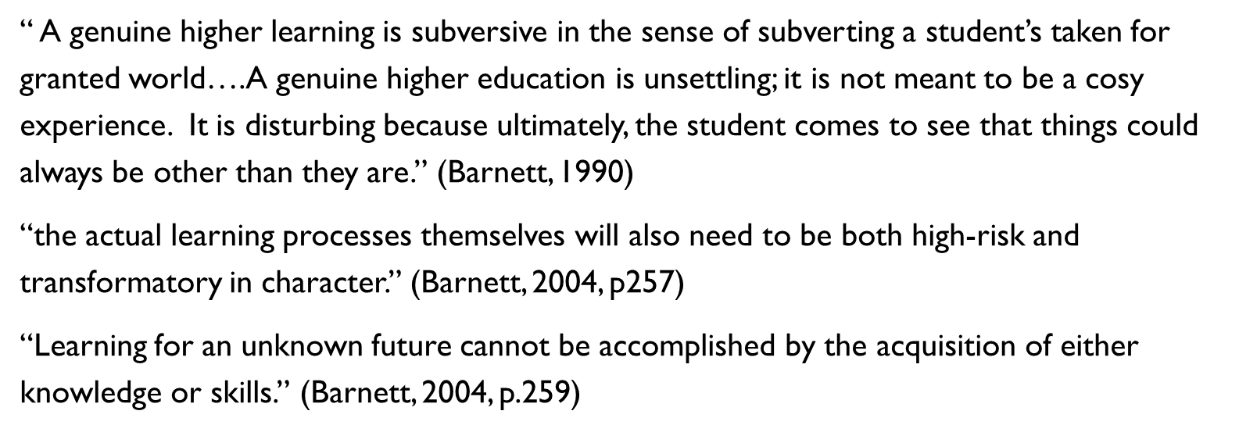
It seems to me that he could be talking about threshold concepts – irreversible, transformative (often troublesome), integrative and bounded. We need to be in the business of changing our students taken for granted view of the world if we want them start to think like entrepreneurs, and perhaps one day to think as entrepreneurs. He even talks about risk - this is an entrepreneurial approach to entrepreneurship education! He also mentions that the about (knowledge) and through (skills) approaches in themselves are not sufficient.
Understanding the threshold concepts in any subject is going to be an unsettling process – it requires an ontological shift. The world is no longer as we thought it once was. Using threshold concepts theory as a way to clarify what we mean when we talk about learning entrepreneurship in higher education strikes me as eminently relevant.
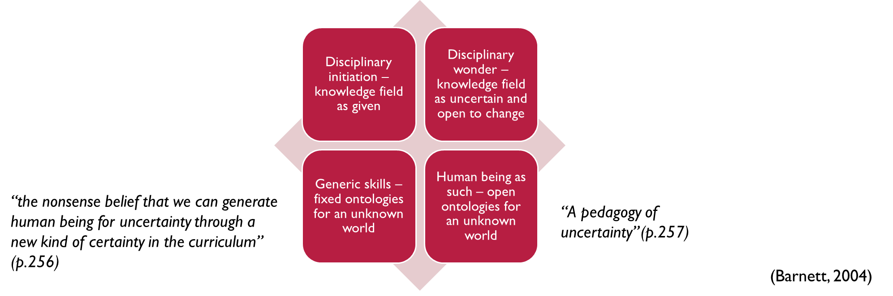When we talk of educating “about” we are in the low risk domain of educational development - when we teach about entrepreneurship or about employability. It’s unlikely to cause any transformations in our students.
So that alone will not be enough. We need to also teach “through” and “for” entrepreneurship – in order to move to the higher risk domains where we can prepare our students for the unknown world through transformational learning. That is likely to mean that developing our curriculum around competencies and learning outcomes is not going to be sufficient. And measuring the success of entrepreneurship initiatives through number of business start-ups, or destination of leavers, or academic achievement are all unlikely to really indicate their true effectiveness, even if we fix the reliability issues of these measures.
We also need to look at the transformational aspects of our initiatives and try to identify where we want those transformations to take place – we need a pedagogy of uncertainty.
That’s where I think the potential of threshold concept theory lies. By understanding how entrepreneurs think we can develop entrepreneurship threshold concepts. We can design and develop our curricula around these entrepreneurship threshold concepts. And we can measure how effectively we are transforming the way our students think. When policy makers talk about future proofing our graduates – it implies the future is predictable. However we know this not to be the case. Entrepreneurship educators can prepare students of higher education for value creation in an unknown and unknowable world through transformational learning programmes informed by entrepreneurship threshold concepts.

Lucy Hatt
2017

References
Dearing. (1997). Higher Education in the Learning Society. London; HMSO.
Lackéus, M. (2015). Value Creation as Educational Philosophy. (Doctor of Engineering), Chalmers University of Technology, Gothenburg, Sweden.
Mill, J.S. (1867). Inaugural lecture at the University of St Andrews. In F.A. Cavanagh (Ed.), James and John Stuart Mill on Education: Cambridge University Press.
Newman, J.H. (1852). Idea of the University. London: Longmans, Green & Co.
Barnett, R. (1990). The idea of higher education: McGraw-Hill Education (UK).
Barnett, R. (2009). Knowing and becoming in the higher education curriculum. Studies in Higher Education, 34(4), 429-440.
Barnett, R. (2012). Learning for an unknown future. Higher Education Research & Development, 31(1), 65-77.
Bechard, J.-P., and Toulouse, J.-M. (1993). Entrepreneurship Training: A Look from Educational Sciences, Working Paper 93-03-01, HEC, Montreal.

Dearing. (1997). Higher Education in the Learning Society. London: HMSO.
Entwistle, N., & Percy, K. A. (1973). Critical thinking or conformity? An investigation into the aims and outcomes of higher education. London: Society for Research into Higher Education.
Hannon, P.D. (2005). Philosophies of enterprise and entrepreneurship education and challenges for higher education in the UK. Entrepreneurship and Innovation, 105 - 114.
Lackéus, M. (2015). Value Creation as Educational Philosophy. (Doctor of Engineering), Chalmers University of Technology, Gothenburg, Sweden.
Mill, J. S. (1867). Inaugural lecture at the University of St Andrews. In F. A. Cavanagh (Ed.), James and John Stuart Mill on Education: Cambridge University Press.
Newman, J. H. (1852). Idea of the University. London: Longmans, Green & Co.
Pring, R. (2001). The changing nature of universities; economic relevance, social inclusion or personal excellence? Retrieved from
QAA. (2012). Enterprise and Entrepreneurship Education. Guidance for UK Higher Education Providers: The Quality Assurance Agency for Higher Education London.
SFC. (2005). Learning to Work - Enhancing employability and enterprise in Scottish FE and HE Scottish Funding Council Retrieved from http://www.sfc.ac.uk/web/FILES/ReportsandPublications/Learning_to_Work_-_Enhancing_employability_and_enterprise_in_Scottish_FE_and_HE.pdf.
UNCTAD. (2012). Entrepreneurship Policy Framework and Implementation Guidance, available at http://unctad.org/en/PublicationsLibrary/diaeed2012d1_en.pdf

