Sustainable Business Model Design: A review of tools for developing Responsible Business Models

Alex Hope, Newcastle Business School, Northumbria University

Abstract
Sustainable and Responsible Business has become a mainstream concept as organisations seek to adapt to a changing business environment and address social, environmental and economic challenges. However, many academics and practitioners suggest that such efforts are prone to inevitable failure as they are peripheral, uneconomic, and incremental. It is common for businesses to innovate at the level of their products and services yet to be truly sustainable and responsible, activities should be linked with the core business of the firm and requires more radical innovation. There is then a need to that innovate at the level of a firm's value creation process, at the level of the business model. Whilst there is much research which present case studies of companies who utilise sustainable business model designs, only recently has attention turned to the development and application of tools and techniques which can assist business leaders in developing models to apply to their own organisations. This chapter discusses sustainable business model design before reviewing a range of toolkits designed to integrate sustainability principles into business strategic planning and assessing their applicability to sustainable and responsible business model design. The aim is to identify and review some of the key tools available for firms to utilise when developing new sustainable business model pathways.

Keywords: Sustainable Business Model, Responsible Innovation, Responsible Business, CSR, Strategic Planning.

Introduction
Sustainability is increasingly recognised as one of the most important challenges of our time. Issues such as global climate change, poverty and inequity, and the unsustainable use of resources are becoming more commonly understood amongst the public, governments and organisations. As a result, the pressure on businesses to incorporate the principles of sustainable development into policies and activities is mounting, as is the pressure to broaden reporting and accountability from economic performance for shareholders to sustainability performance for all stakeholders. This, coupled with the challenging economic times that follow the 2008 global financial crisis and more recent geopolitical shocks such as the withdrawal of the UK from the European Union, austerity measures and retrograde policies from the US administration, have driven business to seek to identify new sources of innovation which may be exploited as a means to renew competitive advantage. Whilst it can be difficult to convince business leaders that their business models need to change based on threats and opportunities that my not have yet fully materialised, global environmental, social, economic and political trends conspire to challenge existing paradigms and suggest a need to develop fundamentally different approaches to value creation.

The need for innovation that can enhance organization's competitive advantage has to be mediated by the need to consider social, environmental and economic sustainability. These often competing drivers have led to the notion of ‘responsible innovation’ which demands the consideration of ethical and social aspects during innovation processes as a means to lead not only to technological innovations which are socially acceptable, but also socially desirable (von Schomberg, 2013). Here the aim is to consider a wider set of stakeholders and environmental externalities when innovative products or services to ensure that the dual aim of business performance and sustainability are met. Traditionally innovation has taken place through the development of new products, services, efficiency measures, supply chain or marketing initiatives, however increasingly companies are attempting to address this within the framework of existing business models and exploring business model innovations (H. Chesbrough, 2013). Changing business model can provide one method by which an organisation may implement a sustainability strategy either in response to a changing business environment such as shifts in competition, declining customer base or critical economic situations. As such, business model innovation is an increasing area of focus both for academics and practitioners alike (Schaltegger, Hansen, & Lüdeke-Freund, 2015).

Business models can be understood as structured management tools which are essential for an organisations' success (Baden-Fuller & Morgan, 2010; Magretta, 2002). Improved understanding of the role of the business model has developed into a more integrated picture of of organisation's strategy and operations and increasingly business models can be seen as a representation of a company in general (Amit & Zott, 2001; Eriksson & Penker, 2000). On one hand business model innovation can be understood as the incremental evolution of parts of an organisations strategy over time in over to meet the changing demands of the market or exploit new technologies (De Reuver, Bouwman, & Maclnnes, 2009; Voelpel, Leibold, & Tekie, 2004). Another view of business model innovation considers the complete re-invention of an existing organisations business model in order to achieve similar ends (Johnson, Christensen, & Kagermann, 2008). Existing business models are often based on creating, delivering and capturing economic value with limited or no consideration of social or environmental value (Evans, Rana, & Short, 2014), yet sustainability is increasingly essential for the long term success of organisations (Nidumolu & Prahalad, 2009). Many authors have asserted that business model innovation is key to business success (Henry Chesbrough, 2010; see for example H. Chesbrough & Rosenbloom, 2002; Zott, Amit, & Massa, 2011) and that business model innovation and redesign is essential in generating real long term sustainable value (Lüdeke-Freund, 2010; Porter & Kramer, 2011; Schaltegger, Luedeke–Freund, & Hansen, 2012; Stubbs & Cocklin, 2008). Those organisations that do not rethink their business models around sustainability will be more limited in their ability to create competitive advantage than those which do (Rana, Short, Evans, & Granados, 2017).

Accordingly attention has turned to the development and deployment of sustainable and responsible business models that seek to improve the performance of organisations to create greater environmental and social value while delivering economic sustainability (Bessant, 2013; Porter & Kramer, 2011). Stubbs and Cocklin (2008) conceptualize a ‘sustainability business model’ as one which includes a combination of sustainability practices; features attributes and characteristics; sufficient conditions; business processes; and firm or system level descriptions. With this in mind, a sustainable business model seeks to deliver value to all stakeholders both now and in the future by minimising any impact on the environment, improving social outcomes in the communities through which the business operates and providing economic value both to shareholders and wider stakeholder groups. In this respect, the sustainable and responsible business model sits at the intersection of for­ profit business motivations and social impact potential as illustrated in Figure 1.
Figure 1: The Responsible Business Model domain (Hope & Moehler, 2015).

One of the key difficulties faced by business seeking to incorporate responsible and sustainability principles into their business model and operational strategy is the tension between value as profit and social value. Birkin et al (2009) suggest that it is very likely that new sustainable business models will have to address issues that appear to be counter to business interest. For this reason responsible business model innovation requires the inclusion of stakeholders values in the process of design in the same way that a responsible technical innovation does (Breuer & Lüdeke-Freund, 2016a; Taebi, Correljé, Cuppen, Dignum, & Pesch, 2014). In summary sustainable and responsible business model innovations must address the following challenges (Hope & Moehler, 2015).

- Incorporation of the principles of sustainable development, social responsibility and ethics into the business model;
- Reconciliation of the often conflicting interests of profit and social value;
- Flexibility to incorporate local needs and markets;
- Scalability across a wide range of business sizes;
- Replicable both within and across a range of business sectors;
- Inclusion of all relevant stakeholders in the design of new responsible business
Models;
- Be operationalizable in practice.

Innovating more sustainable business models requires the development of new and revised business models that go beyond a profit oriented economic focus to one which can integrate environmental, social and economic value throughout the strategy and operations of an organisation (N. Bocken, Short, Rana, & Evans, 2013; Willard, 2012). Sustainable business models must be economically sustainable as a prerequisite. The overall objective in sustainable business modelling is to identify solution that allow firms to capture economic value whilst also generating environmental and social value (Schaltegger & Wagner, 2011). Whilst business models that align with the principles of sustainable development are increasingly popular both within industry and within the academic literature, tools that assist in sustainable business modelling are little known (N. Bocken et al., 2013) especially within academic literature.
For businesses seeking to develop new or revised business models that incorporate sustainability principles, there is a need to understand the range of supportive tools available to facilitate the process of sustainable business modelling. The aim of this chapter is to identify some of the key tools available for business leaders to utilise when developing new or revised business models.

Tools for Sustainable and Responsible Business Model Innovation
Tools for responsible sustainable and responsible business model design may be split into two different categories. The first typifies generic strategic management tools which may be used to develop new and revised business processes in general and not necessarily developed specifically for business model design. Such tools can be used to assist organisations in developing new business models and assesses their applicability to sustainable and responsible business model design. There are several tools that can be used at different stages including Visioning, Metrics and charts, SWOT analysis, PESTLE analysis, Affinity Diagrams, Portfolio Analysis and Interrelationship diagrams. The aim is to identify where the business wants to be in the future and identify new sustainable business model pathways before quantifying impacts, understanding macro level external factors that impact the organisation, assess the health of organisation by examining its strengths, weaknesses, opportunities and threats, set out tasks and projects required to implement strategy and determine which are more important or significant.

A second category of tools that are becoming increasingly important in business model design and are currently attracting a lot of interest from academics and practitioners alike are those which have been developed specifically for business model design. Some of these tools deal simply with business model design in general, whilst others set out to specifically incorporate sustainability considerations into business model design from the outset. Table 1 sets out a number of these tools which are presented in the academic and practitioner literature.

Table 1. Sustainable Business Model Design Tools

Toolkit | Authors
Business Innovation Kit | (Breuer, 2013)
Sustainability Innovation Pack | (Breuer & Lüdeke-Freund, 2016a)
Flourishing Business Canvas | (Upward & Jones, 2016)
Sustainable Value Analysis Tool | (M. Yang, Vladimirova, Rana, & Evans, 2014)
The Cambridge Value Mapping Tool | (N. Bocken et al., 2013)
Triple Layered Business Model Canvas | (Joyce & Paquin, 2016)
Sustainable Business Transformation (SBT) roadmap | (M. Daud Ahmed & Sundaram, 2012)
Framework for Strategic Sustainable Development | (Broman & Robèrt, 2017)

The next section sets out these business model tools reviews their potential for application in the development of sustainable and responsible business models.

The Business Model Canvas

The Business Model Canvas (BNC) proposed by Osterwalder and Pigneur (2010) is a tool popular with practitioners when formulating business models. It can be useful in helping business model designers understand an organization's existing business model though a visual representation of the elements of the model and potential interconnections and impacts on value creation (Joyce & Paquin, 2016). The BNC is broken down into nine interrelated building blocks - customer segment, customer relationships, value propositions, channels, key activities, key resources, key partners, cost structure and revenue streams. Whist the BNC may assist organisations in aligning profit and purpose and therefore support sustainability principles on its own, in practice it is suggested that environmental and social value is in fact de-emphasised due the models more explicit profit or economic value creation orientation (Coes, 2014; Upward, 2013).

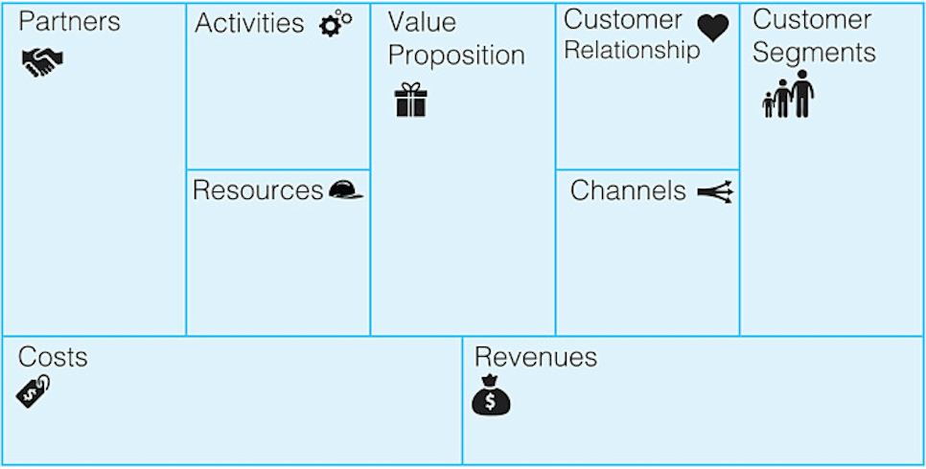

Figure 2: The Business Model Canvas (BMC)

The key strength of the BMC is its ability to generate a visual representation of the structure of a business model. This is perhaps the main reason that the BMC has become popular amongst practitioners as a strategic management tool. The canvas can be printed out so that groups of people can start discussion, sketching and debating business model elements with the result that the hands-on nature of the tool fosters increased understanding, discussion, creativity and analysis. There are however some limitations to the tool in practice. Despite its popularity as a framework to support the generic business modelling process, it has a narrow view of the value proposition focussing as it does on the customer (N. Bocken et al., 2013). As a result, the BMC has been adapted to suit specific business applications and scenarios such as product to market fit, examining the supply chain, cash flow, internal communications and as the 'Lean Canvas' (Maurya, 2012) developed specifically for startup businesses. Another critique of the tool is its absence of a strategic approach toward competition. It is primarily an internally focussed tool which focusses on what an organisation delivers, how it does so and the process required to bring products and services to market. As a result of these critiques, a range of sustainable business model tools have been developed, many of which build on the BMC adding sustainability principles into the original model.

Triple Layered Business Model Canvas

The Triple Layered Business Model Canvas (TLBMC) is a tool for exploring sustainability oriented business model innovation. It extends Osterwalder and Pigneur’s (2010) original Business Model Canvas (BMC) by adding two additional layers: an environmental layer which introduces a product lifecycle perspective and a social layer which is based on a stakeholder perspective (Joyce & Paquin, 2016). This approach is designed to allow sustainability issues to be structured into business model design and innovation in a more holistic manner. The TLBMC adopts a triple bottom line (TBL) perspective to provide the opportunity for business leaders to explicitly integrate economic, environmental and social value into a holistic view of sustainability. The TBL advocates that organisations formally account for their environmental and social impacts alongside their economic goals. The environmental layer of the TLMBC introduces a lifecycle perspective of environmental impact. It integrates a Life Cycle Assessment (LCA) approach to measuring a product or services environmental impact at each stage of its life (Rebitzer et al., 2004/7). The social layer of the TLMBC extends the original business model canvas through a stakeholder approach to capture the mutual interactions between an organisation and its stakeholders (Joyce & Paquin, 2016). Both layers are depicted in Figure 3.

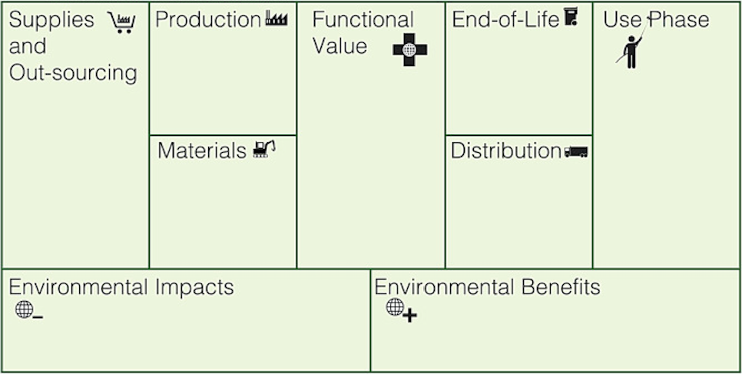

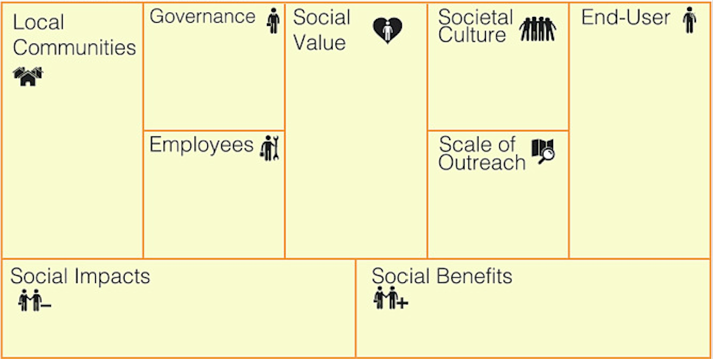

Fig. 3. The Environmental and Social layers of the TLBMC (Joyce & Paquin, 2016)

In use, the TLBMC can support business model analysis, innovation and design towards more sustainable business models by highlighting the intangible and tacit connections internal and external to an organisation. Here it may be used to provide a visual representation of an organization's existing business model. It may also be used as a business model creation tool by demonstrating the consequences of changing the individual elements of a business model through the aggregated impacts across all three levels. Finally, it can be used as a validation tool to balance the costs and benefits of their business model idea with consideration of the environmental, social and economic perspective.

Business Innovation Kit and Sustainability Innovation Pack

The Business Innovation Kit (BIK) was developed by UXBerlin, a management consultancy led by Breuer and Ludeke-Freund (2015, 2016a). The toolkit aims to enable entrepreneurial teams to explore, dispute, and co-define business models for new or existing organisations through a structured and focussed process (Lüdeke-Freund, 2015). It provides practical exercises which enable business leaders to specify revenue models, walk through the customer journey and pursue specific orientations such as sustainability or values based responsible business (Breuer, 2012). The toolkit consists of a number of sets of cards which contain exercises for use in a workshop setting that enable business leaders to unfold a range of alternatives when modelling a new business. The original BIK has recently been supplemented with the ‘Sustainability Innovation Pack’ developed by Ludeke-Freund (2015), two additional card sets that focus on the creation of sustainability-oriented business models and the improvement of sustainability performance in existing businesses. The cards enable uses to reflect on current innovation maturity within their business and define one of five levels of sustainability innovation maturity. They then work through eight business case drivers to integrate social, economic and ecological sustainability issues into their business models.

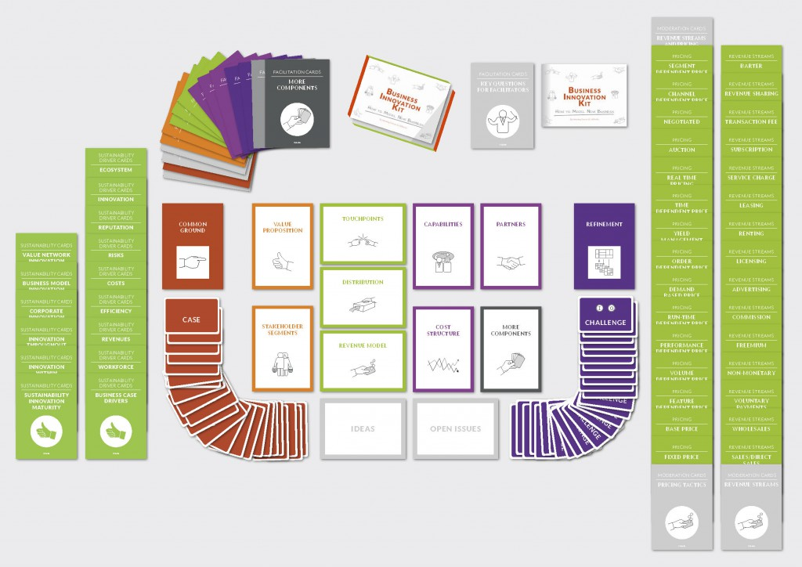

Fig 4. The Business Innovation Kit card sets (Breuer, 2012).

The Business Innovation Kit and Sustainability Innovation Kit incorporate ideas and concepts first developed by Osterwalder and Pigneur’s business model canvas (2010). Success when using the tool depends on the workshops where business leaders and participants are led through the process of sustainable business model design by appropriately trained facilitators (Breuer & Lüdeke-Freund, 2016b). The tool has been tested within a range of organisations to validate is effectiveness in use and has proved useful in assisting organisations in adding a corporate sustainability perspective to their business model innovations.

Flourishing Enterprise Innovation Toolkit and Flourishing Business Canvas

The Flourishing Enterprise Innovation Toolkit has been designed to assist businesses in improving their social, environmental and economic performance in collaboration will all stakeholders. Developed by Upward and Jones (2016) at York University Toronto’s Faculty of Environmental Studies and Schulich School of Business, the toolkit assists organisations across a range of goals from financial viability to how to do good by doing well. This is achieved by enabling the identification of risks and opportunities relevant to a business’s chosen objectives (Flourishing Enterprise Innovation, 2017). The Flourishing Business Canvass at the heart of the toolkit is a visual design tool that embeds a common language to enable more effective collaboration by any group of stakeholders that participants deem relevant to designing the social, economic and environmental aspects of an organization's business model. The canvas uses common language to enable a business to work with a broad range of stakeholders to sketch, prototype, design, communicate, measure and create stories about the sustainability aspects of their business model (Flourishing Enterprise Innovation, 2017).

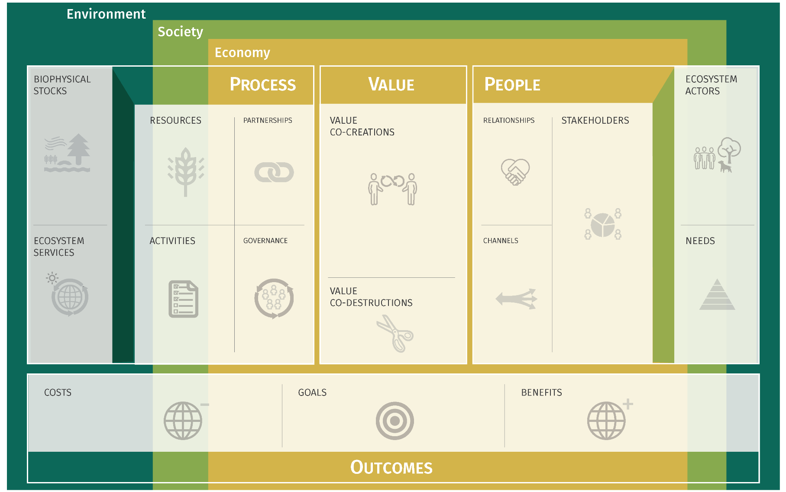

Fig 5. The Flourishing Business Canvas (Flourishing Enterprise Innovation, 2017).

The Flourishing Business canvas supports sustainable business model design through its participatory approach to business modelling. The result is an approach that increases an organisation's ability to learn and reflect on sustainability and and increase their ability to take practical action.

Sustainable Value Analysis Tool

The Sustainable Value Analysis Tool (SVAT) was developed out of a PhD thesis at the Institute for Manufacturing, University of Cambridge (M. Yang et al., 2014). The tool was designed to assist companies in identifying opportunities to capture value through sustainability by analysing captured and uncaptured value for key stakeholders across a product lifecycle. Uncaptured value may be typified by waste streams in production, under-utilised resources, reusable components, labour capacity issues and the insufficient use of expertise and knowledge (M. Yang, Evans, Vladimirova, & Rana, 2017). In a similar manner to other tools described here, the tool is used in a facilitated workshop environment with the facilitator playing a pivotal role in guiding the process. The SVAT tool was developed with the intention to support business model ideation rather than implementation, however it may be used in conjunction with other tools to create actionable plans and opportunities (Miying Yang, Vladimirova, & Evans, 2017).

When considering sustainable business model design, the SVAT tool recognises the fact that ‘value’ is commonly understood predominantly as monetary value and that sustainability requires a more comprehensive view of value that incorporates social and environmental benefits (Evans et al., 2014). The premise of the tool is that in order to effectively integrate sustainability into their business models, companies should consider the environment and society as valuable and integrate these with the other sources of value that they consider. In this respect, the tool provides a useful conceptual framework

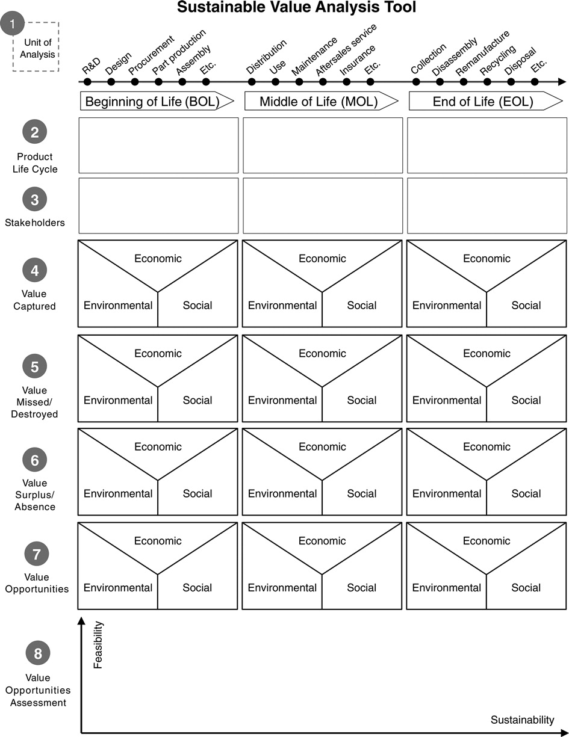

Fig 6. The Sustainable Value Analysis Tool (Miying Yang et al., 2017).

The Cambridge Value Mapping Tool

Another business model specific tool developed out of the University of Cambridge’s Institute of Manufacturing, the Cambridge Value Mapping Tool also aims to enhance value creation through business model design. It was conceived to help companies create value propositions that support sustainable business goals (N. Bocken et al., 2013). The tool adopts a qualitative approach to value analysis as a means to understand positive and negative aspects of a business's value proposition; identify conflicting values such as those between differing stakeholder groups; and identifying opportunities for business model redesign to align economic, environmental and society sustainability goals (N. Bocken et al., 2013). The tool is deployed in a workshop model which utilises a facilitated brainstorming process to populate the tool and explore stakeholder’s perceptions of value assisting in prioritising, exploring potential transformation paths and planning the evolution of a business model (N. M. P. Bocken, Allwood, Willey, & King, 2012/1).

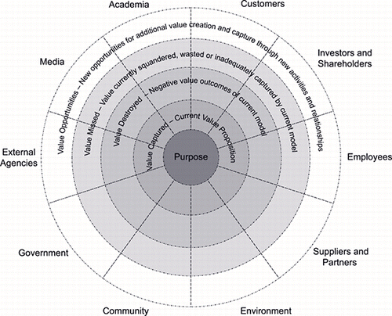

Fig 7. The Cambridge Value Mapping Tool (N. Bocken et al., 2013).

The tool aids organisations in developing sustainable business models by incorporating a wide array of stakeholders and perspectives. It is also deployed in a participatory manner to gather a wide range of thoughts and opinions from stakeholder representatives. It encourages the elimination of wastes and generation of new products and services in a similar fashion to the model of a circular economy.

Business Model Road-mapping for Sustainable Business Model development

When developing sustainable and responsible business models, organisations seek to integrate their systems, structures, people and technology to achieve sustainability (M. Daud Ahmed & Sundaram, 2012). It is in this endeavour that business model roadmapping can act as a useful tool by providing a common format from which to develop clear objectives, defined action plans and analyse critical decision points. Ahmed and Sundaram (2012) have developed the Sustainable Business Transformation (SBT) roadmap as a procedural tool to assist businesses in developing a new sustainable business model. The idea of the roadmap is to articulate a cyclic journey through the stages indicated in Figure 7. The aim is to aid decision makers in the development of sustainable business models by encouraging them to understand the initial sustainability challenges the business potentially faces, envisaging strategies to deal with these challenges before designing new models, transforming existing ones and monitoring their success. The SBT roadmap is supported by framework and architecture for integrated sustainability modelling and reporting (M. Daud Ahmed & Sundaram, 2012).

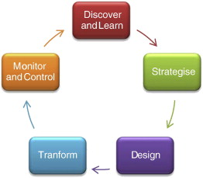

Fig 8: Sustainable Business Transformation Roadmap (M. Daud Ahmed & Sundaram, 2012).

The benefits of the tool reside in its ability to provide a procedural framework which prescribes the use of modelling paradigms and methodologies which business can use to develop their strategy and business models. Essentially the SBT roadmap integrates generic business tools such as a Sustainability Modelling and Reporting (SMART) framework (M. D. Ahmed & Sundaram, 2008), balanced scorecard, data and document modelling and business process modelling. The SBT roadmap identifies the models and tools required at each stage of the business model development process in order to enable decision makers to consider the full range of social, economic and environmental sustainability issues. The SBT roadmap is not without its limitations however. Whist the roadmap itself is relatively simple to understand and apply, the methodologies, tools and decision support systems that underpin the approach are complex and difficult for non-expert practitioners to use. As with the TLBMC, the tool relies on users understanding of business model strategies to unlock the benefits of the tool so again may require further testing with businesses specifically at the level of business model design.

Framework for Strategic Sustainable Development (FSSD)

The Framework for Strategic Sustainable Development (FSSD), also known as the Natural Step Framework is a tool developed by Karl-Henrik Robert in the late 1980’s as a means to set out the system conditions required for sustainability (Robèrt & Anderson, 2002). The FSSD pioneered a backcasting from principles' approach as opposed to forecasting current situations and trends. Backcasting is a methodology which can be used to examine complex issues (Holmberg & Robert, 2000). The FSSD involves a funnel metaphor to facilitate an understanding of sustainability challenges and the benefit of a proactive approach to dealing with the issues (França, Broman, Robèrt, Basile, & Trygg, 2017) and is designed to provide guidance on how to develop a project, organisation or region towards socially and environmental sustainability in an economic fashion. The funnel metaphor depicts the gradual loss of social and environmental systems capacity as the system moves through the funnel. The narrower circumference represents increasingly harsher constraints suggesting that the risk of being hit financially by the narrowing wall of the funnel are relatively higher for those organisations whose contribution to global sustainability issues are large and that business risk is accelerating down the funnel (Broman & Robèrt, 2017; Holmberg & Robert, 2000). The framework can assist business organisations identify the opportunities to develop new services, products and business models that align with the changing conditions in the global market which can already be foreseen in principle (Basile, Broman, & Robert, 2011; Willard, 2012).

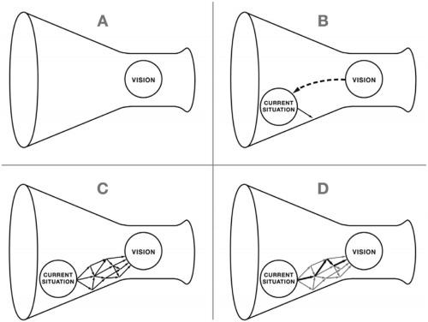

Fig 9: The FSSD and ABCD Procedures (Broman & Robèrt, 2017).

The FSSD uses an operational procedure with four steps as indicated in Figure 2. In step A participants learn about the FSSD and apply the model to discuss a topic, project or business model design and agree on the vision of success framed against sustainability principles. When the business case for sustainability is understood participants move onto step B and explore the current situation in the context of the sustainability orientated success of the A step. The result is a list of challenges of current activities in relation to the objective to be reached. In step C participants brainstorm solutions to the challenges listed under step B and set out future possible solutions. These solutions are scrutinised against the goal with disregard to the constraints of the current situation. The question is 'what is theoretically possible within the constraints provided by the integrated goal' (França, 2017). In step D participants prioritise the brain-stormed solutions from step C and set out a business plan to implement the identified solutions. When considering sustainable business model design the FSSD framework offers a participatory approach to understanding sustainability issues.

FSSD for Sustainable Business Model development

The FSSD helps support business leaders in overcoming trade-offs and provides assistance to enable them in gaining competitive advantage in sustainability-driven markets (Baumgartner & Rauter, 2017). When considering the use of the FSSD for business model development, its strength is its ability to provide a robust, generic and comprehensive principles for sustainability and a method for integrating these into strategic planning (Baumgartner & Rauter, 2017). Whilst the FSSD used alone can facilitate greater understanding of the social, environmental and economic challenges facing businesses seeking to develop sustainable and responsible business models, its real strength comes from its ability to be combined with other tools. The FSSD can then inform the development of sustainable and responsible business models in a similar way to business model roadmapping by integrating visioning techniques with other tools and methods such as value mapping, lifecycle assessment and the Business Model Canvas (França et al., 2017). It is here that the limitation of the FSSD become apparent. It should be recognised the the FSSD is a generic tool for examining sustainable development. Whilst it provides critical information and guidance for sustainable development in a broad range of institutional contexts, it does not provide the full range of information a business would require when developing a business model (França et al., 2017). As a result, the FSSD does need to be used in conjunction with a more business specific too such as the BMC to facilitate sustainable business model innovation.

Conclusion
Many organisations are seeking to incorporate the principles of sustainability and responsibility into their core business through the development of sustainable and responsible business models. In doing so they are seeking tools and methods to assist them in identifying new or improved business model pathways. This Chapter has examined the concept of sustainable and responsible business models and business model innovation as a means to integrate social, environmental and economic sustainability into the core of a business. In order to do so business leaders can employ tools and methods designed to assist them in developing sustainable responsible business models. The tools reviewed here approach the design of sustainable business models from different perspectives, however they do share some common elements.

Firstly, all of the tools reviewed here incorporate the visioning stage of business model design in some way in that they seek to envisage how the business may move forward by adopting a motivational and emotive process. Second in contrast to the majority of strategic management tools used by business the ones reviewed here utilise the concept of backcasting from future scenarios and prioritise steps towards their realisation. Thirdly they build on, or integrate, existing business model creation tools that are proven in practice and reasonable well established. Finally, they all seek to develop a holistic understanding of sustainability from environmental, social and economic perspectives.
Tools such as those outlined in this chapter can prove useful in the design of sustainable and responsible business models, but as Chesbrough (2010) points out, they cannot by themselves promote experimentation and innovation within the models. In other words, business leaders can design, innovate and develop new models, but implementing them is a difficult and risky endeavor. Businesses need to develop and change organisational processes as well as encouraging and empowering leaders to experiment with new sustainable and responsible business models. Despite this, strategic planning tools which aid the development of sustainable business models represent an important first step in the process of developing sustainable, responsible business models that create value for the business and society at large.

References
Ahmed, M. D., & Sundaram, D. (2008). Sustainability modelling and reporting: Integrative frameworks and architectures. Decision Sciences and Technology for Globalisation, Allied Publishers, New Delhi, 426–439.
Ahmed, M. D., & Sundaram, D. (2012). Sustainability modelling and reporting: From roadmap to implementation. Decision Support Systems, 53(3), 611–624.
Amit, R., & Zott, C. (2001). Value creation in e‐business. Strategic Management Journal. Retrieved from http://onlinelibrary.wiley.com/doi/10.1002/smj.187/full
Baden-Fuller, C., & Morgan, M. S. (2010). Business Models as Models. Long Range Planning, 43(2), 156–171.
Basile, G., Broman, G., & Robert, K. H. (2011). A Systems-Based Approach to Sustainable Enterprise: Requirements, utility, and limits. In S. G. McNall, J. C. Hershauer, & G. Basile (Eds.), The Business of Sustainability – Trends, Policies, Practices and Stories of Success, Vol. I: Global Challenges and Opportunities (Vol. 1, pp. 3–28).
Baumgartner, R. J., & Rauter, R. (2017). Strategic perspectives of corporate sustainability management to develop a sustainable organization. Journal of Cleaner Production, 140, Part 1, 81–92.
Bessant, J. (2013). Innovation in the Twenty-First Century. In R. Owen, J. Bessant, & M. Heintz (Eds.), Responsible Innovation (pp. 1–25). John Wiley & Sons, Ltd.
Birkin, F., Cashman, A., & Koh, S. (2009). New sustainable business models in China. Business Strategy and the Environment. Retrieved from http://onlinelibrary.wiley.com/doi/10.1002/bse.568/full
Bocken, N. M. P., Allwood, J. M., Willey, A. R., & King, J. M. H. (2012/1). Development of a tool for rapidly assessing the implementation difficulty and emissions benefits of innovations. Technovation, 32(1), 19–31.
Bocken, N., Short, S., Rana, P., & Evans, S. (2013). A value mapping tool for sustainable business modelling. Corporate Governance: The International Journal of Business in Society, 13(5), 482–497.
Breuer, H. (2012). Business Innovation Kit | UX Berlin Innovation Consulting. Retrieved August 10, 2017, from http://www.uxberlin.com/businessinnovationkit/
Breuer, H. (2013). LEAN VENTURING: LEARNING TO CREATE NEW BUSINESS THROUGH EXPLORATION, ELABORATION, EVALUATION, EXPERIMENTATION, AND EVOLUTION. International Journal of Innovation Management, 17(03), 1340013.
Breuer, H., & Lüdeke-Freund, F. (2015). Values-Based Innovation Framework -- Innovating by What We Care About. https://papers.ssrn.com/sol3/papers.cfm?abstract_id=2620564. Retrieved from https://papers.ssrn.com/sol3/papers.cfm?abstract_id=2620564
Breuer, H., & Lüdeke-Freund, F. (2016a). Values-Based Innovation Management: Innovating by What We Care About. Palgrave Macmillan.
Breuer, H., & Lüdeke-Freund, F. (2016b). VALUES-BASED NETWORK AND BUSINESS MODEL INNOVATION. International Journal of Innovation Management, 21(03), 1750028.
Broman, G. I., & Robèrt, K.-H. (2017). A framework for strategic sustainable development. Journal of Cleaner Production, 140, Part 1, 17–31.
Chesbrough, H. (2010). Business Model Innovation: Opportunities and Barriers. Long Range Planning, 43(2–3), 354–363.
Chesbrough, H. (2013). Business model innovation: it’s not just about technology anymore. Strategy & Leadership, 35(6), 12–17.
Chesbrough, H., & Rosenbloom, R. S. (2002). The role of the business model in capturing value from innovation: Evidence from Xerox Corporation’s technology spin-off companies. Industrial and Corporate Change, 11(3), 529–555.
Coes, D. H. (2014, March 13). Critically assessing the strengths and limitations of the Business Model Canvas. University of Twente. Retrieved from http://essay.utwente.nl/64749/
Comes, S., & Berniker, L. (2008). Business Model Innovation. In D. Pantaleo & N. Pal (Eds.), From Strategy to Execution (pp. 65–86). Springer Berlin Heidelberg.
De Reuver, M., Bouwman, H., & Maclnnes, I. (2009). Business model dynamics: a case survey. Journal of Theoretical and Applied Electronic Commerce Research, 4(1), 1–11.
Eriksson, H.-E., & Penker, M. (2000). Business Modeling with UML: Business Patterns and Business Objects. John Wiley & Sons Inc.
Evans, S., Rana, P., & Short, S. W. (2014). Final set of tools and methods that enable analysis of future oriented, novel, sustainable, value adding business models and value-networks. Deliverable D2, 6.
Flourishing Enterprise Innovation. (2017). The Toolkit & Canvas – Flourishing Enterprise Innovation. Retrieved August 11, 2017, from http://www.flourishingbusiness.org/the-toolkit-flourishing-business-canvas/
França, C. L. (2017). Business Model Design for Strategic Sustainable Development. Blekinge Tekniska Högskola. Retrieved from http://www.diva-portal.org/smash/record.jsf?pid=diva2%3A1060784&dswid=-9256
França, C. L., Broman, G., Robèrt, K.-H., Basile, G., & Trygg, L. (2017). An approach to business model innovation and design for strategic sustainable development. Journal of Cleaner Production, 140, Part 1, 155–166.
Holmberg, J., & Robert, K.-H. (2000). Backcasting — a framework for strategic planning. International Journal of Sustainable Development and World Ecology, 7(4), 291–308.
Hope, A., & Moehler, R. (2015). Responsible Business Model Innovation: Reconceptualising the role of business in society. In Proceedings of the European Academy of Management EURAM’15 Conference. Warsaw, Poland: European Academy of Management. Retrieved from http://nrl.northumbria.ac.uk/22974/
Johnson, M. W., Christensen, C. M., & Kagermann, H. (2008). Reinventing your business model. Harvard Business Review, 86(12), 57–68.
Joyce, A., & Paquin, R. L. (2016). The triple layered business model canvas: A tool to design more sustainable business models. Journal of Cleaner Production, 135, 1474–1486.
Lüdeke-Freund, F. (2010). Towards a Conceptual Framework of’Business Models for Sustainability'. Retrieved from https://papers.ssrn.com/sol3/papers.cfm?abstract_id=2189922
Lüdeke-Freund, F. (2015, February 26). “Sustainability Innovation Pack” (Beta) – Facilitation Tool for Sustainable Business Model Innovation. Retrieved August 10, 2017, from https://blog.ssbmg.com/2015/02/26/sustainability-innovation-pack/
Magretta, J. (2002). Why business models matter. Harvard Business Review, 80(5), 86–92, 133.
Maurya, A. (2012). Running lean : iterate from plan A to a plan that works. Sebastopol, CA: O’Reilly.
McGrath, R. G. (2010). Business Models: A Discovery Driven Approach. Long Range Planning, 43(2–3), 247–261.
Nidumolu, R., & Prahalad, C. K. (2009). Why sustainability is now the key driver of innovation. Harvard Business Review. Retrieved from http://www.businessandsociety.be/assets/ee902e549915b8586e8a8daa338e073e.pdf
Osterwalder, A., & Pigneur, Y. (2010). Business model generation: a handbook for visionaries, game changers, and challengers. Retrieved from https://books.google.com/books?hl=en&lr=&id=UzuTAwAAQBAJ&oi=fnd&pg=PA7&dq=osterwalder+and+pigneur+business+model+canvas&ots=yWJUyaE63x&sig=wqgzdMQk0Twd5LGlx8OI7tw9bKM
Porter, M. E., & Kramer, M. R. (2011). The big idea: Creating shared value. Harvard Business Review, 89(1), 2.
Rana, P., Short, S. W., Evans, S., & Granados, M. H. (2017). Sustainable Business Models: Theoretical Reflections. In J. P. Liyanage & T. Uusitalo (Eds.), Value Networks in Manufacturing (pp. 95–109). Springer International Publishing.
Rauter, R., Jonker, J., & Baumgartner, R. J. (2017). Going one’s own way: drivers in developing business models for sustainability. Journal of Cleaner Production, 140, Part 1, 144–154.
Rebitzer, G., Ekvall, T., Frischknecht, R., Hunkeler, D., Norris, G., Rydberg, T., … Pennington, D. W. (2004/7). Life cycle assessment: Part 1: Framework, goal and scope definition, inventory analysis, and applications. Environment International, 30(5), 701–720.
Robèrt, K.-H., & Anderson, R. (2002). The Natural Step story: Seeding a quiet revolution. New Society Publishers Gabriola Island.
Schaltegger, S., Hansen, E. G., & Lüdeke-Freund, F. (2015). Business Models for Sustainability. Organization & Environment, 29(1), 3–10.
Schaltegger, S., Luedeke–Freund, F., & Hansen, E. G. (2012). Business cases for sustainability: the role of business model innovation for corporate sustainability. International Journal of Innovation & Sustainable Development, 6(2), 95–119.
Schaltegger, S., & Wagner, M. (2011). Sustainable entrepreneurship and sustainability innovation: categories and interactions. Business Strategy and the Environment, 20(4), 222–237.
Stubbs, W., & Cocklin, C. (2008). Conceptualizing a “Sustainability Business Model.” Organization & Environment, 21(2), 103–127.
Taebi, B., Correljé, A., Cuppen, E., Dignum, M., & Pesch, U. (2014). Responsible innovation as an endorsement of public values: the need for interdisciplinary research. Journal of Responsible Innovation, 1(1), 118–124.
Upward, A. (2013). Towards an ontology and canvas for strongly sustainable business models: A systemic design science exploration. York University Toronto. Retrieved from http://yorkspace.library.yorku.ca/xmlui/handle/10315/20777
Upward, A., & Jones, P. (2016). An Ontology for Strongly Sustainable Business Models. Organization & Environment, 29(1), 97–123.
Voelpel, S. C., Leibold, M., & Tekie, E. B. (2004). The wheel of business model reinvention: how to reshape your business model to leapfrog competitors. Journal of Change Management, 4(3), 259–276.
von Schomberg, R. (2013). A Vision of Responsible Research and Innovation. In R. Owen, J. Bessant, & M. Heintz (Eds.), Responsible Innovation: Managing the Responsible Emergence of Science and Innovation in Society (pp. 51–64). London: Wiley.
Willard, B. (2012). The New Sustainability Advantage: Seven Business Case Benefits of a Triple Bottom Line. New Society Publishers.
Yang, M., Evans, S., Vladimirova, D., & Rana, P. (2017). Value uncaptured perspective for sustainable business model innovation. Journal of Cleaner Production, 140, 1794–1804.
Yang, M., Vladimirova, D., & Evans, S. (2017). Creating and Capturing Value Through Sustainability. Research-Technology Management, 60(3), 30–39.
Yang, M., Vladimirova, D., Rana, P., & Evans, S. (2014). Sustainable value analysis tool for value creation. Asian J. of Management Science and Applications, 1(4), 312.
Zott, C., & Amit, R. (2010). Business model design: an activity system perspective. Long Range Planning. Retrieved from http://www.sciencedirect.com/science/article/pii/S0024630109000533
Zott, C., Amit, R., & Massa, L. (2011). The business model: recent developments and future research. Journal of Management. Retrieved from http://jom.sagepub.com/content/37/4/1019.short

