Evaluation of Public-Private Partnerships: A Life-Cycle Performance Prism for Ensuring Value for Money

Abstract
Public-Private Partnerships (PPPs) have become an integral strategy to deliver infrastructure projects in Australia. Yet, PPPs have been plagued with controversy due to recurrent time and cost overruns. The paucity of an approach to evaluate the performance of PPPs throughout their life-cycle has hindered the ability of governments to manage their effective and efficient delivery. This paper examines the practice of evaluation for a hospital and prison that were delivered using PPPs. The empirical evidence indicates that with PPPs: (1) performance is typically measured during the construction and operation phases using time, cost and quality and a restricted number of key performance indicators; and (2) a process-based and stakeholder-oriented measurement approach would be better suited to evaluate performance. Building upon the extant literature and the findings emerging from ‘practice’ (i.e., actual activity, events or work), a Performance Prism for ameliorating the evaluation of PPPs throughout their lifecycle is proposed. The research presented in this paper provides stakeholders of PPPs, especially governments, with a robust framework for governing and future proofing their assets to ensure value for money.

Keywords: Evaluation, PPPs, Performance Prism, Social infrastructure, Australia

Introduction
Public-Private Partnerships (PPPs) have been extensively used to deliver public assets, when governments’ budgets for infrastructure development are limited. The PPP market in Australia is considered to be mature and sophisticated; it forms an integral part of State Governments’ procurement strategies for delivering infrastructure (Hodge, 2004; Duffield and Clifton, 2008). Yet, the use of PPPs has been plagued with controversy, particularly in Australia and the United Kingdom (UK), where many projects have experienced substantial overruns and poor operational performance, for example, Southern Cross Station, Melbourne, Australia (cost overruns), Latrobe Regional Hospital, Victoria, Australia (poor service quality) and Dalmuir Wastewater Treatment Works, Scotland, UK (poor operational outputs) (Harris et al., 2014; Regan, 2014).

A variety of factors can contribute to the unsatisfactory performance of PPPs (Liu et al., 2015b), including ineffective project evaluation which has been reported in the literature (e.g., Yuan et al., 2012; Liu et al., 2015a; Love et al., 2015). Essentially, performance evaluation is critical to business success, particularly at the corporate and project levels (Love and Holt, 2000; Kagioglou et al., 2001; Liu et al., 2014; 2015c). Yuan et al. (2009) has suggested that the absence of an effective performance evaluation within PPPs acts as a trigger for producing below optimum quality of the public services. Despite this, most procured PPP projects have not undergone a comprehensive evaluation in terms of what has been delivered (Hodge, 2005; Regan et al., 2011). Further, the accountability of the government involved with PPPs has shifted to enhancing the effectiveness of service quality and efficiency of public resources. This has resulted in increasing demand for a more robust evaluation as a governance tool for the projects (Wu et al., 2016).

This paper examines the ‘practice’ (i.e., actual activity, events or work) of performance evaluation for two social infrastructure projects procured using a PPP: (1) hospital; and (2) prison. In conjunction with the extant literature, the findings are used to interpret PPP performance evaluation and then adapt and develop a life-cycle Performance Prism valuable for the public sector to improve the projects’ evaluations and ensure Value for Money (VfM) is delivered for an asset from ‘cradle’ to ‘grave’.

Public-Private Partnerships and Performance Evaluation
There is no universally accepted definition for PPPs. The European Investment Bank (EIB) (2004) defines PPPs as “the relationships formed between private sector and public bodies often with an aim of introducing private sector resources and/or expertise to provide and deliver public assets and services (p.2).” Notably, the European Commission (2003) states that governments embark on PPPs to:

- accelerate the provision of infrastructure by allowing the public sector to translate capital expenditure into a flow of on-going service payments;
- ensure timely project implementation by allocating responsibility for design and construction to be undertaken by the private sector;
- reduce whole life cost and provide incentives to the private sector to minimise costs and improve the management of a project’s life-cycle;
- reduce government risk exposure by transferring to the private sector;
- improve service quality and innovation via the use of private-sector expertise and performance incentives; and
- enhance prudent management of public expenditure and reduce corruption by increasing accountability and transparency.
There has been a tendency for PPP research to focus on the following areas: (1) the development of critical success factors (CSF); (2) governments’ roles/responsibilities; (3) selection of concessionaire; (4) risk allocation/management; (5) effectiveness/efficiency of project implementation; and (6) project finance (Liu et al., 2015b). Table 1 summarises the scope of PPP research over the past two decades. Noteworthy, there is a dearth of research that has addressed PPP evaluation with empirical research being limited to Garvin et al. (2011), Yuan et al. (2012) and Mladenovic et al. (2013).

Table 1: Scope of the research on PPPs
Research Themes | Authors
Critical Success Factors | Tiong (1996); Qiao et al. (2001); Jefferies et al. (2002); Li et al. (2005); Jefferies (2006); and Liu et al. (2015c).
Government’s roles/responsibilities | Kumaraswamy and Zhang (2001); Pongsiri (2002); Koch and Buser (2006); da Cruz et al. (2013); Van den Hurk (2016); and Wu et al. (2016).
Concessionaire selection | Zhang and Kumaraswamy (2001); Zhang et al. (2002); Zhang (2004, 2005a); and Jang (2011).
Risk allocation/management | Wang et al. (2000); Grimsey and Lewis (2002); Thomas et al. (2003); Jin (2011); Chan et al. (2011); and Roberts and Siemiatycki (2015).
Effectiveness/efficiency of implementation of PPPs | Lemos et al. (2002); Edelenbos and Teisman (2008); Trumbull (2009); Beisheim and Campe (2012); Taylor and Harman (2015); Kort et al. (2015).
Project finance | Levy (1996); Ye and Tiong (2000); Zhang (2005b); Devapriya (2006); Regan et al. (2011); and Engel et al. (2013).

While the aforementioned studies have made a valuable contribution to raising the significance of performance evaluation within PPPs, they have stopped short of tackling how to comprehensively evaluate them throughout their life-cycle (Liu et al., 2015b; Love et al., 2015). Thus, empirical research aiming to address this significant theoretical issue is required (Koontz and Thomas; 2012; Liu et al., 2016). Haponava and Al-Jibouri (2012) further this view as they have suggested that there is a need to identify a new approach for evaluating construction projects (especially infrastructure projects) to enable life-cycle project success. In fact, the traditional approach for performance evaluation is based on the triumvirate of time, cost and quality (TCQ). It has been widely criticised for not being able to accommodate the dynamic and changing nature of projects throughout their life-cycle. Baccarini (1999) suggests project success needs to encapsulate both product and process views. Product success is concerned with the long-term impacts of the built asset on local community/region. Conversely, process success relates to effectiveness and efficiency of the managerial actions or activities that are performed (Baccarini, 1999).

Research Approach
The debate about PPPs has moved beyond ideological arguments about their advantages and disadvantages to focusing on ‘how’ to structure and/or manage the projects throughout their life cycles to achieve the predetermined policy objectives and goals (Yong, 2010). In line with this focus, a case study is used to determine and explore ‘how’ performance measurement in PPP projects can be improved. According to Flyvbjerg (2006), a case study is suitable for all stages of a research, and particularly useful for generalizing and/or examining new knowledge. Moreover, performance measurement research tends to marry with the ontology and epistemology of interpretivism. Therefore, practitioners’ experiences and insights should not be ignored when deriving a new performance measurement system (PMS) for the organisation (Neely et al., 2000). Similarly, Love et al. (2002) identify that research of this nature should not rely on a positivist approach, as it may neglect the impact of human behaviour and subsequent decision-making processes that can be enacted.

The cases selected for this research were the only social infrastructure PPPs being delivered by a State Government at the time of the research. The State Government and participants of each of the Special Purpose Vehicles (SPV) demonstrated a willingness to participate in the research. A cross-sectional case study was adopted to provide an in-depth understanding of the nature of performance measurement. The cross-sectional approach was intended to minimize disruption to participants who agreed to partake in the research. Since the completion of the research other social infrastructure PPPs have commenced.

Data Collection
Triangulation formed the basis of the data collection process as it can be used to overcome problems associated with bias and validity (Yin, 1984; Stake, 1995; Love et al., 2002). A series of informal discussions, semi-structured interviews and documentary sources (e.g., contractual documents) formed the cornerstones of the data collection process.

Interviews were conducted at the interviewees’ offices and were digitally recorded, and then transcribed verbatim, to allow for any finer nuances to be detected. Interviews were purposely kept relaxed using phrases such as ‘tell me about it’ or ‘can you give me an example’. The indicative questions that were used for the interviews included:

- What approach is being used to evaluate the performance of the PPP project you are involved with?
- What do you consider to be the shortcomings of the performance evaluation process in the project?
- How do you think performance evaluation can be improved in the project?

The open nature of the questions stimulated avenues of interest to be pursued as they arose without introducing bias in the response. Additional notes were taken during interviews to support the digital transcription process and to maintain validity and safeguard against the digital recorder’s failure. Notably, focused sampling was used for selecting interviewees as it is particularly effective for a case study that aims to explore new lines of inquiry.

A total of 22 interviews were conducted with each varying in length from 90 minutes to two hours. A conscious effort was made to break down any barriers that may have existed between the interviewer and interviewee. Interviews were transcribed and then sent to the interviewee for checking and approval. Table 1 provides a summary of interviewees. To ensure confidentiality, each case is referred to as Project-A and Project-B with the data collection process occurring over a period of a year.

Table 2: Interview respondents of Projects A and B
Projects and Interviewees | Serial Codes | Organisations
Project-A
Procurement Director (PD) | PD-A&B | State Government
Project Manager | PM-A | State Government
Service Director | O/FM-A | Clinical & Healthcare Provider
Construction Manager | CM-A | Construction Company
Architect | D/A-A | Design Firm
Contract Advisor/Manager | CM/PA-A | State Government
Project-B
Project Manager (PM) | PM-B | Construction Company
Design Manager (DM) | DM-B | Design Firm
Contract Manager (CM) | CM-B | Construction Company
Engineering Manager (CEM) | CEM-B | Construction Company
Facility/Asset Manager (F/AM) | F/AM-B | FM Group

The Procurement Director was responsible for overseeing the progress of both case projects (A/B) as well as the senior management in charge of the essential parts of the delivery of the assets (e.g., design, construction, operation and/or facility maintenance – FM). All practitioners that were interviewed had minimum of 10-years’ experience delivering social infrastructure PPPs in Australia and/or Europe.

Data Analysis
The narratives that were compiled were analysed using NVivo 10 software, which combines the efficient management of non-numerical, unstructured data with powerful processes of indexing and theorizing. NVivo 10 enabled additional data sources and journal notes to be incorporated into the analysis as well as identifying emergent new themes. The development and re-assessment of themes, as the analysis progressed, accords with calls to avoid confining data to pre-determined sets of categories. This process complied with the approach developed by Silverman (2006) for interpreting qualitative data. Kvale (1996) suggests that ad hoc methods for generating meaning enables the researcher to access “a variety of common-sense approaches to interview text using an interplay of techniques such as noting patterns, seeing plausibility, making comparisons etc. (p.204).”

Case Background
Project-A is a public hospital, encompassing more than 300 beds and housing more than 1,000 staff. State-of-the-art facilities are embedded into the hospital. For example, Magnetic Resonance Imaging scanners, which ensure that a comprehensive range of clinical and healthcare services (e.g., pathology, general medical and medical specialities, general surgery and surgical specialities, maternity, intensive care, and adult rehabilitation) are offered to the local communities. The hospital had a contract value of AU$340 million in 2008, was procured using a Design Build Operate and Maintain (DBOM) and became operational in 2016. Contrastingly, Project-B was a regional prison, which aimed to deliver more than 1,600 additional beds across the State’s prison system. This project replaced the existing facility, which initially was built in the 1980s and incorporated only 100 beds. Project-B had a contract value of AU$200 million in 2009 and was procured employing a Design Build Finance Maintain (DBFM) and was completed in 2016.

Both DBOM and DBFM are forms of PPP. In the case of Project-A, the private-sector SPV handled the asset’s design, build, operation and maintenance, while the SPV of Project-B was responsible for designing, building, financing and maintaining the facility. Unlike Project-B, which was fully funded by the private-sector SPV by introducing equity investors and debt providers, Project-A was co-funded by the Australian Commonwealth and State Governments (i.e., AU$170 million from each). Figures 1 and 2 illustrate the structures of the case projects.

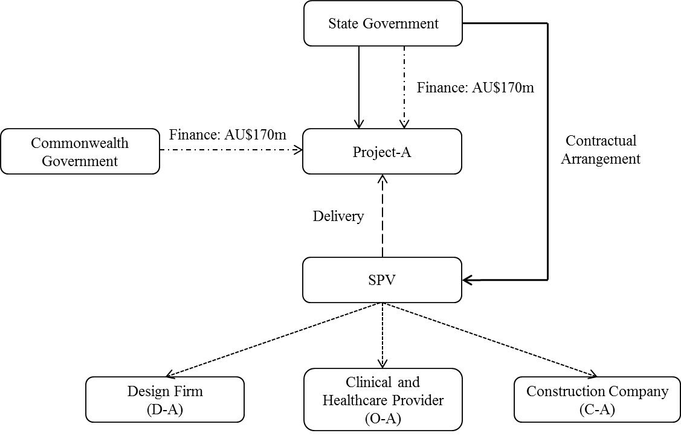
Figure 1: Structure of Project-A
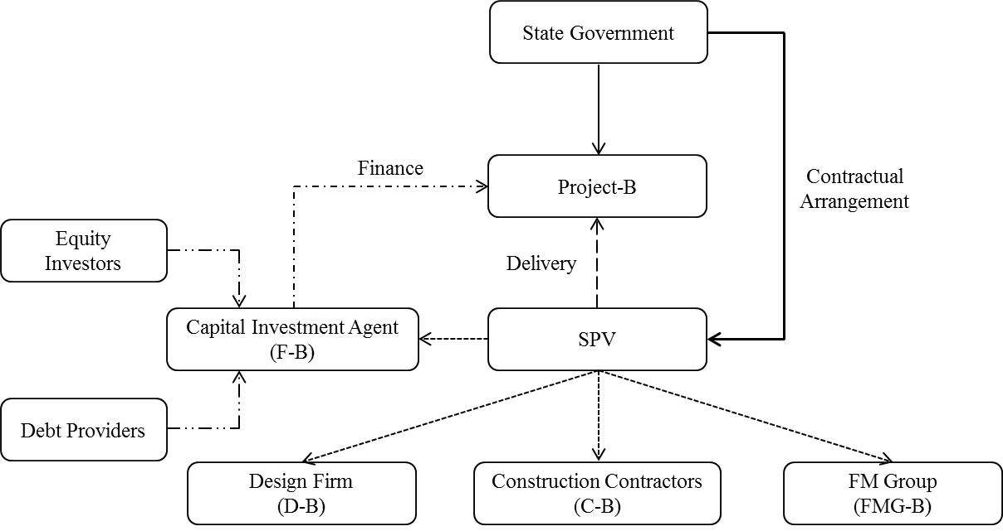
Figure 2: Structure of Project-B

Both projects have a similar delivery process, involving: (1) Initiation & Planning (e.g., business case study, invitation for the Expression of Interest and evaluation of submitted proposals), Procurement (e.g., request for proposal, tendering/bidding and financial close) and Partnership (e.g., design, construction and/or operation and maintenance).

Performance Evaluations of Case Projects
The performance evaluation systems of Projects A and B contain two separate parts that were handled by the public authorities and the private-sector SPVs, respectively. The evaluations undertaken by the government focused on the assessment for VfM as well as business case development and the effectiveness of the tendering decision. Conversely, the measurements initiated by the private-sector entities concentrated adhering to the predetermined deliverables of schedule, budget and service (i.e., asset quality and/or operational outputs). For example, the Procurement Director stated:
“There are two parts of performance evaluation in the projects. For the government, we used the concept of ‘Gateway Review’ to control the performance of the project. So, during the inception stage, strategic evaluation for feasibility, such as value for money assessment under the Public Sector Comparator and a number of qualitative issues (for Project-A), and then an evaluative review for business case development were conducted, followed by assessments for confirming the defined outputs and checking the tender decision. For the private consortia, they checked if the projects were delivered on time and on budget or assessed if the operation can meet our devised key performance indicators (KPIs) (Project-A) …”

The objective information obtained from documentary sources provided an understanding of the practice of evaluation being implemented in the case projects. According to the ‘Project Summary’ of each case project, Project-B used only the Public Sector Comparator (PSC) for assessing VfM. In the case of Project-A VfM assessment depended upon the PSC and several non-quantitative measures (e.g., quality of services, range of services and additional services) (Tables 3 and 4). The ‘Service Agreement’ of Project-A also indicated that a total of 159 KPIs determined by the relevant public authority of the State Government were being used to monitor the service quality of the built facility.

Table 3: VfM assessment of Project-A
Methods | Main Contents
Quantitative comparison | PSC: (,000): AU$6,268,756
 | Private-Sector Delivery (,000): AU$4,960,040
 | Saving (,000): AU$1,308,715
 | Saving (%): 20.9%
Qualitative consideration | Quality of Services, Range of Services and Additional Services

Table 4: VfM assessment of Project-B
State’s Risk Adjusted PSC (AU$,000) | SPV’s Risk Adjusted Proposal (AU$,000) | Savings (AU$,000) | Saving Percentage
$452,590 | $372,312 | $80,278 | 17.7%

The interviewees from the private SPVs of both PPPs further explained the evaluation systems of the projects. For instance, the Service Director, who oversaw the subcontractors and the operation and maintenance of Project-A, made the following comment:

“We are evaluating each component in the design and construction by examining financial and time performance, and we employed external engineering specialists to inspect the quality regularly, to ensure the quality of the asset. We have key performance indicators (KPIs) determined by the government to control operational outputs. If we cannot meet those KPIs, we will get abatement.”

Like Project-A, the performance evaluation that was undertaken by the SPV of Project-B focused on traditional measures of TCQ. The Project Manager (PM-B), for example, introduced that:

“As a private contractor, we talk about time, cost and quality in the evaluation. They are the only performance measures we have for this project. Time is now our premium, and in terms of costs, we are running within the budget. Quality – this measure is about once we start building – the quality of the product that we put forward.”

The performance evaluation systems for Projects A and B are illustrated in Figures 3 and 4, with attention being placed on a quantitative VfM assessment, reviews of business case development and tendering decisions, examinations of TCQ or operational measurement that relied on KPIs. All interviewees (Projects A and B) maintained that the approaches that were applied to evaluate PPPs needed to be improved owing to a series of shortcomings, which are presented and discussed below.

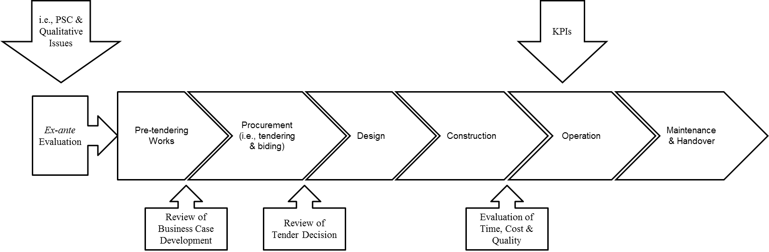
Figure 3: Performance Evaluation System of Project-A

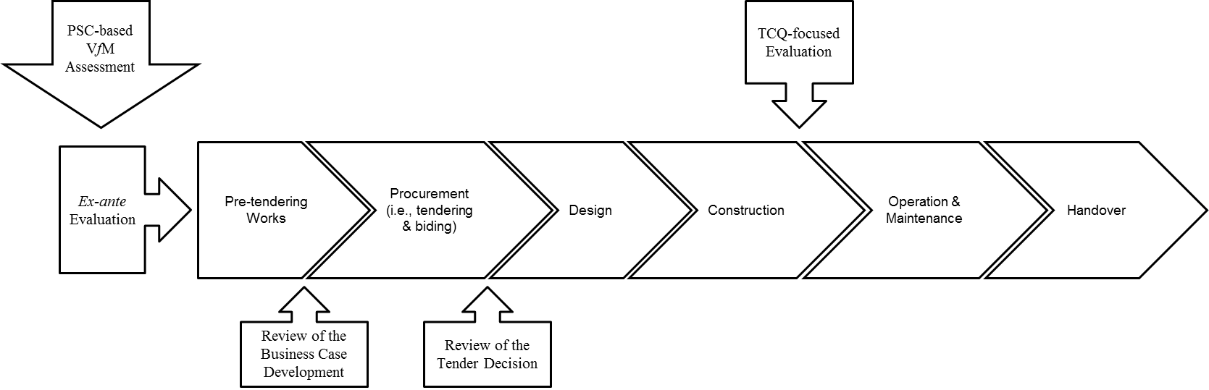
Figure 4: Performance Evaluation System of Project-B

Shortcomings of Existing Performance Evaluations
There was consensus amongst interviewees from the public sector (i.e., PD-A&B and CM/PA-B in Table 1) that there was a need to improve the existing performance evaluations as they were not robust enough to accommodate the deliverables to ensure the long-term success of their projects. These included, for example, a mechanism to engender and enact continuous improvement, efficiency and competitiveness of the tendering/bidding procedures and non-financial benefits in VfM assessment. The Procurement Director stated that:

“The track record of our approach used for performance evaluation is good, but we will have to refine it. In particular, there is a need to ensure that lessons learned are properly captured. But this internal process with the projects was not robust enough and we are constantly improving it. And, PPP approval process within the government in the Procurement phase sometimes has been protracted. Although we can get through that quickly, focusing more on the approval procedure in evaluation can increase its efficiency. Moreover, competition of tendering/bidding is important but this was missed when we measured our projects, and, the PSC for assessing VfM is not perfect though it has worked well with us. VfM is a holistic consideration of project benefits, not just delivering the required scope at the cheapest cost. It is related to a wide range of benefits to the public, such as economic and social.”

In addition to these issues, the Contract Manager of Project-A identified the deficiency of the KPIs that were designed and implemented with an aim of controlling the operational outputs of the private-sector SPVs. This experienced PPP practitioner stated:

“KPIs for the operation of the facility will be used for next a couple of years, but we are in an intensively changing business environment and there is no doubt the indicators designed today will not be suitable for the whole contractual period.”

The information derived from the interviews with the key managerial practitioners of the private SPVs of Projects A and B (e.g., Corporate Service Director, Project Manager and Design Manager) indicated that the project measurements conducted by the private-sector entities were confronted with challenges. As mentioned above, the approaches adopted by the SPVs to the performance measurement of the case projects are referred to as ex-post evaluation, which were concerned with TCQ. The use of TCQ in an evaluation of PPPs has been criticised by both academia and practitioners as it cannot capture such issues as design innovation, asset sustainability and stakeholders’ satisfaction, all of which are expected by the governments from SPVs. This was re-stated by the Procurement Director (PD-A&B) for the two case projects as the following comment:

“We expected an introduction of private consortia would be an opportunity to drive innovation in design through the whole of life perspective and enhance the sustainability of the facilities and end-users’ satisfaction.”

The current performance evaluation of the projects, however, failed to indicate whether the public client’s expectations had been met. For instance, the Construction Manager of Project-A identified that traditional TCQ assessment is too simplistic to capture inherent complexities and uncertainties of PPPs and stated:

“An effective measurement should reflect not only tangible but also intangible issues. But the TCQ-focused assessment failed in doing so because it is not a complete measurement. For example, the state government would like to expand the hospital in the future. Under the long-term planning by 2020, they will expand the hospital by another 100 beds. So, what we did was we came up with a design which allowed, effectively, half of the ward to be replicated and then built with minimal interruption to the existing facility, and then all the services which are involved for the hospital are able to be added on - hooked into - to supplement the additional hundred beds. In the existing evaluation, how are these innovative works being reflected?”

The Project Manager and Design Manager of Project-B possessed a similar view as they considered that more intangible performance measures should have been implemented to evaluate the design and construction of the PPP project, with emphasis being placed on innovation and asset sustainability. Such intangibles are critical to the satisfaction levels of the owner and end-users of an asset. The Service Director of Project-A supported this view as well, not only of the TCQ measures adopted for design and construction, but also the KPIs devised for asset operation and facility maintenance. The Service Director stated:

“If I were the director of the State government responsible for setting up this contract, I would devise far more engineering KPIs. I would like to make sure the hospital is well maintained and there was proper asset planning or condition reporting etc. The government now is focusing too much on clinical care and has got their clinical care covered, but they don’t have the building measurement covered and the performance indicators for FM have not been documented well. This is not good for ensuring VfM.”

This was confirmed by the Asset Manager of Project-B, who suggested that as the project had been delivered using a DBFM, the State government and SPV should have made explicit the measures for controlling the quality of the FM work. After all, operational expenditure far outweighs capital costs when the life of an asset is taken into consideration. Stressing the importance of measuring the performance of operations and maintenance the Director stated:

“Maintenance is a key thing. You cannot improve or repair something until you know what is wrong. You need to measure it to find out, so effective indicators are required.”

The key emergent themes and issues arising from the second part of the interviews regarding the shortcomings of traditional performance measurement in PPPs are presented in Figure 5. There were a series of deficiencies in the performance evaluation systems of Projects A and B, which included: (1) a cost-based VfM assessment rather than a complete evaluation for both financial and non-financial benefits; (2) an ineffective and inefficient internal process for absorbing the lessons learned from project evaluation; (3) neglect of critical issues relating to the procurement of the projects (i.e., tendering/bidding); (4) a simplistic TCQ assessment for design and construction; (5) the lack of performance measures for the outputs of FM works; and (6) the weak ability of operational KPIs in accommodating business environment changes.

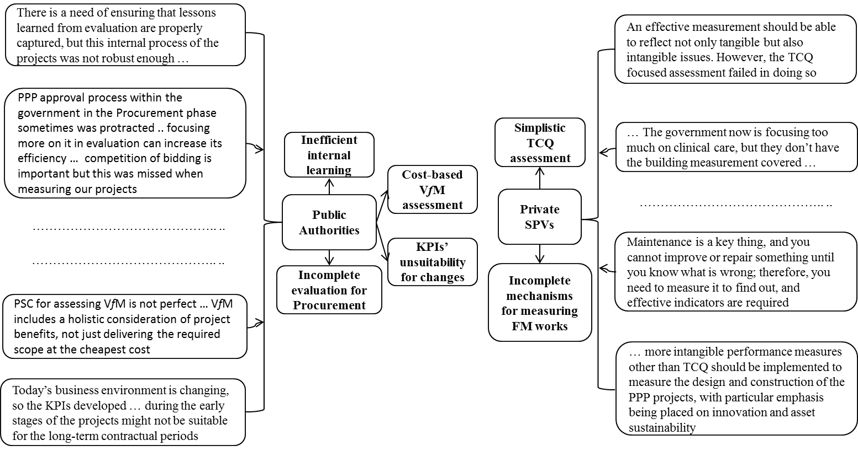
Figure 5: Key emergent themes from the case studies

Recommendations for Improvements
The case studies undertaken have identified shortcomings with the performance evaluation that was used to measure PPPs. Based on these findings, a process-based and stakeholder-oriented perspective should be addressed in the performance evaluation of PPPs. If, for example, KPIs focus on process and key stakeholders’ expectations, they can reflect the distinct feature of PPPs related to a unique delivery process and sophisticated stakeholder networks. In fact, most of the interviewees considered that a life-cycle/process-based measurement approach is ideal for PPPs and can supersede traditional ex-post evaluation due to its robustness in being able to capture all the deliverables of PPPs (i.e., tangible and intangible) that cascade from the initiation and planning to operation and maintenance phases. For example, the Contract Manager of Project-A from the public authority explicitly proffered that:

“As a consultant, I care about delivery process and key stakeholders, especially in a social infrastructure project, like a hospital. This is because PPPs are unique for their life-cycle with a long-term contractual arrangement between public and private sectors and a sophisticated stakeholder network … So, addressing process and stakeholders’ needs can reveal all important deliverables and then improve the effectiveness of the performance evaluation system of the project.”

The Project Manager and Design Manager of Project-B supported the view expressed above. They also argued that future PMSs devised for PPPs must be ‘life-cycle’ oriented and designed for reflecting whether or not the key project stakeholders’ expectations have been satisfied, rather than just simply indicating if the projects were delivered on ‘time’ and/or on budget. Furthermore, some of the interviewees suggested that a life-cycle/process-based and stakeholder-oriented measurement could be achieved by deriving and using a sequence of project-phase-based KPIs (e.g., indicators of PPP initiation, procurement, construction, operation and facility maintenance as well as those indicators in respect of client’s and/or end-users’ satisfaction). Additionally, it was identified during the case studies that KPIs for assets’ operations are not capable of accommodating intensive changes throughout a long-term contractual period. Thus, as proposed by the Contract Manager of Project-A, a review mechanism needs to be launched into PPP projects to update the operational KPIs:

“The contractual arrangement of our PPP project is up to 25 years. So, a review mechanism is useful for the operational KPIs in order to ensure they will be able to accommodate future social and economic changes. But the state government obviously does not have such a robust mechanism to update them.”

A review mechanism for KPIs, theoretically, can underpin the implementation of a process-based PMS. This is because the performance measures of the process-based PMSs are required to reflect the long-term business environment in which the organisation operates (Neely, 1999). With this principle, a review mechanism of life-cycle PMSs (in PPPs) will help to ensure VfM and success of the projects.

Assessment for VfM, as discussed above, is a pivotal component of the performance evaluation system of PPPs. The Office of Government Commerce in the UK (2002) defines VfM as “the optimum combination of whole life cost and quality to meet the user’s requirement.” It is a concept relating to overall outcomes achieved, covering a wide range of issues involving life-cycle costs, physical and service quality, maintainability, social benefits and sustainability (Department of Treasury and Finance Victoria, 2007). Nonetheless, the PSC, which is widely applied to PPPs, is a purely cost-based assessment, and thus it largely ignores non-quantitative issues. For instance, in the case projects, net present values (NPVs) of the projects were adopted as the key criteria by decision makers in state government to determine whether a PPP would be a feasible way for procuring the public assets, though limited non-financial benefits of services (quality and range) had been considered in Project-B. A broad life-cycle VfM assessment with consideration of both qualitative and quantitative issues should be proposed and developed for PPPs. Such issues include whole-life cost, physical quality, service quality and range, asset’s conditions (e.g., maintainability and sustainability) and social or economic impacts on local community and the public. This view was confirmed by the two interviewees who claimed that it is necessary to shift VfM assessment of PPPs from a cost-based evaluation to a whole-life measurement conducted within both quantitative and qualitative contexts.

It is also noted from the empirical findings that ineffective and inefficient internal learning is a weakness of the performance evaluation systems of the case projects. Theoretically, organisational learning is an enabler for business growth and success and maintains a vital role in the process-based performance measurement of the organisation (Love et al., 2004). Kululanga et al. (2001) also claim that organisational learning provides a vehicle” for delivering continuous improvement and incremental innovation. This implies that the “mechanisms” that stimulate effective and efficient learning must be integrated into the entire business process of the organisation to enhance their ability to capture and absorb “lessons” learned. As stated by the Procurement Director (PD-A&B), the public authority that oversaw the delivery progress of Projects A and B had already initiated actions to improve and accelerate its internal learning process of PPPs. The State Government is currently implementing a new system to absorb the information that was derived from the projects. Therefore, a learning mechanism should be incorporated into the PPP life-cycle to serve as a key function of their future performance evaluation.

Life-Cycle Performance Prism
Emerging from the case studies is the recommendation for a process-based and stakeholder-oriented measurement to be developed with consideration of VfM assessment and continuous improvement that engenders learning. Neely et al. (2001) have suggested that the measurement for what stakeholders’ need and how they contribute to the organisation should be conducted simultaneously in a PMS. At this juncture, a new Performance Prism, which is different from that one originally proposed by Neely et al. (2001), can be developed as a ‘stepping stone’ for ameliorating performance evaluation of future PPPs (Figure 6).

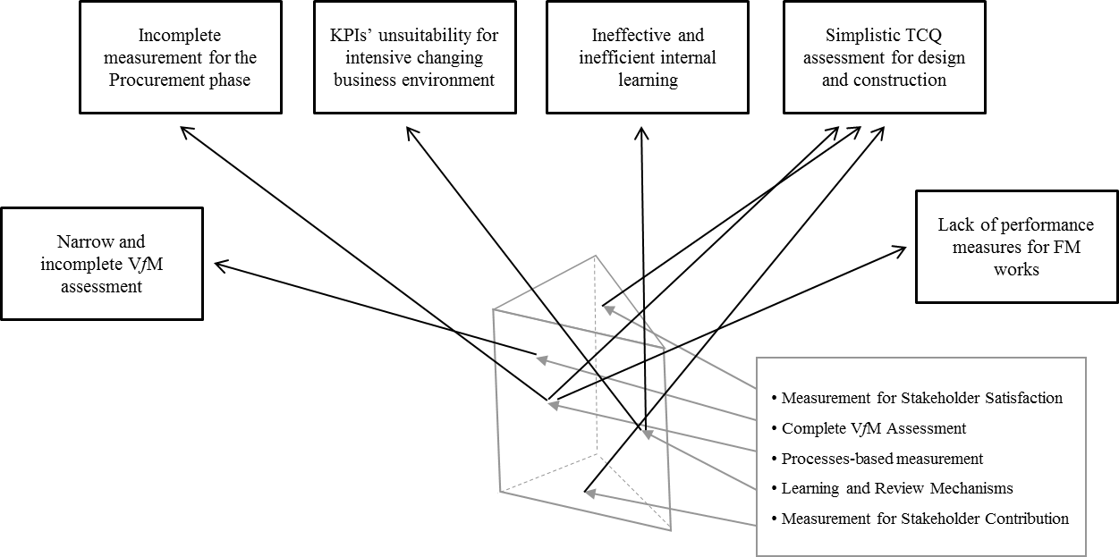
Figure 6: Life-cycle Performance Prism for PPP Evaluation (Adapted from Neely et al. 2001)

Figure 6 illustrates how the proposed framework can deal with the prevailing issues confronting PPP performance evaluation. Specifically, the process-based and stakeholder-oriented measurements, as demonstrated above, focus on evaluating the deliverables of each project phase of a PPP (e.g., the suitability of business case development, completeness of macro-environmental study, competitiveness of tendering procedure and innovation in design). Consequently, the problematic issues in the existing performance evaluation system of a PPP, for example, incomplete and ineffective measurements for the project’s procurement, design and construction, operations and maintenance, would be resolved by applying the Performance Prism framework.

Benefiting from a KPI review mechanism, the performance measures developed with the process and stakeholder-oriented measurement will be equipped with a robust capability in accommodating demographic and environmental changes (i.e., political, economic, social and legal). In addition, the proposed life-cycle Performance Prism possesses can improve the derived paucities, such as the myopia of VfM assessment and weak internal learning. This is because it emphasises: (1) a comprehensive evaluation for VfM that considers financial benefits as well as macro-impacts on local communities and the public (e.g., social benefits and economic development); and (2) effective and efficient organisational learning to absorb the “lessons” emerging from the projects.

Implications for Practice
The proposed life-cycle Performance Prism provides stakeholders of a PPP (e.g., public governor, designer, builder, operator and facility maintainer) with an explicit and reliable direction of how to improve the systems or approaches applied to measure the performance of their projects. The application of the Performance Prism has the potential to provide the public and private-sector with the ability to: (1) evaluate their projects by concentrating on the process-based deliverables (e.g., business case, planning, decision on tendering or bidding, asset design, construction and operation and/or facility maintenance); (2) undertake an examination of VfM; and (3) examine the effectiveness/efficiency of learning mechanisms to be employed. These immediate benefits will provide the basis for ensuring projects processes and product are delivered successfully. Figure 7 depicts how a shift from conventional ex-ante/ex-post evaluations to a life-cycle measurement that addresses the perspectives of the developed Performance Prism will be future-proofing PPPs, for example, enabling an asset’s sustainability and ensuring a continuous value to meet key stakeholders’ expectations.

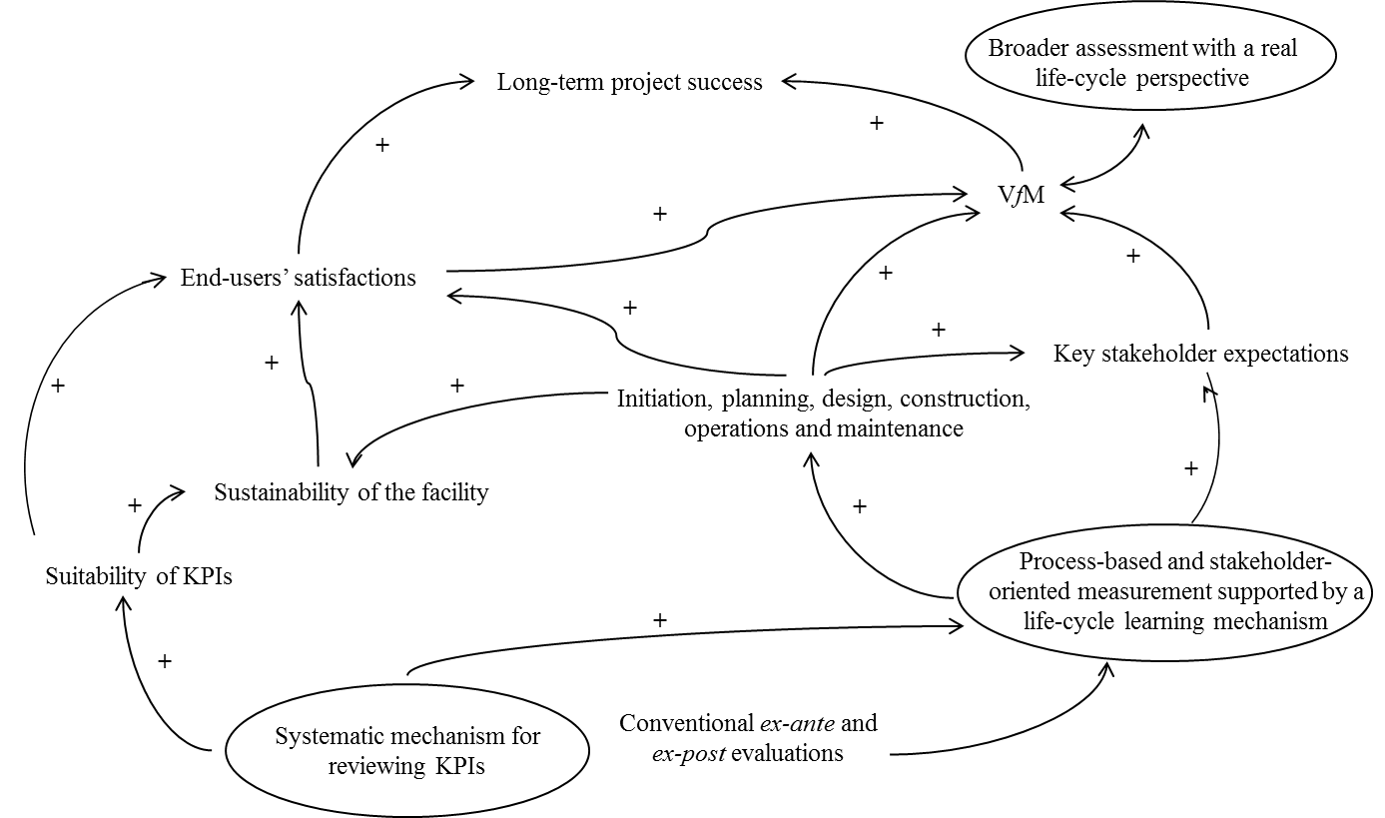
Figure 7: Performance Prism framework in benefiting PPPs
Note: “+” denotes the positive effects generated by the framework on PPPs

As noted from Figure 7, changing a VfM assessment from a finance-focused evaluation to a comprehensive life-cycle examination may significantly improve the veracity of the business cases of PPPs. In turn, this may provide the government with a broader concept of VfM and provide guidance to pursue a complete realization of project success. The process- and stakeholder-oriented measurement, which is underpinned by a life-cycle learning mechanism, is capable of effectively capturing the conditions of a PPP project’s initiation and planning, procurement, construction, operation and facility management.

This type of measurement can benefit the government by improving their efficiency in decision making in terms of the options for infrastructure delivery. At the same time, it can assist the private-sector entity to effectively and efficiently monitor their deliverables and completely meet the key stakeholders’ expectations over the project life-cycle. For instance, while the government can oversee the performance of its PPP project by screening the design KPIs or FM KPIs, the private SPV can also examine such KPIs to understand whether the public client/end-users are satisfied with the operational outputs.

As a consequence of embedding a learning mechanism into the KPIs, the quality (e.g., physical quality and service quality) as well as the sustainability of the built asset will be enhanced. This leads to an increase in end user satisfaction and a decrease in risks that can result in the underachievement of VfM and project long-term success. Moreover, the systematic mechanism for reviewing/updating the implemented KPIs can facilitate PPPs in accommodating changes to the internal and external environment, thereby enhancing the whole-of-life suitability of the asset. From this stance, increased end-user satisfaction may occur, which in turn will be significant to the realisation of VfM and the project success. In summary, the Performance Prism framework can enable the continuous value of the asset throughout the life-cycle of a PPP.

Conclusion
PPPs have been widely used to deliver public infrastructure projects. Nevertheless, the question remains about how to comprehensively and effectively evaluate their performance. Previous research has identified that an understanding of the practice of performance evaluation/measurement is a prerequisite for the successful design and implementation of a new PMS in the organisation. Therefore, case studies of the Australian social infrastructure PPPs, which relied on semi-structure interviews and documentary reviews, were conducted and have been presented in this paper.

The empirical examination of a prison and hospital projects delivered using a form of PPPs has provided the basis to identify that there are paucities and “gaps” existing in the projects’ performance evaluations. These included a narrow assessment for VfM, an incomplete evaluation from procurement phase to post-implementation stages (e.g., design, construction, operation and maintenance) and ineffective and inefficient internal learning. Because of these findings, an innovative life-cycle Performance Prism was proposed and it was demonstrated how it can contribute to effectively address the current problematic issues in the performance evaluation of PPPs.

The outcome of this paper is theoretically significant, and a new approach for measuring PPPs throughout a project’s lifecycle has been proposed. It contributes to the body of knowledge of public project governance and evaluation within the context of PPPs. Additionally, this paper is practical, as the developed framework was empirically derived from an interpretation of ‘real-world’ projects. It can therefore ensure VfM is achieved as an effective and efficient evaluation and governance for PPP is established. However, future research is required to develop a balanced abatement mechanism, which can form the foundation for an application of the proposed Performance Prism framework. This will be useful for PPP performance measurement practice, which is particularly significant for the public authority to govern a project’s outputs and outcomes. In addressing this issue, emphasis needs to be placed on the development of incentives and guidance so that SPVs can understand and accommodate an asset’s performance risks. Therefore, an appropriate payment mechanism that is calibrated to monitor and measure PPPs needs to be designed to engender a contract capable of providing long-term value to key stakeholders.

Acknowledgments
The authors would like to thank the PPP practitioners who participated in this study. The authors also would like to acknowledge the financial support provided by the Australian Research Council (LP120100347).

References
Baccarini, D. (1999). “The logical framework method for defining project success.” Project Management Journal, 30(4), 26-32.

Beisheim, M. and Campe, S. (2012). “Transnational Public-Private Partnerships’ performance in water governance: Institutional design matters.” Environment and Planning C: Government and Policy, 30(4), 627-642.

Chan, A.P.C., Yeung, J.F.Y., Yu, C.C.P., Wang, S.Q. and Ke, Y. (2011). “Empirical study of risk assessment and allocation of public-private partnership projects in China.” Journal of Management in Engineering, 27(3), 136-148.

da Cruz, N.F., Simões, P. and Marques, R.C. (2013). “The hurdles of local government with PPP contracts in the waste sector.” Environment and Planning C: Government and Policy, 31(2), 292-307.

Department of Treasury and Finance Victoria (2007). “Facts and fictions about public private partnerships.”, <http://www.partnerships.vic.gov.au> (08 March 2016).

Devapriya, K.A.K. (2006). “Governance issues in financing of public private partnership organizations in network infrastructure industries.” International Journal of Project Management, 24(7) 557-565.

Duffield, C.F. and Clifton, C.J. (2008). “Combining finance and design innovation to develop winning proposals.” In Beck, M. and Akintoye, A. (eds), Policy, Finance & Management for Public-Private Partnership, Wiley Blackwell, Chichester, 327-345.

Edelenbos, J. and Teisman, G.R. (2008). “Public-Private Partnerships: On the edge of project and process management insights from Dutch practice: The Sijtwende spatial development project.” Environment and Planning C: Government and Policy, 26(3), 614-626.

Engel, E., Fischer, R. and Galetovic, A. (2013). “The basic public finance of public-private partnerships.” Journal of European Economic Association, 11(1), 83-111.

European Commission (2003). “Guidelines for successful public-private partnerships.” European Commission, Brussels, Belgium.

European Investment Bank (EIB) (2004). “The EIB’s role in public-private partnerships (PPPs).” European Investment Bank, Brussels, Luxembourg.

Flyvbjerg, B. (2006). “Five misunderstanding about case-study research.” Qualitative Inquiry, 12(2), 219-245

Garvin, M., Molenaar, K., Navarro, D. and Proctor, G. (2011). “Key performance indicators in public-private partnerships.” Federal Highway Administration, Washington, D. C., USA.

Grimsey, D. and Lewis, M. K. (2002). “Evaluating the risks of public private partnerships for infrastructure projects.” International Journal of Project Management, 20(2), 197-118.

Haponava, T. and Al-Jibouri, S. (2012). “Proposed system for measuring project performance using process-based key performance indicators.” Journal of Management in Engineering, 28(2), 140-149.

Harris, P., Mundy, W. and Lindwall, P. (2014). Public infrastructure. Productivity Commission Inquiry Report, 1(71), 1-138.

Hodge, G.A. (2004). “The risky business of public-private partnerships.” Australian Journal of Public Administration, 63(4), 37-49.

Hodge, G.A. (2005). “Public private partnerships: the Australasian experience with physical infrastructure.” In: Hodge, G. A. and Greve, C. (eds) The challenge of public-private partnerships: Learning from international experience. Edward Elgar, Cheltenham, UK, 305-331.

Jang, S. (2011). “A concessionaire selection decision model development and application for the PPP project procurement.” Unpublished Doctoral Thesis, University of Southampton.

Jefferies, M. (2006). “Critical success factors of public private sector partnerships: a case study on the Sydney SuperDome.” Engineering, Construction and Architectural Management, 13(5), 451-462.

Jefferies, M., Gameson, R. and Rowlinson, S. (2002). “Critical success factors of the BOOT procurement system: reflection from the stadium Australia case study.” Engineering, Construction and Architectural Management, 9(4), 352-361.

Jin, X.H. (2011). “Model for efficient risk allocation in privately financed public infrastructure projects using neuro-fuzzy techniques.” Journal of Construction Engineering and Management, 137(11), 1003-1014.

Kagioglou, M., Cooper, R. and Aouad, G. (2001). “Performance management in construction: a conceptual model.” Construction Management and Economics, 19(1), 85-95.

Koch, C. and Buser, M. (2006). “Emerging metagovernance as an institutional framework for public private partnership networks in Denmark.” International Journal of Project Management, 24(7), 548-556.

Koontz, T.M. and Thomas, C.W. (2012). “Measuring the performance of Public-Private Partnerships.” Public Performance & Management Review, 35(4), 769-786.

Kort, M., Verweij, S. and Klijn, E. (2015). “In search for effective public-private partnerships: An assessment of the impact of organizational form and managerial strategies in urban regeneration partnerships using fsQCA.” Environment and Planning C: Government and Policy, 34(5), 777-794.

Kululanga, G.K., Edum-Fotwe, F. and McCaffer, R. (2001). “Measuring construction contractors’ organisational learning.” Building Research and Information, 29(1), 21-29.

Kumaraswamy, M.M. and Zhang, X.Q. (2001). “Governmental role in BOT-led infrastructure development.” International Journal of Project Management, 19(4), 195-205.

Kvale, S. (1996). Interviews: An introduction to qualitative research interviewing, Sage Publications, Thousand Oaks California, USA.

Lemos, M.C., Austin, D., Merideth, R. and Varady, R.G. (2002). “Public-Private Partnerships as catalysts for community-based water infrastructure development: The border waterworks program in Texas and New Mexico colonias.” Environment and Planning C: Government and Policy, 20(2), 281-295.

Levy, S.M. (1996). “Build, operate, transfer: paving the way for tomorrow’s infrastructure.” Wiley, New York, USA.

Li, B., Akintoye, A., Edwards, P.J. and Hardcastle, C. (2005a). “Critical success factors for PPP/PFI projects in the UK construction industry.” Construction Management and Economics, 23(5), 459-471.

Liu, J., Love, P.E.D., Carey, B., Smith, J. and Regan, M. (2015a). “Ex-ante evaluation of public-private partnerships: Macroeconomic analysis.” Journal of Infrastructure Systems, 21(2), 04014038.

Liu, J., Love, P. E. D., Davis, P. R., Smith, J. and Regan, M. (2015b). “Conceptual framework for the performance measurement of public-private partnerships.” Journal of Infrastructure Systems, 21(1), 04014023.

Liu, J., Love, P.E.D., Smith, J., Matthews, J. and Sing, C.P. (2016). "Praxis of performance measurement in Public-Private Partnerships: Moving beyond the Iron Triangle." Journal of Management in Engineering, 10.1061/(ASCE)ME.1943-5479.0000433, 04016004.

Liu, J., Love, P.E.D., Smith, J., Regan, M. and Davis, P.R. (2015c). “Life cycle critical success factors for public-private partnership infrastructure projects.” Journal of Management in Engineering, 31(5), 04014073.

Liu, J., Love, P.E.D., Smith, J., Regan, M. and Palaneeswaran, E. (2015d). “Review of performance measurement: Implications for public-private partnerships.” Built Environment Project and Asset Management, 5(1), 35-51.

Love, P.E.D. and Holt, G. (2000). “Construction business performance measurement: the SPM alternative.” Business Process Management Journal, 6(5), 408-416.

Love, P.E.D., Holt, G.D., and Li, H. (2002). “Triangulation in construction management research.” Engineering, Construction and Architectural Management, 9(4), 294-303.

Love, P. E. D., Huang, J. C., Edwards, D. J. and Irani, Z. (2004). “Nurturing a learning organization in construction: a focus on strategic shift, organizational transformation, customer orientation and quality centered learning.” Construction Innovation, 4, 113-126.

Love, P.E.D., Liu, J., Matthews, J., Sing, C.P., Smith, J. and Regan, M. (2015). “Future proofing public-private partnerships: Life-cycle performance measurement and building information modelling.” Automation in Construction, 56, 26-35.

Mladenovic, G., Vajdic, N., Wündsch, B. and Temeljotov-Salaj, A. (2013). “Use of key performance indicators for PPP transport projects to meet stakeholders’ performance objectives.” Built Environment Project and Asset Management, 3(2), 228-249.

Neely, A. (1999). “The performance measurement revolution: why now and what next?.” International Journal of Operations & Production Management, 19(2), 205-228.

Neely, A., Adams, C. and Crowe, P. (2001). “The performance prism in practice.” Measuring Business Excellence, 5(2), 6-12.

Neely, A., Mills, J., Platts, K., Richards, H., Gregory, M., Bourne, M. and Kennerley, M. (2000). “Performance measurement system design: developing and testing a process-based approach.” International Journal of Operations & Production Management, 20(10), 1119-1145.

Office of Government Commerce (2002). “Green public private partnerships.” UK.

Pongsiri, N. (2002). “Regulations and public-private partnerships.” International Journal Of Public Sector Management, 15(6), 487-495.
Qiao, L., Wang, S. Q., Tiong, R.L.K. and Chan, T.S. (2001). “Framework for critical success factors of BOT project in China.” Journal of Project Finance, 7(1), 53-61.

Regan, M., Smith, J. and Love, P.E.D. (2011). “Infrastructure procurement: learning from private-public experiences ‘down under.” Environment and Planning C: Government and Policy, 29(2), 363-378.

Roberts, D.J. and Siemiatycki, M. (2015). “Fostering meaningful partnerships in public-private partnerships: innovations in partnership design and process management to create value.” Environment and Planning C: Government and Policy, 33(4), 780-793.

Silverman, D. (2006). Interpreting qualitative data, 3rd ed., London: Sage Publications.

Stake, R. (1995). The art of case research. Newbury Park, CA: Sage Publications.

Taylor, B.M. and Harman, B.P. (2015). “Governing urban development for climate risk: What role for public-private partnerships.” Environment and Planning C: Government and Policy, 34(5), 927-944.

Tiong, R.L.K. (1996). “CSFs in competitive tendering and negotiation model for BOT projects.” Journal of Construction Engineering and Management, 122(3), 205-211.

Thomas, A.V., Kalidindi, S.N. and Ananthanarayanan, K. (2003). “Risk perception analysis of BOT road project participants in India.” Construction Management and Economics, 21(4), 393-407.

Toor, S.U.R. and Ogunlana, S.O. (2010). “Beyond the ‘iron triangle’: stakeholder perception of key performance indicators (KPIs) for large-scale public sector development projects.” International Journal of Project Management, 28(3), 228-236.

Trumbull, N. (2009). “Fostering Public-Private Partnerships in the transition economies: Helcom as a system of implementation review.” Environment and Planning C: Government and Policy, 27(5), 858-875.

Van den Hurk, M. (2015). “Bundling the procurement of sports in infrastructure projects: How neither public nor private actors really benefit.” Environment and Planning C: Government and Policy, 0263774X15614672.

Wang, S.Q., Tiong, R.L.K., Ting, S.K. and Ashley, D. (2000). “Evaluation and management of foreign exchange and revenue risks in China’s BOT projects.” Construction Management and Economics, 18(2), 197-207.

Wu, J., Liu, J., Jin, X. and Sing, M.C.P. (2016). “Government accountability within infrastructure Public-Private Partnerships.” International Journal of Project Management, 34(8), 1471-1478.

Ye, S. and Tiong, R.K.L. (2000). “Government support and risk-return trade-off in China’s BOT power projects.” Engineering, Construction and Architectural Management, 7(4), 412-422.

Yin, R. (1984). Case study research: Design & methods, 1st ed., Sage Publishing, Beverly Hills, CA, USA.

Yong, H.K. (2010). “Public-private partnerships policy and practice.” Commonwealth Secretariat, London, UK.

Yuan, J., Wang, C., Skibniewski, M.J. and Li, Q. (2012). “Developing key performance indicators for Public-Private Partnership projects: Questionnaire survey and analysis.” Journal of Management in Engineering, 28(3), 252-264.

Yuan, J., Zeng, A. Y., Skibniewski, M. J. and Li, Q. (2009). “Selection of performance objectives and key performance indicators in public-private partnership projects to achieve value for money.” Construction Management and Economics, 27(3), 253-270.

Zhang, X.Q. (2004). “Improving concessionaire selection protocols in public/private partnered infrastructure projects.” Journal of Construction Engineering and Management, 130(5), 670-679.

Zhang, X.Q. (2005a). “Criteria for selecting the private-sector partner in public-private partnerships.” Journal of Construction Engineering and Management, 131(6), 631-644.

Zhang, X.Q. (2005b). “Financial viability analysis and capital structure optimization in privatized public infrastructure projects.” Journal of Construction Engineering and Management, 131(6), 656-668.

Zhang, X.Q. and Kumaraswamy, M.M. (2001). “Hong Kong experience in managing BOT projects.” Journal of Construction Engineering and Management, 127(2), 154-162.

Zhang, X.Q., Kumaraswamy, M.M., Zheng, W. and Palaneeswaran, E. (2002). “Concessionaire selection for build-operate-transfer tunnel projects in Hong Kong.” Journal of Construction Engineering and Management, 128(2), 155-163.

