Diverse Political Identities within a Working Class Presence: Revisiting Red Clydeside
Abstract:
This paper revisits the histories of Red Clydeside to foreground a diversity of political identities. The paper argues that this diversity is crucial to defining the working class presence found within the West of Scotland during the early twentieth century. By approaching this period through the historical lives of three activists, the paper illuminates the intersecting contributions of traditions such as anarchism, the suffrage movement, communism, and parliamentary activism. The breadth offered by this approach asserts the continued importance of a much-celebrated labour history but also links to ongoing debates within historical, political and labour geography. The paper argues for the inclusion of diverse, yet intersecting, political positions within an account of radical cultures by returning to E.P. Thompson’s notion of ‘working class presence’. This notion of presence has geographical resonance and is developed here alongside understandings of assemblage, topology and throwntogetherness, to foreground an attentiveness to diversity within place-based politics and spatial connections. The paper utilises this lens to illuminate factors often downplayed in the characterisation of urban memory and to argue for greater diversity in approaches to such political and social histories.
Highlights:
- The importance of revisiting historical geographies with a renewed emphasis upon E.P. Thompson’s notion of working class presence
- Diverse, yet intersecting, lives and traditions of the political left to indicate a broader spatial politics
- Material cultures of political radicalism and their spatial implications for historical geography
- Historical geographies of internationalism through different modalities of urban political practice

Introduction
At Christmas 1915, the spirit of rebellion both against the continuance of the War, and against working and living conditions was so strong that Mr Lloyd George accompanied by Mr Arthur Henderson paid a special visit to Glasgow to try to pacify workers.
James Maxton Diaries, 1915-16
In their work on the political contributions and links between anarchism and syndicalism, Schmidt and van der Walt (2009, p.14) claimed that anarchism specifically ‘emerged within and was an integral part of modern socialist and working-class movements’. Their book Black Flame challenges bounded accounts of anarchism through an analysis of some of the broader spatial and temporal connections between working class movements with anarchist and syndicalist sympathies. Through their attentiveness to political intersections, left political identities and traditions, such as anarchism and syndicalism, are positioned as distinctive but importantly temporarily and spatially connected. This positioning is conceptually useful for revisiting distinctive political histories, to rethink their composition and to further stress the spatiality of political moments. It also raises the importance of missing perspectives or voices of political difference within accounts of social movements and labour geographies.
This paper seeks to contribute to such an approach by revisiting the histories of Red Clydeside. Red Clydeside is framed here as a period during the opening decades of the twentieth century which witnessed unparalleled social, political and industrial unrest in Glasgow and the surrounding towns and villages along the River Clyde of Scotland. Key moments include the Singer Strike in 1911, the rent strikes and anti-war movement during the First World War and the Forty Hours Movement of 1919 (Glasgow Labour History Workshop 1989; McLean 1983). Such moments of unrest and negotiation contributed towards, and were complemented by, an increasing recognition of collective labour as a political actor, through rising trade union membership and parliamentary successes of the left (Griffin 2015).
The traditions of workers’ struggles and organising from this period informed later phases of radicalism, such as the anti-Poll Tax movement of the late 1980s, and now also form an integral part of contemporary popular memory within Scotland and beyond (Gibbs 2016). Historicising this period has been increasingly readdressed with a greater emphasis on the diversity of struggles and an increasing recognition of broader connections beyond Glasgow and Scotland (for example Domosh 2008; Jenkinson 2008). This paper is situated within this emerging body of work and aims to engage with the political geographies associated with the ‘spirit of rebellion’ noted by James Maxton during the First World War that prompted visits from representatives of the state.
This is a pertinent time to revisit the history given its historical resonance and the prevalence of centenary events to remember moments such as the 1915 rents strikes and anti-war campaigns (see Garavelli 2015). Such connections indicates a need for critical thought on how such histories are retold and through what perspectives. This paper aims to provide an insight into Clydeside’s ‘working class presence’ (see Thompson 1968) by exploring the multiplicity of political positions evident during this period. This approach to Red Clydeside is considered through the political lives of three significant activists and resonates with broader trends within labour geography, work on the historical geographies of protest and understandings of internationalism through practice. The paper briefly maps out these possibilities below before considering key aspects of the lives of three political activists from the Red Clydeside period.
Working class presence, material cultures and internationalism
E.P Thompson’s work has received renewed attention in recent years. Authors have stressed the continued relevance of his work and have placed increased emphasis on the conceptual uses of his writing, to accompany the admiration for the rigorous empiricism of his work (Gregory 1982; Sewell 1990). This renewed vigour for Thompson’s work has been well received and been commented upon within labour geography (Hastings 2016). Indeed, Thompson’s work has been as acknowledged by Andrew Herod (2018, p.19) as being integral to establishing labour at ‘the center of its own history’. One concept that holds particular geographical resonance is that of ‘working class presence’ (Thompson 1968). This has prompted an analysis whereby ‘particular organisations, working class publications, reading groups and meeting places become politically significant in their own right’ (Featherstone and Griffin 2016, p.382). As Crossan et al. (2016, p.359) identify through their public engagement work on ‘Banner tales’, the notion of presence enables an ‘attention to some of the micro-spatial practices shaped through labour disputes and organising that are beginning to gain more attention in labour geography’.
Thompson’s historical characterisation of presence speaks to emerging political geography work on assemblage, ‘throwntogetherness’ and topology (Dittmer 2014; Massey 2005; Martin and Secor 2014). His drawing together of multiple trajectories to construct an account of class antagonism, most notably in The Making of the English Working Class, resonates with attempts to blend continuity, fluidity and difference within accounts of spatial politics (Featherstone 2008). In this regard, conceptual engagements with assemblage through urban landscapes have advanced an understanding of political histories whereby:
Understood through the lens of assemblage, elements of the urban can be incorporated into new assemblages (such as historical narratives) that then act back upon the dominant history. The notion of assemblages as constantly becoming embeds exactly this sense of dynamism within. The point is not specifically to create a revisionist history, but rather to bring elements of the urban archive into the present to create new lines of flight and new potentialities. (Dittmer 2014, p.482)
Such attempts to convey political dynamism and diversity link to Thompson’s account of presence, and suggests potential for more topological understanding of prominent political histories, through a wider range of practices read alongside the success or failures of particular disputes. In particular, such attentiveness allows an analysis ‘to open up space to a multiplicity of modes of connection, continuity, and discontinuity’ (Martin and Secor 2014, p.431). It is argued here that such an approach speaks to theoretical and methodological approaches within labour geography by developing a wider notion of what constitutes agency and more specifically to account for wider political, as well as economic, action (Peck 2018). Thus, this paper stresses the continuity and fluidity of Red Clydeside as working class presence to characterise a wider spatial politics of political antagonism (see also Featherstone 2008).
Given this empirical engagement with a period characterised by labour organising, this approach, engaging with a wider realm and longer trajectories of working class organising, addresses recent comments by Lier (2007), suggesting that the labour geography has privileged trade union organisations as the focus of workers’ agency. In contrast, a wider positioning of working class presence, through multiple strands of antagonism, conveys a political diversity within and between moments of struggle. This positioning links with Massey’s (2005) understanding of place-based politics through ‘throwntogetherness’, and illuminates the uneven and messy, yet productive ways in which political organising shape, whilst simultaneously being shaped by, particular working class presences, such as the landscapes of activism associated with Red Clydeside (see also Nolan 2015).
An emphasis upon diverse practices and a broader characterisation of what counts as labour geography and history is important (McDowell 2015). The broader approach encouraged here indicates the relational and intersecting nature of labour and social-economic disputes, within and beyond class dynamics (Wills 2008). Indeed, Thompson took seriously the diversity of political practices within his notion of a ‘working class presence’, perhaps characterised most by chapters in The Making of the English Working Class on field labourers, artisans and others, and the weavers that documented a range of working experiences, including industrial disputes and wider forms of political activism. Thompson’s conceptualisation was not without issue though. Catherine Hall (1990), for example, extended the notion of presence to include connections between gender, culture and class to show how during the nineteenth century working class politics developed increasingly male dominated political spaces that were exclusionary to women.
In this regard, the paper’s use of presence is informed by a critical borrowing of Thompson’s processual understanding of class forged through antagonisms. The research below aims to attend to a wide range of experiences and connections, while foregrounding less well-recognised historical narratives. Navickas (2009) has shown the merits of such an approach by stressing the geographies of popular protest in South Lancashire and Yorkshire during the early nineteenth century. Her work engages with the different landscapes of protest, the moors and fields, and engages with diverse, yet connected, micro-political acts and traditions that forged mass meetings and protest such as the Luddite movement. Here, it is argued that Red Clydeside can be revisited with a similar emphasis upon working class presence, through diverse political agency found within the intersecting material cultures and a sense of spatial connectivity through wider communications.
This understanding speaks to a broader conceptualisation of class politics, envisioned by Thompson’s understanding of presence, and developed further by Chitra Joshi in relation to Indian labour history. Thompson’s approach was taken forward by subaltern historians to consider more popular forms of protest, notably in more rural locations, and focus on social relations specifically ‘from below’. Joshi highlights how this established that:
Not only have questions of culture, community, family, and gender become more important, boundaries of labour history have opened up to incorporate ‘unorganised’ home-based workers, casual labourers, self-employed artisans and others who existed on the fringes of academic writing. (Joshi 2003, p.6)
Her comments reflected the major shift prompted in part by Thompson and others, who encouraged more dynamic and open accounts of labour history with a greater sensitivity to labour or subaltern experience. Joshi considers labour history in this manner to reveal the politics of social struggle and the confronting of authority in India. She considers the Indian labour strikes of 1919 and those that followed, illustrating the complex and contested nature of worker’s agency by highlighting moments of repression as well as collective success. This paper argues that such an approach is applicable to revisiting Red Clydeside, when combined with a sensitivity to the multiple demands and diverse positions that constitutes radical urban politics. This nuancing of a working class presence links to the engagements with assemblage and topology noted above, and more broadly with Sharp’s (2013, p. 21) approach towards political resistance and alternative imaginations through ‘subaltern geopolitics’ whereby research addresses ‘the need for a political geography that is open and engaging with a number of voices’. Thus, an understanding of historical geographies of oppositional and radical politics can be understood through a variety of practices and political positions, indicating more dynamic forms of resistances and longer trajectories of political struggle (Featherstone 2015).
Working class presence, internationalism and micro-scale activism
The conceptual framing discussed above develops as a methodological reading of assemblage, in this case through drawing together territorial activism and ‘spatially extensive connections’ through biographies and individual lives of activists (Davies 2012, p.277). It illuminates how solidarity and spatial political relations are forged through political lives, micro-practices and disputes alongside longer trajectories and spatial connections. Geographically, this approach contributes not only a sense of working class presence through the particularity of place-based politics but also produces synergies with recent work on the historical geography of internationalism, in particular a recent special issue in Political Geography (see Hodder et al. 2015).
The focus on urban presence facilitates an understanding of how ‘the spirit of internationalism has been symbolically and materially presented’ within city spaces (Hodder et al. 2015, p.5). Elsewhere Hodder (2015, p.41) has developed a more empirically grounded understanding of internationalism through conferences such as the world conferences of pacifists, whereby actors can ‘negotiate, perform and project an alternative vision of internationalism’. Such accounts indicate how different forms of internationalism are produced spatially through actions, material cultures and imaginations (see also Domosh, 2015; Nally and Taylor 2015). In similar terms, reflecting on labour geography, Waterman and Wills (2001, p.306) have argued that efforts to portray labour internationalisms should now seek to illustrate greater sensitivity to the ‘complexity, difference and multideterminacy’ within grounded experience of internationalism. Political activism understood through the micro-scale activism of a working class presence begins to facilitate such an analysis with the emphasis in this paper on the contrasting modalities of political left internationalism
Recent work on biography and individual lives within historical geography is conceptually and methodologically relevant here. Biography provides a way of paying attention to such practices, nuances and lived experiences found within a working class presence. An emphasis on individual lives, through more personal documents and archives (memoirs, diaries, letters, etc.), can provide insights into the nuances of historical geography (McGeachan et al. 2012). In this regard, biography understood as a ‘qualitative sample device’ can engage with experiences to ‘cast light on the wider social and cultural worlds that a life inhabits’ (Hodder 2017, p.2). Hodder’s work points to how a focus on the individual does not necessarily individuate political traditions and can still reveal a broader sense of shared histories. Such attentiveness to experience through biography also attempts to address recent labour geography calls for an ‘analytical space for individual as well as collective action’ (Coe and Jordhus-Lier 2010, p.7). Below, an emphasis on those actors that reflect the diversity of Clydeside’s working class presence is made through the archives of three political lives. The remainder of the paper introduces the individuals considered, before focusing on two aspects of the working class presence; firstly the making of radical culture and secondly the making of radical connections. This approach engages with geographically salient practices that are integral to understanding the nature of working class presence.
Red Clydeside: diverse political identities
Arguably, the most prominent examples of Red Clydeside’s working class presence and ‘spirit of rebellion’ can be found through the work of numerous propagandists and political leaders during this period. Guy Aldred (1886-1963), Helen Crawfurd (1877-1954) and James Maxton (1885-1946) were just three of many individuals who made significant contributions to the working class presence of Clydeside. The rationale for their inclusion here is due to their contributions towards the ‘spirit of rebellion’ initially introduced, and the diverse positionalities they contributed to the overall working class presence often characterised through particular disputes and perspectives. In this regard, the activists were notable for their intersecting activism during the anti-war movement during the First World War, a key Red Clydeside moment notable for its unity amongst political left groups. Their intersecting activism during this period was the primary justification for pursuing the longer trajectories of their biographical fragments within the archive. Further detail on their individual biographies is available elsewhere but the emphasis below falls upon specific practices and spatial connections that contributed to the broader characterisation of Red Clydeside, reflecting the continuities and fluidity of a working class presence.
The diversity of working class politics presented can be summarised as highlighting contributions from traditions such anarchism (Aldred), the suffrage and communist movement (Crawfurd) and parliamentary left activism through the Independent Labour Party (Maxton). This crude characterisation of each political position further highlights the importance of scrutinising and combining their contributions. All three individuals were politically active in Glasgow during the Red Clydeside period of the early twentieth century, contributing to many disputes and devoting the majority of their lives to their campaigns. Each activist spent periods of their lives in prison because of their political beliefs and their unique campaigning should not be diluted through an over emphasis on relational accounts of radical history. Their lives also introduce diverse forms of internationalism, which have often been less well recognised within Red Clydeside’s narrative (Griffin 2015). The inclusion of these activists is not presented here as fully representative of Clydeside’s working class presence but rather, considered as reflecting the diversity of positions within it. This account is thus not exhaustive and is positioned instead as a prompt to further explore the diversity of activism found within political movements and urban histories.
Given the emphasis on working class presence, antagonism and the theoretical engagements noted above, the paper provides a more nuanced portrayal of the activities and activists within Clydeside’s diverse working class presence. The inclusion of Guy Aldred and Helen Crawfurd introduces two lives that have often been less prominent or positioned as marginal in historical accounts of the Red Clydeside period, despite their significant contributions. Crawfurd’s memoirs remain unpublished whilst Aldred has been the subject of significant work by J.T. Caldwell (1978; 1988) but is often only briefly mentioned, if at all, within many labour histories of Red Clydeside. In contrast, Maxton’s life has been the subject of several biographies and is relatively well documented, with many accounts of his life already available (for example Brown 1986), but his intersections with other political lives and traditions have remained underplayed. Thus, these lives are foregrounded below through biographical moments to begin to characterise the working class presence of Red Clydeside.
Red Clydeside: the making of a working class presence
Aldred, Crawfurd and Maxton all developed distinctive political positions within the working class presence of Clydeside. A selection of their contributions are raised below as a means of representing the diverse radical culture present within Clydeside during the early twentieth century. Before considering each individual experience, though, it is worth acknowledging a specific point of intersection during the anti-war movement. They shared speaking platforms, publications and developed solidarities to develop their arguments from Clydeside. This temporary combination was best surmised by Maxton who claimed in reference to Aldred and other Clydeside activists that:
When a common platform was agreed upon to secure unity of working class outlook on a particular issue, one could go on to the platform with full confidence that they would deal with that issue, and struggle to get a united workers’ mind on the subject.
(Maxton cited in Aldred 1944, p.107)
These temporary collaborations were perhaps most identifiable when Clydeside activists articulated a strong anti-war message, recognised internationally at a time where other left political traditions became complicit with the war (Eley 2002). Their contributions during this period were integral to the working class presence and an articulation of radical politics on Clydeside. Their activism, including organising anti-war demonstrations and contesting conscription, reflected the dynamism and tensions emerging through the social movements of this period (Griffin 2015).
Below, the paper continues by drawing attention to the diversity brought to this presence. By raising snapshots of political lives and engaging with key moments of activism, it is argued that Clydeside’s working class presence can be revisited as reflective of diverse working class politics, often downplayed through accounts stressing singular narratives of place-based histories (Featherstone 2008). This analysis begins by engaging with their contributions to the wider material culture of Clydeside’s working class presence. Snapshots of each individual life are selected to best represent this diversity with particular emphasis upon the micro-practices and material cultures that characterised the continuity and fluidity within the working class presence as previously raised.
Guy Aldred
Guy Aldred moved from to London to Glasgow in 1919, having briefly been employed on Fleet Street as a journalist. He first visited Glasgow in 1912, following an invite from the ‘Clarion Scouts’, and spoke at the Pavilion Theatre. He established himself as a public speaker and radical publisher and his political activism on Clydeside was mostly found through the material cultures of publications and public speaking appearances. Developing his anti-parliamentary position in his edited Glasgow based newspapers such as The Commune, and later The Council, Aldred would continually challenge labour and socialist political groups. The papers articulated a damning critique of the official parliamentary approach and proposed definitions and demands for wider antagonism and eventual revolution. The Independent Labour Party (ILP) and James Maxton are included in these critiques, with Aldred retrospectively describing Maxton as ‘not yet in Parliament, but ever hopeful, and most anxious to fall foul of no one’ (The Council, October 1931). This challenging of the dominant political groups within Clydeside provided a key contribution to the working class presence and was a substantial component of particular movements.
This trajectory of anti-parliamentarianism must not be ignored within historical accounts of Red Clydeside as it often articulated a shared disillusionment towards organised labour and substantial frustration emanating from portions of the working class presence, particularly in the 1920s. Although statistically difficult to measure in terms of membership, the anarchist movement was clearly influential within the broader working class movement. Despite a clear and deliberate sense of antagonism, Aldred developed working relationships with fractions of the left on specific disputes (the anti-war movement being one example). These temporary collaborations allowed him to extend his networks beyond his organising groups and indicated his significance within the wider working class presence.

Figure 1 – Photograph of Guy Aldred taken during his first visit to Glasgow, 1912
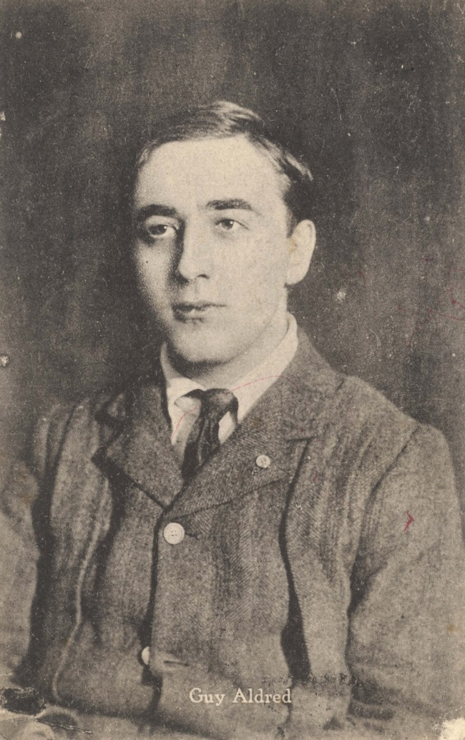
In 1919 for example, on his return from prison during the war, Aldred made many speaking appearances for the ILP and other well-supported left political groups in Glasgow. He spoke on a range of topics, such as ‘The Present Struggle of Liberty’, ‘Crises: Past, Present and to be’ and ‘Our duty to Russia’, and would later lead a long-running, and successful, campaign to protect freedom of speech on Glasgow Green through the 1920s (a key demonstration site that remains active), supported by the wider labour movement (McShane 1978). Such collaboration is indicative of the significance of Aldred and the dynamic and temporal working relationships of the political left. Further, in this particular instance, it is clear that the landscape came to the ‘foreground’ (Navickas 2009, p.94) of working class politics and particular places were sites of contestation. These landscapes were central to the working class political movements and the significance of open platforms further illustrates this relationship. The leadership of Aldred and the wider free speech movement most explicitly signalled this importance of public space for political activity and foregrounded the importance of particular landscapes in developing a working class presence.
Aldred’s anti-parliamentary communism thus continually intersected with Glasgow based struggles and provided a consistent challenge to the dominant narrative emerging from major working class organisations. His edited publications also indicated the significance of the anarchist tradition within his thought and he would regularly cite Michael Bakunin (publishing several of his essays in The Spur) as a significant influence. Elsewhere The Commune (February 1923) described Communism as ‘far from being antagonistic to anarchism’ it ‘thus forms the necessary foundation of the latter, its ever lasting basis.’ In the same publication, Aldred’s critique of the ‘policeman dwelling within one’s own mind’ and his commitment to ‘working class administration’ and a ‘league of workers’, articulated a clear antagonism directed towards the established parliamentary groups of organised labour, pushing for more radical strategies. These comments, and his wider activities, reflected Aldred’s broader critique of reformism within the labour movement and his commitment to a revolutionary workers’ movement. Here, it is argued that this anarchist informed thread of political activism, and the associated material cultures of publications, speaking appearances and organised disputes, must be read alongside the more dominant narratives of labour politics associated with Red Clydeside.
James Maxton
Like Aldred, Maxton was also a regular speaker at public meetings within Clydeside during the early twentieth century. He was renowned for his distinctive presence and ability to articulate working class politics and demands. The Glasgow Herald described Maxton as ‘one of the ablest speakers and lecturers in the Labour Movement’ (in Brown 1986, p.12). These appearances and broader contributions incorporated parliamentary and non-parliamentary forms of activism and were a central component of the working class presence. Maxton was a key figure during much celebrated Red Clydeside disputes and protests such as the anti-war movements and the rent strikes. Below, aspects of his life are briefly introduced to raise a further element of Clydeside’s working class presence.
Although explicitly criticised by Aldred for doing so, Maxton pursued election success on behalf of the ILP in the Bridgeton constituency. His appearance in Westminster with other ‘Red Clydesiders’ was largely viewed as representative of the increasing significance of labour politics in Glasgow. Alongside 29 Scottish Labour and ILP Members of Parliament (including John Wheatley, Emanuel Shinwell and David Kirkwood), Maxton travelled to London in November 1922 as a Member of Parliament with the support of much of Glasgow’s working class (he would go on to serve 24 years as an MP). Before they travelled to London, a large gathering of workers took place at St. Enoch station and Maxton claimed that people ‘will see the atmosphere of the Clyde getting the better of the House of Commons.’ (Brown 1986, p.13).
Despite his parliamentary approach, Maxton held strong reservations for the practices of the parliamentary Labour Party. His own politics, particularly during the 1920s through the ILP, were notably to the left of the party and argued for socialist measures, as documented in his pamphlet Twenty Points for Socialism (Maxton 1925), calling for public ownership of the banks, land, food supply and mines. His activism associated with this line of thought is reflected in the manifesto he produced with miners’ leader Arthur James Cook (for more on Cook’s life see Davies 1987) who he was extremely impressed with during the miners’ strike of 1926. Cook was a trade unionist and leader of the Miner’s Federation of Great Britain (MFBG) who co-ordinated the general strike in 1926. By 1928, Cook had become particularly frustrated by the Trades Union Congress (TUC) and specifically its actions at the culmination of the strike. Combining their frustration with key pillars of the labour movement, Maxton and Cook toured the United Kingdom with their ‘Cook-Maxton Manifesto’ in 1928. The manifesto developed some of Maxton’s ideas identified above and Cook’s critique of British trade unionism. This collaboration followed a Westminster meeting between Cook, Maxton and other Clydesiders (including William Gallacher and John Wheatley) where the leadership of the ILP combined with the leadership of the Miners’ Federation of Great Britain (MFGB). Cook decided to co-operate in the campaign and, as Davies (1987, p.151) has argued, he ‘undoubtedly welcomed the support of Clydesiders at a time when he was becoming increasingly isolated within the MFGB and TUC.’

Figure 2 - Postcard entitled 'Vote for Maxton and save the children', 15 Nov 1922
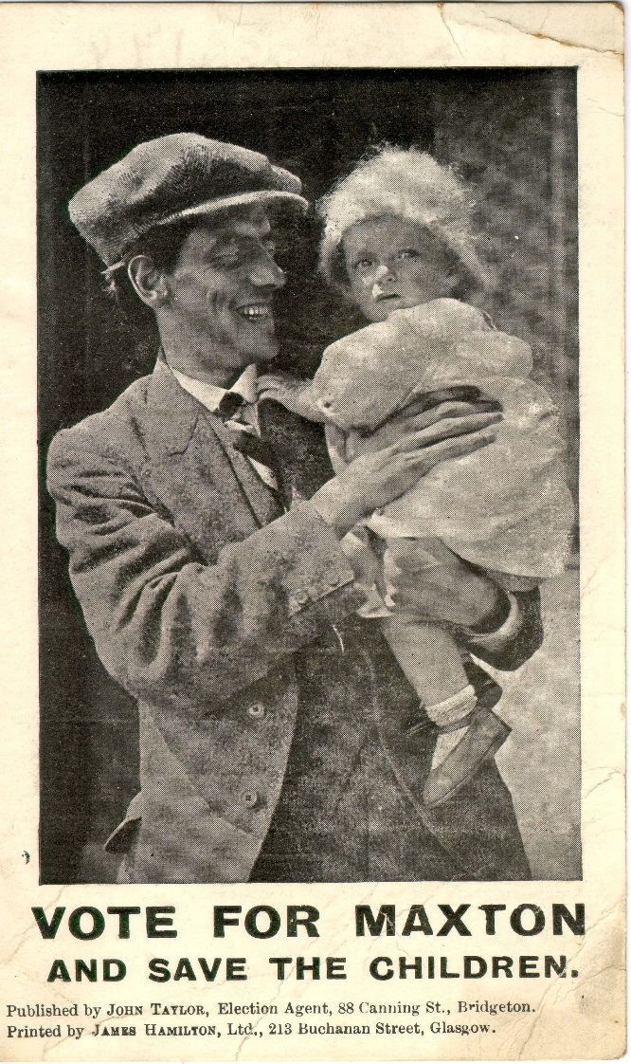
Their frustrations towards the wider labour movement were shared following Cook’s expulsion from the TUC and a sense that the Labour Party had shifted away from socialist legislation towards a capitalist vision. Maxton argued for their manifesto by claiming in an interview that:
The Labour Movement is practically dead. We are trying to bring it back to life. That’s all. In the old days there was a goal to reach and we felt that every meeting, every pamphlet, every vote concerted and every seat won was a tangible and positive step nearer the goal. Today nobody believes that anything makes a difference.
(Glasgow Eastern Standard 1928 in Brown 1986, p.198)

Here Maxton cites the same methods, pamphlets and meetings that were championed by Aldred and Crawfurd, as being integral to articulating working class politics on Clydeside and beyond. This commitment towards a working class movement was not always reflected on the open platform, though, with Davies (1987, p.151) highlighting that Cook’s ‘typewritten dissertation on Marxism’ and Maxton’s speech on the need for a ‘Labour government mandated to introduce large socialist measures’ were not particularly well received by the working class audience. After an unsuccessful appearance from Cook in St. Andrew’s Hall in Glasgow and significant criticism from large parts of the ILP, the pair decided not to pursue the manifesto further.
Figure 3 - Photograph of Maxton speaking at an open-air meeting sometime in the 1920s
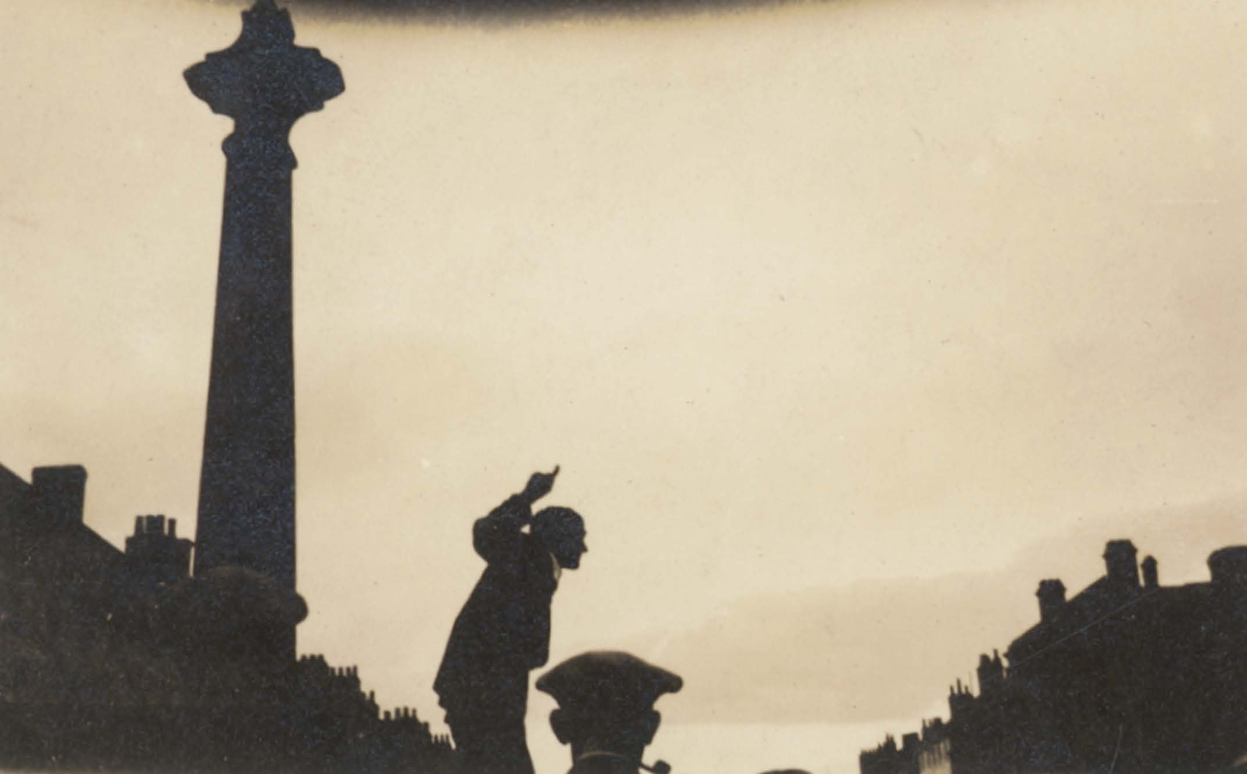

The development of such antagonism, though, was illustrative of the wider challenges to parliamentary labour politics that characterised Maxton’s political life. The collaboration, as further considered below, illustrates connections between political activists and traditions during the early twentieth century. It also reflects the radical content of Maxton’s activism, whilst electoral successes require acknowledgment alongside other complementing and conflicting components within a characterisation of Clydeside’s working class presence. Such links and connections were assembled, dismantled and held the possibilities for being reassembled again rather than being viewed as simply networked and then maintained or broken.
Helen Crawfurd
Figure 4 - Election address of Helen Crawfurd, Communist candidate for Govan ward, 1 Nov 1921
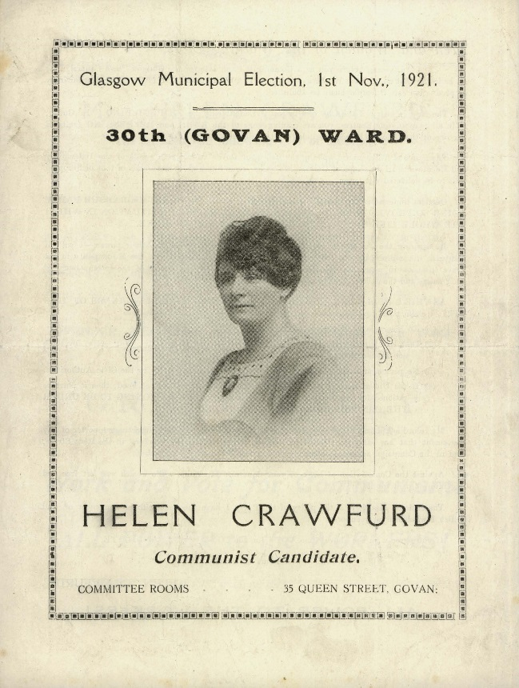
Crawfurd’s activism was a similarly prominent feature on Clydeside, with her actions and connections shaping a fluid and porous political life. Her initial political activism came as part of the suffrage movement. In 1912, alongside other Glasgow women, she travelled to London where she was arrested after breaking the window of the Minister of Education with a demand attached for the enfranchisement of women (Crawfurd n.d., p.89-90). Following this direct action she spent several days in prison (a common experience for those in the suffrage movement) alongside other Glasgow women. On her return to Glasgow she helped organise the visit of suffragette Emmeline Pankhurst in 1914, who was released from prison on hunger strike, and violent scenes followed between police and the women (Crawfurd estimated around 3,000) attending. Crawfurd was incarcerated again after a public speech in Perth where she defended an attempt by suffragettes to blow up Burns Cottage in Alloway. The militancy of the Scottish suffrage movement is notable and provides further evidence of the importance of women within the radical presence on Red Clydeside and Scotland.
Previous commentaries have described women as missing from Scottish history and have particularly targeted scholarship of the Red Clydeside period. For example, Breitenbach (1997, n.p.) has argued that the ‘valorisation of particular types and forms of political or trade union action, which may be regarded as typically masculine, has its counterpoint in the devaluation and negative stereotyping of women's forms of organisation and action.’ Crawfurd’s life suggests otherwise though, not only illuminating women’s forms of action but also further indicating the diversity within the working class presence. The support of the ILP’s Forward newspaper, for example, which published ‘Our Suffrage Column’ (including contributions from Crawfurd) during the period when The Suffragette newspaper was suppressed, and collaborative work such as her activities with the Women’s Peace Crusade as part of the anti-war movement, indicates a connection between suffrage activism and the broader working class presence.
Such connections are important for destabilising assumptions regarding the suffrage movement as largely being an upper or middle-class led movement (see Neale 1967). In contrast, the inclusion of Crawfurd’s life as part of Red Clydeside foregrounds intersections between working class struggle and broader suffragette trajectories (see also Liddington and Norris 2000). Crawfurd’s anti-war stance ended her previous political loyalty to the Women’s Social and Political Union in 1914, who she described as supporting the war, as she joined the anti-war ILP alongside Maxton, yet her involvement with women’s political organising remained. This was evident during the successful 1915 rent strikes (Melling 1983) whereby the campaigners, primarily women within Glasgow Women’s Housing Association, including Crawfurd, forced the government into imposing a rent restriction act that returned rent costs pre-war rates. During this dispute, Crawfurd claimed that the women leading the strike ‘was essentially a women’s fight’ and that ‘all who were taking part in the demonstration were showing their solidarity’ (Glasgow Herald 15 October 1915).
These connections alongside the actions of women across multiple struggles begin to illustrate the political contributions of women within Red Clydeside. As part of these groups, women had a significant presence within the city and held regular open-air meetings around Clydeside and produced leaflets, pamphlets and badges that were distributed throughout Scotland. Such activities were representative of the strong position of women like Crawfurd within the working class presence of Clydeside. Reflecting on her involvement with this movement Crawfurd also stressed the importance of the street corner as a political meeting place for her activism (Crawfurd n.d., p.155). The street corner strategy was common within Glasgow and is also commented upon by Aldred in The Commune. These meetings were integral to articulating an alternative working class and feminist politics. Aldred claimed that his own activism ‘is concentrating on making a Socialist proletariat’ and ‘that is why we prefer the street-corners to the comfortable atmosphere at St Stephens’ (The Commune, March 1923). Crawfurd’s activism and involvement in women led struggles complimented her organising through her ILP membership during the First World War and later Communist Party membership (reflected on further below through her international connections). Such fluid and porous political identities contributed towards the establishment of universal suffrage (with acts in 1918 and 1928 establishing rights for women’s votes) and were a common feature of this period more broadly, reflecting the dynamics of the working class presence, within and beyond particular traditions.
Red Clydeside’s working class presence
These contributions, from three seemingly diverse strands of political activism, begin to characterise the working class presence of Red Clydeside. Each activist and their activities indicates an example of the class antagonism present within the region during this period and the diversity of political positions and working class demands which defined it. These elements have been presented here to reflect a diversity of political activism but also to illustrate the wider political landscape of antagonism which informed and shaped more specific disputes and demand making. These more temporary and sometimes unsuccessful forms of political relationship speak to the previous discussion of working class presence, assemblage and topology, and are foregrounded here as a challenge to seemingly more coherent and neat historical narratives. They are also considered here to foreground the variety of antagonisms found within the Red Clydeside archive.
This emphasis on antagonism speaks to Thompson’s understanding of class and more geographically to a sense of place-based politics and ‘throwntogetherness’ whereby a more intangible and uncertain sense of political possibility is offered (Massey 2005). Given the emphasis on material cultures found here, the biographies also link with Routledge’s (2018, p.137) work on radical protest geographies and the notion of a ‘war of words’ whereby ‘the creative utilisation of activist media can create protest cultures’ which can become ‘a critical tool in generating sites of potential.’ This generative understanding allows links to develop within sites between seemingly unconnected acts. In this regard, the free speech struggles and wider work of Aldred can be connected to, and contrasted with, the campaigns of Maxton and Crawfurd. More broadly, Clydeside’s ‘spirit of rebellion’ introduced above reflected the work of activists such as those considered here, and was crucial to providing the grounding for the notable disputes that have often defined this working class presence.
Thus, these biographical snippets introduce distinctive yet intersecting lives of Red Clydeside activists and are closely linked to Thompson’s notion of working class presence. The impact of their work above is difficult to quantify and the coherence between each position immeasurable, but their political contributions remain important when remembering Red Clydeside nonetheless. For example, Aldred’s speaking appearances and publishing should be viewed as contributing towards the broader assemblage of left political activism and as developing a class based antagonism through the anti-parliamentarian position. Similarly, Maxton’s campaigning with Cook, and Crawfurd’s commitment to the intersection of suffrage and class politics continually intersected with the broader working class presence, providing moments of difference and collaboration. These diverse positionalities introduced are illustrative of a dynamic and fluid working class presence that developed successful movements such as the 1915 rent strikes and the electoral success of the political left in the 1920s. Such an understanding links to Gidwani’s reading of the Grundrisse by Marx, which proposes that ‘labor politics does not have to take the archetypical forms of labor union and labor party in order to stake out opposition to capital’ (Gidwani 2008, p.198). In contrast, a more sympathetic reading of diverse political traditions provides a dynamic and subtle account of labour politics in a pluralising manner (see Peck 2018).
Aldred, Crawfurd and Maxton’s political engagements were similarly creative in their opposition to capital. Such accounts of oppositional politics indicate a broader understanding of particular disputes, such as those that often characterise the Red Clydeside period (such as the 1911 Singer dispute and 1919 forty-hour movement). Tufts and Savage have argued for this broader account of labour politics by suggesting that:
[L]abour geographers have yet to engage in any sustained fashion with unpacking the complex identities of workers and the way in which those identities simultaneously are shaped by and shape the economic and cultural landscape.
(Tufts and Savage 2009, p.946)
The inclusion of these experiences, relationships and diverse material cultures of a working class presence begins to unpack the inadequacies of bounded or unitary representations of labour politics and instead foregrounds the importance of intersections between radical cultures. In this regard, struggles over the wider sphere of social reproduction (see Harvey 2017), such as those relating to housing and free speech, become a central component of the historical narrative of Red Clydeside, which has often been characterised through industrial disputes. More broadly, the intersecting practices of diverse political traditions, such as publications, meetings and public speaking appearances, contributed to a wider landscape of radical content. This characterisation of Red Clydeside as working class presence is continued with further analysis below, which situates such material cultures within broader translocal networks of connection.
Working class presence and internationalism
The spatial dynamics of a working class presence are forged through connections within and beyond the particularities of place. As noted above, the concept of internationalism has received increasing historical geography scrutiny. In this regard, Legg’s (2009) understanding of assemblage and internationalist politics assists an exploration of Red Clydeside by foregrounding a practice-based analysis of internationalism and the makings of scale. Such practices are introduced below through an analysis that engages with contrasting modalities of internationalism to indicate how the three individuals considered were part of wider networks beyond Clydeside. These connections develop a further layer of Clydeside’s working class presence, revealing multiple influences and interactions that extended, complemented and shaped the place-based activism considered above. Such spatial relations, alongside the diversity of political positions raised previously, complement geographical notions of topology by engaging with the ‘dialectic between continual change and enduring relations’ (Martin and Secor 2014, p.422).
In terms of the activists considered here, their spatial strategies of internationalism, including charitable connections, correspondences and radical publishing networks, provide forms of ‘radical internationalism’ (Halliday 1988), which have often been less well recognised within Scottish labour history. Halliday stressed how such revolutionary internationalism ‘sees internal and international conflicts as recurrently linked’ (Halliday 1988 p.195). Aldred, Crawfurd and Maxton all developed many connections, friendships and solidarities that informed their contributions to the working class presence and shaped their geographical imaginations. This section emphasises the different forms of transnational connection experienced by the three activists, as representative of Clydeside’s multiple modalities of connectivity, beginning with Crawfurd’s experience with Workers’ International Relief (WIR).
Workers’ International Relief
Crawfurd attended the Second Congress of the Communist International (alongside fellow Red Clydesiders William Gallacher and John Clarke) in 1920 and during her stay she organised an interview with Lenin. In her memoirs, she summarises the interview:
The three things which we spoke of were the importance of women being brought into the struggle, my appreciation of the first Workers’ Republics attitude to the oppressed colonial workers, and the value and importance of the work of organization industrially and on an international scale. (Crawfurd n.d., p.210)

Crawfurd was conscious that ‘invitations had been sent only to those elements who had retained their international socialist outlook during the War’ and that there was an emphasis on gathering those willing to ‘co-operate in the establishing of an international organization for action’ (Crawfurd, n.d., p.190). The presence of Clydeside activists within the conference was particularly notable and reflected the translocal influences and travels of the political figures on Clydeside. The emphasis on the co-operation and inclusion of workers in developing forms of direct action appealed to Crawfurd and was soon embodied in her involvement with Workers’ International Relief (WIR).

Figure 5 - Helen Crawfurd helping in the distribution of food for children of striking miners at Lochore in Fife, 1926

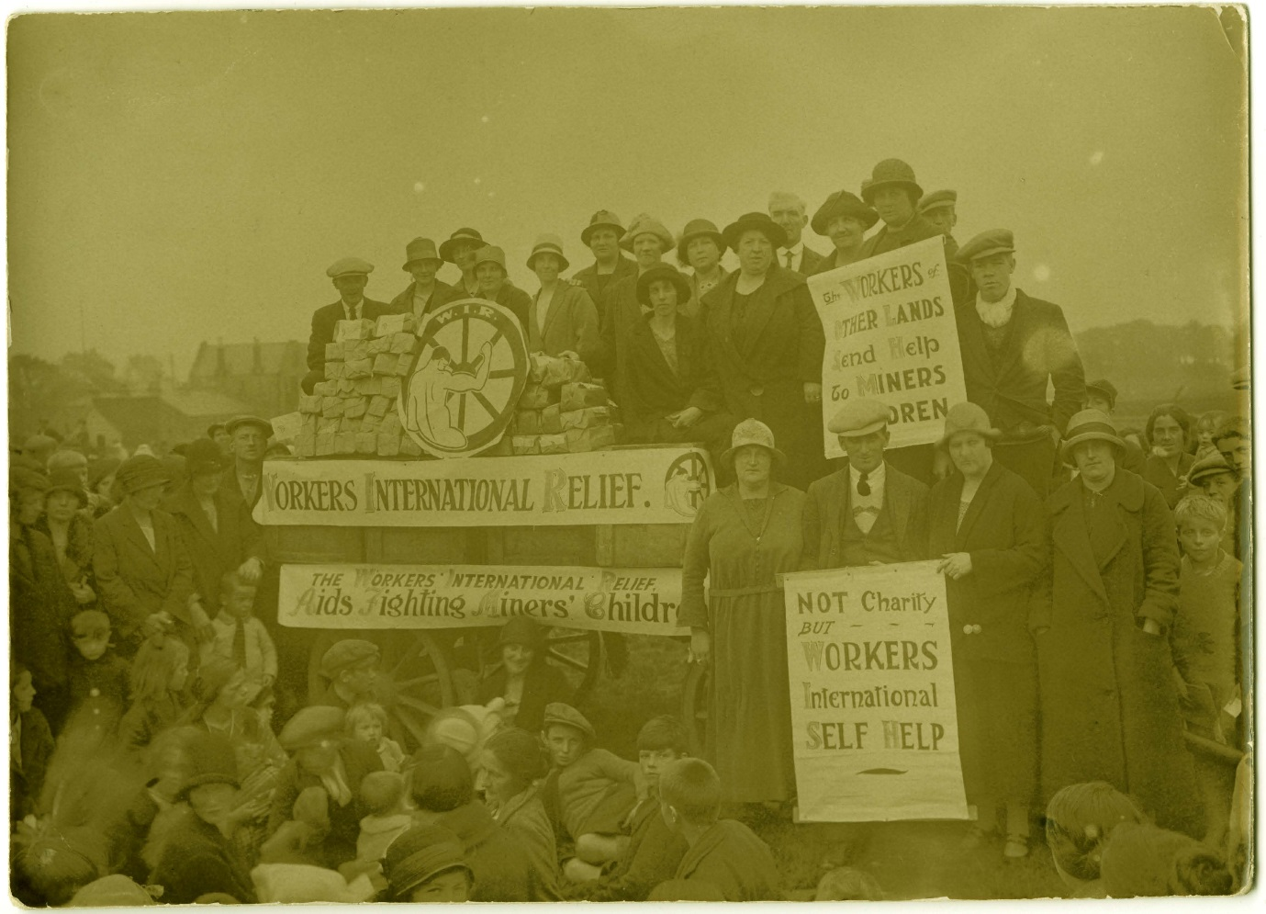

Following the founding of the Communist International in 1920, the Comintern ‘sponsored a series of ‘fronts’’ (O’Connor 2004, p.7) including WIR (1921-35). This organisation was established primarily in response to the famine in the Volga provinces of Russia, but held more general objectives of distributing support to workers’ struggles across international boundaries. It held committees across Europe and also in America and Japan, with Crawfurd becoming secretary of the British Branch of the WIR in 1921 (for more on WIR see Braskén, 2015). This role was one of her most challenging and involved regular travel around Europe, with the head office of WIR in Berlin, and communication with diverse working class organisations. Their intentions were very clear and aimed to specifically challenge notions of international solidarity:

It is the duty of workers to help workers. It admits neither creed nor colour bar and gives help to workers of all shades of political opinion. Help without distinction, help without discrimination. (WIR cited in Canning 2004)

This sentiment appealed to Crawfurd and reflected the global outlook she had held from an early age. Crawfurd was active in relief efforts for the Volga provinces, disputes in Ireland and the 1926 General Strike in Britain, where she documented support from Russia, Germany and other countries amounting to thousands of pounds. She edited their Relief Bulletin and attended deputations to the TUC requesting assistance for particular struggles, raising £920 for the ‘Hunger in Germany’ campaign in 1924. In her memoirs, she describes how the WIR reflected her international positionality and facilitated assistance to workers who were struggling in their own conditions:
It was nothing new for workers to send help or relief to each other. In mining disasters, in earthquakes and famines, money had been collected and help rendered, but it had been sporadic and uncoordinated. The promoters of the Workers’ International Relief sought to build up an organization which would be available for workers’ relief on an international scale, and would not be a makeshift sporadic type.
(Crawfurd n.d., p.243)
The construction of ‘relief on an international scale’ described by Crawfurd emerged specifically through workers collaboration (albeit with Comintern support) and established the aim of encouraging collective workers decision making. More broadly, this form of financial assistance to international struggles may be deemed simply as charitable, but in actuality represented a challenge towards organised labour and explicitly demanded workers participation in political organisations. This international outlook and solidarity was arguably a privileged position, linked to Crawfurd’s ability to travel, yet the continual exchange of materials, political ideas and practical support was a further crucial element of Clydeside’s working class presence. The combination of practical actions and wider communicative geographies are indicative of the wider influence of Clydeside and the connections which informed the working class presence, reflective of a ‘throwntogetherness’ within urban politics (Massey 2005).

International Travels and Friendships
In 1911, Maxton travelled across Europe alongside his socialist friends George Dallas and James Houston in an attempt to understand the broader labour movement beyond Clydeside and the United Kingdom. His diaries document this trip and are illustrative of a willingness to engage with politics beyond Clydeside. Aldred and Crawfurd also travelled as part of their political activism and the influence of such connectivity must be stressed when characterising a working class presence, not limited by the particularity of place (Featherstone 2008). Maxton’s diary entries from this trip are in short bullet point form yet still illustrate his political interests, such as his reflections on his ‘ramble around Amsterdam’ where seamen were on strike. He compared the conditions of the teachers in Amsterdam with his own teaching experience in Scotland and also reflected on conversations with several socialist organisations during his visit. Whilst in Brussels, he participated in a large workers’ demonstration and his diaries document conversations with labour and socialist leaders where they discussed methods within the movement and again highlighted the importance of propaganda, open-air meetings and the distribution of literature. Such connections, friendships and experiences informed the working class presence of Clydeside and begin to disrupt a sense of disparate traditions or place-bound politics.
In later years, Maxton became an influential labour politician internationally, with the letters (held at the Mitchell Library) received during his significant illness in 1926 and after his death in 1946 reflecting his network of connections across Europe and beyond. One example reflected on a summer school visit to Caerleon in 1934 and praised Maxton’s internationalism, describing him as representing ‘the best traditions of international socialism’ recognising him for his voice against the First World War. Another letter received from Mexico detailed a previous meeting in Paris where the collective was attempting to save a party of Spanish revolutionists and praised ‘the precious aid’ Maxton gave to the cause. Similar letters were received from America, France and Germany. Perhaps one of the most notable links, though, was found between Maxton and Pan-African journalist and political organiser George Padmore. Pennybacker (2009, p.68) has reflected on this relationship and described how they met during the second conference of the League Against Imperialism (LAI) in Frankfurt. She considers Maxton to have been one of Padmore’s ‘white allies’ and how Maxton challenged (unsuccessfully) the House of Commons to rescind a ban on the Negro Worker newspaper in the colonies. Padmore’s tribute to Maxton following his death further reflects the importance of this translocal relationship:
Maxton’s memory will ever be cherished by Africans and peoples of African descent as the Wilberforce of his generation.
(James Maxton Papers, Mitchell Library, TD 956/11/11)
These interactions and collaborations reveal solidarity between Glasgow political activists and Pan-African political figures, which have previously been understated. Helen Crawfurd held similar international linkages and in her memoirs she commented on the British worker as being ‘insular in outlook’ and she considered the African and Asiatic workers to be often ‘excluded’ from socialist propaganda. These perspectives challenged the more bounded or restricted notions of Red Clydeside and further illustrate the importance of (re)assembling the spatial connections and diverse political views within the working class presence of the period.
Maxton’s attendance and participation within international labour relations were not always as uncontentious. He became part of the LAI in 1927 and chaired the British section between 1927-1929 (despite the resignation of fellow ILP members due to the communist allegiances of the league). The LAI was established with the intention of gathering a ‘coalition of global fighters for freedom and justice’ (Pennybacker 2009, p.68). Maxton himself described the importance of the league in a Foreword to their publication the The Anti-Imperialist Review:
The LAI is providing for the first time, an organisation within which the peoples of the oppressing and oppressed nations can meet on common ground and pursue in common the task of emancipation. It has established contact with every part of the world, and is amassing exact information about the conditions of the workers everywhere, which it will make available for the education of all the peoples. It will aid the fight for freedom in all parts of the world.
(‘Foreword’ The Anti-Imperialist Review, 1928 1: 1, p.2)

Maxton’s view of the ‘common ground’ for the ‘oppressing’ and the ‘oppressed’ nations was not shared by all, though, and perhaps reflected internal power relations within the organisation. He received scrutiny from fellow members due to his position on particular struggles within the organisation and his allegiance to the ILP. He came under increasing pressure from Communist member Sharpurji Saklatvala in particular, who criticised his position within the LAI and the ILP’s links to the history of the British Labour Party:
Several active members of the British Independent Labour Party are assiduous in acting as decoy birds, misleading Indian politicians into the belief that there is still hope in this section of the British Labour Party, and that they respect India’s self determination, when one hundred and twelve of their own members are really and truly responsible for the most treacherous anti-Indian decisions of the Labour Party in Parliament.
(Saklatvala 1928 in Squires 1990, p.173)
Maxton was expelled from LAI in 1929 following considerable disagreement over his contentious ILP commitments, but his commitment to many of the issues raised by the league, such as the self-government of India, were retained and expressed elsewhere (Knox, 1987). More broadly, his personal archives indicate translocal influences on his own life and the wider political movement on Clydeside but also illustrate how such connections were not made without tensions. The spatial politics of race for example were particularly complex during this time on Clydeside and was linked to more exclusionary and hostile labour politics, most notably during the 1919 race riots (see Jenkinson 2008). Such tensions and exclusions must inform a more holistic account of a working class presence to ensure a representative account of diverse experiences is portrayed. This does not undermine the diversity of positions presented but rather indicates the temporality of consensus moments within a working class presence and a wider context within which the political lives were located.
The Postal Mission
Aldred’s links and connections were continually referenced within his many publications that reflected a network of likeminded groups and activists. He described his preference for the ‘postal mission’ in his memoirs, and in doing so also foregrounded the value of international correspondences. Such connections and communications were a common feature of anarchist networks as detailed by Ferretti’s (2017a; 2017b) accounts of Pyotr Kropotkin’s intersecting political and academic correspondences. Below Aldred describes the inherent possibility for exchanges of political material:
It possessed the charm of penetration into unknown territory. There was a touch of mystery about such activity. One could not see what would result from the mere putting of a pamphlet, duly stamped, into a post box, and thus sending it by unknown hands to an unknown person. It was like performing a miracle. (Aldred 1957, p.429)
The uncertainty of outcome should not undermine the importance of such political correspondence and articulations. It is difficult to trace and map Aldred’s political networks or the outcomes of such work but the importance of the articulation and labour towards developing alternative political positions remains a substantial part of an account of a working class presence. His activism in this regard was characterised before his arrival in Glasgow when he published the Indian Sociologist from London in 1909 (see also Ramnath 2011). For this act, Aldred was arrested following the publication and charged under the Newspaper Libel Act of 1871. Aldred’s friend and subsequent biographer JT Caldwell (1988, p.213) recalled that Aldred maintained ‘a continuing correspondence’ with Indian radicals beyond this engagement. He suggests that Aldred was one of the only radicals that Indians trusted as he ‘was the only Englishman to go to prison for India’. Ramnath (2011) supports this claim and suggests that Aldred was integral to the development of an international network of radicals who published the paper.
A further example of international imaginaries from his Glasgow-based newspapers (The Commune, June 1923) were the links and correspondence with the Socialist Party of Victoria, Melbourne, that emerge. A letter comments on the ‘mental apathy set up among the working class as the result of the war’ and the difficulties in generating interest in revolutionary propaganda. These international letters and exchanges became a regular feature within Aldred’s publications and reflected Aldred’s links and connections. The Australian connection is particularly pertinent as Aldred was very critical of the Scottish Left (the Forward newspaper published an article which advocated Australian Socialism) for considering ‘Queensland Socialism’ to be a successful model. In The Commune, Aldred challenged this interpretation by critiquing two particular statements from the Queensland State Labor platform published in the Brisbane Worker newspaper:
The cultivation of an Australian sentiment: the maintenance of a White Australia and the development in Australia of an enlightened and self reliant community.
Protection of State against slanders of newspapers and politicians.
(The Commune, September 1923)
Aldred described these planks as ‘absolute menaces to working class progress’ and retained a rejection of such influences. This more critical perspective indicates the wider exchanging of correspondence and publishing of international material that was not necessarily common practice within British left-wing publishers. Thus, Aldred’s publications not only reflected a set of personal networks beyond Clydeside, but also played a key role in introducing critical engagements with international perspectives for his audiences. In this regard, his activities were aligned with those of Crawfurd and Maxton, in connecting and sharing political messages, revealing a more spatially connected, informed and contested sense of Red Clydeside.
Figure 6 – The Commune, May 1924
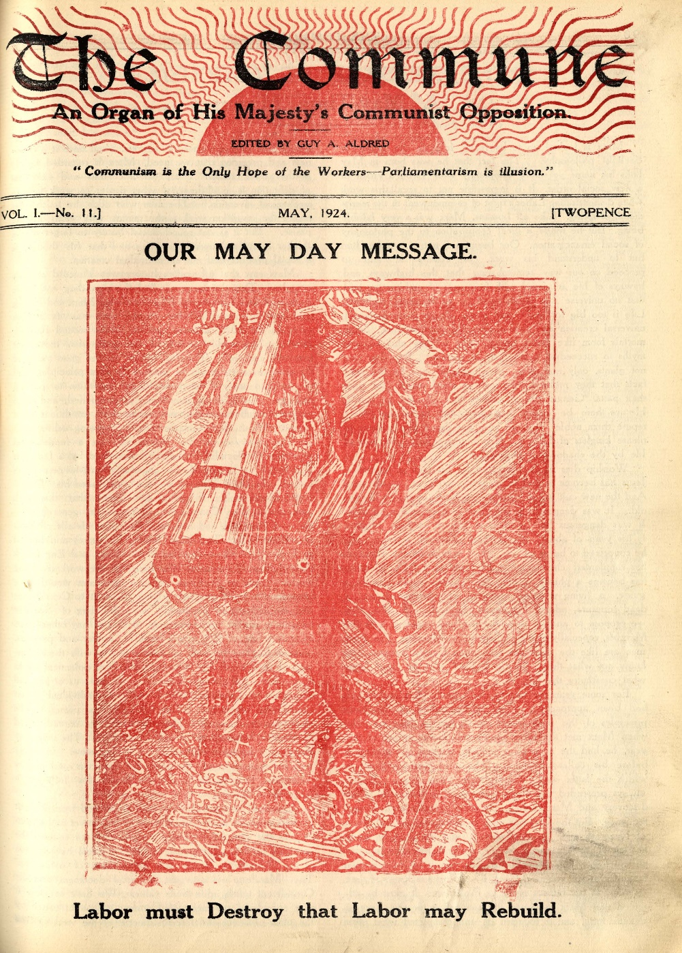

Spatial politics and longer trajectories
These connections have been introduced to further reflect the dynamism that characterised Red Clydeside. The snapshots provided above indicate the centrality of particular individuals in developing such connections, and hints at a privileged and individualised experience of spatial connectivity (see Hasty 2011). Yet their experiences also point to an internationalism forged through the broader working class presence, through diverse modalities with varying consequences. This points to a wider urban geography of spatial connections and a more material sense of internationalism (Hodder et al. 2015). Such spatial relations are indicative of a working class presence and illustrate the ‘throwntogetherness’ of place-based politics, reflecting the plurality of positions which informed defining moments of Red Clydeside.
In this regard, these spatial connections had tangible impacts within Clydeside itself. Many of the protests and actions within the anti-war movement for example had a notable international solidarity tone, in contrast to pacifist stances elsewhere. Similarly, Britton (2010) has documented another such moment through the 1938 Workers’ Exhibition held on Clydeside that acted as ‘both an explicit political statement and an impassioned critique of imperialism’ and was specifically positioned as ‘counter-exhibition’ to the 1938 Empire Exhibition hosted in Glasgow. James Maxton conducted the opening of this event but the exhibition arguably reflected a longer trajectory of organising and international connections throughout the Red Clydeside period. Such events and the lives discussed above also indicates a more multicultural sense of Red Clydeside from below, through the lives of activists who attempted to subvert and contest some of the less progressive and sometimes hostile ways in which Glasgow positioned itself globally (see Jenkinson, 2008).
Conclusions: continuity and difference within a working class presence
This paper has provided an overview of three diverse, yet interconnected, political figures found within the histories of Red Clydeside. They have been specifically positioned here to reflect the topological nature of activism during this period and to identify an assemblage of political activism. The snippets above speak to Routledge’s (2018) notion of a ‘war of words’ and the generative nature of diverse activisms that constructed wider political antagonisms. Some of the activities listed above may appear marginal in terms of creating change and difficult to measure in terms of successful demands, but here it is argued that they were crucial to the radical culture that informed such change. In this regard, they reflect an assemblage of political activism and the significance of ‘actors that hold assemblages together’ whilst also raising ‘the processes of connection and disconnection that they are involved in’ (Davies 2012, p.277). Three concluding arguments follow from this.
Firstly, the methodology of understanding Red Clydeside as working class presence facilitates an innovative framing of the political activism associated with this historical period. The activism considered indicates a more contentious and fluid working class presence, whereby political positions developed connections and solidarities yet also occasionally clashed and changed. This temporality of connection and disconnection provides a link with Thompson’s processual understanding of working class presence. The activism considered had a distinctive geography, whereby diverse political positions forged a presence within Clydeside’s urban landscape. Aldred, Crawfurd and Maxton shared the same meeting halls, publications and working class audience, whilst Clydeside’s urban space formed a key node as part of wider transnational networks. This sharing of a radical space shaped their contributions, whether through co-ordinated actions or distinct differences. Cross-referencing their contributions highlights a more rounded sense of working class presence and a pluralised sense of labour struggles (see Peck 2018).
Secondly, comments such as those by Maxton in 1928 that ‘the labour movement is practically dead’ may resonate with some concerns in contemporary settings, yet the wider realm of organising introduced here is foregrounded to imply otherwise. The construction of a working class presence indicates a need for a wider political engagement within labour geography that reflects broader conflicts, particularly through analyses within and beyond the official organising models (Lier 2007). The political differences noted here did not undermine the campaigns, organising and disputes of particular movements during this period. In contrast, there is evidence of gains throughout the historiography of Red Clydeside on issues such as rent, working conditions and working hours. These gains were not made in a linear manner and the organising structures were not necessarily cohesive, but were at particular times coherent and informed by strategic solidarities. Here it is suggested that a wider geographical understanding of working class presence begins to capture this construction. When framed in conversation with more spatial approaches, the discussion of connections has included contrasting modalities of internationalism (for example communicative, charitable and propagandist), as a central element of the politicised characterisation of a working class presence.
Thirdly, and as previously noted, such histories allow the city can be read as an ‘urban archive’ with possibilities to be reassembled through methods that ‘bring elements of the urban archive into the present to create new lines of flight’ (Dittmer 2014, p.482). The working class presence constructed above has considered three activist lives that have traditionally been viewed as contributing towards fairly disparate traditions. Here it is argued that accounts of working class presence must emerge with recognition of diverse traditions and practices, such as anarchism, the suffrage movement and modalities of internationalism in this case, to characterise a spatial political account of urban politics. The framing of a working class presence, through material cultures and spatial connections, allows a more nuanced understanding of the fluid boundaries within place-based politics, labour movements and popular protests.

Acknowledgements
Thank you to the archival staff and collections which informed this research. I also wish to acknowledge the helpful comments of David Featherstone for his input and feedback on previous drafts. Further thanks to Kevin Grove for his editorial guidance and three anonymous reviewers for helpful, insightful and constructive comments.

References
Aldred, G. (1944) A Call to Manhood and other Studies in Socials Struggle, 26 essays by Guy A. Aldred. Glasgow University Special Collections, Broady Collection, I1.
Aldred, G. (1963) No Traitor’s Gait, The Autobiography of Guy. A. Aldred. Glasgow University Special Collections, Broady Collection, I22 – I40.
Braskén, K. (2015) The International Workers’ Relief, Communism, and Transnational Solidarity: Willi Münzenberg in Weimar Germany. Basinstoke, Palgrave Macmillan.
Breitenbach, E. (1997) Curiously Rare? Scottish Women of Interest or the Suppression of the Female in the Construction of National Identity. Scottish Affairs, 18 (1), 82-94.
Britton, S. (2010) ‘Come and See the Empire by the All Red Route!’: Anti-Imperialism and Exhibitions in Interwar Britain. History Workshop Journal, 69 (1), 68-89.
Brown, G. (1986) Maxton. Edinburgh, Mainstreaming Publishing.
Caldwell, J.T. (1978) Guy Alfred Aldred, Antiparliamentarian, 1886-1963: a Memoir. In MacDougall, I. (ed) Essays in Scottish Labour History. Edinburgh, John Donald Publishers, pp. 225-246.
Caldwell, J.T. (1988) Come Dungeons Dark: The Life and Times of Guy Aldred. Glasgow Anarchist. Ayrshire, Luath Press.
Canning, A. (2004) Helen Crawfurd –Internationalist. An article based on the talk Audrey gave to the meeting during International Women’s Day. Gallacher Memorial Library, Glasgow Caledonian Research Collection.
Coe, N. and Jordhus-Lier, D. (2010) Constrained Agency? Re-evaluating the Geographies of Labour. Progress in Human Geography, 35 (2), 211-233.
Crawfurd, H. (no date) Unpublished Memoirs. Original version held at Marx Memorial Library and Worker’s School, HC/1/3. Uncatalogued copy consulted at the Research Collection at Glasgow Caledonian University.
Crossan, J., Featherstone, D., Hayes, F., Hughes, H, Jamieson, C. and Leonard, R. (2016) Trade union banners and the construction of aworking-class presence: notes from two labour disputes in 1980s Glasgow and North Lanarkshire. Area, 48 (3), 357-364.
Davies, A. (2012) Assemblage and Social Movements: Tibet Support Groups and the Spatialities of Political Organisation. Transactions of the Institute of British Geographers, 37 (2), 273-286.
Davies, P. (1987) A.J. Cook. Manchester, Manchester University Press.
Dittmer, J. (2014) Narrating urban assemblages—Chris Ware and Building Stories, Social & Cultural Geography, 15 (5), 477-503.
Domosh, M. (2008) Labor Geographies in a Time of Early Globalization: Strikes Against Singer in Scotland and Russia in the Early 20th Century. Geoforum, 39 (5), 1676-1686.
Domosh, M. (2015) International Harvester, the U.S. South, and the makings of international development in the early 20th century. Political Geography, 49, 17-29.
Eley, G. (2002) Forging Democracy: the History of the Left in Europe, 1850-2000. Oxford, Oxford University Press.
Featherstone, D. (2008) Resistance, Space and Political Identities. West Sussex, Wiley-Blackwell.
Featherstone, D. (2015) Thinking the crisis politically: lineages of resistance to neo-liberalism and the politics of the present conjuncture. Space and Polity, 19 (1), 12-30.
Featherstone, D. and Griffin, P. (2016) Spatial relations, histories from below and the makings of agency: Reflections on The Making of the English Working Class at 50. Progress in Human Geography, 40 (3), 385-393.
Ferretti, F. (2017a) Publishing anarchism: Pyotr Kropotkin and British print cultures. Journal of Historical Geography, 57, 17-27.
Ferretti, F. (2017b) Evolution and revolution: Anarchist geographies, modernity and poststructuralism. Environment and Planning D. Society and Space. Available online via early view.
Garavelli, D. (2015) Insight: Remembering the Glasgow rent strikes. Available from: http://www.scotsman.com/heritage/people-places/insight-remembering-the-glasgow-rent-strikes-1-3712451http://www.scotsman.com/heritage/people-places/insight-remembering-the-glasgow-rent-strikes-1-3712451 Last accessed: 25/5/17
Gibbs, E. (2016) Historical tradition and community mobilisation: narratives of Red Clydeside in memories of the anti-poll tax movement in Scotland, 1988–1990. Labor History, 57:4, 439-462.
Gidwani, V. (2008) Capital Interrupted: Agrarian Development and the Politics of Work in India. Minneapolis, University of Minnesota Press.
Glasgow Labour History Workshop. (1989) The Singer Strike, Clydebank, 1911. Glasgow, Clydeside Press.
Gregory, D. (1982) Regional Transformation and Industrial Revolution: A Geography of the Yorkshire Woollen Industry. Cambridge, Cambridge University Press.
Griffin, P. (2015) The spatial politics of Red Clydeside: historical labour geographies and radical connections. PhD thesis. Available from: http://theses.gla.ac.uk/6583/ Last Accessed: 8/6/17
Halliday, F. (1988) Three Concepts of Internationalism. International Affairs, 64 (2), 187-198.
Hall, C. (1990) The Tale of Samuel and Jemima: Gender and Working-class Culture in Nineteenth century England. In Kaye, H and McClelland, K. (eds) E.P. Thompson: Critical Perspectives. Philidelphia, Temple University Press, pp.78-103.
Hastings, T. (2016) Moral Matters: De-Romanticising Worker Agency and Charting Future Directions for Labour Geography, Geography Compass 10 (7), 307-318.
Hasty, W. (2011) Piracy and the Production of Knowledge in the Travels of William Dampier, c.1679–1688. Journal of Historical Geography, 37 (1), 40-54.
Harvey, D. (2017) Video: Visualizing Capital with Professor David Harvey. The New School, NYC. June 12, 2017. Available online: http://davidharvey.org/2017/06/video-visualizing-capital-david-harvey-2017-icsi-public-lecture/?utm_content=buffer3be00&utm_medium=social&utm_source=twitter.com&utm_campaign=buffer Last accessed: 30/6/17
Herod, A. (2018) Labor. Cambridge, Polity Press.
Hodder, J., Legg, S. and Heffernan, M. (2015) Introduction: Historical Geographies of Internationalism, 1900-1950. Political Geography, 49, 1-6.
Hodder, J. (2017) On absence and abundance: biography as method in archival research. Area (early view access). Available from: http://onlinelibrary.wiley.com/doi/10.1111/area.12329/full Last accessed: 1/6/17
Jenkinson, J. (2008) Black Sailors on Red Clydeside: Rioting, Reactionary Trade Unionism and Conflicting Notions of ‘Britishness’ Following the First World War. Twentieth Century British History, 19 (1), 29-60.
Joshi, C. (2003) Lost Worlds: Indian Labour and its Forgotten Histories. London, Anthem Press.
Knox, W. (1987) James Maxton. Manchester, Manchester University Press.
Legg, S. (2009) Of Scales, Networks and Assemblages: the League of Nations Apparatus and the Scalar Sovereignty of the Government of India. Transactions of the Institute of British Geographers, 34 (2), 234-253.
Lier, D. (2007) Places of Work, Scales of Organising: A Review of Labour Geography. Geography Compass, 1 (4), 814–833.
Liddington, J. and Norris, J. (2000) One Hand Tied Behind Us: The Rise of the Women’s Suffrage Movement. London, Rivers Oram Press.
Martin, L. and Secor, A. (2014) Towards a post-mathematical topology. Progress in Human Geography, 38 (3), 420-438.
Maxton, J. (1925) Twenty Points for Socialism. Held at the London School of Economics Library, ILP/5/1925/45
Massey, D. (2005) For Space. London, Sage.
McDowell, L. (2015) Roepke Lecture in Economic Geography- the Lives of Others: Body Work, the Production of Difference and Labor Geographies. Economic Geography, 91(1), 1-23.
McGeachan, C., Hasty, W. and Forsyth, I. (2012) Certain Subjects? Working with Biography and Life-Writing in Historical Geography. Historical Geography, 40, 169-185.
McLean, I. (1983) The Legend of Red Clydeside. Edinburgh, John Donald.
McShane, H. (1978) No Mean Fighter. Pluto Press, London.
Nally, D. and Taylor, S. (2015) The politics of self-help: The Rockefeller Foundation, philanthropy and the ‘long’ Green Revolution. Political Geography, 49, 51-63.
Navickas, K. (2009) Moors, Fields, and Popular Protest in South Lancashire and the West Riding of Yorkshire, 1800–1848. Northern History, 46 (1), 93–111.
Neale, R.S. (1967) Working-Class Women and Women's Suffrage. Labour History, 12, 16-34.
Nolan, L. (2015) Space, politics and community: the case of Kinning Park Complex. PhD thesis. Available from: http://theses.gla.ac.uk/6771/ Last accessed: 23/5/18
O’Connor, E. (2004) Reds and the Green: Ireland, Russia and the Communist Internationals 1919-43. Dublin, University College Dublin Press.
Peck, J. (2018) Pluralising labour geography. In Wójci, D., Clark, G., Feldman, M. and Gertler, M. (eds) The New Oxford Handbook of Economic Geography. Oxford, Oxford University Press, pp. 465-485.
Pennybacker, S. (2009) From Scottsboro to Munich: Race and Political Culture in 1930s Britain. Princeton, NJ, Princeton University.
Ramnath, M. (2011) Decolonizing Anarchism. Oakland, AK Press.
Routledge, P. (2018) Space Invaders: Radical Geographies of Protest. London, Pluto Press.
Sharp, J. (2013) Geopolitics at the margins? Reconsidering genealogies of critical geopolitics. Political Geography, 37, 20-29.
Schmidt, M. and van der Walt, L. (2009) Black Flame: The Revolutionary Class Politics of Anarchism and Syndicalism. Edinburgh, AK Press.
Squires, M. (1990) Saklatvala: A Political Biography. London, Lawrence and Wishart.
Thompson, E.P. (1968) The Making of the English Working Class. Middlesex, Pelican.
Tufts, S and Savage, L. (2009) Labouring geography: Negotiating scales, strategies and future directions. Geoforum, 40 (6), 945-948.
Waterman, P. and Wills, J (2001) Space, Place and the New Labour Internationalisms: Beyond the Fragments? Antipode, 33 (3), 306-311.
Wills, J. (2008) Mapping class and its political possibilities. Antipode, 40 (1), 25–30

Glasgow Mitchell Library, TD 956/6/15
Image licence with Historic Environment Scotland. © Guy Aldred Collection - The Mitchell Library.
Image licence with Historic Environment Scotland. © McCallum Scott Papers.
Image licence with Historic Environment Scotland. © Glasgow City Archives.
Image licence with Historic Environment Scotland. © Gallacher Memorial Library - Glasgow Caledonian University Library.
Image licence with Historic Environment Scotland. © Gallacher Memorial Library.
Image licence with Historic Environment Scotland. © Gallacher Memorial Library - Glasgow Caledonian University Library.

