Ultra-sensitive room-temperature H₂S sensor using Ag-In₂O₃ nanorod composites
Shengnan Yan¹, Zhijie Li^{1*}, Hao Li¹, Zhonglin Wu¹, Junqiang Wang¹, Wenzhong Shen², Yong Qing Fu^{3*}
¹School of Physics, University of Electronic Science and Technology of China, Chengdu, 610054, P. R. China
²State Key Laboratory of Coal Conversion, Institute of Coal Chemistry, Chinese Academy of Science, Taiyuan, 030001, China
³Faculty of Engineering and Environment, Northumbria University, Newcastle Upon Tyne, NE1 8ST, UK

Shengnan Yan: ORCID: 0000-0003-0327-3277
Zhijie Li (Corresponding Author): ORCID: 0000-0001-9870-9939;
*E-mail: zhijieli@uestc.edu.cn ; TEL: +86 02883202160
Hao Li: ORCID: 0000-0002-5894-8537
Zhonglin Wu: ORCID: 0000-0001-7600-0507
Junqiang Wang: ORCID: 0000-0003-3999-9336
Wenzhong Shen: ORCID: 0000-0002-5957-5759
Yong Qing Fu (Corresponding Author): ORCID: 0000-0001-9797-4036;
*E-mail: Richard.fu@northumbria.ac.uk; TEL: +44 (0)191 2274662

Abstract
Ultra-sensitive H₂S sensors operated at room temperature were fabricated using Ag-In₂O₃ nanorod composites synthesized using sol-hydrothermal method followed by NaBH₄ reduction process. TEM proved that the In₂O₃ was nanorod structures of ~110 nm in length and ~35 nm in diameter. Ag nanoparticles with diameters from 10 to 15 nm homogeneously decorated on the surfaces of the In₂O₃ naonorods. XRD and XPS analysis proved that the Ag elements are existed as zero-valent metallic silver on the surface of the In₂O₃ nanorods. Ag nanoparticles could enhance the formation of chemisorbed oxygen species and interactions between H₂S molecules and oxygen species due to spill-over effect, and the electron transfer between Ag and In₂O₃ nanorods also enhanced the sensing properties. Therefore, the H₂S sensors based on the Ag-In₂O₃ nanorod composites showed significantly improved sensing performance than those based on the pure In₂O₃ nanorods. The optimized content of Ag nanoparticles is 13.6 wt%. Operated at room temperature, the H₂S sensors made of 13.6 wt% Ag-In₂O₃ nanorod composites exhibited an ultra-highly response of 93719 to 20 ppm H₂S and a superior detection limit of 0.005 ppm. The sensor also showed good reversibility, good selectivity, excellent reproducibility and stability for detection of H₂S gas.
Keywords: In₂O₃, Ag, Nanorods, Composite, H₂S, Gas sensors

1 Introduction
Hydrogen sulfide (H₂S) is widely used as a raw chemical material in many industrial processes, and it is also commonly released from natural gases or biodegradation of organic matters. However, it is one of the most dangerous and toxic gases, which can significantly affect human health, even with extremely low concentrations. Therefore, developing a highly sensitive H₂S sensor is of great importance [1]. Metal oxide semiconductors materials are often reported as promising candidates of sensing materials for H₂S sensors, and these include SnO₂ [2,3], ZnO [4], Fe₂O₃ [5,6], TiO₂ [7], CuO [8] and In₂O₃ [9]. However, many reported H₂S gas sensors only show good sensitivities at a higher working temperature [2−9], and at room temperature, most these H₂S sensors often show low responses. Another common problem for many reported H₂S gas sensors is the difficulty to quickly recover to their initial state after finishing the H₂S detection process. Incomplete recovery often occurs, and a long recovery time or even irreversibility of sensing performance are commonly existed. A room temperature H₂S gas sensor with a high response and an excellent reversibility is urgently required.
Among many different types of metal oxides, In₂O₃ has been reported to have good sensing performance to many hazardous gases [10,11]. In particular, because of its high response to H₂S, the In₂O₃ based H₂S sensors have been attracted much attention in recent years. Various nanostructures of In₂O₃ have been synthesized to detect H₂S gas, such as nanoparticles [12], nanowhiskers [13], nanobelt [14], nanotubes [15], nanofiber [16,17], and nano-films [18], etc. However, we needs to point out that the response and reversibility of all the above mentioned nanostructures of In₂O₃ to H₂S at room temperature are still far from satisfied. Nanorods of In₂O₃ with their large ratios of surface area-to-volume are a promising gas sensing material, which have been used to detect formaldehyde [10], NO₂ [11], ethanol [19, 20] and acetone [21] at high working temperature above 100 ℃, but its H₂S gas sensing properties at room temperature have not been explored extensively so far. In₂O₃ nanorods have been prepared using magnetron sputtering [19], template [10], sol-gel [22], electrochemical deposition [23], evaporation deposition [24], and hydrothermal method [20]. Among these, the hydrothermal method is facile and effective. However, surfactant or urea is generally needed to prepare In₂O₃ nanorods [11, 20, 21]. In this paper, the In₂O₃ nanorods were synthesized in aqueous alkali using sol-hydrothermal method without urea or surfactant.
Due to their effectiveness in improving chemical sensitization and electronic sensitization, noble metals have often been used for surface modification of sensing materials in gas sensing applications. These noble materials include Pt [25,26], Au [27,28] and Ag [29-35]. Among them, Ag is an excellent and active catalyst. If the Ag nanoparticles can be decorated onto nanostructured In₂O₃ surfaces, fast chemical adsorption of oxygen molecules can be obtained to produce lots of oxygen species on the surface on the surface of sensing materials due to spill-over effect. The interaction between chemisorbed oxygen and target gas molecules such as H₂S can be significantly enhanced, thus resulting in a significantly improved sensing performance. However, as far as we have searched in the literature, there was no previous reports for the room-temperature operated H₂S gas sensor using Ag-In₂O₃ composite nanostructures.
Therefore, in this paper, we will aim to explore H₂S gas sensing performance of a new types of nanocomposite, i.e., Ag nanoparticle decorated In₂O₃ nanorods. In₂O₃ nanorods were synthesized using sol-hydrothermal method without surfactant and their surface were further decorated with Ag nanoparticles through NaBH₄ reduction process. H₂S sensors operated at room temperature were fabricated using these Ag nanoparticles/In₂O₃ nanorods composites. At room temperature, the sensor exhibited an excellent reversibility, ultra-highly responses and a superior detection limit to H₂S gas. The enhanced gas sensing mechanisms using this nanocomposites design were systematically investigated.
2 Experimental
2.1 Preparation of In₂O₃ nanorods
In₂O₃ nanorods were prepared using sol-hydrothermal and calcination process. Firstly, 20 ml of NaOH aqueous solution (0.75 mol/L) was added into 20 ml of InCl₃ˑ4H₂O ethanol solution (0.075 mol/L) under a vigorous stirring. Then, this mixed solution was stirred for another hour to form a sol, which was transferred into a 50 ml Teflon-lined autoclave. The solution was kept at 180 ºC in an oven for hydrothermal reactions for 12 hrs. After that, the white precipitates from the autoclave were washed by a mixture of deionized water and ethanol for three times using centrifuge and dried at 80 ºC for 6 hrs to obtain white In(OH)₃ powers. Finally, the white In(OH)₃ powers were further calcined at 500 ºC in air for 2 hrs to obtained yellow In₂O₃ powders.
2.2 Decoration of Ag nanoparticles on In₂O₃ nanorods
An aqueous solution of 1 ml citric acid (with a concentration of 0.02 mol/L) were mixed with an aqueous solution of 100 ml AgNO₃ with a concentration of 0.2 mmol/L. In₂O₃ powders of 40 mg were added into the above mixed solution and stirred for 30 min. Then, 3 ml NaBH₄ with a concentration of 7 mmol/L was added into the above liquid drop-by-drop within 10 min under an ultra-sonication process and maintained for 2 hrs. Finally, the black suspension liquid was centrifuged and then washed by a mixture of deionized water and ethanol for three times and dried at 60 ºC for 6 hrs to obtain the composites.
2.3 Characterization
Microstructures of the Ag-In₂O₃ nanorod composites were characterized using a transmission electron microscope (TEM, JEM-2100F, 200 kV), attached with an energy dispersive X-ray (EDX) analyzer. The powder X-ray diffraction (XRD, D/MAX-2500, Cu Kα radiation, Dandong Co.) was employed to analyze the crystalline structures of the samples. The Brunauer-Emmett-Teller (BET) surface areas of samples were estimated using a N₂ physisorption testing method (JW-BK122W, JWGB SCI. TECH.). X-ray photoelectron spectroscope (XPS, Kratos Axis-Ultra DLD apparatus, Al Kα radiation) was used to analyze chemical states and element composition. The concentrations of Ag element in the samples were measured using Inductive Coupled Plasma (ICP) Emission Spectrometer of AtomScan 16 (ICP, TJA, USA).
2.4 Sensor fabrication and measurement
An aluminum oxide ceramic tube (with a length of 4 mm and a diameter of 1 mm) was used as the substrate of the sensor. Two gold electrodes were made on its surface at both ends, which were connected using Pt wires (with the sensor’s photo shown in the sensor’s photo in Fig. S1 in the Supplementary Material). The sensing materials of In₂O₃ or Ag-In₂O₃ nanoconposites were uniformly dispersed in alcohol ultrasonically for 5 minutes. Then a thick film was dip-coated onto the ceramic tube to form a thick film. The ceramic tube with the film of sensing materials was then dried at 100 ºC for 1 hr to remove the alcohol. The Pt wires on the ceramic tube were connected to a Keithley 2400 digital source-meter in order to measure the electrical resistance of the sensing film between the two gold electrodes. To precisely control the working temperature, a Ni–Cr alloy resistive heater was placed inside the ceramic tube to heat the film of sensing materials. The gas response of the sensors (R) is defined as Ra/Rg, where Ra is the baseline electrical resistance in air, and Rg is the electrical resistance in the target gas of H₂S, respectively. The relative humidity in the testing process is 30%.
3 Results and discussion
3.1 Microstructure analysis of samples
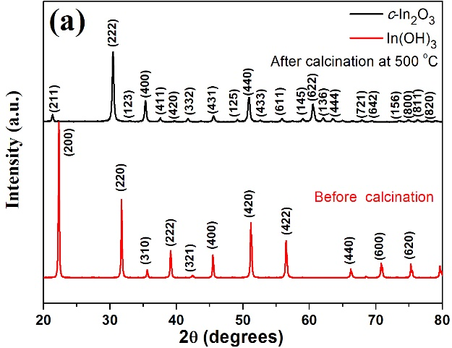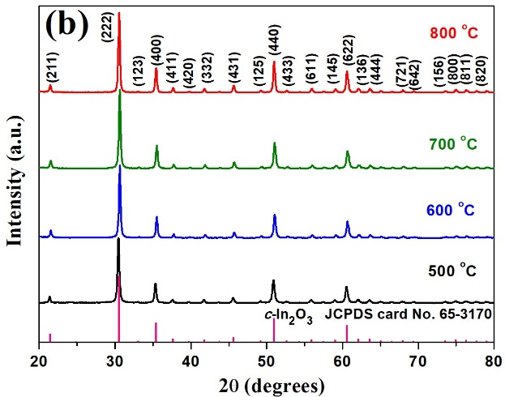
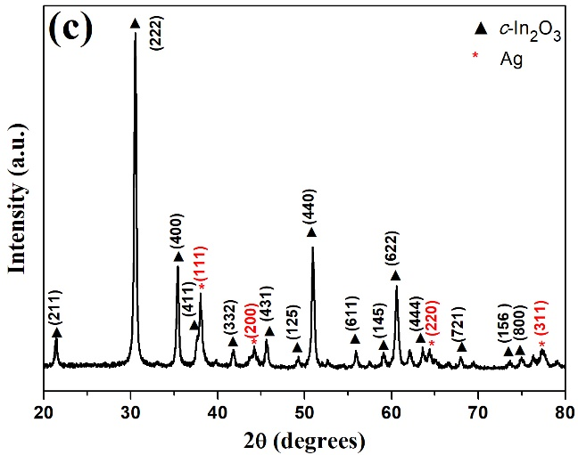
Figure 1 XRD patterns of a samples before and after calcination at 500 ºC for 2 hrs, b In₂O₃ after calcination at different temperatures for 2 hrs, c 13.6 wt% Ag-In₂O₃ nanorod composites.
The XRD patterns of the samples obtained from the hydrothermal process before and after calcination are shown in Fig. 1a. It can be seen that the product after the hydrothermal reaction is crystalline In(OH)₃ (JCPDScard No. 16-0161). After it has been calcinated at 500 ºC for 2 hrs, the XRD diffraction peaks shown in Fig. 1a are corresponding to the crystal planes of cubic In₂O₃ crystallites (JCPDS card No. 65-3170). There are no other phases observed, meaning that the In(OH)₃ have completely transformed into In₂O₃ crystallites after calcination. To investigate the effect of calcination to the crystallinity of In₂O₃, the In₂O₃ have been calcinated at 600 ºC, 700 ºC and 800 ºC for 2 hrs respectively, and the corresponding XRD patterns are shown in Fig. 1b. As the calcination temperature rises, the increase of intensity of all XRD diffraction peaks is very small, meaning that the crystallinity of In₂O₃ is stable at the calcining temperature from 500 ºC to 800 ºC. After the Ag nanoparticles were decorated onto the nanorods, some extra-diffraction peaks at 38.1º, 44.3º, 64.4º and 77.5º appear in the XRD pattern of the Ag-In₂O₃ nanorod composites (see Fig. 1c), which are corresponding to those of (111), (200), (220) and (311) of the metallic Ag (JCPDS card No. 04-0783), indicating that the Ag elements are existed as metallic silver with zero valence.
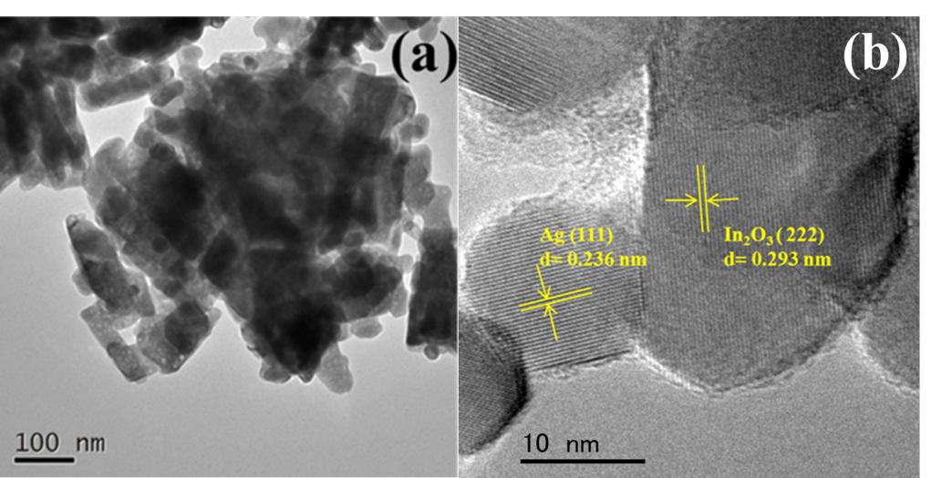
Figure 2 a TEM and b HR-TEM image of 13.6 wt% Ag-decorated In₂O₃ nanorods.
Fig. 2 presents TEM and HR-TEM images of Ag-In₂O₃ nanorod composites. The In₂O₃ shows nanorods of ~110 nm in length and ~35 nm in diameter. Surfaces of the In₂O₃ naonorods are decorated by many Ag nanoparticles, whose diameters are ranged between 10 and 15 nm. Fig. 2b shows a typical HR-TEM image of Ag-In₂O₃ nanorod composites. The aligned interplanar spacing of 0.293 nm is in a good agreement with the (222) lattice planes of In₂O₃, and the interplanar spacing of 0.236 nm of the nanoparticle is corresponding to the (111) lattice plane of sliver. EDX pattern (shown in Fig. S2 in the Supplementary Material) also proves that there are Ag elements in the sample. Modification of the In₂O₃ nanorods by Ag nanoparticles can decrease the contact potential barriers of Ag and In₂O₃ and thus facilitate the efficient electronic transport between noble metal Ag nanoparticles and In₂O₃.
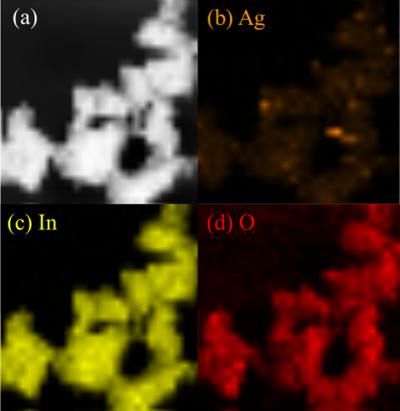
Figure 3 EDX elemental color mapping images of 13.6 wt% Ag-In₂O₃ nanorod composites. a TEM, b Ag, c In, d O.
In order to further investigate the spatial distributions of Ag, In and O elements in the Ag-In₂O₃ nanorod composites, EDX color mapping analysis was conducted and the images are presented in Fig. 3. The elemental mapping revealed the Ag, In and O elements are homogeneously distributed in the Ag-In₂O₃ nanorod composites, which confirm that the Ag nanoparticles are homogeneously decorated on the surfaces of In₂O₃ nanorods. ICP analysis also confirmed the presence of Ag elements in the Ag-In₂O₃ nanorods composites and the measured Ag weight percentage is 13.6 wt%. The specific surface areas of the pure In₂O₃ nanorods and Ag-In₂O₃ nanorod composites are 9.8 and 19.1 m²/g, respectively based on the BET nitrogen adsorption/desorption analysis. The addition of Ag nanoparticles onto the In₂O₃ nanorods apparently increases the surface areas of the samples, which are surely beneficial for the increase of the response of H₂S gas sensing [2].
3.2 Gas sensing properties
The sensors made of Ag-In₂O₃ nanorod composites operated at different operation temperatures from 25 ºC to 300 ºC (as shown in I-V characteristic curves in Fig. S3 in the Supplementary Material) all show good linear behaviors, indicating a good ohmic contact of Ag-In₂O₃ nanorod composites with the Au electrodes. Furthermore, the measured electrical resistance is 52.6 MΩ at the room temperature of 25 ºC and it decreases with the increase of temperature, a characteristic of the standard semiconductor materials.
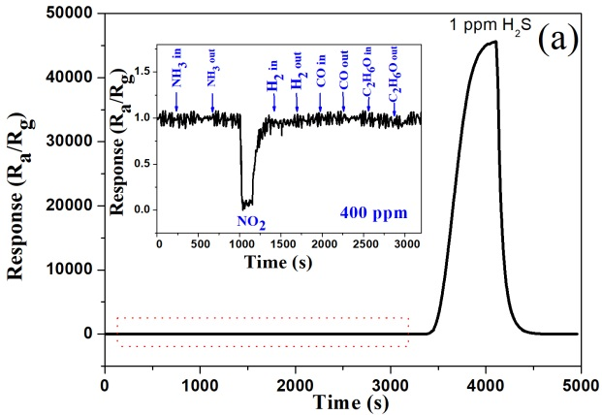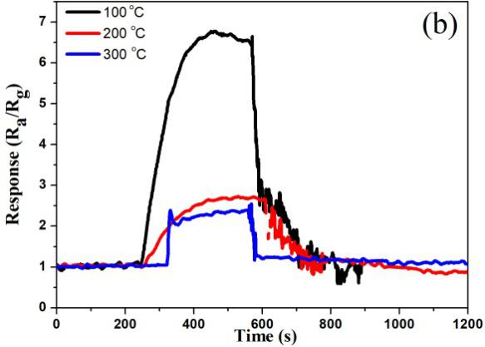
Figure 4 a Response of the sensors based on 13.6 wt% Ag-In₂O₃ nanorod composites for 1 ppm H₂S and other gases of 400 ppm (NH₃, H₂, CO, NO₂, alcohol) at room temperature of 25 ºC, b Response of the sensors for 1 ppm H₂S at different working temperatures from 100 ºC to 300 ºC.
To investigate sensing selectivity of the sensors, the response of the sensors based on Ag-In₂O₃ nanorod composites to 1 ppm H₂S and other gases of 400 ppm (NH₃, H₂, CO, NO₂ and alcohol) at room temperature of 25 ºC were obtained and the results are shown in Fig. 4a. It can be seen that the sensors have an ultra-high response value of 45627 to 1 ppm H₂S. Results also showed that the responses of the sensors to other gases of 400 ppm are negligible, such as NH₃, H₂, CO and alcohol. Only for 400 ppm NO₂ gas, there was an obviously response. Because the NO₂ is an oxidizing gas, the electrical resistance of the sensor based on the n-type sensing material of Ag-In₂O₃ nanorod composites has been increased after injecting of the NO₂ gas. However, the response value of the sensor to NO₂ gas of 400 ppm is only 0.06, which is far lower than that of H₂S of 1 ppm (i.e., 45627). Therefore, the above results clearly indicate that the sensors based on Ag-In₂O₃ nanorod composites have a very good selectivity towards H₂S compared with the other gases.
To investigate the effect of working temperature on responses of the sensors to H₂S, the sensor was tested at different working temperatures. Fig. 4b shows the responses of the sensors based on Ag-In₂O₃ nanorod composites to 1 ppm H₂S with testing temperatures from 100 ºC to 300 ºC. Compared to the response value of the sensors of 45627 at room temperature of 25 ºC, those response values obtained at working temperatures of 100 ºC, 200 ºC and 300 ºC are 6.8, 2.7, and 2.3, respectively. Clearly, the responses of the sensors based on Ag-In₂O₃ nanorod composites decrease significantly with the increase of working temperature. The largest H₂S sensing response was obtained at room temperature.
Figs. 5a and 5b show the dynamic response/recovery curves of the sensors based on Ag-In₂O₃ nanorod composites to H₂S gas with different concentrations from 20 ppm to 0.005 ppm measured at room temperature. The sensors have a steady baseline of electric resistance in air at room temperature. When the H₂S gas was injected into the testing chamber, the electric resistance of sensors was decreased instantly. After the H₂S was released, the electric resistance of sensors was quickly recovered to its original baseline before the injection. This means that the sensors have a good reversibility for the H₂S gas sensing at room temperature. Furthermore, it was found that the sensors have ultra-high changes of electric resistance values before and after their exposures to the H₂S gas.
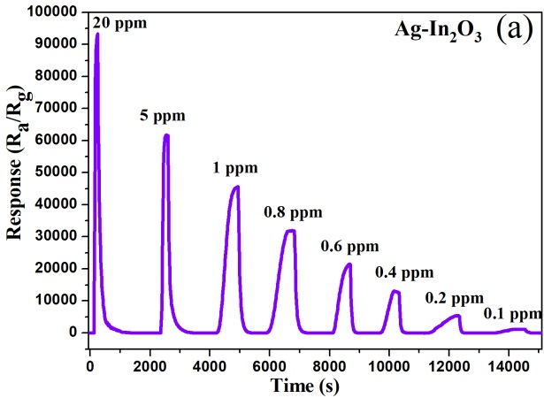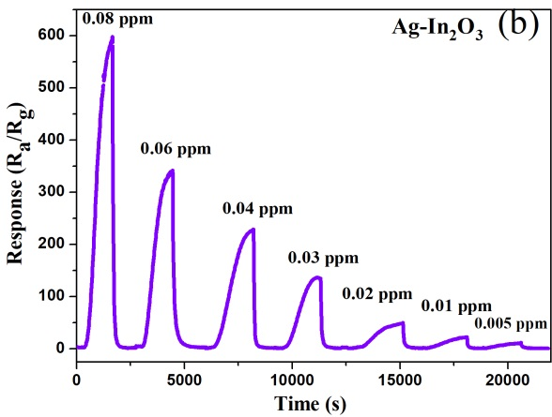
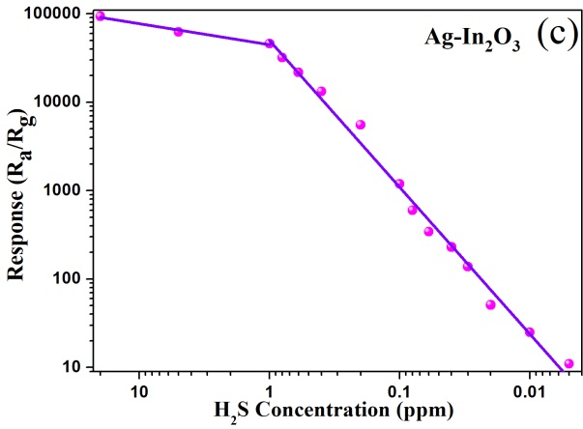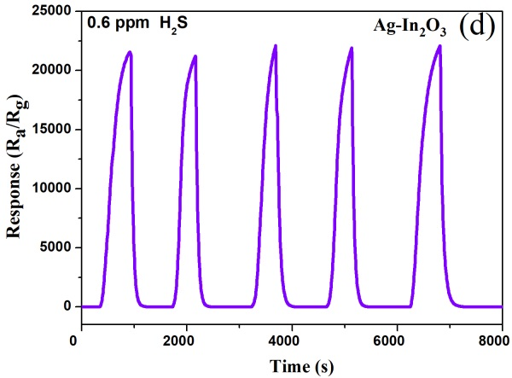
Figure 5 Response/recovery curves of the sensors based on 13.6 wt% Ag-In₂O₃ nanorod composites to H₂S gas with different concentrations at room temperature a from 20 ppm to 0.100 ppm and b from 0.080 ppm to 0.005 ppm, c The response values of the sensors to different concentrations of H₂S gas, d The response/recovery curves by successively testing the sensors to 0.600 ppm of H₂S gas for five times.

Fig. 5c shows the corresponding response values of the sensors to different concentrations of H₂S gas. The response value is 93719 to 20 ppm of H₂S. When exposed to sub-ppm concentration of H₂S, it still has a high response value. For example, for 0.005 ppm of the H₂S gas, the sensor exhibited a high response value of 11, meaning that the sensor has a superior detection limit in detecting the H₂S, and the response values of the sensor are dependent on the H₂S concentration. The response values of the sensor are linearly increased with the increase of H₂S concentration, meaning that the responses have good linearity characteristics with the H₂S concentration (R²= 0.9675). However, with the concentrations of H₂S above 1 ppm, the rate of increase of response values becomes smaller, which is mainly because the adsorption of H₂S on the surface of Ag-In₂O₃ nanorod composites tends to be gradually saturated.
To investigate the reproducibility of the H₂S sensors based on Ag-In₂O₃ nanorod composites, the sensor was successively tested in 0.600 ppm of H₂S gas for five times and the response/recovery curves are shown in Fig. 5d. For these five tests, the response/recovery curves are reproducible with the successive injection and releasing of the H₂S gas. When the sensor was exposed to 0.600 ppm of H₂S gas, the response signals were increased to the highest values with almost the same response value of 21689, and after the H₂S gas was replaced by the air, the curves were all returned to the baseline, indicating a good reproducibility.
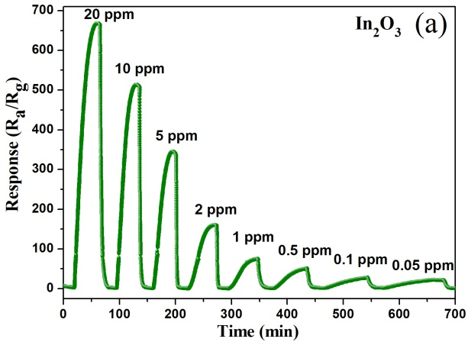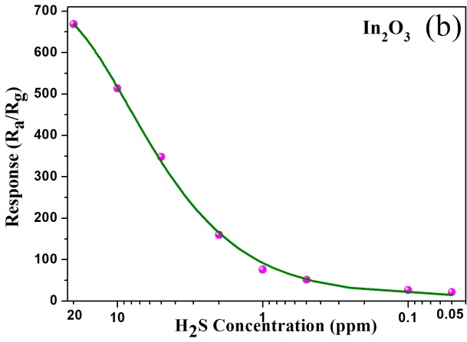
Figure 6 a Response/recovery curves and b the response values of the sensors based on pure In₂O₃ nanorods to H₂S gas with different concentrations from 20 ppm to 0.05 ppm at room temperature.
As a comparison to the sensor based on Ag-In₂O₃ nanorod composites, the H₂S sensing properties of the sensors made of pure In₂O₃ nanorod have also been studied. Fig. 6a shows the dynamic response/recovery curves of the sensors based on pure In₂O₃ nanorods to H₂S gas with different concentrations at room temperature, and the corresponding response values of the sensors to different concentrations of H₂S gas are shown in Fig. 6b. Similar to those of the Ag-In₂O₃ nanorod composites, the responses of sensors based on pure In₂O₃ nanorods increase with the increase of H₂S concentration. However, it was found that the response values of the pure In₂O₃ nanorods based sensors are far lower than these based on the Ag-In₂O₃ nanorod composites. For example, the response value of the pure In₂O₃ nanorods based sensors was 668.4 to 20 ppm H₂S, whereas it was 93719 for the sensor based on the Ag-In₂O₃ nanorod composites. The detection limit of the pure In₂O₃ nanorods based sensors is 0.050 ppm, which is much higher than that of 0.005 ppm of the Ag-In₂O₃ nanorod composites based sensors. Obviously, a significant improvement of the H₂S response (approximately 140 times of increase) and a decrease of H₂S detection limit were obtained by decorating the surface of the In₂O₃ nanorods with Ag nanoparticles.
The response and recovery times were calculated based on the times for the sensor to achieve 90% of the resistance changes in the processes of response and recovery, respectively. All the response time and the recovery time of the Ag-In₂O₃ nanorod composites based sensors to H₂S gas with different concentrations at room temperature are apparently shorter than those of the pure In₂O₃ nanorods based sensors (as shown in the histogram of the response/recovery times of the sensors in Fig. S4 in the Supplementary Material). For example, the response/recovery times to 20 ppm of H₂S for the Ag-In₂O₃ nanorod composites based sensors are 84s/186s at room temperature, whereas those are 1512 s/318 s for the pure In₂O₃ nanorods based sensors.
Table 1. Summary of sensing properties of various H₂S sensors made of various metal oxides operated at room-temperature
Material | Structures | Response (concentration) | Response  /recovery time (s) | Detection limit (ppm) | Ref.
In₂O₃ | Nanotubes | 167 (20 ppm) | 250/500 | 1 | [36]
In₂O₃ | Nanowires | 1.4 (1 ppm) | 48/56 | 1 | [37]
In₂O₃ | Nanocrystals | 25 (1 ppm) | 1500/300 | 0.030 | [38]
PVA-In₂O₃ | Films | 1.9 (1 ppm) | 300/1860 | 0.500 | [39]
In₂O₃ | Toruloid nanotubes | 320.14 (50ppm) | 45/127 | 1 | [15]
CeO₂ | Nanowires | 1.98 (100 ppm) | 100/260 | 0.050 | [40]
ZnO | Flower-like structures | 581 (5 ppm) | 500/6000 | 0.500 | [41]
ZnO | Comb-like | 4 (1 ppm) | 48/540 | 0.100 | [42]
ZnO | Nanobelt | 8 (10 ppm) | 2000/No recovery | 0.500 | [43]
ZnO | Quantum dots | 113.5 (50 ppm) | 16/820 | 10 | [44]
CuO | Porous nanosheets | 5.01 (0.2 ppm) | 336/543 | 0.010 | [45]
SnO₂:NiO | Thin films | 440 (10 ppm) | 800/6000 | 0.100 | [46]
Sb-SnO₂ | Nanoribbons | 1.6 (0.1 ppm) | 320/450 | 0.100 | [47]
α-Fe₂O₃ | Porous nanoparticles | 38.4 (100 ppm) | 100/3750 | 0.050 | [48]
Ag-In₂O₃ | Nanorods | 93719 (20 ppm) | 84/186 | 0.005 | This work
As noble metal catalysts, the Ag nanoparticles accelerate the absorption of oxygen molecules and desorption of H₂S molecules. Therefore, the Ag-In₂O₃ nanorod composites based sensors have much better sensing properties than the pure In₂O₃ nanorods based sensor. It can be concluded that the addition of Ag nanoparticles in In₂O₃ can remarkably increase the H₂S sensing properties at room temperature. So far, there are many reports of the room-temperature H₂S gas sensors based on various metal oxides, such as In₂O₃ [15,36-39], CeO₂ [40], ZnO [41-44], CuO [45], SnO₂ [46,47] and Fe₂O₃ [48], and most of them were all reported to detect sub-ppm H₂S as listed in the Table 1. However, compared with the room-temperature H₂S sensors based on Ag-In₂O₃ nanorod composites in this study, the responses of these H₂S gas sensors values are much lower, and the detection limit was much higher than 0.005 ppm. Also the recovery times of those reported room-temperature H₂S gas sensors in Table 1 were generally very long, sometimes there was incomplete recovery observed. Therefore, the room-temperature H₂S sensors based on Ag-In₂O₃ nanorod composites in this study have obviously better sensing properties.
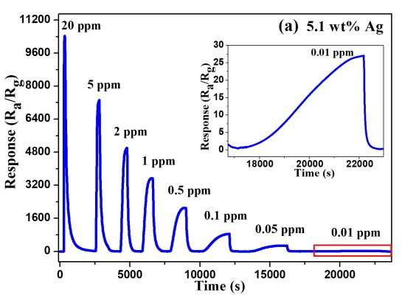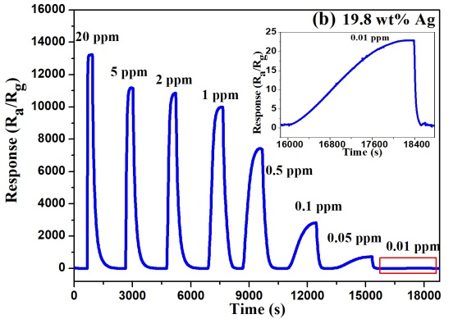
Figure 7 Room temperature response/recovery curves to different concentrations H₂S gas of the sensors based on Ag-In₂O₃ nanorod composites with different Ag contents: a 5.1 wt% and b 19.8 wt%.
To investigate the effect of Ag contents on the sensing properties of H₂S gas sensors, In₂O₃ nanorods decorated with two other Ag concentrations of 5.1 wt% and 19.8 wt% were also prepared and then were used to make the H₂S sensor. Their room temperature response/recovery curves to different concentrations of H₂S gas are shown in Fig. 7. It can be found that these Ag-In₂O₃ nanorod composites with different Ag contents all have higher responses than those based on the pure In₂O₃ nanorods, but they are obviously lower than that of the 13.6 wt% of Ag-In₂O₃ nanorod composites. Therefore, we can conclude that the optimized content of Ag nanoparticles in this study is around 13.6 wt%.
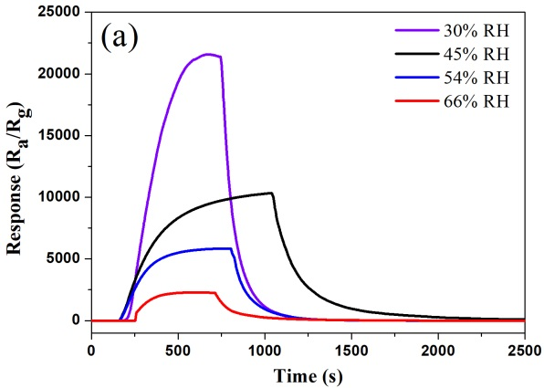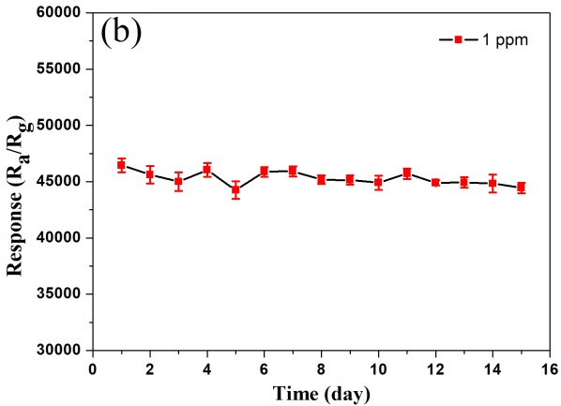
Figure 8 a Dynamic response/recovery curves of the sensor based on 13.6 wt% Ag-In₂O₃ nanorod composites to 0.6 ppm of H₂S gas under different relative humidity at room temperature, b Stability of the sensor based on 13.6 wt% Ag-In₂O₃ nanorod composites to 1 ppm of H₂S gas at room temperature and 30% RH for 15 days.
The humidity have been reported that could influence the sensing properties of gas sensors [49]. Therefore, the sensing properties of the sensor based on 13.6 wt% Ag-In₂O₃ nanorod composites to 0.6 ppm of H₂S gas under different relative humidity at room temperature were measured, and the dynamic response/recovery curves are shown in Fig. 8a. When the relative humidity is higher than 45%, the response and recovery speeds are enhanced. However, the response values of the H₂S sensor decrease with the increase of relative humidity from 30% to 70%. Stability of the sensors based on 13.6 wt% Ag-In₂O₃ nanorod composites to 1 ppm of H₂S gas at room temperature and 30% RH was measured and the response values in 15 days are shown in Fig. 8b. It can be found that the response values are stability in the testing process, and the deviation of gas response values is less than 3%, which means that the sensor based on 13.6 wt% Ag-In₂O₃ nanorod composites has a good stability.
3.3 Enhanced gas sensing mechanism of Ag-In₂O₃ nanorod composites.
Sensing properties of the gas sensors are strongly affected by the chemical states of the surface of sensing materials [50]. In order to obtain the information of the chemical states of the chemical elements in the Ag-In₂O₃ nanorod composites, XPS analysis was performed and the obtained XPS spectra are shown in Fig. 9. Based on the XPS survey spectrum shown in Fig. 9a, the sample is comprised of In, O and Ag elements. The relative contents of all elements on the surface were calculated and the ratio of the surface atoms of O, In and Ag is 61.7:32.75:5.55. The binding energies at 451.6 and 444.1 eV in Fig. 9b of the high resolution XPS spectrum are corresponding to the In 3d_{3/2} and In 3d_{5/2} of In³⁺ in the Ag-In₂O₃ nanorod composites [51].
As shown in the XPS spectrum of Ag 3d (Fig. 9c), the peaks at the binding energies of 373.6 and 367.6 eV are attributed to the Ag 3d_{3/2} and Ag 3d_{5/2} of metallic Ag [52], which indicates that the Ag elements are existed as zero-valent silver in the composites. This result are consistent with the XRD analysis. Compared with the standard binding energy of metallic Ag (374.2 eV and 368.2 for Ag3d_{3/2} and Ag 3d_{5/2}, respectively.), an obvious shift to lower binding energy side can be observed, meaning that there are electron transfers from Ag nanoparticles to In₂O₃ at their interfaces [52] This indicates that there are strong interactions of Ag with In₂O₃. Two obvious peaks at 529.6 and 531.2 eV can be observed in the O 1s spectrum in Fig. 9d. The former binding energy of 529.6 eV is assigned to the O^{2–} ions in the crystal lattice of In₂O₃, and the latter of 531.2 eV can be attributed to the surface chemisorbed oxygen ions [34].The content of chemisorbed oxygen ions is as high as 57 % in total oxygen content, based on the calculation from integral proportion in XPS spectrum of O1s. Therefore, the content of chemisorbed oxygen ions is very high on the surface. The plenty of surface chemisorbed oxygen ions on the surface of In₂O₃ nanorods is beneficial to the increase of response of the sensors [53].
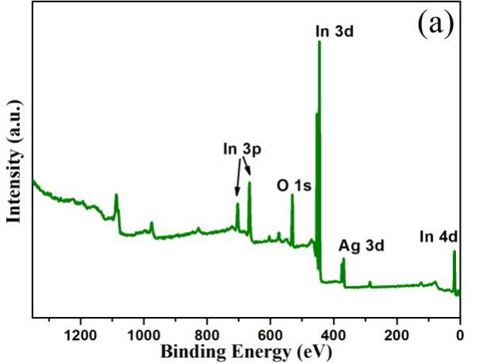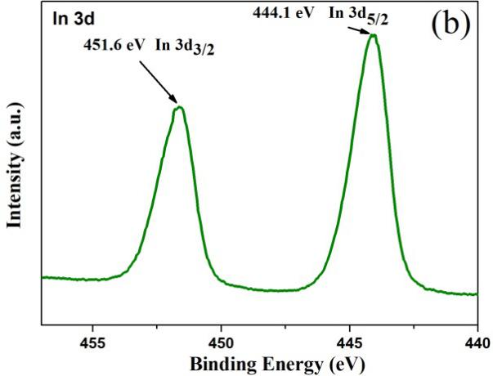
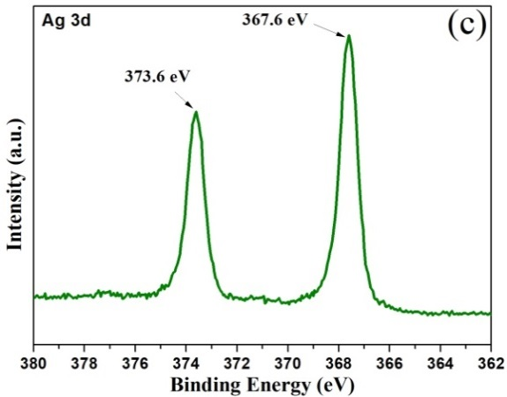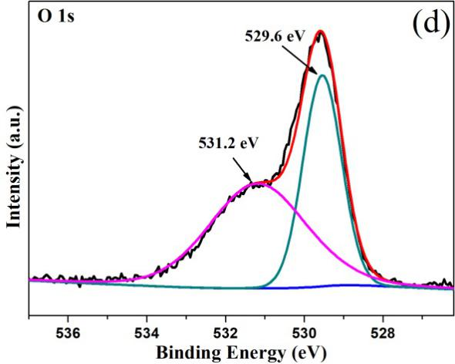
Figure 9 a XPS survey spectrum of Ag-In₂O₃ nanorod composites and high-resolution spectra of b In 3d, c Ag 3d, d O 1s.
In₂O₃ is an n-type semiconductor material. The gas-sensing mechanism of In₂O₃ based sensors is based on the conductivity changes of the In₂O₃ sensing materials, which is mainly resulted from the reaction of the target gases with the chemisorbed oxygen ions on the surface of In₂O₃. In air, oxygen molecules are easily absorbed onto the surface of In₂O₃ nanorods, and then form chemisorbed oxygen ions (O²⁻, O⁻, O₂⁻) by trapping electrons from the conduction band of In₂O₃ nanorods. At room temperature, the chemisorbed oxygen species is O₂⁻ [54]. As a result, the formation of chemisorbed oxygen ions leads to the formation of a depletion layer on the surface of the In₂O₃ nanorods and eventually results in an increase of electrical resistance of the sensor [5].The Ag nanoparticles can act as highly active catalysts on the surfaces of In₂O₃ nanorods to create more specifically active sites, and thus enhance the absorption of oxygen molecules and formation of chemisorbed oxygen ions on the surface of Ag by trapping more electrons from In₂O₃. This will result in an increase of width of the electron depletion layers of In₂O₃ sensing materials. In addition, due to the spill-over effect [55], the chemisorbed oxygen ions will be spilled over to the surface of In₂O₃ to increase the quantity chemisorbed oxygen ions on the surfaces of In₂O₃ nanorods.
When the sensor based on Ag-In₂O₃ nanorod composites is exposed to H₂S gas, H₂S molecules will be absorbed on the surface of In₂O₃, and then react with the surface chemisorbed O₂⁻ ions. At the same time, the Ag nanoparticles also absorb the H₂S molecules, which are diffused into the surfaces of In₂O₃ through the spill-over effect [31,33,55]. Thus, more H₂S molecules will be absorbed and then react with the chemisorbed oxygen ions. Finally, the H₂S molecules will be oxidized into SO₂ and H₂O, which then releases many electrons based on the following reaction formula [54]:
H₂S + 3/2O₂⁻ → SO₂ + H₂O + 3/2e⁻ (1)
The released electrons will be transferred to the electron deletion layer on the surfaces of the In₂O₃ nanorods, thus reducing its thickness, and finally result in the decrease of the electric resistance of the sensor. Because the Ag nanoparticles are strongly decorated on the surfaces of In₂O₃ nanorods, apart from the chemical sensitization by the spillover effect explained before, the electronic sensitization also affects the sensing property of the sensors by accelerating the electron transfer between H₂S and the sensors [33]. Therefore, because of the combined chemical sensitization and electronic sensitization, there are significant changes in the resistance of film of the Ag-In₂O₃ nanorod composites than those of the pure In₂O₃ nanorods, thus resulting in much higher responses. Furthermore, the detection limit to the H₂S will also be much lower and the response/recovery times will be significantly reduced.
4 Conclusion
The Ag-In₂O₃ nanorod composites were successfully synthesized to be used to detect the H₂S at room temperature. Compared with pure In₂O₃ nanorods based sensors, the Ag-In₂O₃ nanorod composites based H₂S sensors showed much better sensing properties. At room temperature, it exhibited an ultra-highly response, good sensing selectivity, excellent reversibility and low detection limit. The enhanced sensing performance of the Ag-In₂O₃ nanorod composites was attributed to be the chemical sensitization and electronic sensitization. Therefore, the H₂S sensor based on Ag-In₂O₃ nanorod composites is promising in H₂S detection at room temperature.

Acknowledgments
Funding supports from UK Engineering Physics and Science Research Council (EPSRC EP/P018998/1), Newton Mobility Grant (IE161019) through Royal Society and NFSC, and Royal academy of Engineering UK-Research Exchange with China and India are acknowledged.

Appendix A. Supplementary material

Photo of the room temperature H₂S sensors based on Ag-In₂O₃ nanorod composites. EDX pattern of Ag-In₂O₃ nanorod composites. I–V curves of the sensors based on Ag-In₂O₃ nanorod composites at different operation temperatures. The histogram of the response/recovery times of the sensors to H₂S gas with different concentrations at room temperature.

Reference
[1] Fu D, Zhu C, Zhang X, Li C, Chen Y (2016) Two-dimensional net-like SnO₂/ZnO heteronanostructures for high-performance H₂S gas sensor. J Mater Chem A 4 (4):1390-1398. doi:10.1039/c5ta09190j
[2] Bulemo PM, Cho H-J, Kim N-H, Kim I-D (2017) Mesoporous SnO₂ Nanotubes via Electrospinning-Etching Route: Highly Sensitive and Selective Detection of H₂S Molecule. ACS Appl Mater Interfaces 9 (31):26304-26313. doi:10.1021/acsami.7b05241
[3] Sukunta J, Wisitsoraat A, Tuantranont A, Phanichphant S, Liewhiran C (2017) Highly-sensitive H₂S sensors based on flame-made V-substituted SnO₂ sensing films. Sens Actuators B Chem 242:1095-1107. doi:10.1016/j.snb.2016.09.140
[4] Deng J, Fu Q, Luo W, Tong X, Xiong J, Hu Y, Zheng Z (2016) Enhanced H₂S gas sensing properties of undoped ZnO nanocrystalline films from QDs by low-temperature processing. Sens Actuators B Chem 224:153-158. doi:10.1016/j.snb.2015.10.022
[5] Li Z, Lin Z, Wang N, Huang Y, Wang J, Liu W, Fu Y, Wang Z (2016) Facile synthesis of alpha-Fe₂O₃ micro-ellipsoids by surfactant-free hydrothermal method for sub-ppm level H₂S detection. Mater Design 110:532-539. doi:10.1016/j.matdes.2016.08.035
[6] Peng WH , Yao F, Zhang D, Zhu CG, Li Y, Zhu SM (2013) Biomimetic fabrication of a-Fe₂O₃ with hierarchical structures as H₂S Sensor, J Mater Sci 48:4336–4344. doi:10.1007/s10853-013-7249-1
[7] Chaudhari GN, Bambole DR, Bodade AB, Padole PR (2006) Characterization of nanosized TiO₂ based H₂S gas sensor. J Mater Sci 41 (15):4860-4864. doi:10.1007/s10853-006-0042-7
[8] Ayesh AI, Abu-Hani AFS, Mahmoud ST, Haik Y (2016) Selective H₂S sensor based on CuO nanoparticles embedded in organic membranes. Sens Actuators B Chem 231:593-600. doi:10.1016/j.snb.2016.03.078
[9] Yao K, Caruntu D, Zeng Z, Chen J, O'Connor CJ, Zhou W (2009) Parts per Billion-Level H₂S Detection at Room Temperature Based on Self-Assembled In₂O₃ Nanoparticles. J Phys Chem C 113 (33):14812-14817. doi:10.1021/jp905189f
[10] Lai X, Wang D, Han N, Du J, Li J, Xing C, Chen Y, Li X (2010) Ordered Arrays of Bead-Chain-like In₂O₃ Nanorods and Their Enhanced Sensing Performance for Formaldehyde. Chem Mater 22 (10):3033-3042. doi:10.1021/cm100181c
[11] Li X, Yao S, Liu J, Sun P, Sun Y, Gao Y, Lu G (2015) Vitamin C-assisted synthesis and gas sensing properties of coaxial In₂O₃ nanorod bundles. Sens Actuators B Chem 220:68-74. doi:10.1016/j.snb.2015.05.038
[12] Zhang SC, Huang YW, Kuang Z, Wang SY, Song WL, Ao DY, Liu W, Li ZJ (2015) Solvothermal Synthesized In₂O₃ Nanoparticles for ppb Level H₂S Detection. Nanosci Nanotech Let 7 (6):455-461. doi:10.1166/nnl.2015.1993
[13] Kaur M, Jain N, Sharma K, Bhattacharya S, Roy M, Tyagi AK, Gupta SK, Yakhmi JV (2008) Room-temperature H₂S gas sensing at ppb level by single crystal In₂O₃ whiskers. Sens Actuators B Chem 133 (2):456-461. doi:10.1016/j.snb.2008.03.003
[14] Chen W, Liu Y, Qin Z, Wu Y, Li S, Ai P (2015) A Single Eu-Doped In₂O₃ Nanobelt Device for Selective H₂S Detection. Sensors 15 (12):29950-29957. doi:10.3390/s151229775
[15] Duan H, Yan L, He Y, Li H, Liu L, Cheng Y, Du L (2017) The fabrication of In₂O₃ toruloid nanotubes and their room temperature gas sensing properties for H₂S. Mater Res Express 4 (9). doi:10.1088/2053-1591/aa89f9
[16] Liang X, Kim T-H, Yoon J-W, Kwak C-H, Lee J-H (2015) Ultrasensitive and ultraselective detection of H₂S using electrospun CuO-loaded In₂O₃ nanofiber sensors assisted by pulse heating. Sens Actuators B Chem 209:934-942. doi:10.1016/j.snb.2014.11.130
[17] Liu J, Guo W, Qu F, Feng C, Li C, Zhu L, Zhou J, Ruan S, Chen W (2014) V-doped In₂O₃ nanofibers for H₂S detection at low temperature. Ceram Int 40 (5):6685-6689. doi:10.1016/j.ceramint.2013.11.129
[18] Bari RH, Patil PP, Patil SB, Bari AR (2013) Detection of H₂S gas at lower operating temperature using sprayed nanostructured In₂O₃ thin films. B Mater Sci 36 (6):967-972. doi:10.1007/s12034-013-0572-y
[19] Park S, Kim S, Sun GJ, Lee C (2015) Synthesis, Structure, and Ethanol Gas Sensing Properties of In₂O₃ Nanorods Decorated with Bi₂O₃ Nanoparticles. ACS Appl Mater Interfaces 7 (15):8138-8146. doi:10.1021/acsami.5b00972
[20] Zhao J, Zheng M, Lai X, Lu H, Li N, Ling Z, Cao J (2012) Preparation of mesoporous In₂O₃ nanorods via a hydrothermal-annealing method and their gas sensing properties. Materials Letters 75:126-129. doi:10.1016/j.matlet.2012.01.075
[21] Xing R, Xu L, Song J, Zhou C, Li Q, Liu D, Wei Song H (2015) Preparation and Gas Sensing Properties of In₂O₃/Au Nanorods for Detection of Volatile Organic Compounds in Exhaled Breath. Sci Rep 5:10717. doi:10.1038/srep10717
[22] Cheng Z-X, Dong X-B, Pan Q-Y, Zhang J-C, Dong X-W (2006) Preparation and characterization of In₂O₃ nanorods. Materials Letters 60 (25-26):3137-3140. doi:10.1016/j.matlet.2006.02.065
[23] Younis A, Chu D, Li S (2013) Tuneable resistive switching characteristics of In₂O₃ nanorods array via Co doping. RSC Adv 3 (32):13422. doi:10.1039/c3ra41276h
[24] Maestre D, Häussler D, Cremades A, Jäger W, Piqueras J (2011) Nanopipes in In₂O₃ Nanorods Grown by a Thermal Treatment. Crystal Growth & Design 11 (4):1117-1121. doi:10.1021/cg101350f
[25] Kang J-g, Park J-S, Lee H-J (2017) Pt-doped SnO₂ thin film based micro gas sensors with high selectivity to toluene and HCHO. Sens Actuators B Chem 248:1011-1016. doi:10.1016/j.snb.2017.03.010
[26] Kamble VB, Umarji AM (2016) Achieving selectivity from the synergistic effect of Cr and Pt activated SnO₂ thin film gas sensors. Sens Actuators B Chem 236:208-217. doi:10.1016/j.snb.2016.05.119
[27] Dinesh VP, Sukhananazerin A, Biji P (2017) An emphatic study on role of spill-over sensitization and surface defects on NO₂ gas sensor properties of ultralong ZnO@Au heterojunction NRs. J Alloy Compd 712:811-821. doi:10.1016/j.jallcom.2017.04.123
[28] Guo J, Zhang J, Gong H, Ju D, Cao B (2016) Au nanoparticle-functionalized 3D SnO₂ microstructures for high performance gas sensor. Sens Actuators B Chem 226:266-272. doi:10.1016/j.snb.2015.11.140
[29] Tarwal NL, Rajgure AV, Patil JY, Khandekar MS, Suryavanshi SS, Patil PS, Gang MG, Kim JH, Jang JH (2013) A selective ethanol gas sensor based on spray-derived Ag-ZnO thin films. J Mater Sci 48 (20):7274-7282. doi:10.1007/s10853-013-7547-7
[30] Yao Y, Ji F, Yin M, Ren X, Ma Q, Yang J, Liu SF (2016) Ag Nanoparticle-Sensitized WO₃ Hollow Nanosphere for Localized Surface Plasmon Enhanced Gas Sensors. ACS Appl Mater Interfaces 8 (28):18165-18172. doi:10.1021/acsami.6b04692
[31] Anand K, Kaur J, Singh RC, Thangaraj R (2017) Preparation and characterization of Ag-doped In₂O₃ nanoparticles gas sensor. Chem Phys Lett 682:140-146. doi:10.1016/j.cplett.2017.06.008
[32] Yoon J-W, Hong YJ, Kang YC, Lee J-H (2014) High performance chemiresistive H₂S sensors using Ag-loaded SnO₂ yolk-shell nanostructures. RSC Adv 4 (31):16067-16074. doi:10.1039/c4ra01364f
[33] Xue Y-Y, Wang J-L, Li S-N, Jiang Y-C, Hu M-C, Zhai Q-G (2017) Mesoporous Ag/In₂O₃ composite derived from indium organic framework as high performance formaldehyde sensor. J Solid State Chem 251:170-175. doi:10.1016/j.jssc.2017.04.024
[34] Xiao B, Song S, Wang P, Zhao Q, Chuai M, Zhang M (2017) Promoting effects of Ag on In₂O₃ nanospheres of sub-ppb NO₂ detection. Sens Actuators B Chem 241:489-497. doi:10.1016/j.snb.2016.10.107
[35] Wang S, Xiao B, Yang T, Wang P, Xiao C, Li Z, Zhao R, Zhang M (2014) Enhanced HCHO gas sensing properties by Ag-loaded sunflower-like In₂O₃ hierarchical nanostructures. J Mater Chem A 2 (18):6598-6604. doi:10.1039/c3ta15110g
[36] Xu L, Dong B, Wang Y, Bai X, Liu Q, Song H (2010) Electrospinning preparation and room temperature gas sensing properties of porous In₂O₃ nanotubes and nanowires. Sens Actuators B Chem 147 (2):531-538. doi:10.1016/j.snb.2010.04.003
[37] Zeng Z, Wang K, Zhang Z, Chen J, Zhou W (2009) The detection of H₂S at room temperature by using individual indium oxide nanowire transistors. Nanotechnology 20 (4). doi:10.1088/0957-4484/20/4/045503
[38] Caruntu D, Yao K, Zhang Z, Austin T, Zhou W, O'Connor CJ (2010) One-Step Synthesis of Nearly Monodisperse, Variable-Shaped In₂O₃ Nanocrystals in Long Chain Alcohol Solutions. J Phys Chem C 114 (11):4875-4886. doi:10.1021/jp911427b
[39] Singhal A, Kaur M, Dubey KA, Bhardwaj YK, Jain D, Pillai CGS, Tyagi AK (2012) Polyvinyl alcohol-In₂O₃ nanocomposite films: synthesis, characterization and gas sensing properties. RSC Adv 2 (18):7180-7189. doi:10.1039/c2ra20416a
[40] Li Z, Niu X, Lin Z, Wang N, Shen H, Liu W, Sun K, Fu YQ, Wang Z (2016) Hydrothermally synthesized CeO₂ nanowires for H₂S sensing at room temperature. J Alloy Compd 682:647-653. doi:10.1016/j.jallcom.2016.04.311
[41] Hosseini ZS, Zad AI, Mortezaali A (2015) Room temperature H₂S gas sensor based on rather aligned ZnO nanorods with flower-like structures. Sens Actuators B Chem 207:865-871. doi:10.1016/j.snb.2014.10.085
[42] Faisal AD (2017) Synthesis of ZnO comb-like nanostructures for high sensitivity H₂S gas sensor fabrication at room temperature. B Mater Sci 40 (6):1061-1068. doi:10.1007/s12034-017-1461-6
[43] Kaur M, Kailasaganapathi S, Ramgir N, Datta N, Kumar S, Debnath AK, Aswal DK, Gupta SK (2017) Gas dependent sensing mechanism in ZnO nanobelt sensor. Appl Surf Sci 394:258-266. doi:10.1016/j.apsusc.2016.10.085
[44] Zhang B, Li M, Song Z, Kan H, Yu H, Liu Q, Zhang G, Liu H (2017) Sensitive H₂S gas sensors employing colloidal zinc oxide quantum dots. Sens Actuators B Chem 249:558-563. doi:10.1016/j.snb.2017.03.098
[45] Li Z, Wang N, Lin Z, Wang J, Liu W, Sun K, Fu YQ, Wang Z (2016) Room-Temperature High-Performance H₂S Sensor Based on Porous CuO Nanosheets Prepared by Hydrothermal Method. ACS Appl Mater Interfaces 8 (32):20962-20968. doi:10.1021/acsami.6b02893
[46] Kaur M, Dadhich BK, Singh R, Ganapathi K, Bagwaiya T, Bhattacharya S, Debnath AK, Muthe KP, Gadkari SC (2017) RF sputtered SnO₂: NiO thin films as sub-ppm H₂S sensor operable at room temperature. Sens Actuators B Chem 242:389-403. doi:10.1016/j.snb.2016.11.054
[47] Ma J, Liu Y, Zhang H, Ai P, Gong N, Wu Y, Yu D (2015) Room temperature ppb level H₂S detection of a single Sb-doped SnO₂ nanoribbon device. Sens Actuators B Chem 216:72-79. doi:10.1016/j.snb.2015.04.025
[48] Huang Y, Chen W, Zhang S, Kuang Z, Ao D, Alkurd NR, Zhou W, Liu W, Shen W, Li Z (2015) A high performance hydrogen sulfide gas sensor based on porous alpha-Fe₂O₃ operates at room-temperature. Appl Surf Sci 351:1025-1033. doi:10.1016/j.apsusc.2015.06.053
[49] Wang T, Yu Q, Zhang S, Kou X, Sun P, Lu G (2018) Rational design of 3D inverse opal heterogeneous composite microspheres as excellent visible-light-induced NO₂ sensors at room temperature. Nanoscale 10 (10):4841-4851. doi:10.1039/c7nr08366a
[50] Wang J, Li Z, Zhang S, Yan S, Cao B, Wang Z, Fu Y (2018) Enhanced NH₃ gas-sensing performance of silica modified CeO₂ nanostructure based sensors. Sens Actuators B Chem 255:862-870. doi:10.1016/j.snb.2017.08.149
[51] Dong C, Liu X, Han B, Deng S, Xiao X, Wang Y (2016) Nonaqueous synthesis of Ag-functionalized In₂O₃/ZnO nanocomposites for highly sensitive formaldehyde sensor. Sens Actuators B Chem 224:193-200. doi:10.1016/j.snb.2015.09.107
[52] Ganesh RS, Navaneethan M, Patil VL, Ponnusamy S, Muthamizhchelvan C, Kawasaki S, Patil PS, Hayakawa Y (2018) Sensitivity enhancement of ammonia gas sensor based on Ag/ZnO flower and nanoellipsoids at low temperature. Sens Actuators B Chem 255:672-683. doi:10.1016/j.snb.2017.08.015
[53] Li Z, Huang Y, Zhang S, Chen W, Kuang Z, Ao D, Liu W, Fu Y (2015) A fast response & recovery H₂S gas sensor based on alpha-Fe₂O₃ nanoparticles with ppb level detection limit. J Hazard Mater 300:167-174. doi:10.1016/j.jhazmat.2015.07.003
[54] Chang S-J, Hsueh T-J, Chen IC, Huang B-R (2008) Highly sensitive ZnO nanowire CO sensors with the adsorption of Au nanoparticles. Nanotechnology 19 (17). doi:10.1088/0957-4484/19/17/175502
[55] Mirzaei A, Janghorban K, Hashemi B, Bonyani M, Leonardi SG, Neri G (2016) A novel gas sensor based on Ag/Fe₂O₃ core-shell nanocomposites. Ceram Int 42 (16):18974-18982. doi:10.1016/j.ceramint.2016.09.052

