Grasping the nettle of ‘doctorateness’ for practitioner academics: a framework for thinking critically about curriculum design
Elaine Hall
Professor of Legal Education, School of Law, Northumbria University, UK
Abstract
This paper is both a reflexive report on an attempt to operationalise ‘doctorateness’ in a specific case context and a synthesis of theory from the philosophy of education and curriculum design. Using the context of a new Professional Doctorate programme in Law (the DLaw) at a University in the North-East of England, it is an exploration of the conceptual framework of the students and the curriculum designer. All participants have consented to the use of their reflections and contribution to discussions, recognising the potential for them to be identified through publically available data about the programme and cohort members. This was the focus of discussion in the group and the decision –that whilst individuals are not directly identified, there has been no attempt to conceal the identity of the institution or programme – was made collaboratively. The paper articulates the particularity of the ‘Category 3’ doctorate (QAA, 2015) and its position as a pathway for staff development and recognition (within post-1992 institutions in particular) as a way of setting the boundaries and context of what follows. Experiential data in this paper describes both my aspirations for the DLaw and how that initial model has been developed through dialogue with the first cohort of students as a vehicle for illuminating the theoretical discussions.
Keywords: doctorate study, curriculum design, threshold concepts, pedagogy and learning
Introduction and Context
For students embarking on a professional doctorate programme one of the key sources of anxiety is how to produce, from their existing knowledge and practice, a plan for activities and outputs that constitute ‘doctorateness’. It can seem like an unimaginable leap (Wellington, 2013). If the ‘we’ who can recognise doctorateness are all on the far side of the barrier and we are not successfully communicating to students the nature of the jump required, there is work to be done – if of course our collective intent is to de-mystify the process. There is a defensive action fought in all sectors of education against forms of assessment which appear to be too clear or which allow too many people to succeed, based on the conflict between the idea of assessment as a normative measure of knowledge or skill and the idea of assessment as a tool to differentiate between individuals or groups (Ecclestone, 2000).
As the director of a professional doctorate programme, I want to counter that ‘bad faith’ position in which the doctorate can be devalued through success. This paper seeks to undermine reified ideas about knowledge, learning and the doctorate- my own and others’- by placing these assumptions in harm’s way and attempting to articulate the moments in which I have become aware of the tensions in my practice when enabling, nudging and recognising my doctoral students’ ‘conceptual threshold crossing’ (Trafford and Leshem, 2009, Kiley and Wisker, 2009).
The DLaw professional doctorate is a new programme (now in its third year) which has been designed as a route to doctoral qualification for new and established academic staff in the Law School, most of whom have come from professional practice as barristers or solicitors. Some candidates have research credits at Masters level that they use to join the programme while others complete a portfolio demonstrating their engagement with research training. Candidates’ fields of enquiry range from issues of substantive law and their application and implications to a focus on the teaching and learning of legal skills and the development of professional identity, the common thread being the investigation of and contribution to professional practice as lawyer, law teacher and academic. It is a part-time programme running over three and a half years, with a six month taught element culminating in a proposal assignment. Assessment of this assignment is parallel to project approval in a traditional PhD and candidates then move to research stage. The DLaw is therefore an intensive and relatively structured programme which has the principal aim of advancing staff professionally from a previously unacknowledged level of advanced standing. As programme leader, I have additional aims related to the development of a sustainable faculty research culture which has meaning and relevance for our practice partners in the commercial, legal aid, voluntary and policy sectors.
Why are doctorates important for professionally qualified academic staff?
The professional skills of the doctorate alluded to earlier are arguably the same skills valued in the senior levels of business and the professions: innovation, enquiry, rigour and the communication of knowledge. Doctoral qualification, rather than simply being an academic entry point, has become a form of currency in the professions, where it operates as a signal of readiness for senior leadership. Professional doctorate programmes have been developed to support these candidates, who bring significant practice experience and specialised knowledge but that is not the focus of this enquiry. This paper focuses on how the professional doctorate has been used for university teachers in my department, where the warrant of real world experience is still required for students and accrediting bodies. To run our programmes, we need staff with extensive professional experience and, in many cases, ongoing professional accreditation as all our students perform live client casework under supervision. These staff are experts and many of them have worked at the university for some years, so their experience of the professional doctorate exists in a qualitatively different space to both the senior practitioner outside the academy and to the aspirant academic with a recent Masters degree. The body that in the UK sets academic standards, the Quality Assurance Agency (QAA) state that
It is now the case that most academic staff in UK universities have a doctoral degree; this is an expected qualification for most new entrants to academia and contributes to the ongoing high quality research output from higher education providers. (QAA, 2015, p.4)
This is both true and slightly misleading. HESA data confirms (figure 1 below) that just over half of academic staff have doctorates.
Figure 1
In fact, the spread of doctorally qualified staff across both institutions and disciplines is extremely variable, particularly in institutions in the UK with a history as professional or technical institutions or for those in practice-oriented disciplines. Such institutions and departments are dependent upon considerations of who is best qualified in terms of skills and experience to lead learning. For disciplines like nursing, law and architecture, the credibility of lecturers for students, professional governing bodies and employers has come from their being professional qualified and experienced rather than having a doctorate. There is also the question of market-led considerations of employment choices for potential staff – until recently the doctorate had little currency for professionals and so candidates for lecturing posts coming directly from practice were unlikely to have one.
However, the persistence of the traditional model of PhD as passport to academic life means that in recent years doctoral qualification for university staff is, if not expected on entry, certainly expected for progression and retention. Professional doctorate programmes, particularly EdD routes that allow staff to enquire into their pedagogy and the transmission of disciplinary knowledge have traditionally accommodated these colleagues alongside practitioner colleagues from the field. There is sometimes in the discourse (noted by Neumann, 2005; and more recently by Schildkraut and Stafford, 2015) an implied criticism of professional doctorates as somehow ‘remedial’ and a sense that, unlike ‘traditional’ students, ‘prof docs’ – particularly internal candidates - have extrinsic and managerial motivations for study. This is long overdue for challenge. Since the doctorate has its own intrinsic joys and value (at times more visible to the candidate than at others), since it has a specific currency for each person and since the combination of intrinsic and extrinsic motivation is complex I pose this question. How many doctoral candidates doing traditional theses in established disciplines are more motivated to have done a PhD than to be doing one?
Moving beyond motivation to access, we need to ask: who are these ‘prof doc’ candidates and what kinds of existing practices and forms of knowledge do they bring? As they have not come along the first degree, masters linear path, their ‘graduateness’ and entry status becomes particularly complicated and slippery and subject to local and disciplinary conditions. Cooper and Harris (2013) unpack this in relations to recognition of prior learning (RPL), an integral part of many prof doc students’ journeys. They note that the dominant and artificial binary of theoretical and practice knowledge (Gibbons et al 1994; Hessels and van Lente 2008) creates a ‘taken for granted’ separation so that
As a result RPL is mainly seen as a device to map one body of knowledge (e.g. working knowledge) against another (e.g. academic knowledge) rather than an exploration of the relationship between the two. (ibid., 449)
The traditional balance of power (Armsby et al, 2006; Armsby, 2012) is not disrupted by the RPL process: the university runs the bureau de change and the practitioner hopes that her currency will be accepted and will suffice. It is perhaps not surprising that she has a lingering uncertainty about her status.
Doctorateness as an operational and theoretical construct
A doctorate is such an intrinsic part of academic culture, such an important signifier of belonging that it is tempting to take it for granted. However, we are dealing with a culturally constructed concept, like ‘quality’ which as Wittek and Kvernbekk point out “even in the absence of an agreed-upon, unified definition [..], we all (think we) recognize [..] when we see it” (2011, p.675, emphasis in original). To begin with the official definition: the QAA’s statement of doctoral characteristics highlights the personal and disciplinary specificity of the doctorate:
Doctoral degrees are the most individually distinct of the academic qualifications available because of their roots in research and the pursuit of knowledge, and the requirement for the candidate to produce work demonstrating original thought, based on independent study. (QAA 2015, p.4)
This fits with a traditional model of the doctoral pathway, in which the relationship between the individual researcher and her supervisors shapes the epistemological and technical boundaries of the activity. In this model, the doctorate as artefact, the free-standing ‘contribution to knowledge’ is of principal importance, the methodological and theoretical innovation of the researcher often relegated to supporting roles. This academic apprenticeship (Eraut, 1994) is important to our cultural ideas of expertise as something that is ipsatively assessed within disciplinary standards and is particularly congruent with the doctorate as entry qualification to academic life, where the student as newcomer necessarily locates themselves within theoretical and methodological traditions as part of joining the community of practice (Wenger-Traynor et al 2014). Raised within the community, it is likely that the criticality required of the doctoral student will emerge developmentally.
However, in the same document (ibid, 2015), the QAA go on to recognise that this traditional model is something that is no longer the only or principal purpose of the doctorate for alongside the substantive contribution to disciplinary knowledge the candidate is also laying claim to a number of higher level skills and types of knowledge. The idea of ‘doctoral skills’ is now mainstream and QAA (2015) note the evolution of research training in doctoral programmes, in part as a response to the demands of research councils, so it may be fair to say that in the last twenty years all doctorates have become ‘professionalised’ (Eraut, 1994). Doctoral programme directors therefore offer guidance helpfully summarised in this web resource:
some common characteristics of doctoral quality--such as the ability to engage with the literature in the discipline and use its theoretical foundations to create new knowledge; the ability to abide by principles of research ethics; and to theorize about research findings in a meaningful and creative way (Dmitrov, 2012)
This model of doctorateness as a critical and engaged process is much more congruent with a professional doctorate where the student, while a neophyte researcher, is bringing established professional knowledge structures directly into play. The inevitable issues of translation that the student encounters bringing her practice and academic perspectives together mean that the professional doctorate candidate has the potential to engage with criticality from the start.
For the academic already in post, preparing undergraduate students for specific disciplinary practice – whether this is the legal hermeneutic tradition or professional skills such as advocacy - and simultaneously fostering the graduate attributes of research skill and critical autonomy, it may be that these more generic markers of ‘doctorateness’ may be the academic capital she uses, in tandem with or separately from her subject knowledge.
Trafford and Leshem cite Pearce to support their argument that doctorateness is a trans-disciplinary phenomenon
all of the key benchmarks of doctoral quality cut across disciplines. While the measurement of originality may well be different in the humanities and the sciences, that all important criterion for doctoral level research remains the same (2005, 25)
From this, they developed their deservedly popular synergic framework (figure 2) in which these common criteria are unpacked and on which doctoral programme directors base their support structures.

Figure 2
The DLaw as a case example
This therefore is the territory in which these concepts will be encountered, stuckness endured and embraced and finally, thresholds crossed. My students have significant professional experience and standing as legal and educational practitioners, they are confident in using and translating their expertise in courtrooms and classrooms. They were, at the beginning of the process, fervently united in their idea of themselves as “not traditionally academic”. Trafford and Leshem’s exploration of threshold moments focused on students already engaged whereas an additional layer of complication was that my cohort had not taken on the ‘doctoral student’ identity in the same way, as part of their core sense of self or aspiration. This translated in a particular pattern in relation to the core components, for like one of Trafford and Leshem’s students, they could see that these were “mutually interdependent actions” (2009, 310) but lacked the belief that they could enact all of them. As figure 3 below indicates, drawn from analysis of their initial proposals and notes of my conversations with them, they were confident in the strongly shaded areas which reflected their knowledge of the field and the ability to devise relevant questions from gaps in existing knowledge, their skills in communication and the construction of arguments that meant they felt that their work could potentially (lightly shaded areas) answer their research questions and be a contribution to knowledge.
Figure 3
The unshaded areas on the right of the figure reflect their lack of confidence in their research skills: design, application and analysis. Undergraduate and taught Masters law students are relatively unlikely to have encountered research methods training, although DLaw candidates had to have 60 credits of Masters level research or the equivalent experience demonstrated by portfolio as part of the application process. This lack of confidence was widely held to be temporary, they believed that the taught elements of the DLaw, reading and supervision would rectify this ‘skills gap’ and that they would able to achieve a level of competence that would be acceptable. This mastery orientation was much less evident in the remaining (wavy) areas, which all relate to conceptual and theoretical work (Kiley, 2015). This area was seen as alien, both in terms of language, practice and perhaps, relevance to their own self-concept. These less concrete elements are perhaps the critical threshold elements of doctorateness for my students.
Working with threshold concepts
In this section I will relate my attempt to deal with the some of the conceptual slipperiness of threshold concepts (Meyer and Land, 2005) by providing a new framing. Threshold concepts, with their emphasis on ‘troublesome knowledge’ and the ‘repositioning of the self’ (ibid, 374) seem an ideal theoretical tool to investigate doctorateness. Most particularly to be celebrated about threshold concept theory is that the idea of not-yet-knowing is central, something to be welcomed and to linger around.
Figure 4
However, threshold concepts are themselves an area in which boundaries and thresholds are evolving and the identification and use is being problematised. In theoretical terms, Barradell’s (2013) review maps the emergence of the five original descriptors, the move to seven and then eight (figure 4 above), and highlights the ongoing ambiguity. Threshold concepts are more than a list of symptoms whereby if enough are present then a diagnosis is justified and so recent work (see, for example, Qunilan et al 2013, Shinners-Kennedy and Fincher, 2013) focuses around the interactions between elements and debates about which of these elements are foundational and necessary and which supererogatory. There is an emerging sense that troublesomeness and transformativeness must be present for something to be called a threshold concept and that liminal spaces are where this phenomenon is likely to be found. The pertinence of threshold concepts for lawyers is brilliantly illustrated by Weresh in her discussion of how the law changes:
Malleability of law is a concept bounded within the discipline, because it serves as a demarcation of law as a disciplinary area. It is a concept that is integrative, because, once revealed, it exposes students to interrelated concepts. Once mastered, the concept is irreversible. Understanding the malleability of law is troublesome for most students and may seem counterintuitive or alien. Finally, it is transformative as it occasions a shift in the student's perception of the law and how it applies to society. (2014: 690, emphases in original)
My problem came from the difficulty of working with the theory in real time. It was possible to look back on experiences with the first cohort and to identify experiences which were sufficiently similar to count as common, one example being the first time a student used the word ‘epistemology’ in conversation without self-consciousness. There was little or no debate in the student cohort about the status of ‘epistemology’ as troublesome! We could agree that this represented a moment in which the student became aware that she had integrated this previously alien language into her discourse and that in this integration, she had reconstituted her frame of reference irreversibly. However, was this moment of recognition the same as the moment of transformation, or had this already occurred? Was the socio-cultural scaffolding of awareness the moment and was a private ‘aha!’ moment philosophically analagous to the tree that falls in the forest when no-one is around?
In struggling with this, I have taken inspiration from the most recent description – ‘a pedagogy of uncertainty’ (Land, 2016) to locate threshold experiences more experientially at an individual and social level. This model focuses on the individual learner’s ‘aha!’ experience which I have called, borrowing from the literature on change in psychotherapy (Goncalves and Ribiero, 2012) a ‘moment of innovation’. These experiences are identified by the learner as pivotal, so the democratic and discursive elements of threshold concepts are foregrounded.
In this formulation, (figure 5 below) threshold concepts are centrally defined by the (disciplinary-contextual) attributes of troublesomeness, irreversibility and boundedness represented by the static and solid shape in the centre.
Figure 5
These attributes are encountered by students in a liminal experiential space, represented as a shaded, permeable area to emphasise that entering or leaving the space is not always done in awareness and, for the tutor or curriculum designer, creating the space is an activity of intent, not certainty. The liminal space is characterised by discourse and the revision of ideas, for as long as this is tolerable. It is very important to recognise that all learners can only tolerate the ‘slippery ground’ of uncertainty and challenge for limited periods of time (Wittgenstein, 1953; Peirce, 1877). Individuals experience moments of innovation - represented by flashes - within this space that are personal to them and bound up with the disciplinary state or attribute. These moments produce feelings of euphoria which contrast with the struggle and discomfort of the liminal space, though the tolerable pain-pleasure balance is unique to each learner. As the new awareness is integrated by the individual and they themselves are transformed by it, the new understanding can then also feed into the discourse of the group. This model aligns with theories of collaborative learning – linking threshold concepts with the Pragmatists (Dewey, 1986), the social constructivists (Vygotsky 1978) and the aphorism attributed to Lawrence Stenhouse that ‘people can think for themselves but not by themselves’.
There is, then, a particular kind of curricular space that doctoral students need, populated with socio-cultural and procedural support and with well-signposted rest point and exits so that individuals can build up personal autonomy at their own pace. If this is what they need, how can the balance be reflected in the design of experiences and support?
Constructively aligning a curriculum: what, in which proportions, when?
Curriculum design has been likened to ‘grasping the nettle’, since the close handling of our assumptions about what we are about breaks down, often painfully, into the gaps and omissions between the curriculum as written, as taught and as experienced (Billett, 2006). Priestley and Biesta (2014) note that curriculum studies are now moving away from theoretical agnosticism and over-instrumentalism to grapple with these contradictions. The taught element of the programme consists of two blocks of intensive teaching and group work at either end of the autumn term, linked together by a weekly seminar series designed by the cohort themselves. The first block is highly structured in terms of content, vocabulary and reflective exercises: for example, students are introduced to a number of theoretical positions by specialist researchers, invited to apply the perspectives to real world examples and then later in the block, once they have an emergent sense that they may, perhaps be something of a critical realist, challenged to switch positions and ask questions as if they were a hermenuet or queer theorist. The seminar series has invited speakers – often specialists returning to deepen or problematize their initial presentations – in roughly equal balance with interactive group sessions based around a reading or a particular methodological or practical issue. The final block focuses on questions of meaning-making and the potential of different kinds of data collection, their susceptibility to different forms of analysis and the ways in which they can be communicated. The programme contains a number of opportunities to encounter ontological, epistemological and methodological knowledge and skills but how could this be tracked and understood by everyone as we progressed?
Figure 6
The design of the DLaw set out to privilege constructive alignment (van der Vleuten and Schuwirth, 2005) by making use of the framework for classifying and investigating learning outcomes developed by the TLRP research team (James and Brown, 2005; figure 6 above).
Mapping this on to the doctorate and sharing this with the students as a tool for reflection and planning their development was a deceptively successful first step (figure 7 below in its final, collaboratively edited format).
Figure 7
We were able to agree that these were the components of the doctorate and that the goal was to gain a degree of autonomy in relation to each of them and that this would require different kinds of support. We lighted upon an issue which echoes the difficulty with threshold concepts: which of these underpin the others, what has to be privileged when and how much autonomy do individual learners have to map this out? We engaged with the framework together and came up with a model to reflect this; though acknowledging the fuzziness of boundaries we were even able to agree that some elements would loom larger than others (figure 8 below). Understanding and higher order learning dominate and membership – crossing the threshold to a new academic identity - takes a larger slice than the creative, the use or even the attainments. Dispositions were seen as something to be worked with, rather than fundamentally changed in the process –an unsurprising response from a group of seasoned professionals.
Figure 8
However, even as we were converging on this overarching model, we had to recognise another problem: assessment and the time-frame for certain thresholds to be crossed. Whilst a wholly constructivist and learner-led stance might resist prescriptive linearity, there were some brutal realities to be engaged. The DLaw is a three and a half year programme on the part time route. Project approval follows the six month taught element, there are two rounds of annual progression and then pre-submission assessment before the thesis (60,000 words) or portfolio (collected work and a commentary of 30,000 words) is handed in and the viva commences. We therefore had to engage with the elements of ‘doctorateness’ that simply had to be in place in order to meet the Project Approval milestone, with some awareness of the degree of autonomous competence- procedural, personal and critical (Ecclestone 2000) that was being assessed by a 3,000 word proposal and 1,000 word project plan.
Figure 9
So, as Bernstein (1996) could have told me, assessment drives pedagogy and curriculum, particularly when it is not at the heart of an epistemological discussion about the nature of the learning experience. The pie at project approval has very different proportions to that at submission readiness (figure 10 below) though even here what we are mapping is activity, not the troublesomeness or integration.
Figure 10
Although these pies are the result of a group endeavour, it is important that I own my power in these transactions. My conceptual framework for the activities and measures of doctorateness shape the culture, as Sfard’s detailed analysis of classroom discourse points out:
the learner’s vision of the sources of [mathematical] narratives was not any different than that of their teacher: those narratives are to be received from an authority, such as the teacher, and then memorized to perfection. (2016, 23)
These assessment gateways - project approval and submission readiness, indeed the viva itself- are cultural artefacts: perhaps ‘proxy indicators’ (Hattie 2012); perhaps a process of enculturing or ascription (Reskin, 2003) as much as an accurate measure of readiness or progress. My underlying assumptions of how to adequately negotiate these barriers can be explored by using Wittek and Kvernbekk’s examination of the various meanings contained within ‘quality’ (table 1, below).
Table 1
When we talk about quality in an everyday manner, it is likely that we mean one or perhaps two of these things. It is not logically possible to mean all of them at once, though it is very easy for our conversational partners to use a different frame without any of us realising it. The discourse of quality in curriculum design is vulnerable to this:
“an ‘unholy alliance’ of progressive language and neo-liberal instrumentalism.. [which] re-contextualises and thus repositions within its own ideology, features of apparently oppositional discourses” (Priestley and Biesta, 2014, p4)
As these forms of quality are arguably in tension with one another and we cannot simultaneously be serving exception and perfection, even if we might seek to serve them alternately (Baumfield, et al, 2016) then it is reasonable to consider when and how we might be reaching for quality and what sorts of claims we might make for our doctorate programmes. As the table below outlines, what I might assert on behalf of the DLaw would depend critically upon context and audience; what I might focus on depends on my (and my colleagues’) core values and how brave we are feeling.
Table 2
A programme that privileges perfection and fitness for purpose would have a more convergent skills training, an engagement with theory and epistemology that focuses on congruence and an emphasis on timeliness and tidiness. We might argue that such a programme is ethically addressing the needs of its doctoral students, who need the qualification for retention and advancement and is protecting its institution (at department, faculty or HEI level) from disparaging comparisons with others. A design that ‘plays it safe’ in terms of these measurable outcomes might hope that there would be some transmission into value for money, with medium-term benefits emerging as a result. However, Biesta and Priestley warn of an emphasis on capacities in which
“the student shifts from being the subject in education – that is the one who is supposed to study, learn, master, acquire, evaluate, judge etcetera – to being the outcome of education” (2014, p36).
The research culture in which innovation, creativity and divergence are privileged are more closely associated with the achievement of transformation and exception, where the excitement and curiosity are sustained through and beyond the doctorate into other writing, teaching and practice. A programme aiming for these would have to make space for, indeed, provoke incongruence and struggle (Mezirow, 2003); students would need to spend a good deal more time in the liminal space (Keefer, 2015). My students’ enquiries are highly personal and authentically grounded in complex ecosystems, so divergence and inter-disciplinarity can appear pragmatic as well as attractive when dialogues develop between the various landscapes of practice (Wenger-Trayner, et al, 2014).
This is the place for a summarising and concluding paragraph and I have drafted and discarded six of them. The liminality and troublesomeness referred to in this paper apply directly to this task and cause me to question whether a summary is a semiotic rather than a realistic expectation. I offer instead a postcard from the journey.
The reality is that we need to hit our deadlines and acquire the currency of the doctorate without losing the epistemic character of the research process (Knorr Cetina, 2001) and I am embracing the as-yet-unknown elements of how this will play out for each individual student on the DLaw. My sense is that we can make use of the frameworks of quality, the curriculum ‘nettle’ and threshold concepts to say with greater precision what we are trying to do at any one point. This will enable the support and feedback in this learning community to be a focus of enquiry, for when we miss one another is as important as when we meet.

References
Armsby, P., Costley, C., and Garnett, J. (2006) The legitimisation of knowledge: a work-based learning perspective of APEL International Journal of Lifelong Education 25, 4, 369-383
Armsby, P. (2012) Accreditation of experiential learning at doctoral level Journal of Workplace Learning 24, 2, 133-150
Baillie, C. Bowden J.A. and Meyer, J.H. F. (2013) Threshold capabilities: threshold concepts and knowledge capability linked through variation theory Higher Education 65: 227–246
Barradell, S. (2013) The identification of threshold concepts: a review of theoretical complexities and methodological challenges Higher Education 65: 65–276
Baumfield, V., Hall, E., Lofthouse, R. and Wall, K. (2016) What Do We Mean When We Talk About Practice? Working In Partnership To Understand Teachers’ Labour, Work And Action In The Classroom. Paper presented at the European Conference on Educational Research, University College Dublin, August 23-26.
Bernstein, B. (1996) Pedagogy, symbolic control and identity, theory, research, critique London: Taylor and Francis
Biesta, G and Priestley, M. (2014) ‘Capacities and the Curriculum’ in Priestley, M. and Biesta, G (Eds.) Reinventing the Curriculum London: Bloomsbury
Billett S. (2006) Constituting the workplace curriculum, Journal of Curriculum Studies, 38:1, 31-48
Cooper L. and Harris, J. (2013): Recognition of prior learning: exploring the ‘knowledge question’, International Journal of Lifelong Education 32, 4, 447-463
Dewey, J. (1986). Experience and education. The Educational Forum 50, 3, pp. 241-252)
Dmitrov, N. (2012) Mastering "Doctorateness": Helping Graduate Students Understand How to Move from ABD to PhD Reflections Newsletter Western University, Ontario accessed at http://www.uwo.ca/tsc/resources/publications/newsletter/selected_articles/mastering_doctorateness.html
Ecclestone, K. (2000) Bewitched, bothered and bewildered: a policy analysis of the GNVQ assessment regime 1992–2000, Journal of Education Policy, 15:5, 539-558
Eraut, M. (1994 ) Developing Professional Knowledge and Competence. London, Falmer
Gibbons, M., Limoges, C., Nowotny, H., Schwartzman, S., Scott, P., Trow, M., (1994) The New Production of Knowledge: The Dynamics of Science and Research in Contemporary Societies. SAGE, London.
Hattie, J. (2012). Visible Learning for Teachers: maximising impact on learning, London: Routledge
Hessels, L.K. and van Lente, H. (2008) Re-thinking new knowledge production: A literature review and a research agenda Research Policy 37, 740–760
Goncalves, M. M. and Ribiero, A. P. (2012) Therapeutic Change, Innovative Moments, and the Reconceptualization of the Self: A Dialogical Account. International Journal for Dialogical Science, 6, 1, 81-98
Hattie, J. (2012). Visible Learning for Teachers: maximising impact on learning, London: Routledge
James, M. and Brown, S. (2005) Grasping the TLRP nettle: preliminary analysis and some enduring issues surrounding the improvement of learning outcomes, The Curriculum Journal, 16:1, 7-30
Keefer, J.M. (2015) Experiencing doctoral liminality as a conceptual threshold and how supervisors can use it, Innovations in Education and Teaching International, 52, 1, 17-28
Kiley , M. and Wisker, G. (2009) Threshold concepts in research education and evidence of threshold crossing, Higher Education Research & Development, 28, 4, 431-441
Kiley, M. (2015) ‘I didn’t have a clue what they were talking about’: PhD candidates and theory, Innovations in Education and Teaching International, 52, 1, 52-63
Knorr Cetina, K. (2001). Objectual Practice. In T. R. Schatzki, K. Knorr Cetina, & E. von Savigny (Eds), The Practice Turn in Contemporary Theory. Abingdon: Routledge
Land, R. (2016) ‘Toil and Trouble’ in Land R., Meyer, J.H.F. and Flanagan, M.T. (Eds.) Threshold Concepts in Practice. Rotterdam: Sense Publishers
Makinen, M. and Annala, J. (2010) Meanings behind curriculum development in higher education Prime 4, 2, 9-24.
Meyer, J.H. F. and Land, R. (2005) Threshold concepts and troublesome knowledge (2): Epistemological considerations and a conceptual framework for teaching and learning Higher Education 49: 373–388
Mezirow, J. (2003). Transformative learning as discourse. Journal of transformative education, 1, 1, 58-63.
Neumann, R. (2005). Doctoral differences: professional doctorates and PhDs compared. Journal of Higher Education Policy and Management, 27(2), 173–188.
Pearce, L. (2005) How to examine a thesis Maidenhead, UK: OUP.
Peirce, C. S. (1877) The Fixation of Belief Popular Science Monthly 12 (November 1877), pp. 1-15
Priestley, M. and Biesta, G (2014) (Eds.) Reinventing the Curriculum London: Bloomsbury
QAA (2015) Characteristics Statement – Doctoral Degree UK Quality Code for Higher Education Part A: Setting and Maintaining Academic Standards http://www.qaa.ac.uk/en/Publications/Documents/Doctoral-Degree-Characteristics-15.pdf
Quinlan, K.M., Male, S., Baillie, C., Stamboulis, A., Fill, J. and Jaffer, Z. (2013) Methodological challenges in researching threshold concepts: a comparative analysis of three projects. Higher Education 66, 585-601
Reskin, B. F. (2003). Including mechanisms in our models of ascriptive inequality: American Sociological Review 68 (1): 1–21
Schildkraut, J. & Stafford, M.C. (2015) Researching Professionals or Professional Researchers? A Comparison of Professional Doctorate and PhD Programs in Criminology & Criminal Justice American Journal of Criminal Justice 40: 183
Sfard, A. (2016). Ritual for ritual, exploration for exploration or What the learners get is what you get from them in return. In J. Adler & A. Sfard (Eds.), Research for educational change: Transforming researchers' insights into improvement in mathematics teaching and learning. London: Routledge.
Shinners-Kennedy, D and Fincher, S.A. (2013) Identifying threshold concepts: from dead end to a new direction Paper presented at ICER '13 Proceedings of the ninth annual international ACM conference on International computing education research New York, NY, USA . Full text available at http://dl.acm.org/citation.cfm?id=2493396 [Accessed Sep 12 2016]
Trafford, V. and Leshem, S. (2009) Doctorateness as a threshold concept, Innovations in Education and Teaching International, 46:3, 305-316
van der Vleuten, C. and Schuwirth, L. (2005) Assessing professional competence: from methods to programmes. Medical Education, 39 (3). pp. 309-17
Vygotsky, L. (1978) Mind in society: the development of higher psychological processes Cambridge, MA, Harvard University Press
Wellington, J. (2013) Searching for ‘doctorateness’ Studies in Higher Education 38, 10, 1490-1503.
Wenger-Trayner, E., Fenton-O'Creevy, M., Hutchinson, S., Kubiak, C., and Wenger-Trayner, B. (2014) Learning in Landscapes of Practice: Boundaries, Identity, and Knowledgeability in Practice Based Learning Abingdon: Routledge
Weresh, M. H. (2014) Stargate: Malleability as a Threshold Concept in Legal Education. Journal of Legal Education. 63, 689-728
Wittgenstein, L. (1953/2001) Philosophical Investigations, 107. London: Blackwell
Wittek, L. & Kvernbekk, T. (2011) On the Problems of Asking for a Definition of Quality in Education, Scandinavian Journal of Educational Research, 55:6, 671-684
Tables
Table 1: Summary of the Forms of Quality from Wittek and Kvernbekk (2011, pp673-4)
Quality as | Description | Paradoxical qualities
exception | Distinctiveness [possessors, e.g. Oxford or Harvard] simply embody quality and thus have no need to prove themselves | Self-evident and holistic/ unattainable, inimitable
perfection | Based on specifications for how quality is to be strived for in every part of a process, emphasizing the responsibility of individual actors for their contribution | Processual and atomized/ reliant upon perfect knowledge of system
fitness for purpose | Functional meeting the needs of an external ‘client’ e.g. the education received by students should match the requirements of work life | Who is the client? Imagining the future/ Concrete or simple outcome measures
value for money | Similar to fitness but the emphasis is on profit…. accountability to the funders (tax payers) and the consumers (the students) | Is there a good enough overlap between efficiency and effectiveness?
transformation | Cognitive and personal growth… enhancing the student and empowering the students | Phenomenological and individualistic/ are all transformations equal?

Table 2: Forms of quality in relation to the DLaw
A claim made for quality as | On the basis that we have achieved | Evidenced by
exception | ‘Four star’ research and impact, transcending or expanding disciplinary norms | Associated publications, use of the work in practice contexts
perfection | Disciplinary standards of appropriate methodologies | Thesis and successful viva
fitness for purpose | Increased numbers of doctorally qualified staff creating a ‘research rich’ learning environment for students | Numbers of successful (and timely) vivas
value for money | A range of outputs that hit REF, TEF and NSS metrics | Associated publications  High quality ‘research-led’ teaching  Enthusiastic and expert lecturers
transformation | Academic identity – peer rather than supplicant | Increased range and integration of practice, research and teaching activities

Figures

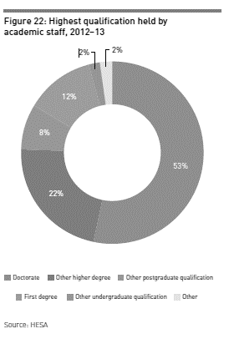
Figure 1: doctoral qualification in UK universities, acquired from http://www.universitiesuk.ac.uk/highereducation/Documents/2014/PatternsAndTrendsInUKHigherEducation2014.pdf

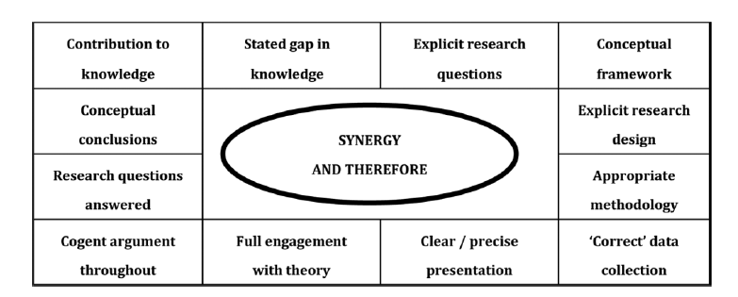
Figure 2: Trafford and Leshem’s doctoral components

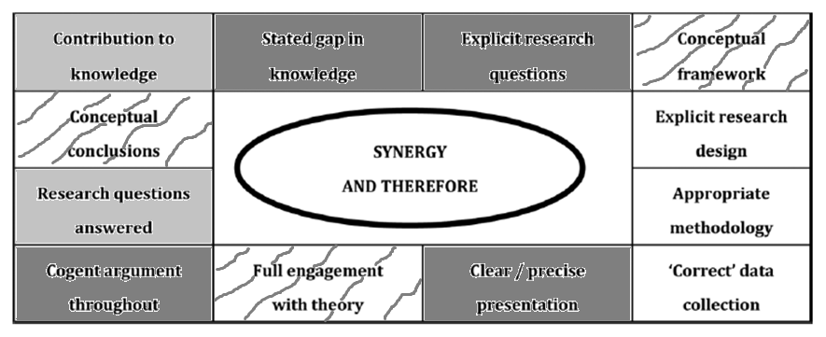
Figure 3: DLaw students’ initial views of the doctoral competencies

Figure 4: evolution of threshold concept theory drawn from Barradell (2013)

Experiential Space
Liminality, Reconstitution, Discourse
Moments of Innovation
Transformation, Integration
Attribute/ State
Troublesomeness, Irreversibility, Boundedness
Figure 5: new model of threshold concepts as experienced

Attainments |  | Understanding
curriculum based (literacy, numeracy, science) or measures of basic competence in the workplace. These tend to be outcomes with relatively precise and familiar meanings, often implying mastery of specific rules or mental procedures associated with particular tasks, and are frequently open to straightforward traditional means of assessment. |  | of ideas, concepts, processes. These imply more conceptual ways of thinking and the capability to make intelligent judgements about meanings. Rather than focusing on mastery of specific knowledge or procedures, understandings concern the development of abstract processes for reasoning and inference
Cognitive and creative | Using |  | Higher-order learning
imaginative construction of meaning, arts or performance. These focus on the capability to create or discover ‘new’ knowledge.. While other categories reflect the passing on to learners of extant knowledge, here there is direct concern with knowledge innovation by learners themselves | how to practise, manipulate, behave, engage in processes or systems. This implies the development of known practical and technological skills and being able to apply them in appropriate contexts |  | advanced thinking, reasoning, metacognition. These concepts of learning transcend other learning outcomes. They are invoked to place emphasis on more sophisticated overarching cognitive processes.. agreement about how they are to be assessed is even more difficult to achieve
Dispositions:  attitudes, perceptions, motivations. |  | Membership, inclusion, self-worth
reflect the affective conditions within learners that it is assumed will be necessary if they are to feel inclined to learn effectively in the context and community where the learning takes place. |  | reflect the learners’ affinity towards readiness, to participate in and sense of worthwhile contribution to the group where the learning takes place… establishing social and substantive identities
Figure 6: Varieties of nettle: types of learning outcome from James and Brown 2005

Attainments |  | Understanding
At entry: M level credits or equivalent;  Taught programme: proposal assignment ;  Research stage: annual progressions;  Pre-submission assessment: mock viva  Final assessment: viva result |  | Theoretical integration;  complex ethical reflexivity;  positionality in the field
Cognitive and creative | Using |  | Higher-order learning
Research design;  philosophical,  methodological,  analytical and/ or  communicative innovation | Research process,  data management,  design of research plan  and  execution of research plan |  | Engagement with literature, engagement with data, analysis,  reflexive process  and  critical synthesis
Dispositions:  attitudes, perceptions, motivations. |  | Membership, inclusion, self-worth
metacognitive and  self-regulatory awareness |  | personal and  professional research identity
Figure 7: Nettle and the DLaw

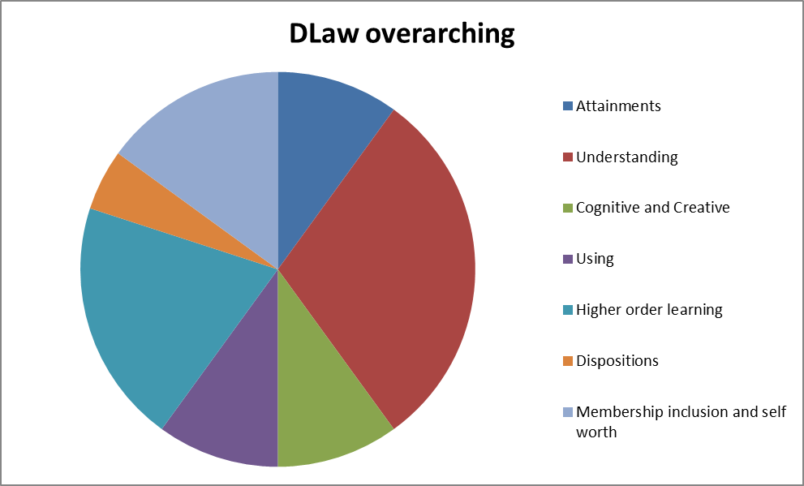
Figure 8: proportions of elements in the DLaw

Attainments |  | Understanding
proposal assignment mark representing:  literature review;  epistemology- methodology -research design;  ethics;  planning |  | Personal theory integration;  ethical sensitivity;  awareness of roles in the field
Cognitive and creative | Using |  | Higher-order learning
Evolution of the research design,  Investigation , identification and rejection of alternate models  Location of self and research design on epistemological map  Identification of the potential originality | Research plan created, strategies and fall-backs delineated |  | First cycle of engagement with literature and theory synthesised  First iteration of critical synthesis
Dispositions: |  | Membership, inclusion, self-worth
Ambition |  | Planning to become
Figure 9: The proposal nettle

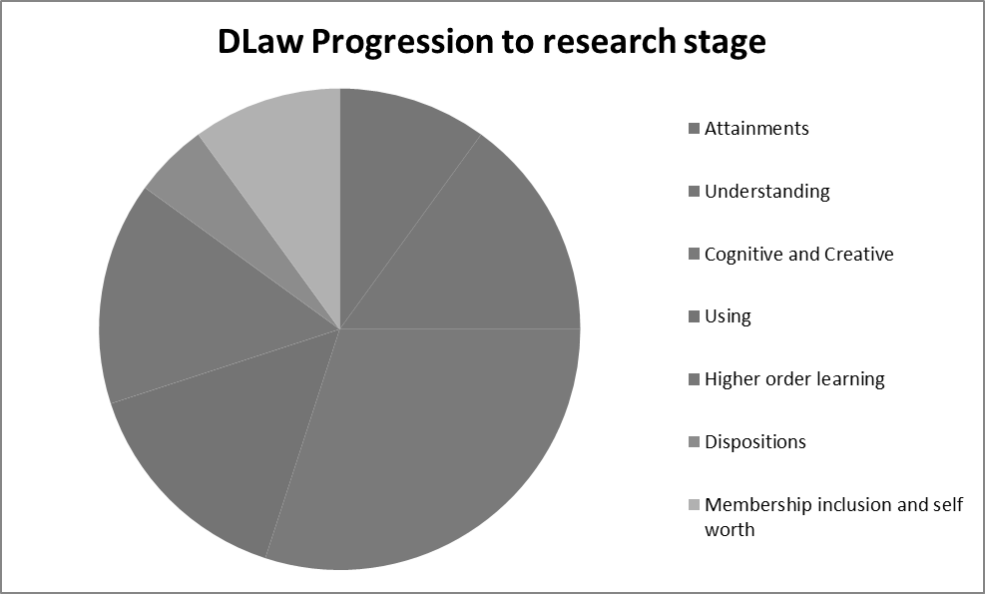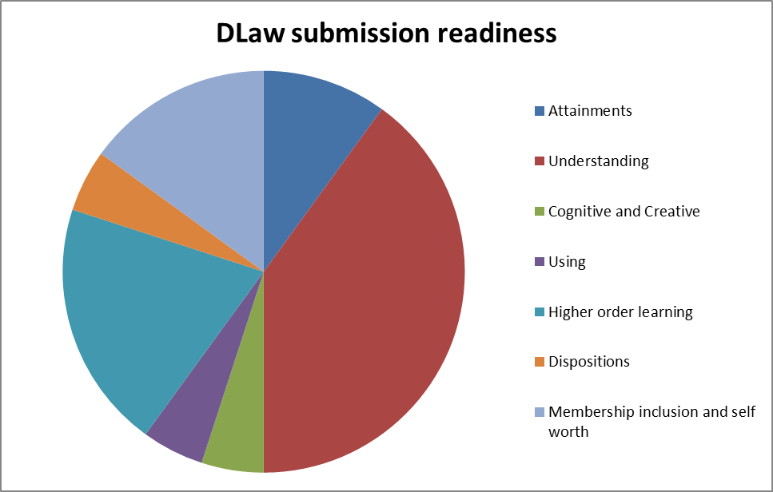
Figure 10: activities at different stages of the DLaw

Also often referred to as APL- accreditation of prior learning and/or APEL – accreditation of prior experience and learning.

