Transcending Ethnicity through Photography: Representing the Cham
Claire Sutherland
ABSTRACT
This article explores how photographs selected from an archive represent the Cham ethnic group. It argues that portrait photographs provide a useful analytical focus for critiquing ethnonational categories and their visual representations. Cham live across Southeast Asia, speak a Malayo-Polynesian language and exemplify the global and protracted nature of forced displacement. Little unites them beyond their self-identification as such, and their minority status in every country they call home. The article examines the extent to which selected photographs engage with and challenge dominant depictions of Cham ethnicity as a basis for considering an alternative approach to belonging that is not bound to the dichotomy of self and other. It concludes that the materiality of the sea holds greater potential to capture the emotional and atemporal elements of living as a migrant or an ethnic minority than analyses trapped within the linear and bounded spatiotemporal frames that create those conceptual categories.
Key words: Cham, photography, ethnicity, migration, minority, sea
Introduction
This article draws on critical International Relations (Ni Mhurchu 2014), critical political geography (Kuusisto-Arponen 2009) and critical ethnography (Stock 2016) to suggest an analytical approach to the Cham that goes beyond conventional ethnonational categories of majority and minority within a bounded, nation-state framework. It is not about the Cham ethnic group itself, but about how a photographic archive depicting self-identifying Cham might help us think beyond the very idea of a Cham ethnic group as a starting point for analysis. As such, it does not attempt to count how many Cham individuals live across Southeast Asia, as that would reproduce the very census categories the article seeks to critique (Anderson 1991). It does not discuss whether the Cham diaspora is politically mobilised, or compare and contrast different Cham minorities across nation-states, as this would also take an ethnonational framework as an analytical point of departure, rather than a subject of critical analysis in itself (see Nakamura 2019, Nakamura 2020). Nor does it claim that the images selected for discussion are in any way representative of a wider Cham community. On the contrary, following Emiko Stock (2016, 788); ‘let’s not. Because, if we did, we would be projecting into the modem a continuity that blurs past and present, in all their ruptures and interruptions.’
Rather, the interpretation offered in this article gestures towards a different reading of a Cham photographic archive, one that - perhaps paradoxically given its unifying label of Cham - does not seek to document or represent homogeneity in any way. Indeed, the archive can be seen as inviting the viewer to interrogate that label and its meaning in light of the diversity and individuality depicted in the photographs. The article considers whether an archive of photographs constituted by a white, male, Western gaze can ever contribute to subverting assumptions of commonality associated with ethnic belonging and a unifying ‘portrait of a people’, concluding that it can do so when individual portraits are read against the grain and bounded ethnonational categories are rejected as the overarching analytical framework. As Emiko Stock (2016, 786) notes; ‘Scholarship on Muslims in Cambodia often revolves around a series of cultural, religious and social contrasts between Champa and Cambodia, between Chams and Khmers. Yet such an approach depends in turn on an apprehension of ethnic boundaries as given, fixed, and permanent.’ The same can be said of the Cham in Vietnam (Author 2010, Nakamura and Author 2019) and of countless ethnographic studies across the world. Anthropology as a discipline has now been confronting and critiquing this approach for decades (Clifford 1997). Using a novel conceptualisation derived from water and its materiality, this article contributes to the ongoing social scientific debate by analysing a newly-amassed archive of non-anthropological, professional photography.
The article explores how photographs selected from an archive represent the Cham ethnic group. It argues that portrait photographs provide a useful analytical focus for critiquing ethnonational categories and their visual representations. The photographic archive in question presents something of a paradox in that it orders and presents images of self-identifying Cham within a research project that was partly conceived precisely to interrogate the validity of that very ethnic category. The body of work was created by the professional photographer James Sebright in 2017, during an ESRC/AHRC-funded research project entitled ‘Cham Centuries’ on Cham resident in Malaysia, Vietnam and the island of Hainan in the People’s Republic of China. As well as supporting academics’ anthropological research on the project, the photographs are a research object in their own right and will be considered as such in this article. In representing the photographer’s artistic vision, they reflect the sensibility of a white, British, male photographer born in 1970, and the language of othering that pervades the social sciences. Therefore, they offer a useful basis for critically analysing ethnonational categories and exploring alternative interpretive approaches that seek to transcend the stark dichotomy of ‘us’ and ‘them’.
Cham live across Southeast Asia, speak a Malayo-Polynesian language and exemplify the global and protracted nature of forced displacement. Between the 7th and 15th centuries, the Cham occupied coastal plains and mountain zones in today's central and southern Vietnam. They never formed a unified kingdom but rather a cultural and political space in what is today central and southern Vietnam, that was progressively conquered by the Dai-Viet empire to the north. The Cham ethnic minority has been inscribed into today’s nation-state order through notions of homogeneous, bounded space that replaced pre-modern, unbounded understandings of space and territory. One focus of the Cham Centuries research project was on translocal, transregional connections, as exemplified by seaborne travel and trade. This was intended to disrupt the methodological nationalism - understood as taking the nation for granted as an analytical starting point - that tends to frame ethnonational categories and their histories, both politically and in scholarly analysis. The retreat and final disintegration of the Cham ‘federation’ following decisive Vietnamese defeats in the fifteenth and early nineteenth centuries prompted some Cham to take refuge on Hainan island in the South China Sea. Others took waterborne flight to the Mekong Delta spanning eastern Cambodia and southern Vietnam. Therefore, no ‘ancestral homeland’ now exists in the form of a modern polity anchoring the Cham diaspora to a specific place. In the 1970s, Cham were among the many persecuted groups during Cambodia’s murderous Khmer Rouge regime; thousands fled as refugees to Malaysia and as far as the United States, France, Australia and Canada. Today, Cham are officially recognized as one of Vietnam’s and China’s minority ethnic groups, but remain economically and culturally marginalized compared to the dominant Kinh (ethnic Vietnamese) and Han Chinese. As Muslims, Cham refugees to Malaysia were more easily integrated.
Though many Cham are Muslim, they practise different strands of this faith, and some Cham in Vietnam follow a form of Hinduism. Indeed, little unites the Cham people beyond their self-identification as such, and their minority status in every country they call home. Even Cham communities living in southern central Vietnam and in the country’s Mekong Delta differ markedly in their lifestyles and religious beliefs. There is no one way to be Cham. This raises broader questions about the politics of belonging in a world of nation-states, what it means to be labelled as an ethnic minority in relation to a dominant national majority, and how taken for granted ethnic categories dangerously simplify people’s sense of self. This article explores three facets of Cham ethnic belonging. The first section situates photography within the research project and the broader context of visual ethnography. The second section examines the extent to which selected photographs engage with and challenge dominant depictions of Cham ethnicity in the context of the photographer’s subjectivity and artistic project. The final section draws out the theoretical implications of the case study to think about an alternative approach to belonging, one that is not bound to the dichotomy of self and other. Using the Shakespearian notion of a ‘sea-change’, it looks at ways of conceptualising ethnic belonging that pay more attention to emotion and self-identification. The article concludes that the materiality of the sea holds greater potential to capture the emotional and atemporal elements of living as a migrant or an ethnic minority than analyses trapped within the linear and bounded spatiotemporal frames that create the categories of migrant and minority in the first place.
Context
The title of the edited collection Photography, Anthropology and History (Morton & Edwards 2009) helpfully itemises key elements in studying visual representations of ethnicity. Photographs are snapshots that can be framed in terms of time, place, perspective and background, all of which combine to unique effect. Lighting and composition can lend photographs an ‘aura’ of the kind that Walter Benjamin first identified as a “peculiar weave of space and time” (2015 [1931], 83). Even more so than film, which also captures the sound and movement of a moment, the framing of a photograph entails selection and bias. Indeed, photographs’ standard, rectangular format already crops the original, circular image. Writing in the late 1970s, Rosalind Krauss (1978, 30) marvelled at ‘the immense impact of photography, the way it has shaped our sensibilities without our quite knowing it.’ In today’s image-saturated, digital world, as debates around the repercussions of retouching celebrities and representing race continue to rage, the sense of responsibility associated with labelling a collection of photographs as ‘Cham’ feels particularly acute. Graham Clarke (1992, 1-2) discusses the particular constraints of the portrait photograph, which ‘reflects the terms by which the culture itself confers status and meaning on the subject, while the subject as image hovers problematically between exterior and interior identities.’ This codification of the individual subject is heightened in a photographic collection that claims to represent the category of Cham in some way. To read a portrait as a cipher of an ethnic signifier or an ethnonational category clearly relates to politics, in particular the delimitation of ‘them’ from ‘us’.
The use of photography in political enquiry is perhaps less established than in other social sciences such as visual anthropology, though recent work discusses International Relations and film (Barabantseva and Lawrence 2015), comics (Hansen 2017), and images as ‘icons’ (Hansen 2015). Edward Hall (in Collier and Collier, 1986, xv) argues that visual images can help overcome projections of ‘the compartmentalized, segmented, linear world of Western thought onto non-Western peoples.’ By being self-reflective regarding the ‘grammar’ one uses to read an image and alive to its political power, it may be possible to subvert the ethnonational categorisations that have long characterised the social sciences (Morton and Edwards 2009). For example, the ‘Writing with Light’ initiative represented a collaboration between the journals Cultural Anthropology and Visual Anthropology Review, both published by the American Anthropology Association. To the anthropologists involved, it represented one means of ‘rethinking our intellectual endeavours’ (Campbell et al 2016, online). They asked whether images might create and represent knowledge differently to text and film because photographic analysis lends itself to highlighting how scholarship is always a work in progress, never definitive, closed and impervious to challenge, and dependent on constructive critique to move forward (Campbell et al 2016, online). This approach can also be applied to a political analysis of ethnographic images.
Lene Hansen (2015) has shown how iconic images are appropriated into political discourse, explicitly theorising ‘icons as inherently contested and always invoking national and international ‘wes’ [plural] which are fractured and thus not identical to a homogenous national citizenry or international community’ (Hansen 2015, 267). Although Hansen uses illustrative examples from international politics – specifically the image of the hooded torture victim taken at Abu Ghraib prison in Iraq in 2003 – her analysis has broader implications for ethnonational categorisation. As discussed elsewhere (Nakamura and Author, 2019), certain images and performances of Cham identity are frequently repeated across associated heritage sites in Vietnam, to the point of becoming a sort of essentialised ethnic marker of the Cham people as one of many picturesque minorities; ‘[T]hey are folklorized and aestheticized in museum exhibits, festivals, and cultural performances, made into contemplative figures that reflect back to the state its vision as a multicolored “flower garden” or “mosaic” of ethnic cultures’ (Taylor 2008, 16). This clichéd representation is reminiscent of some celebrations of multiculturalism in western Europe. For example, portrait galleries showing people of different ethnicities who identify as Catalan and Scottish have featured in Catalonia’s Museum of History and the National Museum of Scotland, respectively (Author 2014b).
In Southeast Asia, centuries of Cham displacement long preceded the establishment of the nation-state system, thereby putting their categorisation as ethnic minorities into historical context. Cham have long been displaced, but borders have also been created and moved across their bodies and communities. The category of ethnic minority is thus a relational one predicated on the current hegemony of the nation-state. As such, it serves to describe the current status of all Cham and gives some indication of their relative powerlessness within their home/‘host’ countries. Embarking on research into the Cham entails pulling that ethnic category apart, not into smaller, homogenous communities, but into a dynamic flow of human movement through time and space. This article argues that viewing the Cham through a photographic lens is helpful in achieving this abstract goal. Rather than evoke past political autonomy, for example, some self-identifying Cham in Vietnam do not refer to a Champa homeland in accounting for and recounting their origins, preferring instead to put their Muslim identity or narratives of multiple provenance to the fore (Taylor 2007). Philip Taylor (2007, 17) suggests that ‘[j]ust as we might best understand Cham localities as places in motion, we can also gain much by seeing their culture in process’. An analysis that privileges motion and process also helps to unpick assumptions surrounding a unified Cham culture, both within and between self-identifying Cham communities across Southeast Asia.
The ethnonym Cham comes from the kingdoms of Champa that were progressively conquered by Dai Viet, the Vietnamese Empire centred around present day Hanoi and the Red River Delta, from 1571 until the final defeat of the kingdom of Panduranga in 1832. The Cham thus experienced forced displacement over centuries, most recently during the Khmer Rouge rule in Cambodia (1975-79). If it can be termed a diaspora at all, the Cham diaspora today is one without an existing homeland, and any sense of ancestral connection to Champa is certainly not a foregone conclusion. Self-identifying Cham may or may not be tethered to ancestral myths of belonging, but they certainly no longer gravitate around or towards an existing home. And yet, their history of forced displacement suggests someone who is in the ‘wrong’ place against their will, with all the implicit scaffolding of the nation-state order underpinning that assumption. It is the same nation-state structure that prompted Nando Sigona (2003) to ask ‘How can a “nomad” be a “refugee”?’ The term refugee presupposes an underlying national order, whereas the term nomad need not. A refugee has a putative ‘homeland’ from which they are displaced, whereas a nomad’s mobility is not defined by nation-state borders. If we take the long view of displacement, how does ‘the homeland’ remain relevant, if at all, for subsequent generations?
The migration scholar Stephen Castles (2003, 27) has long called for a perspective whereby migrants would be ‘seen as moving, not between “container societies”, but rather within “transnational social space.”’ Yet not much has changed since the turn of the twenty-first century, neither in terms of the methodological nationalism that continues to be employed across the social sciences (Author 2016b), nor in the political narratives and policy-driven literature that deem migration to be a problem, thereby accepting ‘the problem definitions built into its terms of reference’ (Castles 2003, 26). Southeast Asia is an important crucible for challenging this prevailing view, not least because many of those who are today classified as ethnic minorities in post-colonial nation-states - including the Cham - were engaged in long-distance networks and mobilities well before those nation-states came into being (Taylor 1998, 20; Scott 2009). Religious, trading and historical/legendary links still connect Cham communities across both land and sea (Tran 2016), but historical memory surfaces in different ways and to different extents in self-identifying Cham (Taylor 2007, Taylor 2008, 20; Weber 2004; Weber 2008). For example, Philip Taylor’s work on the Cham of An Giang in the Mekong delta highlights their multilingualism and cosmopolitan outlook despite the relative isolation of their villages and communities within the region (Taylor 2007).
Following Julia Kristeva, Aoileann Ni Mhurchu (2014, 153) proposes ‘an alternative way of understanding human Being (sic) which is a production of displacement and dispersal rather than substance.’ This seeks to break the confines of a spatio-temporal understanding of ethnic or national identities as bounded, and time as progressing in a linear, chronological way. It thus transcends the dichotomy between insider/outsider and native/immigrant, drawing attention instead to the way in which ‘subjectivity is constructed by virtue of exile, separation and foreignness as that which is always already within the subject, as opposed to against it (its constitutive outside)’ (Ni Mhurchu 2014, 153). It is a truism that belonging is often defined as much against the constructed ‘Other’ as in terms of unifying characteristics. Adopting Ni Mhurchu’s approach would break down the category of Cham minority as constructed in opposition to ‘native’ Vietnamese or Malaysians, for example. Thus, Cham displacement would no longer be defined as an irregular part of a nation-state system that continues to revolve largely around an ideal of homogeneity, but could be considered from a different analytical plane altogether. Ni Mhurchu (2014, 165) points to the shifting ‘relationship between identity (people), place (territory) and history (narrative)’ in the case of so-called second generation migrants in Ireland. She asks why their identity should be defined in terms of parental origin and ancestry when they themselves may feel they belong neither to the ‘home’ or ‘host’ countries, or to both, or to something else. The same question can be levelled at the ethnic category of Cham. Why should past forced displacement define the Cham as eternal migrants or minorities in opposition to the dominant ethnic group, or even so-called ‘native citizens’ (Miller 2016, 8), which sets naturalised citizens apart in a hierarchy of belonging? In light of this question, the Cham Centuries research project raised a number of issues around how photographic representations of the Cham should be interpreted, which are discussed in the next section.
Case
Employing a professional photographer to work alongside Cham Centuries project researchers resulted in an archive of documentary photographs spanning all three country cases, which provided a glimpse - albeit still from an outsider’s perspective - of some aspects of self-identifying Cham people’s lives. It is important to note that, rather than being under a researcher’s direction, the photographer James Sebright pursued his own artistic vision. This resulted in two co-curated exhibitions, held in Durham and Kuala Lumpur, and also Sebright’s solo photographic exhibition entitled Homelands, which ran from 1st February – 16th September 2019 at Durham University’s Oriental Museum. The first two paragraphs of the artist’s statement for the solo exhibition are cited below:
Whilst creating the work, it was very important to me to understand how people lived, where they came from, what they were doing and why, rather than just recording the surface or veneer of an existence. With no formal training in anthropology, the process was one of questioning, observing, learning, with inevitably more questions than answers. I often arrived at the local mosque before prayer-time, hanging around, hopeful that there might be someone who spoke English to create an entry for me. “Muslim?” I was often asked. “No,” I would honestly reply. “I’m here to meet Cham people.” I was never turned away, but invariably was asked to sit, drink tea, engage in sign language, laugh, share in the jokes. Yes, of course you can take photos, no problem. They looked on with delight as I showed them photographs on my Instagram feed of other Cham communities in other countries. “Cham?” they asked, surprised, almost in disbelief. “Yes, Cham!” I replied. We quickly became friends. As an outsider, the warmth I experienced from these people is something that I will never forget. Yet looking back, perhaps this is not so strange, for they too are outsiders. We were more alike than I realised, travellers a long way from home.
Beyond telling the stories of some of the people that I encountered, central to these images is the broader theme of representation. In this work, I seek to challenge how ethnic minorities are portrayed photographically, often through a “western - and invariably male - gaze”. In the west we are familiar with a picture-postcard view of ethnic minorities, popularised by publications such as National Geographic. Whilst these images are not pure fabrications, they are inevitably just one facet of a broader, more interesting truth. As such, I was keen to photograph young people, students, entrepreneurs, professors, people wearing their ubiquitous Barcelona football shirts, people glued to their mobile phones, checking what’s happening on their social media feeds. In short, people like ‘me and you’, rather than some exotic ‘other’. For whilst all of the people in these images are united by their ethnicity, they are also united by something larger still […]
In the first paragraph, Sebright is explicit in constructing a rather romanticised affinity between himself and his Cham subjects as ‘outsiders’ and ‘travellers a long way from home’. The first gestures towards Cham as ethnic minorities in all four countries he visited (including Cambodia) and the second to their status as migrants from their putative ‘home’, namely the formerly Cham lands now in southern-central Vietnam. Sebright also intervenes to make connections with other Cham communities of which his interlocutors were clearly not aware, thereby introducing a notion of Cham community that was not actually present in their lives. In the second paragraph, Sebright is at pains to distance himself from essentialising, folkloric depictions of ethnic minorities. Even though his own gaze is Western and male, he critiques this and seeks to replace the ‘picture-postcard’ stereotype with a ‘broader, more interesting’ perspective that escapes a visual tradition deeply rooted in colonial, hierarchical and frequently racist tropes. Ultimately, however, Sebright does not question the Cham’s shared ethnicity, as is clear from the last sentence. This precedes his evocation of a universal humanity and thus continues to other them. ‘People like “me and you”’ are tacitly assumed to be like Sebright, namely white, Western and possibly male, so that ethnic categorisations continue to pervade and structure his narrative. Nonetheless, it is still possible to read Sebright’s images in a way that effectively critiques some of these underlying assumptions.
Lene Hansen (2015) draws attention to the emotional charge of an iconic photograph and its ability to point to something outside the immediate realm of what is depicted. That is, it has both symbolic value and the power to make a political statement. For example, even though young women in Cham costume are regularly depicted in official Vietnamese government discourse, typically in order to attract tourists, highlight the country’s ethnic diversity or celebrate it in terms of colourful folklore, the image in figure 1 adds further dimensions to this essentialising view. As Hansen (2015, 271) notes, ‘icons are significant precisely because they are articulated in relations [sic] to a community or identity, which is inherently unstable.’ This is clearly represented in figure 1, which zooms out from the archetypal image of the graceful young Cham woman, wearing traditional costume and dancing with a piece of typical Cham pottery on her head. She is framed by the surrounding tourists capturing the spectacle on their smartphones. The mats that have been laid out as a makeshift stage are visible, as are other members of the audience. The Cham temples themselves are literally and figuratively in the background, though they lend a veneer of authenticity to the proceedings. As such, this image has a critical, or even subversive, force in drawing attention to the fact that this dance performance really is purely for show. The subject’s eyes are lowered. This could be interpreted as a sign of modesty, but also as a refusal to meet the tourists’ gaze even as she courts it, in order to avoid becoming a cipher for the Cham ethnic minority as a whole.

Figure 1: Cham dance performance at Po Nagar, Nha Trang, April 2017

This simulacrum of ethnic Cham folklore, with its matching outfits and choreographed moves, contrasts strongly with other images taken on the same day depicting Cham women dancing as part of a private ritual honouring the temple gods. The scene shown in figure 2 took place directly behind the tourist performance and shared the same musicians. Wearing her own festive clothes in the Cham style, each woman expresses herself spontaneously to the music in her individual way (including a very energetic lady in white.) Tourists still surround the scene, but the Cham women certainly do not dance for them; their backs are turned to the spectators and they face the trays of offerings. As Philip Taylor (2008, 16-17) puts it; ‘When minority groups sing and dance, they dramatize the geopolitical imaginary of the multiethnic nation. Here, the nation-state looms even larger as the very condition for existence of minority ethnicities, providing the language, categories, and contexts in which their identity can be imagined.’ The critical reading of figures 1 and 2 work against this framing of ethnic identity in terms of the nation-state.

Figure 2: Cham ritual dance at Po Nagar, Nha Trang, April 2017

Figure 3 below is a portrait of Thuyet Minh Vien, a Cham guide at the Po Klong Garai temples near Phan Rang. This photograph represents a young Cham woman who wears traditional costume but is not essentialised as a timeless symbol of ‘her people’. The Cham temples in the background here are her place of work as much as a place of Cham ritual devotion. Her name badge signals her professional identity as a tour guide, albeit one who works for Vietnam’s Ministry of Culture and Information, and her microphone amplifies her voice as one who explains Cham culture - principally to ethnic Vietnamese tourists - and engages in dialogue with them about what it means (to her) to be Cham. This expression of agency differs markedly from a passive projection of ethnic cultural diversity principally designed to benefit foreign tourists and Vietnam’s international image. This reading is supported by a second portrait (Figure 4) taken in Thuyet Minh Vien’s home village of Van Lam, where she poses in a skirt suit on an unremarkable street, and projects an image of quiet confidence and professionalism. It is important to note that in this instance she chose this location, and was not directed by the photographer (Nakamura 2018, personal communication). The ordinariness of the setting contrasts with aestheticized depictions of ethnic minorities as colourful and exotic. The wide frame serves to focus on Thuyet Minh Vien as an individual, rather than as a representative of her ethnicity. Neither of these images would do as an essentialising image of a ‘typical’, timeless Cham woman, not least due to the contemporary professional paraphernalia (Taylor 2008, 14). This points to the inherent instability of any self-identifying Cham’s identity and the fact that it cannot be defined in opposition to Vietnameseness or any other binary of belonging.

Figure 3: Thuyet Minh Vien at Po Klong Garai, Phan Rang

Figure 4: Thuyet Minh Vien at Van Lam Village, Ninh Thuan

Taken as a whole, the Cham Centuries project’s portfolio of photographs can be seen as an invitation to interact with and explore different representations of identity that do not necessarily fit conventional ethnonational frames. Depicting a diverse range of self-identifying Cham against the backdrop of their daily lives rather than as a picturesque minority offers one alternative to essentialising, folkloric representations. It does not seek to be a corrective, however, in that it only reflects the eye of a single photographer, and a non-Cham one at that, in the course of fieldwork. At best, it can hope to provoke comment from self-identifying Cham, as to what they see and what it means to them, though attempts to encourage this within the ambit of the research project largely failed (Rahman 2019). Seeking to step outside the conventional framing of the Cham is not to deny the ethnonym’s ongoing importance and power (Ni Mhurchu 2014). Nevertheless, it does something to reclaim being Cham from its associations with minority, periphery and marginality, always in relation to and thus defined in the shadow of the nation-state as the dominant ‘Other’ and primary point of reference. It also gives due weight to the importance of aesthetics and symbols in creating and shaping different perspectives on the imagined community (Anderson 1991). The final section builds on this critical analysis of ethnonational categories to explore alternative approaches to belonging that are not premised on a rigid dichotomy between native self and migrant or minority other, but rather bring fluidity, change and emotional self-identification to the fore.

Conceptualisation

This section argues that the materiality of the sea can be used to transcend conventional ethnonational framings of the Cham as migrants and minorities, which inevitably relate them to the nation-state construct. Emily Merson cites Rebecca Belmore, the first indigenous artist to represent Canada at the Venice Biennale in 2005, as follows; ‘I want to be careful not to limit my identity or to be disingenuous about the complexity of those social or political structures that, for better or worse, have framed my experience. My work is really happening at the intersection of many identities. It is seeing how these sit together, often through my own body and the power relations that affect it’ (Belmore, cited in Merson 2017, 52). Belmore’s decision to title her work Fountain and project her video installation onto water was designed both to directly ‘engage with the performative power of water’ and point to how ‘a decolonial sensibility emphasises cultivating respect for the inherent power of water and understanding water as a foundational element of decolonising political relationships’ (Merson 2017, 61, 65). This suggests that the elemental force of water can be harnessed not only to ‘wet ontologies’ seeking to apprehend politics outside conventional understandings of space and time (Steinberg and Peters 2015, Author 2017, Peters and Steinberg 2019), but also as an environment of visceral action and emotion. For example, in describing the sensual world of white (Anglo), male, Australian surfers, Clifton Evers (2009, 894) not only evokes the elaborate coding of friendships as aggressively heterosexual and exclusive but also, more interestingly, ‘what surfing bodies could reveal.’
Evers’ description of the embodied sensation of a surfer’s body lost in a wipeout evokes a universe where man loses control, where gendered expectations have no purchase, where a body electrified by fear and exhilaration tumbles together with a tangle of seaweed, jellyfish and driftwood until the currents decide to let it reach the surface. As a surfer himself, Evers (2009, 903) describes the surfer’s body as ‘a way of thinking.’ The physical power of water is immediately present here. Through the medium of surfers’ relationship with water, Evers is making a similar argument to Aoileann Ni Mhurchu (2014) in relation to migrants who find themselves ‘in between’ dominant definitions of citizenship as belonging to neatly bounded nation-state containers; ‘Dominant discourses very often attempt to restrict or hide the openings and closings, transformations, adaptations, and the like. Even within what appear to be hegemonic representation or practice of masculinity such as surfing big waves, difference, uncertainty, confusion, ambiguity, and a sensual life also happen’ (Evers 2009, 903). While these ‘dominant discourses’ may remain the conventional frame of reference, both Evers and Ni Mhurchu argue that they do not capture the inherent ambiguity of identity and belonging that plays out ‘under the surface.’ My argument is that the materiality of water may be able to resist categorisations and at the same time capture the emotion, confusion and instability that characterise identity at least as much as fixed ethnonational frames, thereby encouraging a more nuanced understanding of belonging as a never-ending process of becoming.
Anna-Kaisa Kuusisto-Arponen (2009) has studied the emotional significance of forced displacement in the case of Karelia, which was ceded from Finland to the Soviet Union in 1944. Inhabitants of Karelia evacuated to Finland were expected to conform to ‘the national atmosphere which emphasised loyalty to the Finnish nation’ (Kuusisto-Arponen 2009, 547). She notes, however, the way in which ‘the ceded area was left behind physically, while being constantly mentally reconstructed and commemorated in several communal practices’ (Kuusisto-Arponen 2009, 547). That is, the evacuees’ identities and narratives of self did not fit neatly within the newly created confines of the Finnish nation-state. Kuusisto-Arponen also draws attention to the temporal dimension, whereby a re-enactment of the seventeen-kilometre trek decades later caused some of the original evacuees to recall the original experience with astonishing, cathartic immediacy. Again, this suggests that methodological nationalism is an insufficiently sophisticated lens through which to view the experience of migration as forced displacement. As Kuusisto-Arponen (2009, 550) puts it; ‘Mobility is moving across time and space. It is also movement in and through historical, cultural, social and political dimensions.’ Approaching belonging as a process of becoming rejects rigid ethnonational categories as a starting point for political analysis. Rather, it refocuses attention on the process of becoming itself, and the maintenance of an emotional sense of belonging (Author 2017).
As groups of self-identifying Cham have experienced forced displacement for close to a millennium, Nicolas Weber (2019, 80) argues ‘that exile is an intrinsic and indefectible part of the Cam [Cham] identity.’ Weber’s sources – six nineteenth-century Cham narratives of migration across southern Vietnam that were designed to be chanted or recited aloud to Cham audiences – highlight the emotional power of poetry and storytelling that remembered ancestors and recreated a sense of community through the performance itself, without once referring to Champa as a homeland (Weber 2019, 82). Instead, the narratives ‘offer an emotional link’ (Weber 2019, 80) to the past that is as much about nourishing memory and identity as constructing a historical record. As Weber (2019, 80) notes; ‘It is quite possible that the recitation or chanting of the poetic narratives created an atmosphere of solidarity and clearly served as a means to reinforce intra-community ties and bonds.’ This exemplifies a politics of belonging that is less concerned with ethnopolitical categories and claims, and more with how individuals’ sense of belonging is constituted and reconstituted in fluid and malleable ways.
Religious, trading and historical/legendary links continue to connect some self-identifying Cham communities across land and sea (Tran 2016). This evokes not only actual seaborne trade and exchange, and ways of life embodying fluidity and mobility, but also dynamic ways of thinking about identity that go beyond predetermined categories and ultimately serve to destabilise the very name Cham as a label and a unifying category. In turn, this subverts the organising and oppressive power of ethnonational categorisation, both in theory and practice. Inhabitants of the Champa kingdoms were famed for their skills in boat-building and seaborne trade, though it is important to note that entrepreneurial lowlanders prospered in a symbiotic relationship with resource-rich highland peoples further inland. Eaglewood, for example, once an important source of Champa’s wealth and still a highly lucrative business for some Cham today, comes from Vietnam’s central highlands. The sea also plays an important role in Cham legends. For example, one myth has the goddess Po Nagar, who can be taken to embody nature itself, floating across the sea in the shape of a piece of eaglewood (Hardy 2009, 118). Elsewhere, Ing-Britt Trankell (2003, 34) recounts a legend retold by Cham in Cambodia, in which a Champa king resists the Vietnamese at sea in a boat made from a sacred tree, which bleeds when cut. The sea thus has particular resonance in both Champa history and, by extension, legend. Trade, military expeditions and royal marriages took place between Champa, Malaysia and more widely across the South China Sea. Cham were famed as seamen and recruited to the Thai navy, for instance (Weber 2004). Vietnamese conquest therefore deliberately cut off inhabitants of the last Champa kingdom of Panduranga from the sea, leading to the gradual loss of maritime knowledge, though some Cham in central Vietnam continue to tend old graves on the beach (Weber 2004, 2008). This knowledge had been essential to Cham trading activity and thus to their livelihoods, but they were set to work building boats for the Vietnamese Nguyen dynasty instead. Nevertheless, as the account of the deity Po Nagar returning by sea on a piece of eaglewood suggests, the symbolic significance of the sea has not been lost. Cham also continue to maintain religious, trade and cultural links across the South China Sea and beyond. This historical memory surfaces in different ways and to different extents in the islands’ inhabitants today.
The conquest of Champa and the forced displacement of its people is yet another chronological narrative centred on (loss of) sovereignty and its consequences for successive generations’ sense of belonging. However, as Philip Taylor (2007) notes, the process of building identity and belonging does not necessarily foreground ancestral origins and historical facts. Rather, as Kuusisto-Arponen (2009) points out, narratives of origin can be as much about the identifying features that make sense of the world in the present, that are politically safe to maintain in the face of dominant narratives, and that help to organise contemporary social life. Similarly, Weber (2019, 81) suggests that nineteenth-century ‘Cam [Cham] narrative poems reveal less about events than their meanings.’ Today, the danger and undesirability of asserting descent from ancient Champa for Cham settled in Cambodia and Vietnam may be what leads some to trace their origins to Islam ‘as an alternative identity that allowed them greater autonomy’ (Taylor 2007, 6). Clearly, this autonomy relates to the state, and its power to shape eligible identities.
Rejecting imposed categorisations is empowering, as is retrieving untold stories. Narratives of origin will shift and change across and within generations as part of each individual’s process of ‘transferring history into their own maps of life’ (Livonen, cited in Kuusisto-Arponen 2009, 554). Aspects of memory live on, adapted and selectively adopted. These may be inherited and thus indirectly experienced, yet by virtue of contributing to an existing ‘map of life’ they are not necessarily in the past. Both Ni Mhurchu (2014) and Kuusisto-Arponen (2009) step outside the spatiotemporal constraints of chronological time and two-dimensional cartography that maps lives into bounded territorial units. Elsewhere I have also sought to capture spatiotemporal alternatives to Westphalian sovereignty in terms of spiritual and spectral presences in the present (Author 2014a, 2016a) and social practices derived from mobility and ever-changing relationships (Author 2017, 93-6). The Cham ethnonym in itself reveals little about how self-identifying Cham themselves understand that category, how it might change across time and place, and how it might even serve to telescope time in non-linear, non-chronological ways. Photographs help us step outside conventional temporalities that assume ethnic origins and ancestral roots to be markers of ‘authentic’ belonging, in order to explore just some of the manifold ways of being Cham.
In his call to focus on asymmetry and fluidity in global flows rather than bounded identities, John Kelly (1998) used the Shakespearian notion of ‘sea change’. This has been heeded by many scholars since, and yet the methodological nationalism that takes national belonging as the norm and views migration as a departure from that norm remains dominant, both in theory and in practice. Indeed, the idea of sea-change can be understood as an invitation to view the individual as more than simply a member of a given community. Shakespeare’s lines in the Tempest Act 1 Scene II are as follows; ‘Full fathom five thy father lies/ Of his bones are coral made/ Those are pearls that were his eyes/ Nothing of him that doth fade/ But doth suffer a sea-change/ Into something rich and strange’ (cited in Kelly 1998, 853). Shakespeare conjures how a body immersed in a new context, in this case water, has taken on a new form. Likewise, if we think of the sea as a ‘space that can be harnessed and occupied in any direction’ (Steinberg and Peters 2015, 253), then the individual forms within it need not conform to imposed ethnonational categories or to spatiotemporal conventions. Following Latour, Kelly evokes ‘a world in which all similarity and difference is made, negotiated, renegotiable, a world both multiply ordered and orderable, and inexhaustibly chaotic as well’ (Kelly 1998, 853). As Evers (2009) notes, the sea is a place where social constructs fall away. Therefore, a sea-change evokes an alternative, all-encompassing space to that of politically ordered territories, in which it is possible to imagine other ways of being, belonging and moving in any direction, not only within and across borders or along linear time.
Conclusion
This article has critiqued standard ethnonational and spatiotemporal categorisations of migrants and national minorities as essentially outside the nation-state norm. Using photographs from a research project on the Cham, it has discussed some of the practical implications of stepping outside this frame. Various interpretations of the Cham experience may diverge from historical evidence and even from historical time. That does not render them less worthy of investigation and analysis. Embarking on research into the Cham entails pulling that very category apart, not into even smaller, supposedly homogenous communities, but into a dynamic flow of human movement through time and space. A sense of belonging may or may not be rooted in historical lineage and the distant past, and need not follow a standardised, ethnonational script. Yet it is particularly challenging for ‘national minorities’ to step outside that very category, since it is so deeply embedded in spatiotemporal norms. Philip Taylor (2008, 4) notes how in Vietnam, ‘the delineation of national borders, the census, and the ethnological survey have constituted “national minorities,” who are assigned a name, place, and rank within the modern nation, written into national history, and reformed in line with national mores.’
The Cham Centuries research project was built on the notion of shared Cham ethnicity, only to challenge its underlying assumption of unity and the power dynamics inherent in designating Cham as migrants and/or members of a minority. By bearing witness to different ways of being Cham, the photographic archive amassed for the Cham Centuries research project seeks to trouble the ethnic labels, which presuppose one or more nation-state containers into which the Cham fit as an identified minority. James Sebright’s photographs also view the Cham through an external (camera) lens, but can be used to question that category. The photographs capture individuals from all walks of life being themselves in their ‘home’ environments. What unites them, if anything, is their self-identification as Cham. This in itself is a radically different starting point from the imposed category of ‘national minority,’ with all its connotations of (lack of) conformity to a national norm. Such an approach also resists essentialising and folkloric depictions of ethnic minorities as colourful and timeless, whereby ‘the daily is, in its normality, its banality, not central to the definition of "Chamness", to the meaning of "Cham culture"’ (Stock 2016, 796). By contrast, the photographs pay close attention to the everyday and can be read as subverting ritualised performances of ethnic identity as ‘authentic’, focusing instead on self-identifying individuals’ experience of what it means to be Cham.

Acknowledgements
Thanks to James Sebright for permission to reproduce his photographs.
Funding
This work was supported by the Arts and Humanities Research Council and the Economic and Social Research Council, grant number ES/P004644/1.

References
Anderson, B. (1991) Imagined Communities, London; Verso
Barabantseva, E. and Lawrence, A. (2015) ‘Encountering vulnerabilities through “filmmaking for fieldwork”’, Millennium, 43(3): 911–30

Benjamin, W. (2015 [1931]) On Photography, Reaktion: London

Campbell, C., Choi, V., Shankar, A. and Westmoreland, M. (2016) ‘Writing with Light: Photo-essays’, www.culanth.org/photo_essays, accessed 12th July 2017

Castles, S. (2003) ‘Towards a Sociology of Forced Migration and Social Transformation’ in Sociology 37(1), 13-34

Clarke, G. (1992) The Portrait in Photography, Reaktion: London

Clifford, J. (1997) Routes: Travel and translation in the late twentieth century, Cambridge, MA, and London: Harvard University Press

Evers, C. (2009) ‘The Point’: surfing, geography and a sensual life of men and masculinity on the Gold Coast, Australia, Social & Cultural Geography, 10:8, 893-908

Hall, E. (1986) ‘Foreword’ in Collier, J. & Collier, M. Visual Anthropology: Photography as a Research Method, University of New Mexico Press; Albuquerque

Hansen L. (2015) ‘How images make world politics: International icons and the case of Abu Ghraib’ Review of International Studies, 41, 263–288

Hansen, L. (2017) ‘Reading comics for the field of International Relations: Theory, method and the Bosnian War in European Journal of International Relations 23(3), 581–608

Hardy, A. (2009) ‘Eaglewood and the Economic History of Champa and Central Vietnam’ in Hardy, A., Cucarzi, M. & Zolese, P. (eds.) Champa and the Archaeology of My Son (Vietnam), National University of Singapore Press, Singapore
Kelly, J. (1998) ‘Time and the Global: Against the Homogeneous, Empty Communities in Contemporary Social Theory’ in Development and Change 29, 839-71

Krauss, R. (1978) ‘Tracing Nadar’ in Photography 5, 29-47

Kuusisto-Arponen, A-K. (2009) The mobilities of forced displacement: commemorating Karelian evacuation in Finland, Social & Cultural Geography, 10:5, 545-563,

Merson, E. (2017) ‘International Art World and Transnational Artwork: Creative Presence in Rebecca Belmore’s Fountain at the Venice Biennale’ in Millennium: Journal of International Studies, 46(1), 41–65

Miller, David (2016) Strangers in our midst, Harvard University Press, Cambridge, MA

Morton, C. & Edwards, E. (2009) Photography, Anthropology and History, Ashgate; Farnham

Nakamura, R. (2019) ‘Becoming Malay: The Politics of the Cham Migration to Malaysia,’ Studies in Ethnicity and Nationalism, 19 (3): pages to follow

Nakamura, R. (2020) A Journey of Ethnicity: In Search of the Cham of Vietnam, Cambridge Scholars Press; Cambridge

Nakamura, R. and Sutherland, C. (2019) ‘Shifting the Nationalist Narrative? Representing Cham and Champa in Vietnam’s Museums and Heritage Sites’ in Museum and Society 17(1), 66-79

Ni Mhurchu, A. (2014) Ambiguous Citizenship in an Age of Global Migration, Edinburgh; Edinburgh University Press

Peters, K & Steinberg, P. (2019) ‘The Ocean in Excess: Towards a more-than-wet ontology,’ Dialogues in Human Geography 9(3), 293–307

Rahman, M. R. (2019) Cham Centuries Website Engagement Report

Scott, J. (2009) The art of not being governed, New Haven, CT, and London: Yale University Press

Steinberg, P. and Peters, K. (2015) ‘Wet ontologies, fluid spaces: giving depth to volume through oceanic thinking’, Environment and Planning D, 33(2): 247–64

Sigona, N. (2003) ‘How can a ‘nomad’ be a ‘refugee’?’ Sociology 37(1): 69–79

Stock, E. (2016) ‘Two Rituals, a Bit of Dualism and Possibly Some Inseparability: “And so that's how we say that Chams and Khmers are one and the same”’ Sojourn: Journal of Social Issues in Southeast Asia, 31 (3), 786-825

Sutherland, C. (2014a) ‘Vietnamese Diasporic Citizenship’ in Isin, E. & Nyers, P. (eds.) Routledge Handbook of Global Citizenship Studies. Routledge. pp. 522-531.

Sutherland, C. (2014b) ‘Leaving and Longing: Migration Museums as Nation-Building Sites’ in Museum and Society 12(2): 118-131

Sutherland, C. (2016a) ‘Inviting Essential Outsiders in: Imagining a Cosmopolitan Nation’ in European Review of History 23(5-6): 880-896.

Sutherland, C. (2016b) ‘A post-modern Mandala? Moving beyond methodological nationalism,’ HumaNetten, 37: online.

Sutherland, C. (2017) Reimagining the Nation; Togetherness, belonging and mobility, Bristol, Policy

Taylor, K. (1998) ‘Surface orientations in Vietnam: beyond histories of nation and region’ in Journal of Asian Studies, 57(4): 949–78

Taylor, P. (2007) Cham Muslims of the Mekong Delta, Singapore: National University of Singapore Press

Taylor, P. (2008) ‘Minorities at Large: New Approaches to Minority Ethnicity in Vietnam’ in Journal of Vietnamese Studies 3 (3), 3-43

Tran. A.N. (2016). 'Weaving Across Borders: The Cham Muslim Migrants Traversing Vietnam and Malaysia'. In K.F. Lian et.al (eds.) International Migration in Southeast Asia, Asia in Transition. Singapore: Springer

Trankell, I-B. (2003) ‘Songs of our Spirits: Possession and Historical Imagination among the Cham in Cambodia’, Asian Ethnicity, 4 (1), 31-46
Weber, N. (2004) ‘The Cham Diaspora in Southeast Asia: Patterns of Historical, Political, Social and Economic Development’ in Engelbert, T. (ed.) Vietnam’s Ethnic and Religious Minorities: A Historical Perspective, Frankfurt am Main; Peter Lang
Weber, N. (2008) ‘The Vietnamese Annexation of Panduranga (Champa) and the End of a Maritime Kingdom’ in Wong Tze Kenn, D. (ed.) Memory and Knowledge of the Sea in Southeast Asia, Kuala Lumpur; University of Malaya
Weber, N. (2019) ‘“Moving in an Endless Single Line”: Memory, Exile and History in Cam Diaspora’s Narrative Poems’, Sojourn: Journal of Social Issues in Southeast Asia, 34 (1), 76-109

Figure 1
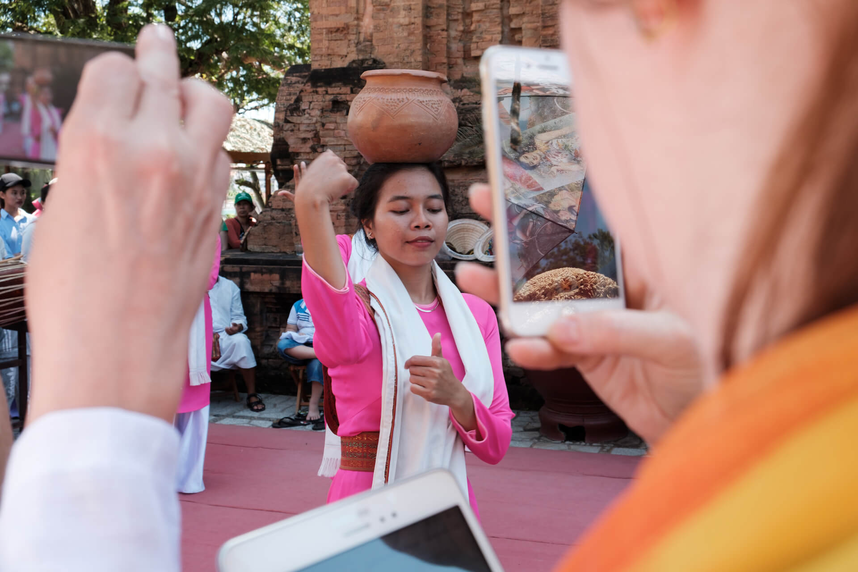

Figure 2
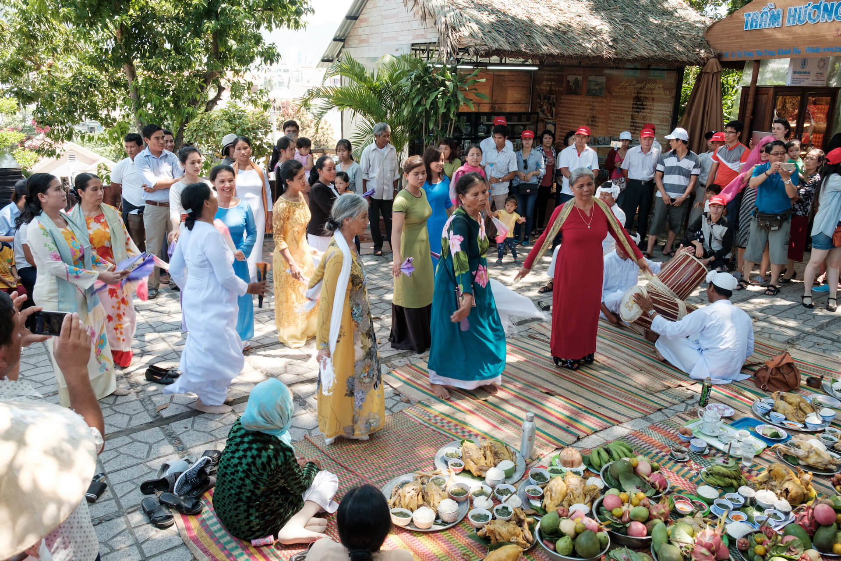

Figure 3
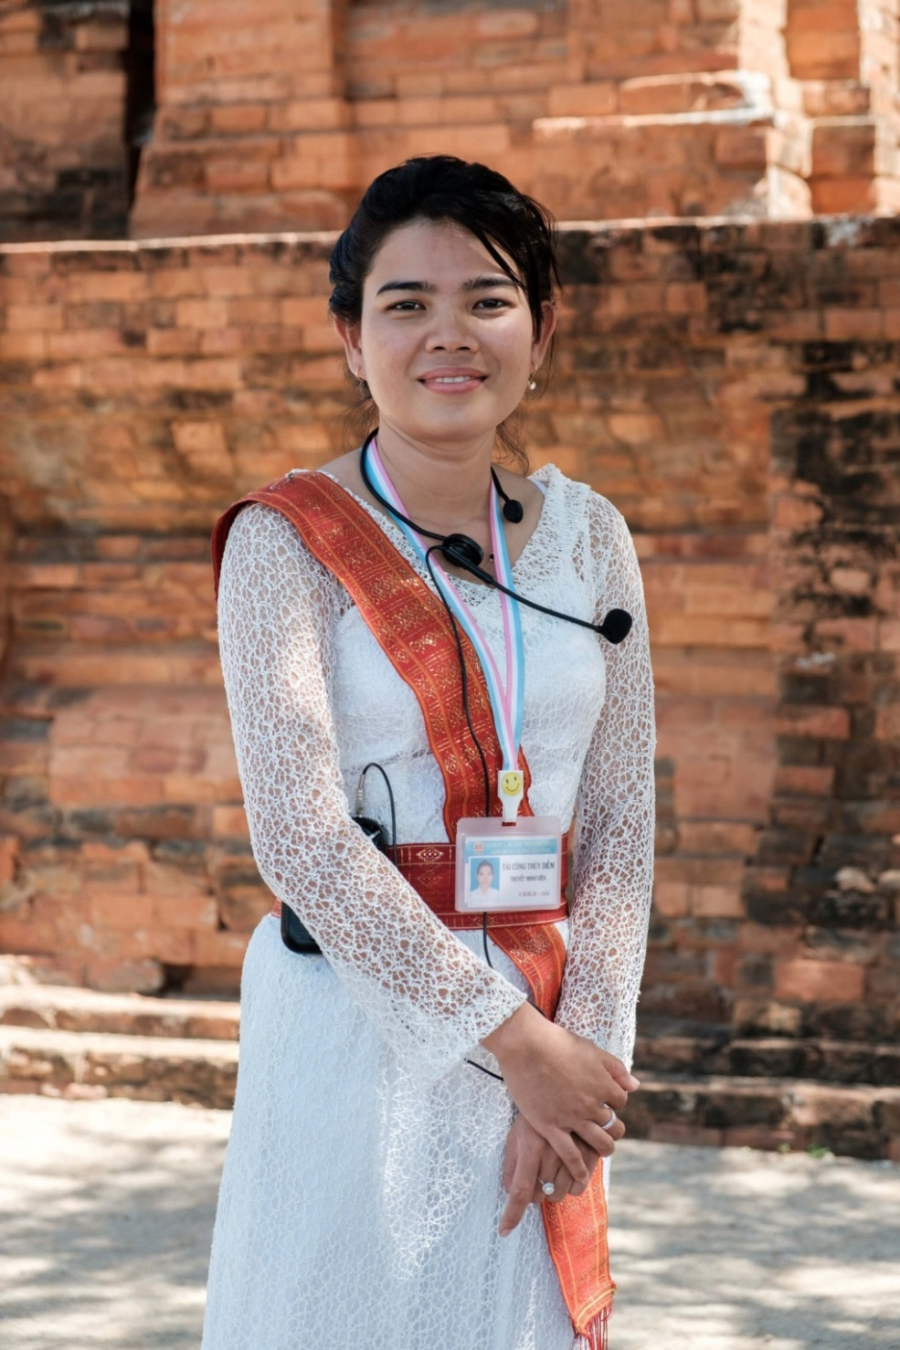

Figure 4
