A Spatiotemporal Indirect Evaporative Cooler Enabled by Transiently Interceding Water Mist

Muhammad Wakil Shahzad^{1*}, Jie Lin², Ben Bin Xu¹, Laurent Dala¹, Qian Chen³, Muhammad Burhan³, Muhammad Sultan⁴ William Worek⁵ and Kim Choon Ng³
¹Department of Mechanical and Construction Engineering, Northumbria University,
Newcastle Upon Tyne NE1 8ST, United Kingdom.
²Department of Engineering Science, University of Oxford, Oxford OX1 3PJ, United Kingdom
³Water Desalination and Reuse Centre, King Abdullah University of Science & Technology, 23955-6900 Thuwal, Kingdom of Saudi Arabia.
⁴Department of Agricultural Engineering, Bahauddin Zakariya University, Bosan Road, Multan 60800, Pakistan.
⁵Department of Mechanical and Industrial Engineering, Texas A&M University,
Kingsville TX 78363, USA

*Muhammad.w.shahzad@northumbria.ac.uk

Abstract
The building sector consumes around half of the global energy produced and air-conditioning processes guzzle over 55% of building sector energy. The conventional refrigerant-based chillers, covering over 90% of the current cooling market, are not only energy-intensive but also have high ozone depletion and global warming potentials. Indirect evaporative coolers were introduced but they were difficult to commercialize due to their practical lower achievable temperature limits. All existing indirect evaporative coolers use hydrophilic interface to provide wet surfaces for evaporative potential. These hydrophilic surfaces not only increase heat transfer resistance but also provide excellent conditions, wet and damp surface, for mold formation. The treatment of mold is almost impossible as the height of the channel is only 3-5mm and the fungus can be dangerous to health. Therefore, we proposed an innovative indirect evaporative cooling cycle in which there are no hydrophilic surfaces inside the system. The humidification of the working air is carried out before it is introduced into the wet channel. Also, the interface between dry and wet channel is only a thin aluminium foil that boosts heat transfer from supply air to working air in the transverse direction. A generic cell of 1800mm long and 280mm wide can produce 182.5watt cooling capacity. The measured coefficient of performance and effectiveness are 45 and 80% respectively for sensible cooling. This basic information of the proposed innovative indirect evaporative cooling system can be used to design a commercial unit as the total capacity is based on number of generic cells.
Keywords: air-conditioning, chillers, evaporative cooler, coefficient of performance.

Introduction
In the developed countries, the building sector could consume 40-50% of the primary energy supply, of which over 55% is attributed to Heating, Ventilation, and Air Conditioning systems [1]. In hot regions of the world, e.g., Gulf, Southeast Asia and North American, the air-conditioning (AC) system is considered as a mandatory to provide comfortable living household conditions. On the other hand, in countries with moderate climates, such as the UK and Denmark, the AC is less demanded [2]. The overall electricity consumption by the ACs is expected to grow up to 3 folds by 2050, which makes the building sector to be the second-largest electricity consumer after the industrial sector [3-6].
In the past decades, mechanical vapor compression (MVC) chillers have been the most favourable AC systems for residential and commercial purposes. Driven by the chemical refrigeration cycle, MVC chillers can achieve good efficiencies and stability, covering 95% of the current cooling market. However, with billions of units of MVC chillers being deployed, the chemical refrigerant released from them has been recognized as a major cause of the greenhouse effect and ozone depletion. Apart from the energy and environmental concerns, other disadvantages like high maintenance cost, noise, and safety issues, also discouraged the use of MVC chillers. Under these circumstances, the Montreal protocol was established to develop a framework for the mitigation of ozone-depleting substances employed in the cooling industry, particularly CFCs and HCFCs [7]. Thus, alternative low ozone depletion potential (ODP) refrigerants such as Hydrofluorocarbon (HFC) fluids and their mixtures have been widely used during the last decade. Unfortunately, the low ODP feature of these refrigerants comes at a cost of high global warming potential (GWP), which yet have a significant impact on climate change [7-10]. Also, the energy efficiency of the conventional chiller has been levelled at 0.85±0.02 kW/Rton in the last 30 years that influence the energy requirement with a capacity boost. Therefore, scientists and engineers are motivated to investigate alternate potential cooling technologies that will help to reduce energy consumption and environmental impact to meet the goal of future sustainable cooling.

The indirect evaporative cooler (IEC) is deemed as a game-changer to achieve low-carbon green air conditioning [11]. It allows the air to be substantially cooled merely by a water evaporation process at a constant humidity while eliminating the essential need for compressors and chemical refrigerants [12]. This enables the decoupling of air’s latent and sensible heat loads, where the latent heat can be handled by heat-driven or membrane-based technologies [13]. Additionally, the less capital and operational cost of IEC, as well as reliability in safety, makes itself a favorable approach in practical applications. These merits of IEC have attracted a lot of attention in recent years, yielding great progress in research and development.

The current advances in IEC steps on the base of a milestone initiated by the Maisotsenko cycle (M-cycle) [14], which proposes the pre-cooling of working air (WA) before it is directed to cool the supply air (SA). By doing so, the thermodynamic limit of the conventional IEC can be extended from the air’s wet bulb (WB) temperature to the dew point (DP) temperature, known as dew point evaporative cooling. Following this, a cross-flow M-cycle cooler has been proposed and commercialized by Coolerado, and its cooling performance has been investigated by Elbering [15] and Zube et al. [16]. Jradi et al. [17] also developed a cross-flow dew point evaporative cooling system, and it could achieve 1054–1247 Watt cooling capacity and 5.9–14.2 COP. Upon these experimental studies, Anisimov et al. [18] proposed a modified ε-NTU method to simulate the heat and mass transfer process in the M-cycle cooler. The cooling effectiveness and energy efficiency of different flow patterns were examined [19].
Later on, it was found that the cross-flow cooler had an uneven temperature distribution in different dry air channels, and its heat and mass transfer rate was limited [20]. In contrast, the counter-flow regime was demonstrated to have better cooling effectiveness, at the sacrifice of a slightly larger pressure drop [21]. Subsequently, Bruno [22] examined the feasibility of counter-flow dew-point cooler in residential and commercial buildings. It was observed that the ambient air temperature, varying from 27.5 to 40.4 °C, could be cooled well below 20.0 °C, with a minimum record of 10.2 °C. Cui et al. [23] proposed a counter-flow closed-loop dew point evaporative cooler, where a separate dry channel was designed for the WA. To ensure the WB effectiveness of above 1.0, the acceptable ranges of the design parameters, i.e., SA velocity, channel length, channel height and product to WA ratio, were determined. Xu et al. [24] investigated a dew point air cooler with guideless corrugated air channels. They reported a super performance of the cooler with 1.14 WB effectiveness and 52.5 COP under the Australian test standard. Furthermore, Lin et al. [25, 26] studied a few fundamental phenomena in the counter-flow dew point evaporative cooler, including the transient response of temperature and conjugated heat and mass transfer rate. It was revealed that the Nusselt number and Sherwood number in the water evaporation process were larger than their conventional analytical values. Oh et al. [27] compared the performance of counter-flow IECs with single- and four-purge configurations of the WA. They proved that the single-purge counter-flow cooler was the best choice, based on its effectiveness and simplicity. Pandelidis et. al [28] studied the counter flow IEC as a heat recovery in conventional air-conditioning systems. They found that limitation of outdoor air temperature 32ºC. Pandelidis et. al [29] also compared classical cross-flow Maisotsenko cycle with combination of cross and counter-flow and parallel and counter-flow schemes and concluded that proposed systems are more efficient than M-cycle but it might face operational challenges at higher temperature and sever weather conditions. Similarly, Wang et. al [30], Akhlaghi et. al. [31] and Liu et. al. [32], conducted theoretical investigation on different configurations of dew point cooler but without experimental validation of proposed model.
In summary, a variety of IECs have been proposed, fabricated and tested in the literature, covering a wide range of geometries, flow patterns, and design parameters. The key feature, which these coolers have in common but distinguish from a normal heat exchanger, lies in the wet channels that have to be covered by water on the surfaces [33]. This requires a special design of the heat and mass exchanger, in order to form a thin uniform water layer. However, fabrication of such a cooler had never been easy and it took a few decades for the researchers to finally figure out a workable design [34]. In existing prototypes and commercial products, a layer of hydrophilic/wick material is pasted on the wet channel surface wettability to absorb and retain water. A water supply system is established to distribute water into each channel [35, 36]. Various kinds of material such as fiber, cellulose, metal foam, and ceramic, have been tried as the wick, while the channel wall is normally made of metal foil or polymer sheet [37]. Although earlier attempts have dramatically improved the surface wettability of the channel, promoting the formation of an evenly-distributed water film for evaporative cooling, several problems still occur and remain to be addressed: (1) manufacturing cost. Adding a wicking layer to the wet channel requires a complex fabrication process where the bonding between the wick and channel wall has to be specifically cared to resist water. Also, the wet channels need to be fully sealed to prevent any water leakage. These steps have led to greater difficulty and larger cost, compared to a traditional heat exchanger; (2) maintenance issue. The impurity of water and air may leave sediment and result in fouling effect on the porous wick material. On the other hand, an efficient approach to cleaning the wet surfaces or replacing the wick material is currently unavailable; (3) flow resistance. Ideally, the thickness of the water film depends on that of the wick material. Nonetheless, it is often the case that the wet channel is overflooded and excessive water exists in the wet channels. This occurrence will bring about a larger pressure drop for the bulk airflow to overcome; (4) thermal resistance. The wick material and its water content create additional thermal resistance between the SA and the WA. As the wick material degrades due to fouling, the heat and mass transfer performance of the cooler further deteriorates. All these challenges have become the stumbling blocks to the large-scale production and application of IECs, which are left to be tackled before further commercialization.

Therefore, to bridge the aforementioned gaps and to give insights into long-term durable products, this paper aims to propose a novel robust IEC with simplified channel design. The wick material is removed from the wet channels, making the cooler not different from a conventional heat exchanger. Instead, a humidifier is installed outside the heat and mass exchanger where a direct water spray is introduced to pre-cool the WA before entering the wet channels. Due to the bulk air flow, small water droplets are carried into the channels and gradually wet the surfaces. Pertaining to this idea, a generic lab-scale prototype has been engineered and tested under different operating conditions. The inlet and outlet air conditions of the dry and wet channels are measured to analyze the cooler’s performance. Concurrently, a simplified 2-D computational fluid dynamics (CFD) model is developed to simulate the cooling process of the proposed cooler design. The outlet air temperatures predicted by the model are judiciously validated with the acquired experimental data.

Concept of IEC Cooling
The conventional IEC is mainly suitable for hot and dry climates, as the outdoor air (OA) whose humidity is below 10g/kg throughout the year, has large evaporative potential. In conventional IECs, the supply and WA streams are independent in the dry and wet channels, as shown by a schematic diagram in Figure 1(a). The corresponding cooling process is plotted on a psychrometric chart in Figure 1(b). The SA (state points 1-2) is cooled following a constant humidity line, while the WA (state points 3-4) undergoes temperature, humidity, and enthalpy increments. Known as wet bulb IEC (WB-IEC), the lowest achievable temperature in this type of cooler is the wet-bulb temperature of the WA, which has become the bottleneck for large applications [38-47].
(a)
2
2
3
1
1
4
Dry channel
Dry channel
Wet channel

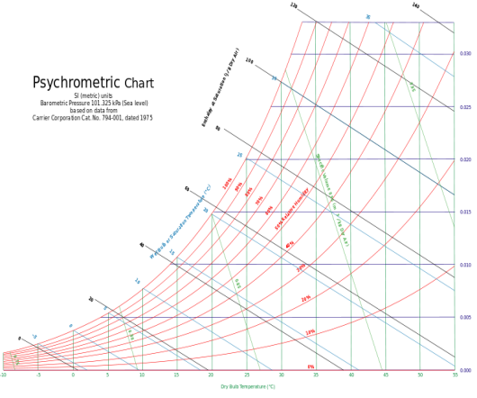
2
1
4
3
(b)

Figure 1. Wet bulb indirect evaporative cooler (WB-IEC) schematic and process on psychometric chart.

An improved IEC proposed by Valeriy Maisotsenko can cool the SA towards the dew point temperature of the inlet air, named as M-cycle (M-IEC) [48]. Unlike WB-IECs, there are two types of dry channels in the M-cycle cooler. One dry channel is dedicated to direct the SA and the other dry channel is designed to pre-cool the WA. The latter has many perforations along the channel length so that the WA can be gradually diverted into the wet channel. The schematic diagram and cooling process of M-cycle are shown in Figure 2(a, b) [49-57]. The SA (state points 1-2) follows a constant humidity line and approaches the inlet dew point temperature at the end. The second dry channel, having the same outdoor air at the inlet, purges the air to the wet channel section by section. The process 1-3 goes through a similar thermodynamic process as the SA, where the state a-e are in between. Starting from point 3, the moisture content of the WA accumulates until it leaves the channel at point 4. Although M-IEC can achieve sub-wet bulb cooling, earlier efforts to commercialize this complex geometry have failed due to its wetting difficulty and excessive pressure drop. Instead, a cross-flow M-IEC was successfully launched [58].

2
3
1
1
4
Wet channel
Dry channel
(a)

Dry channel
(b)
2
1
4
3
a
b
c
d
e

Figure 2. M-cycle indirect evaporative cooler (M-IEC) schematic and process on psychometric chart.

To further improve the effectiveness of IEC, the dew point evaporative cooler, also known as a regenerative indirect evaporative cooler (R-IEC), was developed. In R-IEC, the WA is extracted from the SA at the end of the dry channel. Since the SA has been cooled and its small portion is used as the WA, the cooler could also achieve a thermodynamic limit of the inlet dew point temperature. The schematic diagram of R-IEC is shown in Figure 3 (a, b). It can be seen that the WA (state points 3-4) has a nonlinear behaviour on the psychrometric chart. At the wet channel entrance, the WA temperature continues to decrease while its humidity rises due to water evaporation. After the WA becomes saturated, it starts to follow the saturation line where both its temperature and humidity are increased [59-62].

Wet channel
Dry channel
Dry channel
(a)
2
2
3
1
1
4

(b)
2
1
4
3

Figure 3. Regenerative indirect evaporative cooler (R-IEC) schematic and process on psychometric chart.

As has been stated in the introduction, existing IEC rely on the wick material in the wet channels to supply uniformly distributed water for evaporative cooling. In contrast, this study is motivated to investigate a novel IEC by eliminating the wick material while still obtaining sufficient evaporative cooling in the wet channels. This idea will not only help to resolve the key limitations of previous IECs, e.g., maintenance and flow resistance issues but also improve the heat transfer by reducing the transverse thermal resistance [63]. The details of the proposed cooler are presented in the following section.

Proposed Innovative IEC System
The proposed system consists of generic cells, a blower, and a humidifier as shown in Figure 4 (a &b). The overall capacity of the system depends on the number of generic cells. The generic cell is a combination of alternative dry and wet channels separated with aluminium foil. The separator aluminium foil is only 0.025mm thick that promotes heat transfer in the transverse direction from dry to wet channel. The blower is arranged to create induced draft flow in the dry channel and forced draft in the wet channel. This arrangement helps to overcome pressure losses in the SA duct and wet channel with a single blower, making it simple and energy efficient in operation.
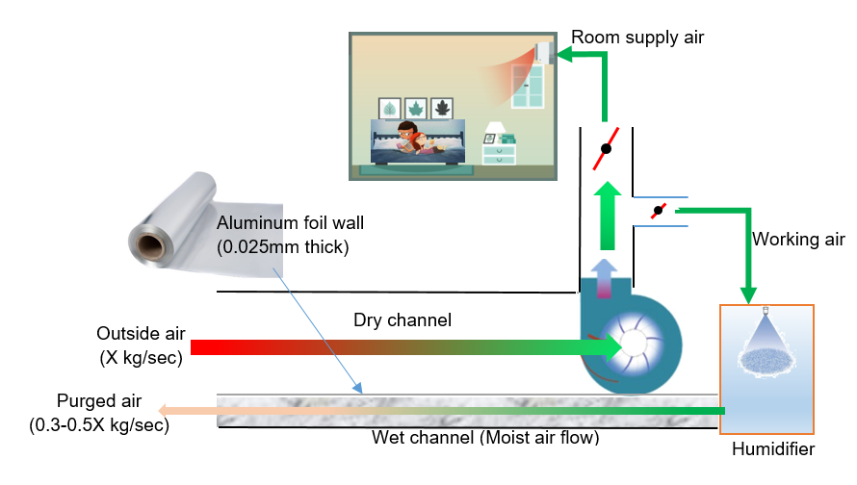
(a)

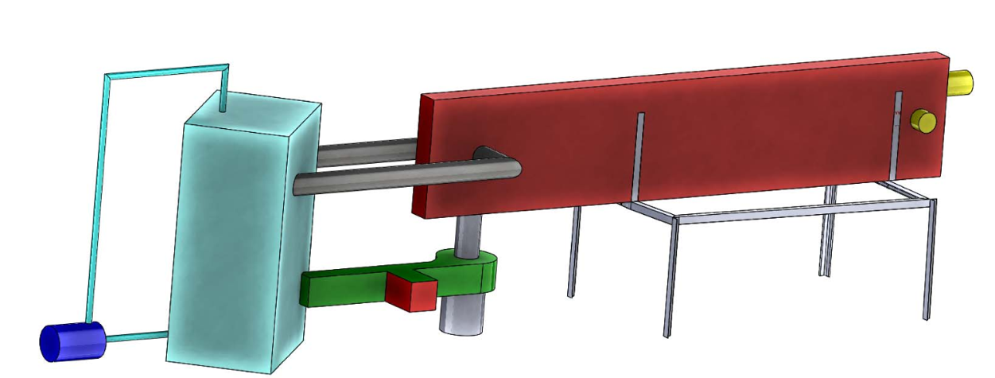
Dry channel sandwich between wet channels
(b)
Water spray
OA
WA

PA

Blower
SA
Humidifier

Figure 4. (a) Proposed indirect evaporative cooler operational schematic, (b) generic cell model for experimental system fabrication.

After the outdoor air flows through the dry channel and air blower, a portion of the SA is purged and diverted into the humidifier. In the humidifier, water is sprayed into the chamber by a fine mist nozzle. Due to direct evaporative cooling, the WA temperature is reduced to its wet-bulb temperature while being humidified to nearly 100% RH. The cool and humid air which also carries an additional mist of small water droplets is then directed into the wet channel. During operation, the excessive water droplets will gradually accumulate on the channel surface to form a thin water layer. As heat is exchanged from the dry channel to the wet channel, the water droplets on the wet channel surface continue evaporating due to lifted temperature. Furthermore, multiple spacers are placed along the wet channel to induce turbulence into the air flows, leading to enhanced heat and mass transfer rate. Ultimately, the SA in the dry channel can be sufficiently cooled to approach its inlet dew point temperature. It can be seen that the proposed configuration can overcome all the limitations and disadvantages in conventional IEC coolers. The issues faced by the previous IECs while addressed in the proposed IEC are highlighted in Table 1.
Table 1. Comparison of the proposed and conventional indirect evaporative cooler.
Sr # | Issues in previous IECs | Advantages in the proposed IEC
1 | Manufacturing cost due to the difficulty in sticking a wicking layer to the wet channel surface and sealing the channels. | The cooler is comprised of alternative channels separated by aluminium foil, where the wick layer is removed.
2 | Maintenance issue due to the fouling effect on the porous wick material. | All accessory components like a humidifier and water supply are outside the cooler, which can be accessed easily without the need to open the exchanger.
3 | Flow resistance due to the difficulty in controlling the right amount of water content in the wet channel. | The amount of water in the wet channel is controlled by the mist generation in the humidifier. It is much less than the water preserved by the wicking layer, so the friction between the air flow and water layer is minimized.
4 | Thermal resistance due to an additional layer of wick material and its water content. | The wicking layer is eliminated, and the thickness of the water layer formed by the mist is negligible.

To demonstrate the performance of proposed IEC, a generic cell was designed and fabricated. The details of the generic cell and experimentation is presented in the following sections.

Generic Cell Design & Fabrication
Proposed improved IEC generic cell was designed based on authors earlier experience with conventional coolers [25-27, 63]. The authors learned lesson from previous experimentations and improved the design parameters and interface material accordingly for better performance. The effective length and width of new generic cell are 1800 mm and 280 mm respectively. The height of both dry and wet channels is 5mm. The separator or interface material is an aluminium foils of 0.025mm thickness to ensure the good heat transfer across the channels in transverse direction. The detailed design parameters are presented in Table 2 and assembled cell at King Abdullah University of Science and Technology, Saudi Arabia is shown in Figure 5(a,b).

Table 4. Design parameters proposed generic cell.
Description | Symbol | Dimensions | units
Generic cell effective length | L | 1800 | mm
Generic cell effective width | W | 280 | mm
Separator Aluminium foil thickness | δ | 0.025 | mm
Dry and wet channels height | H | 5 | mm
Purge ratio | r | 35-55 | %

In a generic cell, one dry channel is sandwiched between two wet channels. The ambient OA firstly flows through the dry channel, as driven by a blower at the end of the channel. After passing through the blower, part of the air flow is purged, and the rest is delivered to the room as SA. The purged air (PA) then flows through a humidifier and utilized as a WA in wet channels on both sides of the dry channel. The cool and humid air, WA, in the wet channels is responsible for the cooling of the SA in the dry channel, due to conjugate heat and mass transfer in the evaporative cooling process. The purge ratio of WA to SA depends on the set value of SA temperature. The proportional damper controller automatically adjusts the PA flow to achieve the SA temperature. Different ambient temperatures are simulated by a heater to investigate the performance of the cooler under a wide range of weather conditions.

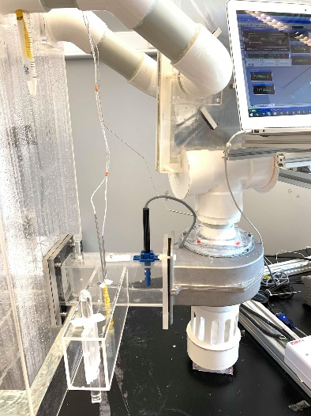
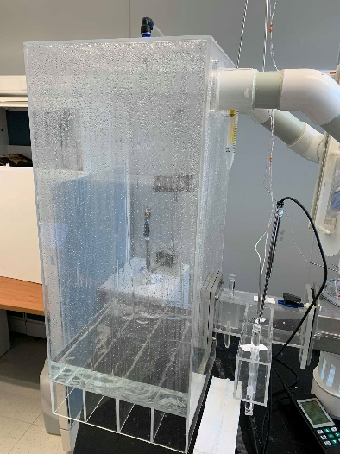
Blower
SA
PA
Humidifier

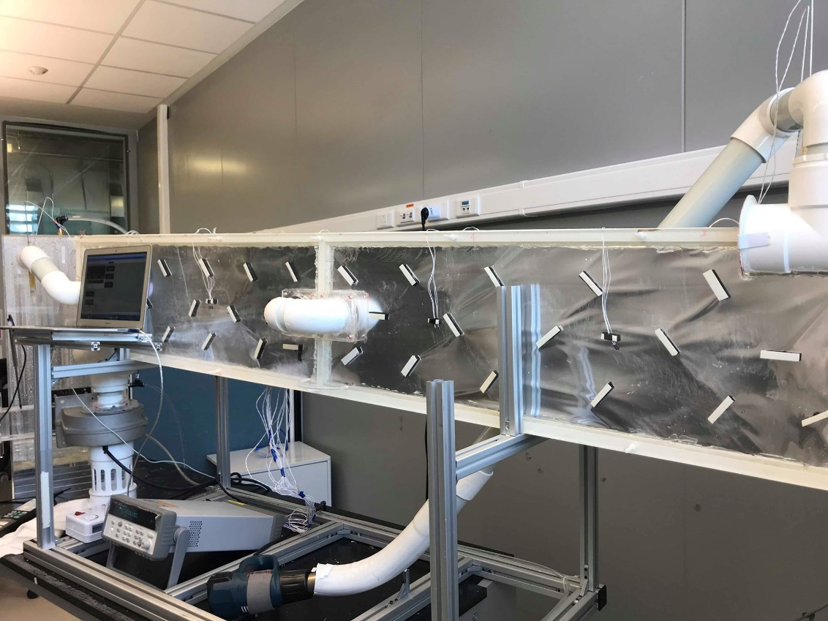

1800mm long generic cell

Data logger
Outdoor air temperature simulator

Figure 5(a). Proposed indirect evaporative cooler generic cell pilot at test conditions.

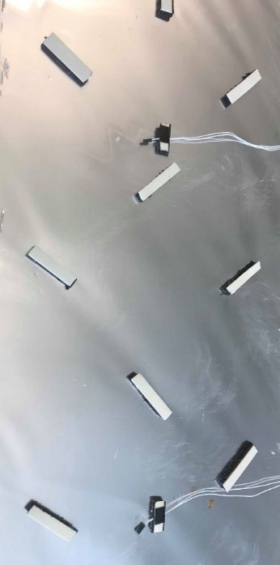

Figure 5(b). Spacers cum turbulent promotors on aluminium foil and temperature sensors in dry and wet channels.
The cell is fully instrumented to capture all important parameter trends such as temperature, humidity and velocity. The specifications of the instruments used in the test system are summarized in Table 3.
Table 3: Details of sensors and specifications installed in the IEC test cell.
Measurements | Sensor type
Humidity | Humidity temperature dew point meter  Manufacturer: Fisher Scientific  Measuring range: 10 to 100%  Accuracy: ±0.5%
Temperature | Thermistors  Manufacturer: OMEGA  Measuring range: 0 to 80°C & 0 to 100°C  Accuracy: ±0.15°C
Air velocity | Thermal flow probe air velocity meter  Manufacturer: Testo (model:425)  Measuring range: 0 to 20 m/s  Accuracy: ±0.03 m/s

To validate the experimental performance of proposed IEC, a detailed mathematical model was also developed, and simulation was conducted. The details of the model are presented in the following sections.

Mathematical Model
A computational fluid dynamics (CFD) model has been formulated to predict the thermodynamic performance of the proposed IEC. As the working air conditions before and after the humidifier are measured in the test system, it has been found that the working air after humidification has similar properties (see Section 6). In this case, the working air inlet is set to be one known input to the model, which eliminates the need to simulate the humidifier chamber. Therefore, the model takes into account the conservation of momentum, energy and species of the airflow in both dry and wet channels. Due to the large Reynolds number in the dry channel (Re≈3000) and the channel spacers installed along the channels, a turbulent flow model is thought to be appropriate to simulate the airflow field. On the other hand, it is noticed that to reproduce the exact 3-D geometry of the IEC cell considering the locations of channel spacers provides no favorable accuracy in predicting outlet air conditions, but will introduce much more model complexity and time-consuming simulation. Since the objective of this study is to investigate the overall cooling performance of the proposed IEC cell design, it is not necessary to obtain a precise local flow field inside the channels. Therefore, a 2-D model geometry is employed, despite the existence of the channel spacers, as presented in Figure 6. Several assumptions have been made prior to deriving the governing equations for the model geometry as below:
- The air flows are assumed to be uniform in the channel width direction due to the large channel aspect ratio (W/H).
- The air flows are treated as Newtonian incompressible flows due to their small density variation in the narrow temperature and pressure ranges.
- The WA extracted from the SA is evenly separated into two streams for the two wet channels.
- The wet channel surface is thought to be fully wet by the mist brought in with the WA flow after humidifier.
- The interaction between WA and mist in the wet channel is neglected as the WA is saturated.
- The outer surface of the wet channel is deemed to be well insulated so there is no heat transfer to the environment.

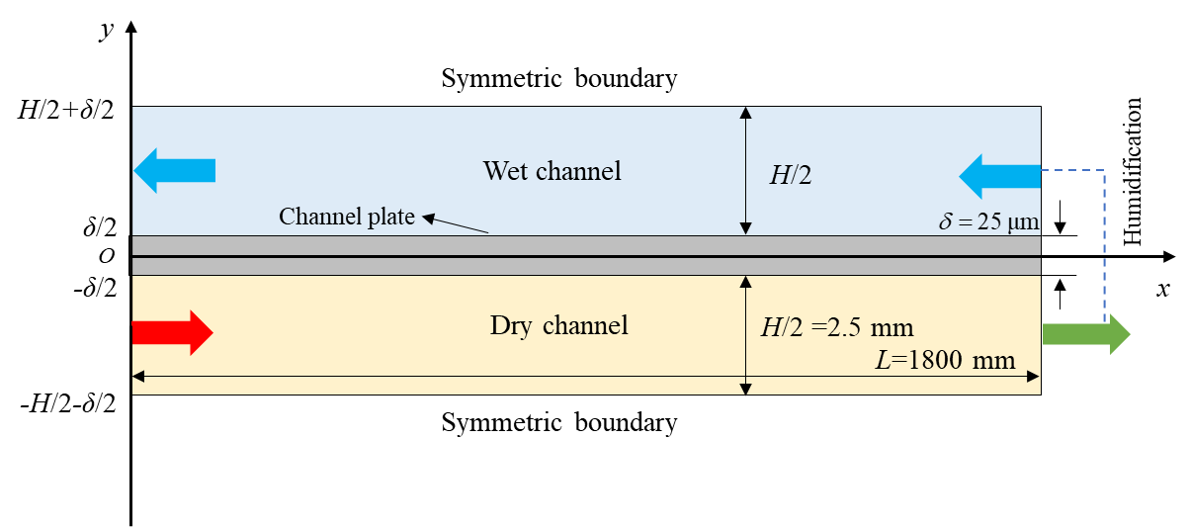
Figure 6: Model geometry of the proposed IEC .

Subsequently, the relevant physical mechanisms involved in the IEC process are revealed by the following equations. In the turbulence flow, the unsteady flow properties are decomposed into a steady mean value with a fluctuating component as follows
where y denotes u_{x}, u_{y}, P and s, etc.
Then the momentum balance equations of the air flows due to the turbulent fluctuations are modeled by the Reynolds-averaged Navier-Stokes (RANS) equations, and the effects of the turbulence in the equations are captured by the standard k-ε model.
Dry and wet channels
X-momentum:
Y-momentum:
Turbulent kinetic energy:
Rate of dissipation:
Continuity:
Energy:
Channel plate
Energy
where μ_{t} is the eddy viscosity specified as below
The coefficients appearing in the k-ε model are given as
According to the test conditions, the boundary conditions of the above governing equations are listed in Table 4.

Table 4: Boundary conditions for governing equations.
Dry channel | Wet channel
Channel plate

In the above model, the input variables are the outside air temperature, WA temperature, and humidity, as well as their velocities (or purge ratio). Consequently, the objective variables to be solved, are the temperature/humidity of the SA and PA. The proposed model can determine the relations between the input and output variables, which can be mathematically represented as
$T_{do}, T_{wo}, ω_{wo}∼T_{di}, T_{wi}, ω_{wi}, u_{di}, u_{wi}$
where ω is equivalent to the partial vapor density ρ_{v}.

Simulation Scheme
The proposed mathematical model was established and numerically simulated in COMSOL Multiphysics platform. The model geometry of the IEC unit was meshed into a number of small quadrilateral cell elements, as shown in Figure 7. A finite element method (FEM) was used to discretize the partial differential momentum, continuity, energy, and species balance equations into a set of algebraic equations. The equations were solved simultaneously with a MUltifrontal Massively Parallel sparse direct Solver (MUMPS). Newton iterations are carried out to refine the solutions, which is executed until the estimate relative error drops to below 10⁻³. A grid independence test was conducted by increasing the number of cell elements from 300×20 to 600×40 (L×H) at each channel domain. It was found that the variation of outlet air temperatures were within ±0.05 °C, hence the mesh number was determined to be 300×20 to balance the computation accuracy and efficiency.

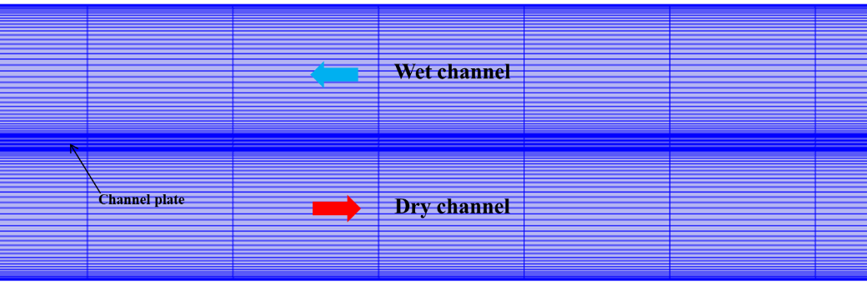
Figure 7: Mesh scheme of the IEC test cell.

Results and Discussion
Detailed experiments were conducted at assorted OA conditions and compared with simulation results as presented in the following sections.

Generic Cell Experimentation
The PA ratio is controlled by proportional damper to achieve the required SA temperature. The temperature profiles of OA and corresponding SA are presented in Figure 8. This specific experiment was conducted with a fixed 40% PA to investigate the possible SA temperature at assorted OA temperature. It can be seen from chevron shapes that the highest temperature difference is measured at the highest OA temperature. The temperature difference between OA and SA drop with decrease in OA temperature and this is due to drop in evaporative potential of WA. Since it is an evaporative cooler and nature controls the process limited by thermodynamics.

Figure 8: Temperature profiles of outdoor air and corresponding supply air at 45% purge air.
After a successful test at 45% PA and ensuring all components are working as per design specification, the experiments were conducted at assorted OA temperature with different PA ratio to investigate the full performance of the proposed cell. The summary of results is presented in Table 5.
Table 5. Summary of proposed IEC generic cell results.
 | DC_inlet | DC_outlet | WC_inlet | WC_outlet | DT1 | DT2 | LMTD
55% purge | 45.0 | 24.0 | 22.2 | 25.7 | 19.3 | 1.8 | 7.4
 | 40.0 | 23.8 | 22.2 | 25.0 | 15.0 | 1.6 | 6.0
 | 35.0 | 23.5 | 22.0 | 24.5 | 10.5 | 1.5 | 4.6
 | 30.0 | 23.0 | 21.8 | 24.0 | 6.0 | 1.2 | 3.0
 | DC_inlet | DC_outlet | WC_inlet | WC_outlet | DT1 | DT2 | LMTD
45% purge | 45.0 | 26.8 | 22.4 | 26.4 | 18.6 | 4.4 | 9.9
 | 40.0 | 25.9 | 22.2 | 26.0 | 14.0 | 3.7 | 7.7
 | 35.0 | 25.0 | 22.0 | 25.2 | 9.8 | 3.0 | 5.7
 | 30.0 | 24.2 | 22.0 | 24.1 | 5.9 | 2.2 | 3.8
 | DC_inlet | DC_outlet | WC_inlet | WC_outlet | DT1 | DT2 | LMTD
35% purge | 45.0 | 27.5 | 22.4 | 27.0 | 18.0 | 5.1 | 10.2
 | 40.0 | 26.8 | 22.2 | 26.5 | 13.5 | 4.6 | 8.3
 | 35.0 | 26.0 | 22.3 | 25.8 | 9.2 | 3.7 | 6.0
 | 30.0 | 25.4 | 22.4 | 25.0 | 5.0 | 3.0 | 3.9

It can be seen that the SA temperature varies from 23ºC (at 30ºC OA temperature and 55% PA ratio) to 24ºC (45ºC OA temperature and 55% PA ratio) and it is within the comfortable zone of ASHRAE55. It shows very high potential application for commercial, residential as well as data centre cooling. Based on data presented in Table 5 on temperature difference and airflow rate, the cooling capacity of the generic cell was calculated as shown in Figure 9. It can be seen that the maximum cooling capacity of the generic cell is 182.5 watt at 45ºC OA temperature and 55% PA ratio. This important information will provide the baseline for commercial system design. The commercial units can now be designed by stacking the generic cells as per the required capacity. For example, for 1 Rton commercial unit, around 20 number of cells will be required (20x182.5=3.65kW).

Figure 9. Cooling capacity of a generic cell at assorted outdoor air temperature and working air purge ratio.

The blower and pump power was measured as 4.0 Watt with voltmeter during all experiments. The coefficient of performance (COP) is calculated based on cooling produced and energy consumed by the blower (as shown in Equation 12) and presented in Figure 10. It can be seen that the IEC cooling COP value is quite high (up to 45) but the main bottleneck in overall COP is dehumidification processes. It clearly shows that if dehumidification processes can achieve COP in the level of 3-5, the overall COP level of 10-15 is achievable and it will help to meet the sustainable development goals, 0.5±0.03 kW/Rton.
$$Coefficient of performance (COP)=\frac{{\dot{m}}_{a }Cp {∆T}_{a}}{Blower power+pump power}$$
(12)

Figure 10. COP of a generic cell at assorted outdoor air temperature and working air purge ratio.

The effectiveness of an IEC generic cell is defined as actual cooling capacity to maximum possible potential as shown on Psychometric chart in Figure 11. Thermodynamically, it should be always less than 100% due to internal losses and heat leaks. In literature, sometimes it is presented over 100% and this is because the author considered only a sub-set of heat rejected (Q). The Q is a function of (T, and humidity) whilst the >100% case considered only T of dew points.

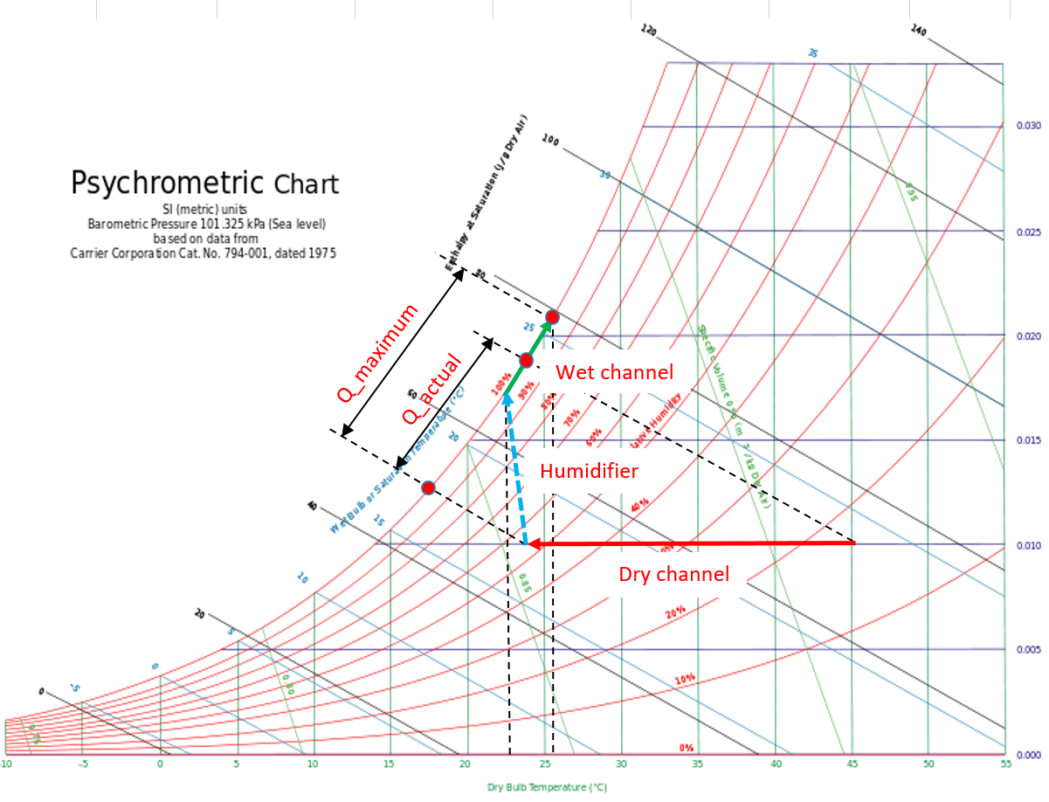

Figure 11. Effectiveness calculations concept on psychometric chart.

Based on definition presented in Equation (13), the effectiveness is calculated for different operational conditions and presented in Figure 12. It can be seen that maximum effectiveness is around 80% at 45ºC OA temperature. This high effectiveness is due to the higher evaporative potential of hot and dry air. The effectiveness drop at lower OA temperature due to a decrease in evaporative potential when outdoor air is cooler. This is also correct thermodynamically.

$Effectiveness=\frac{Q_{actual}}{Q_{maximum}}=\frac{{\dot{m}Δh}_{actual}}{{\dot{m}Δh}_{maximum}}$ (13)

Figure 12. Effectiveness of IEC generic cell at assorted operation conditions.

Generic Cell Simulation
The detailed simulation was conducted in COMSOL Multiphysics platform to investigate the performance of the purposed system and to validate the experimental results. To simulate the generic cell, identical cell geometry was reproduced in the model while the model equations remain similar. Table 6(a) shows the SA temperature and coefficient of performance at assorted OA conditions and PA ratio. The two important conclusions can be made from the results; Firstly, to achieve comfortable temperature for residential applications (23-24ºC) up to 55% PA is needed but for commercial applications such as data center cooling (25-27ºC) can be achieved with 35% PA. Secondly, the coefficient of performance (COP) varies significantly with OA temperature and PA ratio. This is because the IEC system performance depends on evaporative potential so higher OA temperature will have higher evaporative potential that leads to higher performance. Similarly, higher PA also promotes evaporative potential and hence improve system performance. The velocity of air in the dry channel was calculated as 5.2 m/sec. It is important to note that COP presented in Table 6(a) is just for sensible cooling processes and it doesn’t include the moisture removal processes. The overall COP will be a combination of both, sensible as well as latent load.

Table 6 (a): Simulation results of SA temperature and COP at assorted operational conditions
T_OA | 55% |  | 45% |  | 35%
 | T_SA | COP | T_SA | COP | T_SA | COP
45 | 24.2 | 45.2 | 26.9 | 39.3 | 27.5 | 38.0
40 | 24.0 | 34.7 | 26.0 | 30.5 | 26.7 | 28.9
35 | 23.5 | 25.0 | 24.9 | 21.8 | 26.1 | 19.3
30 | 23.2 | 14.8 | 24.1 | 12.9 | 25.4 | 10.0

The WC conditions are presented in Table 6(b) for same operational parameters. It can be noticed that WC inlet air temperature is almost same after humidifier in all cases, wet bulb with nearly 100% RH. The humidification process help to decrease the PA temperature from SA to WA prior to introducing it into the wet channel. In all cases, WA achieved wet bulb temperature and 100% RH due to effective mist nozzle water spray. These water droplets create a film on aluminum foil and enhance heat transfer from dry channel to the wet channel due to surface evaporation. The velocity of WA in the wet channel was calculated as 2.9m/sec, 2.3m/sec, and 1.8m/sec at 55%, 45%, and 35% PA respectively.

Table 6 (b): Simulation results of WC air at assorted operational conditions
T_OA | 55% |  |  | 45% |  |  | 35%
 | T_in | T_out | RH | T_in | T_out | RH | T_in | T_out | RH
45 | 22.2 | 25.6 | 0.90 | 22.4 | 26.6 | 0.93 | 22.4 | 27.7 | 0.93
40 | 22.2 | 24.8 | 0.90 | 22.2 | 25.7 | 0.95 | 22.2 | 26.7 | 0.97
35 | 22.0 | 24.0 | 0.92 | 22.0 | 24.7 | 0.97 | 22.3 | 25.7 | 1.00
30 | 21.8 | 23.4 | 0.97 | 22.0 | 23.8 | 1.00 | 22.4 | 24.5 | 1.00

These simulation results are compared with experiments as presented in following section.

Comparison of Experimental & Simulation Results
Experimental results are compared with simulation to verify the deign accuracy. The simulated and experimental SA temperatures have good agreement as presented in Figure 13. Only ±1% variations are noted in simulation and experiments and that can be sensor measurement range. This shows the excellent simulation as well as accurate fabrication and experimentation of generic cell.

Figure 13. Simulated and experimental SA temperature comparison.

Figure 14. Simulated and experimental COP comparison.
Similarly, the calculated COP from simulation and measured values from experiments have only ±5% variation as shown in Figure 14. These small variations are directly related to temperature differences. Overall, simulation and experimental results have good agreement. The robust simulation code and accurate design provided the baseline results for commercial system design.

Conclusions
Detailed simulation and experimental investigation have been conducted of an innovative IEC system. The innovative aspects include (i) only external water supply via the WA stream with a humidifier and an induction blower. Hence, the fouling issues from wetted-fibre surfaces are mitigated, (ii) high heat transfer across the non-porous foil barrier is enhanced by direct water film evaporation, and water droplets are entrained in the flowing air of wet channels. Simulation and experimental results have an excellent agreement. The maximum COP value of 45 for the generic cell was recorded at 45ºC outdoor air temperature at 55% PA with respect to the product air. Also, the maximum effectiveness of the generic cell is measured as 80%. However, both COP and effectiveness are decreasing with respect to lower inlet air temperature, as the generic cell IEC is dependent on the evaporative potential of the WA. It is also noted being a passive cooler, capacity control must be supported with close monitoring of temperature and humidity of both working and product air which can then be used as control parameters of the operation of IEC.

Acknowledgments
Authors would like to thank KAUST, Saudi Arabia, and Northumbria University, Newcastle Upon Tyne, UK for this experimental study.

Abbreviations
AC Air Conditioning
MVC Mechanical vapor compression
COP Coefficient of performance
HFC Hydrofluorocarbon
ODP Ozone depletion potential
GWP Global warming potential
IEC Indirect evaporative cooler
OA Outdoor air
SA Supply air
PA Purge air
WA Working air
DB Dry bulb
WB Wet bulb
DC Dry channel
WC Wet channel
RH Relative humidity
Exp Experiments
Sim Simulation

Nomenclatures
 | specific heat at constant pressure, J/(kg·K) |  | coefficient
 | coefficient |  | dynamic viscosity, Pa·s
 | coefficient of performance |  | eddy viscosity, Pa·s
 | diffusion coefficient, m²/s |  | kinematic viscosity, m²/s
 | channel height, m |  | thermal conductivity, W/(m·K)
 | latent heat evaporation, J/kg |  | density, kg/m³
 | turbulent kinetic energy, m²/s² |  | humidity ratio, g/kg dry air
 | channel length, m
 | pressure, Pa | Subscripts
 | working air ratio | a | air
 | rate of deformation, s⁻¹ | d | dry channel
 | temperature, K | i | inlet
 | velocity, m/s | o | outlet
 | fluctuating velocity, m/s | pl | plate
 | mean velocity, m/s | sa | saturation
 | channel width, m | v | water vapor
 |  | w | wet channel/working air
Greek symbols |  | x | x-direction
 | thickness, mm | y | y-direction
 | turbulent kinetic energy dissipation rate, m²/s³

References

- Luis PL, Jose´ O, Christine P, A review on buildings energy consumption information, Energy and Buildings 40-3(2008) 394–398.
- Smith ST, Hanby VI, Harpham C. A probabilistic analysis of the future potential of evaporative cooling systems in a temperate climate, Energy and Buildings 43-2:3(2011) 507–16.
- International Energy Agency (IEA). The Future of Cooling 2018:92.
- La D, Li Y, Dai YJ, Ge TS, Wang RZ. Development of a novel rotary desiccant cooling cycle with isothermal dehumidiﬁcation and regenerative evaporative cooling using thermodynamic analysis method, Energy 44 (2012)778-791.
- Waite M, Cohen E, Torbey H, Piccirilli M, Tian Y, Modi V. Global trends in urban electricity demands for cooling and heating, Energy 127(2017) 786-802.
- Izquierdo M, Moreno-Rodríguez A, Gonzalez-Gil A, García-Hernando N. Air conditioning in the region of Madrid, Spain: an approach to electricity consumption, economics and CO2emissions, Energy 36 (2011)1630-1639.
- UN environment, https://www.unenvironment.org/ozonaction/who-we-are/about-montreal-protocol (accessed on July 10, 2019)
- D.S. Kima and C.A. Infante Ferreirab Solar refrigeration options – a state-of-the-art review, international journal of refrigeration 31 (2008) 3–15.
- Alexis G.K. and Karayiannis E.K., A solar ejector cooling system using refrigerant R134a in the Athens area, Renewable Energy 30 (2005) 1457–1469.
- Alizadeh, S., Multi-pressure absorption cycles in solar refrigeration: a technical and economical study, Solar Energy 69 (2000) 37–44.
- Duan Z, Zhan C, Zhang X, Mustafa M, Zhao X, Alimohammadisagvand B, et al. Indirect evaporative cooling: Past, present and future potentials, Renewable and Sustainable Energy Reviews 16 (2012) 6823-6850.
- Mahmood MH, Sultan M, Miyazaki T, Koyama S, Maisotsenko VS. Overview of the Maisotsenko cycle – A way towards dew point evaporative cooling, Renewable and Sustainable Energy Reviews 66 (2016) 537-555.
- Lin J, Huang S-M, Wang R, Chua KJ. Thermodynamic analysis of a hybrid membrane liquid desiccant dehumidification and dew point evaporative cooling system, Energy Conversion and Management 156 (2018) 440-458.
- Chua KJ, Chou SK, Yang WM, Yan J. Achieving better energy-efficient air conditioning – A review of technologies and strategies. Applied Energy. 2013;104:87-104.
- Elberling L. Laboratory Evaluation of the Coolerado Cooler™ Indirect Evaporative Cooling Unit. USA: PG&E Company (2006).
- Zube D, Gillan L. Evaluating coolerado corportion's heat‐mass exchanger performance through experimental analysis, International Journal of Energy for a Clean Environment 12 (2011)101-116.
- Jradi M, Riffat S. Experimental and numerical investigation of a dew-point cooling system for thermal comfort in buildings, Applied Energy 132 (2014)524-535.
- Anisimov S, Pandelidis D. Numerical study of the Maisotsenko cycle heat and mass exchanger, International Journal of Heat and Mass Transfer 75 (2014)75-96.
- Anisimov S, Pandelidis D, Danielewicz J. Numerical analysis of selected evaporative exchangers with the Maisotsenko cycle, Energy Conversion and Management 88 (2014) 426-441.
- Lin J, Wang RZ, Kumja M, Bui TD, Chua KJ. Modelling and experimental investigation of the cross-flow dew point evaporative cooler with and without dehumidification, Applied Thermal Engineering 121 (2017)1-13.
- Lin J, Bui DT, Wang R, Chua KJ. The counter-flow dew point evaporative cooler: Analyzing its transient and steady-state behavior, Applied Thermal Engineering 143 (2018)34-47
- Bruno F. On-site experimental testing of a novel dew point evaporative cooler, Energy and Buildings 43 (2011)3475-3483.
- Cui X, Chua KJ, Yang WM. Numerical simulation of a novel energy-efficient dew-point evaporative air cooler, Applied Energy 136 (2014)979-988.
- Xu P, Ma X, Zhao X, Fancey K. Experimental investigation of a super performance dew point air cooler, Applied Energy 203 (2017)761-777.
- Lin J, Wang RZ, Kumja M, Bui TD, Chua KJ. Multivariate scaling and dimensional analysis of the counter-flow dew point evaporative cooler, Energy Conversion and Management 150 (2017)172-187.
- Lin J, Bui DT, Wang R, Chua KJ. On the fundamental heat and mass transfer analysis of the counter-flow dew point evaporative cooler, Applied Energy 217 (2018)126-142.
- Oh SJ, Shahzad MW, Burhan M, Chun W, Jon CK, KumJa M, and Ng K. C., Approaches to energy efficiency in air conditioning: A comparative study on purge configurations for indirect evaporative cooling, Energy 168 (2019) 505-515.
- Demis Pandelidis, Aleksandra Cichoń, Anna Pacak, Sergey Anisimov and Paweł Drąg, Counter-flow indirect evaporative cooler for heat recovery in the temperate climate, Energy 165 (2018) 877-894.
- Demis Pandelidis, Sergey Anisimov, Krzysztof Rajski, Ewa Brychcy and Marek Sidorczyk, Performance comparison of the advanced indirect evaporative air coolers, Energy 135 (2017) 138-152.
- Lei Wang, Changhong Zhan, Jianli Zhang and Xudong Zhao, Optimization of the counter-flow heat and mass exchanger for M-Cycle indirect evaporative cooling assisted with entropy analysis, Energy 171 (2019) 1206-1216.
- Yousef Golizadeh Akhlaghi, Xiaoli Ma, Xudong Zhao, Samson Shittu and Junming Li, A statistical model for dew point air cooler based on the multiple polynomial regression approach, Energy 181 (2019) 868-881.
- Yuting Liu, Jun Ming Li, Xu Yang and Xudong Zhao, Two-dimensional numerical study of a heat and mass exchanger for a dew-point evaporative cooler, Energy168 (2019) 975-988
- Lin J, Thu K, Bui TD, Wang RZ, Ng KC, Chua KJ. Study on dew point evaporative cooling system with counter-flow configuration, Energy Conversion and Management 109 (2016)153-165.
- Glanville P, Kozlov A, Maisotsenko V. Dew Point Evaporative Cooling: Technology Review and Fundamentals, ASHRAE Transactions 117 (2011).
- Duan Z, Zhan C, Zhao X, Dong X. Experimental study of a counter-flow regenerative evaporative cooler, Building and Environment 104 (2016)47-58.
- Lee J, Lee D-Y. Experimental study of a counter flow regenerative evaporative cooler with finned channels, International Journal of Heat and Mass Transfer 65 (2013)173-179.
- Zhao X, Liu S, Riffat SB. Comparative study of heat and mass exchanging materials for indirect evaporative cooling systems, Building and Environment 43 (2008)1902-1911.
- Alonso, J.F.S.J., Martíez, F.J.R., Gómez, E.V., Plasencia, M.A.A.-G., Simulation model of an indirect evaporative cooler, Energy and Buildings 29 (1998) 23-27.
- Armbruster, R., Mitrovic, J., Evaporative cooling of a falling water film on horizontal tubes, Experimental Thermal and Fluid Science 18 (1998)183-194.
- Delfani, S., Esmaeelian, J., Pasdarshahri, H., Karami, M., Energy saving potential of an indirect evaporative cooler as a pre-cooling unit for mechanical cooling systems in Iran, Energy and Buildings 42 (2010) 2169-2176.
- Finocchiaro, P., Beccali, M., Nocke, B., Advanced solar assisted desiccant and evaporative cooling system equipped with wet heat exchangers, Solar Energy 86 (2012) 608-618.
- Hsu, S.T., Lavan, Z., Worek, W.M., Optimization of wet-surface heat exchanger. Energy 14 (1989) 757-770.
- Khalajzadeh, V., Farmahini-Farahani, M., Heidarinejad, G., A novel integrated system of ground heat exchanger and indirect evaporative cooler, Energy and Buildings 49 (2012)604-610.
- Riangvilaikul, B., Kumar, S., An experimental study of a novel dew point evaporative cooling system, Energy and Buildings 42 (2010) 637-644.
- Saman, W.Y., Alizadeh, S., Modelling and performance analysis of a cross-flow type plate heat exchanger for dehumidification/cooling, Solar Energy 70 (2001)361-372.
- Stoitchkov, N.J., Dimitrov, G.I., Effectiveness of crossflow plate heat exchanger for indirect evaporative cooling, International Journal of Refrigeration 21 (1998) 463-471.
- Tejero-Gonzalez, A., Andres-Chicote, M., Velasco-Gomez, E., Rey-Martinez, F.J., Influence of constructive parameters on the performance of two indirect evaporative cooler prototypes, Applied Thermal Engineering 51 (2013) 1017-1025.
- Pandelidis D, Anisimov S, Worek WM. Performance study of the Maisotsenko Cycle heat exchangers in different air-conditioning applications, International Journal of Heat and Mass Transfer 81 (2015)207-221.
- Valeriy MaisotsenkoLeland E. GillanTimothy L. HeatonAlan D. Gillan, Method and apparatus of indirect-evaporation cooling, US patent # 6497107B2 (2002).
- Benjamin Weerts, Coolerado and modeling an application of the maisotsenko cycle, International Journal of Energy for a Clean Environment 12 (2011) 2-4.
- Ahmad, A., Rehman, S., Al-Hadhrami, L.M., Performance evaluation of an indirect evaporative cooler under controlled environmental conditions, Energy and Buildings 62 (2013) 278-285.
- Caliskan, H., Hepbasli, A., Dincer, I., Maisotsenko, V., Thermodynamic performance assessment of a novel air cooling cycle, International Journal of Refrigeration 34 (2011) 980-990.
- Elberling, L., Laboratory Evaluation of the Coolerado Cooler-Indirect Evaporative Cooling Unit. Pacific Gas and Electric Company (2006).
- Velasco Gómez, E., Tejero González, A., Rey Martínez, F.J., Experimental characterization of an indirect evaporative cooling prototype in two operating modes. Applied Energy 97 (2012) 340-346.
- Xuan, Y.M., Xiao, F., Niu, X.F., Huang, X., Wang, S.W., Research and application of evaporative cooling in China: A review (I) – Research, Renewable and Sustainable Energy Reviews 16 (2012) 3535-3546.
- Xuan, Y.M., Xiao, F., Niu, X.F., Huang, X., Wang, S.W., Research and applications of evaporative cooling in China: A review (II) - Systems and equipment, Renewable and Sustainable Energy Reviews 16 (2012) 3523-3534.
- Gillan L. Maisotsenko cycle for cooling processes, International Journal of Energy for a Clean Environment 9-1:3 (2008)47-64.
- Bellemo, L., Elmegaard, B., Reinholdt, L.O., Kaern, M.R, Modeling of a regenerative indirect evaporative cooler for a desiccant cooling system, 4th IIR Conference Thermophysical Properties and Transfer Processes of Refrigerants, Delft, The Netherlands (2013) (http://orbit.dtu.dk/files/56233310/MODELING_OF_A_REGENERATIVE.pdf accessed 01.07.2019).
- Kiran, T.R., Rajput, S.P.S.,An effectiveness model for an indirect evaporative cooling (IEC) system: Comparison of artificial neural networks (ANN), adaptive neuro-fuzzy inference system (ANFIS) and fuzzy inference system (FIS) approach, Applied Soft Computing Journal 11 (2011) 3525-3533.
- Lee, J., Choi, B., Lee, D.-Y., Comparison of configurations for a compact regenerative evaporative cooler, International Journal of Heat and Mass Transfer 65 (2013) 192-198.
- Mathews, E.H., Kleingeld, M., Grobler, L.J., Integrated simulation of buildings and evaporative cooling systems, Industrial and Engineering Chemistry Research 33 (1994) 197-206.
- Wani, C., Ghodke, S., Shrivastava, C., A Review on Potential of Maisotsenko Cycle in Energy Saving Applications Using Evaporative Cooling, International Journal of Advance Research in Science, Engineering and Technology 1 (2012) 15-20.
- Muhammad Wakil Shahzad, Muhammad Burhan , Doskhan Ybyraiymkul , Seung Jin Oh and Kim Choon Ng, An Improved Indirect Evaporative Cooler Experimental Investigation, Appled Energy 256 (2019) 113934.

