E-business in European Food and Beverage Industry: Current Applications & Future Trends
By
Ilias P. Vlachos
Lecturer, Agricultural University of Athens (AUA)
Agricultural Economics Dept., Agribusiness Laboratory,
Iera Odos 75, Botanikos 118 55, Athens, Greece
Phone: +30 210 5294757 / Fax: +30 210 5294776
email: ivlachos@aua.gr / iliasvlachos@yahoo.co.uk

ABSTRACT
For consideration for publication in
INTERNATIONAL CONFERENCE on INFORMATION SYSTEMS & INNOVATIVE TECHNOLOGIES IN AGRICULTURE, FOOD and ENVIRONMENT
18-20 March 2004
Thessaloniki Greece
This study examined a number of key issues regarding applications of e-business and Information & Communication Technologies in European Food and Beverage Industry. For this purpose a pan European survey was conducted during the period October-November 2002.
The role and use of ICT technologies mirrors the structure of the industry: dominance by large multinationals, where the creation of industrial groups (tied to mergers and subsidiaries) has encouraged the installation of interconnected local networks.
The main factors that push companies in the food sector to consider ICT solutions include greater efficiency in internal processes (productive, administrative, delivery of orders, etc) as well as integration of internal processes with external organisations to improve logistics and reduce costs.
E-business solutions (ICTs & software) focus predominately on the business interface and on integrating activities such as accounting, administration, and stock control. Large software houses have developed flexible ERP systems for many food manufacturers. It is mostly the larger agribusinesses that deploy this software, though there are examples of bespoke applications created by small in-house IT teams (often in medium-sized enterprises). Core sector business areas are: supply, production, logistics, services, and marketing & sales. Other critical areas now being targeted for improvement are: packaging processes, the control of quality in Hazard Analysis and Control Critical Points (HACCP), the quality of the product, and the reverse supply chain management of returned products.
Recently there has been a growing trend for larger companies to concentrate on improving logistics, by upgrading inventory management and storage capacity and trying to improve the flows of input and output in order to avoid stock breaches and guarantee more punctual deliveries. Sophisticated electronic infrastructures have been installed to improve distribution.
However, whilst there is a demand for increased ICT integration, the current diffusion of applications is believed to be low outside of large multinationals and their larger suppliers. For the most part, suppliers have more traditional relationships and communication techniques, and the operational focus is on quantity, quality, and delivery schedules.
The study concludes with recommendations for further research.
Introduction
Electronic business (e-business) today plays a major role in the world’s economy. During the last decades, information and communication infrastructure and a wide spectrum of commercial applications have supported information and knowledge as primary assets in a networked, knowledge economy. Developments in web technologies gave companies new tools to re-engineer business processes and strengthen their competitive advantage. The capabilities made possible by web technologies, combined with the rapid adoption of the Internet by consumers around the globe, are changing the competitive landscape. E-business B2B sales are projected to grow to more than $6.1 trillion by 2004.
The Internet has created new business models that expanded the traditional view of Information Technology (IT) as a productivity resource. A company can shift its “bricks and mortar” business model with the “clicks and mortar” model where bricks are the “physical” location of a business and clicks are the “virtual” storefront. Although this strategy gains cost reductions and produces better customer service, its contribution to the attainment of a sustainable competitive advantage remains an open question.
Lumpkin et al. (2002) observed that the Internet bring the most profound changes not at dot.com start-ups, but at incumbent firms that are being transformed into e-businesses. Porter (2001) argued that the question whether or not to deploy new e-business is not the right one; on the contrary, managers should ask how to do it in order to mould a full capacity to compete.
Managers need to understand what those changes mean for their companies by trying to answer key questions such as: How companies should adopt their strategies to those changes? Should they take a proactive or reactive stance to new technologies? What the Internet means for their businesses: is it a source of growth and profit, a cost reduction tool, a differentiation instrument, or a combination of them? How the Internet and web technologies affect the present competitive advantages of their companies? How the Internet and web technologies affect the future competitive advantages of their companies?
This study reviews e-business applications in European Food and Beverage Industry. It also assesses future trends and discusses the evolution of e-business applications. Finally, it posits a set of research directions that will enable scholars to further advance the research on e-business. The study is based on a large quantitative survey conducted by the European Union market observatory of e-business market watch.
E-Business Applications
E-Business can be defined as any business transaction that takes place using information and communication technologies. This broad definition includes three mainstream e-business applications (a) commercial activities such as buying and selling products and services electronically, (b) business activities such as enterprise resource planning, customer relationship marketing as well as collaboration in new product development, and (c) social activities such as supporting social interaction and cultural enforcement i.e. by the use of discussion groups, e-mail, chat, and so forth.
According to the type of trading partners, e-business applications are classified into several categories such as Business to Business (B2B), Business to Consumer (B2C), Business to Government (B2G), and Government to Citizen (G2C). The dominant characteristic is the conduct of a business transaction electronically by using a communication network. The basic components of an e-business application are:
(a) the infrastructure which consists of hardware and a communications network in the form of the electronic medium. The most popular electronic medium is the Internet.
(b) Software applications that manage e-business transactions i.e. to present information, storage and retrieve data in databases, or exchange information. Web-based applications such as a corporate web site, an electronic marketplace, and a web-based data interchange are increasingly become accepted by corporations of any size. The Web gives businesses a global presence; the corporate site becomes a company’s shop front at a worldwide downtown. As a result, internal software applications have to integrate with the Web applications seamlessly, a task which is more easily said than done.
(c) The type of e-business application, which can be classified into three categories according to the purpose it serves (Table 1):
- Informative. The purpose of informative e-business application is to provide technical, professional or business information such as in the case of a corporate web site. In this case, the content is typically unstructured and dynamic. Typical informative transactions include the corporate web site, business communication transactions, and e-promotions using e-newsletters and e-mail. Recent developments in web technologies such as the Extensible Markup Language (XML) aim to develop a unified framework for unstructured informative transactions. The XML is a language that defines a document format which is very similar to semi-structured data and can support the integration of multiple data sources (Deutsch et al., 1999).
- Transaction. The purpose of e-business transactions is to facilitate current or future transactions with business partners and customers. In this case, electronic transactions should be codified in advance. Instead of using the post office to exchange mail invoices, receipts, and other sort of business documentation, companies can exchange EDI messages, which are structured according to predefined standards e.g. the UN/EDIFACT standard. The majority of e-marketplaces are also characterized by codified business transactions. Humphrey (2002) found it useful to classify e-business marketplaces according to the extent to which transactions are either transaction- or information-oriented. In the transaction-oriented type, Humphrey classifies the online auctions, which take place in real time and also facilitate on-line payment.
- Growth. Chandler in his seminal work pointed out that the purpose of a firm, particular of a large and/or innovative one, is more than to reduce transaction costs: firms actually define new markets and resource uses (Chandler, 1990). E-business can be used as an instrument to open up new markets, leverage new product development, and engineer innovative business processes. E-tailing is an example of how technology has created a new market of on-line shoppers, who, instead of paying a visit to the local retail store, prefer to do their shopping electronically from home or work. Although the initial target group of e-tailing consisted of busy people, reports i.e. by Andersen consulting indicate that as high as 42% of shoppers in the US and Europe is willing to order groceries from home (Verhoef and Langerak, 2001; Narayanan, 1997).
Table 1 A taxonomy of e-business applications
 |  | Objective of E-Business Application
 |  | Informative | Operations | Growth
Type & Scale of Users | Individuals  (Customers) | - Discussion groups  - Mailing  - Portals  - Vortals | - Internet access  - Retail  - Auctions  - Build-to-order  - Banking  - Brokerage  - Travel | - P2P  - Mobile commerce  - G2C
Type & Scale of Users | SMEs (including SBC) | - E-Procurement  - Search Engines  - Electronic Agents | - ASPs  - Hosting  - E-Banking  - B2G  - Auctions & marketplaces | - ASPs  - Mobile commerce
Type & Scale of Users | LSEs | - B2E  - Electronic Agents | - ERP  - CRM  - Enterprise Application Integration (EAI)  - Sales Force Automation | - Mobile commerce  - Virtual Chain
SBC: Small Business Customers
SME: Small & Medium Enterprises
LSE: Large Scale Enterprises
B2E: Business-to-Employee: Services provided to employees e.g. corporate/industry news and key contacts.
E-Business Applications to Agriculture & Food Industry
The advent of advanced information and communication technologies has created a multitude of challenges and opportunities in food sectors in developed economies. E-business applications have received particular consensus, given the fact that food industries depend on effective distribution systems in order to meet diversified consumer demands and short delivery times, as well as maintain effective reverse logistics (Vlachos, 2003; Iijima et al., 1996).
During the last two decades, large companies, especially retailers and manufactures, have used e-business applications to increase their power in agrifood supply chains by enhancing customer service, creating economies of scale, reducing logistics costs, and facilitating the efficient flow of food and information (Bell et al., 1997). Such an achievement has been strategically leveraged by information and communication technologies (ICTs) that enhance the performance of food chains, i.e. in terms of cost, time and accuracy of deliveries, and at the same time, assure food quality and safety. Small and medium-sized food companies can use web-based e-business solutions to exploit niche markets and create new market segments by gaining sporadic, low volume suppliers and customers at low marginal cost.
Table 2 presents the e-business applications to various agribusiness functions. A multitude of e-business solutions can be applied to each business function, e.g. EDI and web-based integrated inventory management for warehousing and automated replenishment.
Table 2 Applications of E-business tools to Food & Agribusiness Management
Business Functions | E-business tools | Applications
Marketing | B2B e-commerce, Internet ordering, Corporate Websites | Product promotion, new sales channels, direct savings, reduced cycle time, customer services
Purchasing | EDI, Internet-purchasing, EFT | Ordering, fund transfer, supplier selection
Production | B2B e-commerce, MRP, ERP. | Production planning and control, scheduling, inventory management, quality control
Sales and distribution | Electronic funds transfer, On-line TPS, Bar-coding system, ERP, WWW integrated inventory management, Internet delivery of products and services | Internet sales, selection of distribution channels, transportation, scheduling, third party logistics
Warehousing | EDI, EFT, web-based integrated inventory management | Inventory management, forecasting, scheduling of work force
Supplier development | WWW assisted supplier selection, communication using Internet (e-mails), research on suppliers and products with WWW and intelligent agents | Partnership, supplier development
Source: Adopted from Gunasekaran et al. (2002)
There is consensus that e-business applications have a profound impact on the food supply chain. E-business adds flexibility to operations management, allowing for smaller lots of orders and shipments, real-time inventory replenishment, and shorter order cycle time and, subsequently, shorter lead times. Vorst et al. (1998) argue that Supply Chain Management should be concerned with the reduction or even elimination of uncertainties to improve the performance of the chain and suggest that reduction of uncertainties could improve service levels significantly. Myoung et al. (2001) pointed out that the successful implementation of SCM in agriculture means that all involved parties in production, distribution, and consuming should trust each other in order to gain by information sharing. However, a substantial body of evidence suggests that the competitive advantages from the implementation of e-business in food chain may be distributed unevenly among the parties involved (Loebbecke and Powell, 1998).
Methodology
The European e-Business Market Watch is a market observatory established by the European Commission, DG Enterprise. Laying the groundwork for a continuous facility, the e-Business W@tch monitors and assesses the maturity of electronic business in 15 industry sectors across all EU Member States, including seven manufacturing and eight service sectors.
Most of the data presented in this study are derived from the recent European e-Business Survey 2003. In total, 3.515 telephone interviews with decision makers in European enterprises in all EU Member States were conducted between 24th February and 20th March 2003. The field work was carried out using computer-aided telephone interview (CATI) technology. The decision maker in the enterprise targeted by the survey was normally the person responsible for ICT within the company, typically the IT manager. Alternatively, particularly in small enterprises which may not have a separate IT unit, the managing director or owner was interviewed.
The sample drawn was a random sample of companies from the respective sector population in each Member State. Further details on methodology as well as the full range of data and reports can be freely accessed via the market monitor website http://www.ebusiness-watch.org/.
Key Findings

Online selling
Only 5% of food companies use online selling. This percentage is slightly higher in the case of medium-sized enterprises (9%) and large enterprises (8%) but in the food industry, online selling is less developed in comparison to the average of other sectors, in which there is a 16% rate of online selling.
Spain and the United Kingdom use online sales the most, with 10% and 9% respectively. Instead, France is the least oriented to online selling (only 2% of companies). 8% of companies, mostly medium-sized, are planning to commence online sales within the next twelve months (during 2004). Among companies that sell online, 64% declared that they have been doing this for less than a year.
Table 3 shows the percentage of online sales in relation to total sales. For one over seven companies (15%), online selling represents over 50% of total sales. For 61% of the companies that sell online, this represents less than 5% of total sales. For 23% of companies, online sales range from 5% to 10%. In Italy, which has the highest number of SMEs, this figure rises to 34%.
Table 3 Share of online sales on total sales
Share of online sales on total sales | D | S | F | I | UK | EU
Online share of total sales: > 50% | 0 | 16 | 0 | 34 | 2 | 15
Online share of total sales: 26 to 50% | 3 | 0 | 0 | 0 | 0 | 0
Online share of total sales: 11 to 25% | 0 | 0 | 0 | 0 | 0 | 0
Online share of total sales: 5-10% | 3 | 33 | 3 | 33 | 20 | 23
Online share of total sales: < 5% | 94 | 51 | 97 | 33 | 78 | 61
Source: e-Business W@tch (2003)
Most enterprises (and particularly SMEs) that sell online use the company website as a base to expand their distribution platform. In addition, Internet marketplaces are used rather extensively (above all Spain and Italy), and they have been listed by 31% of companies that sell online. Instead, Extranets and EDI are used more marginally, and EDI systems are used mainly by large enterprises.
The main challenge of e-business is to achieve full integration of company processes and, in this specific case, the process of receiving and managing online orders. Typically, the reception of an order generates an e-mail. 11% of the companies receive orders by fax and 10% by web-based forms. Only 1% of companies have integrated the received orders with their backend systems.
40% of the companies are equipped with online selling systems that can provide secure transactions through a server, using an SSL protocol (Secure sockets layer). 50% of the companies provide their customers with online after-sales services (Spain is the most sensitive country with regard to this type of service).
Online selling has a positive impact in food companies largely in terms of the number of customers following on the quality of customer service (58%) and on the efficiency of internal processes (57%). The impact of online selling on sales turnover was found very positive by 12% of the companies. Online selling has a limited impact on logistics costs and stock management

E-Procurement
E-procurement is used by 19% of food companies whereas large companies are the ones that mainly adopt online procuring (54%) (Figure 1). Online procuring is more widespread on Germany (40%) and the United Kingdom (30%). Inversely, French companies are the least oriented towards e-procurement (only 6%). In comparison to online selling, where 8% of companies plan to implement this within the next 12 months, online procuring this percentage drops slightly (only 5%). This may be an indication that e-procurement has reached a certain degree of saturation. In this respect, e-procurement have penetrated early adopters and seems to lay between early majority and late majority while online selling still rests among early adopters expecting to double its users in the next 12 months.
Figure 1 Enterprises procuring online
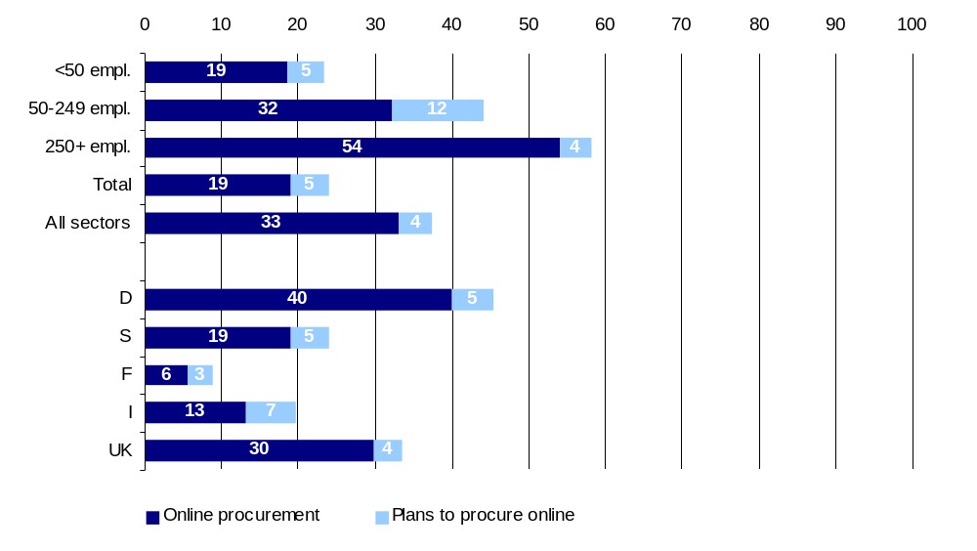
Source: e-Business W@tch (2003)
For 70% of the companies that use e-procurement, online purchases represent less than 5% of total purchases. This leaves a wide window for future online purchases. For 20% of these companies, online procuring represents a share ranging from 5% to 10%, whereas for 9% of the companies online procuring represents a share of 11% to 25%, whereas there are no companies (except UK) for which e-procurement exceeds 26% of total purchases. This means we must expect two-fold increase in e-procurement: firstly, an increase on the percentage of companies purchasing on line and secondly, an increase on the percentage of e-procurement volume over total purchases.
Most companies place their orders via website. EDI is used rather extensively (21%), above all in Italy. Instead, only a few companies place their orders through a marketplace, a supplier’s Extranet, or by integrating their systems with those of their suppliers for placing their orders.
Online procuring seems to have a positive impact above all on procurement costs (52%) and on the efficiency of in-house company processes (45%). Positive, although with a lower percentage, was found the impact on supplier relations (33%) and on the costs of logistics and stock management (27%).

B2B electronic marketplaces
Participation of food companies in marketplaces is marginal. Only 1% of the survey sample markets its products through marketplaces or other B2B initiatives. This percentage rises slightly in the case of large companies (8%). This situation does not appear to change significantly in the immediate future. In fact, only 1% of the enterprises stated they are planning initiatives in the next 12 months.
The types of activities involving companies that participate in marketplaces are, first of all, participation in auctions as sellers (indicated by 71% of enterprises). The other activities, occurring at a far lower percentage, are: the offer of catalogue products (indicated by 3% of the companies), the purchase of catalogue products (3%), launching bid tenders (3%), and participation in auctions as bidding (2%).

IT skills development
The success of e-business and other types of ICT requires not only the availability of adequate technology within the company, but also the presence of specialised, trained personnel capable of accessing and using these technologies. 67% of the interviewed companies back their employees in acquiring specialised skills in using a personal computer and network-related information technology (Figure 2). Companies with more than 250 employees are the most training-oriented (92% of them support their personnel), whereas small companies with less than 50 employees are the ones that feel the problem of ICT training the least.
With regard to the training instruments offered by companies, 52% of enterprises stated that their employees can use some of their work hours for learning, 48% of them use specific training courses offered by outside consultants, and 32% of them rely on computer or IT training courses conducted in-house.
Figure 2 IT training offered to employees
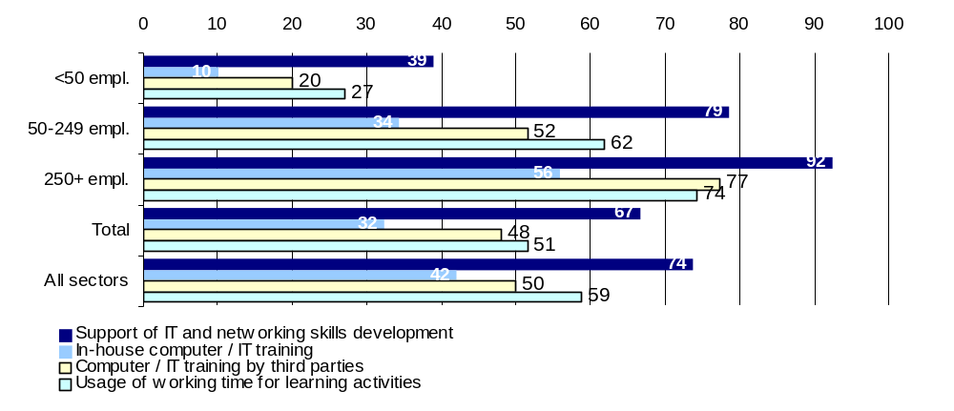
Source: e-Business W@tch (2003)

Processes of the extended enterprises
Enterprise Resource Planning (ERP) are used by 12% of the sample. Companies in the sector have implemented ERP to integrate their information system with their customers. The functionalities of ERP systems are integrated by means of specific sector utilities, for example management of returns, handling recyclable packaging, HACCP quality control, handling with double independent units of measurement or recipe management.
Supply Chain Management (SCM) is in an embryonic phase, but presents significant opportunities. After reengineering internal processes to increase efficiency, large companies have attempted to increase their competitive advantage by achieving inter-organisational goals, such as decreasing time-to-market and distribution costs. SCM projects move toward integration of processes throughout the complete supply chain, from receiving the order to procurement and from production to delivery.
Customer Relationship Management (CRM) is a strategy typically used by large companies in order to tackle the automation of the sales force and call centre management. CRM systems use or reuse of investments already made in structures such as Helpdesks and websites, redirecting them to meet CRM needs (for instance at Coca Cola). With the exception of ERP, these applications are still not very widespread on the whole less than 5%), but there is a strong growth trend.

Future perspectives
70% of the interviewed enterprises stated that they would maintain the same level of investments, whereas 26% of the enterprises plan to increase their investments in e-business technologies over the next 12 months. Only 2% of the enterprises think that ICT expenditures may diminish. Large enterprises are not the only ones that are oriented towards increasing their ICT expenditures in the next 12 months, but that a very high percentage of SMEs is also planning to increase these expenditures.
90% of the enterprises indicated that they are satisfied with the effect and success of the e-business activities and initiatives -they have undertaken. The growth of online selling has been favoured, on the one hand, by the market entry of websites belonging to companies that were already operating on the traditional market (favoured over dot-coms in that they already have infrastructures and an established brand), and on the other hand, by the creation and success of several sites offering typical food products.
With regard to the use of specific e-business solutions, there is a growth trend in terms of ERP. This growth has been driven by requests from larger companies (thanks to increasingly customised software to meet the specific needs of food businesses), as well as the tendency among ERP suppliers to broaden their target to include SMEs. EDI systems and corporate banking have essentially remained stable, and they have reached a mature phase in terms of life cycle. Among the more “evolved” systems, there has been a slight growth trend in SCM applications, which have also been introduced at several small and medium-sized businesses.

Summary and conclusions
The food, beverages and tobacco sector comprises 15% of the total manufacturing production of the European Union. This intensely competitive sector is characterised, on the one hand by a relatively small group of large companies that tend to operate globally and, on the other, by a large number of small and medium-sized business that operate locally, with the balance varying between countries.
The spread of ICT reflects the structure of the food industry. Large multinational companies (usually leaders in their sectors) are the most technologically advanced companies, while smaller companies lag in adopting ICT, especially upstream of the various product lines.
The main factors that push companies in the food sector to consider ICT solutions include greater efficiency in internal processes (productive, administrative, delivery of orders, etc.) and integration of internal processes with external organisations to improve logistics and reduce costs. A more integrated view is emerging, with leading companies looking for ways to apply technology strategically to improve business management activities.
The most widespread technologies in both large companies as well as SMEs are e-mail and websites, with ERP and EDI systems trailing far behind. The most state-of-the-art technologies, such as CRM, SCM systems, and Knowledge Management solutions, are still not very widespread and can be found almost exclusively at larger enterprises. E-commerce has grown steadily in the recent years. In particular, online procuring has reached a certain level of diffusion, as it is used by nearly 20% of the enterprises in the sample. Instead, online selling has spread to a much more modest extent, and it is used by approximately 5% of the enterprises interviewed. With respect to online procuring, however, online selling presents slightly more favourable prospects. In fact, based on the results of the survey, whereas 5% of companies have planned e-procurement initiatives in the next 12 months, when it comes to online selling this percentage rises to 8%.
E-business is rather perceived as a complex concept which is mostly viewed as a facilitator of competitiveness (“we are happy with e-business initiatives”) than a source of competitive advantage (“does not contribute significantly to the company”). This indirect role of e-business in creating the backbone of competitive efficiencies is more visible by large companies that rush to invest in e-business applications as well as state-of-the-art technologies such as CRM and KM. SMEs face difficulties in understanding the complex role of how e-business applications today help businesses developing the infrastructure of tomorrow.
E-business tools are more suitable for leading agribusiness corporations. Large European and US agribusiness corporations have already applied e-business solutions. Large retailers and manufacturers take advantage of e-business solutions in order to leverage their power in the supply chain over competing companies and alternative supply channels. However, small and medium enterprises (SMEs) lack the operational readiness of large corporations and the necessary (slack) resources to invest in expensive e-business applications. SMEs usually use the Internet to disseminate information about their products and to a lesser extent distribute their products and services electronically. The adoption of an e-business model by SMEs depends on external pressure such as in the case when a big retailer inflicts an EDI system on its food suppliers.
Furthermore, the agriculture and food sector is unique due to the characteristics of food products such as perishability and freshness as well as the public health issues of food consumption. Food quality and safety, which has attracted considerable attention due to the recent food crises and altered consumer awareness, requires reliable food traceability which can be safely applied using standard product identification and bar coding, the cornerstones of ECR. The life cycle of food products can be a few days requiring a time efficient supply chain from the ‘field to plate’.
The apparent advantages of e-business applications in agriculture and the food industry need to be transformed into competitive advantages in order for agribusiness companies to take full advantage of the existing technologies. Yet, existing e-business applications are suitable predominately for large companies that can develop an appropriate business model in order to sustain a competitive advantage. More research needs to study each e-business model in depth in order to examine the managerial implications of the adoption of those technological innovations.
References
Bell, R., Davies, R., and Howard, E., (1997), “The changing structure of food retailing in Europe: the implications for strategy”, Long Range Planning, Vol. 30, No 6, pp. 853-861.
Chandler, A. D., (1990) Scale and Scope, Cambridge MA, Belknap Press.
Deutsch, A., Fernandez, M., Florescu, D., Levyd, A., and Suciu, D., (1999) A query language for XML, Computer Networks, Vol. 31, pp. 1155–1169.
EbusinessWatch, (2003), ICT & e-Business in the Food, Beverages & Tobacco Industry, Sector Report No.1 III, The European e-Business Market Watch, July (http://www.e-business-watch.org/).
Gunasekaran, A., Marri, H. B., McGaughey, R. E., and Nebhwani, M.D., (2002), “E-commerce and its impact on operations management”, International Journal of Production Economics, Vol. 75, pp. 185–197.
Humphrey, J., (2002) Business-to-business e-commerce and access to global markets: exclusive or inclusive outcomes?, Institute of Development Studies, Globalisation and Poverty Working Paper.
Iijima, M., Komatsu, S., and Katoh, S., (1996), “Hybrid just-in-time logistics systems and information networks for effective management in perishable food industries”, International Journal of Production Economics, Vol. 44, pp. 97-103.
Loebbecke, C. and Powell, P. (1998), “Competitive Advantage from IT in logistics: The Integrated Transport Tracking System”, International Journal of Information Management, Vol. 18, No.1, pp.17-27.
Lumpkin, G. T. Droege, S.B., and Dess, G. G., (2002) E-Commerce Strategies: Achieving Sustainable Competitive Advantage and Avoiding Pitfalls, Organizational Dynamics, Vol. 30, No. 4, pp. 325-340.
Myoung, K. Park, S. Yang, K. Kang, D. and Chung, H. (2001), “A supply chain management process modelling for agricultural marketing information system”, EFITA, 3rd conference of the European Federation for Information Technology in Agriculture, Food and the environment, Montpellier, France, June 18-20, 409-414.
Narayanan, S., (1997) Home shopping: the way of the future is here, Retail World, Vol. 50, No. 20, p. 6.
Porter, M., (2001) Strategy and the Internet, Harvard Business Review, March, pp. 63–78.
Verhoef, P. C., and Langerak, F., (2001) Possible determinants of consumers' adoption of electronic grocery shopping in the Netherlands, Journal of Retailing and Consumer Services, Vol. 8, pp. 275-285.
Vlachos, I. P., (2003) Investigating the Adoption of Electronic Data Interchange by Agribusiness Organizations, Journal of International Food & Agribusiness Marketing, Vol. 15, November 3
Vorst, (Van Der) J. G. A. J., Beulens, A. J. M., Wit, (De) W., and Beek, (Van) P. (1998), “Supply Chain Management in Food Chains: Improving Performance by Reducing Uncertainty”, International Transactions Operational Research, Vol. 5, No. 6, pp. 487-499.

