CMMS - COMPUTER-AIDED CONSTRUCTION MATERIALS MANAGEMENT SYSTEM
Srinth Perera & G.I. Karunasena

Abstract
Many management-oriented problems exist amongst various construction organizations in the world, especially in developing countries. Among these materials management has been an important issue. This research is aimed at identifying drawbacks associated with materials management as practiced in the industry and developing a computerized Construction Materials Management System (CMMS) to overcome these. CMMS consists of five main modules i.e., materials requisition, purchase, delivery, reports generate, and system maintenance. It was developed with the collaboration of three grade M1¹general contractors operating in Colombo metropolitan area in order to ensure its ability to address materials management needs. The development was carried out using “Access 2000” software since it is a prototype. CMMS is a tool for managing construction materials in a timely manner and provides the ability to retrieve relevant file in an efficient and effective manner. The system has been successfully tested within the participatory organisations.

Key words: Construction Materials Management System (CMMS), construction industry, information modeling, System Development Life Cycle.

INTRODUCTION

Background
Materials management has been an issue of interest in the construction industry for a long time. The need for efficient and effective materials management in construction is apparent when considering [1]:

- Materials account for 50-60% of project cost and the most common cause of delays in construction is lack of materials.
- The problem of unnecessary material wastage.

These facts illustrate that even the slightest increase of efficiency of materials management realizes substantial absolute advantages. Due to such strategic role materials management has assumed greater importance in the modern management.
This paper address the issues of present materials management practice in the construction industry of Sri Lanka and provide a detailed overview of the Construction Materials Management System (CMMS) that was developed as a solution for the effective management of materials in the construction industry. The authors define that the objectives of an effective materials management system include establishing a more organized and systematic flow of materials, ensuring that materials are used and managed efficiently and improving the profit margin.

Aims of the Research
This research aims at identifying the materials management practices in the construction industry in Sri Lanka and the nature of problems associated with materials management and to introduce a new

construction materials management system to overcome the identified problems.

Objectives
The following are the main objectives of this research project.

- To identify the materials management approaches in the local construction industry.
- To identify the problems associated with materials management.
- To suggest recommendations to alleviate the prevailing problems.
- To introduce a new computerized materials management system as means of efficient and effective materials management.

Scope and Limitations
The research was confined to the contractors with grade one M1 registered with ICTAD. Since they account for the major portion of building work being carried out and handle large quantities of materials makes the scoping more realistic.

The following are some limitations of the research.
- Case studies were limited to three main general contractors.
- Development of CMMS was limited to the prototype.

Methodology
The research methodology adopted for the project can be summarized as follows:
- Basic information survey of materials management through literature survey and case studies.
- Requirement analysis of information gathered from above sources.
- Designing an information model for the proposed system.
- Implementation of the model to a computer aided software (CMMS).
- Testing & validation of the system.

The following sections of the paper first identify information modeling and materials management techniques prior to explanation of the system development life cycle and validating the system.

INFORMATION MODELING

Information modeling is the logical representation of the system, which is used to represent the information identified by the analysis. Simply it is a logical, complete, concise and unequivocal statement of what is required rather than how it is to be attained. Information modeling defines the procedures, which must be followed and the data required to achieve the user requirements. There are various techniques for information modeling, such as, structured and object oriented. For this the author has used the structured technique, since and there are various standard software packages to develop the model. The main activities of this process as follow [2];

- Process modeling - This specifies the process, involved in the system. It clearly shows, what must happen for the input data to be transformed into the output data. Main technologies available for process modeling are Data Flow Diagram (DFD), data dictionary and structured English [2].

- Data modeling - This is used to specify data of the system. It consists of defining the data entities, their relationships and translating the relationships into tables. This is done along with a normalization processes, which translate the relationship into tables and normalizes it until it removes data redundancy and dependency. Technologies available for data modeling are Entity Relationship Diagram (ERD), semantic nets etc [3].

MATERIALS MANGEMENT

The scope of construction materials management may be defined as follows:

- Materials management is the single manager or organization concept embracing planning, organizing, motivating, and controlling of all those activities and personal principally concerned with the flow of materials into an organization [4].
- Materials management would embrace all activities concerned with materials except those directly concerned with designing or constructing the product or maintaining the facilities and tooling [5].

There are differences of emphasis between these descriptions although all are concerned with management of materials. However the attributes of materials management consist of the following [6]:
- Materials planning
- Construction control
- Inventory control
- Purchasing function
- Receiving and inspection
- Store keeping
- Materials handling
- Traffic

Conflicts Associated with Construction Materials Management
The conflicts associate with construction materials management can be illustrated as follows [6];

- The performances of the materials management function in isolation without considering total materials management system.
- In adequate communication among the several materials management functions.
- In efficient record keeping.
- Lack of use of advanced planning techniques.
- Delay in delivery of materials.

Same author states that the solution for the above is the introduction of an integrated system concept as the initial step for achieving effective materials management. It means that bringing all the attributes of materials management under one umbrella. Nevertheless other authors also describe various benefits of adopting a computerized materials management system in Japanese construction firms, such as, less material shortage, surpluses, idle time and delays. Viz: Just in time method (JIT) [7].

SYSTEM DEVELOPMENT LIFE CYCLE

The CMMS development life cycle consists of five phases as described below.

- Basic information survey
- Requirement analysis
- Modelling proposed system
- System development and testing
- System implementation and maintenance

Basic Information Survey
This stage consists of information gathering from literature review and case studies.

- Literature survey
It was carried out to identify local as well as global view of materials management practices, to develop a working knowledge of the physical process associated with the research under consideration. The survey was done through the Internet, published journal, books etc.

- Case studies
To obtain industry-wide perspective of how local contractors manage materials, case studies were conducted among the three Grade M1 general contractors operating in the Colombo metropolitan area. Semi-structured style of interview was used in case studies, to collect the information on materials management. The first section of the interview was carried out to identify the corporate information, which covers organization structure, organization history, main functions of organization, financial resources, etc. This is necessary because the proposed system should function in similar context and be consistent with the organization’s strategic plans. The second section focused on the analysis of existing system operation, which covers the existing operations and its record keeping methods, materials reconciliation techniques, the usage of computers, and the types of security system employed.

Requirement analysis
The main emphasis of this stage was the identification of current problems and determining the information requirements. This process was carried out through the analysis of information gathered from interviews and literature survey. The technique used for the capturing information requirements was DFD & ERD. The findings of the requirement analysis can be summarized as follows.
- The corporate appraisal reveals that the objectives of materials management are same for all contractors in spite of their nature of work. These can be summarised as: minimize wastage of materials, to achieve good quality, to achieve on time deliveries, to minimize cost, to achieve reliability etc. It also reveals that the organisations are feasible in terms of technology, economically, legally and operationally to implement newer technology.

- Upon further analysis of the present manual materials management system, the main functions of it were revealed as; materials purchasing, quotation for special items and evaluation, materials delivery, control of central store, pre-qualification for subcontractors and suppliers, quality assurance.

- Further, it is observed that in managing materials, 80% of work is done manually. For the remaining 20% computers are used, but mainly by way of isolated spreadsheets and databases applications. This signifies the lack of computer application in materials management amongst local contractors and the factors behind that were identified as; computers were too expensive, inadequate manpower to operate computers, high initial cost involved with implementation etc.

- The case studies further reveals that: inadequate communication between sites and head office, absence of materials scheduled for each project, insufficient use of existing computerized facilities for materials management as other problems existing in construction organizations.

Requirement Specifications for the proposed model
The Model for the system should be capable of addressing these issues and more specifically should have the ability to;
- Generate purchase orders and to acquire materials related information on time, efficiently and effectively while having the ability to assimilate ad-hoc information generated from the system or queried through the system.
- To have direct connection with the supplier.
- System to check for quality and accuracy of the data.
- Facility to carry out materials reconciliation.

Modeling the proposed system
Once the requirement specifications are finalized, the next step is information modeling. The main objective of this phase is the definition of functions and data required to achieve the output identified in the previous phase. The techniques of, DFD and ERD used for process and data modeling respectively.

Process Modeling
Figure 1 & Figure 2 illustrate the context level and the level 1 diagram for the proposed system. Level 1 explains the main process of the system. These are summarized as follows;
System maintenance -This process consists of functions, which are required for the system operating and maintenance.

Materials requisition - This indicates the functions associated with materials requisition.

Materials purchase - This indicates the function of materials purchase.

Materials delivery - This process illustrate the function of materials deliveries.

Report generation - This process relate to the preparation of reports.

- Data modeling
Relationships among data entities of proposed model can be illustrated by using ERD. Simplified ERD of proposed model is shown in figure 3. Basically there are 21 data entities. There are one to one and one to many relationships as a result of normalization process.

Based on this ERD, File Specifications are created. Figure 4 shows these tables with the relationships between them.

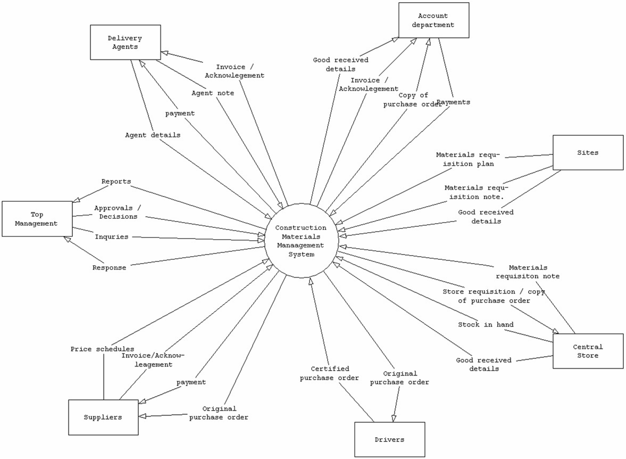
Figure 1: Context diagram of CMMS

Figure Error! No text of specified style in document.-1: Context diagram of CMMS

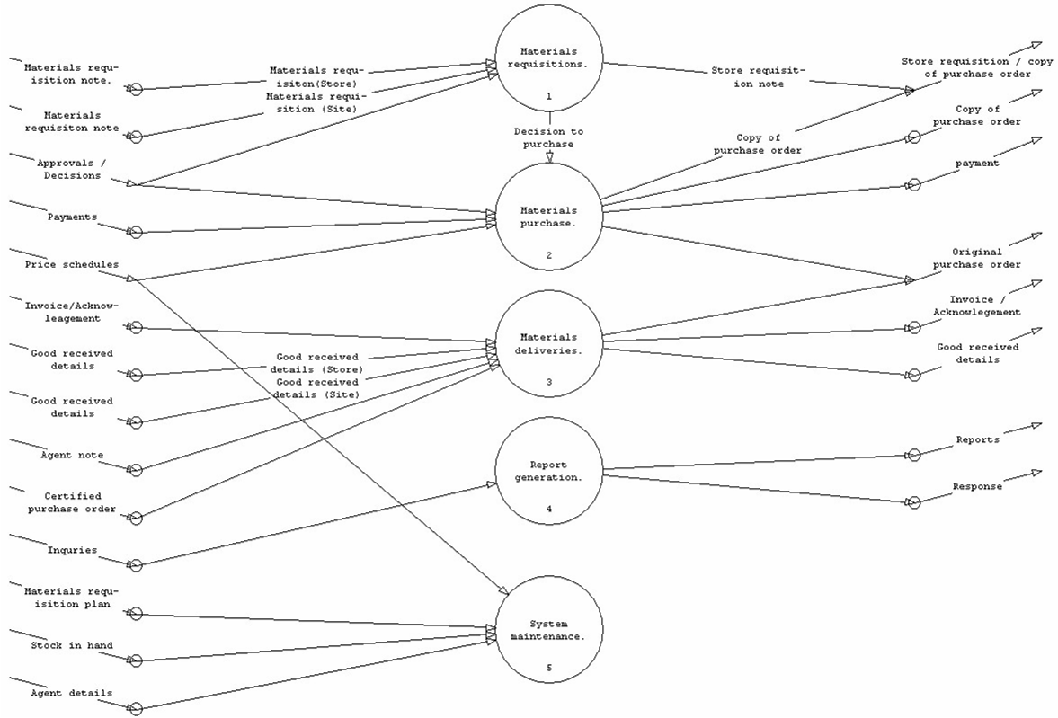
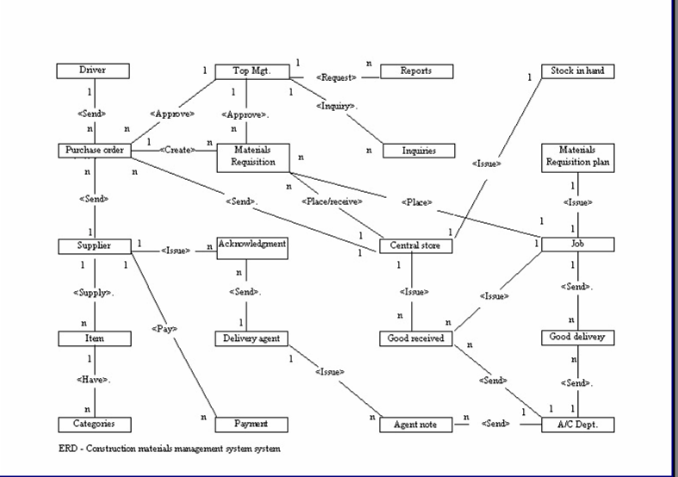
Figure 2: Level 1 diagram of CMMS
Figure 3: ERD of CMMS

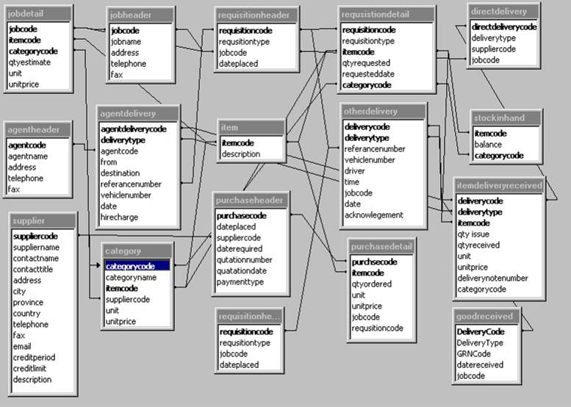
Figure 4: File specification of CMMS

System development and testing
This phase involved the development of software based on the information model created during the previous phase. The main activities involved are;

- Database development
CMMS Database uses the structure of a relational database model since it provides the ability for end users to create, and change the records in the database in a user-friendly way [8]. In addition to that, many standard software packages facilitate the development of relational databases. The file specification used for the database development of CMMS is illustrated in the section of information modeling (Figure 4) and MicrosoftTM Access was 2000 used as the tool for the system development.

- Database Interface development.
User interface in the CMMS database system was also developed using MicrosoftTM Access 2000, which is more user friendly. There are 20 user interfaces including main menu and submenus, which facilitate to enter/query data in the CMMS (E.g.: Requisition detail entry form, purchase order entry form, etc.).

- Testing of the system
In testing the system, a bottom – up approach was employed. It consisted of following steps.

- Using black box testing methodology the system functions were tested.
- Testing the grouping of functions into modules.
- Final step of the testing can be defined as the system testing stage in which the testing concentrates on checking whether the system does what is required. For this fault-based testing was employed. Program was tested by entering actual data and reports were generated accordingly.

System implementation and maintenance
System implementation can be carried out in various ways, such as Direct, Parallel or in Phases [2]. Since the development is restricted to the prototype the actual implementation of the system and the maintenance was not implemented.

CMMS prototype should be further developed through the use of the same software or any other software such as Visual BasicTM and OracleTM prior to real commercial implementation.

CONSTRUCTION MATERIALS MANAGEMENT SYSTEM (CMMS)

CMMS developed to satisfy requirements identified in the requirements specifications. It is a practice-oriented and automated materials management system. The main modules of the CMMS can be illustrated as follows;
- Materials requisition
- Materials purchase
- Materials delivery
- Report generation
- System maintenance

The above modules facilitate the same functions identified in the information model (Figure 2).

Figure 5 shows the main interface of the CMMS. It consists of 6 main menus, which facilitate the use of the above stated modules.

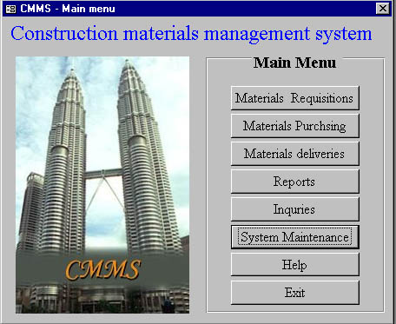
Figure 5: Main interface of the system

The six main menu options are briefly explained below;
- Materials requisition - Entry of all approved requisition details.
- Materials purchasing - Entry of approved materials purchase order details.
- Materials deliveries - Entry of all materials delivery details. E.g: Purchase delivery, Agent delivery, Store delivery, Direct purchase, Good return, Good receive
- Reports - Select this menu to view and print reports needed for the materials management. E.g.: Material purchase order, Material requisition, Store requisition, Material requisition report, Materials purchase report, Materials reconciliation report (figure-6 /figure-7).
- Inquiries - This facilitates system inquiries. E.g.: Item inquires, Materials price list etc.
- System maintenance - This provides the options to enter data, which require for the system maintenance. E.g.: Supplier detail, Item detail, Category detail, Agent detail, Job detail, Job materials, Stock in hand.
- Help - This consist of two sub menus: Help topics and about CMMS.
- Exit - Exit from the system.

All the entry forms provided with the system interface have the options for adding, deleting, editing, canceling etc.

Special features of the CMMS – database
Special features of the CMMS database system can be described as follows.
- Materials Requisitions
This facilitates for decision support. E.g. when the requested quantities are entered for particular material, it provides the up to date relevant information of BOQ estimated value, stock in hand and total quantity issued of that material.
- Materials Purchase
This makes the preparation of purchase orders much easier than before, and a short time. It can be manipulated easily to suit the requirements and review as required. If E-mail facilities are available, the copy of the same document can be sent to the supplier in few minutes.
- Materials Deliveries
This can be mainly used to keep track of the various deliveries, such as agent delivery, direct supply, store delivery, goods return etc. This information is used to prepare the monthly statement of agent charges etc. This can also be used to track the person responsible for a particular delivery in conflict situations.

Reports Generation
CMMS provides kinds of reports, which are required for effective materials management such as purchase report, requisition report and materials reconciliation report on a project basis. Two sample reports are provided in figure 6 & 7.

Inquires
CMMS allows inquiring about any supplier just by entering the name of the supplier. It provides all the details about the supplier and the items supplied with prices.

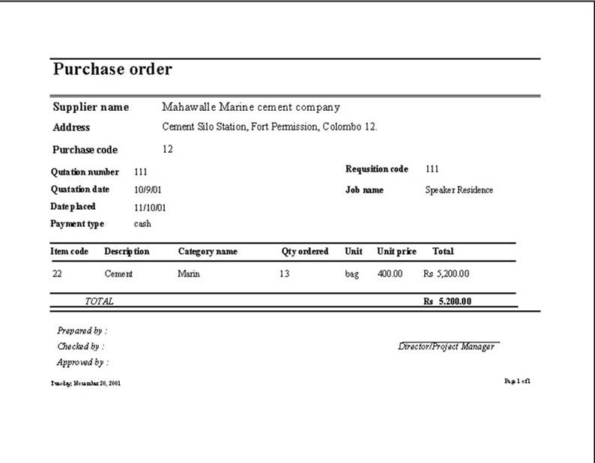
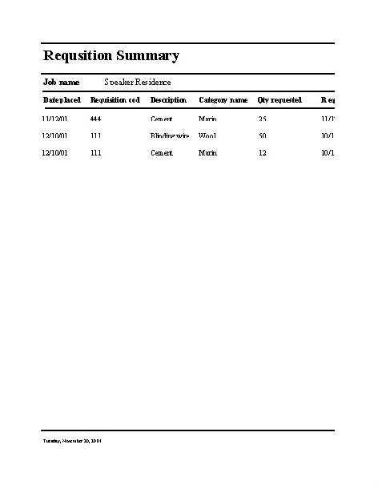
Figure 6: Purchase order report
Figure 7: Requisition summary report

Benefits of CMMS
CMMS provide the following benefits;
- Provides speed and accuracy in response.
- Records and controls materials for a project.
- Retrieves information on materials used for a particular project.
- Avoids data duplication and redundancy.
- Automated materials reconciliation and management.

Limitation of CMMS
Following limitations exist in the development;
- This is only a prototype system.
- This only a management information system (MIS) and does not provide direct decision support.
- There is no flexibility for the user to query for reports other than the ones provided in the database system.
- CMMS does not facilitate management of financial data such as invoices received from the suppliers etc.

However, CMMS methodology provides for further expansion of it’s models to overcome, most of the limitations identified in this prototype version.

CONCLUSIONS

Materials in many cases, account for an increasing proportion of construction costs. Further many management-oriented problems encountered in construction are related to materials and tend to become more difficult and numerous than ever before. In consequence, management needs to focus more attention, more talent and more time on the management of materials [6].

The Computer Aided Construction materials management System (CMMS) presented in this article provides an interactive and automated system for managing construction materials in a timely manner. The system is effective itself, satisfying established objectives and requirements, and has the potential to be expanded to facilitate and eliminate deficiencies in financial management. It can further be extended to be used as an online system with E-mail facilities for placing purchase orders. The system developed is practice – oriented and user friendly, has the ability to access large amount of data, reduces data redundancy, increases data integrity and makes information available when needed. This paper explained in detail the CMMS database system and its development process. The key feature of the system development process is the successful

application of information modeling concepts in developing a real life industry oriented system. Though the system was developed as a prototype it has been used by the participatory contracting organizations in real time projects. Continued use of this system will contribute to the increased efficiency and greater profitability for the contractors. It is envisaged that it will lead to the development of a full-scale system in these organisations.

REFERENCES

- Construction Industry Institute, Project Materials Management Handbook, Austin, TX (1987).
- Kennethe, K. and Julie, E.K.K., System Analysis and Design, 2nd edn., Prentice-Hill international, U.K (1992).
- Martin, G., System Analysis and Design, 1st edn., Anchor Press Ltd, U.K (1989).
- Ian, E.C., Materials management on building site, 1st edn., Long man Inc., New York (1978).
- Leenders, M.R., Fearon, H.E., and England, W.B., Purchasing and Materials Management, 9th edn, Trwin, Boston, MA (1989).
- Chunawalla, S.A. and Patel, D.R., Integrated materials management concepts and cases, 1st edn., Himalaya Publishing house, Bombay (1984).
- Oguri, T., Integrated material management system implemented on a relational database concept, In Proceedings of the Project Management Seminar Symposium, San Francisco, California, 1988, pp. 594-600 (1988).
- Lonnie E.M. & David M.B., Microsoft Office 97, 2nd edn., BPB publications, New Delhi (1997).

According to the Institute Construction Training and Development (ICTAD) classification of construction contractors M1 stands for contractors having the highest grading in terms of capacity.

